**Secure Management of Patient Medical Records using Blockchain Technology**

.

ABSTRACT

|  |
| --- |
| Blockchain technology has transformed the way information is stored and secure. It provides a transparent and tamper-proof ledger system for transactions in optimized time frame hence serving as the foundation for cryptocurrencies such as bitcoin, but its applications have now extended to healthcare data privacy. The mining process is an essential part of blockchain technology, which ensures validity and immutability of data. The primary objective of this study is to create a blockchain-based framework for managing patient medical record to prevent unauthorised access and maintain data integrity. It deals with mining of blocks in a blockchain to securely store patient medical information.  The presented methodology implements a blockchain based approach, which uses Python and Flask for block generation, mining and verification, with API testing though Postman. Postman allows users to send transactions that are subsequently included to the next block for mining. All patient record is securely mined into a block which contain patient name, ID, registration number and cryptographic hashes to ensure immutability. The results show that the system effectively mines patient records while maintaining chain integrity and validity, as validated by simulated mining and retrieval operations. The article not only gives a theoretical view of mining but also includes hands-on experience, users may have a better understanding of the fundamentals process by mining blocks, making the concepts more practical and interesting for the users. |

*Keywords: Blockchain Technology, Data Mining,* HealthCare System, *Security, Transaction Processing*

1. INTRODUCTION

Blockchain technology has changed the digital environment through its decentralized nature and tamper-proof ledger system. It is based on the concept of distributed database used to maintain data integrity, consistency, and transparency over the network [1].

One of the crucial aspects of blockchain technology is the process of mining of blocks. Mining is the process of validating and adding the information to the blockchain ledger system. It is not only used for adding new blocks to the chain but also ensures the security of the entire system and verifies the legitimacy of transactions [2]. Mining of blocks is a multi-step process that needs the involvement of specialized nodes called miners. The participating miners execute complex mathematical computations to solve cryptographic puzzle. The miners who successfully solve the puzzle may be able to add a new block to the blockchain and get a reward as a cryptocurrency. The steps of mining of a block start by collecting unconfirmed transactions from the mem-pool, which is an interim repository for awaiting transactions [3]. After collecting a transaction, the miners start the mining process by selecting a block header which contains crucial details like the hash value of the block, the previous block address, a timestamp, and nonce. Consequently, the miners integrate the block header with the chosen transactions and then employ a hashing technique, such as SHA-256, to create the block hash value. The main goal of miner is to find a hash value that meets a certain difficulty target defined by the blockchain network [4]. The difficulty target is a fixed number that indicates that the hash value of a block should be below from the target. When miners find a hash value that satisfies the goal difficulty, then disseminate the solution to the network. Other miners on the network confirm the solution by independently validating the computations [5]. The miner block gets added to the blockchain if the solution is accepted as valid and the miner gets rewarded for the work. Furthermore, the blockchain technology was initially developed for the digital cryptocurrency bitcoin. However, it is not limited to bitcoin but also used in various domains such as Internet of Things (IoT) security, banking sectors, supply chain management, healthcare, and many more due to its secure, transparent, and immutable nature [6].

Due to the growing frequency of data breaches and cyberattacks, managing and protecting medical information is a crucial concern in healthcare sectors. Traditional centralised databases compromise patient safety and privacy due to the vulnerability to single points of failure, illegal access, and data tampering.

The purpose of this research is to implement a blockchain-based approach for the secure management of patient medical records, ensuring data integrity, privacy, and unauthorised access.

The increasing need for reliable data security solutions in the healthcare industry serves as the motivation behind this study. There is an urgent need for innovative technology that can ensure data authenticity and stop breaches. Blockchain presents a promising solution, by storing patient records into separate blocks that cannot be changed once they are mined into the chain. The complete mining procedure of blockchain is explained in the Fig. 1.

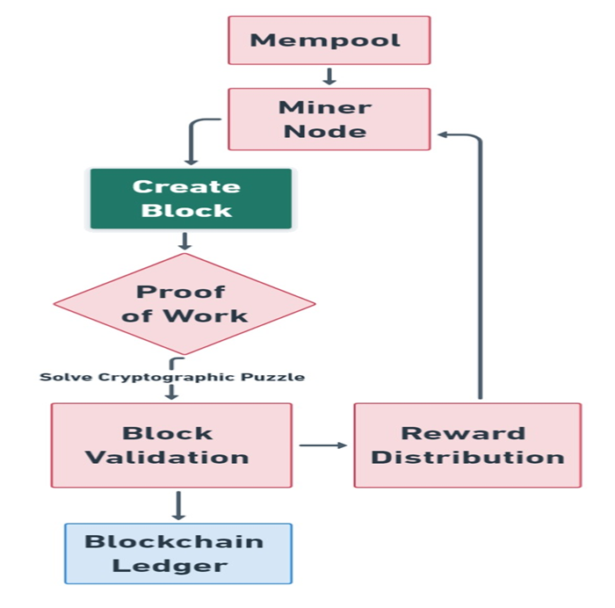

**Fig. 1. Data Mining Process through Blockchain Technology**

* 1. **Main Contribution**

On the basis of above, the present article provides an in-depth analysis of the mining process through practical implementation and simulate the procedure for users to mine the blocks. The study evaluates the blockchain mining process, focusing on a secure method of maintaining health data. The presented method involves creating a health record ledger that securely stores patient health record and registration numbers on the blockchain. This guarantees that only authorized individuals have access to the records.

Users or medical professional mines the patient health record into the blockchain. Once a record is entered into the blockchain, it becomes immutable and tamper-proof. Additionally, the approach also ensures data integrity and transparency of the data.

* 1. **Scope of the study**

This research focuses on the development and deployment of a blockchain mining framework to protect patient medical information. It does not include statistical data analysis tests like cointegration, unit root, and robustness tests because the primary goal is to show technical feasibility rather than statistical correlations. These analyses are being considered as part of future research into combining patient data trends or performance evaluations with blockchain mining for advanced healthcare analytics.

1. **Related Work**

From the literature, it is observed that there are some studies conducted, that discuss the concept of mining, but there has been limited progress in discovering the detailed workings of the mining process. Chen et al. [7] have discussed the issues of centralization in mining power in the context of a Proof of Work (PoW) blockchain system. Additionally, it developed Endex, a decentralized index that measures the degree of decentralization Cong et al. [8], have designed a mining pool that highlights the risk sharing as a natural centralized factor and described how a blockchain system may continue to be decentralized over time and provide actual data from the bitcoin mining sector to back up our hypothesis. Todorović et al. [9], have proposed Combinatorial Optimization Consensus Protocol (COCP) which is a Proof-of-Useful-Work (PoUW) consensus protocol that substitutes typical cryptographic puzzles with real-life examples of Combinatorial Optimization (CO) issues. A block withholding attack avoidance technique is based on blockchain mining behaviors which has been presented in [10]. The goal is to identify malicious miners, reduce the income, and enhance the income of legitimate miners.

In the context of healthcare sector, the blockchain technology provide efficient solution in securing the patient data. Rathee et. al [11] a hybrid framework for processing multimedia data in IoT-based healthcare systems is proposed that combines the blockchain and IoT in the healthcare domain to store the data securely. Kaur et. al [12] have proposed a Ciphertext-Policy Attribute-Based Encryption (CP-ABE) which is a decentralised system that combines blockchain to securely store and distribute Electronic Health Records (EHRs). Allam et al. [13] presented a comprehensive survey on IoT-Healthcare systems using blockchain, that enhances data integrity, auditability, and interoperability across healthcare networks. Albshri et al. [14] presented a conceptual architecture for modelling blockchain-based IoT networks for healthcare data management, highlighting its ability to provide real-time data access while maintaining high security assurances. Furthermore, Tiwari and Kumar [15] created a smart blockchain architecture that employs safe hash algorithms to improve data security and decentralisation in healthcare data exchange.

In blockchain technology, mining is a crucial procedure which guarantees the security and integrity of the distributed ledger. It is a process of adding new blocks to the blockchain using computing resources and consensus procedures [16]. As per Fig. 1, the overview of mining process is discussed below:

1. **Transaction Pool (Mempool)**

Mempool is the area where all the unconfirmed transactions exist. The transactions indicate cryptocurrency like bitcoin or data transfer on the blockchain. Every transaction comprises information such as the sender, receiver, and amount (in cryptocurrency), or the exact data being transferred as discussed by Priyanka et al. [17]. Initially, every bitcoin transaction is store into a Mempool. Thereafter, the miners retrieve transactions from the Mempool and organize them into blocks.

1. **Block Creation**

Miners gather all of the transactions and then combine into a block, which includes the three components containing the transaction list, the block header, and the merkle tree root [18]. Transaction list serves as an inventory of approved transactions that will be added in the block. Block header contains essential information about the block, like the timestamp of the block, a previous block hash, and other essential information used in the mining process. Further, Merkle tree root, which also referred to as a binary hash tree, is generated by hashing the transactions and it also ensures the data integrity.

1. **Transaction Validation**

Before a block is mined, all transactions go through with verification process to ensure block authenticity and integrity [19]. Firstly, each transaction is checked to confirm that the sender has enough funds and then the transaction is properly organized. Next, a signature checked is performed, where the sender cryptographically signs transactions, which are subsequently verified to guarantee the legitimacy of block. Finally, a double-spending check is performed to ensures that the same funds are not used multiple times, which prevent from fraud transaction in blockchain network.

1. **Proof of Work (PoW)**

It is a consensus mechanism as well as a primary mining process used in blockchain. It is like a tournament where miners race to solve cryptographic puzzles as discussed by Choudhary and Saxena [20]. The process involves determining nonce, it is a 32-bit random number used to generate a hash value. When the block header is combined with this nonce, it generates a hash with a particular number of leading zeroes. The nonce range start from $0 to 2^{32}-1$ $≅0 to$ 4 ${10}^{9}$*, while the total number of valid hashes ${10}^{77}.$ The SHA-256 hash algorithm is widely used to compute the hash value. Miners repeatedly calculate the hash of the block with various nonce values until a valid hash is discovered. Furthermore, obtaining a hash less than a specific target is measured by the difficulty target. Once miners discover a nonce that generates a valid hash and meet the difficulty threshold, the solution is broadcast to the network for validation.

1. **Block Validation and Addition**

When a miner discovers a valid solution, the proposed block distributes all over the network. Other nodes in the network then performs the several checks [21]. First, the verification of block header hash is accurate and satisfies the difficulty target. Next, to reverify the transaction within the block to ensure that no tampering has occurred. Finally, if the block is deemed legitimate then node appends the block to blockchain. This process ensure consensus, as the majority of the network collectively determine the blockchain's current state.

1. **Reward and Incentive**

A certain amount of new digital currencies is granted to miners, as a reward, who successfully mines the block [22]. After that, the process is then restarted and miners compete to create the subsequent block and add it to the blockchain.

1. **Propagation and Synchronization**

The new block is transmitted all over the network, ensuring that all nodes have the most recent version of the blockchain.

1. **Methodology**

The present work proposes a blockchain architecture which includes block generation, mining, and verification. Each block contains essential information, including the patient's name, ID, registration number, proof, hash value, previous hash, and timestamp. The methodology is outlined below.

* 1. **System Design**

The system design covers building a blockchain in which each block contains the following attributes:

* **Patient name and ID:** The patient ID, or unique identifying number, is obtained from the patient's medical report and is linked to the patient's name on the record.
* **Registration number (Reg_no):** The registration number from the medical report is appended into the block to verify its authenticity.
* **Proof:** The result of the proof-of-work algorithm is a nonce value that meets the specified criteria of the difficulty target to validate the block.
* **Previous Hash:** The hash value of the preceding block, ensuring the continuity of the chain.
* **Timestamp:** Each block's creation time is recorded. Because timestamps change every second, the hash result likewise varies over time, adding an extra level of protection. The range of nonce is 4 ${10}^{9}$* and the total valid hash is ${10}^{77}.$ Therefore, 4 ${10}^{9}$* the entire nonce range is exhausted in 40 seconds because of ${10}^{8}$ hashes generate in 1 second and (4 ${10}^{9}$*) / ${(10}^{8})$ = 40 seconds. So, there is a problem that all hashes are generated within the nonce range; that’s why “Timestamp” comes into the picture. Consequently, every 1-second timestamp will change; if the timestamp changes, then the hash also changes. So, nonce is not completely utilized. Due to the timestamp, the nonce generates a large number of hashes.

* **Hash:** The cryptographic SHA-256 hash of the current block.
  1. **Implementation**

The blockchain system is implemented with Python and Flask, a lightweight web framework for Python that allows developers to construct web applications. Furthermore, the Postman is used to test the blockchain, which is an Application Programming Interface (API) development tool that helps build, test, and modify API’s. It makes various types of HTTP requests (GET, POST, PUT, PATCH) for mining blocks, obtaining chains, and validating blockchains. The implementation consists of the following main functions and the complete procedure of mining of patient medical record is represented in algorithm 1.

|  |
| --- |
| **Chart 1:** Patient Medical Record Mining in the Blockchain |
| *Input: patient_name, patient_ID, Reg_no*  *Output: Updated blockchain with mined patient record*  *Begin*  *If blockchain is empty then*  *Create genesis block with default data*  *Calculate hash of genesis block*  *Append genesis block to chain*  *EndIf*  *previous_block ← get last block in chain*  *previous_proof ← previous_block.proof*  *new_proof ← 1*  *While True do*  *hash_val ← SHA256(new_proof^2 - previous_proof^2)*  *If hash_val starts with '0000' then*  *Break*  *Else*  *new_proof ← new_proof + 1*  *EndIf*  *EndWhile*  *previous_hash ← hash(previous_block without its hash field)*  *Create new block with:*  *patient_name, patient_ID, Reg_no*  *index ← length of chain + 1*  *timestamp ← current time*  *proof ← new_proof*  *previous_hash ← previous_hash*  *block_hash ← hash(new block without its hash field)*  *Add block_hash to new block*  *Append new block to chain*  *Return "Patient record securely added to blockchain ledger"*  *End* |

* **Block Creation:** Creating new blocks with the appropriate properties, such as create_block(patient_name, patient_ID, Reg_no, proof, previous_hash)
* **Proof of Work:**  The function proof_of_work(previous_proof) implements the proof-of-work methods to verify a blockchain by finding a nonce that generates a hash value.
* **Hash Calculation:** Determine the hash of each block with the help of hash(block). Further, convert and encode the block dictionary into a JSON string. Return the SHA-256 hash of the encoded block.
* **Chain validation:** It is the process of ensuring the blockchain integrity with the method is_chain_valid(chain). It is verifying that each block's 'previous_hash' matches the hash previous block.
  1. **Testing and validation**

The system is tested by mining several patient records and retrieving the blockchain to ensure each block is mined successfully with the correct hash. Hence, the step-by-step procedure is described as follows:

*Step-1 Define a route* ***/get_chain****: It returns the whole blockchain with all patient records and ensures that each block has the right hash value;*

*Step-2 Define a route* ***/mine_block****: It is used for mining a new block with the patient name, patient ID and registration number;*

*Step-3 Define a route* ***/is_valid****: It ensures the blockchain integrity and verifies whether the blockchain is valid.*

1. **Results and Discussion**

The present work represents code snippets and details about the implementation. It demonstrates Postman interacts with a simulated network. It also includes a sample scenario in which users submit details and mine blocks, showing the validity blocks to the blockchain.

* 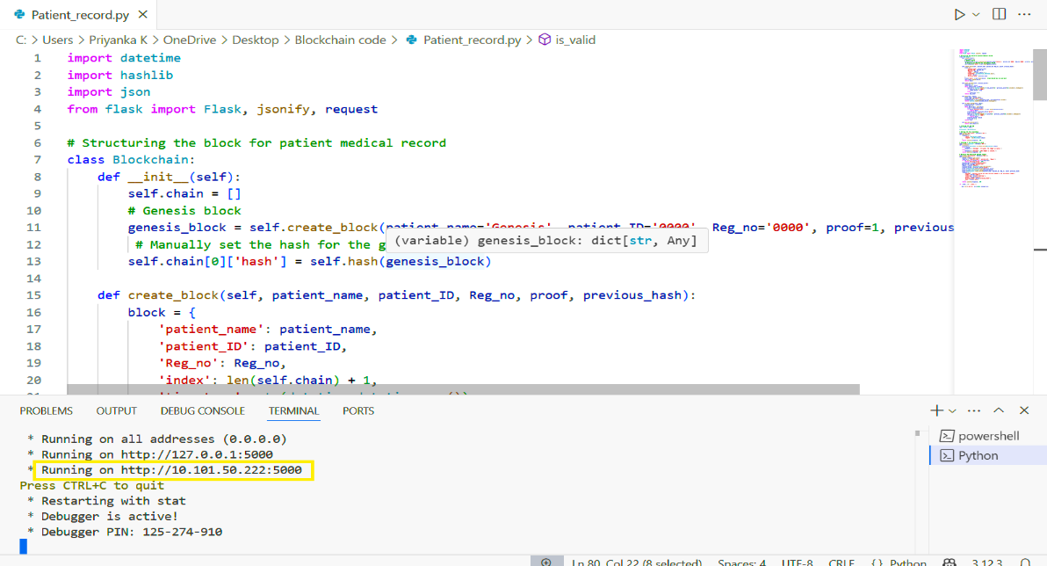The JSON output below indicates the successful establishment and validation of the blockchain. Therefore, Fig. 2 describes the code, that generates the HTTP request as shown in the box.

**Fig. 2. Code of Blockchain**

* 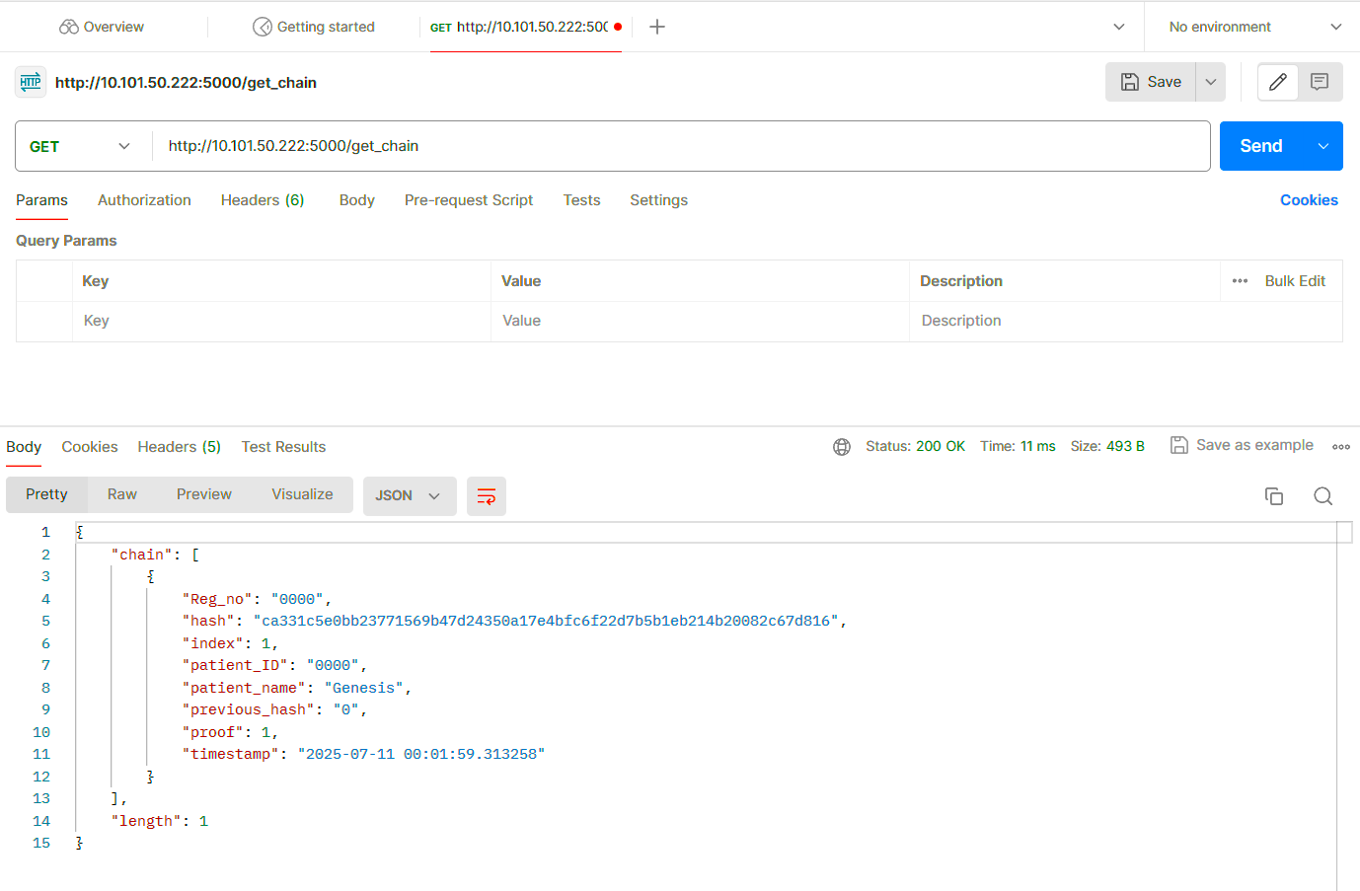The HTTP request is produced, as seen in the Fig. 2. The HTTP call is executed in the Postman workspace to get a chain using the **/get_chain** function. Furthermore, after hitting the GET request, we will get the first block (Genesis block) as shown in Fig. 3.

Fig. 3. Genesis Block Generation

* 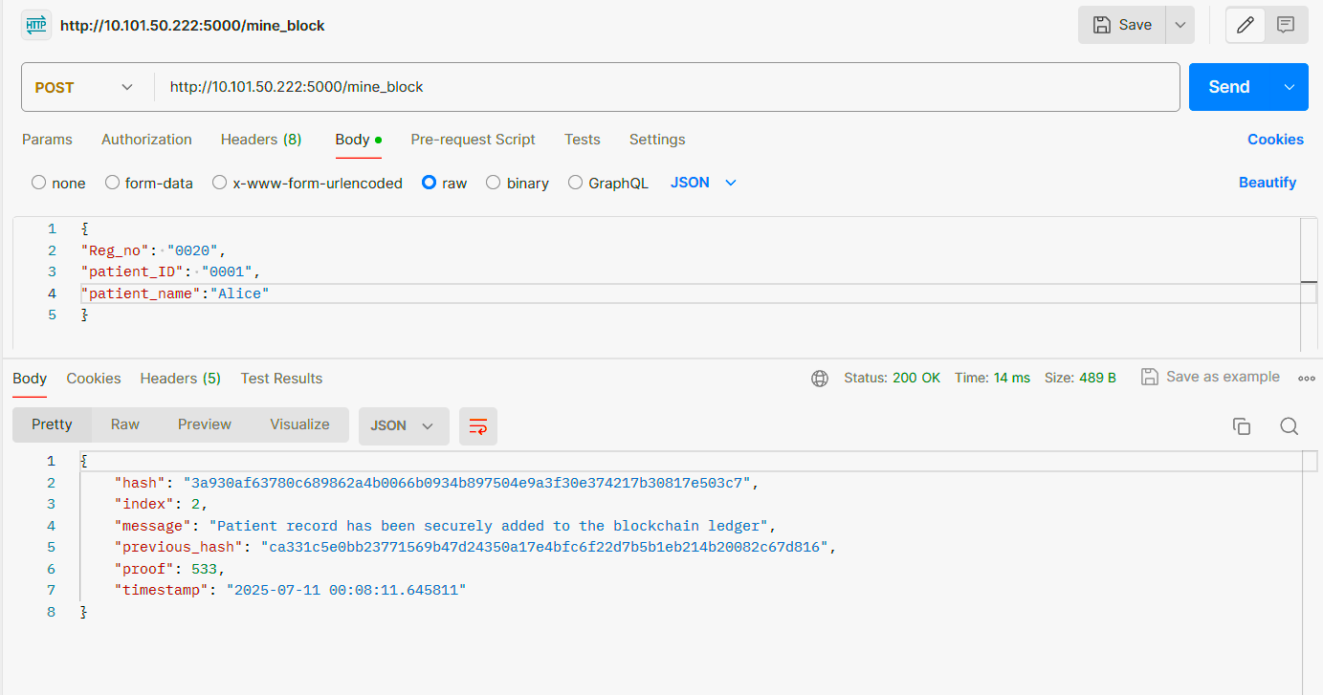Now to mine a new block in this chain, the mine function like **/mine_block** is executed as shown in Fig. 4. After hitting the POST request, the new block is mine. The patient’s name of the second block is “Alice”.

**Fig. 4. Mining of the Second Block**

* After mine the second block, the researcher wants to retrieve the chain. As a result, the authors again perform the **/get_chain** function to obtain the chain, as shown in Fig. 5.

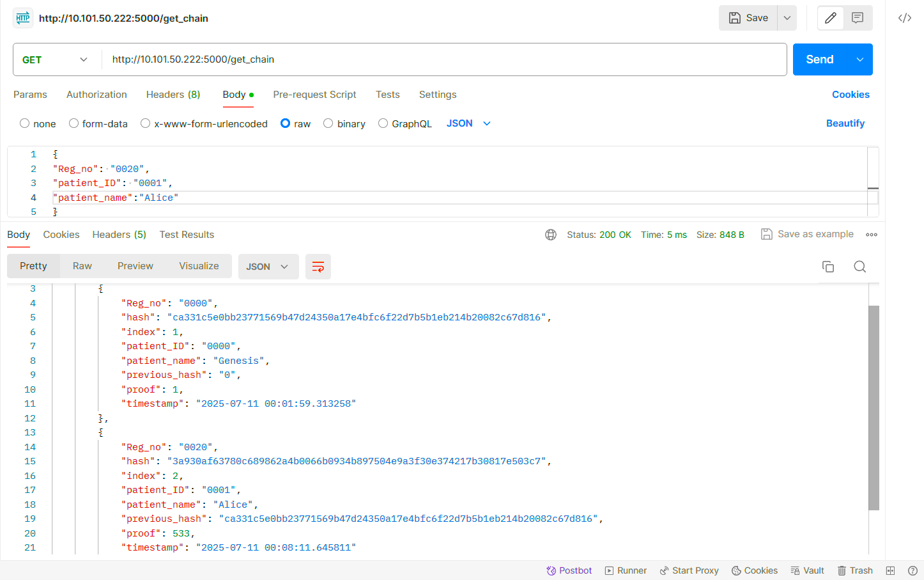

**Fig. 5. Second Block Generation**

* 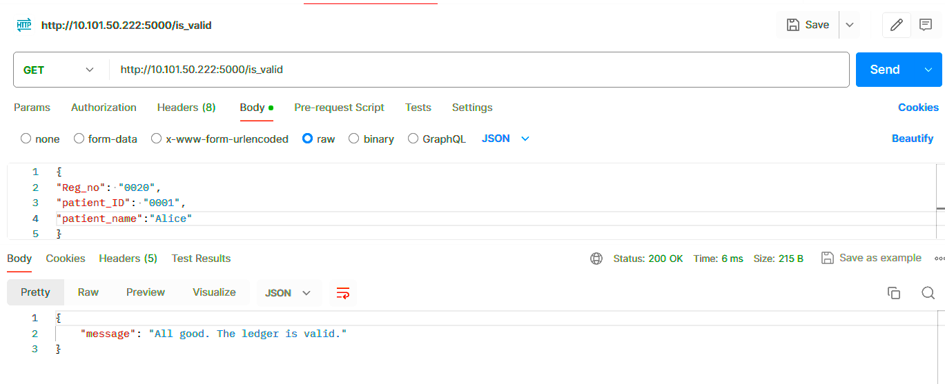To verify the blockchain validity, the function such as **/is_valid** is executed. Fig. 6, represents the validation of blocks and the results show that the chain is valid. In this way, the miner may mine new block one after the other.

**Fig. 6. Verification of the blockchain.**

The said findings show that the mining process is critical to the security and integrity of the data in blockchain. By making it, miners solve complicated mathematical problems, the method assures that changing any block in the chain requires re-mining of all the blocks. It offers significant security against tampering of data. The study gives the fundamental concept of block mining and users or medical professional may experience the real time mining process by mined the patient medical record.

# Conclusion and Future Scope

The mining process in blockchain technology is a complex but necessary mechanism that protects the blockchain’s privacy, integrity, and decentralization. Miners use computing effort and cryptographic techniques to authenticate transactions, solve cryptographic puzzle, and add new blocks to the chain, ensuring the trust and stability of the whole blockchain ecosystem. The study describes a technique for simulating blockchain mining with Python, flask, and Postman. It also gives useful insights into the fundamental functions of blockchain technology. However, the method employs simulated inputs for core mining without time-series data analysis or network efficiency evaluation.

Future work may expand the simulation to include a multi-user environment with block rewards and network synchronization features. Additionally, using real-time healthcare data and statistical tests like cointegration, unit root, and robustness could help to analyse blockchain performance in medical data systems.

**Disclaimer (Artificial intelligence)**

Author(s) hereby declares that NO generative AI technologies such as Large Language Models (ChatGPT, COPILOT etc.) and text-to-image generators have been used during the writing or editing of manuscripts.

References

[1] Sultan, A., Mushtaq, M. A., & Abubakar, M. (2019, March). IOT security issues via blockchain: a review paper. In *Proceedings of the 2019 international conference on blockchain technology* (pp. 60-65) doi: [10.1145/3320154.3320163](http://dx.doi.org/10.1145/3320154.3320163).

[2] Klinkmüller, C., Ponomarev, A., Tran, A. B., Weber, I., & van der Aalst, W. (2019, August). Mining blockchain processes: Extracting process mining data from blockchain applications. In *International conference on business process management* (pp. 71-86). Cham: Springer International Publishing. <https://doi.org/10.1007/978-3-030-30429-4_6>.

[3] Taylor, P. J., Dargahi, T., Dehghantanha, A., Parizi, R. M., & Choo, K. K. R. (2020). A systematic literature review of blockchain cyber security. *Digital Communications and Networks*, *6*(2), 147-156.<https://doi.org/10.1016/j.dcan.2019.01.005>.

[4] Feng, J., Zhao, X., Chen, K., Zhao, F., & Zhang, G. (2020). Towards random-honest miners selection and multi-blocks creation: Proof-of-negotiation consensus mechanism in blockchain networks. *Future Generation Computer Systems*, *105*, 248-258.<https://doi.org/10.1016/j.future.2019.11.026>.

[5] Hamza, N. M., Ouf, S., & El-Henawy, I. M. (2020, March). A Proposed Technique for Enhancing the Mining Process in Blockchain Architecture. In *2020 Fourth International Conference on Computing Methodologies and Communication (ICCMC)* (pp. 7-12). IEEE.DOI:[10.1109/ICCMC48092.2020.ICCMC-0002](https://doi.org/10.1109/ICCMC48092.2020.ICCMC-0002)

[6] Ding, X., Guo, J., Li, D., & Wu, W. (2020). Attract More Miners to Join in Blochchain Construction for Internet of Things. *arXiv preprint arXiv:2003.10560*.[10.48550/arXiv.2003.10560](https://ui.adsabs.harvard.edu/link_gateway/2020arXiv200310560D/doi:10.48550/arXiv.2003.10560)

[7] Chen, R., Tu, I. P., Chuang, K. E., Lin, Q. X., Liao, S. W., & Liao, W. (2020). Endex: Degree of mining power decentralization for proof-of-work based blockchain systems. *IEEE Network*, *34*(6), 266-271.[10.1109/MNET.011.2000178](https://doi.org/10.1109/MNET.011.2000178)

[8] Cong, L. W., He, Z., & Li, J. (2021). Decentralized mining in centralized pools. *The Review of Financial Studies*, *34*(3), 1191-1235.<https://doi.org/10.1093/rfs/hhaa040>

[9] Todorović, M., Matijević, L., Ramljak, D., Davidović, T., Urošević, D., Jakšić Krüger, T., & Jovanović, Đ. (2022). Proof-of-useful-work: Blockchain mining by solving real-life optimization problems. *Symmetry*, *14*(9), 1831.[**https://doi.org/10.3390/sym14091831**](https://doi.org/10.3390/sym14091831)

[10] Soria, J., Moya, J., & Mohazab, A. (2023). Optimal mining in proof-of-work blockchain protocols. *Finance research letters*, *53*, 103610..<https://doi.org/10.1016/j.frl.2022.103610>

[11] Rathee, Geetanjali, Ashutosh Sharma, Hemraj Saini, Rajiv Kumar, and Razi Iqbal. "A hybrid framework for multimedia data processing in IoT-healthcare using blockchain technology." *Multimedia Tools and Applications,* 79, no. 15, (2020), pp. 9711-9733. <https://doi.org/10.1007/s11042-019-07835-3>.

[12] Kaur, Jasleen, Rinkle Rani, and Nidhi Kalra. "Attribute-based access control scheme for secure storage and sharing of EHRs using blockchain and IPFS." *Cluster Computing,* 27, no. 1, (2024), pp. 1047-1061. <https://doi.org/10.1007/s10586-023-04038-2>.

[13] Allam, A. H., Gomaa, I., Zayed, H. H., & Taha, M. (2024). IoT-based eHealth using blockchain technology: a survey. *Cluster Computing*, *27*(6), 7083-7110.<https://doi.org/10.1007/s10586-024-04357-y>.

[14] Albshri, A., Alzubaidi, A., Alharby, M., Awaji, B., Mitra, K., & Solaiman, E. (2023). A conceptual architecture for simulating blockchain-based IoT ecosystems. *Journal of Cloud Computing*, *12*(1), 103.<https://doi.org/10.1186/s13677-023-00481-z>.

[15] Tiwari, M. G. D., & Kumar, K. A. (2023). Decentralization System Using Smart Blockchain with Secure Hash. *SN Computer Science*, *4*(5), 620.<https://doi.org/10.1007/s42979-023-02026-2>

[16] Chen, H., Chen, Y., Xiong, Z., Han, M., He, Z., Liu, B., ... & Ma, Z. (2023). Prevention method of block withholding attack based on miners’ mining behavior in blockchain. *Applied Intelligence*, *53*(9), 9878-9896.<https://doi.org/10.1007/s10489-022-03889-3>.

[17] Priyanka, K., Vipin, S., & Shalini, C. (2025). Prediction of Type-II Diabetic through Blockchain Technology. *Indian Journal of Science and Technology*, *18*(15), 1177-1188.[10.17485/IJST/v18i15.3423](https://doi.org/10.17485/IJST/v18i15.3423)

[18] Chanal, P. M., & Kakkasageri, M. S. (2024). Blockchain-based data integrity framework for Internet of Things. *International Journal of Information Security*, *23*(1), 519-532.. <https://doi.org/10.1007/s10207-023-00719->

[19] Choudhary, B., & Saxena, V. (2023). Blockchain Implementation for Faster Accessing of Database of Banking Industry. *International Journal on Recent and Innovation Trends in Computing and Communication*, *7*, 504-512.Available from: <https://www.researchgate.net/publication/379986243_Blockchain_Implementation_for_Faster_Accessing_of_Database_of_Banking_Industry>

[20] Saxena, V., Verma, V., Verma, V., & Singh, K. V. (2023, October). Data Cube Technology for Accessing of Large Database. In *International Conference on Computer & Communication Technologies* (pp. 39-48). Singapore: Springer Nature Singapore. <https://doi.org/10.1007/978-981-99-9704-6_4>.

[21] Verma, V., Kumar, H., Saxena, V., Singh, K.V. and Verma, V. (2025) Blockchain Technology: A Comprehensive Review, Grenze International Journal of Engineering and Technology, January Issue, 2445-2458, Grenze Scientific Society, Grenze ID: 01. GIJET.11.1.8

[21] Abbasi, F. N., & Sidhu, S. M. (2021). The Implementation and Impact of Blockchain Technology in the Finance and Trade Sector of Economy of the Developing World. Asian Journal of Economics, Business and Accounting, 21(11), 70–73. <https://doi.org/10.9734/ajeba/2021/v21i1130442>

[22]Mistri, A., & Dudhagara, C. R. (2025). Harnessing Blockchain Technology for Transforming Indian Agriculture: A Review of Innovations and Applications. Journal of Scientific Research and Reports, 31(7), 813–823. <https://doi.org/10.9734/jsrr/2025/v31i73301>