**Reliability and Profit Analysis of a Two-Unit Redundant System with Periodic Rest Mechanism**

**Abstract**

This study examines the reliability measures of a system where two identical or similar units (or components) are used, with one serving as a backup for the other in case of failure, ensuring continued operation of a two-unit redundant system enhanced by a resting mechanism designed to improve performance. The system consists of two units, with one unit operating actively while the other remains in a cold standby mode. A distinctive aspect of the model is the inclusion of periodic rest for the active unit, during which it is not considered failed. The failure, repair, and rest rates are modeled using exponential distributions. Key reliability metrics such as MTSF, availability, and the busy period of the server are analyzed through linear differential equations. To evaluate the system’s performance, graphs are employed to demonstrate how varying rest rates influence reliability measures and profitability. The findings reveal that the resting mechanism plays a critical role in enhancing system availability and operational efficiency. Through this study, a mathematical basis for evaluating system performance is established, and solutions for optimizing profitability and reliability in redundant systems are provided.

**Keywords:** Reliability, Steady -State Availability, Busy period analysis, Profit analysis, Mean time to system failure (MTSF).

**MSC 2020 :** 62N05 , 90B25 , 68M15

1. **Introduction**

Evaluating system performance is essential for assessing effectiveness and identifying key measures of any system. The widespread usage of two-unit redundant systems in commercial and industrial applications has attracted a lot of attention in reliability studies. Several configurations of these systems have been investigated by researchers, who have concentrated on criteria including cost analysis, repairman busy periods, steady-state availability, and MTSF. The regenerative point technique and the Markov renewal process are frequently used in these studies.. Previous studies have addressed different aspects of two-unit redundant systems.[2] Garg and Garg (2022) analyzed availability metrics and profit optimization in systems with a single unit featuring a suboptimal switch-over device. [10] Malhotra et al. (2021) examined the dependability of a two-unit cold standby system with preventive maintenance in the pharmaceutical sector. [9] Lawan et al. (2022) investigated the reliability and performance of a two-unit active parallel system with two repairable machines. [11] Saini et al. (2021) conducted a stochastic evaluation of two-unit redundant systems incorporating different repair strategies. [8] Kumar et al. (2023) studied the reliability of spare standby systems with refreshment, using linear differential equations for computing reliability measures an approach that simplifies calculations and is often implemented using software like MATLAB. For instance,[6] Khaled and El-Said (2008) used linear differential equations to analyze cost performance in systems with preventive maintenance, while [ 1] Ali et al. (2013) applied the Kolmogorov forward equation technique to evaluate a system with two units, where one unit operates while the other remains powered off as a backup system with three operational modes. [4] Haggag M.Y. (2009) also employed Equations describing linear relationships between derivatives to assess the cost of systems with preventive maintenance. Similarly,[13] Ibrahim Yusuf (2012) compared reliability characteristics across spare systems with supporting units, and [5] Joshi et al. (2013) conducted stochastic analyses of redundant systems with rest periods, leveraging the regenerative point technique and Markov renewal processes.

The reliability measures of a two-unit system having a backup system that includes a rest mechanism are the main emphasis of this study. In this model, one unit operates actively while the other remains in cold standby, ensuring it does not fail while inactive. After operating continuously for an arbitrary amount of time, the active unit switches to a rest state. During rest, the system halts operation without experiencing failure. A complete system failure happens only when both units fail at the same time. Through the analysis of numerical examples with particular system parameters, the present study investigates how rest rates affects MTSF, steady-state availability, repairman busy periods, and profit functions.

1. **Model Description and Assumption**

The mathematical model has been developed based on the given assumption assumptions.

• The setup consists of two distinct units, The system after continuously operating for an arbitrary amount of time enters rest,

• The system enters a resting state after an uncertain Period, and the system becomes down but not failed during this interval. The system restarts after rest, and the process is repeated with alternate intervals of rest and operation.

• The standby mode is quickly transitioned to operational mode.

• It is assumed that the failure time, repair time, and the rate at which the system's rest provision applies follow an exponential distribution.

• Repaired to like-new condition

• Only one modification is permitted at a time.

1. **Notation and Symbol**

Si : State of transition for the system , i =0,1 , 2 ,3 ,4 ,

N0 ; Normal unit kept as operative

NS ; Normal unit kept as cold standby

Nrest ; Normal operative unit in the position of rest due to proviso of rest to the system

Fr ; Failed unit under repair

$α-$ rate of failure for the initial unit

$β$– second unit failure rate

γ- first unit repair rate

μ- repair rate of second

- constant rate of time after which rest is applicable to the first unit

δ - constant rate of time after which rest is applicable to the second unit

η - constant rate of end of rest first unit

- constant rate of end of rest second unit

4. **States within the system**

Up State ; S0 ≡ ( N0, NS) , S2 ≡ ( Fr, N0)

Rest State S1 ≡ ( Nrest, NS) S3≡ ( Fr, ,Nrest)

Down State ; S4 ≡ ( Fr,, ,Fr)

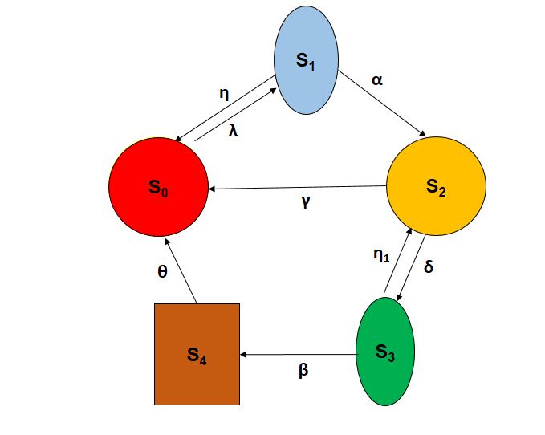

Figure 1. State Transition Diagram

**5. Mean time to failure of the system (MTSF).**

In the context of Figure 1, P(t) denotes the row vector of probabilities at time t, where each element Pi(t) signifies the probability of the system residing in state Si at that time. The problem's primary conditions are then given as.

|  |  |
| --- | --- |
| *P(0)= [ P0 (0), P1 (0), P2 (0), P3 (0), P4 (0),], = [ 1, 0 , 0 ,0, 0 ]* | (1) |

Based on the preceding information, the following differential equations are obtained:

|  |
| --- |
| = -λ *P0(t)+* η *P1(t)+ γP2(t)+* θ *P4*(t)  = -*(* + α)*P1*(t)+ λ *P0(t)*  = -( *)P2*(t) + α *P1*(t)+η1 *P3*(t)  = -( η1+β) *P3*(t) + *P2(t)*  *=-θ P4*(t) +β *P3(t)* |

The matrix representation of above differential equation is as follows.

|  |  |
| --- | --- |
| $\frac{dp(t)}{dt}$ = *A P* | (2) |

where

|  |  |
| --- | --- |
| *A* = $\left[\begin{matrix}-λ & η & γ & 0 & θ \\ λ & -(η+α) & 0 & 0 & 0 \\ 0 & α & -(γ+δ) & η₁ & 0 \\ 0 & 0 & δ & -(η₁+ β) & 0 \\ 0 & 0 & 0 & β & -θ\end{matrix}\right]$ |  |

Directly calculating the transient solution is overly complex. Therefore, we opt for an alternative method to determine the MTSF. This involves creating a new matrix, Q, by transposing matrix A, and then removing the rows and columns associated with the absorbing state.

The anticipated duration for attaining a terminal state is derived from

*E[TP(0) →(absorbing)]* = P(0) (3)

and

= -*Q-1*,since *Q-1< 0* (4)

where

|  |  |
| --- | --- |
| *Q* = $\left[\begin{matrix}-λ & λ & 0 & 0 \\ η & -(η+α) & α & 0 \\ γ & 0 & -(γ+δ) & δ \\ 0 & 0 & η₁ & -(η₁+ β)\end{matrix}\right]$ |  |

The MTSF has an Explicit expression provided by

|  |  |
| --- | --- |
| $\text{MTSF}=E[TP(0) →(absorbing)] =P(0)\left(-Q^{-1}\right)\left[\begin{matrix}1 \\ 1 \\ 1 \\ 1\end{matrix}\right]$ | (5) |
| MTSF= | (6) |

7. **Steady -State Availability**

In the availability analysis for Figure 1, we use the same initial state as in the reliability evaluation. This means the system begins in state P0, represented by the vector P(0) = [1, 0, 0, 0, 0]. The system's dynamics are then described by the following differential equation:

$\dot{P}$*=A P*

$$\left[\begin{matrix}{\overset{˙}{p}}_{0} \\ {\overset{˙}{p}}_{1} \\ {\overset{˙}{p}}_{2} \\ {\overset{˙}{p}}_{3} \\ {\overset{˙}{p}}_{4}\end{matrix}\right]= \left[\begin{matrix}-λ & η & γ & 0 & θ \\ λ & -(η+α) & 0 & 0 & 0 \\ 0 & α & -(γ+δ) & η₁ & 0 \\ 0 & 0 & δ₁ & -(η₁+ β) & 0 \\ 0 & 0 & 0 & β & -θ\end{matrix}\right] \left[\begin{matrix}P_{0} \\ P_{1} \\ P_{2} \\ P_{3} \\ P_{4}\end{matrix}\right]$$

The value of steady-state availability is provided by

|  |  |
| --- | --- |
| $A\left(∞\right)=1-P_{4}\left(∞\right)$ Since the rate of change of state probabilities approaches zero in steady-state, therefore | (7) |
| *A P $(∞)$ = 0* | (8) |

The matrix representation is given by

$\left[\begin{matrix}-λ & η & γ & 0 & θ \\ λ & -(η+α) & 0 & 0 & 0 \\ 0 & α & -(γ+δ) & η₁ & 0 \\ 0 & 0 & δ₁ & -(η₁+ β) & 0 \\ 0 & 0 & 0 & β & -θ\end{matrix}\right] \left[\begin{matrix}P_{0}(∞) \\ P_{1}(∞) \\ P_{2}(∞) \\ P_{3}(∞) \\ P_{4}(∞)\end{matrix}\right] = \left[\begin{matrix}0 \\ 0 \\ 0 \\ 0 \\ 0\end{matrix}\right]$ (9)

$P_{0}\left(∞\right)+p_{1}\left(∞\right)+P_{2}\left(∞\right)+p_{3}\left(∞\right)+p_{4}\left(∞\right)=1$ (10)

To determine P4(∞) by reducing the complexity of equation (9). This is achieved by replacing a redundant equation with the expression from equation (10). The resulting linear system, presented as a matrix, is then solved.

. $\left[\begin{matrix}-λ & η & γ & 0 & θ \\ λ & -(η+α) & 0 & 0 & 0 \\ 0 & α & -(γ+δ) & η₁ & 0 \\ 0 & 0 & δ₁ & -(η₁+ β) & 0 \\ 1 & 1 & 1 & 1 & 1\end{matrix}\right] \left[\begin{matrix}P_{0}(∞) \\ P_{1}(∞) \\ P_{2}(∞) \\ P_{3}(∞) \\ P_{4}(∞)\end{matrix}\right] = \left[\begin{matrix}0 \\ 0 \\ 0 \\ 0 \\ 1\end{matrix}\right]$ (11)

For fig.1 "Equation (9)'s solution provides the availability. The precise expression for $A\left(∞\right)$.

*A $\left(∞\right) =$ $\frac{αθ\left[\left(η₁+δ\right)+β\left(λ+δ\right)+γ\left(η₁+β\right)\right]+θ(λ+η)(δβ+η₁γ+βγ)}{λδαβ+αθ\left[λ\left(η₁+δ\right)+β\left(λ+δ\right)+γ\left(η₁+β\right)\right]+θ(λ+η)(δβ+η₁γ+βγ)}$ (12)*

**8 Busy period Evaluation**

The starting condition for this issue is identical to that of the reliability event

$P(0)=\left[P_{0}(0),P_{1}(0),P_{2}(0),P_{3}(0),P_{4}(0),\right]=[1,0,0,0,0,]$ (13)

$$\left[\begin{matrix}{\overset{˙}{p}}_{0} \\ {\overset{˙}{p}}_{1} \\ {\overset{˙}{p}}_{2} \\ {\overset{˙}{p}}_{3} \\ {\overset{˙}{p}}_{4}\end{matrix}\right]= \left[\begin{matrix}-λ & η & γ & 0 & θ \\ λ & -(η+α) & 0 & 0 & 0 \\ 0 & α & -(γ+δ) & η₁ & 0 \\ 0 & 0 & δ₁ & -(η₁+ β) & 0 \\ 0 & 0 & 0 & β & -θ\end{matrix}\right] \left[\begin{matrix}P_{0} \\ P_{1} \\ P_{2} \\ P_{3} \\ P_{4}\end{matrix}\right]$$

The following process can be used to find the busy period. the derivatives of the state probabilities with respect to time become negligible. By setting these derivatives to zero.

B $\left(∞\right)=1- [p_{0}\left(∞\right)+P_{1}\left(∞\right)]$ (14)

*A P $(∞)$ = 0 (15)*

Alternatively as a matrix

$\left[\begin{matrix}-λ & η & γ & 0 & θ \\ λ & -(η+α) & 0 & 0 & 0 \\ 0 & α & -(γ+δ) & η₁ & 0 \\ 0 & 0 & δ₁ & -(η₁+ β) & 0 \\ 0 & 0 & 0 & β & -θ\end{matrix}\right] \left[\begin{matrix}P_{0}(∞) \\ P_{1}(∞) \\ P_{2}(∞) \\ P_{3}(∞) \\ P_{4}(∞)\end{matrix}\right] = \left[\begin{matrix}0 \\ 0 \\ 0 \\ 0 \\ 0\end{matrix}\right]$

The given system, equation (15), along with the normalizing condition must be solved in order to get $p_{0}\left(∞\right),{ P}_{1}\left(∞\right)$

$P_{0}\left(∞\right)+p_{1}\left(∞\right)+P_{2}\left(∞\right)+p_{3}\left(∞\right)+p_{4}\left(∞\right)=1$ (16)

By replacing a redundant row in equation (15) with equation (16), we obtain

$\left[\begin{matrix}-λ & η & γ & 0 & θ \\ λ & -(η+α) & 0 & 0 & 0 \\ 0 & α & -(γ+δ) & η₁ & 0 \\ 0 & 0 & δ₁ & -(η₁+ β) & 0 \\ 1 & 1 & 1 & 1 & 1\end{matrix}\right] \left[\begin{matrix}P_{0}(∞) \\ P_{1}(∞) \\ P_{2}(∞) \\ P_{3}(∞) \\ P_{4}(∞)\end{matrix}\right] = \left[\begin{matrix}0 \\ 0 \\ 0 \\ 0 \\ 1\end{matrix}\right]$

B $\left(∞\right)$ the average length of time the system is unavailable is given by

*B $\left(∞\right) =$ $\frac{\left(λ+δ\right)\left(β+θ\right)+λαθ(η₁+ β)}{λδαβ+αθ\left[λ\left(η₁+δ\right)+β\left(λ+δ\right)+γ\left(η₁+β\right)\right]+θ(λ+η)(δβ+η₁γ+βγ)}$ (17)*

**9 Profit Analysis**

The anticipated cumulative gain per unit of time invested in the state’s system is provided thru

Profit = Gross revenue –total cost

PFC0 *A -* C1 *B (18)*

where,

P F $\left(∞\right)$; represents the system’s profit incurred

C0 ; is the system’s revenue per unit of uptime

C1 ; is the price per minute that the system needs to be repaired .

**10 Numerical and Graphical Representation of Different Reliability Measure**

Table 1 provides an in-depth analysis of the model's performance, emphasizing the relationship between essential reliability and economic measures and the rest rate (λ). The table specifically contrasts the server's busy period B (∞), MTSF, availability A (∞), and profit made at different rest rates. A controlled environment for observing the impact of λ is ensured by conducting this comparison under a predetermined set of system characteristics. The fixed parameters include: α =1.5 ,β =2 γ =2.5 ,η =2 θ=1 , δ = 3 ,η₁ =3.5 C0 =1000 ,C1 =100.

**Table 1** : Effect of Rest rate on MTSF , Availability and Profit

|  |  |  |  |
| --- | --- | --- | --- |
| **λ** | **MTSF** | $$A\left(∞\right)$$ | $$PF\left(∞\right)$$ |
| 0.1 | 80.417 | 0.9877 | 973.898 |
| 0.2 | 42.014 | 0.9767 | 962.219 |
| 0.3 | 29.213 | 0.9669 | 951.729 |
| 0.4 | 22.813 | 0.9580 | 942.254 |
| 0.5 | 18.972 | 0.9499 | 933.654 |
| 0.6 | 16.412 | 0.9425 | 925.813 |
| 0.7 | 14.583 | 0.9358 | 918.636 |
| 0.8 | 13.212 | 0.9296 | 912.041 |
| 0.9 | 12.145 | 0.9239 | 905.959 |
| 1.0 | 11.291 | 0.9186 | 900.335 |

Graphs of MTSF, availability, and profit function against varying rest rates are plotted. These graphics gave useful information for adjusting parameters and effectively depicted the nonlinear dependencies.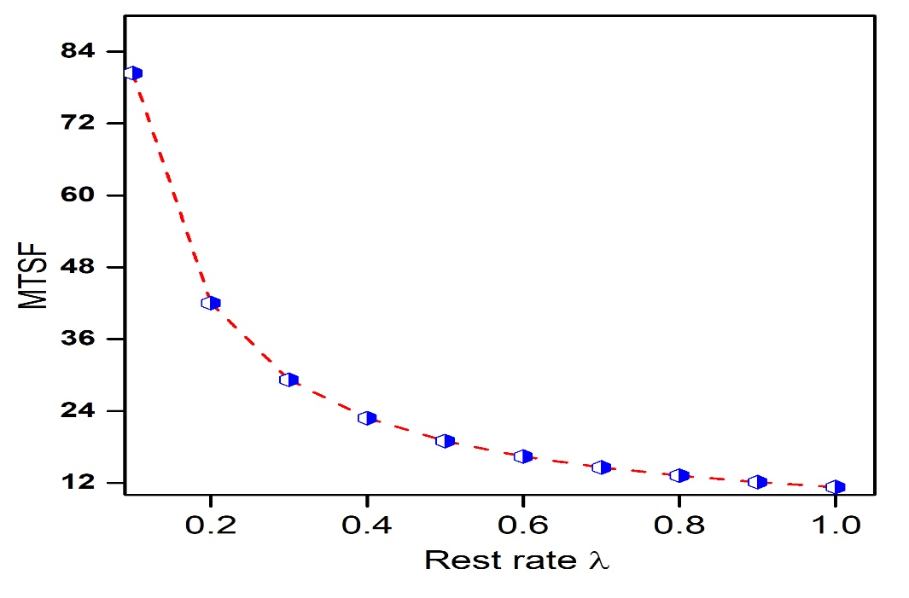

Figure 2 : MTSF Vs Rest rate (λ) Relationship

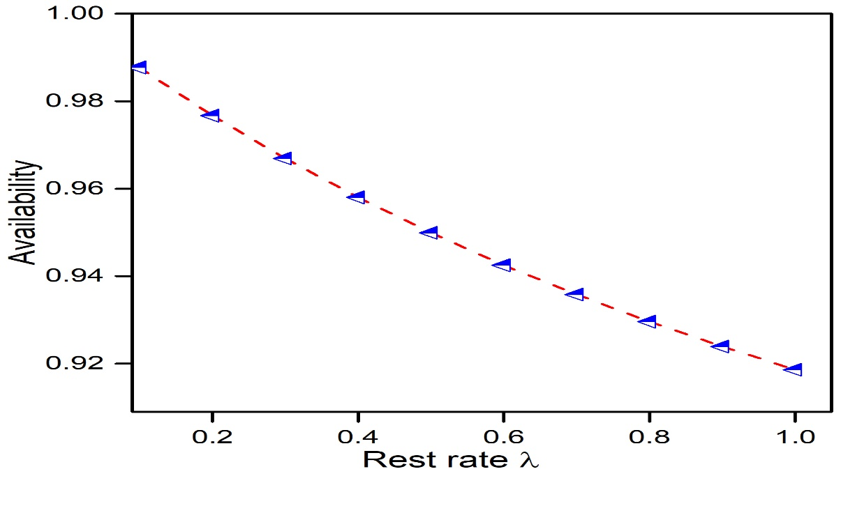

Figure 3: Availability Vs. Rest rate (λ) Relationship

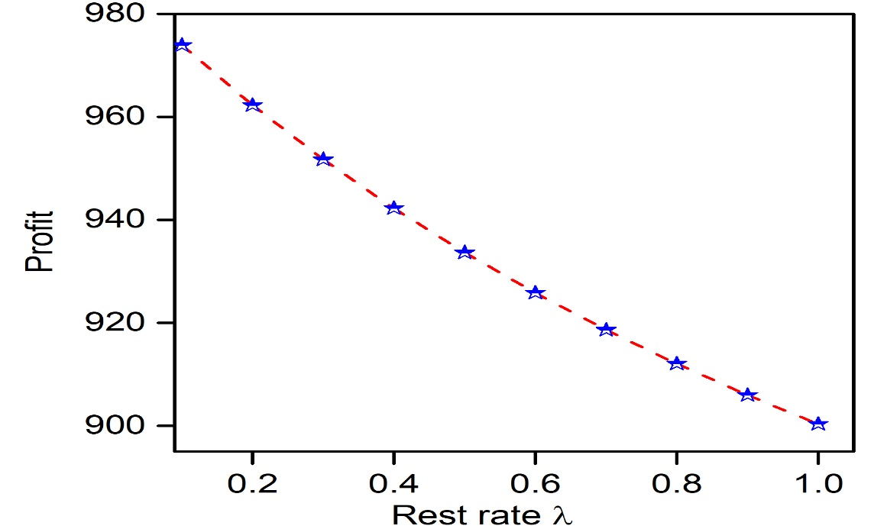

Figure: 4 Profit Vs. Rest rate (λ) Relationship

**11 Result and Discussion**

The analysis of a system that has a rest mechanism provides essential details regarding its reliability, where rest rates are an essential component. It is significant that the Mean Time to System Failure (MTSF) improves significantly with higher rest rates. This suggests that scheduled rest periods minimize workload on operating units and avoid catastrophic failures, hence improving operational a long lifespan. However, the relationship between steady-state availability and rest rates is nonlinear. While low rest rates maintain high availability, exceeding an optimal threshold leads to decreased availability due to extended downtime, emphasizing the need for a balanced approach. Additionally, the server's busy period decreases with optimal rest rates because fewer failures needs repairs, whereas excessively long rest intervals lead to longer idle periods, which negatively affect profitability. As a result, the profit function indicates a positive trend with low rest rates, which minimize failure and repair costs while maintaining high availability, while excessive resting intervals reduce profit due to lost operational time, bringing out the significance of careful parameter optimization to achieve optimal system performance.

The results validate the efficiency of incorporating rest mechanisms in redundant systems. Rest rates must be carefully selected based on system-specific operational and cost parameters to maximize reliability and profit. The findings align with earlier studies, demonstrating that mathematical modeling using linear differential equations provides an effective tool for analyzing the reliability measures of complex systems.

**13. Conclusion**

In this study, reliability measures were calculated using linear differential equations to examine a two-unit redundant system with a provision of rest. The findings emphasize that the resting mechanism plays a crucial role in system performance by improving measures related to availability and reliability.By providing components to rest, the system's overall wear and tear is minimized. Using mathematical modeling and analysis, it can be seen that system performance and profit may be satisfactorily integrated with the proper parameter optimization, primarily the rest rate. In future the model could be expanded to include energy consumption and environmental factors, which are critical in modern industrial systems.

Disclaimer (Artificial intelligence)

Option 1:

Author(s) hereby declare that NO generative AI technologies such as Large Language Models (ChatGPT, COPILOT, etc.) and text-to-image generators have been used during the writing or editing of this manuscript.

Option 2:

Author(s) hereby declare that generative AI technologies such as Large Language Models, etc. have been used during the writing or editing of manuscripts. This explanation will include the name, version, model, and source of the generative AI technology and as well as all input prompts provided to the generative AI technology

Details of the AI usage are given below:

1.

2.

3.

**References**

[1] Ali, U. A., Bala, N. I., Yusuf, I. (2013). Reliability analysis of a two dissimilar unit cold standby system with three modes using Kolmogorov forward equation method. Nigerian Journal of Basic and Applied Science, 21(3), 197–206.

[2] Garg, R. and Garg, D.( 2022). Availability measures and profit optimization of redundant system having single unit with imperfect switch-over device. Life Cycle Reliability and Safety Engineering, 11(2), pp.155-162.

[3] Gupta, R., Mittal, M. (2006). Stochastic analysis of a compound redundant system involving human failure. Journal of Mathematics and Statistics, 2(3), 407–413.

[4] Haggay,M.Y. (2009) Cost analysis of two-dissimilar unit cold standby system with three states and preventive maintenance using Linear first order differential equation.J.Math.;Stat.5(4);395-400.

[5] Joshi, P. K., Sharma, C. Sharma ;D.S. Sharma, C. (2013).Stochastic analysis of priority redundant system with proviso of rest. Int. J. of Sci. Tech Management . Vol IV 90-103

[6] Khaled, M. El-Said,(2008).Cost analysis of a system with preventive maintenance by using the Kolmogorov’s forward differential equation method.Am.J.Appl.Sci 5(4);405-410

[7] Khaled M. El-Said , EL-Sherbeny,M. S. (2005) Evaluation of reliability and availability characteristic of two different systems by using linear first-order differential equation. Journal of Mathematics Statistics, 1, 119–123.

[8] Kumar, A., Garg, R. and Barak, M.S., (2023). Reliability measures of a cold standby system subject to refreshment. International Journal of System Assurance Engineering and Management, 14(1), pp.147-155.

[9] Lawan, M.A., Ali, U.A., Ismal, A.L., Isa, M.S., Maihulla, A.S. and Yusuf, I., (2022).Reliability and performance analysis of two unit active parallel system attended by two repairable machines. International Journal of Operations Research, 19(2), pp.27-40.

[10] Malhotra, R., Dureja, T. and Goyal, A., (2021), May. Reliability analysis a two-unit cold redundant system working in a pharmace Jo utical agency with preventive maintenance. In  urnal of Physics: Conference Series (Vol. 1850, No. 1, p. 012087).IOP Publishing.

[11] Saini, M., Kumar, A. and Devi, K., (2021). Stochastic Investigation of Two-Unit Redundant System with Provision of Different Repair Schemes. In Innovations in Computational Intelligence and Computer Vision: Proceedings of ICICV 2020 (pp. 3-9). Springer Singapore

[12] Yusuf, I., Hussaini, N. (2012). Evaluation of reliability and availability characteristics of 2-out of -3 standby system under a perfect repair condition. American Journal of Mathematics and Statistics, 2(5), 114–119.

[13] Yusuf, I. (2013). Comparison of some reliability characteristics between redundant systems requiring supporting units for their operations. Journal of Mathematics and Computer Science,3(1), 216–232. ISSN: 1927-5307.