***Efficacy* of natural farming inputs, botanicals and bio agents against foot rot disease of finger millet caused by *Sclerotium rolfsii***

**Abstracts**

An in vitro study was conducted to evaluate the efficacy of natural farming inputs, botanicals, and bio-agents against *Sclerotium rolfsii* using the poisoned food technique at varying concentrations (3%, 5%, and 10%). Among the natural farming inputs, Shuntiastra at 10% concentration exhibited complete (100%) inhibition of the pathogen, followed by Jeevamruta with 90.78% inhibition against *Sclerotium rolfsii*. Among botanicals Neem leaf extract and Pongamia leaf extract at higher concentration of 10 per cent recorded 100 per cent inhibition of the pathogen. However the combination of leaf extracts viz., Neem, Pongamia, Yekka, Tulsi and cow urine at 5 per cent also showed 100 per cent inhibition of the pathogen. Among the bio agents, *Trichoderma spp.* showed 72.11 per cent inhibition over control. A subsequent pot culture study under greenhouse conditions revealed that seedling treatment and soil drenching with Mancozeb 75 WP @ 0.25% recorded the lowest percent disease index (PDI) with no wilting symptoms. This was followed by seedling treatment and drenching with *Trichoderma* spp. @ 5%, which also demonstrated effective management of finger millet foot rot. The study highlights the potential of integrating natural inputs and biocontrol agents for sustainable disease management in finger millet.

**Key words ;** **finger millet,** **natural farming ,** **foot rot disease,** **Sclerotium rolfsii,** **plant extracts, Plant disease**

**Introduction**

Finger millet (*Eleusine coracana* (L.) Gaertan, is commonly referred to as "ragi" in various regions, plays a crucial role as a staple crop in parts of Eastern Africa and Asia originated to Ethiopia. It is often referred to as a "nutritious millet," is rich in proteins, calcium, minerals, fiber, and essential vitamins. Its high calcium content makes it especially beneficial for infants and the elderly, while its fiber aids in preventing constipation, lowering cholesterol, and reducing the risk of intestinal cancer. As a gluten-free grain packed with nutrients, it plays a key role in combating malnutrition. Additionally, finger millet supports rural livelihoods by providing both a staple food source and income-generating opportunities, thereby promoting nutrition and economic stability. A large amount of phytic acid present in millets, especially finger millets (ragi), reduces carbohydrate digestibility and mitigates postprandial blood glucose levels (Gupta *et al*., 2017)[[11](https://pmc.ncbi.nlm.nih.gov/articles/PMC10560538/#REF24)]. Finger millet consumption also helps to strengthen and develop bones and prevent anemia because they are rich in calcium and polyphenols (Goron and Raizada, 2015)[[10](https://pmc.ncbi.nlm.nih.gov/articles/PMC10560538/#REF26)].

It is a resilient crop believed to have originated in the Ethiopian highlands, is now extensively cultivated across Africa, Madagascar, Sri Lanka, Malaysia, China, Japan, and especially India. In India alone, it spans approximately 10.04 lakh hectares, yielding around 17.55 lakh tonnes with an average productivity of 1,747 kg per hectare. In India major finger millet-producing states of Karnataka, Tamil Nadu, Andhra Pradesh, Odisha, Maharashtra, Uttar Pradesh, Bihar, and Gujarat together contribute over 95 per cent of the country’s total production (Sonnad, 2005) [23].

Where as in Karnataka it has covers more than 6.41 lakh ha mainly in the districts of Tumkuru Bangalore rural, Kolar, Chikkaballapura, Mandya, Mysore, Chamarajanagara, Hasan Chitradurga, and Davanagere with a production of 11.64 lakh tonnes and a productivity of 1816 kg ha-1. (ICAR-IIMR, 2019-20)[3]

Coleman (1920)[9] was the first in India to record the occurrence of *Sclerotium rolfsii* from the then princely state of Mysore. Loss up to 50 per cent was recorded at Rampur, Nepal (Basta and Tamang, 1983)[7].The disease appears randomly in the field. The infection occurs around the collar region, the infected area being restricted to two to three inches above ground level, initially symptoms appears as water soaked lesion. Later on it turns brown and subsequently dark brown with a concomitant shrinking of the stem in the affected region. Profuse white cottony mycelial growth occurs in this area. Soon small roundish white velvety grain like structures starts appearing in the fungal matrix. They grow, become mustard seed like, turn brown and are the sclerotial bodies of the fungus. Meanwhile the leaves lose their lustre, droop and dry. Ultimately, the plant dries up prematurely

*Sclerotium rolfsii* causes foot rot which belongs to a corticoid fungus in the family athelcea (Kwon *et al.,* 2017)[12] and having teleomorphic stage *Athelia rolfii* Tu & Kimbrough. It is destructive soil borne plant pathogenic fungus with a wide host range. Several scientists have already discovered this pathogen in India and elsewhere. This pathogen infects about 500 different crop and has a wide host range (Aycock, 1966)[5] like ground nut, chickpea, onion, chilly, barley, wheat, ragi, soybean, potato and other plant and cause grain yield loss upto 27.40 % and 23.31% in fodder yield (Pawar *et al,* 2013)[20]

Foot rot which has been reported to cause more than 50 per cent yield loss. As the disease was minor and sporadic in nature, extensive systematic studies have not been carried out, but it is increasing in the recent past; particularly under in high rainfall situations (Nagaraja and Reddy, 2009) [19]. The present research work was conducted to investigate the combinations of various treatments including chemicals, bio-agents and organic amendments to manage the disease to minimum level and to obtain the maximum yield.

The effectiveness of natural farming inputs (Jeevamrutha and Shuntiastra), plant-based extracts (from Neem, Pongamia, Yekka, and Tulsi leaves), and biological control agents (Trichoderma species and *Pseudomonas fluorescens*) against the growth of the pathogen was evaluated using poisoned food technique and inhibition zone assay methods.

**Material and methods**

**Jeevamrutha preparation:**

Jeevamrutha was prepared by combining 10 kg of desi cow dung, 10 liters of cow urine, 2 kg of jaggery, 2 kg of gram flour, and a handful of farm soil. These ingredients were thoroughly mixed in a 200-liter plastic drum, and the volume was adjusted to 200 liters with water. The mixture was stirred vigorously in a clockwise direction and kept in a shaded area, covered with a moist jute sack. To ensure proper fermentation, the solution was stirred in the morning, afternoon, and evening each day for seven consecutive days. After this period, the preparation was used for soil application.

**Preparation of Shuntiastra**

**List 1: Composition of shuntiastra**

|  |  |
| --- | --- |
| Desi cow milk | 2 liters, |
| Ginger | 200 gram |
| Water | 200 liters |

**Preparation**

To prepare the formulation, 200 grams of dried ginger was weighed and ground into a powder. This powder was then mixed with 2 liters of water and boiled until the volume was reduced by half. Separately, 2 liters of desi cow milk were boiled in another vessel, and the cream layer was removed. The reduced ginger extract and the milk were then combined in a separate container and kept in a shaded area for 24 hours. During this period, the mixture was stirred in a clockwise direction three times a day.

**Preparation of plant extracts and evaluation by poison food technique**

**Preparation of plant extracts**

Freshly collected leaves of Neem, Pongamia, Tulsi, and Yekka were shade-dried at room temperature, then chopped using a mortar and pestle and ground into a coarse powder using an electric blender. The powdered samples were stored in separate sealed containers for extraction. For each extract, 200 g of the powder was soaked in 80% analytical-grade methanol and gently agitated on an electronic shaker for five days. The resulting mixtures were filtered through Whatman No. 1 filter paper, and the filtrates were concentrated using a rotary evaporator. The dried extracts were weighed and re-dissolved in sterile double-distilled water to obtain concentrations of 25 mg/ml and 50 mg/ml. These solutions were stored under refrigeration until used in the experiments.

The poisoned food technique was employed to assess the efficacy of fungitoxicants and bio-organic agents against *Sclerotium rolfsii*. In this method, the test fungus is allowed to grow on a nutrient medium amended with the test substances. All glassware used in the experiment was sterilized prior to use. Potato Dextrose Agar (PDA) was prepared, sterilized at 15 lbs per square inch for 15 minutes using an autoclave, and distributed into 250 ml conical flasks. The required concentrations of each fungicide and bio-organic agent were added to the flasks, thoroughly mixed with the medium, and poured into sterile Petri plates. Each treatment was replicated three times.

A 4–5-day-old culture of *Sclerotium rolfsii* grown on PDA, prior to sclerotia formation, was used for inoculation. Fungal discs (0.5 cm in diameter) were aseptically cut using a sterile cork borer and placed at the center of each Petri plate containing the poisoned medium. PDA plates without any fungicide or bio-organic agents but inoculated with fungal discs served as controls. All plates were incubated at 28 ± 1°C, and observations on colony diameter were recorded until the mycelium in the control plates completely covered the surface.

The efficacy of the fungicides was expressed as per cent inhibition of mycelial growth over control, which was calculated by using the formula given by Vincent (1947)[26].

$$I=\frac{C-T}{C}×100$$

Where,

I = per cent inhibition

C = pathogen growth in control plate

T = pathogen growth in treatment plate

**Dual culture technique for evaluation of bio agents**

To evaluation of fungal and bacterial biocontrol agents, 20 ml of sterilized, cooled Potato Dextrose Agar (PDA) was poured into sterile Petri plates and allowed to solidify. To assess fungal antagonists, a mycelial disc of the test pathogen was placed at one end of the Petri plate, while a disc of the antagonistic fungus was placed at the opposite end. For bacterial antagonists, the bacterium was streaked from one end of the Petri plate toward the center one day prior to inoculating the test fungus, which was then placed at the opposite end. All plates were incubated at 27 ± 1°C. The zone of inhibition was determined by measuring the clear distance between the margins of the test fungus and the antagonist. Colony diameter of the pathogen in control plates (without any antagonist) was also recorded. The percentage inhibition of mycelial growth was calculated using the formula described by Vincent (1947) [26].

$$I=\frac{C-T}{C}×100$$

Where,

I = per cent inhibition

C = Growth of the pathogen in control plate

T = Growth of the pathogen treatment plate

**Table 1: Treatment details on *in vitro* evaluation of Natural farming inputs, Plant extracts and bio agents against *Sclerotium rolfsii***

|  |  |  |
| --- | --- | --- |
| **Treatments** | | **Concentrations** |
| T1 | Shuntiastra (*Zingiber officinale*) | 3% |
| T2 | Shuntiastra (*Zingiber officinale*) | 5% |
| T3 | Shuntiastra (*Zingiber officinale*) | 10% |
| T4 | Neem leaf extract *(Azadirachta indica)* | 3% |
| T5 | Neem leaf extract *(Azadirachta indica)* | 5% |
| T6 | Neem leaf extract *(Azadirachta indica)* | 10% |
| T7 | Pongamia leaf extract *(Pongamia pinnata)* | 3% |
| T8 | Pongamia leaf extract *(Pongamia pinnata)* | 5% |
| T9 | Pongamia leaf extract *(Pongamia pinnata)* | 10% |
| T10 | Tulsi leaf extract (*Ocimum gratissimum)* | 3% |
| T11 | Tulsi leaf extract (*Ocimum gratissimum)* | 5% |
| T12 | Tulsi leaf extract (*Ocimum gratissimum)* | 10% |
| T13 | Yekka leaf extract [*(Calotropis gigantea)*](https://en.wikipedia.org/wiki/Calotropis_gigantea) | 3% |
| T14 | Yekka leaf extract [*(Calotropis gigantea)*](https://en.wikipedia.org/wiki/Calotropis_gigantea) | 5% |
| T15 | Yekka leaf extract [*(Calotropis gigantea)*](https://en.wikipedia.org/wiki/Calotropis_gigantea) | 10% |
| T16 | Combinations (Neem+Pongamia+Tulsi+Yekka+Desi cow urin) | 5% |
| T17 | Jeevamruta | 3% |
| T18 | Jeevamruta | 5% |
| T19 | Jeevamruta | 10% |
| T20 | Desi cow urin | 5% |
| T21 | Desi cow urin | 10% |
| T22 | *Pseudomonas fluorescence* |  |
| T23 | *Trichoderma sp.*(Maddur isolate) |  |
| T24 | Carbendazime (Standard check() | 0.2 % |
| T25 | Control | water |

The most effective combinations of Astras, plant extracts and bio agent from in vitro studies were tested under greenhouse condition against *S. rolfsii*. Experiment was carried out at the AICRP on Small Millets, Zonal Agricultural Research Station, V.C Farm, Mandya in the year of 2023. The soil was sterilized with formalin and Finger millet seeds were collected from AICRP on Small Millet (Indaf-5). 21 days old seedlings were transplanted into the pot, Giant culture of *S. rolfsii* was applied to make the soil sick and kept under shade. Each pots 5 plants were transplanted and three replications were maintained, complete randomized block design (CRD) used for data analysis. Observations on number of wilted plants were recorded and based on that PDI was calculated.

**Table 2: *Invitro* evaluation of under greenhouse condition**

|  |  |
| --- | --- |
| **Treatments details** | |
| T1 | Absolute control |
| T2 | Seedling treatment with beejamruta + drenching and spraying with shuntiastra 10% at 30,45 and 60 DAT |
| T3 | Soil drenching with Combinations of plant extracts (Neem+Pongamia+Tulsi+Yekka)+ Desi cow urine 5% at 30,45 and 60 DAT |
| T4 | Seedling treatment and drenching with *Trichodermasp*. 5% at 30,45 and 60 DAT |
| T5 | Seedling treatment and drenching with Mancozeb 75 WP at 0.25% (Check) |

The foot rot per cent disease incidence was recorded at tillering and maturity stages.

Per cent disease incidence was calculated by the following formula

$$Per cent disease incidence=\frac{Number of infected plants}{Total number of plants }×100$$

**Results and discussions**

In the present in vitro study, various natural inputs were evaluated using the poisoned food technique, the results are summarized in Table 3 and plate 1. The results revealed among natural farming inputs, shuntiastra at 10 per cent shows significantly superior and recorded 100 % inhibition against *Sclerotium rolfsii* followed by Jeevamruta at 10 per cent shows 90.78 per cent inhibition and Shuntiastra(5%) recorded 89.89 per cent inhibition. The least inhibition was recorded by jeevamrutha (3%) recorded 73 per cent over control. Similar results were obtained by Sneha *et al.,*(2016)[22] showed that aqueous extracts of Ginger(5%) recorded 51.5 per cent inhibition of the *Sclerotium rolfsii* while at lower concentration viz., 1- 4% were less effective. However, Suleiman and Emua, (2009)[24] also showed 100% inhibition against root rot fungus by ginger extract. The antifungal and antibacterial properties of ginger are primarily attributed to bioactive compounds such as gingerol and shogaol, which are present in its ethanolic extracts. (Atai *et al*., 2009)[4]. Among the various plant extracts tested, Neem leaf extract and Pongamia leaf extract at a higher concentration of 10 per cent, Similar results were recorded by Thomas *et al.* (2022)[25] found average percent mycelial inhibition was recorded highest with Neem leaf extract. And a combination of leaf extracts (Neem, Pongamia, Yekka, Tulsi) with cow urine at 5 per cent showed complete inhibition (100%) of the pathogen. Pongamia leaf extract at 5 per cent concentration also demonstrated strong inhibition, recording 96.67 per cent pathogen suppression. The lowest inhibition, 57.44 per cent, was observed with Yekka leaf extract at 5 per cent. These results are consistent with findings by Madhavi *et al.* (2011)[15], who reported that neem leaf extract (*Azadirachta indica*) caused significant mycelial growth inhibition (80.74%) against *Sclerotium rolfsii* in vitro. Similarly, Muhammad *et al.* (2010)[16] observed maximum inhibition of 73.8 per cent by *Azadirachta indica* against the same pathogen. Among the bioagents tested, *Trichoderma* species exhibited the highest inhibition of mycelial growth at 72.11 per cent, followed by *Pseudomonas fluorescens*, which showed 48.22 per cent inhibition. Similar observations were reported by Basamma (2008)[6] and Kulkarni [13], who recorded 59.81 per cent and 53.33 per cent inhibition of *Sclerotium rolfsii* mycelial growth by *Trichoderma harzianum*. These findings suggest that *Trichoderma* isolates exert their antagonistic effects through competition, mycoparasitism, and lytic activity against the pathogen. This may be attributed to the production of antibiotic compounds such as gliotoxin and viridin, as well as cell wall–degrading enzymes, which can diffuse through air-filled pores and inhibit *S. rolfsii* growth, as reported by Brain (1951)[8]. These results also align with those of Karthikeyan (1996)[14] and Mukherjee (2001)[17], who demonstrated that *T. harzianum* inhibits *S. rolfsii* by penetrating the pathogen’s hyphae at points of contact. However, the present findings also showed that poor inhibitory effect of synthetic fungicide carbendazim (0.1%) was recorded 18.33 per cent over Absolute control.

**Table 3: Percent inhibition of *Sclerotium rolfsii* under *in vitro* condition**

|  |  |  |  |
| --- | --- | --- | --- |
| **Sl. No** | **Treatment details** | **Concentration** | **Per cent Inhibition** |
| **T1** | Shuntiastra | 3% | 79.89 |
| **T2** | 5% | 89.89 |
| **T3** | 10% | 100.00 |
| **T4** | Neem leaf extract | 3% | 89.22 |
| **T5** | 5% | 94.00 |
| **T6** | 10% | 100.00 |
| **T7** | Pongamia leaf extract | 3% | 88.44 |
| **T8** | 5% | 96.67 |
| **T9** | 10% | 100.00 |
| **T10** | Tulsi leaf extract | 3% | 88.11 |
| **T11** | 5% | 94.44 |
| **T12** | 10% | 94.44 |
| **T13** | Yekka leaf extract | 3% | 57.44 |
| **T14** | 5% | 82.67 |
| **T15** | 10% | 86.44 |
| **T16** | Combinations @ 5% (Neem, Pongamia, Tulsi, Yekka leaf extract with Desi cow urin) | 5% | 100.00 |
| **T17** | Jeevamruta | 3% | 73.11 |
| **T18** | 5% | 77.11 |
| **T19** | 10% | 90.78 |
| **T20** | Desi cow urin | 5% | 66.22 |
| **T21** | 10% | 84.78 |
| **T22** | *Pseudomonas fluorescence* |  | 48.22 |
| **T23** | *Trichoderma sp.* |  | 72.11 |
| **T24** | Standard check(Carbendazim) |  | 18.33 |
| **T25** | Absolute control |  | 1.11 |
| S.Em | | | 2.04 |
| CD (1%) | | | 7.6 |

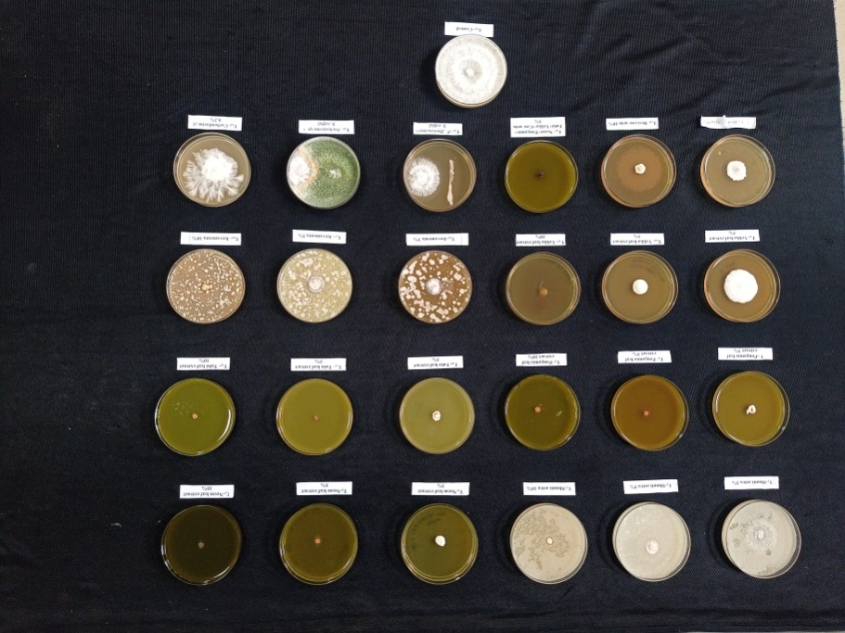

**Plate 1: *In vitro* evaluation of Natural farming inputs, Plant extracts and bio agents against *Sclerotium rolfsii***

***Invitro* evaluation of effective treatments under greenhouse condition**

The pot culture study under in vitro, various natural inputs were evaluated using the poisoned food technique, the results are summarized in Table 3 and plate 1. Under greenhouse condition, the finger millet plants showed wilting symptoms, no disease was observed in T5 (Seedling treatment and drenching with Mancozeb 75 WP at 0.25%) followed by T4 (Seedling treatment and drenching with Trichoderma @ 5%) recorded 20 per cent PDI with 80 per cent reduction over control. T3[Combinations of plant extracts (Neem+Pongamia+Tulsi+Yekka+Desi cow urine) at 5% with PDI of 25 per cent followed by T2(Seedling treatment with beejamruta + drenching and spraying with shuntiastra10% at 30,45 and 60 DAT) with PDI of 45 per cent over absolute control showed 100 per cent wilting of the plants. Similar results obtained by Manu et al, 2012[18]showed that, mancozeb at higher concentrations found effective against *S. rolfsii*, however among the bioagents *T. harzianum* (GKVK) isolate was found to be effective than other biogents. Similarly Pooja R. and Somasekhara Y. M., (2017) [21] reported that, the *S. rolfsii* population was drastically reduced from 80.67 to 6.60 cfu/ g of soil and 0.00%wilt incidence was observed in *T. viridae,* Tv GKVK–2 treated soil followed by Tv–19(3.83%),

**Table 4: Percent disease index on foot rot of finger millet caused by *Sclerotium rolfsii* under greenhouse condition**

|  |  |  |  |
| --- | --- | --- | --- |
| **Treatment details** | | **Percent Disease Incidence** | **Percent reduction of disease over control** |
| T1 | Absolute control | 100 |  |
| T2 | Seedling treatment with beejamruta + drenching and spraying with shuntiastra10% at 30,45 and 60 DAT | 45 | 55.00 |
| T3 | Soil drenching with Combinations of plant extracts 5% (Neem+ Pongamia+ Wild Tulsi+ Yekka+ Desi cow urine) at 30,45 and 60 DAT | 25 | 75.00 |
| T4 | Seedling treatment and drenching with *Trichoderma sp.* 5% at 30,45 and 60 DAT | 20 | 80.00 |
| T5 | Seedling treatment and drenching with Mancozeb 75 WP at 0.25% (Check) | 0 | 100.00 |
|  | S.Em | 3.16 |  |
|  | CD at5% | 9.53 |  |

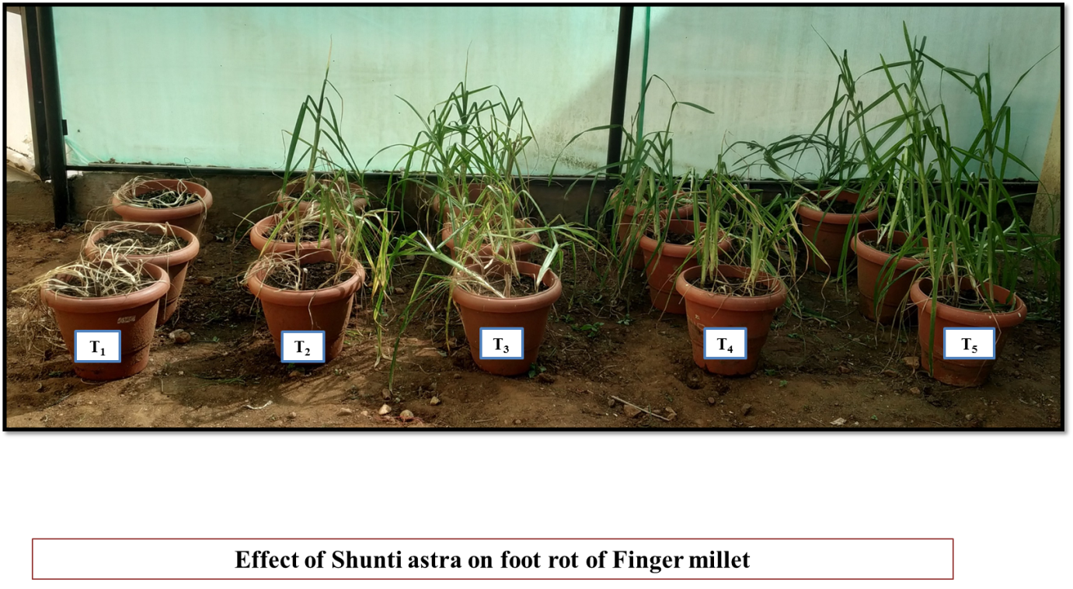

**Plate 2: Wilting symptoms of Finger millet recorded due to foot rot caused by *Sclerotium rolfsii* under green house*.***

**Figure 1: Graphical representation of *in vitro* evaluation of Natural farming inputs, Plant extracts and bio agents against *Sclerotium rolfsii***

**Conclusions**

Among the natural farming inputs tested, Shuntiastra at 10% concentration demonstrated complete (100%) inhibition of *Sclerotium rolfsii*. Within the plant extracts category, higher concentrations of Neem leaf extract, Pongamia leaf extract, and a combination of various plant extracts showed the greatest inhibitory effects against the pathogen. Among the bioagents, *Trichoderma* species exhibited the highest inhibition of *Sclerotium rolfsii*. However, to validate these findings, further evaluation of these natural farming inputs, plant extracts, their combinations, and bioagents under field conditions is recommended.

**Reference:**

1. Abdel-Hafez, S.I.I., Abo-Elyousr K.A.M. and Abdel-Rahim, I.R.,2013 Effect of certain plant extracts to control purple blotch disease of onion plants (*Allium cepa* L.). *J. Plant Physiol. Pathol*., 1(4).
2. Ankit Kumar, Prashant Mishra, Kamal Khilari, Gopal Singh, Ramesh Singh and Gaje Singh, 2021 Efficacy of bio-agents and fungicides against Sclerotium rolfsii Sacc. Causing collar rot in chickpea (Cicer arietinum L.) In-vitro, *The Pharma Innovation Journal*, 10(**10**): 1136-1139
3. Anonymous, 2025, ICAR-IIMR, <https://www.milletstats.com/apy-stats/>, Official website of the Government of India.
4. Atai, Z., Atapour, M.,and Mohseni, M., 2009 Inhibitory effect of Ginger Extract on Candida Albicans. *Am. J. Applied Sci.,*6**(6)**: 1067-1069.
5. Ayock. R. 1966, Stem rot and other diseases caused by *Sclerotium rolfsii* or the status of *S. rolfsii* fungus after70 years. *North Carolina Agri. Exp. St. Tech. Bulletine.,***733**:93
6. Basamma, 2008, Integrated management of sclerotium wilt of potato caused by *Sclerotium rolfsii* sacc. M.Sc. (Agri.) thesis, Uni. Agric. Sci, Dharwad.
7. Batsa, B.K. and Tamang, D.B., 1983, Preliminary report on the study of millet diseases in Nepal. In : Maize and finger millet, *10th summer workshop 23-28 Jan*. 1983, Rampur, Chitwan
8. Brain PW, 1951 Antibiotics produced by fungi. *Bot Rev*;**17:** 357-370.
9. Coleman, L.C**.,** 1920 The cultivation of ragi in Mysore. *Bull. Dep. Agric. Mysore. Gen. Ser*. 11-12.
10. Goron T. L., Raizada M. N. 2015, Genetic diversity and genomic resources available for the small millet crops to accelerate a New Green Revolution. *Front. Plant Sci*. 6:157
11. [Gupta](https://pubmed.ncbi.nlm.nih.gov/?term=%22Gupta%20SM%22%5BAuthor%5D), S. M., [Arora](https://pubmed.ncbi.nlm.nih.gov/?term=%22Arora%20S%22%5BAuthor%5D) S.,  [Mirza](https://pubmed.ncbi.nlm.nih.gov/?term=%22Mirza%20N%22%5BAuthor%5D), N. [Anjali P.](https://pubmed.ncbi.nlm.nih.gov/?term=%22Pande%20A%22%5BAuthor%5D), [Charu Lata](https://pubmed.ncbi.nlm.nih.gov/?term=%22Lata%20C%22%5BAuthor%5D), [Puranik](https://pubmed.ncbi.nlm.nih.gov/?term=%22Puranik%20S%22%5BAuthor%5D) S. [Kumar](https://pubmed.ncbi.nlm.nih.gov/?term=%22Kumar%20J%22%5BAuthor%5D) J., [Anil Kumar](https://pubmed.ncbi.nlm.nih.gov/?term=%22Kumar%20A%22%5BAuthor%5D), 2017, Finger millet: A "certain" crop for an "uncertain" future and a solution to food insecurity and hidden hunger under stressful environments. *Front. Plant. Sci.* 8: 1311.
12. Kwon J. H, Park C. S. 2002, Stem rot of tomato caused by Sclerotium rolfsii in Korea. *Microbiology*, 30(**4**): 244-246.
13. Kulkarni, V. R., 2007 Epidemiology and integrated management of potato wilt caused by *Sclerotium rolfsii* SACC. Ph.D. thesis, *Univ Agric Sci,* Dharwad.
14. Karthikeyan, A., 1996 Effect of organic amendments, antagonist *Trichoderma viride* and fungicides on seed and collar rot of groundnut. *Plant Dis Res*;**11:** 72-74.
15. Madhavi G. B, Bhattiprolu S. L. 2011 Integrated disease management of dry root-rot of chili incited by *Sclerotium rolfsii.* *Int. J. of Pl. animal and envi. Sci.* 1(**2**): 31-37.
16. Muhammad Asad Farooq, Umer Iqbal, Sh. M. Iqbal, Rukhsana Afzal and Awais Rasool, 2010 *In-vitro* evaluation of different plant extracts on mycelial growth of *Sclerotium rolfsii* the cause of root rot of sugar beet, *Mycopath* 8(**2**): 81-84
17. Manu, T.G., Nagaraja, A, Chetan, S. Janawad and Vinayaka H., 2012, Efficacy of fungicides and biocontrol agents against *Sclerotium rolfsii* causing foot rot disease of finger millet, under *in vitro* conditions, G.J. B.A.H.S., 1(2): 46-50
18. Nagraja, A. and Reddy B,. 2009Foot rot of Finger millet-an increasing disease problem in Karnataka. *Crop Res.,* **38(2):**224-225.
19. Pawar. Dnyaneshwar, M and Sabalpara, A. N. 2013, Management of foot rot (*S. rolfsii)* of finger millet (*Eleusine coracana* (L.) Gaertan). Thesis, Navsari Agric. Univ., Navsari, Gujarat.pp:150.
20. Pooja R. and Somasekhara Y. M., 2017, Evaluation of fungicides and bioagents for the management of collar rot of groundnut (*Sclerotium rolfsii* Sacc.) *International Journal of Advanced Life Sciences,* 10 (**4**)
21. Sneha. S., Maurya S., and Choudhary, A.K., 2016 Antifungal efficacy of garlic and ginger against *Sclerotium rolfsii, International J. of Agric. Sci. and Res.* **6***:*419-424
22. Sonnad S.K., 2005 Stability analysis in white ragi (*Eleusine coracann* Gaertn) genotypes. M.Sc. (Ag.) thesis submitted to *University of Agricultural Sciences*, Dharwad.
23. Suleiman, M. N. and Emua S. A. 2009, Efficacy of four plant extracts in the control of root rot disease of cowpea (*Vigna unguiculata* [L.] Walp). *African J. of Biotech.,* 8(**16**), 3806-3808
24. Thomas, J., Sarada Jayalakshmi Devi, R., Khayum Ahammed, S., Jayalakshmi, V. Reddy, V. L. N., 2022, Efficacy of botanical extracts and organic amendments against Sclerotium rolfsii Sacc. incitant of collar rot of Chickpea and its Compatibility with potential Trichoderma isolate, *Envi. and Ecology* 40 (4C) : 2615—2623
25. Vincent, J. M., 1947, Distortion of fungal hypae in the presence of certain inhibitors. Nature, **159**: 239-241