Original Research Article

The Potential of Neem as an Organic Fertilizer and Bio-Pesticide for Enhancing Soil Fertility, Nematode and Foliar Pest Suppression, and Okra Growth

.

ABSTRACT

|  |
| --- |
| Neem (*Azadirachta indica*) is a rapidly growing tree from the mahogany family (Meliaceae), and it has traditionally been used in agriculture, environment, and public health. Previous research, however, has not explored the promising impact of neem as a basal and foliar organic fertilizer and pesticide. It is against this background that this study was done to investigate and examine the use of neem as a basal organic fertilizer and pesticide alternative for environmental and consumer safety. Using a randomized complete block design with three replications, we evaluated seven treatments, including neem leaf paste (NLP), neem leaf extract (NLE), synthetic fertilizers (NPK), and controls in 5×4 m plots. The results revealed that the organic IPM module (NLP × NLE) significantly improved soil health parameters by increasing organic matter content by 53% compared to the control while reducing the C/N ratio. The treatment also showed remarkable pest suppression, decreasing root-knot nematode populations by 89% and maintaining beneficial insect numbers. Neem-treated plots experienced a 40% reduction in foliar damage from Podagrica spp., resulting in a yield increase of 296% compared to the control. These findings demonstrate a practical application of neem in sustainable okra cultivation, thereby offering a low-cost and environmentally friendly solution for smallholder farmers. The result of this study presents a practical application of neem in sustainable okra cultivation by offering cost-effective and eco-friendly solutions for smallholder farmers. The organic IPM module 3 is therefore recommended for improving soil fertility, reducing soil and foliar pest pressure, and enhancing crop yield safely and sustainably. |

*Keywords: Fertilizer, Insect, Module, Neem, Okra, Pest*

1. INTRODUCTION

Okra (*Abelmoschus esculentus* L. Moench) is a flowering plant in the Malvaceae family, originating from tropical and subtropical Africa, specifically native to West Africa (Tindall, 1983). Okra is a commercially significant crop in Ghana, mostly grown for its immature fruit 'pods,' which are prepared in various cuisines and utilized as a thickening agent for soups. Okra provides a valuable source of vitamins, minerals, calories, and amino acids, similar to those found in poultry eggs and soybeans (Schippers, 2000). Okra enjoys a premium market price in Ghana, particularly during the off-season, due to its frequent inclusion in the meals of several households. Global agricultural productivity is limited by abiotic and biotic variables. Okra plants require nitrogen (N), phosphorus (P), and potassium (K) for optimal growth and yield; however, enhancing soil fertility without the use of mineral fertilizers can be achieved through the application of organic materials as soil amendments, given that chemical fertilizers are costly and, when used continuously, can degrade agricultural land (Savci, 2012; Roba, 2018).

Biotic variables, including plant parasitic nematodes (PPN) and foliar insects, have been identified as significant limitations on okra production (Asare-Bediako et al., 2014). Among all infections, root-knot nematodes (*Meloidogyne* spp.) provide the most significant, pervasive, and concerning threat, resulting in substantial yield losses (Hussain et al., 2011; Mukhtar et al., 2013). More than 72 bug species have been documented on okra in tropical and subtropical regions (Rao & Rajendran, 2002). The cotton flea beetle (*Podagrica* spp.) is the predominant and most damaging pest of okra in Ghana (Obeng-Ofori & Sackey, 2003; Asare-Bediako et al., 2014), Nigeria (Fasunwon & Banjo, 2010), and other regions (Mani et al., 2005). These insects inflict significant economic damage by perforating leaves; hence, they diminish their translocation and photosynthetic capacity. Their feeding causes a big drop in okra production and helps spread the okra mosaic virus (Echezona & Offordile, 2011). This infection has been documented to result in yield losses of up to 90% (Vanlommel et al., 1996; Alegbejo et al., 2008). The okra mosaic virus is identified by signs of mosaic patterns, vein chlorosis, banding, and stunted development in okra (Krishnareddy et al., 2003). Management strategies include crop rotation, antagonistic flora, biological control agents, host resistance, soil amendments, and chemical applications, which have consistently been utilized to reduce plant-parasitic nematodes and insect infestations (Mukhtar et al., 2013). Of all the management strategies, chemical usage is the most effective. Nevertheless, the detrimental impacts of this policy on humanity and the environment have faced significant denunciation from environmentalists.

Global interest in biorational pesticides (botanical and microbial) is increasing for the sustainable management of pests. This is because biorational pesticides are environmentally safe, degradable, and target-specific (Nathan et al., 2006) and therefore provide the future direction of pest management. The neem plant (*Azadirachta indica*) is one of the emerging plants used in the sustainable management of pests and insects (Sarawaneeyaruk et al., 2015; Wahjono et al., 2024). Every part of the neem plant has been advocated as possessing pesticidal and medicinal properties. Pruthi and Samuel (1937) were among the first researchers to scientifically demonstrate its insecticidal effects. It consists of around 200 allelochemicals present in varying amounts throughout various plant sections, offering diverse pesticidal effects (Koul & Wahab, 2004; Mishra et al., 2023; Bakewell-Stone, 2024). Schmutterer (2022) identified neem components as having poisonous, repellent, antifeedant, and growth-regulating effects on many insect pests. Due to the multiple modes of action of the neem plant on insects, neem exhibits fewer chances of resistance (Dua et al., 2009). Gajalakshmi and Abbasi (2004) and Lokanadhan et al. (2012) have documented the application of neem leaf pastes for nutrient preservation and enhancement of soil fertility. Neem also exhibits powerful nematicidal potential and provides satisfactory control of nematodes (Akhtar, 2000). Neem leaf paste, when efficiently and effectively used, ensures sustainable crop productivity by immobilizing nutrients that are susceptible to leaching (Mala et al., 2017). The nutrients in neem leaf paste (NLP) are released gradually, providing prolonged residual effects and supplying nutrients to plants (Celsia & Mala, 2014). In addition to improving the soil, it exhibits pesticidal properties against foliar arthropods and nematodes (Chaudhary et al., 2017; Perveen, 2024; Javid et al., 2025).

The potential of dual benefits of NLP to crop production has been demonstrated in previous research (Brotodjojo & Arbiwati, 2016; Chaudhary et al., 2017; Arunachalam et al., 2025). These benefits could significantly support both farmers and consumers if further explored as a basal organic fertilizer and pesticide alternative, especially for environmental and consumer safety. No study has been conducted on investigating the potential of neem as a fertilizer and pesticide. We therefore investigated and examined the use of neem as a basal organic fertilizer and pesticide alternative for environmental and consumer safety. This work is motivated by its suitability for small-scale farmers who are confronted with the expenses and significant risks associated with traditional, costly pesticides available in the market.

2. material and methods

**2.1 Study Area Description**

The research was conducted in the Amansie West District, situated in the Ashanti region of Ghana. The study area covers approximately 1,364 square kilometers, constituting about 5.4% of the total land area of the Ashanti Region. It is located between latitudes 6° North and 7° North and longitudes 2° West and 3° West, as illustrated in Figure 1 (MoFA, 2022).

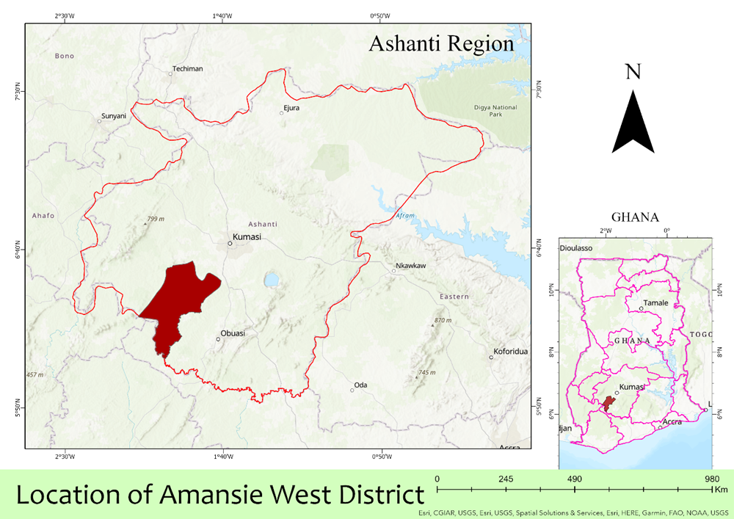

Figure 1: Location of the study area. Source: author’s own construct

The area experiences a humid, semi-equatorial climate. It has a dual rainfall maxima pattern, with the principal rainy season spanning from March to July. The light precipitation season transpires from September to November. The mean annual precipitation varies from 855 mm to 1,500 mm. The annual average of rainy days ranges from 110 to 120. The period from December to March is often arid, marked by elevated temperatures and early morning humidity, fog, and chilly weather conditions (MoFA, 2022). The district's landscape is predominantly hilly, at an elevation of 210 meters above sea level.

**2.2. Experimental Design**

A field experiment was carried out on a farm in Amansie Asamang, located in the Amansie West area of the Ashanti Region. The purpose was to assess the efficacy of an organic integrated pest management (IPM) module against nematodes and insect pests of okra during the primary growing season of 2022. The area is noted for producing vegetables in commercial quantities for a long period of time, resulting in high pest build-up and poor fertility of the soil. Okra suffers seriously from insect pests, nematodes, and disease attacks, and hence it was used as our test crop. The seeds of the okra crop were immersed in water for 24 hours to facilitate the softening of their seed coat in the laboratory. The crop was planted in February 2022 with three replications for each treatment, adhering to a randomized full block design. The dimensions of each plot were 5 x 4 meters, with a plant-to-plant spacing of 60 cm. Alleys of 1.5 meters between plots and 3 meters between replications were allowed (Figure 2).

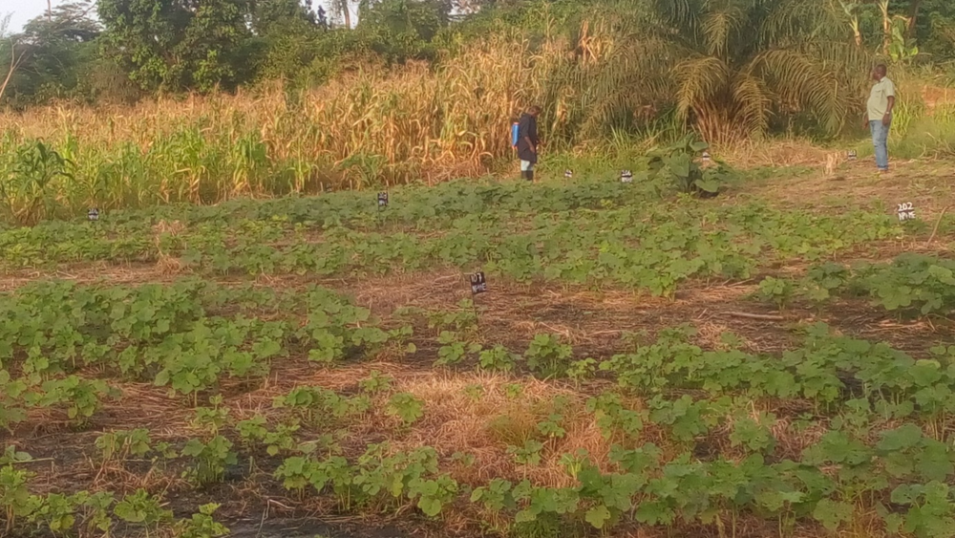

Figure 2: Field establishment of okra at Asamang

All prescribed agronomic procedures (e.g., weeding, hoeing, fertilizing, etc.) were executed uniformly across each experimental plot. Ten harvests of the crop’s fruits occurred during the growing season. In each treatment duplicate, five plants in the middle row were tagged, and the abundance of podagrica beetles, damage score, and natural enemy populations were recorded at a fortnightly interval from the appearance of insect pests.

***2.*3. Acquisition of Insecticides and Fertilizers**

Leaves of neem (*Azadirachta indica*) were obtained from the wild, specifically at Adidwan, a town on the Mampong Ejura road in the Ashanti region of Ghana, while NPK fertilizer, lambda cyhalothrin (a synthetic insecticide), and Agyenkwa liquid fertilizer were purchased from agro-input dealers in Kumasi.

**2.4. Processing and Application of Neem Products**

The leaves were detached and pounded into a paste by using a mortar and pestle (Figure 3a). Two hundred grams of the paste was applied at the base of each plant (Figure 4a). The neem extract was prepared by dissolving 200 g of neem paste in a liter of distilled water. This batch was mixed thoroughly and allowed to stay overnight for the extraction of the active ingredient into the liquid, as reported by McCloud (2010). The mixture was filtered using a nylon sieve into Kilner jars, ready for application (Figure 3b). Five drops of liquid detergent were added to the extract as an emulsifier before application. The other treatments were applied using recommended rates.

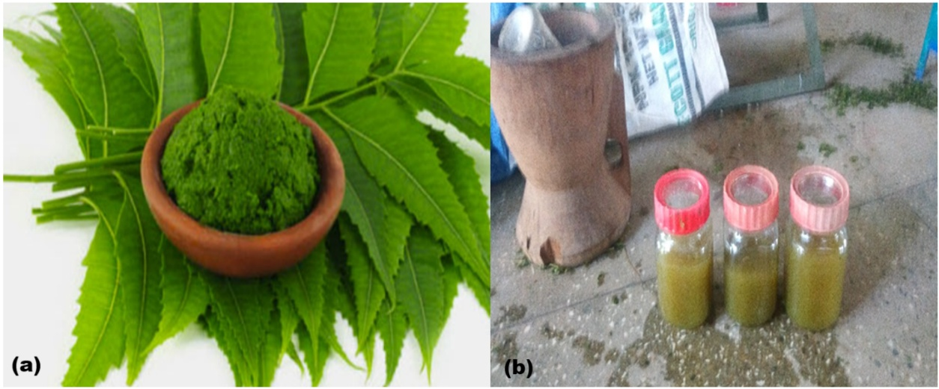

Figure 3: (a) Freshly prepared neem leaf paste; (b) Freshly prepared neem leaf extract

**2.5. Interventions/Treatments**

NPK and NLP (basal application), neem leaf extracts (NLE), liquid fertilizer (LF), and pesticide lambda cyhalothrin (L) foliage. Treatments comprised two basal applications, three foliar applications, and no treatment control, as shown in Table 1 below. The IPM module comprised the following: NPK x L, NPK x NLE, NLP x NLE, NPK x LF, NLP x L, NLP x LF, and control. These treatments were applied to the okra plant two weeks after germination, as shown in Figures 4a and 4b, with NLP x NLE illustrated in Figure 5a. The untreated control (Figure 5b) received no treatment.

Table 1: Integrated Pest Management strategies evaluated in the study area.

|  |  |  |
| --- | --- | --- |
| **Treatment no.** | **Treatment description** | **Rate of application** |
| 1 | Farmer Practice: application of NPK fertilizer and two sprays of lambda-cyhalothrin at seedling and flowering stages | NPK = 250 kg ha-1  Lambda = 2.4 ml l-1 |
| 2 | Conventional IPM: application of NPK and spray of NLE | NPK = 250 kg ha-1  NLE = 200 g l-1 |
| 3 | Organic IPM: application of NLP and NLE | NLP = 200 g plant-1  NLE = 200 g l-1 |
| 4 | Conventional Practice II: application of NPK fertilizer and spray of LF | NPK = 250 kg ha-1  LF = 10 ml l-1 |
| 5 | Conventional IPM II: application of NLP and lambda cyhalothrin at seedling and flowering stages | NLP = 200 g plant-1  Lambda = 2.4 ml l-1 |
| 6 | Organic IPM II: application of NLPs and LF | NLP = 200 g plant-1  LF = 10 ml l-1 |
| 7 | Untreated control | No treatment |

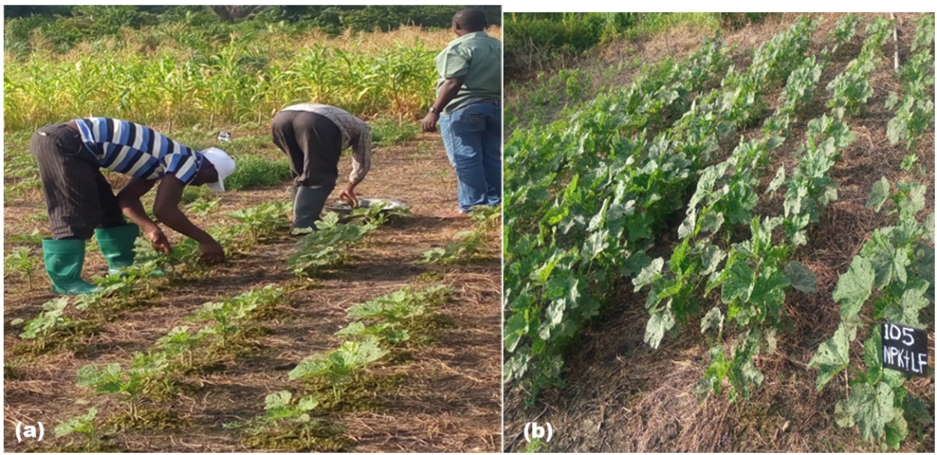

Figure 4: (a) Basal application of neem leaf pastes, (b) NPK + LF plot

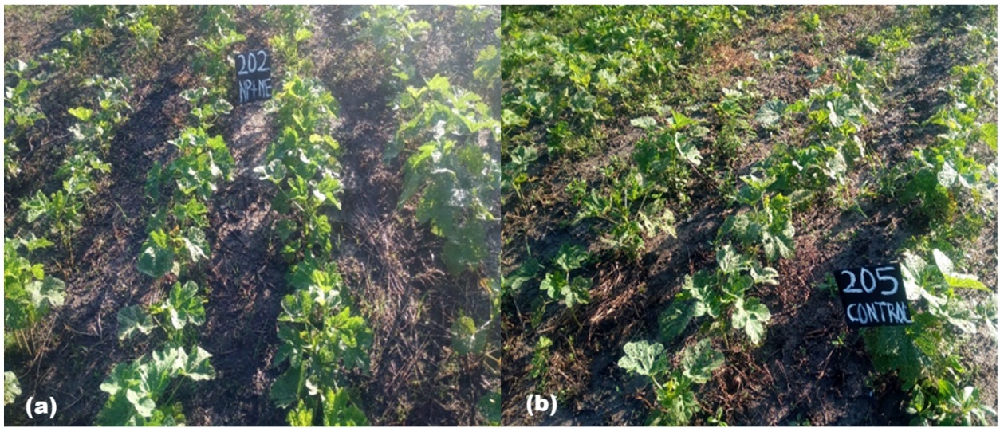

Figure 5: (a) NLP + NLE; (b) Control plot

**2.6. Sampling and Laboratory Analysis**

**2.6.1. Soil sampling**

Seven (7) soil samples were collected from each of the three (3) blocks at a depth of 15 cm utilizing an auger. Soil samples were obtained before planting and during harvest, aligning with the early growth and senescence phases of okra plants, respectively. A total of 42 (21 samples each) soil samples were taken from the study area, bagged, labeled, and transported to the laboratory for physicochemical analysis.

**2.6.2. Physicochemical Analysis**

Soil samples were air-dried and subjected to sieving through a 2 mm mesh before physicochemical analysis. The physicochemical parameters of the soil samples were assessed using standard procedures as outlined by Allison (1960). This investigation utilized the following physicochemical parameters: pH, organic matter, total nitrogen, calcium, magnesium, potassium, sodium, and cation exchange capacity.

**2.6.3. Soil samples for nematode extraction**

Soil samples were collected at planting and harvest, corresponding to the early growth and senescence of okra plants, respectively. Samples were collected from the two center rows of the plot utilizing a hand trowel. In addition to soil, root samples were also collected at harvest. The samples were worked on at the Nematology Laboratory of CSIR-Crops Research Institute, Fumesua, Ghana.

**2.7. Insect population and damage assessment**

The occurrence and extent of pest damage were evaluated according to the population of flea beetles and the proportion of leaf area affected by the pests (Podagrica spp.). The population was evaluated based on the number of beetles observed on the uppermost leaves. The extent of leaf damage caused by Podagrica spp. was evaluated utilizing a modified version of Peterson’s damage assessment scale, as employed by Asare-Bediako et al. (2014) (Table 2). All records were taken on the central row plants.

Table 2: Visual scale evaluating level of pest damage to okra plants caused by *Podagrica* spp.

|  |  |  |
| --- | --- | --- |
| **Damage score** | **Percentage damage** | **Description** |
| 0 | 0 | No visible damage |
| 1 | 25 | Approximately a quarter (¼) of total leaf area defoliated |
| 2 | 50 | About half (½) of total leaf area defoliated |
| 3 | 75 | Three-quarters (¾) of total leaf area defoliated |
| 4 | 95 | Very few leaves remaining; leaves and stem still green |
| 5 | 100 | All leaves defoliated |

2.8. Analysis of Data

The data obtained were analyzed using a one-way analysis of variance (ANOVA). We compared yield, infestation levels, damage scores, and the numbers of nematodes and podagrica beetles across different modules, employing Tukey’s Honestly Significant Difference (HSD) tests for multiple comparisons at a significance level of *p* = 0.05. All analyses were performed using the statistical analysis software (SAS, 2020).

3. results and discussion

**3.1. Soil Nutrient Content**

Figure 6 below represents the initial soil nutrient levels of some parameters analyzed from the laboratory. During our study, the information that we had from the indigenes indicated that the field had previously been used by okra farmers, and some amendments had been made in the soil. Therefore, not much fertilizer was applied to the field. The soil pH quantifies the acidity of the soil. This variable is significant since it regulates several chemical reactions occurring in the soil. The pH level, or soil response, indicates the circumstances in the soil solution, notably with the availability of macro- and micronutrients. The ideal pH range for the majority of plants is between 5.5 and 7.0 (Motsara & Roy, 2008). Soil pH ranged from 6.16 to 8.60 (Figure 6a). This could be described as slightly acidic to alkaline, respectively, with the mean value of 6.98. This was similar to the report by Amuah et al. (2022) in the Amansie West district and the Bekwai municipality. The pH values observed from the site were generally suitable for the cultivation of most food and tree crops, except in the areas with pH > 7.5. A little amendment was therefore made by applying gypsum to those areas.

Given the extensive influence of soil organic matter on soil physicochemical characteristics and crop yield, enhanced management of organic matter may be the most crucial action to enhance soil productivity for vegetables (Horneck et al., 2011). The presence of soil organic matter (SOM) is deemed essential for soil function and quality. The application of manure, compost, and organic amendments rich in soil organic matter is a management option that could be explored in vegetable cultivation. SOM ranged from 1.26 to 2.24% (Figure 6b), and this could be described as low to medium, respectively, with a mean value of 1.75%. These results were not different from a report by Antwi et al. (2022). Due to the activities of artisanal small-scale mining, which had polluted the soil, various management practices that promote the accumulation of organic matter were being used. Other soil nutrients, such as total nitrogen, available phosphorus, etc., were generally low to moderate. The soil samples showed loamy sand and sandy loam textures, respectively. This soil had a light texture, retaining significantly less water and hence losing moisture quickly, adversely impacting plant development.

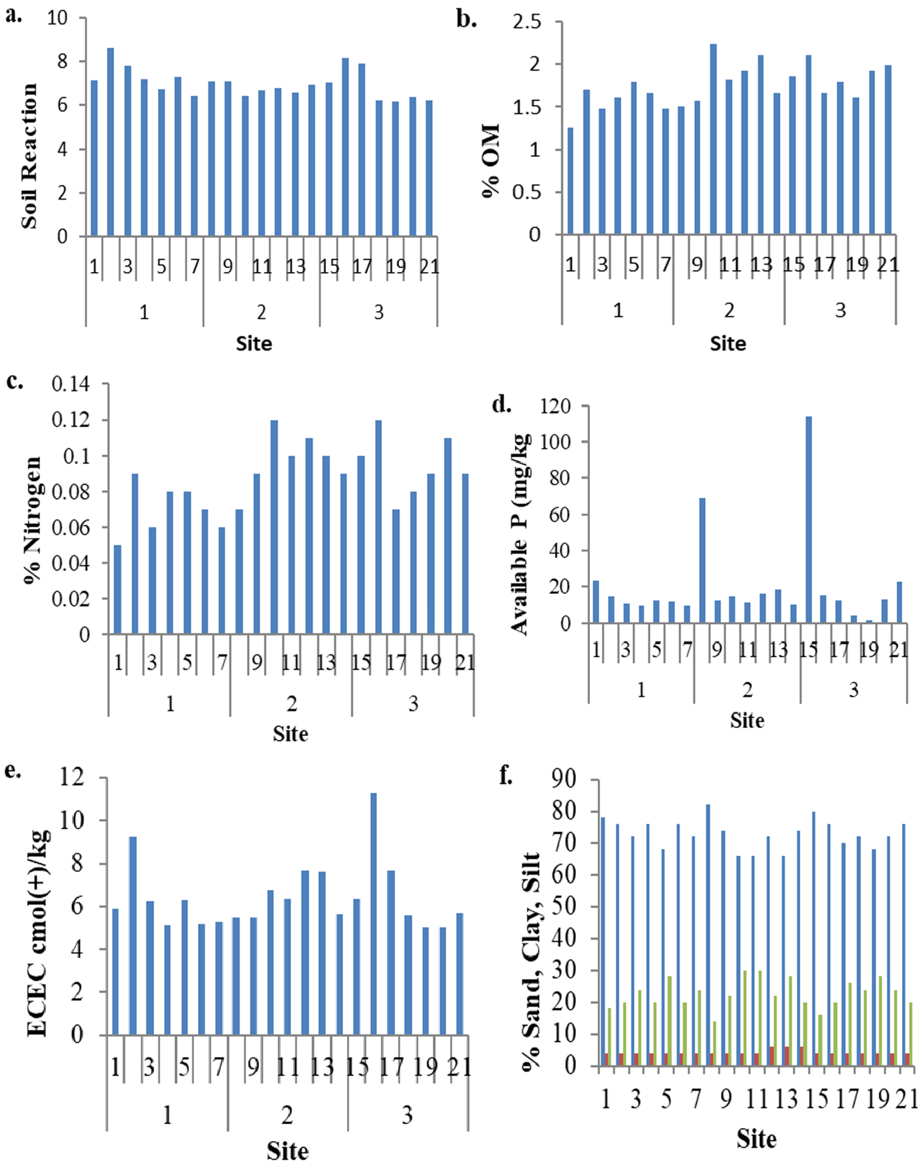Figure 6: Nutrient contents of initial soil in the block of the study area (blocks are indicated by numbers 1, 2, and 3)

**3.2. Effect of Modules on the Physicochemical Analysis of the Soil**

Comparatively, there was an improvement in soil nutrients after the application of the treatments to the soil in the study area. Significant differences (p < 0.05) occurred between control and organic matter (module 3) (Table 3). This was a better option because, as stated above, organic matter improves soil productivity under crop production (Horneck et al., 2011). This finding is supported by Cardoso et al. (2006), suggesting that the incorporation of organic matter into the soil can be utilized to battle plant diseases, as this practice typically enhances the soil's physical and chemical properties. Soil acidity increased after application of treatments; however, the neem paste modules were better than the chemical fertilizer, but the difference was not significant (p < 0.05). The carbon-to-nitrogen ratio is lowest in all the treatments, indicating that the rate of decomposition is high in all treatments.

The suppression of pests observed under module 3 (neem leaf paste × neem leaf extract) may be attributed to the presence of allelochemicals in neem, including azadirachtin. This is particularly with the reduction in root-knot nematode populations (Tables 4 and 5) and foliar arthropod pests such as Podagrica beetles (Figure 8a). These compounds have been reported to have nematicidal, insect-repellent, and antifeedant properties (Chaudhary et al., 2017; Schmutterer, 2022; Perveen, 2024), which likely contributed to the effectiveness of module 3 as a biopesticide. Although the soil pH levels changed slightly across the different treatments (with a range from 5.3 to 6.4), the differences were not statistically significant. However, the possibility that these changes in soil pH played a contributing role in reducing pest populations cannot be ruled out.

The field results in this study show a strong efficacy of neem derivatives to suppress pests and nematodes, although the study did not investigate the physiological or biochemical pathways through which these effects occur. Therefore, future research should explore the direct effects of neem on insect biology and nematode physiology, as well as interactions with soil chemistry and potential pH alterations.

**Table 3: Effect of modules on the physicochemical analysis of the soil**

|  |  |  |  |  |  |  |  |  |  |
| --- | --- | --- | --- | --- | --- | --- | --- | --- | --- |
| Treatment | pH | OC | N | C:N ratio | OM | Ca | Mg | K | Na |
| Control | 6.06ab | 0.85b | 0.20a | 4.25a | 1.47b | 5.89a | 1.89a | 0.09a | 0.40a |
| NP+Lambda | 6.40a | 1.14ab | 0.13a | 8.85a | 1.97ab | 4.64a | 1.60a | 0.14a | 0.42a |
| NP+LF | 6.13ab | 1.06ab | 0.15a | 7.07a | 1.83ab | 3.94a | 1.94a | 1.10a | 0.50a |
| NP+NE | 6.04ab | 1.30a | 0.20a | 6.55a | 2.25a | 5.88a | 1.31a | 0.10a | 0.52a |
| NPK+Lambda | 5.30ab | 1.00ab | 0.22a | 4.55a | 1.73ab | 4.30a | 1.98a | 0.15a | 0.35a |
| NPK+LF | 5.38ab | 1.10ab | 0.19a | 5.79a | 1.89ab | 5.02a | 1.57a | 0.25a | 0.40a |
| NPK+NE | 5.88ab | 1.02ab | 0.17a | 6.00a | 1.75ab | 5.16a | 1.65a | 0.20a | 0.49a |

NB: Different letters indicate that the means of the parameter for various treatments are significantly different from each other, and vice versa for similar letters.

**3.3. Soil samples for nematode extraction**

**3.3.1. Effect of modules on nematode population and gall index**

Initial soil samples were taken at planting time for plant parasitic nematode population densities. The nematode extraction method followed the modified Baermann extraction protocol. As shown in Figure 7, root-knot nematode recorded the highest population density, followed by reniform and spiral nematodes. Initial results also attest to the fact that continuous okra cultivation has necessitated the buildup of nematodes, especially the *Meloidogyne* species.

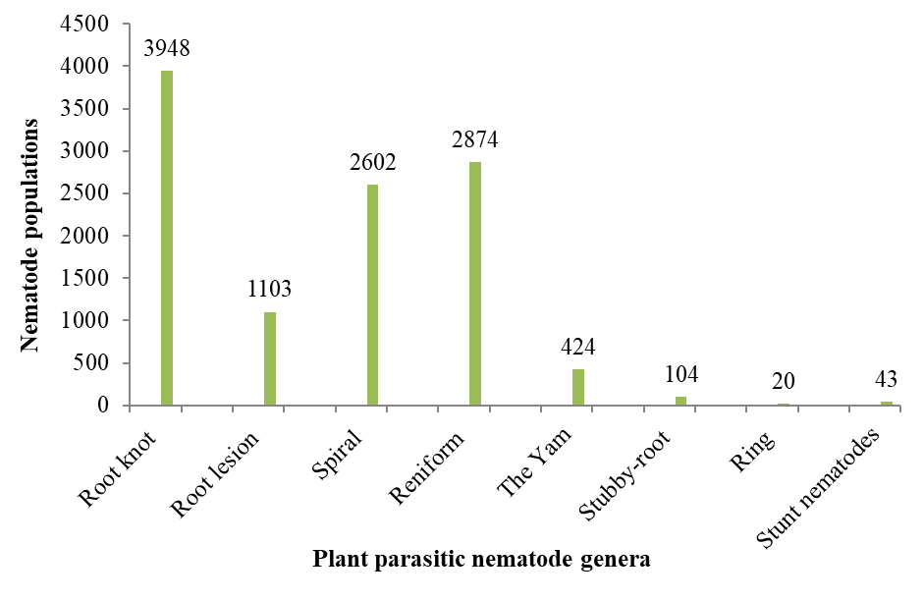

**Figure 7: Plant parasitic nematode populations per 200 ml of soil**

Five economically important plant-parasitic nematodes were recovered from the okra plant in the final rhizosphere soil samples. They were root-knot nematodes (*Meloidogyne* species), spiral nematodes (*Helicotylenchus multicinctus*), root lesion nematodes (*Pratylenchus bracyurus*), reniform nematodes (*Rotylenchulus reniformis*), and the yam nematodes (*Scutellonema bradys*). All the nematode species encountered belong to the order Tylenchida. The control treatment recorded the highest significant (p < 0.05) population densities of four nematode species (root-knot, root lesion, spiral, and reniform nematodes). The population densities of yam nematodes did not show significant differences between the treatments. However, the control treatment recorded the highest population density of 16 nematodes (Table 4).

Table 4: Plant parasitic nematode populations per 200 cm3 rhizosphere soil at harvest time

|  |  |  |  |  |  |
| --- | --- | --- | --- | --- | --- |
| **Module** | **Root-knot nematodes** | **Root lesion nematodes** | **Spiral nematodes** | **Reniform**  **nematodes** | **The Yam nematodes** |
| Module 1  NPK + Lambda | 316 b | 37 b | 114 ab | 123 | 3 b |
| Module 2  NPK + NE | 414 b | 11 b | 15 b | 41 b | 8 b |
| Module 3  NP + NE | 276 b | 4 b | 81 b | 48 b | 4 b |
| Module 4  NPK + LF | 353 b | 23 b | 57 b | 122 b | 11 ab |
| Module 5  NP + lambda | 180 b | 14 b | 62 b | 49 b | 7 b |
| Module 6  NP + LF | 187 b | 4 b | 122 ab | 130 b | 5 b |
| Module 7  Control | 2443 a | 73 a b | 367 ab | 449 a | 16 a |
| **LSD (0.05)** | **590** | **22** | **161** | **158** | **13** |
| **CV (%)** | **6.0** | **3.3** | **18.6** | **14.9** | **53.0** |

NB: The figures are means of three replicates. Within each column, means followed by the same letter are not significantly different (p < 0.05). LSD = Least Significant Difference; CV = Coefficient of Variation.

Treatment NP + NE recorded the least (12) root-knot nematode population recovered from okra plant roots. This, however, was not significantly higher than those of the other treatments except that of the control treatment (177) (Table 5). This finding is corroborated by Agyarko et al. (2005), who found that the application of neem-based amendments considerably reduced the population of plant-parasitic nematodes while increasing the population of non-parasitic nematodes. Treatments NP + LF and NP + NE recorded the least (1.7) okra plant gall index on the scale of 0-5. The control treatment scored the highest gall index of 4.7. This, however, was not significantly higher than those of the NPK + NE and NPK + LF treatments (Table 5). Soil amendment with NLP could therefore act as a substitute for chemical nematicides in managing plant-parasitic nematodes in okra.

Table 5: Root-knot nematode populations per 5 g okra plant root and gall index on the scale of 0 to 5 at harvest

|  |  |  |  |
| --- | --- | --- | --- |
| **Module** | **Root-knot nematodes** | **Gall index (1-5)** | **Yield (kg/ha)** |
| Module 1: NPK + Lambda | 58 b | 2.0 b | 2040.54 b |
| Module 2: NPK + NE | 62 b | 2.7 a b | 6183.25 e |
| Module 3: NP + NE | 12b | 1.7 b | 6079.09 e |
| Module 4: NPK + LF | 37 b | 2.7 a b | 5913.90 e |
| Module 5: NP + Lambda | 21 b | 2.0 b | 3331.98 c |
| Module 6: NP + LF | 13 b | 1.7 b | 4037.32 d |
| Module 7: Control | 177 a | 4.7 a | 1536.95 a |
| **LSD (0.05)** | **80** | **1.5** | **503.29** |
| **CV (%)** | **2.6** | **8.8** | **30.6** |

The figures are means of three replicates. Values within a column that share the same letter are not significantly different based on Tukey’s 95% confidence intervals. LSD = Least Significant Difference; CV = Coefficient of Variation.

**3.4. Effect of Modules on Insect Population, Damage Assessment, and Yield**

**3.4.1. Effect of Modules on Insect Population**

Significant variations (*p* < 0.05) were seen between treatments for the quantity of flea beetles per plant following foliar sprays. The peak Podagrica population was recorded in module 7, i.e., the control group without treatment (45/plant) (Figure 8a). All seven modules of the pest management strategies exhibited markedly reduced populations of Podagrica beetles compared to the control group. With respect to beneficial insects, however, significantly higher numbers were observed in the control (2.7/plant), and then the organic IPM module 3 and conventional IPM module 2 all registered (1.3/plant). Module 1: Farmer’s practice/Conventional I, module 5: Conventional IPM II, and module 6: Organic IPM II all had no record of natural enemies (Figure 8b). The efficacy of organic amendments, specifically neem leaf pastes and neem leaf extracts, against pests has been proven by several researchers (Akhtar, 2000; Gajalakshmi & Abbasi, 2004; Lokanadhan et al., 2012; Mala et al., 2017), which corroborates the present findings. Organic IPM module 3 proved to be the most effective treatment against the Podagrica beetle, in which the lowest incidence was recorded. All six modules of the pest management strategies exhibited markedly reduced populations of Podagrica beetles compared to the control group. However, the control attracted more beneficial insects as compared to other IPM modules. The highest number (3 per plant) of natural enemies was recorded from module 7, the control, followed by organic IPM module 3, module 2, and module 4. No natural enemies were recorded for the remaining modules.

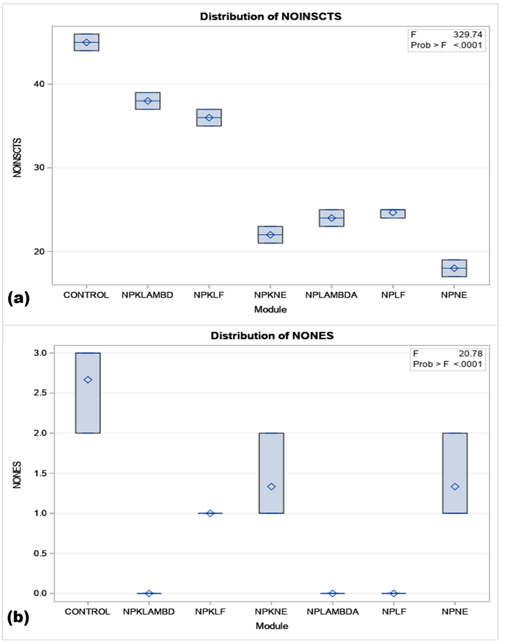

Figure 8: (a) Effect of modules on insect population; (b) Effect of modules on natural enemies per plant

**3.4.2. Effect of Modules on Insect Damage**

A significant difference in damaged plants as a result of Podagrica feeding was detected across various modules (*p* < 0.05). The results indicated a disparity between the organic IPM module 3 and all other modules (Figure 9). A significantly lower plant population was damaged by Podagrica beetles (27 plants), followed by module 2/conventional IPM (22 plants). The peak Podagrica population was recorded in the untreated control group (45 individuals per plant) (Figure 8a).

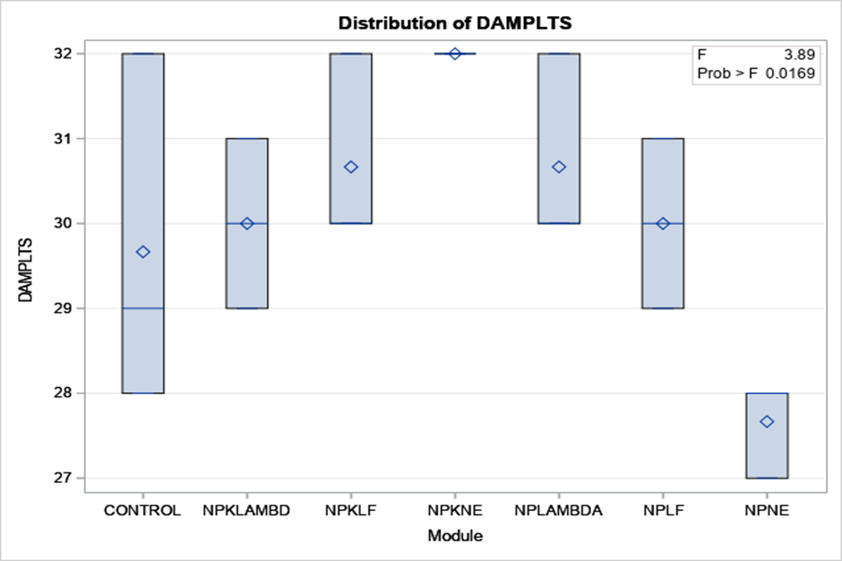

Figure 9: Effect of modules on damaged plants

**3.5. Effect of Modules on Yield**

Okra fruit yield varied considerably across different modules (*p* < 0.05) (Figure 10). The fresh fruit yield of okra observed was significantly highest and at par for organic IPM module 3, module 2, and module 4 at 6079.09, 6183.25, and 5913.90 kg ha-1, respectively. The observed yield in the other modules reduced in the order of module 6 (4037.32), module 5 (3331.98), module 1 (2040.54), and module 7 (1536.95). In terms of damaged fruits, a medium level of damaged fruit per plant was observed for organic IPM module 3, module 2, and module 4. The highest occurred in the control with 30 fruits. The least fruit damage was recorded in the conventional farmer practice module 1 and the conventional IPM module 5. The results indicate that organic IPM module 3, module 2, and module 4 were significantly successful, yielding a much greater quantity of marketable okra fruits compared to the untreated control, which produced only 1536 kg ha-1.

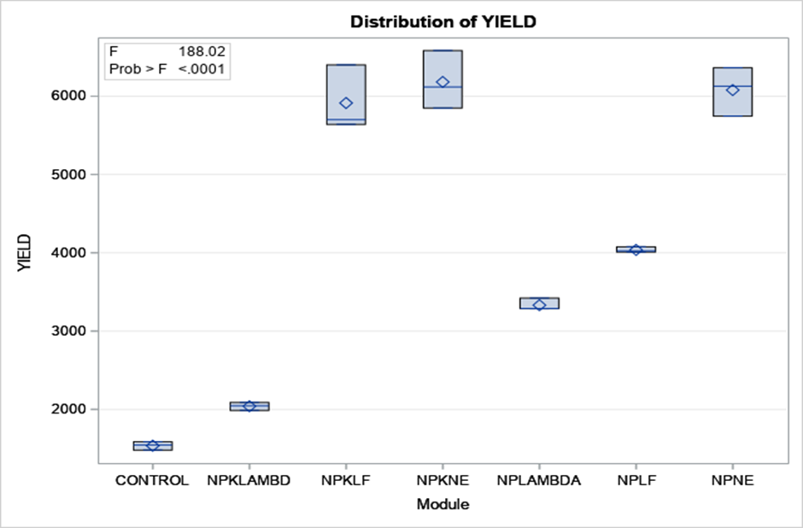

Figure 10: Effect of Modules on Yield

4. Conclusion

The potential of the dual benefits of neem leaf paste to crop production has been demonstrated by other researchers and further explored to investigate and examine its fertilizer and pesticidal effects. The results revealed that the organic IPM module 3, representing NLP x NLE, recorded a significantly lower population of the root-knot nematode and gall index. Similarly, the organic IPM module 3, representing NLP x NLE, yielded lower insect populations and considerable beneficial insect numbers. This also recorded the least damaged plant and was at par with modules 2 and 6 in terms of damage severity by podagrica species. The organic IPM module, together with modules 2 and 4, gave the highest fresh fruit weight and consequently the highest yield. The enhancement of soil quality, the decrease in insect and nematode infestations, and the augmented yield of the okra crop may be attributed to the organic IPM module 3 derivatives of neem. The organic IPM module 3 is therefore recommended for improved soil amendment, reduction of soil and foliar arthropods, ensuring environmental and consumer safety, and increased yield of okra. Through the continuous evaluation and consistent validation of its pesticidal attributes, neem has demonstrated its non-synthetic natural bio-insecticide and environmentally safe alternative to commercially synthesized pesticides. Neem pastes, therefore, exhibited soil fertility potential and adequately controlled nematodes. Overall, in combination with neem extracts, it moderately managed the podagrica species, and its combined effect translated into yield. Its dual role as both a pesticide and fertilizer will transform the agro-input business for the benefit of consumers. Organic IPM offers significant promise for crop production improvement to farmers in developing countries. This work is motivated by its potential to provide these farmers with a cost-effective and environmentally sustainable alternative to the expensive and high-risk synthetic pesticides currently on the market.

Disclaimer (Artificial intelligence)

Option 1:

Author(s) hereby declare that NO generative AI technologies such as Large Language Models (ChatGPT, COPILOT, etc.) and text-to-image generators have been used during the writing or editing of this manuscript.

Option 2:

Author(s) hereby declare that generative AI technologies such as Large Language Models, etc. have been used during the writing or editing of manuscripts. This explanation will include the name, version, model, and source of the generative AI technology and as well as all input prompts provided to the generative AI technology.

Details of the AI usage are given below:

1.

2.

3.

References

Agyarko, K., Kwakye, P., Bonsu, M., Osei, B., & Asante, J. (2005). Note: Effect of neem and organic amendments on nematode populations in a coastal savanna tropical soil. *Phytoparasitica*, *33*(4), 343-346. <https://doi.org/10.1007/BF02981300>

Akhtar, M. (2000). Nematicidal potential of the neem tree Azadirachta indica (A. Juss). *Integrated Pest Management Reviews*, *5*(1), 57-66. <https://doi.org/10.1023/A:1009609931223/METRICS>

Alegbejo, M., Ogunlana, M., & Banwo, O. (2008). Survey for incidence of okra mosaic virus in northern Nigeria and evidence for its transmission by beetles. *Spanish Journal of Agricultural Research*, *6*(3), 408-411. <https://doi.org/10.5424/SJAR/2008063-342>

Allison, L. E. (1960). Wet‐combustion apparatus and procedure for organic and inorganic carbon in soil. *Soil Science Society of America Journal*, *24*(1), 36-40.

Amuah, E. E. Y., Fei-Baffoe, B., Sackey, L. N. A., Douti, N. B., & Kazapoe, R. W. (2022). Understanding the distribution, source-pattern and geochemical controls of soils in an artisanal mine site during a ban on illegal mining activities: Is a ban an absolute solution? *Soil Security*, *9*, 100078. <https://doi.org/10.1016/J.SOISEC.2022.100078>

Antwi, E. K., Setiawati, M. D., Tetteh, J. D., Boakye-Danquah, J., Owusu-Banahene, W., & Yohuno, P. T. (2022). Agricultural Land Suitability Assessment towards Promoting Community Crop Production in Tolon-Ghana.

Arunachalam, B., Ganesan, S., Natarajan, H. P., Suthandhirajan, R., Muthuswamy, S., Balaiyan, S., & Satheesan, A. (2025). Advancing Neem's Role in Environmental Sustainability: Genetic Potential and Industrial Applications. *Environmental Quality Management*, *34*(3), e70041. <https://doi.org/10.1002/tqem.70041>

Asare-Bediako, E., Addo-Quaye, A., & Bi-Kusi, A. (2014). Comparative efficacy of phytopesticides in the management of Podagrica spp. and mosaic disease on okra (Abelmoschus esculentus L.). <https://ir.ucc.edu.gh/xmlui/handle/123456789/4514>

Bakewell-Stone, P. (2024). *Azadirachta indica (neem tree)*. CABI Digital Library. <https://doi.org/10.1079/cabicompendium.8112>

Brotodjojo, R. R., & Arbiwati, D. (2016). Effect of application of granular organic fertilizer enriched with boiler ash and neem leaves powder on plant resistance against insect pests. *International Journal of Bioscience, Biochemistry and Bioinformatics*, *6*(4), 152. <https://doi.org/10.17706/ijbbb.2016.6.4.152-157>

Cardoso, S. C., Soares, A. C. F., Brito, A. d. S., Laranjeira, F. F., Ledo, C. A. S., & Santos, A. P. d. (2006). Control of tomato bacterial wilt through the incorporation of aerial part of pigeon pea and crotalaria to soil. *Summa Phytopathologica*, *32*, 27-33. <https://doi.org/10.1590/S0100-54052006000100004>

Celsia, A. R., & Mala, R. (2014). Fabrication of nano structured slow release fertilizer system and its influence on germination and biochemical characteristics of Vigna raidata. *International Journal of ChemTech Research*, *6*(10), 4497-4503. <https://scholar.google.com/scholar_url?url=https://www.academia.edu/download/80383969/4497-4503_20014.pdf&hl=en&sa=T&oi=gsb-ggp&ct=res&cd=0&d=14597651406293459588&ei=h-J3aICTJffWieoPg4Tq4Qg&scisig=AAZF9b81lFaeFznBOBoFLaZ6xL0U>

Chaudhary, S., Kanwar, R. K., Sehgal, A., Cahill, D. M., Barrow, C. J., Sehgal, R., & Kanwar, J. R. (2017). Progress on Azadirachta indica based biopesticides in replacing synthetic toxic pesticides. *Frontiers in plant science*, *8*, 610. <https://www.frontiersin.org/journals/plant-science/articles/10.3389/fpls.2017.00610/full>

Dua, V. K., Pandey, A. C., Raghavendra, K., Gupta, A., Sharma, T., & Dash, A. P. (2009). Larvicidal activity of neem oil (Azadirachta indica) formulation against mosquitoes. *Malaria Journal*, *8*(1), 124. <https://doi.org/10.1186/1475-2875-8-124>

Echezona, B., & Offordile, J. (2011). Responses of flea beetles (Podagrica spp.) and okra plants (Abelmoschus esculentus L. Moench) to differently coloured polyethylene shades. *International Journal of Pest Management*, *57*(2), 161-168. <https://www.tandfonline.com/doi/abs/10.1080/09670874.2010.547282>

Fasunwon, B. T., & Banjo, A. D. (2010). Seasonal population fluctuations of Podagrica species on okra plant (Abelmoschus esculentus). *Res. J. Agric. Biol. Sci*, *6*, 283-288.

Gajalakshmi, S., & Abbasi, S. (2004). Neem leaves as a source of fertilizer-cum-pesticide vermicompost. *Bioresource Technology*, *92*(3), 291-296. <https://doi.org/10.1016/J.BIORTECH.2003.09.012>

Horneck, D. A., Sullivan, D. M., Owen, J. S., & Hart, J. M. (2011). Soil test interpretation guide. <http://extension.oregonstate>.

Hussain, M., Mukhtar, T., & Kayani, M. (2011). Assessment of the damage caused by Meloidogyne incognita on okra (Abelmoschus esculentus). *Journal of Animal and Plant Sciences*, *21*(857), 861.

Javid, A., Hussain, A., Ikram, M., Siddique, M., Zahoor, M., Ullah, R., Ibrahim, M. A., & Gulfam, N. (2025). Application of Azadirachta indica (Neem) organic crude macerated extracts against postharvest decay of fruits caused by Penicillium expansum, Colletotrichum gloeosporioides and Botrytis cinerea. *Notulae Botanicae Horti Agrobotanici Cluj-Napoca*, *53*(1), 14086-14086. <https://www.notulaebotanicae.ro/index.php/nbha/article/view/14086>

Koul, O., & Wahab, S. (2004). Neem biotechnology-A synthesis. In O. Koul & S. Wahab (Eds.), *Neem: Today and in the New Millennium* (pp. 243-259). Springer Netherlands. <https://doi.org/10.1007/1-4020-2596-3_12>

Krishnareddy, M., Jalali, S., & Samuel, D. (2003). Fruit distortion mosaic disease of okra in India. *Plant Disease*, *87*(11), 1395-1395. <https://doi.org/10.1094/PDIS.2003.87.11.1395A>

Lokanadhan, S., Muthukrishnan, P., & Jeyaraman, S. (2012). Neem products and their agricultural applications. *Journal of Biopesticides*, *5*, 72.

Mala, R., Celsia Arul Selvaraj, R., Barathi Sundaram, V., Blessina Siva Shanmuga Rajan, R., & Maheswari Gurusamy, U. (2017). Evaluation of nano structured slow release fertilizer on the soil fertility, yield and nutritional profile of Vigna radiata. *Recent patents on nanotechnology*, *11*(1), 50-62. <https://doi.org/10.2174/1872210510666160727093554>

Mani, M., Krishnamoorthy, A., & Gopalakrishnan, C. (2005). Biological control of lepidopterous pests of horticultural crops in India-a review. *Agricultural Reviews*, *26*(1), 39-49. <https://eurekamag.com/research/004/402/004402518.php>

McCloud, T. G. (2010). High throughput extraction of plant, marine and fungal specimens for preservation of biologically active molecules. *Molecules*, *15*(7), 4526-4563.

Mishra, P. K., Kumar, A., Aman, A. S., Verma, S. K., & Yadav, S. K. (2023). Crucial Role of Neem (Azadirachta indica) Plant in the Management of Pests. *Vigyan Varta*, *4*(2), 5-6.

MoFA. (2022). *Facts & Figures: Agriculture in Ghana, 2021*. Ministry of Food and Agriculture. Statistics, Research and Information Directorate (SRID), September 2022. <https://mofa.gov.gh/site/images/pdf/AGRICULTURE%20IN%20GHANA%20(Facts%20&%20Figures)%202021.pdf>

Motsara, M., & Roy, R. N. (2008). *Guide to laboratory establishment for plant nutrient analysis* (Vol. 19). 220. Rome. FAO Fertilizer and Plant Nutrition Bulletin.

Mukhtar, T., Kayani, M. Z., & Hussain, M. A. (2013). Nematicidal activities of Cannabis sativa L. and Zanthoxylum alatum Roxb. against Meloidogyne incognita. *Industrial Crops and Products*, *42*, 447-453. <https://doi.org/10.1016/J.INDCROP.2012.06.027>

Nathan, S. S., Savitha, G., George, D. K., Narmadha, A., Suganya, L., & Chung, P. G. (2006). Efficacy of Melia azedarach L. extract on the malarial vector Anopheles stephensi Liston (Diptera: Culicidae). *Bioresource Technology*, *97*(11), 1316-1323. <https://doi.org/10.1016/j.biortech.2005.05.019>

Obeng-Ofori, D., & Sackey, J. (2003). Field evaluation of non-synthetic insecticides for the management of insect pests of okra Abelmoschus esculentus (L.) Moench in Ghana. *SINET: Ethiopian Journal of Science*, *26*(2), 145-150. <https://www.ajol.info/index.php/sinet/article/view/18210>

Perveen, K. (2024). Neem’s promise: the way to a sustainable future and eco-friendly biopesticides. *Int J Sci Res Arch*, *11*(02), 1073-1082. <https://doi.org/10.30574/ijsra.2024.11.2.0532>

Pruthi, H., & Samuel, C. (1937). Entomological Investigations on the Leaf-curl Disease of Tobacco in North Bihar. I. Transmission Experiments with Some Suspected Insect Vectors. II. An Alternative Host of the Virus and the Insect Transmitter. *Indian Journal of Agricultural Science*, *7*, 659-670. <https://www.cabidigitallibrary.org/doi/full/10.5555/19380500174>

Rao, N., & Rajendran, R. (2002). Joint action potential of neem with other plant extracts against the leafhopper, Amrasca devastans (Distant) on okra. *Pest Management and Economic Zoology*, *10*(2), 131–136. <https://www.cabidigitallibrary.org/doi/full/10.5555/20043012727>

Roba, T. B. (2018). Review on: The effect of mixing organic and inorganic fertilizer on productivity and soil fertility. *Open Access Library Journal*, *5*(06), 1.

Sarawaneeyaruk, S., Krajangsang, S., & Pringsulaka, O. (2015). The effects of neem extract and azadirachtin on soil microorganisms [SAS. (2020). User’s Guide The MI Procedure. SAS Institute]. *Journal of Soil Science and Plant Nutrition*, *15*(4), 1071-1083. <https://doi.org/10.4067/S0718-95162015005000075>

SAS. (2020). *User’s Guide: The MI Procedure*. SAS Institute.

Savci, S. (2012). An agricultural pollutant: chemical fertilizer. *International Journal of Environmental Science and Development*, *3*(1), 73-80. <https://doi.org/10.7763/IJESD.2012.V3.191>

Schippers, R. R. (2000). *African indigenous vegetables: an overview of the cultivated species*. Natural Resources Institute (Great Britain). <https://gala.gre.ac.uk/id/eprint/12060/>

Schmutterer, H. (2022). *The neem tree: Azadirachta indica A. Juss. and other meliaceous plants: sources of unique natural products for integrated pest management, medicine, industry and other purposes*. VCH. <https://cir.nii.ac.jp/crid/1130000794308272128>

Tindall, H. D. (1983). *Vegetables in the tropics*. Macmillan Press Ltd. <https://www.cabidigitallibrary.org/doi/full/10.5555/19840321042>

Vanlommel, S., Duchateau, L., & Coosemans, J. (1996). The effect of okra mosaic virus and beetle damage on yield of four okra cultivars. *African Crop Science Journal*, *4*(1), 71-77. <https://www.bioline.org.br/abstract?cs96042>

Wahjono, T. E., Suhatman, A., Wihermanto, W., & Hadiyanto, H. (2024). Neem (Azadirachta indica A. Juss; Meliaceae) as the source for plant-based pesticides as an effective and sustainable biocontrol alternative. *Journal of Bioresources and Environmental Sciences*, *3*(3), 128-141. <https://doi.org/10.61435/jbes.2024.19928>