**Comparative Efficacy of CIDR-Based Estrus Synchronization Protocol in Post-Partum Anestrus Gir and Ongole Cows under Field Conditions**

**Abstract**

This study investigates the effectiveness of a Controlled Internal Drug Release (CIDR) protocol in synchronizing estrus among post-partum anestrus Gir and Ongole cows, under field condition in Nalgonda district, Telangana. The study aimedto improve reproductive outcomes under field conditions. Anestrus, a major cause of infertility in Indian Zebu cattle breeds, reduces reproductive efficiency by prolonging calving intervals and lowering fertility rates. Twelve post-partum anestrus cows, comprising six Gir and six Ongole cattle breeds, were selected for this study. The cows underwent a CIDR-based fixed-time artificial insemination (FTAI) protocol, which included administering GnRH and PGF2α hormones. The protocol’s impact was assessed based on estrus response rate, onset of estrus, duration of estrus, conception rate, and plasma progesterone levels. Results showed that the CIDR protocol achieved a 100% estrus induction rate in both breeds, with conception rates of 100% in Ongole and 94% in Gir cows. Progesterone analysis indicated a significant (P<0.05) rise in levels on day 7, followed by a significant decrease (P<0.05) around insemination. The study highlights the CIDR protocol's potential for enhancing reproductive performance by synchronizing estrus, leading to higher conception rates in native cattle breeds under field conditions.

Key words: Estrus synchronization, post-partum anestrus, plasma progesterone, conception rate

***INTRODUCTION***

In India, the main cause of infertility in Zebu cattle is anestrus, primarily due to delayed post-partum conception in cows and delayed cyclicity in heifers. This condition lowers reproductive efficiency, extending calving intervals and reducing overall fertility (Roche et al. 1998). Gir cattle breed is recognized as one of the most resilient high-yielding breeds globally (Kumar and Singhal, 2006). Similarly, Ongole cattle breed are a dual-purpose breed known for their heat tolerance, resilience, and disease resistance. This breed is also highly regarded for its ability to survive on limited dry fodder and perform well on tropical pastures (Reddy *et al.,* 2021). Both Ongole and Gir cattle breeds are among the most resilient native breeds with high production potential. However, compared to temperate breeds raised under similar conditions, they exhibit slower reproductive cycles, with extended periods of post-pubertal and post-partum anestrus periods. Anestrus is a key factor hindering their reproductive efficiency. Hormonal interventions have been implemented to increase the probability of estrus detection and insemination to increase pregnancy rates of dairy cattle across different management systems. The Ovsynch protocol (Pursley et al., 1995) is commonly used for timed artificial insemination (TAI), with conception rates improving when initiated between days 5 and 12 of the estrus cycle (Vasconcelos et al., 1999). Supplementing with short-term progesterone through intravaginal devices can improve synchronization by maintaining progesterone levels, preventing premature estrus and ovulation (El-Zarkouny et al., 2004; McDougall, 2010). Most estrous synchronization methods focus on regulating follicular wave development, inducing ovulation in anestrus cows, causing the regression of the corpus luteum in cycling cows, and synchronizing estrus or ovulation at the end of the treatment. Timed artificial insemination systems offer advantages in improving estrus detection and conception rates. Despite their success in various breeds, no studies have assessed the impact of the CIDR protocol on indigenous cattle breeds in India.Therefore, this study was designed to evaluate the effect of the CIDR protocol on post-partum anestrus Gir and Ongole breeds, focusing on the induced estrus response, conception rates and plasma progesterone concentration levels.

***Materials and Methods***

The present study was conducted in the Department of Animal Reproduction, Gynaecology and Obstetrics, RIVER, Puducherry. Twelve post-partum anestrus native cattle consisting of (6-Gir and 6- Ongole) with body condition score between 3.0 to 3.5 (Edmonson et al., 1989), with more than 100 days in milk and free from any palpable abnormality of the reproductive tract at a private dairy farm, Nalgonda, Telangana, India were selected. Rectal examination was performed for all the animals twice at 10 days interval and only animals having no palpable mature Corpus Luteum on the ovaries on both the examinations was considered as anestrus and utilized for the study. The selected animals were treated with progesterone based CIDR estrous synchronization protocol (Fig.1)

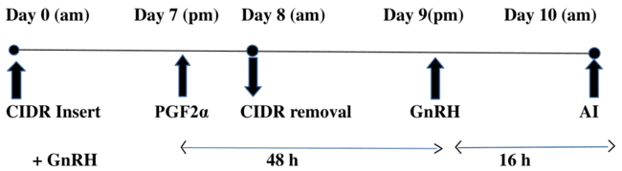

**Figure.1 Schematic representation of CIDR protocol**

On day 0, GnRH (Buserelin acetate; 10µg) and Intravaginal implantation of CIDR (Fig 2) up to 8 days and on day 7 PGF2α (Cloprostenol sodium; 500 µg), on day 9 second GnRH (Buserelin acetate; 10µg) was administered through intramuscular route. Fixed Time Artificial Insemination (FTAI) was done in all the cattles using good quality frozen thawed semen at 16 hours after the second dose of GnRH. After PGF2α injection the onset to estrus and induced estrus response (%) was evaluated on the basis of number of cows responded i.e., those exhibited estrus symptoms. The duration (hr) of induced estrus was calculated from expression of first sign of behavioural symptoms of estrus to the cessation of behavioural symptoms of estrus. All the animals were subjected to pregnancy diagnosis using ultrasound scanner (Draminski, 4Vet Slim, Poland; Fig 3) equipped with a B-mode linear array trans-rectal probe operating at 7.5 MHz frequency. The ultrasound examination was performed to confirm pregnancy 50 days post insemination.

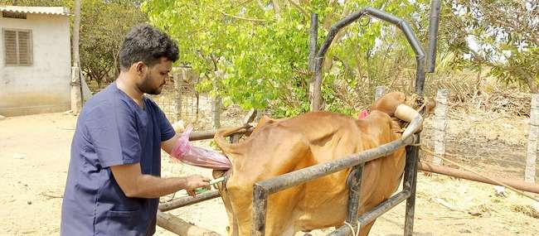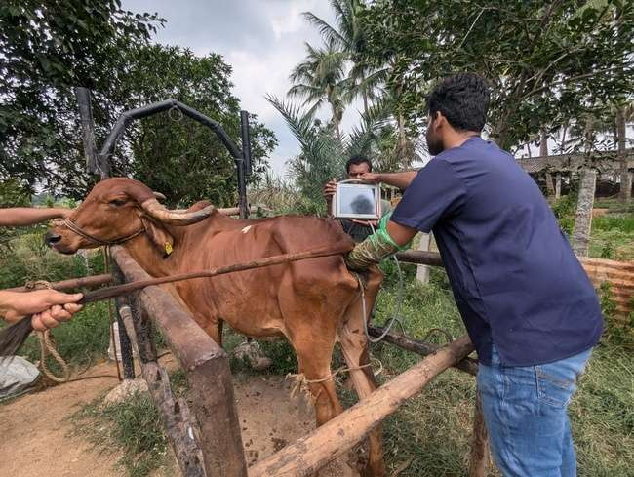**.**

Fig 2. **CIDR insertion**. Fig 3 Pregnancy **diagnosis**

Whole blood samples were collected from jugular vein in the sterile vacutainer on -10, 0, 7, 8 and 10th day of the protocol for progesterone estimation. The collected blood samples were allowed to clot at room temperature and serum was separated by centrifuging at 3000 rpm for 15 min and stored at -20 C. Progesterone concentration was estimated using (Fig 4) Cal biotech progesterone ELISA kit (Catalogue number: PG362S)10461 Austin Dr, Spring Valley, CA 91978, United States. The test was performed according to manufacture assay protocol (Fig 5). The whole data was analysed using SPSS ver. 26.

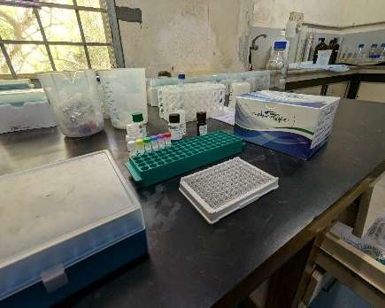

Fig 4 **Cal biotech ELISA kit**

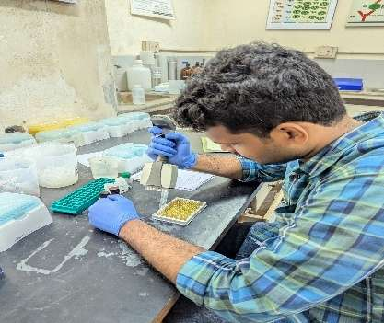

Fig 5 **Progesterone hormone estimation**

***Results and Discussion***

The objective of the present study was to evaluate the effects of the CIDR protocol on estrus response, duration of estrus, onset to estrus, and conception rate in postpartum anestrus Gir and Ongole cows. CIDR successfully induced estrus observation in both Ongole and Gir cows, achieving a 100% response rate, consistent with findings by Bhoraniya et al. (2012) in Kankrej cows and Zaabel et al. (2009) in buffaloes. Sanchetz et al. (1993) noted that progesterone from CIDR devices enhances estrus intensity post-removal, likely improving reproductive responses in treated cows, while Fabre-Nys and Martin (1991) suggested progesterone increases estrogen sensitivity in the hypothalamus, thus boosting estrus response. Similar outcomes were reported by Vijayrajan et al. (2009), Chaudhary et al. (2012), and Prajapathi et al. (2019), who found 100% estrus induction rates in postpartum anestrus cows. Conversely, Naiko et al. (2016) documented only a 50% induction rate with the Ovsynch + CIDR protocol in Kankrej cattle.

In the current study, the mean duration of estrus for Ongole and Gir cattle was recorded at 28.34 ± 0.37 and 27.49 ± 0.36 hours, respectively. These findings are consistent with the estrus duration of 24.6 ± 5.2 hours observed by Sathiamoorthy and Kathirchelvan (2010) in postpartum cows subjected to a 9-day CIDR protocol. Naidu and Rao (2006) also reported a comparable duration of 27.49 hours in Ongole cows. Reddy et al. (2020), however, documented slightly shorter estrus durations of 22.94 ± 0.87 hours in postpartum anestrus cows and 21.26 ± 0.81 hours in cows with repeat breeding issues. Additional studies on postpartum anestrus cows using the Ovsynch protocol found that the average duration of estrus ranged from 20.50 ± 2.50 to 21.2 ± 0.58 hours, as reported by Sathiamoorthy and Subramanian (2003).

In this study, the onset of induced estrus following CIDR removal occurred at 58.1 ± 3.1 hours in Ongole cows and 57.4 ± 2.3 hours in Gir cows. These findings align with previous studies on estrus induction timing using various protocols. Reddy et al. (2022) found that the onset of induced estrus with the Ovsynch protocol was 54.13 ± 0.97 hours and 52.58 ± 1.04 hours. Peralta-Torres et al. (2020) observed a 100% ovulation rate in buffaloes within 69 to 78 hours after CIDR removal, while Khan et al. (2018) recorded ovulation rates of 74% at 72.2 hours and 93% at 68.1 hours with CIDR+EB and CIDR+eCG protocols, respectively. Ahmed et al. (2016) and Vijayarajan et al. (2009) reported estrus onset at 48.75 ± 0.71 and 52.1 ± 2.39 hours, respectively, with similar synchronization protocols. Hirole et al. (2018) and Ratnaparkhi et al. (2020) also reported times close to these findings, with estrus onset at 53.20 ± 1.8 and 54.60 ± 2.44 hours in dairy cows using Ovsynch. In contrast, Prajapathi et al. (2019) reported 62.1 ± 2.26 hrs with Ovsynch protocol which is slightly longer than the present findings.

The conception rates observed in Ongole and Gir cows were 100% and 94% respectively, Andurkar and Kadu (1995) reported a 100% conception rate in buffaloes treated with CIDR plus PGF2α . Drost (2007) reported a conception rate of 57.5% in dairy cows when treated with the Ovsynch protocol combined with CIDR. According to Senger (2005), the use of exogenous progesterone (CIDR) restricts follicular development and maturation, thereby delaying ovulation until the CIDR device is removed, which aids in the synchronization of estrus and enhances timing for conception. Pursley et al. (2001) found that anovulatory cows fitted with an intravaginal progesterone device during the GnRH and PGF2α administration of the Ovsynch protocol had higher pregnancy rates (55.2%) compared to those subjected to Ovsynch without a CIDR (34.7%). In comparison, López-Gatius and López-Béjar (2002) found that the CIDR protocol resulted in a higher pregnancy rate (28.1%, n = 64) compared to the Ovsynch protocol (3.1%, n = 64). Murugavel et al. (2009) reported a 27.30% conception rate in buffaloes following the CIDR plus Ovsynch protocol. However, improved conception rates with CIDR treatment may be attributed to fixed-time breeding, as suggested by (Zaabel *et al.,* 2009), which helps in better synchronization. Additionally, CIDR withdrawal influences the secretion of estrogen and progesterone, enhancing reproductive outcomes, as noted by Singh et al. (2010). In contrary, Naiko *et al.* (2016) reported a 17% conception rate using the Ovsynch + CIDR protocol in Kankrej cattle, which was lower than the results of this study.

The 100% estrus response in postpartum anestrus Gir and Ongole cows is due to CIDR protocol. The notably high conception rate achieved in this study using the CIDR protocol may be attributed to the precise regulation of plasma progesterone levels during the preconception period (Honparkhe *et al.,* 2011). Additionally, the adequate priming of the reproductive system with sufficient circulating progesterone before conception likely facilitated better development of ovulatory follicles, that would yield a better developed CL (Folman *et al.,* 1990). Subsequently, the administration of PGF2α on day 7 would have lysed the well-developed corpus lutem resulting in sudden withdrawal of progesterone. The reduced levels of progesterone would have triggered the hypothalamic GnRH release and subsequent and pituitary Lutenizing Hormone release that induced ovulation and conception.

The mean serum progesterone concentrations on days -10, 0, 7, 8, and 10 were measured and compared between Ongole and gir cows were graphically represented in respectively (Table 2). A significant increase (P<0.05) in progesterone levels was observed on day 7, attributed to the exogenous progesterone source from the CIDR device, with levels subsequently decreasing to sub-basal levels (0.32±0.03 ng/ml) by the day of AI due to PGF2α administration. This pattern aligns with Bhoraniya et al. (2012), who reported significantly higher plasma progesterone on day 7 in Kankrej cows under Ovsynch (5.727 ± 1.26 ng/ml) and CIDR (4.37 ± 0.66 ng/ml) protocols. Pothireddy et al. (2022) and Jyothi (2011) similarly found lowest serum progesterone levels at AI: 0.77–1.17 ng/ml with Ovsynch, 0.04–1.46 ng/ml with Ovsynch + CIDR, and 0.62–1.69 ng/ml with CIDR + PG. These elevated progesterone levels are thought to contribute to improved conception rates, as noted by Kawate et al. (2004).In the present study CIDR insertion to postpartum anestrus Ongole and Gir cows showed higher estrus response and conception rate. This is indicative of need for use of exogenous progesterone source in field conditions.

**Table 1. Mean±SE values of estrus response, duration of estrus, onset of induced estrus and conception rate in postpartum anestrus Ongole and Gir cattle.**

|  |  |  |
| --- | --- | --- |
| **Parameters** | **Ongole (n= 6)** | **Gir (n=6)** |
| **Estrus response rate %** | 100% | 100% |
| **Duration of estrus (h)** | 28.34 ± 0.37 | 27.49 ± 0.36 |
| **Onset of induced estrus (h)** | 58.1 ± 3.1 | 57.4 ± 2.3 |
| **Conception Rate** | 100% | 94% |



Figure 6. Mean±SE values of progesterone concentration on day -10, 0, 7, 8 and 10 of CIDR insertion in Ongole and Gir cattle.

**CONCLUSION**

**The study demonstrates the effectiveness of the CIDR protocol in synchronizing estrus and improving reproductive outcomes in post-partum anestrus Gir and Ongole cows under field conditions. The CIDR protocol achieved high estrus induction and conception rates in both breeds. Plasma progesterone levels showed a significant increase during the protocol, followed by a decrease to sub-basal levels by the day of artificial insemination. The high estrus response and conception rates suggest that exogenous progesterone supplementation may be particularly beneficial for managing post-partum anestrus in these breeds, potentially improving reproductive efficiency in Indian Zebu cattle.**

**DISCLAIMER (ARTIFICIAL INTELLIGENCE)**

I confirm that no generative AI technologies, including Large Language Models (such as

ChatGPT, Copilot) or text-to-image generators, were used in the writing or editing of this

manuscript.

**ACKNOWLEDGEMENT**

The Authors wish to thank the Dean, Rajiv Gandhi College of Veterinary Education and

Research, Puducherry for giving permission to carry out the work.

**COMPETING INTERESTS**

Authors have declared that they have no known competing financial interests or non-financial

interests or personal relationships that could have appeared to influence the work reported in

this paper.

**REFERENCES**

Ahmed, N., Kathiresan, D., Ahmed, F. A., Lalrintluanga, K., Mayengbam, P., & Gali, J. M. (2016). Pattern of induced estrus and conception rate following Ovsynch and Ovsynch based gonadotropin-releasing hormone treatments initiated on day 6 of estrous cycle in repeat breeding crossbred cows. *Veterinary World*, *9*(4), 342.

Andurkar, S. B., & Kadu, S. B. (1995). Induction of estrus and fertility with CIDR device and combination with PGF2α in non-cycling buffaloes. *Indian Journal of Animal Reproduction*, 16, 81–84.

Balakrishnan, M., Bhaskar, B. V., Chinnaiya, G. P., Arora, V. K., Ramu, A., & Sharma, T. A. (1994). Progesterone supplementation and pregnancy rate receipt cross bred cattle. *Indian Journal of Animal Reproduction*, *15*, 94-97.

Bhoraniya, H. L., Dhami, A. J., Naikoo, M., Parmar, B. C., & Sarvaiya, N. P. (2012). Effect of estrus synchronization protocols on plasma progesterone profile and fertility in postpartum anestrous Kankrej cows. *Tropical Animal Health and Production*, 44(3).

Chaudhary AK, Panchal MT, Dhami AJ, Shah RG. Effect of Ovsynch and one shot PGF2α protocols on estrus synchronization, plasma progesterone and conception rate in cyclic crossbred cows under field condition Proc. National Symposium on Addressing Animal Reproductive Stresses through Biotechnological Tools and XXVII Annual Convention of ISSAR, Nov. 21-23, Pantnagar, UP, 2012, 71p.

Drost, M. (2007). Bubaline versus bovine reproduction. Theriogenology, 68, 447–449.

El-Zarkouny, S. Z., Cartmill, J. A., Hensley, B. A., & Stevenson, J. S. (2004). Pregnancy in dairy cows after synchronized ovulation regimens with or without presynchronization and progesterone. *Journal of Dairy Sciences*, 87, 1024–1037.

Fabre-Nys, W. R., & Martin, S. (1991). Retention of fetal membranes in buffaloes: Serum protein and blood glucose levels. *Indian Journal of Animal Reproduction*, 4, 56–58.

Folman, Y., Kaim, M., Herz, Z., & Rosenberg, M. (1990). Comparison of methods for the synchronization of estrous cycles in dairy cows. 2. Effects of progesterone and parity on conception. *Journal of dairy science*, *73*(10), 2817-2825.

Ghuman, S. P. S., Honparkhe, M., Singh, J., & Gandotra, V. K. (2011). Ovsynch plus CIDR-based fixed-time AI protocol as a therapeutic strategy in repeat-breeder crossbred dairy cattle. *Indian Journal of Animal Sciences*, *81*(3), 257.

Hirole, P. D., Deshmukh, S. G., Ingawale, M. V., Kuralkar, S. V., Thorat, M. G., Ratnaparkhi, A. R., & Godbole, P. V. (2018). Comparative efficacy of two different synchronization protocol in postpartum dairy cows. *International Journal of Livestock Research*, *8*(11), 283-290.

Honparkhe, M., Ghuman, S. P. S., Singh, J., & Dhaliwal, G. S. (2011). A CIDR-based AI protocol establishes pregnancy in repeat-breeder dairy cattle. *Indian Journal of Animal Sciences*, *81*(4), 340.

Jyothi, K. (2011). *Efficacy of different estrus synchronization protocols on fertility in postpartum crossbred cows* (Doctoral dissertation, Thesis submitted to Sri Venkateswara Veterinary University, Tirupati).

Kawate, N., Itami, T., Choushi, T., Saitoh, T., Wada, T., Matsuoka, K., & Sawada, T. (2004). Improved conception in timed-artificial insemination using a progesterone-releasing intravaginal device and Ovsynch protocol in postpartum suckled Japanese Black beef cows. *Theriogenology*, *61*(2-3), 399-406.

Khade. (2010). Estrous induction in pubertal anestrous Gir heifers using different hormone protocols and early pregnancy diagnosis by transrectal ultrasonography, MVSc Thesis submitted to Anand Agriculture University Gujarat.

Khan, A. S., Haider, M. S., Hassan, M., Husnain, A., Yousuf, M. R., & Ahmad, N. (2018). Equine chorionic gonadotropin (eCG) enhances reproductive responses in CIDR-EB treated lactating anovular Nili-Ravi buffalo during the breeding season. *Animal reproduction science*, *196*, 28-34.

Kumar, P., & Singhal, L. K. (2006). Gir: An important milch cattle of Western India. *The Indian Cow*, *7*, 67-68.

Lopez-Gatius, F., & Lopez-Bejar, M. (2002). Reproductive performance of dairy cows with ovarian cysts after different GnRH and cloprostenol treatments. *Theriogenology*, *58*(7), 1337-1348.

Mann, G. E., Fray, M. D., & Lamming, G. E. (2006). Effects of time of progesterone supplementation on embryo development and interferon-τ production in the cow. *The Veterinary Journal*, *171*(3), 500-503.

McDougall, S. (2010). Effects of treatment of anestrous dairy cows with gonadotropin-releasing hormone, prostaglandin, and progesterone. *Journal of Dairy Sciences*, 93, 1944–1959.

Murugavel, K., Antoine, D., Raju, M. S., & Lopez-Gatius, F. (2009). The effect of the addition of equine chorionic gonadotropin to a progesterone-based estrous synchronization protocol in buffaloes (Bubalus bubalis) under tropical conditions. Theriogenology, 71(7), 1120–1126.

Naikoo M, Dhami AJ and Ramakrishnan A. (2016). Effect of estrus synchronization on plasma progesterone profile and fertility response in postpartum suckled anestrus Kankrej cow: *Indian Journal of Animal. Research.* 50(4), 460-465.

Naidu G V Babu Rao K 2006 Estrus pattern and conception rate in postpartum lactating Ongole cows. Indian Journal of Animal Reproduction 27 (1) 14-17.

Pandey, N. K. J., Gupta, H. P., Prasad, S., & Sheetal, S. K. (2016). Plasma progesterone profile and conception rate following exogenous supplementation of gonadotropin-releasing hormone, human chorionic gonadotropin, and progesterone releasing intra-vaginal device in repeat-breeder crossbred cows. *Veterinary world*, *9*(6), 559.

Peralta-Torres, J. A., Torres-Chablé, O. M., Segura-Correa, J. C., Ojeda-Robertos, N. F., Chay-Canul, A. J., Luna-Palomera, C., ... & Aké-Villanueva, J. R. (2020). Ovarian dynamics of buffalo (Bubalus bubalis) synchronized with different hormonal protocols. *Tropical Animal Health and Production*, *52*, 3475-3480.

Pothireddy, S. K., Honparkhe, M., Ahuja, A. K., Dhindsa, S. S., & Singh, P. (2022). Fertility Response Following Estradoublesynch and Progesterone Based Ovsynch Protocols in Delayed Pubertal Buffalo Heifers. *The Indian Journal of Animal Reproduction*, *43*(1), 66-70.

Prajapati, A. R., Dhami, A. J., Hadiya, K. K., Patel, J. A., & Prajapati, J. P. (2019). Efficacy of different estrus synchronization protocols on estrus induction response and conception rate in acyclic and cyclic crossbred cows. *Indian Journal of Dairy Science*, *72*, 201-6.

Pursley, J. R., Fricke, P. M., Garverick, H. A., Kesler, D. J., Ottobre, J. S., Stevenson, J. S., & Wiltbank, M. C. (2001). Improved fertility in noncycling lactating dairy cows treated with exogenous progesterone during Ovsynch. *J. Dairy Sci*, *84*, 1563.

Pursley JR, Mee MO and Wiltbank MC (1995) Synchronization of ovulation in dairy cows using

PGF2alpha and GnRH. Theriogenology, 44 (7):915-923.

Rastegarnia, A., & Savojbolghi, A. (2010). Effect of CIDR-based (CIDR-Synch) protocol, for timed artificial inseminations, and on the conception rate of dairy cows. *journal of veterinary clinical research*, *1*(4), 242-253.

Ratnaparkhi, A. R., Deshmukh, S. G., Birade, H. S., Kale, V. B., Harkal, S. B., & Jadhao, A. D. (2020). Comparative efficacy of synchronization protocols for improving fertility in postpartum crossbred dairy cows. *Haryana Vet*, *59*, 23-26.

Reddy, P. P., Hiremath, S., Sudhakar, K., Metta, M., Vinoo, R., & Reddy, P. R. (2021). Genetic analysis of production and reproduction traits of Ongole cattle in an organized farm of Andhra Pradesh. *Indian Journal of Animal Research*, *1*, 5.

Reddy, T. J., Krishna, N. V., Tej, J. N. K., & Eswara, E. R. (2022). Effect of ovsynch synchronization protocol in postpartum anoestrous and repeat breeding cattle: A field study. *The Pharma Innovation Journal*, (8), 955-959.

Roche JF, Mihn M, Diskin MG, Ireland JJ (1998). A review on regulation of follicle growth in cattle. J. Anim. Sci. 76 (Suppl. 3): 16 – 19

Sanchetz, R., Fricke, P. M., Ferreria, J. C. P., Ginther, O. J., & Wiltbank, M. C. (1993). Follicular deviation and acquisition of ovulatory capacity in bovine follicles. *Biology of Reproduction*, 65, 1403–1409.

Sathiamoorthy, T., & Kathirchelvan, M. (2010). Efficacy of PGF2α, CIDR and Ovsynch treatment on estrus response and fertility rate in crossbred cows.*Indian Journal of Animal Reprodution,* 31(2), 43-45.

Sathiamoorthy, T., & Subramanian, A. (2003). Effect of GnRH and PGF2α combination on fixed-time breeding and fertility in dairy cows.*Indian Journal of Animal Reprodution,*80(1),543-546

Senger, P. L. (2005). Pathways to pregnancy and parturition. Current Conceptions, Inc.

Singh, J., Ghuman, S. P. S., Dadarwal, D., Honparkhe, M., Dhaliwal, G. S., & Jain, A. K. (2010). Estimations of blood plasma metabolites following melatonin implants treatment for initiation of ovarian cyclicity in true anestrus buffalo heifers. Indian Journal of Animal Science, 80(3), 229–231.

Vasconcelos, J. L. M., Silcox, R. W., Rosa, G. J. M., Pursley, J. P., & Wiltbank, M. C. (1999). Synchronization rate, size of the ovulatory follicle, and pregnancy rate after synchronization of ovulation beginning on different days of the estrous cycle in lactating dairy cows. *Theriogenology*, 52, 1067–1078.

Vijayarajan, A., Chandrahasan, C., & Napolean, R. E. (2009). Synchronization of ovulation in repeat breeding crossbred cows. *The Indian Journal of Field Veterinarians*, *5*(1), 57-58.

Wilmut, I., Sales, D. I., & Ashworth, C. J. (1986). Maternal and embryonic factors associated with prenatal loss in mammals. *Reproduction*, *76*(2), 851-864.

Zaabel, S. M., Hegab, A. O., Montasser, A. E., & El-Sheikh, H. (2009). Reproductive performance of anestrous buffaloes treated with CIDR. Animal Reproduction, 6(3), 460–464.

Zaabel, S. M., Hegab, A. O., Montasser, A. E., & El-Sheikh, H. (2009). Reproductive performance of anestrous buffaloes treated with CIDR. *Animal Reproduction,* 6(3), 460–464.