**Approaches for Haploid detection in Maize**

**Abstract**

Doubled haploid (DH) technology, based on in vivo maternal haploid induction, is widely employed in maize breeding. This in vivo system involves haploid inducers, a male genotype capable of inducing haploids and source germplasm that serves as the donor genotype. Modern haploid inducers yield only a small percentage of haploids among many hybrid kernels, making haploid identification expensive, time-consuming and labor-intensive task. As a result, it is considered one of the most critical steps in the doubled haploid breeding. This review provides an overview of various haploid identification methods, including those based on morphological differences between haploids and diploids, biomarker-assisted selection using haploid inducers, cytogenetic, molecular markers and high throughput image-based methods. The morphological traits and their genetic basis, benefits and limitations of each biomarker system are discussed in detail. Earlier haploid selection prioritized finding clear and effective marker systems. Today, the focus has shifted to integrating multiple dependable biomarkers to enhance efficiency, while exploring opportunities for automation. Fully automated and high-throughput haploid detection is a promising advancement for the near future, with robustness and reliable accuracy as critical factors.

KEYWORDS: Haploid, diploids, cytogenetic, robustness, germplasm

**Introduction**

Haploids play a crucial role in crop breeding, especially in maize, by enabling the rapid development of doubled haploid (DH) lines. There are several methods to obtain haploids from plants, either during the gametophyte (haploid) or sporophyte (diploid) stages (Figure 1). From the gametophyte phase in angiosperms, haploids can be generated through in vitro culture of anthers or pollen, as well as through ovule or ovary culture. Natural processes such as parthenogenesis—where an egg cell develops into an embryo without fertilization—and apogamy—where other haploid cells within the embryo sac give rise to an embryo—also result in haploid formation. Additionally, haploids can be derived from the sporophyte stage shortly after fertilization through chromosome elimination, where one parent's genome is selectively removed.

In 1908, Shull proposed that the key objective of maize breeding is to identify the best hybrid combination of inbred parents to produce high-yielding hybrids. Throughout the 20th century, the development of inbred maize lines relied on six to eight generations of recurrent self-pollination and selection to reach the necessary level of homozygosity (Hallauer et al., 2010) and the entire process starting from the initial crosses to the release of new cultivars typically spans 11 to 13 years after including the time needed for field trials and variety registration (Figure 3). So, there was a pressing need to accelerate inbred line development, especially in maize. Over the past two to three decades, doubled haploid technology has emerged as a powerful alternative to traditional methods. This technique enables the rapid production of fully homozygous inbred lines in a single step by doubling the genome of segregating gametes from a biparental cross. Maize doubled haploid lines can be produced using both in vitro and in vivo methods, but in vitro approaches have notable limitations (Figure 2). Anther-culture can sometimes generate diploid plants from anther wall cells, the success of in vitro culture varies greatly depending on the genotype, and the tedious process of dissecting ovules and ovaries from flowers makes it expensive. Due to these challenges, in vitro methods are not practical for large-scale commercial production of DH lines. In contrast, in vivo methods for haploid production include interspecific crosses, which are commonly used in wheat; pollen treatments like irradiation used in melons; and inducer lines, frequently employed in maize and to some extent in potato. Among these, inducer lines are the most widely used in maize because of their efficiency in producing large numbers of doubled haploid lines.

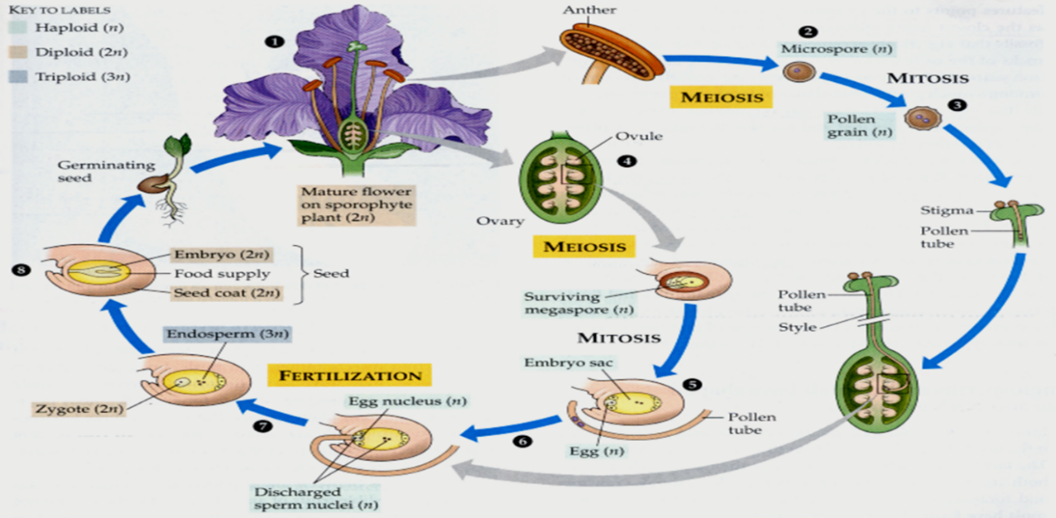

**Figure 1:** Complete life cycle of angiosperm and possible ways of isolating haploid plants from it. (lifeofplant.blogspot.com)

**Figure 2:** Haploid induction methods

Hybrid maize cultivars are popular because they offer high and stable yields. However, producing homozygous inbred lines to serve as parents for these hybrids through traditional breeding methods can take six to eight generations before the full advantages of heterosis are realized ([Hallauer et al., 2010](https://www.frontiersin.org/journals/plant-science/articles/10.3389/fpls.2024.1378421/full#B74)). Doubled haploid technology accelerates the breeding process by producing completely homozygous inbred lines in just two generations. This not only increases genetic gain over a shorter period but also facilitates compliance with varietal registration standards such as distinctness, uniformity, and stability ([Geiger and Gordillo, 2009](https://www.frontiersin.org/journals/plant-science/articles/10.3389/fpls.2024.1378421/full#B66)).

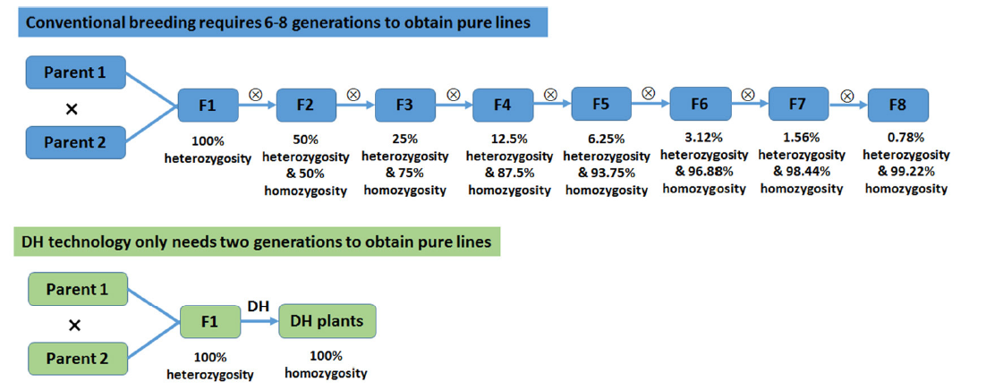

**Figure 3:** A comparison between traditional and DH method of developing inbreds in maize (Yan et al., 2017).

**Genetic gain in DH lines**

As outlined in the breeder’s equation (Falconer and Mackay, 1996), the time required for inbreeding (Y) is a key factor in the denominator. By significantly shortening this period, DH technology enhances the rate of genetic gain over time (Rt). Furthermore, the fully homozygous nature of DH lines enables more accurate phenotyping, eliminating the residual heterozygosity often found in inbreds developed through repeated selfing. This leads to more accurate gene-trait associations in genetic mapping and functional genomics studies. Additionally, due to their genetic uniformity and stability, DH lines are highly suitable for variety registration and protection, as they fully meet the DUS guidelines. It streamlines logistics such as seed shipment, inventory management, nursery planting, selfing, and line maintenance, making the entire process more efficient. As a result, developing new breeding lines requires less time, labor, and financial investment. The resources saved through this efficiency can then be redirected toward more effective selection and the faster release of elite varieties (Prasanna, 2012). DH technology is also applied in reverse breeding, enabling the recreation of the original parental lines from an elite segregating hybrid, allowing the same hybrid combination to be reproduced consistently as needed (Dirks *et al*., 2009). DuPont Pioneer reported that, using DH technology, they were able to develop more DH lines in a single year than the total number of inbred lines produced through conventional breeding over the previous 80 years (Maqbool et al., 2020).

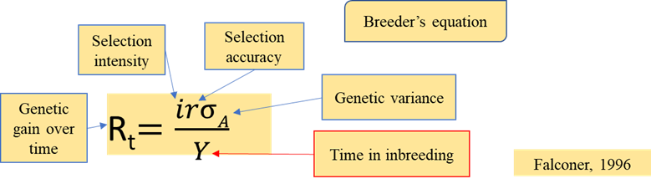

Image 1: Genetic gain in DH lines

**Haploid inducer:**

Haploid inducers are special genetic stocks used to trigger the formation of haploid embryos, which contain only a single set of chromosomes after crossing with diploid parent. The ancestral maternal haploid inducer line, Stock 6, was reported to induce haploids at about 3% when used as the male parent (Coe, 1959). Modern inducer lines derived from Stock 6 have since enhanced the haploid induction rate (HIR) to nearly 15% (Uliana Trentin et al., 2020).

Identification of true haploid seeds from a mixture that includes haploids (H), diploids (D), outcrossed (OC), and embryo-aborted (EmA) seeds is one of the most critical steps. Post treatment of seeds with colchicine significant proportional of plant loss. Several reports revealed that only 0.89% of the treated haploids were successfully converted into DH lines. This significant loss may be attributed to several factors, with the most critical being the toxic effects of colchicine. According to Battistelli et al. (2013), only 62% of plants survived colchicine treatment. Furthermore, the surviving plants frequently exhibited twisted leaves and stunted growth during the initial stages of development. The efficiency of chromosome duplication using colchicine was reported to range between 59.1% and 80%. Sectorial diploidization is also a significant cause of failure in converting haploids to doubled haploids. In this process, diploidization within the tassel is uneven—some tassels may undergo complete diploidization and exhibit full fertility, while others show only partial diploidization, resulting in limited fertile branches. In many instances, diploidization fails entirely in the tassel tissue, leading to complete sterility of the resulting plants.

**Table 1:** Types of haploid inducer with its characteristic features

|  |  |  |  |  |
| --- | --- | --- | --- | --- |
| **Inducer** | **Product** | **Cytoplasm** | **Chromosomes** | **Characteristics** |
| **Maternal inducer (used as male)**  (Coe, 1959) | Maternal haploids | **Source (Female)** | Source (Female) | * Widely used for haploids development |
| **Paternal inducer (used as female)**  (Kermicle, 1969) | Paternal haploids | **Inducer (Female)** | Source (Male) | * Used for conversion of an inbred line to its cytoplasmic male sterile form |

As breeders need to develop and evaluate thousands of lines in a breeding program, a large number of unique induction crosses are required to generate sufficient haploid seeds. Assuming a haploid induction rate (HIR) of 10%, ten times more seeds must be produced and evaluated to obtain the desired number of haploids. This results in an extremely large number of seeds needing to be screened. However, growing all these seeds in nurseries or fields for chromosome doubling is not economically viable due to the high costs of doubling treatments, labor, and limited field space. Therefore, accurately identifying haploid seeds at the seed stage is essential to improve efficiency and reduce resource use. Another key reason is that chromosome doubling is more effective when performed at the seedling stage (Prasanna, 2012). Several methods for identifying haploid seeds from induction cross seeds exist, and these will be discussed further.

**Haploid identification in Maize**

**Morphological traits**

**Purple stem and sheath**

It is a morphological marker to identify the haploids among the diploids in maize. Purple coloration on the stem and sheath tissues is controlled by the dominant genes *Pl1* (purple1) and *B1* (booster1). The *Pl1* gene triggers pigmentation independent of sunlight, while *B1* enhances this coloration in response to sunlight (Rotarenco et al., 2010). Integration of this trait into the haploid inducer line allows for the identification of haploid plants by the absence of purple pigmentation on the stem and sheath, while diploid plants show purple coloration. Although this method is effective for distinguishing haploids, it requires all plants, including diploids, to be grown to the seedling or mature stage. This requirement poses a limitation for its use in large-scale breeding programs.

**Root colour**

Red root color is another useful morphological marker for identifying haploids. Since it follows a dominant inheritance pattern, it can be integrated into haploid inducer lines and used for haploid screening (Chaikam et al., 2016). Haploids are identified at the seed germination stage by the absence of red root coloration (Figure 4), making this method practical for large-scale breeding programs, as it avoids the need to grow all plants to maturity. However, the trait can lead to some false positives where diploids mistakenly identified as haploids mainly due to delayed germination or poor growth of diploids affected by ear rot fungi (Chaikam et al., 2016).

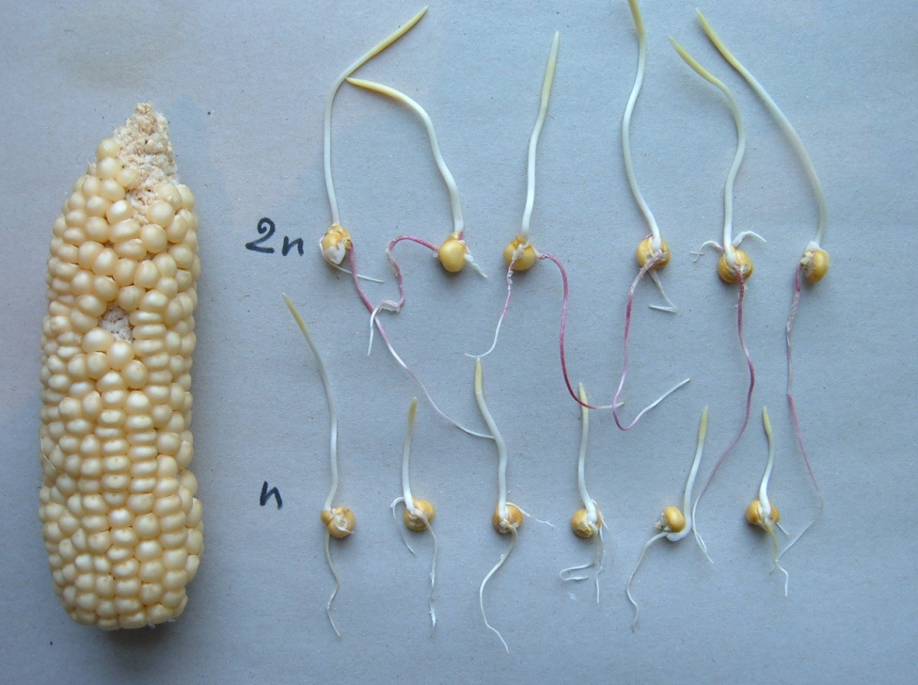

**Figure 4:** Red root marker based haploid identification (Rotarenco et al., 2010)

**Liguleless marker**

The liguleless (lglg) trait is a recessive mutation that leads to the absence of a ligule at the base of the leaf, resulting in a more upright leaf posture compared to liguled plants (LgLg) (Prigge et al., 2011). This phenotype can be accurately identified at the 3–4 leaf seedling stage. Haploids (lg) exhibit the liguleless trait, while diploids display the normal liguled phenotype (Cengiz and Esmeray, 2021) (Figure 5). However, because it is a recessive trait, it must be present in the source germplasm—something generally lacking in breeding materials. This limits its applicability in practical doubled haploid (DH) breeding programs. Still, it can be effectively used in research settings as a tester line to evaluate the haploid induction rate (HIR) of new inducer lines.

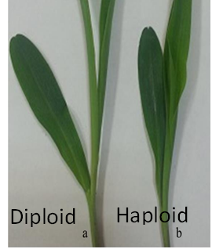

**Figure 5:** Liguleless marker for identification of haploids at seedling stage (a) liguled diplod (b) liguleless haploid (Cengiz and Esmeray, 2021)

**Glossy marker**

The glossy leaf trait is a recessive marker that causes plants to retain water droplets on the leaf surface when sprinkled, unlike non-glossy plants that shed water completely (Chaikam and Prasanna, 2020). This trait results from the absence or reduced presence of wax bodies on the leaf surface (Bianchi and Marchesi, 1960), while non-glossy plants exhibit prominent wax deposits (Figure 6). At the 3–4 leaf seedling stage, haploids (gl) can be identified by their glossy phenotype, whereas diploids (Glgl) display a non-glossy appearance (Figure 6). However, like the liguleless marker, the recessive nature of this trait requires its presence in the source germplasm, limiting its application in routine doubled haploid (DH) breeding programs.

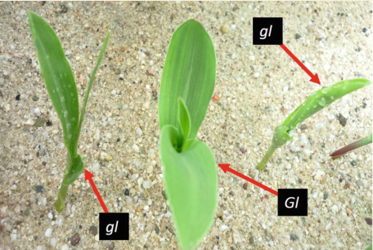

**Figure 6:**  Glossy marker based haploid identification (Chaikam and Prasanna, 2020)

**Seedling traits**

Haploid seedlings typically have shorter coleoptile length (CL), shorter radicle length (RL), and fewer lateral seminal roots (NLSR) compared to diploid seedlings Baleroni et al. (2021) (Figure 7). These differences were more noticeable and easier to detect at temperatures between 25°C and 30°C, regardless of the maize cultivar used. Similar observations were also reported by Chaikam et al. (2017). The false discovery rate (FDR) for the Navajo marker alone was approximately 26.9%, while the FDR using seedling traits was around 25.2%. When both markers were combined, the FDR was significantly reduced to 9.4%, representing a 3.5-fold improvement in identification accuracy.

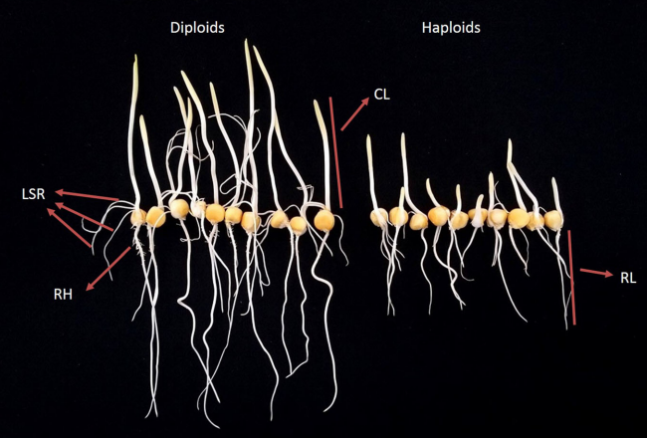

**Figure 7:** seedling traits. Radicle length (RL), Coleoptile length (CL), Number of lateral seminal roots (LSR) (Chaikam et al., 2017)

**Leaf width and anther size**

Haploids exhibit noticeably narrower leaves and smaller anthers compared to diploids (Figure 8) (Lin et al., 2018). Although these traits can be used to identify haploid plants, they are only observable at the adult stage, which limits their usefulness in doubled haploid breeding programs

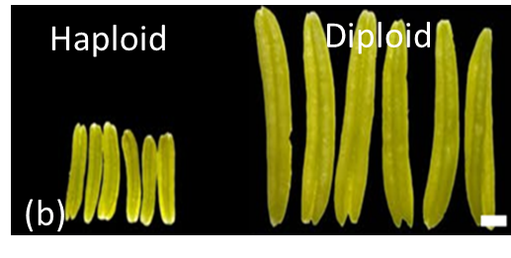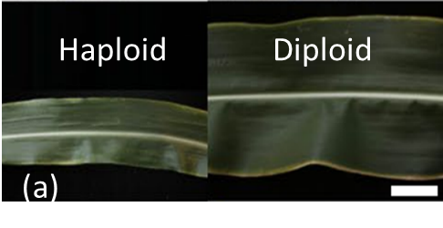

**Figure 8:** (a) leaf width (haploid-left; diploid-right) (b) anther size (haploid-left; diploid-right) (Lin *et al.*, 2018)

***R1-navajo* anthocyanin kernel marker**

Most haploid inducer lines carry the R1-navajo (R1-nj) allele, a dominant form of the R1 gene that is monogenic (Nanda and Chase, 1966) and exhibits additive inheritance (Dermail et al., 2023). The R1-nj marker produces purple pigmentation in the aleurone layer and the scutellum of the seed. After maternal haploid induction, seeds are initially screened based on this anthocyanin marker. Purple coloration in the aleurone layer confirms successful fertilization by the inducer line. However, to distinguish haploid seeds from diploids, further observation of the scutellum is required. Haploid kernels show a colorless embryo with purple pigmentation restricted to the crown of the endosperm (Chaikam et al., 2015). Haploid kernels are characterized by a triploid endosperm and a haploid embryo, whereas diploid kernels exhibit purple pigmentation in both the embryo and endosperm, containing a triploid endosperm and a diploid embryo (De La Fuente et al., 2017). The visual selection enabled by the R1-nj marker is practical and user-friendly, as it does not require advanced equipment. Moreover, this method is non-destructive and can be carried out at the seed stage, offering flexibility in scheduling haploid selection and subsequent genome doubling. Due to these benefits, the R1-nj marker remains the most commonly used approach for haploid identification.

The reliability of haploid kernel selection using the R1-nj marker can be affected by several factors such as (a) the presence of dominant anthocyanin inhibitor genes such as *c1-I*, *c2-Idf*, and *in1-D* (Khulbe et al., 2022) (b) donor germplasm that naturally expresses anthocyanin in the aleurone layer (c) physical characteristics of the seed and (d) environmental conditions that influence anthocyanin expression (Prigge et al., 2011; Trentin et al., 2022). Dominant anthocyanin inhibitor genes such as *C1-I*, *C2-Idf*, and *In1-D* are known to suppress the expression of the R1-nj marker (Coe et al., 1988; Stinard and Sachs, 2002). Among these, *C1-I* has been widely reported to inhibit R1-nj activity in tropical maize germplasm, with suppression observed in approximately 25%–30% of lines. The extent of inhibition varies, ranging from partial to complete suppression (Prigge et al., 2011; Chaikam et al., 2015).

**Kernel oil content**

Kernel oil content (KOC) marker system was developed to differentiate diploid and haploid kernels by leveraging the xenia effect (Alexander and Lambert, 1968; Chen and Song, 2003). When pollen from high-oil inducer lines fertilizes the egg, viable diploid seeds exhibit increased KOC. In contrast, haploid seeds resulting from single fertilization or male genome elimination after fertilization show low or similar KOC levels compared to the source germplasm. The kernel oil content marker system offers two main benefits compared to the R1-nj system: (1) it allows adjustable oil content thresholds to optimize the balance between false discovery rate (FDR) and false negative rate (FNR), and (2) it reduces time and labor by enabling automated haploid sorting techniques, such as nuclear magnetic resonance (NMR) (Dong et al., 2014). The KOC system has certain drawbacks. Environmental conditions and measurement inaccuracies often lead to considerable variation and overlapping kernel oil content between diploid and haploid seeds (Melchinger et al., 2014). Furthermore, donor and xenia effects slow the breeding of high-oil inducer lines, making it advisable to use at least two different testers to reliably evaluate the haploid induction rate of inducer lines (Dong et al., 2014).

**Fluorescence protein**

A well-known example of a transgenic approach is the use of green fluorescent protein (GFP), originally isolated from the jellyfish *Aequorea victoria*, which emits bright green fluorescence under UV light (Shimomura et al., 1962). Yu and Birchler (2016) developed the RWS-GFP haploid inducer system, employing GFP as a dominant marker for haploid selection in sweet maize. In this system, a homozygous GFP transgene is introduced into the RWS haploid inducer line, allowing early identification of haploids by detecting GFP expression in germinated kernels using a fluorescence microscope. Diploid seedlings display GFP fluorescence in their radicles and coleoptiles, whereas haploids do not (Yu and Birchler, 2016) (Figure 9). This method is particularly useful in genetic backgrounds lacking reliable markers like R1-nj, such as sweet maize. However, the system can produce false positives, occasionally misclassifying diploids or aneuploids as haploids.

Transgenic methods using fluorescent proteins are highly effective and compatible with genome-editing platforms. However, their adoption remains limited due to GMO regulatory restrictions. Importantly, haploids derived from transgenic inducers are transgene-free. Dong et al. (2018) and Wang et al. (2019) demonstrated through Basta resistance screening that all genome-edited haploids lacked the Cas9 transgene. This is because the paternal genome carrying the transgene is eliminated during early embryo development. Despite this, fragments of inducer chromosomes have occasionally been detected in haploids, as confirmed by morphological and molecular evidence. A small number of haploid kernels have shown weak purple pigmentation in the embryo scutellum, elevated kernel oil content (KOC), and retained approximately 1.84% of the paternal genome from the CAUHOI inducer line (Li et al., 2009). These observations suggest that although the transmission of inducer transgenes to haploid offspring is rare, it is possible. Even this low probability is enough for regulatory agencies to classify such haploids as genetically modified, preventing their acceptance as non-GMO.

**Flow cytometry**

Most common method in scientific studies for determining ploidies is flow cytometry. It determines the ploidy of the sample based on DNA content and ultimately producing different G1 peaks. Flow cytometry (FC) is widely recognized for its effectiveness in plant research due to several key advantages. It offers a fast and precise method for determining ploidy levels in early plant development, requiring only 3.5 minutes per sample (De Laat et al., 1987; Molenaar et al., 2019). FC is highly sensitive to DNA content variations, making it ideal for distinguishing among haploid, diploid, mixoploid, aneuploid, and polyploid individuals in maize (Rayburn et al., 1989; Cousin et al., 2009; Rádi et al., 2020; Jiang et al., 2021). Moreover, it can measure nuclear DNA content across species (Galbraith et al., 1983), estimate genome size (Yanpaisan et al., 1999), and detect generative polyploidy and endopolyploidy. These capabilities have established FC as the gold standard for confirming true haploids and quantifying false positive rates in maize (Melchinger et al., 2016).

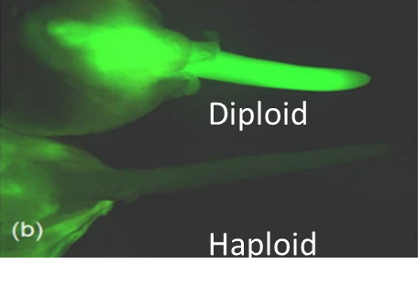

**Figure 9:** Green fluorescence for identification of haploids

In maize, flow cytometry (FC) is well-suited for ploidy determination in samples obtained through both *in vitro* microspore culture and *in vivo* haploid induction. In *in vivo* methods, nuclei are usually extracted from meristematic tissues such as young leaves (Molenaar et al., 2019; Baleroni et al., 2021) or root tips (Rádi et al., 2020). For *in vitro* systems, nuclei are typically sourced from callus tissues (Wan et al., 1991) or young plantlets (Ismaili and Mohammadi, 2016).

**Molecular markers**

DNA molecular markers are classified into two groups: dominant markers, such as random amplified polymorphic DNA (RAPD) and amplified fragment length polymorphism (AFLP), and codominant markers, including simple sequence repeats (SSR) and single nucleotide polymorphisms (SNP). Codominant markers are favored because they allow differentiation between heterozygous F1 diploids and homozygous donor females, enabling precise identification of haploids and diploids. Polymorphic SSR markers can differentiate homozygous from heterozygous alleles in progeny by detecting variations in band size. Haploids carry a single band inherited from the maternal donor, while diploids show bands from both the maternal donor and the paternal inducer, indicating heterozygosity.

Single nucleotide polymorphisms (SNPs) are variations at a single base pair in the genome that differ between individuals. They are abundant, evenly distributed, easily automated, and more stable than markers like simple sequence repeats (SSRs). Before using SNP genotyping for haploid identification, it is important to eliminate non-polymorphic markers. For instance, Zhao et al. (2013) screened 50,904 SNPs with the Illumina MaizeSNP50 chip and found fewer than 40% were polymorphic between the donor line Z58 and the inducers CAU5 and CAUHOI. Kelliher et al. (2017) employed TaqMan zygosity assays to detect the wild-type *MTL* and mutant *mtl* alleles, revealing that haploids carry two copies of the maternal *MTL* allele and no copies of the *mtl* allele, while diploids have one copy of each.

**Advanced methods of haploid identification**

**Hyperspectral imaging**

Hyperspectral imaging utilizes hundreds to thousands of narrow wavelength bands to capture high-resolution images. By covering a broad and continuous spectrum, it produces images with seamless pixels and no gaps. This technology can extract detailed information about color, morphology, texture, and chemical composition of samples, including maize kernels. Wang et al. (2018) demonstrated its effectiveness in distinguishing haploid from diploid maize seeds. The system uses a spectral camera that combines the Imspector imaging spectrometer series with a CCD camera. Images are captured using SpecView software, and features are extracted through MATLAB. To test its classification ability, the reflectance spectra of the non-embryo side of seeds were also analyzed, revealing significant differences between haploid and diploid seeds. When data from both the embryo and non-embryo sides were combined in a joint model, the classification accuracy exceeded 98%.

**VideometerLab3 spectral imaging system**

Human eyes can only perceive wavelengths between 280 nm and 780 nm, limiting the efficiency and speed of seed screening based on R1-nj embryo pigmentation. The VideometerLab3 spectral imaging system addresses this limitation by capturing high-resolution images that integrate reflectance from 19 different wavelengths across the ultraviolet (UV), visible, and near-infrared (NIR) spectra—extending beyond human visual capacity (de La Fuente et al., 2017). Each pixel in these images contains spectral information covering this wide range. The system produces 19 reflectance wavelengths and 60 excitation-emission combinations using four different cutoff filters. Using built-in software, seed images are segmented into binary-labeled objects to differentiate seeds from the background. By labeling the embryo and non-embryo regions of haploid and diploid seeds, a classification model is created to distinguish between them. It is necessary to develop a separate model for each induction cross to accurately sort seeds from that specific cross (de La Fuente et al., 2017).

This sorting method has the advantage of being non-destructive and makes use of the existing R1-nj classification system, avoiding the need for new optical sensors or software development. However, it requires seeds to be positioned with the embryo facing upward during imaging, which poses challenges for round or flattened seeds. In medium-scale breeding programs, where breeders may produce 50 to 200 unique F1 crosses, creating a separate model for each cross is a demanding process. Additionally, the study noted that seeds that are difficult to classify visually often need to be run through the system multiple times to ensure accurate sorting (de La Fuente et al., 2017).

**Conclusions and future prospects**

Doubled Haploid lines are routinely applied in many commercial hybrid maize breeding programs. Detection of haploid plants is one of the critical steps in doubled haploid breeding as it contributes to greater success in efficient production of inbreds. A range of tools, from manual cytological and morphological markers to high-throughput imaging, aid haploid identification in maize, each serving distinct roles in selection. Natural differences between haploids and diploids, along with heterosis, assist rouging in nurseries. Cytological and molecular markers are gold standards for verification after initial biomarker-based screening. Visual selection using biomarkers integrated into haploid inducers is practical, but markers like R1-nj, Pl-1, and kernel oil content may fail if the source germplasm carries similar traits. Therefore, haploid inducers should possess multiple distinct markers in kernels, stems, roots, and oil content to ensure compatibility across diverse germplasm. Enhancing efficiency in haploid identification can greatly increase doubled haploid line development while reducing the cost per line, making DH technology practical for maize breeding programs worldwide, including in tropical regions.

Disclaimer (Artificial intelligence)

Author(s) hereby declares that NO generative AI technologies such as Large Language Models, etc. have been used during the writing or editing of manuscripts

**References:**

Alexander, D.E. and Lambert, R.J., 1968. Relationship of Kernel Oil Content to Yield in Maize. *Crop Science*, *8*(3), pp.273-274.

Baleroni, A.G., Ré, F., Pelozo, A., Kamphorst, S.H., Carneiro, J.W.P., Rossi, R.M. and Scapim, C.A., 2021. Identification of haploids and diploids in maize using seedling traits and flow cytometry. *Crop Breeding and Applied Biotechnology*, *21*(4), p.e38422145.

Battistelli, G.M., Von Pinho, R.G., Justus, A., Couto, E.G.O. and Balestre, M., 2013. Production and identification of doubled haploids in tropical maize. *Genetics and Molecular Research*, *12*(4), pp.4230-4242.

Cengiz, R. and Esmeray, M., 2021. Development of late temperate in vivo haploid inducers. *Genetika*, *53*(1), pp.51-64.

Chaikam, V. and Prasanna, B.M., 2020. Doubled haploid technology for rapid and efficient maize breeding. In *Accelerated Plant Breeding, Volume 1: Cereal Crops* (pp. 257-292). Cham: Springer International Publishing.

Chaikam, V., Lopez, L.A., Martinez, L., Burgueño, J. and Boddupalli, P.M., 2017. Identification of in vivo induced maternal haploids in maize using seedling traits. *Euphytica*, *213*(8), p.177.

Chaikam, V., Martinez, L., Melchinger, A.E., Schipprack, W. and Boddupalli, P.M., 2016. Development and validation of red root marker‐based haploid inducers in maize. *Crop Science*, *56*(4), pp.1678-1688.

Chaikam, V., Nair, S.K., Babu, R., Martinez, L., Tejomurtula, J. and Boddupalli, P.M., 2015. Analysis of effectiveness of R1-nj anthocyanin marker for in vivo haploid identification in maize and molecular markers for predicting the inhibition of R1-nj expression. *Theoretical and applied genetics*, *128*(1), pp.159-171.

Cheng, J.H., Dai, Q., Sun, D.W., Zeng, X.A., Liu, D. and Pu, H.B., 2013. Applications of non-destructive spectroscopic techniques for fish quality and safety evaluation and inspection. *Trends in food science & technology*, *34*(1), pp.18-31.

Coe Jr, E.H., Neuffer, M.G. and Hoisington, D.A., 1988. The genetics of corn. *Corn and corn improvement*, *18*, pp.81-258.

Coe, E.H., 1959, A line of maize with high haploid frequency. *Am. Nat*., **93**:381–382.

Cousin, A., Heel, K., Cowling, W.A. and Nelson, M.N., 2009. An efficient high‐throughput flow cytometric method for estimating DNA ploidy level in plants. *Cytometry Part A: The Journal of the International Society for Advancement of Cytometry*, *75*(12), pp.1015-1019.

De La Fuente, G.N., Carstensen, J.M., Edberg, M.A. and Lü bberstedt, T., 2017. Discrimination of haploid and diploid maize kernels via multispectral imaging. *Plant Breeding*, *136*(1), pp.50-60.

De La Fuente, G.N., Carstensen, J.M., Edberg, M.A. and Lü bberstedt, T., 2017. Discrimination of haploid and diploid maize kernels via multispectral imaging. *Plant Breeding*, *136*(1), pp.50-60.

De Laat, A.M.M., Verhoeven, H.A., Sree Ramulu, K. and Dijkhuis, P., 1987. Efficient induction by amiprophos-methyl and flow-cytometric sorting of micronuclei in Nicotiana plumbaginifolia. *Planta*, *172*(4), pp.473-478.

Dermail, A., Lübberstedt, T., Suwarno, W.B., Chankaew, S., Lertrat, K., Ruanjaichon, V. and Suriharn, K., 2023. Combining ability of tropical× temperate maize inducers for haploid induction rate, R1-nj seed set, and agronomic traits. *Frontiers in Plant Science*, *14*, p.1154905.

Dirks, R., Van Dun, K., De Snoo, C.B., Van Den Berg, M., Lelivelt, C.L., Voermans, W., Woudenberg, L., De Wit, J.P., Reinink, K., Schut, J.W. and Van Der Zeeuw, E., 2009. Reverse breeding: a novel breeding approach based on engineered meiosis. *Plant biotechnology journal*, *7*(9), pp.837-845.

Dong, D., Nagasubramanian, K., Wang, R., Frei, U.K., Jubery, T.Z., Lübberstedt, T. and Ganapathy subramanian, B., 2023. Self-supervised maize kernel classification and segmentation for embryo identification. *Frontiers in Plant Science*, *14*, p.1108355.

Dong, X., Xu, X., Li, L., Liu, C., Tian, X., Li, W. and Chen, S., 2014. Marker-assisted selection and evaluation of high oil in vivo haploid inducers in maize. *Molecular Breeding*, *34*(3), pp.1147-1158.

Falconer, D.S., Mackay, T.F. and Frankham, R., 1996. Introduction to quantitative genetics (4th edn). *Trends in Genetics*, *12*(7), p.280.

Galbraith, D.W., Harkins, K.R., Maddox, J.M., Ayres, N.M., Sharma, D.P. and Firoozabady, E., 1983. Rapid flow cytometric analysis of the cell cycle in intact plant tissues. *Science*, *220*(4601), pp.1049-1051.

Geiger, H.H. and Gordillo, G.A., 2009. Doubled haploids in hybrid maize breeding. *Maydica*, *54*(4), p.485.

Hallauer, A.R., Carena, M.J. and Miranda Filho, J.D., 2010. *Quantitative genetics in maize breeding* (Vol. 6). Springer Science & Business Media.

Ismaili, A. and Mohammadi, P.P., 2016. Effect of genotype, induction medium, carbohydrate source, and polyethylene glycol on embryogenesis in maize (*Zea mays* L.) anther culture. *Acta Physiologiae Plantarum*, *38*(3), p.74.

Jiang, L., Jin, G., Chen, D., Yu, X., Yu, H. and Li, J., 2021. Natural restoration and diploidization of haploids in maize. *Agronomy Journal*, *113*(2), pp.711-720.

Kelliher, T., Starr, D., Richbourg, L., Chintamanani, S., Delzer, B., Nuccio, M.L., Green, J., Chen, Z., McCuiston, J., Wang, W. and Liebler, T., 2017. MATRILINEAL, a sperm-specific phospholipase, triggers maize haploid induction. *Nature*, *542*(7639), pp.105-109.

Kermicle, J.L., 1969, Androgenesis conditioned by a mutation in maize. *Science*, **166**:1422–1424.

Khulbe, R.K., Pattanayak, A., Panday, V. and Sharma, D., 2022. Use of kernel dorsal basal pigmentation in the absence of crown pigmentation for haploid classification in maize using R1-nj-based haploid inducers. *Cereal Research Communications*, *50*(4), pp.1165-1171.

Li, L., Xu, X., Jin, W. and Chen, S., 2009. Morphological and molecular evidences for DNA introgression in haploid induction via a high oil inducer CAUHOI in maize. *Planta*, *230*(2), pp.367-376.

Lin, J., Yu, L., Li, W. and Qin, H., 2018. Method for identifying maize haploid seeds by applying diffuse transmission near-infrared spectroscopy. *Applied Spectroscopy*, *72*(4), pp.611-617.

Maqbool, M.A., Beshir, A. and Khokhar, E.S., 2020. Doubled haploids in maize: Development, deployment, and challenges. *Crop Science*, *60*(6), pp.2815-2840.

Melchinger, A.E., Brauner, P.C., Böhm, J. and Schipprack, W., 2016. In vivo haploid induction in maize: comparison of different testing regimes for measuring haploid induction rates. *Crop Science*, *56*(3), pp.1127-1135.

Melchinger, A.E., Schipprack, W., Friedrich Utz, H. and Mirdita, V., 2014. In vivo haploid induction in maize: identification of haploid seeds by their oil content. *Crop Science*, *54*(4), pp.1497-1504.

Molenaar, W.S., de Oliveira Couto, E.G., Piepho, H.P. and Melchinger, A.E., 2019. Early diagnosis of ploidy status in doubled haploid production of maize by stomata length and flow cytometry measurements. *Plant Breeding*, *138*(3), pp.266-276.

Nanda, D.K. and Chase, S.S., 1966. An embryo marker for detecting monoploids of maize (*Zea mays* L.) 1. *Crop Science*, *6*(2), pp.213-215.

Prasanna, B.M., Chaikam, V. and Mahuku, G., 2012. Doubled haploid technology in maize breeding: an overview. *Doubled Haploid Technology in Maize Breeding: Theory and Practice. BM Prasanna, V. Chaikam and G. Mahuku (eds). CIMMYT. México, DF pp*, pp.1-8.

Prigge, V., Sánchez, C., Dhillon, B.S., Schipprack, W., Araus, J.L., Bänziger, M. and Melchinger, A.E., 2011. Doubled haploids in tropical maize: I. Effects of inducers and source germplasm on in vivo haploid induction rates. *Crop science*, *51*(4), pp.1498-1506.

Rádi, F., Török, K., Nagymihály, M., Kereszt, A. and Dudits, D., 2020. Improved reliability in production of maize inbred lines by the combination of the R1-navajo marker with flow cytometry or microsatellite genotyping. *Cereal Research Communications*, *48*(4), pp.423-430.

Rayburn, A.L., Auger, J.A., Benzinger, E.A. and Hepburn, A.G., 1989. Detection of intraspecific DNA content variation in *Zea mays* L. by flow cytometry. *Journal of experimental botany*, *40*(11), pp.1179-1183.

Rotarenco, V., Dicu, G., State, D. and Fuia, S., 2010. New inducers of maternal haploids in maize.

Shimomura, O., Johnson, F.H. and Saiga, Y., 1962. Extraction, purification and properties of aequorin, a bioluminescent protein from the luminous hydromedusan, Aequorea. *Journal of cellular and comparative physiology*, *59*(3), pp.223-239.

Stinard, P.S. and Sachs, M.M., 2002. The identification and characterization of two dominant r1 haplotype-specific inhibitors of aleurone color in *Zea mays*. *Journal of Heredity*, *93*(6), pp.421-428.

Trentin, H. U., Frei, U. K., Lübberstedt, T. (2020). Breeding maize maternal haploid inducers. *Plants* 9, 614

Uliana Trentin, H., Batîru, G., Frei, U.K., Dutta, S. and Lübberstedt, T., 2022. Investigating the effect of the interaction of maize inducer and donor backgrounds on haploid induction rates. *Plants*, *11*(12), p.1527.

Uliana Trentin, H., Frei, U.K. and Lübberstedt, T., 2020. Breeding maize maternal haploid inducers. *Plants*, *9*(5), p.614.

Wan, Y., Duncan, D.R., Rayburn, A.L., Petolino, J.F. and Widholm, J.M., 1991. The use of antimicrotubule herbicides for the production of doubled haploid plants from anther-derived maize callus. *Theoretical and applied Genetics*, *81*(2), pp.205-211.

Wang, B., Zhu, L., Zhao, B., Zhao, Y., Xie, Y., Zheng, Z., Li, Y., Sun, J. and Wang, H., 2019. Development of a haploid-inducer mediated genome editing system for accelerating maize breeding. *Molecular plant*, *12*(4), pp.597-602.

Wang, Y., Lv, Y., Liu, H., Wei, Y., Zhang, J., An, D. and Wu, J., 2018. Identification of maize haploid kernels based on hyperspectral imaging technology. *Computers and Electronics in Agriculture*, *153*, pp.188-195.

Yan, G., Liu, H., Wang, H., Lu, Z., Wang, Y., Mullan, D., Hamblin, J. and Liu, C., 2017. Accelerated generation of selfed pure line plants for gene identification and crop breeding. *Frontiers in plant science*, *8*, p.1786.

Yanpaisan, W., King, N.J. and Doran, P.M., 1999. Flow cytometry of plant cells with applications in large-scale bioprocessing. *Biotechnology advances*, *17*(1), pp.3-27.

Yu, W. and Birchler, J.A., 2016. A green fluorescent protein-engineered haploid inducer line facilitates haploid mutant screens and doubled haploid breeding in maize. *Molecular Breeding*, *36*(1), p.5.

Zhong, Y., Liu, C., Qi, X., Jiao, Y., Wang, D., Wang, Y., Liu, Z., Chen, C., Chen, B., Tian, X. and Li, J., 2019. Mutation of ZmDMP enhances haploid induction in maize. *Nature plants*, *5*(6), pp.575-580.