**Exploring Linseed (*Linum usitatissimum* L.) Germplasm Diversity through Morphological, Biochemical, and Molecular Markers**

**ABSTRACT**

The study focused on the characterization of 18 linseed (*Linum usitatissimum* L.) germplasms to evaluate genetic diversity through morphological, biochemical, and molecular markers. Germplasm characterization is essential for identifying valuable traits and facilitating the development of effective breeding programs. Significant variation was observed among the eighteen genotypes for agro-morphological traits. Similarity coefficients ranged from 0.00 (indicating complete dissimilarity) to 0.78, with GP-381 – R-4237, GP-208 – R-4253, and others being the most dissimilar. Days to first flowering ranged between 38.5 days (R-4218) and 41.5 days (GP-405), with an average of 39.41 days. GP-208 showed the earliest 50% flowering (51.5 days), while GP-345 was the latest (56.5 days). Capsule production varied from 14 (R-4237) to 23 (GP-208), with a mean of 16.75 per plant. Plant height ranged between 48.16 cm (GP-381) and 72.12 cm (R-4266), with a mean height of 56.71 cm. The number of seeds per capsule ranged from 4.5 (R-4218) to 12 (GP-208), with a mean of 7.22. The 1000 seed weight ranged between 4.72 g (R-4253) and 6.97 g (R-4237, R-4275). Primary branches varied from 3.5 (GP-345) to 11 (R-4244, GP-209), with an average of 6.4. Among the 18 lines, 15 had purple flowers, while GP-433 was off-white, GP-411 had white, and GP-345 had dark purple flowers. Yield ranged from 74.7 g per plant (GP-405) to 143.75 g per plant (GP-208), with an average of 97.09 g per plant. SDS-PAGE revealed 13 protein bands, with eight being polymorphic and five monomorphic. Cluster analysis using UPGMA grouped the genotypes into two major clusters at 50% homology, indicating moderate genetic variation. ISSR markers revealed high diversity in genotypes GP-352, GP-208, and GP-473. Primers UBC-815, UBC-819, and UBC-825 showed high polymorphism and PIC values (0.41 to 0.48). SSR analysis confirmed that GP-473 and GP-208 were the most diverse. Primers LU-3, LU-6, LU-8, and LU-9 had the highest PIC values and 100% polymorphism.

*Keywords:**Linseed; agro morphological; germplasms; protein; SDS-PAGE; PIC.*

**1. INTRODUCTION**

Linseed (*Linum usitatissimum* L., 2n = 30), belonging to the family Linaceae and order Malpighiales, is one of the earliest cultivated crops, with a history spanning over 6,000-7,000 years. The genus name *Linum* originates from the word "lin" or "thread," and *usitatissimum* means "most useful" in Latin. Linseed is widely recognized for its dual purpose-used as an oilseed (flaxseed) and as a fiber crop (fiber flax) (Vaisey-Genser and Morris, 2003). Its genome size is approximately 368–373 Mb (Ragupathy et.al 2011). Flax is considered one of the top five oilseed crops globally and the third-largest source of natural fiber. It thrives in tropical and temperate climates, particularly in silt loam, clay loam, and alluvial soils with pH varying between 6 and 7 (Rai, 2012). Ideal growing regions include black soils in peninsular India and the Indo-Gangetic plains. Despite its importance, linseed is still underutilized and is cultivated in only 34 countries, with major producers including India, USA, Canada, Argentina, China, Ethiopia, and Australia (Wakjira et al., 2004; Green et al., 2008). Linseed is highly valued for its nutritional composition, especially its rich content of omega-3 and omega-6 fatty acids. Key omega-3 fatty acids like α-linolenic acid (ALA), docosahexaenoic acid (DHA), and eicosapentaenoic acid (EPA) are known for their role in reducing cardiovascular disease (Hurteau, 2004). Linseed contains about 16% ALA and 57% linoleic acid (LA), making it a rich source of essential polyunsaturated fatty acids (PUFAs) (Ganorkar and Jain, 2013).

To improve linseed cultivars, characterization of germplasm and assessment of genetic variability are essential. Though traditional breeding techniques like selection, hybridization, and introduction have been employed, modern tools such as molecular and biochemical markers are now increasingly used. Among molecular tools, the ISSR (Inter Simple Sequence Repeat) technique stands out for its simplicity, high reproducibility, and independence from prior genomic information (Wolfe and Liston, 1998). ISSR-PCR primers are effective in identifying polymorphisms across multiple loci (Zietkiewicz et al.1994). Additionally, SSR (Simple Sequence Repeat) markers, or microsatellites, offer high polymorphism, heritability, and co-dominant nature, making them ideal for marker-assisted selection (MAS) and diversity studies. These approaches have significantly contributed to the development of improved linseed cultivars (Sandip et al., 2012).

**Objectives**

1. To study linseed germplasms lines using morphological and biochemical characteristics

2. To study linseed germplasms lines at molecular level

**2. MATERIALS AND METHODS**

**2.1 Study Site and Plant Material**

The study was conducted during 2024-2025 at the Department of Plant Biotechnology, Vilasrao Deshmukh College of Agricultural Biotechnology, Latur [Vasantrao Naik Marathwada Agricultural University, Parbhani (M.S.)] The linseed germplasm used in this study was obtained through a Material Transfer Agreement from the collection maintained at Indira Gandhi Agricultural University, Raipur (C.G.). A total of 18 germplasm lines (Table 1 and Figure 1) were utilized for morphological, biochemical, and molecular analyses in this investigation.

**Table 1. List of linseed germplasms used in present investigation**

|  |  |  |  |
| --- | --- | --- | --- |
| **Sr. No.** | **Germplasms** | **Sr. No.** | **Germplasms** |
| 1. | R- 4218 | 10. | GP- 333 |
| 2. | R- 4237 | 11. | GP- 345 |
| 3. | R- 4244 | 12. | GP- 352 |
| 4. | R- 4253 | 13. | GP- 381 |
| 5. | R- 4266 | 14. | GP- 405 |
| 6. | R- 4275 | 15. | GP- 411 |
| 7. | GP-208 | 16. | GP- 418 |
| 8. | GP-209 | 17. | GP- 455 |
| 9. | GP-312 | 18. | GP- 473 |

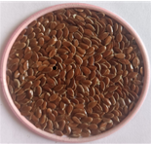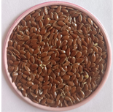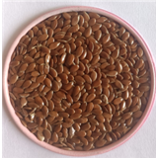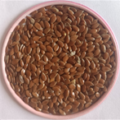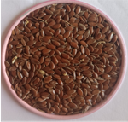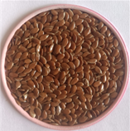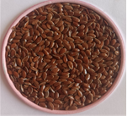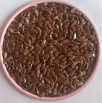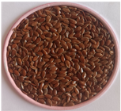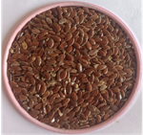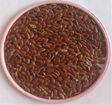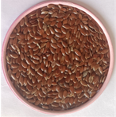

**R-4218** **R-4237**  **R-4244 R-4253**

**R-4266 R-4275 GP-208 GP-209**

**GP-312** **GP-333 GP-345 GP-352**

**GP-381 GP-405 GP-411 GP-418**

**GP-455 GP-473**

**Fig. 1. Linseed germplasm used in the present study**

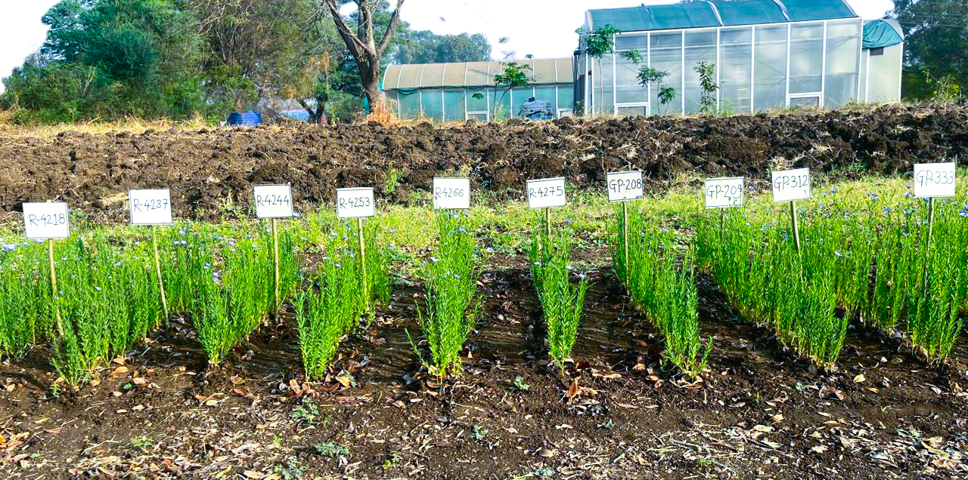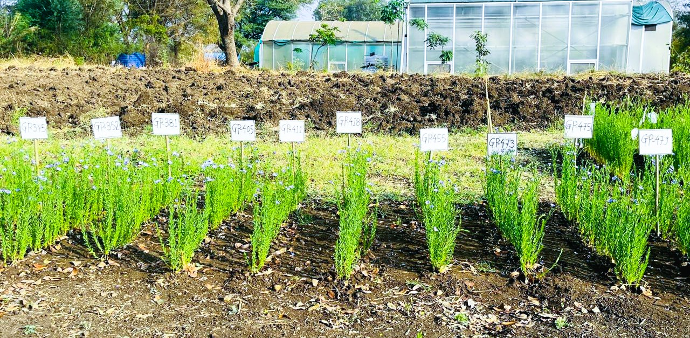

**Fig. 2. Experimental plot**

**2.2 Experimental Design and Cultivation Conditions**

A randomized block design with three replications was used for morphological characterization. The experiment was conducted in Rabi season (November to January) of 2024-2025 at Vilasrao Deshmukh College of Agricultural Biotechnology, Latur (M.S.) India, the genotypes were grown in 2m long rows with 30cm × 10cm spacing between rows and between plants, respectively. Well-drained loamy or clay-loam soil pH varying with 6-7 was used. Seeds were hand-dibbled 10cm apart within a row, and a fertilizer dose of 40 kg/ha N, 20 kg/ha P2O5 and 5 kg/ha K2O for irrigated conditions at the time of sowing. Two irrigations were carried out, at 20-30 days after sowing (first flowering) and another at 60-65 days after sowing (pod development) stage. Standard package of practices was followed to raise the good crop**.**

**2.3 Data Collection**

The analysis of variance for eight characters is displayed in Table 2 and 3. According to ANOVA, there was sufficient variability among the traits examined since the differences across treatments, or germplasm, were significant for each of the characters.

**Table 2. Variation in number of plant height at maturity, days to 1st flower, days to 50% flowering, yield per plant by DMRT (Duncan multiple range test) analysis.**

|  |  |  |  |  |  |
| --- | --- | --- | --- | --- | --- |
| **Sr.**  **No.** | **Germplasms** | **Plant Height at Maturity (cm)** | **Days to 1st flower** | **Days to 50% flowering** | **Yield Per Plant (g)** |
| 1. | R- 4218 | 52.93j | 38.5d | 55.5ab | 93.26g |
| 2. | R- 4237 | 55.16i | 38.5d | 52.5de | 86.25h |
| 3. | R- 4244 | 60.815f | 39.5bcd | 53.5cd | 96.865f |
| 4. | R- 4253 | 66c | 40abcd | 53.5cd | 66.255k |
| 5. | R- 4266 | 72.125a | 38.5d | 53.5cd | 115.815d |
| 6. | R- 4275 | 68.665b | 39.5bcd | 52.5de | 102.68e |
| 7. | GP-208 | 64.5d | 39.5bcd | 51.5e | 143.75a |
| 8. | GP-209 | 50.575k | 38.5d | 55.5ab | 120.71c |
| 9. | GP-312 | 48.5l | 39.5bcd | 54.5bc | 83.12i |
| 10. | GP- 333 | 55.7i | 38.5d | 55.5ab | 94.275g |
| 11. | GP- 345 | 48.48l | 39.5bcd | 56.5a | 75.92j |
| 12. | GP- 352 | 48.5l | 40.5abc | 53.5cd | 92.91g |
| 13. | GP- 381 | 48.165l | 39cd | 53.5cd | 120.5c |
| 14. | GP- 405 | 50.65k | 38.5d | 54.5bc | 74.7j |
| 15. | GP- 411 | 52.815j | 39.5bcd | 55.5ab | 128.75b |
| 16. | GP- 418 | 56.53h | 39.5bcd | 53.5cd | 94.215g |
| 17. | GP- 455 | 62.8e | 41.5a | 54.5bc | 74.995j |
| 18. | GP- 473 | 57.9g | 41ab | 55.5ab | 82.705i |
| CD | - | 0.77 | 1.643 | 1.459 | 2.111 |
| SE  (m) | - | 0.256 | 0.546 | 0.485 | 0.702 |
| SE  (d) | - | 0.362 | 0.772 | 0.686 | 0.992 |
| CV | - | 0.638 | 1.959 | 1.266 | 1.022 |
| CD | - | 0.77 | 1.643 | 1.459 | 2.111 |

**Table 3. Variation in number of capsules per plant, number of capsules per plant, number of primary branches per plant, 1000 Seed weight by DMRT (Duncan multiple range test) analysis**

|  |  |  |  |  |  |
| --- | --- | --- | --- | --- | --- |
| **Sr. No.** | **Germplasms** | **No. of Capsules Per Plant** | **No. of Seeds Per Capsule** | **No. of Primary branches**  **Per Plant** | **1000 seed weight (g)** |
| 1. | R- 4218 | 15bc | 4.5c | 6.5bcd | 6.36abc |
| 2. | R- 4237 | 14c | 6.5abc | 8.5abc | 6.975a |
| 3. | R- 4244 | 14.5bc | 5.5bc | 11a | 6.59ab |
| 4. | R- 4253 | 15.5bc | 7abc | 5cd | 4.72e |
| 5. | R- 4266 | 19.5ab | 6bc | 4.5d | 6.77ab |
| 6. | R- 4275 | 16bc | 6.5abc | 9.5ab | 6.97a |
| 7. | GP-208 | 23a | 12a | 5cd | 6.7ab |
| 8. | GP-209 | 19.5ab | 6bc | 11a | 5.16cde |
| 9. | GP-312 | 15.5bc | 10abc | 5cd | 5.905abcde |
| 10. | GP- 333 | 17bc | 9abc | 6bcd | 5.455bcde |
| 11. | GP- 345 | 14c | 6.5abc | 3.5d | 5.81abcde |
| 12. | GP- 352 | 17.5bc | 6.5abc | 6.5bcd | 6.14abcd |
| 13. | GP- 381 | 19.5ab | 7abc | 6bcd | 5.925abcde |
| 14. | GP- 405 | 15.5bc | 11ab | 4.5d | 5.515bcde |
| 15. | GP- 411 | 14c | 7abc | 6bcd | 5.865abcde |
| 16. | GP- 418 | 19abc | 6bc | 5cd | 5.455bcde |
| 17. | GP- 455 | 17.5bc | 6.5abc | 6bcd | 5.515bcde |
| 18. | GP- 473 | 15bc | 6.5abc | 6bcd | 4.835de |
| CD | - | 4.57 | 3.417 | 3.158 | 1.17 |
| SE (m) | - | 1.519 | 1.632 | 1.05 | 0.389 |
| SE (d) | - | 2.148 | 2.308 | 1.485 | 0.55 |
| CV | - | 12.827 | 31.957 | 23.138 | 9.286 |

**2.3.1 Morphological evaluations**

Observations were made on five plants chosen at random in every entry derived from every replication. Days to first flower, days to 50% flowering, colour of flower, plant height at maturity (cm), number of primary branches per plant, number of capsules per plant, number of seeds per capsule, 1000 seed weight (g), yield per plant (g) by Duncan multiple range test analysis. (Akbar et al., 2003).

**2.3.2 Biochemical analysis**

Using linseed flour from mature, dehulled grains, the total seed protein content was calculated according to Sardar et al. (2012). After preparing a mixture of 3 mg of flour and 100μl of extraction buffer (which included 0.1% bromophenol blue, 2.3% SDS, 5% β-mercaptoethanol, 10% glycerol, and 0.055 M Tris-HCl at pH 6.8), the mixture was heated for 10 min. After adding the freshly made protein extraction solution to each tube, a cyclo-mixer was used to thoroughly mix the mixture. The tubes were then incubated from 1 - 2 h at -20°C. The samples were centrifuged at 10,000 rpm for 5 min at 4°C after incubation. After mixing with dye, the supernatant was collected and heated in a water bath at 95°C for 5 min, yielding denatured proteins that were subsequently used for SDS-protein profiling. SDS-PAGE (Sodium Dodecyl Sulfate Polyacrylamide Gel Electrophoresis) in a discontinuous buffer system was used to analyze the extracted samples' proteins, with a 5% stacking gel and a 15% acrylamide resolving gel. After loading a 10 μL sample of extracted proteins and a protein marker, the gel was electrophoresed in Tris-glycine buffer at 30 mA for 3 h. The resulting protein banding patterns were considered the genotype's "fingerprint".

Genomic DNA was extracted from the leaves of 18 linseed genotypes following the Cetyltrimethyl Ammonium Bromide (CTAB) method with some modifications as described by Doyle and Doyle (1987).

The analysis involved the use of five SSR and six ISSR primers. 25 µL of reaction volume containing the following chemicals was used for PCR amplifications: 0.1 µmol L-1 of primer, 1x PCR buffer, 3U Taq polymerase, 25–30 ng of genomic template DNA, 2.0 mmol L-1 MgCl2, and 100 µmol L-1 of each dNTP. To enhance the findings, some modifications were made to the original program, including alterations to the annealing temperature and the number of amplification cycles. The amplification procedure involved pre-denature at 94 °C for 5 min, 45 cycles of 94 °C for 1 min, 36 °C (for ISSR analysis) or 58-60 °C (for SSR analysis) for 1 min, and 72 °C for 1 min, with a final extension at 72 °C for 10 min. The amplification results were observed using ethidium bromide-stained 1.8% (for ISSR analysis) or 2.5% (for SSR analysis) agarose gel electrophoresis. Using the 100 bp and 1000 bp DNA marker ladders, the length of each fragment (bp) in the amplified product was calculated (Rajwade et al. 2010; Soto-Cerda et al., 2011; Kale et al., 2012; Chandravati et al., 2018; Saroha et al., 2022).

**2.4 Statistical Analysis**

The Statistical analysis was carried out using Duncan multiple range test (DMRT) to compare treatment means, utilizing the OPSTAT software developed by CCS HAU, Hisar.

**3. RESULTS AND DISCUSSION**

**3.1 Morphological evaluation**

The phenotypic data has been obtained on 18 genotypes. Agro-morphological characterization was tried. The character days to first flower ranged from 38.5 days for R-4218 to 41.5 days for GP-405, with an average of 39.41 days. R-4218 flowers the earliest (38.5 days), while GP-455 had the first flower (41.5 days). The character days to 50% flowering varied from 51.5 days (GP-208) to 56.5 days (GP-345), with a mean of 54.17 days. GP-208 had the earliest 50% flowering time of any genotype (51.5 days). Among all germplasm, GP-345 showed late 50% flowering (56.5 days). (Akbar et al., 2003). The number of capsules each plant varied between 14 (R-4237) and 23 (GP-208), with an average of 16.75 capsules per plant. The shortest plant among all genotypes was GP-381 (48.16 cm), while the tallest was R-4266 (72.12 cm). The average number of seeds per capsule was 7.22, with a range of 4.5 (R-4218) to 12 (GP-208). R-4218 contained the fewest seeds (4.5 seeds per capsule), whereas GP-208 contained the most seeds (12 seeds per capsule). Across all linseed genotypes, the 1000 seed weight varied from 4.72 g (R-4253) to 6.97 g (R-4237) and (R-4275). R-4237 and R-4275 had the highest 1000 seed weight (6.97 g), while R-4253 had the lowest (4.72 g). The genotypes of linseed varied greatly in the number of primary branches per plant, with a mean of 6.4 and a range of 3.5 (GP-345) to 11 (R-4244) and (GP-209). While GP-345 had the fewest primary branches (3.5), R-4244 and GP-208 (11) had the most. The mean linseed germplasm yield was 97.09 g, with a range of 74.7 g (GP-405) to 143.75 g (GP-208) per plant. Plant yields were best for GP-208 (143.75 g) and lowest for GP-405 (74.7 g). Only one of the eighteen lines (GP-433) has an off-white flower, one (GP-411) has a white flower, and one (GP-345) has a dark purple flower. The last fifteen lines were colored purple.

**3.1.1 SIMILARITY MATRIX BASED ON MORPHOLOGICAL CHARACTERS**

Jaccard's estimates of similarity matrix were evaluated for a collection of eighteen linseed germplasms based on the morphological character score. These 18 promising linseed germplasms had an average similarity of 0.22, ranging from 0.00 to 0.78. For 18 linseed accessions, the morphological analysis showed a similarity matrix ranging from 0.00 (GP-381 - R-4237), (GP-208 - R-4253), (GP-455 - R-4275), (GP-333 - GP-208), (GP-381 - GP-208), (GP-473 - GP-208), (GP-405 - GP-352) to 0.78 (GP-312 - R-4244). Therefore, the genotypes that were most similar to one another were GP-312 and R-4237, whereas the genotypes that were the most distinct were GP-381 - R-4237, GP-208 - R-4253, GP-455 - R-4275, GP-333 - GP-208, GP-381 - GP-208, GP-473 - GP-208, and GP-405 - GP-352 (Fig. 3)

**Fig. 3. Morphological characterization based on phenotypic observations**

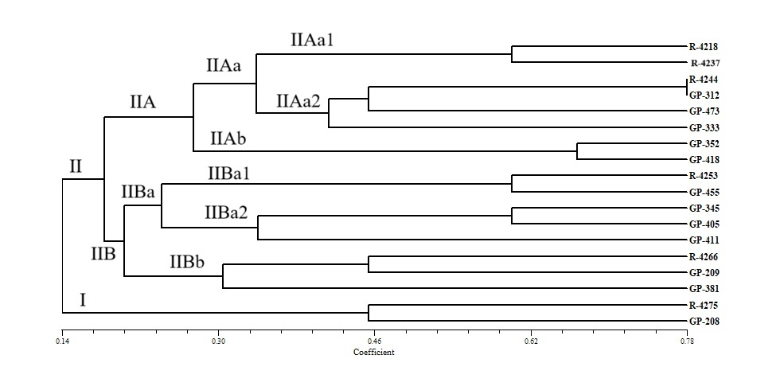**Fig. 4. Dendrogram generated by UPGMA analysis based on morphological characters**

**3.2 BIOCHEMICAL CHARACTERIZATION**

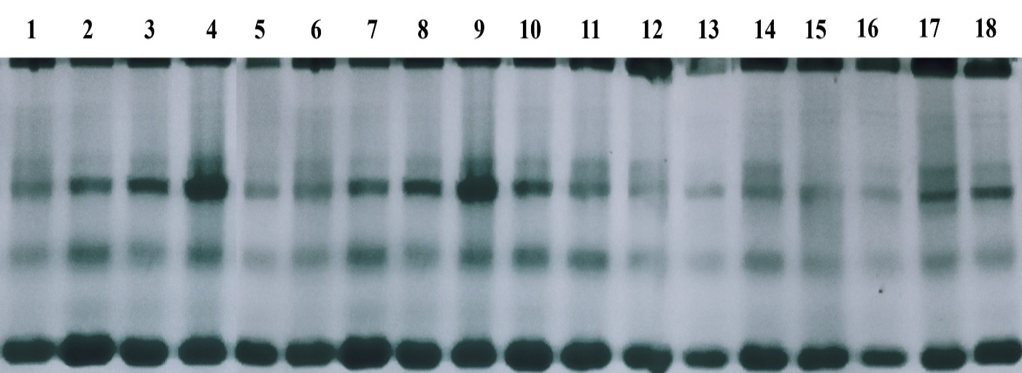Thirteen distinct protein bands that could be scored were identified in each linseed germplasm. Protein bands were verified using a stacking gel (5 mL) and observed during protein assembly using 0.05% Bromophenol Blue (Fig. 5). Five bands were monomorphic, and eight bands were polymorphic among these thirteen bands. The two primary clusters identified by UPGMA cluster analysis are I and II. GP-411 is the only genotype found in the out-grouped main cluster I. Two minor clusters, IIA and IIB, which sprang from main cluster II, were like each other, according to a 50% cut-off on the scale. It was shown that the minor clusters IIAa and IIAb were similar with a 72% cut-off on the scale. The genotypes in minor cluster IIAa that are 100% comparable to those of R-4244 and R-4253 are R-4218, R-4237, R-4275, GP-208, GP-209, GP-381, and GP-352. The genotypes of GP-333, GP-345, GP-418, and GP-455 were 87% identical. Between GP-312 and GP-405, there exist distinctions and out groupings. In a related study, Saradar et al. (2012) found that the genetic diversity of total seed protein profiles was low. Gulla et al. (2021) found a high level of variation among linseed genotypes.

**Fig. 5.** **Gel-electrophoresis based on total seed protein**

**Fig. 6. Cluster analysis via UPGMA**

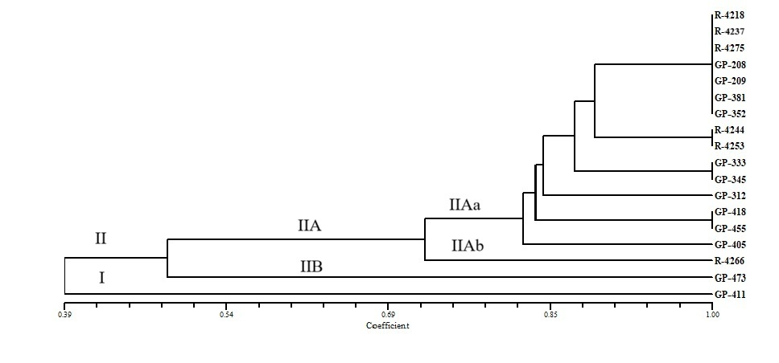

**3.3 MOLECULAR CHARACTERIZATION**

**3.3.1 CHARACTERIZATION BY USING ISSR PRIMERS**

Using a set of ten ISSR primers, 18 genomic DNA was amplified by PCR. Six of the ten ISSR primers employed in this investigation were effective at amplifying genomic DNA. In this study, six ISSR primers produced a total of 24 amplicons. 21 amplicons were found to be polymorphic, with an average polymorphism of 87.5%. On average, each primer produced four amplicons. The size of the amplification product varied from 400bp to 6000bp. The primers UBC-807, UBC-819, and UBC-825 produced the most amplicons (5), whereas UBC-810 and UBC-850 produced four and three amplicons, respectively, and UBC-815 produced the fewest amplicons (2). Primer UBC-850 has the lowest polymorphism rate (66.66%). The polymorphic information content (PIC) of each primer ranged between 0.29 and 0.48, with an average of 0.40. The most informative ISSR primers were UBC-815, UBC-819, and UBC-825, which had 100% polymorphism and PIC values of 0.41, 0.47, and 0.48, respectively. The primers UBC-807 exhibit 80% polymorphisms with a PIC value of 0.36. Primer UBC-810 demonstrates that 75% of polymorphisms have a PIC value of 0.37. While ISSR primer, the least informative primer, UBC-850, had a PIC value of 0.29, while the most informative marker, UBC-825, had a PIC value of 0.48. (Fig. 7) The ISSR data show that the similarity matrix between 18 linseed accessions varied from 0.94 (GP-411 - R-4244) to 0.26 (GP-352 - GP-208) and (GP-473 - GP-208). As a result, the most like germplasm was GP-411 and R-4244 (0.97), while the most dissimilar genotypes were GP-352 - GP-208 and GP-473 - GP-208, which had the lowest similarity score (0.26).

The genetic history of the native lines is extremely varied, according to the cluster analysis based on ISSR markers across multiple linkage groups. Separate groups of 18 linseed germplasm were found to be represented by two distinct and sizable clusters (I and II). Two subclusters, IA and IB, comprise the main cluster I. GP-208, the most diverse genotype, is the only genotype found in Subcluster IA. There are two genotypes in sub-cluster IB: GP-333 and GP-381. It was found that subclusters IA and IB were similar at the 57% scale cut-off. Two smaller clusters, IIA and IIB, were created by further subdividing the big cluster II. Two minor clusters, IIA and IIB, that were produced in main cluster II were found to be similar to each other at about the 65% cut-off on the scale. Eleven linseed genotypes were found in each of the two sub-clusters, IIAa and IIAb, that were formed from the minor cluster IIA. Two sub-clusters, IIAb1 and IIAb2, were identified from the minor cluster IIAb. R-4244 and GP-411 are the two genotypes that comprise Subcluster IIAb1. The six genotypes that make up sub cluster IIAb2 are 100% similar and are R-4253, R-4266, GP-345, GP-209, GP-418, and GP-455. IIBa and IIBb are the two minor clusters that make up IIB. R-4275 and GP-352, the two genotypes that comprise the minor cluster IIBa, are 100% identical. The two genotypes that make up the minor cluster IIBb, GP-312 and GP-473, were 100% identical. (Fig. 8)

ISSR profiling of 18 linseed lines obtained with primer UBC-819

ISSR profiling of 18 linseed lines obtained with primer UBC-807

ISSR profiling of 18 linseed lines obtained with primer UBC-815

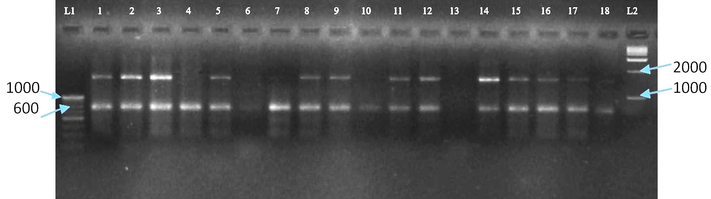

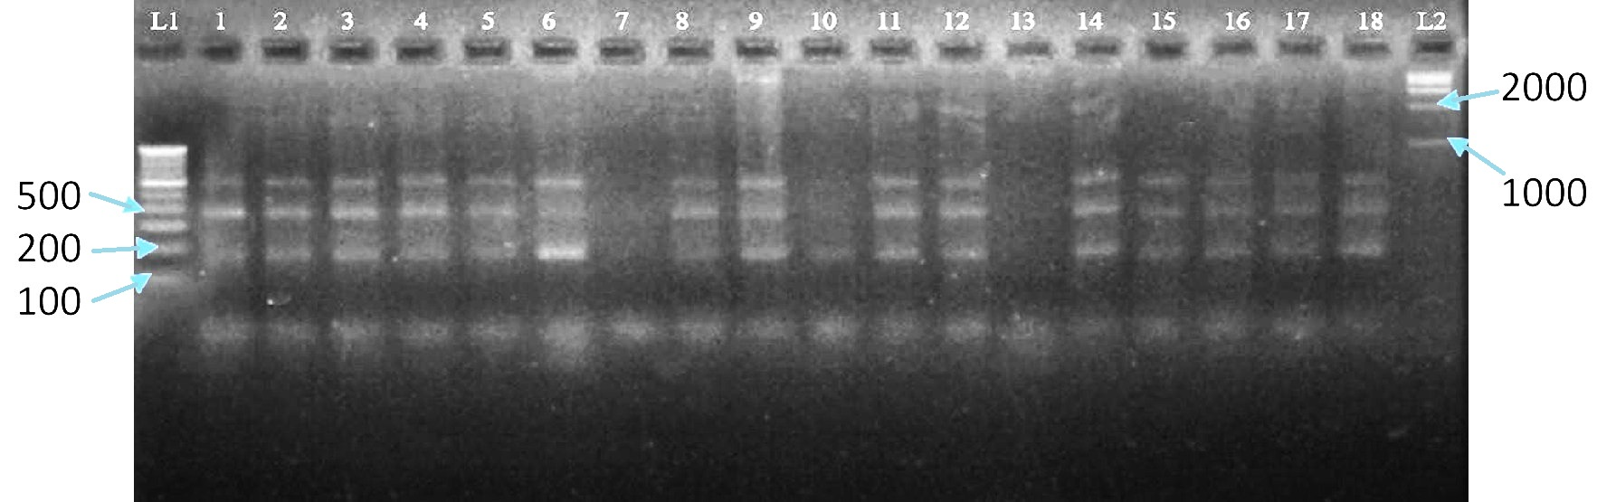

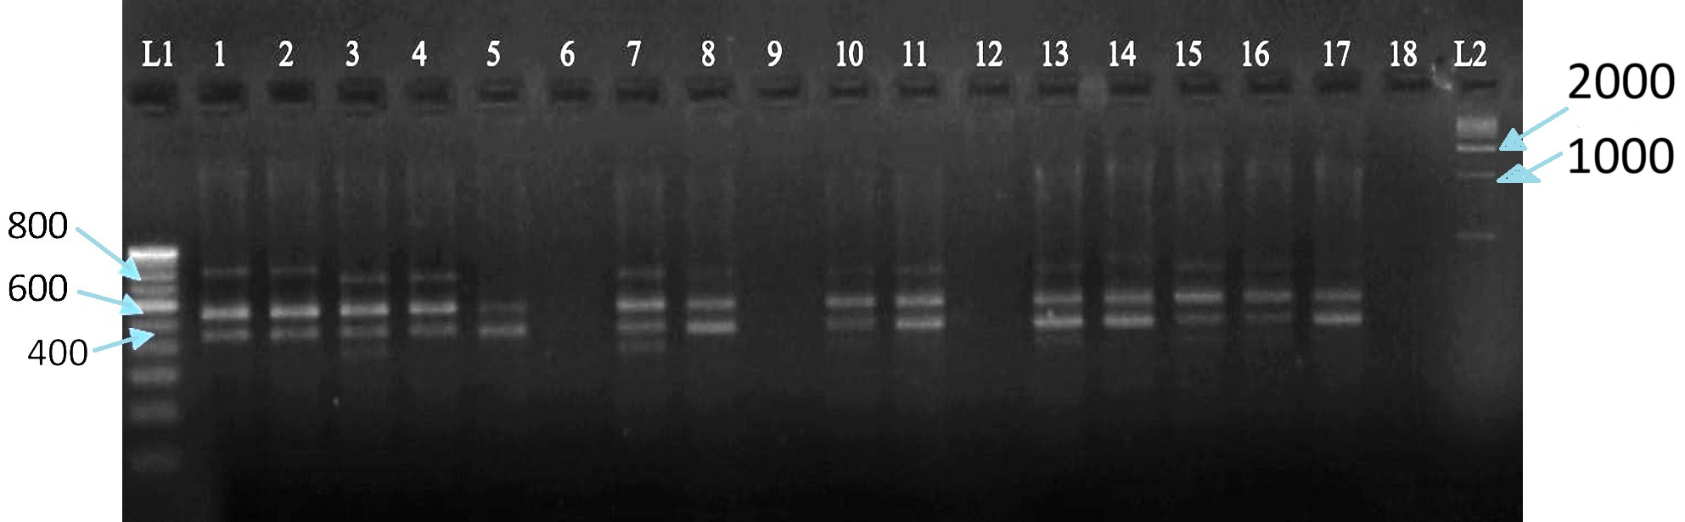

**Fig. 7. Characterization of linseed germplasm using ISSR primers**

**Fig. 8. Cluster analysis via UPGMA**

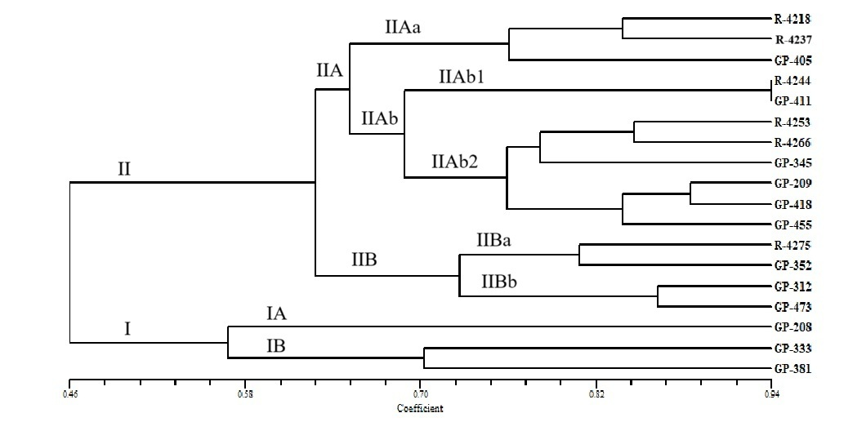

**3.3.2 CHARACTERIZATION BY USING SSR PRIMERS**

In the present study, thirteen amplicons were obtained using five SSR primers. The average polymorphism of 12 amplicons was found to be 90%. The average yield of each primer was 2.6 amplicons. With a range of 0.19 to 0.47, the average polymorphic information content (PIC) value for every primer was 0.32. With 100% polymorphism and a PIC value of 0.47, SSR primer LU-6 was the most informative marker. The PIC value of 0.19 for SSR primer LU-8 indicated that it was the least informative primer. The SSR analysis revealed that the similarity matrix between the 18 linseed accessions varied from 0.09 (GP-473, GP-208) to 1.0 (R-4266, R-4253, R-4275, GP-312, GP-209, GP-455, GP-405). Thus, the most divergent genotypes found (GP-473, GP-208) and the most similar genotypes (R-4266, R-4253, R-4275, GP-312, GP-209, GP-455, GP-405) were discovered. (Fig. 9.)

UPGMA-based cluster analysis was utilized to create a dendrogram from the genetic similarity matrix, revealing two significant clusters (I and II). The giant cluster I was subdivided into the two lesser clusters, IA and IB. Cluster IB is the primary cluster that contains the only germplasm, GP-418. The genotype that was found to be the most distinct was GP-418. The major cluster IA was found to have two subsidiary clusters, IAa and IAb, that were equivalent to each other at a cut-off of roughly 65% on the scale. There are eight genotypes that show 80% similarity with each other: GP-209, GP-312, GP-352 & GP-333, GP-405, GP-455, GP-473, and GP-411. GP-411 was found to be out-grouped within the cluster IAa2. IAa1 and IAa2 were the two subclusters that were created from the minor cluster IAa. The minor cluster IAb contains two genotypes, GP-345 and GP-381, that are 100% identical to each other. Another noteworthy cluster, Cluster II, was further separated into IIA and IIB. There is only one germplasm, GP-208, in Subcluster IIB. GP-208 was shown to be the most distinct genotype. Subcluster IIA contains six genotypes, designated R-4218, R-4237, R-4253, R-4266, R-4275, and R-4244. Clusters IIA and IIB were found to be similar on the scale at roughly 80% cut-off. The genotypes of GP-345, GP-381, GP-405, GP-455, and GP-405 are all 100% identical. GP-418 and GP-208 were the most dissimilar genotypes, whereas GP-411, GP-433, and R-4244 were found to be out-grouped. The genotypes GP-209 and GP-352 and R-4218 and R-4275 are 100% similarity. (Fig. 10)

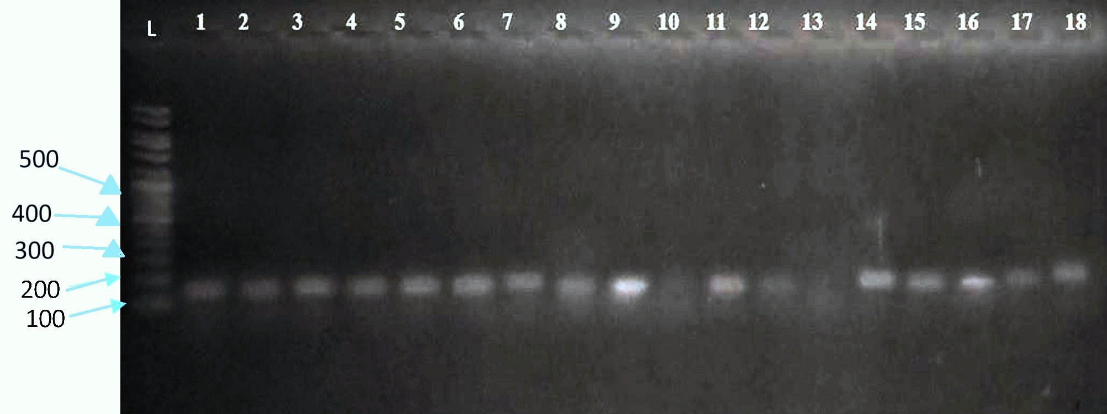

SSR profiling with primer LU-3

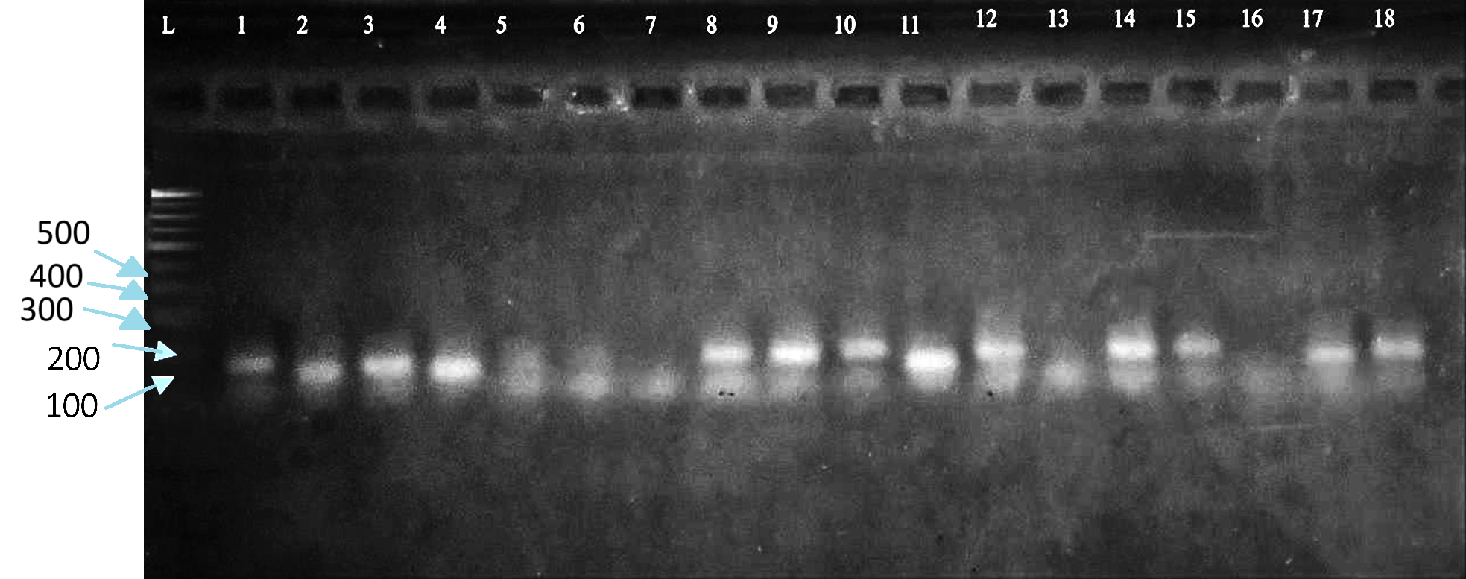

SSR profiling with primer LU-6

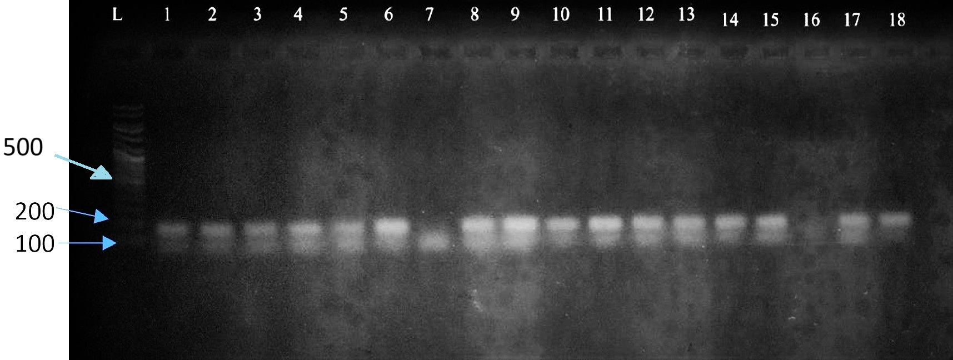

SSR profiling with primer LU-9

**Fig. 9. Characterization of linseed germplasm using SSR primer**

**Fig. 10. Cluster analysis via UPGMA**

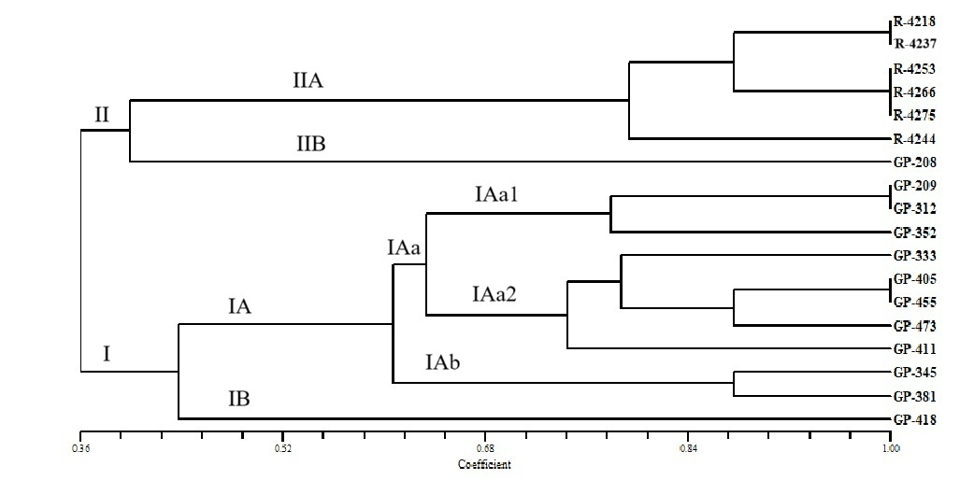

**4. CONCLUSION**

The study found that GP-208 was the best-performing linseed genotype, with the earliest 50% flowering at 51.5 days, the most capsules per plant (23), the greatest seed count per capsule (12), the most primary branches (11), and the highest yield per plant (14.375 g). In contrast, GP-405 yielded the least (4.7 g), whereas GP-4218 had the fewest seeds per capsule (4.5). R-4266 was the tallest at 72.12 cm, while GP-381 was the shortest at 48.16 cm. R-4237 and R-4275 had the highest 1000 seed weight (5.97 g), while R-4253 had the lowest (4.72 g). Biochemical study using SDS-PAGE revealed 13 protein bands, eight of which were polymorphic, indicating substantial protein diversity. GP-411 emerged as a distinct out-group in the UPGMA cluster based on protein profiles. Molecular marker analysis with ISSR markers amplified 24 bands with 87.5% polymorphism, with UBC-815, UBC-819, and UBC-825 being the most informative with 100% polymorphism and PIC values up to 0.48. Similarly, SSR markers with 5 primers yielded thirteen bands with 92% polymorphism, while LU-6 was the most informative (PIC 0.47, 100% polymorphism), and LU-8 was the least informative (PIC 0.19). The genetic closeness between genotypes varied from 0.26 to 0.94. The most genetically dissimilar genotypes were GP-208 and GP-473 (similarity index 0.09), whereas the most similar were GP-411 and R-4244 (0.97). SSR-based cluster analysis divided genotypes into two main clusters and several sub-clusters. The most genetically dissimilar genotypes were GP-208 and GP-418, whereas others had 100% genetic resemblance.

Disclaimer (Artificial intelligence)

Option 1:

Author(s) hereby declare that NO generative AI technologies such as Large Language Models (ChatGPT, COPILOT, etc.) and text-to-image generators have been used during the writing or editing of this manuscript.

Option 2:

Author(s) hereby declare that generative AI technologies such as Large Language Models, etc. have been used during the writing or editing of manuscripts. This explanation will include the name, version, model, and source of the generative AI technology and as well as all input prompts provided to the generative AI technology

Details of the AI usage are given below:

1.

2.

3.

**REFERENCES**

Adhikari, S., Saha, S., Bandyopadhyay, T. K., & Ghosh, P. (2015). Efficiency of ISSR marker for characterization of Cymbopogon germplasms and their suitability in molecular barcoding. *Plant systematics and evolution*, *301*, 439-450.

Akbar, M., Mahmood, T., Anwar, M., Ali, M., Shafiq, M., & Salim, J. (2003). Linseed improvement through genetic variability, correlation and path coefficient analysis. *Int. J. Agric. Biol,* 5(3), 303-305.

Beer, S. C., Goffreda, J., Phillips, T. D., Murphy, J. P., & Sorrells, M. E. (1993). Assessment of Genetic Variation in Avena sterilis using Morphologicall Traits, Isozymes, and RFLPs. *Crop Science*, *33*(6), 1386-1393.

Chandrawati, D., Singh, N., Kumar, R., Kumar, S., Ranade, S. A., & Kumar Yadav, H. (2018). Agro-Morphological Traits and Microsatellite Marker s Based Genetic Diversity in Indian Genotypes of Linseed (Linum usitatissimum L.).

Cloutier, S., Miranda, E., Ward, K., Radovanovic, N., Reimer, E., Walichnowski, A., s & Ragupathy,R. (2012). Simple sequence repeats marker development from bacterial artificial chromosome end sequences and expressed sequence tags of flax (*Linum usitatissimum* L.). *Theoretical and applied genetics*, *125*, 685-694.

Doyle J.J. & J.V. Doyle. (1987). A rapid DNA isolation procedure for small amounts of leaf tissue. *Phytochem. Bull.,* 19: 810–815.

Ganorkar, P.M. and Jain, R.K. 2013. Flaxseed – a nutritional punch. International Food Research Journal, 20(2): 519-525.

Green, A. G., & Marshall, D. R. (1981). Variation for oil quantity and quality in linseed (*Linum usitatissimum*). *Australian Journal of Agricultural Research*, *32*(4), 599- 607.

Green, A. G.; Chen, Y.; Singh, S.P. and Dribnenki, J.C. (2008). Flax in compendium of transgenic crop plants. Edited by Kole C, Hall,T. C.; Oxford: Blac/...--well Publishing Limited. 199-226.

Gulla, B., Jadhav, V., & Dudhare, M. S. (2021). Assessment of genetic diversity and physiochemical analysis of linseed (Linum usitatissimum L.) genotypes. *TPI*, *10*(2), 328-331.

Hurteau, M.C. 2004. Unique new food products contain good omega fats. J. Food Sci. Edu., 3: 52-53.

Kale, S. M., Pardeshi, V. C., Kadoo, N. Y., Ghorpade, P. B., Jana, M. M., & Gupta,V. S. (2012). Development of simple genomic sequence repeat markers for linseed using next-generation sequencing technology. *Molecular breeding*, *30*(1), 597-606.

Kumari, S., Prasad, B.D. & Nirala, R.B.P. (2020). Assessment of molecular diversity among linseed (*Linum usitatissimum* L.) genotypes using SSR markers*. The Indian Society of Oilseeds Research.* 142.

Pali, V., & Mehta, N. (2016). Genetic diversity assessment of flax (*Linum usitatissimum* L.) germplasm using molecular and morphological markers. *Electronic Journal of Plant Breeding,* 7(4), 986-995.

Pali, V., Mehta, N., Verulkar, S. B., Xalxo, M. S., & Saxena, R. R. (2015). Molecular diversity in flax (*Linum usitatissimum* L.) as revealed by DNA based markers. *Int J Plant Res*, 28, 157-165.

Ragupathy, R., Rathinavelu, R., & Cloutier, S. (2011). Physical mapping and BAC-end sequence analysis provide initial insights into the flax (*Linum usitatissimum* L.) genome*. BMC genomics*, 12, 1-17.

Rai, M. (2012). oil seed. Handbook of agriculture, pp 1186-1194.

Rajwade, A.V., Arora, R.S., Kadoo, N.Y., Harsulkar, A.M., Ghorpade, P.B. & Gupta, Reddy, M.P.; Sarla, N. & Siddiq, E.A. (2002). Inter simple sequence repeats (ISSR) polymorphism and its application in plant breeding. Euphytica. 128, 9–17.

Sandip, M.K., Varsha, C.P., Narendra, Y.K., Prakash, B.G., Murari, M.J. & Vidya, S.G. (2012). Development of simple genomic sequence repeat markers for linseed using next generation sequencing technology. Mol. Breed. 30, 597– 606. doi: 10.1007/s11032-011-9648-9

Sardar AK, Shinwari ZK, Rabbani A. (2012) Study of total seed protein pattern of rice (Oryza sativa L.) breeding lines of Pakistan through sds-page. Pak. J Bot 2012;45(3):871- 876.

Saroha, A., Pal, D., Kaur, V., Kumar, S., Bartwal, A., Aravind, J., ... & Wankhede, D. P. (2022). Agro-morphological variability and genetic diversity in linseed (Linum usitatissimum L.) germplasm accessions with emphasis on flowering and maturity time. Genetic Resources and Crop Evolution, 69(1), 315-333.

Soto-Cerda, B. J., Maureira-Butler, I., Muñoz, G., Rupayan, A., & Cloutier, S. (2012). SSR-based population structure, molecular diversity and linkage disequilibrium analysis of a collection of flax (*Linum usitatissimum* L.) varying for mucilage seed-coat content. *Molecular breeding*, *30*, 875-888

Soto-Cerda, B. J., Saavedra, H. U., Navarro, C. N., & Ortega, P. M. (2011). Characterization of novel genic SSR markers in Linum usitatissimum (L.) and their transferability across eleven Linum species. *Electronic Journal of Biotechnology*, *14*(2), 4-4.

Tadesse, T., Parven, A., Singh, H., & Weyessa, B. (2010). Estimates of variability and heritability in linseed germplasm. *International Journal of Sustainable Crop Production*, *5*(3), 8-16.

Vaisey-Genser M, Morris D.H. (2003) Introduction: History of the cultivation and uses of flaxseed. In AD Muir, ND Westcott, eds, Flax: The genus Linum. Taylor & Francis, London, pp 1-21.

Wakjira, A.; Maryke, T. and Arno, H. (2004). Variability in oil content and fatty acid composition of Ethiopian and introduced cultivars of linseed. Journal of Science Food and Agriculture. 84: 1-8

Wolfe, A.D. & Liston, A. (1998). Contributions of PCR-based methods to plant systematics and evolutionary biology. In: "Molecular systematics of plants", 67 (Eds.): Soltis, D.E., P.S. & Doyle J.J., 2nd Edition. Kluwer Academic Publishers, Boston. PP. 43-86.

Zietkiewicz, E., Rafalski A. & Labuda, D. (1994). Genome fingerprinting by simple sequence repeat (SSR) anchored polymerase chain reaction amplification. Genomics. 20: 176–183.