Original Research Article

# 1 Recombinant Expression of *Taq* DNA Polymerase Using pBluescript SK(+) and 2 Chromatography-Free Purification: A Cost-Effective Strategy for Low-Resource 3 Laboratories

4

6

7

8

9

10

11

12

13

14

# 15 ABSTRACT

|  |
| --- |
| 17  18  19  20  21  22  23  24  25  26  27  28  29  30  31  32  33  34  35  36  37 38  39 40 |

16 *Taq* DNA polymerase is a cornerstone of molecular biology. However, its production typically relies on proprietary vectors and affinity-based purification systems. These requirements limit access in educational and resource-constrained environments. In this study, we demonstrate the first experimentally confirmed expression of the thermostable Taq DNA polymerase using the widely available, open-access pBluescript SK(+) vector. This vector, traditionally used for blue-white screening, was repurposed as a protein expression platform in *E. coli*. Expression was paired with a simplified purification strategy involving heat denaturation and ammonium sulfate precipitation. This chromatography-free strategy requires no affinity tags or vendor-specific reagents. It yielded enzymatically active Taq DNA polymerase with a mean purity of 90.1 ± 2.1%, as determined by SDS-PAGE densitometry. Functional validation through PCR amplification and thermostability assays confirmed that the enzyme is comparable in PCR fidelity to commercial Ex Taq (Takara Bio). We also assessed the workflow’s performance across different production volumes, result consistency, and compatibility with basic laboratory infrastructure. Compared to commercial enzyme, our protocol reduced the cost-per-reaction by 70–85%, depending on enzyme input. These findings demonstrate that pBluescript SK(+), typically reserved for cloning, can support effective recombinant protein production when paired with optimized conditions. This study provides a low-cost, accessible solution for molecular biology instruction and research in under-resourced settings.

**Keywords:** Taq DNA polymerase, protein expression, pBluescript SK(+), heat purification, ammonium sulfate precipitation, low-cost biotechnology, chromatography-free purification, resource-limited laboratories

# 1. INTRODUCTION

Thermostable DNA polymerase from *Thermus aquaticus* (*Taq*) has been one of the most impactful enzymes in molecular biology. It enabled the polymerase chain reaction (PCR) through its ability to catalyze DNA synthesis at high temperatures (Chien et al., 1976; Ishino and Ishino, 2014). Its heat resistance allows for repeated denaturation of DNA strands without enzyme degradation, a feature essential for reliable PCR amplification (Zhu et al., 2020). Current industrial-scale Taq DNA polymerase production typically relies on high-expression systems such as pET vectors with T7 promoters in *Escherichia coli*, and purification via affinity chromatography using His-tags and nickel-based matrices (Olszewski et al., 2017; MendozaRojas et al., 2021; Samman et al., 2023). While they offer high yields, the dependence on licensed vectors and specialized purification tools makes them costly and difficult to implement in teaching labs. As a result, hands-on recombinant protein work is often restricted in teaching labs, despite its pedagogical value for training students in core molecular biology techniques (Gomes et al., 2022).

Earlier studies explored simpler expression systems for producing Taq DNA polymerase. Lawyer et al. (1989) cloned the *Taq* polymerase gene into general cloning vectors and demonstrated functional expression in *E. coli* (Lawyer et al., 1989). Engelke et al. (1990) later showed that active enzyme could be isolated using heat denaturation alone. These early protocols, while groundbreaking, were not easily transferable to undergraduate or resourcelimited teaching labs. They often required extensive troubleshooting and specialized equipment to achieve repeatable results (Carroll and Keller, 2014). More recent workflows have prioritized engineered variants of *Taq* DNA polymerase, including Stoffel fragments and fusion proteins. These modifications aim to enhance specificity, processivity, or inhibitor resistance (Olszewski et al., 2017; Samman et al., 2023; Lee et al., 2023). Examples include fusion constructs with thermostable single-stranded DNA-binding proteins and variants optimized for hot-start PCR. Some codon-optimized systems, such as those using the rhaBAD promoter, can reach expression levels of ~8.5 mg/L. Yet they still require affinity resins and column-based purification (Laksmi et al., 2024).

Simplified approaches using heat denaturation and ammonium sulfate precipitation have shown that >90% pure enzyme can be obtained (Pluthero, 1993). Still, these protocols are rarely used in teaching environments, particularly where chromatography tools are unavailable (Carroll and Keller, 2014; Bhadra et al., 2022). Moreover, most published strategies do not leverage open-source plasmids or offer easy-to-follow protocols tailored for education. Thus, a gap remains: a need for a reliable, easy-to-replicate, chromatography-free protocol for producing active Taq polymerase in academic settings.

Although widely available, the pBluescript SK(+) vector is not commonly used for protein expression. Most production systems continue to rely on T7 promoters, affinity tags, or chromatographic steps—creating barriers for educational use. There is currently a lack of lowcost systems that use familiar plasmids and produce functional protein without proprietary components. This study addresses that need. We demonstrate that pBluescript SK(+), a highcopy cloning vector, can be repurposed for expressing thermostable Taq polymerase. The gene was inserted between *EcoRI* and *SalI* sites under control of the *lac* promoter. Expression was performed in *E. coli*, followed by a purification protocol based solely on heat denaturation and ammonium sulfate precipitation.

We evaluated enzyme yield, SDS-PAGE purity, thermostability, and PCR performance in comparison to commercial Taq. A cost analysis and troubleshooting guide are also provided to enhance reproducibility. Our results show consistent production of active enzyme with

90.1 ± 2.1% purity and comparable fidelity to commercial Ex Taq (Takara Bio). The reagent cost is ~65% lower than Ex Taq, and the entire protocol is compatible with standard lab setups. By repurposing a familiar cloning plasmid and using a chromatography-free purification scheme, this approach offers a practical and affordable option for instructional or under-resourced settings. It bridges the gap between expensive commercial kits and the limitations of teaching labs, promoting broader participation in molecular biology education. This strategy eliminates the need for proprietary tools, making it a viable solution for academic training worldwide.

# 2. MATERIALS AND METHODS

## 2.1 PCR amplification and gel confirmation of the *Taq* DNA polymerase gene

Genomic DNA was extracted from *Thermus aquaticus* strain ATCC 25104 (Brock and Freeze, 1969), obtained from the American Type Culture Collection (Manassas, VA, USA), using the DNeasy Blood & Tissue Kit (Fisher Scientific, Waltham, MA, USA). The *Taq* DNA polymerase gene was amplified using gene-specific primers containing restriction sites for directional cloning. The forward primer (5′-

AAGCTT**GAATTC**ATGAGGGGGATGCTGCCCCTC-3′) included an *EcoRI* site (**GAATTC**) and an overhang (AAGCTT); the reverse primer (5′-

CGCGAA**GTCGAC**TTAGGTGGTATCACTCCTTGGCGG-3′) included a *SalI* site (**GTCGAC**) and an overhang (CGCGAA). Primers were synthesized by Integrated DNA Technologies (Coralville, IA, USA).

PCR reactions (50 µL) included 10 ng genomic DNA, 0.5 µM of each primer, 200 µM dNTPs, 1× Ex Taq buffer (Mg²⁺ plus), and 1.25 U Ex Taq DNA Polymerase (Takara Bio USA, San Jose, CA, USA; Cat. #RR001A). Thermocycling conditions were: 95 °C for 3 min; 30 cycles of 95 °C for 30 s, 68 °C for 30 s, and 72 °C for 2.5 min; final extension at 72 °C for 7 min. Amplicons were resolved on 1% agarose gels in 1× TAE containing ethidium bromide alongside 1 Kb DNA ladder (NEB, Ipswich, MA, USA ), and visualized using a Gel Doc XR+ System (Bio-Rad, Hercules, CA, USA). A 2523 bp (2499 bp gene + 24 bp overhangs with restriction sites) band confirmed successful amplification.

## 2.2 Cloning, transformation, colony PCR, and sequencing

The PCR product and pBluescript SK(+) vector were double-digested with EcoRI-HF and SalI-HF (New England Biolabs, Ipswich, MA, USA) in CutSmart buffer at 37 °C for 2 h. Digested DNA fragments were gel-purified using the Zymoclean Gel DNA Recovery Kit (Zymo Research, Irvine, CA, USA). Ligation was performed overnight at 16 °C using T4 DNA Ligase (NEB, Ipswich, MA, USA), and 5 µL of ligation mix was transformed into 100 µL chemically competent *E. coli* DH5α cells (prepared in-house) using a standard heat-shock method.

Transformants were plated on LB agar supplemented with 100 µg/mL ampicillin,

40 µg/mL X-gal, and 0.5 mM IPTG (GoldBio, St. Louis, MO, USA). Plates were incubated at

37 °C overnight. White colonies were screened by colony PCR using the M13 forward primer

(5′-GTAAAACGACGGCCAGT-3′) and a *Taq* DNA polymerase gene-specific reverse primer

(5′-GGCGGGAAGCCCTAGCTCGTC-3′). A ~1.5 kb product confirmed insertion. Plasmid

DNA was isolated using the QIAprep Spin Miniprep Kit (Qiagen, Germantown, MD, USA), and

Sanger sequencing (Eurofins Genomics) was performed using T7 (5′-

TAATACGACTCACTATAGGG-3′) and T3 (5′-ATTAACCCTCACTAAAGGGA-3′) primers.

Sequences were aligned to the reference gene (GenBank: J04639.1) using SnapGene v6.0.2 to verify orientation and fidelity.

## 2.3 Expression and purification of *Taq* DNA polymerase

The confirmed plasmid was transformed into *E. coli* BL21 (DE3) cells (Thermo Fisher,

C600003). A single colony was cultured overnight in LB with 100 µg/mL ampicillin, then diluted 1:100 into 200 mL LB + ampicillin and grown to OD₆₀₀ ≈ 0.6. Protein expression was induced with 1 mM IPTG and continued for 6 h at 30 °C. Cells were pelleted at 4,000 × g for 20 min at 4 °C. Cell pellets were resuspended in Buffer A (500 mM Tris-HCl, pH 8.0; 50 mM glucose; 1 mM EDTA; 4 mg/mL lysozyme) and incubated 20 min at room temperature. Buffer B (10 mM Tris-HCl, pH 8.0; 50 mM KCl; 1 mM EDTA; 0.5% Triton X-100; ~0.5% IGEPAL CA630) was added to the suspension. The lysate was then incubated at 75 °C for 90 minutes in a hybridization oven. Following centrifugation (12,000 × g, 30 min, 4 °C), the clarified lysate was treated with ammonium sulfate to 60% saturation (390 g/L) and stirred at 4 °C for 1 h. Precipitated proteins were pelleted (12,000 × g, 30 min, 4 °C), and resuspended in cold storage buffer (50 mM Tris-HCl, pH 8.0; 150 mM NaCl; 1 mM EDTA; 0.1% Triton X-100; 1 mM DTT).

Dialysis was performed using a 10 kDa MWCO membrane (Spectra/Por 7; Repligen) against 1 L storage buffer with three buffer changes (2 h × 2, then overnight), followed by centrifugation at 15,000 × g for 20 min to remove aggregates. The supernatant was mixed with sterile-filtered 80% glycerol to a final concentration of 40%, aliquoted, and stored at –20 °C.

## 2.4 SDS-PAGE and purity analysis

Protein purity was assessed by SDS-PAGE using a 10% resolving gel and 4% stacking gel in a Mini-PROTEAN Tetra Cell system (Bio-Rad, Hercules, CA, USA). Samples were prepared in 2× Laemmli buffer with 5% β-mercaptoethanol (Sigma-Aldrich, St. Louis, MO, USA), heated at 95 °C for 5 min, and electrophoresed alongside a Thermo Scientific PageRuler Prestained Protein Ladder (Thermo Fisher Scientific, Waltham, MA, USA). Gels were stained with Bio-Safe Coomassie G-250 and imaged on a Gel Doc XR+ system. Band intensities were analyzed using Image Lab Software (v6.1; Bio-Rad). The ~94 kDa band corresponding to Taq DNA polymerase was selected as the region of interest (ROI) for each sample. Purity was calculated as the intensity of the Taq DNA polymerase band divided by the total lane intensity, expressed as a percentage. Preparations with ≥90% purity were considered high quality.

## 2.5 Functional and thermostability evaluation

Protein concentration was determined by Bradford assay using bovine serum albumin

(BSA) standards and absorbance at 595 nm measured with a SpectraMax M3 Microplate Reader (Molecular Devices, San Jose, CA, USA). A standard curve was generated from known concentrations of Bovine Serum Albumin (BSA), and the concentration of the purified Taq enzyme was interpolated from the linear regression equation. For activity testing, PCR amplification of an 813 bp fragment from λ DNA (10 ng) was performed in 25 µL reactions containing 0.2 mM dNTPs and 0.5 µM each of the forward (5′-GCCCGTTCTGCGAGGCGG-3′) and reverse (5′-CACGAATAGTCGGCTCAACGTGGG-3′) primers. Reactions were carried out using decreasing volumes of purified Taq polymerase enzyme (1.0, 0.8, 0.7, 0.6, 0.5, 0.4, and 0.3 µL). For comparison, a parallel set of reactions was performed using decreasing volumes of commercial Ex Taq (Takara Bio) enzyme. PCR conditions were: 95 °C for 2 min; 30 cycles of 95 °C for 30 s, 55 °C for 30 s, and 72 °C for 1 min; final extension at 72 °C for 7 min. Products were analyzed alongside a 1 Kb DNA ladder (NEB, Ipswich, MA, USA) on 1% agarose gel stained with ethidium bromide. Band intensities were quantified using ImageJ software by selecting regions of interest (ROIs) corresponding to the 813 bp bands. Intensities were normalized to the highest value (Ex Taq enzyme at 1.0 µL) and averaged across three independent biological replicates. Data were expressed as mean ± standard deviation, and differences between in-house and commercial enzyme intensities at each titration point were evaluated using an unpaired two-tailed t-test.

To evaluate thermostability, 5 µL aliquots of purified Taq polymerase enzyme (1 U/µL) were subjected to repeated heat stress. Since we did not directly measure nucleotide incorporation, unit equivalency was estimated by matching PCR efficiency between in-house and commercial enzyme. Specifically, we compared the amplification efficiency of serially diluted in-house enzyme with commercial Ex Taq enzyme under identical conditions and designated the volume that matched 1 U of Ex Taq (as defined by Takara Bio) as equivalent to 1 U of in-house enzyme. This value was used to standardize enzyme concentrations in subsequent thermostability assays. An untreated aliquot was used as a control. Enzymatic activity after heat treatment was assessed by PCR under the same reaction conditions described above, using 25 cycles. Band intensity of the 813 bp product was used to evaluate thermal resilience. Following PCR, band intensities of the 813 bp products were measured using ImageJ software. Each band’s intensity was normalized to the untreated control (set as 100%) to calculate relative activity. The resulting values were expressed as percentage residual activity. Data from three independent experiments were averaged, and the mean ± standard deviation (SD) was plotted as a bar graph to represent the relative enzymatic activity after thermal stress.

## 2.6 Scalability assessment of the *Taq* DNA polymerase expression and purification

To evaluate the capacity of the expression and purification strategy to function across varying culture volumes, recombinant *E. coli* BL21(DE3) cells harboring the *pBluescript SK(+)–*

*Taq* construct were cultured in 5 mL, 50 mL, and 300 mL volumes of LB broth with 100 µg/mL ampicillin. Cultures were grown, induced with IPTG, and processed following the same expression and purification strategy described in Sections 2.3 and 2.4. Final protein concentrations were quantified using the Bradford assay (Section 2.5). Enzyme activity was verified by PCR amplification of an 813 bp λ DNA fragment using the same reaction conditions. Three biological replicates were performed per condition. Mean yield (µg) and standard deviation were calculated to evaluate production efficiency at each scale.

## 2.7 Cost analysis

To assess the economic feasibility of the in-house Taq polymerase production workflow, a detailed expense analysis was performed based on actual reagent usage and enzyme yield from a representative 300 mL culture. Only direct material expenses were included—such as growth media, restriction enzymes, PCR reagents, buffers, IPTG, lysozyme, detergents, ammonium sulfate, and glycerol. Expenditures for durable equipment, consumables (e.g., pipette tips, centrifuge tubes), and labor were excluded to reflect conditions typical of academic and teaching laboratories. Academic list prices were obtained from suppliers including Fisher Scientific, NEB, Bio-Rad, and Zymo Research.

Total reagent expenses and individual item breakdowns for the 300 mL scale are provided in Supplementary Table 4, which details all materials used from cloning through final storage. The average yield of purified Taq polymerase (1620 µg per 300 mL culture) was calculated from three independent preparations, and the price per microgram was computed by dividing total reagent expenditure by total protein yield. A direct pricing comparison between inhouse enzyme and commercial Ex Taq (Takara Bio) is presented in Supplementary Table 3, which highlights an estimated ~65% reduction in expense.

Supplementary Table 2 summarizes total yield and cost-efficiency data across the 50 mL and 300 mL cultures, supporting the applicability of the strategy to different production volumes. Supplementary Table 1 provides a full itemized list of reagent and consumable expenses used in both scales. These values are visualized in Table 1 (cost/yield comparison) and Figure 6 (costper-µg bar graph), confirming the workflow’s affordability and suitability for varying production volumes.

# 3. RESULTS

## 3.1 Cloning and restriction-based confirmation of the *Taq* DNA polymerase gene

The cloning and expression strategy for *Taq* DNA polymerase is outlined in Figure 1A. The full-length *Taq* gene (2499 bp) was PCR-amplified from *Thermus aquaticus* genomic DNA using primers engineered with 5′ *EcoRI* and 3′ *SalI* restriction sites and short overhangs, resulting in a 2523 bp amplicon. As shown in Figure 1B, successful amplification was confirmed by a 2523 bp (2499 bp gene + 24 bp restriction sites with overhang) band in lanes 2 and 3. No product was detected in the negative control (lane 4), indicating high specificity of the primers.

For directional cloning, the amplified insert and the pBluescript SK(+) vector were double-digested with EcoRI-HF and SalI-HF. Gel electrophoresis (Figure 1C) revealed the expected 2499 bp *Taq* gene (lane 2), linearized pBluescript vector (~2.9 kb, lane 3), and undigested supercoiled vector (lane 4), confirming digestion efficiency. The digested products were gel-purified, ligated, and transformed into chemically competent *E. coli* DH5α for initial propagation and screening. The ligation product was then used to create expression-ready plasmids, which were transformed into *E. coli* BL21(DE3). Protein expression was driven by the lac promoter in the pBluescript SK(+) vector. This highlights the vector’s underappreciated capacity to support thermostable protein expression beyond its typical cloning role.

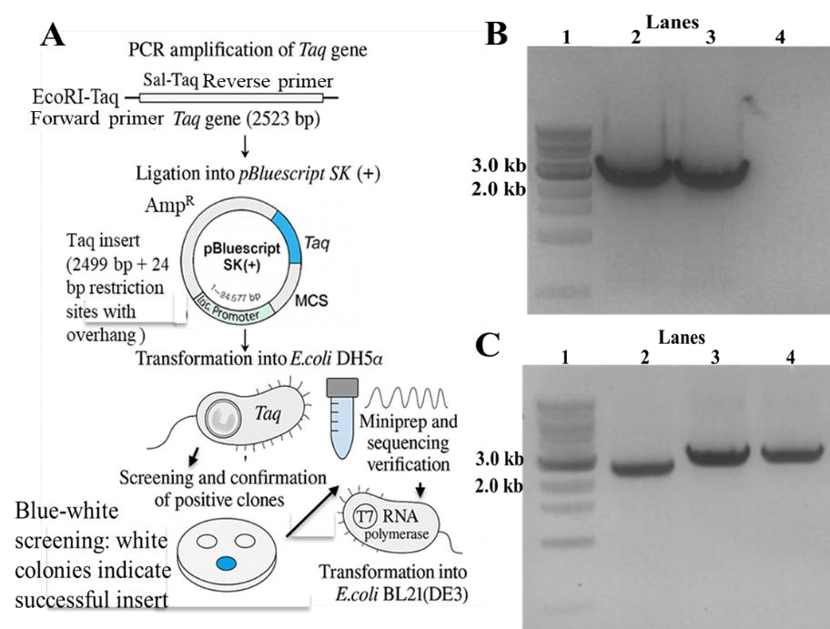**Figure 1. Cloning workflow and molecular verification of the *Taq* DNA polymerase gene.**

**(A)** ***Cloning and expression workflow for recombinant Taq DNA polymerase using pBluescript SK(+).*** The full-length *Taq* DNA polymerase gene (2499 bp) was PCR amplified from *Thermus aquaticus* genomic DNA using primers engineered with *EcoRI* and *SalI* restriction sites and additional overhangs, resulting in a total amplicon size of 2523 bp. The PCR product was ligated into the multiple cloning site (MCS) of the pBluescript SK(+) vector downstream of the *lac* promoter. The recombinant plasmid was introduced into chemically competent *E. coli* DH5α cells. Positive clones were identified through white/blue colony screening on X-gal/IPTG plates and confirmed by

plasmid miniprep and Sanger sequencing. Verified plasmids were subsequently transformed into *E. coli* BL21(DE3) cells for inducible expression using IPTG. Expression was driven by the lac promoter. **(B)** ***Agarose gel confirmation of Taq DNA polymerase amplification and vector-insert preparation.*** Agarose gel (1%) analysis of PCR product. Lane 1: 1 Kb DNA ladder (NEB); Lanes 2 and 3: 2523 bp (2499 bp gene + 24 bp overhangs with restriction sites) PCR product; Lane 4: negative control (no template). **(C)** ***Restriction digest of the Taq polymerase PCR product and pBluescript SK(+) vector for ligation***. Lane 1: 1 Kb DNA ladder (NEB); Lane 2: digested *Taq* gene (2499 bp); Lane 3: linearized vector (~2.9 kb); Lane 4: undigested pBluescript SK(+) (supercoiled).

## 3.2 Colony screening and PCR-based confirmation of insert-positive clones

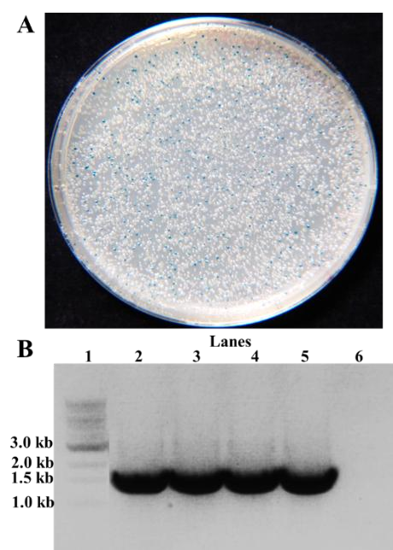To screen for recombinant plasmids, transformants were plated on LB agar supplemented with ampicillin, Xgal, and IPTG. Blue-white screening yielded a high density of white colonies (Figure 2A), consistent with disruption of the *lacZ* α-fragment due to insertion of the *Taq* gene into the multiple cloning site (MCS) of pBluescript SK (+). Blue colonies, indicative of empty vectors, served as negative controls. White colonies were further screened via colony PCR using the M13 forward primer and a *Taq*specific reverse primer. As shown in Figure 2B, four independent white colonies (lanes 2–5) yielded the expected ~1.5 kb PCR product, confirming successful insertion of the *Taq* gene. The blue colony (lane 6) did not produce any amplification product, verifying the absence of insert in non-recombinant clones.

**Figure 2. Colony screening and insertion verification of the *Taq* gene.**

1. ***Blue-white screening for identification of recombinant E. coli DH5α colonies.*** Blue-white selection of *E. coli* DH5α transformants on LB/ampicillin/IPTG/X-gal plates. White colonies indicate disruption of *lacZ* αcomplementation due to *Taq* gene insertion into the multiple cloning sites.
2. ***Colony PCR screening of E. coli DH5α transformants for Taq insert verification*.** Colony PCR using M13 forward and a *Taq* gene-specific reverse primer. Agarose gel (1%) analysis of PCR product. Lane 1: 1 Kb DNA ladder (NEB); Lanes 2, 3, 4, 5: positive clones with ~1.5 kb product; Lane 6: negative control (blue colony).

Following PCR verification, plasmid DNA was isolated from confirmed colonies and sequenced using T7 and T3 primers to assess insert orientation and sequence fidelity. Full-length sequence alignment with the reference *Taq* polymerase gene (GenBank: J04639.1) revealed 100% identity and an intact open reading frame with the *EcoRI* and *SalI* restriction sites (Supplementary Figure 1).

Together, these results confirmed successful cloning and sequence validation of the fulllength Taq gene into the pBluescript SK(+) plasmid.

## 3.3 Expression, purification, and purity assessment of Taq DNA polymerase

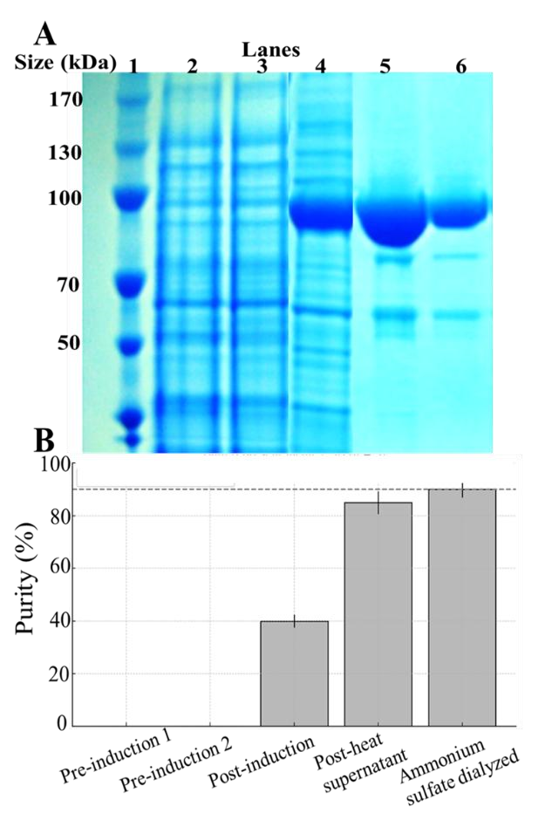To evaluate the expression and purification efficiency of recombinant Taq polymerase, SDS-PAGE was performed across key stages of the workflow. As shown in Figure 3A, a prominent band at ~94 kDa, corresponding to the expected molecular weight of Taq DNA polymerase, was absent in the uninduced lysates (lanes 2 and 3) but strongly induced following IPTG treatment (lane 4). This confirms the successful recombinant expression of Taq polymerase in *E. coli* BL21(DE3) under control of the *lac*-inducible promoter. Heat treatment at 75 °C for 90 min enriched thermostable Taq polymerase in the soluble fraction (lane 5). This step effectively eliminated many heat-labile bacterial proteins. The final dialyzed preparation, following ammonium sulfate precipitation, yielded a single dominant band at ~94 kDa (lane 6), indicating successful purification and minimal contamination.

Densitometric analysis of band intensities (Figure 3B) quantitatively tracked purity progression. Taq polymerase accounted for <5% of total protein pre-induction, increasing to ~40% post-induction. Following heat treatment, the Taq band comprised ~85% of total lane intensity, and the final ammonium sulfate dialyzed preparation achieved an average purity of 90.1 ± 2.1% (n = 3), surpassing the high-purity threshold (dashed line at 90%). These findings demonstrate that the nonaffinity purification protocol was sufficient to achieve high-quality preparations suitable for downstream applications.

**Figure 3. Expression, purification, and purity assessment of recombinant Taq DNA polymerase.**

**(A) *SDS-PAGE analysis of Taq DNA polymerase expression and purification workflow.*** Protein fractions from various stages of the purification workflow were separated by SDSPAGE (10% resolving, 4% stacking gel) and visualized using

Coomassie Brilliant Blue staining. Lane 1: Thermo Scientific

PageRuler Prestained Protein Ladder (10–170 kDa); Lanes 2–3: Uninduced *E. coli* BL21(DE3) lysate (negative control); Lane 4: Cell lysate following IPTG induction, prior to heat treatment, showing a prominent ~94 kDa band corresponding to Taq polymerase; Lane 5: Supernatant after heat treatment at 75 °C for 90 min, demonstrating thermal enrichment of soluble Taq polymerase; Lane 6: Final purified Taq polymerase following ammonium sulfate precipitation and dialysis, appearing as a single dominant ~94 kDa band with estimated purity 90.1 ± 2.1%. **(B) *Quantification of purified Taq polymerase purity across purification steps***. Band intensities from the SDS-PAGE gel in (A) were quantified by densitometry. The ~94 kDa band corresponding to Taq polymerase was measured and expressed as a percentage of the total lane intensity. Purity increased following IPTG induction and heat treatment, with the final ammonium sulfate dialyzed sample reaching 90.1 ± 2.1% purity. Bars represent the mean estimated purity at each step. The dashed line marks the 90% threshold commonly used to define high-quality enzyme preparations. Data represent mean ± SD (n = 3).

## 3.4 Functional characterization and thermostability of purified Taq DNA polymerase

We assessed the functional activity of the purified Taq DNA polymerase using titrationbased PCR amplification of an 813 bp λ DNA fragment. As shown in Figure 4A, robust amplification was achieved across decreasing enzyme volumes (1.0 to 0.3 µL) for both commercial Ex Taq polymerase (lanes 2–8) and the in-house purified Taq enzyme (lanes 9–15). Band intensities declined with reduced enzyme input, but even the lowest volume tested (0.3 µL) yielded detectable PCR product in both cases, confirming that the purified enzyme retains high catalytic activity. These results confirm that the in-house Taq DNA polymerase provides comparable fidelity to Ex Taq (Takara Bio) in PCR performance.

Quantification of PCR product intensities from this titration experiment is shown in Figure 4B. Normalized intensities declined with decreasing enzyme volume for both commercial and in-house Taq. Importantly, corresponding lanes showed highly similar intensity values, with no statistically significant differences observed between the two enzyme sources at any titration point (p > 0.05, unpaired two-tailed t-test). These data further validate the catalytic equivalence of in-house and commercial Taq across the tested enzyme dilutions

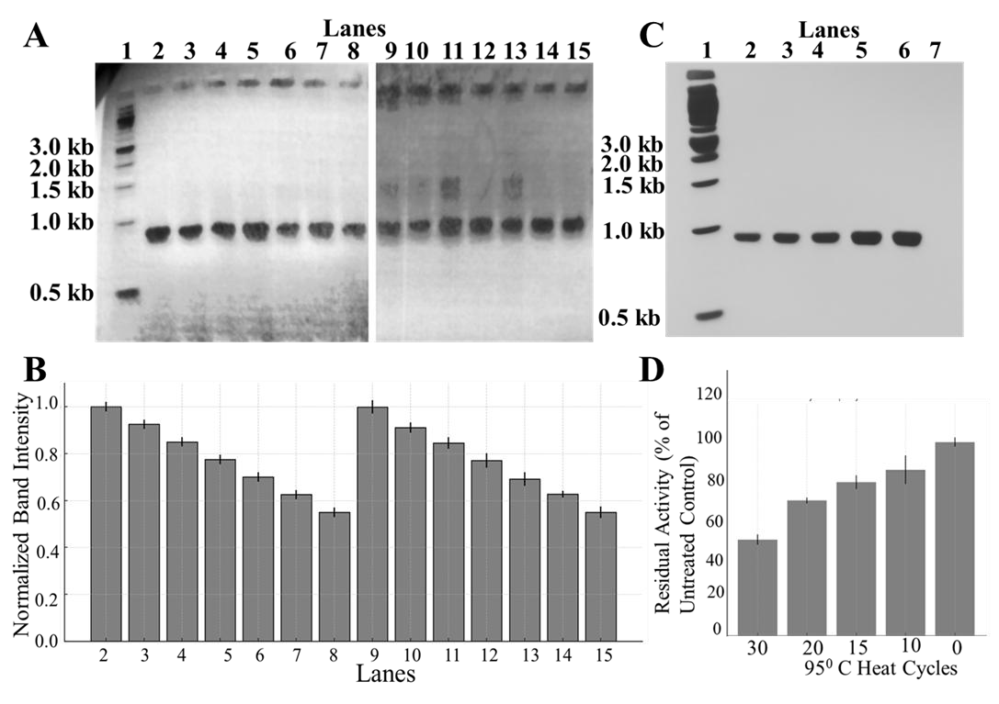**Figure 4. PCR titration and thermostability analysis of purified Taq DNA polymerase.** **(A) *PCR titration to determine the functional equivalence of purified Taq polymerase.*** Agarose gel electrophoresis (1%) of 813 bp λ DNA PCR products generated using decreasing volumes of Taq polymerase enzymes (1.0, 0.8, 0.7, 0.6, 0.5, 0.4, 0.3 µL). Lane 1: 1 kb DNA ladder (NEB); Lanes 2–8: PCR products amplified with decreasing volumes of commercial Ex Taq enzyme; Lanes 9–15: PCR products amplified with decreasing volumes of purified in-house Taq enzyme. **(B)** ***Quantification of PCR product band***

***intensities from Figure 4A.*** Intensities were normalized to the brightest band (lane 2: Ex Taq enzyme at 1.0 µL) and measured using ImageJ software. Bars represent mean ± SD (n = 3) from three independent biological replicates. No statistically significant differences were observed between purified and commercial Taq at corresponding enzyme volumes (unpaired two-tailed t-test, p > 0.05). These results confirm the equivalent catalytic performance of the inhouse enzyme compared to Ex Taq (Takara Bio). **(C) *Thermostability assay of purified in-house Taq DNA polymerase.*** Agarose gel (1%) was used to compare PCR products generated with heat-treated and untreated Taq polymerase. Lane 1: 1 kb DNA ladder; Lanes 2–5: purified in-house Taq treated for 30, 20, 15, and 10 cycles at 95 °C, respectively; Lane 6: untreated control Taq; Lane 7: negative control (no template). Band intensity reflects residual polymerase activity following thermal stress. **(D) *Quantification of Taq polymerase thermostability***. Graph shows the mean residual activity of the Taq polymerase enzyme after each heat treatment, expressed as a percentage of the untreated control (set as 100%). Band intensity was quantified using ImageJ software, and values represent mean ± SD (n = 3) from three independent experiments.

To further test thermal robustness, aliquots of the purified in-house Taq enzyme were subjected to repeated 95 °C heat stress cycles (0, 10, 15, 20, 30 cycles, 30 s each) followed by PCR amplification of the same target. As shown in Figure 4C, untreated enzyme (lane 6) produced strong amplicons, while enzyme subjected to 10–30 heat cycles (lanes 2–5) displayed progressive but partial loss of activity. No amplification was observed in the negative control (lane 7). Quantitative analysis of residual enzymatic activity is shown in Figure 4D. The purified Taq enzyme retained 85.7 ± 4.3%, 79.6 ± 6.1%, and 70.4 ± 5.8% of its activity after 10, 15, and 20 thermal cycles, respectively. Even after 30 cycles, residual activity remained at 50.2 ± 3.7%, underscoring the inherent thermostability of the enzyme. These results demonstrate that the simplified purification method preserved the enzyme’s thermostability and catalytic function.

## 3.5 Scalability of *Taq* polymerase expression and purification

To assess workflow performance across different culture volumes, *E. coli* BL21(DE3) cultures were grown at three volumes: 5 mL, 50 mL, and 300 mL. Taq polymerase yield was quantified using a Bradford assay. As shown in Figure 5, the Taq enzyme yield increased proportionally with culture volume, demonstrating a strong linear correlation and confirming the robustness of the workflow across small to moderately large batch sizes. From 5 mL cultures, an average yield of 24.5 ± 2.2 µg of purified Taq was obtained, while 50 mL and 300 mL cultures yielded 265.1 ± 12.4 µg and 1612.3 ± 63.9 µg, respectively.

This ~40-fold yield increase from 5 mL to 300 mL cultures closely aligned with the expected 60-fold volume difference, indicating minimal loss during scale-up. Moreover, all scaled preparations consistently produced active enzyme, as confirmed by PCR amplification

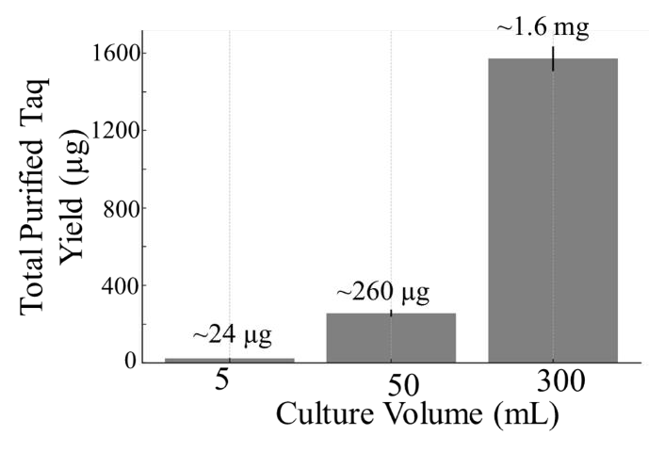(data not shown), indicating that neither protein integrity nor catalytic activity was compromised during upscaling.

**Figure 5. Scalability of *Taq* DNA polymerase expression and purification.**

Graph showing total yield of the purified in-house Taq polymerase enzyme (µg) obtained from 5 mL, 50 mL, and

300 mL LB cultures, using the same IPTG-inducible expression and heat-based purification strategy. Protein concentrations were determined by Bradford assay, and values represent the mean ± SD (n = 3) from three biological replicates. Yields increased proportionally with culture volume, confirming the consistent performance of the production workflow across different volumes.

These results support the feasibility of the pBluescript SK(+)-based system for scalable production of functionally active enzyme using basic lab tools. The workflow is thus suitable for flexible implementation in educational or under-equipped settings, requiring no specialized equipment, commercial kits, fermenters, or affinity purification systems.

## 3.6 Cost analysis and scalability of in-house Taq DNA polymerase production

We evaluated economic efficiency by comparing enzyme yields and material expenses between 50 mL and 300 mL cultures (Table 1). The 300 mL culture yielded 1,620 µg of purified Taq polymerase enzyme at a total expense of $13.62, while the 50 mL culture produced 260 µg for $12.20. This scale-up reduced the per-microgram cost from $0.0469 to $0.0086, representing a major improvement in production efficiency.

# Table 1. Purified in-house Taq polymerase production cost and yield from a 300 mL culture

*Averaged data from three independent preparations used for final cost-effectiveness calculations.*

|  |  |  |  |
| --- | --- | --- | --- |
| **Replicate** | **Total Yield (µg)** | **Total Cost (USD)** | **Cost per µg (USD)** |
| 1 | 1,570 | 13.62 | 0.0087 |
| 2 | 1,640 | 13.62 | 0.0083 |
| 3 | 1,650 | 13.62 | 0.0083 |
| **Mean ± SD** | **1,620 ± 40** | **13.62** | **0.0086 ± 0.0002** |

Figure 6 visualizes this comparison, highlighting a ~65% cost reduction relative to commercial Ex Taq polymerase. Supplementary Table 3 provides the pricing data used in this comparison. Supplementary Table 1 lists all reagents, enzymes, and consumables used from gene amplification through enzyme storage. Supplementary Table 2 summarizes yield and cost outcomes across the two tested volumes, confirming consistent improvements with scale-up. Supplementary Table 4 presents the complete reagent cost breakdown for the 300 mL benchmark, including media, enzymes, buffers, and additives.

Although capital equipment and labor costs were excluded, this conservative estimate strongly supports the affordability of the strategy for academic or instructional use, including in budget-limited research settings. Based on typical enzyme use of 0.5–1.0 U per 25 µL PCR reaction, as estimated from titration assays (Figure 4A), the per-reaction cost ranges from $0.004–$0.009. By comparison, commercial Ex Taq typically costs $0.03–$0.05 per reaction. This corresponds to a ~70–85% reduction, underscoring the affordability of our in-house approach.

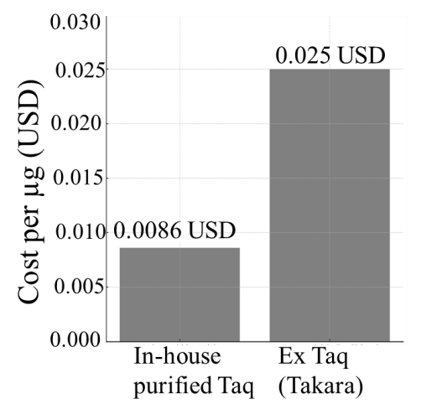Collectively, these findings confirm that the in-house production method is cost-efficient, catalytically robust, and adaptable to educational or budget-limited settings.

**Figure 6. Cost comparison of in-house versus commercial Taq polymerase production.**

Graph comparing the cost per microgram (µg) of Taq DNA polymerase produced using the simplified in-house strategy described in this study versus the cost of commercially available Ex Taq DNA polymerase (Takara Bio). In-house production from a 300 mL culture yielded 1,620 µg of enzyme at an estimated cost of $0.0086/µg, compared to $0.0250/µg for the commercial preparation—reflecting a ~65% cost reduction. Cost estimates were based on actual reagent usage, yield per batch, and current academic pricing (see Supplementary Table 3). Bars represent mean ± SD (n = 3) based on three independent preparations. These results demonstrate that in-house enzyme production is economically viable and does not require specialized equipment or proprietary kits.

# 4. DISCUSSION

This study establishes that the pBluescript SK(+) plasmid, a commonly used cloning vector for blue-white screening, can be repurposed to express thermostable Taq DNA polymerase. This was achieved using heat-based purification and ammonium sulfate precipitation. The approach removes reliance on affinity tags, column chromatography, or commercial expression systems (Menacho‑Melgar et al., 2021; Samman et al., 2023) and consistently yields enzymatically active Taq polymerase with high purity (90.1 ± 2.1%). These findings address a critical gap in molecular biology education and under-equipped environments, especially in settings where commercial enzymes are prohibitively expensive or unavailable, and access to expression systems like T7 vectors is limited (Carroll and Keller, 2014; Bhadra et al., 2022). This challenge is well documented in reviews of diagnostic limitations in low-income settings (Rodrigues et al., 2016; Chakraborty, 2024).

The performance of the recombinant enzyme was confirmed through multiple functional assays, demonstrating the experimentally confirmed expression and retention of catalytic activity and thermal stability. Titration-based PCR amplification using an 813 bp target fragment showed that the in-house enzyme performed comparably to commercial Ex Taq across a range of input volumes. No statistically significant differences in PCR product yield were observed (p > 0.05), confirming functional equivalence to Ex Taq (Takara Bio). Thermostability assays further demonstrated that the enzyme retains >70% residual activity after 20 repeated 95 °C heat cycles, and ~50% after 30 cycles at 95 °C, levels consistent with commercial thermostable polymerases (Lawyer et al., 1989; Ghadessy et al., 2001). Thermal stability of family A DNA polymerases has been closely correlated with structural adaptations in both theoretical and experimental studies (Borhani and Arab, 2023; Bulygin et al., 2023), supporting the mechanistic basis for heatbased purification.

The purification protocol—based solely on heat denaturation at 75 °C and 60% ammonium sulfate precipitation—achieved high purity without the need for chromatography or resin-based enrichment, consistent with earlier heat- and salt-based enrichment workflows (Zhou et al., 2018). Our findings expand significantly on these prior reports by incorporating functional assessment, consistency testing, adaptability across culture volumes, and cost analysis in an instructional context. The rationale for this approach dates back to the earliest characterization of Taq polymerase stability and utility in PCR workflows (Gelfand, 1989). Recent innovations have further authenticated the feasibility of chromatography-free workflows for Taq polymerase using auto-inducible expression systems (Menacho-Melgar et al., 2021). Additional work has demonstrated strain-optimized *E. coli* expression with rapid purification techniques (Teng et al., 2023). A recent study further demonstrated high-yield expression of Taq polymerase using an IPTG-independent autoinduction system in a benchtop bioreactor (Laksmi et al., 2025). This approach enables high-yield enzyme production but still depends on controlled fermentation conditions and remains less accessible for low-resource laboratories. Additional work has explored expression of thermostable polymerases from *Pyrococcus furiosus* and *Geobacillus stearothermophilus*, offering further models for scalable, low-cost production (Nuryana et al., 2023; Agustriana et al., 2023; Khaerunnisa et al., 2025). While consistent with earlier reports on simplified purification (Zhou et al., 2018), this study advances the field by integrating functional testing, reliability analysis, volume-range adaptability, and cost assessment tailored to educational use. Experiments at 5 mL, 50 mL, and 300 mL volumes confirmed the workflow’s robustness across varying production capacities. Yield increased ~40-fold from 5 mL to 300 mL cultures, closely matching the scale-up factor and indicating minimal loss during purification. This yield compares favorably to more complex systems using codon-optimized constructs and

T7-driven vectors, which typically generate 2–8 mg/L but rely on costly affinity purification (Olszewski et al., 2017; Zhou et al., 2018; Samman et al., 2023). These expression levels are consistent with reports from recombinant protein factories and high-cell density systems (Rosano and Ceccarelli, 2014; Choi et al., 2006; Ferrer-Miralles et al., 2009).

A key finding of this study is the substantial reduction in material costs. The 300 mL culture yielded 1,620 µg of purified enzyme for $13.62. This represents a ~65% reduction in cost-per-microgram compared to commercial Ex Taq. More strikingly, the per-reaction cost— estimated at $0.004–$0.009 for 0.5–1.0 U per 25 µL PCR—represents a 70–85% reduction relative to the $0.03–$0.05 per reaction cost of commercial enzyme. These values are consistent with previous educational or diagnostic efforts that reported higher per-unit costs for studentprepared or recombinant Taq polymerase, ranging from $0.05 to $0.50 per unit depending on strategy complexity and expression system (Ferralli et al., 2007; Zhra et al., 2024). Recent theoretical and cost-focused studies support the viability of in-house enzyme production over commercial kits, especially in decentralized or teaching labs (Wingfield, 2015; Chakraborty, 2024). These savings are especially impactful in instructional labs, where enzyme costs often limit hands-on molecular biology. Educationally, this strategy reinforces core molecular biology skills—including restriction enzyme digestion, blue-white screening, colony PCR, protein expression, and non-affinity purification—all without reliance on kits from specialized suppliers. These features make the workflow ideal for biotechnology instruction and align with global initiatives to democratize molecular biology education, including platforms like BioBuilder and DIYBio (Bernstein et al., 2015; Vilanova and Porcar, 2014). The open-source framework is particularly aligned with new trends in decentralized biotech training and resource-sharing initiatives (Ferrer-Miralles et al., 2009; Chakraborty, 2024). By using reagents and vectors already available in most teaching laboratories, this strategy lowers barriers to entry for institutions with limited infrastructure. This is especially important in low- and middle-income countries—such as those in Africa, South America, and parts of Asia—where infrastructure limitations and high reagent costs often hinder routine molecular biology. The use of nonproprietary tools, combined with independence from specialized equipment or supplier-specific kits, makes the method suitable for academic or instructional use, including under-equipped settings.

A key novelty of this study lies in experimentally demonstrating the repurposing of the common pBluescript SK(+) cloning vector for expression of a thermostable polymerase—a use that, to our knowledge, has not been demonstrated in published experimental workflows. Unlike traditional T7-driven systems, the pBluescript SK(+) plasmid is widely available in teaching labs and provides a truly open-access, licensing-free platform for protein expression—a novel application for a vector typically reserved for cloning. When paired with a chromatography-free purification strategy, this approach offers a streamlined alternative to supplier-dependent workflows. Individual elements of this strategy —such as heat denaturation and salt precipitation—have been described in earlier studies (e.g., Pluthero, 1993). However, they were not previously optimized or applied in combination with a non-expression vector like pBluescript SK(+) for enzyme production in cost-constrained environments. Critically, our approach achieves a ~65% reduction in cost-per-microgram and up to 85% reduction in cost-per-reaction relative to commercial enzymes. This study includes benchmarking, thermostability testing, and cost analysis. These elements together make it a practical and reliable solution. To our knowledge, this is the first experimentally verified use of pBluescript SK(+) for expressing Taq DNA polymerase. By centering accessibility, we address an urgent need in molecular biology training and promote broader adoption of core tools in underfunded teaching and research environments. This aligns with broader calls for expanded access to core molecular technologies via DIY science, synthetic biology education, and local enzyme manufacturing (Vilanova and Porcar, 2014; Nuryana et al., 2023).

This work builds on foundational efforts to express and purify Taq polymerase (Lawyer et al., 1989; Engelke et al., 1990), extending their utility into the modern landscape of open science and decentralized biotechnology education. By integrating widely available molecular tools with rigorous functional testing, evaluation across varying production volumes, and cost analysis, we provide a sustainable framework for enzyme production that is accessible, standardized, and instructionally relevant. Our approach contributes to a growing ecosystem of low-cost, open-source workflows that empower resource-limited teaching and research laboratories.

Specifically, this study: (1) repurposes the pBluescript SK(+) vector—traditionally reserved for cloning—as a functional expression platform for a thermostable polymerase; (2) eliminates the need for affinity tags and chromatography by relying on heat denaturation and salt precipitation; (3) delivers a robust, low-cost strategy tested across culture scales, performance assays, and cost comparisons; and (4) supports decentralized enzyme production using tools already common in academic labs. To our knowledge, no prior study integrates all these elements into a single, experimentally demonstrated, instructional-grade workflow. As enzyme access remains a persistent barrier to practical molecular biology, this strategy offers a viable model for expanding hands-on training and enabling community-based life science innovation.

# 5. CONCLUSION

We demonstrate a reliable and budget-friendly approach for producing thermostable Taq DNA polymerase with accessible tools and reagents, using the pBluescript SK(+) plasmid. The commonly used cloning vector, typically reserved for blue-white screening, was repurposed for IPTG-inducible expression in *E. coli*. Purification was achieved without chromatography—using heat denaturation and ammonium sulfate precipitation. The resulting enzyme showed

90.1 ± 2.1% purity and retained catalytic activity across multiple PCR titrations. Thermostability was confirmed, with >70% activity after 20 heat cycles and ~50% after 30 cycles at 95 °C. These results are comparable to commercial Ex Taq (Takara Bio). Critically, this strategy reduced material cost per microgram by ~65% and lowered per-reaction cost by 70–85%, without requiring licensed vectors, affinity resins, or specialized tools.

Beyond technical performance, this work offers an open-access alternative to commercial enzyme production. The approach reinforces foundational molecular biology skills and provides a turnkey, instructional-grade solution suitable for decentralized use. By avoiding the need for specialized equipment or proprietary kits and instead relying on reagents and tools commonly found in academic laboratories, the method remains broadly accessible. It is well-suited for instructional and research applications in under-equipped environments. Overall, this study presents a sustainable, well-established model for enzyme production and highlights the untapped potential of broadly available molecular tools to support equitable and practical molecular biology training worldwide.

# Supplementary Materials

The following supplementary data are available:

**Supplementary Figure 1.** Sequence verification of the recombinant *pBluescript-Taq* plasmid.

**Supplementary Table 1.** Itemized reagent and consumable costs for 50 mL and 300 mL cultures

**Supplementary Table 2.** Yield and cost summary by culture volume

**Supplementary Table 3.** Comparison of production costs for in-house Taq DNA polymerase and commercial Ex Taq (Takara Bio).

**Supplementary Table 4.** Detailed Cost Breakdown (300 mL scale)

# DISCLAIMER (ARTIFICIAL INTELLIGENCE)

Authors hereby declare that NO generative AI technologies such as Large Language Models and text-to-image generators have been used during the writing or editing of this manuscript.

# ACKNOWLEDGEMENTS

We thank the Biology Department at the University of Scranton for supporting undergraduate research infrastructure.

**COMPETING INTERESTS**

Authors have declared that no competing interests exist.

# Authors’ contributions

This work was carried out in collaboration with both authors. Authors NR and BRK jointly performed the experiments and analyzed the data. Author BRK supervised the project, guided the experimental design, and led the manuscript writing and revision. Both authors read and approved the final manuscript.

# REFERENCES

Chien, A., Edgar, D. B., & Trela, J. M. (1976). Deoxyribonucleic acid polymerase from the extreme thermophile Thermus aquaticus. *Journal of Bacteriology, 127*(3), 1550–1557.

Ishino, S., Ishino, Y. (2014) DNA polymerases as useful reagents for biotechnology–the history of developmental research in the field. *Frontiers in microbiology*, *29(5),* 465.

Zhu, H., Zhang, H., Xu, Y., Laššáková, S., Korabečná, M., Neužil, P. (2020) PCR past, present and future. *Biotechniques*, *69(4)*, 317-25.

Olszewski, M., Śpibida, M., Bilek, M., & Krawczyk, B. (2017). Fusion of Taq DNA polymerase with single-stranded DNA binding-like protein of Nanoarchaeum equitans—Expression and characterization. *PLOS ONE, 12*(9), e0184162.

Mendoza-Rojas, G., Sarabia-Vega, V., Sanchez-Castro, A., Tello, L., Cabrera-Sosa, L., Nakamoto, J. A., Peñaranda, K., Adaui, V., Alcántara, R., & Milón, P. (2021). A low-cost and open-source protocol to produce key enzymes for molecular detection assays. *STAR Protocols, 2*(4), 100899.

Samman, N., Al-Muhalhil, K., & Nehdi, A. (2023). A simple and efficient method for Taq DNA polymerase purification based on heat denaturation and affinity chromatography. *Journal of King Saud University – Science, 35*(3), 102565.

Gomes, L. C., Ferreira, C., & Mergulhão, F. J. (2022). Implementation of a practical teaching course on protein engineering. *Biology, 11*(3), 387.

Lawyer, F. C., Stoffel, S., Saiki, R. K., Myambo, K., Drummond, R., & Gelfand, D. H. (1989). Isolation, characterization, and expression in Escherichia coli of the DNA polymerase gene from Thermus aquaticus. *Journal of Biological Chemistry, 264*(11), 6427–6437.

Engelke, D. R., Krikos, A., Bruck, M. E., & Ginsburg, D. (1990). Purification of Thermus aquaticus DNA polymerase expressed in Escherichia coli. *Analytical Biochemistry, 191*(2), 396– 400.

Carroll, C. W., & Keller, L. C. (2014). An adaptable investigative graduate laboratory course for teaching protein purification. *Biochemistry and Molecular Biology Education, 42*(6), 486–494.

Lee, S. J., Park, S. Y., Lee, K. H., Lee, M. W., Yu, C. Y., Maeng, J., Kim, H. D., Kim, S. W. (2023) Development of a simple direct and hot-start PCR using Escherichia coli-expressing Taq DNA polymerase. *International* *journal of molecular sciences*, *24(14)*, 11405.

Laksmi, F. A., Dewi, K. S., Nuryana, I., Yulianti, S. E., Ramadhan, K. P., Hadi, M. I., & Nugraha, Y. (2024). High-level expression of codon-optimized Taq DNA polymerase under the control of rhaBAD promoter. *Analytical Biochemistry, 692*, 115581.

Pluthero, F. G. (1993). Rapid purification of high-activity Taq DNA polymerase. *Nucleic Acids Research, 21*(20), 4850.

Bhadra, S., Paik, I., Torres, J. A., Fadanka, S., Gandini, C., Akligoh, H., Molloy, J., & Ellington, A. D. (2022). Preparation and use of cellular reagents: a low‐resource molecular biology reagent platform. *Current Protocols, 2*(3), e387.

Brock, T. D., & Freeze, H. (1969). Thermus aquaticus gen. n. and sp. n., a nonsporulating extreme thermophile. *Journal of Bacteriology, 98*(1), 289–297.

Menacho-Melgar, R., Yang, T., & Lynch, M. D. (2021). Instant Taq: Rapid autoinducible expression and chromatography-free purification of Taq polymerase. *bioRxiv*. <https://doi.org/10.1101/2021.09.25.461831>

Rodrigues, C., Desai, N., & Fernandes, H. (2016). Molecular diagnosis in resource-limited settings. *Clinical Microbiology Newsletter, 38*(7), 51–56.

Chakraborty, S. (2024). Democratizing nucleic acid-based molecular diagnostic tests for infectious diseases at resource-limited settings–from point of care to extreme point of care. *Sensors & Diagnostics, 3*(4), 536–561.

Ghadessy, F. J., Ong, J. L., & Holliger, P. (2001). Directed evolution of polymerase function by compartmentalized self-replication. *Proceedings of the National Academy of Sciences, 98*(8), 4552–4557.

Borhani, S., & Arab, S. S. (2023). Investigation of thermal stability characteristic in family A DNA polymerase—A theoretical study. *Progress in Biophysics and Molecular Biology, 182*, 15– 25.

Bulygin, A. A., Kuznetsova, A. A., Fedorova, O. S., & Kuznetsov, N. A. (2023). Comparative analysis of Family A DNA-polymerases as a searching tool for enzymes with new properties. *Molecular Biology, 57*(2), 182–192.

Zhou, H., Zhang, Y., Hu, Z., Mu, A., & Gu, X. (2018). High-efficiency separation and purification of Taq DNA polymerase. In Liu, H., Song, C., & Ram, A. (Eds.), *Advances in Applied Biotechnology. ICAB 2016. Lecture Notes in Electrical Engineering, 444* (pp. 663–672). Singapore: Springer. <https://doi.org/10.1007/978-981-10-4801-2_68>

Gelfand, D. H. (1989). Taq DNA polymerase. In *PCR Technology: Principles and Applications for DNA Amplification* (pp. 17–22). London: Palgrave Macmillan UK.

Teng, X. C., Nag, S. Y., Citartan, M., Tang, T. H., Ahmed, S. A. (2023) Simple approach for expression and rapid purification of Taq DNA polymerase in three Escherichia coli strains. *Asia‑Pacific Journal of Molecular Biology and Biotechnology,* *31(1),* 45-52.

Laksmi, F. A., Lischer, K., Nugraha, Y., Violando, W. A., Helbert, Nuryana, I., Khasna, F. N.,

Nur, N., Ramadhan, K. P., Tobing, D. A., Hariyatun. (2025) A robust strategy for overexpression of DNA polymerase from Thermus aquaticus using an IPTG-independent autoinduction system in a benchtop bioreactor. *Scientific reports*, *15(1)*, 5891.

Nuryana, I., Laksmi, F. A., Dewi, K. S., Akbar, F. R., & Harmoko, R. (2023). Codon optimization of a gene encoding DNA polymerase from Pyrococcus furiosus and its expression in Escherichia coli. *Journal of Genetic Engineering and Biotechnology, 21*(1), 129.

Agustriana, E., Nuryana, I., Laksmi, F. A., Dewi, K. S., Wijaya, H., Rahmani, N., Yudiargo, D.

R., Ismadara, A., Helbert, H., Hadi, M. I., & Purnawan, A. (2023). Optimized expression of large fragment DNA polymerase I from Geobacillus stearothermophilus in Escherichia coli expression system. *Preparative Biochemistry & Biotechnology, 53*(4), 384–393.

Khaerunnisa, L., Laksmi, F. A., Rahayuningsih, M., Amalia, A. R., Violando, W. A., Nuryana,

I., Ertanto, Y., & Nugraha, Y. (2025). One-step rapid production of DNA polymerase from Pyrococcus furiosus in Escherichia coli system under optimized culture conditions. *Preparative Biochemistry & Biotechnology*. Advance online publication. https://doi.org/10.1080/10826068.2025.0000000

Rosano, G. L., & Ceccarelli, E. A. (2014). Recombinant protein expression in Escherichia coli: Advances and challenges. *Frontiers in Microbiology, 5*, 172.

Choi, J. H., Keum, K. C., & Lee, S. Y. (2006). Production of recombinant proteins by high cell density culture of Escherichia coli. *Chemical Engineering Science, 61*(3), 876–885.

Ferrer-Miralles, N., Domingo-Espín, J., Corchero, J. L., Vázquez, E., & Villaverde, A. (2009). Microbial factories for recombinant pharmaceuticals. *Microbial Cell Factories, 8*(1), 17.

Zhra, M., Al Saud, A., Alzayer, M., Okdah, L., Tamim, H., Fakhoury, H. M. A., & Aljada, A. (2024). Cost-effective in-house COVID-19 reverse transcription-polymerase chain reaction testing with yeast-derived Taq polymerase. *Annals of Thoracic Medicine, 19*(2), 165–171. https://doi.org/10.4103/atm.atm_180_23

Wingfield, P. T. (2015). Overview of the purification of recombinant proteins. *Current Protocols in Protein Science, 80*(1), 6.1–6.35.

Bernstein, R., Ingram, K., & Hart, K. M. (2015). *BioBuilder: Synthetic Biology in the Lab*. O’Reilly Media, Inc.

Vilanova, C., & Porcar, M. (2014). iGEM 2.0—Refoundations for engineering biology. *Nature Biotechnology, 32*(5), 420–424.

Ferralli, P., Egan, J. D., & Erickson, F. L. (2007). Making Taq DNA polymerase in the undergraduate biology laboratory. *Bios, 78*(2), 69–74.

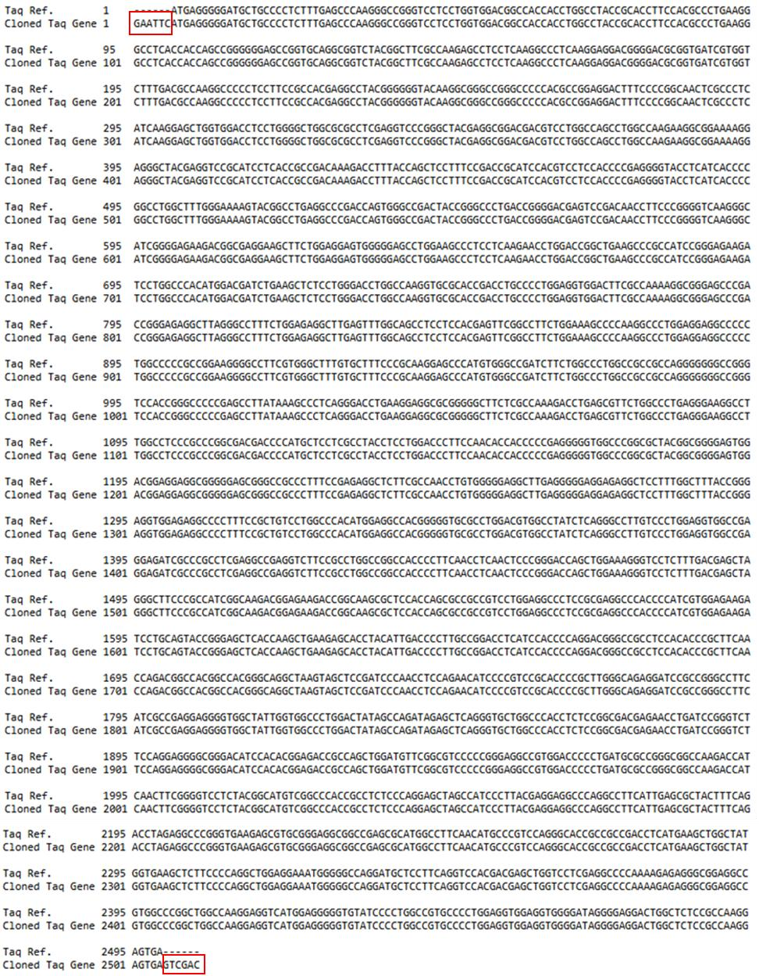

1. **Supplementary Figure 1. Sequence verification of the recombinant *pBluescript-Taq* plasmid.**
2. In silico alignment of the cloned *Taq* sequence with the reference gene (GenBank: J04639.1), confirming 100% 745 sequence identity and correct reading frame. Red boxes highlight restriction sites.

**Supplementary Table 1. Itemized reagent and consumable costs for gene cloning, expression, purification, and activity validation workflows at 50 mL and 300 mL culture volumes.**

*All prices reflect 2024–2025 U.S. academic rates using standard vendors (e.g., NEB, Fisher Scientific, GenScript). Labor and equipment costs were excluded, as is standard in academic cost estimates.*

|  |  |  |  |  |
| --- | --- | --- | --- | --- |
| **Item / Reagent** | **Unit**  **Cost**  **(USD)** | **Total Cost -**  **50 mL (USD)** | **Total Cost -**  **300 mL (USD)** | **Notes** |
| LB broth powder | 0.20 | 0.20 | 0.60 |  |
| Ampicillin | 0.10 | 0.10 | 0.30 |  |
| IPTG | 0.25 | 0.25 | 0.75 |  |
| Restriction enzymes (EcoRI + SalI) | 0.40 | 0.40 | 0.40 | Used for cloning |
| T4 DNA Ligase | 0.30 | 0.30 | 0.30 | For ligation |
| Agarose + EtBr | 0.25 | 0.25 | 0.25 | 1% gel |
| Competent *E. coli*  BL21(DE3) | 0.80 | 0.80 | 0.80 | Commercial cells |
| X-gal + IPTG + plates | 0.30 | 0.30 | 0.30 | For blue-white selection |
| Ammonium sulfate | 0.15 | 0.15 | 0.45 | Heat precipitation |
| Tris/KCl/EDTA buffer | 0.10 | 0.10 | 0.30 | Buffer preparation |
| Dialysis tubing  (MWCO 10 kDa) | 0.30 | 0.30 | 0.30 |  |
| Bradford reagent +  BSA | 0.15 | 0.15 | 0.20 | Protein quantification |
| Pipette tips, tubes, plasticware | 0.20 | 0.20 | 0.30 | General consumables |
| PCR primers (M13 + gene-specific) | 0.10 | 0.10 | 0.10 | Used in colony PCR |
| dNTPs (colony PCR) | 0.05 | 0.05 | 0.05 | One reaction |

|  |  |  |  |  |
| --- | --- | --- | --- | --- |
| **Miniprep spin columns** | **1.00** | **1.00** | **1.00** | Assumes screening of a single clone |
| **Sanger sequencing** | **6.00** | **6.00** | **6.00** | Based on T7 and T3 primers |
| SOC media | 0.20 | 0.20 | 0.20 | Used after transformation |
| **Homemade**  **competent cell reagents** | **0.10** | **0.10** | **0.10** | CaCl₂ and glycerol |
| **Labor/technical time** | **0.00** | **0.00** | **0.00** | Labor costs excluded as per academic standard practice |
| DNeasy kit (gDNA extraction) | 1.00 | 1.00 | 1.00 | From *T. aquaticus* |
| IGEPAL CA-630 | 0.05 | 0.05 | 0.05 | Lysis buffer component |
| Triton X-100 | 0.05 | 0.05 | 0.05 | Lysis buffer component |
| DTT | 0.05 | 0.05 | 0.05 | Storage buffer component |
| **Glycerol** | **0.05** | **0.05** | **0.05** | 50% in storage buffer |
| λ DNA template | 0.05 | 0.05 | 0.05 | Used for PCR verification |
| β-mercaptoethanol | 0.05 | 0.05 | 0.05 | For SDS-PAGE |
| **DNA ladder (1 kb)** | **0.15** | **0.15** | **0.15** | NEB ladder used for gel analysis |
| **PCR reaction dNTPs + buffer** | **0.15** | **0.15** | **0.15** | For full λ DNA PCR confirmation |
| **TOTAL (including optional items)** | **—** | **$12.20** | **$13.62** | Confirmed after itemization |

752

|  |  |  |  |
| --- | --- | --- | --- |
| **Prep Scale** | **Total Yield (µg)** | **Total Cost (USD)** | **Cost per µg (USD)** |
| 50 mL | 260 | 12.20 | 0.0469 |
| 300 mL | 1,620 | 13.62 | 0.0086 |

753 **Supplementary Table 2. Yield and cost summary by culture volume** 754 *Total protein yield and cost efficiency from scaled-up culture volumes.* 755 **Supplementary Table 3. Comparison of production costs for in-house Taq DNA** 756 **polymerase and commercial Ex Taq (Takara).**

|  |  |  |  |
| --- | --- | --- | --- |
| **Source** | **Total Yield (µg)** | **Total Cost (USD)** | **Cost per µg (USD)** |
| In-house (this study) | 1,620 | 13.62 | 0.0086 |
| Commercial Ex Taq | 250 | 6.25 | 0.0250 |

757

# 758 Supplementary Table 4, Detailed Cost Breakdown (300 mL scale)

|  |  |  |  |
| --- | --- | --- | --- |
| **Culture Volume** | **Total Yield** | **Total Cost (USD)** | **Cost per µg (USD)** |
| 50 mL | 260 µg | 12.20 | 0.0469 |
| 300 mL | 1,620 µg | 13.62 | 0.0086 |

759