**Seed and Seedling Quality coupled with Biochemical Perceptions: Paving the way for improved yield and stress resilience in Mungbean [*Vigna radiata* (L.) Wilczek]**

**ABSTRACT**

**Aim:** The present study aims to evaluate the seed and seedling quality traits alongside key biochemical parameters in diverse mungbean genotypes to identify promising lines with superior germination potential, early seedling vigour, and biochemical resilience. The ultimate goal is to associate these physiological and biochemical traits with improved yield potential and stress tolerance, thereby contributing to the development of robust mungbean cultivars suited for diverse agro-ecological conditions.

**Study Design:** The laboratory experiment was laid in a CRD design with three replications.

**Place and duration of Study:** The laboratory experiment was carried out in the Department of Seed Science and Technology, Odisha University of Agriculture and Technology (OUAT), Bhubaneswar, Odisha.

**Methodology:** The seed physiological parameters such as germination percentage (%), root length (cm), shoot length (cm), Seedling length (cm), Seedling fresh weight (g), Seedling dry weight (g), Seed vigour index-I (SV-I), Seed vigour index-II (SV-II), Speed of germination (SOG) and Mean germination time (MGT) and biochemical parameters such as total soluble proteins, total soluble sugars, total phenol content were estimated using the standard procedure.

**Results:** Significant genotypic variation was observed across 14 mungbean genotypes for seed quality parameters. ML-2479 exhibited the highest germination percentage and seed vigour index-I, while IPM-410-3 had the highest seedling fresh weight and vigour index-II. OKGG-9 (F5) showed consistently good performance across multiple parameters including seedling length, dry weight, and both vigour indices. Faster germination (low MGT) was seen in IPM-410-3 and ML-1808, which is desirable for early establishment. Biochemical analysis revealed that LGG-460 had the highest protein and sugar content, whereas V-02-709 had the highest phenol content. Variation in phenol, sugar, and protein content among genotypes also points toward diverse nutritional and defensive capacities.

**Conclusion:** The study revealed a wide range of genetic variability among mungbean genotypes for both physiological and biochemical traits. Genotypes such as ML-2479, IPM-410-3, ML-1808, and OKGG-9 (F5) emerged as superior in seed vigour and early seedling growth, making them suitable for cultivation and breeding for high early vigour. Overall, the integration of seed quality and biochemical data provides a strong foundation for identifying mungbean genotypes with enhanced yield potential, stress resilience, and resistance to storage pests. These insights can inform targeted breeding programs and improve mungbean productivity under diverse agro-ecological conditions.

**Keywords:** Biochemical Parameters, Mungbean, Seed Vigour Index, Speed of Germination, Seedling Quality

1. **INTRODUCTION**

Mungbean [*Vigna radiata* (L.) Wilczek] is an economically significant legume, known for its short life cycle, high nutritional value, and crucial role in sustainable agricultural systems through nitrogen fixation (Majhi and Mogali, 2020; Majhi *et al*., 2022; Nair *et al*., 2012). It serves as an affordable protein source, especially in developing countries, and contributes to soil health in cereal-based cropping systems. However, the productivity of mungbean remains inconsistent due to challenges such as poor seed quality, susceptibility to abiotic stresses, and uneven crop establishment (Majhi *et al*., 2020a, b). Seed quality is a cornerstone of successful crop production, influencing early seedling establishment, growth uniformity, and ultimately, yield potential. Key physiological parameters, including germination percentage, root and shoot length, seedling fresh and dry weight, and seedling length, are fundamental indicators of seed vigour and seedling performance (Bewley *et al*., 2013; Kumar *et al*., 2024). Moreover, indices such as Seed Vigour Index-I (SV-I), Seed Vigour Index-II (SV-II), Speed of Germination (SOG), and Mean Germination Time (MGT) provide quantitative measures of seed performance, vigour, and uniformity under both optimal and stress conditions (Ali et al., 2010).

Beyond physical growth metrics, biochemical attributes play a critical role in determining seed quality and stress resilience. Total soluble proteins are essential for cellular functions and serve as metabolic reserves during germination, influencing seedling vigour. Total soluble sugars provide an immediate energy source critical for germination, osmotic regulation, and early seedling establishment, particularly under stress environments. Additionally, total phenol content contributes to the plant’s antioxidant defence system, protecting seedlings against oxidative damage induced by environmental stresses such as drought or salinity (Diya and Jayalekshmy, 2024). Recent interventions also underscore the impact of **seed treatments** such as nutrient sprays and electromagnetic or integrated treatments on these biochemical profiles, which in turn elevate seed germination, vigour, and stress resilience in mungbean.

The integration of physiological and biochemical assessments provides a holistic approach to evaluating seed vigour, seedling performance, and potential stress tolerance. While several studies have independently focused on seed physiological traits or biochemical traits, a combined understanding remains limited for mungbean, particularly concerning its contribution to yield improvement and stress mitigation (Kumar *et al*., 2024; Diya and Jayalekshmy, 2024). In this context, the present investigation aims to comprehensively evaluate seed and seedling quality parameters in mungbean alongside key biochemical parameters, including total soluble proteins, sugars, and phenols. The objective is to identify reliable indicators of seed vigour and early-stage stress resilience, thereby contributing to improved mungbean productivity under variable agro-climatic conditions.

1. **MATERIALS AND METHODS**
   1. **Experimental Site**

The laboratory experiment was carried in the Department of Seed Science and Technology, Odisha University of Agriculture and Technology (OUAT), Bhubaneswar, Odisha.

* 1. **Experimental Materials**

The research material consisted of total 14 mungbean entries which includes four advanced breeding lines with F5 generation (OKGG-9 OKGG-10, OKGG-11 and OKGG-12); five parental lines (OBGG-52, OBGG-56, OBGG-58, VIRAT and V-02-709), and five check varieties (LGG-460, OUM-11-5, ML-2479, ML-1808 and IPM-410-3).

* 1. **Experimental Design**

The laboratory experiment was conducted using Completely Randomized Design (CRD) with the number of replications set at three.

* 1. **Study of Seed physiological parameters** 
     1. **Germination percentage (%):**

The germination test of seeds was done using Between Paper Method with three replications. The seeds were kept inside the germinator at 25oC and germination percentage was found out by using the following formula:

Seed germination (%) =

* + 1. **Root length (cm):**

Five normal seedlings were randomly selected and the length of their roots was measured using a scale on 8th day of germination test and expressed in centimeters.

* + 1. **Shoot length (cm):**

Five seedlings were selected randomly and their lengths were measured from the collar to the tip region. The values obtained were averaged and the mean value was recorded in centimeters.

* + 1. **Seedling length (cm):**

Five seedlings were randomly picked and the length from the topmost portion to the root tip was measured by a scale and their mean was recorded in centimeter.

* + 1. **Seedling fresh weight (g):**

The seedlings used for measurement of seedling length were weighed using an electronic balance and their mean was recorded in grams up to three decimal places.

* + 1. **Seedling dry weight (g):**

The seedlings used for measurement of seedling length were further put in butter paper bags and heated in hot air oven at 80oC for 24 hours. Then they were weighed using an electronic balance and their mean was recorded in grams up to three decimal places.

* + 1. **Seed Vigour Index-I (SV-I):**

The vigour index of seeds was calculated by the method given by Abdul Baki and Anderson (1973). The average root and shoot lengths calculated earlier were used in its calculation.

Seed Vigour Index-I = Germination per cent× Mean Seedling length (cm)

* + 1. **Seed Vigour Index-II (SV-II):**

Calculation of Seed Vigour Index-II was done as per formula given by Abdul Baki and Anderson (1973). Mean seedling dry weights calculated earlier were used in its calculation.

Seed Vigour Index-II = Germination per cent× Mean Seedling Dry Weight (g)

* + 1. **Speed of Germination (SOG):**

It is calculated with the formula given by Maguire (1962) considering the number of seeds germinated daily up to the final count.

SOG **= $\sum{\frac{n}{d}}$**

Where n = number of seeds germinated, d = days from sowing

* + 1. **Mean Germination Time (MGT):**

It is conducted in a similar way as for Speed of germination, using the formula given by Ellis and Roberts (1980).

MGT = $\frac{N_{1}T_{1} + N_{2}T_{2} + …N_{n}T_{n}}{N}$

Where N1 = number of seeds which germinate on 1st day

N2 = number of seeds which germinate on 2nd day

T1, T2 = days after sowing

N = Total number of germinated seeds

* 1. **Study of Seed Biochemical parameters** 
     1. **Total soluble proteins:**

**Reagents used:**

1. Phosphate buffer [0.2M solution of monobasic sodium phosphate + 0.2M solution of dibasic sodium phosphate]
2. Reagent A [0.1N NaOH + 2g Na2CO3]
3. Reagent B [0.5% CuSO4.5H2O + 1% Sodium-Potassium tartarate]
4. Reagent C [50ml of Reagent A + 1 ml of Reagent B]
5. Reagent D [7mlFolin-Ciocalteau reagent + 7 ml water]
6. Bovine serum albumin

**Preparation of phosphate buffer:**

A solution of monosodium dihydrogen sulphate was made by dissolving 2.78 g in 100 ml of distilled water, and another solution of disodium monohydrogen sulphate was prepared by dissolving 5.365 g in 100 ml of distilled water. From these, 5.3 ml of the monosodium dihydrogen sulphate solution and 94.7 ml of the disodium monohydrogen sulphate solution were combined.

**Procedure:**

Analysis of Seed Protein content was conducted by using the protocol stated by Lowry *et al*. (1951) with a few modifications. 0.2 g powdered mungbean seeds were macerated using 10 ml Phosphate buffer followed by centrifugation at 5000 rpm for 10 minutes. After discarding the supernatant, 10 ml of 1N NaOH was added, thoroughly mixed, followed by centrifugation at 10,000 rpm for 10 minutes. Protein estimation was performed using the supernatant. A working standard solution of 0, 0.2, 0.4, 0.6, 0.8 and 1.0 ml was pipetted into each test tube, followed by 0.2 ml of 1N NaOH. Subsequently, two additional test tubes were prepared by pipetting 0.1 ml and 0.2 ml of the sample extract, respectively, followed by the addition of 1 ml of water to each tube. In addition, a control tube containing 1 ml of water was also set up, serving as a blank for comparison purposes. Following thorough mixing, 5 ml of Reagent C was added to each of the tubes, including the blank, and the mixture was incubated at room temperature for 10 minutes. Subsequently, there was addition of 0.5 ml of Reagent D to each tube, and after stirring, the tubes were set for incubation for 30 minutes, or until a distinct blue coloration developed. The optical density (O.D.) value of the sample was checked at 660 nm. A standard curve was generated (Fig. 1), using which the concentration of protein present in the sample was calculated, with the results expressed as mg/g or percentage.

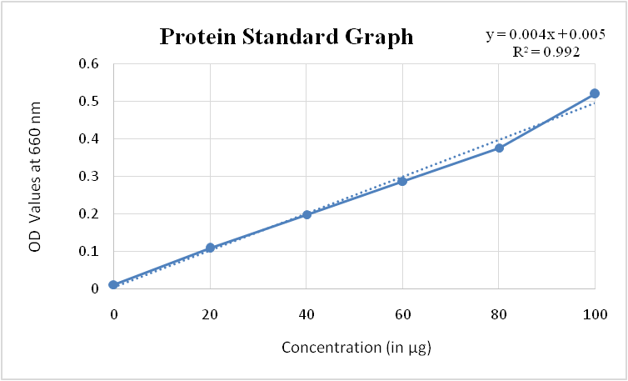

**Fig. 1. Standard graph for total soluble proteins**

* + 1. **Total Soluble Sugars:**

**Reagents required:**

1. 80% ethanol–Ethanol (80ml) was dissolved in 20 ml water
2. Anthrone solution – 400 mg anthrone dissolved in 200 ml conc. sulphuric acid and stored in refrigerator. It was prepared fresh.
3. Glucose stock solution – 5mg glucose was added to 80 % ethanol to make it to 50 ml. This was labeled as 100 ppm glucose stock solution.

**Procedure:**

Seeds were grinded and 0.1 g of the ground seed sample was taken along with 10 ml of 80% ethanol. The tube was then subjected to a heat treatment, where it was submerged in a water bath maintained at a temperature of 80°C for duration of 30 minutes. Subsequently, the tube underwent centrifugation at a speed of 3000 rpm for 15 minutes. The supernatant was decanted into a volumetric flask, and the extraction procedure was repeated for a second time. The final supernatant was collected in a 50 ml volumetric flask and diluted to the 50ml mark with 80% ethanol. The mixture was then filtered through a filter paper, and the resulting filtrate was used for sugar estimation. A 1 ml aliquot of the sugar extract was transferred to a 25 ml volumetric flask and diluted to the 25ml mark with 80% ethanol. From each of these diluted samples, a 5 ml portion was then transferred to 50ml test tubes. The tubes were subsequently refrigerated to cool. For standard preparation, five test tubes were used. To each tube, the following volumes of glucose stock solution were added: 0ml, 1.0ml, 1.5 ml, 2.0 ml and 2.5 ml respectively. Each tube was then diluted to a final volume of 5 ml by adding distilled water. The tubes were then chilled in a refrigerator to lower their temperature. After cooling, anthrone reagent (10 ml) was added to each tube including the standards by allowing it to slowly run down the walls of the tubes. The contents of the tubes were gently agitated using a glass rod to ensure thorough mixing, followed by shaking. The tubes were then immersed in a boiling water bath, where they were heated for 7.5 minutes, followed by rapid cooling in an ice bath. After cooling, the optical density (O.D.) values of the solutions were measured using a spectrophotometer at a wavelength of 630 nm. The sugar content was subsequently calculated using a standard curve (Fig. 2).

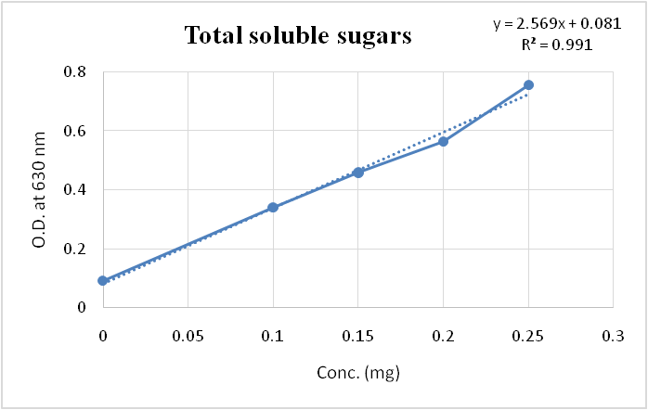

**Fig. 2. Standard graph for Total soluble sugars**

* + 1. **Total phenol content:**

Total Phenol Content of seeds was analyzed following the procedure by Malik and Singh (1980). The seed samples were dried, ground, and 0.5g of the powdered sample was macerated with 5 ml of 80% ethanol (v/v). The mixture was then spun in a centrifuge at 5,000 revolutions per minute for 10 minutes, and the supernatant was collected. After that, all the test tubes were submerged in a hot water bath at 70°C for 15 minutes. A 1 ml aliquot of the sample was diluted to a final volume of 5 ml with distilled water. 500 μl of Folin reagent was then mixed to the diluted sample, which was then incubated at room temperature for 3 minutes. After this initial incubation, 2 ml of a 20% sodium carbonate (Na2CO3) solution was added to the mixture, which was then further incubated at room temperature for a period of 1 hour. The final absorbance of the mixture was measured using a spectrophotometer at a wavelength of 650 nm. At last, the total phenol content in the seed sample was quantified by referencing a standard curve created using a known sample of catechol and expressed in mg catechol equivalents (CEt) per gram.

**Preparation of standard curve:**

A precise amount of 100 mg of Catechol was measured and dissolved in distilled water, and then the volume was adjusted to 100 ml. From this solution, 10 ml was extracted and mixed with 100ml of distilled water to create a 100ppm solution, which served as the working standard. Various quantities of 0.2 ml, 0.4 ml, 0.6 ml, 0.8 ml and 1.0 ml were taken from this working standard and the volume was adjusted to 5.5 ml with all necessary reagents for the analysis. The absorbance was then measured to construct the standard curve (Fig. 3). It is recommended to store the standard Catechol solution in a dark and cool environment or use it immediately.

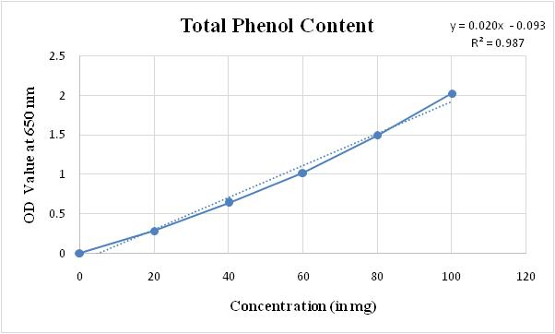

**Fig. 3. Standard graph for total phenol content**

1. **RESULTS AND DISCUSSION**
   1. **Analysis of seed quality parameters in mungbean genotypes**

The evaluation of seed quality parameters such as germination percentage, seedling fresh and dry weight, seedling length, seed vigour indices, speed of germination and mean germination time for 14 mungbean genotypes showed significant variations as depicted in Fig. 4. These parameters are crucial indicators of seed performance and vigour, providing insights into the potential of each genotype for successful establishment under field conditions. Analyzing seed quality parameters for various mungbean genotypes offers valuable insights into their germination patterns, seedling vigour, and potential performance in the field. Each parameter provides a unique perspective on seed quality, helping to assess the overall viability of the genotypes being studied.

The results, outlined in Table 1, offer a comprehensive comparison of the genotypic performance across various seed quality parameters.

* + 1. **Germination percentage**

The germination percentage ranged from 86.00% in OKGG-10 (F5) to 98.67% in ML-2479, with a mean of 94.26%. Among the elite breeding lines, OKGG-9 (F5) showed higher germination percentage than the best check LGG-460, aligning with previous findings that high germination rates contribute significantly to early crop establishment and uniform seedling growth (Diya and Jayalekshmy, 2024). ML-2479 had the highest germination percentage, followed by IPM-410-3. OKGG-9 (F5) displayed high seed vigour index-I as well as high seed vigour index-II indicating its strong potential for rapid field establishment. The germination percentage ranged significantly among the genotypes, indicating variability in the ability of the seeds to germinate under standardized conditions. A higher germination percentage suggests better seed viability and potential field performance. The findings from the present study are at par with the result of Ali et al. (2010); Dubey and Syed (2025); Bangar et al., (2019).

* + 1. **Seedling fresh weight and seedling dry weight (g)**

Seedling fresh weight varied significantly, with IPM-410-3 showing the highest value (0.50 g) with a mean fresh weight of 0.35 g. IPM-410-3 (0.50 g) and OBGG-52 (0.46 g) are statistically at par. Among the elite breeding lines studied, OKGG-12 (F5) showed higher seedling fresh weight as compared with the best check LGG-460.

The dry weight ranged from 0.012 g in OKGG-10 (F5), OUM-11-5 and OKGG-12 (F5) to 0.019 g in OKGG-9 (F5) and OKGG-11 (F5). The average dry weight was 0.0148 g.OKGG-9 (F5) (0.019 g) and OKGG-11 (F5) (0.019 g) are statistically at par. Also, OKGG-10 (F5) (0.012 g), OUM-11-5 (0.012 g), and OKGG-12 (F5) (0.014 g) are at par indicating efficient biomass accumulation in more seedling fresh weight, consistent with findings of Harini *et al*. (2022) Dubey and Syed (2025) that seedling dry weight serves as an indicator of seedling robustness and physiological efficiency. The seedling fresh weight and seedling dry weight represent the biomass accumulation in seedlings. Higher fresh and dry weights, such as that for IPM-410-3 are indicative of healthier and more vigourous seedlings, which are better equipped to thrive under field conditions. Genotypes with higher biomass accumulation are likely to develop stronger root and shoot systems, improving their stress resilience and ability to produce higher yields.

* + 1. **Seedling length (cm)**

Seedling length ranged from 28.62 cm (OKGG-12 (F5)) to 38.42 cm (OKGG-9 (F5)), with a mean of 34.61 cm. OKGG-9 (F5) and ML-1808 showed superior seedling lengths (38.42 cm and 37.90 cm), while OKGG-12 (F5) showed the shortest length. Similar trends were reported by Harini *et al*. (2022) and Nivethitha *et al*. (2024) where seedling length correlated positively with crop establishment under both optimal and stress conditions. The variation in seedling length consists of both root as well as shoot length. Genotypes with longer root lengths are likely to establish better in the field, especially under stress conditions such as drought. Shoot length is an important indicator of the initial vegetative growth of the plant. Genotypes with longer shoot lengths demonstrate greater early-stage vigour, which is beneficial for outcompeting weeds and establishing a healthy crop stand. Variations in shoot length among the genotypes reveal differences in early growth potential, which could impact final plant stature and yield.

* + 1. **Seed Vigour Index-I (SV-I)**

It ranged between 2,649.04 in OKGG-12 (F5) and 3,806.67 in ML-2479, with an average of 3,311.25. ML-2479 and ML-1808 had the highest vigour indices (3,806.67 and 3,786.00), indicating their superior seed quality.ML-1808 (3786.00) and ML-2479 (3806.67) are statistically at par. Similarly, OKGG-9 (F5) and OBGG-52 have nearly identical values, indicating they are statistically at par. Among the elite breeding lines studied, the performance of OKGG-9 (F5), OKGG-10 (F5) and OKGG-11 (F5) were better than the best check LGG-460. These findings in accordance with the result of Ali et al. (2010), Dubey and Syed (2025); Bangar et al., (2019).

* + 1. **Seed Vigour Index-II (SV-II)**

The values ranged from 1.11 in OKGG-11 (F5) to 1.90 in IPM-410-3. The grand mean for SV-II was 1.43, with IPM-410-3 displaying the best performance. Among the elite breeding lines studied, the performance of OKGG-9(F5), OKGG-10(F5) and OKGG-12 (F5) were better than the best check LGG-460. Seed Vigour Index-II (SV-II), based on dry weight and germination percentage, ranged from **1.11 to 1.90**, with **IPM-410-3** showing the highest value, suggesting better energy mobilization and seedling development. The significance of SV-II in predicting stress resilience has been previously documented in leguminous crops (Ali et al., 2010; Diya and Jayalekshmy, 2024). The seed vigour index-I (SV-I) and vigour index-II (SV-II) provide a comprehensive assessment of seedling vigour by integrating germination percentage, root and shoot length (for SV-I) and dry weight (for SV-II). Higher vigour indices (genotypes like ML-2479 and IPM-410-3) indicate superior seedling performance, combining both growth and biomass traits. Genotypes with higher vigour indices are likely to perform well in terms of seedling establishment and growth, translating into better field performance and yield potential. These findings are in parallel with the previous study by Ali et al. (2010), Dubey and Syed (2025); Bangar et al, (2019).

* + 1. **Speed of Germination (SOG) (days):**

SOG ranged from 6.47 days (OKGG-11 (F5)) to 20.55 days (ML-2479). The average speed of germination was 13.89 days, and ML-2479 took the longest to germinate. Among the elite breeding lines studied, the speed of germination of OKGG-9 (F5), OKGG-10 (F5), OKGG-11 (F5) and OKGG-12 (F5) were lesser than the best check, signifying better performance, indicating rapid seedling emergence, an essential trait for drought avoidance and competitive growth. Speed of germination reflects the rate at which seeds begin to germinate under optimal conditions. A higher SOG indicates a faster germination process, which can be advantageous for early seedling establishment which was observed in ML-2479. In the analysed genotypes, SOG varied, with some genotypes exhibiting rapid germination (Bangar et al, 2019; Dubey and Syed, 2025 and Nivethitha *et al*., 2024).

* + 1. **Mean Germination Time (MGT):**

MGT varied from 1.56 days in IPM-410-3 to 4.27 days in OKGG-12 (F5), with a mean of 2.60 days, indicating that IPM-410-3 had the fastest germination rate. Faster germination, as seen in **IPM-410-3, ML-2479**, and **ML-1808**, is advantageous for rapid crop establishment, reducing vulnerability to environmental stress during critical early stages. Mean germination time (MGT) represents the average time taken for a seed to germinate. It provides an estimate of the germination period required for a genotype under specific conditions. Genotypes with shorter MGT are preferable as they indicate quicker germination, leading to earlier seedling development as observed in IPM-410-3.

Collectively, the superior performance of genotypes like **ML-2479, ML-1808, IPM-410-3**, and **OKGG-9** in multiple seed quality parameters suggests their potential as promising candidates for cultivation under diverse agro-ecological conditions and for breeding programs focused on enhancing early vigour and stress tolerance. Moreover, significant differences in SOG and MGT underline the genotypic influence on germination dynamics, consistent with earlier studies on mungbean and other pulse crops. Similar findings alro recorded by Bangar et al, (2019) and Nivethitha *et al*. (2024).

**Table 1. Seed quality parameters of different Mungbean genotypes**

|  |  |  |  |  |  |  |  |  |  |
| --- | --- | --- | --- | --- | --- | --- | --- | --- | --- |
| **Sl. No.** | **Genotype** | **Germination percentage (%)** | **Seedling fresh Weight (g)** | **Seedling dry Weight (g)** | **Seedling Length (cm)** | **SV-I** | **SV-II** | **SOG (days)** | **MGT**  **(days)** |
| **1.** | **OKGG-9 (F5)** | 96.33 | 0.26 | 0.019 | 38.42 | 3571.97 | 1.50 | 13.95 | 2.47 |
| **2.** | **OKGG-10 (F5)** | 86.00 | 0.27 | 0.012 | 34.28 | 3298.21 | 1.21 | 9.07 | 3.08 |
| **3.** | **OKGG-11 (F5)** | 91.00 | 0.24 | 0.019 | 33.84 | 3248.65 | 1.11 | 6.47 | 3.99 |
| **4.** | **OKGG-12 (F5)** | 89.00 | 0.37 | 0.014 | 28.62 | 2649.04 | 1.35 | 6.61 | 4.27 |
| **5.** | **OBGG-52** | 96.00 | 0.46 | 0.015 | 35.74 | 3574.89 | 1.71 | 13.10 | 2.45 |
| **6.** | **OBGG-56** | 95.00 | 0.38 | 0.013 | 32.48 | 3286.24 | 1.30 | 12.24 | 2.75 |
| **7.** | **OBGG-58** | 97.33 | 0.43 | 0.016 | 34.96 | 3496.00 | 1.75 | 15.49 | 2.35 |
| **8.** | **VIRAT** | 93.33 | 0.33 | 0.015 | 34.38 | 2611.88 | 1.19 | 7.15 | 3.86 |
| **9.** | **V-02-709** | 94.00 | 0.38 | 0.016 | 34.96 | 3358.52 | 1.45 | 15.79 | 2.31 |
| **10.** | **ML-1808** | 96.33 | 0.34 | 0.013 | 37.90 | 3786.00 | 1.37 | 19.61 | 1.66 |
| **11.** | **ML-2479** | 98.67 | 0.34 | 0.013 | 37.50 | 3806.67 | 1.37 | 20.55 | 1.60 |
| **12.** | **LGG-460** | 93.00 | 0.28 | 0.016 | 33.70 | 2871.80 | 1.16 | 15.30 | 2.29 |
| **13.** | **OUM-11-5** | 95.67 | 0.39 | 0.012 | 32.80 | 3281.00 | 1.64 | 18.72 | 1.74 |
| **14.** | **IPM-410-3** | 98.00 | 0.50 | 0.014 | 34.96 | 3516.67 | 1.90 | 20.42 | 1.56 |
| **Grand mean** | | 94.26 | 0.35 | 0.0148 | 34.61 | 3311.25 | 1.43 | 13.89 | 2.60 |
| **Standard Error (±)** | | 2.09 | 0.01 | 0.0004 | 0.28 | 19.23 | 0.04 | 0.23 | 0.065 |
| **C.D. (5%)** | | 6.05 | 0.03 | 0.0010 | 0.81 | 55.70 | 0.12 | 0.67 | 0.19 |
| **C.D. (1%)** | | 8.16 | 0.04 | 0.0014 | 1.09 | 75.14 | 0.16 | 0.90 | 0.25 |
| **C.V. (%)** | | 3.84 | 4.91 | 4.16 | 1.40 | 1.01 | 4.99 | 2.88 | 4.34 |

Where, **SV-I:** Seed Vigour Index-I; **SV-II:** Seed Vigour Index-II; **SOG:** Speed of Germination (days); **MGT:** Mean germination time (days)

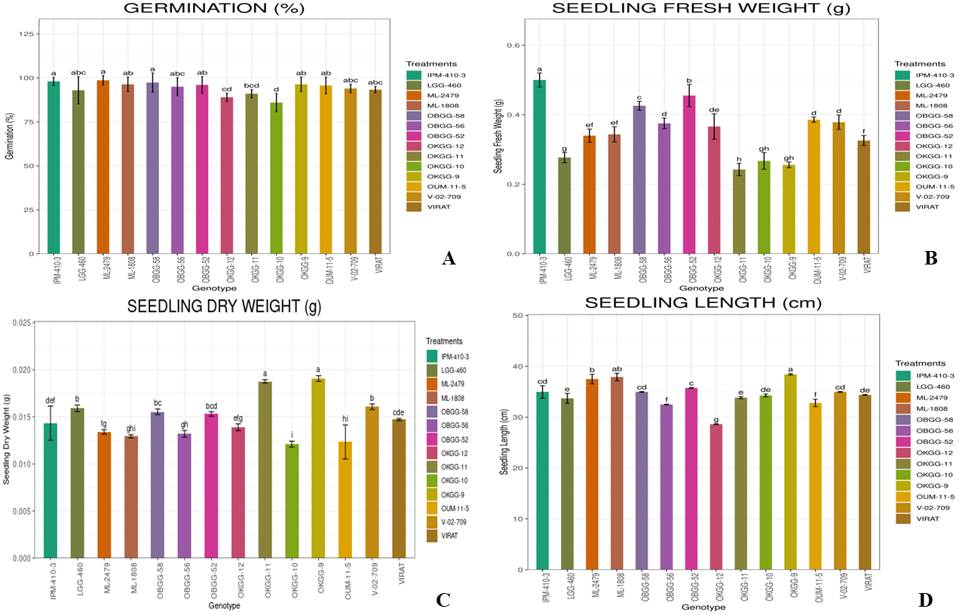

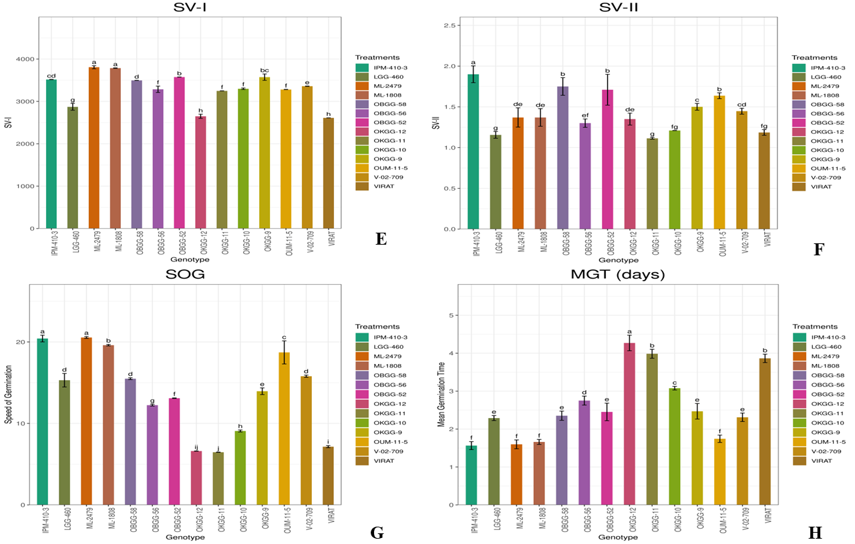

**Fig. 4. Seed quality parameters in mungbean genotypes: (A) Germination %; (B) Seedling fresh weight; (C) Seedling Dry weight; (D) Seedling length; (E) Seed Vigour Index-I (SV-I); (F) Seed Vigour Index-II (SV-II); (G) Speed of Germination (SOG); (H) Mean germination time (MGT)**

* 1. **Analysis of biochemical parameters in mungbean genotypes**

The biochemical analysis of mungbean genotypes showed significant variations in total soluble protein, total soluble sugars and phenol content. These biochemical traits play a crucial role in determining the nutritional value, stress tolerance and overall quality of mungbean seeds. The data presented in Table 2 provided a comprehensive overview of these biochemical attributes, highlighting differences among genotypes and identifying those with superior nutritional profiles and stress resistance. The subsequent sections provide an analysis of the biochemical characteristics of each genotype.

* + 1. **Total Soluble Proteins (mg/g):**

The total soluble protein content among the mungbean genotypes ranged from 165.62 mg/g in V-02-709 to 281.25 mg/g in LGG-460, with a mean of 205.08 mg/g. ML-1808 (251.87 mg/g), OBGG-56 (233.58 mg/g) and OBGG-52 (226.25 mg/g) are statistically at par, with lesser protein than LGG-460. OKGG-10 (F5) (190.00 mg/g), VIRAT (191.25 mg/g), ML-2479 (193.75 mg/g), and OKGG-9 (F5) (184.38 mg/g) are statistically at par with each other. Among the elite breeding lines studied, almost all of them had lesser protein content as compared to the best check LGG-460, which meant lesser bruchid attack. The biochemical analysis revealed significant variability among genotypes for traits such as total soluble protein, total soluble sugars, and phenol content. LGG-460 exhibited the highest total soluble protein content, while V-02-709 recorded the lowest. These results are in consonance with findings of other researchers such as Lekshmi *et al*. (2023); Kavitha (2021) and Sekar and Nalini (2017) in mungbean. High protein content is essential for improving the nutritional quality of mungbean, and genotypes like LGG-460 hold promise for breeding programs focused on enhancing this trait.

* + 1. **Total Soluble Sugars (mg/g):**

The total soluble sugar content varied significantly, ranging from 3.72 mg/g in V-02-709 to 9.77 mg/g in both ML-1808 and LGG-460. The mean value was 6.50 mg/g. OKGG-9 (F5) (4.55 mg/g) and OKGG-12 (F5) (4.44 mg/g), with a difference of only 0.11 mg/g, are statistically at par. V-02-709 (3.72 mg/g), having the lowest sugar content, is statistically different from all other genotypes. All the elite breeding lines studied had lesser sugar content than the best check LGG-460, which can be positively correlated with bruchid attack. Hence, these genotypes can be useful in resistance to bruchid. The total soluble sugar content was highest for both ML-1808 and LGG-460, which could contribute to the flavour and marketability of these genotypes. These results are in consonance with findings of other researchers such as Kavitha (2021); Singh and Singh (2019) and Sekar and Nalini (2017).

* + 1. **Total Phenol Content (mgCEt/g)**

Phenol content, which influences seed defense mechanisms, ranged from 0.413 mg CEt/g in LGG-460 to 0.926 mg CEt/g in V-02-709. The mean phenol content was 0.66 mg/g. Genotypes like V-02-709 and OKGG-11 (F5) recorded the highest phenol levels, indicating enhanced potential for stress resistance, while LGG-460 had the lowest phenol content. V-02-709 (0.926 mg CEt/g) and OKGG-11 (F5) (0.857 mg CEt/g) are statistically at par with each other. OKGG-11 (F5) (0.857 mg CEt/g), OKGG-9 (F5) (0.806 mg CEt/g), and OKGG-12 (F5) (0.838 mg CEt/g) are statistically at par. All the elite breeding lines studied had higher phenol content than the best check LGG-460. The phenol content, which plays a crucial role in stress resistance, was highest in V-02-709, suggesting its potential for enhanced resistance against biotic and abiotic stresses. Similar results were obtained by Sekar and Nalini (2017). However, Lekshmi *et al*. (2023) and Kavitha *et al*. (2021) displayed slightly different results, which may be due to effects of storage. The variation in biochemical parameters can be attributed to inherent characteristics of the genotypes, implying their vitality in breeding programs. Also, a relation was found out between the biochemical parameters and susceptibility to bruchids. It was observed that genotypes with high protein (LGG-460), high sugars (ML-1808 and LGG-460) showed higher susceptibility while genotypes with high phenol content (V-02-709) was resistant, signifying the importance of observing these traits. These results were similar to those found by Lekshmi *et al*. (2023); Lazar *et al.* (2014) and Deepika *et al.* (2020)**.**

**Table 2. Biochemical parameters for different Mungbean genotypes**

|  |  |  |  |  |
| --- | --- | --- | --- | --- |
| **Sl. No.** | **Genotype** | **Total Soluble Protein (mg/g)** | **Total Soluble Sugars (mg/g)** | **Phenol content (mgCEt/g)** |
|  | **OKGG-9 (F5)** | 184.38 | 4.55 | 0.806 |
|  | **OKGG-10 (F5)** | 190.00 | 4.87 | 0.784 |
|  | **OKGG-11 (F5)** | 181.87 | 4.32 | 0.857 |
|  | **OKGG-12 (F5)** | 176.25 | 4.44 | 0.838 |
|  | **OBGG-52** | 226.25 | 8.25 | 0.479 |
|  | **OBGG-56** | 233.58 | 9.07 | 0.507 |
|  | **OBGG-58** | 197.50 | 7.16 | 0.541 |
|  | **VIRAT** | 191.25 | 5.06 | 0.737 |
|  | **V-02-709** | 165.62 | 3.72 | 0.926 |
|  | **ML-1808** | 251.87 | 9.77 | 0.455 |
|  | **ML-2479** | 193.75 | 5.96 | 0.706 |
|  | **LGG-460** | 281.25 | 9.77 | 0.413 |
|  | **OUM-11-5** | 200.63 | 7.36 | 0.532 |
|  | **IPM-410-3** | 196.87 | 6.70 | 0.604 |
| **Grand mean** | | 205.08 | 6.50 | 0.6561 |
| **S.E.m(±)** | | 2.52 | 0.05 | 0.0147 |
| **C.D. (5%)** | | 7.31 | 0.16 | 0.0426 |
| **C.D. (1%)** | | 9.86 | 0.21 | 0.0575 |
| **C.V. (%)** | | 2.13 | 1.43 | 3.88 |

*Mean of three replications

*mg CEt/g: mg Catechol equivalents per gram seeds

1. **CONCLUSION**

The comprehensive evaluation of seed quality and biochemical parameters across 14 mungbean genotypes revealed significant genotypic variability, offering valuable insights into their potential for breeding, cultivation, and stress resilience. Genotypes such as ML-2479, IPM-410-3, ML-1808, and OKGG-9 (F5) consistently outperformed others in key seed quality traits, including germination percentage, seedling vigour indices (SV-I and SV-II), seedling length, and mean germination time. These genotypes demonstrated superior early growth potential and seedling establishment capacity, indicating their suitability for direct cultivation and use in breeding programs aimed at improving early vigour and field performance. Biochemical characterization further differentiated genotypes based on total soluble proteins, sugars, and phenol content. While LGG-460 showed the highest protein and sugar content traits associated with enhanced nutritional value it also exhibited lower phenol content, correlating with higher susceptibility to bruchid infestation. In contrast, V-02-709 and OKGG-11 (F5), with elevated phenol levels, demonstrated better potential for stress and pest resistance, particularly against bruchids. These findings underline the importance of integrating physiological and biochemical markers in varietal selection. Genotypes with balanced seed quality and biochemical traits, such as OKGG-9 (F5) and IPM-410-3, offer promising avenues for future mungbean improvement programs targeting both yield performance and biotic stress resistance. The observed relationships between biochemical parameters and bruchid tolerance support the use of phenol content as a biochemical marker in resistance breeding. In summary, the identified superior genotypes could serve as potential candidates for varietal release or as donor parents in mungbean improvement programs, contributing to the development of nutritionally enhanced and pest-resilient cultivars suited for diverse agro-climatic conditions.

**Disclaimer (Artificial intelligence)**

Author(s) hereby declare that NO generative AI technologies such as Large Language Models (ChatGPT) manuscript.

**REFERENCES**

Abdul Baki, A. A., & Anderson, J. D. (1973). Vigour determination in soybean seed by multiple criteria. Crop Science, 13(6), 630–633.

Ali, M.Z., Khan, M.A.A., Rahaman, A.K.M.M. Ahmed, M., Ahsan, A.F.M.S. (2010). Study on seed quality and performance of some mungbean varieties in Bangladesh. *Int. J. Expt. Agric.* 1(2), 10-15.

Bewley, J. D., Bradford, K. J., Hilhorst, H. W., & Nonogaki, H. (2013). Seeds: Physiology of development, germination and dormancy (3rd ed.). Springer.

Bangar, P., Chaudhury, A., Tiwari, B., Kumar, S., Kumari, R., & Bhat, K. V. (2019). Morphophysiological and biochemical response of mungbean [Vigna radiata (L.) Wilczek] varieties at different developmental stages under drought stress. Turkish journal of biology, 43(1), 58-69.

Deepika, K. L., Singh, P. S., Singh, S. K., & Saxena, R. (2020). Biochemical basis of resistance against pulse beetle, Callosobruchus chinensis (L.) in stored chickpea genotypes. Journal of Experimental Zoology India, 23(2), 1175–1180.

Dubey, A. and Syed, M. (2025). Analysis of seed physiological characterization in Mungbean (*Vigna radiata* L.) genotypes. Asian Journal of Research and Review in Agriculture. 7(1): 215-221.

Ellis, R. H., & Roberts, E. H. (1980). Towards a rational basis for testing seed quality. In Seed Production (pp. 605–635). Butterworths, London.

Harini, G., Gupta, J. P., & Gupta, P. (2022). Assessment of Variability for Yield Attributing Traits and Seed Quality Parameters in Mung Bean (*Vigna radiata* L. Wilczek). International Journal of Environment and Climate Change, 12(11), 2819–2826. https://doi.org/10.9734/ijecc/ 2022/v12i1131275

Kavitha, G., Mahalakshmi, M. S., Reddy, K. B., Reni, Y. P., & Radhika, K. (2021). Physicochemical basis of resistance in certain green gram genotypes to pulse bruchid, Callosobruchus chinensis (L.). Environment Conservation Journal, 22(3), 231–242.

Kumar, P.P., Lavnaya, G.R., Sanadya, S.K., Dwivedi, A. and Supriya, K. (2024). Analysis of Genetic Parameters for Yield, Quality and Related Traits in Mungbean [*Vigna radiata* (L.) Wilczek] Genotypes. Legume Research. 47(10): 1692-1697. doi: 10.18805/LR-4763.

Nivethitha, T., Babu, C., Jayamani, P., & Vijayalakshmi, D. (2024). Impact of drought stress on seedling vigor and physio-biochemical attributes of diverse mungbean genotypes for drought tolerance through in vitro and field evaluation. Euphytica, 220(12), 182.

Lazar, L., Panickar, B., & Patel, P. S. (2014). Impact of biochemicals on the developmental stages of pulse beetle, Callosobruchus maculatus infesting green gram. Journal of Food Legumes, 27(2), 121–125.

Lekshmi, J. K., Kennedy, J. S., Uma, D., Senthil, N., Murugan, M., & Malarvizhi, D. (2023). Deciphering biochemical traits in selected RILs of mungbean (Vigna radiata (L.) Wilczek) against bruchids (Callosobruchus maculatus F.). Legume Research – An International Journal, 46(7), 911–919.

Lowry, O. H., Rosebrough, N. J., Farr, A. L., & Randall, R. J. (1951). Protein measurement with folin phenol reagent. Journal of Biological Chemistry, 193, 265–275.

Maguire, J. D. (1962). Speed of germination: Aid in selection and evaluation for seedling emergence and vigour. Crop Science, 2, 176–177.

Majhi, P. K., & Mogali, S. C. (2020). Characterization and selection of bruchid (*Callosobruchus maculatus* (F.)) tolerant greengram (*Vigna radiata* (L.) Wilczek) genotypes. Indian Journal of Agricultural Research, 54(6), 679-688.

Majhi, P. K., Bhoi, T. K., Mogali, S. C., Shiv, A., Sahoo, K. C., & Saini, V. (2022). Advances in molecular breeding for bruchid (*Callosobruchus spp.*) resistance in mungbean (*Vigna radiata* (L.) Wilczek): A review. Legume Research, 45(8), 933-941.

Majhi, P. K., Mogali, S. C., & Abhisheka, L. (2020a). Genetic variability, heritability, genetic advance and correlation studies for seed yield and yield components in early segregating lines (F3) of greengram (*Vigna radiata* (L.) Wilczek). International Journal of Chemical Studies, 8(4), 1283-1288.

Majhi, P. K., Mogali, S. C., & Bhoi, T. K. (2020b). Towards development of mungbean (*Vigna radiata* (L.) Wilczek) genotypes with combined resistance to bruchid (*Callosobruchus maculatus*) and mungbean yellow mosaic virus (MYMV). Annals of Agriculture and Crop Science, 5(2), 1064.

Malik, E. P., & Singh, M. B. (1980). Plant Enzymology and Histoenzymology (1st ed., p. 286). Kalyani Publishers, New Delhi.

Nair, R. M., Schafleitner, R., Beebe, S., Blair, M. W., Wang, Y., & Liu, C. (2012). Genetic improvement of mungbean: Current status and future prospects. Euphytica, 186(2), 303–322. https://doi.org/10.1007/s10681-012-0656-4

Diya, A., Beena, R., & Jayalekshmy, V. G. (2024). Physiological, Biochemical and Molecular Mechanisms of seed priming: a review. Legume Research, 47(2), 159-166.

Sekar, S., & Nalini, R. (2017). Screening of mungbean genotypes against pulse beetle Callosobruchus chinensis and evaluating the biochemical basis of resistance. International Journal of Chemical Studies, 5(4), 1296–1301.

Singh, S. K., & Singh, P. S. (2019). Screening of certain green gram varieties/genotypes against Callosobruchus chinensis under laboratory conditions. Journal of Entomological Research, 43(1), 43–48.