Gamma irradiation coupled packaging for improved nutritional and storage stability of dried indigenous fish

.

ABSTRACT

|  |
| --- |
| This study evaluates the nutritional quality and storage stability of selected dried and gamma-irradiated small indigenous fish species- *Amblypharyngodonmola* (Moa), *Penaeus indicus* (Prawn), and *Monopteruscuchia* (freshwater eel) which are known for their high nutritional value and potential in addressing malnutrition. The primary objective was to optimize gamma radiation treatment (1, 2, and 3 kGy) for fresh, semi-dried, and dried fish to improve microbial safety, shelf life, and consumer acceptability without compromising nutritional integrity.The study was conducted in the Department of Food Science and Nutrition, College of Community Science, Assam Agricultural University, Jorhat and Bhabha Atomic Research Centre, Mumbai for 1 year. Fish samples were subjected to standard pre-processing, dehydration (cabinet and freeze drying), and gamma irradiation at Bhabha Atomic Research Centre, Mumbai. Proximate analysis revealed increased nutrient concentration post-drying, especially in protein content (up to 75.98 ± 0.09g/100 g in *P. indicus*). Rehydration ratio ranged from 6.32 *±* 0*.*02 to 7.02 *±* 0.06 across species. Packaging studies using high-density polyethylene (HDPE) and low-density polyethylene (LDPE) showed HDPE to be superior in maintaining microbial quality, with significantly lower total plate counts over 60 days. **Conclusion:** The findings demonstrate that gamma irradiation combined with appropriate packaging is an effective, non-thermal preservation method for enhancing the shelf stability and nutritional retention of dried fish products, offering a sustainable approach to food security and public health nutrition.  **Keywords:** *Small indigenous fishes; irradiation; nutritional analysis; non thermal processing* |

1. INTRODUCTION

**The preservation of food, particularly highly perishable commodities, remains a significant challenge in the pursuit of global food security. Among the various preservation strategies, food irradiation has emerged as a highly effective non-thermal technique for extending shelf life and ensuring microbial safety. This process involves the application of controlled doses of ionizing radiation such as gamma rays, X-rays, and high-energy electron beams which can penetrate deeply into food matrices to inactivate pathogenic and spoilage microorganisms including *Salmonella spp.*, *Listeria monocytogenes*, and *Escherichia coli*, while maintaining the food's nutritional and sensory integrity (Farkas, 2006; Jadhav *et al*., 2021).Unlike thermal treatments, irradiation does not increase the temperature of the food, thereby preventing degradation of heat-sensitive components. The mechanism of microbial inactivation involves both direct damage to DNA and indirect oxidative damage through the ionization of water molecules, ultimately leading to microbial cell death (Bashir *et al.,* 2021; Jan & Maurya, 2021; Castell-Perez & Moreira, 2021). As a result, food irradiation is gaining acceptance as a safe and effective tool for enhancing the microbial quality and shelf life of a wide range of food products. Irradiation not only serves as an alternative to conventional preservation techniques such as thermal processing and refrigeration but also offers advantages such as reduced allergenicity and enhanced shelf stability. Moreover, its effectiveness can be further amplified when combined with other food processing techniques like vacuum packaging and mild heat treatment (Pi *et al.,* 2021).**

**Fish and fishery products are highly valued for their nutritional benefits, being rich sources of high-quality protein, essential fatty acids—especially EPA and DHA—alongside vital vitamins and minerals. Small indigenous fishes (SIFs), in particular, play a crucial role in combating malnutrition in rural and economically marginalized populations. These species, often consumed whole, are excellent sources of micronutrients such as calcium, iron, zinc, and vitamin A. Their integration into daily diets has proven effective in addressing widespread micronutrient deficiencies (Bijayalakshmi*et al*., 2014).Among SIFs, *Amblypharyngodonmola* (Moa) is widely distributed in South Asia and recognized for its nutritional richness and rapid growth. Its whole-body consumption contributes significantly to dietary iron and vitamin A intake, making it an important candidate for nutrition-sensitive aquaculture and public health interventions (Thilsted*et al*., 2014). Similarly, *Penaeus indicus*, or Indian white shrimp, is commercially important and nutritionally superior, providing high protein, essential amino acids, B-complex vitamins, and minerals such as selenium and phosphorus (Abdel-Salam, 2019). Additionally, *Monopteruscuchia*, a freshwater eel, is noted for its high content of iron, omega-3 fatty acids, and therapeutic value in traditional medicine. Its ecological adaptability and consumer demand position it as a potential species for sustainable aquaculture and nutritional improvement strategies (Hasan *et al*., 2015).The growing demand for fishery products is well-documented, with global production exceeding 160 million tonnes in 2014 (FAO, 2016). However, their high perishability due to elevated moisture content, neutral pH, and biochemical composition presents significant obstacles in post-harvest handling and storage. This accelerates microbial spoilage, leading to economic losses and food safety concerns.**

**In light of these challenges, gamma irradiation offers a viable preservation approach capable of extending shelf life and maintaining the nutritional quality of fish products. As a cold process, it is especially suitable for treating fresh, cooked, semi-dried, and dried fish without causing thermal degradation. This study aims to explore and evaluate the application of gamma irradiation on selected nutritionally important fish species, with a focus on improving product safety, shelf stability, and consumer acceptability.**

**Objectives of the study:**

1. Optimization of radiation treatment of fresh, cooked, semi-dried and dried fish to prevent microbiological spoilage and to improve commercial viability of the products.
2. To evaluate the effect of exposure to gamma irradiation over nutritional, physico-chemical and cooking qualities of the fish products.
3. To assess the acceptability, shelf life and quality of the products across storage.

2. material and methods

1. **Selection of raw materials:**

In the present study, the raw materials were procured from local market of Jorhat on the month of September, 2022. *Monopteruscuchia, Penaeus indicus, Amblypharyngodonmola*

1. **Pre-Processing of fish**
2. **Collection of fresh fish:** The fish samples in the present investigation were procured from local fish market of Jorhat, Assam. The fresh fishes were brought to the fish processing laboratory of Department of Food Science and Nutrition , Jorhat in an insulated box within 30 minutes. Cold temperature in the range of 0°C and +4°C inside the insulated box was maintained by placing gel ice packets in it at a ratio 1:1.
3. **Washing:** Fresh fish samples procured from market were washed thoroughly to remove dust, dirt and other foreign matters. Fishes were washed thrice in chilled potable water. The fish: water ratio for washing of fishes was 1:1. This 1:1 ratio of fish: water is suggested for washing of fishes by FSSAI (2011)**.**
4. **Processing of fish samples**
5. **Moa (*Amblypharyngodonmola*)**

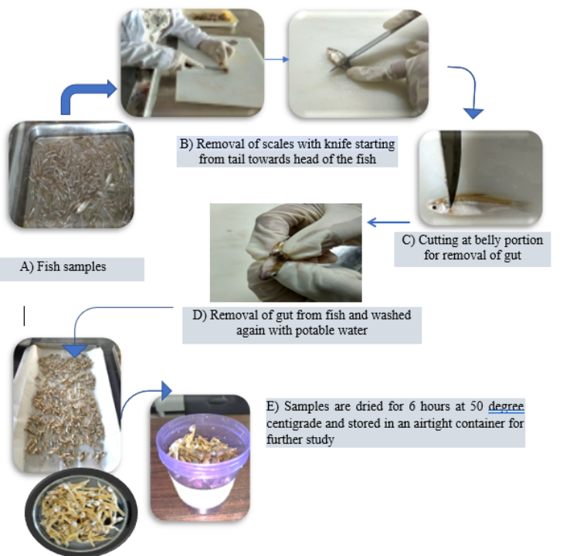

**Fig 1–Processing of Moa (*Amblypharyngodonmola*) fish samples**

1. **Prawn (*Penaeus indicus*)**

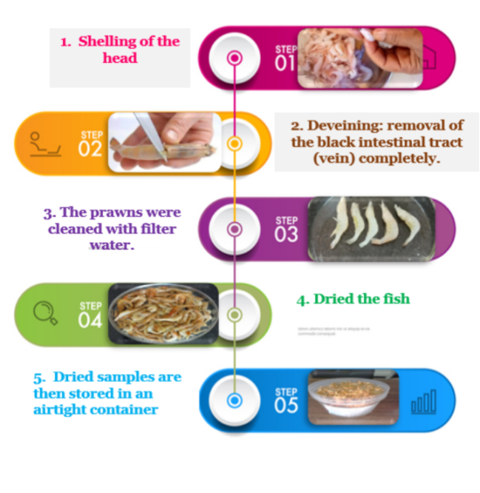

**Fig 2 – Processing of Prawn (*Penaeus indicus*) fish samples**

1. **Eel(*Monopteruscuchia)***

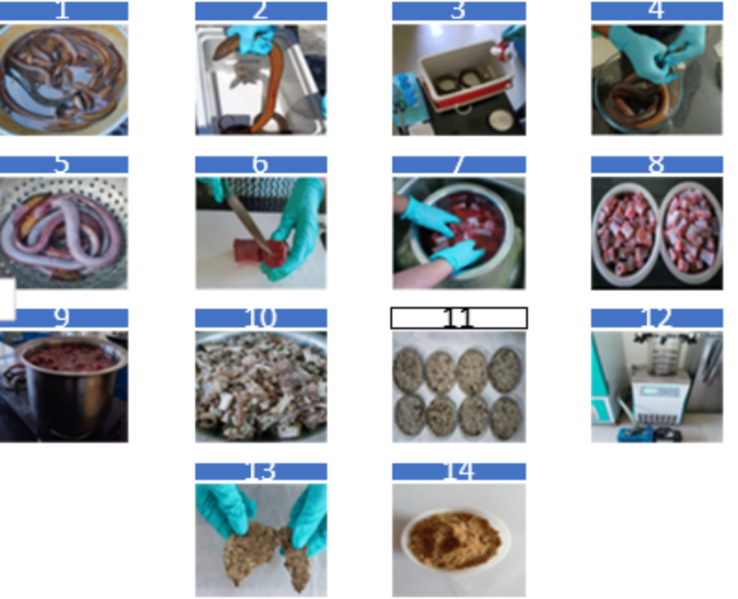

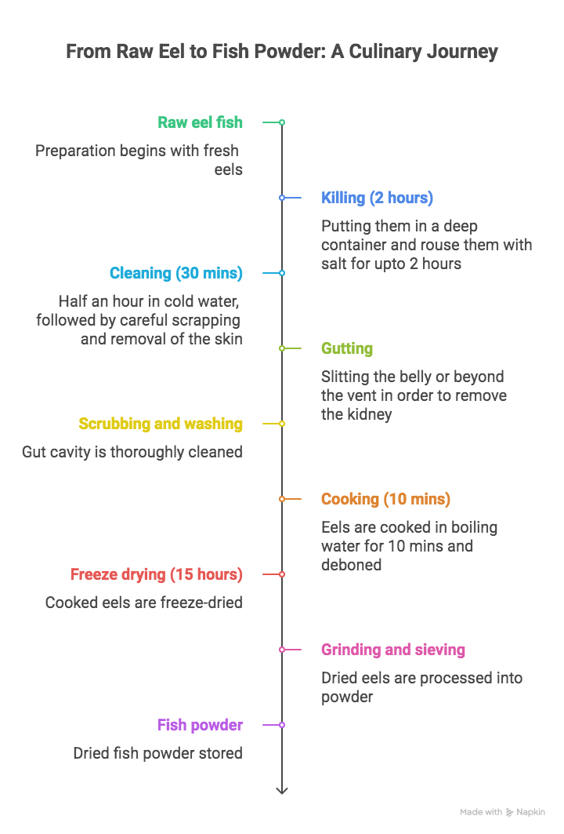

**Fig 3 – Processing of Eel (*Monopteruscuchia)* fish samples**

1. **Radiation treatment of processed dried fish products**

Samples were irradiated at different doses in food package irradiator at Bhabha Atomic Research Centre, Bombay, Mumbai - 400085 India at different dose rate of 1, 2 and 3 kGy/h) while un-irradiated samples served as control. After irradiation, the fish were transported to the laboratory for microbiological, chemical, and organoleptic analysis.

1. **Determination of rehydration ratio**

Rehydration ratio of samples was assessed by the method suggested by [Jokic *et al.* (2009)](http://www.sciencedirect.com/science/article/pii/S1658077X14000526#b0090).

1. **Determination of proximate composition**

Moisture content, crude protein content, crude fat content, ash content and crude fibre was determined by following the A.O.A.C. (2000) method. Carbohydrate content of samples were determined as per difference method given by West *et al*., (1988) and energy content samples was calculated by the formula outlined by Akubor (2003).

1. **Packaging material used for storage study**

High Density Polyethylene pouch (HDPE) and Low Density Polyethylene pouch (LDPE) were used for storage study.

1. **Shelf life evaluation of the processed fish samples**

**Change in Moisture**

Moisture content of the developed fish soup mix powder were analyzed across the storage of two months at an interval of 30 days and change in moisture was observed with each successive analysis. Moisture analysis was done as per the method of AOAC (2000).

**Change in Free Fatty Acid**

Free fatty acid content of the samples was determined following the AOAC (1970) method.

**Change in Peroxide Value**

Peroxide value of the sample was determined following the A.O.A.C. (1975) method.

1. results and discussion

**Rehydration ratio of dehydrated fish samples**

**Table 1: Rehydration ratio of dehydrated fish samples**

|  |  |  |
| --- | --- | --- |
| **Sl. No.** | **Name of fish samples** | **Rehydration ratio** |
| 1. | Moa (*Amblypharyngodonmola)* | 6.80*±*0*.*04 |
| 2. | Prawn *(Penaeus indicus)* | 7.02*±*0.06 |
| 3. | Eel (*Monopteruscuchia)* | 6.32*±*0*.*02 |

*Values are mean of three replications, expressed in Mean ± Standard Deviation (SD)*

Rehydration ratio indicates the capacity of dehydrated samples to absorb the moisture. In the present study, the rehydration ratio of dehydrated fish samples was found to be7.02*±*0.06in *Penaeus indicus*, 6.80*±*0*.*04 in *Amblypharyngodonmola* and 6.32 *±* 0*.*02 in *Monopteruscuchia.*

Similar trends were observed in dried fish such as anchovies, with rehydration ratios typically ranging from 2.5 to 3.0 (Sarsenbek*et al*., 2013; Wang *et al*., 2020). These variations in RR are primarily attributed to differences in drying rate, temperature, and sample thickness, which directly affect the porosity, microstructure, and capillarity of dried tissue (Krokida & Maroulis, 2001; Balachandran *et al*., 2006).

**Nutritional Profiling of Fresh fish samples**

**Table 2: Nutritional Profiling of Fresh fish samples**

|  |  |  |  |
| --- | --- | --- | --- |
| **Nutrients** | **Name of Fish** | | |
| Moa (*Amblypharyngodonmola)* | Prawn *(Penaeus indicus)* | Eel (*Monopteruscuchia)* |
| Moisture (g) | 77.85±0.04 | 71.24±0.06 | 75.58±1.54 |
| Protein (g) | 18.31±0.05 | 25.84±0.20 | 17.75± 0.20 |
| Fat (g) | 4.32±0.01 | 1.54±0.06 | 1.06± 0.09 |
| Ash (g) | 1.65±0.11 | 0.81±0.02 | 1.09±0.33 |
| Carbohydrate (g) | 0.43±0.04 | 0.57±0.01 | 4.52±0.80 |
| Energy (Kcal) | 90.80±0.04 | 119.47±0.07 | 98.62±0.15 |

The moisture, protein, fat, ash, carbohydrate content, and energy values of Moa 77.85± 0.04%, 18.31 ± 0.05 g/100 g, 4.32 ± 0.01 g/100 g, 1.65 ± 0.11 g/100 g, 0.43 ± 0.04 g/100 g and 90.80 ± 0.04 kcal respectively. These results are similar with the findings of Mazumder*et al.,* (2008), who studied the proximate composition of several small indigenous fish species (SIS) in Bangladesh. A more recent study by Kalita & Basumatari (2024) and Al Mamun *et al.,*(2023)also reported similar nutritional values for A. mola. For Penaeus indicus (prawn), the recorded values for moisture, protein, fat, ash, carbohydrate content, and energy were 71.24 ± 0.06 g/100 g, 25.84 ± 0.20 g/100 g, 1.54 ± 0.06 g/100 g, 0.81 ± 0.02 g/100 g, 0.57 ± 0.01 g/100 g, and 119.47 ± 0.07 kcal, respectively. These findings are in close agreement with the results of Singh & Talpade (2024), who conducted a comparative nutrient analysis of P. indicus, Scylla serrata (mud crab), and Sagmariasusverreauxi (rock lobster). However, their reported fat content for P. indicus was slightly higher than observed in the present study. The nutritional composition of Monopteruscuchia (freshwater eel) showed values of 75.58 ± 1.54% moisture, 17.75 ± 0.20 g/100 g protein, 1.06 ± 0.09 g/100 g fat, 1.09 ± 0.33 g/100 g ash, 4.52 ± 0.80 g/100 g carbohydrate, and an energy value of 98.62 ± 0.15 kcal. These results align well with those reported by Rana *et al.,* (2019) in their study on seasonal variations in the nutritional profile of M. cuchia, confirming its high protein and moderate carbohydrate content across different conditions.

**Nutritional Profiling of dried fish samples**

**Table 3: Nutritional Profiling of Dried fish samples**

|  |  |  |  |
| --- | --- | --- | --- |
| **Nutrients** | **Name of Fish** | | |
| **Cabinet dried**  **Moa (*Amblypharyngodonmola)*** | **Cabinet dried**  **Prawn *(Penaeus indicus)*** | **Freeze dried**  **Eel (*Monopteruscuchia)*** |
| Moisture (g) | 5.92 ± 0.02 | 8.60 ± 0.10 | 5.30 ± 0.07 |
| Protein (g) | 71.77 ± 0.01 | 75.98 ± 0.09 | 69.40 ± 0.02 |
| Fat (g) | 12.89 ± 0.07 | 7.94 ± 0.03 | 4.03 ± 0.02 |
| Ash (g) | 7.46 ± 0.40 | 5.63 ± 0.04 | 4.14 ± 0.02 |
| Carbohydrate (g) | 1.68 ± 0.11 | 1.85 ± 0.05 | 17.22 ± 0.04 |
| Energy (Kcal) | 409.81 ± 0.04 | 382.78 ± 0.12 | 375.74 ± 0.05 |

The increase in protein concentration in cabinet-dried samples particularly in P. indicus (75.98 ± 0.09/100 g) is attributable to the reduction in moisture content, which concentrates the macronutrients. Abdel-Salam 2019 found that drying shrimp led to higher nutrient density per unit weight, however he reported lower protein contain and higher fat content. Moreover, A. mola, known for its rich micronutrient content, maintained high protein (71.77 ± 0.01 g/100 g) and fat levels (12.89±0.07/100 g), aligns with study conducted by Kalita & Basumatari, 2024 on the nutritional importance of small indigenous fish species. M. cuchia recorded the highest carbohydrate content (17.22 g/100 g), potentially due to glycogen retention in freeze-dried muscle tissue (Rana *et al*., 2019). Ash content was greatest in A. mola (7.46 g/100 g) reflecting mineral density from whole-body consumption (Mazumder *et al*., 2008).

**Effect of packaging materials on** **total plate count of fish samples**

Fish samples total plate count (TPC) was monitored throughout storage in order to assess the microbiological stability offered by various packing materials. According to FSSAI (2011), all samples initial TPC values fell within acceptable microbiological limits (<5 log CFU/g). In both packaging options, a progressive rise in the microbial load was noted during the storage period. However, TPC values were substantially lower in HDPE-packaged samples than in LDPE-packaged samples (p < 0.05).

In HDPE *P. indicus* recorded a TPC of 3.56 ± 0.04 log CFU/g by day 60, but in LDPE, the same TPC was 4.82 ± 0.07 log CFU/g. Similar patterns were noted in A. mola and M. cuchia, suggesting that HDPE packing has a better protective effect. The higher barrier qualities against oxygen and moisture, which are essential for reducing microbial growth and oxidation, are probably the cause of the increased microbiological stability in fish packaged with HDPE (Kumolu-Johnson *et al.,* 2010). The findings are in line with past research that suggests packaging material is essential for maintaining the sensory and microbiological quality of dried fish while it is being stored (Ihuahi & Omojowo, 2005; Ojagh*et al.,* 2010).High-barrier materials considerably decreased bacterial multiplication and prolonged shelf life in trials using smoked and vacuum-packed seafood products (Sivertsvik*et al*., 2002; Ababouch*et al.,* 1996).

**Table 4: Total plate count of non-irradiated fish, dilution factor 10³ (cfu/g); 72 hrs of incubation at 28.8 ˚C**

|  |  |  |  |  |
| --- | --- | --- | --- | --- |
| **Name of fish samples** | **Packaging material** | **Day** | | |
| **0th day** | **30th day** | **60th day** |
| Moa (*Amblypharyngodonmola)* | HDPE  LDPE | 3.56 ± 0.07  3.56 ± 0.07 | 4.00 ± 0.15  4.18 ± 0.11 | 4.33 ± 0.10  4.52 ± 0.12 |
| Prawn *(Penaeus indicus)* | HDPE  LDPE | 3.37 ± 0.10  3.37 ± 0.10 | 3.86 ± 0.10  4.01 ± 0.12 | 3.92 ± 0.20  4.22 ± 0.08 |
| Eel (*Monopteruscuchia)* | HDPE  LDPE | 3.22 ± 0.11  3.22 ± 0.11 | 3.42 ± 0.20  3.77 ± 0.09 | 4.05 ± 0.09  4.15 ± 0.16 |

cfu: Colony forming unit

**Table 5: Total plate count after 60 days of Irradiated fish, dilution factor 10³ (cfu/g); 72 hrs of incubation at 28.8 ˚C**

|  |  |  |  |  |  |  |
| --- | --- | --- | --- | --- | --- | --- |
| **Name of fish samples** | **1 KGy** | | **2 KGy** | | **3 KGy** | |
| **HDPE** | **LDPE** | **HDPE** | **LDPE** | **HDPE** | **LDPE** |
| Moa (*Amblypharyngodonmola)* | 3.11 ± 0.17 | 3.71 ± 0.21 | 2.66 ± 0.11 | 2.74 ± 0.15 | 1.55 ± 0.15 | 1.80 ± 0.15 |
| Prawn *(Penaeus indicus)* | 2.87 ± 0.04 | 3.20 ± 0.08 | 2.62 ± 0.06 | 2.96 ± 0.01 | 1.53 ± 0.04 | 1.78 ± 0.04 |
| Eel (*Monopteruscuchia)* | 3.01 ± 0.01 | 3.89 ± 0.07 | 2.76 ± 0.01 | 2.82 ± 0.04 | 1.59 ± 0.10 | 1.67 ± 0.04 |

cfu: Colony forming unit

According to Hossain *et al.*, (2016), dried fish products treated with gamma doses ranging from 2 to 5 kGy showed a significant decrease in bacterial counts. These results are in line with their findings. Gamma irradiation is successful at improving microbiological quality, as demonstrated by the current study's significant decrease in total plate count (TPC) in irradiated samples as compared to their non-irradiated counterparts.

**Effect of packaging materials on peroxide value of fish samples**

**Table 6: Peroxide Value after 60 days of non-irradiated fish.**

|  |  |  |  |  |
| --- | --- | --- | --- | --- |
| **Name of fish samples** | **Packaging material** | **Day** | | |
| **0th day** | **30th day** | **60th day** |
| Moa (*Amblypharyngodonmola)* | HDPE  LDPE | 1.10±0.42  1.10±0.42 | 2.10±0.14  2.42±0.11 | 3.00±0.28  3.20±0.28 |
| Prawn *(Penaeus indicus)* | HDPE  LDPE | 1.08±0.10  1.08±0.10 | 1.89±0.10  2.12±0.12 | 2.71±0.20  2.92±0.08 |
| Eel (*Monopteruscuchia)* | HDPE  LDPE | 0.32±0.02  0.32±0.02 | 1.02±0.07  1.10±0.06 | 1.16±0.06  1.24±0.05 |

During a 60-day storage period, non-irradiated fish samples in this investigation showed a significant (P<0.05) increase in PV, with values rising more significantly in LDPE-packaged samples than in HDPE. Compared to 3.00±0.28 mEq O₂/kg in HDPE, amblypharyngodonmola attained 3.20±0.28 mEq O₂/kg in LDPE. Because HDPE is better at preventing the intrusion of moisture and oxygen and LDPE has a higher oxygen permeability, which contributes to its enhanced oxidative rancidity (Sivertsvik*et al.,* 2002). All three fish species showed this pattern, which suggests that HDPE has comparatively better barrier qualities against oxidative degradation. These results are consistent with previous studies by Jeyamkondan et al. (2000), who highlighted the significance of oxygen transfer rate (OTR) in packaged fish oxidative stability.Similarly, **Chytiri*et al.,* (2004)** found that low-permeability packaging films significantly delayed lipid oxidation in fish stored under refrigeration.

**Table 7: Peroxide Value after 60 days of Irradiated fish.**

|  |  |  |  |  |  |  |
| --- | --- | --- | --- | --- | --- | --- |
| **Name of fish samples** | **1 KGy** | | **2 KGy** | | **3 KGy** | |
| **HDPE** | **LDPE** | **HDPE** | **LDPE** | **HDPE** | **LDPE** |
| Moa (*Amblypharyngodonmola)* | 0.71±0.18 | 0.85±0.05 | 0.55±0.02 | 0.61±0.04 | 0.16±0.06 | 0.34±0.02 |
| Prawn *(Penaeus indicus)* | 0.98±0.01 | 1.04±0.04 | 0.72±0.01 | 0.84±0.05 | 0.42±0.01 | 0.62±0.01 |
| Eel (*Monopteruscuchia)* | 1.01±0.20 | 1.27±0.07 | 0.71±0.05 | 0.84±0.04 | 0.40±0.04 | 0.61±0.05 |

Samples irradiated at 3 kGy exhibited the lowest peroxide values, indicating significantly reduced lipid oxidation. For example, Amblypharyngodonmola stored in HDPE recorded a PV of just 0.16±0.06 mEq O₂/kg after 60 days, in contrast to higher values observed at lower irradiation doses. These findings are consistent with the study by **Hossain *et al*., (2016)**, which demonstrated that gamma irradiation in the range of 2–5 kGy effectively inhibits oxidative spoilage in dried fish by suppressing microbial activity and retarding the function of oxidative enzymes. The enhanced oxidative stability observed in irradiated samples is further supported by **Madhavi & Carpenter (1993),** who reported that gamma irradiation deactivates key lipid-degrading enzymes, such as lipoxygenase, thereby limiting peroxide formation in irradiated meat and fish products. The synergistic effect of gamma irradiation and HDPE packaging, which provides superior oxygen and moisture barriers, thus offers a highly effective strategy for preserving the lipid quality of dried fish during prolonged storage.

**Effect of packaging materials on Free Fatty Acid of fish samples**

**Table 8: Free- Fatty Acid Content after 60 days of non-irradiated fish.**

|  |  |  |  |  |
| --- | --- | --- | --- | --- |
| **Name of fish samples** | **Packaging material** | **Day** | | |
| **0th day** | **30th day** | **60th day** |
| Moa (*Amblypharyngodonmola)* | HDPE  LDPE | 0.37±0.08  0.37±0.08 | 0.54±0.08  0.62±0.11 | 0.71±0.06  0.83±0.05 |
| Prawn *(Penaeus indicus)* | HDPE  LDPE | 0.32±0.02  0.32±0.02 | 0.85±0.08  0.94±0.09 | 1.26±0.06  1.32±0.07 |
| Eel (*Monopteruscuchia)* | HDPE  LDPE | 0.28±0.05  0.28±0.05 | 0.51±0.07  0.63±0.06 | 0.81±0.03  0.86±0.04 |

As shown in Table 8, free fatty acid (FFA) levels increased significantly (P<0.05) in all non-irradiated fish samples over the 60-day storage period, with the highest values recorded in LDPE-packaged samples. The FFA content of Penaeus indicus stored in LDPE rose from 0.32 ± 0.02% on day 0 to 1.32 ± 0.07% by day 60, indicating substantial lipid hydrolysis during storage. In comparison, HDPE-packaged samples showed lower FFA accumulation, suggesting more effective protection against oxygen and moisture ingress due to the material’s superior barrier properties. These findings align with previous reports by Connell (1995) and Gram and Dalgaard (2002), who emphasized that packaging material permeability plays a critical role in lipid degradation and microbial enzymatic activity.

**Table 9: Free Fatty Acid Contentafter 60 days of Irradiated fish.**

|  |  |  |  |  |  |  |
| --- | --- | --- | --- | --- | --- | --- |
| **Name of fish samples** | **1 KGy** | | **2 KGy** | | **3 KGy** | |
| **HDPE** | **LDPE** | **HDPE** | **LDPE** | **HDPE** | **LDPE** |
| Moa  (*Amblypharyngodonmola)* | 0.48±0.05 | 0.56±0.11 | 0.44±0.06 | 0.41±0.10 | 0.32±0.02 | 0.14± 0.04 |
| Prawn *(Penaeus indicus)* | 0.44±0.04 | 0.50±0.11 | 0.37±0.06 | 0.41±0.17 | 0.31±0.01 | 0.32±0.05 |
| Eel (*Monopteruscuchia)* | 0.61±0.07 | 0.40±0.11 | 0.42±0.02 | 0.45±0.02 | 0.27±0.03 | 0.32±0.02 |

In contrast, irradiated fish samples (Table 9) exhibited significantly lower FFA levels across all irradiation doses, with the most notable reduction observed at 3 kGy. For instance, Monopteruscuchia stored in HDPE had an FFA content of 0.27±0.03% at 3 kGy, compared to 0.61±0.07% at 1 kGy. This reduction can be attributed to the antimicrobial effect of gamma irradiation, which inhibits spoilage microorganisms and their associated lipase activity, thereby limiting hydrolytic rancidity. Similar effects have been documented by Venugopal et al., (1999) and Reddy *et al*., 2015, reported that irradiation suppresses microbial populations, particularly Pseudomonas spp. which is commonly involved in lipid degradation in fish.

Furthermore, Arvanitoyannis *et al*., 2009 highlighted that combining gamma irradiation with oxygen-impermeable packaging materials not only extends shelf life but also helps preserve the nutritional and sensory attributes of seafood. In the present study, this synergistic benefit was most evident in samples treated with 3 kGy and stored in HDPE, which consistently showed the lowest FFA values across all species examined. These results underscore the effectiveness of integrating gamma irradiation with high-barrier packaging to minimize hydrolytic spoilage and maintain the quality of dried fish during extended storage.

1. **Conclusion**

This study demonstrates that the simultaneous use of drying and gamma irradiation techniques improves the nutritional quality and shelf life of small indigenous species like *Amblypharyngodonmola, Penaeus indicus and Monopteruscuchia*. These species are especially beneficial for nutritional intervention programs because of their increased protein value and decreased moisture content following cabinet and freeze-drying. Following drying, *P. indicus* notably displayed the highest protein value, demonstrating its value as a concentrated protein source for issues related to dietary deficiencies.

The best storage conditions were offered by HDPE packing, while gamma irradiation shown remarkable effectiveness in reducing oxidative degradation and microbiological load at a dose of 3 kGy. Products made from dried fish can be made safer and last longer in situations with limited resources by using irradiation and appropriate packaging materials. These findings demonstrate the value of contemporary preservation techniques in protecting public health and food security in fishing-dependent areas.

**DISCLAIMER** (ARTIFICIAL INTELLIGENCE) Author(s) hereby declare that NO generative AI technologies such as Large Language Models (ChatGPT, COPILOT, etc) and text-to-image generators have been used during writing or editing of this manuscript.

Competing interests

Authors have declared that no competing interests exist.

Consent (whereever applicable)

All authors declare that ‘written informed consent was obtained from the patient (or other approved parties) for publication of this case report and accompanying images. A copy of the written consent is available for review by the Editorial office/Chief Editor/Editorial Board members of this journal.

References

* Ababouch L, Emsellem K, Rhaliby K, Busta FF, Moye W. Quality and safety of sardines preserved by smoking, salting or drying. *Food Microbiol.* 1996;13(5): 437–445. doi:10.1006/fmic.1996.0052
* Abdel-Salam HAS. Effect of drying methods on the nutritional composition and quality of shrimp (*Penaeus* spp.). *Egypt J Aquat Biol Fish.* 2019;23(2): 45–58. doi:10.21608/ejabf.2019.30696
* Akubor PI. Functional properties and performance of cowpea/plantain/wheat flour blends in biscuits. *Plant Foods Hum Nutr.* 2003; 58:1–8.
* Al Mamun MZU, Hossen MS, Begum M, Satter MA, Sathee RA, Yeasmin S, et al. Nutritional comparison of experimentally and commercially sundried lean fish and small prawns of Bangladesh. *J Agric Food Sci Biotechnol.* 2023; 1(3):176–181.
* Arvanitoyannis IS, Stratakos AC, Tsarouhas P. Irradiation applications in vegetables and seafood: A review. *Crit Rev Food Sci Nutr.* 2009; 49(5): 427–462. doi:10.1080/10408390802067995
* Balachandran KK, Joseph J, Suseela M. Quality assessment of dehydrated fish products. *Fish Technol.* 2006; 43(1): 21–26.
* Chytiri S, Chouliara I, Savvaidis IN, Kontominas MG. Microbiological, chemical and sensory assessment of iced whole and filleted aquacultured rainbow trout. *Food Microbiol.* 2004;21(2): 157–165.
* Connell JJ. Control of fish quality. 4th ed. Oxford: Fishing News Books; 1995.
* Food Safety and Standards Authority of India (FSSAI). Manual of methods of analysis of foods: Microbiological testing. Ministry of Health and Family Welfare, Government of India; 2011.
* Gram L, Dalgaard P. Fish spoilage bacteria–Problems and solutions. *Curr Opin Biotechnol.* 2002; 13(3): 262–266.
* Hossain MA, Basher A, Khatun MA, Kaysar MI. Microbiological quality improvement of dried fish by gamma irradiation and assessment of food value upon irradiation with respect to biochemical aspect. *Int J Eng Sci.* 2016;3(3): 52–58.
* Ihuahi JA, Omojowo FS. Effect of different packaging materials on the shelf stability of smoked fish. *J Fish Int.* 2005;1(2–4): 135–139.
* Jeyamkondan S, Jayas DS, Holley RA. Pulsed light treatment of foods. *Int J Food Sci Technol.* 2000; 35(4): 303–310. doi:10.1046/j.1365-2621.2000.00391.x
* Kalita A, Basumatari D. Nutritional evaluation of small indigenous fish species of Assam. *Uttar Pradesh J Zool.* 2024; 45(4): 318–326.
* Krokida MK, Maroulis ZB. Structural properties of dehydrated products during rehydration. *Int J Food Sci Technol.* 2001; 36(5): 529–538. doi:10.1046/j.1365-2621.2001.00495.x
* Kumolu-Johnson CA, Aladetohun NF, Ndimele PE. The effects of smoking on the microbial load and shelf life of *Clarias gariepinus* (African catfish). *Nat Sci.* 2010; 8(12):77–82.
* Madhavi DL, Carpenter CE. Aging and processing effects on lipid oxidation and lipid-soluble antioxidants in beef muscle. *Meat Sci.* 1993;35(1):75–86. doi:10.1016/0309-1740(93)90052-8
* Mazumder MSI, Rahman MM, Ahmed T, Hossain MM. Proximate composition of some small indigenous fish species (SIS) in Bangladesh. *Int J Sustain Crop Prod.* 2008; 3(4): 18–23.
* Ojagh SM, Rezaei M, Razavi SH, Hosseini SMH. Effect of chitosan coatings enriched with cinnamon oil on the quality of refrigerated rainbow trout. *Food Chem.* 2010; 120(1): 193–198. doi:10.1016/j.foodchem.2009.09.070
* Rana MJ, Rahman MM, Hossain MA, Alam MA. Seasonal variation in the proximate composition of *Monopterus cuchia*. *J Fish Aquat Sci.* 2019; 14(3): 55–62.
* Reddy KVR, Reddy G, Reddy SM. Role of gamma irradiation on shelf life of fish. *J Radiat Res Appl Sci.* 2015; 8(3): 362–368. doi:10.1016/j.jrras.2015.01.004
* Sarsenbek A, Kang N, Seo HW. Effects of drying methods on quality characteristics of dried anchovy. *Korean J Food Sci Anim Resour.* 2013; 33(2): 180–186. doi:10.5851/kosfa.2013.33.2.180
* Sivertsvik M, Jeksrud WK, Rosnes JT. A review of modified atmosphere packaging of fish and fishery products – significance of microbial growth, activities and safety. *Int J Food Sci Technol.* 2002;37(2): 107–127. doi:10.1046/j.1365-2621.2002.00544.x
* Venugopal V, Doke SN, Thomas P. Radiation processing to improve the hygienic quality of dry fish: A review. *J Food Saf.* 1999; 19(4): 209–222. doi:10.1111/j.1745-4565.1999.tb00253.x
* Wang Y, Wang L, Li J, Wang Z. Effect of drying methods on the quality and microstructure of anchovy (*Engraulis japonicus*). *LWT Food Sci Technol.* 2020; 123: 109108. doi:10.1016/j.lwt.2020.109108
* West E, Repping F, Temalilwa CR. Handbook on the composition of food commonly eaten in East Africa. Wageningen, The Netherlands: Wageningen Agricultural University; 1988