**GROSS MORPHOLOGICAL STUDIES ON HYPOTHALAMO-PITUITARY AXIS OF MALE COIMBATORE SHEEP**

1. **ABSTRACT:**

The sheep, serve as the primary source of meat production within the country. They also yield a wide range of valuable products, including milk, skin, wool, and manure. They are widely used in the field of biomedical research because it serves as one of the most influential models of human organ systems. The hypothalamo-pituitary axis serves as a central regulatory unit for numerous physiological functions, including growth, reproduction, metabolism, and homeostasis. Heads of 21 Coimbatore sheep ram were procured from the Palakkad abattoir for gross anatomical examination. The study encompassed rams from three distinct age categories: pre-pubertal (<6 months), pubertal (9–24 months), and post-pubertal (>36 months). Gross anatomical structure and biometrical studies of the hypothalamus and pituitary gland were done. The hypothalamus extended from the optic chiasma to the end of the mammillary body. The length of the hypothalamus showed significant increase with advancing age. The pituitary gland exhibited an oval morphology, presenting a boat-like appearance in lateral view. The length, width, and depth of the pituitary gland were measured, all of which demonstrated a significant progressive increase with advancing age. The significant increase in one organ across age groups was closely associated with corresponding growth in other related organs, reflecting the coordinated development of the hypothalamo-hypophyseal axis.

**Keywords -** Gross anatomy, hypothalamus, pituitary, morphometry, sheep hypothalamo-pituitary axis.

1. **INTRODUCTION:**

The hypothalamo-pituitary axis (HPA) is a vital neuroendocrine unit responsible for regulating a broad range of physiological functions, including growth, reproduction, metabolism, lactation, and homeostasis. It comprises the hypothalamus—part of the diencephalon that synthesizes and secretes releasing and inhibiting hormones—and the pituitary gland (hypophysis), often termed the "master gland," due to its regulatory control over other endocrine organs (Guyton and Hall, 2011).

This axis functions via complex interactions between neurosecretory neurons and endocrine cells, integrating signals from the central nervous system to maintain internal equilibrium. Structural and morphometric evaluations of the hypothalamo-pituitary complex provide essential baseline data, especially in livestock species where reproductive efficiency and growth are key economic traits (Dellmann and Eurell, 1998).

In domestic animals, gross morphological features of the hypothalamus include clear anatomical landmarks such as the optic chiasma, mammillary bodies, and infundibulum. The pituitary gland is situated within the sella turcica of the sphenoid bone and is connected to the hypothalamus via the infundibular stalk. This connection facilitates the transport of releasing hormones to the adenohypophysis and neurohormones to the neurohypophysis (Konig and Liebich, 2014).

Sheep, particularly indigenous breeds like Coimbatore sheep, serve as valuable models in both agricultural and biomedical research. These animals are adapted to the semi-arid climate of Tamil Nadu and exhibit resistance to endemic diseases (Sethi et al., 2025). Despite their economic and genetic importance, anatomical documentation of their neuroendocrine system, especially the HPA, is lacking. Such data are crucial for understanding breed-specific physiological traits and optimizing reproductive strategies. Moreover, sheep have long been recognized as a translational model in neuroendocrine research, owing to their well-mapped hypothalamic anatomy and suitability for advanced experimental approaches such as intracerebroventricular infusion and push-pull perfusion, which are ethically challenging in humans (Misztal et al., 2021).

Age-related changes in the hypothalamo-pituitary axis have been associated with the onset of puberty and the maturation of reproductive function. The morphometry of these structures reflects hormonal changes and functional activation of the axis, as observed in several domestic species including buffaloes (Pathak and Bansal, 2015), goats (Pathak and Bhardwaj, 2004), and camels (Jaspal *et al*., 2011). Comparative anatomical studies among different age groups aid in understanding the ontogenic development of the neuroendocrine system and its impact on endocrine output.

Furthermore, advancements in reproductive biotechnology, including estrus synchronization, artificial insemination, and embryo transfer, necessitate a deeper anatomical understanding of neuroendocrine regulation in native breeds. The structural integrity and dimensional growth of the HPA components may also serve as indirect markers of sexual maturity, reproductive health, and endocrine efficiency (Hough *et al*., 2013; Chaves *et al*., 2024). Comparative anatomical studies across age groups also shed light on ontogenic development, reflecting hormonal influence during puberty and adulthood.

In this context, the present study was designed to carry out a comprehensive gross morphological and morphometrical investigation of the hypothalamo-pituitary axis in male Coimbatore sheep across different age groups. The objective was to establish normative anatomical baselines, assess age-related changes, and compare the findings with other domestic species, thereby contributing to the anatomical and physiological understanding of this essential endocrine axis.

1. **MATERIALS AND METHODS :**

**3.1. ANIMALS AND SAMPLING**

The study was conducted on 21 clinically healthy male Coimbatore sheep obtained from a government-approved slaughterhouse in Palakkad, Kerala. The animals were categorized into three age groups based on dental eruption patterns and farm records:

* Pre-pubertal (< 6 months)
* Pubertal (9–24 months)
* Post-pubertal (> 36 months)

Seven animals from each group were selected for morphometric analysis.

**3.2. SPECIMEN COLLECTION AND PREPARATION**

Immediately after decapitation, the heads were collected and flushed via both common carotid arteries using 2% sodium citrate solution to prevent blood coagulation and clots. This was followed by perfusion with fixatives to ensure tissue preservation. The fixatives used were:

* 10% Neutral Buffered Formalin
* Bouin’s Solution
* Zenker’s Fluid

Each fixative was used for 7 animals to ensure consistency across the groups and to allow comparison for histochemical compatibility in subsequent investigations.

**3.3. DISSECTION AND MORPHOMETRY**

After a minimum fixation period of 72 hours, the brains were dissected to expose the hypothalamus and pituitary gland. The hypothalamus was identified as the ventral part of the diencephalon, extending from the optic chiasma anteriorly to the mammillary bodies posteriorly.

Length of the hypothalamus were taken using digital Vernier calipers, and it was recorded from the anterior optic chiasma to the posterior margin of the mammillary body.

The pituitary gland was carefully separated from the sella turcica. Morphometric parameters recorded included:

* **Length**: Anteroposterior diameter
* **Width**: Transverse/lateral diameter
* **Depth**: Dorsoventral diameter

Each measurement was recorded to the nearest 0.01 cm using stainless steel Vernier calipers.

**3.4. DATA ANALYSIS**

Mean values and standard errors for each parameter were calculated for all three age groups. Statistical analysis was performed using one-way ANOVA followed by Tukey’s Honest Significant Difference (HSD) test to determine significant differences between age groups. A p-value of < 0.05 was considered statistically significant.

1. **RESULTS** 
   1. **HYPOTHALAMUS**

The hypothalamus of Coimbatore sheep was seen below the thalamus, which extended from the optic chiasma to the end of the mammillary body (Figure 1). The anterior boundary of the hypothalamus was the anterior commissure and optic chiasma, the posterior boundary was the tegmentum and mammillary body (Figures 2 and 3). Dorsally, it was limited by the hypothalamic sulcus, a shallow horizontal groove which separated it from the thalamus. The ventral hypothalamus related to the pituitary by the pituitary stalk (infundibulum).

Length of the hypothalamus at prepubertal, pubertal and post-pubertal was 2.282±0.014cm, 2.500±0.032cm and 2.633±0.017cm, respectively (Table 1). The length of the hypothalamus during the prepubertal period was significantly shorter than during the pubertal and post-pubertal period.

* 1. **PITUITARY**

The pituitary gland was located beneath the hypothalamus. It began just behind the optic chiasma and extended obliquely backwards and downwards. It rested on the part the sella turcica and was enveloped by a fold of dura mater known as diaphragm sellae, which completely covered the pituitary except for a small aperture on the superior aspect for the infundibular stalk, connecting it to the hypothalamus. In Coimbatore sheep, the pituitary gland had an oval shape, and when viewed from the side, it appeared boat-shaped (Figure 3).

In the cross-section of the pituitary gland, three regions can be visualised. Rostrally pars distalis, caudally pars intermedia and pars nervosa. Anterior and posterior parts were separated by a narrow intra glandular cleft. The pituitary gland was connected to the ventral aspect of the hypothalamus by the infundibular stalk (Figure 3). The infundibular stalk was connected to a bulged portion of the hypothalamus called the median eminence between the optic chiasma and the mammillary body.

The length of the pituitary was 1.502±0.022 cm, 1.603±0.023 cm, and 1.802±0.005 cmin prepubertal, pubertal, and post-pubertal individuals, respectively. The pituitary width in prepubertal, pubertal, and post-pubertal individuals was 0.807±0.006 cm, 1.205±0.007 cm, and 1.528±0.018 cm, respectively. Meanwhile, the depth of the pituitary was 0.602±0.019 cm in prepubertal, 0.710±0.011 cm in pubertal, and 1.082±0.025 cm in post-pubertal rams (Table 1). All three parameters showed significant increase with advancing age group.

1. **DISCUSSION**
   1. **HYPOTHALAMUS**

In the present study, the hypothalamus in Coimbatore sheep was observed as a ventrally positioned part of the diencephalon, extending from the optic chiasma anteriorly to the mammillary bodies posteriorly. These anatomical landmarks are consistent with descriptions in other domestic species, including in rats (Bleier *et al*., 1979), goats (Pathak, 2001), sheep (Paramasivan, 2007), camels (Jaspal *et al*., 2011), and buffaloes (Pathak and Bansal, 2015). The dorsolateral boundary marked by the hypothalamic sulcus and the ventral connection to the pituitary via the infundibular stalk agrees with the classical anatomical framework presented by Konig and Liebich (2014). In humans, Fink *et al*. (2012) reported similar anatomical boundaries to the hypothalamus: the optic chiasma anteriorly, mammillary bodies posteriorly, optic tracts laterally, and the thalamus dorsally.

The mean hypothalamic length showed a statistically significant increase across the three age groups—pre-pubertal, pubertal, and post-pubertal. This increase likely reflects maturational changes driven by neuroendocrine activation during puberty. Similar trends were reported in female buffaloes, where hypothalamic dimensions increased significantly at puberty but remained relatively stable thereafter (Pathak and Bansal, 2015). These morphological changes may correspond to the upregulation of hypothalamic releasing hormones, particularly gonadotropin-releasing hormone (GnRH), which is known to surge during the pubertal transition.

The increase in hypothalamic size may also reflect a rise in neuronal connectivity, neuroglial support, and axonal branching of neurosecretory cells, particularly in areas such as the arcuate nucleus and preoptic area, which regulate gonadotropin secretion. Moreover, the functional integrity of the hypothalamus is essential for maintaining pituitary output, and its development can be viewed as a morpho-functional marker of reproductive readiness.

* 1. **PITUITARY GLAND**

The pituitary gland in Coimbatore sheep appeared oval in shape and boat-like in lateral view, which is in agreement with earlier findings in Indian buffaloes (Muhammad and Khan, 1984) and Gaddi goats (Pathak and Bhardwaj, 2004). The gland was situated on the sella turcica and covered by the diaphragm sellae, with a superior aperture accommodating the infundibular stalk. On sagittal sectioning, the three major divisions—pars distalis, pars intermedia, and pars nervosa—were clearly identifiable. This anatomical organization is consistent across ruminants and aligns with standard mammalian neuroendocrine architecture (Dellmann and Eurell, 1998).

Morphometric parameters—length, width, and depth—of the pituitary gland showed a progressive and significant increase with age. The most substantial increase was observed between the pubertal and post-pubertal groups, suggesting an active role of endocrine signaling in pituitary maturation. These findings correspond with those of Pathak and Bansal (2015) in buffaloes, where increased pituitary volume paralleled the onset of reproductive function. Increase in the weight of pituitary gland in camels with age was also reported (Jaspal *et al*, 2011).

The increase in pituitary dimensions may also be functionally linked to elevated secretory demands as the animal transitions into sexual maturity. The adenohypophysis (pars distalis) becomes increasingly active in secreting tropic hormones like luteinizing hormone (LH) and follicle-stimulating hormone (FSH), which are crucial for testicular development and spermatogenesis. Concurrent enlargement of the neurohypophysis may reflect increased axonal transport and release of vasopressin and oxytocin from hypothalamic nuclei.

* 1. **CORRELATION AND FUNCTIONAL SIGNIFICANCE**

The simultaneous and proportional growth of the hypothalamus and pituitary gland observed in this study strongly indicates the coordinated maturation of the hypothalamo-hypophyseal axis. This anatomical and functional integration is essential for establishing reproductive capability and systemic endocrine regulation in adult animals.

Breed-specific insights from Coimbatore sheep are particularly relevant in the context of reproductive management and nutritional endocrinology. Understanding baseline morphometry and its correlation with age can help veterinarians and animal scientists identify deviations linked to developmental delays, nutritional insufficiency, or endocrine disorders.

1. **CONCLUSION**

The present study provides a detailed account of the gross morphological and morphometric characteristics of the hypothalamo-pituitary axis in male Coimbatore sheep across different developmental stages. The hypothalamus extended from the optic chiasma to the mammillary bodies, and its length significantly increased from the pre-pubertal to post-pubertal stages, indicating neuroendocrine maturation. Similarly, the pituitary gland, situated within the sella turcica, exhibited age-related increases in length, width, and depth, with a characteristic oval, boat-like morphology.

These findings suggest a strong correlation between hypothalamic growth and pituitary enlargement, reflecting the coordinated maturation of the hypothalamo-hypophyseal axis. Establishing morphometric benchmarks for native breeds like Coimbatore sheep offers critical insights into age-related endocrine development and supports future applications in reproductive management, veterinary endocrinology, and breed-specific anatomical education.

1. **COMPETING INTERESTS**

The authors declare that they have no competing interests.

**Disclaimer (Artificial intelligence)**

1. Author(s) hereby declare that NO generative AI technologies such as Large Language Models (ChatGPT, COPILOT, etc.) and text-to-image generators have been used during the writing or editing of this manuscript.
2. **REFERENCES**

Bleier, R., Cohn, P. & Siggelkow, I. R. (1979). A cytoarchitectonic atlas of the hypothalamus and hypothalamic third ventricle of the rat. In: Handbook of the Hypothalamus. Vol I Anatomy of the Hypothalamus. Eds: PJ Morgane, Marcel Dekker Inc, New York. pp 137-220.

Chaves,A. S., Silva,F., Valentim,R., & Quintas,H. (2024). Body Condition in Small Ruminants—Effects of Nutrition on the Hypothalamic–Pituitary–Gonad Axis and Ovarian Activity*.* *Physiologia*, 4(2), 213–225.

Dellmann, H. D., & Eurell, J. A. (1998). Textbook of Veterinary Histology (5th ed.). Lippincott Williams and Wilkins.

Fink. G., Peafd, D., & Levine, J. (2012). Handbook of Neuroendocrinology. Elsevier publishers Amsterdam.

Guyton, A.C., & Hall, J.E. (2011). Textbook of Medical Physiology (12th ed.). Elsevier Saunders.

Hough, D., Swart, P., & Cloete, S. (2013). Exploration of the Hypothalamic–Pituitary–Adrenal Axis to Improve Animal Welfare by Means of Genetic Selection: Lessons from the South African Merino*.* *Animals,* 3(2), 442–474.

Jaspal, S.A.S., Rahman, Z.U. & Cheema, A.M. (2011). Gross morphology and adenohypophyseal cells in camel (Camelus dromedaries) using a new combination of stains. *Pakistan Veterinary Journal*, 31(1), 50-54.

Konig, H.E., & Liebich, H.G. (2014). Veterinary Anatomy of Domestic Mammals: Text Book and Colour Atlas. 6th Edn, Scattauer publisher, New York.

Lakhssassi, K., Urena, I., Marín, B., Sarto, M. P., Lahoz, B., Alabart, J. L., Calvo, J.H., & Serrano, M. (2023). Characterization of the pars tuberalis and hypothalamus transcriptome in female sheep under different reproductive stages. *Animal biotechnology*, 34(8), 3461-3474.

Misztal, T., Młotkowska, P., Marciniak, E., Roszkowicz-Ostrowska, K., & Misztal, A. (2021). Involvement of neurosteroids in the control of hypothalamic-pituitary-adrenal axis activity in pregnant sheep under basal and stressful conditions. *Theriogenology*, 174, 114-120.

Muhammad, G., & Khan, M.Z. (1984). Studies on the anatomy, histology and biometry of the pituitary gland (adenohypophysis) of buffaloes. *Pakistan Veterinary Journal*, 2,113-17.

Paramasivan, S. (2007). Gross anatomical and histomorphological studies on hypothalamohypophysio- mammary axis of sheep (*Ovis aries*). PhD Thesis submitted to TNVASU, Chennai.

Pathak, D., & Bansal, N. (2015). Gross morphological studies on hypothalamo hypophyseal-ovarian axis of Indian buffalo. *Ruminant Science*, 4 (2), 137-143.

Pathak, V. (2001). Correlative anatomical studies on the hypothalamo-hypophysio-gonadal axis of gaddi doe. MVSc Thesis submitted to CSK HPKV, Palampur.

Pathak, V. & Bhardwaj, R.L. (2004). Seasonal variation in the gross and biometrical parameters of hypophysis cerebri in Gaddi doe. *Indian Journal of Veterinary Anatomy*, 15(1-2), 77-79.

Sethi, L., Sarma, K., Suri, S., Devi, J., Sasan, J. S., & Chakraborty, D. (2025). Age Related Morphological Studies on the Tongue of Non-Descript Sheep of Jammu Region with Special Emphasis on Lingual Papillae*. Ind J Vet Sci and Biotech*, 21(4), 6-11.

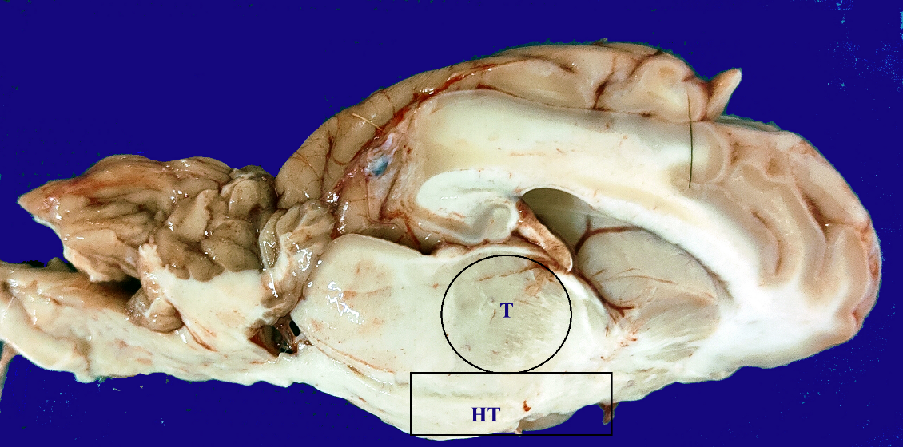

Figure 1: Mid-sagittal section of the brain of pubertal Coimbatore sheep showing thalamus (T) and hypothalamus (HT).

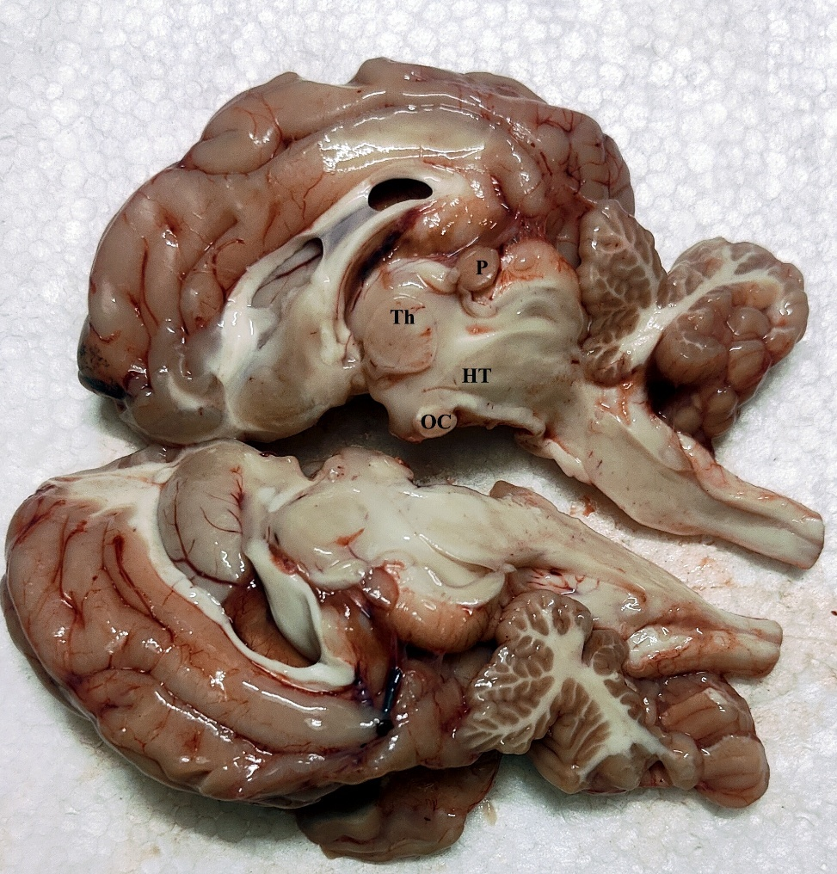

Figure 2: Mid-sagittal section of the brain of Post-pubertal Coimbatore sheep showing thalamus (T), hypothalamus (HT), OC- Optic chiasma and P – Pineal gland

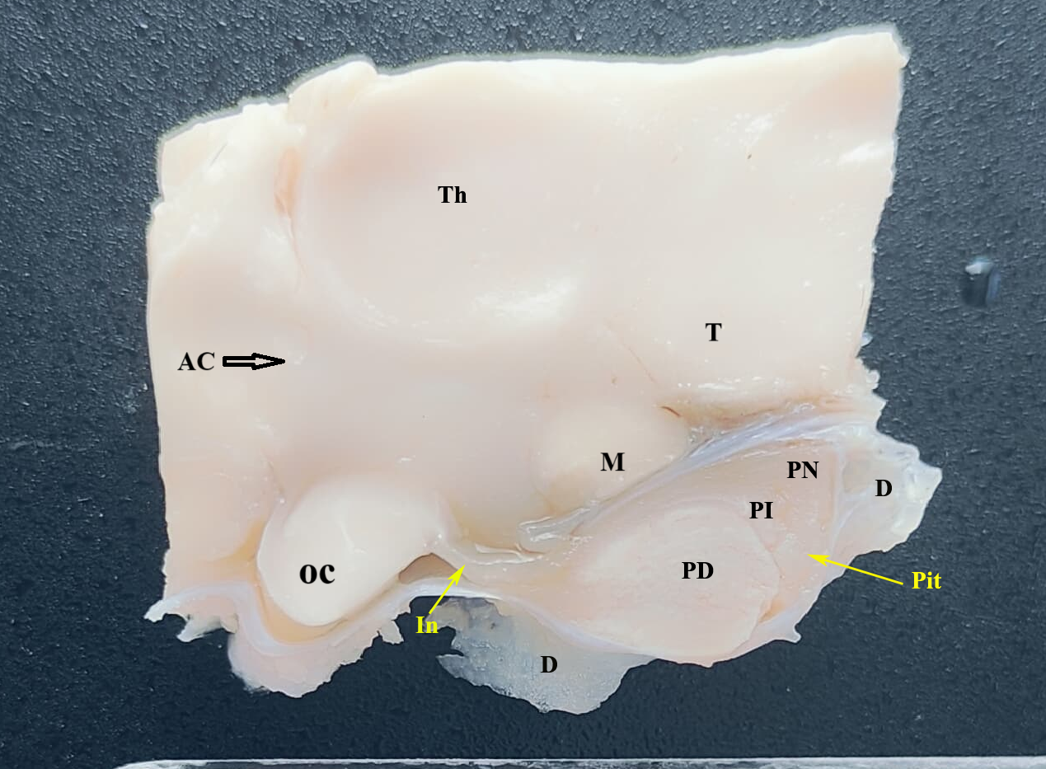Figure 3: Mid-sagittal section of pre-pubertal sheep hypothalamus. Th- Thalamus, AC – Anterior Commissure, M- Median eminence, T – Tegmentum, OC- Optic chiasma, In – Infundibular stalk, Pit – Pituitary, PD – Pars Distalis, PI – Pars Intermedia, PN – Pars Nervosa and D – Dura (diaphragm sellae)

**Table 1. Mean ± SE of morphometric parameters of hypothalamus and pituitary gland, across different age groups in Coimbatore sheep ram (n = 6 per group)**

|  |  |  |  |  |
| --- | --- | --- | --- | --- |
| **Parameter** | **Pre-pubertal** | **Pubertal** | **Post-pubertal** | **F-value (Age Effect)** |
| Hypothalamus Length (cm) | 2.282 ± 0.014ᵃ | 2.500 ± 0.032ᵇ | 2.633 ± 0.017ᶜ | 50.641** |
| Pituitary Length (cm) | 1.502 ± 0.022ᵃ | 1.603 ± 0.023ᵇ | 1.802 ± 0.005ᶜ | 55.573** |
| Pituitary Width (cm) | 0.807 ± 0.006ᵃ | 1.205 ± 0.007ᵇ | 1.528 ± 0.018ᶜ | 818.579** |
| Pituitary Depth (cm) | 0.602 ± 0.019ᵃ | 0.710 ± 0.011ᵇ | 1.082 ± 0.025ᶜ | 143.439** |

- Different superscripts within rows (a, b, c) indicate significant differences among age groups at p < 0.05 based on One-Way ANOVA followed by Tukey’s HSD test.  
- Significance levels: *p < 0.05, **p < 0.01, ***p < 0.001; NS = Not Significant.