**Therapeutic Prospects of Mulberry-Derived DNJ: A Review**

**Abstract**

Deoxynojirimycin (DNJ) is a naturally occurring iminosugar primarily found in mulberry (Morus *spp*.) leaves and is known for its potent α-glucosidase inhibitory activity. Due to this property, DNJ plays a significant role in regulating blood glucose levels, making it a promising natural compound for the management of type 2 diabetes. Beyond its antidiabetic effects, DNJ exhibits potential in combating obesity and improving lipid metabolism. It also shows antiviral, antimicrobial, and hepatoprotective activities, expanding its therapeutic relevance. The extraction and purification of DNJ from mulberry have been optimized to enhance its yield and bioavailability. Overall, DNJ from mulberry presents a valuable bioactive compound with diverse applications in pharmaceuticals and functional foods.

Keywords: *1-Deoxynojirimycin, Mulberry plant, Anti-diabetic agent, Natural compound*

1. **Introduction**

“Mulberry is deciduous and perennial tree found in temperate and subtropical regions of the northern hemisphere to the tropics of the southern hemisphere and is referred as ‘one plant many uses’ due to its multifaceted uses. It has long been used sin traditional Chinese medicine to treat disease. 1Deoxynojirimycin (1-DNJ/DNJ) is an alkaloid azosugar or iminosugar is a natural product first reported in 1976 in the root bark of *Morus* spp.” (Ramappa *et al*., 2020). “It is also found in the leaves, roots and fruits of the mulberry plant (*Morus spp.*). DNJ is particularly notable for its ability to inhibit α-glucosidase, aiding in diabetic management by controlling blood sugar levels. Mulberry produces multiple secondary metabolites, of which the major bioactive constituents comprise alkaloids, flavonoids, and terpenoids which play a significant role in hypoglycemic activity, anticancer, antioxidant and anti-inflammatory actions. interest because of their antioxidant properties” (Kumar and Chauhan, 2008) [31]. “Several new functional food products that contain mulberry leaves have been manufactured in China, Japan, Korea and other countries” (Asano et al., 2001) [5]. “Korean scientists developed ice-cream containing mulberry leaf powder with functionality and palatability, and demonstrated that it could decrease blood glucose levels after consumption” (Kim et al., 1999) [26]. “Traditionally, the species are used for the prevention of liver and kidney diseases, joint damage, and anti-aging, due to their antioxidant properties” (Mena et al., 2016) [39]. “In addition, it has been shown to be an ally in the treatment of type 2 diabetes mellitus (DM2), due to its hypoglycaemic effects” (Sanchez et al., 2017) [45]. “Further studies revealed that DNJ and its derivatives could inhibit hepatitis B” (Mehta et al., 2013; Lazar et al., 2007) [38, 33] and hepatitis C (Durantel et al., 2001; Chapel et al., 2001) [15, 10], “as well as glycosphingolipid storage disorders such as Gaucher disease” (Cox et al., 2000) [12]. Iminosugars are monosaccharide analogues in which the ring oxygen has been replaced with an imino group. These iminosugars can inhibit α-glucosidase activity because of their structural resemblance to the sugar moiety of the natural substrate. Deoxy iminosugars are chemically more stable than normal iminosugars because of absence of a hydroxyl group at the C1 positions. DNJ and its derivatives were isolated from many plants and microbes including mulberry and found highest compared to other plants.

**Deoxy nojirimycin**: “The 1-Deoxynojirimycin or azasugar, a representative of iminopyranose alkaloid, was first reported in 1976 in the root bark of Morus species and named as moranoline” (Yagi et al., 1976) [58]. “Till date more than 20 polyhydroxy alkaloids were identified from mulberry and also in silkworm. DNJ and its derivatives were isolated from many plants and microbes including mulberry and found highest in mulberry compared to other plants” (Asano et al., 2000: Qin-Xue *et al*., 2013) [4, 43]. 1- Deoxyiminosugars are chemically more stable than normal iminosugars because of absence of a hydroxyl group at the C1 positions (Fig1). 1-Deoxynojirimycin belongs to the group of piperidine ring alkaloids derived from lysine (Robinson, 1917) [44] and are D-glucose analogues with an NH group substituted for the oxygen atom of the pyranose ring. “Deoxynojirimycin is white in colour soluble in water and dimethyl sulfoxide, melts at 195 – 196°C with a Density 1.456 g/cm3, Molar Mass is 163.173±0.06g/mol and Boiling point of 361.1±42.0 °C” (Wang *et al*., 2017) [52].

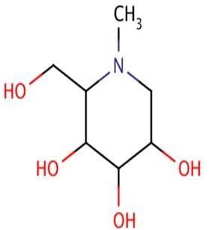

## **Fig. 1: Structure and molecular formula of DNJ**



**Fig**



**.**



**2**



**:**



**Various sources of DNJ**

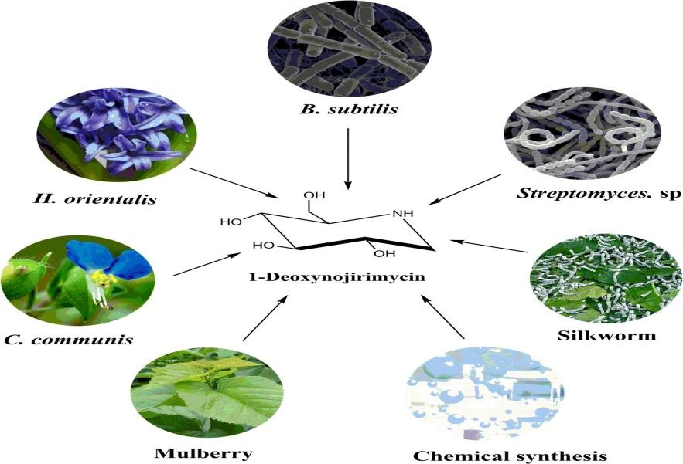

“In addition to mulberry, other plants also contain DNJ. Naoki extracted DNJ from *Hyacinthus orientalis* bud using water:methanol (50:50). Gas chromatography mass spectrometry (GC-MS) detected 31 mg of DNJ from 7.6 kg wet weight of bud. In addition to DNJ, Kim also obtained a pyrrolidine alkaloid (2,5-bishydroxymethyl3,4dihydroxypyrrolidine) and four other piperidine alkaloids (1deoxymannojirimycin, α-homonojirimycin, 7-O-β-D-glucopyranosyl and αhomonojirimycin) from *Commelina communis* but its content was only 0.01125%. In *Adenophora triphyllavar* var. japonica, DNJ as well as several other alkaloids were extracted. The lepidopteran insect Bombyx mori also contains DNJ. DNJ was also found in some strains of *B. subtilis* strain DSM704 and *Streptomyces. Sp*. Ezure *et al*. (1985) isolated *Streptomyces lavendulae* GC-148 from the soil and isolated DNJ in the culture filtrate, the DNJ content was 4,200 mg/mL. Therefore, the natural source of DNJ was very low, making it very difficult to obtain a large quantity of natural DNJ by traditional extraction methods. At present, DNJ and its derivatives were mainly obtained by chemical synthesis and the combination of chemical synthesis and microbial transformation.” (Song and Hollingsworth, 2000; Danieli and Murphy, 2001) [50, 13].

**Table 1. DNJ content in various parts of mulberry plant**

|  |  |
| --- | --- |
| Stem | 0.17 ±0.003mg/g |
| Root | 0.09 ±0.01mg/g |
| Callus | 0.07 ±0.003mg/g |
| Mature Leaf | contain high DNJ (2.90mg/g) |
| Younger fruit | contain high DNJ (0.150mg/g) |
| Male larvae contain high DNJ than female larvae | (male larvae-133.25mg/g) and (female larvae-  129.65mg/g) |

Marisa *et al*., 2021

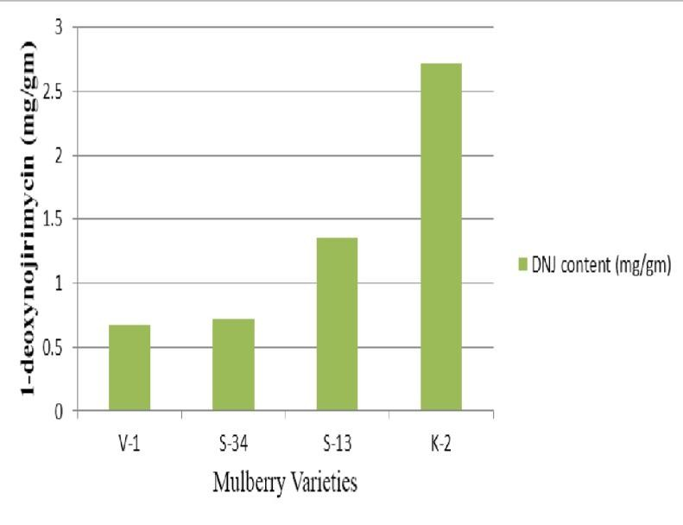

**Fig 3: 1-Deoxynojirimycin content of mulberry leaves in four varieties**

Bajpai and Baskar Rao (2014) [7] screened four mulberry varieties of south India to quantify the 1-deoxynojirmycin in different varieties namely K-2, S-13, S-34, and V-1.

TheDNJ content in different mulberry varieties ranged from 0.68-2.78 mg/gm. The order of 1-deoxynojirimycin concentration in varieties was K-2 > S-13 > S-34 > V-1 (Fig.3). Though V-1 variety was developed by breeding methods (interspecific hybridization of S30 x Ber C776). It contains less DNJ when compared to the K-2 variety which exhibited highest content of 1-deoxynojirimycin, and was developed by natural selection (OPH). Study also coincide with values obtained by other researchers from different varieties and in different countries (Kimura *et al.,* 2007; Yatsunami *et al*., 2008; Wei, *et al.,* 2009; Kefei *et al.,* 2011 and Qin-Xue *et al.,* 2013) [28, 61, 55, 25, 43]. The DNJ content observed that the different Chinese mulberry leaves ranged from 1.57 to 3.48 mg/gm (Wei, *et al.,* 2009) [55]. In general, the results revealed that DNJ content was less in Indian varieties as compared to the Chinese varieties. Chaluntorn *et al*. (2012) [11] observed leaf position in plant is also a factor responsible for DNJ concentration, and the DNJ content was highest in shoots followed by young leaves and mature leaves. Wei-qi (2006) [54] studied variation in mulberry plant organs and the sequence of concentration was observed as Branch Phloem> Leaves > Branch Xylem and the DNJ concentration was ranging from 0.40-4.9 mg/gm when recorded with the help of HPLC-PDA.

**Properties of DNJ:**

* ▸ **MELTING POINT**— 195 – 196°C
* ▸ **BOILING POINT** –361.1± 42.0° C
* ▸ **DENSITY**— 1.456 g/cm3
* ▸ **COLOUR** –white
* ▸ **SOLUBILTY**–water and dimethyl sulfoxide
* 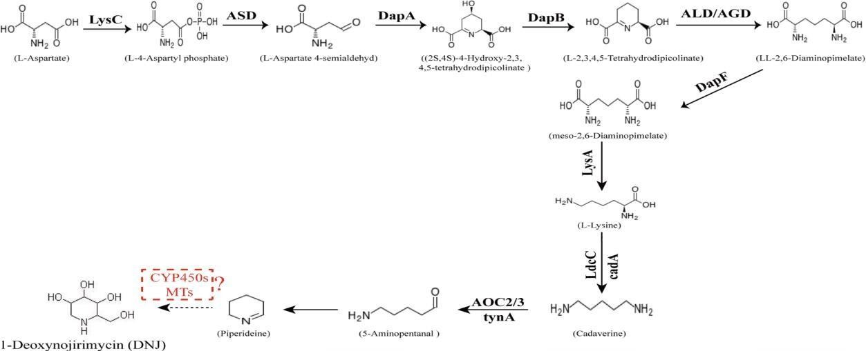**MOLAR MASS** – 163.173± 0.06g/mol

**Fig. 4: Pathway for the biosynthesis of DNJ alkaloids in mulberry (Morus alba L.).**

A DNJ alkaloid biosynthetic pathway biosynthetic pathway was outlined on the basis of differentially expressed transcripts and KEGG pathway assignments. DNJ in mulberry is derived from lysine. The two main biosynthesis pathways of lysine, involving more than 32 enzymes, were identified using the Kyoto Encyclopedia of Genes and Genomes (KEGG) database Wang *et al.*, 2017.

1. **diaminopimelic acid (DAP) pathway: “**This is utilized by most of the bacteria and green plants to produce lysine” (Bhattacharjee, 1985) [8], and it begins with Laspartate as the reaction substrate.
2. **a-aminoadipate (AAA) pathway**: “(a-aminoadipate (AAA) pathway, with (a-ketoglutarate as the initiator, is preferentially used by fungi, euglena, and some bacteria. Whereas, diaminopimelic acid(DAP) pathway which is utilized by most bacteria and green plants to produce lysine begins with L-aspartate as the reaction substrate. lysine was generated using aspartic acid as a substrate, and then the lysine was used as a substrate to generate the DNJ alkaloid. In this pathway, lysine is first converted to cadaverine through the catalytic effect of LDC, followed by the AOC-catalysed formation of a piperidine ring structure and subsequent multi-step reactions to produce the corresponding products. CYP450 enzymes exist in plant cells in both soluble and membrane-bound forms and are widely involved in plant secondary metabolic reactions. DNJ is formed through the methylation and hydroxylation of the 1-piperidine structure by methyltransferases and cytochrome P450 (CYP450) enzymes. The CYP450 enzymes exist in plant cells in both soluble and membrane-bound forms and are widely involved in plant secondary metabolic reactions, including hydroxylation, alkylation, and alkenyl epoxides, hydrocarbon oxidation, and dealkylation of nitrogen, sulphur, oxygen sites, and hydroxylation and oxidation of nitrogen sites assignments.” (Wang *et al*., 2018) [53].

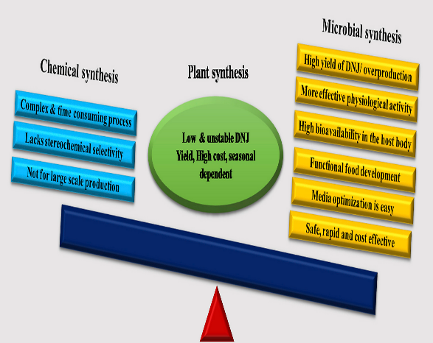

**Fig. 5: Advantages of microbial biosynthesis over plant and chemical synthesis**

**Table 2. DNJ Extraction methods**

|  |  |  |  |
| --- | --- | --- | --- |
| **Methods** | **Advantages** | **Disadvantages** | **Reference** |
| Distilled water  extraction | Crude extraction | Long heating time, destroy DNJ easily | Liu and Zhu, 2006 |
| Acid extraction | Convenient  operations | Concentrating extracts  difficult | Liu and Wang, 2006 |
| Organic  solvents  extraction | Strong penetrability | Consumes more reagent | Zhang and Wang, 2011 |

A traditional method to extract DNJ is through a water extraction method. First, the sample is dried and boiled with distilled water. Then, the sample mixture is filtered and methanol is added to the filtrate, which is then centrifuged and DNJ collected in the supernatant. Apparently, the operation processes are simple and crude. However, long heating times may destroy DNJ. Furthermore, extracting DNJ that is bound to fat, sugar, or protein may experience some difficulties. Because DNJ is an alkaloid, it can also be extracted with acids via the formation of soluble salts. Convenient and mild as it is, the method is less than satisfactory in concentrating the extracts. Organic solvents such as methanol and ethanol are commonly used to extract DNJ because these solvents can easily penetrate into the cell wall. Compared with methanol, ethanol is less toxic and therefore more widely applied in the extraction of DNJ. In addition to organic solvents, microwave assisted methods can also crush cell walls and release DNJ. The method is becoming very popular due to its simple operation, fast extraction rate and pollution-free procedure.

## **Table 3. DNJ Purification methods**

|  |  |  |  |
| --- | --- | --- | --- |
| **Methods** | **Advantages** | **Disadvantages** | **References** |
| Macro porous resin chromatography | Low cost | Crude separation inaccurate | Liu *et al*., 2009 |
| Ion exchange resin | Accurate | Produces harmful substances such as  ammonium hydroxide | Luo and Wu, 2012 |
| Solvent extraction | Simple operation | consumes solvents heavily | Liu *et al*., 2014 |

Macroporous resin chromatography, which utilizes a spherical polymer with a macroporous structure to selectively adsorb organic compounds from aqueous solution and achieves the purpose of separating the target compound. It has the advantage of strong adsorption, easy desorption and good mechanical strength. Using this method, the mass fraction of DNJ increased from 0.23% in dried extracts to 4.9% in the collected chromatographic fraction, and the rate of recovery was 98%. Different types of macroporous resins had different adsorption/desorption capacities. Ion exchange resin chromatography, which takes advantage of electric charges on target products in the sample, is a finer separation method than macroporous resin chromatography, and the DNJ mass fraction increased from 4.9% to 16.7% using this method. During the operations, however, it may produce harmful waste such as ammonium hydroxide. Another purification method is through solvent extraction, which is based on the different solubility of the target compounds in the sample. DNJ was extracted from mulberry branch leachate with diethyl ether, ethyl acetate and 1-butanol separately and HPLC was used to examine each solvent extraction. Results showed that the mass fraction of DNJ was the highest (0.48%) in 1-butanol, followed by ethyl acetate (0.21%) and no DNJ was detected in the diethyl ether. In practice, specific methods should be used according to actual needs. Recently, a new extraction method was reported, which used cellulase produced by microorganisms such as *Trichoderma reesei* ATCC 26921, *Aspergillus niger* DSMZ821, *Trichoderma viride* CICC 40502 and *T. koningii* CICC 13012 for the extraction of DNJ from mulberry leaves. The amount of DNJ extracted after 12 hours of pretreatment with *Trichoderma reesei* fermentation fluid could reach a maximum of 1.995 mg/g of leaf powder, which was 18 times higher than that of the distilled water-soaked group. The microorganism Ganoderma lucidum was screened for fermenting mulberry leaves in order to improve the extraction efficiency of DNJ.

**Table 4. DNJ Detection methods**

|  |  |  |  |
| --- | --- | --- | --- |
| **Methods** | **Advantages** | **Disadvantages** | **References** |
| HPLC – FLD | High selectivity and repeatability | Time inefficient and  derivative | Ou and Chen, 2004 |
| HILIC ELSD | Good sensitivity and repeatability | Good sensitivity and  repeatability | Kimura *et al*., 2007 |
| Colorimetry | Sensitive and simple operations | Color error and inaccurate | Long *et al.,* 2016 |
| Ion chromatography | Fast and convenient | Bad chemical strength | Chen *et al*., 2004 |
| GC & MS | Can separate complex mixtures  sensitively | Sample requires minimal water | Zhong *et al*., 2004 |
| Gas chromatography | High efficiency and detection sensitivity | Give analysis results  indirectly | Qiang *et al*., 2006 |

“Because there is no chromophore in DNJ, the molecule needs derivatization in order to be detected by fluorescence detectors. Such processes are usually complicated, costly and time inefficient and may cause environmental pollution. Researchers have recently developed a new method, namely direct analysis in real time mass spectrometry (DART-MS), for qualitative and quantitative analysis of DNJ in mulberry leaves. Without lengthy derivatization and separation processes, the method greatly shortens the experimental time periods. Compared with the HPLC method that uses a fluorescence detector (FLD), DART-MS can process 8 samples in 6 minutes, while only three samples were handled by HPLC in a 45 minute period. Additionally, the DART-MS method is more environmentally friendly because it does not consume toxic reagents or produce toxic compounds like other methods that require derivatizations, and DART-MS does not require an organic mobile phase for separation. In order to verify the reliability of this method, the results were compared with the data obtained by the 9fluorenylmethyl chloroformate derivatization-HPLC-FLD method. The results obtained using the two methods were essentially the same, suggesting that DART-MS is accurate and reliable for the determination of mulberry DNJ.” (Wang *et al.*, 2017).

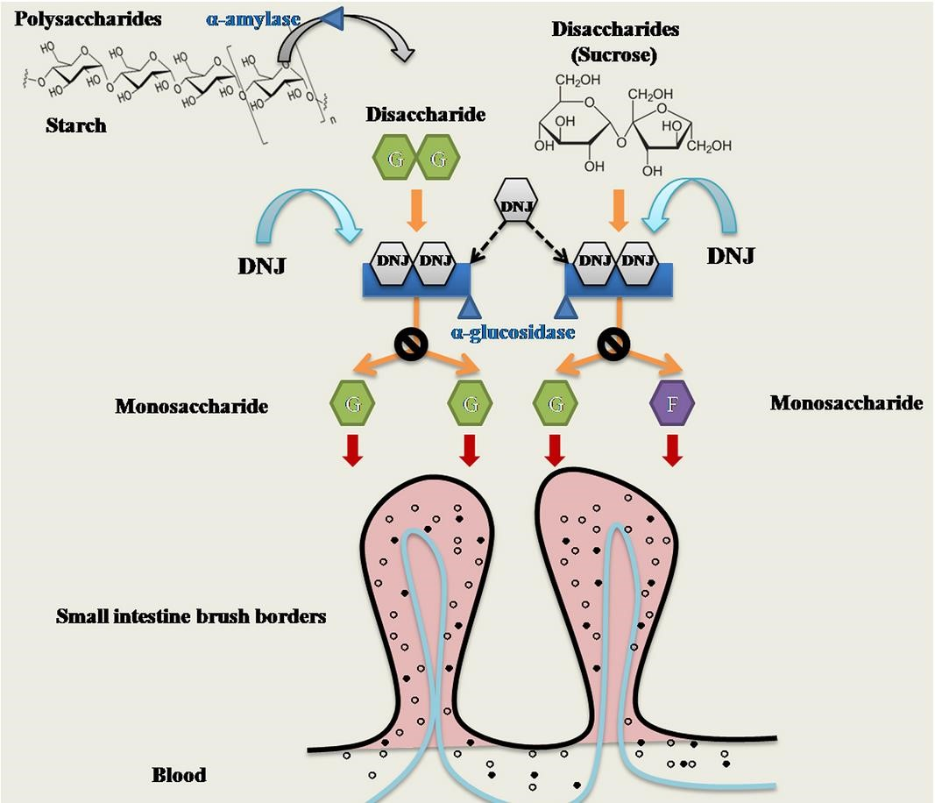

**Fig. 6: Possible mechanism of DNJ as α-glucosidase inhibitor in the human digestive tract**

“Diabetes is a complex metabolic disordered characterized by high blood glucose levels with defects in insulin secretion and is associated with high risks of cardiovascular disease” (American Diabetes Association, 2007; Jiao *et al.,* 2017) [1, 22]. “Mulberry leaf extracts had authenticated proofs of anti-diabetic effects in experimental animals” (Andallu *et al*., 2001; Kuriyama *et al*., 2008 and Naowaboot *et al.,* 2009) [2, 32, 41], “Mulberry leaves are considered as an herbal medicine for the treatment of diabetes for decades” (Ji *et al*., 2016) [24]. In healthy individuals blood glucose levels are tightly regulated through the secretion of insulin from the β cells of the pancrease. In diabetic patients β cell functions decline and glucose levels are not well-regulated high intake of carbohydrates produces high glucose levels. Thus, demands for insulin by putting pressure on β cells. 6 enzymes involved in the complete digestion of starch to sucrose. α amylase are responsible for conversion for polysaccharides to disaccharides. And α- glucosidase is responsible for conversion of disaccharides to monosaccharides. In DNJ administered humans, DNJ blocks this αglucosidase activity which affects conversion of disaccharides to monosaccharides therefore disaccharides cannot be digested and absorbed and are passed into the intestine and eventually excreted. Thus reduces glucose absorption and lowers blood sugar levels. Thakur *et al*. (2019)

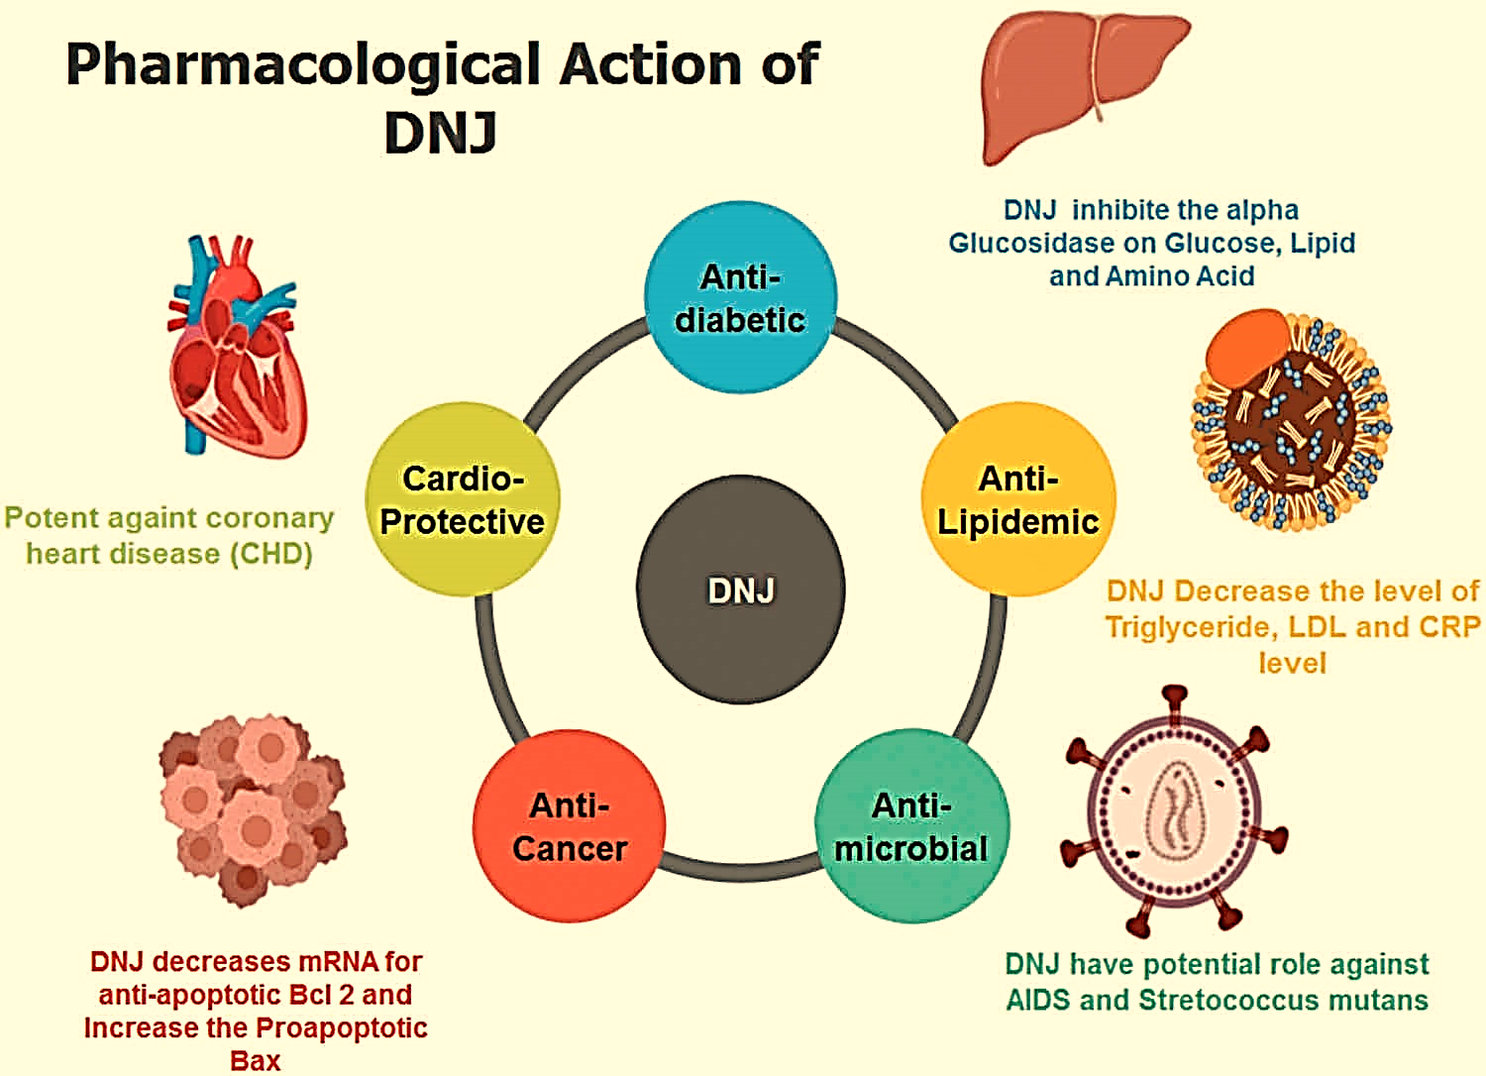

**Alginate-based carriers:** DNJ systemic activity for the Nutraceutical management of Hyperglycemic conditions

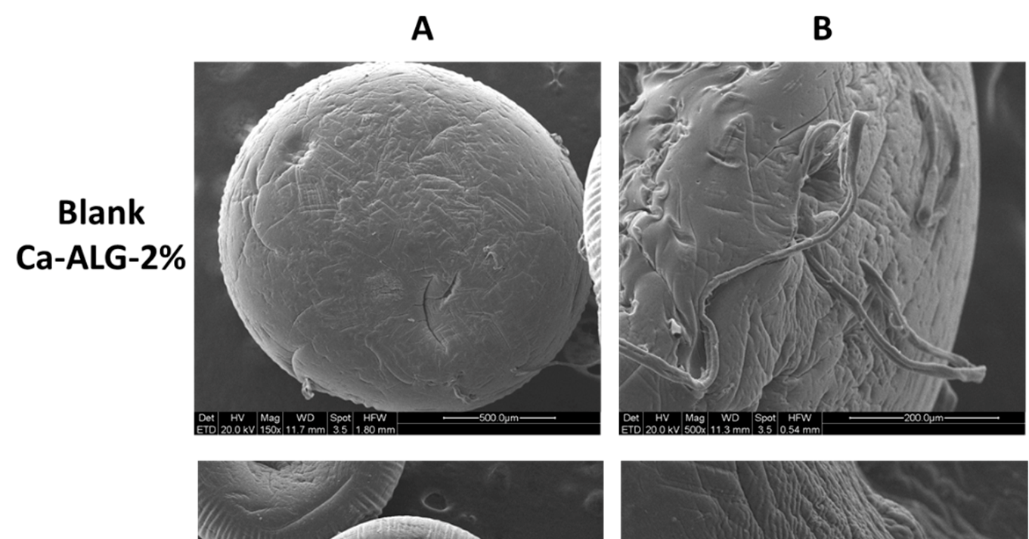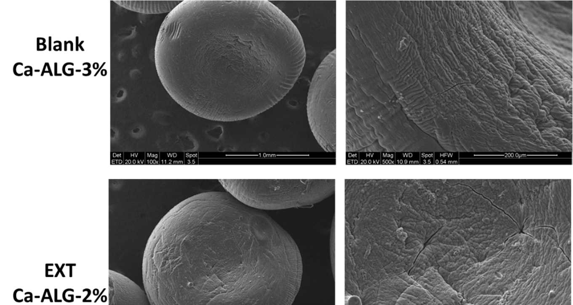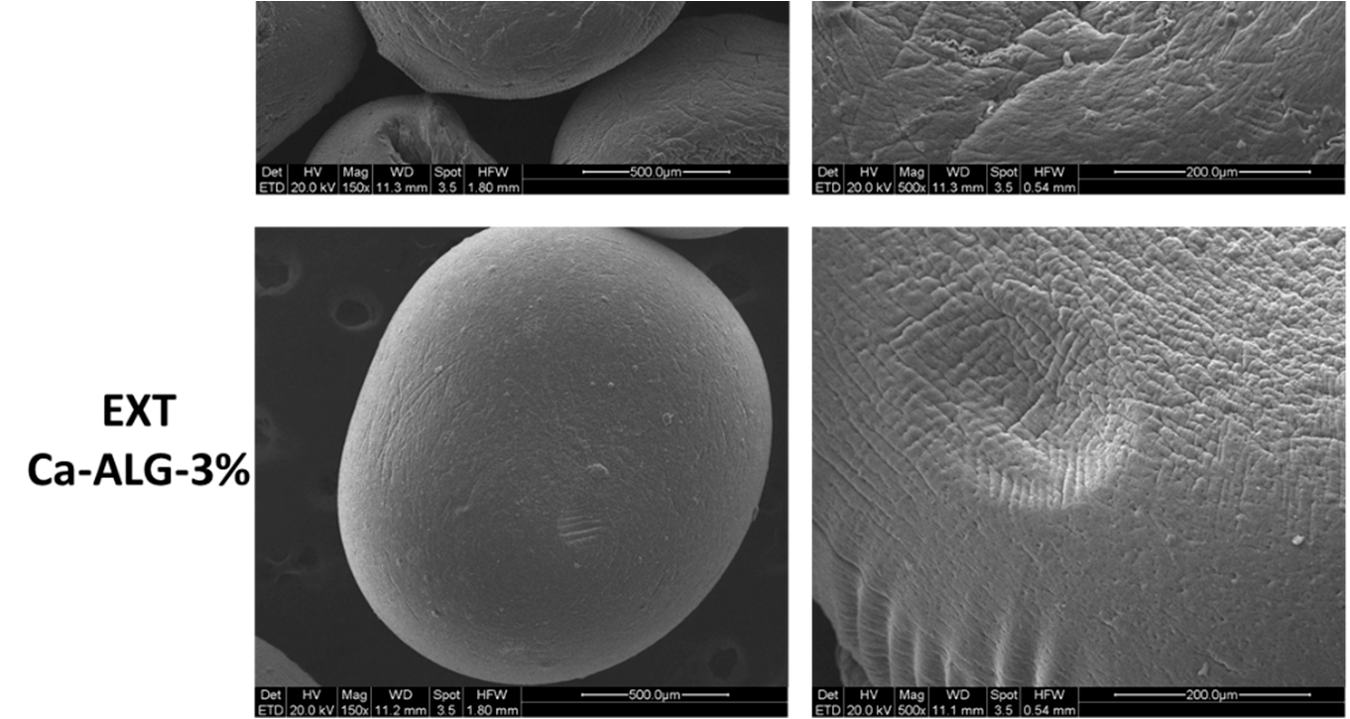

**Fig. 7: ESEM micrograph of blank and EXT-loaded ALG beads 2 and 3% at 100 or 150× (A) and 500× (B) magnification**

“Ca-ALG beads had spherical geometry and good size homogeneity which implies a monodisperse population of particles. Both 2 and 3% blank Ca-ALG beads showed a slightly higher mean diameter than their respective unloaded formulation. Nonetheless, bead size homogeneity was not significantly affected by the addition of the extract, maintaining the narrow distribution for both concentrations. No significant difference in size was observed either between 2 and 3% Ca-ALG beads, suggesting that the small variation in ALG concentration did not impact the particle dimensions. Dry EXT was also solubilized in CaCl2 solution in the same proportion as for ALG solution to attempt the maximum efficiency in DNJ encapsulation. However, a quite low EE% of DNJ was achieved in the beads due to the extremely high water solubility, hydrophilic nature, and low molecular weight. A critical loss of compound could have been caused by the final washing step to remove the excess cross-linking agent. Furthermore, DNJ might have been lost during the drying process, when the water incorporated in the gelled beads was removed and partially absorbed on filter paper. In the case of Ca-ALG-3% beads, a higher EE% was found (*p* < 0.05) due to the higher concentration of Na-ALG employed in the formulation process. The increase in ALG concentration provided a greater availability of binding sites for Ca2+ ions, leading to the formation of a more compact gel membrane with a smaller pore size. Thus, the leak of DNJ during the formulation process was moderate” [22,23]. The morphological analysis confirmed the roundness of the beads and highlighted some differences in the surface structure mainly depending on the polymer concentration. Indeed, the particle surface of blank-Ca-ALG-2% appeared rough and less compact than blank-Ca-ALG-3%. The encapsulation of the EXT seemed to confer a more compact surface texture**.** Marchetti *et al*., 2024

**DNJ on resistin-induced Hepatic steatosis and insulin resistance in mice**

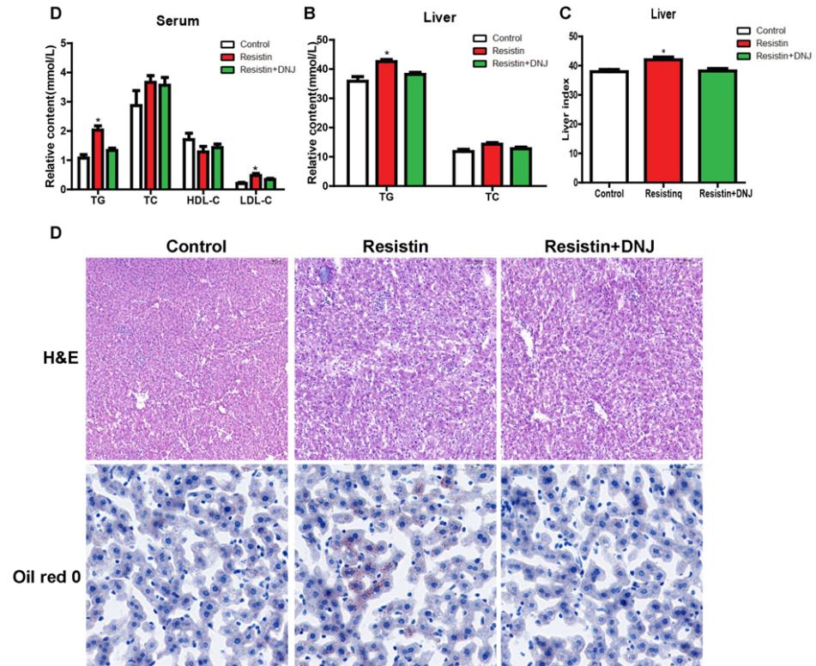

**Fig. 8: Mulberry leaf DNJ *(folium mori*) alleviate resistin-induced lipid accumulation in mice liver.(A) both in serum (A) and in liver (B) were used to investigate the lipid metabolism, (c) Liver index was calculated between the three groups, (D) H&E staining and oil red o staining of liver sections were detected**

The mulberry leaf DNJ could lower blood sugar and decrease lipid accumulation in liver

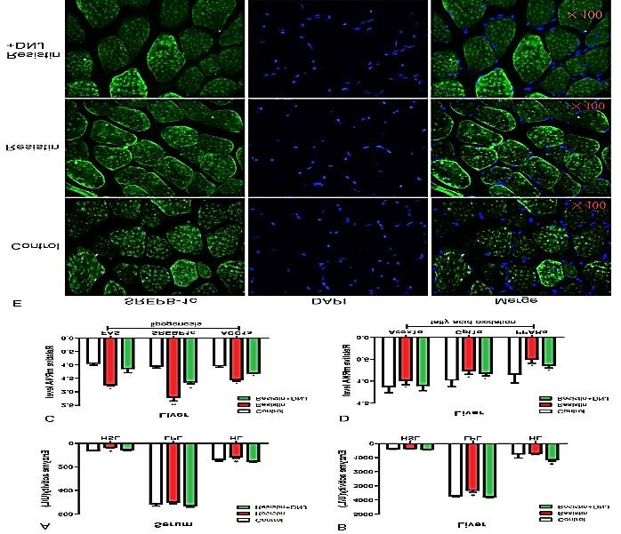

**Fig. 9: Mulberry leave DNJ restore the activities of enzyme and fatty acid oxidation. Male C57BL/6J mice were treated and enzyme activity both in serum (A) and in liver (B) were measured. The relative mRNA expression level of genes related to lipogenesis (C) and fatty acid oxidation (D). (E) SREBP-1c expression level**

DNJ significantly inhibited the resistin-induced decline in enzyme activities of serum HSL and HL and liver LPL. *FAS* and *Acoxlα* were significantly altered by resistin but restored by DNJ. DNJ reduces lipid accumulation by inhibiting *SREBP-1c.* Wen *et al*., 2022

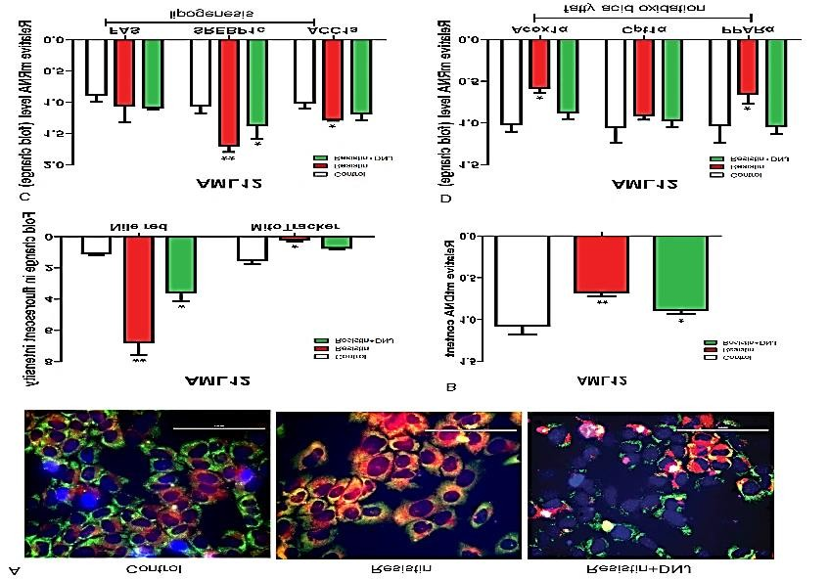

**Fig. 10: DNJ increase the mitochondrial content and reduce the lipid accumulation in AML12 cells. (A) AML12 cells were cultured and treated with resistin (25ng/mL) for 24 h and then treated with or without DNJ (30µM). (B) Mitochondrial content was identified. (C) mRNA expression level of genes related to lipogenesis and (D) fatty acid oxidation were detected.**

Mulberry leaf DNJ decreased lipid accumulation in mouse, which was at a high level after treatment with resistin, by inhibiting the upregulation of *SREBP-1c* and reversing enzyme activities responsible for lipolysis and synthesis. DNJ avoid the decrease of mitochondrial content regulated by resistin, revealing that DNJ may be an effective drug for treating mitochondrial diseases.

**DNJ prevents colorectal cancer in mice**

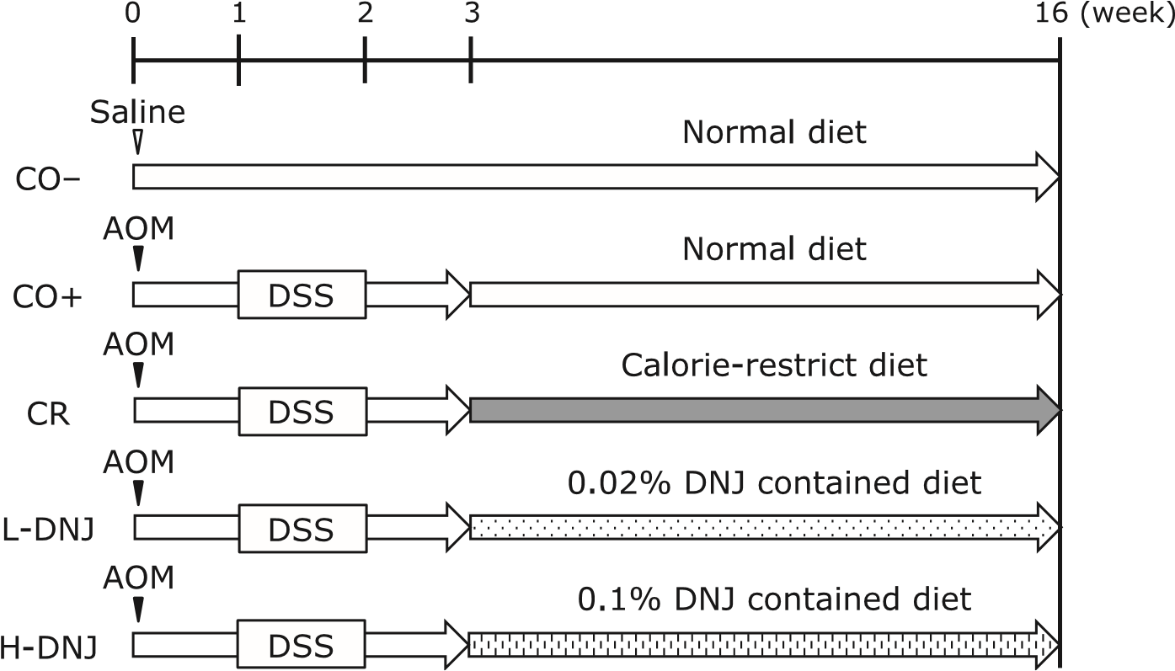

The CO+, CR, LDNJ and H-DNJ groups received a single intraperitoneal injection of AOM in sterile saline at a dose of 10 mg/kg body weight to induce colorectal cancer. Starting one week after the injection, animals received 2% DSS in drinking water for one week to promote tumor progression. The CO– group received a single intraperitoneal injection of sterile saline only. The CO– and CO+ groups were fed CE-2 diet only. The CR, L-DNJ and H-DNJ groups were fed CE-2 diet for three weeks from the start of the experiment. Then, the CR group was fed every other day with CE-2 diet for 13 weeks, starting 1 week after cessation of DSS exposure. The L-DNJ and H-DNJ groups were fed CE-2 diet containing 0.02% and 0.1% DNJ, respectively, for 13 weeks, starting one week after cessation of DSS exposure. At the end of the 16-week period (21 weeks old), the mice were weighed and blood samples were collected after decapitation. Yamamoto *et al.,* 2017

**Fig. 11: Effect of caloric restriction and DNJ on colon tissue in male**

**mice with induced**

**colorectal cancer**

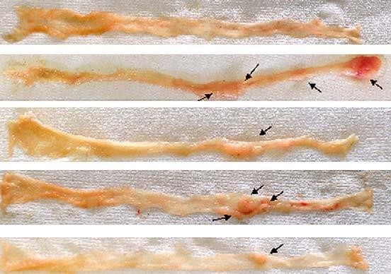

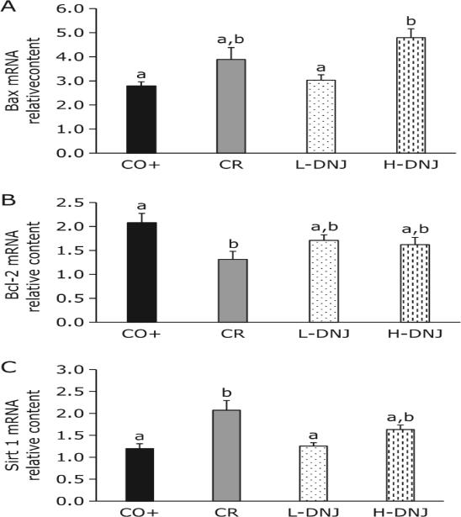Effects of caloric restriction and DNJ on growth para meters. There were significant decreases in food and energy intake in the CR group compared to the CO− and CO+ groups. The CR group had caloric restriction of about 20% compared to the CO+ group. In contrast, there were significant increases in food and energy intake in the H-DNJ group compared to the CO− group (fig 11). There were no significant differences in body weight and tissue weights among the groups with induced colorectal cancer.

**Fig. 12: Effect of caloric restriction and DNJ on apoptosis: (A) BAX (B) Bcl-2 and Sirt 1(c) mRNA levels in male mice with induced colorectal cancer**

Tumor suppression through caloric restriction occurs through induction of apoptosis in cancer cells. To confirm this mechanisms, we measured mRNA levels of the anti-apoptotic gene Bcl-2 and pro-apoptotic gene Bax. In caloric restriction, mRNA for Bax increased and mRNA for Bcl-2 decreased in cancer cells. Similar results were obtained with DNJ intake, which suggests that DNJ induces apoptosis in cancer cells through the Bcl-2/Bax signaling pathway. These findings are also consistent with the role of DNJ as a caloric restriction mimetic. Sirt1 is involved in acute and chronic energy limitation, such as fasting and diet restriction, and controls metabolism by deactivating many transcriptional regulatory factors and affecting gene expression. Therefore, we used Sirt1 as a marker to judge the effect of caloric restriction on colorectal cancer tissue. Sirt1 was increased in the CR group and also increased in a DNJ dose dependent manner. In addition, serum and liver parameters were measured to confirm a CR effect. Since the trend similar to the previous report was confirmed, it was objectively shown that DNJ has a CR effect. Thus, caloric restriction appears to be involved in one of the tumor suppressor mechanisms of DNJ.

# **DNJ isolated from mulberry plant for its Anticariogenic efficacy**

**Table 6. DNJ concentration of mulberry plant extracts**

|  |  |  |  |  |
| --- | --- | --- | --- | --- |
| **Sample** | **DNJ Conc.**  **(µg/mL)** | **Dilute Conc. (%)** | **Conc. (µg/10mg)** | **Conc.(mg/g)** |
| **DNJ** | 1.00 | - | - | - |
| **V1** | 0.132 | 100 | 13.171 | 1.32 |
| **S36** | 0.146 | 100 | 14.550 | 1.46 |
| **RE** | 0.057 | 50 | 2.870 | 0.29 |

The S36 variety of mulberry contains more DNJ than the V1 variety because it has higher levels of the specific compounds that produce DNJ. This can be due to genetic differences or growing conditions that influence DNJ production. Gaviappa *et al*., 2024

**Table 7. Anti-adherence activity of plant extract against *Streptococcus mutans***

|  |  |  |
| --- | --- | --- |
| **Test compound** | **Absorbance** | **% inhibition** |
| **DNJ standard (10µg/mL)** | 0.054 | 89.07 |
| **Leaf (S36) 1mg/mL** | 0.061 | 90.43 |
| **Root (S36) 1mg/mL)** | 0.125 | 77.78 |

DNJ prevents cavities because it blocks bacteria from making sticky substances that form plaque on teeth.

**Challenges and Future Directions:**

DNJ (1-Deoxynojirimycin) from mulberry has shown promising medicinal benefits, especially for managing type 2 diabetes due to its α-glucosidase inhibitory activity. However, its clinical application is limited by low bioavailability, short half-life and gastrointestinal side effects at higher doses. Additionally, variability in DNJ content across different mulberry extracts poses challenges for standardization and consistent dosing. Current research is exploring advanced formulations such as nanoparticles and controlled-release systems to improve absorption and reduce side effects. Biotechnological methods like microbial biosynthesis are also being developed to produce DNJ more efficiently and consistently. Future directions include more human clinical trials, exploring DNJ’s antiviral and neuroprotective potential and combining it with other bioactives for synergistic effects. These advancements could pave the way for DNJ to become a viable therapeutic agent beyond traditional herbal use.

**Conclusion**

DNJ from mulberry demonstrates significant promise due to its multifaceted benefits. Its ability to influence glucose metabolism indicates its potential use in managing diabetic and metabolic disorders. The antiviral properties suggest potential in combating various viral infections, while its possible anticancer effects offer exciting possibilities for developing new cancer therapies. As research progresses, understanding the full range of DNJ's effects and mechanisms will be crucial for optimizing its applications in medicine. Additionally, investigating potential synergies with other treatments and evaluating long-term safety will be essential for effective clinical application.

**DISCLAIMER (ARTIFICIAL INTELLIGENCE):**

Author(s) hereby declare that NO generative AI technologies such as Large Language Models (ChatGPT, COPILOT, etc) and text-to-image generators have been used during writing or editing of manuscripts.

**COMPETING INTERESTS**

Authors have declared that no competing interests exist.

**References:**

1. American Diabetes Association. Diagnosis and classification of diabetes mellitus. Diabetes care*.* 2007; 30:42-47.
2. Andallu B, Suryakantham V, Lakshmisrikanthi B, Reddy GK. Effect of mulberry (*Morus indica* L.) therapy on plasma and erythrocyte membrane lipids in patients with type 2 diabetes. Clinical chimica acta. 2001; 314:47-53.
3. Asano N. Naturally occurring iminosugars and related compounds: structure, distribution, and biological activity. Curr. Top. Med. Chem. 2003; 3(5):471-484
4. BAJPAI, S. AND BHASKAR RAO, A.V., 2014, Quantitative determination of 1Deoxynojirimycin in different mulberry varieties of India. *J. Pharmacogn. Phytochem*., **3**(3): 17-22.
5. Chaluntorn V, Kiyotaka NP, Sookwong OH, Somchai LT, Miyazawa. Development of high 1-deoxynojirimycin (DNJ) content mulberry tea and use of response surface methodology to optimize tea-making conditions for highest DNJ extraction*.* Food Sci. Technol. 2012; 45(2):226-232.
6. Chapel HM, Christie JM, Peach V, Chapman RW. Fiveyear follow-up of patients with primary antibody deficiencies following an outbreak of acute hepatitis C. *Clin. Immunol*. 2001; 99:320-324.
7. Cox T, Lachmann R, Hollak C, Aerts J, Weely SV, Hrebícek M *et al*. Novel Oral Treatment of Gaucher's Disease With N-butyl deoxynojirimycin (OGT 918) to Decrease Substrate Biosynthesis. National. Lib. Med. 2000; 355(9214):1481-1486.
8. Danieli V, Murphy. Effect of heat-induced disturbance on microbial biomass and activity in forest soil and the relationship between disturbance effects and microbial community structure. Appl. soil ecol. 2001; 40(1):109119.
9. Durantel D, Branza-nichita N, Carrouée-durantel S, Butters TD, Dwek RA, Zitzmann, N *et al*. Study of the mechanism of antiviral action of iminosugar derivatives against bovine viral diarrhoea virus*.* J Virol. 2001; 75:8987–8998.
10. GAVIAPPA, D., MATTHEW, S., DEVESWARAN, R. AND BHARKHAVY, K.V., 2024, Evaluation of 1-DNJ isolated from mulberry plant for its anticariogenic efficacy. *Adv. Sci. Technol. Healthc. Ag. Environ. Sustain*, : 89-93.
11. HU RJ. Che ZM. Studies on the microwave-assisted extraction method of DNJ from mulberry leaves. J Food Eng. 2008; 1:50-53.
12. Jiang YG, Wang CY, Jin C, Jia JQ, Guo, XJ, Zhang GZ *et al*. Improved 1-deoxynojirimycin (DNJ) production in mulberry leaves fermented by microorganism. Braz. J Microbiol. 2014; 45:721-729. 24. Ji T, Li J, Su SL, Zhu ZH, Guo S, Qian DW *et al*. Identification and Determination of the polyhydroxylated alkaloids of thecompounds with α-Glucosidase inhibitory activity in mulberry leaves of different origins. Molecules. 2016; 21:206.
13. Kefei H, Yonghua L, Yukai D, Benwai S, Dong L. Analysis of 1-deoxynojirimycin component correlation between medicinal parasitic loranthus from loranthaceae and their mulberry host trees. J Med. Plant Res. 2011; 5(11):4326-4331.
14. Kim HB, Choung WY, Ryu KS. Sensory characteristics and blood glucose lowering effect of ice-cream containing mulberry leaf powder. Korean. J Seric. Sci. 1999; 4:129-134.
15. Kimura T, Nakagawa K, Kubota H, Kojima Y, Yamaqishi K, Oita S *et al*. Food-grade mulberry powder enriched with 1-deoxynojirimycin suppresses the elevation of postprandial blood glucose in humans*.* J Agric. Food. Chem. 2007; 55(4):5869-5874.
16. Kumar RV, Chauhan S. Mulberry: Life enhancer. J Med. Plant. Res. 2008; 2(10):271-278.
17. Kuriyama C, Kamiyama O, Ikeda K, Sanae F, Kato A, Adachi I *et al*. *In vitro* inhibition of glycogen-degrading enzymes and glycosidases by six-membered sugar mimics and their evaluation in cell cultures. Bioorg. Med. Chem. 2008; 16:7330-7336.
18. Lazar C, Durantel D, Macovei A, Zitzmann N, Zoulim F, Dwek RA *et al*. Treatment of hepatitis B virus infected cells with α-glucosidase inhibitors results in production of virions with altered molecular composition and infectivity. Antivir. Res. 2007; 76:30-37.
19. Li H, Qiang YH, Wang JF, Xiao NK. Determination of 1deoxynojirimycin (DNJ) in mulberry leaves by gas phase. North Seric. 2006; 3:31-32.
20. Liu C, Xu L, Shi ZQ, He ZL, Lan J. Progress in separation and purification technology of 1deoxynojirimycin from plants. Sci Seric. 2014;3:544- 550.
21. Luo LL, Wu J. Isolation and purification of 1deoxynojirimycin from *Morus alba* L. leaves. Mod Food Sci. Technol. 2012; 28:167-169.
22. MARCHETTI, L., TRUZZI, E., ROSSI, M. C., BENVENUTI, S., CAPPELLOZZA, S., SAVIANE, A., BOGATAJ, L., SILIGARDI, C. AND BERTELLI, D., 2024, Alginate-based carriers loaded with mulberry (*Morus alba* L.) leaf extract: A promising strategy for prolonging 1-Deoxynojirimicyn (DNJ) systemic activity for the nutraceutical management of hyperglycemic conditions. *Mol.*, **29**(4): 797-816.
23. Mehta KD, Sejul A, Madhulika M, Yogesh G. Seropositivity of hepatitis B, hepatitis C, syphilis, and HIV in antenatal women in India*.* J Infect Dev Ctries. 2013; 7(11):832-837.
24. Mena P, Sanchez-salcedo EM, Tassoti M, Martinez JJ, Hernández F, Del Rio D *et al*. Phytochemical evaluation of eight white (*Morus alba* L.) and black (*Morus nigra* L.) mulberry clones grown in Spain based on UHPLC-ESIMSn metabolomic profiles. Int. Food Res. 2016; 89:1116-1122.
25. Naowaboot J, Pannangpetch P, Kukongviriyapan V, Kukongviriyapan U, Nakmareong S, Itharat A *et al*. Mulberry leaf extract restore sartorial pressure in streptozotocin-induced chronic diabetic rats. Nutri Res. 2009; 29:602-608.
26. Qin-xue H, Jiang-lie, Guo-Jian Z, Wen D, Li-Hui W, Jun-Zhao W *et al*. Quantitative determination of 1- deoxynojirimycin in mulberry leaves from132 varieties. *Ind. crops and prod.* 2013; 49:782-784.
27. RAMAPPA, V.K., SRIVASTAVA, D., SINGH, P., KUMAR, U. AND SINGH, V., 2020, Mulberry 1-deoxynojirimycin (DNJ): An exemplary compound for therapeutics.  *J. Hortic. Sci. Biotechnol.,* **95**(6): 679-686.
28. Robinson R. A theory of the mechanism of the phytochemical synthesis of certain alkaloids. J. Chem. Soc. 1917; 11(1):876-899.
29. Sanchez-Salcedo EM, Amoros A, Hernandez F, Martinez JJ. Physicochemical Properties of White (*Morus alba*) and Black (*Morus nigra*) Mulberry Leaves, a New Food Supplement. J Food Nutr. Res. 2017; 5:253-261.
30. Song X, Hollingsworth RI. A stereoselective synthesis of N-β-D-glycosyl amides by a Ritter-type reaction Synlett. 2000; 3:3451-3454.
31. THAKUR, K., ZHANG, Y., MOCAN, A., ZHANG, F., ZHANG, J. AND WEI, Z., 2019, 1Deoxynojirimycin, its potential for management of non-communicable metabolic diseases. *Trends in Food Science & Technology*, **89**(2): 88-99.
32. Wang N, Zhu F, Chen K. 1- Deoxynojirimycin: sources, extraction, analysis and biological functions. Nat. Prod. Commun. 2017; 12(9):1521-1526.
33. Wang D, Zhao L, Wang D, Liu J, Yu X, Wei Y *et al*. Transcriptome analysis and identification of key genes involved in 1- deoxynojirimycin biosynthesis of mulberry (*Morus alba* L.). J Peer. 2018; 64(4):5443-5467.
34. Wei S, Jing-Han W, Peter B, Pei-Fang Z, Dong-Zhi, LuHua Y *et al*. Phytochemical profiles of different Mulberry (*Morus* sp.) Species from China. J Agric. Food Chem. 2009; 59:9133-9140.
35. Wei-QI L, Xiang-RUI Z. The Determination of 1- Deoxynojirimycin (DNJ) in Three Parts of Mulberry. Bulletin of Sericulture. 2006; 4:1-9.
36. WEN, F., DAI, P., SONG, Z., JIN, C., JI, X., HOU, J. AND LIU, N., 2022, Alleviating effect of mulberry leaf 1-Deoxynojirimycin on resistin-induced hepatic steatosis and insulin resistance in mice. *J. Physiol. Pharmacol*., **73**(6): 745-754.
37. Yagi M, Kouno T, Aoyagi Y, Murai H. The structure of moraoline, a piperidine alkaloid from *Morus* species. *Nippon Nougei Kagaku Kaishi,* 1976; 50:571-572.
38. YAMAMOTO, K., SAKAMOTO, Y., MIZOWAKI, Y., IWAGAKI, Y., KIMURA, T., NAKAGAWA, K.,
39. Yatsunami K, Ichida M, Onodera S. The relationship between 1-deoxynojirimycin content and alpha glucosidase inhibitory activity in leaves of 276 mulberry cultivars (*Morus* spp.) in Kyoto. Jpn. Nat. Med. 2008; 62(1):63-66.
40. ZHANG, H.Y., WANG, T.C., LIU, J.Z., HU, J. X. AND LIU, C.L., 2011 Determination and analysis of 1deoxynojirimycin content in latex of mulberry branch. *Sci. Sericulture*, 1: 121-124.
41. Niannian Wanga, Feifei Zhua and Keping Chena (2017). 1-Deoxynojirimycin: Sources, Extraction, Analysis and Biological Functions. 2017 Vol. 12 No. 9 1521 - 1526