***Review Article***

**Recent Advances in Elucidating the Mechanism of Embryonic Diapause in Silkworm, *Bombyx mori* L.**

**ABSTRACT**

Diapause in silkworm *Bombyx mori* L. is a complex adaptive strategy that ensures survival under adverse environmental conditions by temporarily halting embryonic development. Diapause hormone is a 24-amino acid neuropeptide secreted by suboesophageal ganglion of female pupae, which modulates trehalose metabolism, glycogen accumulation and oxygen consumption. Molecular mechanisms involved in calcineurin and protein kinase C (PKC) signaling, ROS-mediated stress responses and differential expression of ecdysteroid biosynthesis and signaling genes including *Spo*, *Nvd*, *Shd*, *EcRA* and *E75*. Key metabolic genes such as *UGT*, *glucose dehydrogenase* and *mannosidase* show stage-specific expression patterns between diapausing and non-diapausing eggs. The epigenetic regulation, PP1 and PP4 phosphatases and AMPK/ERK-MAPK pathways also play significant roles in embryonic arrest and reactivation. Artificial diapause termination techniques such as acid treatment, chilling and corona discharge impact gene expression patterns related to oxidative phosphorylation and chromatin remodeling. Integrating both physiological and molecular insights will enhance ability to manipulate diapause, offering promising applications for sericulture sustainability.

**Key words:** Diapause, non-diapause, hormone, enzymatic regulation, calcineurin, corona treatment

1. **INTRODUCTION**

Diapause is an essential adaptation in many insects enabling them to withstand in regions which could otherwise be unfavorable for permanent habitation. The term diapause was first time applied by Wheeler short-winged meadow katydid, *Conocephalus ensiferum* egg stage at which its development was ceased (Wheeler, 1893). Later the scope widened into various life stages of insects as “period of arrest in ontogenetic (origin and development of organisms) development” (Chahil *et al.,* 2018). “The diapause in mulberry silkworm, *Bombyx mori* L.is determined by manifestation of genetic characters and endocrinological mechanisms under the influence of environmental stimuli *viz*. temperature and photoperiod” (Yokoyama, 2021).

Diapause begins on the second day of oviposition when cephalic lobe and caudal lobe are formed at anterior and posterior region, respectively on embryo and complete embryonic diapause seen after third day (Liang *et al.,* 2018). “The per cent embryonic cells in G1, S and G2 phase of cell division were 10, 35 and 55%, respectively, at cephalic lobes stage, while 98% of cells were in G2 at diapause stage. After diapause termination, the cells rapidly entered S phase through G1 from M phase indicates that embryonic cells are arrested at G2 stage of cell division.” (Nakagaki *et al*., 1991)

Diapause in insects can be categorized based on seasonal variations, developmental stages and environmental influence. According to seasonal variations, diapause may occur during summer (aestivation), as seen in coccinellids, or during winter (hibernation), observed in species like *B. mori* and grasshoppers (Hand *et al*., 2016). Based on life stages, diapause can take place in the egg stage (embryonic diapause) in *B. mori* and *Aedes aegypti*, the larval stage in *Cydia pomonella*, the pupal and egg stage in *Antheraea yamamai* and the adult or reproductive stage in *Musca autumnalis* (Yevgeniya, 2013). In terms of environmental influence, diapause is classified as obligatory or facultative. Obligatory diapause occurs regardless of external conditions, as in univoltine *B. mori* and the cinnabar moth, while facultative diapause is environmentally induced, seen in multivoltine *B. mori* and certain mosquitoes (Hadley, 2025).

1. **Diapause hormone (DH) composition**

“DH is the active principle of diapause. It is a neuropeptide hormone synthesized and released by sub-oesophageal ganglion (SG) of female pupae which are programmed to lay diapausing eggs” (Okitsugu, 1996, Imai *et al*., 1991). “DH isolated from SGs are determined to be 24 amino acid peptide with the sequence: Thr-Asp-Met-Lys-Asp-Glu-Ser-Asp-Arg-Gly-A1a-His-Ser-Glu-Arg-Gly-Ala-Leu-Cys-Phe-GIy-Pro-ArgLeu-NH2” (Gu *et al.,* 2020). “Two forms of DH (DH-A and DH-B) are identified which consists of 12 – 14 amino acids. DH-B activity was more than threefold that of DH-A” (Yamashita, 1996). “Major functions of DH include determines voltinism, inhibit cytochrome oxidase enzyme thereby reducing respiration rate and decreases oxygen consumption due to which metabolism is also reduced” (Denlinger, 2005).

1. **Stage dependent changes in diapausing eggs**

“Incubation *B. mori* eggs below 15°C causes moth to lay of non-diapause eggs in the next generation, whereas, diapause eggs are induced when incubated at 25°C. Embryonic diapause is regulated by photoperiod and temperature during egg stage of the female and is independent of the photoperiod during post-embryonic development” (Feng *et al*., 2012). Glycogen phosphorylase involved in sorbitol synthesis is observed in induction phase (Bianchi and Russo, 1985). During diapause initiation, reduced oxygen and water content has been observed. “The oxygen uptake is 30µl/g of eggs/hr. Within 4 hrs of egg laying it reached to 100 µl/g of eggs/hr to 24 hrs, after which declined rapidly to 10µl/g and 8µl/ of eggs/hr on 10th and 70th day, respectively. Lower level of oxygen uptake by day 10 at 25°C indicates establishment of stable physiological status of the diapause” (Jiang *et al*., 2017). During diapause termination, during which NAD+ sorbitol dehydrogenase activity increases thereby leading to glycogen synthesis. Exposure of silkworm diapause eggs to oxygen or acid treatment also terminates diapause in eggs (Hiroyoshi *et al.*, 2018).

1. **Termination of Diapause**

Termination of diapause can be done by cold storage – chilling (hibernation schedule) (Clark and Worland 2008). “Exposure of diapausing eggs below 5°C temperature over 60 days terminates diapause and embryonic development resumes when they are transferred to 25°C. The optimum chilling duration to terminate the diapause depends on the time gap of eggs kept for aestivation at 25°C after oviposition. Hydrochlorization refers to hot or cold acid treatment. The first method of acid treatment involves soaking 20 – 24 hrs old oviposited eggs in HCL solution of specific gravity 1.064 at 46.1°C for 5 minutes. This prevents the eggs to enter into diapause. Therefore, when incubated at 25°C, larva hatch in 10 to 11 days after treatment. In the second method 20 to 24 hrs old oviposited eggs are soaked in HCl solution of specific gravity 1.10 at 10°C and keeping them at room temperature for 60 to 90 minutes” (Gong *et al*., 2016; Dandin and Giridhar, 2014). “Cold storage followed by HCl treatment method, is also followed. This treatment causes diapausing eggs to hatch in two months after oviposition.” (Singh *et al*., 2013)

1. **Physiological and biochemical changes during diapause**

“Diapause eggs accumulate high levels of 3-hydroxykynurenin and glycogen. Various changes exist on commencement of diapause, where 3-hydroxykynurenine from haemolymph in developing eggs is oxidized to ommochrome, resulting in the dark coloration of diapause-destined eggs and glycogen is converted into sorbitol, acting as an anti-freeze for the embryo” (Zhang, 2017). “Diapause hormone acts directly to induce the expression of trehalase gene in developing ovary and enhances trehalase activity which is localized in plasma membrane of the vitellogenic follicles” (Deng *et al*., 2018). “In the oocyte, glucose is immediately utilized to synthesize glycogen as a storage reserve, by which hyperglycogemia is induced in eggs, a pre-requisite for diapause initiation” (Singh and Saratchandra, 2002).

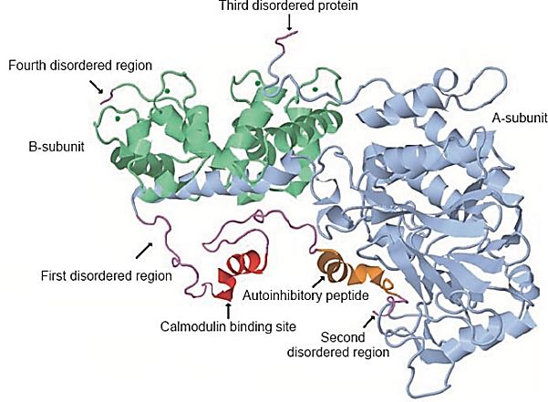

**Fig. 1: Structure of Calcineurin (Bo *et al*., 2019)**

1. **Calcineurin expression in relation to the silkworm embryonic diapause**

“Calcineurin (CN) is Ca2+ /calmodulin-activated serine/threonine protein phosphatase identified to be involved in various cellular processes and signal transduction pathways” (Gu *et al*., 2010). “It is activated by the influx of intracellular Ca2+. An immunoblot analysis found that CN is heterodimeric protein consisting of catalytic A subunit, calcineurin A (CNA) and a regulatory B subunit, calcineurin B (CNB)” (Gu *et al*., 2021). “The expression levels of CNA, CNB and a CN regulator calcipressin vary in diapausing and non-diapausing eggs” (Hsieh *et al*., 2019).

“Western blot analysis of *B. mori* eggs showed that on day 4 post-treatment, CNA levels were lower and CNB levels were higher in HCl-treated eggs compared to diapausing ones, while CAL levels remained unchanged” (Hsieh and Gu, 2019). Total protein levels (via HSP70) were stable. In HCl-treated eggs, CNA levels decreased and CNB levels increased during early embryogenesis, suggesting a role in diapause regulation. In contrast, diapause eggs maintained high CNA and CAL levels with declining CNB, indicating a possible suppression of CN activity. The higher CNB expression and enzymatic activity in non-diapausing eggs suggests that CN is involved in embryonic development, possibly regulated by non-catalytic CNA domains (*viz.* CNAac (CNAa and CBD) and CNAaci (CNAa, CBD and AI) (Denlinger and Armbruster 2014). It was also suggested that calcipressin act as endogenous feedback inhibitor of Calcineurin (Kingsbury and Cunningham, 2000) and over expression in several organisms revealed calcipressins inhibitory activity (Liu, 2003). Thus, it can be hypothesized that high protein levels of calcipressin detected in diapause eggs may also contribute to very low endogenous CN activity. “The subunit CNB was localized in serosa cells and yolk cells, suggesting CNB is activated by intracellular Ca2+ or efflux Ca2+ resulting from HCl treatment and that it plays a role in the molecular mechanisms of artificial diapause prevention or the breaking of diapause in the silkworm” (Sato *et al*., 2021). Additional studies for clarifyingt the regulation of CN activity and the map upstream and downstream signaling would highlight new insights in understanding the possible mechanisms regulating embryonic development in silkworm *B. mori*.

1. **Expression of Kinases and Phosphatases**

“Protein kinases C (PKCs) are a family of serine/threonine kinases that are ubiquitously present in animal tissues and play central roles in eukaryotic cellular differentiation, activation of signaling cascades and survival” (Tougeron, 2019). “PKCs have been classified into three subfamilies: classical (cPKC), novel (nPKC) and atypical (aPKC)” (Jing *et al.,* 2018). “Western blot analysis of PKC-dependent protein phosphorylation and PKC protein in silkworm eggs showed higher PKC protein levels in HCl-treated eggs compared to control (water treated) eggs. Temporally total PKC protein levels also showed gradual increases during the first 9 days of embryonic development in HCl-treated eggs and gradually decrease in diapausing eggs. Increased phosphorylation levels of multiple PKC-dependent proteins and PKC enzyme activity in developing eggs during early and middle stages in non-diapause eggs and cold treated eggs (5 °C for 70 days) are related to embryonic development” (Kostal, 2006). “The termination of egg diapause under low temperature makes the extracellular signal-regulated kinase (ERK)/mitogen-activated protein kinase (MAPK) signaling to activate in yolk cells” ([Iwata *et al*., 2005](https://www.frontiersin.org/journals/cell-and-developmental-biology/articles/10.3389/fcell.2020.593613/full#B44)).  “ERK/MAPK increases sorbitol levels and 20-hydroyxecdysone (20E) metabolism by regulating transcription of downstream genes thereby, promoting embryogenesis, yolk-cell dispersion and yolk protein degradation” ([Fujiwara *et al*., 2006](https://www.frontiersin.org/journals/cell-and-developmental-biology/articles/10.3389/fcell.2020.593613/full#B26), Fujinaga *et al*., 2017). “Adenosine monophosphate (AMP)-activated protein kinase (AMPK) regulates the functions in embryonic development and hatching of *Nilaparvata lugens* (Rice brown plant hopper)” (Klee *et al*., 1998). “Likewise, phosphotransferase-protein phosphatases are involved in dephosphorylation regulate signal transmission throughout the cell. PP1-C and PP4-C phosphatases are identified to be differentially regulated during the egg stage between diapause and developing eggs. Higher protein levels and enzymatic activities of PP4-C and PP1 are likely related to the embryonic development of *B. mori”* (Gu and Linn 2022)*.*

1. **Effect of Hypoxia on embryo development**

“Hypoxia refers to low levels of oxygen in the body tissues. When non-diapause silkworm eggs were exposed to 5% and 10% oxygen concentrations for more than 2 days, their hatching time was delayed compared to control normoxia (25°C, RH 75%) and the eggshell color changed from pale yellow to pale red (5% O2) which could be attributed to deposition of serosal layer” (Jing *et al.,* 2019). “On day 1 after oviposition (Fig. 2 A, B), the embryos under hypoxia were smaller and rectangular than those normoxia treated embryos (pyriform-shape) (Fig. 2 C). On day 2, appendages were witnessed in control but not in the hypoxia-treated embryos. From day 3, however, morphology of hypoxia-treated embryos almost exhibited no changes whereas, control embryos changed drastically each day till hatching. This is the reason why hibernating schedule is followed in sericulture, during which oxygen is depleted to low level and remained constant thereafter. During the time of release eggs are gradually kept in higher temperature to regain the activity” (Hernández-García et al., 2010). “Further, peak ROS levels were observed in diapause eggs within 3 days of oviposition, after which the levels decreased; in contrast, ROS levels in non-diapause eggs were significantly lower. Reactive oxygen species (ROS) are produced by the metabolic pathways in almost all cells. As signaling components, ROS are known for roles in biotic and abiotic stresses.” (Mhamdi et al., 2018). “Higher concentrations of ROS can cause temporary arrest in the growth, depression of the housekeeping genes and expression of the stress-related genes. ROS might be inducing specific responses thereby regulating patterns of tissue development during embryonic development” (Davies, 1999).

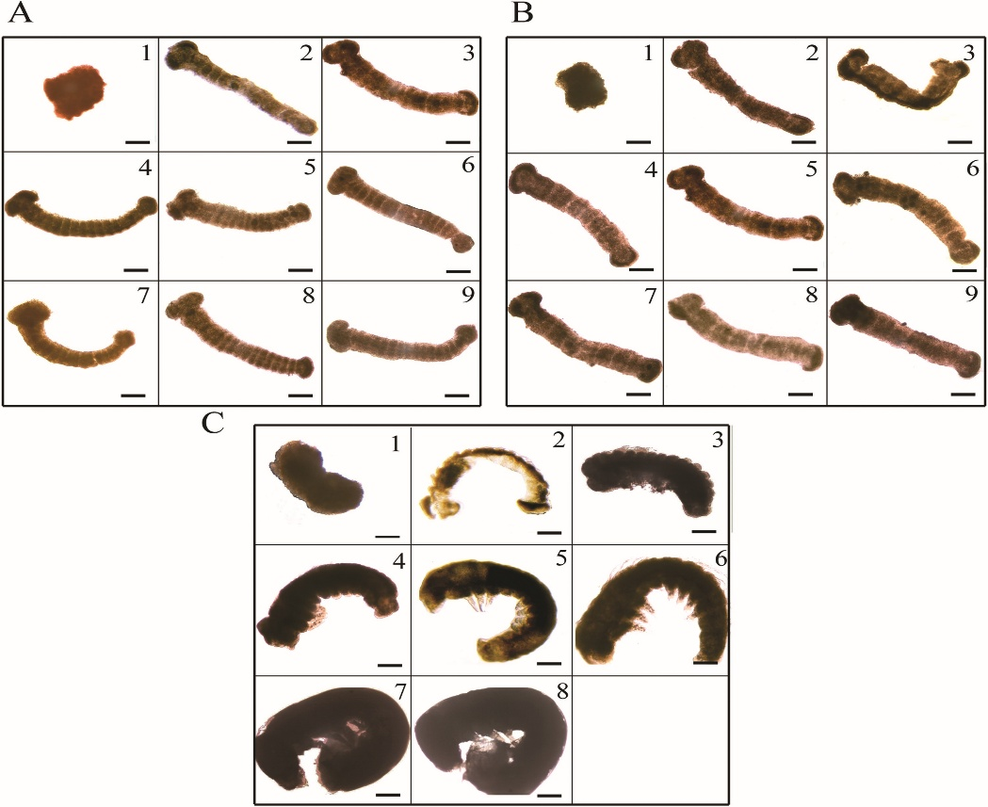

**Fig. 2: Embryo of (A) non-diapause egg, (B) diapause egg under hypoxia and (C) non- diapause egg under normoxia. Numbers 1 to 9 represent days after oviposition.**

1. **Ecdysteroidogenic enzyme and ecdysteroid signaling genes**

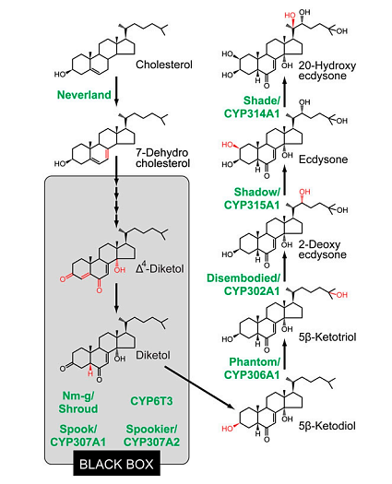

**Fig.3: The ecdysteroid biosynthesis pathway and ecdysteroidogenic enzymes in insects**

“The biosynthetic pathway of ecdysteroids begins from oxidation of cholesterol into 7‐dehydrocholesterrol (7dC) (Fig. 3). This initial step is mediated by a *Neverland* (*Nvd*) gene. Between this 7dC and the first upstream compound exhibiting the highly characteristic ecdysteroid structure, diketol, lays the “black box.” This black box includes a series of unidentified and uncharacterized reactions which ultimately result in the oxidation of 7dC to diketol” (Ryusuke and Yuko, 2014). “Involvement of *CYP307A1* (also called *Spook* (*Spo*) in several insect species)/A2 (also called *Spookier* in *Drosophila*) in the black box, which appears to the rate‐limiting enzyme. Hydroxylation at C25, C22 and C20 is mediated by *CYP306A1* (also called *Phantom* (*Phm*), *CYP302A1* also called *Disembodied* (*Dib*) and *CYP315A1* also called Shadow (Sad), respectively” (Nagasawa *et al.,* 1986, Mizuguchi *et al.,* 1987, Sakurai *et al.,* 1989).

The final hydroxylation from ecdysone to 20‐hydroxyecdysone (20E) is catalyzed by a fourth hydroxylase, *CYP314A1*, *Shade* (*Shd)* in peripheral target tissues. Role of different enzymes is discussed here. *Eppase*: Ecdysteroid Phosphate Phosphatase converts ecdysteroid phosphate to free ecdysteroids. The halloween genes: *Spo, Nvd, Phm, Dib, Sad* and *Shd* code for cytochrome P450 enzymes in the ecdysteroidogenic pathway (biosynthesis of ecdysone from cholesterol) (Gu *et al*., 2021, Marchal *et al.,* 2011, Chavez *et al*., 2000). *E75A, E75B, E74A, E74B*: Ecdysone inducible 75A, 75B, 74A, 74B. *Br-C*: Broad- Complex: Encodes family of transcription factors needed for metamorphic processes (Niwa and Niwa, 2014). Receptors: *EcRA* (Ecdysteroid receptor A), *EcRB1* (Ecdysteroid receptor B1) and *USP* (Ultraspiracle). *HR* (Hormone receptor), *Kr-h1* (Kruppel homolog1) and *FTZ‐F1* (Fushi-tarazu factor-F1)

The study clearly demonstrated that the expression patterns of key genes involved in ecdysteroid synthesis (EPPase, Spo, Nvd, Shd) and signaling (EcRA, E75A, E75B, HR3, HR4, FTZ-F1) differ significantly between diapause and HCl-treated (developing) silkworm eggs. In diapause eggs, these genes generally showed either low or transient expression, while in HCl-treated eggs, their expression increased during specific stages of embryonic development, especially the middle to late phases of embryonic development. These patterns were also consistent with non-diapause eggs, confirming that the differences in gene expression are directly linked to the diapause state. Similar observations in other insects, such as *Locusta migratoria* (Petryk *et al*., 2003, Lenaerts *et al*., 2016), where ecdysteroid levels are lower in diapause eggs. The results highlight the critical role of stage-specific regulation of ecdysteroidogenic and nuclear receptor genes in controlling embryonic diapause in silkworms indicating development arrested at the G2 phase of the embryonic cell cycle (Jarvela *et al.*, 2017). To maintain this arrested state, the production and activation of ecdysteroids must be minimal. (Nakagaki *et al*., 1991, Jarvela and Pick, 2017)

1. **Expression analysis and functional identification of diapause genes**

“*B. mori* diapause is based on the principle that silkworm offspring diapause is regulated by the environmental conditions experienced by the parents during the embryonic period was constructed Jiang *et al*., 2019. The gene product of *BGIBMGA003835* is UDP-glycosyltransferase (UGT), which catalyzes the transfer of the glucuronic acid group of UDP-glucuronic acid to a small hydrophobic molecule. The gene product of *BGIBMGA012335* is related to the solute carrier family 35 member F6(SLC35F6). It may be involved in transmembrane transport of glucose, amino acids and other substances” (Parvy *et al*., 2014). “The gene product of *BGIBMGA002426* is mannosyl-oligosaccharide α-1,2- mannosidase, which is involved in the procession of protein or peptide in endoplasmic reticulum. The product of *BGIBMGA012996* is glucose dehydrogenase (FAD, quinone) which is important for glucose metabolism and energy supply” (Hahn and Denlinger 2011).

“The expression levels of *BGIBMGA003835* and *BGIBMGA012335* were significantly higher in the PDD (progeny diapause destined) group than the PNDD (progeny non-diapause destined) group, with 8-fold and 45-fold differences seen for the two genes, respectively indicating that the manufacture and storage of glycogen is increased in diapause eggs” (Lin *et al*., 2009). “The expression levels of *BGIBMGA002426* and *BGIBMGA012996* were significantly decreased in the PDD group compared with PNDD group, with 7-fold times and 16-fold differences, respectively indicating that activity of Mannosyl- oligosaccharide α- 1,2- mannosidase and Glucose dehydrogenase activity is reduced in diapausing egg” (Chen *et al.,* 2017).

1. **VECT-mediated artificial breaking of silkworm egg diapause**

Zhang *et al*., (2022) designed an artificial corona instrument which can be used to disrupt the diapause of newly laid as well as refrigerated eggs successfully. Subsequently, they invented more eco-friendly, less expensive, safer and handier strategy with broader adaptability, named as very early corona (electric field) treatment (VECT) at voltage 12 Kv, pole pitch, 8 mm to prevent eggs from entering diapause. This is achieved by incorporating corona on newly laid eggs within 4 hours of oviposition. The maximum hatching rates of the larvae reached 95.77 to 97.15 per cent, which was comparable to the effect of HCl treatment in preventing diapause of eggs at 20 h after oviposition**.** VECT method revealed that the larval hatching rates of Dazao eggs collected at 0.5–1.5 h after oviposition increased significantly with the variation in the corona treatment times from 5 s to 1min 30s. The average maximum hatching rates of the larvae reached 88.57–93.19 per cent. However, when the length of the corona treatment time was longer than 2min, the larval hatching rates decreased significantly. Moreover, the hatching rates at 2–4 h after oviposition increased significantly with the variation in corona treatment times from 5s to 30s and reached the maximum following treatment for 30s. Subsequently, the larval hatching rates of DZ eggs did not change significantly with an increase in the corona treatment times (from 30s to 5 min).

The mechanism of VECT to disrupt diapause of silkworm eggs is still unclear. However, it can be speculated that corona treatment disrupted the serosal layer formation which is key characteristic of diapuase initiation. Some studies speculated that the electric field may cause conformational changes in the diapause hormone, leading to inactivation, thereby inducing embryo to disrupt diapause and initiate development (Yang *et al*., 1994). Other studies speculated that free radicals generated from corona discharge in eggs are among the important factors which disrupt diapause (Ye *et al*., 1996, Hernandez-Garcia *et al*., 2010). It was also reported that the mortality of silkworm eggs after corona treatment was low, which may be due to disinfection and sterilization effect created by ozone in the air (Chen and Zhu, 1997). However further studies regarding buildup of effects of radiation due to continuous treatment generation after generation need to be demonstrated. Also, large-scale implication of this technique need to be addressed to check ease of installation of VECT set-up, maximum disease free layings that can be treated commercially in short time and provide to farmers for rearing. Success in commercial utilization will revolutionize the field of sericulture.

1. **CONCLUSION**

Diapause acts as a strategy for insects to withstand adverse climate and ensures their long-term survival. The integration of physiological observations with gene expression studies highlights how diapause hormone, ecdysteroidogenic pathways, signaling cascades like calcineurin and PKC and stress-related responses like ROS collectively govern initiation, maintenance and termination of diapause. Studies in molecular biology have shed light on the gene regulatory network underlying diapause in silkworms. Unraveling the intricacies of gene expression during diapause opens avenues for targeted genetic interventions. Further, understanding diapause breaking mechanisms help in developing tools and techniques for diapause termination thereby, controlling time of hatching and ensuring timely crop leading to sustainable sericulture.

**Disclaimer (Artificial intelligence)**

Authors hereby declare that NO generative AI technologies such as Large Language Models (ChatGPT, COPILOT, etc.) and text-to-image generators have been used during the writing or editing of this manuscript.

**REFERENCES**

Bianchi A, Russo A. The influence of sorbitol on the glycogenolytic pathway. Physiol Chem Phys Med NMR. 1985;17(4):401-5.

Chahil, G., Gill, H., & Goyal, G. (2018). Insect diapause: A review. Journal of Agricultural Science and Technology, 454–473.

Chavez, V. M., Marques, G., Delbecque, J. P., Kobayashi, K., Hollingsworth, M., Burr, J. *et al*., (2000). The *Drosophila* disembodied gene controls late embryonic morphogenesis and codes for a cytochrome P450 enzyme that regulates embryonic ecdysone levels. Development, 127, 4115–4126.

Chen, J., & Zhu, X. (1997). A promising technology in agricultural production: Corona discharge technique. *Physics*, *26*, 671–674.

Chen, Y. R., Jiang, T., Zhu, J., Xie, Y. C., Tan, Z. C., Chen, Y. H., & Shen, X. J. (2017). Transcriptome sequencing reveals potential mechanisms of diapause preparation in bivoltine silkworm *Bombyx mori* L. (Lepidoptera: Bombycidae). Comparative Biochemistry and Physiology Part D: Genomics and Proteomics, 24, 68–78.

Clark, M. S., & Worland, M. R. (2008). How insects survive the cold: Molecular mechanisms—a review. Journal of Comparative Physiology B: Biochemical, Systemic and Environmental Physiology, 178(8), 917–933. <https://doi.org/10.1007/s00360-008-0286-4>

Dandin, S. B., & Giridhar, K. (2014). *Handbook of sericulture technologies* (p. 427). Central Silk Board (CSB) Publications.

Davies, K. J. (1999). The broad spectrum of responses to oxidants in proliferating cells: A new paradigm for oxidative stress. IUBMB Life, 48, 41–47.

Deng, L., Li, C., Chen, L., Liu, Y., Hou, R., & Zhou, X. (2018). Research advances on embryonic diapause in mammals. Animal Reproduction Science, *198*, 7–10.

Denlinger, D. L., & Armbruster, P. A. (2014). Mosquito diapause. Annual Review of Entomology, 59, 73–93. <https://doi.org/10.1146/annurev-ento-011613-162023>

Denlinger, D. L., Yocum, G. D., & Rinehart, J. P. (2005). Hormonal control of diapause. In L. I. Gilbert, K. Iatrou, & S. S. Gill (Eds.), Comprehensive Molecular Insect Science, 3, 615–650.

Feng, H., Chen, P., Li, G., Qiu, F., & Guo, X. (2012). Diapause induction in *Apolygus lucorum* and *Adelphocoris suturalis* (Hemiptera: Miridae) in northern China. Environmental Entomology, 41(6), 1606–1611. <https://doi.org/10.1603/EN12099>

Fujiwara, Y., Tanaka, Y., Iwata, K., Rubio, R. O., Yaginuma, T., Yamashita, O., *et al*., (2006). ERK/MAPK regulates ecdysteroid and sorbitol metabolism for embryonic diapause termination in the silkworm, *Bombyx mori*. Journal of Insect Physiology, 52, 569–575. <https://doi.org/10.1016/j.jinsphys.2006.02.004>

Gong, J., Tian, S., Zhou, X., Yang, H., Zhu, Y., & Hou, Y. (2016). Transcriptional response of silkworm (*Bombyx mori*) eggs to O₂ or HCl treatment. International Journal of Molecular Sciences, 17(11), 1838. <https://doi.org/10.3390/ijms17111838>

Gu, S. H., & Lin, P. L. (2022). Expressions of the protein phosphatases PP1 and PP4 during the embryonic diapause process of the silkworm *Bombyx mori*. Zoological Studies, 61. <https://doi.org/10.6620/ZS.2022.61-61>

Gu, S. H., Chen, C. H., & Lin, P. L. (2021). Expression of protein tyrosine phosphatases and *Bombyx* embryonic development. Journal of Insect Physiology, 130, 104198. <https://doi.org/10.1016/j.jinsphys.2021.104198>

Gu, S. H., Lin, J. L., & Lin, P. L. (2010). PTTH‐stimulated ERK phosphorylation in prothoracic glands of the silkworm, *Bombyx mori*: Role of Ca²⁺/calmodulin and receptor tyrosine kinase. Journal of Insect Physiology, 56(1), 93–101. <https://doi.org/10.1016/j.jinsphys.2009.09.014>

Gu, S. H., Yeh, W. L., Young, S. J., Lin, P. L., & Li, S. (2012). TOR signaling is involved in PTTH‐stimulated ecdysteroidogenesis by prothoracic glands in the silkworm, *Bombyx mori*. Insect Biochemistry and Molecular Biology*, 42*(4), 296–303. <https://doi.org/10.1016/j.ibmb.2012.01.005>

Gu, S., Chein, C., & Lin, P. (2021). Changes in expressions of ecdysteroidogenic enzyme and ecdysteroid signaling genes in relation to *Bombyx mori* L. embryonic development. Journal of Experimental Zoology Part A: Ecological and Integrative Physiology, 335(5), 477–488.

Gu, S., Chein, C., Hsieh, H., & Lin, P. (2020). Expression of protein kinase C in relation to the embryonic diapause process in the silkworm, *Bombyx mori* L. Journal of Insect Physiology, 121.

Hadley, D. (2025). Diapause in insects. *ThoughtCo*. <https://www.thoughtco.com/types-of-diapause-1968243>

Hahn, D. A., & Denlinger, D. L. (2011). Energetics of insect diapause. Annual Review of Entomology, 56, 103–121. <https://doi.org/10.1146/annurev-ento-112408-085436>

Hand, S. C., Denlinger, D. L., Podrabsky, J. E., & Roy, R. (2016). Mechanisms of animal diapause: Recent developments from nematodes, crustaceans, insects and fish. American Journal of Physiology-Regulatory, Integrative and Comparative Physiology, 310(12), R1193–R1211. <https://doi.org/10.1152/ajpregu.00250.2015>

Hernández-García, D., Wood, C. D., Castro-Obregón, S., & Covarrubias, L. (2010). Reactive oxygen species: A radical role in development. Free Radical Biology and Medicine*,* 49(2), 130–143. <https://doi.org/10.1016/j.freeradbiomed.2010.03.020>

Hiroyoshi, S., Reddy, G. V. P., & Mitsuhashi, J. (2018). Effects of photoperiod, temperature and aging on adult diapause termination and post-diapause development in female Asian comma butterflies, *Polygonia c-aureum* Linnaeus (Lepidoptera: Nymphalidae). Journal of Comparative Physiology A: Neuroethology, Sensory, Neural and Behavioral Physiology, 204, 849–858. <https://doi.org/10.1007/s00359-018-1293-z>

Hsieh, H. Y., & Gu, S. H. (2019). Expression of calcineurin in relation to the embryonic diapause process in the silkworm, *Bombyx mori*. Comparative Biochemistry and Physiology Part A: Molecular & Integrative Physiology, *228*, 35–42. <https://doi.org/10.1016/j.cbpa.2019.01.014>

Hsieh, H., & Gu, S. (2019). Expression of calcineurin in relation to the embryonic diapause process in the silkworm, *Bombyx mori* L. Comparative Biochemistry and Physiology Part A: Molecular & Integrative Physiology, 228, 35–42.

Imai, K., Konno, T., Nakazawa, Y., Komiya, T., Isobe, M., Koga, K., Goto, K., Yaginuma, T., Sakakibara, T., Hasegawa, K., & Yamashita, O. (1991). Isolation and structure of diapause hormone of the silkworm, *Bombyx mori* L. Proceedings of the Japan Academy, Series B, 67.

Iwata, K., Shindome, C., Kobayashi, Y., Takeda, M., Yamashita, O., Shiomi, K., *et al*., (2005). Temperature-dependent activation of ERK/MAPK in yolk cells and its role in embryonic diapause termination in the silkworm *Bombyx mori*. Journal of Insect Physiology, 51, 1306–1312. <https://doi.org/10.1016/j.jinsphys.2005.07.009>

Jarvela, A. M., & Pick, L. (2017). The function and evolution of nuclear receptors in insect embryonic development. *Current Topics in* Developmental Biology, 125, 39–70. <https://doi.org/10.1016/bs.ctdb.2016.12.004>

Jiang, T., Chen, Y., Tan, Z., Li, J., Qian, P., Tang, S., & Shen, X. (2019). Expression analysis and functional identification of several genes related to diapause in *Bombyx mori* L. Development, Growth & Differentiation, 61(2), 150–157.

Jiang, T., Shen, X., Tang, S., & Qian, P. (2017). Advances in diapause physiology and molecular regulatory mechanism of silkworm, *Bombyx mori*. Acta Sericologica Sinica, 43, 1031–1038. <https://doi.org/10.13441/j.cnki.cykx.2017.06.020>

Jing, Y. P., An, H., Zhang, S., Wang, N., & Zhou, S. (2018). Protein kinase C mediates juvenile hormone-dependent phosphorylation of Na⁺/K⁺-ATPase to induce ovarian follicular patency for yolk protein uptake. Journal of Biological Chemistry, 293, 20112–20122. <https://doi.org/10.1074/jbc.RA118.005692>

Kingsbury, T. J., & Cunningham, K. W. (2000). A conserved family of calcineurin regulators. Genes & Development, 14, 1595–1604.

Klee, C. B., Ren, H., & Wang, X. (1998). Regulation of the calmodulin-stimulated protein phosphatase, calcineurin. Journal of Biological Chemistry, 273, 13367–13370.

Kostal, V. (2006). Eco-physiological phases of insect diapause. Journal of Insect Physiology, 52(2), 113–127. <https://doi.org/10.1016/j.jinsphys.2005.09.008>

Lenaerts, C., Van Wielendaele, P., Peeters, P., Vanden Broeck, J., & Marchal, E. (2016). Ecdysteroid signalling components in metamorphosis and development of the desert locust, *Schistocerca gregaria*. Insect Biochemistry and Molecular Biology, 75, 10–23. <https://doi.org/10.1016/j.ibmb.2016.06.006>

Lin, J. L., Lin, P. L., & Gu, S. H. (2009). Phosphorylation of glycogen synthase kinase‐3β in relation to diapause processing in the silkworm, *Bombyx mori*. Journal of Insect Physiology, 55, 593–598.

Liu, J. O. (2003). Endogenous protein inhibitors of calcineurin. Biochemical and Biophysical Research Communications, 311, 1103–1109.

Marchal, E., Badisco, L., Verlinden, H., Vandersmissen, T., Van Soest, S., Van Wielendaele, P., *et al*., (2011). Role of the Halloween genes, *Spook* and *Phantom*, in ecdysteroidogenesis in the desert locust, *Schistocerca gregaria*. Journal of Insect Physiology, 57, 1240–1248.

Mhamdi, A., & Van Breusegem, F. (2018). Reactive oxygen species in plant development. Development, 145(15), dev164376. <https://doi.org/10.1242/dev.164376>

Mizoguchi, A., Ishizaki, H., Nagasawa, H., Kataoka, H., Isogai, A., Tamura, S., *et al*., (1987). A monoclonal-antibody against a synthetic fragment of bombyxin (4k-prothoracicotropic hormone) from the silkmoth, *Bombyx mori* L.: Characterization and immunohistochemistry. Molecular and Cellular Endocrinology, 51, 227–235.

Nagasawa, H., Kataoka, H., Isogai, A., Tamura, S., Suzuki, A., Mizoguchi, A., *et al*., (1986). Amino acid sequence of a prothoracicotropic hormone of the silkworm *Bombyx mori*. Proceedings of the National Academy of Sciences, 83, 5840–5843.

Nakagaki, M., Takei, R., Nagashima, R., & Yaginuma, T. (1991). Cell cycles in embryos of the silkworm, *Bombyx mori*: G2-arrest at diapause stage. Roux's Archives of Developmental Biology, 200, 223–229.

Niwa, Y. S., & Niwa, R. (2014). Enzymes for ecdysteroid biosynthesis: Their biological functions in insects and beyond. Bioscience, Biotechnology and Biochemistry, 78(8), 1283–1292. <https://doi.org/10.1080/09168451.2014.933269>

Parvy, J. P., Wang, P., Garrido, D., Maria, A., Blais, C., Poidevin, M., *et al*., (2014). Forward and feedback regulation of cyclic steroid production in *Drosophila melanogaster*. Development, 141(19), 3955–3965. <https://doi.org/10.1242/dev.111716>

Petryk, A., Warren, J. T., Marques, G., Jarcho, M. P., Gilbert, L. I., Kahler, J., *et al*., (2003). Shade is the *Drosophila* P450 enzyme that mediates the hydroxylation of ecdysone to the steroid insect molting hormone 20‐hydroxyecdysone. Proceedings of the National Academy of Sciences of the United States of America, 100(24), 13773–13778. <https://doi.org/10.1073/pnas.2336145100>

Ryusuke, N., & Yuko, S. (2014). Enzymes for ecdysteroid biosynthesis: Their biological functions in insects and beyond. Bioscience, Biotechnology and Biochemistry, 78, 1283–1292.

Sakurai, S., Warren, J. T., & Gilbert, L. I. (1989). Mediation of ecdysone synthesis in *Manduca sexta* by a hemolymph enzyme. Archives of Insect Biochemistry and Physiology, 10, 179–197.

Sato, D., Yamahama, Y., Koyama, R., Mase, K., & Sawada, H. (2021). Molecular characterization and tissue distribution of calcineurin regulatory B subunit during the prevention of diapause in the silkworm, *Bombyx mori*. Zoological Science, 38(4).

Singh, T., & Saratchandra, B. (2002). Biochemical changes during embryonic diapause in domestic silkworm, *Bombyx mori* L. (Lepidoptera: Bombycidae). International Journal of Industrial Entomology, 5, 1–12.

Singh, T., Singh, P. K., & Sahaf, K. A. (2013). Egg diapause and metabolic modulations during embryonic development in the silkworm, *Bombyx mori* L. (Lepidoptera: Bombycidae). Annals of Biological Research, 4(1), 12–21.

Tougeron, K. (2019). Diapause research in insects: Historical review and recent work perspectives. Journal of Agricultural Science and Technology, *167*(1), 27–36. <https://doi.org/10.1111/eea.12767>

Wheeler, W. M. (1893). A contribution to insect embryology. Journal of Morphology, 8(1), 1–161.

Yamashita, O. (1996). Diapause hormone of the silkworm, *Bombyx mori*: Structure, gene expression and function. Journal of Insect Physiology, 42(7), 669–679. <https://doi.org/10.1016/0022-1910(95)00110-7>

Yang, M., Lu, Q., Chen, J., Ye, S., Ye, Y., & Wu, C. (1994). Study on hatching silkworm eggs by activation of corona I. Bulletin of Sericulture, 25, 1–4.

Ye, S., Chen, J., Ye, Y., Sun, S., Yang, M., & Wu, C. (1996). A study on the corona hatching method for silkworm eggs. Acta Sericologica Sinica,22, 26–29.

Yokoyama, T., Saito, S., Shimoda, M., *et al*. (2021). Comparisons in temperature and photoperiodic-dependent diapause induction between domestic and wild mulberry silkworms. Scientific Reports, 11, 8052. <https://doi.org/10.1038/s41598-021-87590-4>

Zhang, H., Lin, Y., Shen, G., Tan, X., Lei, C., Long, W., *et al*., (2017). Pigmentary analysis of eggs of the silkworm *Bombyx mori*. Journal of Insect Physiology, 101, 142–150. <https://doi.org/10.1016/j.jinsphys.2017.08.005>

Zhang, Y., Huang, Y., Wang, P., Li, Q., Bi, L., Zhao, A., *et al*., (2022). Very early corona treatment-mediated artificial incubation of silkworm eggs. Frontiers in Bioengineering and Biotechnology, 10, 843543. <https://doi.org/10.3389/fbioe.2022.843543>