Short communication

Screening and evaluation of Linseed (Linum usitatissium L.) genotypes against Fusarium wilt under field and artificial condition
Abstracts
Wilt disease is a significant constraint in linseed production, necessitating the identification of resistant cultivars. This study evaluated 23 linseed cultivars under high inoculum pressure in both pot and field conditions during the 2023-24 and 2024-25 growing seasons. Wilt incidence varied significantly among the entries, with some exhibiting strong resistance and others showing high susceptibility. RLC-92, RLC-148 and Selection EC-99001 recorded the lowest wilt incidence across both conditions and years, while NL-260 and IC0499042 exhibited the highest susceptibility. The findings suggest the potential for selecting resistant cultivars for breeding programs and improving linseed productivity.
Key Words: Linseed, Wilt, Screening, Fusarium , Resistance, Genotypes

Introduction
Linseed (Linum usitatissimum L.) is a significant oilseed crop with high Omega-3 fatty acids cultivated during the Rabi season in India, ranking just after rapeseed-mustard in terms of both cultivation area and production volume. The crop is predominantly grown under resource-limited conditions, including rainfed systems, relay cropping or Utera methods, and to a lesser extent under irrigation. While only around one-fifth of the oil extracted from linseed is used for edible and household purposes, the remaining majority serves as a key raw material in various industries such as paints, varnishes, linoleum, oil cloth, and printing ink. In the 2023–24 agricultural year, linseed cultivation covered approximately 2.39 lakh hectares, yielding about 1.67 lakh tonnes, with an average productivity of 698 kg/ha. Madhya Pradesh, Jharkhand, and Uttar Pradesh were the leading states in both area and output, jointly contributing nearly 80% to national production. Notably, Rajasthan recorded the highest productivity, followed by Bihar and Nagaland. These figures highlight linseed’s industrial importance and the need for targeted interventions to enhance its productivity and economic value (Anon.2023-24; Ambati et al. 2025).
Linseed wilt, one of the most serious diseases affecting flax in India, is caused by Fusarium oxysporum f. sp. lini. The pathogen can infect the crop at any growth stage, potentially leading to complete crop loss in highly susceptible cultivars (Edirisinghe et al. 2023). It is both soil- and seed-borne, entering the plant through the roots and colonizing the xylem vessels. The fungal mycelium disrupts water transport by growing within the xylem, ultimately causing wilting. Depending on the stage of plant development, the disease may lead to seedling mortality or premature death of mature plants, often appearing randomly or in patches across the field. Once a field is infested, eradication is extremely challenging due to the pathogen’s ability to survive for extended periods as a saprophyte in plant residues or as dormant chlamydospores in the soil. The most effective management strategy involves the use of resistant cultivars in combination with crop rotation for a minimum of three years, which helps in reducing the soil inoculum load (Raghuvanshi et al., 2024). However, many commercially grown cultivars in India are susceptible, highlighting the urgent need for extensive germplasm screening to identify resistant sources. Developing and adopting high-yielding, wilt-resistant varieties suited to local pathogen races remains the most practical and economically viable approach to controlling the disease.
Materials and methods
Details of the experiments

Seeds from 23 linseed cultivars were obtained from the AICRP on Linseed, College of Agriculture, Nagpur, India. These cultivars were screened for differential responses to the highly virulent F. oxysporum f. sp. lini isolate during the 2023-24 and 2024-25 season (Table 1). During the rabi season, a field experiment was carried out at the AICRP on Linseed experimental plots located at the College of Agriculture, Nagpur, affiliated with Dr. PDKV, Akola, Maharashtra, India (GPS coordinates: 21.41°N–20.35°N latitude and 78.15°E–79.45°E longitude). The trial followed standard agronomic protocols, including appropriate irrigation, timely weeding, hoeing, and application of fertilizers as per crop requirements. The experimental design featured 3-meter-long rows with row-to-row spacing of 30 cm and plant-to-plant spacing of 10 cm.

Assessment of disease and yield

Wilted plants in each pot were counted periodically before maturity, and the percentage of wilt incidence was calculated based on the number of wilted plants out of a total of 12. Disease severity was assessed using Wheeler's (1969) formula. The plants were categorized into the following groups: resistant (up to 10% wilt), moderately resistant (10.1–20% wilt), moderately susceptible (20.1–30% wilt), susceptible (30.1–50% wilt), and highly susceptible (50.1–100% wilt), as described by Haware and Nene (1982).

Statistical analysis
All data collected from the in vivo experiments were analyzed statistically using the online software package OPSTAT, COBS&H CCS HAU, Hisar (14.139.232.166/opstat/default.asp).

Results and Discussion
Among the 23 linseed cultivars screened, Selection EC-99001, RLC-92, and RLC-148 consistently exhibited strong resistance to wilt disease under both pot and field conditions across the 2023–24 and 2024–25 cropping seasons. These three entries recorded the lowest wilt incidences, significantly lower than the susceptible checks and the overall cultivar mean.
Under pot conditions, wilt incidence in Selection EC-99001 was 5.55% in 2023–24 and 4.12% in 2024–25; RLC-92 recorded 2.61% and 3.56%, while RLC-148 showed 4.71% and 2.64%, respectively. Similarly, in field conditions, wilt incidence remained very low across both seasons: Selection EC-99001 recorded 5.79% and 6.98%, RLC-92 had 0% and 2.64%, and RLC-148 maintained 0% and 2.51% in 2023–24 and 2024–25, respectively (Table 1, Table 2, Fig 1 and Fig 2). In contrast, highly susceptible cultivars such as NL-260 and IC0499042 showed extremely high wilt incidences, with NL-260 reaching 100% under field conditions in 2023–24, indicating a strong disease pressure during the study period.
The consistent performance of Selection EC-99001, RLC-92, and RLC-148 under high inoculum pressure highlights their stable resistance across environments and years. These genotypes emerge as promising sources of resistance for wilt management and hold potential for use in linseed improvement programs focused on developing durable wilt-resistant cultivars The study highlights the genetic variability among linseed cultivars, underscoring the importance of resistant genotypes in wilt management strategies. The current investigation demonstrates the value of screening linseed germplasm under natural epiphytotic conditions to pinpoint genotypes with potential disease resistance. The present study underscores the significance of systematic germplasm screening under natural epiphytotic field conditions for the identification of disease-resistant linseed genotypes. The results are consistent with prior studies that have emphasized the effectiveness of such screening methods in evaluating resistance to the root-rot wilt complex caused by Fusarium oxysporum f.sp. lini. Singh and Singh (2011) conducted extensive evaluations of commercially cultivated linseed varieties, including Jawahar-23, Jeevan, Kiran, Padmini, R-552, Surbhi, Type-397 and Chambal, under wilt-sick field conditions at N.D.U.A. &T., Kumarganj, Faizabad (U.P.). Their findings categorized Jeevan and Padmini as resistant, while Jawahar-23, Kiran, Type-397, R-552, and Surbhi were moderately resistant. Notably, Jeevan recorded the highest yield (1118.05 kg/ha), followed by Surbhi and Padmini indicating a positive correlation between resistance and yield performance. In a subsequent evaluation of 280 genotypes, they identified ten lines—NP-19, NPRR-271, No-294, LC-2221, LMS-154-03, LMS-166-03, RLC-94, SLS-56, Ayogi, and LMS-129-1—as resistant, further highlighting the availability of diverse genetic resources for resistance breeding.
Similarly, Kishor et al. (2011) evaluated 78 linseed germplasm lines obtained from the Project Coordinating Unit (Linseed) and screened them under highly wilt-sick conditions at the Nawabganj Research Farm, C.S.A. University of Agriculture & Technology, Kanpur, during the 2003–04 and 2004–05 cropping seasons. Their work identified 26 genotypes—including Ayogi, BAU-9906, DPL-19, Padmini, Jeevan, Rashmi, R-552, Surbhi and Type-397 as resistant to wilt. Gopala et al (2025) screened 52 linseed cultivars using a virulent isolate (Fol-4) revealed cultivars RLC-92, RLC-148, RLC-133, Selection EC99001, and Binwa showing resistance under pot condition. These findings not only confirm the genetic variation for disease resistance among linseed germplasm but also validate the effectiveness of field-based screening under natural disease pressure. The integration of field screening with artificial inoculation techniques is critical for confirming the durability and stability of resistance traits across different environments and seasons (Hiremani et al., 2019; Kumawat et al., 2024). While natural infection offers insights into real-world field performance, artificial validation ensures uniform disease pressure and helps rule out environmental escape mechanisms. Together, these approaches form a comprehensive resistance evaluation framework. Furthermore, the inclusion of diverse germplasm in both present and past studies emphasizes the importance of broadening the genetic base by incorporating both indigenous and exotic lines. This genetic diversity is vital for the development of resilient linseed cultivars capable of withstanding varying pathogen populations and climatic conditions. Such efforts contribute significantly to sustainable crop production and the long-term management of wilt disease in linseed.
Conclusion
The present study underscores the critical importance of identifying wilt-resistant linseed cultivars to mitigate yield losses and ensure sustainable production. Through rigorous evaluation under both pot and field conditions across two growing seasons, distinct variability in resistance levels among 23 cultivars was observed. Notably, RLC-92, RLC-148, and Selection EC-99001 consistently exhibited low wilt incidence, highlighting their potential as promising sources of resistance. In contrast, cultivars such as NL-260 and IC0499042 were highly susceptible, reaffirming the need for careful selection in breeding programs. These findings contribute valuable insights for the development of disease-resistant linseed varieties and can aid in enhancing crop resilience and productivity in wilt-prone regions.
Conflicts of interest: All the help and financial assistance has been duly acknowledged. The authors declare that they have no conflicts of interest and have full control of all primary data and agree to allow the journal to review the data if requested.

Disclaimer (Artificial intelligence)
Author(s) hereby declare that NO generative AI technologies such as Large Language Models (ChatGPT, manuscript.

References
Ambati Divya., Rathnakumar A. L, Beena Nair. & Sujatha, M. (2025). Linseed Varietal Development in India and Approaches for Development of Genotypes with High and Low Linolenic Acid. In: Zanwar, A.A., Adekar, S.P., Hegde, M.V. (eds) Omega-3 Fatty Acids. Springer, Cham. https://doi.org/10.1007/978-3-031-84200-9_32
Anonymous. (2024). Annual Report, Linseed 2023-24. ICAR-Indian Institute of Oilseeds Research Rajendranagar, Hyderabad-500 030.
Edirisinghe, P., Wang, L., Young, L., Booker, H., Rashid, K. & Kutcher, H. (2023). Inheritance of Fusarium wilt resistance in flax. Canadian Journal of Plant Pathology, 46(1), 39–49.
Gopala., Beena Nair., Parbat, J.M., Katore, J.R., Sujatha, M., Rathnakumar, A.L., Mathur, R.K., Ambati, D. & Mane, S.S. (2025). Characterization of Fusarium oxysporum f. sp. lini based on ITS and SSR Markers and identification of resistance of Indian Linseed (Linum usitatissimum L.) to Fusarium oxysporum f. sp. lini. 3 Biotech, 15(6), pp.1-17.
Haware, M. P. & Nene, Y. L. (1982). Symptomless carriers of the chickpea wilt Fusarium. Plant Disease. 66(3): 250-251.
Hiremani, N. S. & Dubey, S. C. (2019). Genetic diversity of Fusarium oxysporum f. sp. lentis populations causing wilt of lentil in India. Indian Phytopathology. 72(4):657–663
Kishore, R., Manjul Pandey., Tripathi, U. K. & Jyoti Singh. (2011). Evaluation of elite genotypes of linseed against Fusarium wilt. Indian Phytopathology. 64:203.
Kumawat, K., Goyal, S. K., Chandrawat, B. S., Kumawat, G. L., Yadav, S., Kansotia, K., Sharma, P., Meena, D. K., & Brijesh. (2024). Screening of Fennel Varieties/ Germplasm against Fusarium solani and Meloidogyne javanica. Journal of Scientific Research and Reports, 30(7), 313–318. https://doi.org/10.9734/jsrr/2024/v30i72147

Raghuvanshi, H. R., Singh, N., Shukla, P., Singh, V. & Upadhyay, U. (2024). Morphological Studies and Its Biological Management Practices of Fusarium Wilt (Fusarium oxysporum f. sp. lini) of Linseed. Journal of Experimental Agriculture International. 46(6), 13-23.
Singh, R.B. & Singh, R.N. (2011). Date of sowing and varieties for the management of root-rot wilt complex of linseed (Linum usitatissimum L.). The Indian Journal of Agricultural Sciences. 81(3):287-289.
Wheeler, B. E. J. (1969). An introduction to plant diseases. The English language Book Society and Wiley and Sons Ltd.

Legends and Figures
Table 1: Evaluation of promising entries/ Elite material under high inoculum pressure (wilt)
Sl. No | Cultivar name | Wilt incidence (%)
Sl. No | Cultivar name | Pot condition |  | Field condition
Sl. No | Cultivar name | 2023-24 | 2024-25 | 2023-24 | 2024-25
1 | NL-260 | 85.25  (67.50) | 76.61  (61.06) | 100  (90.00) | 95.63  (78.07)
2 | RLC-92 | 2.61  (9.23) | 3.56  (10.84) | 0  (0) | 2.64  (8.88)
3 | Kota Barani 4 | 55.99  (48.42) | 45.21  (42.23) | 26.30  (30.88) | 31.02  (34.12)
4 | T-397 | 38.17  (38.13) | 31.17  (33.92) | 62.10  (52.23) | 45.26  (42.16)
5 | Shekar | 35.26  (36.41) | 46.17  (42.78) | 75.23  (60.15) | 65.12  (54.19)
6 | Selection EC-99001 | 5.55  (13.60) | 4.12  (11.65) | 5.79  (13.22) | 6.98  (14.61)
7 | Neela | 26.90  (31.22) | 20.13  (26.63) | 7.58  (15.41) | 19.36  (26.36)
8 | Priyam | 31.89  (34.35) | 26.26  (30.80) | 31.20  (33.90) | 36.15  (36.86)
9 | NL-407 | 18.08  (25.15) | 15.28  (22.97) | 21.14  (27.57) | 19.60  (26.08)
10 | NL-408 | 15.93  (23.50) | 20.85  (27.15) | 15.69  (22.99) | 20.19  (26.52)
11 | NL-97 | 28.19  (32.04) | 23.42  (28.91) | 12.56  (20.92) | 23.67  (28.70)
12 | NL-371 | 15.99  (23.56) | 12.84  (20.87) | 15.21  (23.27) | 14.70  (22.48)
13 | Fathehpur | 42.45  (40.64) | 46.42  (42.92) | 42.26  (40.66) | 40.68  (39.68)
14 | Divya | 32.80  (34.90) | 28.12  (31.99) | 32.56  (34.51) | 45.26  (42.44)
15 | Neelam | 28.16  (32.03) | 24.84  (29.88) | 16.21  (23.59) | 29.47  (32.64)
16 | LSL-93 | 36.12  (36.91) | 40.09  (39.24) | 12.25  (20.29) | 35.19  (36.64)
17 | ES-16138 | 35.84  (36.75) | 42.79  (40.83) | 19.25  (25.94) | 29.41  (32.54)
18 | JLS-95 | 15.24  (22.96) | 18.32  (25.31) | 21.63  (27.76) | 14.26  (22.61)
19 | IC0499042 | 75.83  (60.52) | 72.49  (58.36) | 75.89  (60.35) | 65.48  (53.94)
20 | BAU-A-4 | 9.54  (17.97) | 12.58  (20.61) | 9.56  (17.66) | 13.64  (21.45)
21 | Binwa | 9.21  (17.64) | 8.21  (16.49) | 12.36  (20.79) | 10.25  (18.43)
22 | Nagarkot | 13.27  (21.35) | 16.17  (23.62) | 13.39  (21.76) | 19.32  (26.31)
23 | RLC-148 | 4.71  (12.50) | 2.64  (9.33) | 0  (0.00) | 2.51  (9.42)
SE(m) |  | 0.70 | 1.00 | 1.03 | 1.15
CD |  | 2.01 | 2.87 | 2.95 | 3.30
CV |  | 3.91 | 5.74 | 6.02 | 6.26

Table 2: Reaction of linseed germplasm against wilt diseases of linseed
Grade | Category & Reaction | Wilt incidence (%) | Cultivar name
0 | Highly Resistant | 0 | ---
1 | Resistant | 0.1- 10 | RLC-92, RLC-148, Selection EC-99001, BAU-A-4, Binwa
2 | Moderately Resistant | 10.01 to 20.00 | NL-407, NL-408, NL-371, JLS-95, Nagarkot
3 | Moderately Susceptible | 20.1-30 | Neela, NL-97, Neelam
4 | Susceptible | 30.1-50 | T-397, Shekar, Priyam, Fathehpur, Divya, LSL-93, ES-16138
5 | Highly Susceptible | >50 | NL-260, Kota Barani-4, IC 0499042

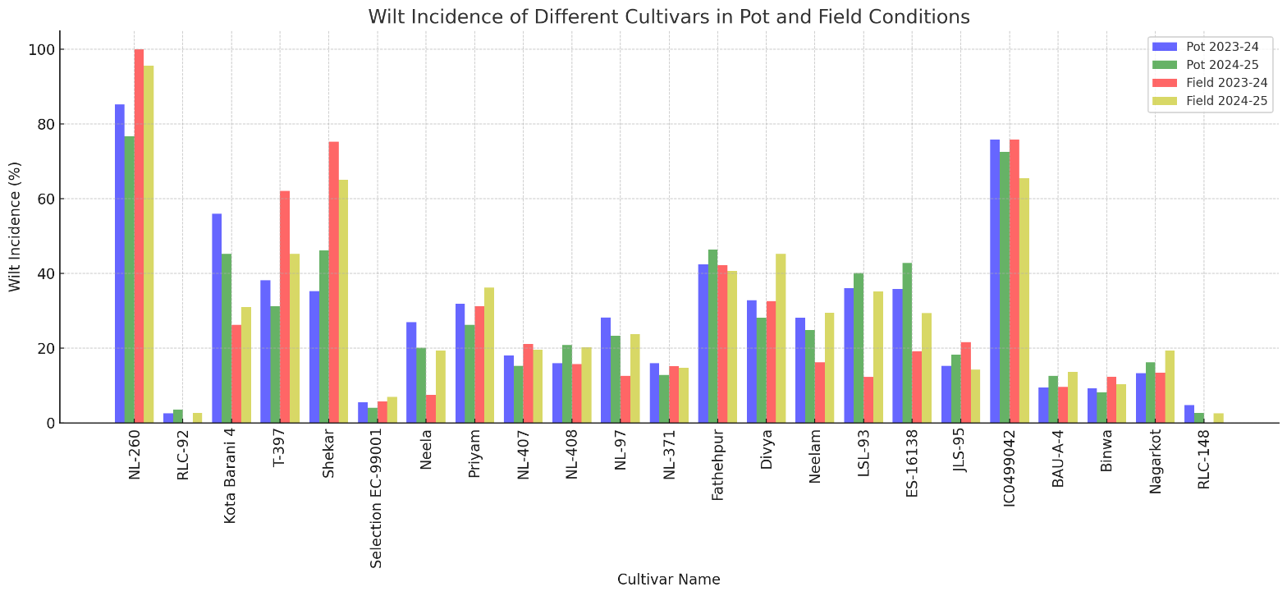

Figure1. Screening of linseed genotypes against wilt under artificially in pot and field condition

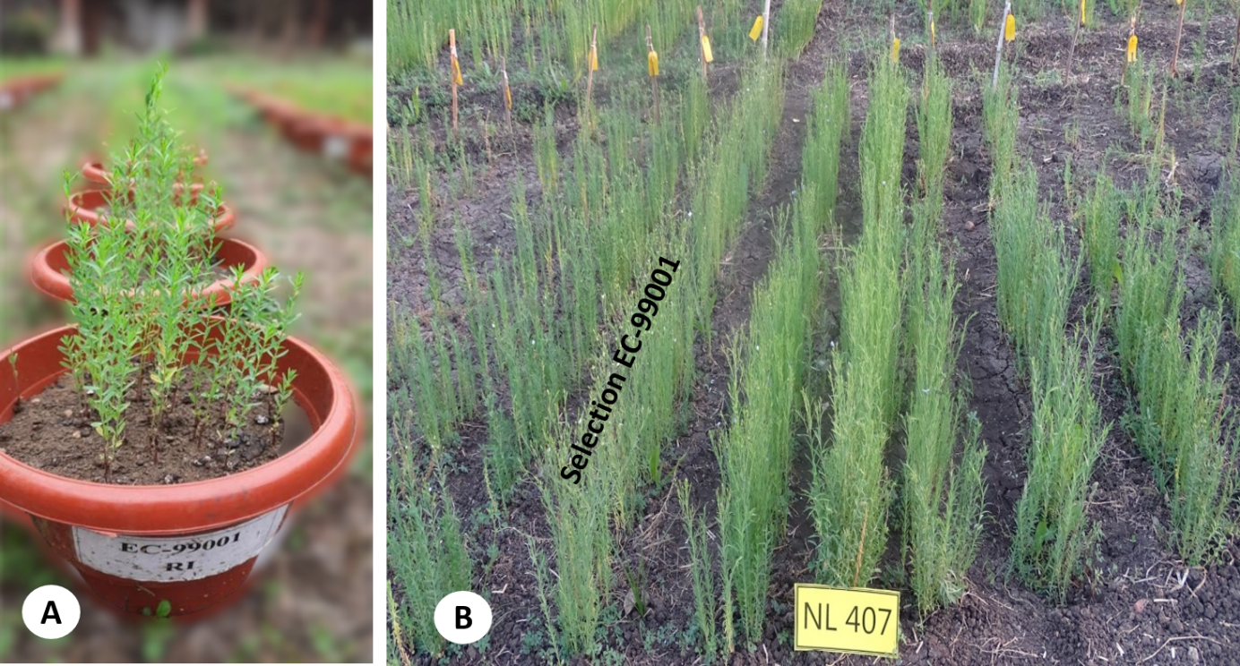
Fig 2. Screening of linseed genotypes against Fusarium wilt. The picture shows resistant reaction line ‘Selection EC-99001’ under pot and field condition (A,B).

