**Influence of Growing Media on Seed Germination, Growth and Development of Phalsa (*Grewia subinaequalis*) Seedlings**

**ABSTRACT**

This study was carried at Horticulture Farm, Department of Horticulture, Rajasthan College of Agriculture, Maharana Pratap University of Agriculture and Technology, Udaipur during July, 2024 to November, 2024. The twelve treatment combinations comprised of different growing media were evaluated with three replications under completely randomized design (CRD). The results exhibited significant effect of various treatment combinations on germination and growth parameters of phalsa seedling during investigation.The results showed that the medium, T11 - Soil + Sand + FYM + Vermicompost + Cocopeat + Perlite (2:1:1:1:1:1) was recorded with minimum days required for initiation of seed germination (12.26 days), 50 per cent seed germination (17.37 days), 100 per cent seed germination (21.83 days), germination percentage (82.54%), maximum seedling height 19.15, 26.94 and 35.47 cm at 60,90 and 120 days after sowing (DAS), stem diameter 0.91, 1.53 and 2.39 mm at 60,90 and 120 days after sowing, number of leaves per seedlings 8.69,10.61 and 13.09 at 60,90 and 120 DAS, fresh weight of root 2.25 g, fresh weight of shoot 6.94 g, dry weight of root 0.75 g, dry weight of shoot 1.94 g, tap root length 21.73 cm, root shoot ratio 0.38, vigour index-I and II 4721.28 and 212.13 g and survival percentage (76.38%) compared to all other treatment during investigation.

**Key words**: Seedling, soil, sand, FYM, vermicompost, cocopeat, perlite, plant growth.

**1. INTRODUCTION**

Phalsa (*Grewia subinaequalis* L.) is known to be one of the oldest indigenous fruits in country. It belongs to family ‘Tiliaceae’. Phalsa is either a big, straggling shrub or a tiny tree. Its bark is rough and grey and its leaves range in shape from widely cordate to oval with an angled base. 1-2 seeded, drupe globose, edible, flowers in yellow clusters along the axilla, indistinctly lobed, irregularly serrated (Anonymous., 1958). Phalsa is a drought – hardy, subtropical crop and thus suitable for arid and semi-arid region. The plant can withstand temperature as high as 440C and higher temperature promote fruit ripening. It necessitates good weather at the period of flowering. Rains at flowering time affect setting of fruits. Phalsa may be grown in a variety of soil types, even on moderately alkaline soils. However, best results are obtained in well drained and loamy soil.

Propagation of phalsa by seeds and cuttings has been practiced since long time but commercially, phalsa is propagated by seed. Only due to easy in propagation and short juvenility. General practice for seed propagation, freshly extracted seeds are used for raising these seedlings and seeds should be sown in June month at 1.5-2.0 cm deep in poly bags filled with growing media. Success of germination depends on number of factors *i.e*., water management and plant protection etc. In summer, these are very difficult and reduce the success rate drastically (Sarolia *et al*., 2019).

There are three to seven peduncles and each peduncle have three to six flowers of yellow colour. Phalsa is self-compatible, but pollens are not able to reach the stigma to affect the self-pollination due to detraction of stamens away from the stigma causes low fruit set. Phalsa fruit ripe in second fortnight of April and continue upto middle of June (Randhawa and Dass., 1962).

There are no distinct varieties in phalsa but the varieties grown by farmers are known as ‘Local’ and ‘Sharbati’. Two distinct types *i.e*., ‘Tall’ and ‘Dwarf’ were recognized at Hissar. Among them, ‘Dwarf’ type was reported more productive (Dhawan *et al*., 1993). The ICAR-CIAH, Bikaner has identified ‘Thar Pragati’ an improved cultivar of phalsa for cultivation in arid and semi - arid region.

**2. MATERIALS AND METHODS**

The present research work entitled “**Influence of Growing Media on Seed Germination, Growth and Development of Phalsa (*Grewia subinaequalis*) Seedlings**” was conducted with twelve treatment combinations comprised of different growing media *i.e*., T0 - Soil (Control), T1 - Soil + Sand + FYM (2:1:1), T2 - Soil + Sand + Vermicompost (2:1:1), T3 - Soil + Sand + Cocopeat (2:1:1), T4 - Soil + Sand + Perlite (2:1:1), T5 - Soil + Sand + FYM + Vermicompost (2:1:1:1), T6 - Soil + Sand + FYM + Cocopeat (2:1:1:1), T7 - Soil + Sand + FYM + Perlite (2:1:1:1), T8 - Soil + Sand + Vermicompost + Cocopeat (2:1:1:1), T9 - Soil + Sand + Vermicompost + Perlite (2:1:1:1), T10 - Soil + Sand + Cocopeat + Perlite (2:1:1:1), T11 - Soil + Sand + FYM + Vermicompost + Cocopeat + Perlite (2:1:1: 1:1) were evaluated with three replications under completely randomized design. The growth, development and germination parameters of the seedling were recorded at 60, 90 and 120 days after sowing (DAS) and growth parameters were recorded at 120 days after sowing with 3 replications in Completely Randomized Design (CRD).

**2.1 Experimental site**

The experiment for the research work was conducted during the year, 2024 at the Horticulture Farm, Department of Horticulture, Rajasthan College of Agriculture, Udaipur. The experiment was laid in the nursery. Udaipur is situated at 24° 34' N latitude and 73° 42' E longitude at an elevation of 582.17 m above mean sea level. The region falls under the Agro-climatic Zone IV-A which is sub-humid southern plain and Aravalli hills of Rajasthan.

**2.2 Climatic and weather conditions**

Udaipur comes under typical sub-tropical climatic condition *i.e*., both winters and summers are experienced in this region at their appropriate time. The average rainfall ranges from 760 to 900 mm per year. More than 90 per cent rainfall was received during mid-June to September with scanty showers during winter months. Data recorded for mean weekly weather parameters during the period of field experimentation.

**2.3 Growing media**

**2.3.1 Garden soil**

The garden soil collected from field were used as growing media. Soil was well decomposed and rich in organic matter having 5.5 to 7.5 pH.

**2.3.2 Farmyard manure (FYM)**

It is vital in growing media as it enriches soil with organic matter, nutrients and beneficial microbes. FYM enhances soil structure, water retention and nutrient availability. Its sustainable use reduces chemical dependency and promotes soil health, contributing to resilient and sustainable agriculture (Rai *et al*., 2024).

**2.3.3 Cocopeat**

Cocopeat is an by-product obtained after the extraction of fiber from the coconut husk and is considered as a good growing media component with acceptable pH, electrical conductivity and other chemical attributes (Abad *et al.*, 2002).

**2.3.4 Vermicompost**

Vermicompost refers to a mixture of worm casting, organic material, humus, living earthworms, their cocoons and other organisms. Earthworms reduces CN ratio, increase humic acid content, cation exchange capacity (CEC) and water soluble carbohydrates (Talashilkar *et al*., 1999).

**2.3.5 Perlite**

Perlite is a greyish-white silicaceous volcanic rock in origin, mined from lava flows which improves aeration and drainage. Perlite is almost pH neutral. (Cho *et al.*, 2006).

**2.4** **Collection of seed**

The fruit seeds were collected from Horticulture farm, RCA, Udaipur. The fruit seeds were pulped manually to extract the seeds. The seed of phalsa is recalcitrant, so viability of seed is very low.

# **2.5 Filling of polybags**

# 360 poly bags of 15 x 10 cm size were taken for each treatment in each replication. Four to six small holes were made on each bag, for proper drainage after that bags were filled as per treatments with different growing media and kept replication wise for sowing of phalsa seed.

**2.6 Sowing of seeds**

Seeds were sown in polythene bags filled with different types of growing media. The poly bags were watered regularly. On the lower part of poly bags, 4-6 holes were made for maintaining proper drainage.

Germination percentage (%) = $\frac{Number of seeds germinate}{Number of seed sown }$ x100

Root shoot ratio = $\frac{Dry weight of the root }{Dry weight of the shoot}$

Vigour index – I = Height of seedling (cm) x Germination percentage (%)

Vigour index – II = Dry weight of seedling (g) x Germination percentage (%)

Survival percentage (%) = $\frac{Number of survived seedling }{Total number of seedling}$ x 100

**3. RESULTS AND DISCUSSION**

**3.1 Germination attributes**

However, significantly the minimum days required for initiation of seed germination after sowing ( 12.26 days), minimum days required for 50 and 100 per cent seed germination ( 17.37 and 21.83 days) and germination percentage ( 82.54% ) were recorded under growing media T11 - soil + sand + FYM + vermicompost + cocopeat + perlite (2:1:1:1:1:1 v/v), while the maximum days required for initiation of seed germination ( 18.46 days) , maximum days required for 50 and 100 per cent germination ( 19.81 and 25.69 days) and germination percentage (59.36%) were recorded under T0 comprising soil (control). It might be due to that physical and nutritional conditions of media which initiate the early germination. The findings are supported by Bhardwaj *et al*., (2014) in papaya, Lepakshi *et al*., (2021) in jamun and Rai *et al*., (2024) in phalsa.

**3.2 Seedlings height (cm)**

As regard to growing media, the maximum seedlings height (19.15, 26.94 and 35.47 cm) was observed at 60, 90 and 120 days, respectively in T11. While the minimum seedling height was observed (13.17, 17.90 and 25.37 cm) in T0 at 60, 90 and 120 DAS. The increase in height of seedling in T11. The seedling height in growing media combination T0 soil (Control) might be due that having lower clay content, pH, compactness, which improve drainage, aeration, water holding capacity and highest nutrients uptake by root system, respectively results in highest plant height in growing media T11. The results have been supported by Bhardwaj *et al.,* (2014) who obtained maximum seedling height in papaya due to vermicompost application and Thakur and Shylla (2018) in strawberry due to FYM.

**3.3 Stem diameter (mm)**

The maximum stem diameter was observed at 60, 90 and 120 days after sowing in growing media T11 - *i.e*., 0.91, 1.53 and 2.39 While, minimum stem diameter (0.85, 1.25 and 1.94 mm) was observed at 60, 90 and 120 days after sowing in growing media T0. The results have been supported by Bhardwaj *et al.,* (2014) obtained maximum stem diameter in papaya due to FYM and vermicompost application. The application of FYM, vermicompost and perlite media might be due to suitable physical properties and good water holding capacity that supports the good availability of nutrients for seedling growth and development The findings are supported by Parasana *et al*., (2013) in mango and Meena *et al*., (2017) in papaya.

**3.4 Number of leaves**

The maximum number of leaves per seedling (8.69, 10.61 and 13.09) was observed in T11 - at 60, 90 and 120 days after sowing. Whereas, minimum number of leaves per seedling (6.30, 8.40 and 10.19) was observed in T0 at 60, 90 and 120 days after sowing. The increase in number of leaves as a result of application of vermicompost and perlite. This might be due to the fact that the activity of vermicompost and perlite is reported to have bioactive principles which are considered to be beneficial for root growth and this has been hypothesized to result in greater root initiation, increased biomass, enhanced growth and development. The findings are supported by Parasana *et al*., (2013) in mango and Thakur and Shylla (2018) in strawberry.

**3.5 Fresh and dry weight of root and shoot (g)**

The maximum fresh and dry weight of shoot (6.94 and 1.94 g) and roots (2.25 and 0.75 g) were obtained at 120 days after sowing under T11 - soil + sand + FYM + vermicompost + cocopeat + perlite (2:1:1:1:1:1 v/v). While minimum fresh and dry weight of shoot (4.18 and 1.17 g) and root (1.18 and 0.33 g) were observed under T0 which comprising soil (control). The findings are supported by Yadav *et al.,* (2012) in acid lime and Dhakar *et al.,* (2016) in papaya.

**3.6 Root shoot ratio**

The perusal of data presented in proceeding chapter revealed that the different growing media increased in the root shoot ratio. In the growing media, maximum root shoot ratio (0.38) was recorded under T11 - soil + sand + FYM + vermicompost + cocopeat + perlite (2:1:1:1:1:1 v/v) while, minimum root shoot ratio was observed under T9 (0.25) treatment. Growing media T11 maximum root shoot ratio of phalsa seedlings because of better physical properties and optimum water holding capacity (cocopeat based). The present findings are supported by Bhardwaj *et al.,* (2014) and Desai *at el*., (2017) in papaya.

**3.7 Tap root length (cm)**

The highest tap root length per seedling (21.73) was observed under  
growing media T11 - soil + sand + FYM + vermicompost + cocopeat + perlite (2:1:1:1:1:1 v/v) at 120 days after sowing whereas, the lowest root length (12.33 cm) was recorded with T0 - soil (control) The findings are supported by Bhardwaj *et al*., (2014) in papaya and Mandal *et al.,* (2022) in papaya.

**3.8 Seedling vigour index (g)**

It is evident from the data presented in the preceding chapter on seedling vigour index-I and II as affected by different growing media. In the growing media, maximum seedling vigour index-I and II (4721.28 and 212.13 g) was recorded under T11 - soil + sand + FYM + vermicompost + cocopeat + perlite (2:1:1:1:1:1 v/v) as well as minimum (2237.87 and 89.04 g) under T0 – soil (control). It might be due at initial stage soil and FYM improve soil texture, porosity, water holding capacity, activity of useful soil micro fauna and flora which maintain soil temperature and improved soil health and nutrient status of media, while at later stage vermicompost which contain plant growth regulators which are responsible for root length. The present investigation accordance with the finding of Ramateke *et al.,* (2015) in papaya and Prajapati *et al*., (2017) in citrus.

**3.9 Survival percentage (%)**

The growing media had significant influence on highest survival percentage (76.38 %) was recorded in T11 - soil + sand + FYM + vermicompost + cocopeat + perlite (2:1:1:1:1:1 v/v), while minimum plant survival percentage (52.33 %) was recorded in growing media T0 - soil as control on phalsa. It might be because of media containing organic manures possess organic acid within them. Therefore, more available moisture and some acids may have helped in minimum days to germination and better germination percentage these results are in accordance with Parasana *et al*., (2013) in mango and Rai *et al*., (2024) in phalsa.

**Table 1: Influence of growing media on seed germination of phalsa**

|  |  |  |  |  |
| --- | --- | --- | --- | --- |
| **Treatments** | **Initiation of germination (Days)** | **50 per cent germination (Days)** | **100 per cent germination (Days)** | **Germination**  **per cent**  **(%)** |
| **T0** | 18.46 | 19.81 | 25.69 | 59.36 |
| **T1** | 17.52 | 18.43 | 24.65 | 68.24 |
| **T2** | 15.15 | 18.87 | 23.18 | 67.91 |
| **T3** | 18.02 | 19.17 | 25.10 | 63.70 |
| **T4** | 16.32 | 17.91 | 22.73 | 72.58 |
| **T5** | 13.14 | 17.85 | 22.47 | 81.96 |
| **T6** | 15.97 | 18.25 | 23.64 | 77.83 |
| **T7** | 14.89 | 19.76 | 22.96 | 75.12 |
| **T8** | 14.26 | 19.41 | 22.85 | 67.38 |
| **T9** | 17.20 | 18.15 | 24.28 | 70.13 |
| **T10** | 16.68 | 18.64 | 23.92 | 79.66 |
| **T11** | 12.26 | 17.37 | 21.83 | 82.54 |
| **SE(m)±** | 0.267 | 0.533 | 0.379 | 0.761 |
| **CD at 5%** | 0.836 | NS | 1.188 | 2.384 |

**Table 2: Influence of growing media on seedling height (cm), stem diameter (mm) and number of leaves of phalsa seedlings**

|  |  |  |  |  |  |  |  |  |  |
| --- | --- | --- | --- | --- | --- | --- | --- | --- | --- |
| **Treatments** | **Seedling height (cm)** | | | **Stem diameter (mm)** | | | **No. of leaves** | | |
| **60**  **DAS** | **90**  **DAS** | **120 DAS** | **60**  **DAS** | **90**  **DAS** | **120 DAS** | **60**  **DAS** | **90**  **DAS** | **120 DAS** |
| **T0** | 13.17 | 17.90 | 25.37 | 0.85 | 1.25 | 1.94 | 6.30 | 8.40 | 10.19 |
| **T1** | 16.73 | 22.63 | 30.73 | 0.86 | 1.29 | 2.27 | 7.60 | 9.42 | 11.84 |
| **T2** | 17.12 | 23.09 | 31.05 | 0.88 | 1.39 | 2.17 | 7.95 | 9.50 | 12.11 |
| **T3** | 15.36 | 20.78 | 28.87 | 0.87 | 1.32 | 2.01 | 6.79 | 8.97 | 11.17 |
| **T4** | 13.68 | 18.87 | 26.94 | 0.86 | 1.28 | 1.90 | 6.68 | 8.88 | 10.48 |
| **T5** | 18.79 | 26.12 | 34.48 | 0.90 | 1.49 | 2.31 | 8.48 | 10.24 | 12.87 |
| **T6** | 17.48 | 23.54 | 31.64 | 0.89 | 1.45 | 2.23 | 8.05 | 9.62 | 12.37 |
| **T7** | 15.67 | 21.45 | 29.19 | 0.87 | 1.32 | 2.02 | 7.13 | 9.15 | 11.40 |
| **T8** | 18.45 | 25.38 | 33.56 | 0.90 | 1.46 | 2.27 | 8.28 | 9.86 | 12.63 |
| **T9** | 16.24 | 22.18 | 29.94 | 0.87 | 1.38 | 2.09 | 7.38 | 9.30 | 11.57 |
| **T10** | 14.82 | 19.92 | 27.92 | 0.88 | 1.41 | 2.13 | 6.94 | 8.87 | 10.79 |
| **T11** | 19.15 | 26.94 | 35.47 | 0.91 | 1.53 | 2.39 | 8.69 | 10.61 | 13.09 |
| **SE(m)±** | 0.221 | 0.328 | 0.354 | 0.013 | 0.017 | 0.025 | 0.109 | 0.155 | 0.180 |
| **CD at 5%** | 0.693 | 1.027 | 1.109 | NS | NS | 0.078 | 0.342 | 0.485 | 0.565 |

**Table 3: Influence of growing media on growth and survival of phalsa seedlings at 120 DAS**

|  |  |  |  |  |  |  |  |  |  |
| --- | --- | --- | --- | --- | --- | --- | --- | --- | --- |
| **Treatments** | **Fresh weight**  **(g)** | | **Dry weight**  **(g)** | | **Root**  **shoot**  **ratio** | **Tap root length**  **(cm)** | **Vigor index**  **(g)** | | **Survival percentage**  **(%)** |
| **Shoot** | **Root** | **Shoot** | **Root** | **I** | **II** |
| **T0** | 4.18 | 1.18 | 1.17 | 0.33 | 0.28 | 12.33 | 2237.872 | 89.04 | 52.33 |
| **T1** | 5.47 | 1.63 | 1.53 | 0.45 | 0.29 | 17.67 | 3302.816 | 135.12 | 63.74 |
| **T2** | 5.78 | 1.71 | 1.61 | 0.47 | 0.29 | 18.43 | 3360.187 | 141.25 | 61.45 |
| **T3** | 4.87 | 1.88 | 1.36 | 0.52 | 0.32 | 14.75 | 2778.594 | 119.76 | 55.62 |
| **T4** | 4.28 | 1.21 | 1.19 | 0.33 | 0.28 | 13.57 | 2940.216 | 110.32 | 63.42 |
| **T5** | 6.87 | 2.07 | 1.92 | 0.66 | 0.34 | 20.11 | 4474.196 | 204.08 | 73.40 |
| **T6** | 5.98 | 1.73 | 1.67 | 0.48 | 0.29 | 19.64 | 3991.122 | 167.33 | 68.37 |
| **T7** | 5.03 | 1.38 | 1.40 | 0.38 | 0.27 | 15.78 | 3378.146 | 133.71 | 65.33 |
| **T8** | 6.47 | 1.88 | 1.81 | 0.52 | 0.29 | 19.88 | 3600.787 | 157.00 | 62.65 |
| **T9** | 5.33 | 1.33 | 1.49 | 0.37 | 0.25 | 17.02 | 3293.305 | 130.44 | 61.28 |
| **T10** | 4.69 | 1.61 | 1.31 | 0.45 | 0.30 | 14.15 | 3351.296 | 140.20 | 66.35 |
| **T11** | 6.94 | 2.25 | 1.94 | 0.75 | 0.38 | 21.73 | 4721.288 | 212.13 | 76.38 |
| **SE(m)±** | 0.064 | 0.023 | 0.021 | 0.007 | 0.004 | 0.282 | 65.841 | 2.175 | 0.732 |
| **CD at 5%** | 0.200 | 0.072 | 0.065 | 0.021 | 0.013 | 0.884 | 206.367 | 6.816 | 2.294 |

**Fig. 1: Influence of growing media on germination attributes of phalsa**

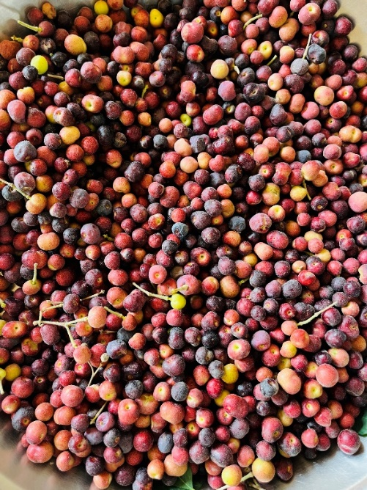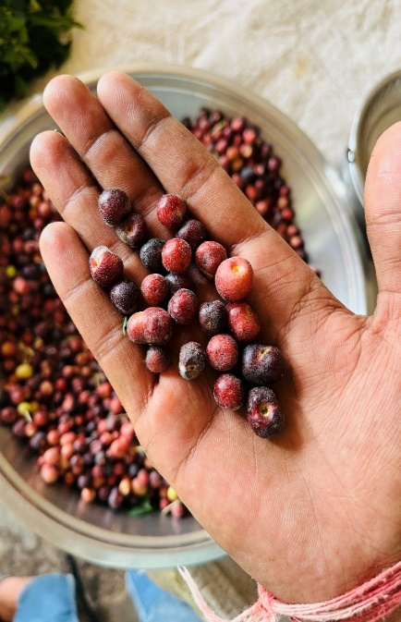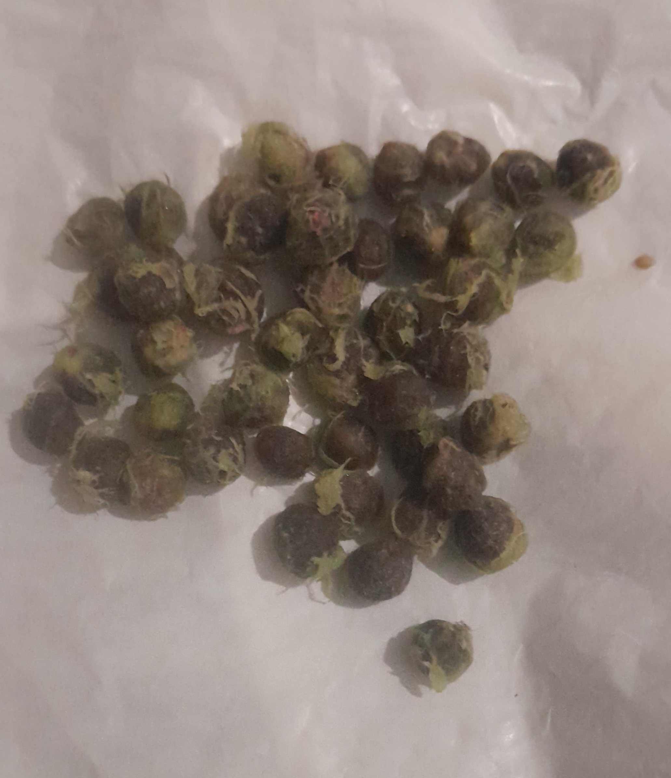

**(A)**

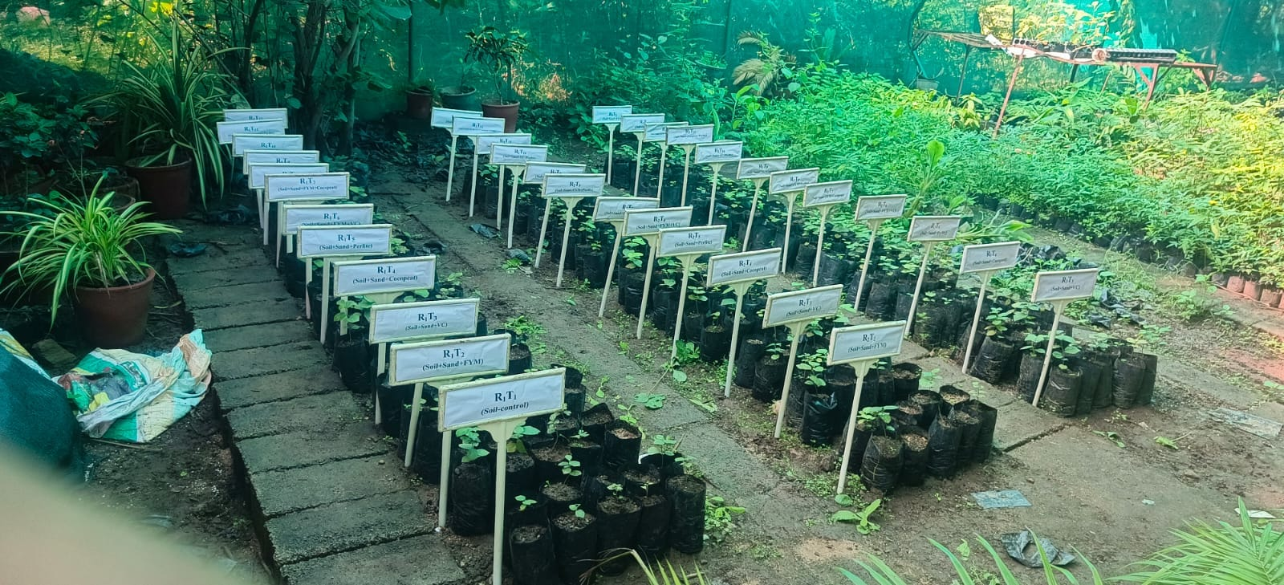

**(B)**

**Fig. 2: General view of experimental trial**

**4. CONCLUSION**

The present experimentation entitled “**Influence of Growing Media on Seed Germination, Growth and Development of Phalsa (*Grewia subinaequalis*) Seedlings**” was conducted at the Rajasthan College of Agriculture, Udaipur during July, 2024 to November, 2024. Different growing media was used as per technical plan during the course of investigation. It is concluded from the study that application of T11  *i.e*., Soil + Sand + FYM + Vermicompost + Cocopeat + Perlite (2:1:1:1:1:1) was found superior with significantly highest values of various character of phalsa seedling such as initiation of seed germination, 50 per cent seed germination, 100 per cent seed germination, germination percentage, maximum seedling height, number of leaves per seedlings, stem diameter (120 days after sowing), root length, fresh weight of root and shoot, dry weight of root and shoot, root shoot ratio, vigour index-I and II and survival percentage of phalsa seedling.

**ACKNOWLEDGMENTS**

Authors acknowledge Department of Horticulture, RCA, MPUAT, Udaipur for providing necessary support and fundings to carry out this research work.

**COMPETING INTERESTS**

Authors have been declared that no competing interests exits.

Disclaimer (Artificial intelligence)

Option 1:

Author(s) hereby declare that NO generative AI technologies such as Large Language Models (ChatGPT, COPILOT, etc.) and text-to-image generators have been used during the writing or editing of this manuscript.

Option 2:

Author(s) hereby declare that generative AI technologies such as Large Language Models, etc. have been used during the writing or editing of manuscripts. This explanation will include the name, version, model, and source of the generative AI technology and as well as all input prompts provided to the generative AI technology

Details of the AI usage are given below:

1.

2.

3.

**REFERENCES**

1. Abad, M., Noguere, P., puchades, R., Maquieira, A. and Noguera, V. 2002. Physio-chemical and chemical properties of some coconut dusts for use as a peat substitute for containerized ornamental plants. *Bioresource Technology*, **82**(5): 241-245
2. Anonymous. 1958. The wealth of India. Raw materials, **4**(2): 262-266.
3. Bhardwaj, R. L. 2014. Effect of growing media on seed germination and seedling growth of papaya cv.‘Red lady’. *African Journal of Plant Science*, **8**(4): 178-184.
4. Cho, M. S., Park, Y. Y., Jun, H. J. and Chung, J. B. 2006. Growth of gerbera in mixtures of coir dust and perlite. *Horticulture Environment Biotechnology*, **47**(4): 211-216.
5. Desai, A., Trivedi, A., Panchal, B. and Desai, V. 2017. Improvement of papaya seed germination by different growth regulator and growing media under net house condition. *International Journal of Current Microbiology and Applied Science*, **6**(9): 828-834
6. Dhakar, S. S., Kaushik, R. A. and Sarolia, D. K. 2016. Influence of growing media and containers on germination and seedling growth of papaya (*Carica papaya* L.) cv. Pusa Nanha. *Green Farming*, **7**(2): 451-454.
7. Dhawan, K., Malhotra, S., Dhawan, S.S., Singh, D. and Dhindsa, K.S. 1993. Nutrient composition and electrophoretic pattern of protein in two distinct types of phalsa (*Grewia subinaequalis* DC). *Plant Foods for Human Nutrition*, **44**(8): 255–260.
8. Lepakshi, P., Reddy, P. V. K. and Venkataramann agudem, W. G. A. 2021. Effect of different growing media on seed germination and seedling growth of jamun (*Syzygium cumunii* L. Skeels). *International Journal of Agricultural Science*, **17**(1): 138-41.
9. Mandal, G., Nag, G. P., Sigh, K. P., Singh, D. P. and Haldar, P. 2022. Evaluation of different growing media and pre-sowing treatments on germination and growth of papaya. *The Pharma Innovation Journal*, **11**(12): 1071-1075.
10. Meena, A. K., Garhwal, O. P., Mahawar, A. K. and Singh, S. P. 2017. Effect of different growing media on seedling growth parameters and economics of papaya (*Carica papaya* L.) cv Pusa Delicious. *International Journal of Current Microbiology and Applied Science*, **6**(6), 2964-2972.
11. Parasana, J. S., Leua, H. N. and Ray, N. R. 2013. Effect of different growing medias mixture on the germination and seedling growth of mango (*Mangifera indica*) cultivars under net house conditions. *An International Quarterly Journal of Life Science*, **8**(3): 897-900.
12. Prajapati, D. G., Satodiya, B. N., Desai, A. B. and Nagar, P. K. 2017. Influence of storage period and growing media on seed germination and growth of acid lime seedlings (*Citrus aurantifolia* Swingle) cv. Kagzi. *Journal of Pharmacognosy and Phytochemistry*, **6**(4): 1641-1645.
13. Rai, P. K., Mishra, S., Bahadur, V., Bharoshe, R., Nath, S., Sahi, V. P. and Kushwaha, H. 2024. Effect of different growing media and biocapsules on seed germination, seedling growth and survivability percentage of phalsa (*Grewia asiatica* L.) under greenhouse condition. *International Journal of Advanced Biochemistry Research*, **8**(6): 236-239.
14. Ramteke, V., Paithankar, D. H., Kamatyanatti, M., Baghel, M. M., Chauhan, J. and Kurrey, V. 2015. Seed germination and seedling growth of papaya as influenced by GA3 and propagation media. *International Journal of Farm Sciences*,**5**(3): 74-81.
15. Randhawa, G. S. and Dass, H. C. 1962. Studies on floral biology of phalsa (*Grewia asiatica* Linn.). *Indian Journal of Horticulture*, **19**(1-2): 10-24.
16. Sarolia, D. K., Kumar, K. and Meena, R. K. 2019. Standardization of seed and seedling standards of phalsa (*Grewia subinaequalis* L.). *Indian Journal of Arid Horticultutre*, **1**(2): 67-71.
17. Talashilkar, S.C., Bhangarath, P.P. and Metha, V.B. 1999. Changes in chemical properties during composting of organic residues as influenced by earthworm activity. *Journal of The Indian Society of Soil Science*, **47**: 50-53.
18. Thakur, M. and Shylla, B., 2018. Influence of different growing media on plant growth and fruit yield of strawberry (*Fragaria* × *ananassa* Duch.) cv chandler grown under protected conditions. *International Journal of Current Microbiology and Applied Sciences.***7**(4): 2724-27.
19. Yadav, R. K., Jain, M. C. and Jhakar, R. P. 2012. Effect of media on growth and development of acid lime (*Citrus aurantifolia* Swingle) seedling. *African Journal of Agricultural Research*, **7**(48), 6421-6426.