**Modulation of Morphological Parameters in Onion (*Allium cepa* L.) through Plant Growth Regulators in the Subtropical Climate of Jammu**

**Abstract**

The present study was initiated to assess the effect of plant growth regulators paclobutrazol and cycocel on morphological characters of onion (*Allium cepa* L.) under the subtropical agro-climatic conditions of Jammu. The field experiment was laid out at SKUAST-Jammu using two varieties of onion, N-53 and Agrifound Dark Red, in a randomized complete block design (RCBD) with three replications. Treatments consisted of foliar applications of PBZ @ 30, 60, and 90 ppm and CCC @ 50, 100, and 150 ppm plus untreated controls. It is evident from the results that the growth regulators induced significant modulation in most of the important vegetative and reproductive characters. Raising levels of PBZ and CCC caused a big decrease in plant height, neck width, scape length, and leaf count; the strongest blocking seen at higher amounts especially 90 ppm PBZ and 150 ppm CCC. Otherwise moderate levels like 60 ppm PBZ and 100 ppm CCC greatly improved flower parts such as number of flowers per umbel effective fruits and scape thickness showing better reproductive success. Varietal differences were obviously seen. Agrifound Dark Red showed best floral characteristics. N-53 showed best vegetative performance in non-treated and low-dose conditions. Justified use of PBZ and CCC mainly at moderate concentrations can be a strategic tool for regulation of plant architecture and reproductive success in onion cultivation within stress-prone subtropical environments.

**Keywords:** *Onion (*Allium cepa *L.), Paclobutrazol, Cycocel, Morphological traits, Subtropical climate, Growth regulators*

**Introduction:**

Onion is one of the most important bulbous vegetable crops grown all over the world. Onion (*Allium cepa* L.) belongs to the family *Amaryllidaceae* (*Alliaceae*) and locally known as Pyaj. India is next to China in area and production of onion. Among the different states Maharastra is leading state in terms of area and production. Other major onion states are Gujrat, Karnataka, Odisha, Uttar Pradesh, Andhra Pradesh, Tamil Nadu and Rajasthan. The area of onion is 1270.4 thousand hectares, total production is 21563.9 thousand metric tonnes and productivity is about 17.0metric tonnes per hectare in India (Sengar *et al*., 2020). The area of onion production in Madhya Pradesh is 118.20 thousand hectares. Total production is 2848.0 thousand metric tonnes and productivity is about 24.09 metric tonnes per hectare (Saxena *et al*., 2014). Government of India has declared onion as an essential commodity. Onions are grown in three seasons, spring, autumn and late autumn. For maintaining steady supply in the market, autumn crop of onion plays a major role. The production of autumn onion has several advantages i.e. increases total production per annum and fulfils the demand of fresh onion in the market. Autumn onion provides high price as compared to spring season onion. The excessive vegetative growth is a problem in autumn onion (Singh et al., 2021). The plant height goes up to one meter and neck of the plant become thick, while, the bulb remains small. This is due to poor translocation of assimilates from leaves to bulbs (Bista et al., 2022). This translocation of food materials or for altering source to sink relationship is changed by application of plant growth regulators. The positive effect of plant growth regulators on horticultural crops have been shown by many workers (Lal *et al*., 2013, Lal and Das, 2017, Jain *et al*., 2017, Tameshwar *et al*., 2017). The vegetative growth of autumn onion as represented by plant height, number of leaves per plant, fresh and dry weight of plant, increased to optimum level using GA3 and NAA. Among the widely used PGRs in horticultural crops are **paclobutrazol (PBZ)** and **cycocel (CCC)**. Paclobutrazol is a triazole-based gibberellin biosynthesis inhibitor that reduces shoot elongation, promotes root growth, enhances chlorophyll content, and often results in more compact and stress-resilient plants (Arvin and Banakar, 2002; Ashrafuzzaman *et al*., 2009). PBZ has been reported to significantly reduce plant height, scape length, and vegetative growth in onions. CCC is very effective in inducing hardening of seedlings and increased growth of root and shoot.

The Jammu region has a unique tropical climate of sub-tropical-cold in winters and hot in summers, which is unsuitable for onion farming. Changes in temperature, erratic distribution of rainfall and periods of low soil moisture frequently influence onion vegetative growth, bolting developments, and eventually the bulb yield and quality. Under such conditions, maximising plant growth through PGRs applications may become an important strategy in improving crop performance. PBZ and CCC could optimize plant architecture by adjusting vegetative growth and delaying bolting, which would contribute to the good development of bulbs. However, with increasing surge in studies on PGRs, very little specific information has been available on their impact under the agro-climatic scenario of Jammu. Because of the sensitivity of onion to environmental conditions and the capability of PGRs to overcome adversities imposed by climate, it is important to assess treatment effects of onion growth under the subtropical condition. Therefore, the current research aims to investigating the impact of paclobutrazol and cycocel on certain morphological characters of onion (*Allium cepa* L.) grown under subtropical conditions of Jammu in order to evolve new package of practices for better vegetative growth and productivity of the crop.

**Methodology:**

A field experiment was carried out during 2023-24 at Research Farm, SKUAST Jammu, Chatha to study the impact of Paclobutrazol and Cycocel on morphological attributes of onion (Allium cepa L.) under sub-tropical agro-climate conditions. The experiment was arranged in Randomized completely block design (RCBD) a variety of hormonal concentrations i.e PBZ @ 30ppm, 60ppm and 90ppm including but CCC @ 50ppm, 100ppm and 150ppm were applied along with control. Each treatment was replicated thrice. Foliar spray of growth regulators was sprayed at the rate of once at one month after transplanting, with hand operated sprayer in the early hours of morning, to see that they were effectively absorbed and evaporation losses were minimum. Advised cultural and management practices were equally followed in all the fields. Morphological observations were recorded at regular intervals from five randomly selected plants per plot. The parameters included plant height (cm), no. of leaves per plant, neck diameter (cm), scape length and diameter (cm), number of umbels per plant, umbel diameter (cm), number of flowers per umbel, and number of effective fruits per umbel. Plant height was measured from the base to the tip of the longest leaf, neck size was recorded at the junction between foliage and bulb using a digital Vernier calliper, and umbel and scape dimensions were measured using a scale and calliper, respectively. The collected data were statistically analyzed using analysis of variance (ANOVA), and treatment means were compared using the critical difference (CD) at a 5% level of significance to determine the impact of different treatments on the morphological traits of onion.

**Results:**

Results of the present study revealed that the application of plant growth regulators paclobutrazol (PBZ) and cycocel (CCC) had a very significant statistically significant effect on the morphological characteristics of the onion plant. Significant variation was observed among treatments and also between these two varieties of onions, N-53 (V₁) and Agrifound Dark Red, (V₂). The height of the plant was significantly affected by both the type and concentration of growth regulators. Control plants recorded maximum height in both varieties. Agrifound Dark Red recorded 53.17 cm and N-53 recorded 48.93 cm. With increasing concentrations, PBZ and CCC induced an incremental decrease in height. The greatest decrease noted at 150 ppm CCC was to 32.27 cm in N-53 and 33.70 cm in Agrifound Dark Red. This drastic decrease can be attributed to the growth-retarding nature of PBZ and CCC since they act as inhibitors of the biosynthesis of gibberellins which suppress cell elongation and internodal expansion. More of such effects were exhibited by PBZ at higher concentrations, which means its stronger anti-gibberellin action in limiting vertical growth. The number of leaves per plant was also significantly affected by the treatments. Control plants produced the maximum number of leaves (10.83) whereas the minimum was observed under 90 ppm PBZ (7.50), particularly in N-53. Reduction in foliage may be attributed to restricted meristematic activity and reduced photosynthate allocation towards the vegetative organs under growth regulator stress. However, the leaf count stayed relatively stable in moderate doses of CCC which implies better tolerance and lesser inhibition of foliage development at those levels.

Neck diameter is an important morphological character that is strongly correlated with bulb firmness and bolting susceptibility. The widest neck sizes were measured in the control (2.18 cm) and the narrowest necks were attained at 90 ppm PBZ (0.83 cm of N-53). A similar sensitivity was reflected with CCC application, where 150 ppm CCC has produced least neck girth (0.83 cm in V1 and 0.97 cm in V2). Generally, a smaller neck contributes to later bolting and better bulb quality, which explains the beneficial effect of increased regulator doses under these conditions, despite that they also negatively affected vegetative biomass. The highest elongation in scape length and height was obtained in the control treatment (scape length: 55.10 cm and 53.60 cm in N-53 & Agrifound Dark Red and scape height: 33.47 cm and 34.77 cm, respectively). These values sharply decreased with higher concentrations of PBZ and CCC. At 90 ppm PBZ and 150 ppm CCC, scape length dropped below 40 cm, and height decreased to nearly 20 cm in both varieties. Such suppression is indicative of bolting inhibition, suggesting that PBZ and CCC are effective in delaying or suppressing floral initiation, an important objective in this study. Interestingly, scape diameter responded differently. Although the length of the scape was reduced the diameter was higher in PBZ-treated plants than in non-treated ones and especially with 90 ppm (2.73 cm in N-53), possibly as a consequence of the accumulation of assimilates in shorter and thicker stems. This indicates that the vertical expansion changed into a radial thickening under the control of growth regulators.

In respect of flower characters, only moderate doses of PBZ (60 ppm) and CCC (100 ppm) resulted in an increase in the number of flowers per umbel and effective fruits per umbel. Maximum number of flowers (192.67) was observed in Agrifound Dark Red with 60 ppm PBZ and 100 ppm CCC respectively. These results suggest that if growth regulators at high levels inhibit both vegetative and floral growth, at intermediate concentrations they could increase the reproductive efficiency by regulating the hormonal and the assimilate partitioning. On the other hand, the fewest flower and fruit number was observed at 90 ppm PBZ and 150 ppm CCC, indicating inhibitory effects of supra- optimal dose. The umbels per plant and umbel diameter also decreased with the increased regulator concentration. Umbel size in control plants were not only the greatest, but they also produced the largest number of umbels (7.47 cm in V1), whereas umbel size and number was significantly decreased by 90 ppm PBZ and 150 ppm CCC. These characters are paramount for reproductive success and grain production, and their inhibition demonstrates a successful decrease on bolting (though at the expense of seed yield). In addition, varietal variation was found for all body parts in general. The performance of Agrifound Dark Red exceeds N-53 significantly for some reproductive traits (number of flowers, effective fruits and umbel diameter), indicating that this is plant which has a good genetic makeup of development of floral. On the other hand, N-53 had higher vegetative vigour, mainly with the untreated and low dose treatments, highlighting the differential response of varieties to exogenous growth regulators.

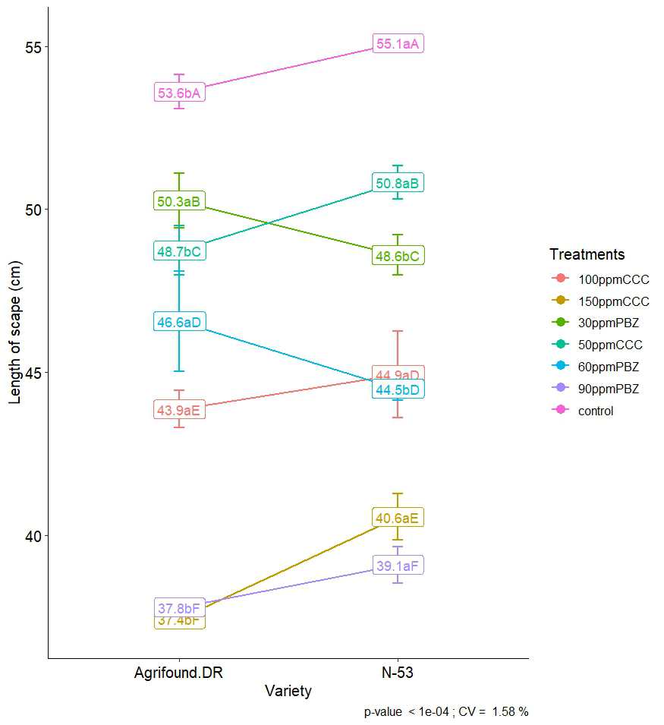

Fig. No. 1: Interaction Effect of Variety and Growth Regulator Treatments on length of scape in Onion.

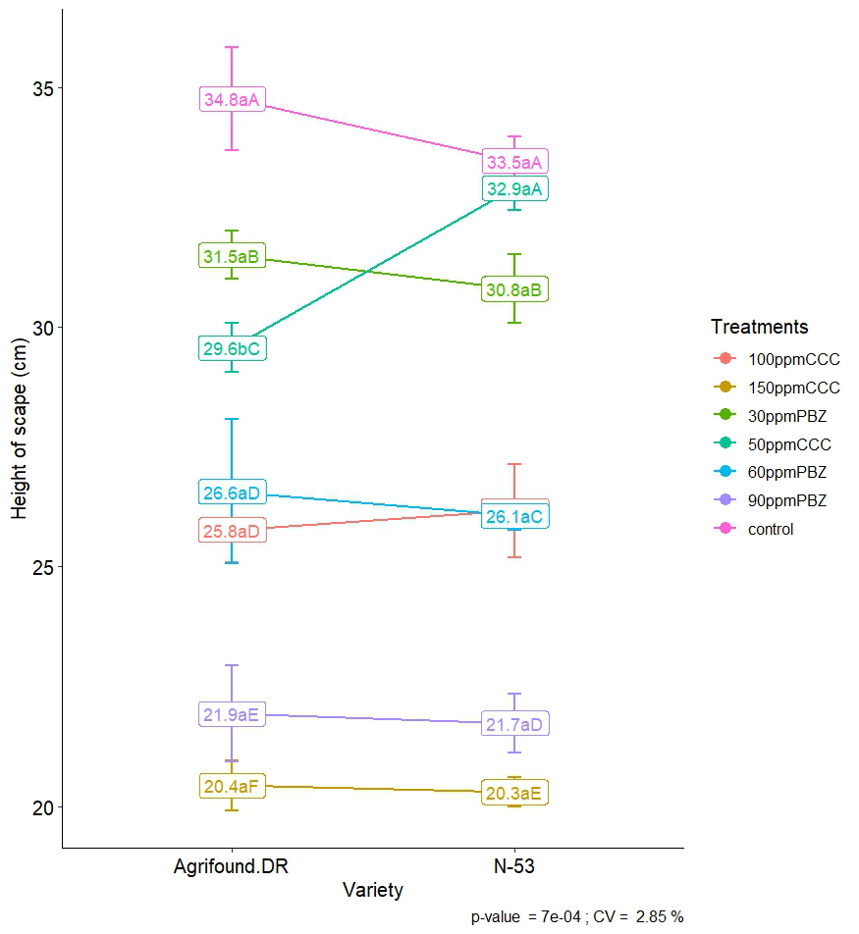

Fig. No. 2: Interaction Effect of Variety and Growth Regulator Treatments on height of scape in Onion.

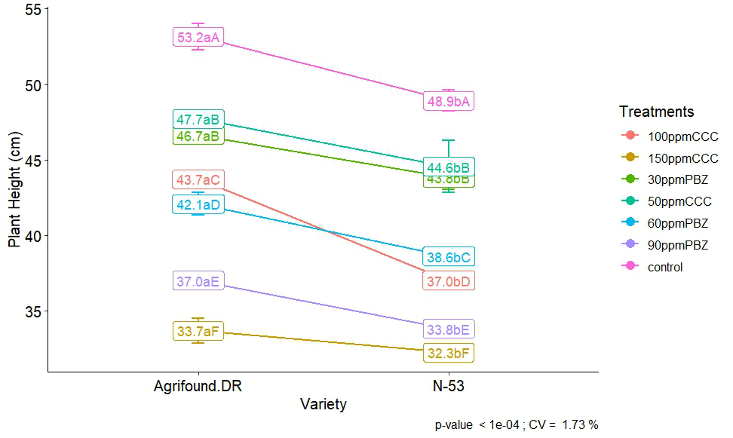

Fig. No. 3: Interaction Effect of Variety and Growth Regulator Treatments on Plant height in Onion.

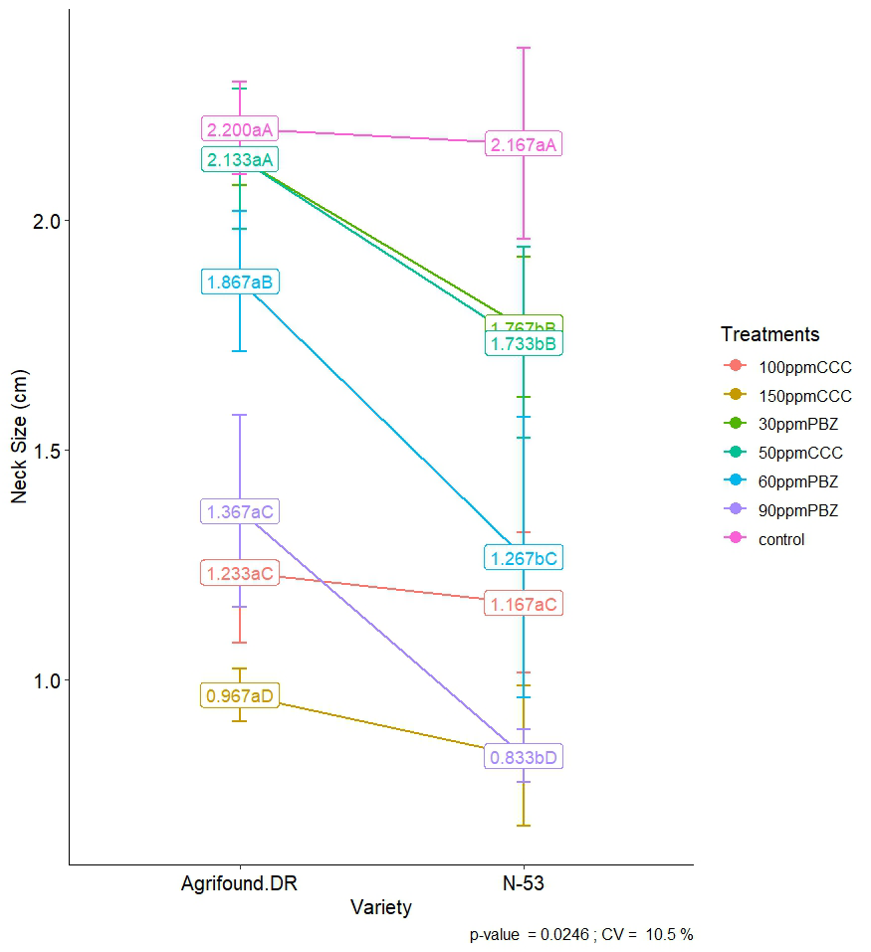

Fig. No. 4: Interaction Effect of Variety and Growth Regulator Treatments on neck size in Onion.

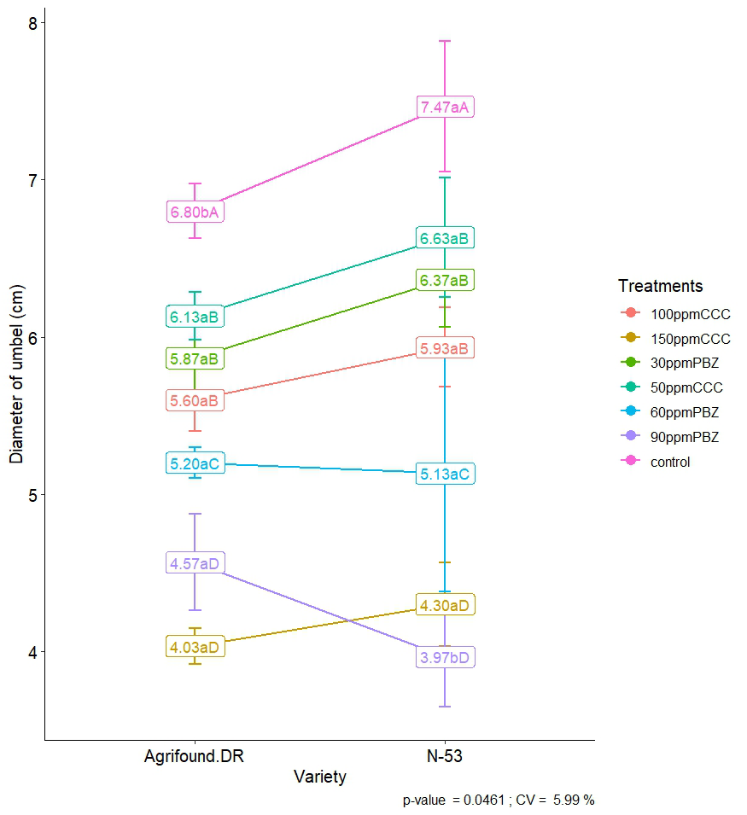

Fig. No. 5: Interaction Effect of Variety and Growth Regulator Treatments on diameter of umbel in Onion.

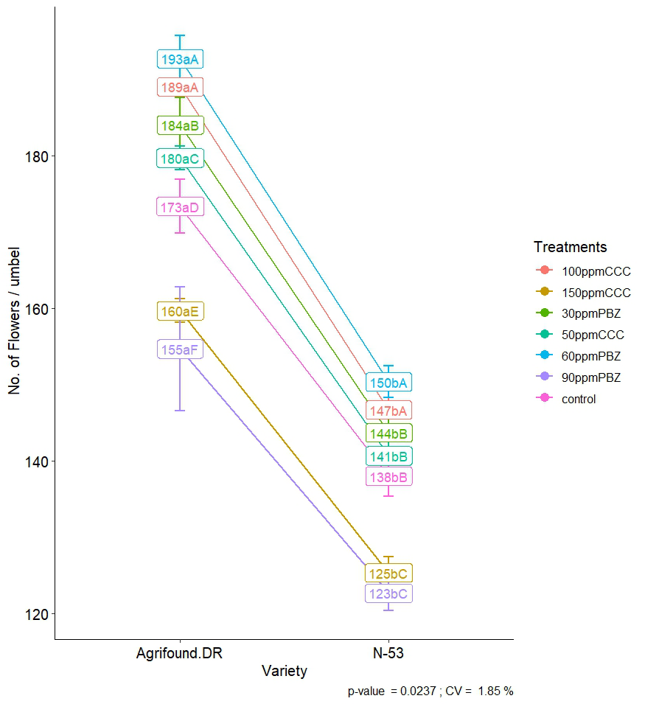

Fig. No. 6: Interaction Effect of Variety and Growth Regulator Treatments on no. of flowers per umbel in Onion.

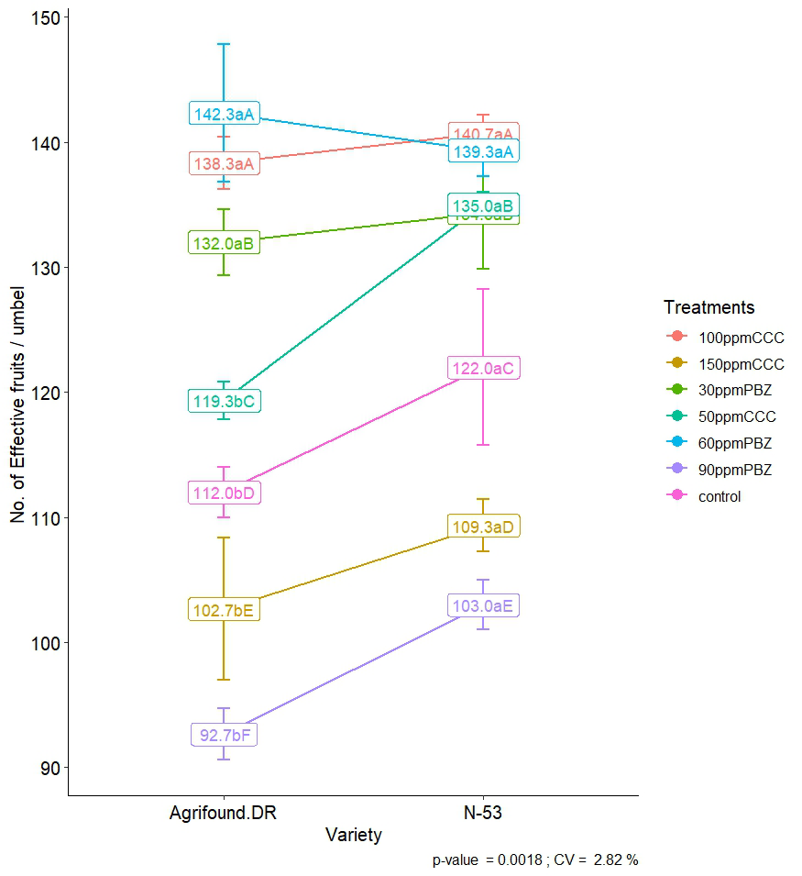

Fig. No. 7: Interaction Effect of Variety and Growth Regulator Treatments on no. of effective fruits per umbel in Onion.

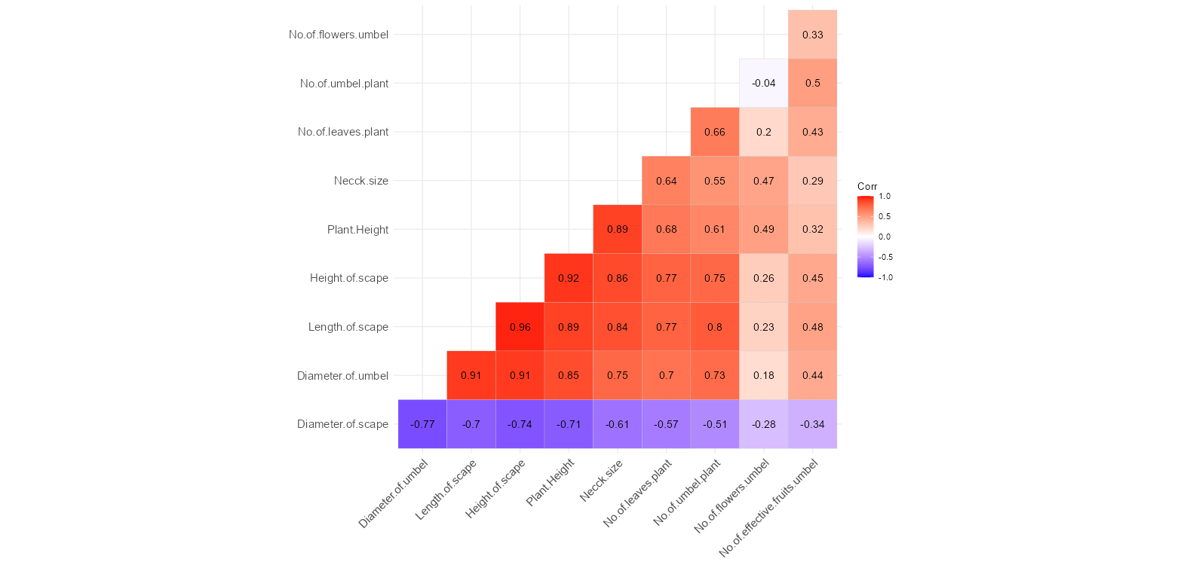

**Fig. no. 8: Correlation Matrix of Morphological Traits in Onion Plants under Plant Growth Regulator Treatments.**

Correlation matrix heatmap illustrates the magnitude and direction of linear relationship among different morphological traits of onion plants due to PGR applications. The r, which corresponds to the correlation between each two traits and varies from -1 to +1, is showed between the pair of traits in matrix cells. Positive values (in red hues) indicate that two traits are directly related, or that they increase together, whereas negative values (in blue hues) show an inverse relationship. The most favorable correlations were appeared among growth and yield characters. Length of scape showed very strong positive correlations with diameter of umbel (r = 0.96), height of scape (r = 0.92), and plant height (r = 0.89). This means that, overall, the elongation of the scape is the most important factor influencing the whole plant architecture as well as the reproductive structures. The other two variables also correlated significantly: plant height with height of scape (r = 0.92) and neck size (r = 0.64). This is an indication that there is vertical growth coordination between both vegetative and reproductive parts. A moderate positive correlation was observed between number of umbels per plant and number of flowers per umbel (r = 0.50) also, along with neck size and number of leaves per plant (r = 0.66). This means that better vegetative vigor, bigger plants tend to have more flowering parts which can potentially increase yield. Scan diameter showed major negative associations with most attributes, especially length of scape (r = -0.77), height of scape (r = -0.70), and plant height (r = -0.74). This means that thicker scapes may allocate resources in terms of sacrifice for vertical growth and reproductive structures. Diameter of the scape and effective fruit number per umbel also had low or negative correlations with most other traits, it was r = -0.34 with diameter of the scape and r = -0.28 with number of umbels per plant; thus, it indicates very little dependence on these vegetative indicators. Overall, correlation analysis reiterates that scape-related traits are tightly linked to plant height while unveiling possible trade-offs for example between diameter of the scape and aspects of reproductive growth. These results serve as a basis for qualities that could be selected to improve onion productivity under PGR treatments focusing mainly on vegetative growth and blooming attributes.

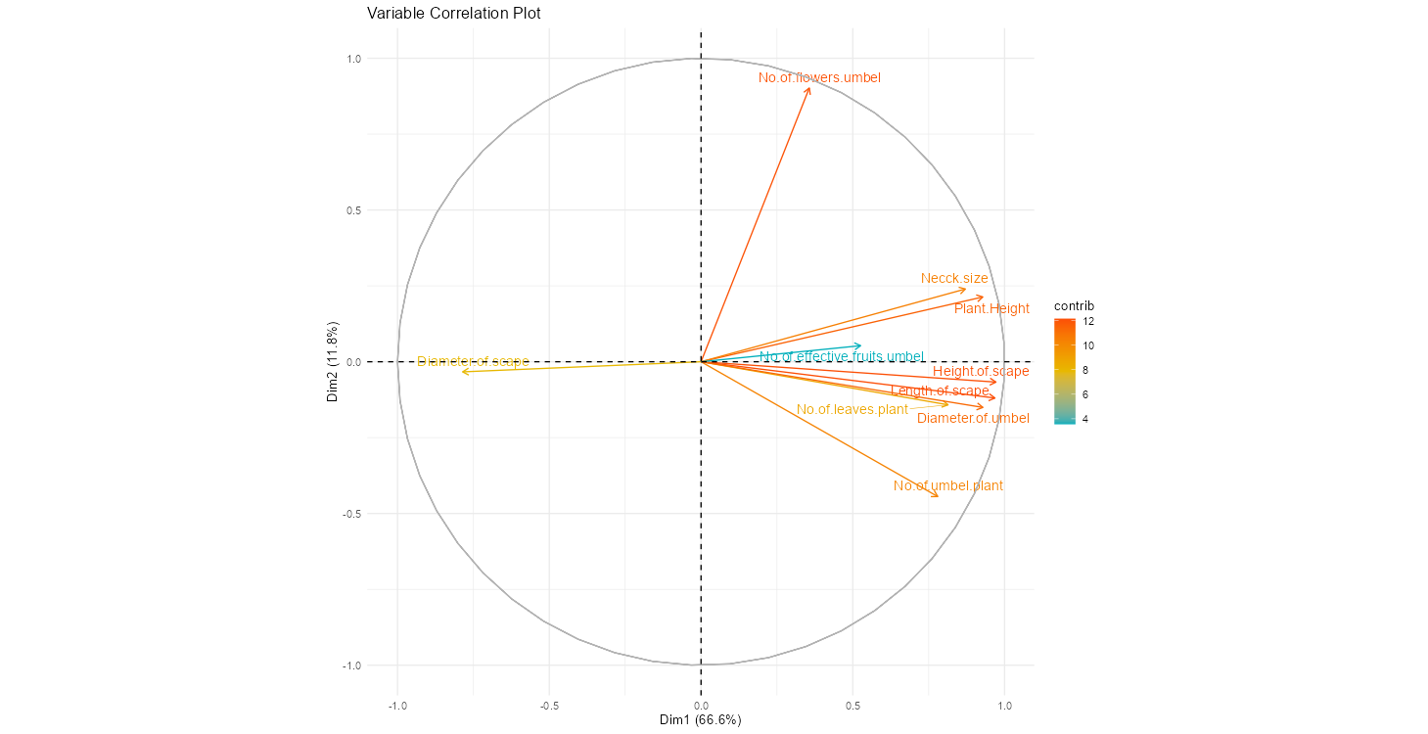

**Fig. No. 9: PCA Biplot Showing Correlation Among Morphological Parameters of Onion under Plant Growth Regulator Treatments.**

The interrelationship between different morphological characters of onion plants under PGR Treatments. The plot is showing the first two principal components PC 1versus PC 2, where PC 1 is the first principal component and PC 2 is the second principal component, and represents 84.4% of the total variance (66.6% for PC1 and 17.8% for PC2). Characteristics such as plant height, scape length, scape height, neck width, number of umbels per plant and number of flowers of umbel are closely grouped and overlaid in the same direction, indicating their strong positive correlation and its massive contribution to PC1. These traits are the most important in determining variation in plant structure and reproductive potential. Displacement of the diameter of scape, however, is in the opposite direction, indicating that it should have a negative relation to the traits mentioned. The size and direction of the vectors are on behalf of the strength and the direction of the trait contributions; those located closer to the origin show smaller contributions; plant height and scape traits contributed the most to the variation. This PCA model successfully separates the key traits and explores the organization structure in the dataset, which would make clearer understanding the relationships among traits related PGR application.

**Discussion:**

According to the results of this study, the exogenous application of cycocel (CCC) and paclobutrazol (PBZ) considerably altered the morphological growth of onion plants in Jammu's subtropical climate. The observed reduction in plant height, neck diameter, number of leaves per plant, and scape elongation with increasing concentrations of PBZ and CCC can be attributed to their well-established role as gibberellin biosynthesis inhibitors. The similar findings were observed by (Desta and Amare, 2021 and Ashrafuzzaman *et al*., 2009), that elongation of shoot is inhibited in plants treated with PBZ by interfering in metabolism of gibberellin effectively restricts shoot elongation by interfering with gibberellin metabolism, while improving bulb firmness and seed quality under stress conditions. In the current study, the enhanced scape diameter and flower production at moderate PBZ (60 ppm) and CCC (100 ppm) concentrations may reflect a favourable hormonal balance that redirects assimilate from vegetative organs to reproductive sinks. Comparable results were reported by Hojjati *et al*. (2011), who observed that flowering performance in landscaping plants like Rudbeckia hirta was improved by applying minimum doses of growth retardants by modulating source–sink relationships. The significant varietal differences observed in this study, where Agrifound Dark Red exhibited superior floral characteristics while N-53 maintained stronger vegetative vigour, support earlier findings that genotypic background significantly influences responsiveness to growth regulators (Youssef & Abd-El-Aal, 2013). Moreover, the reduction in umbel number and diameter at higher PBZ and CCC concentrations (90 ppm and 150 ppm, respectively) points to the detrimental effect of supra-optimal doses, which may disrupt the hormonal equilibrium needed for balanced growth and reproductive development. This study essentially demonstrates that although both PBZ and CCC are successful in controlling onion shape and preventing unwanted bolting, their effectiveness varies greatly depending on the dosage. Treating the plant with the right concentrations—particularly PBZ at 60 ppm and CCC at 100 ppm—that encourage balanced vegetative growth with increased reproductive production is the best way to produce onions in tough climates. These findings contribute to the growing body of research that demonstrates the prudent use of plant growth regulators to improve horticultural performance in climate-specific areas.

**Conclusion:**

Strategic use of CCC and PBZ significantly modifies morphological characteristics of onions (*Allium cepa* L.) under Jammu’s challenging agroclimatic conditions, as clearly observed in this study. Characteristic responses in morphology were observed following the exogenous application of these PGRs, with higher concentrations (90 ppm PBZ and 150 ppm CCC) exerting most severe inhibitory effect on vegetative growth characteristics such as plant height, neck thickness, and scape elongation -attributes frequently associated with early bolting. On the other hand, intermediate levels (PBZ @ 60 ppm and CCC @ 100 ppm) were the most effective in inducing flowering as evidenced by high flower number, higher percentage effective fruit set, and sturdy scape. The varietal disparities with regard to their differential responses, i.e., Agrifound Dark Red for reproductive characters versus N-53 for vegetative growth in both the treatments, indicate the need for genotype-specific approaches. This study creates a scientific basis that may be useful in developing region specific production protocols with growth regulator application for increasing productivity in onion.

**Disclaimer (Artificial intelligence):**

Author(s) hereby declare that NO generative AI technologies such as Large Language Models (ChatGPT, COPILOT, etc) and text-to-image generators have been used during writing or editing of this manuscript.

**References:**

1. Arvin, M. J., & Banakar, M. H. (2002). Effects of plant growth regulators on bolting and several traits of onion (*Allium cepa* L.) cv. Texas Early Grano. *Isfahan University of Technology–Journal of Crop Production and Processing*, *6*, 59–70.
2. Ashrafuzzaman, M., Millat, M. N., Ismail, M. R., & Shahidullah, S. M. (2009). Influence of paclobutrazol and bulb sizes on seed yield and yield attributing traits of onion (*Allium cepa* L.) cv. Taherpuri. *Archives of Agronomy and Soil Science*, *55*(6), 609–621.
3. Desta, B., & Amare, G. (2021). Paclobutrazol as a plant growth regulator: Implications for agricultural productivity and environmental sustainability. *Chemical and Biological Technologies in Agriculture, 8*(1), 1–11.
4. Hojjati, M., Etemadi, N., & Baninasab, B. (2011). Effect of Paclobutrazol and Cycocel on Vegetative Growth and. *Journal of Horticultural Science*, *24*(2).
5. Lal, N., Das, R.P. and Verma, L.R. 2013. Effect of plant growth regulators on flowering and fruit growth of guava (Psidium guajava L) cv. Allahabad Safeda. Asian Journal of Horticulture. 8(1):54-56.
6. Lal, N. and Das, R.P. 2017. Effect of plant growth regulators on yield and quality of guava (Psidium guajava L.) cv. Allahabad Safeda. Int.J.Curr.Microbiol.App.Sci., 6(5): 857-863.
7. Tameshwar, Prasad, V.M. and Lal, N. 2017. Effect of plant growth regulators on gladiolus cv. Jester. Trends in Biosciences. 10 (20): 3982-3985.
8. Sengar, R. S., & Rani, V. 2020. Opportunities and prospective of integrated development of horticulture: A review. *Annals of Horticulture*, *13*(1), 1-8.
9. Saxena, M., & Gandhi, C. P. 2014. *Indian horticulture database-2014* (pp. 76-83). National Horticulture Borad.
10. Youssef, A. S. M., & Abd-El-Aal, M. M. (2013). Effect of paclobutrazol and cycocel on growth, flowering and chemical composition of *Tabernaemontana coronaria* Stapf. plants. *Journal of Applied Sciences Research, 9*(2), 1354–1362.
11. Singh, R. K., Meena, M., Singh, S. P., Singh, S. S., Hasmi, S., & Meena, D. (2021). Influence of plant growth regulators on growth, yield and quality of onion (Allium cepa L.). Pharma Innov. J, 10(9), 725-727.
12. Bista, D., Sapkota, D., Paudel, H., & Adhikari, G. (2022). Effect of foliar application of growth regulators on growth and yield of onion (Allium cepa). International Journal of Horticultural Science and Technology, 9(2), 247-254.