***Short Research Article***

**Influence of Foliar Spray of Micronutrients on Growth and Yield of Cauliflower (*Brassica oleraceae var. botrytis* L.)**

**ABSTRACT**

A field experiment was conducted during the Rabi season of 2024–25 at the Research Farm of Mewar University, Chittorgarh (Rajasthan), to evaluate the influence of foliar-applied micronutrients on the growth and yield of cauliflower (*Brassica oleracea* var. *botrytis* L.) cv. Pusa Snowball K-1. The study comprised nine treatment combinations of micronutrients, including Borax, FeSO₄, ZnSO₄, and Ammonium molybdate, applied as foliar sprays at 30, 45, and 60 days after transplanting (DAT), using a randomized block design with three replications. Results revealed that combined foliar application of Borax (0.2%) + FeSO₄ (0.5%) + ZnSO₄ (0.5%) + Ammonium molybdate (0.2%) significantly improved all measured growth and yield parameters over the control. The highest plant height (35.25 cm), number of leaves per plant (16.87), and stalk length (23.00 cm) were recorded under this treatment. Similarly, yield parameters such as curd diameter (41.15 cm), curd depth (9.45 cm), net curd weight (645.68 g), gross curd weight (1020.63 g), and curd yield (145.36 q/ha) were also maximized with this micronutrient combination. These findings indicate that foliar application of a micronutrient cocktail effectively enhances cauliflower vegetative growth and productivity, particularly under micronutrient-deficient soil conditions. The synergistic effect of these micronutrients appears to support improved physiological functions such as nutrient uptake, photosynthesis, and curd development. The study concludes that integrated foliar supplementation with Boron, Iron, Zinc, and Molybdenum is a promising agronomic practice for optimizing cauliflower yield and quality under semi-arid conditions.

***Keywords****: Cauliflower, Micronutrients, Foliar spray, Yield, Zinc sulfate, Ammonium molybdate*

1. **Introduction**

“Cauliflower (*Brassica oleracea var. botrytis* L.) is one of the most important vegetables among the all-Cole crops. Eastern Mediterranean region is its centre of origin and probably developed from broccoli. India is the highest producer of cauliflower in the whole world apart from India other major producers of cauliflower are china, France, Italy, UK, USA, Spain, Poland, Germany and Pakistan, Mexico. The crop grown in open fields is often exposed to fluctuating temperature, humidity, unexpected heavy rains and insect pest diseases which ultimately affect the crop productivity adversely. Micronutrient plays an important role in growth and development of plant. Though these are required in small amount but equally indispensable for the normal growth of the plant and in deficient condition these lead to the occurrence of some physiological disorders and ultimately affect the yield and quality of the cauliflower. Micronutrient improves the chemical composition of curd and general condition of the plant. It increases seed germination, macronutrient uptake, production and quality through enhanced photosynthetic activity and increased metabolite content of leaves. They also reduce the incidence of diseases, pests and disorders and improve the postharvest quality of the crop produce” (Hemphill *et al*., 1982).

“Different micronutrients have specific role in cauliflower production. Among all (Boron, Molybdenum, Iron, Copper, Chlorine, Zinc and Manganese), Boron and Molybdenum are more important than others due to its availability in soil, mobility in plants and soil and more dependency upon pH in soil” (Chaudhari *et al.,* 2017). Boron is an essential micronutrient which plays an important role in a diverse range of plant activity including cell wall development and provides the structural stabilities and functional integrity of biological membranes, facilitates the move of sugar or energy into different growing parts of plants. It also helps in pollination and seed set. Adequate amount of boron is the recommended for effective nitrogen fixation in plants. Different micronutrients have specific role in cauliflower production. Among all (Boron, Molybdenum, Iron, Copper, Chlorine, Zinc and Manganese), Boron and Molybdenum are more important than others due to its availability in soil, mobility in plants and soil and more dependency upon pH in soil (Chaudhari *et al.* 2017).

Zinc plays a crucial role in plant nutrition. Zinc acts as a metal activator of enzyme like dehydrogenase, proteinases and peptinases. Tryptophan is essentially synthesized by Zinc, which is a precursor of IAA. These are essentially required for synthesis of chlorophyll and help in the cell division and different metabolic process in plant. Zinc required for transformation of carbohydrates because of its catalytic nature (Singh *et al.* 2018). Zinc required for transformation of carbohydrates because of its catalytic nature. Interveinal chlorosis, decrease root growth blossoming, flowering are caused due to the deficiency of zinc. Its deficiency also causes, shortened internodes and chlorosis of older leaves. (Sabri *et al.* 2021).

1. **Materials and Methods**

#### **2.1 Experimental Site and Soil Characteristics**

A field experiment was conducted during the Rabi season of 2024–2025 at the Research Farm of the Department of Horticulture, Faculty of Agriculture and Veterinary Sciences, Mewar University, Gangrar, Chittorgarh, Rajasthan, India. The experimental site is geographically located in a semi-arid region with hot summers and mild winters. The soil of the experimental plot was sandy loam in texture, slightly alkaline in reaction (pH 7.6), low in organic carbon content (0.16%), and deficient in available zinc (0.48 ppm) and iron (1.2 ppm). The soil was also low in available nitrogen (176 kg/ha), phosphorus (20.2 kg/ha), and medium in potassium content (320 kg/ha), indicating the necessity for supplemental micronutrient application.

#### **2.2 Experimental Design and Treatment Details**

The experiment was laid out in a **Randomized Block Design (RBD) with nine treatments** and **three replications,** totaling **27 experimental plots.** Each treatment consisted of foliar application of one or a combination of micronutrients at three critical crop growth stages: 30, 45, and 60 days after transplanting (DAT). The cauliflower variety used for the study was Pusa Snowball K-1.

The following treatments were evaluated:

* **T1** – Control (Only Recommended Dose of Fertilizers - RDF)
* **T2** – Borax @ 0.2%
* **T3** – FeSO₄ @ 0.5%
* **T4** – ZnSO₄ @ 0.5%
* **T5** – Ammonium molybdate @ 0.2%
* **T6** – FeSO₄ @ 0.5% + ZnSO₄ @ 0.5%
* **T7** – Borax @ 0.2% + FeSO₄ @ 0.5%
* **T8** – Borax @ 0.2% + FeSO₄ @ 0.5% + ZnSO₄ @ 0.5% + Ammonium molybdate @ 0.2%
* **T9** – Borax @ 0.2% + ZnSO₄ @ 0.5% + Ammonium molybdate @ 0.2%

Each foliar spray was applied using a hand-held sprayer to ensure uniform coverage. The recommended dose of fertilizers (RDF) was applied uniformly to all plots at the rate of 120:60:60 kg/ha N:P₂O₅:K₂O, with half nitrogen and full P and K applied at planting, and the remaining N as top dressing at 30 DAT.

#### **2.3 Crop Management and Observations**

Healthy seedlings of cauliflower (Brassica oleracea var. botrytis L.) cv. Pusa Snowball K-1 were transplanted at a spacing of 45 × 45 cm in each plot. Standard agronomic practices, including irrigation, weed control, and pest management, were uniformly followed for all plots throughout the cropping period.

#### **2.4 Data Collection and Statistical Analysis**

Growth parameters such as plant height (cm), number of leaves per plant, and stalk length (cm) were recorded at 30 and 60 days after transplanting. Yield attributes including curd diameter (cm), curd depth (cm), net curd weight (g), gross curd weight (g), and total curd yield (q/ha) were measured at harvest. The recorded data were subjected to statistical analysis using analysis of variance (ANOVA) for randomized block design. Critical difference (CD) at 5% level of significance was used for comparison among treatment means as per standard methods (Panse and Sukhatme, 1985).

1. **RESULTS AND DISCUSSION**

**3.1 growth parameters**

Effect of foliar spray of micronutrients on growth attributes of cauliflower tabulated in Table 1 and illustrated in Fig. 1. The data were showed significant in respect of plant height at 30 days after transplanting. At 30 days after transplanting maximum plant height (17.62 cm) was observed in T8-Borax @ 0.2% + FeSO4 @ 0.5% + ZnSO4 @ 0.5% + Ammonium molybdate @ 0.2% (Foliar spray at 30, 45 and 60 DAT). The minimum plant height (11.26 cm) was recorded in treatment T1-Control (only RDF). The data were showed significant in respect of plant height at 60 days after transplanting. At 60 days after transplanting maximum plant height (35.25 cm) was observed in T8-Borax @ 0.2% + FeSO4 @ 0.5% + ZnSO4 @ 0.5% + Ammonium molybdate @ 0.2% (Foliar spray at 30, 45 and 60 DAT). The minimum plant height (22.56 cm) was recorded in treatment T1-Control (only RDF). The data were showed significant in respect of number of leaves per plant at 30 days after transplanting. At 30 days after transplanting maximum number of leaves per plant (11.63) was observed in T8-Borax @ 0.2% + FeSO4 @ 0.5% + ZnSO4 @ 0.5% + Ammonium molybdate @ 0.2% (Foliar spray at 30, 45 and 60 DAT). The minimum number of leaves per plant (7.22) was recorded in treatment T1-Control (only RDF). The data were showed significant in respect of number of leaves per plant at 60 days after transplanting. At 60 days after transplanting maximum number of leaves per plant (16.87) was observed in T8-Borax @ 0.2% + FeSO4 @ 0.5% + ZnSO4 @ 0.5% + Ammonium molybdate @ 0.2% (Foliar spray at 30, 45 and 60 DAT). The minimum number of leaves per plant (12.44) was recorded in treatment T1-Control (only RDF). The data were showed significant in respect of stalk length. The maximum stalk length (23.00 cm) was observed in T8-Borax @ 0.2% + FeSO4 @ 0.5% + ZnSO4 @ 0.5% + Ammonium molybdate @ 0.2% (Foliar spray at 30, 45 and 60 DAT). The minimum stalk length (36.12 cm) was recorded in treatment T1-Control (only RDF). Similar result also reported by Kotecha *et al.* (2011), Kumar *et al.* (2012), Trivedi and Dhumal (2013), Hassan *et al.* (2013), Ballabh *et al.* (2013), Kumar *et al.* (2014), Bairwa *et al.* (2024) and Kumar *et al.* (2024).

**Table 1: Effect of foliar spray of micronutrients on growth attributes of cauliflower**

|  |  |  |  |  |  |
| --- | --- | --- | --- | --- | --- |
| **Treatments** | **Plant height (cm)** | | **Number of leaves per plant** | | **Stalk length**  **(cm)** |
| **30 DAT** | **30 DAT** | **30 DAT** | **60 DAT** |
| **T1** | 11.26 | 22.56 | 7.22 | 12.44 | 20.00 |
| **T2** | 15.725 | 31.44 | 9.80 | 15.04 | 21.82 |
| **T3** | 16.00 | 32.05 | 10.33 | 15.57 | 21.95 |
| **T4** | 16.12 | 32.28 | 10.48 | 15.72 | 22.05 |
| **T5** | 14.68 | 29.36 | 9.48 | 14.72 | 21.58 |
| **T6** | 16.82 | 33.65 | 11.03 | 16.27 | 22.55 |
| **T7** | 16.52 | 33.05 | 10.78 | 16.02 | 22.30 |
| **T8** | 17.62 | 35.25 | 11.63 | 16.87 | 23.00 |
| **T9** | 17.06 | 34.15 | 11.33 | 16.57 | 22.65 |
| **S. Em. ±** | **0.41** | **0.55** | **0.41** | **0.55** | **0.52** |
| **CD at 5%** | **1.23** | **1.63** | **1.23** | **1.63** | **1.56** |

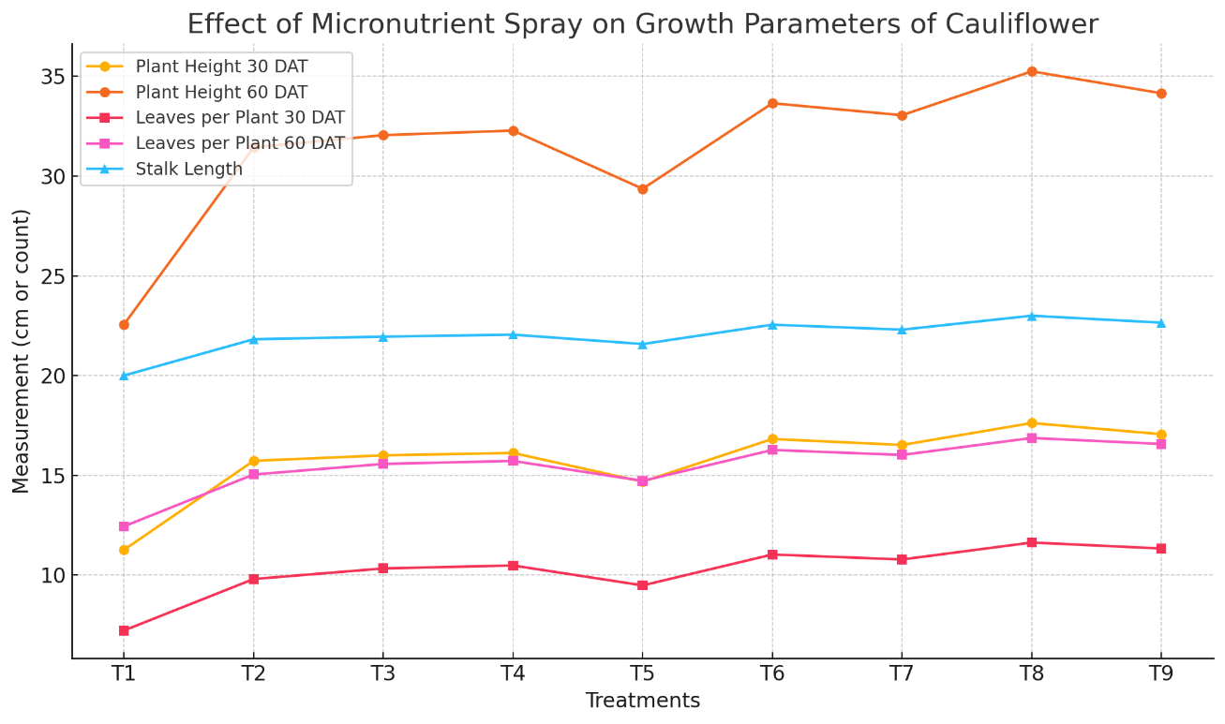

**Fig. 1 Effect of foliar spray of micronutrients on growth attributes of cauliflower**

**3.2 Yield attributes**

Effect of foliar spray of micronutrients on yield parameters and yield of cauliflower tabulated in Table 2 and Fig. 2. The data were showed significant in respect of curd diameter. The maximum curd diameter (31.15 cm) was observed in T8-Borax @ 0.2% + FeSO4 @ 0.5% + ZnSO4 @ 0.5% + Ammonium molybdate @ 0.2% (Foliar spray at 30, 45 and 60 DAT). The minimum curd diameter (26.85 cm) was recorded in treatment T1-Control (only RDF). The data were showed significant in respect of curd depth. The maximum curd depth (9.45 cm) was observed in T8-Borax @ 0.2% + FeSO4 @ 0.5% + ZnSO4 @ 0.5% + Ammonium molybdate @ 0.2% (Foliar spray at 30, 45 and 60 DAT). The minimum curd depth (8.00 cm) was recorded in treatment T1-Control (only RDF). The data were showed significant in respect of net curd weight. The maximum net curd weight (645.58 g) was observed in T8-Borax @ 0.2% + FeSO4 @ 0.5% + ZnSO4 @ 0.5% + Ammonium molybdate @ 0.2% (Foliar spray at 30, 45 and 60 DAT. The minimum net curd weight (430.02 g) was recorded in treatment T1-Control (only RDF). The data were showed significant in respect of gross curd weight. The maximum gross curd weight (1020.63 g) was observed in T8-Borax @ 0.2% + FeSO4 @ 0.5% + ZnSO4 @ 0.5% + Ammonium molybdate @ 0.2% (Foliar spray at 30, 45 and 60 DAT). The minimum gross curd weight (800.22 g) was recorded in treatment T1-Control (only RDF). The data were showed significant in respect of curd yield (Fig. 3). The maximum curd yield (145.36 q/ha) was observed in T8-Borax @ 0.2% + FeSO4 @ 0.5% + ZnSO4 @ 0.5% + Ammonium molybdate @ 0.2% (Foliar spray at 30, 45 and 60 DAT). The minimum curd yield (102.52 q/ha) was recorded in treatment T1-Control (only RDF). Similar concluded by Sitapara *et al. (*2011), Singh *et al.* (2011), Naher (2014), Sathiyamurthy *et al.* (2017), Singh *et al.* (2018), Ranjan *et al*. (2019) and Saurabh *et al.* (2024).

**Table 2: Effect of foliar spray of micronutrients on yield parameters and yield of cauliflower**

|  |  |  |  |  |  |
| --- | --- | --- | --- | --- | --- |
| **Treatments** | **Curd diameter (cm)** | **Curd depth (cm)** | **Net curd**  **weight (g)** | **Gross curd weight (g)** | **Curd yield**  **(q/ha)** |
| **T1** | 36.85 | 8.00 | 430.02 | 800.22 | 102.52 |
| **T2** | 39.45 | 8.89 | 562.25 | 885.02 | 130.78 |
| **T3** | 40.00 | 9.00 | 580.44 | 900.45 | 133.63 |
| **T4** | 40.32 | 9.05 | 589.36 | 920.36 | 136.20 |
| **T5** | 39.78 | 8.78 | 538.78 | 848.25 | 127.45 |
| **T6** | 40.85 | 9.30 | 612.25 | 962.85 | 140.56 |
| **T7** | 40.65 | 9.20 | 600.52 | 940.15 | 138.45 |
| **T8** | 41.15 | 9.45 | 645.68 | 1020.63 | 145.36 |
| **T9** | 41.00 | 9.38 | 628.47 | 985.36 | 142.52 |
| **S. Em. ±** | **0.58** | **0.09** | **13.92** | **27.73** | **2.91** |
| **CD at 5%** | **1.73** | **0.28** | **41.74** | **83.14** | **8.73** |

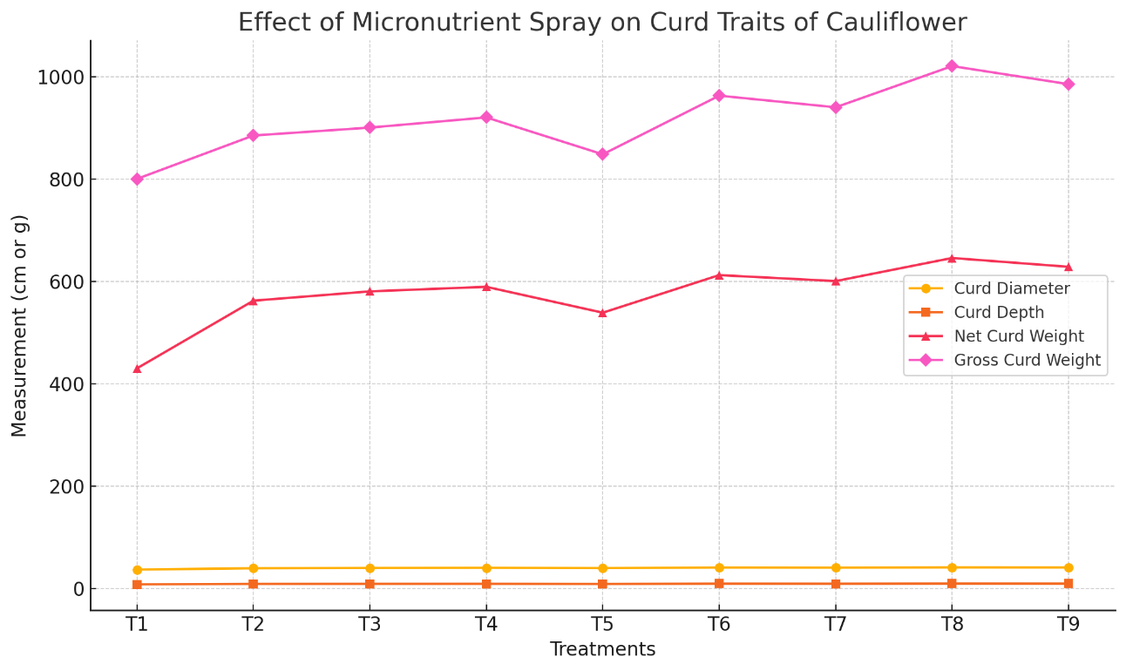

**Fig. 2** **Effect of foliar spray of micronutrients on yield parameters and yield of cauliflower**

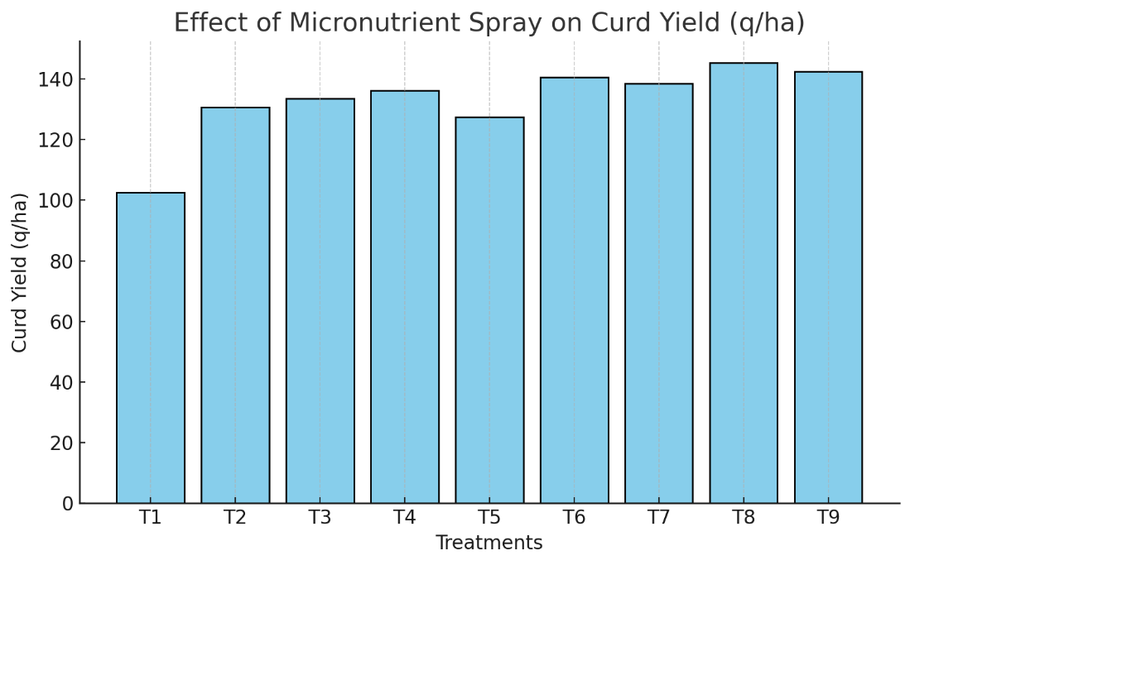

**Fig. 3** **Effect of foliar spray of micronutrients on curd yield of cauliflower**

1. **CONCLUSION**

The present investigation demonstrated that foliar application of micronutrients significantly enhanced the growth and yield of cauliflower (*Brassica oleracea* var. *botrytis* L.) under field conditions. Among all treatments, the combined foliar spray of Borax (0.2%) + FeSO₄ (0.5%) + ZnSO₄ (0.5%) + Ammonium molybdate (0.2%) applied at 30, 45, and 60 days after transplanting (DAT) proved to be the most effective in improving key growth parameters such as plant height, number of leaves, and stalk length. Similarly, this treatment also resulted in superior yield attributes, including curd diameter, curd depth, net and gross curd weight, ultimately leading to the highest curd yield of 145.36 q/ha. The synergistic interaction among micronutrients likely contributed to enhanced physiological activity, nutrient uptake, and curd development. The findings emphasize the importance of integrating balanced micronutrient management through foliar application for optimizing productivity, particularly in soils deficient in essential elements like zinc and iron. Thus, it can be concluded that the targeted foliar application of a micronutrient mixture is a promising strategy for enhancing cauliflower growth, curd quality, and overall yield potential. This approach is economically feasible and can be recommended to farmers aiming for higher productivity under similar agro-climatic conditions.

**DISCLAIMER (ARTIFICIAL INTELLIGENCE)**

Author(s) hereby declare that NO generative AI technologies such as Large Language Models (ChatGPT, COPILOT, etc.) and text-to-image generators have been used during the writing or editing of this manuscript.

**REFERENCES**

Bairwa, P. L., Dixit, A., Bala, J., & Singh, V. (2024). Effect of Different Macro and Micro Nutrient Uptake on Soil and Plant in Cauliflower (*Brassica oleracea* var. botrytis L.) cv. Pusa Sharad. *Journal of Advances in Biology & Biotechnology*, 27(6), 878-895.

Ballabh, K., Rana, D. K., & Rawat, S. S. (2013). Effects of foliar application of micronutrients on growth, yield and quality of onion. *Indian Journal of Horticulture*, *70*(2), 260-265.

Bhupenchandra, I., Basumatary, A., Datta, S., Kanta Singh, L., Bora, S. S., Helena Devi, S., ... & Tamuli, B. (2020). Micronutrient content in plant, its uptake, and crop yield in cauliflower–cowpea-okra cropping sequence as impacted by graded level of boron fertilization. *Communications in Soil Science and Plant Analysis*, *51*(14), 1870-1887.

Chaudhari VJ, Patel NK, Tandel BM and Chaudhari V. (2017). Effect of foliar spray of micronutrients on growth and yield of cauliflower (*Brassica oleracea* L. var. botrytis). *International Journal of Chemical Studies*. 5(6), 1133-1135.

Hassan H.A, Ahmed M.Y. Aboull EI-magd M.M. and Anwar M.T. (2013). Effect of different phosphorous fertilizer rates and foliar spray with some commercial nutrients on growth and yield of broccoli grown in sandy soils*. J. of applied sci*. 9(3), 2052-2062.

Hemphill, D. D. (1982). Anticrustant Effects on Soil Mechanical Resistance and Seedling Emergence1. *Hort. Science*, 17(3), 391-393.

Kotecha A.V., JJ. Dharuve and N.J. Vihol (2011). Effect of foliar application of micronutrients and growth regulators on growth and yield of cabbage *{Brassica oleracea L. var.capitata)* cv. Golden Acre. *The Asian journal of Horticulture,* 6, 381-384.

Kumar Anil D.K. Parmar and V.K. Suri (2012). Effect of boron fertilizers and organic manure on Autumn cauliflower in western Himalayas. *Annals of Horticulture,* 5(1), 17-24.

Kumar Santosh, S.S. Singh, Singh Pradeep Kumar and Singh Vivekanand (2014). Response of cauliflower (*Brassica oleracea L. var. botrytis)* to Boron and Molybdenum application. *Vegetable science,* 37(1), 40-43.

Kumar, V. V., Ramesh, E., Triveni, V., & Dash, B. (2024). Enhancement of Growth and Yield of Valentena (Purple Cauliflower) through Different Micronutrient Optimization. *Environment and Ecology*, 42(3B), 1369-1374.

Naher M.N.A., M.N. Alami and N. Jahan (2014). Effect of nutrient management on the growth and yield of cabbage *(Brassica oleracea var. capitate L.) in calcareous soil of Bangladesh- The Agriculturists,* 12(2), 24-33.

Ranjan S, Misra S, Sengupta S, Parween S and Kumari U. (2019). Influence of micronutrients on growth and yield of cauliflower. *Journal of Pharmacognosy and Phytochemistry*. 9(1), 238-240.

Sabri ZN, Mujawal AK and Kshash BH. (2021). Effect of ethephone, zinc and boron on growth and yield of cucumber (*Cucumis melo* var. flexuosus) cultivated in plastic houses. *Earth and Environmental Science*, 910, 1-6.

Sathiyamurthy VA, Shanmugasundaram T, Rajasree V and Arumugam T. (2017). Effect of foliar application of micronutrients on growth, yield and economics of tomato (*Lycopersicon esculentum* L.). *Madras Agricultural Journal*. 104, 88-193.

Saurabh, A., Kaur, M., Khan, R., Guleria, G., Shandilya, M., & Thakur, S. (2024). Foliar application of Fe2O3 nano fertilizer on growth and yield of cauliflower (*Brassica oleracea* var. Botrytis L.) cv. Pusa Snowball K-1. *International Journal of Phytoremediation*, 26(7), 993-1002.

Singh, K. P., Singh, V. K., & Roy, R. K. (2011). Effect of different levels of boron and its methods of application on growth and yield of cauliflower (*Brassica oleracea* var. botrytis L.). *Vegetable Science*, *38*(01), 76-78.

Singh, R. K., Singh, M., Singh, B., Singh, A., Maurya, R., Singh, P., & Singh, A. (2025). Impact of Micronutrients Foliar Application on the Growth Traits of Cauliflower (Brassica oleracea var. botrytis L.). *International Journal of Plant & Soil Science*, *37*(4), 356-365.

Singh, V., Singh, A. K., Raghuvanshi, T., Singh, M. K., Singh, V., & Singh, U. (2017). Influence of Boron and Molybdenum on Growth, Yield and Quality of Cauliflower (Brassica oleracea L. var. botrytis). *International Journal of Current Microbiology and Applied Sciences*, *6*(10), 3408-3414.

Singh, V., Singh, A. K., Singh, S., Kumar, A., & Shikha, K. (2018). Assessment of effect of foliar spray of micronutrients on quantitative and qualitative attributes of broccoli (Brassica oleracea var. italica) cv. Pusa KTS-1. *Journal of Pharmacognosy and Phytochemistry*, *7*(4), 3189-3192.

Trivedi, A. P., & Dhumal, K. N. (2013). Effect of soil and foliar applications of zinc and iron on the yield and quality of onion (Allium cepa L.). *Bangladesh Journal of Agricultural Research*, *38*(1), 41-48.