**Studies on growth and yield behavior of short grain aromatic traditional, improved scented and fortified quality rice varieties under organic production system**

# ABSTRACT

An investigation was conducted at the Instructional Cum Research Farm, Department of Agronomy, College of Agriculture, Indira Gandhi Krishi Vishwavidyalaya, Raipur (Chhattisgarh), to evaluate the performance of various quality rice varieties under organic farming conditions. The study utilized a Randomized Block Design with three replications and fifteen treatments, consisting of eight traditional short-grain aromatic, four high-yielding scented, and three fortified rice varieties. The findings showed significant differences in plant height among varieties, with Amrit Bhog, a traditional short-grain aromatic variety, exhibiting the maximum plant height at harvest, while CG Devbhog, a high-yielding scented variety, displayed the minimum plant height. In terms of tiller production, Indira Sughandhit Dhan 1 and Chhattisgarh Sugandhitbhog, both high-yielding scented varieties, showed superior performance, whereas Zinco rice MS, a fortified variety, demonstrated exceptional performance within its group. Amrit Bhog excelled in dry matter accumulation, leaf area, and leaf area index (LAI) across all varieties. Notably, CG Devbhog achieved the highest grain yield (37.0 q ha-1), outperforming all high-yielding scented varieties. Among traditional short-grain aromatic varieties, Tarunbhog Selection 1 and Lokti Machhi produced higher yields, while Protezin, a fortified variety, showed superior performance within its group. This study underscores the potential of diverse quality rice varieties under organic farming conditions in Chhattisgarh's agro-climatic conditions.

***KEY WORDS:*** *Organic rice production, Rice varieties, Grain yield and Agronomic performance*

# INTRODUCTION

Rice (*Oryza sativa* L.) continues to be a cornerstone of India's food security, feeding over half of the world’s population. In the 2023–24 period, India’s total rice production is estimated at approximately 128 million metric tonnes, comprising roughly 109 MMT of *Kharif* rice and about 21 MMT from *Rabi* and *summer* crops. In Chhattisgarh, rice remains the dominant crop. The state accounts for about 5% of India’s *Kharif* rice output in 2023, according to USDA data, with its contribution gradually rising from ~8% in earlier years. Rice productivity in Chhattisgarh remains below the national average due to limited irrigation (around 27.6 % of cultivated land irrigated) and predominantly rainfed farming systems. Smallholder farmers overwhelmingly dominate rice cultivation in Chhattisgarh, and the adoption of mechanization and modern agronomic practices remains limited. Studies show the majority of farmers rely on traditional animal-drawn implements and manual labor, with a significant portion lacking access to credit to acquire machinery (Shriwas & Awasthi, 2019; Sahu & Sahu, 2020). In areas like Bastar, the prevalence of wooden ploughs and negligible tractor usage further underscores the reliance on traditional methods and low mechanization levels (Bastar District profile, 2025). This limited mechanization, combined with rainfed cultivation and low irrigation coverage (about 20–23% irrigated area), contributes to the state's underperformance in rice productivity compared to national averages (ICAR, 2022; Wikipedia, 2025). Together, these findings highlight the urgent need for targeted interventions— such as custom hiring centers, cooperative access to farm machinery, and credit facilitation—to help smallholders adopt sustainable and profitable systems.

India’s organic farming sector has witnessed steady growth in recent years. As of the 2023– 24 period, the total area under certified organic cultivation in India reached approximately 4.48 million hectares, showing a significant rise from 1.1 million hectares in 2014–15 (APEDA, 2024). During the same period, organic agricultural production was estimated at around 3.6 million metric tonnes, including food grains, pulses, oilseeds, fruits, and spices. India holds the top global position in the number of organic producers and ranks among the top 10 countries in terms of organically certified land area (APEDA, 2024; IFOAM & FiBL, 2024). This expansion has been largely driven by the National Programme for Organic Production (NPOP), administered by the Agricultural and Processed Food Products Export Development Authority (APEDA) under the Ministry of Commerce and Industry. NPOP provides the framework for accreditation of certification bodies, standards for organic production, and promotes organic exports (APEDA, 2024).

In the state of Chhattisgarh, the indigenous and aromatic rice variety known as Jeeraphool has gained widespread attention due to its unique fragrance, fine grain quality, and historical cultivation in tribal regions, especially Surguja district. Jeeraphool rice has been granted a Geographical Indication (GI) tag, highlighting its cultural and economic significance. It is traditionally cultivated using organic and indigenous practices without synthetic inputs, and it commands a premium price in both domestic and niche export markets (The IP Press, 2021; Shalikuta, n.d.; Wikipedia, 2024). This variety provides an excellent example of how traditional crops, when combined with organic certification and market development, can create value-added opportunities for smallholder farmers.

Biofortification has emerged as a sustainable and scientifically validated strategy to address widespread micronutrient deficiencies in populations heavily reliant on staple crops like rice. This approach focuses on breeding nutrient-dense varieties enriched with essential micronutrients such as zinc and iron, thereby enhancing the nutritional quality of rice without reducing yield or agronomic performance. Foundational studies by Bouis and Welch (2010) and Nestel *et al*. (2006) emphasized the potential of biofortified crops in reducing "hidden hunger." In India, the Indian Council of Agricultural Research (ICAR) and global initiatives like HarvestPlus have significantly advanced biofortification through the development and dissemination of several zinc-rich rice varieties. Notably, Zinco Rice MS, developed by the Indian Institute of Rice Research (IIRR), contains up to 24–28 mg/kg of zinc in polished rice and has demonstrated superior agronomic traits. Similarly, Protazin is a promising biofortified line designed for both protein and zinc enhancement, aiding in improved dietary quality. In Chhattisgarh, the state-released variety CG Madhuraj-55, which offers higher zinc content along with aromatic and short-duration traits, supports both nutritional goals and farmer preferences. These varieties have been integrated into frontline demonstrations and public seed distribution systems. ICAR reports confirm increasing adoption rates and nutritional benefits among vulnerable populations (ICAR, 2022), while HarvestPlus continues to monitor and assess the health impacts of biofortified rice across multiple Indian states (HarvestPlus, 2023). Collectively, these efforts establish biofortification as a viable tool in achieving national targets related to food and nutritional security.

# MATERIALS AND METHODS

A research investigation was carried out during the *Kharif* season of 2021 at the Research cum Instructional Farm, Indira Gandhi Krishi Vishwavidyalaya, Raipur (Chhattisgarh), to assess the performance of diverse rice varieties under organic farming conditions. The experimental site, located at 21º 16' N latitude and 81º 36' E longitude, with an elevation of 298.15 meters above mean sea level, had a *Vertisol* soil type with a mildly alkaline pH, moderate electrical conductivity (0.31 dsm-2), and relatively low levels of organic carbon (0.42%), available nitrogen (204.7 kg ha1), and available phosphorus (16 kg ha-1), but high levels of available potassium (340.2 kg ha-1).

The study employed a Randomized Block Design with three replications and fifteen treatments, consisting of eight traditional short-grain aromatic rice varieties, four high-yielding scented rice varieties, and three fortified rice varieties. The experimental field was prepared using a combination of tractor ploughing, puddling, and leveling. Rice seedlings were raised in a nursery using a dry seedbed method and transplanted to the main field after 25 days, with a spacing of 20 x 10 cm. Organic manures, including Farm Yard Manure, Vermicompost, Neem Cake, and Rock Phosphate, were applied based on the specific nutrient requirements of each variety. Foliar applications of Vermiwash 10% were made at 30 and 50 days after transplanting, and a broadspectrum bio-pesticide, Neembant 3% liquid ha-1, was applied twice after tillering to control pests. The crop was maintained under saturated conditions during the establishment phase and subsequently at a water level of 5 ± 2 cm throughout the growth period. Weeds were controlled through hand weeding at 30 and 50 days after transplanting. The crop was harvested manually, and the produce was threshed and winnowed to separate the grains from the chaff and straw. The grains were weighed plot-wise to determine the yield. This study aimed to evaluate the performance of various rice varieties under organic production conditions and identify suitable varieties for sustainable rice production.

Growth parameter evaluations were conducted prior to harvest to assess various aspects of rice variety development. Plant density was assessed at 30 days after transplanting (DAT) and at harvest by counting the number of plants in 1 m² areas from four randomly selected spots in each plot, using the formula: Plant density = Area / Plant spacing. Plant height was measured in centimeters from the soil surface to the topmost leaf at 30, 60, and 90 DAT. Tiller production was evaluated by counting the number of tillers from five tagged hills at 30, 60, and 90 DAT, expressing the results as tillers hill-1. Dry matter accumulation was assessed by harvesting one hill per plot, removing roots, and drying the shoot portion in an oven at 65°C for 24-48 hours. The duration from transplanting to 50% flowering was recorded by observing each plot to determine the time taken for 50% of the plants to reach heading stage. Leaf area was measured at 30, 60, and 90 DAT using the formula: Leaf area (cm²) = K × L × W, where K represents the leaf area coefficient (0.75), L is the maximum leaf length, and W is the maximum leaf width. Leaf Area Index (LAI) was calculated using the formula: LAI = Total leaf area per hill (cm²) / Total ground area per hill (cm²), representing the total leaf area in relation to the total ground area.

Crop growth rate (CGR) and relative growth rate (RGR) are crucial metrics for assessing the growth and productivity of rice varieties. CGR represents the total dry matter productivity of the crop per unit land area over a specified time period, measured in g day-1 hill-1. It is calculated using the formula: CGR = (W2 - W1) / (T2 - T1), where W1 and W2 are the dry weights per unit area at the initial and final sampling times, respectively, and T1 and T2 are the corresponding time intervals. RGR, on the other hand, expresses the dry weight increases over a time interval relative to the initial weight. It is measured as the mass increase per aboveground biomass per day, typically in g g-1 day-1 hill-1. The mean RGR is calculated using the formula: RGR = (logeW2 - logeW1) / (T2 – T1), where ln is the natural logarithm, and W1 and W2 are the dry weights of the plant at times T1 and T2, respectively.

**RESULTS AND DISCUSSION**

# Plant height

The impact of genetic variation on plant height in diverse quality rice varieties was investigated under an organic production system. The results presented in Table 1 demonstrate a gradual increase in plant height with crop age, with the most rapid growth occurring between 30 to 60 days after transplanting (DAT). The growth rate subsequently slowed down between 90 DAT and harvest. Significant differences in plant height were observed among varieties at all growth stages, attributable to their genetic makeup (Lakra *et al*., 2012). The initial growth rate (0-30 DAT) was highest in Tarunbhog Selection 1, closely followed by Samund Chini. At harvest, Amrit Bhog exhibited the maximum plant height (202 cm), surpassing Samund Chini (198 cm) and Chinni Kapoor (194 cm). Among traditional varieties, Tarunbhog Selection-1 had the shortest plant height (163 cm) at harvest, followed by Lohandi (166 cm). In contrast, Indira Sugandhit Dhan-1, a highyielding scented variety, displayed the highest plant height (140 cm), while CG Devbhog had the lowest (85.9 cm). Among fortified rice varieties, CG Madhuraj 55 had the highest plant height (135.8 cm), whereas Zinco rice MS had the shortest plants (96.7 cm). These findings are consistent with previous research (Sharma *et al*., 2022; Lalrindiki *et al*., 2024), highlighting the significant influence of genetic variation on plant height in rice varieties under organic production condition.

# Number of tillers

The tillering behavior of diverse quality rice varieties exhibited significant variation, emphasizing the crucial role of tillering ability as a key yield attributing character (Sharma *et al*., 2022). The number of tillers hill-1 increased with crop age up to 90 days after transplanting (DAT), followed by a slight reduction at maturity, consistent with previous findings (Singh *et al*., 2020). Among traditional aromatic rice varieties, Lokti Machhi displayed the highest number of tillers hill-1, with a mean value of 11.4, which was comparable to other short-grain traditional aromatic rice varieties, except Amrit Bhog (Lakra *et al*., 2012). In contrast, Chhattisgarh Sugandhitbhog, a high-yielding scented rice variety, produced the highest number of tillers hill-1 at all observation stages, surpassing other high-yielding scented rice varieties. Regarding fortified rice varieties, Zinco rice MS produced the maximum number of tillers hill-1 at all observation stages, including 30, 60, 90 DAT, and at harvest, supporting similar findings by Lalrindiki *et al*., (2024). These results underscore the significance of genetic variation in determining tillering dynamics in quality rice varieties under organic production system.

# Dry matter accumulation

The data presented in Table 1 demonstrate a notable progression in dry matter accumulation as the rice varieties mature, emphasizing the crucial role of genetic diversity in influencing dry matter accumulation. Distinct variations in dry matter accumulation were observed among the rice varieties at different growth stages, aligning with previous research findings. Among the traditional short-grain aromatic rice varieties, Chinni Kapoor and Amrit Bhog exhibited exceptional dry matter accumulation, with mean values of 6.7g hill-1 and 6.5g hill-1, respectively. Lohandi displayed remarkable dry matter accumulation at 60 DAT, while Amrit Bhog showed superior accumulation at 90 DAT and at harvest. In contrast, Aatma Sheetal recorded the lowest dry matter accumulation across various stages. High-yielding scented rice varieties, CG Devbhog and Indira Sugandhit Dhan 1, displayed impressive dry matter accumulation at 30 DAT, with mean values of 6g hill-1 and 5.9g hill-1, respectively. Chhattisgarh Sugandhitbhog exhibited higher accumulation at 60 DAT, while CG Devbhog showed superior accumulation at 90 DAT and at harvest. Among fortified rice varieties, Protezin and CG Madhuraj 55 displayed notable dry matter accumulation at 30 DAT, with mean values of 5g hill-1 and 4.5g hill-1, respectively. CG Madhuraj 55 exhibited higher accumulation at 60 DAT, 90 DAT, and at harvest, while Zinco rice MS showed relatively lower accumulation from 30 DAT to harvest. These findings align with previous research highlighting the significance of genetic variation in determining dry matter accumulation in rice varieties under organic production system, supported by the research of Lakra *et al*., 2012.

# Leaf area

The data presented in Table 2 reveal substantial genetic diversity in leaf area among various quality rice varieties grown under an organic production system. At 30 days after transplanting (DAT), Tarunbhog Selection 1 exhibited the largest leaf area (353.2 cm2 hill-1), outperforming Tulsi Manjiri and Chinni Kapoor among short-grain aromatic rice varieties. At 60 DAT, Lokti Machhi displayed the maximum leaf area hill-1, while at 90 DAT, Amrit Bhog recorded the highest leaf area, comparable to other traditional short-grain aromatic rice varieties. Among high-yielding scented rice varieties, CG Devbhog showed notably higher leaf area hill-1 at 30 DAT, but at 60 and 90 DAT, all varieties exhibited similar leaf area hill-1. Fortified rice varieties displayed comparable leaf area hill-1 at all observation stages (Table 2). These findings align with previous research emphasizing the importance of genetic variations in determining leaf area in different quality rice varieties under organic production system. The results suggest that genetic diversity plays a vital role in determining leaf area, a crucial trait for rice productivity.

# Leaf Area Index (LAI)

The leaf area index (LAI) is a crucial parameter in growth analysis, characterizing crop canopy and photosynthetic activity, with a direct impact on growth and yield parameters (Vishnu *et al*., 2020). Table 2 presents data showing an increase in LAI as the crop ages in various quality rice varieties under organic production (Nevendra *et al*., 2024). Traditional short-grain aromatic rice varieties consistently exhibited higher LAI values compared to high-yielding scented and fortified rice varieties at all observational stages. Within the traditional short-grain aromatic varieties, similar LAI values were observed across all stages, indicating minimal variation among these varieties. Similarly, high-yielding scented and fortified varieties displayed comparable LAI values at all stages, suggesting homogeneity within these groups. These findings align with previous research emphasizing the importance of LAI in determining growth and yield parameters in rice varieties under organic production system (Nevendra *et al*., 2024; Vishnu *et al*., 2020). The results highlight the significance of LAI as a critical factor influencing rice productivity and

**Table 1. Plant height, number of tillers and dry matter accumulation of rice as influenced by different quality rice varieties grown under organic production system at various time intervals.**

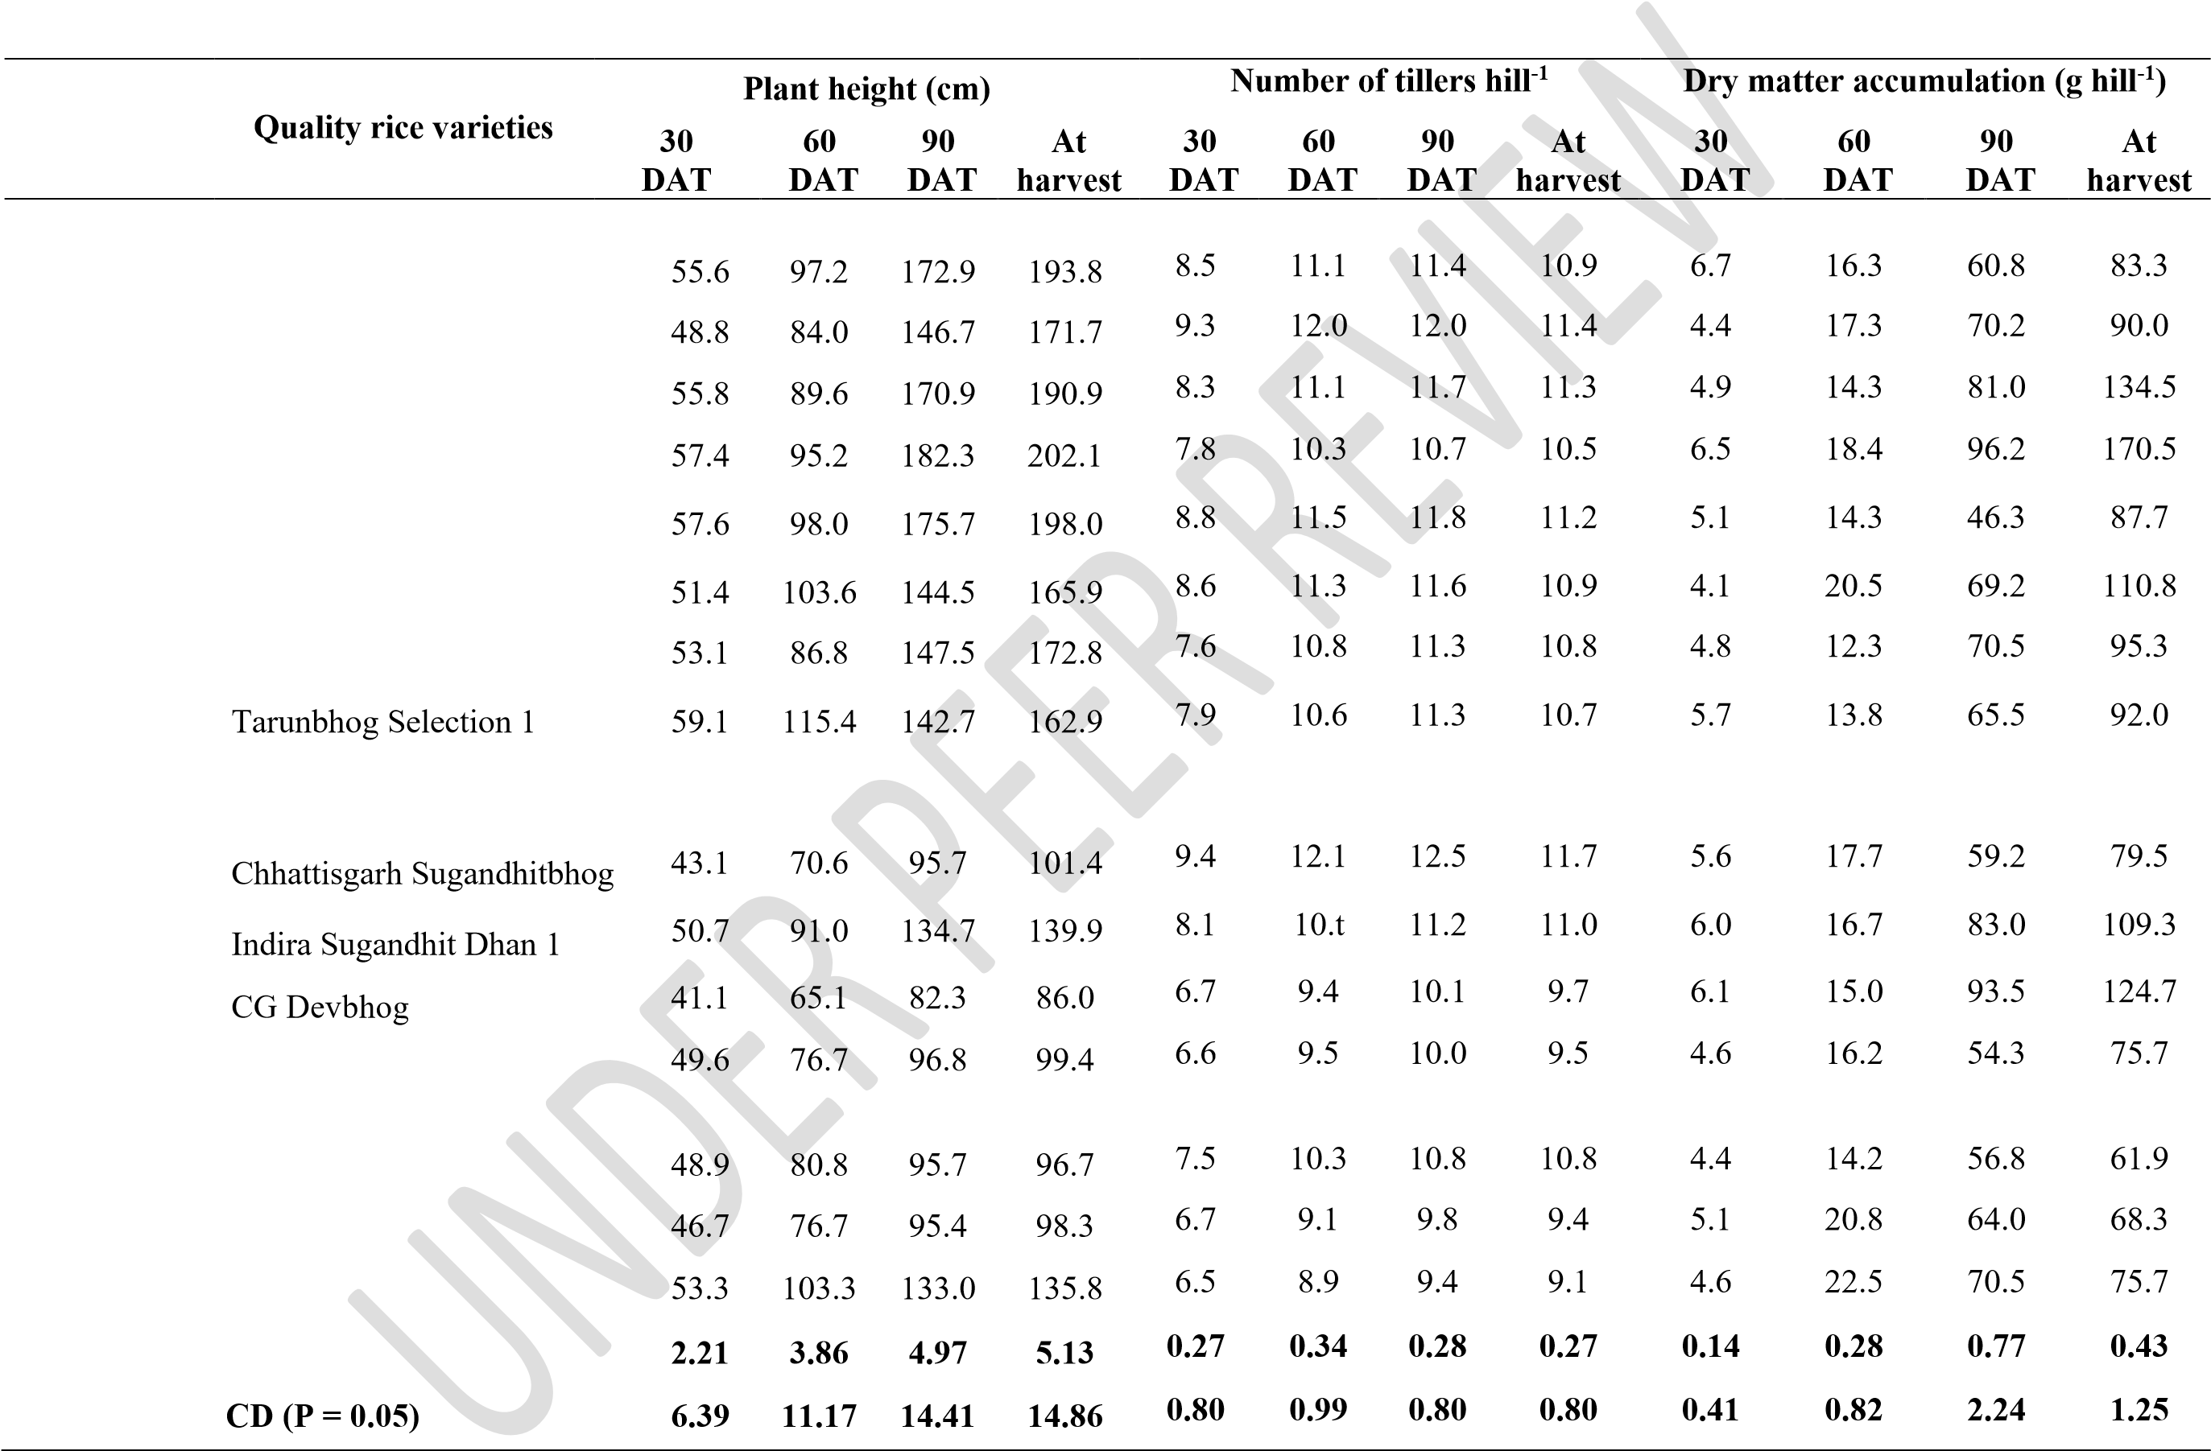**Treatments**

## Traditional short grain aromatic

V1 Chinni Kapoor

V2 Lokti Machhi

V3 Tulsi Manjiri

V4 Amrit Bhog

V5 Samund Chini

V6 Lohandi

V7 Aatma Sheetal

V8

## High yielding scented

V9

V10

V11

V12 Sugandhmati

## Fortified

V13 Zinco rice MS

V14 Protezin

V15 CG Madhuraj 55

𝐒 𝐄𝐦 ±

underscore the need for further research to explore its potential in optimizing crop management strategies.

# Crop growth rate (CGR)

Figure 1 presents the crop growth rate (CGR) of various quality rice varieties grown under an organic production system. A comparative analysis of traditional short-grain aromatic rice varieties reveals distinct CGR patterns. Lohandi exhibited the highest CGR during the initial growth stage (30-60 days after transplanting, DAT), while Tulsi Manjiri and Aatma Sheetal display superior CGR during the subsequent growth stage (60-90 DAT). Amrit Bhog and Lohandi demonstrate higher CGR during the maturation phase (90 DAT to harvest). In contrast, highyielding scented rice varieties exhibit varying CGR dynamics. CG Devbhog records the highest CGR (2.62 g hill-1 day-1) during the active growth stage (60-90 DAT) and maintains a higher CGR (1.04 g hill-1 day-1) during the maturation phase. Conversely, Sugandhmati and Chhattisgarh Sugandhit Dhan 1 exhibit lower CGR values throughout the growth stages. Among fortified rice varieties, CG Madhuraj 55 consistently displays the highest CGR (1.66 g hill-1 day-1) from the initial stage to harvest. In contrast, Zinco rice MS and Chhattisgarh Sugandhitbhog show lower CGR values at different stages. These findings align with previous research on CGR dynamics in rice varieties under organic production system (Vishnu *et al*., 2020: Lakra *et al*. 2012). The results underscore the importance of CGR as a critical factor influencing rice productivity and highlight the need for further research to explore its potential in optimizing crop management strategies.

# Relative growth rate (RGR)

Figure 2 presents the relative growth rate (RGR) of various quality rice varieties grown under an organic production system. RGR measures the increase in dry weight per unit of original dry weight over a specific time interval, providing insight into growth efficiency. Notably, the RGR values among all quality rice varieties exhibit minimal variation at all stages, indicating a similar growth pattern. This suggests that genetic diversity among the rice varieties does not significantly impact RGR under organic production conditions. These findings align with previous research on RGR dynamics in rice varieties under organic production systems, which reported similar uniformity in RGR among varieties. The results also support the findings of Vishnu *et al*. (2020): Lakra *et al*. (2012), who reported that genetic variation does not significantly impact RGR

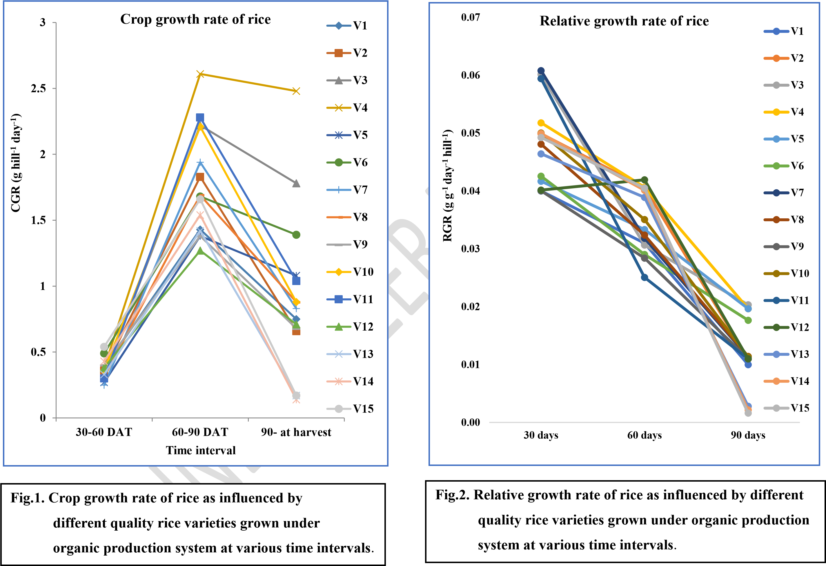

under organic production conditions. The uniformity in RGR among quality rice varieties highlights the significance of environmental factors in influencing growth dynamics, rather than genetic variation. This has important implications for crop management strategies, suggesting that optimizing environmental conditions can lead to improved growth efficiency and productivity. By focusing on environmental factors, farmers and researchers can develop targeted approaches to enhance rice growth and productivity, regardless of genetic variation among varieties.

# Grain yield

The data presented in Table 2 showcasing diverse grain yield performance among quality rice varieties cultivated under an organic production system. A comparative analysis of traditional short-grain aromatic rice varieties reveals that Tarunbhog Selection 1 achieved the highest grain yield (28.2 q ha-1), closely followed by Lokti Machhi (25.2 q ha-1) and Samund Chinni (25.3 q ha1), which exhibit comparable yields. High-yielding scented rice varieties grown under organic production demonstrate exceptional grain yield in CG Devbhog (37.0 q ha-1), outperforming other varieties, with the exception of Chhattisgarh Sugandhitbhog and Sugandhmati, which display similar yields. Among fortified rice varieties, Protezin attained the highest grain yield (32.2 q ha1), closely followed by CG Madhuraj 55 (31.5 q ha-1) and Zinco rice MS (31.1 q ha-1), which exhibit statistically similar yields, indicating minimal variation among these varieties. These findings align with previous research on grain yield in rice varieties under organic production system, which reported significant variation in grain yield among varieties. The results emphasize the crucial role of varietal selection in optimizing grain yield under organic production, highlighting the need for targeted approaches to enhance rice productivity.

# Discussion of growth parameters and grain yield

The current study highlights significant diversity in growth parameters and grain yield among various rice varieties, including traditional aromatic short-grain, high-yielding scented, and fortified types (Rathia, 2019). Notably, traditional aromatic short-grain rice varieties exhibit pronounced genetic variability, characterized by taller plant heights compared to other groups (Lakra *et al*., 2012). Within this group, Amrit Bhog, Tulsi Manjiri, and Chinni Kapoor displayed comparable plant heights, surpassing other varieties across all groups (Rathia, 2019). Conversely,

Lokti Machhi, Tulsi Manjiri, and Samund Chini exhibit higher tiller numbers. Amrit Bhog

# Table 2. Leaf area, leaf area index and grain yield of rice as influenced by different quality rice varieties grown under organic production system

|  |  |  |  |  |
| --- | --- | --- | --- | --- |
| **Treatments** | **Quality rice varieties** | **Leaf area (cm2) hill-1**  **30 60 90**  **DAT DAT DAT** | **Leaf area index**  **30 60 90**  **DAT DAT DAT** | **Grain yield**  **(q ha-1)** |

## Traditional short grain aromatic

V1 Chinni Kapoor 299.7 662.0 982.7 1.5 3.3 4.9 23.5

V2 Lokti Machhi 326.6 682.2 1017.8 1.6 3.4 5.1 25.2

V3 Tulsi Manjiri 307.6 628.2 1010.5 1.5 3.1 5.1 22.6

V4 Amrit Bhog 322.5 648.6 1058.5 1.6 3.2 5.3 23.1

V5 Samund Chini 329.7 639.0 967.7 1.6 3.2 4.8 25.3

V6 Lohandi 322.5 590.1 1050.3 1.6 3.0 5.3 23.2

V7 Aatma Sheetal 321.9 610.8 976.4 1.6 3.1 4.9 23.0

V8 Tarunbhog Selection 1 353.2 604.7 1037.7 1.8 3.0 5.2 28.2

## High yielding scented

V9 Chhattisgarh Sugandhitbhog 272.9 543.9 848.0 1.4 2.7 4.2 34.2

V10 Indira Sugandhit Dhan 1 252.1 538.7 854.2 1.3 2.7 4.3 33.5

V11 CG Devbhog 322.9 567.7 844.9 1.6 2.8 4.2 37.0

V12 Sugandhmati 252.4 546.7 893.2 1.3 2.7 4.5 34.2

## Fortified

V13 Zinco rice MS 240.6 549.0 856.8 1.2 2.7 4.3 31.1

V14 Protezin 260.9 566.5 862.2 1.3 2.8 4.3 32.2

V15 CG Madhuraj 55 236.0 533.8 876.8 1.2 2.7 4.4 31.5

## 𝐒 𝐄𝐦 ± 11.13 21.11 35.6 0.04 0.22 0.2 1.15 CD (P = 0.05) 32.24 43.24 103.1 0.13 0.45 0.5 3.33

demonstrates a superior crop growth rate (CGR), followed closely by Tulsi Manjiri (Rathia, 2019). Interestingly, leaf area, leaf area index, and relative growth rate (RGR) remain unaffected by varietal differences within traditional short-grain aromatic rice, potentially due to the genetic makeup of tall-statured rice varieties (Rathia, 2019). High-yielding scented rice varieties exhibit differential responses in plant height and tiller numbers (Lakra *et al*., 2012). However, leaf area index and RGR remain uninfluenced by varietal differences. CG Devbhog displays a higher CGR, likely attributed to its enhanced response to organic nutrient supply (Lakra *et al*., 2012). Similar trends are observed among fortified varieties, where CG Madhuraj 55 excels in most growth parameters, except leaf area index and RGR, due to its superior response to nutrients and genetic potential (Rathia, 2019). The highest grain yield is recorded in CG Devbhog (37.0 q ha-1), significantly outperforming other high-yielding scented rice varieties, except Chhattisgarh Sugandhitbhog (Rathia, 2019). The lowest grain yield was observed in Tulsi Manjiri (22.6 q ha-1). Varietal differences attributed to genetic variation and disparate responses to organic nutrient sources (Lakra *et al*., 2012: Rathia, 2019: Nevendra *et al*., 2024: Choudhary *et al*., 2021; Sharma *et al*., 2022; Lalrindiki *et al*., 2024; Aravind *et al*., 2022).

# CONCLUSION

An experimental study conducted during the 2021 *kharif* season at the Instructional Cum Research Farm, Department of Agronomy, College of Agriculture, Indira Gandhi Agricultural University, Raipur, Chhattisgarh, India, investigated the growth and yield responses of various growth rice varieties under organic production system. The results revealed significant variations in growth parameters and yield among short-grain traditional aromatic, high-yielding scented, and fortified rice varieties. Notably, Tarunbhog Selection 1 exhibited comparable tiller numbers, leaf area, and leaf area index, leading to enhanced source-sink conversion and ultimately resulting in higher rice yields. Among the high-yielding scented rice varieties, CG Devbhog demonstrated superior growth parameters and yield, outperforming other varieties. Similarly, in the fortified varieties, Protezin showed higher yields, attributed to its enhanced response to organic nutrients and genetic potential. These findings underscore the importance of varietal selection in optimizing rice yields under organic production systems, highlighting the need for further research to explore the potential of different quality rice varieties in diverse agro-climatic conditions.

Disclaimer (Artificial intelligence)

Option 1:

Author(s) hereby declare that NO generative AI technologies such as Large Language Models (ChatGPT, manuscript. No Option 2:

Author(s) hereby declare that generative AI technologies such as Large Language Models, etc. have been used during the writing or editing of manuscripts. This explanation will include the name, version, model, and source of the generative AI technology and as well as all input prompts provided to the generative AI technology

Details of the AI usage are given below:

1.

2.

3.

# REFERENCES

APEDA – Agricultural and Processed Food Products Export Development Authority. (2024). *Organic Products: National Programme for Organic Production (NPOP) – Area, Production & Export*. Ministry of Commerce & Industry, Government of India. <https://apeda.gov.in/apedawebsite/organic/Organic_Products.htm>

APEDA. (2024). *Certified Organic Production and Export Data 2023–24*. <https://sec-npop.apeda.in/organic-certification-data-under-npop-2023-24>

IFOAM – Organics International & FiBL – Research Institute of Organic Agriculture. (2024). *The World of Organic Agriculture: Statistics and Emerging Trends 2024*. <https://www.organic-world.net/yearbook/yearbook-2024.html>

Bouis, H. E., & Welch, R. M. (2010). Biofortification: A sustainable agricultural strategy for reducing micronutrient malnutrition in the global south. *Crop Science, 50*(Supplement_1), S-20–S-32.<https://doi.org/10.2135/cropsci2009.09.0531>

Nestel, P., Bouis, H. E., Meenakshi, J. V., & Pfeiffer, W. (2006). Biofortification of staple food crops. *The Journal of Nutrition, 136*(4), 1064–1067. <https://doi.org/10.1093/jn/136.4.1064>

Indian Council of Agricultural Research (ICAR). (2022). *Annual Report 2021–22: Research*

*Achievements & Impact*. Division of Crop Science. [https://icar.org.in](https://icar.org.in/)

HarvestPlus. (2023). *Biofortified Crops in India: Impact and Reach*. IFPRI – International Food

Policy Research Institute. <https://www.harvestplus.org/where-we-work/india>

Shriwas, Y., & Awasthi, H. K. (2019). Socio-economic profile of rice growers in Chhattisgarh plains with reference to farm mechanization. *Journal of Pharmacognosy and*

*Phytochemistry, 8*(6), 1087–1091.

<https://www.phytojournal.com/archives/2019.v8.i6.10159>

Sahu, D., & Sahu, V. K. (2020). Status of farm mechanization in Durg, Balod District of

Chhattisgarh plains: A case study. *International Journal of Current Microbiology and*

*Applied Sciences, 9*(5), 1433–1448. <https://doi.org/10.20546/ijcmas.2020.905.164>

Wikipedia contributors. (2024, May). *Jeeraphool rice*. In *Wikipedia, The Free Encyclopedia*. <https://en.wikipedia.org/wiki/Jeeraphool_rice>

Shalikuta. (n.d.). *Jeeraphool – Heritage rice of Chhattisgarh*. <https://shalikuta.org/product/jeeraphool>

The IP Press. (2021, July 12). *Geographical Indication (GI) tags of Chhattisgarh*. <https://www.theippress.com/2021/07/12/geographical-indication-gi-tags-of-chhattisgarh>

Wikipedia contributors. (2025, July). *Chhattisgarh*. In *Wikipedia, The Free Encyclopedia*. <https://en.wikipedia.org/wiki/Chhattisgarh>

Wikipedia contributors. (2025, July). *Bastar district*. In *Wikipedia, The Free Encyclopedia*. <https://en.wikipedia.org/wiki/Bastar_district>

USDA Foreign Agricultural Service (FAS). (2023, December). *India – Grain and Feed Update*

*(December 2023)*. USDA GAIN Report No. IN2023-0092.

[https://apps.fas.usda.gov/newgainapi/api/Report/DownloadReportByFileName?fileNam e=India+-+Grain+and+Feed+Update+-+December+2023_New+Delhi_India_IN20230092.pdf](https://apps.fas.usda.gov/newgainapi/api/Report/DownloadReportByFileName?fileName=India+-+Grain+and+Feed+Update+-+December+2023_New+Delhi_India_IN2023-0092.pdf)

Lakra, A. K., Chitale, S., & Lakra, P. K. (2012). Identification and characterization of highyielding, quality traditional aromatic non-basmati rice varieties under organic farming conditions. *Journal of Plant Development Sciences, 11*(7), 414–418.

[https://jpds.co.in/wp-content/uploads/2012/07/12.Akhilesh-Kumar-Lakra-ShrikantChitale-and-Pradeep-Kumar-Lakra.pdf](https://jpds.co.in/wp-content/uploads/2012/07/12.Akhilesh-Kumar-Lakra-Shrikant-Chitale-and-Pradeep-Kumar-Lakra.pdf)

Aravind Balaji, A., Pillai, M. A., Sathwik, B., Rapaka, P. V. S., & Fiyaz, R. A. (2022). Genetic variability studies in traditional rice landraces of India. *The Pharma Innovation Journal,*

*11*(9S), 2954–2960. [https://www.thepharmajournal.com/archives/2022/vol11issue9S/PartAI/S-11-8-477280.pdf](https://www.thepharmajournal.com/archives/2022/vol11issue9S/PartAI/S-11-8-477-280.pdf)

Lalrindiki, H., Seyie, K., Verma, H., Rao, D. P., & Chaturvedi, H. P. (2024). Genetic variation for grain quality and yield attributing traits in upland rice (Oryza sativa L.) landraces of

Nagaland. *Current Agriculture Research Journal, 12*(3), 457–465.

[https://www.agriculturejournal.org/volume12number3/genetic-variation-for-grainquality-and-yield-attributing-traits-in-upland-rice-oryzasativa-l-landraces-of-nagaland](https://www.agriculturejournal.org/volume12number3/genetic-variation-for-grain-quality-and-yield-attributing-traits-in-upland-rice-oryzasativa-l-landraces-of-nagaland)

Sharma, A., Sharma P. B., Vishwakarma S. K., Sahu R. P. and Ahirwal Arvind (2022). *Physiological parameters of different rice varieties grown under organic production system*. Biological Forum – An International Journal, 14(2): 57-62. [https://www.researchtrend.net/bfij/pdf/11%20Physiological%20Parameters%20of%20di fferent%20Rice%20varieties%20Grown%20under%20Organic%20Production%20Syst em%20Aparna%20Sharma.pdf](https://www.researchtrend.net/bfij/pdf/11%20Physiological%20Parameters%20of%20different%20Rice%20varieties%20Grown%20under%20Organic%20Production%20System%20Aparna%20Sharma.pdf)

Vishnu, V., Verma, V., Kumar, A., Rakesh, S., & Gathiye, G. S. (2020). Effect of nutrient

management on physiological growth of rice (*Oryza sativa* L.). *International Journal of*

*Current Microbiology and Applied Sciences, 9*(7), 1223–1229.

<https://ijcmas.com/9-7-2020/Vishnu,%20et%20al.pdf>

Nevendra, N., Bhambri, M. C., Kumar, S., Chandrakar, M., & Diwakar, V. K. (2024). Effect of

organic nutrient sources on growth and yield of traditional scented rice (*Oryza sativa* L.) variety Lokti Machhi Selection-1. *Agronomy Journal, 7*(9S), 392–397. <https://www.agronomyjournals.com/archives/2024/vol7issue9S/PartF/S-7-8-55-238.pdf>

Choudhary, S., Baghel, S. S., Upadhyay, A. K., Singh, A., Rani, M., & Choudhary, S. (2021). Growth indices of direct-seeded rice (*Oryza sativa* L.) as influenced by STCR-based integrated nutrient management. *The Pharma Innovation Journal, 10*(12), 3036–3041.

[https://www.thepharmajournal.com/archives/2021/vol10issue12/PartAP/11-1-470535.pdf](https://www.thepharmajournal.com/archives/2021/vol10issue12/PartAP/11-1-470-535.pdf)