***Original Research Article***

**Preparation and Evaluation of Biochemical properties of Guava Jelly (*Psidium guajava* L.)**

**ABSTRACT**

A laboratory experiment was conducted from February to May 2024–25 at the Post Harvest and Value Addition Laboratory, Mewar University, to evaluate the biochemical properties of guava jelly prepared from three guava cultivars Arka Amulya, L-49, and Allahabad Safeda with varying sugar concentrations (550g, 650g, and 750g per 100% fruit extract). The study aimed to identify the optimal combination for maximizing nutritional retention and shelf stability during 60 days of ambient storage. The results revealed significant differences among treatments in terms of total soluble solids (TSS), ascorbic acid, titratable acidity, total sugar, reducing sugar, and non-reducing sugar content. TSS increased with higher sugar levels, with the highest value (66.84°Brix at 0 DAS) observed in treatment T9 (Allahabad Safeda + 750g sugar), which also recorded the highest levels of total sugar (64.33%), reducing sugar (32.12%), and non-reducing sugar (32.22%) at 60 days after storage (DAS). Conversely, the highest ascorbic acid content (110.76 mg/100g at 0 DAS) was retained in T3 (Arka Amulya + 750g sugar), although this declined over time in all treatments. Titratable acidity showed a gradual decrease during storage, with the highest acidity in T7 (Allahabad Safeda + 550g sugar). Overall, Allahabad Safeda emerged as the most suitable variety for guava jelly preparation due to its superior sugar profile and TSS retention, especially at higher sugar concentrations. Treatment T9 was identified as the most effective formulation for achieving desirable biochemical quality and extended shelf life. These findings can guide commercial guava jelly production using optimal cultivar and sugar combinations for enhanced nutritional and market value.

**Keywords:** *Guava jelly, Biochemical properties, Psidium guajava, Storage stability, Ascorbic acid, Total soluble solids*

1. **INTRODUCTION**

Guava (*Psidium guajava* L.), a member of the Myrtaceae family, stands out as one of the most economically and nutritionally valuable fruit crops cultivated in tropical and subtropical regions across the world. Known for its distinctive flavor, attractive aroma, and rich nutritional profile, guava has secured a significant place in both fresh fruit markets and the processed food industry. It is a highly adaptable fruit species that thrives in a variety of climatic conditions and soil types, and it is cultivated in many countries as an important component of horticultural production systems. Among the many advantages of guava is its exceptional nutrient content. It is particularly renowned for its high vitamin C concentration, which exceeds that of many common citrus fruits (Kapoor et al., 2020). The fruit also contains substantial amounts of pectin, dietary fiber, sugars, and antioxidants, making it not only beneficial for human health but also suitable for processing into a range of value-added products. Guava’s seasonal availability, which typically extends from mid-October to late January, limits its fresh market shelf life. Therefore, the conversion of fresh guava into preserved products offers a sustainable solution for minimizing post-harvest losses, ensuring year-round availability, and enhancing income for producers and processors. Jelly, as a value-added product, is semi-solid in nature and ideally should be crystal-clear, shiny, and devoid of crystallized sugar or stickiness. It is usually produced by concentrating fruit juice with sugar, acid, and pectin to a minimum of 65% TSS (Vijayanand et al., 2010).

The processed fruit industry has increasingly focused on guava due to its versatility and high consumer acceptance. Guava can be transformed into various products such as juices, jams, jellies, squashes, nectars, syrups, fruit bars, and dried slices (Gekonge. 2021). Among these, guava jelly holds a special place as a semi-solid, translucent product with desirable sensory and textural attributes (Saji et al., 2022). A well-prepared jelly is expected to be glossy, firm yet spreadable, free from crystallized sugar, and stable during storage. Its preparation involves the concentration of fruit juice with sugar, pectin, and acid to achieve a suitable gel texture and Total Soluble Solids (TSS) content, which typically must reach or exceed 65°Brix to ensure proper setting and microbial stability (Bekele et al., 2020). Jelly formation is a delicate interplay of several key components—pectin, sugar, and acid—each of which plays a vital role in determining the final product's texture, taste, and shelf life. Pectin, a natural gelling agent present in guava and other fruits, forms a three-dimensional network with sugar and acid that gives jelly its characteristic gel structure. The pectin content of guava is particularly high in some varieties, making it well-suited for jelly manufacturing (Khalid et al., 2024). However, both insufficient and excessive amounts of pectin can result in textural problems, ranging from poor setting to overly rigid gels. Acid is equally essential, contributing not only to flavour enhancement but also to gel formation. If the acidity level is too low, proper gelation may not occur; if it is too high, the product may exhibit syneresis, or the separation of liquid from the gel matrix (Arab et al., 2023).

Sugar, the third major ingredient, serves multiple functions in jelly preparation. It provides sweetness, acts as a preservative, and facilitates gelation by interacting with pectin (Said et al., 2023). However, the concentration of sugar must be carefully managed. Excessive sugar can lead to dehydration of the gel, making the jelly hard and brittle, whereas insufficient sugar can compromise gel structure and promote microbial spoilage (Burey et al., 2009). In addition to these components, processing parameters such as heating temperature, cooking time, and the ratio of fruit extract to sugar significantly influence the quality and storage stability of the jelly. The choice of guava cultivar is another critical factor affecting the success of jelly production. Different guava varieties exhibit considerable variation in fruit characteristics, including juice yield, pectin content, acidity, sugar concentration, and vitamin C content (Noman. 2022). Some cultivars are more desirable for fresh consumption due to their flavor and appearance, while others are particularly well-suited for processing. For jelly preparation, cultivars with high pectin content, balanced acidity, and favorable sugar composition are preferred. Identifying and utilizing such cultivars can greatly enhance the commercial viability of guava-based products (Nidhina et al., 2023).

Despite its potential, guava jelly production has not been widely standardized across different cultivars and processing techniques (Kanwal et al., 2016). Many small-scale processors and local producers still rely on traditional methods that may not optimize the nutritional and biochemical quality of the final product (Liu etal., 2022). Therefore, scientific evaluation and optimization of guava jelly preparation using different varieties and sugar levels are essential for developing a standard protocol that ensures consistent quality, shelf stability, and consumer satisfaction (Khatun et al., 2011). The present study was undertaken to evaluate the biochemical properties of guava jelly prepared from three commercially relevant guava cultivars—Arka Amulya, L-49, and Allahabad Safeda—each processed with varying levels of added sugar (550g, 650g, and 750g per 100% fruit extract). By examining key parameters such as total soluble solids, ascorbic acid content, titratable acidity, total sugars, reducing sugars, and non-reducing sugars over a storage period of 60 days, this study aims to identify the most suitable cultivar-sugar combination for achieving high-quality guava jelly. The ultimate goal is to recommend a formulation that not only preserves the nutritional attributes of guava but also enhances its market value and storage life, contributing to the expansion of guava-based value-added products in the agro-processing sector.

1. **MATERIALS AND METHODS**

A laboratory experiment was systematically conducted between February and May of the year 2024–2025 at the **Post-Harvest and Value Addition Laboratory**, Department of Agriculture (Horticulture), Fruit Science, Faculty of Agriculture and Veterinary Sciences, **Mewar University**, Gangrar, Chittorgarh (Rajasthan). The primary objective of the study was to prepare guava jelly using different cultivars and sugar concentrations, and to evaluate the resulting products for key biochemical parameters over a defined storage period.

#### **2.1 Experimental Design and Treatment Structure**

The experimental layout followed a **Completely Randomized Design (CRD)** to minimize experimental error and ensure statistical reliability. A total of **nine treatment combinations** were developed by varying both the guava cultivar and the amount of added sugar. Each treatment was replicated **three times,** resulting in 27 experimental units. The treatment structure is detailed as follows:

* **T1**: Arka Amulya (100% fruit extract) + 550 g sugar
* **T2**: Arka Amulya (100% fruit extract) + 650 g sugar
* **T3**: Arka Amulya (100% fruit extract) + 750 g sugar
* **T4**: L-49 (100% fruit extract) + 550 g sugar
* **T5**: L-49 (100% fruit extract) + 650 g sugar
* **T6**: L-49 (100% fruit extract) + 750 g sugar
* **T7**: Allahabad Safeda (100% fruit extract) + 550 g sugar
* **T8**: Allahabad Safeda (100% fruit extract) + 650 g sugar
* **T9**: Allahabad Safeda (100% fruit extract) + 750 g sugar

All fruit extracts were prepared from freshly harvested and fully ripened fruits of the respective cultivars. The fruits were washed, peeled, deseeded, and pulped using a mechanical pulper. The extracted juice was then filtered through muslin cloth to obtain a clear fruit extract, which served as the base material for jelly preparation.

#### **2.2 Jelly Preparation Process**

For each treatment, 100% guava extract was used as the fruit base, and the respective quantities of sugar (550g, 650g, or 750g) were added. Standard jelly preparation procedures were followed, involving heating the fruit extract with sugar until the desired **Total Soluble Solids (TSS)** level was achieved (≥65°Brix), as measured by a digital refractometer. Pectin and citric acid were added as natural gelling agents and acidulants, respectively, to ensure proper gelation. The jelly was cooked to the endpoint using the sheet or drop test, poured into sterilized glass jars while hot, sealed, and allowed to cool at ambient temperature. After cooling, the jars were stored under ambient laboratory conditions (25–30°C) for further analysis.

#### **2.2 Storage and Sampling Intervals**

All prepared jelly samples were evaluated at **three storage intervals**: at 0 days (initial), 30 days, and 60 days after storage (DAS). At each time point, biochemical parameters were measured to assess the stability, nutritional retention, and physicochemical changes occurring during storage.

#### **2.3 Biochemical Analysis**

The following biochemical properties were analyzed using standard procedures:

* **Total Soluble Solids (TSS)**: Determined using a hand-held or digital refractometer and expressed in degrees Brix (°B).
* **Ascorbic Acid (Vitamin C) Content**: Estimated using the 2,6-dichlorophenolindophenol titrimetric method and expressed as mg/100g of jelly.
* **Titratable Acidity**: Measured by titrating with standardized NaOH solution and expressed as a percentage of citric acid.
* **Total Sugar Content**: Determined using the Lane-Eynon titration method and expressed as a percentage.
* **Reducing Sugars**: Estimated by the Fehling’s solution method, based on standard titration techniques.
* **Non-reducing Sugars**: Calculated by subtracting reducing sugars from total sugars.

All chemical analyses were performed in triplicate, and data were statistically analyzed to determine significant differences among treatments using analysis of variance (ANOVA).

#### **2.4 Statistical Analysis**

The collected data from the three replications were subjected to statistical analysis using standard procedures appropriate for CRD. The **critical difference (CD) at 5% significance level** was calculated to compare treatment means. The software used for analysis was Microsoft Excel and SPSS (version as applicable), ensuring accurate interpretation of biochemical trends across treatments and storage durations.

1. **RESULTS AND DISCUSSION**

Studies of different treatments on the TSS (°Brix) and ascorbic acid of guava jelly at 0, 30 and 60 DAS tabulated in Table 1 and fig 1. Result revealed that the highest TSS (66.84, 63.48 and 60.40°Brix) at 0, 30 and 60 days after storage was recorded in treatment T₉ – Allahabad Safeda (100% fruit extract) + 750g sugar, and it was found to be the best treatment for maintaining higher soluble solids content in guava jelly as compared to other treatments. It was followed by T₈ – Allahabad Safeda (100% fruit extract) + 650g sugar (65.52, 62.41 and 59.17°Brix), T₇ – Allahabad Safeda (100% fruit extract) + 550g sugar (64.73, 61.40 and 58.13°Brix), and T₆ – L-49 (100% fruit extract) + 750g sugar (63.80, 60.39 and 57.30°Brix) at 0, 30 and 60 DAS, respectively. Whereas the minimum TSS (58.98, 55.46 and 52.29°Brix) at 0, 30 and 60 days after storage was recorded in treatment T₁ – Arka Amulya (100% fruit extract) + 550g sugar.

Studies of different treatments on the titratable acidity and ascorbic acid of total sugar at 0, 30 and 60 DAS tabulated in Table 2 and fig 2.Result revealed that the highest ascorbic acid content (110.76, 110.57 and 109.88 mg/100g) at 0, 30 and 60 days after storage was recorded in treatment T₃ – Arka Amulya (100% fruit extract) + 750g sugar, and it was found to be the best treatment for retaining vitamin C in guava jelly as compared to other treatments. It was followed by T₂ – Arka Amulya + 650g sugar (106.66, 106.47 and 105.78 mg/100g), T₆ – L-49 + 750g sugar (100.53, 100.34 and 99.65 mg/100g), and T₁ – Arka Amulya + 550g sugar (101.78, 101.59 and 100.90 mg/100g) at 0, 30 and 60 DAS, respectively. Whereas the minimum ascorbic acid content (90.16, 89.97 and 89.28 mg/100g) at 0, 30 and 60 days after storage was recorded in treatment T₇ – Allahabad Safeda (100% fruit extract) + 550g sugar. Result revealed that the highest titratable acidity (0.77, 0.70 and 0.64%) at 0, 30 and 60 days after storage was recorded in treatment T₇ – Allahabad Safeda (100% fruit extract) + 550g sugar, and it was found to be the most acidic treatment among all, followed by T₈ – Allahabad Safeda + 650g sugar (0.76, 0.69 and 0.63%), T₉ – Allahabad Safeda + 750g sugar (0.75, 0.68 and 0.63%), and T₄ – L-49 + 550g sugar (0.74, 0.67 and 0.62%) at 0, 30 and 60 DAS, respectively. Whereas the minimum titratable acidity (0.69, 0.63 and 0.58%) at 0, 30 and 60 days after storage was recorded in treatment T₃ – Arka Amulya (100% fruit extract) + 750g sugar. Result revealed that the highest total sugar content (61.35, 62.83 and 64.33%) at 0, 30 and 60 days after storage was recorded in treatment T₉ – Allahabad Safeda (100% fruit extract) + 750g sugar, and it was found to be the best treatment for achieving maximum sweetness in guava jelly as compared to other treatments. It was followed by T₈ – Allahabad Safeda + 650g sugar (60.61, 61.94 and 63.36%), T₇ – Allahabad Safeda + 550g sugar (59.77, 61.25 and 62.60%), and T₆ – L-49 + 750g sugar (58.25, 59.63 and 61.05%) at 0, 30 and 60 DAS, respectively. Whereas the minimum total sugar content (54.96, 56.35 and 57.90%) at 0, 30 and 60 days after storage was recorded in treatment T₁ – Arka Amulya (100% fruit extract) + 550g sugar. These finding also supported by Shrivastava et al., (2018), Yeasmin. (2023), Shakita et al., (2018), Chaudhary et al., (2015) and Gupta et al., (2018).

Studies of different treatments on the reducing sugar and non-reducing sugar of total sugar at 0, 30 and 60 DAS tabulated in Table 3 and 3. Result revealed that the highest reducing sugar content (30.71, 31.48 and 32.12%) at 0, 30 and 60 days after storage was recorded in treatment T₉ – Allahabad Safeda (100% fruit extract) + 750g sugar, and it was found to be the best treatment for enhancing reducing sugar content in guava jelly as compared to other treatments. It was followed by T₈ – Allahabad Safeda + 650g sugar (30.24, 30.91 and 31.69%), T₇ – Allahabad Safeda + 550g sugar (29.87, 30.66 and 31.30%), and T₆ – L-49 + 750g sugar (29.52, 30.27 and 30.91%) at 0, 30 and 60 DAS, respectively. Whereas the minimum reducing sugar content (27.53, 28.14 and 28.92%) at 0, 30 and 60 days after storage was recorded in treatment T₁ – Arka Amulya (100% fruit extract) + 550g sugar. Result revealed that the highest non-reducing sugar content (30.65, 31.35 and 32.22%) at 0, 30 and 60 days after storage was recorded in treatment T₉ – Allahabad Safeda (100% fruit extract) + 750g sugar, and it was found to be the best treatment for retaining non-reducing sugars in guava jelly as compared to other treatments. It was followed by T₈ – Allahabad Safeda + 650g sugar (30.37, 31.04 and 31.67%), T₇ – Allahabad Safeda + 550g sugar (29.90, 30.59 and 31.30%), and T₆ – L-49 + 750g sugar (29.46, 30.19 and 30.89%) at 0, 30 and 60 DAS, respectively. Whereas the minimum non-reducing sugar content (27.42, 28.21 and 28.98%) at 0, 30 and 60 days after storage was recorded in treatment T₁ – Arka Amulya (100% fruit extract) + 550g sugar. Similar result also recorded by Shrivastava et al., (2018), Mathukiya. (2022) and Prabhugouda et al,. (2017).

1. **CONCLUSION**

The present study was undertaken to evaluate the biochemical characteristics and storage behavior of guava jelly prepared from three cultivars Arka Amulya, L-49, and Allahabad Safeda under varying sugar concentrations (550g, 650g, and 750g per 100% fruit extract). Across a 60-day storage period, substantial variation was observed in total soluble solids (TSS), ascorbic acid, titratable acidity, total sugar, reducing sugar, and non-reducing sugar content, indicating a strong influence of cultivar and sugar concentration on the quality and shelf stability of guava jelly. Among all treatments, T9 (Allahabad Safeda + 750g sugar) exhibited the most favorable biochemical profile, recording the highest TSS (66.84°Brix), total sugar (64.33%), reducing sugar (32.12%), and non-reducing sugar (32.22%) at the end of the storage period. These parameters are critical for sensory appeal, sweetness, and gel formation in jelly products. Although T3 (Arka Amulya + 750g sugar) retained the highest initial ascorbic acid content (110.76 mg/100g), it declined steadily over time across all treatments. Titratable acidity also showed a gradual reduction during storage, with T7 (Allahabad Safeda + 550g sugar) maintaining the highest levels. The findings confirm that Allahabad Safeda is the most suitable cultivar for jelly preparation, particularly when combined with higher sugar concentrations, due to its superior sugar content, TSS retention, and stable biochemical attributes during storage. Treatment T9 can be recommended as an optimal formulation for commercial guava jelly production, offering improved shelf life, nutritional value, and consumer acceptability.

**DISCLAIMER (ARTIFICIAL INTELLIGENCE)**

Author(s) hereby declare that NO generative AI technologies such as Large Language Models (ChatGPT, manuscript.

**REFERENCES**

Arab, M., Yousefi, M., Khanniri, E., Azari, M., Ghasemzadeh-Mohammadi, V., & Mollakhalili-Meybodi, N. (2023). A comprehensive review on yogurt syneresis: Effect of processing conditions and added additives. *Journal of Food Science and Technology*, *60*(6), 1656-1665.

Bekele, M., & Satheesh, N. (2020). Screening of Ethiopian mango cultivars for suitability for preparing jam and determination of pectin, sugar, and acid effects on physico-chemical and sensory properties of mango jam. Scientific African, 7, e00277.

Burey, P., Bhandari, B. R., Rutgers, R. P. G., Halley, P. J., & Torley, P. J. (2009). Confectionery gels: A review on formulation, rheological and structural aspects. *International Journal of Food Properties*, *12*(1), 176-210.

Chaudhari, S. N., & Nikam, M. P. (2015). Development and sensory analysis of beetroot jelly. *International Journal of Science and Research*, *4*(10), 827-830.

Choudhary, S., Pandey, A., Khan, M. K., & Thomas, G. (2015). Antioxidant profile determination of off-seasonal guava, Allahabad Safeda (Psidium guajava L.) fruits. *Emer. Life. Sci. Res*, *1*(1), 13-17.

Gekonge, D. O. (2021). *Production, Utilization and Processing of Kenyan Guavas: Development of Nutrient-enriched Guava Nectars From Local Varieties* (Doctoral dissertation, University of Nairobi).

Gupta, M., Wali, A., Gupta, S., & Annepu, S. K. (2018). Nutraceutical potential of guava. In *Bioactive molecules in food* (pp. 1-27). Springer, Cham.

Kanwal, N., Randhawa, M. A., & Iqbal, Z. (2016). A review of production, losses and processing technologies of guava. *Asian Journal of Agriculture and Food Sciences*, *4*(2).

Kapoor, S., Gandhi, N., & Kapoor, A. (2020). Guava (*Psidium guajava*). *Antioxidants in Fruits: Properties and Health Benefits*, 227-249.

Khalid, K., Sanusi, N. N. A. M., Adi, S. N. M., Nor, W., Ali, F. S. W., Anuar, J., & Musa, M. (2024). Cookies with Fruity Kelulut Honey Jam. *APS*, 79.

Khatun, R. A. S. H. E. D. A. (2011). Studies on storage stability of guava juice and jelly. *Masters of Science (MS) Thesis, Department of Food Technology and Rural Industries, Bangladesh Agricultural University, Mymensingh-2202*.

MATHUKIYA, H. M. (2022). *Effect of bio-stimulants and multi micronutrients on flowering, fruiting, yield and quality of guava (psidium guajava l.) Cv. Allahabad safeda 3507* (Doctoral dissertation, JAU JUNAGADH).

Nidhina, K., Abraham, B., Fontes‐Candia, C., Martínez‐Abad, A., Martínez‐Sanz, M., Nisha, P., & Lopez‐Rubio, A. (2023). Physicochemical and functional properties of pectin extracted from the edible portions of jackfruit at different stages of maturity. *Journal of the Science of Food and Agriculture*, *103*(6), 3194-3204.

Noman, A. A. (2022). *Development of guava-strawberry jelly and analysis of its physico chemical properties and bioactive compound* (Doctoral dissertation, Chattogram Veterinary & Animal Sciences University).

Prabhugouda Patil, P. P., Kumar, A. K., Bhagwan, A., & Sreedhar, M. (2017). Influence of crop load on sugars and pectin content of guava (Psidium guajava L.) cv. Allahabad Safeda at different stages of fruit growth under meadow planting system.

Said, N. S., Olawuyi, I. F., & Lee, W. Y. (2023). Pectin hydrogels: Gel-forming behaviors, mechanisms, and food applications. *Gels*, *9*(9), 732.

Saji, A., Nagarajaiah, S. B., & Naik, S. N. R. (2022). Psidium guajava. L Single Plant with Abundant Health Benefits–A Review. *World Scientific Research*, *9*(1), 1-19.

Shakila, C. J. A. (2018). Influence of bio-regulators on quality of guava (Psidium Guajava L.) Cv. Arka Mirdula and Arka Amulya. *IJCS*, *6*(1), 45-47.

Shrivastava, D. C., Singh, N. K., & Jhade, R. K. (2018). Effect of rejuvenation on biochemical properties of fruit and fruit pulp during different storage period in guava (Psidium Guajava) CV Allahabad Safeda. *Int J of Chem Stud*, *6*, 963-966.

Vijayanand, P., Kulkarni, S. G., & Prathibha, G. V. (2010). Effect of pectinase treatment and concentration of litchi juice on quality characteristics of litchi juice. *Journal of food science and technology*, *47*, 235-239.

Yeasmin Rafe, I. (2023). Nutritional composition, phytochemical and antioxidant activity of amloki *(phyllanthus emblica)-PAPAYA (carica papaya) JAM* (Doctoral dissertation, Chittagong Veterinary and Animal Sciences University Chittagong–4225, Bangladesh).

**Table 1: Studies of different treatments on the TSS (°Brix) and ascorbic acid of guava jelly at 0, 30 and 60 DAS**

|  |  |  |  |  |  |  |  |
| --- | --- | --- | --- | --- | --- | --- | --- |
| **T/t** | **Treatments details** | **TSS (°Brix)** | | | **Ascorbic acid (mg/100g)** | | |
| **0 DAS** | **30 DAS** | **60 DAS** | **0 DAS** | **30 DAS** | **60 DAS** |
| **T1** | Arka Amulya (100 % fruit extract) + 550g sugar | 58.98 | 55.46 | 52.29 | 101.78 | 101.59 | 100.90 |
| **T2** | Arka Amulya (100 % fruit extract) + 650g sugar | 59.70 | 56.63 | 53.02 | 106.66 | 106.47 | 105.78 |
| **T3** | Arka Amulya (100 % fruit extract) + 750g sugar | 60.71 | 57.44 | 54.17 | 110.76 | 110.57 | 109.88 |
| **T4** | L-49 (100 % fruit extract) + 550g sugar | 61.63 | 58.73 | 55.19 | 93.84 | 93.65 | 92.96 |
| **T5** | L-49 (100 % fruit extract) + 650g sugar | 62.63 | 59.31 | 56.56 | 98.31 | 98.12 | 97.43 |
| **T6** | L-49 (100 % fruit extract) + 750g sugar | 63.80 | 60.39 | 57.30 | 100.53 | 100.34 | 99.65 |
| **T7** | Allahabad Safeda (100 % fruit extract) + 550g sugar | 64.73 | 61.40 | 58.13 | 90.16 | 89.97 | 89.28 |
| **T8** | Allahabad Safeda (100 % fruit extract) + 650g sugar | 65.52 | 62.41 | 59.17 | 95.51 | 95.32 | 94.63 |
| **T9** | Allahabad Safeda (100 % fruit extract) + 750g sugar | 66.84 | 63.48 | 60.40 | 97.18 | 96.99 | 96.30 |
|  | **S. Em. ±** | **0.75** | **2.20** | **0.73** | **2.51** | **12.74** | **3.60** |
|  | **CD (5%)** | **2.24** | **3.74** | **2.17** | **7.45** | **12.97** | **10.70** |

**Table 2: Studies of different treatments on the titratable acidity and ascorbic acid of total sugar at 0, 30 and 60 DAS**

|  |  |  |  |  |  |  |  |
| --- | --- | --- | --- | --- | --- | --- | --- |
| **T/t** | **Treatments details** | **Titratable acidity (%)** | | | **Total sugar (%)** | | |
| **0 DAS** | **30 DAS** | **60 DAS** | **0 DAS** | **30 DAS** | **60 DAS** |
| **T1** | Arka Amulya (100 % fruit extract) + 550g sugar | 0.71 | 0.65 | 0.59 | 54.96 | 56.35 | 57.90 |
| **T2** | Arka Amulya (100 % fruit extract) + 650g sugar | 0.70 | 0.63 | 0.59 | 55.89 | 57.06 | 58.60 |
| **T3** | Arka Amulya (100 % fruit extract) + 750g sugar | 0.69 | 0.63 | 0.58 | 57.33 | 58.78 | 60.16 |
| **T4** | L-49 (100 % fruit extract) + 550g sugar | 0.74 | 0.67 | 0.62 | 57.49 | 58.79 | 60.25 |
| **T5** | L-49 (100 % fruit extract) + 650g sugar | 0.73 | 0.66 | 0.61 | 58.19 | 59.59 | 60.91 |
| **T6** | L-49 (100 % fruit extract) + 750g sugar | 0.72 | 0.65 | 0.60 | 58.25 | 59.63 | 61.05 |
| **T7** | Allahabad Safeda (100 % fruit extract) + 550g sugar | 0.77 | 0.70 | 0.64 | 59.77 | 61.25 | 62.60 |
| **T8** | Allahabad Safeda (100 % fruit extract) + 650g sugar | 0.76 | 0.69 | 0.63 | 60.61 | 61.94 | 63.36 |
| **T9** | Allahabad Safeda (100 % fruit extract) + 750g sugar | 0.75 | 0.68 | 0.63 | 61.35 | 62.83 | 64.33 |
|  | **S. Em. ±** | **0.01** | **0.02** | **0.01** | **0.65** | **1.93** | **0.56** |
|  | **CD (5%)** | **0.02** | **2.48** | **0.02** | **1.93** | **3.27** | **1.65** |

**Table 3: Studies of different treatments on the reducing sugar and non-reducing sugar of total sugar at 0, 30 and 60 DAS**

|  |  |  |  |  |  |  |  |
| --- | --- | --- | --- | --- | --- | --- | --- |
| **T/t** | **Treatments details** | **Reducing sugar (%)** | | | **Non-reducing sugar (%)** | | |
| **0 DAS** | **30 DAS** | **60 DAS** | **0 DAS** | **30 DAS** | **60 DAS** |
| **T1** | Arka Amulya (100 % fruit extract) + 550g sugar | 27.53 | 28.14 | 28.92 | 27.42 | 28.21 | 28.98 |
| **T2** | Arka Amulya (100 % fruit extract) + 650g sugar | 27.98 | 28.51 | 29.23 | 27.91 | 28.55 | 29.37 |
| **T3** | Arka Amulya (100 % fruit extract) + 750g sugar | 28.31 | 29.03 | 29.65 | 28.25 | 29.06 | 29.67 |
| **T4** | L-49 (100 % fruit extract) + 550g sugar | 28.73 | 29.40 | 30.02 | 28.73 | 29.36 | 30.13 |
| **T5** | L-49 (100 % fruit extract) + 650g sugar | 29.09 | 29.72 | 30.58 | 29.18 | 29.75 | 30.51 |
| **T6** | L-49 (100 % fruit extract) + 750g sugar | 29.52 | 30.27 | 30.91 | 29.46 | 30.19 | 30.89 |
| **T7** | Allahabad Safeda (100 % fruit extract) + 550g sugar | 29.87 | 30.66 | 31.30 | 29.90 | 30.59 | 31.30 |
| **T8** | Allahabad Safeda (100 % fruit extract) + 650g sugar | 30.24 | 30.91 | 31.69 | 30.37 | 31.04 | 31.67 |
| **T9** | Allahabad Safeda (100 % fruit extract) + 750g sugar | 30.71 | 31.48 | 32.12 | 30.65 | 31.35 | 32.22 |
|  | **S. Em. ±** | **0.36** | **0.91** | **0.38** | **0.38** | **1.14** | **0.36** |
|  | **CD (5%)** | **1.08** | **3.07** | **1.14** | **1.11** | **3.86** | **1.06** |

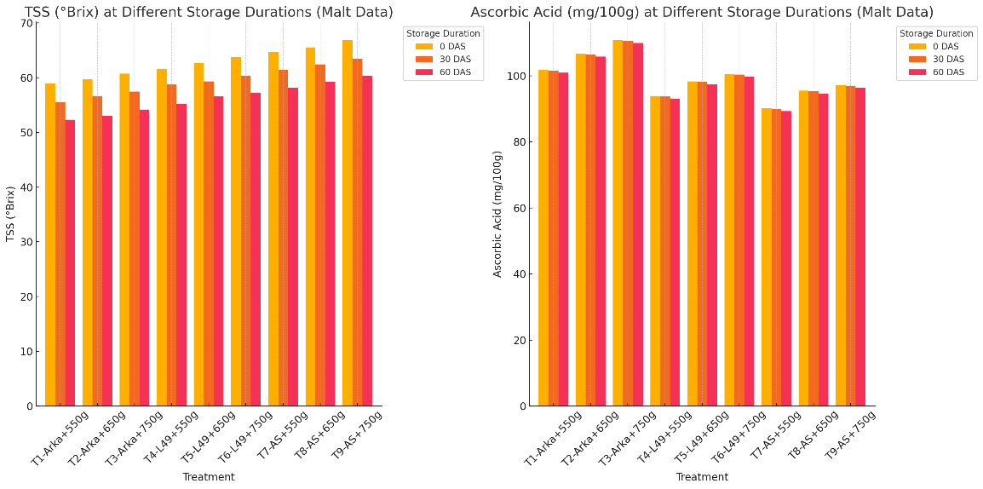

**fig. 1 graph showing Studies of different treatments on the TSS (°Brix) and ascorbic acid of guava jelly at 0, 30 and 60 DAS**

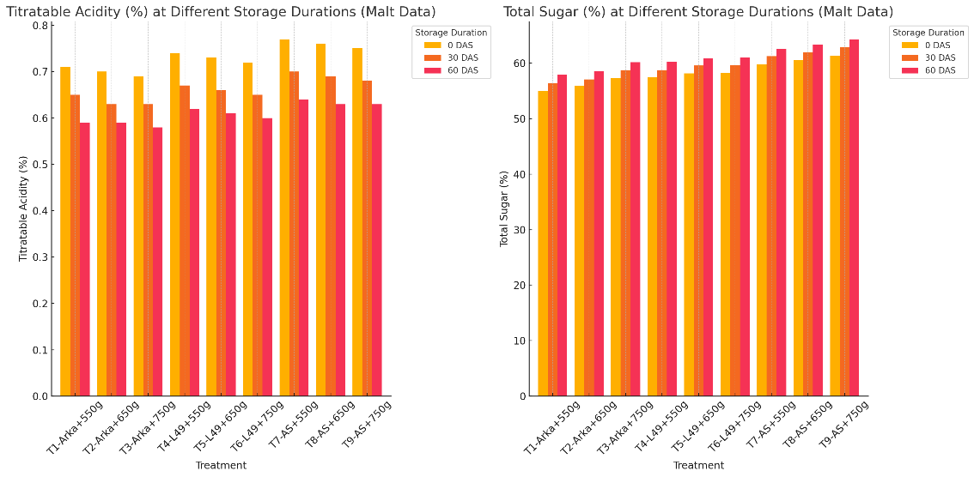

**fig. 2** **graph showing Studies of different treatments on the titratable acidity and ascorbic acid of total sugar at 0, 30 and 60 DAS**

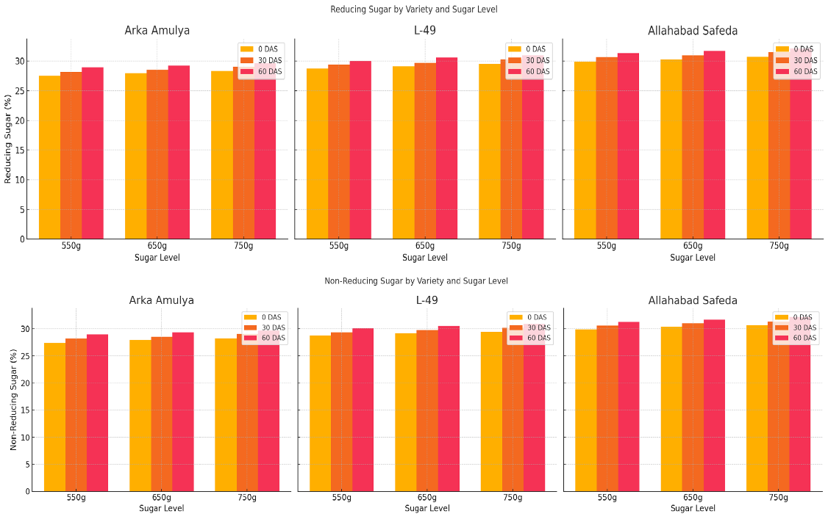

**fig. 3 graph showing Studies of different treatments on the reducing sugar and non-reducing sugar of total sugar at 0, 30 and 60 DAS**