**Sun Basking Behaviour and Ecological Significance of Banbakri Antelope (*Boselaphus tragocamelus*, Pallas 1766), India**

**ABSTRACT**

India is home to the majestic white footed Banbakri antelope (*Boselaphus tragocamelus*), one of the most remarkable antelope species in the world. However, this species has not received the attention given to other charismatic fauna. Basking behaviour plays an important role in animal survival and physiological fitness. While sun basking behaviour has been observed in various mammalian species. The present study aimed to observe and analyze sun basking behaviour in free-ranging Banbakri antelopes in Bihar, India using direct sighting methods. For the sun basking behaviour study, major two Banbakri herds were monitored. During the winter season, these antelopes frequently engaged in sunbathing, likely to regulate body temperature, eliminate ectoparasites, and enhance muscle performance and immunity. The average maximum sun basking time recorded in winter was 15.01 ± 2.46 minutes, while the minimum in summer was 10.06 ± 1.86 minutes. This seasonal difference may be attributed to environmental temperatures, with winter temperatures ranging from 7.85 ± 2.09°C(minimum) to 26.38 ± 1.71°C (maximum), and summer temperatures ranging from 23.28 ± 4.31°C (minimum) to 40.18 ± 2.00°C (maximum). As temperatures increased during summer, basking time decreased or minimum in comparison to winter and antelopes were observed resting in the shade of trees to avoid direct sunlight during peak heat hours. Banbakri antelopes maximize the uptake of radiant heat by adjusting their basking positions to increase the surface area of their body exposed to the sun, while simultaneously minimizing predation risk by keeping basking periods relatively short. This study provides the first evidence of thermoregulatory basking behaviour in *Boselaphus tragocamelus* under free-ranging conditions in Bihar, India. Our findings highlight the adaptive significance and provide the first evidence of sunbathing in Banbakri antelope, (Boselaphus tragocamelus) highlighting its role in thermoregulation.

**Keywords:** *Boselaphus tragocamelus*, thermoregulation, behaviour, adaptation, basking

**INTRODUCTION**

Large hoofed mammals, such as antelopes, inhabit diverse and often thermally challenging environments where survival depends on a range of behavioural, physiological, and morphological thermoregulatory strategies. Among these, sunbathing or basking behaviour is a known adaptation in reptiles, Aves and some mammals (Geiser et al., 2002; Warnecke *et al.,* 2010; Smith *et al.,* 2017; Chishty and Choudhary, 2020; Blank and Yaoming, 2022; Bharos, *et al.,* 2025) but remains largely unstudied in large herbivores like antelopes. Behavioural responses such as basking may serve important ecological functions facilitating passive heat gain, conserving metabolic energy, and aiding in parasite control especially in open landscapes subject to fluctuating temperatures. In antelopes and others mammals, thermoregulatory mechanisms also include shade-seeking, activity timing adjustments, body orientation to solar radiation, and physiological processes like selective brain cooling (via the carotid rete mirabile), heterothermy, and evaporative cooling Mitchell *et al*., 2002. Morphological features such as light-coloured pelage and body conformation further assist in heat management. These adaptations are critical for species like the Banbakri antelope (*Boselaphus tragocamelus*), belongs to the family Bovidae, sub-family Bovinae, and tribe *Boselaphini,* a large-bodied antelope inhabiting the semi-arid regions and human-modified landscapes of the Indian subcontinent (Leslie, 2008; Estes, 2025). This wild mammal has successfully adapted to life under contrasting conditions of extreme heat and cold. It is found in a free-roaming condition across 18 Indian states and all districts of Bihar (Bohra, *et al.,* 1992; Prasad, 2022; Prasad *et al.,* 2023). Numerous studies have explored the energy demands of organisms for various physiological activities. Some researchers have focused specifically on basking and thermoregulatory behaviours, which enable endothermic animals to survive in arid and cold conditions (Schmidt-Nielsen, 1964; Scholander et al., 1955; Nagel et al., 1999; Ruban, 1995; Speakman and Thomas, 2002; Schwimmer and Haim, 2009).

The Banbakri antelope (*Boselaphus tragocamelus)* is categorized as a species of Least Concern on the IUCN Red List (Mallon, 2008). From a conservation perspective, the *Boselaphus tragocamelus* is protected under Schedule III of the Indian Wildlife (Protection) Act, 1972. However, due to significant crop damage, many Indian state governments have declared this free-roaming antelope as vermin. The central government has since reclassified it under Schedule V, for protecting agricultural interests (Prasad *et al.,* 2023). Sunbathing not only helps in maintaining body temperature and thermal energetics (Warnecke *et al.,* 2010) but also plays a vital role in promoting muscle function, maintaining healthy skin, and enhancing mobility for food and water foraging. Contempt its ecological importance, the occurrence and ecological significance of basking behaviour in Banbakri remain undocumented. No previous studies have systematically recorded or analysed this behaviour, nor assessed its potential adaptive value in the context of thermoregulation or ecological adaptation. This study presents the ***first field-based evidence*** of sunbathing behaviour in free-ranging Banbakri antelope, suggesting possible roles in thermoregulation, parasite management, and energy conservation.

Understanding such behaviours is critical for advancing species-specific ecological knowledge and may have practical implications for management and community-based conservation, particularly in agro-ecosystems where this species often comes into conflict with human interests. By highlighting an overlooked aspect of Banbakri behaviour, this study aims to foster broader appreciation for wildlife ecology beyond protected areas.

**MATERIALS AND METHODS**

***Study Area- Animal Ecology***

An intensive investigation was conducted in Dumraon, Buxar, located in the Shahabad region of southeastern Bihar, India, from January 2023 to December 2024. The study area lies between 25°18' to 25°45' North latitude and 84°20' to 84°40' East longitude, encompassing a part of the Gangetic plain with a total area of 1,624 km². The ambient temperature in this region ranges from 4°C during (January–February) winter to 45°C in the peak of during (May–June) summer. The area receives approximately 85–90% of its annual rainfall (1,021 mm) during the monsoon season, which extends from June to October (CGWB, 2013). The forest cover in Buxar district is minimal, and the unused open areas of Dumraon are characterized by undulating sandy soil and sparse forest vegetation. The region is interspersed with canals, the River Kao, and human settlements, creating a unique landscape with contrasting ecological features (Prasad et al., 2020, 2020a). Temperature ambient recorded from department of Agronomy, VKSCOA, Dumraon. Basking is distinguished from resting in shade or active behaviours and is identified by exposure of body surfaces to sunlight without simultaneous foraging or social interaction. The careful behaviour in which an individual or in group Banbakri antelope (*Boselaphus tragocamelus*) positions itself in direct sunlight, typically during early morning or cooler periods, adopting a stationary posture (standing or lying) with minimal movement, for a continuous period of at least **5 minutes**, with the apparent purpose of absorbing heat from solar radiation.

***Methodology and Data Analysis***

The methodology employed was direct sighting, involving close-range behavioural observation of the wild Banbakri antelope (*Boselaphus tragocamelus*). Observations were supported by first-hand visual records using a Sony digital still camera (30x optical zoom, model DSC-WX500), with photographs taken to document behaviours. Observations were analysed based on the behavioural categorization method outlined by Altmann (1974). Data were collected from early morning (06:00 hrs) to late evening (18:00 hrs) on 12 carefully selected days each during the winter and summer seasons. For observing sunbasking behaviour, two distinct herds of Banbakri (*Boselaphus tragocamelus*) were monitored continuously during these observation periods. The recorded behavioural data were compiled and analysed using Microsoft Excel 2010. Descriptive statistics (mean ± standard deviation) were calculated, and the results were visualized using box-and-whisker plots and summarized through simple tabular analyses.

**RESULTS AND DISCUSSION**

Our study demonstrates the importance of basking as a thermoregulatory behaviour in the Banbakri antelope (*Boselaphus tragocamelus*) mostly during cool mornings or winter months. The observed sunbathing behaviour appears to serve multiple functions: aiding in the cleaning of the body, eliminating ectoparasites (including ectozoons), and maintaining the flexibility of limbs. These functions collectively contribute to maintaining a healthy body condition. In the present study, Banbakri antelopes were often observed basking in groups comprising calves, juveniles, adult males, and females. Occasionally, solitary males were also recorded basking alone, suggesting that the behaviour may also serve a social function **(Figure- 1).** More or less similar observations have been reported by Fall, 1972; Gehlot, 2006). Whereas, Prasad *et al.,* 2025, reported that preorbital gland opening in White footed Banbakri antelope (*B. tragocamelus*) under stress, starvation or sexual maturity context and may serve as an essential behavioural indication to communicate with others member Banbakri antelope. Some antelopes possess a specialized vascular structure allowing cooled blood from the nasal passages to lower brain temperature, protecting it from hyperthermia while the core body remains warmer a vital adaptation in arid climates (Mitchell et al., 2002). The Banbakri antelope exhibits diurnal activity patterns. They spend a significant amount of time foraging during the cooler parts of the day typically in the morning and afternoon when ambient temperatures are lower (Das and Dutta, 2024). Their peak activity often coincides with sunrise as environmental temperatures begin to rise. Simultaneously, human activity also increases in nearby towns and villages, paralleling the onset of Banbakri activity (Gautam and Bissa, 2015).

According to Cade, 1973; Mosher, 1976, the sunbathing behaviour observed in certain raptors such as wing-spreading is associated not only with thermoregulation but also with feather maintenance, cleanliness, and preserving the elasticity of flight muscles.

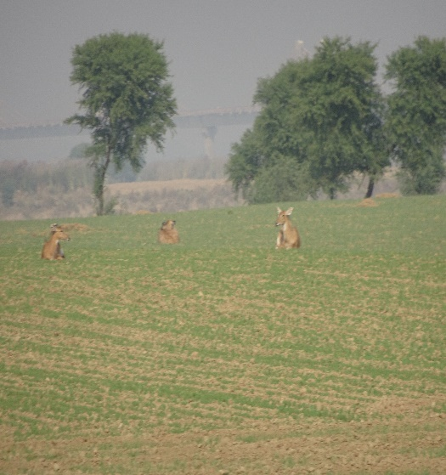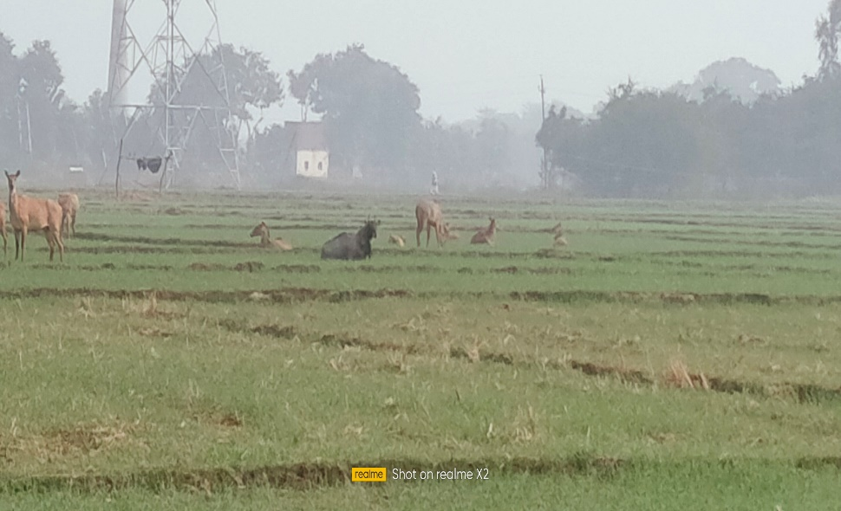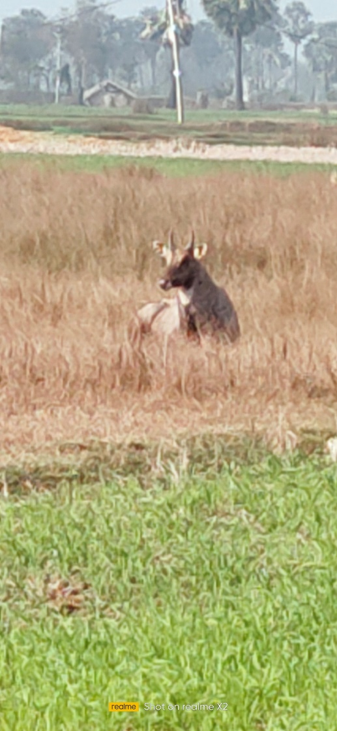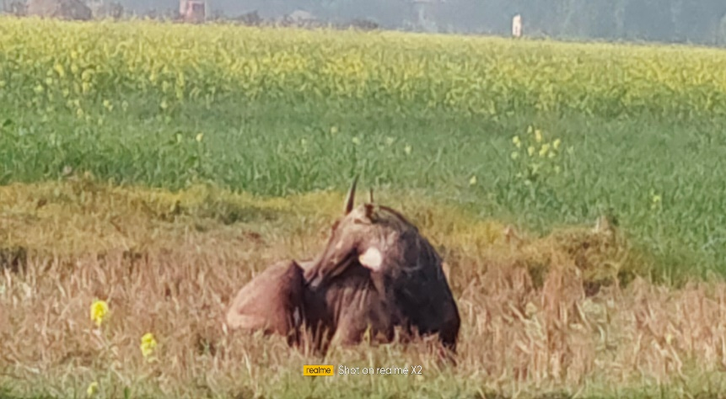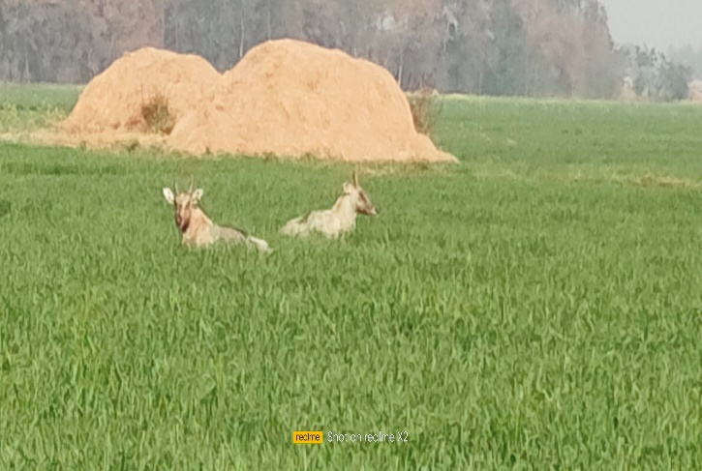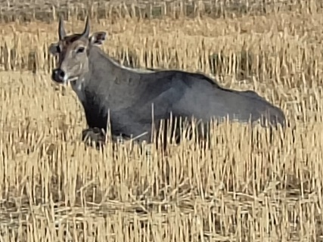**Fig. 1.a. A male (Boselaphus tragocamelus) was observed basking with its back side exposed to the sun to raise its body temperature.**

**f**

**e**

**d**

**c**

**b**

**a**

**b. A male was also seen basking with the front portion (head side) of its body exposed to sunlight to increase body warmth.**

**c. A solitary male was observed basking in the sun for comfort and relaxation, similar to human behaviour.**

**d. Two adult males of B. tragocamelus were seen basking with their heads facing in opposite directions, likely as a strategy to guard against predators.**

**e. A herd of Banbakri antelopes, including calves, juveniles, males, and females, were seen basking in the sun while one member kept watch as a guard.  
f. A herd of female Banbakri antelopes was observed basking in an alert posture.**

Our study provides evidence that sunbasking may serve as an important adjunct to physiological thermoregulation in the Banbakri antelope (*Boselaphus tragocamelus*), especially during the cooler parts of the day. While inactivity is typically absent in large ungulates, early morning basking subsequent resting periods could facilitate passive heat gain, reducing the metabolic cost of thermogenesis. Such behavior, supported by peripheral vasodilation and increased blood flow to the skin surface, may aid in accelerating temperature and achieving normal body temperatures. This suggests that sunbasking in Banbakri not only serves a behavioral function but also has physiological relevance, potentially enhancing daily activity readiness and contributing to the animal’s overall thermal balance and fitness in fluctuating environmental conditions. Interestingly, the different basking postures observed between the two herds of Banbakri antelope yielded unexpected results. Most individuals were found basking in groups, including calves, juveniles, adult males, and females, with some members observed guarding the herd **(Figure- 1).** Some adults were also found basking alone in a flattened posture, maintaining a state of alertness in unfamiliar surroundings. In other instances, individuals were observed basking while standing. It appears that Banbakri antelopes maximize the uptake of radiant heat by adjusting their basking positions to increase the surface area of their body exposed to the sun, while simultaneously minimizing predation risk by keeping basking periods relatively short**.** Similar thermoregulatory behaviours aimed at achieving thermal comfort and conserving energy have been documented in other mammals (Bartholomew and Rainy, 1971). The light-coloured pelage of Banbakri antelope reflects solar radiation, and seasonal adjustments in fur density contribute to thermal insulation. Furthermore, our observations revealed that Banbakri exhibit piloerection during winter, a response that may facilitate heat retention or dissipation as required. Many bird species also adopt specialized postures during sunning, such as spreading their feathers, flattening their bodies on the ground, and exposing either their dorsal or ventral sides to the sun (Campbell and Elizabeth, 2013; Chishty and Choudhary, 2020). For example, long-billed vultures spend considerable time in sunlight for preening, sunbathing, wing-drying, and general thermoregulation (Chishty and Choudhary, 2020). Similarly, sun basking behaviour in the white-footed antelope (*Boselaphus tragocamelus*) is predominantly observed during the morning hours and warmer parts of the day, especially in cloudy or winter seasons.

These antelopes are commonly found basking in rural landscapes, including rabi crop fields and open non-crop areas. Their basking behaviour typically includes both sitting and standing postures, often in groups. Individuals are frequently observed facing opposite directions with their heads turned toward the sunlight, maximizing exposure for thermoregulation. Sunbathing behaviour was also observed in developing 5-month-old calves, maturing juveniles, and young adults. Similar thermoregulatory strategies are seen in other species. For example, the antelope ground squirrel (*Ammospermophilus leucurus*) reduces its body temperature (Tb) by about 6°C at night, and basking is estimated to account for 20% of the energy required to elevate Tb in the morning (Chappell *et al.,* 1981). Likewise, basking behavior in relation to energy usage and food availability has been studied in one of the smallest marsupials, *Planigale gilesi*, by Warnecke *et al.* (2010). Chishty, and Choudhary, (2020) documented sunbathing behaviour in long-billed vultures, where individuals were observed extending their wings in various postures at different times of the day. In the present study, the maximum ambient temperature was recorded in May 2024, while the minimum was observed in December 2024 **(Figure 2 & 3).**

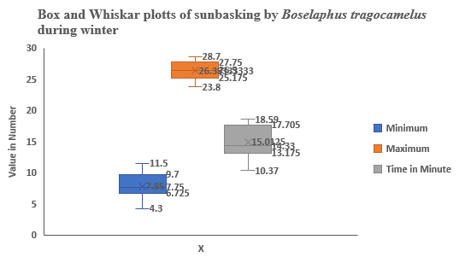

**Figure. 2. Graph showing time spent basking by *Boselaphus tragocamelus*, during winter**

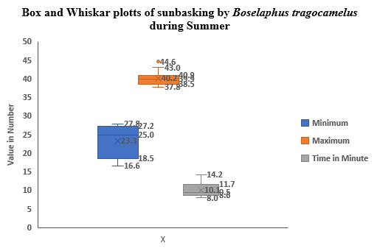

**Figure. 3, Graph showing time spent basking by *Boselaphus tragocamelus*, during summer**

Sunbathing duration was found to be influenced by environmental and climatic conditions such as temperature, rainfall, humidity, wind velocity, and sunshine duration (Chishty and Choudhary, 2020). Weather variables play a critical role in shaping the thermoregulatory behaviour of large ungulates, including the Banbakri antelope (*Boselaphus tragocamelus*). Ambient temperature, solar radiation, wind speed, and humidity collectively influence the expression of basking behaviour. Studies on large mammals have shown that basking is more pronounced during cooler periods of the day or season when passive heat gain from solar radiation helps offset thermoregulatory costs (Bartholomew and Wilke, 1956; Cain *et al.,* 2006). In our observations, Banbakri engaged in prolonged sunbasking during early mornings and cool winter days, suggesting a behavioural strategy to enhance body temperature without increasing metabolic expenditure. Solar radiation provides a critical heat source, but its effectiveness can be modulated by wind speed, which increases convective heat loss (McArthur and Turnbull, 1966), and humidity, which may affect evaporative heat dissipation. Such environmental interactions likely influence both the duration and timing of basking bouts. These findings align with reports from other ungulates, where behavioral thermoregulation complements physiological mechanisms (Hetem *et al.,* 2016). Therefore, basking in Banbakri appears to be a flexible behavioral response finely tuned to prevailing weather conditions, contributing to their thermal balance and daily activity rhythms.

The average basking time for the white-footed Banbakri antelope (*Boselaphus tragocamelus*), commonly known as Banbakri, was 15.01 ± 2.46 minutes during the winter season and 10.06 ± 1.86 minutes during the summer season (**Figure 2 & 3).** These findings are in agreement with earlier studies on mammals and other species from various regions. Geiser et al. (2021), Heidrich et al. (2018), and Warnecke et al. (2010) reported similar basking behaviours in freshwater turtles, terrapins, mammals (including humans), nocturnal marsupials, and even insects. These species often emerge from nocturnal torpor in the morning and bask to raise their body temperature close to the upper threshold of thermal tolerance (Geiser, 2021). Certain animals such as ring-tailed lemurs, roadrunners, and Alpine ibexes use sunlight to conserve energy during cold mornings or when food is scarce. For instance, ibexes are known to bask in the winter sun on frigid mountain slopes, where limited grass availability leaves them with little fuel (Bharos *et al.,* 2025). Some species even enter temporary states of reduced metabolism and lowered body temperature to conserve energy. A study on dunnarts, a small marsupial species, revealed that by soaking up sunlight, they could survive on only a quarter of their usual food and water intake, as solar warmth reduces the metabolic effort needed to maintain body temperature. In birds, sunbathing is known to aid in eliminating pests and bacteria, and in regulating moisture. However, the full range of benefits that sunbathing provides to fur-covered animals remains largely underexplored (Chishty and Choudhary, 2020). These sun-bathing behaviours underscore the significance of sunlight for thermoregulation and energy conservation across a wide array of species. In freshwater turtles, for example, the purpose of basking has drawn special interest some nocturnal species adopt basking-like postures at night, yet studies have shown that certain individuals do not significantly raise their body temperatures while sunning, ruling out thermoregulation as a primary motive.

**CONCLUSION**

This study presents the first documented evidence of sunbathing behaviour in the Banbakri antelope (*Boselaphus tragocamelus*), corroborated by our observations and supported by existing literature. These behaviours appear to serve several adaptive functions, including thermoregulation, parasite control, and energy conservation. While this initial study provides valuable insight, further research is necessary to better understand the ecological and physiological significance of basking in this elegant species. The *Boselaphus tragocamelus* offers a unique opportunity to promote appreciation for wildlife particularly those thriving outside protected areas. By fostering awareness of their behaviours and adaptations, especially among younger generations, we may contribute to more inclusive and community-based conservation efforts.

Disclaimer (Artificial intelligence)

Option 1:

Author(s) hereby declare that NO generative AI technologies such as Large Language Models (ChatGPT, manuscript.

**REFERENCES**

Altman J. 1974. Observational study of behaviour sampling methods. Behaviour. 40:227-26

Bartholomew GA, and Rainy M (1971) Regulation of body temperature in the hyrax, *Heterohyrax brucei*. J Mammal 52:81–95.

Bartholomew, G. A., and Wilke, F. (1956). Body temperature in the antelope ground squirrel. *Journal of Mammalogy*, 37(2), 327–337.

Bharos, A M K., Akhilesh, A., Bharos, Thakur, P., and Nihlani, G., 2025. Observations on Sun Basking, Dust Bath Behaviour of Golden Jackal (Canis aureus) and other Canidae species. *Uttar Pradesh Journal of Zoology* 46 (08):195-202.

Blank, D., Yaoming, L. I., 2022. Antelope adaptations to counteract overheating and water deficit in arid environments, J Arid Land, 14(10): 1069–1085.

Bohra H C, Goyal S P, Ghosh P K, et al. 1992. Studies on ethology and eco-physiology of the antelopes of the Indian desert. Annals of Arid Zone, 31(2): 83–96.

Cade T. J., 1973. Sun-Bathing as a thermoregulatory aid in birds. *The Condor* 75: 106-133. Available at: https://digitalcommons.usf.edu/condor/vol75/iss1/12

Cain, J. W., Krausman, P. R., Rosenstock, S. S., and Turner, J. C. (2006). Mechanisms of thermoregulation and water balance in desert ungulates. *Wildlife Society Bulletin*, 34(3), 570–581.

Campbell, Bruce; Lack, Elizabeth *(*2013). A Dictionary of Birds. A & C Black. pp. 569–560.

CGWB, 2023. Ground water Information Booklet, Central Ground Water Board, Govt. of India, Ministry of Water Resource, District Buxar, Patna, Bihar. 1-17.

Chappell, Mark A. Bartholomew, George A, 1981. Activity and thermoregulation of the antelope ground squirrel *Ammo Spermophilus leucurus* in winter and summer Physiological Zoology, 54 (2);215-223.

Chauhan NPS (2011) Agricultural crop depredation by nilgai antelope (*Boselaphus tragocamelus*) and mitigation strategies: challenges in India. 8th European Vertebrate Pest Management Conference 432.104 pp. 190-191. DOI: 10.5073/jka.2011.432.104.

Chishty, N., and Choudhary, N. L. 2020. Seasonal Fluctuation in Thermoregulatory Behaviour of Long-Billed Vulture (*Gyps indicus*) by Wing Stretching at Southern Rajasthan, India, Current World Environment, 15 (2): 353-362.

Das, M. and Dutta, A. 2024. Activity pattern and time budget analysis of nilgai (*Boselephus tragocamelus*) in captivity at Alipore Zoological Garden, Kolkata, India. Intern. J. Zool. Invest. 10(2):1445-1461, **https://doi.org/10.33745/ijzi.2024.v10i02.146**

Estes, R. 2025, Nilgai / Habitat, Diet and Conservation, Britanica, update January, 28, 2025, [www.britanica.com](http://www.britanica.com).

Fall B. A. 1972. On social organization and behaviour of Nilgai Antelope, *Boselaphus tragocamelus* (Pallas) in South Texas, M.S. thesis, Texas A & M Univ. College Station.

Gautam, R, and Bissa P (2015) Population dynamics, ecology, breeding biology and pest status of Nilgai (*Boselaphus tragocamelus*) in Shekhawati Region of Thar Desert. Ph.D. Thesis submitted, M.G.S. University, Bikaner (Rajasthan).

Gehlot, H. S. (2006) Social organization, behavioural and resources selection patterns in Antelope cervicapra and Gazelle bennetti of thar Desert. PhD thesis, JN Vyas University, Jodhpur, Rajasthan. 195pp. DOI**:** 10.12691/aees-9-4-1.

Geiser, F. (2021). Ecological physiology of Daily Torpor and Hibernation. Book 01-305. DOI:  [10.1007/978-3-030-75525-6](http://dx.doi.org/10.1007/978-3-030-75525-6)

Geiser, F.; Goodship, N.; Pavey, C. (2002). *"Was basking important in the evolution of mammalian endothermy? ".*Naturwissenschaften.89(9):412–414.

Heidrich, Lea; Friess, Nicolas; Fiedler, Konrad; Brändle, Martin; Hausmann, Axel; Brandl, Roland; Zeuss, Dirk (2018). "The dark side of Lepidoptera: Colour lightness of geometrid moths decreases with increasing latitude". Global Ecology and

Hetem, R. S., Maloney, S. K., Fuller, A., and Mitchell, D. (2016). Behavioural thermoregulation in large mammals: A review. *Journal of Comparative Physiology B*, 186(7), 1–15.

Leslie DM (2008) *Boselaphus* *tragocamelus* (Artiodactyls: Bovidae) Mammalian species American society of Mammologist. 813: 1-16. 1–16, [doi.org/10.1644/813.1](https://doi.org/10.1644/813.1).

Mallon D. P. 2008. Boselaphus tragocamelus. IUCN 2013.IUCN red list of threatened species. version 2013.

McArthur, A. J., and Turnbull, J. D. (1966). Heat exchange in ungulates. *International Journal of Biometeorology*, 10(1), 25–34.

Mitchell, D., Maloney, S. K., Jessen, C., Laburn, H. P, Kamerman, P. R., Mitchell, G and Fuller, A. 2002. Adaptive heterothermy and selective brain cooling in arid-zone mammals Comparative Biochemistry and Physiology Part B 131; 571–585.

Mosher, J. A. (1976). Raptor Energetic: A Review. *Journal of Raptor Research.*10(4): 97-107.

Nagel, KA, Girard IA, Brown TK (1999) Energetics of free-ranging mammals, reptiles, and birds. Annu Rev Nutr 19:247–277.

Prasad S (2022) High Time of Pacing Nilgai Antelope (*Boselaphus tragocamelus*) into Mainstream as Community Conservation for Influencing Macroeconomics. Asian Journal of Research in Zoology. 5(1): 21-30.DOI**:**[10.9734/ajriz/2022/v5i130128](https://doi.org/10.9734/ajriz/2022/v5i130128).

Prasad S, Kumar A, Ahmed R, Sah RK (2023) The Indian antelope Nilgai (*Boselaphus tragocamelus*): A Succeeding economic pretender of nation. (Footprints of Biodiversity in the Indian Peninsula), Edited by: Saxena VL, Jaiswal K & Mishra S. Narendra Publishing House, Delhi, India. 155-169. ISBN: 978-93-56511-98-9.

Prasad S, Prabhakar, C. S., Kumar, A., Nath, P. Ahmed, R. (2025). Documentation of Scent Marking with the Preorbital Gland in Banbakri Antelope (*Boselaphus tragocamelus*), *Uttar Pradesh Journal of Zoology, 46,(7), 136-143,*  doi.org/10.56557/upjoz/2025/v46i74870

Prasad S, Singh D. K., Choudhary SK (2020) Residential population structure and abundance of Nilgai (*Boselaphus tragocamelus*) in Bihar, India. Current Journal of Applied Science and Technology P39(13): 110-117.DOI:[10.9734/cjast/2020/v39i1330687](https://doi.org/10.9734/cjast/2020/v39i1330687).

Prasad S, Singh DK, Kumar U, Kumar S (2020) Biodiversity and Ecology of Wild Mammals in Dumraon, Buxar, Bihar. J. exp. 2001. India. 23(1): 643-648.

Ruben J (1995). The evolution of endothermy in mammals and birds: from physiology to fossils. *Annu Rev Physiol* 57:69–95

Schmidt-Nielsen K. 1964. Desert animals: Physiological problem of heat and water. Clarendon Press, Oxford.

Scholander P. F., Hock, R., Walters, V., Johnson, F. and Irving, L.1955. Heat regulation in some arctic and tropical mammals and birds. *Biology Bulletin.*; 99: 237-258.

Schwimmer, H., Haim, A., 2009. Physiological adaptations of small mammals to desert ecosystems, Integrative Zoology 4(4):357-66.  doi: 10.1111/j.1749-4877.2009.00176.x.

Smith, Kimberly G.; Neal, Joseph C.; and Reynolds, J. C. (2017) Sun-bathing by Greater Roadrunners – A Neglected Aspect of Their Range Extension," Journal of the Arkansas Academy of Science: 71,(37).: 208-2010. <https://doi.org/10.54119/jaas.2017.7112>

Speakman JR, Thomas DW (2002) Physiological ecology and energetics of bats. In: Kunz TH (ed) Ecology of bats. II. Academic Press, New York (in press)

Warnecke, L., Schleicher, E., Geiser, F., 2010. Basking behaviour in relation to energy use and food availability in one of the smallest marsupials, Physiology & Behavior, 101: 389-393.