***Original Research Article***

**Assessment of Value Addition in Aonla (*Emblica officinalis* L.) Candy**

**ABSTRACT**

The present investigation was undertaken to assess the value addition in Aonla (Emblica officinalis L.) candy using herbal syrups, conducted from February to May 2024 at the Post-Harvest and Value Addition Laboratory, Mewar University, Rajasthan. Aonla, known for its rich ascorbic acid content and medicinal properties, holds vast potential for processing into functional products. The experiment was laid out in a Completely Randomized Design with nine treatments and three replications, including herbal syrup infusions such as mint, tulsi, lemongrass, and their combinations. Various biochemical parameters Total Soluble Solids (TSS), ascorbic acid, titratable acidity, total sugar, reducing sugar, and non-reducing sugar were recorded at intervals of 0, 30, 45, and 60 days of storage. Among the treatments, the combination treatment T₉ (Mint Syrup 0.5% + Tulsi Syrup 0.5% + Lemongrass Syrup 0.5%) consistently recorded the highest values across all measured parameters at 60 days: TSS (56.91 °Brix), ascorbic acid (324.85 mg/100g), titratable acidity (0.59%), total sugar (67.22%), reducing sugar (33.44%), and non-reducing sugar (35.28%). The findings demonstrate that the herbal-infused treatment not only improved the nutritional profile but also enhanced the storage quality and shelf life of the product compared to conventional processing. The results affirm that incorporation of herbal syrups significantly contributes to the sensory appeal and functional value of Aonla candy. Such formulations can offer a promising avenue for small-scale food entrepreneurs and health-conscious consumers by providing nutritionally enriched and longer-lasting products. This study establishes the potential of natural bio-enhancers in fruit value addition and advocates for their commercial adoption in functional food industries.

**Keywords:** A*onla candy, Herbal syrup, Biochemical traits, Value addition, Storage stability, Functional food*

1. **INTRODUCTION**

Aonla (Em*blica officinalis L*.), commonly known as Indian gooseberry, is a deciduous tree belonging to the family Euphorbiaceae. It holds a unique and time-honored place in Indian horticulture, traditional medicine, and nutritional practices (Singh et al., 2019). Esteemed in Ayurveda and other indigenous medical systems for millennia, Aonla is described as a “Wonder Fruit” due to its exceptional therapeutic potential and rich nutritional profile (Kumari & Khatkar, 2019). Its cultivation, commercial utilization, and functional properties have made it a focal point in modern research concerning health-promoting functional foods and nutraceuticals (Adefegha. 2018). India is the primary producer of Aonla in the world, contributing nearly 80% of the global output. The fruit is extensively cultivated across Uttar Pradesh, Rajasthan, Gujarat, Madhya Pradesh, Maharashtra, Andhra Pradesh, Karnataka, and Tamil Nadu, among other regions. According to FAO statistics (2023), Aonla is cultivated in India across approximately 100,000 hectares, with an estimated production exceeding 1.5 million tons per year (Choudhary. 2024). Despite its wide distribution and traditional importance, the fruit remains underutilized in its fresh form due to its astringent taste and short shelf life. This has led to increasing interest in its processing and value addition, particularly in forms that enhance palatability, shelf stability, and marketability.

Aonla is renowned for its remarkably high vitamin C content, ranging from 200 to 900 mg per 100 grams of pulp, making it one of the richest natural sources of ascorbic acid. This level is significantly higher than in citrus fruits like oranges. Additionally, Aonla contains other bioactive compounds such as polyphenols, flavonoids, tannins, and minerals like calcium and iron (Singh et al., 2022). These constituents contribute to its antioxidant, antimicrobial, hepatoprotective, antidiabetic, and immunomodulatory effects. However, due to its inherently sour and bitter flavor, direct consumption is limited, prompting researchers and processors to develop value-added products that retain its health benefits while improving consumer acceptability (Salta & Du.2024). Among the most popular processed forms of Aonla is Aonla candy, a semi-dry, sweetened product made by immersing fruit segments in sugar syrup followed by drying. This form not only improves taste and shelf life but also retains significant nutritional content. According to (Nayak et al. 2012), Aonla candy is an ideal value-added product due to its extended shelf life, ease of handling, reduced storage volume, and ready-to-eat nature. These advantages have positioned it as a commercially viable option in both domestic and international markets. Modern consumer preferences are shifting rapidly toward natural, health-oriented, and functional foods. As a result, there is growing interest in herbal and botanical fortification of food products.

Various herbs are known for their medicinal value and synergistic health effects when combined with fruit-based products. Incorporating such herbs into Aonla candy offers a dual advantage: enhanced therapeutic potential and organoleptic appeal (Kumari & Khatkar. 2019). In this context, three widely used herbs—Tulsi (Ocimum sanctum), Mint (Mentha spp.), and Lemongrass (Cymbopogon citratus)—are of particular interest. Tulsi is known for its adaptogenic, antimicrobial, and anti-inflammatory properties, while Mint contributes a cooling sensation and digestive benefits. Lemongrass, known for its citrusy aroma and antioxidant activity, adds flavor and may aid digestion and reduce inflammation. These herbs are already appreciated in traditional Indian households, and their infusion into fruit products aligns with both traditional wisdom and modern functional food trends (Gokhale et al., 2021). The formulation of herbal-infused Aonla candy not only elevates its functional value but also caters to increasing consumer demand for holistic wellness. Combining these herbs in varying concentrations could improve flavor, mask astringency, and enhance shelf-life stability by reducing microbial spoilage and oxidative degradation. Such advancements can benefit both producers and consumers—enhancing profitability for small-scale industries, cottage units, and self-help groups, while also delivering health-rich alternatives to the market. Despite the clear potential, there is a lack of systematic studies evaluating the effects of herbal syrup infusions on the nutritional and sensory quality of Aonla candy during storage. Most previous studies have focused on either traditional processing or single-herb fortification.

This study aims to bridge that gap by analyzing the biochemical characteristics and storage behavior of Aonla candy treated with single and combination herbal syrups over time. It investigates how herbal additions affect Total Soluble Solids (TSS), ascorbic acid content, titratable acidity, total sugar, reducing sugar, and non-reducing sugar during a 60-day storage period (Kumari et al., 2025). The present study is particularly significant in the context of value addition and post-harvest management, where the need for low-cost, nutritionally enhanced, and consumer-friendly food products is critical. India’s large-scale production of Aonla offers vast raw material potential, yet much of it goes to waste or is sold at low prices due to perishability (Kore et al., 2013). Transforming this resource through scientifically validated, herbal-enhanced processing not only reduces post-harvest loss but also increases rural income, promotes entrepreneurship, and supports national objectives like Atmanirbhar Bharat and Vocal for Local. Furthermore, the experimental framework of this research, which involves multiple herbal treatments and storage intervals, is designed to identify the most effective formulation for maintaining and enhancing the quality of Aonla candy. By integrating traditional herbal knowledge with modern food processing techniques, the study also highlights the interdisciplinary nature of value addition research—combining horticulture, biochemistry, food science, and health promotion.

1. **MATERIALS AND METHODS**

#### **2.1 Experimental Site and Duration**

A laboratory-scale experiment was conducted during the period from **February to May 2024–25** at the **Post-Harvest and Value Addition Laboratory,** Department of Agriculture (Horticulture), Fruit Science, Faculty of Agriculture and Veterinary Sciences, **Mewar University,** Gangrar, Chittorgarh (Rajasthan). The objective of the study was to evaluate the effect of various herbal syrups on the biochemical properties and storage stability of fruit-based preserved products under controlled ambient storage conditions.

#### **2.2 Experimental Design and Treatment Structure**

The experiment was designed using a **Completely Randomized Design (CRD)** to ensure the validity and reproducibility of results. A total of **nine treatments** were included, with each treatment **replicated three times,** resulting in **27 experimental units.** Treatments were formulated based on the incorporation of different herbal syrups (mint, tulsi, lemongrass, cinnamon) at specific concentrations into a fruit preserve matrix. The treatments were as follows:

* **T₁**: Control (FPO – Fruit Preserve Only, no herbal addition)
* **T₂**: Mint Syrup 0.5%
* **T₃**: Mint Syrup 1.0%
* **T₄**: Tulsi Syrup 0.5%
* **T₅**: Tulsi Syrup 1.0%
* **T₆**: Lemongrass Syrup 0.5%
* **T₇**: Lemongrass Syrup 1.0%
* **T₈**: Cinnamon Syrup 1.0%
* **T₉**: Mint Syrup 0.5% + Tulsi Syrup 0.5% + Lemongrass Syrup 0.5%

The base product (FPO) used for herbal fortification was prepared from high-quality, fully ripened fruits selected for uniformity in size, color, and maturity. After thorough washing, the fruits were peeled, deseeded (if necessary), and pulped to obtain a homogeneous fruit preserve. The herbal syrups were prepared separately using aqueous extracts of the respective herbs and standardized to the required concentrations before blending into the fruit preserve.

#### **2.3 Preparation of Herbal Syrups**

Herbal syrups were prepared using fresh, aromatic leaves (mint and tulsi), lemongrass blades, and dried cinnamon bark. The raw materials were cleaned, washed with distilled water, and subjected to aqueous extraction by boiling at a standardized ratio of 1:10 (w/v) herb to water for 15–20 minutes. The extracts were filtered through muslin cloth, concentrated under low flame to obtain thick syrupy consistency, and then cooled to room temperature. Sugar was added as a natural preservative and sweetener at 40% (w/v) to match the sweetness level of the base preserve.

#### **2.4 Blending and Packaging**

Each treatment was prepared by thoroughly blending the herbal syrup with the fruit preserve base to ensure uniform distribution of bioactive components. The final mixture was heated gently to pasteurize and remove any microbial load. Hot filling was carried out in **sterilized glass jars**, which were sealed with air-tight lids and allowed to cool to ambient temperature. The samples were stored under room conditions (25–30°C) away from direct sunlight for the entire experimental duration.

#### **2.5 Storage Duration and Sampling Intervals**

All prepared samples were analyzed for biochemical parameters at **four distinct intervals**:

* **Day 0 (Initial Analysis)**
* **Day 30 (One month of storage)**
* **Day 45 (Intermediate storage)**
* **Day 60 (Two months of storage)**

#### **2.6 Biochemical Analysis Parameters and Methodology**

Standard analytical methods were followed for assessing the biochemical quality of the samples at each storage interval. The key parameters studied included:

* **Total Soluble Solids (TSS)**: Measured using a digital refractometer and expressed in degrees Brix (°B).
* **pH**: Measured using a calibrated digital pH meter.
* **Titratable Acidity (% citric acid equivalent)**: Determined via titration with standardized NaOH.
* **Ascorbic Acid (Vitamin C) Content**: Estimated using the 2,6-dichlorophenolindophenol titrimetric method and expressed in mg/100g.
* **Total Sugar Content**: Assessed by the Lane and Eynon titration method and reported as a percentage.
* **Reducing Sugar**: Determined using Fehling’s solution method.
* **Non-Reducing Sugar**: Calculated as the difference between total and reducing sugars.

#### **2.7 Statistical Analysis**

Data obtained from all biochemical evaluations were subjected to **analysis of variance (ANOVA)** using appropriate statistical software tools. **Critical Difference (CD) at 5% significance level** was computed to compare treatment means. Graphs and tables were generated to visually interpret treatment performance over the storage period.

1. **RESULTS AND DISCUSSION**

**Studies of different recipes on the TSS (°Brix) and ascorbic acid of aonla candy**

Studies of different recipes on the TSS (°Brix) and ascorbic acid of aonla candy at various storage intervals tabulated in Table 1 and illustrated in fig 1. It was observed from the present investigation that treatment T₉ (Mint Syrup 0.5% + Tulsi Syrup 0.5% + Lemongrass Syrup 0.5%) recorded the maximum TSS (58.63, 63.41, 58.16 and 56.91 °Brix) at 0, 30, 45 and 60 days after storage (DAS), respectively. On the other hand, the minimum TSS (52.76, 56.38, 51.13 and 49.88 °Brix) was recorded in treatment T₁ (Control – FPO) at 0, 30, 45 and 60 DAS, respectively. Similar result also reported by **Binte Ehsan (2022),** Falah et al***.,* (2019),** Bayih *et al.* (2018), khan & Latif (2024) and silaban et al., (2023).

It was observed from the present investigation that treatment T₉ (Mint Syrup 0.5% + Tulsi Syrup 0.5% + Lemongrass Syrup 0.5%) recorded the maximum ascorbic acid content (334.33, 323.56, 319.42 and 327.62 mg/100g) at 0, 30, 45 and 60 DAS, respectively. On the other hand, the minimum ascorbic acid (200.85, 197.53, 193.61 and 191.37 mg/100g) was recorded in treatment T₁ (Control – FPO) at 0, 30, 45 and 60 DAS, respectively. The results indicate superior retention of ascorbic acid in blended herbal syrup treatments. Same findings also observed by (Binte Ehsan, 2022).

**Studies of different recipes on the titratable acidity (%) and total sugar of aonla candy**

Studies of different recipes on the titratable acidity (%) and total sugar of aonla candy at various storage intervals tabulated in Table 2 and illustrated in fig 2. It was observed from the present investigation that treatment T₉ (Mint Syrup 0.5% + Tulsi Syrup 0.5% + Lemongrass Syrup 0.5%) recorded the maximum titratable acidity (0.77, 0.59, 0.59 and 0.59%) at 0, 30, 45 and 60 DAS, respectively. This was followed by T₇ (Lemongrass Syrup 1%) which recorded 0.74, 0.61, 0.59 and 0.60%, and T₅ (Tulsi Syrup 1%) which recorded 0.72, 0.60, 0.60 and 0.59%. The minimum titratable acidity (0.62, 0.60, 0.62 and 0.59%) was observed in treatment T₁ (Control – FPO) over the storage period. Similar concluded by **Nair. (2022), Sharangi et al., (2018) and Senapati et al., (2025).**

It was observed from the present investigation that treatment T₉ (Mint Syrup 0.5% + Tulsi Syrup 0.5% + Lemongrass Syrup 0.5%) recorded the maximum total sugar content (69.74, 69.36, 68.50 and 67.22 %) at 0, 30, 45 and 60 DAS, respectively. The minimum total sugar (49.36, 52.64, 48.12 and 46.84 %) was recorded in treatment T₁ (Control – FPO). This result also correlated with **Singh et al., (2021), Joshi et al., (2017), Ali et al., (2014) and Shailaja et al., (2025).**

**Studies of different recipes on the reducing sugar (%) and non-reducing sugar of aonla candy**

Studies of different recipes on the reducing sugar (%) and non-reducing sugar of aonla candy at various storage intervals tabulated in Table 3 and illustrated in fig 3.It was observed from the present investigation that treatment T₉ (Mint Syrup 0.5% + Tulsi Syrup 0.5% + Lemongrass Syrup 0.5%) recorded the maximum reducing sugar (35.93, 36.70, 34.68 and 33.44%) at 0, 30, 45 and 60 DAS, respectively. The minimum reducing sugar content (25.03, 26.81, 23.78 and 22.54 %) was recorded in treatment T₁ (Control – FPO). Similar summarized Maneesha et al., (2019), Sehrawat et al., (2023), Kaur. (2010) and Chaudhari et al., (2025).

It was observed from the present investigation that treatment T₉ (Mint Syrup 0.5% + Tulsi Syrup 0.5% + Lemongrass Syrup 0.5%) recorded the maximum non-reducing sugar (37.44, 35.64, 36.32 and 35.28%) at 0, 30, 45 and 60 DAS, respectively. The minimum non-reducing sugar (27.13, 27.29, 26.01 and 24.97%) was recorded in treatment T₁ (Control – FPO). This result also supported by **Kataria et al., (2024) and Sehrawat et al., (2023).**

1. **CONCLUSION**

The present investigation clearly demonstrated the effectiveness of incorporating herbal syrups in enhancing the biochemical quality and storage stability of value-added Aonla candy. Among all the treatments evaluated, T₉ (Mint Syrup 0.5% + Tulsi Syrup 0.5% + Lemongrass Syrup 0.5%) emerged as the most promising formulation. This treatment consistently recorded the highest total soluble solids (TSS), ascorbic acid content, titratable acidity, total sugars, reducing sugars, and non-reducing sugars across all four storage intervals (0, 30, 45, and 60 days), outperforming both the individual herbal treatments and the control (FPO). The enhanced retention of ascorbic acid and sugars in T₉ suggests that the synergistic action of the three herbal syrups not only improved the nutritional profile of the candy but also contributed to its stability during storage. Furthermore, the higher titratable acidity observed in this treatment may have contributed to microbial inhibition and preservation, supporting prolonged shelf life without compromising quality. In contrast, the control treatment (T₁) consistently showed the lowest values for all measured parameters, indicating that conventional processing alone was less effective in maintaining biochemical integrity over time. These findings underscore the potential of herbal fortification in developing functional foods with added health benefits. In conclusion, the incorporation of mint, tulsi, and lemongrass syrups at 0.5% each offers a natural and effective approach for producing nutritionally superior and shelf-stable Aonla candy. This strategy can be recommended for commercial applications aimed at promoting value addition and functional product development in fruit-based processing industries.

Disclaimer (Artificial intelligence)

Option 1:

Author(s) hereby declare that NO generative AI technologies such as Large Language Models (ChatGPT, COPILOT, etc.) and text-to-image generators have been used during the writing or editing of this manuscript.

Option 2:

Author(s) hereby declare that generative AI technologies such as Large Language Models, etc. have been used during the writing or editing of manuscripts. This explanation will include the name, version, model, and source of the generative AI technology and as well as all input prompts provided to the generative AI technology

Details of the AI usage are given below:

1.

2.

3.

**REFERENCES**

Adefegha, S. A. (2018). Functional foods and nutraceuticals as dietary intervention in chronic diseases; novel perspectives for health promotion and disease prevention. *Journal of dietary supplements,* 15(6), 977-1009.

Ali, D. O., Ahmed, A. R., & Babikir, E. B. (2014). Suitability of local Sudanese guava (*Psidium guajava* L.) cultivars for concentrates production. *Journal of Agri-Food and Applied Sciences,* 2(8), 225-229.

Bayih, T., & Abdulhakim, A. (2018). Evaluation of Anti-Bacterial Activity of Fresh Plant Extracts on *Salmonella, Shigella and E. Coli*. *Global Journal of Science Frontier Research: C Biological Science*, 18(3).

Binte Ehsan, T. (2022). Study of antibacterial activities of the extracts of Neem, Pomegranate, and Tulsi and essential oils against Salmonella Typhi (Doctoral dissertation, Brac University).

Chaudhari, R., Birajdar, K. M., Birangane, R. S., Parkarwar, P., & Rokade, R. (2025). Ayurvedic Dentistry. OrangeBooks Publication.

Choudhary, N. (2024). An Economic Analysis Of Production And Marketing Of Aonla In Jammu Region (Doctoral dissertation, Kashmir University).

Gokhale, J. S., Lele, S. S., & Ananthanarayan, L. (2021). Indian traditional foods and diets: Combining traditional wisdom with modern science of nutraceuticals and functional foods. *Nutrition, Food and Diet in Ageing and Longevity, 357*-392.

Joshi, H., Kochhar, A., & Boora, R. S. (2017). Organoleptic and nutritional evaluation of value added products developed from new varieties of white and pink-fleshed guavas. *Chem Sci Rev Lett,*6(24), 2108-2113.

Kataria, R. K., Sharma, M., Mittal, A., & Tyagi, V. (2024). The formulation and evaluation of herbal cough syrup. *Journal of Applied Pharmaceutical Sciences and Research,* 7(4), 8-12.

Kaur, D. (2010). Microbiological preparation of non-alcoholic naturally carbonated blended beverage from guava and lemon (Doctoral dissertation, PUNJAB AGRICULTURAL UNIVERSITY LUDHIANA).

Khan, A. Y., & Latif, Z. (2014). Screening of medicinal natural extracts for their antibacterial activity against Salmonella species. *Pak. J. Bot,*46(6), 2269-2275.

Kumari, P., & Khatkar, B. S. (2019). Aonla: Composition, Medicinal Properties, Processing, and Food Applications. In Technologies for Value Addition in Food Products and Processes (pp. 103-126). Apple Academic Press.

Kumari, S., Tripathi, A. D., Nandan, A., Tripathi, A., & Agarwal, A. (2025). Development of Mango-Mentha functional ready-to-serve (RTS) beverage and its shelf-life evaluation. *Discover Applied Sciences,*7(7), 1-17.

Kore, V. T., Devi, H. L., & Kabir, J. (2013). Packaging, storage and value addition of aonla, an underutilized fruit, in India. *Fruits*, *68*(3), 255-266.

Maneesha, S., Deepika, S., & Preety, L. (2019). Preparation and properties of herbal extract blended pineapple Ready To Serve (RTS).*Journal of AgriSearch,*6(1), 34-37.

Nair, K. P. (2022). Herbal and Acidulant Tree Spices: Their Global Commercial Potential. Springer Nature.

Nayak, P., & Mahanta, B. (2012). Women empowerment in India. *Bulletin of Political Economy*, 5(2), 155-183.

Salta, D., & Du, X. (2024). Role of Flavor in Health and Wellness Food Products. In Flavor-Associated Applications in Health and Wellness Food Products (pp. 21-46). Cham: Springer International Publishing.

Sehrawat, A., Bahadur, V., Prasad, V. M., Joseph, A. V., & Topno, S. E. (2023). Standardisation of Recipe with Value Addition for Mango Candy (Mangifera indica Linn). *Int. J. Plant Soil Sci,* 35(15), 288-295.

Senapati, A. K., Raj, D., & Kumar, S. (2025). Spices, Herbs, and Aromatic Plants: Excellent Functional Food Incorporations. In Functional Compounds and Foods of Plant Origin (pp. 59-83). Apple Academic Press.

Shailaja, P., Thippanna, K. S., Jhalegar, M. J., & Kukanoor, L. (2025). Studies On Optimization Of Kokum-Based Anthocyanin Infused White Flesh Guava Ready To Serve Beverage. *Plant Archives,* 25(1), 1201-1207.

Sharangi, A. B., Datta, S., & Deb, P. (2018). Spices: Agrotechniques for Quality Produce. CRC Press.

Silaban, H., & Bakujai, E. E. (2023). Effectiveness test of African leaf ethanol extract against Salmonella typhi bacteria. World Journal of Biology Pharmacy and Health Sciences, 13(1), 56-64.

Singh, A. K., Singh, S., Saroj, P. L., Mishra, D. S., Singh, P. P., & Singh, R. K. (2019). Aonla (*Emblica officinalis*) in India: A review of its improvement, production and diversified uses. *The Indian Journal of Agricultural Sciences*, 89(11), 1773-1781.

Singh, N., Kumar, M., & Sharma, J. R. (2022). Health promoting compounds in Aonla (Phyllanthus emblica Linn.) genotypes growing under Indian semi-arid conditions. *Pharma Innov J,*11(2), 2341-2345.

**Table 1: Studies of different recipes on the TSS (°Brix) and ascorbic acid of aonla candy at various storage intervals**

|  |  |  |  |  |  |  |  |  |  |
| --- | --- | --- | --- | --- | --- | --- | --- | --- | --- |
| **T/t** | **Treatment details** | **TSS (°Brix)** | | | | **Ascorbic acid (mg/100g)** | | | |
| **0 DAS** | **30 DAS** | **45 DAS** | **60 DAS** | **0 DAS** | **30 DAS** | **45 DAS** | **60 DAS** |
| **T1** | Control (FPO) | 52.76 | 56.38 | 51.13 | 49.88 | 200.85 | 206.1 | 193.61 | 191.37 |
| **T2** | Mint Syrup 0.5% | 55.05 | 58.89 | 53.64 | 52.39 | 249.05 | 254.3 | 241.81 | 239.57 |
| **T3** | Mint Syrup 1% | 51.96 | 55.59 | 50.34 | 49.09 | 219.04 | 224.29 | 211.8 | 209.56 |
| **T4** | Tulsi Syrup 0.5% | 53.10 | 59.90 | 54.65 | 53.4 | 260.54 | 265.79 | 253.3 | 251.06 |
| **T5** | Tulsi Syrup 1% | 55.90 | 59.56 | 54.31 | 53.06 | 280.80 | 286.05 | 273.56 | 271.32 |
| **T6** | Lemongrass Syrup 0.5% | 53.93 | 57.77 | 52.52 | 51.27 | 226.63 | 231.88 | 219.39 | 217.15 |
| **T7** | Lemongrass Syrup 1% | 57.55 | 62.57 | 57.32 | 56.07 | 316.98 | 322.23 | 309.74 | 307.5 |
| **T8** | Cinnamon Syrup 1% | 57.89 | 61.01 | 55.76 | 54.51 | 306.48 | 311.73 | 299.24 | 297 |
| **T9** | Mint Syrup 0.5% + Tulsi Syrup 0.5% + Lemongrass Syrup 0.5% | 58.63 | 63.41 | 58.16 | 56.91 | 334.33 | 339.58 | 327.09 | 324.85 |
|  | **S.Em.** | **0.67** | **2.03** | **0.59** | **0.61** | **2.53** | **7.11** | **2.60** | **2.10** |
|  | **CD (5%)** | **2.00** | **3.44** | **1.79** | **1.84** | **7.52** | **2.76** | **7.81** | **6.30** |

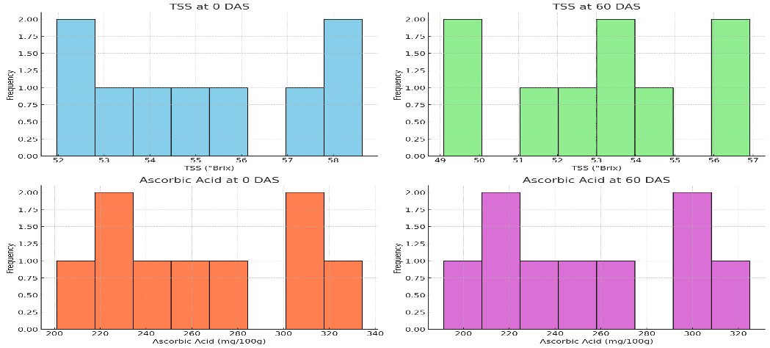

**fig. 1 Graph showing Studies of different recipes on the TSS (°Brix) and ascorbic acid of aonla candy at various storage intervals**

**Table 2: Studies of different recipes on the titratable acidity (%) and total sugar of aonla candy at various storage intervals**

|  |  |  |  |  |  |  |  |  |  |
| --- | --- | --- | --- | --- | --- | --- | --- | --- | --- |
| **T/t** | **Treatment details** | **Titratable acidity (%)** | | | | **Total sugar (%)** | | | |
| **0 DAS** | **30 DAS** | **45 DAS** | **60 DAS** | **0 DAS** | **30 DAS** | **45 DAS** | **60 DAS** |
| **T1** | Control (FPO) | 0.62 | 0.60 | 0.62 | 0.59 | 49.36 | 51.6 | 48.12 | 46.84 |
| **T2** | Mint Syrup 0.5% | 0.65 | 0.60 | 0.60 | 0.62 | 58.42 | 60.66 | 57.18 | 55.9 |
| **T3** | Mint Syrup 1% | 0.62 | 0.61 | 0.61 | 0.57 | 52.94 | 55.18 | 51.7 | 50.42 |
| **T4** | Tulsi Syrup 0.5% | 0.68 | 0.61 | 0.60 | 0.59 | 58.67 | 60.91 | 57.43 | 56.15 |
| **T5** | Tulsi Syrup 1% | 0.72 | 0.60 | 0.60 | 0.59 | 62.14 | 64.38 | 60.9 | 59.62 |
| **T6** | Lemongrass Syrup 0.5% | 0.63 | 0.59 | 0.61 | 0.61 | 54.83 | 57.07 | 53.59 | 52.31 |
| **T7** | Lemongrass Syrup 1% | 0.74 | 0.61 | 0.59 | 0.60 | 67.60 | 69.84 | 66.36 | 65.08 |
| **T8** | Cinnamon Syrup 1% | 0.70 | 0.59 | 0.60 | 0.58 | 64.46 | 66.7 | 63.22 | 61.94 |
| **T9** | Mint Syrup 0.5% + Tulsi Syrup 0.5% + Lemongrass Syrup 0.5% | 0.77 | 0.59 | 0.59 | 0.59 | 69.74 | 71.98 | 68.5 | 67.22 |
|  | **S.Em.** | **0.01** | **0.02** | **0.01** | **0.01** | **0.64** | **1.50** | **0.78** | **0.80** |
|  | **CD (5%)** | **0.02** | **2.74** | **0.02** | **0.02** | **1.93** | **4.48** | **2.34** | **2.41** |

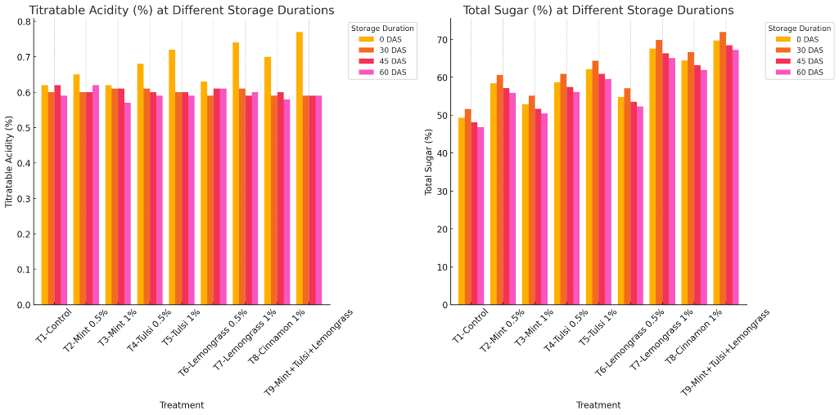

**fig 2. Graph showing Studies of different recipes on the titratable acidity (%) and total sugar of aonla candy at various storage intervals**

**Table 3: Studies of different recipes on the reducing sugar (%) and non-reducing sugar of aonla candy at various storage intervals**

|  |  |  |  |  |  |  |  |  |  |
| --- | --- | --- | --- | --- | --- | --- | --- | --- | --- |
| **T/t** | **Treatment details** | **Reducing sugar (%)** | | | | **Non-reducing sugar (%)** | | | |
| **0 DAS** | **30 DAS** | **45 DAS** | **60 DAS** | **0 DAS** | **30 DAS** | **45 DAS** | **60 DAS** |
| **T1** | Control (FPO) | 25.03 | 26.81 | 23.78 | 22.54 | 27.13 | 28.37 | 26.01 | 24.97 |
| **T2** | Mint Syrup 0.5% | 29.11 | 31.41 | 27.86 | 26.62 | 31.04 | 32.28 | 29.92 | 28.88 |
| **T3** | Mint Syrup 1% | 26.56 | 27.67 | 25.31 | 24.07 | 28.86 | 30.1 | 27.74 | 26.7 |
| **T4** | Tulsi Syrup 0.5% | 29.74 | 31.92 | 28.49 | 27.25 | 32.62 | 33.86 | 31.5 | 30.46 |
| **T5** | Tulsi Syrup 1% | 31.70 | 33.94 | 30.45 | 29.21 | 33.32 | 34.56 | 32.2 | 31.16 |
| **T6** | Lemongrass Syrup 0.5% | 28.03 | 30.16 | 26.78 | 25.54 | 29.66 |  | 28.54 | 27.5 |
| **T7** | Lemongrass Syrup 1% | 33.63 | 37.00 | 32.38 | 31.14 | 36.84 | 30.9 | 35.72 | 34.68 |
| **T8** | Cinnamon Syrup 1% | 32.74 | 34.18 | 31.49 | 30.25 | 35.13 | 36.37 | 34.01 | 32.97 |
| **T9** | Mint Syrup 0.5% + Tulsi Syrup 0.5% + Lemongrass Syrup 0.5% | 35.93 | 36.70 | 34.68 | 33.44 | 37.44 | 38.68 | 36.32 | 35.28 |
|  | **S.Em.** | **0.28** | **0.90** | **0.36** | **0.50** | **0.22** | **0.94** | **0.30** | **0.21** |
|  | **CD (5%)** | **0.84** | **2.25** | **1.08** | **1.51** | **0.67** | **2.84** | **0.91** | **0.64** |

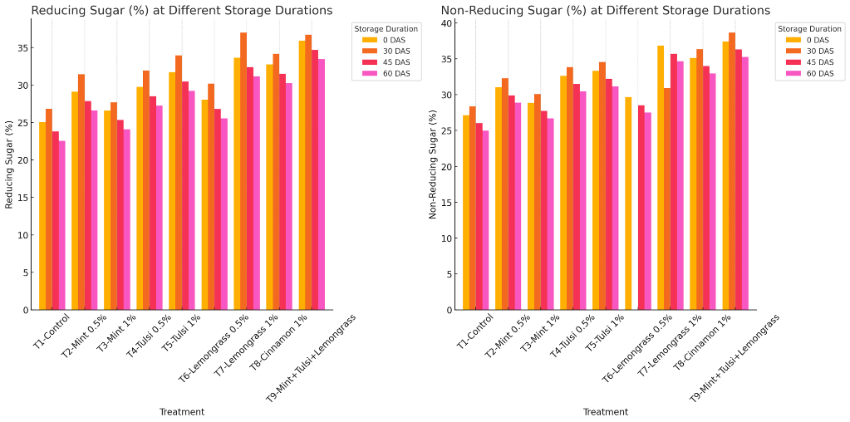

**Fig 3. Graph showing Studies of different recipes on the reducing sugar (%) and non-reducing sugar of aonla candy at various storage intervals**