**Assessing the Effectiveness of Integrated treatments against *Alternaria alternata* in *Stevia rebaudiana* under Prayagraj Condition of India**

ABSTRACT

|  |
| --- |
| A field experiment was conducted during the Rabi season of 2022–23 at the Central Research Field of SHUATS, Prayagraj, to evaluate the integrated efficacy of organic manures (FYM @ 4.5 kg/m² and neem cake @ 40 g/m²), a bioagent (*Pseudomonas fluorescens* @ 2 g/m²), and biomix, applied at two different intervals, in managing ***Alternaria* leaf spot** of *Stevia rebaudiana* caused by *Alternaria alternata*. This disease poses a significant challenge in stevia cultivation, leading to considerable losses in both yield and leaf quality due to necrotic lessions and premature leaf drop. The experiment was laid out in a **Randomized Block Design (RBD)** with eight treatments replicated three times. Disease severity was assessed using a standardized 0–5 rating scale, and data were statistically analyzed with significance determined at p ≤ 0.05. The results demonstrated that the combined application of **FYM + neem cake + P*seudomonas fluorescens* + biomix** (Treatment T7) was the most effective, resulting in the **lowest disease intensity of 18.56%** at 90 days after transplanting (DAT). This treatment also recorded the **lowest disease severity at 45 DAT (10.98%)**, indicating its potential in early disease suppression. The next most effective treatment was the combination of **neem cake + *Pseudomonas fluorescens* + biomix**, which showed a disease intensity of 21.85%. These findings highlight the synergistic effect of integrating organic amendments with biocontrol agents in enhancing plant health and managing foliar fungal diseases in stevia. The use of eco-friendly and sustainable disease management strategies like these can play a pivotal role in organic stevia production and improving crop resilience. |

*Keywords: Alternaria leaf spot, Organic manures, Bioagent, Biomix, Alternaria alternata, Stevia*

1. INTRODUCTION

Sugar plays a significant role in modern dietary habits, with cane sugar historically serving as the primary source, followed by a smaller contribution from beet sugar. However, the excessive consumption of sugar—particularly sucrose—through foods, beverages, and processed products has become a major public health concern. From a medical standpoint, a high intake of sucrose is closely linked to the increasing prevalence of chronic lifestyle diseases such as obesity, type 2 diabetes, cardiovascular disorders, and metabolic syndrome. As awareness of these health risks grows, consumers are increasingly seeking alternatives that help reduce sugar intake without compromising sweetness. This shift has led to a surge in the use of artificial sweeteners, which mimic the sweetness of sugar but contain little or no calories. However, many of these synthetic sweeteners—such as aspartame, saccharin, and sucralose—are chemically synthesized and may pose potential health risks with long-term use, including metabolic disturbances, altered gut microbiota, and potential carcinogenic effects, though findings are still under review. Consequently, there is a rising demand for natural sweeteners derived from plant sources, which are perceived to be safer and healthier alternatives. Among these, stevia (*Stevia rebaudiana*) has emerged as a promising natural sweetener, as it contains steviol glycosides that are many times sweeter than sugar but have negligible caloric value and do not raise blood glucose levels. Such natural options are increasingly being integrated into health-conscious diets and functional food products to promote better long-term health outcomes **(Dushyant *et al*., 2014).**

Native to the Amambay region in northeastern Paraguay, *Stevia rebaudiana* is a bushy shrub with branches that belongs to the *Asteraceae* family. Numerous nations expressed interest in producing stevia and started conducting research. Stevia is grown on 32,000 hectares of land worldwide, with China accounting for 75% of this total and leading the world in both cultivation and supply. India's farmers have been encouraged to grow stevia on a huge scale by the increased demand for natural sweeteners. Many Indian states, including Rajasthan, Punjab, Uttar Pradesh, West Bengal, Madhya Pradesh, Karnataka, Chhattisgarh, Odisha, Maharashtra, and Tamil Nadu, have successfully grown stevia*.* **(Das *et al*.,2010; Singh and Verma, 2015; Pal *et al*., 2015; Maiti *et al.,* 2007).** The plant Stevia rebaudiana produces stevioside, a natural sweetener that is up to 300 times sweeter than sucrose and non-glycemic. Dry stevia leaves are 10–15 times sweeter than sucrose with a glycemic index of zero, meaning they have no calories and have been shown to have no harmful effects on human health. (**Gantait *et al.,* 2015**; **Savita *et al*., 2004)** . The following eleven food items have recently been approved by the FSSAI to use steviol glycoside as a zero-calorie sweetener: ready-to-eat cereals, carbonated water, soft drink concentrate, yoghurt, fruit nectars, non-carbonated water-based beverages, edible ice, jams, jellies, and marmalades, and chewing gum.

According to a survey conducted over the past five years, *Alternaria alternata-*caused *Alternaria* leaf spot disease is highly prevalent in medicinal plants grown in different West Bengali areas in India. At first, the symptoms manifested as tiny, round, light brown patches. Later, some stayed round with concentric rings or zones, while others turned irregular and dark brown to grey. Large necrotic patches were formed on badly infected leaves by the aggregation of several spots. (**Sen *et al*., 2012).**

According to the principles of traditional Indian medicinal systems such as Ayurveda, Unani, and Siddha, raw materials derived from therapeutic herbs must be free from harmful chemical residues to ensure their safety and efficacy. However, the widespread use of agrochemicals in conventional agriculture has resulted in the presence of chemical residues in herbal raw materials used in pharmaceutical preparations. Moreover, the indiscriminate and excessive application of synthetic pesticides and chemical fertilizers not only compromises the quality of medicinal plants but also poses significant environmental and health risks, including soil degradation, water pollution, and bioaccumulation in the food chain. To address these challenges, there is a growing need to adopt sustainable and environmentally responsible agricultural practices for the cultivation of medicinal plants. Organic farming, integrated with the use of bioagents, offers a holistic approach to achieving enhanced vegetative growth, improved yield, and superior phytochemical quality while maintaining ecological balance and consumer safety. In light of these considerations, the present investigation was undertaken to evaluate the effectiveness of organic inputs and biocontrol agents in promoting healthy and sustainable cultivation of medicinal plants, thereby aligning with both traditional medicinal standards and modern environmental concerns.

2. material and methods

During the *Rabi* of 2022, the study was carried out in the experimental field of the Department of Plant Pathology at SHUATS, Prayagraj. The soil is of sandy loam type, uniform, cultivable, and has good drainage. Located at 25.08 ºN latitude and 81.25 ºE longitude, Prayagraj is 98 meters above mean sea level. The current study used a Randomized Block Design in factorial concept with eight treatments and three replications. Statistical analysis was carried out using OPSTAT and ANOVA was used to determine treatment significance.

According to a survey conducted over the past five years, *Alternaria alternata* caused leaf spot disease is highly prevalent in medicinal plants. In FYM, biomass yield and a variety of other yield metrics, such as dry leaf yield and the number of leaves per plant, are growing nicely. Farmyard manure (FYM) has the following nutrient composition: N = 0.55%, P2O5 = 0.28%, and K2O = 0.52%. By adding humus and slowly releasing nutrients to the soil, FYM improves soil fertility. It helps retain nutrients and water. **(Abbasi *et al.,* 2005; Rakesh *et al.,* 2013).** The best soil conditioner is neem cake. When applied in combination rather than separately, organic manures were significantly more effective for stevia. The application of biological control agents as a substitute, environmentally beneficial method *Pseudomonas* are thought to be significant rhizosphere organisms. *Pseudomonas fluorescens* is more metabolically and functionally varied, aids in maintaining the health of the soil, and shields crops from diseases. **Biomix** is an all-purpose organic fertilizer made by vermicomposting fish amino acids, bokashi, humic acid, seaweed extract, and a wide spectrum of beneficial microorganisms. It is the only plant food that contains every nutrient required for healthy crop growth. Biomix not only provides a complete balance of macro- and micronutrients but also enhances soil health by enriching it with organic matter and microbial life. It stimulates robust root development, improves soil structure, and boosts plant immunity against pests, diseases, and environmental stress. The natural compounds present help buffer soil pH and create an ideal environment for plant growth. Fast-acting yet long-lasting, Biomix supports sustainable agriculture by being entirely biodegradable, eco-friendly, and free from harmful chemicals. Its rich, earthy composition nourishes the soil and the plant, making it a powerful, all-in-one solution for farmers and gardeners seeking high yields and long-term soil vitality. In contrast to conventional fertilizers, this product delivers nutrients into the soil gradually so that plants may readily access them. Biofungicides, biopesticides, and growth-promoting bioagents were added to create a new biomix. It contains *Trichoderma viride*, *Trichoderma harzianum*, *Aspergillus niger*, *Pseudomonas fluorescens*, *Pseudomonas striata*, *Beauveria bassiana*, *Metarhizium anisopliae*, *Gluconacetobactor*, *Paecilomyces lilacinus*, *Bacillus subtillis*, *Verticillium lecanii*, *Azospirillum brasilince* **(Garde, 2012)**.

Corning glassware and Borosil were utilized in all laboratory studies. After being wrapped in sterile paper, the pipettes and petri plates were sanitized for two hours at 160 degrees Celsius in a hot air oven (**Chaudhary et al., 2011; Tao et al 2021).** The usual recipe was followed in the preparation of the culture media. Potato Dextrose Agar (PDA) medium was employed to isolate and cultivate the pathogen. The following is the makeup of PDA: 200g of peeled potatoes, 20g of dextrose, 20g of agar, 1000ml of distilled water, and a pH between 6.0 and 6.5. The pathogen was isolated from the diseased leaf exhibiting typical disease symptoms. The pathogen was isolated using the conventional tissue isolation technique. After 60 seconds of surface sterilization with a 1:1000 mercuric chloride (HgCl2) solution, the diseased components were separated and cleaned in sterile distilled water to get rid of any remaining mercury residues. They were then placed in sterile petri dishes with potato dextrose agar (PDA). The growth of pure colonies was monitored on a regular basis while the petri plates were incubated at room temperature (27 ± 1°C) (Gupta et al., 2010). After growing from the pieces, the pure colonies were placed on PDA slants and cultured for five to seven days at 27 ± 1°C. Characters were then studied using such slants. A tiny amount of the culture will be removed with a sterile needle and put onto a sterile glass slide.

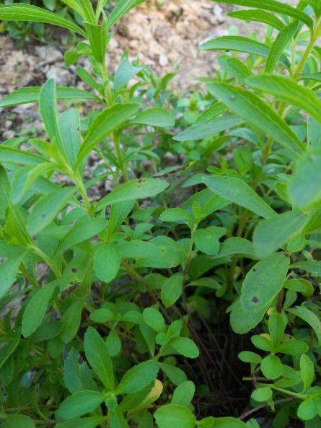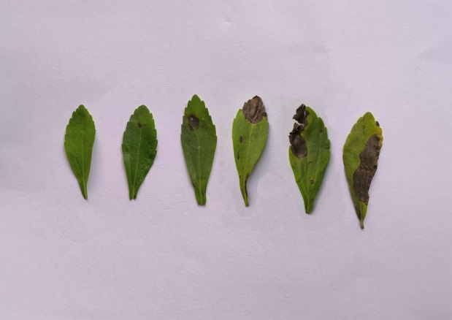

**Fig. 1 Typical symptoms of *Alternaria* leaf spot of stevia**

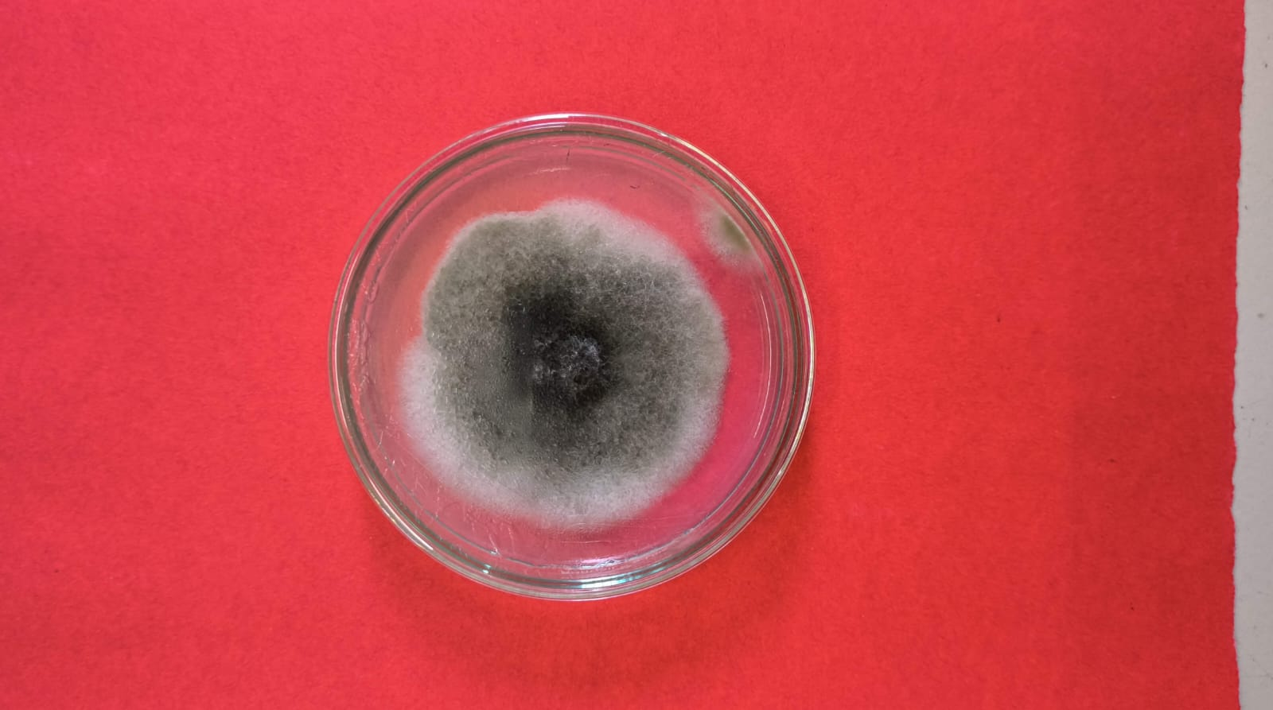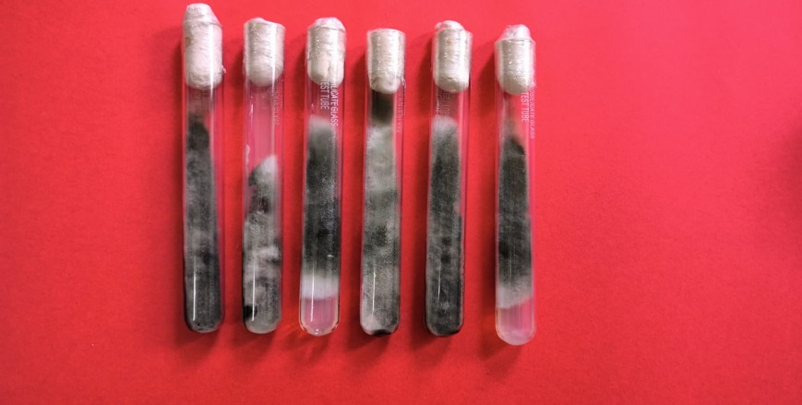

**Fig.2 Pure culture of *Alternaria alternata***

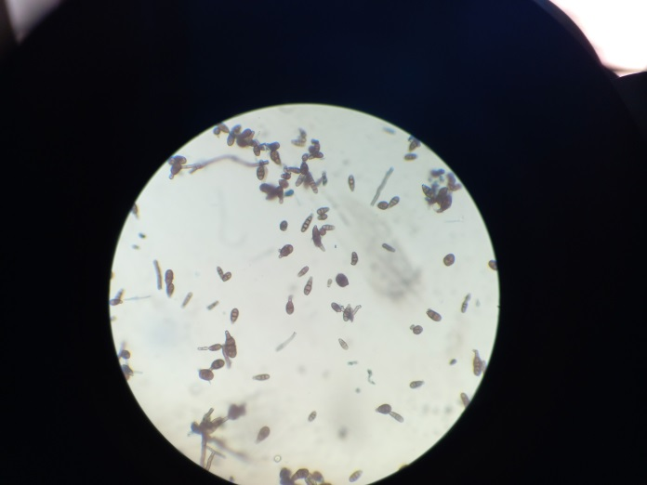

**Fig. 3 Microscopic view of conidia of *Alternaria alternata***

**2.1 Morphological characteristics of Test Pathogen *Alternaria alternata*:**

*A. alternata* conidiophores were light brown, simple, and varied in length from 17.10 to 61.56 μm. They were often 2- to 3-septate, although infrequently they were 4-5-septate **[Dania and Okoye, 2017]**. Conidia were discovered to be light to dark brown in color, uniform in size with 1-6 transverse and 0-2 longitudinal septa, and primarily oval in shape with a simple beak **[Nizamani et al. 2020].** They were roughly 10.26-77.52 x 4.56-14.82 μm. The organism was determined to be *Alternaria alternata* based on its morphological characteristics **(Kumar *et al.,* 2025).**

**1.2 Details of the treatments :**

In this study, FYM (farmyard manure), *Pseudomonas fluorescens*, and neem cake were applied both individually and in various combinations to evaluate their effects on crop performance. The first application of treatment was incorporated into the soil at 30 Days After Planting (DAP), allowing sufficient time for initial microbial colonization and organic matter breakdown. This was followed by the application of **Biomix** at 45 DAP. The second round of the initial treatments (FYM, *Pseudomonas*, and neem cake) was carried out at 60 DAP, helping to maintain soil fertility and microbial activity during the mid-growth stages. This was followed by a second **Biomix application at 75 DAP**.

|  |  |  |  |
| --- | --- | --- | --- |
| Serial Number | Treatment No. | Treatment Name | Doses (Per meter square) |
| 1 | T0 | Control |  |
| 2 | T1 | FYM + Biomix | 4.5kg /m2 + 40g/m2 |
| 3 | T2 | Neem Cake + Biomix | 40g/m2+ 40g/m2 |
| 4 | T3 | *Pseudomonas fluorescens* + Biomix | 2g/m2+ 40g/m2 |
| 5 | T4 | FYM + Neem cake + Biomix | 4.5kg/m2 + 40g/m2+40g/m2 |
| 6 | T5 | FYM + *Pseudomonas fluorescens* + Biomix | 4.5kg/m2 + 2g/m2 + 40g/m2 |
| 7 | T6 | Neem Cake + *Pseudomonas fluorescens* + Biomix | 40g/m2 + 2g/m2 + 40g/m2 |
| 8 | T7 | FYM + Neem Cake + *Pseudomonas fluorescens* + Biomix | 4.5kg/m2 + 40g/m2  + 2g/m2+ 40g/m2 |

**Table 1 : Details of Treatment and their respective Dose**

**Disease intensity:**

The disease intensity was assessed by using 0 to 5 rating scale **(Hilal *et al.,* 2013)** for measuring disease intensity.

**Disease rating scale**

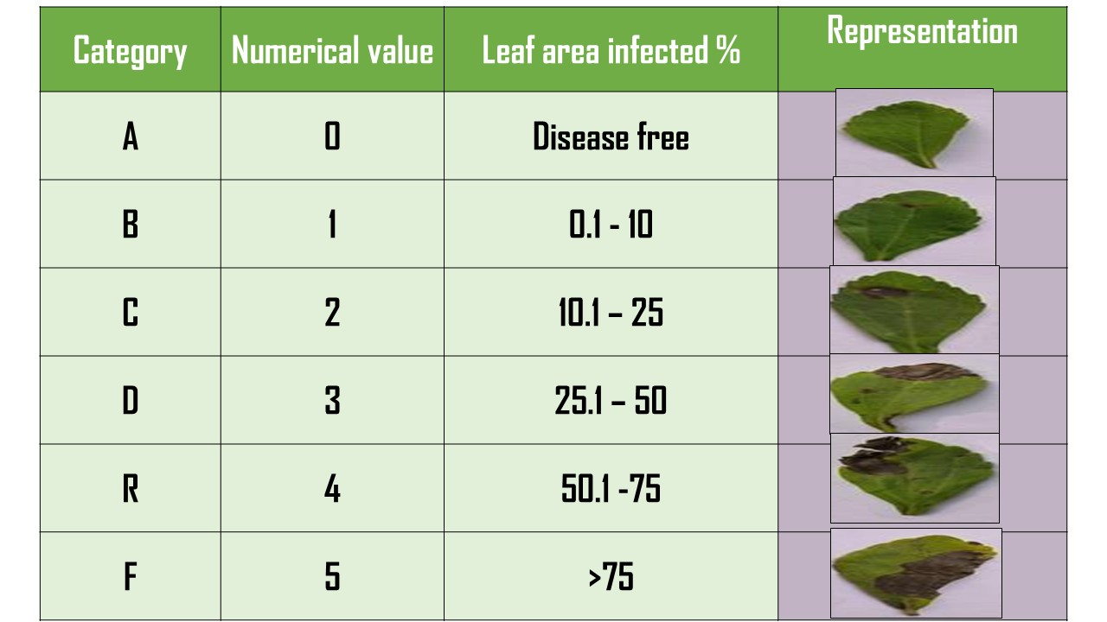

**Figure 4 : Pictorial Representation of Disease Intensity Scale**

$$Disease Intensity \left(\%\right)\frac{Sum of all disease ratings}{Total number of ratings X Maximum Disease Grade }X 100$$

**Figure 5 : Typical symptoms of *Alternaria* leaf spot of stevia**

**Symptoms according to Disease Intensity Scale**

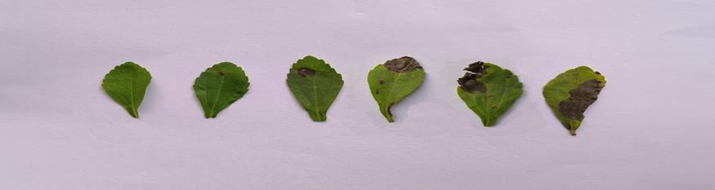

**0**

**1**

**2**

**3**

**4**

**5**

3. results

**3.1 Disease Intensity at 45 Days After Planting (DAP)**

At 45 days after planting (DAP), a significant reduction in the intensity of Alternaria leaf spot in *Stevia rebaudiana* was observed across all treatment combinations when compared to the untreated control (T0), which recorded the highest disease intensity of 22.48%. Among the treatments, T7 (FYM + Neem Cake + *Ps*eudomonas fluorescens + Biomix) was the most effective, achieving the lowest disease intensity of 10.98%. This was closely followed by T6 (Neem Cake + *Pseudomonas fluorescens* + Biomix) with 12.96%, and T4 (FYM + Neem Cake + Biomix) with 14.46%. Other treatments also demonstrated considerable suppression of disease intensity: T5 (15.50%), T3 (17.57%), T2 (18.38%), and T1 (19.24%). Statistical analysis using the critical difference (CD) value of 1.32 indicated that all treatments were significantly more effective than the untreated control. However, no significant differences were observed among the treatment pairs (T1, T2), (T2, T3), and (T4, T5), suggesting similar levels of efficacy among these groups. The observed reduction in disease severity is likely attributed to the enhanced plant vigor conferred by nutrient-rich organic amendments, along with the antagonistic effects of the bioagent *Pseudomonas fluorescens*, which may have suppressed the growth and activity of *Alternaria alternata*. These results support the potential of integrated organic and biological approaches for effective and sustainable disease management in stevia cultivation.

**3.2 Disease Intensity at 90 Days After Planting (DAP)**  
A similar pattern of disease suppression was observed at 90 days after planting (DAP). The treatment T7 (FYM + Neem Cake + *Pseudomonas fluorescens* + Biomix) continued to demonstrate the highest level of efficacy, recording the lowest disease intensity of 18.56%, in stark contrast to the untreated control (T0), which exhibited a disease intensity of 34.50%. This was followed by T6 (21.85%), T4 (22.97%), T5 (26.04%), T3 (28.53%), T2 (29.34%), and T1 (30.13%). Statistical analysis confirmed that all treatment combinations resulted in significantly lower disease intensities compared to the control, based on a critical difference (CD) value of 0.83 at the 5% level of significance. However, no statistically significant differences were detected between the treatment pairs T1 and T2, and T2 and T3, indicating a similar level of effectiveness within these groupings. These results reinforce the consistent and superior performance of T7 across different growth stages and suggest that the integrated use of organic amendments and biocontrol agents is not only effective in early disease suppression but also in maintaining low disease pressure throughout the crop cycle.

**4. Discussion**

The results of this study, assessed using the disease rating scale proposed by Hilal et al. (2013), clearly underscore the efficacy of integrated organic and biological inputs in managing *Alternaria alternata* in *Stevia rebaudiana*. Among the various treatments, T7 (FYM + Neem Cake + *Pseudomonas fluorescens* + Biomix) consistently outperformed all others, suggesting a synergistic effect among the components. This significant disease reduction can be attributed to multiple mechanisms of action. Neem cake, enriched with azadirachtin, is known for its potent antifungal properties, including inhibition of mycelial growth and conidial germination of *Alternaria alternata* (Khajista, 2013; Ruchi & Kanika, 2021). The addition of *Pseudomonas fluorescens*, a well-documented biocontrol agent, further enhances disease suppression by inducing systemic resistance in host plants and exerting microbial antagonism against the pathogen. The role of Biomix in disease management is particularly noteworthy. As a biologically active formulation comprising humic acid, seaweed extract, fish amino acids, bokashi, and beneficial microorganisms, Biomix improves plant health by promoting nutrient uptake, boosting immune responses, and supporting a favorable soil microbial environment. Its presence across all effective treatments likely played a crucial role in minimizing disease severity. These findings are consistent with previous research (Raut et al., 2020), which highlighted the benefits of integrating neem-based products and microbial consortia such as *Pseudomonas fluorescens* for managing foliar diseases in medicinal crops. Overall, the integration of Biomix with FYM, neem cake, and biocontrol agents represents a promising, eco-friendly, and sustainable strategy for controlling *Alternaria* leaf spot in stevia cultivation, aligning with the principles of organic and medicinal plant farming.

Table 2: Effect of organic manures, individually and in combination with a bioagent, on the Disease intensity (%) of *Alternaria alternata* in stevia at 45 and 90 days after planting (DAP)

|  |  |  |  |  |  |
| --- | --- | --- | --- | --- | --- |
| **S.NO** | | **Treatment details** | | **45 DAT** | **90 DAT** |
| **T0** | | Control (Untreated) | | 22.48 | 34.50 |
| **T1** | | FYM + Biomix | | 19.24 | 30.13 |
| **T2** | Neem Cake + Biomix | | 18.38 | | 29.34 |
| **T3** | *Pseudomonas fluorescens* + Biomix | | 17.57 | | 28.53 |
| **T4** | FYM + Neem cake + Biomix | | 14.46 | | 22.97 |
| **T5** | FYM + *Pseudomonas fluorescens* + Biomix | | 15.50 | | 26.04 |
| **T6** | Neem Cake + *Pseudomonas fluorescens* + Biomix | | 12.96 | | 21.86 |
| **T7** | FYM + Neem Cake + *Pseudomonas fluorescens*  + Biomix | | 10.98 | | 18.56 |
| **SE.(d)±** | | | **0.61** | | **0.39** |
| **CD(0.05)** | | | **1.32** | | **0.83** |

Figure 6 : Disease Intensity at 45 and 90 DAT

4. Conclusion

The results of the present study indicate that *Pseudomonas fluorescens*, organic manures, neem cake, and Biomix each possess notable antifungal activity against *Alternaria alternata*, the causal agent of Alternaria leaf spot in *Stevia rebaudiana*. Among all treatment combinations, T7 (FYM + Neem Cake + *Pseudomonas fluorescens* + Biomix) consistently demonstrated superior performance across multiple parameters. This treatment resulted in the greatest plant height (61.88 cm), highest number of suckers (66.03), and maximum fresh and dry leaf yield (66.91 g), along with the lowest disease intensity (18.56%). The observed improvements in plant growth and disease suppression are likely attributed to the synergistic effects of organic amendments and beneficial microorganisms. When applied to the rhizosphere, these components not only suppressed pathogenic activity but also enhanced nutrient availability, microbial activity, and overall plant vigor, making them both effective and environmentally sustainable alternatives to chemical inputs. However, to validate and expand upon these findings, long-term field trials across multiple seasons and locations are recommended. This would help assess the consistency of treatment efficacy and provide more robust recommendations for sustainable *stevia* cultivation practices.

**Authorship Contribution Details**

JJ and SS - Supervision , Conceptualization and Formulation of Methodology.

JJ and CKP : Analysis of Data

JJ, CKP, RC and RK- Data Curation.

JJ and CKP – Writing, Review and Editing.

JJ, CKP and RC - Preparation of Final Draft.

Disclaimer (Artificial intelligence)

Option 1:

Author(s) hereby declare that NO generative AI technologies such as Large Language Models (ChatGPT, manuscript.

References

1. Dushyant, S., Kumar, S., Maurya, A. K., & Meena, K. R. (2014). Efficacy of organic manures on growth, yield and biomolecules of stevia (Stevia rebaudiana Bertoni). *J. Crop Weed*, *10*(1), 107-110.
2. Pal, P. K., Kumar, R., Guleria, V., Mahajan, M., Prasad, R., Pathania, V., ... & Ahuja, P. S. (2015). Crop-ecology and nutritional variability influence growth and secondary metabolites of Stevia rebaudiana Bertoni. *BMC Plant Biology*, *15*, 1-16.
3. Das, A., Biswas, M. and Mandal, N. (2010). An economic analysis of stevia ( *Stevia rebaudiana* Bert.) cultivation through stem cutting and tissue culture propagule in India. *Trends in Agricultural Economics.* 3(4):56-59.
4. Maiti, C.K., Sen, S., Acharya, R. and Acharya, K. (2007). First report of *Alternaria alternata* causing leaf spot on *Stevia rebaudiana*. *Plant Pathology*. 56(4): 723.
5. Singh, A. and Verma, P.P.S. (2015). Survival and growth performance of stevia cutting under different growing media. *Journal of Medicinal Plants Studies*. 3(2): 111-113.
6. Gantait, S., Das, A. and Mandal, N. (2015). Stevia: a comprehensive review on ethnopharmacological properties and *in vitro* regeneration. *Sugar Tech*. 17(1): 95–106.
7. Savita, S.M., Sheela, K., Sunanda, S., Shankar, A.G. and Ramakrishna, P. (2004). *Stevia rebaudiana*–A functional component for food industry. *Journal of Human Ecology*. 15(4): 261-264.
8. Chaudhary, V., Prasanna R., Nain, L., Dubey, S. C., Gupta, V., Singh R., Jaggi S. and Bhatnagar, A. (2012). Bioefficacy of novel cyanobacteria-amended formulations in suppressing damping off disease in tomato seedlings. *World Journal of Microbiology and Biotechnology.*27(2):44-45.
9. Garde, A.P., Shinde, S.J. and Kale, A.S.(2022). Effect of inorganic fertilizers (NPK) with organic sources (biomix and humic acid) on bulbs and roots of onion (*Allium cepa* L.). *Pharma Innovation.*11(1):833-839.
10. Sen, S., Biswas, G., Basu, S. K. and Acharya, K. (2012). Management of leaf spot disease of *Stevia rebaudian*a Bertoni with antagonistic bacteria. *Australian Journal of Crop Science*. 6(2): 350-356.
11. Kumar, P., Rani, P., & Tripathy, P. P. (2025). Indirect mode solar drying of stevia (Stevia rebaudiana) leaves: experimental and numerical investigation of fluid flow pattern, moisture, and temperature distribution profile. *Biomass Conversion and Biorefinery*, *15*(5), 7523-7542.
12. Hilal, A.B., Khurshid, A.R.A., Rayees, A., Ahanger, N. A., Qazi, N.A.D. and Ganie, S.A. (2013) Status and symptomatology of Alternaria leaf blight (*Alternaria alternata*) of Gerbera (*Gerbera jamisonii*) in Kashmir valley. *African Journal of Agricultural Research*. 8(9):819-823.
13. Khajista (2016) Antifungal activity of *Azadirachta indica* against *Alternaria Solani*. *Journal of Life Sciences and Technologies.* 1(1):89-83.
14. Raut, V., Kanitkar, S., Hegade, G., Kulkarni, M. and Kadam, M. (2020). Bio-efficacy of ‘SUDO-TM’ (*Pseudomonas fluorescens*) as a biocontrol agent against early blight (*Alternaria solani*) disease of tomato*. International Journal for Research in Applied Sciences and Biotechnology*.7(10): 31-33.
15. Ruchi and Kanika (2021) *In-vitro* assay of antifungal activity of various elicitors and binders against *Alternaria alternata*. *Plant Archives,* 21(1): 933-938.
16. Tao, J., Cao, P., Xiao, Y., Wang, Z., Huang, Z., Jin, J., ... & Zhou, Z. (2021). Distribution of the potential pathogenic Alternaria on plant leaves determines foliar fungal communities around the disease spot. Environmental Research, 200, 111715.
17. Dania, V. O., & Okoye, U. J. (2017). Evaluation of neem seed extract for the management of early blight (Alternaria solani) disease of tomato (Solanum lycopersicum L.). *Nigerian Journal of Plant Protection*, *31*(1), 39-58.
18. Nizamani, M. H., Abro, M. A., Gadhi, M. A., Keerio, A. U., Talpur, M. S. A., & Qazi, S. (2020). Evaluation of different essential oils and bio control agents against Alternaria alternata the causal agent of fruit rot of jujube. *Journal of Applied Research in Plant Sciences*, *1*(1), 1-8.