Pseudo placentational Endometrial Hyperplasia (PEH) in Female Dog

ABSTRACT
Pseudo-placentational endometrial hyperplasia (PEH) is a distinct uterine lesion in dogs, exhibiting histological features that mimic normal placental structures. Initially reported by Krainz (1914) through the accidental discovery of organized endometrial responses to intrauterine porcelain balls, PEH has since been recognized as a progesterone-driven pathology most commonly occurring during diestrus. Subsequent experiments confirmed that foreign material inserted into the uterus during diestrus reliably induces deciduoma-like formations. Clinically and pathologically, PEH is distinguishable from cystic endometrial hyperplasia (CEH) by its organized, decidualized architecture. Recent studies have shown that PEH may also arise in the absence of pregnancy, often in cases involving pseudopregnancy, early embryonic resorption or failed implantation. Exogenous progestin administration and prolonged luteal phases are strongly implicated in the pathogenesis. Grossly, PEH presents with ovoid uterine swellings, thickened mucosa and villous protrusions that may occlude the lumen. Histologically, the endometrium demonstrates a three-layered structure: a deep glandular zone, a fibrous connective tissue band and luminal epithelial folds, without fetal tissue. Clinically, bitches may show signs of mucoid or hemorrhagic vaginal discharge, abdominal distension, lethargy and signs mimicking pseudopregnancy. Diagnosis is confirmed by combining clinical history, ultrasonography and definitive histopathology. Despite its distinct features, PEH remains underdiagnosed, often misidentified as CEH or pyometra, underscoring the need for improved recognition and differentiation among uterine pathologies.
Keywords: Pseudo-placentational endometrial hyperplasia, Cystic endometrial hyperplasia
1. Introduction
Pseudo-placentational endometrial hyperplasia (PEH) represents a distinct and complex lesion of the canine uterus. This lesion exhibits a bizarre and remarkable degree of structural organization that mimics the architecture of the maternal placenta observed during normal pregnancy (Schlafer and Gifford, 2008). The condition is marked by a hyperplastic response of the endometrium, often displaying an arrangement that suggests a pseudo-decidual reaction and structural mimicry of placental layers. It is most commonly observed during the diestrus phase of the estrous cycle when progesterone levels are elevated (Marino et al., 2021).
Pseudo-placentational endometrial hyperplasia (PEH) in canines has been described for over a century, with early experimental models demonstrating that prolonged progesterone exposure induces cystic and glandular changes in the endometrium. Classical studies, such as those by Krainz (1914) and Nomura et al. (1994–1997), showed that intrauterine insertion of sterile objects like porcelain balls or sponges in dogs could mimic pregnancy and trigger proliferative changes resembling PEH. These experiments established that mechanical or hormonal stimuli alone can drive pseudo-decidualization and glandular proliferation in the absence of conception, laying the groundwork for current understanding of PEH pathogenesis.
More recent observations have suggested that PEH may also arise in the context of early embryonic loss or failed implantation. Cartolano et al. (2016) reported cases of PEH coexisting with the successful delivery of healthy puppies, raising the possibility that early embryonic resorption might trigger localized hyperplastic responses mimicking placental tissue. Similarly, Ma et al. (2021) described instances of PEH occurring in bitches that had undergone natural mating but did not demonstrate confirmed pregnancies, supporting the hypothesis that PEH can develop independently of true gestation.
The hormonal environment appears to play a crucial role in the development of this lesion. In particular, high systemic levels of progesterone whether endogenous during prolonged diestrus or exogenously administered are suspected to drive the exaggerated endometrial response seen in PEH. Koguchi et al. (1995) proposed a correlation between persistent progesterone exposure and the emergence of placentation like endometrial structures. This is supported by observations of PEH in animals with no evidence of mating or pregnancy but with a history of exogenous progestin treatment (Marino et al., 2021).
Histologically, PEH is characterized by a highly ordered and segmental hyperplasia of the endometrium. These changes closely replicate those found at natural implantation sites including glandular proliferation, stromal decidualization and sometimes the presence of villous projections. As noted by Schlafer and Gifford (2008) these lesions can be remarkably complex and their resemblance to early pregnancy can lead to diagnostic challenges. When the uterus is examined grossly, it may exhibit ovoid swellings suggestive of gestational sacs. Upon sectioning, the endometrial surface often reveals a thickened, villous structure with prominent protrusions that may partially occlude the uterine lumen (Schlafer and Foster, 2016).
While PEH does not show a strong age predisposition and may occur in both young and middle-aged bitches, it is distinct from cystic endometrial hyperplasia (CEH), which is more common in older dogs. CEH is typically associated with chronic hormonal exposure and often leads to cyst formation and glandular atrophy. In contrast, PEH is associated with more structured hyperplasia that resembles decidual tissue and may not involve cystic changes (Schlafer, 2012). However, both CEH and PEH can predispose to secondary infections such as endometritis or pyometra due to excessive endometrial secretions and immune suppression induced by progesterone.
Clinically, bitches affected by PEH may present with a range of nonspecific signs, particularly when the lesion is associated with pseudopregnancy or secondary infection. These include abdominal distension, mucoid or hemorrhagic vaginal discharge, lethargy, anorexia and in some cases fever. The clinical signs of pseudo-placentational endometrial hyperplasia are often similar to those of pyometra, so a careful and detailed diagnosis is needed. Imaging modalities such as ultrasonography frequently revealed focal thickening of the uterine wall, hyperechoic areas and sometimes cystic formations. However, definitive diagnosis relies on histopathological examination, which reveal the hallmark features of PEH, including decidua like stromal proliferation and complex glandular hyperplasia (Cartolano et al., 2016; Ma et al., 2021).
2. History
Pseudo-placentational endometrial hyperplasia is characterized by abnormal proliferation of the endometrial glands and stroma, forming placental like structures without pregnancy (Lobaczewsk et al., 2025). Before the study conducted by Schlafer and Gifford (2008), PEH was likely misdiagnosed as cystic endometrial hyperplasia (CEH), contributing to the concept of a CEH-pyometra complex. While a significant association between PEH and pyometra has been established, a cause-and-effect relationship remains undetermined (Santana et al., 2020).
PEH was first identified in 1914 during experiments involving the surgical introduction of porcelain balls into the uterine lumen to induce contraception. Although the experiment failed, some bitches developed organized endometrial reactions resembling a juvenile placenta at the site of incision (Krainz, 1914). Formerly referred to as deciduoma by Nomura (1994) was later renamed and characterized more thoroughly as pseudo-placentational endometrial hyperplasia (Schlafer and Gifford, 2008). Despite evidence suggesting PEH is common in dogs, it is rarely described due to limited knowledge about the condition. Grossly, PEH can appear as localized nodules or diffuse lesions with irregular thickening of the endometrium and formation of cystic structures of varying sizes (Santana et al., 2024; Schlafer and Foster, 2016).
Pyometra is characterized by uterine inflammation with purulent exudate accumulation due to bacterial infection. Early studies linked pyometra with CEH under the term CEH-pyometra complex (Dow, 1959). However, this concept has been questioned due to a lack of clear cause and effect evidence between these two conditions. Both are associated with diestrus and primarily affect older bitches. Additionally, clinical signs of pyometra do not consistently correlate with histological classifications, complicating communication between pathologists and clinicians (De Bosschere et al., 2001). Recent studies have highlighted PEH as a distinct form of endometrial change that commonly develops during diestrus (Schlafer and Gifford, 2008). Improved diagnostic awareness is essential to differentiate PEH from other uterine conditions like CEH and pyometra.
3. Etiology
The development of pseudo-placentational endometrial hyperplasia in dogs is closely linked to prolonged exposure to endogenous progesterone during the diestrus phase of the estrous cycle. In the absence of fertilization, the endometrium remains under the influence of this hormone, promoting hypertrophy and hyperplasia of both the endometrial glands and stroma (Feldman et al., 2014). In PEH, this physiological response becomes pathologically exaggerated, forming a structure that histologically resembles a placental attachment site. Experimental studies have demonstrated that the insertion of sterile foreign materials, such as silk suture or autogenous tissue into the uterus during diestrus reliably induces PEH like lesions, as the physical presence of these substances appears to stimulate decidualization of stromal cells and the formation of highly vascularized fibro glandular tissue similar to the maternal component of the placenta (Nomura, 1995; Koguchi et al., 1995). Clinically, PEH has also been documented in bitches undergoing pseudopregnancy, a hormonally driven condition that simulates gestation. Furthermore, cases have been reported in animals that had mated but experienced early embryonic loss or resorption, suggesting that transient pregnancy related stimuli may serve as a trigger for localized endometrial remodeling (Cartolano et al., 2016; Ma et al., 2021).
In one of the earliest experimental models, porcelain balls were surgically introduced into the uterine lumen to induce contraception, which led to organized endometrial proliferations resembling juvenile placentas (Krainz, 1914). Subsequent studies further elaborated this model by inserting substances such as stainless-steel wire, olive oil, bouillon with or without barium, uterine grafts or Escherichia coli suspensions. These interventions produced decidual like reactions collectively referred to as deciduomas, which were inducible only in early to mid-diestrus, when progesterone levels were elevated (Nomura, 1995).
4. Gross pathology
Gross pathology observed during ovariohysterectomy often reveals distinct macroscopic features indicative of underlying reproductive conditions. The unopened uterus may present with one or more ovoid distended areas resembling early pregnancy, accompanied by numerous longitudinal folds on the uterine surface. These findings are suggestive of structural changes within the reproductive tract. The ovaries typically exhibit corpora lutea, which are indicative of recent ovulation and in some cases, cysts may also be present, reflecting potential ovarian dysfunction. On cut section, the uterine mucosa appears markedly reddish and thickened, particularly at the site of swelling, where soft white greyish tissue is often observed adhered to the mucosal surface (Xavier et al., 2024).
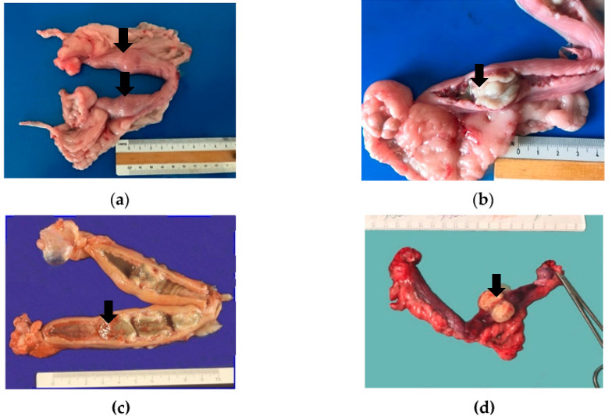 Fig. 01: Gross findings in cases of pseudo-placentational endometrial hyperplasia: (a) the unopened uterus of case with two spherical swellings; (b) the uterus of case opened at the level of the swelling; the uterine mucosa is reddish; the lesion is almost white and seems leaned on the mucosa; (c) the genital tract of another case with four hyperplastic lesions which appeared greenish and accompanied by an abundant dirty fluid; (d) another case lesion with always the same size and appearance (Marino et al., 2021).
This tissue may represent hyperplastic or pathological changes in the endometrium. Additionally, cloudy fluid is frequently noted within the uterine lumen, which could indicate impaired drainage or secretory activity. Notable feature of the uterine mucosa in such cases is the presence of yellowish-white villous protrusions that form cylindrical bands, effectively occluding the lumen. These protrusions may signify advanced endometrial alterations, potentially associated with conditions such as pseudo-placentational endometrial hyperplasia or other hyperplastic disorders. Collectively, these gross findings provide valuable insights into the pathological processes affecting the reproductive tract, aiding in diagnosis and management strategies (Marino et al., 2021). Figure 01 also shows similar gross lesion in the uterus of affected female dog.
5. Histopathology
The histopathological features of pseudo-placentational endometrial hyperplasia are distinctive and crucial for its diagnosis. The hyperplastic endometrium exhibits a characteristic three-layered architecture, comprising a deep glandular zone, a condensed connective tissue band, and folded luminal epithelial junctional zones (Lobaczewsk et al., 2025). This organization closely mimics the layers observed in a normal canine placenta, highlighting the placental-like appearance of the tissue.
Microscopically, the hyperplastic endometrium may appear as a broad-based polypoid mass extending into the uterine lumen or as a continuous band of protruding tissue. The luminal surface is typically necrotic, with no fetal placental tissues present, distinguishing PEH from true pregnancy-related changes. Notable features include the uniform distention of the endometrial glands in the deep zone and the presence of thin luminal folds lined by secretory epithelial cells, corresponding to the junctional zone in a normal implantation site (Schlafer and Foster, 2016). The ends of these folds commonly undergo coagulative necrosis, with necrotic debris mixed with mucoid endometrial secretions.
In some cases, PEH may display variations in the number of layers, such as a four-layered structure (Figure 02), although the three-layered pattern is most characteristic. Pseudo-placentational endometrial hyperplasia-like changes may also affect the remaining uterine mucosa, indicating a more widespread endometrial response (Marino et al., 2021). Additionally, the presence of corpora lutea with degenerated or active luteal cells confirms its association with the luteal phase of the estrous cycle.
These histological features are essential for differentiating PEH from other uterine pathologies, such as endometrial polyps, chronic pyometra, fetal mummification or leiomyoma, due to the absence of fetal tissues and its specific layered structure (Cartolano et al., 2016). The resemblance of this layered pattern to placental development underscores its origin as an exaggerated endometrial response to hormonal cues during diestrus, rather than an actual pregnancy (Schlafer and Foster, 2016).
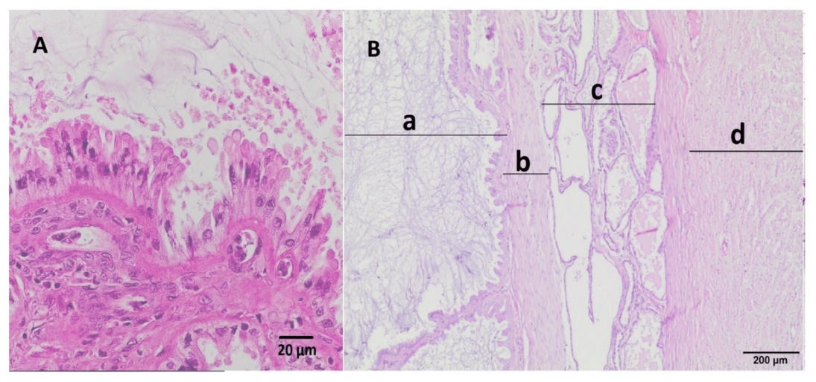
Fig. 02: (A) Histopathological structure of inner surface of mucosa with uterine mucosal projections covered by a layer of cuboidal or columnar epithelium, uterine lumen is visible at the top of figure; hematoxylin–eosin staining, magnification 40×. (B) Microscopic view showing three layers of the uterine mucosa, including (a) villous folds (projections) of the mucosa covered by endometrial epithelium separated by proteinaceous material (b) a thin band of fibrous connective tissue (c) distended endometrial glands commonly filled with proteinaceous fluid and (d) myometrium; hematoxylin–eosin staining, magnification 20X (Lobaczewsk et al., 2025).
Furthermore, the connection of PEH to pseudopregnancy, a state where endometrial changes mimic early pregnancy in the absence of a fetus, emphasizes the hormonal basis of the condition (Schlafer and Foster, 2016).
6. Clinical signs
The clinical signs of Pseudo-placentational endometrial hyperplasia (PEH) in dogs are diverse and often overlap with those of other uterine disorders, such as pyometra or cystic endometrial hyperplasia (CEH). These signs arise from the structural and functional changes in the uterus caused by prolonged progesterone stimulation and the resulting hyperplasia. The severity and presentation of clinical signs can vary depending on the extent of endometrial changes, the presence of secondary complications and the individual dog's overall health status (Johnston et al., 2001).
One of the clinical signs of pseudo-placentational endometrial hyperplasia is vaginal discharge which may range from mucoid to hemorrhagic in nature if secondary bacterial infection is present. This discharge results from the breakdown of hyperplastic endometrial tissue and the associated vascular proliferation, which can lead to bleeding within the uterine lumen (Schlafer and Gifford, 2008). In some cases, the discharge may be intermittent or only noticeable during urination, making it easy to overlook in the early stages of the condition.
Abdominal distension is another hallmark sign of pseudo-placentational endometrial hyperplasia when associated with pyometra, caused by the enlargement of the uterus due to the accumulation of hyperplastic tissue, fluid or blood. This distension can be palpable during physical examination and may cause discomfort or pain in affected bitches (Schlafer and Foster, 2016). In severe cases, the enlarged uterus may compress adjacent organs, leading to secondary signs such as difficulty defecating or urinating.
Systemic signs, such as lethargy, anorexia and fever are often observed in dogs with pseudo-placentational endometrial hyperplasia, particularly if secondary bacterial infection occurs. Progesterone induced immunosuppression and the altered uterine environment create favorable conditions for bacterial growth, which can lead to complications such as pyometra or sepsis (Schlafer and Gifford, 2008). Fever is a common indicator of infection, while lethargy and anorexia reflect the systemic impact of the condition on the dog's overall health.
In some cases, dogs with pseudo-placentational endometrial hyperplasia may exhibit behavioral changes reminiscent of pseudopregnancy, such as nesting behavior, mammary gland enlargement or even lactation. These signs are driven by the hormonal imbalances associated with prolonged progesterone exposure and the pseudo-placentational changes in the endometrium (Whitney, 1967). While these behavioral changes are not specific to pseudo-placentational endometrial hyperplasia, their presence in conjunction with other clinical signs can help guide the diagnostic process.
7. Diagnosis
7.1 Clinical evaluation
A thorough clinical evaluation plays a crucial role in diagnosing and understanding the health status of a bitch. Gathering relevant historical information is essential to assess her overall condition. Pyometra with Endometrial Hyperplasia (PEH) is often linked to pseudopregnancy, making it important to consider the history of one or more episodes of pseudopregnancy following previous heat cycles, as this can raise suspicion of the disease. Notably, female dogs affected by this condition typically remain asymptomatic, which further underscores the importance of a detailed clinical evaluation for accurate diagnosis (Santana and Santos, 2024).
7.2 Ultrasonography
Ultrasonography serves as a valuable non-invasive diagnostic tool for evaluating uterine changes and detecting potential lesions. Common ultrasonographic findings include focal widening of the uterine horn, often accompanied by ovoid, pedunculated masses protruding from the endometrium (Figure 03). These masses may display a heterogeneous echotexture and in certain cases, resemble cerebral convolutions. Additionally, some cases may reveal poorly particulate endoluminal fluid along with parenchymal endoluminal proliferation, providing critical insights into the condition and aiding in accurate diagnosis (Ma et al., 2021).
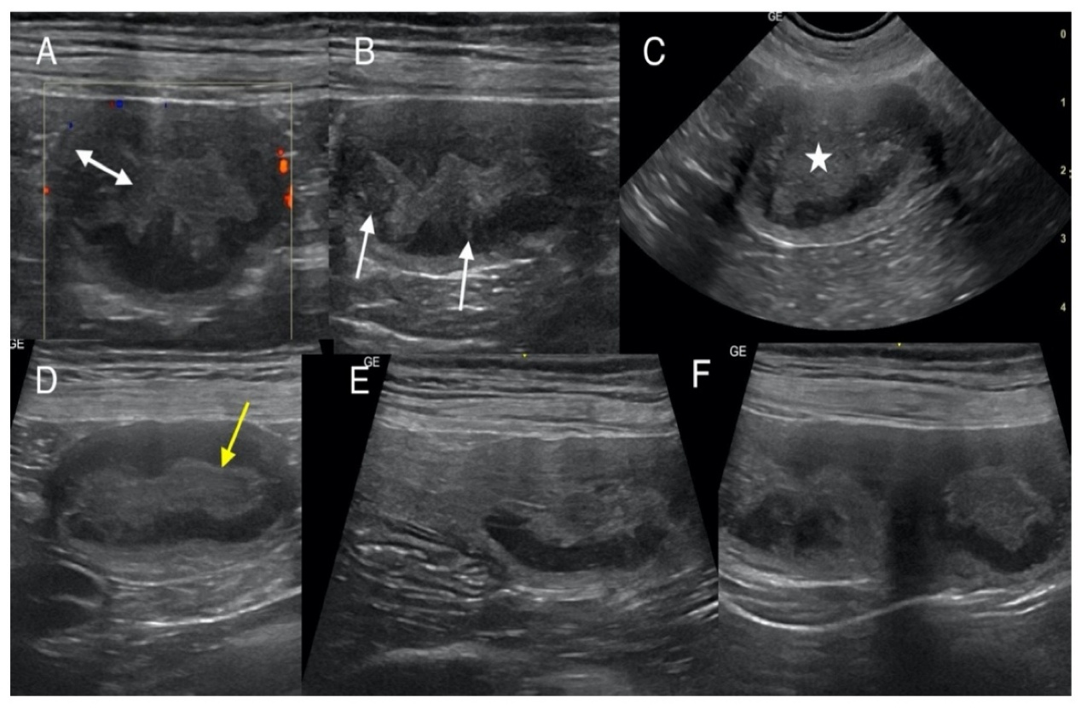
Fig. 03: Transverse and sagittal ultrasound views of the canine uterus displaying segmental mural thickening and organized hyperechoic linear striations in the endometrium—features consistent with pseudo-placentational endometrial hyperplasia
7.3 Gross pathology
Macroscopic examination during ovariohysterectomy often reveals distinct features characteristic of the condition. The unopened uterus may display one or more ovoid distended areas resembling early pregnancy, while the uterine surface frequently exhibits numerous longitudinal folds. The ovaries typically contain corpora lutea and cysts may also be present. Upon cutting into the uterus, the mucosa appears reddish and thickened, especially at the site of swelling with soft, white-greyish tissue observed on the mucosa and cloudy fluid present in the lumen. Additionally, the uterine mucosa may be covered by yellowish-white villous protrusions that form cylindrical bands, effectively occluding the lumen. These findings provide valuable insights into the pathological changes associated with this condition (Marino et al., 2021).
7.4 Histopathological examination
Histopathological examination is the definitive method for confirming the diagnosis of pyometra with PEH. This diagnostic approach highlights key features of the hyperplastic endometrium, which exhibits a distinct three-layered architecture. The deep glandular zone is characterized by the uniform distention of deeper endometrial glands. A condensed connective tissue band forms the middle layer, consisting of tightly packed connective tissue. Additionally, there are folded luminal epithelial junctional zones, featuring thin folds lined by secretory epithelial cells, similar to those found in the junctional zone during normal pregnancies. Notably, the luminal surface typically appears necrotic, and fetal placental tissues are absent, distinguishing this condition from pregnancy-related changes. These histopathological findings are crucial for accurately diagnosing PEH and differentiating it from other uterine conditions (Lobaczewsk et al., 2025).
8. Differential diagnosis
The differential diagnosis of pseudo-placentational endometrial hyperplasia in bitches includes several uterine conditions that share overlapping clinical or histopathological features. These are:
- Cystic endometrial hyperplasia (CEH): CEH is the most common uterine condition in bitches, characterized by cystic dilation of endometrial glands. Unlike PEH, CEH lacks the organized tissue architecture resembling placentation and is often associated with pyometra (Wozzna et al., 2020).
- Endometrial polyps: These benign growths of the endometrium can mimic the focal masses seen in PEH but lack the layered placental like structure typical of PEH (Bigliardi et al., 2004).
- Adenomyosis: This condition involves the invasion of endometrial tissue into the myometrium, which can lead to uterine enlargement and changes resembling PEH, though its histological features differ significantly (Antero et al., 2020).
- Mesonephric duct remnants: Cystic remnants of mesonephric ducts can appear as uterine swellings but are distinct from PEH both histologically and clinically (Roy et al., 2022).
- Uterine inflammation (Endometritis or pyometra): Severe uterine inflammation may present with diffuse or focal changes resembling PEH. However, these conditions are typically accompanied by clinical signs such as discharge and systemic illness (Sasidharan et al., 2016).
- Early embryonic resorption: This condition involves the reabsorption of early embryos, which can mimic the uterine changes seen in PEH but lacks the characteristic placental like tissue organization (Lobaczewsk et al., 2025).
- Pregnancy: Pregnancy itself can cause uterine changes that might resemble PEH, but the presence of fetal placental tissues and a clear gestational sac would differentiate it from PEH (Jauniaux and Burton, 2005).
- Fetal mummification: This condition involves the retention of a dead fetus within the uterus, which can lead to uterine changes and may mimic some features of PEH, though it is typically associated with a distinct history of fetal death and retention (Mantziaras and Zakosek, 2025).
- Leiomyoma: Uterine leiomyomas are benign tumors that can cause focal uterine enlargement and may be mistaken for the masses seen in PEH. However, they are distinct histologically and lack the placental like architecture of PEH (Lobaczewsk et al., 2025).
Histopathological examination remains critical for differentiating PEH from these conditions, as it uniquely exhibits a three-layered architecture resembling placental tissue, which is absent in other uterine disorders.
9. Treatment
The treatment of pseudo-placentational endometrial hyperplasia (PEH) in dogs depends on the severity of the condition, the presence of complications and the reproductive status of the bitch. The primary goals of treatment are to resolve the hyperplasia, prevent life threatening complications and address any underlying causes of prolonged progesterone stimulation. Treatment options include medical management, surgical intervention and supportive care, with the choice of approach tailored to the individual patient.
- Medical management
Medical management is often considered for bitches those intended for breeding. However, it is less effective than surgical treatment and carries a higher risk of recurrence.
- Prostaglandins: Prostaglandin F2α (PGF2α) or its analogs (like- cloprostenol) are commonly used to induce luteolysis, reducing progesterone levels and promoting uterine evacuation. This treatment is particularly useful in cases where progesterone is the primary driver of hyperplasia (Horton and Poyser, 1976). However, prostaglandins can cause side effects such as vomiting, diarrhea and abdominal pain, which may limit their use in some patients.
- Dopamine agonists: Drugs such as cabergoline or bromocriptine can be used to suppress progesterone secretion in cases of functional ovarian cysts or prolonged diestrus. These agents work by inhibiting prolactin secretion, which indirectly reduces progesterone production (Ajaero et al., 2021). Dopamine agonists are generally well tolerated but may require prolonged administration.
- Antibiotics: If secondary bacterial infection is suspected or confirmed, broad-spectrum antibiotics (like amoxicillin-clavulanate or enrofloxacin) should be administered to prevent or treat pyometra (Xavier et al., 2023). Antibiotic therapy is often used in conjunction with other treatments.
- Surgical management
Surgical intervention is the definitive treatment for PEH, particularly in severe cases or bitches not intended for breeding. Ovariohysterectomy (OHE) is the treatment of choice, as it removes the source of progesterone (the ovaries) and the affected uterus, preventing recurrence and eliminating the risk of complications.
Ovariohysterectomy (OHE): OHE involves the complete removal of the ovaries and uterus. This procedure is highly effective in resolving PEH and preventing future uterine disorders (Feldman and Nelson, 2004). It is particularly recommended for bitches with severe clinical signs, such as uterine hemorrhage or rupture or those with concurrent conditions like pyometra or neoplasia.
Preoperative stabilization: In cases of systemic illness or hemorrhage, preoperative stabilization with fluid therapy, blood transfusions, and antibiotics may be necessary to improve the patient's condition before surgery (Case et al., 2020).
- Hormonal therapy
Hormonal therapy may be considered in select cases, particularly when surgical intervention is not feasible or the bitch is intended for breeding.
- Progesterone antagonists: Drugs such as aglepristone, a progesterone receptor antagonist, can be used to block the effects of progesterone and promote regression of hyperplastic tissue (Spitz, 2003). This treatment is particularly useful in cases of exogenous progesterone administration or functional ovarian cysts.
- GnRH agonists: Gonadotropin-releasing hormone (GnRH) agonists, such as deslorelin, can be used to suppress ovarian activity and reduce progesterone levels. However, their use is limited by cost and availability (Ponglowhapan, 2011).
- Supportive care
Supportive care is an essential component of treatment, particularly in bitches with systemic illness or complications.
- Fluid therapy: Intravenous fluids are administered to correct dehydration, maintain perfusion, and support renal function, especially in cases of hemorrhage or sepsis.
- Pain Management: Analgesics such as nonsteroidal anti-inflammatory drugs (NSAIDs) or opioids may be used to manage abdominal pain and discomfort.
- Nutritional Support: Nutritional support including appetite stimulants or assisted feeding may be necessary for bitches with anorexia or prolonged illness (Monteiro et al., 2022).
- Monitoring and follow-up
Regular monitoring is essential to assess the response to treatment and detect complications or recurrence.
- Ultrasonography: Follow-up ultrasounds can be used to evaluate the regression of hyperplastic tissue and monitor for complications such as hemorrhage or infection (England, 1998).
- Hormonal assays: Serum progesterone levels may be measured to ensure that progesterone stimulation has been adequately addressed (Park et al., 2025).
- Clinical evaluation: Regular physical examinations and laboratory tests (like CBC, biochemistry) are necessary to monitor the patient's overall health and recovery (Smith et al., 2025).
Conclusion
Pseudo-placentational endometrial hyperplasia (PEH) is a hormonally driven, non-infectious uterine condition often misdiagnosed as pregnancy or pyometra. Accurate diagnosis requires a combination of clinical signs, ultrasonography, and histopathology. Understanding its distinct pathology is essential to avoid unnecessary treatments and ensure appropriate surgical management. Further studies are needed to elucidate its pathogenesis and clinical implications.
Disclaimer (Artificial intelligence)
Option 1:
Author(s) hereby declare that NO generative AI technologies such as Large Language Models (ChatGPT, COPILOT, etc.) and text-to-image generators have been used during the writing or editing of this manuscript.
Option 2:
Author(s) hereby declare that generative AI technologies such as Large Language Models, etc. have been used during the writing or editing of manuscripts. This explanation will include the name, version, model, and source of the generative AI technology and as well as all input prompts provided to the generative AI technology
Details of the AI usage are given below:
1.
2.
3.

References
Antero, M.F., Ayhan, A., Segars, J. and Shih, I.M. (2020). Pathology and pathogenesis of adenomyosis. Seminars in Reproductive Medicine, 38(2-3): 108-118.
Bigliardi, E., Parmigiani, E., Cavirani, S., Luppi, A., Bonati, L. and Corradi, A. (2004). Ultrasonography and cystic hyperplasia–pyometra complex in the bitch. Reproduction in Domestic Animals, 39(3): 136-140.
Cartolano, C., Cunto, M., Zambelli, D., Bini, C., Gherard, K.D. and Sarli, G. (2016). Pseudoplacentational endometrial hyperplasia (PEH) in a bitch: clinical and hystopathological findings. Veterinaria, 30(4): 251-256.
Case, J.B., Marvel, S., Goh, C.S. and Boston, S. (2020). OHE, OVE or hysterectomy: evolution of the humble spay. In: Veterinary Meeting and Expo Proceedings, Florida, 18-22, January 2020, North American Veterinary Community, pp 732-737.
De Bosschere, H., Ducatelle, R., Vermeirsch, H., Van Den Broeck, W. and Coryn, M. (2001). Cystic endometrial hyperplasia-pyometra complex in the bitch: should the two entities be disconnected? Theriogenology, 55(7): 1509-1519.
Dow, C. (1960). The cystic hyperplasia-pyometra complex in the bitch. Journal of Comparative Pathology and Therapeutics, 69(1): 237-250.
England, G.C. (1998). Ultrasonographic assessment of abnormal pregnancy. Veterinary Clinics: Small Animal Practice, 28(4): 849-868.
Feldman, E.C., Nelson, R.W., Reusch, C. and Scott-Moncrieff, J.C. (2014). Canine and feline endocrinology, 4th Edn., Elsevier health sciences, Philadelphia, pp55
Horton, E.W. and Poyser, N.L. (1976). Uterine luteolytic hormone: a physiological role for prostaglandin F2alpha. Physiological reviews, 56(4): 595-651.
Jauniaux, E. and Burton, G.J. (2005). Pathophysiology of histological changes in early pregnancy loss. Placenta, 26(2-3): 114-123.
Johnston, S.D., Kustritz, M.V. and Olson, P.N. (2001). Canine and feline theriogenology, 1st Edn., W.B. Saunders, Philadelphia, pp65
Koguchi, A., Nomura, K., Fujiwara, T., KAWAI, Y. and OKANIWA, A. (1995). Maternal placenta-like endometrial hyperplasia in a beagle dog (Canine deciduoma). Experimental Animals, 44(3): 251-253.
Krainz, K. (1914). On the irritating effects of foreign bodies on the uterine mucosa of the. Archive of Microscopic Anatomy, 84(1): 122-141.
Lobaczewski, A., Sapierzynski, R., Gizinski, S., Kautz-Wasilewska, E., Jaskiewicz, A., Szalus-Jordanow, O. and Frymus, T. (2025). Multiple pseudo-placentational endometrial hyperplasia (PEH) as a rare uterine disorder in the Bitch. Animals, 15(4): 479.
Ma, L.Y., Heng, H.G., Chia, M.Y., Cheng, F.P., Lin, C.C. and Chen, K.S. (2021). Ultrasonographic appearance of pseudo‐placentational endometrial hyperplasia in a dog. Veterinary Radiology and Ultrasound, 62(6): 58-62.
Mantziaras, G. and Zakosek Pipan, M. (2025). “My bitch Is empty!” an overview of the reasons for pregnancy loss in dogs. Veterinary Sciences, 12(2): 127.
Marino, G., Sfacteria, A., Catone, G., Zanghi, A., Pecchia, F., Difrancesco, A. and Russo, M. (2021). Pseudo-placentational endometrial hyperplasia in the bitch: case series. Animals, 11(3): 718.
Monteiro, B.P., Lascelles, B.D.X., Murrell, J., Robertson, S., Steagall, P.V. and Wright, B. (2023). 2022 WSAVA guidelines for the recognition, assessment and treatment of pain. Journal of Small Animal Practice, 64(4): 177-254.
NOMURA, K. (1994). Induction of a deciduoma in the dog. Journal of Veterinary Medical Science, 56(2): 365-369.
NOMURA, K. (1995). Histological evaluation of canine deciduoma induced by silk suture. Journal of Veterinary Medical Science, 57(1): 9-16.
NOMURA, K. (1995). Histological evaluation of the canine decidual reactions induced by intraluminal injection of olive oil. Journal of Veterinary Medical Science, 57(1): 71-74.
NOMURA, K. (1997). Induction of canine deciduoma in some reproductive stages with the different conditions of corpora lutea. Journal of Veterinary Medical Science, 59(3): 185-190.
Park, C., Tando, K., Soto-Heras, S., Zhou, S., Lin, P.C. and Ko, C. (2025). Absence of mating behaviors in the female dogs neonatally treated with estrogen and progesterone. Animal Reproduction, 22(1): pp 20240080.
Ponglowhapan, S. (2011). Clinical applications of GnRH agonist deslorelin in dogs and cats. The Thai Journal of Veterinary Medicine, 41(1): 59-63.
Roy, S.F., Wong, J., Latour, M., Reichetzer, B. and Rahimi, K. (2022). Ductal-type mesonephric duct/remnant hyperplasia: distinguished from lobular or diffuse mesonephric hyperplasia by the presence of a myoepithelial cell layer and micropapillary tufting. Pathology, 54(3): 378-381.
Santana, C.H. and Santos, R.L. (2021). Canine pyometra-an update and revision of diagnostic terminology. Brazilian Journal of Veterinary Pathology, 14(1): 1-8.
Santana, C.H., Santos, D.O., Trindade, L.M., Moreira, L.G., Paixao, T.A. and Santos, R.L. (2020). Association of pseudoplacentational endometrial hyperplasia and pyometra in dogs. Journal of Comparative Pathology, 180(1): 79-85.
Santana, C.H., Souza, M.F., Da Silva, L.A., De Souza, L.D.R., Santana, A.M., Oliveira, A.R. and Santos, R.L. (2024). Predisposing factors for pseudoplacentational endometrial hyperplasia or cystic endometrial hyperplasia in dogs and their association with pyometra. Veterinary Sciences, 12(1): 1.
Sasidharan, J.K., Patra, M.K., Khan, J.A., Singh, A.K., Karikalan, M., De, U.K. and Krishnaswamy, N. (2023). Differential expression of inflammatory cytokines, prostaglandin synthases and secretory leukocyte protease inhibitor in the endometrium and circulation in different graded CEH-pyometra in bitch. Theriogenology, 197: 139-149.
Schlafer, D.H. (2012). Diseases of the canine uterus. Reproduction in Domestic Animals, 47: 318-322.
Schlafer, D.H. and Foster, R.A. (1993). Female genital system. In: Jubb, K.V.F., Kennedy, P.C. and Palmer, N. (ed.). Pathology of Domestic Animals, 4th Edn., Academic Press, San Diego, pp 382–384.
Schlafer, D.H. and Gifford, A.T. (2008). Cystic endometrial hyperplasia, pseudo-placentational endometrial hyperplasia and other cystic conditions of the canine and feline uterus. Theriogenology, 70(3): 349-358.
Smith, J., Klostermann, C., Garcia, J., Smith, C., Aviles, M. and Prado, E. (2025). Surgical management of pyometra in a miniature sow. Clinical Theriogenology, 17(1): 58-62.
Spitz, I.M. (2003). Progesterone antagonists and progesterone receptor modulators: an overview. Steroids, 68(10-13): 981-993.
Whitney, J.C. (1967). The pathology of the canine genital tract in false pregnancy. Journal of Small Animal Practice, 8(5): 247-263.
Wozna-W.M., Rybska, M., Blaszak, B., Jasskowski, B.M. and Kulus, M. (2020). Morphological markers of pathological changes in bitches endometrium affected by a cystic endometrial hyperplasia–pyometra complex (CEH-P). BioMed Central Veterinary Research, 4(1): 3-8.
Xavier, R.G.C., Santana, C.H., Castro, Y.G., Souza, T.G.V., Amarante, V.S., Santos, R.L. and Silva, R.O.S. (2023). Canine pyometra: a short review of current advances. Animals, 13(21): 3310.
Xavier, R.G.C., Santana, C.H., Silva, P.H.S., Paraguassu, A.O., Nicolino, R.R., Freitas, P.M.C. and Silva, R.O.S. (2024). Association between bacterial pathogenicity, endometrial histological changes and clinical prognosis in canine pyometra. Theriogenology, 214: 118-123.

