Development of two improved water chestnut varieties (Trapa spp.) and their characterization using RAPD and ISSR markers

ABSTRACT
Purpose: To develop improved varieties of water chestnut in terms of yield, and TSS and to compare these two varieties with two local varieties using RAPDs and ISSR molecular markers.
Methods: Improved Red Spineless (IRS) and Improved Green Spineless (IGS) plants were chosen from the Red spineless and Green spineless biotypes in 2016-2027 at the National Research Centre for Makhana, Darbhanga, Bihar. These improved varieties were grown in multilocation trails till 2021. The improved varieties and two popular varieties (RSLL and RSSL) were analysed with 10 RAPD and 10 ISSR markers and the data were analysed using DARwin software in the Centre for DNA Fingerprinting and Diagnostics, Hyderabad.
Results: Improved Red Spineless (IRS) and Improved Green Spineless (IGS) varieties had higher yield, and TSS compared to their parents. These two improved varieties are registered at the National Bureau of Plant Genetic Resources (N.B.P.G.R) as IC 642169 and IC 642170, respectively. The analysis with RAPD and ISSR markers resulted in a total of 78 polymorphic fragments with an average PIC of 0.24 and an average MI of 1.3. The dendrogram analysis has demonstrated that the new improved varieties are molecularly distinct from the locally popular varieties. A few fragments from RAPD and ISSR markers specifically amplified in improved varieties can be used as markers for varietal identification.
Conclusions: First improved water chestnut varieties with higher yield, and TSS in India were developed by National Research Centre of Makhana, Darbhanga, Bihar and are registered as IC 642169 (Swarna Lohit) and IC 642170 (Swarna Harit) by N.B.P.G.R.

Keywords: Trapa spp., crop improvement, molecular markers, Cluster Analysis, PIC

- INTRODUCTION

Water chestnut is a submersed floating herbaceous aquatic plant of the Trapaceae family that grows worldwide in tropical, subtropical and temperate climatic conditions. In most water chestnut growing countries, especially in China, India and Southeast Asia, it is cultivated for edible fruit. Four different species of water chestnut namely Trapa natans L, Trapa bispinosa, Trapa quadrispinosa and Trapa bicornis are found in India. Flowers are bisexual and are born in the axil of the leaves from floating rosettes and are pollinated by insects and sometimes are self-pollinated (Hummel and Erik, 2004). The fruit is highly nutritious with about 80 % starch, 5.0 % protein and significant amounts of vitamins such as thiamine, riboflavin, nicotinic acid, vitamin C, vitamin A and phosphorylases (Crow and Hellquist, 2000, Singh et al. 2024). The fruit can be consumed raw, boiled, canned, roasted, and dried to make flour (Chandana et al. 2013). In addition, the fruits have been used to treat urinary discharges, fractures, bronchitis, and anemia as well as used for anti-inflammatory, anti-diarrheal, intestinal astringent, and antiepileptic purposes (Mahto et al. 2018; Rajput et al. 2023).

Despite having many wetland resources, the average productivity of water chestnut in Bihar is only about 4.5 tons per hectare (Jana, 2022). Therefore, it is essential to develop water chestnut cultivars with higher yields, larger fruits (>25-30g), improved quality (TSS >6.7° Brix), better nutritional content, and good adaptation to the sub-temperate climates of North Bihar to achieve higher returns.

Molecular markers are used for genetic diversity analysis, cultivar identification, purity testing, and crop improvement (Mandal et al. 2018). Molecular markers such as RFLP, RAPD, SCAR, AFLP, SSR, CpSSR, ISSR, RAMP, SAMPL, SRAP, SSCP, CAPS, SNP, DArT, EST, STS, IRAP, REMAP, RBIP, and IPBS are available for various purposes (Amiteye, 2021). However, in crops like water chestnut where genome sequences and SSR markers are not available, markers like RAPDs and ISSRs are the options for molecular studies. RAPD markers have been widely used for genetic diversity research in many crop plants, including water chestnut (Hoque et al. 2005; Kachare et al. 2013; Kumari et al. 2016; Mahto et al. 2018).

Improved Red spineless (IRS) and Improved Green Spineless (IGS) cultivars were developed from the plant population of Red Spineless biotype and Green Spineless biotype, respectively with the improvement in yield, TSS, protein content and these two varieties are compared with two local and popular cultivars [Red Spine Large Local (RSLL) and Red Spine Small Local (RSSL)] grown in wetland ecosystem of north Bihar using RAPDs and ISSR markers and the results of this are discussed in this paper.

MATERIAL AND METHODS
The varieties used in this study are 1. Improved Green Spineless (IGS) 2. Red Spine Small Local (RSSL) 3. Improved Red spineless (IRS) and 4. Red Spine Large Local (RSLL). IGS and IRS are developed in this study at the National Research Centre for Makhana, Darbhanga, Bihar, India.

DNA isolation

DNA was extracted from leaves of all four varieties using the modified CTAB method (Zhang et al., 2019). The leaf powder obtained by grinding in liquid nitrogen was suspended in 1 ml extraction buffer (2% CTAB, 2% polyvinylpyrrolidone (PVP), 100mM Tris-HCl (pH 8.0), 1.4M NaCl, 20mM EDTA, and 0.2% mercaptoethanol). The suspension was incubated at 65°C for 30 minutes followed by extraction with an equal volume of chloroform. Nucleic acid was precipitated with an equal volume of isopropanol. DNA pellet was washed with 70% ethanol, dried and suspended in 100μl of TAE buffer (10 mM Tris, 1 mM EDTA, pH 7.6).

2.2 Polymerase Chain Reaction for RAPD and ISSR markers

PCR was performed in 25µl reaction volumes containing 1X PCR buffer (10mM Tris-HCl (pH 8.3), 50mM KCL, and 1.5mM MgCl2), 200µM dNTPs, 50 ng of template DNA, 5pmol of primer, and 2 units of Taq polymerase (Thermo Scientific).

PCR conditions for RAPD markers included an initial denaturation step at 94°C for 5 min, followed by 45 cycles of 94°C for 1min, 36°C for 1 min and 72°C for 1min and a final extension of 72°C for 7 min. PCR conditions followed for ISSR markers included an initial denaturation step at 94°C for 5 min, followed by 40 cycles of 94°C for 30 sec, 50°C (ISSR-2, ISSR-10, ISSR-22, ISSR-12, ISSR-7, ISSR-13), 55°C (ISSR-23 and ISSR-18), 48°C (ISSR-4 and ISSR-5) for 30 sec and 72°C for 1min and a final extension of 72°C for 7 min. All amplified products were resolved in 1% agarose gels (Lonza Inc., USA) carrying Good View TM Nucleic acid stain. Band images were obtained using the Gel documentation system (E-Box, VILBER) and the size of the amplified fragments was estimated with 1Kb molecular marker (Thermo Scientific).

2.3 Data analysis

Consistently reproducible and well-resolved bands, ranging from 180 to 2300 bp in size were manually scored for the presence of band as 1 and absence of the band as 0. Polymorphic information content (PIC), Marker index (MI) and Resolving power (RP) were calculated as described earlier (Roldan-Ruiz et al. 2000, Kayis et al. 2010). DARwin software version 6.0.000 was used to construct a dendrogram which is based on unweighted pair group method of arithmetic mean (UPGMA) using Jaccard's coefficient (Perrier and Jacquemoud-Collet, 2006). Factorial analysis to study the genetic relationships was also performed using DARwin software (Perrier and Jacquemoud-Collet, 2006)

RESULTS AND DISCUSSION

3.1 Development of two improved water chestnut varieties

Crop improvement for food, fiber and feed is a continuous process to sustain human needs. It is accomplished either through the selection of plants with desirable traits from the population or through breeding approaches (Lamichhane and Thapa, 2022). The goal of this study was to develop superior water chestnut cultivars from chance seedlings based on TSS content, protein content, and yield compared to native cultivars in order to capitalize on the benefits of India's wetlands and integrate them into farmers' fields for higher returns. Two spineless improved water chestnut cultivars were developed which were superior to the popular spine varieties common in North Bihar. In 2016–2017 at National Research Centre for Makhana, Darbhanga, Bihar, India, plants with higher yield and TSS were chosen from the Red spineless and Green spineless biotypes. These plants underwent subsequent multi-location trials till 2021. The NBPGR has registered the improved genotype from the Red spineless biotype as IC 642169, which is referred to as Improved Red Spineless (IRS) in the following sections, and the improved variety from the Green spineless biotypes as IC 642170, which is referred to as Improved Green Spineless (IGS) (Fig. 1A). The original green spineless biotype's fruit is very small, triangular in shape, with a TSS (measured using OTAGO digital refractometer) of 6.7⁰ Brix and a yield of 4.28 t ha⁻¹. In contrast, the fruits of IGS are large, dark green, and oval in shape with a TSS of 8.5⁰ Brix and a yield of 12.76 t ha⁻¹ (Fig.1B. compare plate-1 and plate-2). Similarly, IRS has large oval bright red fruits with a TSS of 9.0⁰ Brix and a yield of 9.45 t ha⁻¹ (Fig. 1B., plate-4) compared to that of Red spineless biotype which has oval-shaped dull red colored fruits with a TSS of 7.5⁰ Brix and a yield of 5.92 t ha⁻¹ (Fig. 1B., plate-3). In terms of protein content (analyzed using Kel Plus Elite Ex Micro Kjeldahl method) both the IRS and IGS cultivars outperform the RSLL and RSSL, two popular indigenous varieties in North Bihar. The former genotypes (IRS) contained 3.5% protein, while the latter (IGS) contained 3.9%. The local RSLL is grown for fresh fruit, whereas RSSL is commonly used to make dry nuts and flour. Selection is a simple and cost-effective breeding method to develop improved varieties in a shorter time. Many improved varieties of rice, maize, wheat, rai, barley and tobacco were developed through selection (Akhtar et al., 2023).

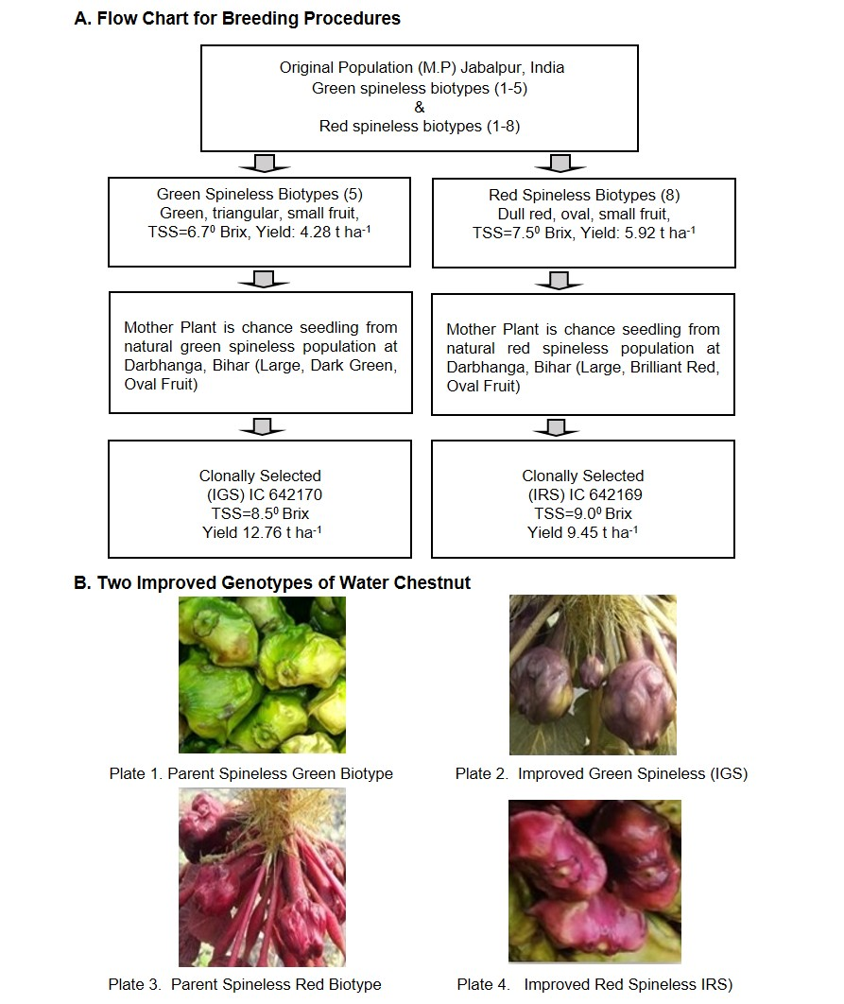
Fig. 1. Breeding Methodology and phenotypes of the improved varieties and their parents
3.2 RAPD and ISSR analysis on IRS, IGS and two controls
Though the plant and fruit color of IGS and RSSL are different, that of IRS and RSLL are very similar (Table 1). The genome of water chestnut is not yet sequenced and hence SSR markers are not available. Therefore, molecular marker analysis using 10 RAPD and 10 ISSR markers, which do not require prior sequence information (Nayak, 2024), was undertaken to differentiate them at genomic level. A representative profile of RAPD and ISSR marker is presented in Fig. 2. RAPD primers generated a total 57 fragments across all 4 varieties of which 45 fragments were polymorphic (Table 2.). RAPD markers generated 2-10 number of fragments in a range of 230 bp to 2300 bp wherein AP-22 generated least number of fragments and AP-30 genera ted highest number (Table 2.). PIC of the markers ranged from 0.19 to 0.5, MI of the markers was 0.19 to 3.6 and RP ranged from 1 to 8 (Table 2.). Of the 10 ISSR markers tested two markers did not work and the remaining eight ISSR markers generated a total of 58 fragments of which 33 fragments were polymorphic with a PIC of 0.05-0.4, MI of 0.007 to 6.8 and RP of 0.5 to 10.5 (Table 3.). Average number of bands and polymorphic bands per primer for RAPD markers was 5.70 and 4.50 respectively while that for ISSR markers was 7.25 and 4.10 respectively (Table 4.).
Table 1. Morphological characteristics of four genotype of Trapa
S.No. | Genotypes | Cultivar | Fruit Colour | No. of Spine | Fruit weight(g) | Fruit Shape
1. | Trapa natans | Improved Green Spineless | Green | 0 | 30.2 | Oval
2. | Trapa bispinosa | Red Spine Large Local (RSLL) | Red | 2 | 26.7 | Triangular
3. | Trapa natans | Improved Red Spineless | Red | 0 | 19.5 | Oval
4. | Trapa bispinosa | Red Spine Small Local (RSSL) | Red | 2 | 12.5 | Traingular
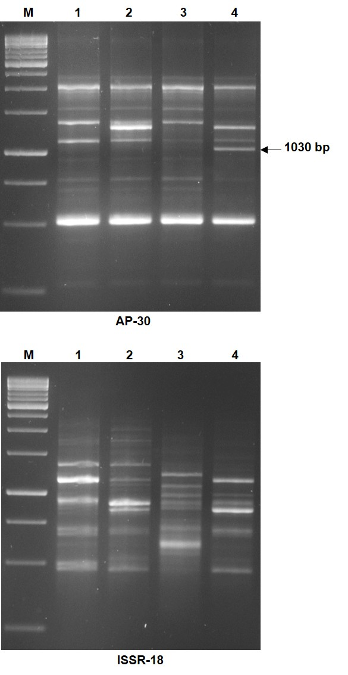
Fig. 2. Profile of four water chestnut varieties with a RAPD (AP-30) and ISSR (ISSR-18) marker. Lane 1. Red Small Spine Local (RSSL), Lane 2. Improved Green Spineless (IGS), Lane 3. Red Spin Large Local (RSLL), Lane 4. Improved Red Spineless (IRS). M is the 1Kb Molecular weight size standard

Table 2. RAPD markers used on the four water chestnut genotypes and their diversity indices
S.No | Primer Name | Primer Sequence  5’-3’ | Size range  (bp) | No. of Fragments | No. of Polymorphic Fragments | % of Poly-  morphism | PIC | RP | MI
1 | AP-1 | AGCCAGCGAA | 280-1100 | 4 | 4 | 100 | 0.38 | 2 | 1.52
2 | AP-4 | CAAACGTCGG | 350-1700 | 9 | 9 | 100 | 0.4 | 5.5 | 3.6
3 | AP-5 | GTTGCGATCC | 230-1200 | 5 | 3 | 60 | 0.23 | 1.5 | 0.42
4 | AP-11 | ATGCTCCGAG | 350-2050 | 5 | 5 | 100 | 0.5 | 5 | 2.5
5 | AP-16 | GACGTACCCT | 850-1400 | 3 | 3 | 100 | 0.46 | 2.5 | 1.38
6 | AP-22 | AAGGCGCGAACG | 1050-1400 | 2 | 0 | 0 | 0.0 | 0 | 0
7 | AP-30 | GGACCTCCATCG | 520-2300 | 10 | 7 | 70 | 0.29 | 4.5 | 1.4
8 | AP-32 | AACATCTCCGGG | 650-1550 | 9 | 8 | 88.9 | 0.44 | 8 | 3.1
9 | AP-36 | TATCCTACCGGC | 600-1750 | 4 | 2 | 50 | 0.19 | 1 | 0.,19
10 | AP-39 | CTTGAGGGATGG | 700-1750 | 6 | 4 | 66.7 | 0.33 | 4 | 0.87
Total |  |  |  | 57 | 45 | 735.6 | 3.22 | 34 | 14.98
Average |  |  |  | 5.7 | 4.5 | 73.56 | 0.32 | 3.4 | 1.5
PIC: Polymorphism information contents; RP: Resolving power; MI: Marker index

Table 3. ISSR markers used on the four water chestnut genotypes and their diversity indices
S.  No. | Primer Name | Primer Sequence  5'-3' | Size range  (bp) | No. of Fragments | No. of PF | % of Poly-  morphism | PIC | RP | MI
1 | ISSR-23 | AGTAGTAGTTCTCTCTCTCTCTC | 300-1500 | 5 | 2 | 40 | 0.18 | 1.5 | 0.14
2 | ISSR-18 | CACACACACACACACAAGC | 480-2000 | 17 | 17 | 100 | 0.4 | 10.5 | 6.8
3 | ISSR-4 | ACACACACACACACACGA | 400-2200 | 9 | 6 | 66.7 | 0.25 | 3 | 1.0
4 | ISSR-5 | GAGAGAGAGAGAGAGAC | 600-1600 | 6 | 3 | 50 | 0.21 | 2 | 0.32
5 | ISSR-11 | AGAGAGAGAGAGAGAGG | 250-1100 | 9 | 4 | 44.4 | 0.2 | 2.5 | 0.35
6 | ISSR-10 | GAGAGAGAGAGAGAGAT | 550-1800 | 7 | 1 | 14.3 | 0.05 | 0.5 | 0.007
7 | ISSR-12 | CTCTCTCTCTCTCTCTA | 180-1300 | 4 | 0 | 0 | 0 | 0 | 0
8 | ISSR-6 | ACACACACACACACACC | 450 | 1 | 0 | 0 | 0 | 0 | 0
Total |  |  |  | 58 | 33 | 315.4 | 1.29 | 20 | 8.62
Average |  |  |  | 7.25 | 4.1 | 39.4 | 0.16 | 2.5 | 1.08
PF: Polymorphic Fragments, PIC: Polymorphism information contents, RP: Resolving power, MI: Marker index

Table 4. Banding patterns of RAPD and ISSR markers used on four water chestnut genotypes

Components | RAPD | ISSR
Total number of primers | 10 | 8
Total number of bands | 57 | 58
Total number of polymorphic bands | 45 | 33
Percentage of polymorphism | 73.56 | 39.40
Average number of bands /primer | 5.70 | 7.25
Average number of polymorphic bands/primer | 4.50 | 4.10

3.3 Cluster analysis

Marker data on RAPD and ISSR markers separately and together was used to construct a dendrogram based on Jaccard's coefficient. Using RAPD markers two groups are formed where IRS and RSSL formed one group and RSLL and IGS formed another group (Fig. 3A.) whereas based on ISSR markers RSLL formed one group while other three formed another group (Fig. 3B.). However, in the second group, IGS and RSSL formed a separate sub group. Factorial analysis based on RAPD markers and ISSR markers also suggest that IGS and RSLL diverge from IRS and RSSL supporting the cluster analysis (Fig. 4.). When both RAPD and ISSR data was combined to construct a dendrogram, again two groups were formed one with RSLL and IGS and another with IRS and RSSL (Fig. 3C.) and the factorial analysis has clearly shown that all four varieties are different from one another (Fig.4.).

In this study we found that RAPD markers generated more polymorphic fragments compared to ISSR markers (Table 4.) and the average PIC, MI and RP of RAPD markers is higher when compared to that of ISSR markers which suggests that RAPD makers are efficient in detecting variation among the water chestnut cultivars. However, in other crops ISSR markers are found to be more informative than RAPD markers (Elmeer et al. 2017; Phong et al. 2011).

Fig. 3. Dendrograms derived from UPGMA analysis using Jaccard’s coefficient for A. RAPD markers, B. ISSR markers C. Combined RAPD and ISSR markers.

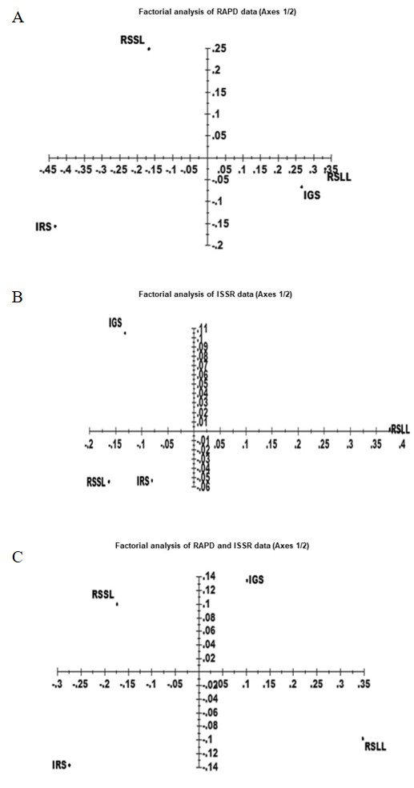

Fig.4. Factorial analysis with A. RAPD B. ISSR and C. combined RAPD and ISSR markers

3.4 Identification of unique DNA fragments in improved cultivars

Trapa species being allogamous, heterogeneity exists in the natural population (Sarmah et al. 2007). Fruit color, size, number of fruits per plant, and spine variation were considered while selecting for improved cultivars. The value of molecular analysis of water chestnut cultivars has been earlier demonstrated (Hoque et al. 2005; Mahto et al. 2018). Hoque et al. (2005) observed that the RAPD markers AP-1, AP-4, AP-5, AP-11, AP-16, AP-22, and AP- 30 are the most polymorphic markers among the water chestnut cultivars.

A unique 1030 bp fragment with AP 30 (Fig.2.) and two unique fragments of 550 bp and 800 bp with AP-4 (Fig. 5A.) RAPD markers were specifically amplified in IRS genotype which are not amplified in other three cultivars. Similarly, ISSR marker ISSR 23 amplified a 1350 bp fragment only in IGS cultivar (Fig. 5B.). These unique fragments can be used as markers for identification of improved cultivars. The genotype specific diagnostic fragments of RAPD and ISSR markers can be converted into SCAR markers (Cho et al., 2015; Deng et al., 2022) for the efficient utilization of these markers in the identification of the varieties as they are more reproducible than RAPD and ISSR markers.
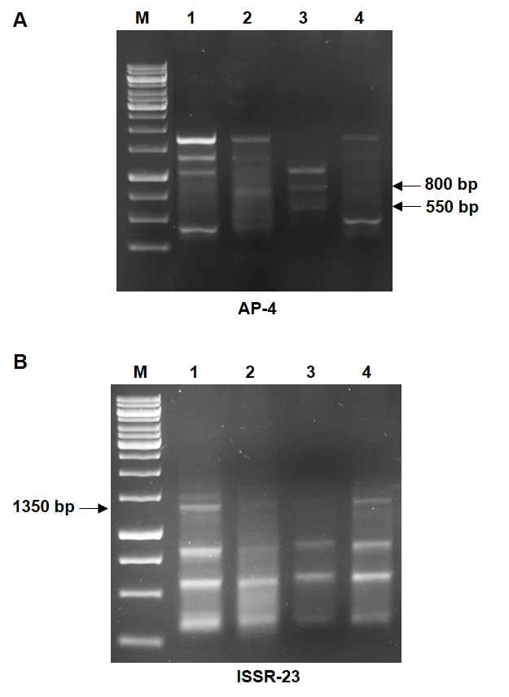

Fig. 5. Profile of four water chestnut varieties with a RAPD (AP-4) and ISSR (ISSR-23) marker. A. AP-4 showing the unique 550 bp and 800 bp fragments in IRS cultivar. B. ISSR-23 showing the unique 1350 bp fragment in IGS cultivar. Lane 1. Improved Green Spineless (IGS), Lane 2. Red Spine Large local (RSLL), Lane 3. Improved Red Spineless (IRS), Lane 4. Red Small Spine Local (RSSL), M is the 1Kb Molecular weight size standard.

- CONCLUSION
Thus, we have developed two improved cultivars of water chestnut that are registered by the NBPGR and we were able to differentiate them from the locally popular cultivated varieties using RAPD markers and ISSR markers. The National Research Centre of Makhana, ICAR, India, has developed the first ever improved water chestnut cultivars in India viz; IRS and IGS which are registered as IC 642169 (Swarna Lohit) and IC 642170 (Swarna Harit), respectively (Jana et.al. 2023; Singh et al. 2024).

Disclaimer (Artificial intelligence)
Author(s) hereby declare that NO generative AI technologies such as Large Language Models (ChatGPT), have been used during the writing or editing of manuscripts manuscript.

REFERENCES
Akhtar, S. F., Rao, E. G., Uike, A R., & Saatu, M. (2023). Plant Breeding Stategies: Traditional and Modern Approaches. In D. K. Janghel Jogender, S. A. Aware, A. S. Jondhale & C. Ratilal (EDS.), Genetic Revolution in Agriculture: Unleashing the Power of Plant Genetics (1st edition, pp. 21-43). Delhi: Elite publishing house.
Amiteye, S. (2021). Basic concepts and methodologies of DNA marker systems in plant molecular breeding. Heliyon, 7, e08093.

Chandana, M., Mazumder, R., & Chakraborthy G. S. (2013). A review on potential of plants under Trapa species. International Journal of Research in Pharmacy and Chemistry, 3, 502-508.

Cho, K. H., Noh, J. H., Park, S. J., Kim, S. H., Kim, D. H., & Chun J.A. (2015). Development of sequence characterized amplified region markers for the identification of grapevine cultivars. Hortic. Sci., 50, 1744–1750.

Crow, G. E., & Hellquist C. B. (2000). Aquatic and wetland plants of Northeastern North America (Vol.1). Pteridophytes, Gymnosperms and Angiosperms: Dicotyledons. The University of Wisconsin Press, pp. 206–207.

Deng, H., Khan, M.A., Liu, X., Fu, J., & Mei, Z. (2022) Identification of SCAR markers for genetic authentication of Dendrobium nobile Lindl. Braz J Biol., 82, e260394. https://doi.org/10.1590/1519-6984.260394

Elmeer, K., Alghanem, M., Al Latifi, L., & Alhemairi H. (2017). Efficiency of RAPD and ISSR markers for the detection of polymorphisms and genetic relationships in date palm. Biotech., 16, 19-26.

Hoque, A., Anai, T., & Arima, S. (2005). Analysis of molecular diversity in water chestnut based on RAPD markers. Biotech., 4, 144-148.
Hummel. M., & Erik, K., (2004). Review of world literature on water chestnut with implications for management in north America. J. Aquat. Plant Manage., 42, 17-28.

Jana, B. R. (2022). Recent production and marketing scenarios of water chestnut (Trapa natans L.) in India. Agricultural Reviews, 10, 18805/ag. R-2555.

Jana, B., Anupama, K., Vaishna, R. & Das A. (2023). Development of two elite water chestnut genotypes (Trapa spp.) and their molecular characterization using RAPD and ISSR markers. Research Square (Preprint). April 12, 2023. http://doi.org/10.21203/rs.3.rs-2741203/v1

Kachare, S., Tiwari, S. & Tripathi, N. (2013). Morphological and molecular assessment of genetic diversity of water chestnut (Trapa natans) from different ponds of central India. World Res J. of Cell Bio., 1, 28-31.

Kayis, S. A., Hakki, E. E. & Pinarkara, E. (2010). Comparison of effectiveness of ISSR and RAPD markers in genetic characterization of seized marijuana (Cannabis sativa L.) in Turkey. Afr. J. of Agril. Res., 5, 2925–2933.

Kumari, A., Paul, S., & Sharma, V. (2016) Genetic diversity analysis using RAPD and ISSR markers revealed discrete genetic makeup in relation to fibre and oil content in Linum usitatissimum L. genotypes. Nucleus, 61, 45–53.

Lamichhane, S. & Thapa, S. (2022) Advances from conventional to Modern Plant Breeding Methodologies. Plant Breed. Biotech., 10, 1-14.

Mahto, K. M., Shaheen, A., Kumari, S., Singh, I.S. & Kumar N. (2018). DNA polymorphism analysis of Indian germplasms of Trapa natans using RAPD molecular marker. Biocatalysis & Agril. Biotech., 15, 146-149.

Mandal, L., Verma, S.K., Sasma, S., & Katara, J. (2018). Potential applications of molecular markers in plant. Curr. Trends Biomedical Eng. Biosci., 12, CTBEB.MS.ID.555844.

Nayak, M. S. (2024). Significance of RAPD and ISSR markers. Agriallis, 6(3), 55-58.

Perrier, X., & Jacquemoud-Collet, J. P. (2006). DARwin software 2006, http://darwin.cirad.fr/darwin.

Phong, D. T., Hien, V. T. T., Thanh, T. T. V. & Tang, D.V. (2011). Comparison of RAPD and ISSR markers for assessment of genetic diversity among endangered rare Dalbergia oliveri (Fabaceae) genotypes in Vietnam. Genet. Mol. Res., 10, 2382-2393.

Rajput, J.D., & Singh, S.P. (2023). Water Chestnut (Trapa natans L.): Functional characteristics, nutritional properties and applications in food industry: a review. J. Phytopharm., 12 (2), 119-126.

Roldan-Ruiz, I., Dendauw, J., Bockstaele, V., Depicker, A., & Loose, M. (2006). AFLP markers reveal high polymorphic rates in ryegrasses (Lolium spp.). Mol. Breed., 6, 125–134.

Sarmah, P., Barua, P. K., Sarma, R. N., Sen, P., and Deka, P. C. (2006). Genetic diversity among rattan genotypes from India based on RAPD-marker analysis. Genet. Resour. Crop Evol., 54, 593–600.

Singh, I., Tarate, S., & Thakur, A. (2024). Water Chestnut (Trapa natans) a Crop of High Nutritional and Economical Importance-Recent Guidelines on Farming Practices. Journal of Scientific Research and Reports, 30(6), 310–321. https://doi.org/10.9734/jsrr/2024/v30i62046
Zhang, F., Yang, Z., Hong, N., Wang, G., Wang, A., & Wang, L. (2019). Identification and characterization of water chestnut soymovirus-1 (WCSV-1), a novel soymovirus in water chestnuts (Eleocharis dulcis). BMC Plant Biol., 19, 1–14.

