Effects of Dietary Inclusion of Chili (Capsicun annuum L.) Leaf Powder on Haemato- Biochemical Profile and Profitability of Rhode Island Red Laying Hens

Abstract
The objective of this study was to investigate the effects of dietary incorporation of chili (Capsicum annuum L.) leaf powder on haemato- biochemical profile and profitability of Rhode Island Red laying hens. Rhode Island Red laying hens were individually weighed and then randomly assigned into four treatment groups with three replicates of 6 birds each. Treatments were arranged into- T1: (control, containing basal diet); T2: inclusion of 0.5% chili leaf powder in basal diet; T3: inclusion of 1.5% chili leaf powder in basal diet; T4: inclusion of 2.5% chili leaf powder in basal diet. Data was analyzed with one way ANOVA, followed by Duncan’s Multiple Range test was used for multiple comparisons using SPSS. Our results indicate that the haemato-biochemical parameters were not significantly affected by the inclusion levels of chili leaf powder. The average feed intake was found to be significantly (P ≤0.05) lowered in T4 group followed by T3, T1 and T2 group. Significantly (P ≤0.05) reduced average feed cost/dozen eggs was observed in T4 treatment group (2.5% CLP) as compared to T3, T1 and T2 group. It can be concluded that chili leaf powder up to the level of 2.5% incorporation in the basal diet has beneficial effects in the RIR laying hens as it reduces average feed cost/dozen eggs. Future research should focus on production performance and formulation optimization to enhance its practical utility in sustainable poultry production.
Keywords: Biochemical parameters, chili leaves powder, haematology, Rhode Island Red laying hens, profitability

1. INTRODUCTION
“Over the past three decades, the production of poultry eggs increased significantly by 150%” (Bist et al., 2024). “The global population is projected to reach approximately 9.7 billion by the year 2050, leading to a significant increase in the demand for poultry products. The expansion of poultry products presents considerable challenges and risks for the sustainable development of poultry production. These challenges include the scarcity of traditional feed resources and the competition between animal feed and essential human food staples” (Govoni et al., 2021; Henchion et al., 2021). “Nearly 95% of total eggs produced in India are from chickens, with the remaining 5% coming from ducks and other poultry species. This indicates the domination of chickens in the poultry industry in India” (DADF, 2014). Feed cost accounts for 60 to 75% of the total cost of poultry production. The unavailability and consequently high costs of conventional chicken feed have severely affected poultry production. Thus, finding economical, cost-effective, and locally available feed alternatives to substitute or replace conventional feed sources could help to reduce poultry feed costs.
“Chili pepper (Capsicum annuum L.) is a globally cultivated and consumed vegetable, primarily utilized for its fresh and cooked fruits. It is also used as a natural feed additive in poultry to improve the growth performance and health of animals (Abd El-Hack et al., 2022; Munglang and Vidyarthi, 2019). Capsaicin (8-methyl-N-vanilla base-6-nonene amide) is the primary bioactive component of chili pepper, accounting for 0.1 to 0.2% of its dry weight” (Govindarajan and Sathyanarayana, 1991). “Studies have demonstrated that capsaicin possesses antioxidants, anti-inflammatory, and antimicrobial properties and regulates lipid metabolism and the gut microbiome” (Prakash and Srinivasan, 2010).
Chili leaves are one of the important agro- industrial wastes of chili farming after harvesting the chili which are not used for human consumption. Hence, chili leaves powder can be added to the list of possible feed alternatives for laying hens feeding. This study was designed to investigate the effects of dietary inclusion of chili (Capsicun annuum L.) leaf powder on haemato- biochemical profile and profitability of Rhode Island Red laying hens .
2. MATERIALS AND METHODS
2.1 Experimental Location
The entire study was conducted at Instructional Poultry Farm (I.P.F.) and Department of Animal Nutrition, College of Veterinary and Animal Sciences, G.B. Pant University of Agriculture and Technology, Pantnagar located at latitude of 28⁰53’24” North, longitude of 77⁰34’27” East at an altitude of 243.84 meters above Mean Sea Level.

2.3 Experimental Design, Treatment and Housing Management
For this feeding trial, seventy two (72), Rhode Island Red laying hens of 28 weeks of age were procured and randomly divided into four treatment groups with three replications having six (6) hens in each in a completely randomized block design. Laying hens were reared in a deep litter system using standard management and health care practices throughout the entire experiment. The birds were individually weighed and leg banded for identification before being assigned to each treatment group. Health of the experimental stock and mortality rate were closely observed and recorded daily. The entire study was investigated further by dividing the 12-week trial into three periods, period-1 (28-32 weeks), period-2 (32-36 weeks), period-3 (36-40 weeks) and overall period (28-40 weeks).
List 1. Experimental design and treatments
Groups | Treatment | No. of birds/  replicate | No. of replicates | Total No. of  birds
T1 | Control (Basal diet) | 06 | 03 | 18
T2 | Basal diet with 0.5% chili leaf powder | 06 | 03 | 18
T3 | Basal diet with 1.5% chili leaf powder | 06 | 03 | 18
T4 | Basal diet with 2.5 % chili leaf powder | 06 | 03 | 18

2.4 Experimental Diet
Standard laying hen basal diets were prepared by combining ingredients to meet the birds' nutritional requirements, as recommended by BIS (2007) presented in Table 1. Chemical analysis was conducted by the method of AOAC, (2003). Feed ingredients required for the formulation of the experimental diet were procured from the feed unit and all the ingredients were ground in feed mill before mixing at the feed unit of the farm.

Table 1: Ingredient composition used for formulation of Rhode Island Red laying hens' diets

Ingredients (%) | Basal diet | T1 | T2 | T3
Yellow Maize | 57.0 | 56.50 | 56.50 | 56.50
Deoiled Rice bran | 6.50 | 6.50 | 5.50 | 4.50
Rice Polish | 4.50 | 4.50 | 4.50 | 4.50
Groundnut cake- Solvent extracted | 09.0 | 09.0 | 09.0 | 09.0
Soyabean meal | 18.0 | 18.0 | 18.0 | 18.0
Chili leaf powder | - | 0.50 | 1.50 | 2.50
Marble powder | 03.0 | 03.0 | 03.0 | 03.0
Dicalcium Phosphate | 01.0 | 01.0 | 01.0 | 01.0
DL-Methionine | 0.15 | 0.15 | 0.15 | 0.15
Choline chloride | 0.10 | 0.10 | 0.10 | 0.10
Mineral mixture | 0.10 | 0.10 | 0.10 | 0.10
Common salt | 0.40 | 0.40 | 0.40 | 0.40
Hepatocare | 0.10 | 0.10 | 0.10 | 0.10
Vitamin Premix | 0.10 | 0.10 | 0.10 | 0.10
Toxin binder | 0.05 | 0.05 | 0.05 | 0.05
Total | 100 | 100 | 100 | 100
Chemical composition (% DM basis) (Calculated)
Crude Protein (%) | 18.13 | 18.12 | 18.07 | 18.02
Metabolisable Energy (kcal/kg) | 2651.75 | 2651.71 | 2651.63 | 2651.42
Calcium (%) | 3.74 | 3.74 | 3.74 | 3.74
Total phosphorus (%) | 0.65 | 0.65 | 0.65 | 0.65

2.5 Procurement of Chili Leaves and Preparation of Leaf Powder
Chili (Capsicun annuum L.) leaves were collected from the plants in the local area of Jaspur, Udham Singh Nagar, Uttarakhand in the month of February 2022. The leaves were first dried for 3-4 days after being picked up, followed by sun drying on a clean concrete floor followed by drying in a hot air oven set to 70°C until they attained consistent weight. Dried chili leaves were then finely ground into powder and kept in sealed plastic bags. The proximate analysis of chili (Capsicum annuum) leaf powder was determined as per the method of AOAC (2003) and presented in Table 2.
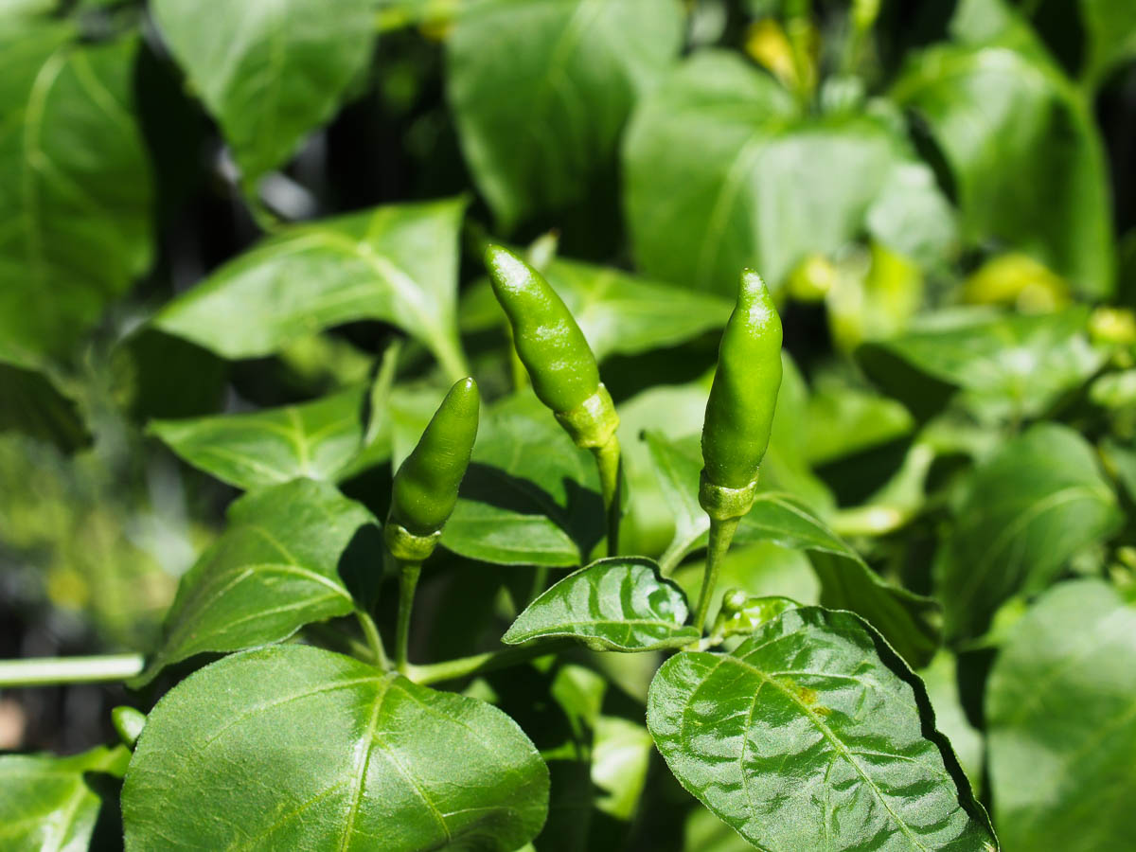
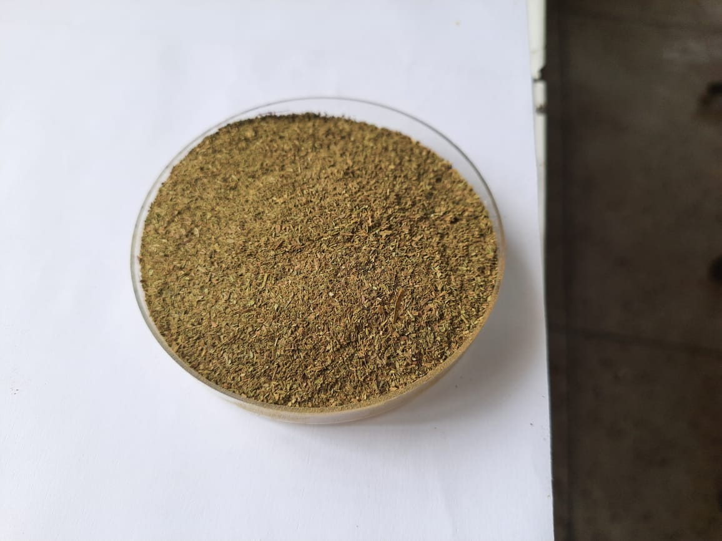
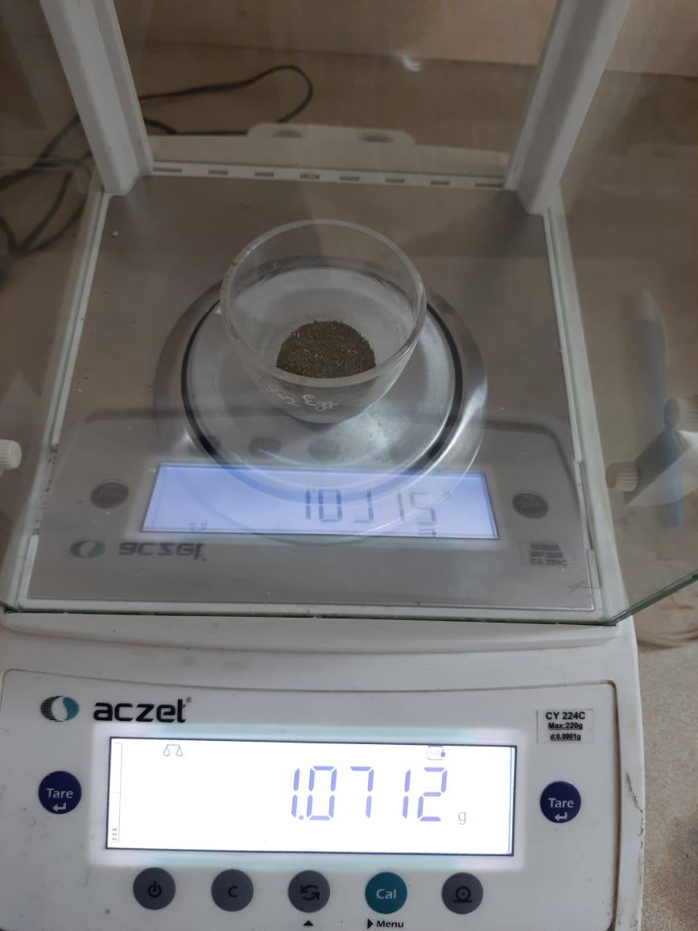

Fig 1. Steps Indicating the Procurement of Chili Leaves and Preparation of Leaf Powder
2.6 Haemato-biochemical Parameters
At the end of the experiment, and after fasting for 12 hours two hens from each replicate were selected for blood sample collection. Three ml of blood was collected into well labeled blood collecting vials containing EDTA which act as anticoagulant for haematological analysis. Simultaneously, 1.5 ml blood was dispensed into another set of vials (without anticoagulant) and allowed to stand for three to four hours at room temperature in slanting position for clotting. After clotting of blood, serum samples were separated by centrifuging at 3000 rpm for 10-15min and collected into Eppendorf tube and was kept at -20⁰C in a deep freeze for serum biochemical parameter analysis. Haematological profile including total erythrocyte count (TEC), haematocrit (PCV), haemoglobin (Hb) and differential leucocytes count (DLC) were analyzed . Haemoglobin concentration (g/dl) was estimated by the procedure outlined by Sharma and Singh (2000) using Sahil’s haemoglobinometer with acid haematin method. Micro haematocrit method was used to estimate PCV as described by Sharma and Singh (2000). Fresh anticoagulant added blood was drawn into micro-capillaries and sealed with wax at one end. Capillaries were centrifuged at 10,000 rpm for 30 minutes. PCV was directly measured using Citro Cap Microhematocrit tube reader and expressed in percent. For total erythrocytes count (TEC) Neubauer's chamber was used for counting the red blood cells, as described by Jain (1986). The TEC (total erythrocyte counts) were expressed in million per microlitre (10⁶/µl). Serum glucose, serum cholesterol, albumin, total protein, calcium and phosphorus parameter were analyzed by Erba diagnostic kit.
2.7 Economics of egg production of Rhode Island Red laying hens
The purchase price of all the ingredients used in formulating the ration was considered and feed cost was calculated. The average dozen egg production was calculated using data obtained from daily observations. The economics of the dozen egg production in each treatment group was determined by calculating the cost of total feed consumed divided by dozen egg production. The average feed cost per dozens of eggs was estimated by multiplying the amount of feed consumed (in kg) over the time by the cost of per kg feed.

2.8 Statistical Analysis
The data were presented as means ± standard error (SE). Statistical analysis was conducted using SPSS version 20 (Snedecor and Cochran, 1994). One-way ANOVA, followed by Duncan’s Multiple Range test was used for multiple comparisons (Kramer, 1957). Statistical differences were determined at the P<0.05 level of significance.
3. RESULTS AND DISCUSSION:
3.1 Nutrient profile of chili (Capsicum annuum) leaf powder
Data pertaining to nutrient composition of chili (Capsicum annuum) leaf powder on (% dry matter basis) fed to laying hens is presented in Table 2.
Table 2: Chemical composition of chili (Capsicum annuum) leaf powder (on% dry matter basis)
Nutrients | Chili Leaf powder (%)
Crude Protein | 6.78
Crude Fibre | 14.52
Ether Extract | 7.89
Total Ash | 5.15
Nitrogen Free Extract | 65.66

3.2 Chemical Composition (%DM Basis) of Experimental Diet Fed to Rhode Island Red laying hens
The proximate composition (%DM basis) of experimental diets fed to Rhode Island Red laying hens is presented in Table 3. Experimental diet was formulated as iso-nitrogenous and iso-caloric to meet the nutritional requirements per BIS (2007) recommendation.

Table 3: Chemical composition of diet (% dry matter basis) provided to different treatment groups
Nutrients | Treatments
Nutrients | T₁ | T₂ | T₃ | T₄
Crude  Protein | 17.56 | 17.50 | 17.40 | 17.29
Ether  Extract | 3.8 | 3.79 | 3.81 | 3.72
Crude  Fibre | 4.19 | 4.28 | 4.45 | 4.35
Total Ash | 9.72 | 9.13 | 8.89 | 8.62
Nitrogen  Free Extract | 64.73 | 65.30 | 65.45 | 66.02
{T₁ : Basal diet; T₂: Basal diet with chili leaf powder (0.5% ); T₃: Basal diet with chili leaf powder (1.5% ); T₄ : Basal diet with chili leaf powder (2.5% )

3.3 Effect of dietary inclusion of chili leaf powder on haematological indices:
The data on the haematological indices of the laying hen fed diet incorporated with chili leaf powder on 90th day of the feeding trial is shown in Table 4.
Table 4 : Average values of haematological parameters in laying hen fed diets incorporated with chili leaf powder
Attributes | Treatments
Attributes | T₁ | T₂ | T₃ | T₄ | P- Value
Hb (g/dl) | 9.40±0.32 | 10.03±0.62 | 9.67±0.43 | 9.67±0.64 | 0.862
PCV (%) | 30.00±1.76 | 30.17±1.48 | 30.33±0.67 | 30.50±2.00 | 0.991
TEC (×10⁶ /μl) | 3.08±0.04 | 3.10±0.06 | 3.13±0.11 | 3.23±0.14 | 0.770
T LC (×10³/μl) | 30.52±0.97 | 30.82±1.06 | 30.90±0.45 | 31.17±0.78 | 0.963
MCV (fl) | 97.04±6.19 | 98.16±4.57 | 98.41±5.19 | 94.86±8.39 | 0.981
MCH (pg) | 30.40±1.36 | 31.03±1.31 | 31.46±2.26 | 30.01±2.55 | 0.950
MCHC (g/dl) | 31.47±0.86 | 31.66±0.92 | 31.84±0.79 | 31.67±0.12 | 0.990
{T₁ : Basal diet; T₂: Basal diet with chili leaf powder (0.5%); T₃: Basal diet with chili leaf powder (1.5%); T₄ : Basal diet with chili leaf powder (2.5%)}

As presented in Table 4, no difference (P≥0.05) was observed in the haemoglobin concentration, packed cell volume, total erythrocytes count (×10⁶/μl), total leukocyte count (×10³/μl), mean corpuscular volume (fl), mean corpuscular haemoglobin (pg) , mean corpuscular haemoglobin concentration (g/dl) across the treatment groups. This results were agreement with Egbewande, (2018) who observed non-significant differences in hematological indices of broiler chicken fed a diet supplemented with hot red pepper (Capsicum annuum) powder. Similarly, Adedoyin et al. (2019) found non significant effect on blood haemoglobin content in broiler chickens supplemented with hot red pepper (Capsicum annuum) powder. Furthermore, Siddiqui et al. (2022) found non-significant differences in blood haemoglobin concentration, PCV, TEC, TLC, MCV, MCH, MCHC of commercial laying hens fed a diets incorporated with mulberry (Morus alba) leaf powder. Also, Kaur et al. (2022) who observed non-significant differences in blood parameters of the commercial laying hens fed a diets incorporated with Eucalyptus (Eucalyptus globulus) leaf powder. Likewise, Cai et al. (2019) also reported non-significant differences in blood parameters of the rats when supplemented with mulberry leaf powder. Similarly, Motaal et al. (2008) and Mashyekhi et al. (2018) reported no effect on hematological indices with supplementation of eucalyptus leaf powder in the diet of laying hens and broilers, respectively. Also, Fathi et al. (2019 and 2020) reported the similar observation in rabbits and Japanese quail.
3.4 Effect of dietary inclusion of chili leaf powder on serum biochemical indices:
The data on the serum biochemical profile of the laying hens fed diet incorporated with chili leaf powder on the 90th day of the feeding trial is presented in Table 5.
Table 5 : Average values of serum biochemical parameters in laying hen on the 90th days period fed diets incorporated with chili leaf powder
Attributes | Treatments
Attributes | T₁ | T₂ | T₃ | T₄ | P- Value
Glucose (mg/dl) | 210.71±8.25 | 205.53±3.30 | 206.04±5.09 | 209.39±5.08 | 0.911
Cholesterol (mg/dl) | 151.69±1.20 | 150.24±2.26 | 148.48±2.59 | 143.33±1.20 | 0.073
Triglyceride (mg/dl) | 211.39±0.20 | 211.03±1.76 | 211.11±1.92 | 207.75±0.63 | 0.262
Total protein (g/dl) | 4.25±0.15 | 4.48±0.29 | 4.79±0.80 | 4.97±0.47 | 0.314
Globulin (g/dl) | 2.94±0.19 | 3.07±0.20 | 3.37±0.85 | 3.60±0.46 | 0.742
Albumin (g/dl) | 1.33±0.04 | 1.41±0.10 | 1.41±0.11 | 1.37±0.08 | 0.990
Calcium (mg/dl) | 22.03±0.42 | 22.56±0.38 | 21.83±1.57 | 21.50±1.52 | 0.920
Phosphorus (mg/dl) | 5.56±0.03 | 5.59±0.03 | 5.57±0.07 | 5.61±0.18 | 0.981
SGPT (U/I) | 24.58±0.26 | 24.13±0.87 | 24.80±0.82 | 24.45±0.73 | 0.922
SGOT (U/I) | 60.22±0.09 | 59.43±1.43 | 59.62±0.48 | 59.91±0.15 | 0.891
{T₁ : Basal diet; T₂: Basal diet with chili leaf powder (0.5%); T₃: Basal diet with chili leaf powder (1.5%); T₄ : Basal diet with chili leaf powder (2.5%)}

As presented in table 5, no difference (P≥0.05) was detected in the serum glucose content, serum cholesterol, triglyceride concentration, serum total protein level, serum globulin, serum albumin concentration, serum calcium and phosphorus levels, SGPT and SGOT level across the treatment groups. These results are in agreement with Egbewande, (2018) who observed a non-significant differences in serum biochemical profile of broiler chicken fed a diet supplemented with hot red pepper (Capsicum annuum) powder. Similarly, Kaur et al. (2022) who observed non-significant differences in serum biochemical attributes among the treatment groups, but a considerable decreased in level of serum cholesterol and triglycerides was observed with an increasing level of eucalyptus leaf powder in diet of laying hens. But Islam et al. (2014) also observed a significant reduction in total cholesterol and triglyceride content in broilers supplementation at day 22 to 42 with mulberry leaf meal as compared to the control and antibiotic groups.
3.5 Cost Benefit Analysis:

The average values of egg production (Rs.) from 28-40th weeks of experimental feeding trial fed diet incorporated with chili (Capsicum annuum) leaf powder are presented in Table 6.
Table 6: Economics of egg production (Rs.) of Rhode Island Red laying hens during 28- 40 weeks (90 days) period fed diet incorporated with chili leaf powder
Attributes | Treatments
Attributes | T₁ | T₂ | T₃ | T₄ | SEm value | P value
Cost/ kg feed/bird (Rs.) | 25.72±0.03^{d} | 25.62±0.01^{c} | 25.13±0.01^{b} | 24.09±0.01ª | 0.195 | 0.001
Average dozen eggs | 4.46±0.41 | 4.43±0.06 | 4.50±0.18 | 4.60±0.11 | 0.052 | 0.757
Average feed intake (kg) | 10.84±0.01ª | 11.11±0.30ª | 10.31±0.31^{ab} | 9.88±0.26^{b} | 0.179 | 0.037
Total feed cost (Rs.) | 279.13±0.01^{ab} | 284.72±7.68ª | 259.27±7.97^{b} | 238.02±6.30^{c} | 6.168 | 0.003
Feed cost/ dozen eggs (Rs.) | 62.59±0.58^{ab} | 64.17±1.35ª | 57.71±2.39^{b} | 51.80±1.91^{c} | 1.625 | 0.004
T₁ : Basal diet; T₂: Basal diet with chili leaf powder (0.5%); T₃: Basal diet with chili leaf powder (1.5%); T₄ : Basal diet with chili leaf powder (2.5%)
^{a,b ,c} Mean values bearing different superscripts within a row differ significantly from each other,*P≤0.05

As presented in Table 6, the calculated cost of per kg feed (in Rs.) of different treatment groups T1, T2, T3 and T4 fed diet incorporated with chili leaf powder were 25.72, 25.62, 25.13 and 24.09 Rs., respectively. There was a significant (P ≤0.05) effect on average feed intake due to dietary incorporation of chili leaf powder in RIR laying hens. Average feed intake was found to be significantly (P ≤0.05) lowered in T4 group followed by T3, T1 and T2 group. Lowest cost per kg feed was observed in T4 (238.02 Rs.) group in which 2.5% CLP was incorporated as, chili leaves was procured from local area without any cost. So, Average feed cost/ dozen eggs was significantly (P ≤0.05) reduced in T4 treatment group (2.5% CLP) as compared to T3 and T1 group.
4. CONCLUSION:
Based on the findings of the present study, it can be concluded that chili leaf powder up to the level of 2.5% incorporation in the basal diet has beneficial effects in the RIR laying hens as it reduces average feed cost/dozen eggs. Furthermore, its incorporation is cost effective with some additional benefits on the egg quality parameters in terms of improvement of yolk colour pigmentation which might help in increasing the demand for such eggs by the consumers.
Ethical Approval
The experiment protocol was conducted in accordance with the guidelines for Institutional Animal Ethical Committee of GBPUAT, Pantnagar, ( no: IAEC/CVAS/ANN/711 )
DISCLAIMER (ARTIFICIAL INTELLIGENCE)
Author(s) hereby declare that no generative AI technologies such as Large Language Models (Chat GPT, COPILOT, etc) and text-to-image generators have been used during writing or editing of this manuscript.
REFERENCES:
Abd El-Hack, M.E., El-Saadony, M.T., Elbestawy, A.R., Gado, A.R., Nader, M.M., Saad, A. M., El-Tahan, A.M., Taha, A.E., Salem, H.M. & El-Tarabily, K.A. (2022). Hot red pepper powder as a safe alternative to antibiotics in organic poultry feed: an updated review. Poultry Science,101, 101684.
Adedoyin, A. A., Mosobalaje, M. A., & Bamimore, A. I. (2019). Performance, Immuno-stimulatory and blood biochemical indices of broiler chickens fed hot red pepper (Capsicum annuum L.) supplemented diets. Journal of Experimental Agriculture International, 36(3), 1-8.
AOAC. (2003). Official methods of analysis (16th ed., Hornitz, W., Ed.). Washington, D.C., USA: Association of Analytical Chemists.
BIS. (2007). Bureau of Indian Standards. Indian Standard: Poultry Feeds- Specification, IS-1374, 9, Bahadur Sah Zafar Marg, Manak Bhawan, New Delhi, India. 36 p.
Bist, R.B., Bist, K., Poudel, S., Subedi, D., Yang, X., Paneru, B., Mani, S., Wang, D., & Chai, L. (2024). Sustainable poultry farming practices: a critical review of current strategies and future prospects. Poultry Science, 103, 104295.
Cai, M., Mu, L., Wang, Z. L., Liu, J. Y., Liu, T. L., Wanapat, M., & Huang, B. Z.(2019). Assessment of mulberry leaf as a potential feed supplement for animal feeding in PR China. Asian-Australasian Journal of Animal Sciences, 32(8), 1145.
Egbewande, O. O.(2018).Effect of hot red peppers on blood chemistry and economics of broiler production. Nigerian Journal of Animal Science, 20(4), 631-639.
Fathi, M.M., Al-Homidan, I., Ebeid,T., Shehab-El-Deen, M., Abd El-Razik,M., Abou-Emera, O., & Mostafa ,M.(2019). Supplemental effects of eucalyptus (Eucalyptus camaldulensis) leaves on growth performance, carcass characteristics, blood biochemistry and immune response of growing rabbits. Annals of Animal Science, 19(3), 779-791.
Fathi, M.M., Al-Homidan, Ebeid, A., Abou-Emera, K., & Mostafa M. M.(2020).Dietary supplementation of Eucalyptus leaves enhances egg shell quality and immune response in two varieties of Japanese quails under tropical condition. Poultry Science, 99, 879-885.
Govindarajan, V.S., & Sathyanarayana, M.N.(1991).Capsicum production, technology, chemistry, and quality. Part V. Impact on physiology, pharmacology, nutrition, and metabolism; structure, pungency, pain, and desensitization sequences. Critical Reviews in Food Science and Nutrition, 29, 435–474.
Govoni, C., Chiarelli, D.D., Luciano, A., Ottoboni, M., Perpelek, S.N., Pinotti, L., & Rulli, M. C. (2021). Global assessment of natural resources for chicken production. Advances in Water Resources, 154, 103987.
Henchion, M., Moloney, A.P., Hyland, J., Zimmermann, J., & McCarthy, S.(2021).Review: trends for meat, milk and egg consumption for the next decades and the role played by livestock systems in the global production of proteins. Animal, 15, 100287.
Islam, M. R., Siddiqui, M. N., Khatun, A., Siddiky, M. N. A., Rahman, M. Z., Bostami, A. B. M. R., & Selim, A.S.M.(2014).Dietary effect of mulberry leaf (Morus alba) meal on growth performance and serum cholesterol level of broiler chickens. SAARC Journal of Agriculture, 12(2), 79-89.
Jain, N.C. (1986). Schalm’s Veterinary Haematology. Lea and Febiger, Philadelphia, USA. pp 56-61.
Kaur, M., Kumar, R., Mondal, B.C., Siddiqui, R., Kumar, A., Palod, J., Lata, M. & Kumar, S. (2022). Effect of supplementation of eucalyptus (Eucalyptus globulus) leaf powder in diet containing phytase enzyme on performance of commercial laying hens. The Indian Journal of Veterinary Sciences and Biotechnology, 18(1), 28-33.
Kramer, C. Y. (1957). Extension of multiple range tests to group correlated adjusted means. Biometrics, 13, 13-18.
Mashayekhi, H., Mazhari, M., & Esmaeilipour, O. (2018). Eucalyptus leaves powder, antibiotic and probiotic addition to broiler diets: Effect on growth performance, immune response, blood components and carcass traits. Animal, 12(10), 2049-2055.
Motaal, A.M., Ahmed, A.M.H., Bahakaim, A.S.A., & Fathi, M.M.(2008). Productive performance and immunocompetence of commercial laying hens given diets supplemented with eucalyptus. International Journal of Poultry Science, 7, 445-449.
Munglang, N.N.,& Vidyarthi, V.K.(2019). Hot red pepper powder supplementation diet of broiler chicken - A review. Livestock Research International, 7, 159–167.
DAHD (2022). Department of Animal Husbandry and Dairying, Ministry of Agriculture, Government of India. National Action Plan for Egg & Poultry.
Prakash, U.N.S., & Srinivasan, K. (2010). Beneficial influence of dietary spices on the ultrastructure and fluidity of the intestinal brush border in rats. British Journal of Nutrition, 104, 31–39.
Sharma, I. J. & Singh, H. S.(2000). Student’s Laboratory Manual of Veterinary Physiology. Kalyani Publishers, New Delhi, India. pp 26-28.
Siddiqui, R., Mondal, B.C., Kumar, R., Kaur, M., Kumar, A., Palod, J. & Lata, M. (2022). Effect of replacing rice polish with mulberry (Morus alba) leaf powder in diet containing phytase enzyme on performance and haemato-biochemical parameters of commercial laying hens. The Indian Journal of Veterinary Sciences and Biotechnology, 18(1): 17-22.
Snedecor, G. W. & Cochran, W. G. (1989). Statistical Methods (8thEdn.). Oxford and International Book House Publishers, New Delhi, India. 324 p.
Abhilasha, B. C., Kumar, R., Palod, J., Huozha, R., Kumar, A., Prasad, S., & Ranwa, S. (2022). Effect of Dietary Incorporation of Chili (Capsicum annuum) Leaf Powder on Production Performance and Egg Quality Parameters of Rhode Island Red Laying Hens. The Indian Journal of Veterinary Sciences and Biotechnology, 18(5), 47.

