**Bioconversionof poultry feather waste by *Bacillus subtilis* strain FWD5: A sustainable approach**

**Abstract**: Feather waste generated by poultry industries primarily composed of recalcitrant keratin protein, poses a significant environmental concern due to its accumulation in landfills and resistance to degradation. In this study efficient keratinolytic bacterium FWD5 capable of degrading poultry feathers and to optimize the biodegradation parameters one variable at a time (OVAT) approach was used. Isolate FWD5 demonstrated the enhanced keratinase production on FMA plate and was identified as *Bacillus subtilis* through 16S rRNA gene sequencing. The effect of various physicochemical parameters including incubation time, substrate concentration, temperature, pH, and inoculum size on feather degradation was investigated. Optimal keratinase activity (21.08 U/mL) and soluble protein release (891.20 µg/mL) were observed on the fourth day of incubation. The highest degradation efficiency was achieved at 1% feather concentration (16.11 U/mL and 896.25 µg/mL), 35°C temperature (20.13 U/mL & 930.33 µg/mL), pH 7 (16.11 U/mL and 982.00 µg/mL) and 2% inoculum load (). Scanning electron microscopy (SEM) confirmed the structural breakdown of feathers post-incubation. The findings highlight the potential of *B. subtilis* as an eco-friendly agent for effective bioconversion of keratinous waste into valuable by-products.

*Key words: Biodegradation; Poultry feathers; Optimization; SEM; Keratinase*

1. **INTRODUCTION**

Commercially poultry production has grown rapidly increasing all over the countries about 20.4 million metric tons of broiler meat was estimated to be produced in 2021 across the globe (Shahbandeh, 2022). India is one of the leading producers of poultry meat in the world with an over four million metric tons of consumption in 2022 (Statista Research Department, 2022). About 8.0 billion tons of poultry feather is generated annually across the globe, of which 350 million tons was produced alone by India. These wastes are thrown with the municipal solid waste, which remains in the land fill for a more extended period creating unpleasant odor, environ mental contamination and various health issues. The disposal of this mass trash is a worldwide environmental issue that pollutes land and groundwater sources (Dietrich *et al*., 2021 and Abdullah *et al*., 2013).

Feathers contain 90% of keratin protein, Keratin degradation is complicated due to its highly cross-linked structure formed by disulfide bonds, hydrogen bonds, ionic interactions and hydrophobic forces. These interactions make keratin extremely stable, insoluble and resistant to breakdown (Prasanthi *et al*., 2016). To avoid the problems associated with traditional disposal so many attempts have been employed to degrade keratinous wastes to ensure the appropriate utilization of keratin protein for different industrial purposes. Physical, chemical and mechanical treatment are the well-known conventional techniques that have been developed to hydrolyze keratin wastes. These conventional methods of feather processing may lead to substantial nutritional loss (Jagadeesan *et al*., 2020), emission of various gases such as CO2 and SO2 into the environment (Tamreihao *et al*., 2018).Hence, microbial processing is considered the only promising system for managing waste feathers into protein hydrolysates which might possess an exciting potential for agricultural use and many other industries (Paul *et al*., 2014 and Kumawat *et al*., 2018).

For the bioconversion keratin waste associated microorganisms are *Bacillus spp, Stenotrophomonas maltophilia*, *Pseudomonas aeruginosa, Streptomyces spp.* and *Microsporum gypseum, etc*., they use keratin as the sole C, N, S and energy source and they secret enzyme keratinase is a specific type of proteolytic enzymes that have the tendency to hydrolyze fibrous, insoluble and highly stable proteins known as keratin. The degradation mechanism of keratin waste by keratinolytic bacteria includes sulfitolysis and proteolysis (Li, 2021).

Biological keratin waste degradation is a modern approach that is more effective than chemical and hydrothermal keratin waste degradation in terms of cost and environmental concerns. The product (feather hydrolysate) obtained by this method is toxin-free and can be used in commercial applications. Therefore, bioconversion/biological degradation of keratin wastes is a novel technique for degrading and using keratin wastes as a valuable biomaterial in terms of cost-effective and environmentally friendly processing, as well as producing commercially useful byproducts that can be used in a wide range of applications such as agriculture, biostimulant, animal feed, biodegradable films, adhesives and pharmaceuticals (Tamreihao *et al*., 2018). Keratinase, an enzyme from feather degradation, serves as a biocatalyst for animal nutrition, leather processing, detergents, fertilizers, cosmetics, and waste management (Sharma & Devi, 2017). As investigated, the mechanism of biodegradation of keratin materials needs the synergistic action of keratinophilic microorganisms and their extracellular keratinase enzyme. This implies that neither keratinophilic cells nor keratinase alone can degrade native keratin materials completely. Hence, the presence of both living cells and the enzyme keratinase is important for the complete degradation of keratin materials (Anbesaw, 2022). The present study was undertaken to investigate keratinase production by the isolate FWD5, which had previously been screened for protease production and characterized morphologically and biochemically. In addition to keratinase production, molecular identification was performed to confirm the identity of the isolate. Furthermore, process parameters were optimized to enhance the degradation of poultry feathers by the isolate FWD5.

1. **MATERIALS AND METHODS**

The isolate FWD5, previously obtained and found to be positive for protease production, was selected for further investigation. Since all keratinases are a type of protease, but not all proteases exhibit keratinolytic activity, FWD5 was specifically screened for keratinase production in the present study. Consequently, further experiments were carried out, including molecular identification and optimization of process parameters, to achieve maximum degradation of poultry feathers.

**2.1 Secondary screening for keratinase production**

The protease positive isolate FWD5 was subjected to secondary screening for keratinase production on feather meal agar (FMA) media (Riffel *et al*., 2003) comprising the following ingredients (g/l): NaCl -0.5g, KH2PO4 -1.4g, K2HPO4 0.7g; NH4Cl -0.5g, MgSO4 -0.1g; chicken feathers powder 10g; Agar -15g and Distilled water (1000mL) pH adjusted to 7.0±0.2 (Chauhan and Devi 2020)). A 24-hour-old culture (106 cells) was spot inoculated (10µl) at the center of the FMA plate. After inoculation, plates were incubated for 72 hours at 30℃. The colonies producing the clear zones were measured using the scale, selected for further studies and maintained at glycerol stocks at 20ºC (Aneja, 2006).

**2.2 Identification of bacterial isolate FWD5**

The most efficient keratinase-producing bacterial isolate FWD5 was characterized through a combination of cultural, morphological and biochemical analyses (Swati *et al*., 2025). Molecular identification of the efficient poultry feather degrading bacterial isolate FWD5 was carried out by genomic DNA from bacterial isolates was extracted using the alkaline lysis method described by Sambrook *et al*., (1989). Pure single colonies of the isolates were cultured in Luria-Bertani (LB) broth overnight at 28℃. The bacterial cells were then harvested by centrifugation at 12,000 rpm for 3 minutes, and the resulting pellets were resuspended in 650 µl of extraction buffer containing 10 mM Tris-HCl (pH 8.0), 20 mM EDTA, and 250 mM NaCl. After thorough vortexing, the suspension was incubated in a water bath at 65℃ for 30 minutes. Subsequently, 100 µl of 5 M potassium acetate was added, and the mixture was incubated on ice for 15 minutes. Following centrifugation at 12,000 rpm for 5 minutes, the supernatant was transferred to a fresh tube and mixed with 100 µl of chilled isopropanol, then incubated at –20℃ for 2 hours to precipitate the DNA. The precipitated DNA was pelleted by centrifugation at 12,000 rpm for 8 minutes, washed with 70% ethanol, air-dried, and finally resuspended in 20 µl of Tris-EDTA (TE) buffer. The quality of the extracted DNA was assessed by electrophoresis on a 0.8% agarose gel. The purified DNA was then used as a template in polymerase chain reactions (PCR) to amplify the 16S rRNA gene using universal primers 27F (5'-AGAGTTTGATCCTGGCTCAG-3') and 1492R (5'-TACGGYTACCTTGTTACGACTT-3'). The PCR mixture (20 µl total volume) contained 2 µl of 1× Taq buffer, 2 µl of dNTP mix, 0.5 µl each of forward and reverse primers, 1 µl of template DNA, 0.3 µl of Taq polymerase, and sterile water to make up the final volume. PCR conditions were set as initial denaturation at 94℃ for 5 min, 35 denaturation cycles at 94℃ for 1 min, annealing at 55℃ for 1 min, extension at 72℃ for 2 min, and a final extension at 72℃ for 10 min. The amplified PCR product was sequenced by Barcode Bioscience Pvt. Ltd., Bangalore. BLAST software of the NCBI database was used to compare the sequences.

**2.3 Optimization of parameters for poultry feather degradation using OVAT approach** The OVAT technique was used to optimize the process parameters; in each trial, just one factor was changed while all other variables remained static. Then the optimized parameter was used in the subsequent experiments. This study used *Bacillus subtilis* to assess the effect of various parameters *viz.,* incubation days (1, 2, 3, 4, 5, 6 and 7 days), substrate concentration (0.5%, 1.0%, 1.5%, 2.0%, and 2.5%), temperature (25, 30, 35, 40 and 45℃), pH (5, 6, 7, 8 and 9) and inoculum load (1, 2, 3, 4 and 5%) on feather degradation. The experiment was conducted in 100 mL conical flask containing 50 mL of sterilized MSM medium was inoculated with 2% bacterial culture containing 106/mL cells, 1% substrate, pH 7 and incubated in a rotatory shaker (Thermocon, Bangalore) at 30o C. The degradation was assessed by measuring keratinase enzyme production and release of soluble protein.

**2.4 Keratinase assay**

The production of keratinase enzyme was determined using the modified method of Gradisar *et al*. (2005). The procedure employed one mL of supernatant two mL of Tris HCl buffer (0.05M, pH 7.5) and one mL of the supernatant taken as crude enzyme solution and 0.1% of keratin powder. The reaction mixture was incubated at 50℃ in a water bath and terminated after 10min by adding 2ml of 0.4M trichloroacetic acid (TCA). The reaction mixture was centrifuged for 20min at 6000rpm and 4℃ to remove the unreacted substrate. Absorbance of the supernatant was quantified colourimetrically at 280 nm using a spectrophotometer (Thermo Scientific, Biomate 3S, China). The amount of keratinase that causes a 0.01unit change in absorbance at 280nm per minute under the conditions described above, calculated by the following equation:

U=4×n×A280 / (0.01×10)

where n- is the dilution rate; 4 is the final reaction volume (ml); 10 is the incubation time (min).

**2.5 Protein estimation**

The soluble protein was estimated by Lowry’s method (Lowry, 1951).

**2.6 Scanning electron microscopy (SEM)**

Feather samples were collected after degradation process and SEM (Model: Carl Zeiss EVO-18, CIF lab UAS, GKVK Bangalore) was used to examine any changes in the microstructure of feather. Following filtering, distilled water washing and 48 hours of drying at 60°C, the structures of hydrolyzed feather was examined (Ablimit *et al*., 2024).

**2.7 Statistical analysis**

The experimental data was statistically analyzed using OPSTAT online statistical analysis platform. URL: <https://opstat.somee.com/opstat/onefactor/onefactor.html>

1. **RESULTS AND DISCUSSIONS**

**3.1 Keratinase assay**

In the present investigation, the FWD5 isolate was screened for keratinase enzyme production on FMA plates, the results showed 17.36mm of clearance index, which indicates the keratinase producing capacity of the isolate. The extent and clarity of the zone reflect both the enzyme diffusion rate and substrate accessibility, serving as a qualitative indicator of keratinase production (Ghosh and Nadda, 2023). Thus, this test not only confirms keratinolytic potential but also helps differentiate true keratinase producers.

**3.2 Molecular identification of the FWD5 isolate**

Further identification was supported by the 16S rRNA sequencing FWD5 isolate was identified as *Bacillus subtilis* with 99.86% similarity. 16S rRNA sequencing provided support for additional identification. BLAST results revealed that isolate FWD5 and Bacillus subtilis strain K5 had a 99.86% identity. MEGA X version 11 assessed the phylogenetic relationship between isolate FWD5 and its highly similar 16S rRNA sequence similarity strains. Based on the phylogenetic tree, the isolate FWD5 was found to be in the same clade as B. subtilis strain K 5 (Fig. 1). The 16S rRNA gene sequences of the isolate was submitted to the NCBI Gene Bank database and accession number was obtained PV467376.



**Figure 1: The FWD5 isolate phylogenetic tree was determined by the Neighbor-Joining technique**

**3.3 Optimization of parameters for the degradation of poultry feathers**

**3.1 Incubation days**

The impact of incubation days (1-7 days) on the degradation feather by *B. subtilis* was evaluated*.* The experimental results revealed that, both keratinase production and soluble protein content varied significantly over the incubation period. Maximum keratinase production 21.08 U/mL and soluble protein 891.20 µg/ml was recorded on 4th day of incubation. Further increase in incubation showed a gradual decrease in the keratinase production and protein content (Fig. 2).

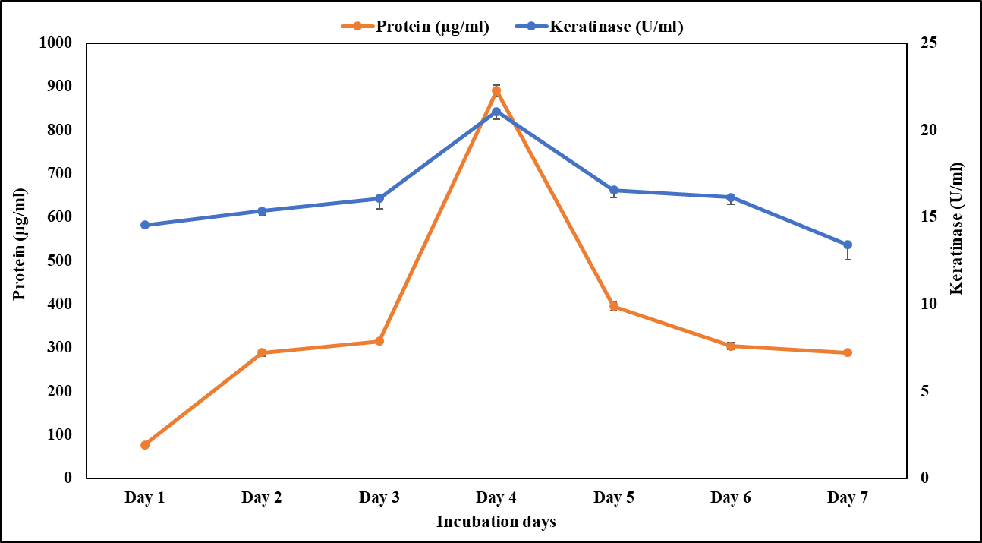

**Figure 2: Impact of varying incubation duration on keratinase production and protein content by *B. subtilis*. Each value represents a mean of three replicate determinations with standard deviation (± SD).**

**3.2 Substrate concentration**

The influence of feather concentration (0.5-2.5%) on degradation of feather by *B. subtilis* was evaluated*.* The experimental results observed that, both keratinase production and soluble protein content varied significantly over the incubation period. The maximum keratinase production 16.11 U/mL and soluble protein 896.25 µg/ml was recorded at 1% feather concentration. A progressive drop in the keratinase and protein content was seen with further incubation (Fig. 3). When there is an adequate supply of keratin substrate, the inducible enzyme keratinase was most effectively synthesized (Akram *et al*., 2020). Similar studies by Mohamad *et al*. (2017) and Abdel-Fattah *et al*. (2018) also observed optimum keratinase production at 1% (w/v) feather concentration respectively.

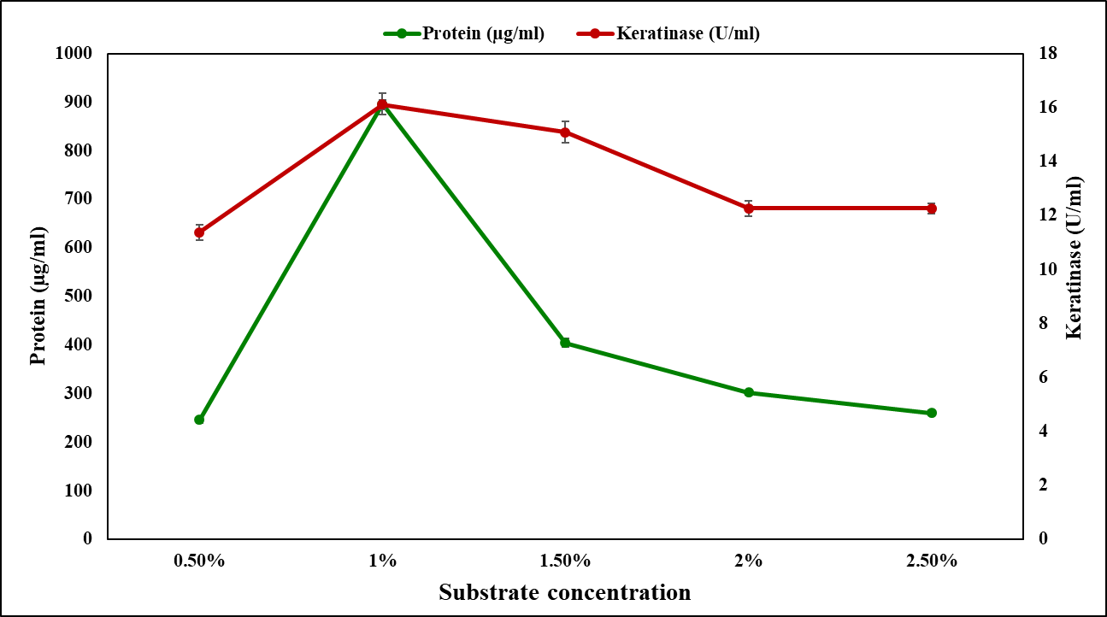

**Figure 3: Effect of different substrate concentrations on keratinase production and protein content by *B. subtilis*. Each value represents a mean of three replicate determinations with standard deviation (± SD).**

**3.3 Temperature**

The impact of incubation temperatures on the degradation of feather by *B. subtilis* was investigated temperatures 25, 30, 35, 40 and 45℃*.* The results revealed that, both soluble protein and keratinase enzyme production varied significantly at different temperatures. A maximum keratinase production 20.13 U/mL and soluble protein 930.33 µg/ml was recorded at 35℃*.* Further, Additionally, keratinase synthesis and protein content gradually decreased as the temperature increased this could be because of denaturation of proteins (Fig. 4). However, at 25℃*.*  (below optimal temperature), low keratinase production and protein content was observed which may have resulted from the membranes lipids hardening and which reduced the effectiveness of the transport proteins buried therein (Verma *et al*., 2016).

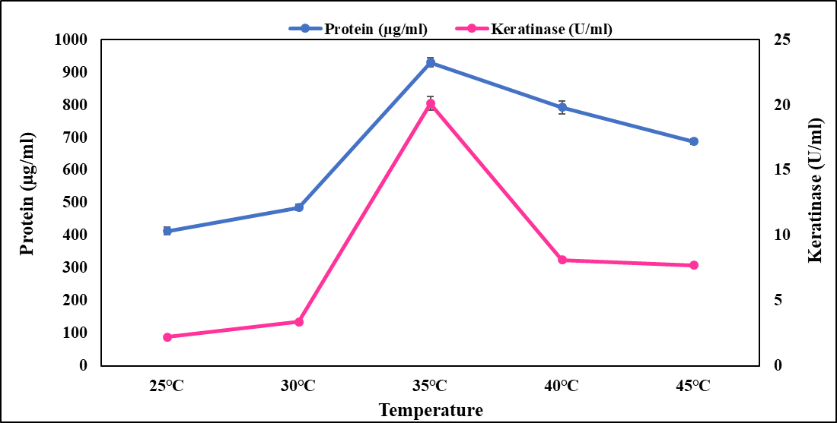

**Figure 4: Effect of different temperatures on keratinase production and protein content by *B. subtilis*. Each value represents a mean of three replicate determinations with standard deviation (± SD).**

**3.4 pH**

The impact of different pH levels on degradation of poultry feather by *B. subtilis* was investigated at 5, 6, 7, 8 and 9 pH levels*.* This study results revealed that, both keratinase enzyme production and soluble protein content varied significantly at different pH levels. Maximum keratinase production 16.11 U/mL and soluble protein 983.30 µg/ml was recorded at 35℃*.* Further, increase in pH showed a gradual decrease in the keratinase production and protein content (Fig. 5). The growth medium pH significantly influences bacterial growth, activity, stability and production of their metabolites. It also affects nutrient transport across the bacterial cell membrane (Akram *et al*., 2020).

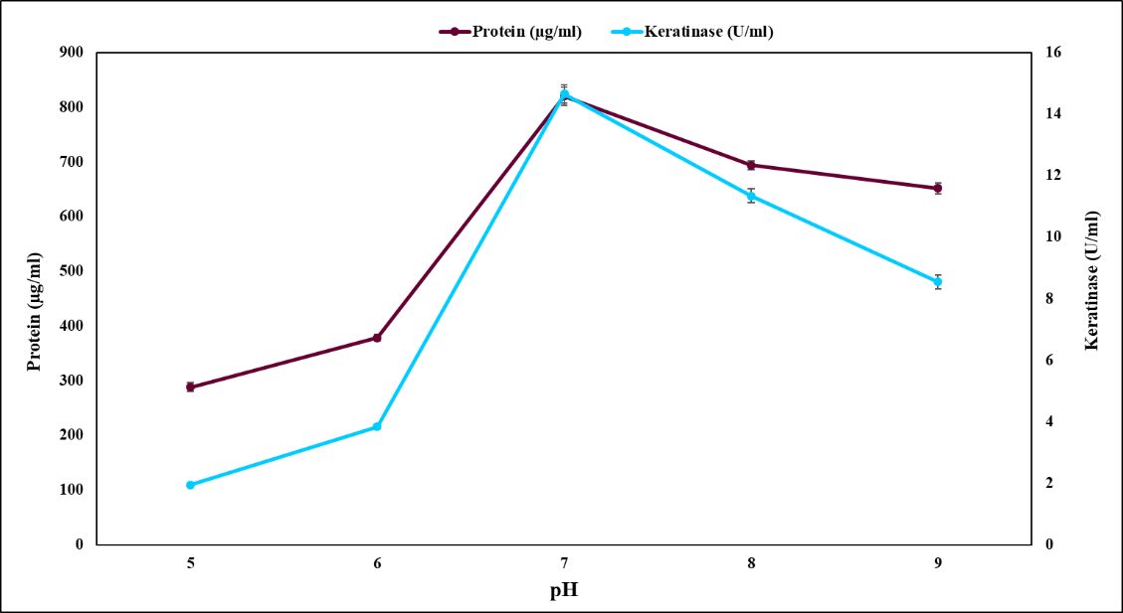

**Figure 5: Effect of different pH on keratinase production and protein content by *B. subtilis*. Each value represents a mean of three replicate determinations with standard deviation (± SD).**

**3.5 Inoculum load**

The impact of different inoculum load on feather degradation by *B. subtilis* was investigated at 1, 2, 3, 4 and 5%*.* The results revealed that, both keratinase production and soluble protein content varied significantly at different inoculum load. Maximum keratinase production 17.66 U/mL and soluble protein 983.43 µg/ml was recorded at 2% load. Further, increase in inoculum load showed a gradual drop in the keratinase and protein content (Fig. 6) this could be either due to a decreased nutrient availability in the medium or catabolite repression of the enzyme (Devi *et al.*, 2023). Similar results were reported by Verma *et al*. 2016 and Akhter *et al*. (2020).

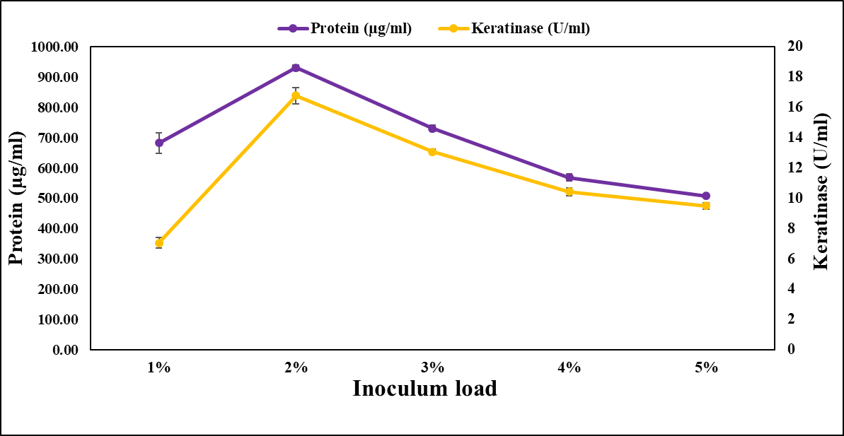

**Figure 6: Effect of different inoculum load on keratinase production and protein content by *B. subtilis*. Each value represents a mean of three replicate determinations with standard deviation (± SD).**

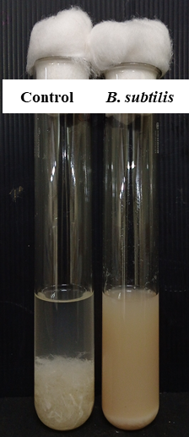

**Plate 1: Degradation of poultry feathers by B. subtilis on 4th day of incubation, 1% substrate concentration at 35℃ temperature, pH 7 and 2% inoculum load.**

**3.4 Scanning electron microscopy (SEM)**

After four days, SEM revealed the general feather deterioration process as well as structural alterations. Prior to deterioration, rachis, barbules, and barbs were evident on chicken feathers. Barbs and barbules were destroyed after 4 days of incubation (Plate 2) and with the exception of the rachis, whose overall feather structure was nearly entirely degraded. In many earlier studies, rachis was not fully broken down by enzyme treatment (Peng *et al*., 2019 and Tesfaye *et al*., 2017).

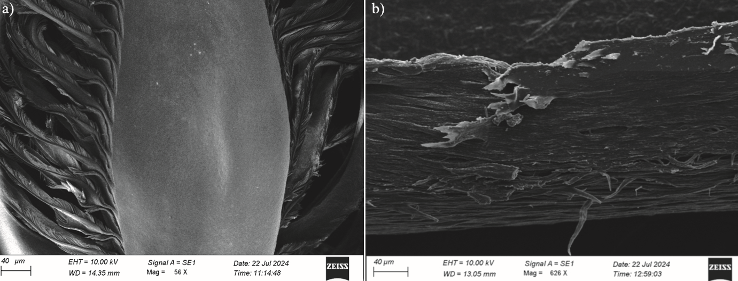

**Plate 2: SEM image showing biodegradation of feather a) control (uninoculated feather). b) inoculated with *B. subtilis* both images in 40 µm scale.**

1. **CONCLUSION**

The present study isolate FWD5 was identified as Bacillus subtilis as an efficient keratinase-producing bacterium capable of degrading poultry feathers. The biodegradation process was significantly influenced by various parameters such as incubation period, substrate concentration, temperature, pH and inoculum load. Optimal conditions for maximum keratinase activity and protein release were established, with the fourth day of incubation and 1% feather concentration at 35°C and pH 7 showing the most effective degradation of poultry feathers. SEM analysis confirmed extensive structural disintegration of feather validating enzymatic activity. The bioconversion of poultry feather waste using *B. subtilis* FWD5 is sustainable approach that reduces the keratin waste under ecofriendly conditions offering a viable alternative to conventional disposal methods and the feather hydrolysate obtained from degradation of poultry feathers is rich in short peptides and amino acids which water soluble and economically feasible product.This approach reduces environmental pollution effective degradation of keratin by utilizing a GRAS-status microorganism in a low-cost, low-energy process, it promotes circular bioeconomy and aligns with sustainable development goals.

Disclaimer (Artificial intelligence)

Option 1:

Author(s) hereby declare that NO generative AI technologies such as Large Language Models (ChatGPT, manuscript.

Option 2:

Author(s) hereby declare that generative AI technologies such as Large Language Models, etc. have been used during the writing or editing of manuscripts. This explanation will include the name, version, model, and source of the generative AI technology and as well as all input prompts provided to the generative AI technology

Details of the AI usage are given below:

1.

2.

3.

**REFERENCES**

Abdullah, N., Chin, N.L., Mokhtar, M.N., Taip, F.S., (2013). Effects of bulking agents, load size or starter cultures in kitchen-waste composting. International Journal of Recycling of Organic Waste in Agriculture, 2, 1–10.

Abdel-Fattah, A., El-Gamal, M., Ismail, S., Emran, M., Hashem, A., (2018). Biodegradation of feather waste by keratinase produced from newly isolated *Bacillus licheniformis* ALW1. Journal of Genetic Engineering and Biotechnology, 16, 311 318.

Ablimit, N., Zheng, F., Wang, Y., Wen, J., Wang, H., Deng, K., (2024). *Bacillus velezensis* strain NA16 shows high poultry feather-degrading efficiency, protease and amino acid production. Ecotoxicology and Environmental Safety, 278, 116353.

Akram, F., Ul Haq, I., Jabbar, Z., (2020). Production and characterization of a novel thermo- and detergent-stable keratinase from *Bacillus* sp. NKSP-7 with perceptible applications in leather processing and laundry industries. International Journal of Biological Macromolecules, 164, 371–383.

Akhter, M., Marzan, L.W., Akter, Y., Shimizu, K., (2020). Microbial bioremediation of feather waste for keratinase production: An outstanding solution for leather dehairing in tanneries. Microbial Insights, 13, 1178636120913280.

Anbesaw, M.S., (2022). Bioconversion of keratin wastes using keratinolytic microorganisms to generate value‐added products. International Journal of Biomaterials, 1, 2048031.

Aneja, K. R., (2006) Experiments in Microbiology, Plant Pathology and Biotechnology. 4th Edition. New Delhi, 245-275.

Chauhan, A., Devi, S., (2020). Optimization of cultural conditions for enhanced keratinase production by *Bacillus cereus* N14 obtained from the poultry farm of Himachal Pradesh (India). International Journal of Chemical Studies, 8(2), 2610–2619.

Devi, S., Chauhan, A., Bishist, R., Sankhyan, N., Rana, K., Sharma, N., (2023). Production, partial purification and efficacy of keratinase from *Bacillus halotolerans* L2EN1 isolated from the poultry farm of Himachal Pradesh as a potential laundry additive. Biocatalysis Biotransformation, 41(3), 222–242.

Dietrich, M., Fongen, M., Foereid, B., (2021). Anaerobic digestion affecting nitrous oxide and methane emissions from the composting process. Bioresource Technology Reports, 15, 100752.

Gradišar, H., Friedrich, J., Krizaj, I., Jerala, R., (2005). Similarities and specificities of fungal keratinolytic proteases: comparison of keratinases of *Paecilomyces marquandii* and *Doratomyces microsporus* to some known proteases. Applied and Environmental Microbiology, 71(7), 3420–3426.

Ghosh, P., Nadda, A.K., (2023) Isolation and characterization of keratin degrading bacterial isolate. Ph.D. Thesis (Unpub.). University of Information Technology, Solan, Himachal Pradesh.

Jagadeesan, Y., Meenakshisundaram, S., Saravanan, V., Balaiah, A., (2020). Sustainable production, biochemical and molecular characterization of thermo-and-solvent stable alkaline serine keratinase from novel *Bacillus pumilus* AR57 for promising poultry solid waste management. International Journal of Biological Macromolecules, 163, 135–146.

Kumawat, T., Sharma, A., Sharma, V., Chandra, S., (2018). Keratin waste: the biodegradable polymers. In: *Keratin*. IntechOpen.

Li, Q., (2021). Structure, application, and biochemistry of microbial keratinases. Frontiers in Microbiology, 12, 674345.

Lowry, O.H., (1951). Protein measurement with folin phenol reagent. Journal of Biological Chemistry, 193, 265–275.

Mohamad, N., Phang, L., Abd-Aziz, S., (2017). Optimization of metallo keratinase production by Pseudomonas sp. LM19 as a potential enzyme for feather waste conversion. Biocatalysis and Biotransformation, 35, 41-50.

Paul, T., Das, A., Mandal, A., Halder, S.K., DasMohapatra, P.K., (2014). Valorization of chicken feather waste for concomitant production of keratinase, oligopeptides and essential amino acids under submerged fermentation by *Paenibacillus woosongensis* TKB2. Waste and Biomass Valorization, 5, 575–584.

Peng, Z., Zhang, J., Du, G., Chen, J., (2019). Keratin waste recycling based on microbial degradation: mechanisms and prospects. ACS Sustainable Chemistry & Engineering, 7(11), 9727–9736.

Prasanthi, N., Bhargavi, S., Machiraju, P.V.S., (2016). Chicken feather waste: a threat to the environment. International Journal of Innovative Research in Science and Technology, 5(9), 16759–16764.

Ramalingum, N., (2021). Biodegradation of poultry feathers using a keratinolytic enzyme to produce feather meal. *PhD Thesis*, Durban University of Technology, Durban, South Africa.

Riffel, A., Lucas, F., Heeb, P., Brandelli, A., (2003). Characterization of a new keratinolytic bacterium that completely degrades native feather keratin. Archives of Microbiology, 179, 258–265.

Sharma, R., Devi, S., (2018). Versatility and commercial status of microbial keratinases: a review. Reviews in Environmental Science and Bio/Technology, 17(1), 19-45.

Sambrook, J., Maniatis, T., Fritsch, E., (1989). *Molecular Cloning*. Cold Spring Harbor Laboratory, Cold Spring Harbor, New York, USA.

Shahbandeh, M., (2022). Poultry production worldwide. *Statista*. https://www.statista.com/aboutus/our-research-commitment/1239/m-shahbandeh

Statista Research Department., (2022). Production volume of poultry meat in India FY 2009–2020. *Statista*. <https://www.statista.com>

Swati, Umashankar, N., Benherlal, P.S., Sathish, A., Lohith Kumar, N., (2025). Isolation, Screening and Characterization of Poultry Feather Degrading Bacteria: A Path to Sustainable Feather Waste Management. Mysore Journal of Agricultural Sciences, (In press).

Tamreihao, K., Mukherjee, S., Khunjamayum, R., Devi, L.J., Asem, R.S., Ningthoujam, D.S., (2018). Feather degradation by keratinolytic bacteria and biofertilizing potential for sustainable agricultural production. Journal of Basic Microbiology, 59(1), 4–13.

Tesfaye, T., Sithole, B., Ramjugernath, D., (2017). Valorisation of chicken feathers: a review on recycling and recovery route—current status and future prospects. Clean Technologies and Environmental Policy, 19, 2363–2378.

Verma, A., Singh, H., Anwar, M.S., Kumar, S., Ansari, M.W., Agrawal, S., (2016). Production of thermostable organic solvent tolerant keratinolytic protease from *Thermoactinomyces* sp. RM4: IAA production and plant growth promotion. Frontiers in Microbiology, 7, 1189.

Verma, A., Singh, H., Anwar, S., Chattopadhyay, A., Tiwari, K., Kaur, S., Dhilon, G., (2016). Microbial keratinases: industrial enzymes with waste management. Frontiers in Microbiology, 7, 476-491.