**Optimisation of Growing Media Composition for Enhanced Vegetative Growth of Broccoli (*Brassica oleracea* L. var. *italica*) in Soilless Culture**

**ABSTRACT**

The name “broccoli” is derived from the Italian word *broccolo*, meaning "cabbage’s flowering crest." It is a heavy feeder and requires ample nutrients for optimal growth. To overcome issues associated with soil-based cultivation-like pest pressure and nutrient inconsistency, soilless cultivation has gained popularity, especially in protected environments. An experiment was conducted at the School of Agricultural Sciences, Malla Reddy University, Hyderabad, during the year 2024-25 to determine the potential of different growing media with different ratios*.* Vermicompost (100%), Cocopeat (100%), Perlite (100%), Vermicompost + Cocopeat (70%+30%), Vermicompost + Perlite (70%+30%), Cocopeat + Vermicompost (70%+30%), Cocopeat + Perlite (70%+30%), Perlite + Vermicompost (70%+30%), Perlite + Cocopeat (70%+30%), Vermicompost + Cocopeat + Perlite (40%+40%+20%). These ten treatments were analysed in RBD with 3 replications. The higher observed in T10 (Vermicompost + Cocopeat + Perlite (40%+40%+20%) *i.e.,* plant height (64.00 cm), leaf length (38.54 cm), leaf width (21.33 cm), number of leaves (15.47), plantspread diameter (77.23 cm) and the lowest plant height (54.87cm) leaf length (31.94 cm), leaf width (17.23cm), number of leaves (11.83), plant spread diameter (67.30 cm) was recorded in the treatment T3 [(Perlite (100%)]. It was concluded that among the treatments, T10 (Vermicompost + Cocopeat + Perlite at 40%+40%+20%) showed the highest yield performance, followed closely by T4 (Vermicompost + Cocopeat at 70%+30%).

**Key words:** Broccoli, Growing media, Soilless cultivation, Vermicompost, Cocopeat, Perlite

# Introduction

Broccoli (*Brassica oleracea* L. *var. italica*), belonging to the Brassicaceae family, is a cool-season vegetable primarily cultivated for its edible, immature flower heads. The name “broccoli” is derived from the Italian word *broccolo*, meaning "cabbage’s flowering crest." It originates from the Mediterranean region and thrives in temperatures between 20–25°C, with optimal head formation occurring at 15–20°C (Thamburaj and Singh, 2001). There are three major types based on colour: green, purple, and white. Broccoli resembles cauliflower in structure but differs mainly in its inflorescence. Consumption of broccoli has been steadily increased due to its health promoting properties and conscious of human towards health.Broccoli has 14 times more beta-carotene than cultivated cabbage (Minz et al., 2023). Nutritionally, broccoli is considered a "crown

jewel" due to its high levels of vitamins A and C, minerals (iron, calcium), fibre and antioxidants. It also contains essential compounds like ascorbic acid, thiamin, riboflavin, niacin and glucosinolates known for their anticancer properties. The vegetable is mainly consumed fresh in India, while in Europe and the U.S., it is used both fresh and frozen. Steaming and microwaving preserve most of their beneficial compounds, whereas boiling can significantly reduce them (Kumar et al., 2024). There are two primary broccoli varieties: The heading type, with a central compact head (similar to cauliflower) and sprouting broccoli, which forms multiple smaller heads. Broccoli is a heavy feeder and requires ample nutrients for optimal growth. To overcome issues associated with soil-based cultivation-like pest pressure and nutrient inconsistency, soilless cultivation has gained popularity, especially in protected environments.

Microgreens can be cultivated using diverse growing media such as soil, a blend of coco and peat, and vermiculite, encompassing loose and soilless germination media. Microgreens are immature, delicate, and characterised by hypocotyl-colored cotyledonary leaves. They are commonly found in various plant families, encompassing a wide range of fruits, vegetables, grains, and herbs (Balik et al., 2024). Artificial growing media, which exclude natural soil, serve as the foundation in these systems. These media can be organic (e.g., vermicompost, cocopeat, peat, compost) or inorganic (e.g., perlite, vermiculite, rock wool). Each medium provides a stable environment for root anchorage, moisture retention, and nutrient availability. Cocopeat, a by-product of coconut fibre extraction, is chemically stable and retains moisture well. Perlite, a volcanic mineral, enhances aeration and drainage due to its porous nature. Effective media must maintain adequate porosity and particle size to ensure proper air-water balance and facilitate healthy root development (Bilderback *et al*., 2005).

Soilless systems offer several agronomic benefits for broccoli cultivation: precise nutrient and water management, enhanced yield and quality, reduced disease incidence, and efficient water use. Year-round cultivation is possible regardless of soil quality or climate variability. Studies, such as Ghasemi *et al*. (2018), have demonstrated that vermicompost significantly increases broccoli head size and weight, while perlite improves root structure through enhanced aeration, emphasising the importance of selecting nutrient-rich, balanced media. The study aimed to determine the potential of different growing media with different ratios on the growth of Broccoli*.*

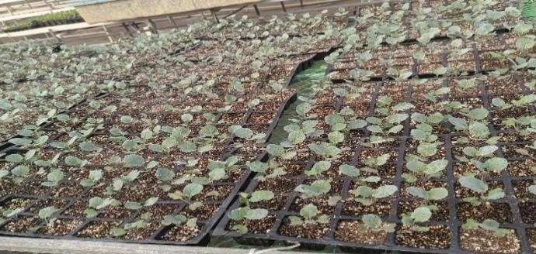

Fig 1: Broccoli seedlings in protrays

# Materials and Methods

The present investigation was conducted in the Experimental Farm, Department of Agriculture, Malla Reddy University, Hyderabad, 2024-2025. The methodology followed and the materials used in the present study are detailed below.

# List 1- Treatment detail (Media composition)

|  |  |  |
| --- | --- | --- |
| **Treatment** | **Components** | **Ratio** |
| **T1** | Vermicompost | (100%) |
| **T2** | Cocopeat | (100%) |
| **T3** | Perlite | (100%) |
| **T4** | Vermicompost + Cocopeat | (70% + 30%) |
| **T5** | Vermicompost + Perlite | (70% + 30%) |
| **T6** | Cocopeat + Vermicompost | (70% + 30%) |
| **T7** | Cocopeat + Perlite | (70% + 30%) |
| **T8** | Perlite + Vermicompost | (70% + 30%) |
| **T9** | Perlite + Cocopeat | (70% + 30%) |
| **T10** | Vermicompost + Cocopeat + Perlite | (40% + 40% + 20%) |

All the observed data were statistically analysed by the method of analysis of variance. The data obtained from different treatments during field experimentation were subjected to the analysis of variance by Randomised Block Design (RBD). The total experimental area was 144 m2. The space between replications was 50 cm, and plant to plant 45 cm.

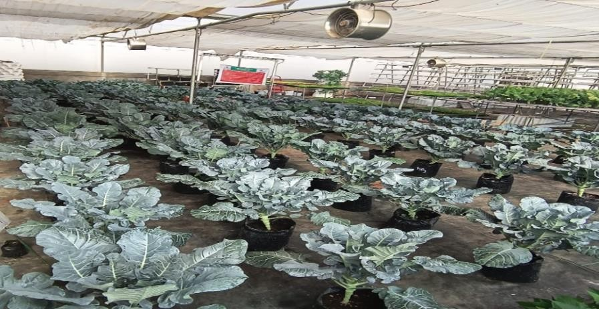

Fig2: Experimental area under fan & pad polyhouse

# Result and Discussion Plant height(cm)

The result reveals that differences were observed among the different growing media in plant height (cm) in broccoli (Table 1) during the experiment. The data have been collected at different intervals, *i.e*, at 30,45, and 60 days after transplanting (DAT). The highest plant height was observed in T10 (Vermicompost + Cocopeat + Perlite 40% + 40% + 20%), i.e, with (42.06cm,58.50cm and 64.00cm) respectively. However, T10 is on par with T4 (Vermicompost + Cocopeat 70%+30%) with values (41.93cm, 57.26cm, 62.97cm). The lowest plant height was observed in T3 (Perlite 100%) with (28.03cm, 40.14 cm, and 54.87cm). Vermicompost boosts nutrient availability and microbial activity, enhancing root growth and overall plant height. Combined with cocopeat's moisture retention and perlite's improved drainage, this mix creates ideal conditions for taller broccoli plants. Vermicompost contributed organic matter and beneficial microbes that supported root development and nutrient uptake (Dharnesh, 2019). Cocopeat enhanced moisture retention and root zone aeration, while perlite improved drainage and reduced compaction. This mix ensured optimal nitrogen, phosphorus and potassium availability, essential for vegetative growth and cell expansion (Khan *et al.,* 2019). Thus, the integrated media provided ideal physico-chemical and nutritional conditions for superior plant growth in soilless cultivation systems

# Leaf length and Leaf width (cm)

The result showed that the significantly highest leaf length and leaf width were among different media with different ratios (Table 1) at different intervals at 30,45, and 60 DAT. The highest Leaf length and Leaf width were showed in T10 (Vermicompost + Cocopeat + Perlite 40% + 40% + 20%) *i.e,* with (27.19 cm, 38.54 cm and 57.81cm), (17.47cm, 20.94cm and 21.33cm) and it is on par with T4 (Vermicompost + Cocopeat 70%+30%) *i.e.,* with (25.90cm, 37.96cm and 52.86cm and) and (15.57cm, 20.22cm and 20.50cm) The lowest leaf length and leaf width was observed in T3 (Perlite 100%) with (17.07cm, 31.94cm and 43.23cm) and (10.42cm, 15.74cm and17.2 cm). The combination of vermicompost, cocopeat and perlite improves nutrient availability, particularly nitrogen and potassium, which are essential for leaf expansion. Enhanced aeration and moisture retention promote efficient physiological processes, supporting greater cell division and elongation in leaves. This results in increased leaf length and width in broccoli plants under optimal soilless conditions.

According to Rabbee *et al.* (2020), the rise in leaf number in broccoli is linked to improved nutrient supply from vermicompost, which enhances soil fertility and microbial activity, promoting better nutrient uptake. Organic components like vermicompost, cocopeat, and perlite contribute to increased leaf width by ensuring the availability of key nutrients such as nitrogen, potassium, and calcium. Nitrogen supports vegetative growth, while potassium aids in water regulation and nutrient transport, both essential for leaf development. The presence of N, P, and K enhances cellular activities, leading to increased cell size and number, as also noted by Dharnesh (2019) and Bhat *et al*. (2023).

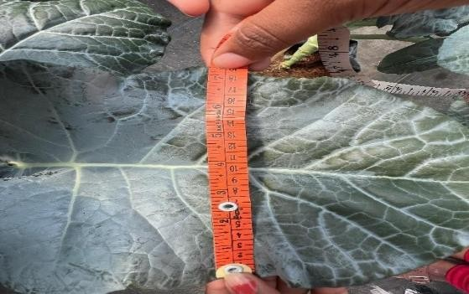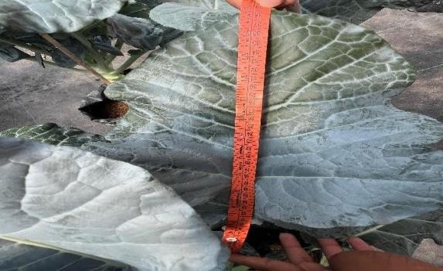

Fig 3: Measuring brocolli (a) Leaf width(cm) (b) Leaf length(cm)

Table 1: Effect of different media on plant height (cm), Leaf length (cm), Leaf width(cm)

|  |  |  |  |  |  |  |  |  |  |
| --- | --- | --- | --- | --- | --- | --- | --- | --- | --- |
| **Treatments** | **Plant height (cm)** | | | **Leaf length (cm)** | | | **Leaf width(cm)** | | |
|  | **30**  **DAT** | **45**  **DAT** | **60**  **DAT** | **30**  **DAT** | **45**  **DAT** | **60**  **DAT** | **30**  **DAT** | **45**  **DAT** | **60**  **DAT** |
| **T1** | 34.53 | 50.66 | 58.50 | 22.57 | 34.99 | 48.65 | 12.77 | 18.43 | 18.93 |
| **T2** | 28.37 | 44.46 | 56.43 | 18.70 | 34.29 | 42.96 | 12.37 | 16.40 | 17.73 |
| **T3** | 28.03 | 40.14 | 54.87 | 17.07 | 31.94 | 43.23 | 10.42 | 15.74 | 17.23 |
| **T4** | 41.93 | 57.26 | 62.97 | 25.90 | 37.96 | 52.86 | 15.57 | 20.22 | 20.50 |
| **T5** | 41.07 | 54.49 | 61.77 | 25.75 | 37.61 | 51.32 | 15.50 | 19.58 | 19.73 |
| **T6** | 36.13 | 51.99 | 59.40 | 23.63 | 37.43 | 50.36 | 15.25 | 19.44 | 19.40 |
| **T7** | 35.33 | 51.08 | 59.07 | 23.22 | 35.70 | 50.06 | 14.47 | 18.83 | 19.07 |
| **T8** | 32.27 | 50.48 | 57.30 | 22.25 | 34.73 | 46.32 | 12.55 | 17.17 | 18.73 |
| **T9** | 31.04 | 44.52 | 57.07 | 21.15 | 34.47 | 44.58 | 12.43 | 17.12 | 18.45 |
| **T10** | 42.06 | 58.50 | 64.00 | 27.19 | 38.54 | 57.81 | 17.47 | 20.94 | 21.33 |

# Fig 4: Graphical representation of leaf width (cm) in broccoli under soilless cultivation using different growing media at 30, 45 and 60 DAT

1 2 3 4 5 6 7 8 9 10

Leaf width

30 DAT 45 DAT 60 DAT

0

0

5

5

10

10

15

15

20

20

25

25

**Number of Leaves/Plant:**

The number of leaves / Plant of broccoli was significantly affected by different growing media at different intervals 30,45, and 60 DAT (Table 2). The maximum number of leaves/ plants was absorbed in T10 (Vermicompost + Cocopeat + Perlite 40% + 40% + 20%), *i.e,* with (7.30, 22.47 and 15.47), which was on par with T4 (6.97, 20.48 and 15.17). While the minimum number of leaves /plants was obtained (5.45,12.32, and 11.83). whereas the lowest number of leaves was recorded in T3 (Perlite 100%), *i.e.,* with (5.45,12.32 and 11.83).

The combination of vermicompost, cocopeat and perlite enhances nutrient availability and root zone aeration, promoting hormonal activity and cell division necessary for leaf initiation. This results in increased leaf production due to improved uptake of nitrogen and other essential nutrients. Vermicompost, as reported by Kumar *et al.* (2023), significantly improves nutrient availability and microbial activity, thereby stimulating robust vegetative growth in crops like broccoli. Its rich nitrogen content promotes chlorophyll formation and cell division, leading to increased leaf formation. Additionally, the improved moisture retention, aeration, and nutrient release from the growing medium enhance root development and photosynthetic efficiency, supporting higher leaf numbers (Chatterjee *et al.,* 2016; Abduli *et al.,* 2013).

# Plant Spread Diameter (cm)

The results revealed that the Plant spread diameter showed a significant difference among the different growing media (Table 2) at different intervals 30,45, and 60 DAT. Vermicompost + Cocopeat + Perlite 40% + 40% + 20% (T10) recorded the highest plant spread diameter, *i.e* with (44.00cm, 75.64cm and 77.23cm), and it is on par with T4 (Vermicompost + Cocopeat 70%+30%) *i.e.,* with values (42.02cm, 67.27cm and 72.60cm). Whereas, the lowest plant spread diameter was recorded in T3 (Perlite 100%), *i.e.,* with (28.90cm, 42.68cm, 67.30cm). Broccoli plant spread was likely improved due to better soil aeration and structure from vermicompost, cocopeat and perlite, which support root expansion and vegetative growth (Arancon *et al.,* 2004). These organic substrates, rich in humic substances, also facilitate gradual nutrient release, enhancing overall plant performance, as similarly reported by Arancon *et al*. (2004). Utilisation of organic amendments, notably vermicompost, has been associated with improved soil fertility and heightened microbial activity, which in turn enhances root growth and nutrient uptake in broccoli (Naorem *et al.,* 2023). This improved root system ensures stronger plant anchorage and efficient nutrient transport, contributing to greater plant spread. Enhanced vegetative development leads to a broader canopy, which supports better light capture and photosynthetic efficiency. As a result, overall plant vigour and productivity are elevated. Similar observations were also reported by Dharnesh (2019).

Table 2: Effect of different soilless media on Number of leaves, Plant Spread Diameter(cm)

|  |  |  |  |  |  |  |
| --- | --- | --- | --- | --- | --- | --- |
| **Treatments** | **Number of leaves(cm)** | | | **Plant Spread diameter(cm)** | | |
|  | **30 DAT** | **45 DAT** | **60 DAT** | **30 DAT** | **45 DAT** | **60 DAT** |
| **T1** | 6.17 | 19.44 | 12.70 | 38 .81 | 54.04 | 69.77 |
| **T2** | 5.80 | 13.92 | 12.63 | 31.77 | 46.59 | 68.53 |
| **T3** | 5.45 | 12.32 | 11.83 | 28.90 | 42.68 | 67.30 |
| **T4** | 6.97 | 20.48 | 15.17 | 42.02 | 67.27 | 72.60 |
| **T5** | 6.73 | 19.94 | 14.77 | 42.55 | 70.57 | 76.90 |
| **T6** | 6.63 | 19.92 | 14.40 | 41.75 | 60.44 | 72.37 |
| **T7** | 6.30 | 19.24 | 13.10 | 39.43 | 55.65 | 71.80 |
| **T8** | 6.10 | 17.17 | 12.50 | 38.73 | 50.28 | 69.50 |
| **T9** | 5.97 | 18.40 | 12.37 | 35.93 | 50.18 | 69.63 |
| **T10** | 7.30 | 22.47 | 15.47 | 44.00 | 75.64 | 77.23 |

# CONCLUSION:

The study revealed that different growing media compositions significantly affected broccoli's morphological traits and yield over a 60-day period. Soilless cultivation using various media combinations demonstrated promising results under controlled conditions. Among the treatments, T10 (Vermicompost + Cocopeat + Perlite at 40%+40%+20%) showed the highest yield performance, followed closely by T4 (Vermicompost + Cocopeat at 70%+30%). These combinations enhanced plant growth and yield potential, making them agronomically and economically viable. Therefore, such media blends are recommended for efficient soilless broccoli cultivation in protected environments.

Disclaimer (Artificial intelligence)

Option 1:

Author(s) hereby declare that NO generative AI technologies such as Large Language Models (ChatGPT, COPILOT, etc.) and text-to-image generators have been used during the writing or editing of this manuscript.

Option 2:

Author(s) hereby declare that generative AI technologies such as Large Language Models, etc. have been used during the writing or editing of manuscripts. This explanation will include the name, version, model, and source of the generative AI technology and as well as all input prompts provided to the generative AI technology

Details of the AI usage are given below:

1.

2.

3.

# Reference:

Abduli, M. A., Amiri, L., Madadian, E., Gitipour, S.and Sedighian, S. 2013. Efficiency of vermicompost on quantitative and qualitative growth of tomato plants. *International Journal of Environment Resource*.7(2):467-472.

Arancon, N. Q., Edward, C. A., Bierman, P., Metzger, J. D., Lee, S. and Welch, C. 2003. Effect of vermicomposts on growth and marketable fruits of field grown tomatoes, peppers and strawberries. *Pedobiologia*.47(5-6):731-735.

Bhat, N., Albaho, M., Suleiman, M. and Thomas, B. 2013. Growing substrate composition influences growth, productivity and quality of organic vegetables. *Asian Journal of Agricultural Sciences*.5:62-66.

Bilderback TE, Warren SL, Owen Jr JS and Albano JP. 2005. Healthy substrates need physicals too Horticulture Technology. 15 :747-757.

Chatterjee, R. and Mal, D. 2016. Influence of nursery technique and growing media on seedling growth and field performance of cabbage (*Brassica oleracea* var. *capitata* L). *Journal of Environmental and Agricultural Science .*9:15-20.

Dharnesh C. (2019). standardization of growing media with biofertilizers for cultivation of sprouting broccoli (*Brassica Oleracea* L. var. *italica plenck*) in grow bags under polyhouse condition. *Krishikosh.*

Ghasemi, K., Emadi, S. M. and Ghasemi, Y. 2018. Effect of different culture media on broccoli (*Brassica oleracea* var. *italica*) yield components and mineral elements concentration in soilless Culture. *Journal of Horticultural Science*. 31(4): 694-704.

Khan, T. H., Aman, F., Muhammad Noman Khan, D., Shah, S. Q., Said, B. and Irfan, I. 2019. Effect of vermicompost on growth, yield and quality of chilli (*Capsicum annum* L.) under

the agro climatic condition of Peshawar, Pakistan. *Pure and Applied Biology (PAB)*. 8(1): 856-865.

Kumar, M., Lata, R., Verma, S., and Sangam, S. 2023. Effect of different organic manures and varieties on growth parameter of sprouting broccoli (*Brassica oleracea* var. *Italica plenck*). *International Journal of Environmental Climate Change*.13(3):1-6.

Naorem, J., Sarkar, A., Kanaujia, S., Adhikary, N., Maiti, C. and Hemanta, L. 2023. Influence of bulky organic inputs on growth, yield and biochemical attributes of broccoli (*Brassica oleracea* L. var. *italica). Annals of Plant and Soil Research.*25(3): 398-403. Rabbee, H. E., Methela, N. J., Hossain, B. and Suhel, R. I. 2020. Growth and yield response of Broccoli to vermicompost and farmyard manure. *Journal of Bioscience and Agriculture*

*Research.* 25(02):2107-2113.

Thamburaj S, Singh N 2001. Vegetables, tuber crops and spices. *Directorate of information and publications of agriculture, Indian Council of Agriculture Research*, New Delhi, pp 137.

Minz , A., Jangre , N., Chandel , Y. K., Kumar , N., lautre , R., & Deepshikha. (2023). Effect of Different Micronutrients on Economics of Broccoli (Brassica oleracea var. Italica) cv. Green Magic under Polyhouse Condition. *International Journal of Environment and Climate Change*, *13*(9), 3065–3072.

Balik, S., Dasgan, H. Y., Ikiz, B., & Gruda, N. S. (2024). The Performance of Growing-Media-Shaped Microgreens: The Growth, Yield, and Nutrient Profiles of Broccoli, Red Beet, and Black Radish. *Horticulturae*, *10*(12), 1289.

Kumar, A., Kumar, S., Sharma, D., Bakshi, P., Singh, S. K., & Samnotra, R. K. (2024). Exploring possibilities of broccoli (Brassica oleracea L. var. italica) production under organic management. *All Life*, *17*(1), 2407899.