***Arnebia benthamii* (Wall. ex G. Don) Johnst.: An Endangered Medicinal plant of the western Himalayas-Pharmacological Insights, Phytochemistry and Agrotechnological Advances**

**Abstract**

The use of medicinal plants dates back to ancient times, with a significant boost in discoveries during the 17th century, known as the "Age of Herbal Medicines." Traditional medicine was widely relied upon before modern pharmaceuticals, endorsed by the World Health Organization. Today, over 75% of the world's population depends on plants for health, with over 30% of plant species used for medicinal purposes. One prominent example is *Arnebia benthamii*, a frequently employed plant species in traditional Himalayan medicine, especially for treating several fatal infections. Furthermore, *Arnebia benthamii* is renowned for its multifaceted pharmacological properties, encompassing anti-cancer, antimicrobial, antioxidant and anti-depressant effects. The secondary metabolites found in *Arnebia benthamii*, including Shikonin, Isovaleryl-shikonin, β,β-di-methylacryl-shikoninconstitute the core classes of bioactive compounds. However, the excessive exploitation of this plant, driven by its extensive therapeutic potential, has placed it on the list of critically endangered medicinal herbs in the Himalayas. Consequently, this review presents current information on phytochemistry, Medicinal value, pharmacological capabilities and agrotechniques of *Arnebia benthamii,* underscoring its significance as a vital medicinal herb in the western Himalayas.

**Keywords:** *Arnebia benthamii*, Medicinal Plants, Phytochemistry, Pharmacology, Agrotechnology, Conservation.

**Top of Form**

**Introduction**

The cultivation of medicinal plants can be traced back to the Vedic period, which occurred between 250 and 500 BCE. However, it was during the 17th century that a significant number of potent drugs and medicines were discovered, earning this era the moniker "Age of Herbal Medicines" (Letsyo et al., 2017). “Prior to the advent of modern pharmaceuticals, people heavily relied on traditional medicine, a practice endorsed by the World Health Organization as a dependable source of therapeutic remedies” (Vandebroek et al., 2008; World Health Organization, 2013). “More than three-quarters of the world's population primarily depend on plant species for addressing health issues, and over 30% of the entire plant kingdom is utilized for medicinal purposes. The global herbal drug market is estimated to be worth nearly ₹ 300,000 crores, with India contributing approximately ₹ 3,000 crores. Currently, herbal plants, often referred to as the "backbone" of traditional medicine due to their significant economic value, are utilized by over 3.3 billion people in developing countries, outnumbering their use in the rest of the world” (Kapoor, 2018).

“The Indian Himalayan Region (IHR) is a veritable treasure trove of medicinal plants, housing more than 8,000 vascular plant species, of which 1,748 are recognized for their medicinal properties” (Kour et al., 2020; Joshi et al., 2016). “Various parts of most herbal plants possess medicinal properties and are employed to treat a wide range of ailments” (Khoshbakht and Hammer 2005, Altaf et al., 2024, Mushtaq et al., 2024, Mushtaq et al., 2023, Rafeeq et al., 2025, Rafeeq et al., 2023, Bhatia et al. 2014, Kaif et al., 2023, Rao et al. 2015; Setzer et al., 2016; Sharifi-Rad et al., 2017, Kaif et al., 2021, Sultan et al., 2022, Rafeeq et al., 2022).

Many species known for their medicinal potential belong to the genus Arnebia (Kumar et al., 2021), including *Arnebia benthamii*, *Arnebia euchroma*, and *Arnebia densifolia* which are frequently used in ethnomedicine. Additionally, Arnebia species are found in commercial herbal preparations, such as *Arnebia benthami* is an important unani medicine and is a major ingredient of the commercial unani drug available under the name Gaozaban and Ratanjot (Parray, *et al*., 2015). The *Arnebia* genus contains Shikonin-a red pigment and alkannin-a lipophilic red pigment, obtained from the roots, is the main active component of this herb (Ganie, *et al*., 2012) and is marketed under the trade name Ratanjot (Kaishwada *et al*., 1995).

Among the numerous Arnebia species, *Arnebia benthamii*, commonly known as Himalayan Arnebia or Ratanjot, is a perennial plant found at altitudes ranging from 3000 to 4300 meters above sea level (amsl) in the sub-alpine and alpine zones of North West Himalaya (Dar *et al*., 2002; Dar and Khuroo 2013; Katoch *et al*., 2016). The plant has been traditionally used to cure various diseases of tongue, throat, fever, eye, hair loss, bronchitis, abdominal pain and cardiac disorders (Khatoon *et al*., 1993; Ganie *et al*., 2014; Fayaz *et al*., 2017).Moreover, it is highly valued for its antioxidant, anti-diabetic, anti-fungal, cardioprotective, anti-inflammatory, anti-pyretic, anti-septic, anti-biotic, anthelmintic, anti-bacterial, anti-cancerous, diuretic and expectorant properties (Ganie, *et al*., 2014; Parray, *et al*., 2015; Shameem, *et al*., 2015). The flowering spikes, leaves and basal part of roots can be utilized for consumption and trade. “Shikonin-a red pigment and alkannin-a lipophilic red pigment, obtained from the roots, is the main active component of this herb” (Ganie, *et al*., 2012) “and is marketed under the trade name Ratanjot” (Kaishwada *et al*., 1995). “The Himalayan Arnebia, *Arnebia benthami-*is mentioned in the most famous Persian medicine books like Makhzan Al Advieh, Tohfat Al-Momenin, Al-Qanun, Al-Seidaneh and Ekhtiarate Badiei for treating menorrhagia, as well as cough and lung problems” (Guna, 2019; Hosseini *et al*., 2018). “The root fibre turns red when combined with apricot or mustard oil, and it can be used to treat hair loss and dandruff. Burns and other skin diseases can also be treated using the roots” (Pirbalouti et al. 2011). “Further this plant can also be used to colour cups, dye textiles, and prepare a variety of dishes.In the frigid Spiti region of the Indian Himalayas, a versatile plant with distinctive roots is blended with mustard oil to create a potent elixir. It strengthens hair and color to dishes like Chog, Chatni, and pickles” (Sharma et al. 2018).

“Beyond its culinary and cosmetic uses, this plant serves as a remedy in Spiti Valley for coughs and lung ailments” (Chawla et al. 2021). “In Himachal Pradesh's Spiti region, it treats toothaches, earaches, eye problems, wounds, and burns” (Chauhan 2011). “It also aids in alleviating backaches, colds, and blood vomiting” (Singh et al. 2009), and is mixed with butter for wound care (Kosger et al. 2009).

In Chinese traditional medicine, *Arnebia* decoction is applied for cutaneous and heart diseases, post-herpetic neuralgia, and dermatitis (Liang et al. 2013; Ma et al. 2014; Tse 2003). Arnebia species, found in Ladakh's freezing desert, addresses renal and urinary issues, regulates urine discharge, reduces inflammation, and curtails kidney bleeding (Ballabh et al. 2008). This versatile plant serves as an invaluable resource for healing worldwide. The active phytochemicals in Arnebia roots with medicinal properties include shikonin, acetyl-shikonin, iso-butyryl-shikonin, β,β-di-methylacrylshikonin, isovaleryl-shikonin, β-hydroxy-isovaleryl-shikonin, deoxy-shikonin, isobutyl-shikonin, arnebinone, arnebin-7, stigmasterol (Kumar et al., 2021).

“Unfortunately, *Arnebia benthamii* is critically endangered due to its delicate nature and the unsustainable, illegal, and unscientific harvesting practices that have been prevalent as a result of the high demand for its medicinal use among consumers, pharmaceutical industries, and stakeholders” (Kala, 2005). “There is an urgent need to conserve *Arnebia benthamii* and remove it from its critically endangered status. In this context, farmers can play a crucial role in conserving the plant species in its natural environment through captive cultivation and by adopting improved agricultural practices, simultaneously meeting market demand” (Ganai and Nawchoo 2002). Herbal medicines have maintained their popularity among consumers, driven by both traditional and cultural factors, resulting in the rapid growth of this industry in recent decades. *Arnebia benthamii* holds immense potential to provide practical and accessible medicinal value in developing countries, especially in areas where Western medicine is not readily available and the population needs healthcare. Therefore, this review aims to comprehensively explore the distribution, morphology, agrotechnology, ethnopharmacology, phytochemistry, and conservation aspects of *Arnebia benthamii*, as well as recent advancements in the study of this plant.

**Methodology**

The pertinent data and details about *Arnebia benthamii* were compiled from a range of sources. These included databases like Science Direct, Springer, PubMed, Taylor and Francis imprints, and ChemDraw, as well as Google Scholar. Both peer-reviewed research and review articles, as well as unpublished data, were considered. Additionally, selected 'grey literature' such as ethnobotanical books, individual chapters, Wikipedia, and various web pages were also consulted.

**Results and Discussion**

**Geographic distribution**

*Arnebia benthamii* is a critically endangered, perennial medicinal herbs that thrive in the alpine regions of the North West Himalayas. Their habitat extends from the Himachal Pradesh, Jammu and Kashmir and Uttaranchal. Typically, these plants are found in challenging environments, including rocky crevices, cliffs, and mountain slopes, at altitudes ranging from 3000 to 4300 meters (Dar and Khuroo 2013).Belonging to the Boraginaceae family, the genus *Arnebia* encompasses25-30 species, distributed across Southwest and Central Asia, the Himalayas, Northeast Africa, and Southeast Mediterranean (Zhu *et al*., 1995; Zakhlenjuk and Kunakh, 1998; Ganai and Nawachoo, 2002; Mabberley, 2008; Ambrish and Srivastava, 2014; Kumar *et al*, 2021). In India the genus comprises of 8 species distributed in Upper gangetic plains and the Himalayan region (Aswal and Mehrotra, 1994; Sekar *et al*., 2009; Ambrish and Srivastava, 2014; Singh *et al* 2017). Amongst them *Arnebia benthamii* is found in the sub-alpine and alpine zones of North West Himalaya at an altitude range of 3000-4300m amsl (Dar *et al*., 2002; Dar and Khuroo 2013; Katoch *et al*., 2016). In union territory of J&K it is found at open stony slopes of Sonamarg, Gulmarg, Pahalgam, Duksum, Wadwan, Kaobal (Tilal), Padder and Seoj (Bhaderwah). It is locally known by various names (Table 1) like Ratanjot (Dogri), Kahzban (Gojri), Gahajawain (Kashmiri), Loljod (Pahadi) and Kaahjawan (Shina) (Manjkhola et al., 2005; Vidyarthi 2010; Fayaz *et al*., 2017). These plants are highly valued for their therapeutic properties and they are extensively used in modern and traditional medicinal systems in India, Nepal, Sri Lanka, China, and Tibet to treat various immune-related disorders.

**Table 1: Name of *Arnebia benthamii* in different languages**

|  |  |
| --- | --- |
| **Language** | **Name of Plant** |
| Dogri | Ratanjot |
| Gojri | Kahzban |
| Kashmiri | Gahajawain/Khahzban |
| Pahadi | Loljod |
| Shina | Kaahjawan |

**Morphology**

*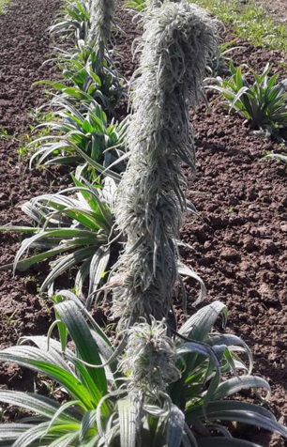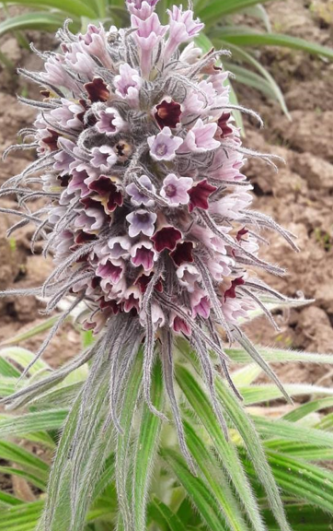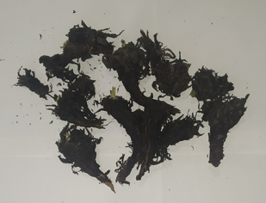Arnebia benthamii*, a plant thriving in high-altitude regions, possesses specific environmental requirements for its growth. It thrives in a cool, moisture-rich climate and demonstrates excellent growth in sandy, loamy, clayey, sandy loam, clayey loam textures. Its roots depend on a porous soil structure, facilitating the horizontal expansion of rhizomes beneath the earth. However, the plant is susceptible to mortality when faced with prolonged and heavy rainfall. The lifespan of *Arnebia benthamii* spans three years. Fig. 1 provides visual representations of both the aerial parts and roots of this plant.

**A B C**

**Fig. 1: Pictures of *Arnebia benthamii*, A- Plant B- Inflorescence C- Rhizomes**

*Arnebia benthamii* is a perennial, erect, hairy herb, 40-80 cm high with stout root stock. Stems simple, fistular, hispid, densely covered with white trichomes of tuberculated base, leafy. Leaves sessile, basal leaves narrowly lanceolate or oblong-lanceolate, 12.5-20.5 × 1.5-2.5 cm, attenuate at base, acute or obtuse at apex, entire on margins, whitish-hairy on both surfaces with spreading trichomes emerging from tuberculate bases; 3-5 nerved; cauline leaves smaller. Inflorescence a long, dense slender thyrse, 15-30 cm long; bracts leafy, linear- lanceolate, up to 5 cm long, densely hairy. Flowers pink or purple to blue. Calyx lobed, linear-lanceolate up to 4.5 cm long. Corolla tubular, tube up to 2.5 cm long, usually shorter than the calyx. Stamens short; anthers elongated. Style shortly bifid; stigmas 2, capitate. Nutlets ovoid, tuberculate, 1-2.5 mm long. Flowering & Fruiting: August – September.

**Arnebia in traditional Persian medicine**

Persian medicine posits that the fundamental nature of all entities is shaped by four essential elements: earth, water, air, and fire, collectively known as the "quadruplet pillars." Each element possesses distinct qualities. These elements interact dynamically, resulting in dominant qualities within objects, which are referred to as their temperament or nature. Specifically, fire conveys warmth and dryness, air embodies warmth and moisture, water represents coldness and moisture, and earth manifests as coldness and dryness. These four elemental forces play key roles in determining various characteristics of entities. Earth fosters stability and the capacity for shaping, water imparts flexibility and formability, air enhances lightness and porosity, and fire increases mobility. Every being exhibits a unique proportion of these quadruple pillars, leading to variations in their temperaments. In the realm of Persian medicine, medicines are categorized into four degrees based on their properties:

1. The first degree pertains to a low medicine dosage that does not significantly impact the body's dominant qualities. However, repeated and higher doses can induce minor alterations in the body's constitution.
2. The second degree comprises a low medicine dose that instills a dominant quality in the body. Additional repeated doses are safe and don't cause harm.
3. The third degree involves a low medicine dose that imparts a dominant quality but becomes toxic with repeated use. However, it is not lethal.
4. The fourth degree of medicine is lethal.

According to Persian medicine literature, *Arnebia* falls under the second degree, characterized as warm and dry (Mirzaee et al. 2017; Tse 2003).

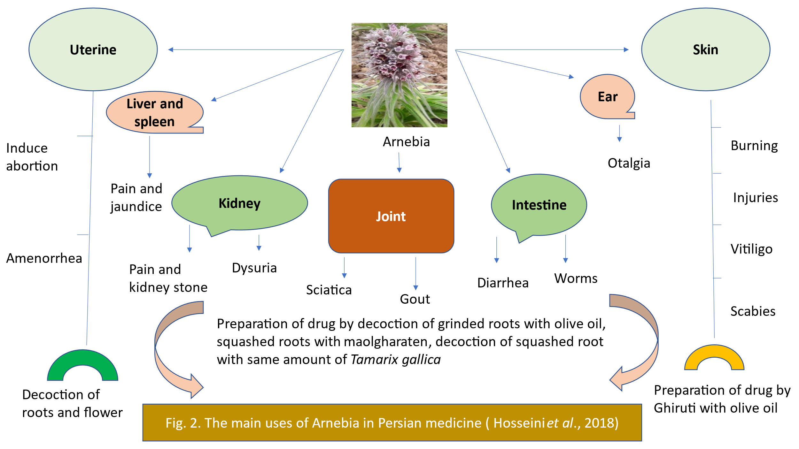

**Phytochemistry**

The plant's actions stem from various secondary metabolites (Fig. 2) that it synthesizes in response to both internal and external triggers. Arnebia spp. has been found to contain a range of phytochemicals, including alkaloids, terpenoids, phenols, and quinones, as reported by Kumar et al. in 2021.

Methalonic and ethanolic extracts of *Arnebia benthamii* were found to contain various compounds, including alkaloids, phenols, flavonoids, saponins, glycosides, tannins, terpenoids, steroids, and carbohydrates, as reported by Fayaz et al. in 2017. High-performance thin-layer chromatography (HPTLC) analysis conducted by Katoch et al. in 2016 identified the major active components as shikonin (with an Rf value of 0.37) and β,β-dimethylacryl shikonin (with an Rf value of 0.58) in A. benthamii.Similarly, Sharma et al. (2009) detected the presence of naphthoquinone shikonin, acetylshikonin, and beta-acetoxyisovaleryl shikonin in various Arnebia spp. Furthermore, a study by Rather et al. in 2018 involving column chromatography of the chloroform extract of *Arnebia benthamii* revealed the presence of kaempferol, aromadendrin, sitosterol, and kaempferol-7-o-methyl ether. In a separate investigation, Parray et al. (2015) isolated the major component shikonin from the roots of *Arnebia benthamii*. Additionally, Ahmad et al. in 2018 reported the presence of pyrrolizidine hepatotoxic alkaloids, including heliotrine, echimidine, and lycopsamine, in A. benthamii from the Neelum Valley of Azad Kashmir.

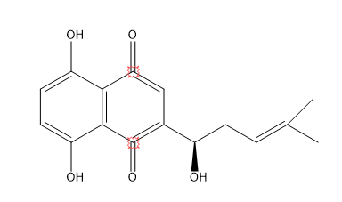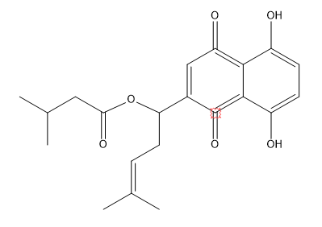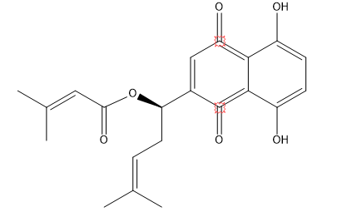

b. Dimethylacrylshikonin

1. Shikonin

c. Isovalerylshikonin

**Fig: 3.** **Structure of different secondary metabolites of *Arnebia benthamii.***

**Pharmacological potential of *Arnebia benthamii.***

**Antioxidant Potential**

The *Arnebia benthamii* ethyl acetate root extract displays noteworthy antioxidant potential, suggesting its potential application as a dietary supplement or traditional medicinal remedy for the prevention and treatment of diseases stemming from oxidative damage. Additionally, it exhibits the capacity to shield DNA from hydroxyl radical-induced damage. The quantification of shikonin, utilizing the HPLC method, offers remarkable sensitivity. Specifically, an 85.9% recovery rate was achieved, and a 50 g/g ethyl acetate extract yielded a shikonin concentration of 5.19 g/g (Parray et al. 2015).Moreover, the methanol extract of *Arnebia benthamii* demonstrated a substantial scavenging activity of 71.29% at a concentration of 800 g/mL. Impressively, this scavenging efficacy, reaching 90.67% at the same concentration, is comparable to that of traditional Vitamin E. These findings underscore the extract's robust antioxidant activity, positioning it as a potential source of lead compounds in the pharmaceutical industry (Ganie et al. 2012, 2014).

**Antidepressant Effects**

To evaluate the antidepressant potential of *A. benthamii* aqueous root extract in rats, two behavioral tests—namely, the forced swim test and the tail suspension test—were employed. These tests induce depressive symptoms in rats, including immobility. The administration of A. benthamii aqueous root extract significantly reduced the immobility period in both the force swim and tail suspension tests, effectively alleviating depressive behaviors. Notably, higher doses of the extract (150 and 300 mg/kg) exhibited greater efficacy compared than lower doses. Furthermore, the higher dose of *Arnebia* benthamii aqueous root extract led to a substantial increase in the levels of superoxide dismutase (SOD) and brain glutathione when compared to the control group. Additionally, malondialdehyde and nitrite levels were notably reduced in the group treated with *Arnebia benthamii* aqueous root extract, particularly at the higher dosage. These findings affirm the efficacy of the aqueous root extract of *Arnebia benthamii* as an antidepressant, demonstrating its ability to alleviate depressive symptoms (Kumar et al. 2017).

**Antimicrobial Properties**

Plants constitute a fundamental source of knowledge for both Ayurvedic and modern medicine. The chloroform extract derived from the leaves of *Arnebia benthamii* exhibited antibacterial activity on par with established standards, as reported by Guna in 2019. In a study conducted by Shameem and her colleagues in 2015, methanol extracts obtained from the aerial parts of *Arnebia benthamii* demonstrated potent antibacterial activity, particularly against Peudomonas aeruginosa CD0023 and Escherichia coli CD0006. Furthermore, methanolic extracts from Arnebia benthamii exhibited substantial antibacterial activity, particularly against Escherichia coli, outperforming a standard antibacterial drug, as reported by Ganie et al. in 2012.The derivatives of alkannin and shikonin, found in contemporary research, showcase robust antioxidant and antimicrobial effects. In a study conducted in 2002 by Sasaki et al., the antifungal properties of shikonin were compared with those of the standard antifungal drug fluconazole. The results revealed that shikonin exhibited superior fungicidal activity compared to fluconazole against Candida krusei and Saccharomyces cerevisiae. Additionally, shikonin demonstrated fungicidal activity on par with fluconazole against Candida glabrata. It's worth noting that this study employed an extract containing pigments from the roots of Lithospermum erythrorhizon and Arnebia euchroma.

**Anticancer Properties**

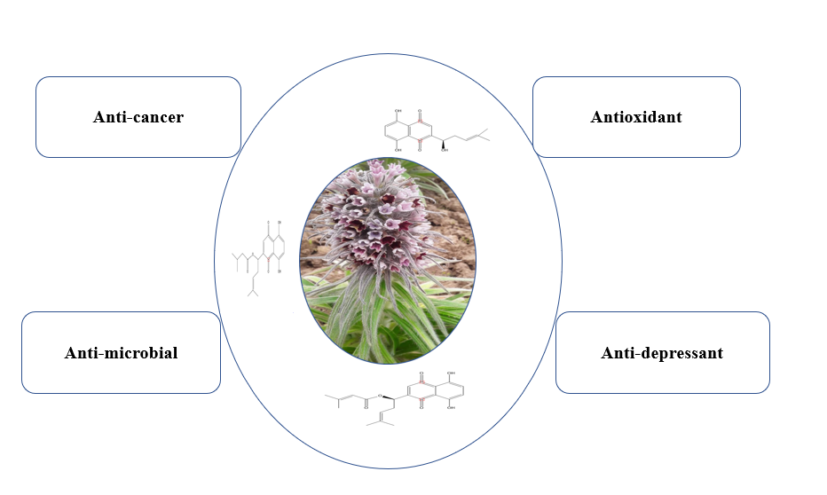Various extracts, including aqueous, ethanolic, methanolic, and ethyl acetate extracts, derived from the entire plant of *Arnebia benthamii*, were assessed for their anticancer potential against five different human cancer cell lines (lung, prostate, leukemia, colon, and pancreatic). Remarkably, these extracts demonstrated notable efficacy in inhibiting cancer cell growth. Furthermore, the inhibition exhibited by these extracts was found to be dependent on the concentration used, as reported by Ganie et al. in 2014.In addition to the plant extracts, shikonin, a phytochemical found in *Arnebia benthamii*, has shown promising results when combined with existing cancer treatment approaches. When used in conjunction with chemotherapeutic agents, immunotherapy, radiation therapy, and other treatment modalities, shikonin has displayed additive to synergistic interactions. This underscores the potential of integrating this phytochemical into standard cancer treatment regimens and pharmaceutical medications, offering new possibilities for cancer therapy, as highlighted by Boulos et al. in 2019.

**Fig. 4: Pharmacological potential of *Arnebia benthamii***

**Dosage and toxicityTop of Form**

A prevalent source of herbal product toxicity arises from the presence of pyrrolizidine alkaloids (PAs). PAs are secondary metabolites that accumulate in certain plants, posing a risk of hepatotoxicity in humans and potential harm to livestock and wildlife, as noted by Avula et al. in 2015. These alkaloids accumulate in plants primarily as PA-N-oxides, serving as defensive compounds. Remarkably, they are synthesized by approximately 6,000 plant species, constituting 3% of all angiosperms, according to research by Letsyo et al. in 2017.Among these species, the Boraginaceae, Fabaceae, and Asteraceae families harbor the largest number of PA-producing species, as highlighted by Coulombe in 2003. Notably, the Boraginaceae family, in particular, is renowned for its association with toxic PAs and their oxides, as reported by El-Shazly and Wink in 2014.The recent exploration of *Arnebia benthamii* has yielded two noteworthy revelations of substantial relevance to stakeholders in the herbal medicine domain, including producers, practitioners, and consumers. Firstly, this investigation unveiled the presence of pyrrolizidine alkaloids (PAs) with hepatotoxic properties—specifically lycopsamine, echimidine, and heliotrine—in *Arnebia benthamii* sourced from the Neelum Valley of Azad Kashmir. This discovery underscores that while *Arnebia benthamii* has long been recognized for its traditional therapeutic applications, it also harbors PAs that pose potential health risks.Secondly, a comprehensive survey conducted as part of this study illuminated a prevalent pattern among local inhabitants, with the majority either utilizing or gathering *Arnebia benthamii* due to its valued traditional therapeutic attributes. In light of these findings, it is strongly recommended that the local marketing and distribution of *Arnebia benthamii* and its herbal formulations be temporarily halted until exhaustive assessments confirm PA levels to be within established safety thresholds. Additionally, a proactive approach is advocated, involving collaboration among local forestry departments, non-governmental organizations, and governmental entities, to instigate educational initiatives and heighten awareness within the community. These efforts should target a diverse range of stakeholders, including individuals, harvesters, herbalists, farmers, herders, pastoralists, and transporters, ensuring their adherence to the safety guidelines set forth by the European Medicines Agency, specifically limiting PA intake to 1 μg per day (Ahmad *et al*., 2018).

**Agrotechnology**

*Arnebia benthamii* can be reproduced through both sexual means using seeds and asexual methods involving rhizomes. However, to maintain plant quality and uniformity, the predominant method of propagation is through rhizome cuttings (Manjkola and Dhar 2002). At maturity, in ex-situ conditions the plants produce about ten vegetative clums or buds which can be separated and transplanted to multiply the species.

**Time of Cultivation**

The plants can be transplanted from mid- March to July. However the studies revealed that the period between March to May is best for the cultivation of the species.

**Seed Sowing**

For raising plants in nursery, the seeds can be sown from March to July. The seeds should not be kept deep inside the soil, a depth of 0.5 cm is appropriate. A 1:1 sand - soil mixture proved ideal for germination. Seeds sown along with fruit wall witness a delayed germination pattern (2-3 months to germinate) as compared to those sown without fruit wall which usually germinate in 25-45 days. However the germination time was reduced successfully to just 15 days by pre-treating seeds with 100 ppm Kinetin. Sowing seeds in March result in maximum percentage germination-75% with 66% seedlings surviving to mature stages.

**Soil texture-Pot trials**

The plants of *Arnebia benthamii* grows well on soils of different textures. The plants thrived well on sandy, loamy, clayey, sandy loam, clayey loam textures. Under open sunny conditions the maximum survival of plants, 90% is witnessed in loamy texture, followed by 70% and 60% in sandy and clayey soils respectively as depicted in the graph.

**Slope and Soil Reaction**

The plants can be grown or cultivated on both sloppy as well as flat land with different soil textures and reactions

**Irrigation**

The studies revealed that under ex situ conditions plants should receive irrigation at least twice in a week. However during summer months plants need to be irrigated on need basis, with irrigation incidence sometimes shooting up to 5 times a week. This holds true for plants growing under open sunny conditions. Under shady conditions frequent irrigation deters survival. However under shady conditions survival is jeopardized when irrigation is carried out daily. Under shady conditions irrigation after intervals of three days and one week gave good results of survival-70% and 90% respectively.

**Water logging**

Water logging is detrimental for the species resulting in rhizome rotting. The effects are reflected much earlier by plants grown in shade as compared to those growing under sunny open condition.

**Pests**

Under shady condition the green caterpillars of the insects order Lepidoptera were observed to feed voraciously on the leaves and stem axis of plants causing tremendous damage to them. However under sunny conditions no such attack was observed.

**Spacing**

For better growth of plants, a spacing of 40-50 centimetres is most appropriate.

**Biotechnological Approaches in *Arnebia benthamii***

**Tissue culture**

Researchers have developed a tissue culture method for *Arnebia benthamii*, utilizing various combinations of suitable media formulations that include adjuvants, Murashige and Skoog (MS) medium, growth hormones, carbohydrates, and agar. The study evaluated the impact of these media combinations and found that the MS medium, along with thiadiazuron and Indole 3-acetic acid, promoted superior regeneration capabilities. Additionally, in vitro herbal extracts demonstrated significant hydroxyl radical scavenging activity, indicative of DNA protection (Parray et al. 2018).

**In Vitro Seed Germination Insights**

Studies on *Arnebia benthamii* seed germination revealed that these seeds contain oil reserves and boast an impressive 98% viability rate. They exhibit good water holding capacity, and their seed coat has a limited impact on physical dormancy. Scarification emerged as the most effective technique for enhancing germination rates and reducing the mean germination time. Scarification treatment resulted in a remarkable increase in seed germination, reaching 97%, while also significantly shortening the germination period to 4.03 days. In contrast, the control group exhibited a germination rate of only 32% and a germination period of 9.2 days. Interestingly, when scarified seeds were subsequently treated with seed coat extract, the germination rate plummeted to 28%, indicating the presence of inhibitory compounds within the seed coat. Additional investigations explored ex situ experiments focusing on the germinability and seedling survival of *Arnebia benthamii*. These experiments revealed that scarification improved germination but was hindered by inhibitors in the seed coat. Gibberellic acid treatment at 25 and 50 ppm proved most beneficial, whereas higher doses (100 and 200 ppm) reduced seed germination. Moreover, in a separate investigation, Thiourea treatment enhanced germination in the alpine population, while cooling treatment significantly improved germination in the subalpine population (Khursheed et al. 2011, Ganai and Nawchoo 2002, Manjkhola et al. 2003)

**In Vitro Multiplication of *Arnebia benthamii***

A highly effective in vitro multiplication and propagation method was developed for *Arnebia benthamii*. This technique involved the use of half-strength Murashige and Skoog (MS) media supplemented with varying concentrations of 6-benzyladenine (BA) to stimulate shoot growth from shoot tip explants. Notably, the treatment with 5 μM benzyladenine resulted in the formation of multiple shoots. Furthermore, the study revealed that the optimal induction of multiple shoots occurred when half-strength MS medium was supplemented with 4 μM BA and 1 μM IBA. For root development from shoots, different doses of IBA, indole-3-acetic acid (IAA), and naphthaleneacetic acid (NAA) were tested. The most successful root development was observed with half-strength MS medium containing 4 μM IBA, and 80% of the plantlets successfully transitioned to field conditions (Quadri et al. 2012).

**Conclusion**

This review underscores the historical significance of *Arnebia benthamii* and its critical role in accurate identification and authentication based on botanical, phytochemical, and pharmacological data. Additionally, it aims to inspire researchers worldwide to explore the extensive pharmaceutical applications of this plant for future advancements. Arnebia benthamii, a vital medicinal plant thriving in the high-altitude Himalayan regions, boasts a plethora of pharmacological attributes, including antioxidant, anticancer, antimicrbial, antibacterial, and anti-depressant effects. Bioactive compounds such as have been identified as Shikonin, Isovaleryl-shikonin, β,β-di-methylacryl- shikoninresponsible for its pharmaceutical efficacy.Despite its widespread utilization for diverse health-related issues across the globe, the primary source of Arnebia benthamii remains wild habitats. Unfortunately, this has led to over-exploitation, habitat loss, suboptimal harvesting methods, underdeveloped cultivation techniques, and a lack of local awareness, posing a significant threat to the biodiversity of this remarkable medicinal plant. Consequently, there is an urgent need to develop efficient cultivation practices, with most research thus far focusing on the roots and rhizomes, while the biological potential of the leaves remains relatively unexplored. Promoting in situ conservation and cultivation methods is crucial, and further investigations should delve into harnessing the untapped biological potential of *Arnebia benthamii's* leaves to optimize harvesting and unlock the plant's maximum capabilities.

**COMPETING INTERESTS DISCLAIMER:**

Authors have declared that they have no known competing financial interests OR non-financial interests OR personal relationships that could have appeared to influence the work reported in this paper.

Disclaimer (Artificial intelligence)

Option 1:

Author(s) hereby declare that NO generative AI technologies such as Large Language Models (ChatGPT, manuscript.

**References**

Ahmad L, He Y, Hao J-C, Semotiuk A, Liu Q-R, Mazari P (2018) Toxic pyrrolizidine alkaloids provide a warning sign to overuse of the Ethnomedicine Arnebia Benthamii. J Ethnopharmacol 210:88–94

Altaf, Z., Mushtaq, T., Sofi, P.A., Peerzada, I.A., Malik, A.R., Singh, A., Jeelani, M.I., Nissar, S., Rafeeq, J. and Fayaz, P.T. 2024. Chemical composition, traditional uses and pharmacological potential of *Podophyllum hexandrum*: An endangered medicinal plant of North-Western Himalayas. *International Journal of Advanced Biochemistry Research* 8(4):16-21.

Ambrish, K., Srivastava, S.K. 2014. Taxonomic studies on the genus" *Arnebia forssk’’*. (Boraginaceae) in India. *Taiwania* **59**(4): 315–325. https://doi.org/10.6165/ tai.2014.59.4.315.

Aswal, B.S. and Mehrotra, B.N. 1994. Flora of Lahul-Spiti – A cold Desert in North- West Himalaya. Bishen Singh Mahendra Pal Singh, Dehradun pp 2-6.

Baig, B. A., Bhat, T. A. and Ramamoorthy, D. 2012. Distribution and Current Conservation Status of Some Important Threatened Medicinal Plants of Ducksum kokernag (Kashmir Himalayas). *New York Science Journal***5**(11): 41-48.

Baig, B. A., Ramamoorthy, D. and Wani, B. A. 2014. Population Status and Conservation Prioritization of Some Threatened Medicinal Plants of Kashmir Himalayas. *International Journal of Applied Biology and Pharmaceutical Technology***5**(4): 1-15.

Ballabh B, Chaurasia OP, Ahmed Z, Singh SB (2008) Traditional medicinal plants of Cold Desert Ladakh—used against kidney and urinary disorders. J Ethnopharmacol 118(2):331–339

Boulos JC, Rahama M, Hegazy M-EF, Efferth T (2019) Shikonin derivatives for cancer prevention and therapy. Cancer Lett 459:248–267

Chauhan K, Sharma S, Agarwal N, Chawla, Kirti, Ramgopal Mopuri, Anil K. Sharma, and Pawan Kumar. 2021. “Arnebia Euchroma.” pp. 27–41 In Nikhil Malhotra, Mohar Singh. Himalayan medicinal plants. Amsterdam: Elsevier

Chauhan NS (2011) Economic, medicinal and aromatic plants: their distribution, trade and utilization in the Cold Desert areas of Himachal Pradesh. Himalayan Ecology 19:17

Dar, G. H. and Khuroo, A. A. 2013. Floristic diversity in Kashmir Himalaya: progress, problems and prospects. *Sains Malaysiana* **42**(10): 1377–1386.

Dar, G.H., Bhagat, R.C., Khan, M.A. 2002. Biodiversity of the Kashmir Himalaya. Valley Book pp 44-60.

El-Shazly, A., Wink, M., 2014. Diversity of pyrrolizidine alkaloids in the boraginaceae structures, distribution, and biological properties. Diversity 6 (2), 188–282

Fayaz, M., Bhat, M. H., Kumar, A. and Jain, A. K. 2017. Comparative studies on different solvents used for the extraction of phytochemicals from the plant parts of *Arnebia benthamii*. (Wall Ex. G. Don) Johnston. *Journal of chemical and pharmaceutical research* **9**(1): 220-224.

Ganai KA, Nawchoo IA (2002) In vitro seed germination studies on Arnebia Benthamii. Indian J Plant Physiol

Ganie, S.A., Dar, T.A., Hamid, R., Zargar, O., Abeer, S., Masood, A., Amin, S. and Zargar, M.A. 2014. In vitro antioxidant and cytotoxic activities of *Arnebia benthamii* (Wall ex. G. Don): A critically endangered medicinal plant of Kashmir valley. *Hindawi Publishing Corporation In Oxidative Medicine and Cellular Longevity***7**:1-8.

Ganie, S.A., Jan, A., Muzaffar, S., Zargar, B.A., Hamid, R. and Zargar, M.A. 2012. Radical scavenging and antibacterial activity of *Arnebia benthamii* methanol extract. *Asian Pac. J. Tropical Med.***5** (10), 766–772. https://doi.org/10.1016/S1995.

Guna, G. 2019. Threat status, conservation and pharmacological activity of *Arnebia benthamii*: A review. *The Pharma Innovation Journal***8**(4): 843-847.

Hosseini, A., Mirzaee, F., Davoodi, A., Jouybari, H.B. and Azadbakht, M. 2018. The traditional medicine aspects, biological activity and phytochemistry of Arnebia spp. *Medicinsk Glasnik***15**(1): 17-21. <https://doi.org/10.17392/926-18>.

Joshi, R.K., Prabodh, S., Setzer, W.N., 2016. Himalayan aromatic medicinal plants: a review of their ethnopharmacology, volatile phytochemistry, and biological activities. Medicines 3, 1–55. <https://doi.org/10.3390/medicines3010006>

Kaif, M., Singh, A., Rafeeq, J., Aata, U., Shah, I.A. and Adil, M. 2021. Seed propagation of endangered medicinal plant *Atropa acuminata* Royle ex lindley: optimizing seed source variation and plant growth regulators for its germination parameters. *SKUAST Journal of Research* 23(2): 204-207.

Kaif, M., Singh, A., Rafeeq, J., Ata, U., Adil, M., Gatoo, A.A., Mughal, A.H., Gangoo, S.A. and Bhat, B.A. 2023. Ethno-medicinal utilization of *Atropa acuminata* in district Bandipora of J&K India. *Indian Forester* 149(1): 60-62.

Kala, C.P. 2005. Indigenous uses, population density and conservation of threatened medicinal plants in protected areas of the Indian Himalayas. *Conservation Biology***19**(2): 368-378.

Kapoor, S., 2018. Inula racemosa: an insight into callus induction, secondary metabolites and its therapeutic potential. The Pharma Innovation Journal 7 (6), 27–32. Kataria, D., Chahal, K.K., 2013. Chemistry and antifungal potential of alantolides from Inula racemosa H. J. Chem. Sci. 125 (1), 187–191

Kashiwada, Y., Nishizawa, M., Yamagishi, T., Tanaka, T., Nonaka, G.I., Cosentino, L.M. and Lee, K.H. 1995. Anti-AIDS agents, 18. Sodium and potassium salts of caffeic acid tetramers from *Arnebia euchroma* as anti-HIV agents. *Journal of Natural Products***58**(3): 392–400. <https://doi.org/10.1021/np50117a007>.

Katoch, P., Rana, S., Kumar, D., Kumar, S. and Bushan S. 2016. Concurrent NP-HPTLC determination of shikonin and β, β -Dimethylacryl shikonin in *Arnebia benthamii. Journal of chromatographic science***54**(8):1421-1427.

Khatoon, S., Mehrotra, S., Shome, U. and Mehrotra, B.N. 1993. Analysis of commercial ‘Ratanjot ‘by TLC fluorescence fingerprinting. *International Journal of Pharmacognosy* **31**(4): 269–277. <https://doi.org/10.3109/13880209309082952>.

Khursheed AG, Shabana A, Nawchoo Irshad A (2011) No chilling obligation for germination in seeds of Arnebia Benthamii: a critically endangered alpine medicinal Plant of North-West Himalaya. Int J Biodivers Conserv 3(5):155–159

Kosger HH, Ozturk M, Sokmen A, Bulut E, Ay S (2009) Wound healing effects of Arnebia Densiflora root extracts on rat palatal mucosa. Eur J Dentist 3(02):96–99

Kour, J., Balgotra, S., Rajput, P., Kour, H., Verma, P.K., Sawant, S.D., 2020. Medicinal value of high-altitude plants of Indian Himalaya. In: Botanical Leads for Drug Discovery. Springer, Singapore, pp. 295–324. [https://doi.org/10.1007/978-981-15- 5917-4_14](https://doi.org/10.1007/978-981-15-%205917-4_14)

Kumar A, Shashni S, Kumar P, Pant D, Singh A, Verma RK (2021) Phytochemical constituents, distributions and traditional usages of Arnebia Euchroma: a review. J Ethnopharmacol 271: 113896

Kumar N, Eloziia N, Kothiyal P (2017) Evaluation of antidepressant activity of aqueous root extract of Arnebia Benthamii in rats. indo Am J Pharm Sci 4(7):1956–1964

Kumar, A., Shashni, S., Kumar, P., Pant, D., Singh, A. and Verma, R. K. 2021. Phytochemical constituents, distributions and traditional usages of *Arnebia euchroma*: A review. *Journal of Ethnopharmacology*. **271**: 1-16.

Letsyo, E., Jerz, G., Winterhalter, P., Beuerle, T., 2017. Toxic pyrrolizidine alkaloids in herbal medicines commonly used in Ghana. J. Ethnopharmacol. 202, 154–161.Top of Form

Liang D, Sun Y, Shen Y, Li F, Song X, Zhou E, Zhao F, Liu Z, Yunhe F, Guo M (2013) Shikonin exerts anti-inflammatory effects in a murine model of lipopolysaccharide-induced acute lung injury by inhibiting the nuclear factor-KappaB Signaling pathway. Int Immunopharmacol 16(4): 475–480

Ma ZQ, Hao H, He TT, Guo H, Zhang MY, Chen MW, Wang YT (2014) An assessment of traditional Uighur medicine in current Xinjiang region (China). Afr J Tradit Complement Altern Med 11(2):301–314

Mabberley, D.J. 2008. Mabberley’s Plant Book: A Portable Dictionary of Plants, their classification and uses. Cambridge University Press. Cambridge, U.K.P pp 7-36.

Manjkhola S and Dhar U (2002) Conservation and Utilization of Arnebia Benthamii (Wall. Ex G. Don) Johnston–a High Value Himalayan Medicinal Plant. Curr Sci 83(4):484–488

Manjkhola S, Dhar U, Rawal RS (2003) Treatments to improve seed germination of Arnebia Benthamii: an endangered medicinal herb of high altitude Himalaya. Seed Sci Technol 31(3): 571–577

Manjkhola, S., Dhar, U. and Joshi, M. 2005. Organogenesis, embryogenesis, and synthetic seed production in *Arnebia euchroma* a critically endangered medicinal plant of the Himalaya. *Vitro Cell Dev. Biol. Plant***41**(3): 244-248. https://doi.org/10.1079/ IVP2004612.

Mirzaee F, Hosseini A, Jouybari HB, Davoodi A, Azadbakht M (2017) Medicinal, biological and phytochemical properties of Gentiana species. J Tradit Complement Med 7(4):400–408

Mushtaq, T., Hussain, I., Sofi1, P.A., Peerzada, I.A., Malik, A.R., Singh, A., Jeelani, M.I., Rafeeq, J., Haq, M.M and Fayaz, P.T. 2024. Ethnobotanical study of medicinal plants used to treat human diseases in Daksum forest range of Kashmir Himalayas. *Journal of Ayurvedic and Herbal Medicine*, 10(3): 89-93.

Mushtaq, T., Sofi, P.A., Ahmad, P.I., Malik, A.R., Jeelani, M.I., Nissar, S. and Rafeeq, J. 2023. Standardization of cultivation techniques of *Artemesia absinthium* - an important medicinal plant of Kashmir Himalayas. *SKUAST Journal of Research* 25(4): 608-613.

Parray JA, Hamid R, Kamili AN, Shameem N, Jan S, Ganai BA (2015) Biological efficacy and radical scavenging potential of Shikonin in Arnebia Benthamii (Wall ex. G Don) Johnston. Ind Crop Prod 74:434–439

Parray JA, Kamili AN, Jan S, Mir MY, Shameem N, Ganai BA, Allah EFA, Hashem A, Alqarawi AA (2018) Manipulation of Plant Growth Regulators on Phytochemical Constituents and DNA Protection Potential of the Medicinal Plant Arnebia Benthamii. Biomed Res Int 2018:6870139

Parray, J.A., Hamid, R., Kamili, A.N., Shameem, N., Jan, S. and Ganai, B.A. 2015. Biological efficacy and radical scavenging potential of shikonin in *Arnebia benthamii* (Wall ex. G Don) Johnston. *Ind. Crop. Prod*. **74**: 434–439. [https://doi.org/10.1016/j. indcrop.2015.04.040](https://doi.org/10.1016/j.%20indcrop.2015.04.040).

Pirbalouti, A.G., Koohpayeh, A., Azizi, S., Golparvar, A., 2011. Evaluation of the burn healing properties of Arnebia euchroma rolye (johnst) in diabetic rats. Int. Confer. Biosci. Biochem. Bioinformat. 5, 144–146.

Quadri RR, Kamili AN, Shah AM, Da Silva AJ (2012) In vitro multiplication of Arnebia Benthamii Wall. A critically endangered medicinal herb of the Western Himalaya. Funct Plant Biol 6(1): 54–57

Rafeeq, J., Qaisar, K.N., Khan, P.A., Mugloo, J.A., Singh, A., Hassan, I., Mir, J.I., Malik, A.R., Dutt, V., Mushtaq, T., Rashid, M., Wagay, O.A., Fayaz, S. and Sultan, A. 2023. Regulation of phytochemical properties of Hawthorn: A Crataegus species. IN Singh, R., Kumar, N (eds.) Genetic Manipulation of Secondary Metabolites in Medicinal Plants. Interdisciplinary Biotechnological Advances. Springer Singapore, pp179-203.

Rafeeq, J., Qaisar, K.N., Mugloo, J.A., Khan, P.A., Singh, Peerzada, I.A., Mushtaq, T., Jeelani, M.I., Fayaz, S. and Wagay, O.A. 2025. Phenological Responses of *Crataegus songarica* K Koch to Climate Variation in the Kashmir Himalayas: Insights from Two Consecutive Years. *Indian Journal of Ecology* 52(2): 373-377.

Rafeeq, J., Qaisar, K.N., Mugloo, J.A., Singh, A., Raj, A Khan, P.A., Khan, I., Hassan, I. and Mir, J.I. 2022. Phenological Characteristics of Hawthorn, *Crataegus songarica* K Koch. in Kashmir Himalayas. *SKUAST Journal of Research* 24(2): 248-252.

Rather MA, Pandey DP, Kumar S, Per TS, Rashid Y (2018) Phytochemical investigation of Arnebia Benthamii (WALL. Ex g. Don) Im John St. Inter J Innova Res Rev 6:21–26

Sasaki, K., Abe, H., Yoshizaki, F., 2002. In vitro antifungal activity of naphthoquinone derivatives. Biol. Pharm. Bull. 25 (5), 669–670. https://doi.org/10.1248/ bpb.25.669.

Sekar, C. K., Rawal, R.S., Gairola, S. and Rawat, B. 2009. *Arnebia nandadeviensis* (Boraginaceae), a new species from India. *Journal of American Science* **5**(2): 105-106.

Setzer, S.M., Sharifi-Rad, J., Setzer, W.N., 2016. The search for herbal antibiotics: an insilico investigation of antibacterial phytochemicals. Antibiotics 5, 30. https://doi. org/10.3390/antibiotics5030030.

Shameem, N., Kamili, A.N., Parray, J.A., Hamid, R. and Bandh, S.A. 2015. Antimicrobial and antioxidant activity of methanol extracts of *Arnebia benthamii* (Wall ex. G. Don) Johnston a critically endangered medicinal plant of North western Himalaya. *The Journal of Analytical Science and Technology* **6**(1): 36-40. <https://doi.org/10.1186/s40543-015-0076-z>.

Sharifi-Rad, M., Varoni, E.M., Salehi, B., Sharifi-Rad, J., Matthews, K.R., Ayatollahi, S.A., Kobarfard, F., Ibrahim, S.A., Mnayer, D., Zakaria, Z.A., Sharifi-Rad, M., Yousaf, Z., Iriti, M., Basile, A., Rigano, D., 2017. Plants of the genus Zingiber as a source of bioactive phytochemicals: from tradition to pharmacy. Molecules 22 (2145), 1–19. <https://doi.org/10.3390/molecules22122145>

Sharma Lipika, SS Samant, Ashish Kumar, Manohar Lal, Kaushalya Devi, and Lalit M Tewari (2018) Diversity, distribution pattern, endemism and indigenous uses of wild edible plants in cold desert biosphere reserve of Indian trans Himalaya

Sharma N, Sharma UK, Gupta AP, Sinha AK, Lal B, Ahuja PS (2009) Simultaneous densitometric determination of Shikonin, Acetylshikonin, and Β-acetoxyisovaleryl-shikonin in ultrasonicassisted extracts of four Arnebia species using reversed-phase thin layer chromatography. J Sep Sci 32(18):3239–3245

Singh A, Lal M, Samant SS (2009) Diversity, indigenous uses and conservation prioritization of medicinal plants in Lahaul Valley, proposed Cold Desert biosphere reserve, India. Int J Biodivers Sci Ecosyst Serv Manag 5(3):132–154

Singh, H., Chauhan, R. and Raina, R. 2017. Population structure, ecological features and associated species of *Arnebia euchroma*. *Journal of*Pharmacognosy*and*Phytochemistry**6**(4): 2005-2007.

Sultan, A., Masoodi, T.H., Syed, Q.A.B., Rafeeq, J. and Adil, M. 2022. Ethno-veterinary uses of medicinal plants in district Bandipora of Jammu & Kashmir Union Territory. *emergent Life Sciences Research* 8(1): 89-94.

Tse TW (2003) Use of common Chinese herbs in the treatment of psoriasis. Clin Exp Dermatol 28(5):469–475

Vidyarthi, O. P. S. 2010. Forest flora of Kashmir. Working plan circle Jammu and Kashmir Forest department pp 1-68.

World Health Organization (WHO), 2013. Traditional Medicine Strategy: 2014–2023. WHO Press, Switzerland.

Zakhlenjuk, O.V. and Kunakh, V.A. 1998. *Arnebia euchroma*: in vitro culture and the production of shikonin and other secondary metabolites. In: Medicinal and Aromatic Plants X. *Springer,* Berlin, Heidelberg pp 28-44. https://doi.org/10.1007/978-3- 642-58833-43.

Zhu, G.-L, Reidl, H. and Kamelin, R. 1995**.** *Arnebia* Forssk. *In*: Wu, Z.Y. and P.H. Raven (Eds.), Flora of China 16 (Gentianaceae to Boraginaceae). Science Press, Beijing and Missouri Botanical Garden Press, St. Louis pp 344-479.