Original Research Article

**EXPLORING GENETIC DIVERSITY IN MATURITY DURATION AMONG PIGEONPEA GENOTYPES GROWN UNDER OFF-SEASON *(Rabi)* CONDITIONS**

.

ABSTRACT

|  |
| --- |
| Pigeonpea (*Cajanus cajan* L. Millspaugh) is an important legume crop cultivated in rainfed areas due to its adaptability and soil-enriching properties. This study evaluated 250 genotypes from the PI-GAP (Pigeonpea International Genome-Wide Association Panel) for days to maturity under *rabi* season at ICRISAT, Patancheru. Maturity ranged from 92 to 209 days, with a mean of 141 days. Genotypes were grouped into five maturity classes, with most falling in the early category. Analysis of variance showed significant genetic effects (*p* < 0.001), supported by moderate GCV and PCV, high heritability (97.63%), and high genetic advance. A strong positive correlation (r = 0.78) was observed between plant height and days to maturity. Principal Component Analysis revealed that PC1 explained 88.64% of the total variance. These results highlight the potential of early and late maturing lines for target-specific pigeonpea breeding under diverse cropping systems. |

*Keywords: Days to maturity, PCA, Stability, Selection, Variability*

1. INTRODUCTION

Legumes are recognized to provide food proteins in the underdeveloped countries and are typically cultivated on low-input, risky marginal areas. It is a popular legume crop, which is found in 82 countries around the world (Ranjani and Jayamani, 2021). Among the legumes, pigeonpea (*Cajanus cajan* (L.) Millspaugh) occupies an essential place in rainfed agriculture (Saxena *et al*., 2010). Pigeonpea is a member of the subtribe *Cajaninae* of the *Phaseoleae* tribe, a sub-family of the *Papilionoideae* and family *Leguminosae*. The single domesticated species in the sub-tribe *Cajaninae* is *C. cajan* (Varshney *et al*., 2010). Pigeonpea is a perfect crop for sustainable agriculture in India's tropical and sub-tropical regions because of its soil-rejuvenating properties, which include the release of soil-bound phosphorous, fixation of atmospheric nitrogen, recycling of soil nutrients, and addition of organic matter and other nutrients (Saxena and Nadarajan, 2010).

The maturation period of pigeon pea germplasm varies over a large period of time (90–300 days), and this variation is nearly constant (Saxena, 2008). Pigeonpea is regarded as a crop that can withstand drought and has a wide range of maturity dates. It is so well suited to a variety of cropping techniques and conditions. Pigeonpea is often classified into four maturity groups: extra early, early, medium, and late. These maturity variations directly impact the crop's fitness and survival in various agro-ecological niches (Choudhary *et al*., 2011). The availability of early and extra-early accessions of Pigeonpea with good adaptability provides a scope for its cultivation as a sole crop in rotation with other crops in areas with a limited cultivation window (*Robertson et al*., 2001). Climate change has resulted in elevated variability in precipitation patterns, shortened growing seasons, and more frequent droughts, especially in rainfed and marginal agricultural regions. Creating pigeonpea varieties with diverse maturity lengths, particularly early and extra-early maturing types, allows farmers to adjust to changing climatic circumstances by optimizing sowing and harvesting periods, minimizing exposure to terminal drought, and enhancing crop resilience. Pigeonpea varieties with diverse maturity lengths, allows farmers to adjust to optimizing sowing windows and harvesting, minimizing crop losses due to climatic vulnerable. The present manuscript is useful for the target specific pigeon pea breeding under diverse cropping system. The heritability and genetic advance reported in this manuscript helps further for the selection of early and late maturing lines in pigeon pea.

2. material and methods

The study was planned and executed at ICRISAT, Patancheru, in 2023. The crop was cultivated in the *rabi* season. The 250 lines of Pigeonpea International Genome-Wide Association Panel (PI-GAP) were taken up for this study. The material was sown in two replications, in alpha lattice design, at ICRISAT’s Vertisol soils. Each plot had a row length of 2m, the spacing between the rows adopted was 60 cm, and the spacing between the plants within a row was 20 cm. Each replication had 25 blocks, accounting for 50 blocks in both replications. The blocks contain 10 plots each, and the total number of plots is 500. The 250 lines in the study were evaluated for variability, heritability, and genetic advance, for days to maturity under *rabi* cultivation. The agronomic and pest management practices were followed per the recommendations to raise a healthy crop. The days to maturity were recorded for the lines when 80% of the pods had turned brown.

For the analysis of the data, Burton's (1952) methodology was used to calculate the genotypic and phenotypic coefficients of variation. The approach suggested by Lush (1940) was used to evaluate heritability, and Johnson *et al.* (1955) provided the methodology for estimating genetic advance. The data was analyzed using R version 4.5.0. The package “lme4” was used to structure the ANOVA (Analysis of Variance) utilizing the mixed-effect models. The package “lmerTest” was employed to test the hypothesis; “dplyr” was used for summarizing the data, and “ggplot2” was employed for creating the visualization plots. Correlation analysis was executed using the base R stats package. The Principal Component Analysis was executed utilizing the “prcomp” function of the stats package in R.

3. results and discussion

# 3.1 Descriptive statistics, Frequency distribution and ANOVA

Significant diversity for this feature in the population was shown by the extensive range of variation seen in the descriptive statistics for days to maturity among the genotypes that were assessed (Table 1). The average days to maturity was 141 days. Both extremely early and very late maturing genotypes were present, as exhibited by the minimum and maximum values of 92 and 209 days, respectively. The range of maturity for the panel was 117 days in the off-season, which suggests a high level of genetic variability. The data dispersion around the mean is represented by the standard deviation (SD) of 27.3 days. Yohane *et al.* (2020) reported that the SD ranged from 11.9 to 22 days for days to maturity among the eighty-one genotypes that they included in the study. The genotypes have exhibited a moderate variability supported by a coefficient of variation (CV) of 19.4%, moderate CV was also reported for the trait by Yohane *et al.* (2022). This amount of variability exhibited is adequate for effective selection in breeding programs aiming for early or late maturity, based on the cropping system or agroecological needs.

# Table 1: Descriptive statistics for Days to Maturity

|  |  |
| --- | --- |
| Statistic | Value |
| Mean (Days) | 141.0 |
| Minimum (Days) | 92 |
| Maximum (Days) | 209 |
| Standard Deviation | 27.3 |
| Coefficient of Variation (%) | 19.4 |

The 250 genotypes were classified into five groups based on the maturity duration. The lines that mature between 90 and 120 days are grouped under extra early; between 120 and 150 days are classified as early; 150 and 165 days as mid-early; 165 and 180 days are grouped under medium, and more than 180 days are classified as late maturing (Figure 1). The frequency distribution revealed that the most significant proportion of genotypes (74 genotypes) belonged to the early maturity class, followed by late (66 genotypes) and extra early (64 genotypes) categories. The mid-early and medium classes had fewer genotypes, with 35 and 11 entries, respectively. This classification indicates the presence of genetic variation for maturity duration, which is beneficial for selection and targeted breeding. The early maturity group was the most populated, suggesting that early maturity is a common or desirable trait in the breeding material.

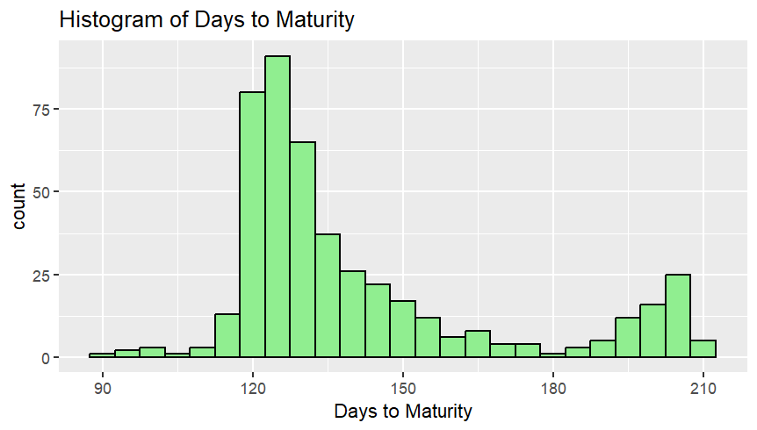

# Figure 1: Frequency distribution histogram for days to maturity

Analysis of Variance (ANOVA) was executed using a mixed model approach to evaluate the significance of genotypic effects on days to maturity. The F-value obtained is 83.51, which is significantly high and indicates a substantial genetic variability among the lines (Table 2). The p-value is extremely small, and the results show significance at p<0.001. The considerable variation for days to maturity was recorded by Kumar *et al.* (2023); Dhanushasree and Hemavathy (2022). This high significance level suggests that the observed variation in maturity duration is not due to chance but mainly genetic differences among genotypes, making selection and genetic improvement feasible.

# Table 2: ANOVA for Days to Maturity

|  |  |  |  |  |  |  |  |
| --- | --- | --- | --- | --- | --- | --- | --- |
| Source | Sum of Squares | Mean Square | (NumDF) | (DenDF) | F Value | Pr(>F) | Significance |
| Genotype | 340,407 | 1,436.3 | 237 | 223.01 | 83.51 | < 2.2e-16 | *** |

# 3.2 Performance of Top and Bottom Ten Genotypes

The panel selected for the study has a wide range of days to maturity. The bottom ten entries (Table 3) constitute the extra-early maturing groups. ICP 10904 is the earliest maturing entry in 94 days, followed by ICP 6370 (99 days). The bottom ten lines ranged from 94 to 118 days. These lines, which are included in the bottom ten, can be utilized for short-season cultivation or intercropping, where early harvesting is preferred. The top ten entries listed are the ones that potentially take a longer time to mature and constitute late-maturing entries. The entries ICP 5863, ICP 8144, ICP 11321, ICP 11406, ICP 11823, ICP 14294, and ICP 14545 matured around 205 days. The entries ICP 7375 and ICP 9577 matured at 209 days. The selection from the longer duration entries can be aided based on the area preference where the perennial red gram is grown and where the marginal lands are available for cultivation.

# Table 3: List of Top and Bottom entries for Days to Maturity

|  |  |  |  |  |
| --- | --- | --- | --- | --- |
| Rank | Early maturing lines (Bottom) | Mean DM | Late maturing lines (Top) | Mean DM |
| 1 | ICP 10904 (G20) | 94.0 | ICP 5863 (G153) | 205.0 |
| 2 | ICP 6370 (G159) | 99.0 | ICP 8144 (G208) | 205.0 |
| 3 | ICP 15014 (G100) | 102.0 | ICP 11321 (G31) | 205.0 |
| 4 | ICP 15021 (G101) | 109.0 | ICP 11406 (G34) | 205.0 |
| 5 | ICP 14444 (G86) | 112.0 | ICP 11823 (G43) | 205.0 |
| 6 | ICP 11538 (G36) | 114.0 | ICP 14294 (G84) | 205.0 |
| 7 | ICP 11613 (G39) | 115.0 | ICP 14545 (G88) | 205.0 |
| 8 | ICP 14886 (G97) | 116.0 | ICP 8921 (G228) | 206.0 |
| 9 | ICP 15597 (G108) | 118.0 | ICP 7375 (G194) | 209.0 |
| 10 | ICP 11505 (G35) | 118.0 | ICP 9577 (G239) | 209.0 |

The box plots of the top and the bottom ten genotypes, the narrow interquartile range genotypes show stability, and the wider genotypes show existing variability within the genotype, as Williamson *et al.* (1989) suggested. The genotypes ICP 5863, ICP 7375, ICP 8144, ICP 9577, ICP 11321, ICP 11406, ICP 11823, ICP 14294, and ICP 14545 among the top ten and ICP 15014, ICP 15597, ICP 11613, and ICP 14444 among the bottom ten, are the genotypes without much variability in the days to maturity within the genotypes (Figure 2).

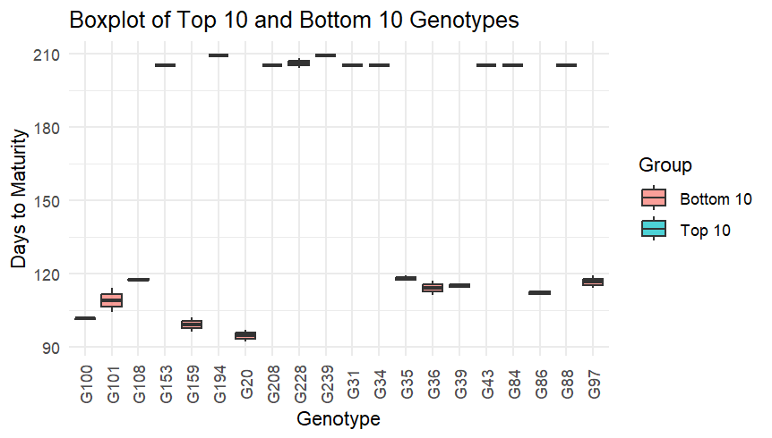

# Figure 2: Box plot to represent the top and bottom ten genotypes

# 3.3 Genetic Parameters

The genetic parameters for the days to maturity have shown a moderate PCV (phenotypic coefficient of variation) and GCV (genotypic coefficient of variation) of 19.0% and 18.86%, respectively (Table 4). Moderate PCV and GCV for days to maturity had been reported by Akshaya *et al*. (2024). The PCV being slightly higher than GCV suggests a slight influence of environment, but mainly the variability exhibited by the trait is genetically controlled. The heritability obtained is 97.63%, which states that the trait had additive genetic effects for its expression. Hussain *et al.* (2021) also reported high heritability for days to maturity. The GA (genetic advance) was 54.87 days, and the GAM (genetic advance as a per cent of the mean) was 38.86%. High genetic advance was also reported by Kumar *et al.* (2014). The GAM recorded is high. This indicates that high heritability and GAM will aid substantial gains in modifying the maturity duration with simple selection methods in pigeonpea.

# Table 4: Genetic Parameters for Days to Maturity

|  |  |
| --- | --- |
| Parameter | Estimate |
| Genotypic Coefficient of Variation (GCV), % | 18.86 |
| Phenotypic Coefficient of Variation (PCV), % | 19.09 |
| Heritability (%) | 97.63 |
| Genetic Advance (GA, days) | 54.87 |
| Genetic Advance as per cent of Mean (GAM) % | 38.86 |

# 3.4. Correlation and PCA for Days to Maturity and Plant Height

Pearson's correlation coefficient for plant height and days to maturity was 0.78, implying a strong positive direct correlation for the two traits this was calculated using the “Stats” package of R. This means that the taller genotypes usually exhibit late maturity, and early maturing types are often linked to shorter height. Singh *et al*. (1995) have reported a strong correlation between plant height and days to maturity. Such a strong correlation suggests that these traits may be under genetic control, or that physiological mechanisms related to plant growth duration are shared. This association is particularly relevant for breeders, as selection for one trait may influence the plant height.

With an eigenvalue of 1.7729, Principal Component Analysis showed that PC1 captured the joint variation of plant height and days to maturity, accounting for 88.64% of the overall variance (Table 5). PC2 explained the remaining 11.36%, or minor independent variation, with an eigenvalue of 0.2273 (Figure 3). The cumulative variance of PC1 and PC2 accounts to the 100% variance. Similar results were reported by Dhanushasree and Hemavathy (2022). This suggests that the first principal component can be used to effectively summarize the majority of the phenotypic variance among genotypes. This work underscores the notable genetic heterogeneity for maturity time in pigeonpea, facilitating the selection of adaptive genotypes. Recognizing early and late maturing varieties provides breeding strategies to alleviate climate-related hazards and promote sustainable agriculture under evolving environmental conditions.

# Table 5: Principal Component Analysis for Days to Maturity and Plant height

|  |  |  |  |  |
| --- | --- | --- | --- | --- |
| Component | Std. Deviation | Eigenvalue | Proportion of Variance (%) | Cumulative Variance (%) |
| PC1 | 1.3315 | 1.7729 | 88.64 | 88.64 |
| PC2 | 0.4767 | 0.2273 | 11.36 | 100 |

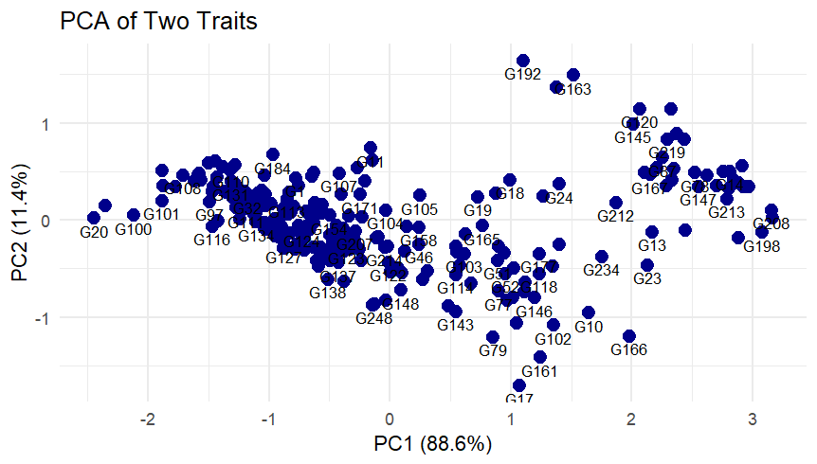

# Figure 3: PCA of days to maturity and plant height

4. Conclusion

The study on 250 pigeonpea genotypes from the PI-GAP revealed significant genetic variation for days to maturity, ranging from 92 to 209 days, with high heritability (97.63%) and genetic advance. Most genotypes were early maturing, and a strong positive correlation (r = 0.78) was found between plant height and maturity. Principal Component Analysis showed PC1 explaining 88.64% of variance. These findings suggest strong potential for breeding early and late maturing pigeonpea lines tailored to diverse cropping systems.

COMPETING INTERESTS DISCLAIMER:

Authors have declared that they have no known competing financial interests OR non-financial interests OR personal relationships that could have appeared to influence the work reported in this paper.

Disclaimer (Artificial intelligence):

Author(s) hereby declare that NO generative AI technologies such as Large Language Models.

**REFERENCES**

1. Akshaya, M., Geetha, K., Nirmalakumari, A., Sharavanan, P. T., Sivakumar, C., & Parasuraman, P. (2024). Genetic variability, correlation and principal component analysis for yield related traits in pigeonpea [*Cajanus cajan* (L.) Millsp.]. *Legume Research*, *47*(7), 1094.
2. Burton, G. W. (1952). Quantitative inheritance in grasses. *Proceedings of the 6th International Grasslands Congress*, *1*, 227.
3. Choudhary, A. K., Sultana, R., Pratap, A., Nadarajan, N., & Jha, U. C. (2011). Breeding for abiotic stresses in pigeonpea. *Journal of Food Legumes*, *24*(3), 165.
4. Dhanushasree, M., & Thanga Hemavathy, A. (2022). Principal component analysis (PCA) in pigeonpea (*Cajanus cajan* (L.) Millsp.) germplasm. *Biological Forum – An International Journal*, *14*(3), 1318.
5. Hussain, M. E., Sharma, S., Joel, A. J., Ravikesavan, R., Senthil, N., & Senthil, A. (2021). Genetic variability of agronomic traits in extra-early maturing introgression lines (ILs) of pigeonpea [*Cajanus cajan* (L.)]. *Electronic Journal of Plant Breeding*, *12*(2), 507–514.
6. Johnson, H. W., Robinson, H. F., & Comstock, R. E. (1955). Estimates of genetic and environmental variability in soybeans. *Agronomy Journal*, *47*, 314.
7. Kumar, A., Sharma, V., Singh, H. C., Kumar, H., Mourya, A. K., & Kumar, A. (2023). Genetic variability and characters of association for yield and its components in pigeon pea [*Cajanus cajan* (L.) Millsp.]. *Journal of Food Legumes*, *36*(1), 16.
8. Kumar, S., Kumar, S., Singh, S. S., & Elanchezhian, R. (2014). Studies on genetic variability and inter-relationship among yield contributing characters in pigeonpea grown under rainfed lowland of eastern region of India. *Journal of Food Legumes*, *27*(2), 104.
9. Lush, J. L. (1940). Intra-sire correlations or regressions of offspring on dam as a method of estimating heritability of characteristics. *Journal of Animal Science*, *1*, 293.
10. Ranjani, M.S. and Jayamani, P. (2021). Characterization of pigeonpea genotypes based on DUS traits. *International journal of plant & soil science*, *33*(23), 289-297.
11. Robertson, M. J., Carberry, P. S., Chauhan, Y. S., Ranganathan, R., & O’Leary, G. J. (2001). Predicting growth and development of pigeonpea: a simulation model. *Field Crops Research*, *71*(3), 195.
12. Saxena, K. B., & Nadarajan, N. (2010). Prospects of pigeonpea hybrids in Indian agriculture. *Electronic Journal of Plant Breeding*, *1*(4), 1107.
13. Saxena, K. B. (2008). Genetic improvement of pigeon pea—a review. *Tropical Plant Biology*, *1*, 159.
14. Saxena, K. B., Vijaya Kumar, R., & Sultana, R. (2010). Quality nutrition through pigeonpea—a review. *Health*, *2*(11), 1335.
15. Singh, N. B., Ariyanayagam, R. P., Gupta, S. C., & Rao, A. N. (1995). Relationship of plant height, days to flowering and maturity to grain yield in short-duration determinate pigeonpea. *Indian Journal of Genetics and Plant Breeding*, *55*(1), 1.
16. Varshney, R. K., Penmetsa, R. V., Dutta, S., Kulwal, P. L., Saxena, R. K., Datta, S., Sharma, T. R., Rosen, B., Carrasquilla-Garcia, N., Farmer, A. D., & Dubey, A. (2010). Pigeonpea genomics initiative (PGI): an international effort to improve crop productivity of pigeonpea (*Cajanus cajan* L.). *Molecular Breeding*, *26*, 393.
17. Williamson, D. F., Parker, R. A., & Kendrick, J. S. (1989). The box plot: a simple visual method to interpret data. *Annals of Internal Medicine*, *110*(11), 916.
18. Yohane, E. N., Shimelis, H., Laing, M., Mathew, I., & Shayanowako, A. (2020). Phenotypic divergence analysis in pigeonpea [*Cajanus cajan* (L.) Millspaugh] germplasm accessions. *Agronomy*, *10*(11), 1682.
19. Yohane, E. N., Shimelis, H., Laing, M., & Shayanowako, A. (2022). Genetic diversity and grouping of pigeonpea [*Cajanus cajan* (L.) Millspaugh] germplasm using SNP markers and agronomic traits. *PLOS ONE*, *17*(11), e0275060.