***In vitro* multiple shoot induction and plant regeneration from single-node cuttings of *Jasminum azoricum* L.**

**ABSTRACT**

Some of the cultivars in Karnataka are specific to certain regions, which produce unique fragrance when grown only in that bio-climatic condition. The GI-registered jasmine varieties of Karnataka, particularly Mysore Mallige, are facing a significant threat due to the declining area under cultivation, primarily driven by the rapid urbanization of Mysuru city, India. The present study explores an In vitro multiple shoot induction and plant regeneration technique from single-node cuttings of *Jasminum azoricum* L. The investigation was undertaken to induce multiple shoots from single-node cuttings of *Jasminum azoricum* L. (Mysore Mallige) during the year 2022-23. Single-node cuttings derived from young shoots were cultured on half-strength Murashige and Skoog (MS) medium supplemented with varying concentrations and combinations of 6-benzylaminopurine (BAP: 0.0–2.5 mg/L), kinetin (Kin: 0.0–2.5 mg/L) and adenine sulphate (Ads: 50 mg/L) for shoot induction. The single node cuttings were inoculated on MS medium containing three per cent sucrose solidified with eight per cent Agar. pH of the medium was adjusted to 5.7 before autoclaving. The nutrient medium was incorporated with different concentrations and combination of Cytokinins were used. Among all treatment combinations, the earliest shoot induction (7.16 days) and maximum shoot length (6.33 cm) were observed on medium containing BAP 1.5 mg/L + Kin 2.5 mg/L + Ads 50 mg/L. The highest number of shoots per explant (3.00) was recorded in the treatment containing BAP 2.5 mg/L + Kin 1.0 mg/L + Ads 50 mg/L. For rooting, among various concentrations of indole-3-butyric acid (IBA: 1.0–2.5 mg/L) and indole-3-acetic acid (IAA: 1.0–2.5 mg/L) used, IBA 2.5 mg/L resulted in the early root initiation (8.33 days), the highest number of roots per shoot (3.16), and the maximum root length (6.56 cm) at 45 days, whereas no significant response was observed with IAA treatments. The results showed that there was increase in all rooting parameters with the increase in concentration of IBA but IAA did not have any effect on root induction. The established protocol can be utilized for large-scale rapid multiplication to fulfil the demand of quality planting material of Mysore mallige (*Jasminum azoricum* L.)

*Keywords*: single node cuttings; micropropagation, *Jasminum azoricum, 'Mysore Mallige*

1. **INTRODUCTION**

Plant tissue culture strategies including micropropagation, callus culture, somatic embryogenesis, thin cell layer culture, cell suspension culture etc. are among the common practices employed for propagation, conservation and secondary metabolite production for numerous aromatic and medicinally important plants (Ahmed et al., 2021). Jasmine plants are evergreen [shrubs](https://en.wikipedia.org/wiki/Shrub) and climbers belonging to family [Oleaceae](https://en.wikipedia.org/wiki/Oleaceae). The word ‘Jasmine’ is derived from the Persian word ‘Yasmin’ meaning ‘fragrance’. It is also called as Belle of India or Queen of fragrance and represents purity, simplicity, humility, and strength.Since the ancient time, it has been regarded as a spiritual flower. Jasmine (*Jasminum* spp.) is a climbing, trailing and erect flowering shrub. A native of tropical and subtropical region and Indo-Malayan region being its center of origin, the diversity existing in jasmine is enormous in India. The distribution of Jasminumgenus is pan-tropical but a large number of species are centered around India, China and Malaya Belonging to family Oleaceae, genus Jasminum comprises of more than 200 species of which many are synonyms and 90 are true in existence (Usha et al., 2022; Ranjitha et al., 2024).

Karnataka is known for the cultivation of jasmines due to its versatile utility as fresh flowers. Some of the cultivars in Karnataka are specific to certain regions, which produce unique fragrance when grown only in that bio-climatic condition. Identifying this, to protect these unique cultivars State Department of Horticulture, Government of Karnataka has obtained the Geographical Indication registration for Mysore mallige, Udupi mallige and Hadagali mallige during the year 2006. Mysore mallige, a popular cultivar in Karnataka, is scientifically known as *Jasminum azoricum* L. The uniqueness of 'Mysore Mallige' lies in its unique lingering fragrance and this particular variety is being grown only in and around Mysore and Srirangapatna taluk of Mandya district. Flowers are highly fragrant. Fragrance is influenced by bio-climatic conditions of Mysore and its surrounding area.

The GI-registered jasmine varieties of Karnataka, particularly Mysore Mallige, are facing a significant threat due to the declining area under cultivation, primarily driven by the rapid urbanization of Mysuru city. Additionally, the availability of planting material is limited, posing challenges for both commercial cultivation and research purposes. Therefore, there is an urgent need for the rapid multiplication of these species under *in vitro* conditions. Traditional methods of propagation, such as layering and cuttings, are constrained by seasonal and climatic dependencies, limiting the number of plants that can be produced. Thus *in vitro* culture can be a reliable alternative to overcome these issues and problems.

1. **MATERIALS AND METHODS**

This experiment was carried out in the Plant Tissue Culture Laboratory, Department of Horticulture, UAS, GKVK, Bengaluru. Single-node cuttings were collected from young shoots and washed in running tap water for 30 minutes followed by soaking in 3 per cent Tween 20 for 15 minutes and rinsed in distilled water for 2-3 times. Thereafter, sterilization of single-node cuttings was carried out in the laminar air ﬂow chamber. Explants were disinfected by treating with 1.0 per cent carbendazim for 45 minutes, washed thrice with sterile distilled water, followed by treating with Mercuric chloride (0.01 %) for five minutes and washed three times with sterile distilled water. Again, explants were treated with Streptomycin (0.1 %) for 30 minutes and then washed thrice with distil water to remove traces of chemical from the explants before transferring to culture medium. The single-node cuttings were inoculated on MS medium (Murashige and Skoog, 1962) containing three per cent sucrose solidified with eight per cent Agar. pH of the medium was adjusted to 5.7 before autoclaving. The nutrient medium was incorporated with different concentrations and combinations of Cytokinins *i.e*., 6-benzylaminopurine (BAP:1.0-2.5 mgL-1), Kinetin (Kin: 1.0-2.5 mgL-1) and adenine sulphate (Ads 50 mgL-1) and for rooting IBA (1-2.5 mgL-1) and IAA (1-2.5 mgL-1) were used. All the treatments were replicated three times. The cultures were incubated in a growth room at 24±2°C under light intensity of 2000 lux using white fluorescence tubes for 16 hours of light and eight hours dark period.

**2.1 Statistical Analysis**

The data recorded during the experiments was analysed according to a Completely Randomized Design (CRD) with three replications using OPSTAT, a free Online Agriculture Data Analysis Tool created by O.P. Sheoran, Computer Programmer at CCS HAU, Hisar, India.

1. **RESULT AND DISCUSSION**

**3.1 Effect of different concentration and combinations of growth regulators on shoot induction of *Jasminum azoricum* L.**

The single-node cuttings were cultured on half-strength Murashige and Skoog (MS) medium supplemented with varying concentrations and combinations of BAP, kinetin and Ads to study their effect on shoot induction. The results are presented in Table 1. Early shoot initiation was recorded on medium containing BAP 1.5 mg/L + Kinetin 2.5 mg/L + Ads 50 mg/L, whereas under controlled conditions without any growth regulators, the longest time was taken for shoot initiation. The time required for shoot induction generally decreased with increasing cytokinin concentration up to an optimum level. However, further increases in cytokinin concentration (BAP 2.5 mgL-1) led to a significant delay in shoot induction, indicating a threshold beyond which their effect becomes inhibitory. Similarly, Ranjitha *et al,* (2024) reported early shoot initiation (18 days) in lower concentrations of cytokinin (BAP 1.5 mg/L and Kinetin 1.5 mg/L). Waseem *et al*, (2011) also stated that higher concentrations of BAP showed poor results in shoot regeneration of chrysanthemum. Cytokinins were found to play a vital role in promoting early shoot induction. They are known to influence key physiological and developmental processes in plants, including cell division, cell expansion, protein synthesis, and the activation of various enzymes (Arab *et al*., 2014).

* 1. **Effect of different concentration and combination of growth regulators on shoot multiplication of *J. azoricum***

Different concentrations and combinations of BAP, kinetin and Ads significantly influenced multiple shoot proliferation. Among the tested treatments, half-strength MS medium fortified with BAP 2.5 mg/L+ Kin 1.0 mg/L + Ads 50 mg/L produced the highest number of shoots per explant. BAP has been identified as the most effective cytokinin for axillary shoot proliferation in various species (Bhattacharya and Bhattacharyya, 1997). While the maximum shoot length, along with an increased number of nodes and leaves, was observed in medium containing BAP 1.5 mg/L + Kinetin 2.5 mg/L + Ads 50 mg/L after 45 days of culture, as indicated in Table 1.

The results showed that increasing BAP concentration enhanced shoot number; however, it negatively affected shoot elongation. Bhat *et al*. (2022) reported comparable findings in Jasminum nudiflorum, where the highest number of shoots per explant was achieved with BAP (3.0 mg/L) + Kinetin (0.5 mg/L), while the maximum shoot length (4.33 cm) was recorded with a lower concentration of BAP (1.0 mg/L) + Kinetin (0.5 mg/L) and stated that shoot length was reduced with an increase in concentration of cytokinin. This may be due to the utilisation of higher energy and nutrition for inducing more axillary shoots with reduced length. Similar results were also reported by Biswal *et al*. (2016), who observed a maximum of shoots (8.70) per explant on medium fortified with BAP (2.0 mg/L) + Kin (1.0 mg/L) + Ads (50 mg/L) in Jasminum sambac. The number of nodes and leaves also increased with rising cytokinin concentrations up to an optimal level, beyond which further increases had a detrimental effect on these growth parameters. Furthermore, the inclusion of adenine sulphate in combination with BAP and Kinetin significantly enhanced multiple shoot induction and supported the development of healthy shoots and leaves (Naaz *et al*., 2014).

**3.3 *In vitro rooting* of regenerated shoots:**

Healthy individual *in vitro* regenerated shoots of uniform size from established cultures were taken and cultured on rooting media supplemented with different auxin types *i.e.,* IBA and IAA at the concentration of 1.0 to 2.5 mgL-1, respectively for initiation of roots (Table 2) and observations were recorded after 45 days of culture. Half-strength MS medium supplemented with IBA 2.5 mgL-1 was found to best medium for rooting of *in vitro* shoots. It resulted in early root initiation, maximum number of roots and maximum root length. However, no root formation was observed in IAA-containing media.

*In vitro* root regeneration is the most difficult and rate limiting step of the micropropagation process and also a deciding factor in establishing a successful micropropagation protocol (Pliego-alfaro and Murashige 1987 and Zulfiqar *et al.*, 2009). Large numbers of factors affect the success of rooting of shoots. Among different plant growth regulators, auxins are important factors involved in rooting because they promote adventitious root formation in the vast majority of species (De Klerk., 1999). In this present study, two different auxins were used for rooting. The results showed that there was an increase in all rooting parameters with the increase in concentration of IBA but IAA did not have any effect on root induction. This may be due to the ability of induction of ethylene by IAA, which is more effective in inducing ethylene production than IBA (Mullins, 1972) and also endogenous hormones present in the plant (Peak *et al*., 1987).

**3.4 Hardening:**

The hardening process of tissue-cultured plants plays an important role in facilitating them to easy adaptation from the controlled conditions of a laboratory to the unpredictable and demanding conditions of natural environment. In this study, for the successful establishment of plants, *in vitro* rooted plantlets were transferred to pots containing sterilized cocopeat for hardening and maintained under greenhouse conditions. It is shown about 60% survival rate after 4 weeks of hardening.

**Table 1: Influence of different concentration and combination of BAP, Kinetin and Adenine sulphate on single node cuttings of *Jasminum azoricum* L.**

|  |  |  |  |  |  |
| --- | --- | --- | --- | --- | --- |
| **Treatments (mgL-1)** | **Number of days taken for shoot initiation** | **Number of multiple shoots proliferated** | **Mean length of shoots at 45 days** | **Number of nodes per shoot at 45 days** | **Number of leaves per shoot at 45 days** |
| T1: Basal medium (Control) | 14.16 | 0.66 | 0.91 | 0.33 | 0.83 |
| T2: 1.0 BAP +1.0 Kin + 50 Ads | 9.83 | 1.16 | 1.50 | 1.16 | 1.33 |
| T3: 1.0 BAP + 1.5 Kin + 50 Ads | 9.16 | 1.33 | 2.25 | 1.16 | 1.83 |
| T4: 1.0 BAP+ 2.0 Kin + 50 Ads | 9.83 | 1.66 | 2.33 | 1.66 | 1.83 |
| T5: 1.0 BAP + 2.5 Kin + 50 Ads | 11.50 | 1.83 | 2.41 | 2.00 | 2.66 |
| T6:1.5 BAP + 1.0 Kin + 50 Ads | 8.83 | 2.00 | 3.66 | 1.83 | 2.33 |
| T7: 1.5 BAP + 1.5 Kin + 50 Ads | 8.00 | 1.83 | 5.33 | 2.26 | 2.83 |
| T8: 1.5 BAP + 2.0 Kin + 50 Ads | 8.00 | 2.00 | 5.66 | 2.56 | 3.30 |
| T9: 1.5 BAP + 2.5 Kin + 50 Ads | 7.16 | 1.83 | 6.33 | 2.83 | 3.66 |
| T10: 2.0 BAP + 1.0 Kin + 50 Ads | 8.00 | 1.83 | 5.41 | 1.93 | 3.00 |
| T11: 2.0 BAP + 1.5 Kin + 50 Ads | 7.50 | 2.00 | 5.13 | 1.83 | 2.66 |
| T12: 2.0 BAP + 2.0 Kin + 50 Ads | 7.83 | 2.00 | 5.16 | 2.10 | 2.50 |
| T13: 2.0 BAP + 2.5 Kin + 50 Ads | 8.00 | 2.16 | 4.98 | 2.20 | 3.00 |
| T14: 2.5 BAP + 1.0 Kin + 50 Ads | 8.33 | 3.00 | 5.53 | 2.46 | 2.93 |
| T15: 2.5 BAP + 1.5 Kin + 50 Ads | 8.83 | 2.33 | 3.20 | 1.83 | 2.83 |
| T16: 2.5 BAP + 2.0 Kin + 50 Ads | 9.16 | 1.83 | 3.16 | 2.00 | 2.33 |
| T17: 2.5 BAP + 2.5 Kin + 50 Ads | 11.16 | 2.00 | 3.96 | 2.00 | 2.66 |
| *P*=0.01 | * | * | * | * | * |
| SE.m± | 0.72 | 0.15 | 0.36 | 0.13 | 0.29 |
| CD | 2.09 | 0.43 | 1.06 | 0.40 | 0.83 |

Note: BAP-6-Benzylaminopurine ,, Kin-Kinetin, Ads- Adenine sulphate

SE.m± Standard error mean, CD- Critical difference, * Significant at 1%

**Table 2: Influence of IBA and IAA on rooting of *in vitro* regenerated shoots of**

***Jasminum azoricum* L.**

|  |  |  |  |
| --- | --- | --- | --- |
| **Treatments (mgL-1)** | **Days taken for root initiation** | **Number of roots formed per shoot at 45 days** | **Root length at 45 days** |
| T1: Basal medium (control) | 0.00 | 0.00 | 0.00 |
| T2: IAA 1.0 | 0.00 | 0.00 | 0.00 |
| T3: IAA 1.5 | 0.00 | 0.00 | 0.00 |
| T4: IAA 2.0 | 0.00 | 0.00 | 0.00 |
| T5: IAA 2.5 | 0.00 | 0.00 | 0.00 |
| T6: IBA 1.0 | 15.50 | 0.83 | 3.76 |
| T7: IBA 1.5 | 12.66 | 1.83 | 5.06 |
| T8: IBA 2.0 | 11.66 | 2.00 | 5.55 |
| T9: IBA 2.5 | 8.33 | 3.16 | 6.56 |
| *P*=0.01 | * | * | * |
| SE.m± | 0.66 | 0.13 | 0.58 |
| CD | 1.99 | 0.40 | 1.75 |

Note:IBA- Indole-3-butyric acid, IAA- Indole-3-acetic acid

SE.m± Standard error mean, CD- Critical difference, * Significant at 1%

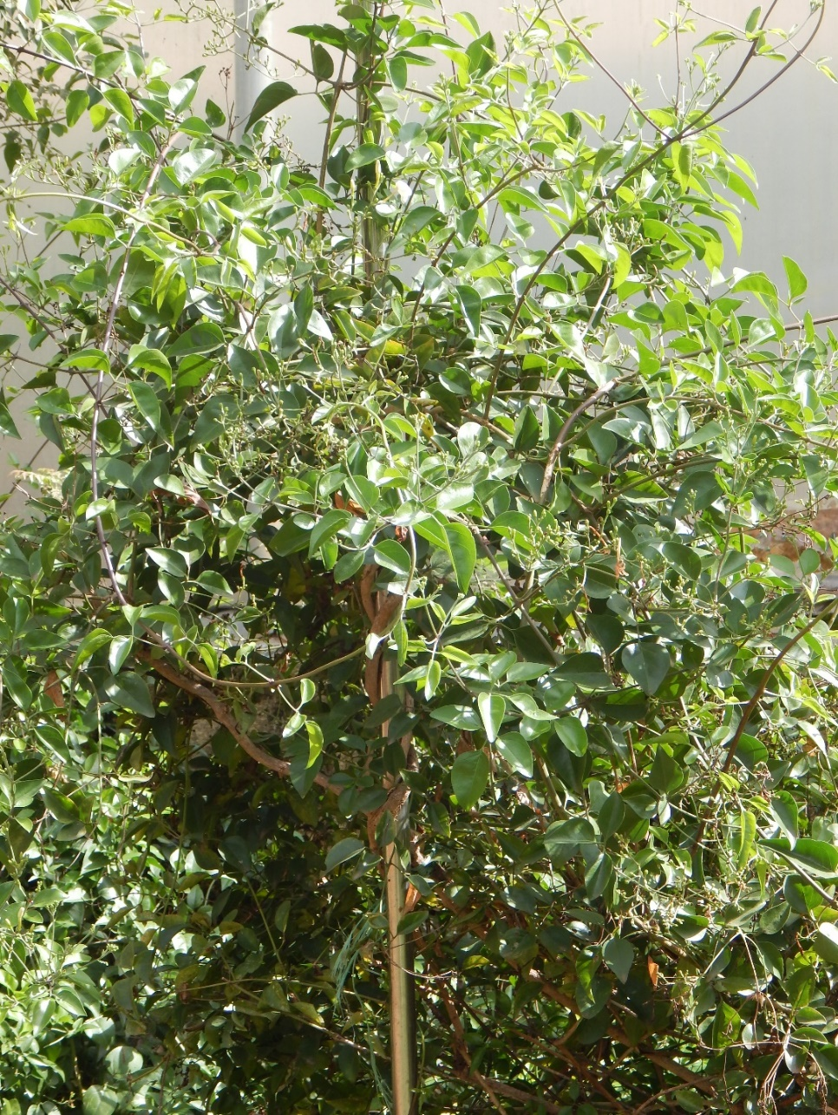

**Figure 1: A general view of *Jasminum azoricum* (Mysore mallige) plant**

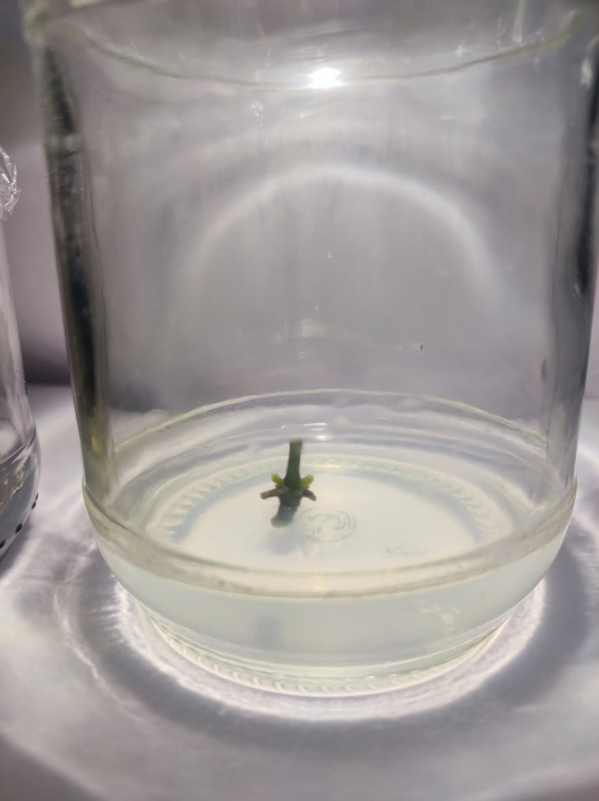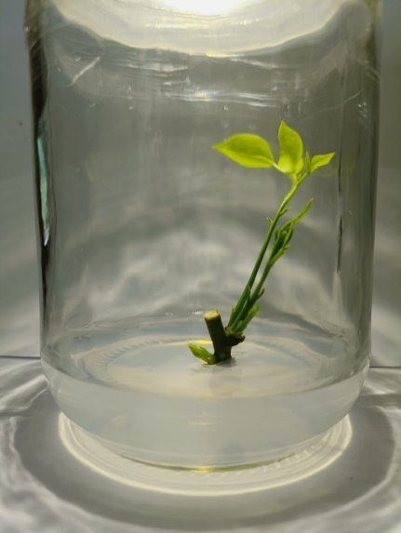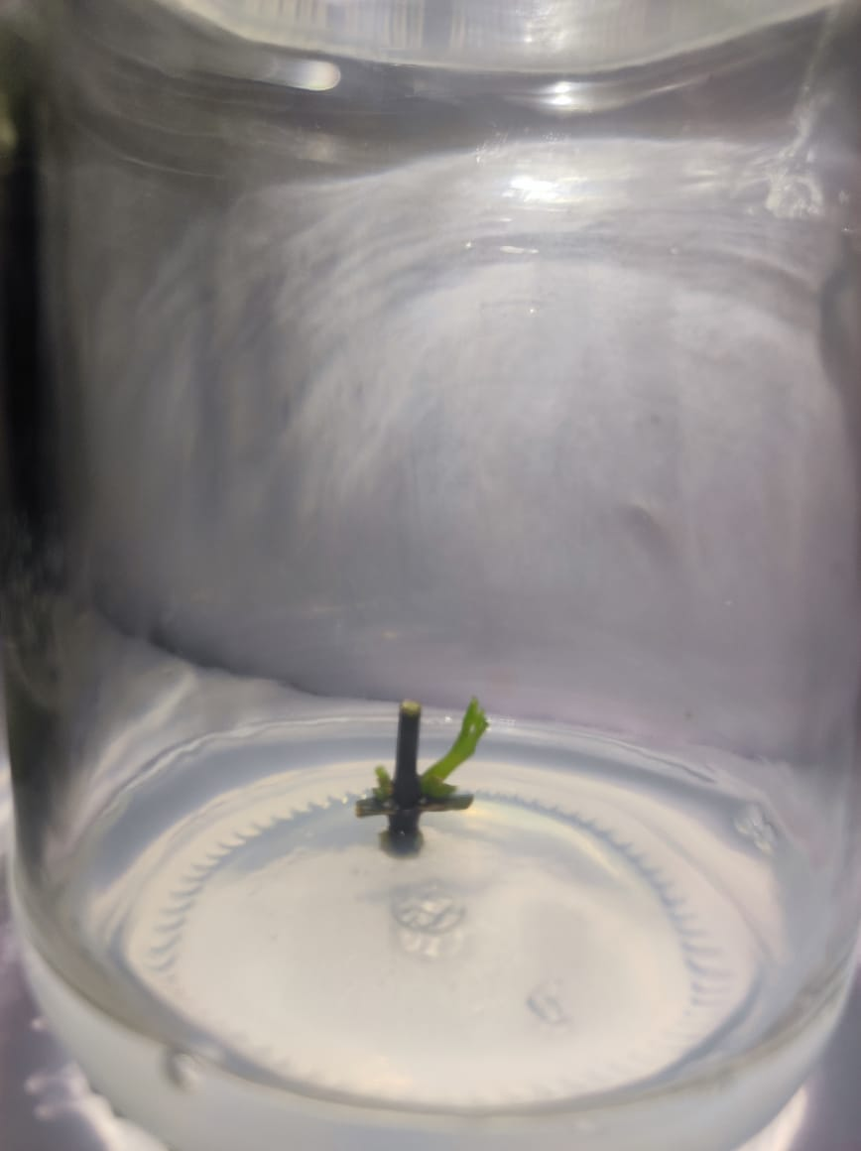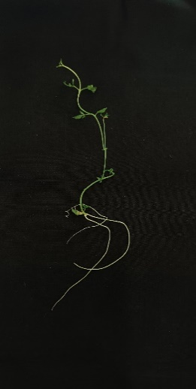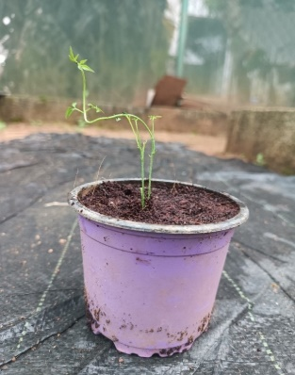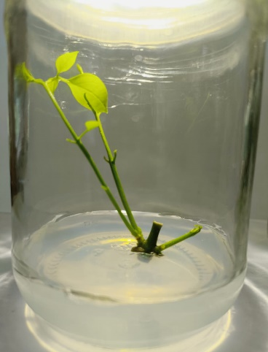**Figure 2: *In vitro* shoot regeneration from single node cuttings of *Jasminum azoricum.***

**A**

**F**

**E**

**D**

**C**

**B**

(A) Explant: (B) Shoot initiation from single node cutting: (C) & (D) Multiple shoot proliferation

(E) Rooting of *in vitro* regenerated shoots: (F) Hardening of *in vitro* rooted shoots.

1. **CONCLUSION:**

Induction of multiple shoots from single-node cuttings of *Jasminum azoricum* was attempted by manipulation of the nutrient medium under *in vitro* conditions. The present study showed that half-strength MS medium supplemented with BAP 2.5 mgL-1 + Kinetin 1.0 mgL-1 + Ads 50 mgL-1 produced maximum number of shoots and medium supplemented with BAP 1.5 mgL-1 + Kinetin 2.5 mgL-1 + Ads 50 mgL-1 has taken minimum number of days for shoot induction (7.16 days) and showed maximum shoot length. Half-strength MS media fortified with IBA 2.5 mgL-1 was found best medium for rooting of regenerated shoots as it yielded plantlets with the maximum number of roots and root length. No roots were noticed in IAA IAA-containing medium. In future, this technique may be used for conservation and large-scale multiplication of true-to-type plants of Mysore mallige (*Jasminum azoricum*).

**ACKNOWLEDGEMENT**

I remain ever thankful to Department of Horticulture, University of Agriculture Sciences, Bengaluru, Karnataka, India for providing the research facilities for this research.

**Author’s contributions**

This work was carried out in collaboration among all authors. All authors read and approved the final manuscript**.**

Disclaimer (Artificial intelligence)

Option 1:

Author(s) hereby declare that NO generative AI technologies such as Large Language Models (ChatGPT, COPILOT, etc.) and text-to-image generators have been used during the writing or editing of this manuscript.

Option 2:

Author(s) hereby declare that generative AI technologies such as Large Language Models, etc. have been used during the writing or editing of manuscripts. This explanation will include the name, version, model, and source of the generative AI technology and as well as all input prompts provided to the generative AI technology

Details of the AI usage are given below:

1.

2.

3.

**REFERENCES:**

1. Arab, M. M., Yadollahi, A., Shojaeiyan, A., Shokri, S., Ghojah, S.M. (2014). Effects of nutrient media, different cytokinin types and their concentrations on *in vitro* multiplication of G N15 (hybrid of almond peach) vegetative rootstock. Journal of Genetic Engineering and Biotechnology. 12 (2), 81–87.
2. Bhattacharya, S. & Bhattacharya, S. (1997). Rapid multiplication of *Jasminum officinale* L. by *in vitro* culture of nodal explants. Plant Cell, Tissue and Organ Culture*.* 51(1), 57-60.
3. Bhat, M. S., Rather, Z. A., Nazki, I. T., Banday, N., Wani, T., Rafiq, S., Farooq, I., Noureldeen, A. & Darwish, H. (2022). Standardization of *in vitro* micropropagation of winter jasmine (*Jasminum nudiflorum*) using nodal explants. Saudi Journal of Biological Sciences. 29 (5), 3425-3431.
4. Biswal, M., Palai, S. K., Mishra, P., Chhuria, S. AND Sahu, P. (2016). Standardization of protocol for shoot multiplication of jasmine (*Jasminum sambac* (L) Aiton). International journal of farm sciences. 6(3), 111-118.
5. De Klerk, G.-J., Van Der Krieken, W., De Jong, J.C. (1999). Review the formation of adventitious roots: new concepts, new possibilities. *In vitro* cellular & developmental biology – plant.35 (3), 189–199.
6. Mullins M. G. (1972). Auxin and ethylene in adventitious root formation by auxin ethylene interaction in pea stem cutting. Physiologia Plantarum*.* 61, 298 – 302.
7. Murashige, T. AND Skoog, F. (1962). A revised medium for rapid growth and bioassay with tobacco tissue culture. Physiologia Plantarum.15, 473-497.
8. Naaz, A., Shahzad, A. AND Anis, M. (2014). Effect of adenine sulphate interaction on growth and development of shoot regeneration and inhibition of shoot tip necrosis under *in vitro* condition in adult *Syzygium cumini* L.- a multipurpose tree. AppliedBiochemistry and Biotechnology*.* 173, 90-102.
9. Peak, K. Y., S. F. Chandler & T. A. Thorpe. (1987). *In vitro* propagation of Chinese cabbage from seedling shoot tip. Journal of the American Society for Horticultural Science. 112(5), 841-845.
10. Pliego-alfaro, F. & Murashige, T. (1987). Possible Rejuvenation of Adult Avocado by Graftage onto Juvenile Rootstocks *In vitro*. HortScience. 22, 1321-1324.
11. Ranjitha, A., Bhavishya, C.M., Navya, V.G. and Nirmala, K.S. (2024). Rapid Multiplication of Geographical Indication (GI) Tagged Mysore Mallige (*Jasminum azoricum* L.) Using Single Node through In vitro Culture. *Journal of Advances in Biology & Biotechnology*, *27*(5), 847-852.
12. Waseem, Kashif & Jilani, Muhammad & Khan, Muhammad & Kiran, Mehwish & Khan, Ghazanfarullah. (2011). Efficient *in vitro* regeneration of chrysanthemum (*Chrysanthemum morifolium* L.) plantlets from nodal segments. AFRICAN JOURNAL OF BIOTECHNOLOGY. 8, 1477-1484.
13. Zulfiqar, B., Abbasi, N.A., Ahmad, T. & Hafiz, I.A. (2009). Effect of Explant Sources and Different Concentrations of Plant Growth Regulators on *In vitro* Shoot Proliferation and Rooting of Avocado (*Persea americana* Mill.) Cv. ‘Fuerte’. Pakistan Journal of Botany. 41, 2333-2346.
14. Ahmed MAA, Miao M, Pratsinakis ED, Zhang H, Wang W, Yuan Y, Lyu M, Iftikhar J,

Yousef AF, Madesis P, Wu B (2021) Protoplast isolation, fusion, culture and

1. transformation in the woody plant Jasminum spp. Agriculture 11:699Ranjitha Ayodhya, Navya VG, Basana Gouda S and HD Varsha. Rapid multiplication of Geographical Indication (GI) tagged Mysore Mallige (Jasminum azoricum L.) using single node for rooting of shoots through in vitro culture. Int. J. Adv. Biochem. Res. 2024;8(7S):379-381. DOI: 10.33545/26174693.2024.v8.i7Se.1549
2. Usha, S., M. Ganga, K. Rajamani, S. Manonmani, and R. Gnanam. 2022. “Reproductive Biology Analyses in Jasmine (Jasminum spp.)”. International Journal of Plant & Soil Science 34 (19):149-60. https://doi.org/10.9734/ijpss/2022/v34i1931098.

.