Carbon Footprint of Tea: A Lifecycle Assessment from Cultivation to Consumption

ABSTRACT

Tea is one of the most consumed beverages globally and plays a significant role in agriculture-driven economies like India. However, its production chain involves processes that emit considerable greenhouse gases (GHGs). This research analyses the carbon footprint of tea across its entire lifecycle from cultivation and processing to distribution and consumption. The study employs a descriptive and exploratory approach using secondary data sourced from peer-reviewed journals, government publications, and technical reports. Key findings highlight that plucking and transportation account for approximately 47% of field emissions, while drying in factories contributes the highest emissions in processing, estimated at 2762.28 kg CO₂ per 1000 kg of made tea. Despite tea bushes sequestering up to 5134.4 kg CO₂/ha/year, total emissions surpass this capacity, indicating a net carbon-positive balance. The research emphasizes the urgent need for mitigation strategies such as renewable energy use, improved agronomic practices, and carbon audits to enhance sustainability in tea production.

Keywords​: Tea, Carbon dioxide, Carbon, Footprint, production, consumption

1. INTRODUCTION

In recent years organizations worldwide have become increasingly concerned about carbon credits, focusing on carbon emissions, the amount of carbon emitted by organizations, and the climate resilience of various systems. While there is considerable discussion about carbon sequestration, the topic of carbon footprints, which has become crucial, is often overlooked. It is very important for tea sector also to maintain a balance sheet in tea factories to measure the amount of carbon emitted and sequestered. Additionally, no carbon audits have been conducted. Although literature on carbon sequestration is available, studies on carbon footprints are limited. Some research has been conducted in China and other regions, but there has been no research on carbon footprints in Assam's tea industry to date. The concentration of CO₂ has increased significantly, rising from an annual average of 280 ppm in the late 1700s to 424 ppm in May 2023 (Aditya et al., 2023). The agricultural sector contributes 15-20% of annual global greenhouse gas (GHG) emissions (FAOSTAT, 2018), with tea being an important agricultural product worldwide. The total planting area and yield of tea have been increasing in recent decades (Liang et al., 2021). Tea production contributes to GHG emissions at various stages, from cultivation to consumption (Cichorowski et al., 2015). The tea industry is considered to have high energy consumption due to its complex life cycle system (Zhang et al., 2023). The production stage accounts for 57% of the environmental burden compared to other steps in the entire tea life cycle (Soheili-Fard et al., 2018). In tea packaging, two-layer packaging is the most polluting scenario, while in terms of consumption, stoves are more environmentally friendly than electric kettles (Soheili-Fard et al., 2018). Different farming management and processing techniques significantly impact the carbon footprint and primary energy demand of various tea products (Xu et al., 2019). The carbon footprint of tea production and consumption is critical as it has substantial effects on the environment, economy, and society.
2. OBJECTIVES
- To evaluate carbon emissions across the tea production lifecycle using secondary data
- To identify emission hotspots and suggest mitigation strategies for sustainable tea production
- To assess carbon balance by comparing emissions with sequestration in tea systems

Lack of Methodology Section:
3. METHODOLOGY
This article employs a descriptive and exploratory research approach, based entirely on secondary data. The information was gathered from a diverse range of credible sources, including peer-reviewed journal articles, technical bulletins, government databases such as FAOSTAT, and industry reports. The research specifically focuses on carbon emissions associated with black and green tea production, with particular emphasis on tea-growing regions in Northeast India. The scope of the research encompasses the entire lifecycle of tea cultivation, processing, packaging, distribution, and consumption. To ensure relevance and reliability, only sources published from 2005 onwards were included, provided they contained quantifiable data on energy use or greenhouse gas (GHG) emissions. Studies lacking detailed lifecycle stages or unrelated to tea production were excluded. Emissions data were categorized according to major lifecycle stages and standardized where possible using units such as kilograms of CO₂-equivalent per hectare or per 1000 kilograms of made tea. Furthermore, estimates of carbon sequestration by tea bushes and associated shade tree systems were reviewed and compared against total emission figures to assess the net carbon balance of tea production systems. This methodological framework enabled the identification of emission hotspots and opportunities for mitigation within the tea value chain.
4. UNDERSTANDING THE CARBON FOOTPRINT
A carbon footprint refers to the total amount of greenhouse gases (GHGs), primarily carbon dioxide, emitted directly or indirectly by an individual, product, company, or country, typically expressed in tonnes of CO₂-equivalents per year. It helps quantify the environmental impact of various activities and is essential for comparing emissions across sectors. A product’s carbon footprint includes emissions throughout its entire life cycle from raw material extraction and production to usage, transportation, and disposal (Wiedemann & Minx, 2008). There are three main types of carbon footprints: individual, product
and corporate. The individual carbon footprint encompasses emissions from personal activities such as transportation choices, household electricity use, food consumption habits, and recycling behaviours (Bai et al., 2019). The product carbon footprint accounts for emissions during all stages of a product’s life, including material extraction, manufacturing, energy use, packaging, distribution, usage, and disposal (Pandey et al., 2011). Lastly, the corporate carbon footprint measures the GHG emissions produced by a company’s operations, serving as a vital tool for assessing energy efficiency and identifying opportunities for emission reductions across industrial and organizational systems (Jeswani & Azapagic, 2016).
5. SIGNIFICANCE OF ASSESSING TEA’S CARBON FOOTPRINT
Tea is one of the most widely consumed beverages and is cultivated on more than 3,691.89 hectares of land worldwide. As demand for tea continues to rise, the production chain consumes significant amounts of energy and materials to achieve higher yields in both cultivation and processing. This increased consumption of resources leads to unfavourable impacts on greenhouse gas emissions and contributes to climate change. Therefore, it is essential to assess the tea production system to identify its carbon footprint throughout its entire life cycle, from cultivation and processing to waste disposal.
Different stages of tea
- Production
- Processing
- Consumption
6. CARBON EMISSIONS ACROSS THE TEA VALUE CHAIN
6.1 Cultivation stage
Tea cultivation involves several stages, each contributing to greenhouse gas (GHG) emissions in varying degrees.
- Land Preparation: During land preparation, especially in virgin areas, extensive clearing of trees and levelling is required, while uprooted areas undergo repeated ploughing using tractors. These operations consume large amounts of diesel, releasing significant quantities of CO₂ into the atmosphere (FAO, 2013).
- Planting: In planting, the manual digging of pits by laborers adds to indirect emissions, primarily through energy use in associated activities such as tool manufacturing and transportation (Pandey et al., 2011).

- Pruning: Pruning, essential for developing a well-structured bush frame, involves repeated manual or mechanical cutting. While mechanized pruning can reduce labour, it increases fuel use, thereby contributing to higher emissions (Tao et al., 2018).
- Fertilizer & Pesticide use: The application of fertilizers, particularly nitrogen-based synthetic types, is a major source of nitrous oxide (N₂O), a potent greenhouse gas, through processes like volatilization, leaching, and surface runoff (IPCC, 2006). In addition, plant protection practices that involve the use of synthetic pesticides also contribute to emissions, both through their chemical breakdown and the energy involved in their production and application (Roy et al., 2014).
- Plucking: The plucking stage is highly labour-intensive, with frequent harvesting cycles requiring a large workforce. Although it involves limited mechanical input, the sheer scale of human involvement contributes to indirect emissions (Bai et al., 2019).
- Transportation: Finally, transportation, which occurs in multiple stages from gardens to factories, then to warehouses, auction centres, and consumers relies heavily on fossil fuels. This stage is considered one of the most carbon-intensive due to the burning of diesel and petrol across long distances (Jeswani & Azapagic, 2016).
Overall, each activity in the tea value chain plays a role in contributing to the total carbon footprint, warranting sustainable intervention strategies.

Table 1. Operation wise fuel consumption & CO₂ produced in tea gardens (Aditya et al., 2023)

Farming Operations | Fuel used (kg/ha) | kg CO₂ eq/ha
Land development and planting | 0.69 | 1.83
Irrigation | 0.45 | 1.20
Fertilizer and chemical application | 0.70 | 1.85
Pruning | 0.89 | 2.35
Plucking and transportation | 2.42 | 6.38

Table 1. provides a breakdown of the fuel usage and associated carbon dioxide emissions across various farming operations in tea cultivation. Land development and planting consume 0.69 kg/ha of fuel, leading to 1.83 kg CO₂ equivalent per hectare. Irrigation uses 0.45 kg/ha of fuel, resulting in 1.20 kg CO₂ equivalent per hectare. Fertilizer and chemical application utilize 0.70 kg/ha of fuel, contributing to 1.85 kg CO₂ equivalent per hectare. Pruning operations use 0.89 kg/ha of fuel, emitting 2.35 kg CO₂ equivalent per hectare. The most fuel-intensive activity is plucking and transportation, which uses 2.42 kg/ha of fuel, resulting in the highest emissions at 6.38 kg CO₂ equivalent per hectare. Overall, plucking and transportation contribute significantly more to carbon emissions compared to other operations.

6.2 Processing stage
Different operations in tea processing
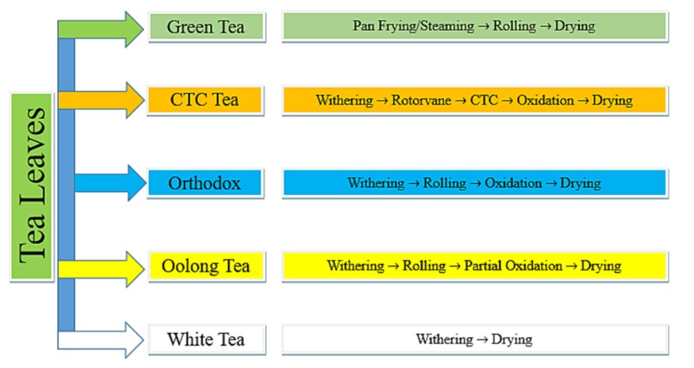
Fig 1.Steps involved in production of various varieties of tea (Aditya et al., 2023)

Different operations in tea processing & their energy consumption
- Withering: The withering process, which involves temporarily storing harvested shoots to partially remove moisture, results in changes to the shoots' texture, making the leaves flaccid. This stage contributes to the tea's flavour, aroma, colour, and taste through chemical changes. Factories typically use equipment such as centrifugal fans, heaters, coal stoves, axial fans, and withering troughs. According to Dutta et al., (2019), energy consumption for withering per 1,000 kg of made tea was estimated at 20.27 L of diesel, 43.93 kg of coal, and 87.17 kWh of electricity. For 100 kg of tea production, Sharma et al., (2019) found that withering required 5.54 kWh of electricity and 179.11 MJ of thermal energy.
- Rolling: The rolling process shapes and sizes the withered tea leaves, making the product acceptable to consumers. There are two types of black tea produced based on the rolling method: Orthodox tea and CTC tea. Factories use rotor vanes for rolling CTC tea and table rollers for Orthodox tea. For every 1,000 kg of made tea, the estimated energy consumption is 190 kWh of electrical energy and 574.63 MJ of thermal energy (Aditya et al., 2023). Additionally, tea-processing units often rely on diesel generators for electricity during power cuts.
- Fermentation: The fermentation process involves the oxidation of tea leaves, which determines the type of tea, such as green, white, oolong, or black, based on the level of oxidation. Factories use equipment like CFM machines, humidifiers, floor fermentation, fermenting troughs, electric fans, and blowers for this process. The energy consumption for fermenting 1,000 kg of tea is estimated at 0.79 litters of diesel and 89.65 kWh of electricity (Aditya et al., 2023). For producing 100 kg of tea, the required electrical consumption for fermentation was 8.63 kWh (Sharma et al., 2019).
- Drying: The drying process reduces the moisture content of tea leaves to 2.8%–3%, halting enzymatic reactions and creating a stable product. It is one of the most energy-intensive stages in tea production. For every 1,000 kg of tea, the estimated energy consumption is 16.08 litters of diesel, 630.22 kg of coal, and 103.41 kWh of electricity (Sharma et al., 2019). The drying process requires 8.41 times more thermal energy compared to withering (Sharma et al., 2019; Aditya et al., 2023).
- Sorting and Packaging: After drying, tea leaves undergo sorting to remove fibres and stalky substances, followed by sieving and grading based on particle size. The final step in tea manufacturing is packaging, which is essential for protecting the tea from moisture and contaminants. These processes together require 61.72 kWh of electricity and 161.48 MJ of thermal energy per 1,000 kg of tea (Aditya et al., 2023). Energy consumption in these stages is relatively lower compared to other stages of tea processing.

Table 2. Thermal and electrical energy requirements per 1000 kilogram of made tea & corresponding CO₂ emissions in tea factories at various stages of tea processing
Operations | Thermal energy (MJ) | Electrical energy (kWh) | kg CO₂ eq per 1,000 kg  of tea made
Withering | 2837.16 | 87.17 | 475.39
Rolling | 574.63 | 190.00 | 41.52
Fermentation | 29.30 | 89.65 | 2.08
Drying | 23868.68 | 103.41 | 2762.28
Sorting | 134.00 | 53.15 | 9.52
Packaging | 27.48 | 8.57 | 1.95
(Aditya et al., 2023)
Table 2 shows the highest carbon footprint in drying process which is 2762.28 kg CO₂ eq per 1,000 kg of tea made.

6.3 Consumption stage
Factors influencing carbon emission in tea consumption are
- Brewing Method
1. Electric Kettle vs. Stovetop: The energy source and efficiency of the appliance used to boil water can significantly impact the carbon footprint. Electric kettles are generally more efficient than stovetop kettles (Murray et al., 2016).
2. Quantity of Water: Boiling more water than necessary increases the energy consumption and, consequently, the carbon footprint (Akash et al., 2024).
- Energy Sour
Carbon intensity of the energy source used for boiling water (e.g., coal, natural gas, renewable energy) plays a significant role. Regions with cleaner energy grids will have a lower carbon footprint for the same activity (Gielen et al., 2019).
- Tea Type and Preparation
Different types of tea (e.g., loose leaf, tea bags, instant tea) have different carbon footprints. Tea bags and instant tea often involve additional processing and packaging, which increase their overall carbon footprint (Sun et al., 2024).
- Packaging and Disposal
The type of packaging (biodegradable vs. non-biodegradable) and the disposal method (recycling, composting, landfill) affect the carbon footprint. Packaging materials that are not biodegradable or recyclable contribute to higher emissions (Islam et al., 2024).
- Additives
Adding milk, sugar, honey, or other ingredients increases the carbon footprint. For example, dairy milk has a higher carbon footprint compared to plant-based alternatives (Craig et al., 2023)
- Frequency of Consumption
The frequency with which an individual consumes tea affects the cumulative carbon footprint.
Regular, heavy consumption will have a higher overall impact (He et al., 2022).
- Waste Management
The disposal of used tea leaves, bags, and any associated waste contributes to the carbon footprint. Proper composting or recycling can mitigate some of these impacts (Morita et al., 2024)

6.4 GREEN TEA SPECIFIC LIFECYCLE OF CARBON FOOTPRINT
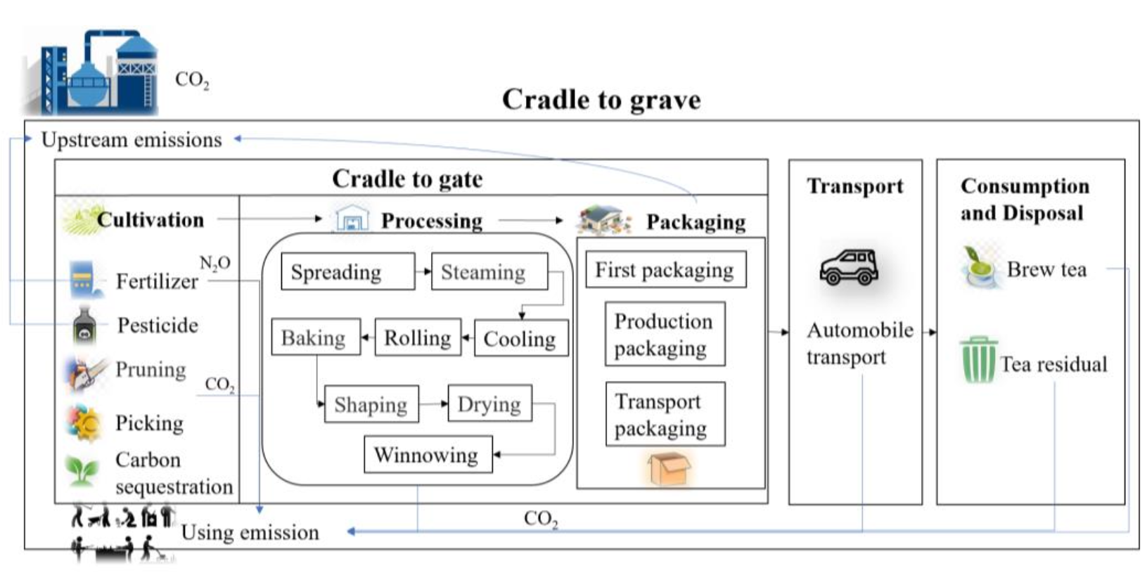
Fig 2. Release and utilization of carbon in green tea production

The specific considerations for each stage are as follows: (He et al., 2023)
Cultivation: Emissions from the upstream production of fertilizer and pesticide, as well as emissions from fertilizer application in the field and the use of agricultural machinery in the pruning and harvesting period
Processing: Emissions from electricity, coal, and pellets consumed by mechanical equipment in the processing stage
Packaging and transportation: Emissions from the production of packaging materials and energy consumption during transportation
Consumption and disposal: Emissions from boiling water and tea residue treatments
7. RESULTS & DISCUSSION
Plucking and transportation are the most significant sources of emissions during the cultivation stage, which is clearly indicates in Table 1, primarily due to frequent harvesting cycles and the extensive use of diesel-powered transport. Similarly, Table 2 identifies drying as the most emission-intensive stage in tea processing, accounting for over 80% of total factory related emissions. When comparing black and green tea systems, black tea generally exhibits a higher carbon footprint due to its energy demanding oxidation and prolonged drying processes. Although green tea requires energy for steaming, its overall processing time and post-harvest energy use are relatively lower. However, variations in cultivation practices such as fertilizer application rates and shade management may offset or exacerbate green tea’s environmental impact, depending on regional conditions. Supporting figures, including lifecycle stage diagrams and energy flow charts, visually emphasize the distribution of energy use across different stages, reinforcing that the greatest opportunities for carbon mitigation lie in post-harvest transportation and drying processes. These trends highlight the importance of targeted strategies, such as adopting biodiesel or electric vehicles for transport, implementing solar-powered drying systems, and improving field operations through optimized pruning and harvesting schedules. To effectively reduce the carbon footprint of tea production, policy interventions and factory-level carbon audits should concentrate on these high-emission stages.
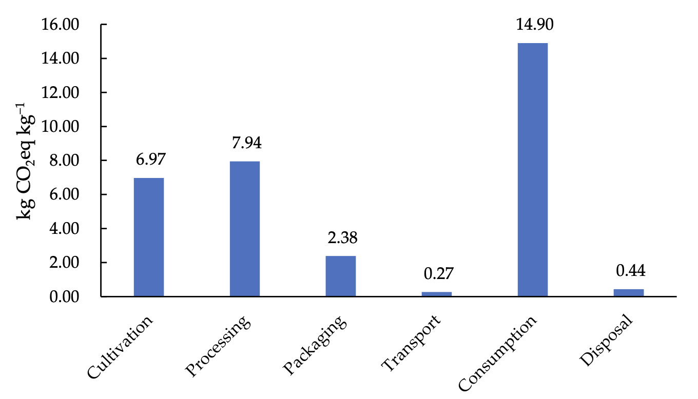  (i) | 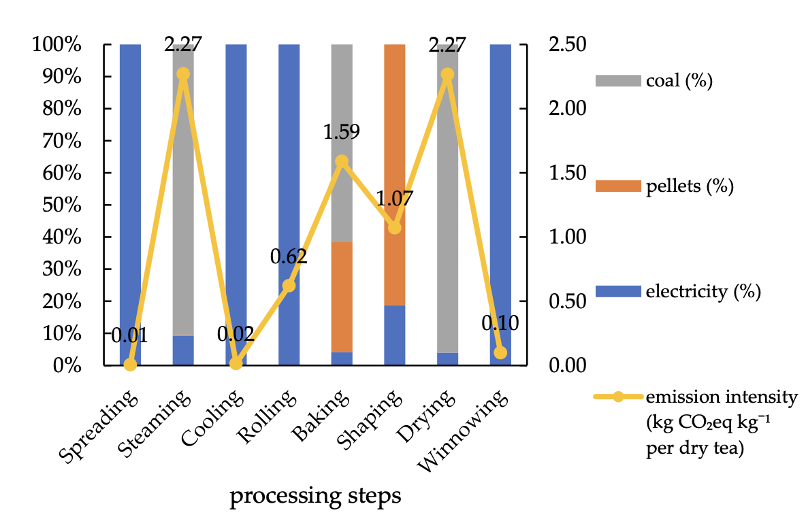  (ii)
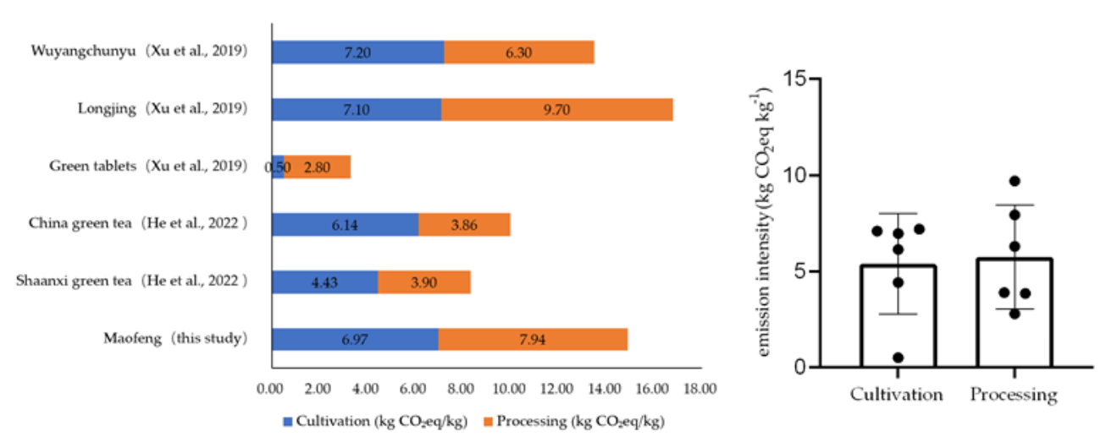  (iii) | 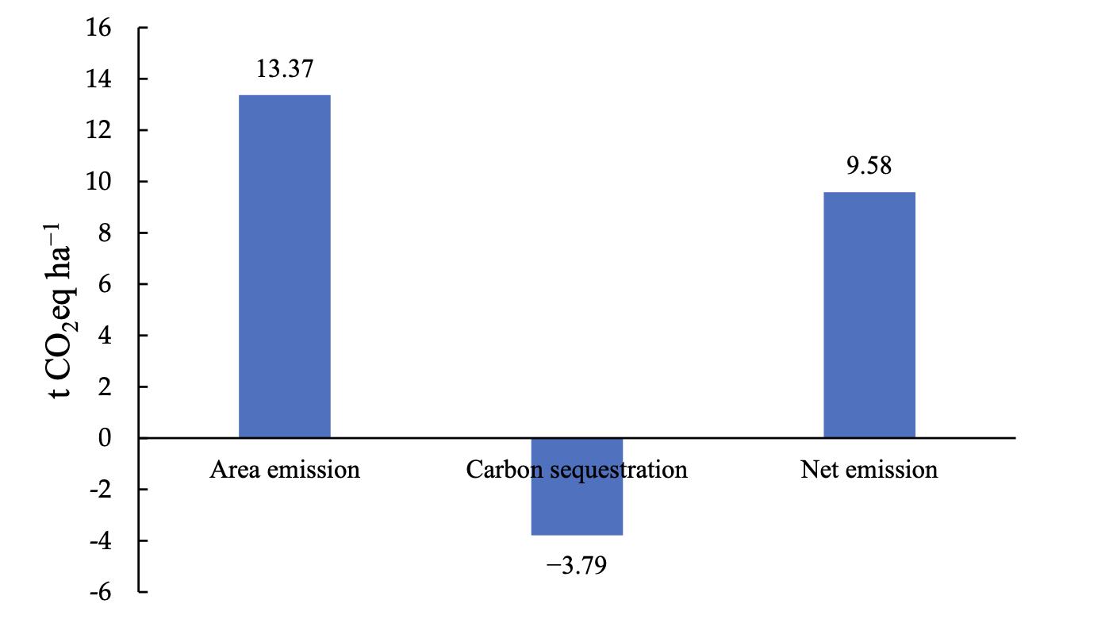  (iv)
(He et al., 2023)

8. CARBON SEQUESTRATION POTENTIAL OF TEA SYSTEMS
Tea bushes exhibit significant CO₂ absorption potential, ranging from 1,243.8 to 2,526.7 kg CO2 per hectare annually (Phukan et al., 2018). Higher-yielding cultivars are more efficient at assimilating CO₂ compared to quality-focused varieties. Approximately 50% of the absorbed atmospheric CO₂ is sequestered in their biomass (Pramanik & Phukan, 2020), while organic carbon is released through roots, equivalent to 5.9%–8.6% of the CO₂ they assimilate. Mature tea bushes (25–30 years old) can sequester about 5,134.4 ± 831.6 kg CO₂/ha annually (Phukan et al., 2018). The tea-albizzia plantation system shows significant carbon offset potential, at 61.2 kg per plant (Alom et al., 2021). Organic tea cultivation leads to 43% higher above-ground biomass production (194.4 t/ha) compared to conventional methods (136 t/ha), with below-ground carbon accumulation at 135 t/ha in organic versus 125 t/ha in conventional systems (Subramanian et al., 2013). For every ton of tea produced, factories emit approximately 3,292 ± 493.91 kg of CO₂, while tea gardens contribute about 13.61 kg CO₂ per hectare (Kalita et al., 2018). In July 2021, North-Eastern tea production reached 157.23 million kgs, resulting in total CO₂ emissions of 514,032.38 tonnes from cultivation and production, while the atmospheric CO₂ sequestration was approximately 410,491.3 tonnes, leading to a discrepancy of 103,541.1 tonnes between emissions and sequestration (Aditya et al., 2023).
9. CONCLUSION
This research article highlights that major carbon emissions in tea production originate from transportation, fuel-intensive field operations, and factory-level drying processes. While tea plantations demonstrate a substantial capacity for carbon sequestration, the current emission levels often exceed the amount sequestered, leading to a net positive carbon balance and contributing to climate change. Addressing this imbalance is essential for achieving environmental sustainability in the tea sector. Future research should focus on the adoption of low-carbon technologies in processing, the development of region-specific carbon auditing frameworks, and the implementation of policy incentives to support sustainable cultivation practices. Mitigation strategies such as deploying solar-powered drying systems, switching to biodiesel or electric transport options, and promoting organic farming can significantly reduce the industry’s carbon footprint. These approaches, combined with strategic planning and regulatory support, are vital for transitioning the tea industry toward a more climate-resilient and ecologically responsible future.

REFERENCES
Aditya, K., Kumar, R., Bharti, & Sanyal, S. (2023). Environmental impact of greenhouse gas emissions from the tea industries of north-eastern states of India. Frontiers in Sustainable Food Systems, 7, 1220775. 10.1504/IJRET.2014.065374

Ahmed, T., Ali, M., Rana, M. M., and Hossen, M. I. (2017). Effect of global warming and climate change on the tea plantation. Tea J. Bangladesh 46, 42–51.

Alom, S., Das, R., Baruah, U., Das, S., and Bhuyan, R. P. (2021). Carbon sequestration potential under tea based cropping system. J. Environ. Biol. 42, 687–693. doi: 10.22438/jeb/42/3/MRN-1498 Annual Bulletin of Statistics, (2020).

Awasom, I. (2011). Commodity of the quarter: tea. J. Agric. Food Inf. 12, 12–22. doi: 10.1080/10496505.2011.540552

Biggs, E. M., Gupta, N., Saikia, S. D., and Duncan, J. M. A. (2018). The tea landscape of Assam: multi-stakeholder insights into sustainable livelihoods under achanging climate. Environ. Sci. Policy 82, 9–18. doi: 10.1016/j.envsci.2018.01.003
Chel, A., and Kaushik, G. (2011). Renewable energy for sustainable agriculture. Agron. Sustain. Dev. 31, 91–118. doi: 10.1051/agro/2010029

Chen, Y., Chen, S., and Chen, Z. (2022). Willingness of tea farmers to adopt ecological agriculture techniques based on the UTAUT extended model. Int. J. Environ. Res. Public Health 19:15351. doi: 10.3390/ijerph192215351

Datta, P. P., and Baruah, D. C. (2014). Possibility of biomass gasification in tea manufacturing industries in Assam, India. Int. J. Renew. Energy Res. 5:310. doi:

FAOSTAT. Food and Agriculture Organization of the United Nations. (2021) Available at: https://www.fao.org/faostat/en/#data/QCL (Accessed on 13

Goswami, R. (2022). Assam tea gardens experiment with solar for reliable power supply and cutting costs, emissions. Mongabay. Available at: https://india.mongabay. com/2022/02/assam-tea-gardens-experiment-with-solar-for-reliable-power-supply- and-cutting-costs-emissions/

Hatibaruah, D., Baruah, D. C., and Sanyal, S. (2012). Microwave drying characteristics of Assam CTC tea (Camellia assamica). J. Food Process. Preserv. 37, 366–370. doi: 10.1111/j.1745-4549.2011. 00656.x

He, M., Li, Y., Zong, S., Li, K., Han, X., & Zhao, M. (2023). Life cycle assessment of carbon footprint of green tea produced by smallholder farmers in Shaanxi province of China. Agronomy, 13(2), 364.

Horvitz, D., and Thompson, D. (1952). A generalization of sampling without replacement from a finite universe. J. Am. Stat. Assoc. 47, 663–685. doi: 10.1080/01621459.1952.10483446

Indian Tea Association. (2023). Available at: https://www.indiatea.org/tea growing regions (Accessed on August 16, 2023 January 2023)

Kephe, P. N., Petja, B. M., and Kwabena, A. K. (2021). Examining the role of institutional support in enhancing smallholder oilseed producers’ adaptability to climate change in Limpopo province, South Africa. OCL 28:14. doi: 10.1051/ ocl/2021004

Kephe, P. N., Siewe, L. C., Lekalakala, R. G., Kwabena, A. K., and Petja, B. M. (2022). Optimizing smallholder farmers’ productivity through crop selection, targeting and prioritization framework in the Limpopo and Free State provinces, South Africa. Front. Sustain. Food Syst. 6:738267. doi: 10.3389/fsufs.2022. 738267

Kumar, A., Singh, D., and Mahapatra, S. K. (2022). Energy and carbon budgeting of the pearl millet-wheat cropping system for environmentally sustainable agricultural land use planning in the rainfed semi-arid agro-ecosystem of Aravalli foothills. Energy 246:123389. doi: 10.1016/j.energy.2022.123389

Kumar, K. R., Dashora, K., Kumar, S., Dharmaraja, S., Sanyal, S., Aditya, K., et al. (2023). A review of drying technology in tea sector of industrial, non-conventional and renewable energy based drying systems. Appl. Therm. Eng. 224:120118. doi: 10.1016/j.applthermaleng.2023.120118

Kumar, R., Dashora, K., Krishnan, N., Sanyal, S., Chandra, H., Dharmaraja, S., et al. (2021). Feasibility assessment of renewable energy resources for tea plantation and industry in India—a review. Renew. Sust. Energ. Rev. 145:111083. doi: 10.1016/j. rser.2021.111083

Kumari, V., Chandra, H., Aditya, K., Kumar, K. R., Dashora, K., Krishnan, N., et al. (2021). Feasibility study on renewable energy system in tea (Camellia sinensis) estates of north-east India. Indian J. Agric. Sci. 91, 1631–1635. doi: 10.56093/ijas. v91i11.118574

Mitra, R., and Totan, S. (2016). An energy audit in a tea manufacturing industry at North Bengal, India. Int. Res. J. Eng. Technol. 5, 83–89. doi: 10.15623/ ijret.2016.0506017
Niyonzima, T., Nduwamungu, J., Izerimana, E., Maniraho, L., & Habiyaremye, G. (2020). Estimation of carbon footprint of tea products at nyabihu tea factory, Western Province-Rwanda. International Journal of Development Research, 10(03), 34129-34138.

Ozbek, O., Gokdogan, O., and Baran, M. F. (2021). Investigation on energy use efficiency and greenhouse gas emissions (GHG) of onion cultivation. Fresenius Environ. Bull. 30, 1125–1133.

Pathak, H., and Wassmann, R. (2007). Introducing greenhouse gas mitigation as a development objective in rice-based agriculture: I. Generation of technical coefficients. Agric. Syst. 94, 807–825. doi: 10.1016/j.agsy.2006.11.015

Phukan, M., Savapondit, D., Hazra, A., Das, S., and Pramanik, P. (2018). Algorithmic derivation of CO2 assimilation based on some physiological parameters of tea bushes in north-east India. Ecol. Indic. 91, 77–83. doi: 10.1016/j. ecolind.2018.03.091

Pramanik, P., and Phukan, M. (2020a). Assimilating atmospheric carbon dioxide in tea gardens of northeast India. J. Environ. Manag. 256:109912. doi: 10.1016/j. jenvman.2019.109912

Pramanik, P., and Phukan, M. (2020b). Potential of tea plants in carbon sequestration in north- east India. Environ. Monit. Assess. 192:211. doi: 10.1007/s10661-020-8164-y

Sarndal, C. E., Swensson, B., and Wretman, J. (1992). Model assisted survey sampling. Springer, New York Shah, S. K., and Patel, V. A. (2016). Tea production in India: challenges and opportunities. J. Tea Sci. Res. 6, 1–6. doi: 10.5376/jtsr.2016.06.0005

Sharma, A., Dutta, A. K., Bora, M. K., and Dutta, P. P. (2019). Study of energy management in a tea processing industry in Assam, India. AIP Conf. Proc. 2091:020012. doi: 10.1063/1.5096503

Silva, W. C. A. (1994). Status review of energy utilization by the tea industry in Sri Lanka. Sri Lanka J. Tea Sci. 63, 46–58.

Sukhatme, P. V., Sukhatme, B. V., Sukhatme, S., and Asok, C. (1984). Sampling theory of surveys with applications. Indian Society of Agricultural Statistics, New Delhi.

Tea Board of India. (2023). Available at: https://teaboard.gov.in Accessed on August 16, 2023 Udeagha, M. C., and Ngepah, N. (2022a). Disaggregating the environmental effects of renewable and non-renewable energy consumption in South Africa: fresh evidence from the novel dynamic ARDL simulations approach. Econ. Chang. Restruct. 55, 1767– 1814. doi: 10.1007/s10644-021-09368-y

Udeagha, M. C., and Ngepah, N. (2022b). Dynamic ARDL simulations effects of fiscal decentralization, green technological innovation, trade openness, and institutional quality on environmental sustainability: evidence from South Africa. Sustainability 14:10268. doi: 10.3390/su141610268

Udeagha, M. C., and Ngepah, N. (2022c). The asymmetric effect of technological innovation on CO2 emissions in South Africa: new evidence from the QARDL approach. Front. Environ. Sci. 10:985719. doi: 10.3389/fenvs.2022.985719

Ulyanin, Y. A., Kharitonov, V. V., and Yurshina, D. Y. (2018). Forecasting the dynamics of the depletion of conventional energy resources. Stud. Russ. Econ. Dev. 29, 153–160. doi: 10.1134/S1075700718020156

Vidanagama, J., and Lokupitiya, E. (2018). Energy usage and greenhouse gas emissions associated with tea and rubber manufacturing processes in Sri Lanka. Environ. Dev. 26,

Zhang, C., Ye, X., Wu, X., & Yang, X. (2023). Carbon footprint of black tea products under different technological routes and its influencing factors. Frontiers in Earth Science, 10, 1046052.

