Optimization and Comparative Assessment of Xylitol Production by Candida tropicalis and Saccharomyces cerevisiae

Abstract
This study focuses on optimizing xylitol production via fermentation using two yeast strains, Saccharomyces cerevisiae MTCC 172 and Candida tropicalis MTCC 230, utilizing hemicellulose as the substrate. The impact of agitation speed (rpm) and fermentation duration (hours) on xylose utilization and xylitol yield was systematically assessed. Among the tested conditions, Candida tropicalis MTCC 230 at 200 rpm for 120 hours exhibited the highest xylose conversion rate (76.16%) and xylitol concentration (16.54 g/L), outperforming Saccharomyces cerevisiae MTCC 172, which showed lower conversion efficiency. The superior performance of C. tropicalis was attributed to its higher tolerance to fermentation inhibitors and efficient xylose metabolism under limited nutrient and agitation conditions. These findings highlight the potential of C. tropicalis MTCC 230 as a robust candidate for industrial-scale xylitol production from renewable hemicellulosic biomass, offering an eco-friendly and cost-effective alternative to chemical synthesis.
Keywords: Xylitol; Candida tropicalis MTCC 230; Saccharomyces cerevisiae MTCC 172; Strain comparison; Xylose metabolism; Inhibitor tolerance
INTRODUCTION
Humans have long sought to harness the benefits of nature, particularly in food production. However, the final decades of the twentieth century marked a notable shift in food technology, largely driven by advances in biological research (Mathur et al., 2023). These developments were influenced by changes in population lifestyles and increasing consumer awareness about the health implications of dietary habits (Thakur et al., 2024a). Among the most widely consumed food ingredients is sucrose, or table sugar (Thakur et al., 2024b). Sucrose, a disaccharide carbohydrate, belongs to a broader class of saccharides that includes monosaccharides like glucose and fructose, disaccharides such as lactose and maltose, and larger polysaccharides (Kumar et al., 2022). The widespread use of fermentable sugars has contributed to significant public health challenges, including dental caries, obesity, and diabetes (Queiroz et al., 2022).
To address these health concerns, there has been growing demand for sugar substitutes that can replicate sweetness without adverse metabolic effects (Estrada-Ávila et al., 2022). Among these alternatives, sugar alcohols, or polyols, have emerged as important low-calorie sweeteners. Polyols are structurally carbohydrates but differ from traditional sugars in their metabolic and functional properties (Ding & Yang, 2021). They occur naturally in small quantities in various fruits, vegetables, and mushrooms. Due to their partial absorption in the intestines, polyols provide fewer calories and exert minimal effects on blood glucose and insulin responses, although excessive intake can sometimes result in gastrointestinal discomfort due to fermentation by gut microbiota (Umai et al., 2022; Park et al., 2016; Santos et al., 2025).
Among commercially used polyols, xylitol is notable for its favorable sweetness profile, low glycemic index, and dental health benefits (Rice et al., 2019; Thakur et al., 2024c). First identified in the late nineteenth century by Fischer and Stahel (1891) and Bertrand (1891), xylitol is a five-carbon sugar alcohol naturally occurring in berries, fruits, and mushrooms (El-Marakby et al., 2017). Its chemical structure, CH₂OH(CHOH)₃CH₂OH, gives it a clean, sweet taste without an aftertaste (Saha & Kennedy, 2022). Xylitol has been widely adopted as a sugar substitute, particularly in low-carbohydrate diets and dental applications, owing to its antibacterial effects against oral pathogens (Jofre et al., 2021). Although commercial production typically relies on catalytic hydrogenation of xylose using metal catalysts such as Raney nickel (Palladino et al., 2021), this approach has drawbacks including high energy demands, complex purification, and high costs (Queiroz et al., 2025).
To address these challenges, microbial fermentation has been explored as a sustainable and cost-effective alternative for xylitol production. Several yeast species, including Candida, Pichia, Debaryomyces, and Pachysolen, have demonstrated the ability to convert D-xylose into xylitol through enzymatic pathways (Kaur et al., 2023). Notably, Saccharomyces cerevisiae, historically regarded as inefficient for xylose metabolism, has shown limited but promising capacity for aerobic growth on xylose substrates (West, 2021). However, comparative studies evaluating process optimization and performance across different yeast strains remain limited. Therefore, the present study aims to optimize and comparatively assess xylitol production by Candida tropicalis and Saccharomyces cerevisiae, focusing on fermentation efficiency, yield, and process parameters under controlled conditions.
This study is important for the scientific community as it addresses the growing industrial demand for xylitol, a high-value polyol widely incorporated into diabetic-friendly and dental health products. By investigating the biotechnological potential of Candida tropicalis and Saccharomyces cerevisiae, this study provides new insights into the microbial versatility necessary for efficient xylitol production. The optimization and comparative evaluation of fermentation processes contribute to advancing scalable, cost-effective strategies for industrial applications. Overall, this work supports the development of sustainable bioprocesses that can meet market needs while promoting healthier alternatives to conventional sugars.
Material and Methods
Plant material and microbial culture
The raw material, specifically corn waste, was collected from local farms and roadside vendors in Solan, Himachal Pradesh, India, during the period from August to October, 2023–2024. Hemicellulose was then extracted using the method described by Sharma et al. (2025).
The lyophilized yeast strains used for xylitol production through fermentation—Saccharomyces cerevisiae MTCC 172 and Candida tropicalis MTCC 230—were obtained from the Microbial Type Culture Collection and Gene Bank (MTCC), CSIR-Institute of Microbial Technology, Chandigarh. The cultures were maintained on Yeast Extract Peptone Dextrose (YEPD) and Xylose Yeast Extract (XYE) agar media (Dasgupta et al., 2022).
Revival of yeast cultures
Media preparation
All components listed in Table 1, except agar, were weighed in the specified quantities and dissolved in distilled water to prepare the broth medium. The pH was adjusted to 6.5 for Saccharomyces cerevisiae MTCC 172 and 5.5 for Candida tropicalis MTCC 230. After pH adjustment, agar was added and mixed thoroughly. The prepared medium was then dispensed into conical flasks and sealed with cotton plugs. Following the standard procedure outlined by Sherman (1991), the culture media, along with petri plates, vials, beakers, and flasks required for the experiment, were sterilized by autoclaving at 121 ± 2 °C for 20 minutes (Vardhan et al., 2024).
Table 1: Composition for Yeast extract peptone dextrose (YEPD)
Composition | Quantity
 | Saccharomyces cerevisiae MTCC 172 | Candida tropicalis MTCC 230
Dextrose (g) | 20.00 | 50.00
Peptone (g) | 20.00 | 20.00
Yeast extract (g) | 10.00 | 10.00
Agar (g) | 15.00 | 15.00
Distilled water (L) | 1.00 | 1.00
Preparation of inocula
Inocula of Saccharomyces cerevisiae MTCC 172 and Candida tropicalis MTCC 230 were prepared for hemicellulose fermentation using four separate slants (15 mL each). The cultures were incubated for 48 hours at 25 ± 1 °C and 30 ± 1 °C, respectively, in a BOD incubator (Khera Model No. KI-216). The pH of the inoculum was adjusted to 5.00. To maintain culture viability, fresh inocula were prepared every two weeks by repeating the same procedure (Sharma, 2024).
Production of xylitol from hemicellulose
Fermentation
Freshly prepared inoculum was combined with pre-pasteurized hemicellulose in a conical flask, following the procedure described by Banerjee et al. (2019). The mixture was incubated in a BOD incubator (Khera Model No. KI-216) at temperatures specific to each yeast strain, with varying agitation speeds (rpm) to enhance the bioconversion of xylose into xylitol. Samples were collected at regular 6-hour intervals throughout the fermentation process to monitor the concentrations of xylose and xylitol. Fermentation was considered complete when the xylitol concentration stabilized.
After fermentation, the collected data were analyzed to assess the efficiency of the process as per the methodology of Mardawati et al. (2018). The fermentation broth containing xylitol was centrifuged at 5000 rpm for 20 minutes using a Remi-Research Centrifuge to separate the yeast biomass. The resulting clear supernatant was transferred into pre-sterilized glass bottles and stored at refrigerated conditions (8 ± 2 °C) for subsequent analysis.
Xylose Content (g/L) and Xylitol Content (g/L)
Xylose Content Determination
The xylose content in the samples was estimated following the method outlined by Horecker (1974), with minor modifications. A standard calibration curve was prepared using varying volumes of xylose solution ranging from 10 µL to 50 µL. To each test tube, 0.2 mL of borate buffer and 0.01 mL of D-xylose were added. The mixture was thoroughly mixed and incubated at 37 ± 2 °C for 1 hour. Following incubation, 1.0 mL of distilled water, 6 mL of sulfuric acid, 0.2 mL of cysteine solution, and 0.2 mL of carbazole solution were added sequentially with thorough mixing after each addition. The reaction mixtures were then left to stand at room temperature for 2 hours. The optical density (OD) was measured at 540 nm using a spectrophotometer. Xylose concentrations were calculated from the standard curve and expressed in g/L.

Xylitol Content Determination
Xylitol concentration in the fermented samples was quantified using the method described by Bassler (1974), with slight modifications. A standard curve was constructed using xylitol solutions ranging from 10 µL to 50 µL. In each test tube, 1 mL of Tris buffer and 1 mL of the sample were mixed, followed by the addition of a reaction mixture consisting of 0.10 mL NAD solution and 0.8 mL distilled water. The solution was mixed thoroughly, and 0.02 mL of standard sorbitol dehydrogenase (sDH) solution was added. After zeroing the spectrophotometer, the absorbance was recorded at 340 nm. Xylitol concentrations were calculated based on the standard curve and expressed in g/L.
Process performance
The process performance, including yeast growth (expressed as specific growth rate), product yield, and xylose substrate utilization, was evaluated using the formulas provided by Mardawati et al. (2018).
Here,
- X0X_0X0​ and XXX represent the initial and final cell concentrations, respectively.
- S0S_0S0​ and SSS denote the initial and final substrate concentrations.
- P0P_0P0​ and PPP correspond to the initial and final product concentrations.
The specific growth rate (μ\muμ) was calculated using the following formula:
μ=ln⁡X−ln⁡X0t−t0\mu = \frac{\ln X - \ln X_0}{t - t_0}μ=t−t0​lnX−lnX0​​
The biomass yield (YX/SY_{X/S}YX/S​) in g/g, representing the ratio of biomass produced to substrate consumed (xylose), was determined from the growth curve of dry cell weight using the equation:
YX/S=X−X0S0−SY_{X/S} = \frac{X - X_0}{S_0 - S}YX/S​=S0​−SX−X0​​
The product yield (YP/SY_{P/S}YP/S​) in g/g of xylitol was calculated as:
YP/S=P−P0S0−SY_{P/S} = \frac{P - P_0}{S_0 - S}YP/S​=S0​−SP−P0​​
The product yield per cell biomass (YP/XY_{P/X}YP/X​) in g/g, defined as the amount of xylitol produced per unit biomass at the end of fermentation, was expressed as:
YP/X=P−P0X−X0Y_{P/X} = \frac{P - P_0}{X - X_0}YP/X​=X−X0​P−P0​​
Xylose utilization (%) was calculated by comparing the amount of xylose consumed during fermentation to the initial xylose concentration, reflecting the proportion of substrate utilized by the yeast for biomass and product formation.
Results and Discussion
Optimization of Conditions for Xylitol Production by Saccharomyces cerevisiae MTCC 172 and Candida tropicalis MTCC 230
The effect of agitation speed (rpm) and fermentation time (hours) on xylose consumption and xylitol production was investigated using two yeast strains: Saccharomyces cerevisiae MTCC 172 and Candida tropicalis MTCC 230.
For S. cerevisiae MTCC 172, among the different agitation speeds tested, the greatest reduction in xylose concentration was observed at 200 rpm (treatment T2), where xylose levels decreased from 20.35 to 11.17 g/L after 96 hours. This was followed by 150 rpm (T1), which showed a decrease to 13.50 g/L after 114 hours. The smallest reduction was recorded at 250 rpm (T3), with xylose decreasing to 14.06 g/L after 78 hours. Correspondingly, the highest xylitol production was also noted at 200 rpm, reaching 9.23 g/L at 96 hours, followed by 7.26 g/L at 150 rpm and 6.28 g/L at 250 rpm. Thus, treatment T2 (200 rpm and 96 hours) yielded the highest xylose-to-xylitol conversion efficiency in the shortest fermentation period and was selected for further research.
Similarly, for C. tropicalis MTCC 230, the most significant reduction in xylose concentration occurred at 200 rpm (T2), where levels dropped from 20.35 to 4.85 g/L after 120 hours. This was followed by reductions to 7.84 g/L at 150 rpm (T1, 144 hours) and to 8.50 g/L at 250 rpm (T3, 114 hours). The corresponding xylitol yields were highest at 200 rpm, reaching 16.54 g/L, followed by 13.48 g/L at 150 rpm and 11.37 g/L at 250 rpm. Again, treatment T2 (200 rpm and 120 hours) showed the highest bioconversion rate within the shortest effective fermentation time.
Overall, both yeast strains demonstrated the most efficient conversion of xylose to xylitol at agitation speeds between 150 and 200 rpm. Beyond this range, conversion efficiency decreased, likely due to suboptimal conditions for yeast metabolism and cell growth. Lower agitation speeds tend to promote better biomass accumulation and longer reaction times, which are favorable for xylose conversion. These observations are consistent with findings reported in previous studies, such as those involving Candida guilliermondii in rice hydrolysate fermentation (Gurpilhares et al., 2009) and metabolic activity variations linked to asynchronous cell growth (de Arruda et al., 2011).
Based on the results, treatment T2 (200 rpm) was identified as optimal for both S. cerevisiae MTCC 172 (at 96 hours) and C. tropicalis MTCC 230 (at 120 hours), demonstrating the highest xylose-to-xylitol bioconversion within the shortest fermentation periods and was chosen for further investigation.
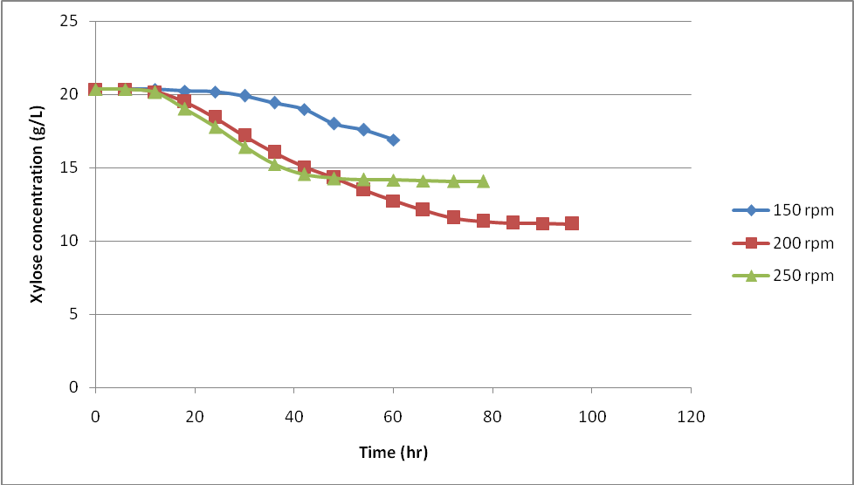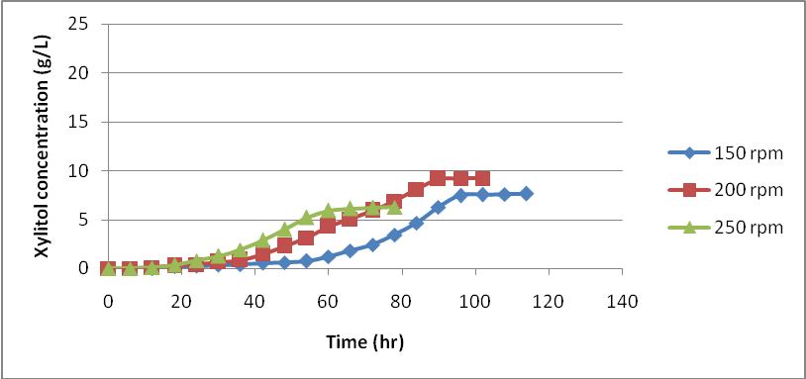
(a) xylose concentration (b) xylitol production
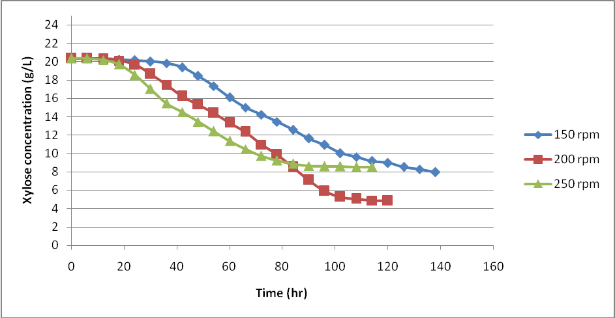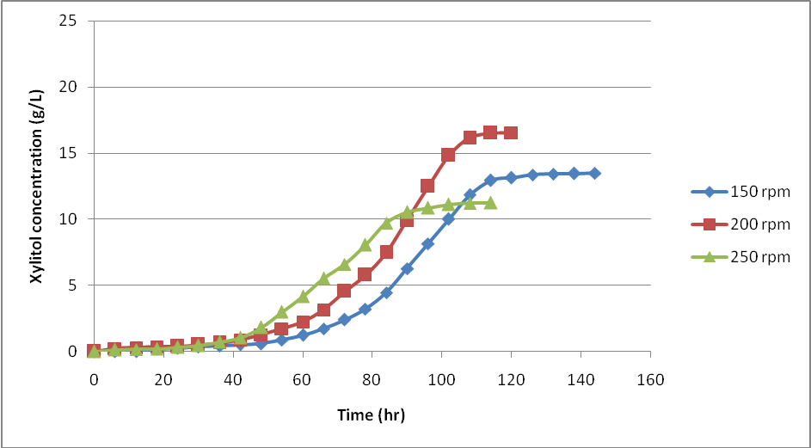
(c) xylose concentration (d) xylitol production

Figure 1: Effect of agitation speed and fermentation time on by Saccharomyces cerevisiae MTCC 172 (a) total xylose concentration (b) xylitol production and (c) total xylose concentration (d) xylitol production by Candida tropicalis MTCC 230
Impact of Fermentation Conditions on the Growth of Microorganisms
After a 4-hour adaption period, the Saccharomyces cerevisiae MTCC 172 fermentation demonstrated a logarithmic growth phase from the 12th to the 96th hour. The fermenting process required 102 hours to complete. The logarithmic phase for Candida tropicalis MTCC 230 spanned from the 12th to the 108th hour, and the adaption phase similarly lasted 4 hours.
S. cerevisiae MTCC 172 had a specific growth rate (μ) of 0.0039 h⁻¹, but C. tropicalis MTCC 230 had a higher specific growth rate of 0.056 h⁻¹ (Table 2). According to these findings, the growth rate of C. tropicalis MTCC 230 was noticeably higher than that of S. cerevisiae MTCC 172.
Minimal cell development during fermentation is suggested by the low or almost nil specific growth rate that was observed. Under circumstances of high initial cell concentration, microbial cells may preferentially use carbohydrates to generate metabolites, which could explain this delayed growth. Inhibited cell development under these high-cell-density fermentation conditions may also be caused by low oxygen supply.
Table 2: Fermentation product of microbial strains after fermentation
Products | Types of microbial hydrolysis
Products | Sacchromyces cerevisiae MTCC 172 | Candida tropicalis MTCC 230
Initial Xylose Concentration (g/L) | 20.35±0.600 | 20.35±0.600
Final Xylose Concentration (g/L) | 11.17±0.140 | 4.85±0.200
Xylose utilization (%) | 45.11±2.900 | 76.16±1.450
Initial Xylitol Concentration (g/L) | 0.00±0.000 | 0.00±0.000
Final Xylitol Concentration (g/L) | 9.20±0.170 | 16.54±0.130
Initial cell concentration (g cell/L) | 0.163±0.900 | 0.163±0.900
Final cell concentration (g cell/L) | 0.013±0.100 | 0.031±0.110
Specific growth rate (h⁻¹) (µ) | 0.0056±0.00 | 0.039±0.00
L* (Lightness) | 83.62 | 87.62
a* (Redness- Greenness) | -5.37 | -6.14
b*(Yellowness- Blueness) | 16.51 | 21.01
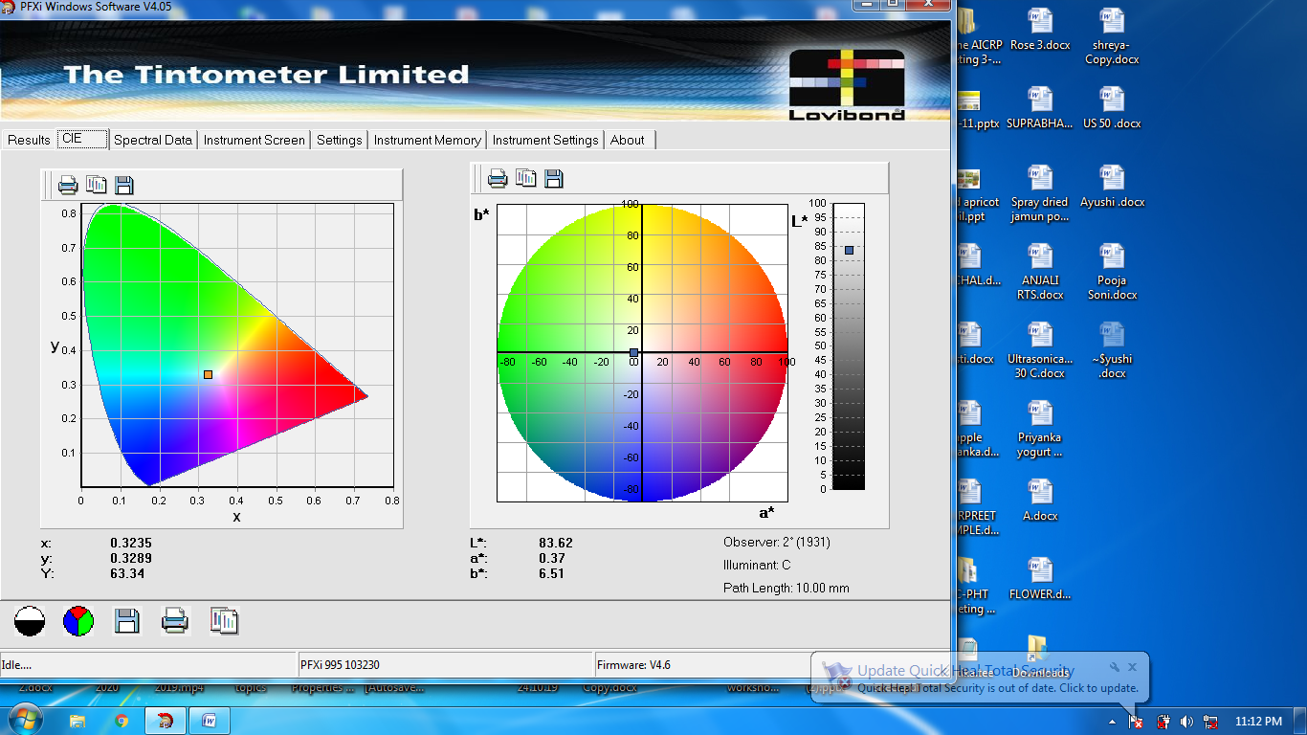
(a)
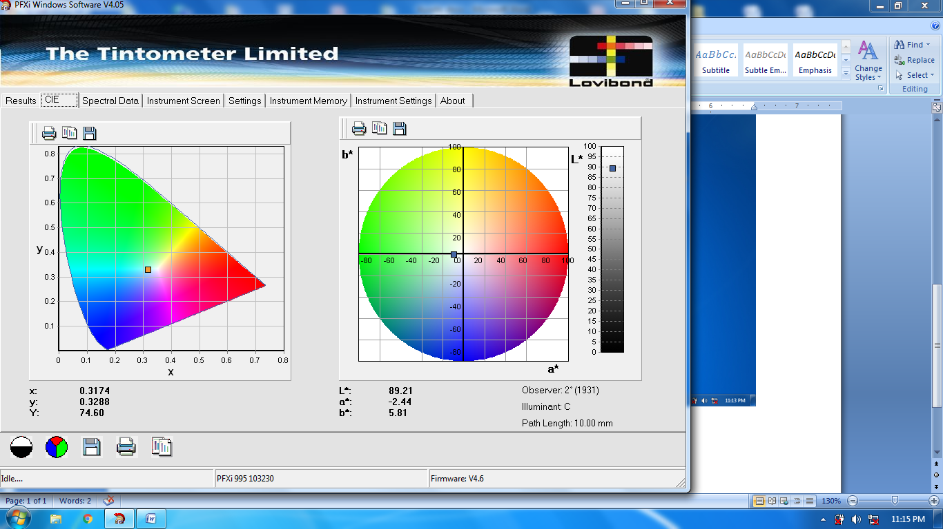
(b)
Figure 2: Color value (L*a*b*) of xylitol fermentation broths (a) Sacchromyces cerevisiae MTCC 172 (b) Sacchromyces cerevisiae MTCC 172
The fermentation process's conversion of xylose to xylitol is shown in Table 2. The starting and final xylose concentrations for Saccharomyces cerevisiae MTCC 172 were 20.35 ± 0.60 g/L and 11.77 ± 0.14 g/L, respectively. By contrast, the initial and final xylose concentrations of Candida tropicalis MTCC 230 were 20.35 ± 0.60 g/L and 4.85 ± 0.20 g/L, respectively. The final xylitol concentrations for S. cerevisiae MTCC 172 and C. tropicalis MTCC 230 were 9.20 ± 0.17 g/L and 16.54 ± 0.13 g/L, respectively, after starting at 0.00 ± 0.00 g/L for both strains.
For S. cerevisiae MTCC 172 and C. tropicalis MTCC 230, the overall xylose utilization during fermentation was 45.11 ± 2.90% and 76.16 ± 1.45%, respectively. Candida tropicalis MTCC 230 produced the most xylitol out of the two yeast strains. This strain demonstrated a higher capacity to consume xylose at low agitation rates and in nutrient-limited conditions. The slow rise in xylitol concentration during fermentation suggests that C. tropicalis MTCC 230 is not affected by inhibitory compounds. This is probably because it is more resistant to xylose fermentation, toxicity, and inhibitors that are frequently found in hemicellulosic hydrolysates (Prakasham et al., 2009). The strain's effective metabolic pattern is demonstrated by the steady bioconversion over time, which supports good xylose fermentability and produces significant xylitol yields.
Saccharomyces cerevisiae MTCC 172, on the other hand, demonstrated significantly reduced xylose-to-xylitol conversion at all agitation speeds. This could be explained by the way it breaks down xylose into furfural, which then breaks down into acetic and formic acids, which are lethal to microbes and severely reduce the production of xylitol (Jia et al., 2016). Comparable results have been documented for the fermentation of xylitol utilizing C. tropicalis with synthetic media (Wang et al., 2015) or sugarcane bagasse (Tizazu et al., 2018).
As yeasts can adapt to various conditions with different nutrient levels, pH, inhibitors, and types of sugar, microbial sources provide a cost-effective way to produce xylitol using xylose-rich substrates without the need for detoxification, yeast cell recycling, and high xylose-to-xylitol yields, productivity, reduced energy consumption, simplified downstream purification, and the use of fermentation media derived from industrial by-products (Yewale et al., 2017). Misra et al. (2012) observed similar results with Hibiscus rosa-sinensis nectar, and Rao et al. (2006) used corn fiber to produce xylitol. As a result, Candida tropicalis MTCC 230 was optimized and chosen for additional research using agitation speed of 200 rpm for 120 hours.
Conclusion
The synthesis of xylitol from xylose by two yeast strains, Saccharomyces cerevisiae MTCC 172 and Candida tropicalis MTCC 230, was successfully assessed and optimized in the present investigation. Candida tropicalis MTCC 230 outperformed the other one, obtaining more xylose consumption and a larger output of xylitol, particularly when agitated at 200 rpm for 120 hours of fermentation. The strain exhibited strong tolerance to fermentation inhibitors commonly present in hemicellulosic hydrolysates, contributing to its efficient bioconversion and stable xylitol production. In contrast, Saccharomyces cerevisiae MTCC 172 showed lower conversion rates, likely due to the production of toxic degradation products during fermentation. The findings highlight Candida tropicalis MTCC 230 as a robust and promising microbial candidate for cost-effective and sustainable xylitol production using xylose-rich substrates without the need for detoxification or complex processing. This research lays the groundwork for scaling up xylitol bioproduction through optimized fermentation conditions, which can be applied in industrial settings to utilize agricultural residues and industrial by-products efficiently.
Future Perspective
Building on the promising results obtained with Candida tropicalis MTCC 230, future research should focus on scaling up the fermentation process to pilot and industrial levels, ensuring consistency and economic viability. Genetic and metabolic engineering approaches could be explored to further enhance the strain’s xylose assimilation and xylitol production efficiency while increasing its tolerance to potential inhibitors. Additionally, integrating renewable and low-cost lignocellulosic biomass sources, such as agricultural residues and industrial waste streams, could improve the sustainability and cost-effectiveness of xylitol production. Developing continuous or fed-batch fermentation systems may optimize productivity and reduce fermentation time. Moreover, comprehensive studies on downstream processing techniques are needed to improve xylitol recovery and purification. Overall, these advances would contribute significantly to the commercialization of microbial xylitol production as an eco-friendly alternative to chemical synthesis.
Ethical Approval
This study did not involve any human participants or animal subjects and therefore did not require ethical approval. All microbial strains used in this research were obtained from authorized culture collections and handled in accordance with institutional biosafety and ethical guidelines.

Disclaimer (Artificial intelligence)
Option 1: NO
Author(s) hereby declare that NO generative AI technologies such as Large Language Models (ChatGPT, manuscript.
Option 2:
Author(s) hereby declare that generative AI technologies such as Large Language Models, etc. have been used during the writing or editing of manuscripts. This explanation will include the name, version, model, and source of the generative AI technology and as well as all input prompts provided to the generative AI technology
Details of the AI usage are given below:
1.
2.
3.

References
Banerjee M, Lazzell AL, Romo JA, Lopez-Ribot JL and Kadosh D. 2019. Filamentation is associated with reduced pathogenicity of multiple non-albicans Candida species. Msphere. 4(10): 11-28.
Baptista, S., Romani, A. P., & Domingues, L. (2021). Biotechnological advancements, innovations and challenges for sustainable xylitol production by yeast.
Bassler KH. 1974. Xylitol. In & Methods of Enzymatic Analysis. (3rd ed). Academic Press, H.O. Bergmeyer, New York.1381p
Bianchini, I. D. A., Jofre, F. M., Queiroz, S. D. S., Lacerda, T. M., & Felipe, M. D. G. D. A. (2023). Relation of xylitol formation and lignocellulose degradation in yeast. Applied microbiology and biotechnology, 107(10), 3143-3151.
Dasgupta, D., Sidana, A., Sarkar, B., More, S., Ghosh, D., Bhaskar, T., & Ray, A. (2022). Process development for crystalline xylitol production from corncob biomass by Pichia caribbica. Food and Bioproducts Processing, 133, 45-56.
Estrada-Ávila, A. K., González-Hernández, J. C., Calahorra, M., Sánchez, N. S., & Peña, A. (2022). Xylose and yeasts: A story beyond xylitol production. Biochimica et Biophysica Acta (BBA)-General Subjects, 1866(8), 130154.
Horecker BL. 1974. D-xylulose and D-xylose determination with D.-xylose isomerase. In: methods of enzymatic Analysis (11th ed) Vol.3. H.u. Bergmeger. New York. 1371p.
Jia H, Shao T, Zhong C, Li H, Jiang M, Zhou H Wei P. 2016. Evaluation of xylitol production using corncob hemicellulosic hydrolysate by combining tetrabutylammonium hydroxide extraction with dilute acid hydrolysis. Carbohydrate Polymers. 151: 676-83.
Jofre, F. M., Hernández-Pérez, A. F., dos Santos, J. C., & de Almeida Felipe, M. D. G. (2021). Use of dry yeast biomass as a new approach for detoxification of hemicellulosic hydrolysates aiming to xylitol production. Industrial Crops and Products, 170, 113812.
Kaur, S., Guleria, P., & Yadav, S. K. (2023). Evaluation of fermentative xylitol production potential of adapted strains of Meyerozyma caribbica and Candida tropicalis from rice straw hemicellulosic hydrolysate. Fermentation, 9(2), 181.
Kumar, K., Singh, E., & Shrivastava, S. (2022). Microbial xylitol production. Applied Microbiology and Biotechnology, 106(3), 971-979.
Kumar, K., Singh, E., & Shrivastava, S. (2022). Microbial xylitol production. Applied Microbiology and Biotechnology, 106(3), 971-979.
Mardawati E, Andoyo R, Syukra KA, Kresnowati MTAP and Bindar Y. 2018. Production of xylitol from corn cob hydrolysate through acid and enzymatic hydrolysis by yeast. Earth and Environmental Science. 141(4): 12-19.
Mathur, S., Kumar, D., Kumar, V., Dantas, A., Verma, R., & Kuca, K. (2023). Xylitol: Production strategies with emphasis on biotechnological approach, scale up, and market trends. Sustainable Chemistry and Pharmacy, 35, 101203.
Misra S, Raghuwanshi S and Saxena RK. 2012. Fermentation behavior of an osmo tolerant yeast D. hansenii for xylitol production. Biotechnology Progress. 28(6): 1457-65.
Palladino, F., Rodrigues, R. C., Cadete, R. M., Barros, K. O., & Rosa, C. A. (2021). Novel potential yeast strains for the biotechnological production of xylitol from sugarcane bagasse. Biofuels, Bioproducts and Biorefining, 15(3), 690-702.
Prakasham RS, Rao RS and Hobbs PJ. 2009. Current trends in biotechnological production of xylitol and future prospects. Current Trends in Biotechnology and Pharmacy. 3(1): 8-36.
Queiroz, S. S., Campos, I. S., Silva, T. F., & Felipe, M. D. G. A. (2025). Xylitol bioproduction by Candida tropicalis: effects of glucose/xylose ratio and pH on fermentation and gene expression. Brazilian Journal of Microbiology, 56(1), 105-116.
Queiroz, S. S., Jofre, F. M., Mussatto, S. I., & Felipe, M. D. G. A. (2022). Scaling up xylitol bioproduction: Challenges to achieve a profitable bioprocess. Renewable and Sustainable Energy Reviews, 154, 111789.
Rao RS, Jyothi CP, Prakasham RS, Sarma PN Rao LV. 2006. Xylitol production from corn fiber and sugarcane bagasse hydrolysates by Candida tropicalis. Bioresource Technology. 97(15): 1974-78.
Saha, B. C., & Kennedy, G. J. (2021). Optimization of xylitol production from xylose by a novel arabitol limited co-producing Barnettozyma populi NRRL Y-12728. Preparative Biochemistry & Biotechnology, 51(8), 761-768.
Santos, H., & Guillen-Lambea, S. (2025). Environmental assessment of xylitol production routes for thermal energy storage applications: A critical review. Renewable and Sustainable Energy Reviews, 214, 115532.
SHARMA, R. (2024). VALORIZATION OF CORN WASTE FOR THE PRODUCTION OF XYLITOL (Doctoral dissertation, Dr. YASHWANT SINGH PARMAR UNIVERSITY OF HORTICULTURE AND FORESTRY).
Sharma, R., Vaidya, D., Kaushal, M., Gupta, A., Shavnam, & Thakur, C. (2025). Valorization of corn waste for hemicellulose extraction and xylitol production: Comparative study of different extraction methods. Biofuels, Bioproducts and Biorefining.
Sherman F. 1991. Getting started with yeast. In Methods in Enzymology. 194(1):3-21.
Singh, A. K., Pandey, A. K., Kumar, M., Paul, T., & Gaur, N. A. (2024). Improved xylitol production by the novel inhibitor-tolerant yeast Candida tropicalis K2. Environmental Technology, 45(1), 1-15.
Suhartini, S., Rohma, N. A., Mardawati, E., Hidayat, N., & Melville, L. (2022). Biorefining of oil palm empty fruit bunches for bioethanol and xylitol production in Indonesia: A review. Renewable and Sustainable Energy Reviews, 154, 111817.
Thakur C, Kaushal M, Vaidya D, Verma A K and Gupta A. 2024b. Optimization of ultrasonication-assisted enzymatic extraction of Kangra orthodox black tea for the development of low-calorie ready-to-drink tea. Journal of Food Measurement and Characterization. 18(11): 9435-64.
Thakur C, Kaushal M, Vaidya D, Verma A K, Gupta A and Sharma R. 2024a. Unlocking the potential of spray drying for agro-products: Exploring advanced techniques, carrier agents, applications, and limitations. Food and Bioprocess Technology. 18(2): 1181-20.
Thakur C. Kaushal M, Vaidya D, Verma A K, Gupta A and Sharma R. 2024c. Optimization of the static brewing technique for ready-to-drink Kangra orthodox green tea, sweetened with selected sweeteners. Journal of Food Measurement and Characterization. 18(5): 3681-3707.
Tizazu BZ, Roy K and Moholkar VS. 2018. Mechanistic investigations in ultrasound-assisted xylitol fermentation. Ultrasonics Sonochemistry. 48: 321-28.
Umai, D., Kayalvizhi, R., Kumar, V., & Jacob, S. (2022). Xylitol: bioproduction and applications-a review. Frontiers in Sustainability, 3, 826190.
Vardhan, H., Sasmal, S., & Mohanty, K. (2024). Detoxification of areca nut acid hydrolysate and production of xylitol by Candida tropicalis (MTCC 6192). Preparative Biochemistry & Biotechnology, 54(1), 61-72.
Wang S, Li H, Fan X, Zhang J, Tang P and Yuan Q. 2015. Metabolic responses in Candida tropicalis to complex inhibitors during xylitol bioconversion. Fungal Genetics and Biology. 82(1): 1-8.
West, T. P. (2021). Xylitol production by Candida species from hydrolysates of agricultural residues and grasses. Fermentation, 7(4), 243.
Yewale T, Panchwagh S, Sawale S, Jain R and Dhamole PB. 2017. Xylitol production from non-detoxified and non-sterile lignocellulosic hydrolysate using low-cost industrial media components. Biotech. 7(1): 68-84.
Zhu, Y., Zhang, J., Zhu, L., Jia, Z., Li, Q., Xiao, W., & Cao, L. (2021). Minimize the xylitol production in Saccharomyces cerevisiae by balancing the xylose redox metabolic pathway. Frontiers in Bioengineering and Biotechnology, 9, 639595.

