**Original Research Article**

## Field Level Resistance of Mungbean Mini Core Collection to Dry Root Rot caused by *Macrophomina Phaseolina*

**Abstract:** Dry root rot caused by *Macrophomina phaseolina* (Tassi) Goid is one of the emerging diseases in mungbean, leading to substantial losses in yield, ranging from 25% to 48% depending on environmental conditions and crop management practices. It is a saprophytic fungus with survival of up to 15 years in the soil with the wide host range of more than 500 plant species. Evaluation of Dry root rot resistance in the mungbean mini core collection (MMC) consists of 293 accessions through field screening at Hyderabad, India revealed significant differences in disease incidence, with VI001509 AG, VI000203 B-BR, VI001400 AG, VI001490 AG, VI002529 B-BL and VI001244 AG exhibiting consistent resistance compared to previously done studies by paper towel method, sick pot method at Hyderabad and sick field method in Myanmar under natural inoculum pressure. Overall, the study provides valuable insights for selecting superior, stable genotypes and highlights specific accessions for mungbean improvement, particularly in developing dry root rot resistant varieties under climate change scenario.

**Key words:** dry root rot, field screening, mungbean, resistance

**Introduction**

Mungbean is one of the protein rich, short duration, feed and fodder legume crops. Globally mungbean is cultivated in nearly 7.3 million ha with average production of about 721 kg/ha (Nair *et al.,* 2020). It improves soil fertility by fixing atmospheric nitrogen, being short duration and photo- insensitive crop it fits well in different cropping systems (Ali *et al.,* 2024 & Abraheem *et al.,* 2024). Mungbean is a rich source of vitamin B-9 (folate), essential amino acids, nutrients and antioxidants which helps in reducing blood pressure. Mungbean is consumed in various forms like grain and as well as sprouts. The yield potential of mungbean is about 2 tonnes per hectare with average productivity of 0.5 tonnes per hectare (Aski *et al*., 2021).

Large germplasm collections typically contain a wide range of crop diversity. The World Vegetable Center is entrusted with the world’s second-largest collection of mungbean (*Vigna radiata*) germplasm, comprising over 6,700 accessions. It is both time-consuming and costly to screen such large collections for specific traits of interest. Hence, in order to facilitate breeder’s access to this diversity, core collection of 1,481 accessions and mini core collection of 296 entries mungbean were developed (Schafleitner *et al*., 2015).

Despite its widespread cultivation and enormous potential, mungbean suffers from various biotic stresses like diseases and pests, abiotic stresses including terminal moisture stress, extreme temperatures, soil salinity and photothermo sensitivity, which all have an impact on grain quality and yield making it less profitable (Nair *et al.,* 2019).

Among biotic constraints, dry root rot (DRR) caused by *Macrophomina phaseolina*, a soil inhabiting necrotrophic pathogen is one of the major diseases of mungbean (Pandey *et al.,* 2021; Pandey *et al.,* 2018; Nair *et al.,* 2019; Basandrai *et al.,* 2021). The pathogen thrives under high soil temperatures (35°C) and moisture stress (soil moisture content (SMC) ≤60%) (Sharma and Pandey, 2013; Chandran *et al.,* 2021). The disease causes yield losses to the extent of 10–44% in India and Pakistan (Kaushik and Chand, 1987; Bashir and Malik, 1988). DRR is a major disease of mungbean in Myanmar, however in recent years, with rapidly changing climatic conditions coupled with rising global temperatures and shift in rainfall patterns have led to DRR becoming an emerging threat in South Asian countries (Bhatia and Raghavan, 2016; Pandey *et al.,* 2021; Chandran *et al.,* 2021). Several approaches are available for management of DRR, including seed treatment, application of bioagents, plant extracts, and fungicides (Pandey *et al.,* 2021; *Pandey et al.,* 2018; Satya *et al.,* 2011; Iqbal *et al.,* 2014). However, host plant resistance remains the most reliable and viable strategy for management of soil borne diseases. The available commercial varieties and advanced breeding materials of mungbean possess a very low level of resistance (Mehta *et al.,* 2018; Basandrai *et al.,* 2021). Therefore, the **objective of this study** is to systematically evaluate a diverse set of accessions from the mungbean minicore collection to **identify** DRR **resistant sources** that can be used in future resistance breeding programs.

**2. Material and Methods**

**Plant material and location**

The mungbean mini core collection (MMC) consists of 293 accessions used for the evaluation. The experiment natural incidence of dry root rot (DRR) disease was conducted during November to January (2023-2024) at the World Vegetable Center, South Central Asia, Hyderabad (17.50209° N, 78.27646° E; elevation 550 m). The region experiences a typically hot and humid climate (**Supplementary Table 2**).

**Field screening for dry root rot (DRR) resistance**

The mungbean minicore germplasm was previously screened by paper towel and sick pot method (Pandey *et al.,* 2021). To assess the field level resistance, a DRR screening was conducted at Hyderabad during post-rainy season (Nov–Jan) 2023- 24. The field layout consisted of alpha lattice design with 2 replications and 45 x 10 cm (Row x Plant) spacing with each accession sown in 2 m length. Mungbean genotypes IPM 99-125 and VC 3960-88 served as resistant and susceptible checks respectively. A basal dose of fertilizer was applied at the rate of 20:40:20 NPK kg per hectare. The trial was maintained free from weeds by manual weeding and to reduce the confounding effects from foliar pests and diseases appropriate management practices were carried out following the mungbean field manual of Mbeyagala *et al.,* 2017. The trial was monitored for DRR infection and observations on disease incidence were recorded at 40 days after sowing. Percent disease incidence (PDI) of each accession was calculated using the formula described by Cooke (2006).

|  |  |  |  |  |
| --- | --- | --- | --- | --- |
| PDI | = | No. of infected plants | X | 100 |
| Total Number of Plants |

Based on the PDI, the accessions were categorized into highly resistant (free from DRR), resistant (≤10.0% incidence), moderately resistant (10.1–20.0% incidence), moderately susceptible (20.1–30%), susceptible (30.1–50.0% incidence), and highly susceptible (>50% incidence) (Pandey *et al.,* 2021) (**Table 1**). A set of 30 promising accessions from repeated paper towel, sick pot method at Hyderabad and field screening in Myanmar during 2018 and 2019 (Pandey *et al.,* 2021) were used to assess the stability of resistance to DRR in the field at Hyderabad.

**Table 1.Disease scale for field screening of mungbean mini-core collection for dry root rot disease**

|  |  |
| --- | --- |
| **Categories** | **Disease Reaction** |
| No incidence | Highly resistant (HR) |
| ≤10% incidence | Resistant (R) |
| 10.1–20% incidence | Moderately resistant (MR) |
| 20.1–30% incidence | Moderately susceptible (MS) |
| 30.1–50% incidence | Susceptible (S) |
| *>*50% incidence | Highly susceptible (HS) |

**Data analysis**

Dry root rot per cent disease incidence data was arcsine transformed before subjected to analysis, all the visualization and graphs were plotted with original data.

**Results and Discussion**:

**Identification of Dry root rot infested plants in the field**

Dry root rot (DRR) affected plants exhibited stunted growth, wilting, and desiccation of foliage and stem (**Figure 1**). Infected taproots showed dark discoloration accompanied by formation of black sclerotia. Additionally, cortical shredding and the absence of secondary roots were observed.

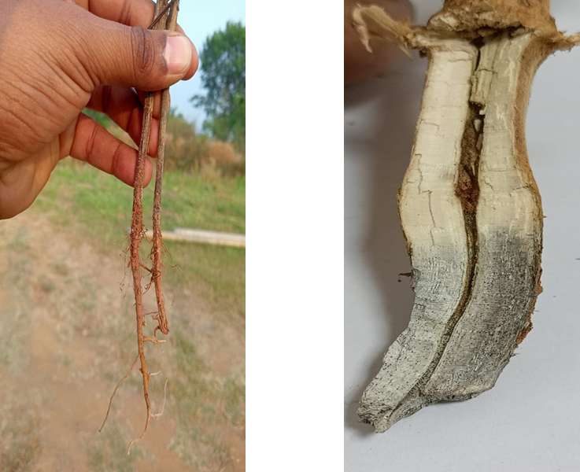

**Figure 1: Typical symptoms of Dry root rot affected roots**

**Confirmation of Dry Root Rot pathogen: *Macrophomina phaseolina***

The pathogen was collected and isolated from the dry root rot infested plants at world vegetable center, South Central Asia, Hyderabad. The pathogen was identified morphologically based on the presence of smooth, irregular shaped, dark greyish/black color microsclerotia (**Figure 2)**.

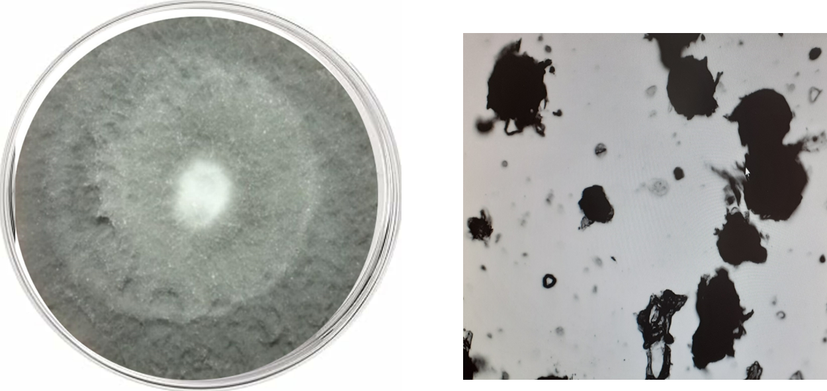

**Figure 2:** Pure culture of *Macrophomina phaseolina* isolated from infected mungbean root on PDA medium and dense aggregation of sclerotia

Molecular confirmation was carried out based on genetic analysis using primers that amplified internal transcribed spacer (ITS) 18S rRNA genes, namely ITS 1 and ITS 4.Several earlier studies have also employed ITS sequencing of the 18S rRNA region to identify and confirm Macrophomina phaseolina from various hosts (**Renugadevi *et al.,* 2022;** Bandamaravuri *et al.,* 2007).The 600bp fragment was sequenced and BLAST results revealed 99.64% resemblance with four isolates of *M. phaseolina* (MN629245, OM760783, MW227301 and MW227295)*.*

**Field screening of mungbean mincore for DRR**

Field evaluation of mungbean mini core collection (293 accessions) for dry root rot (DRR) revealed varying disease reactions. Significant variation (p <0.001) was observed in the DRR disease incidence among the mini core accessions. Among 293 accessions, seven accessions VI002173AG, VI002173BG, VI002437BG, VI002469AG, VI003034BG, VI003364AG, and VI004347B-BLM exhibited a highly resistant (HR) reaction, with no symptomatic DRR plants. Ten accessions have shown resistant (R) reaction with ≤10% disease incidence, while 15 accessions were moderately resistant (MR), 23 moderately susceptible (MS), 78 accessions susceptible (S), and 160 accessions highly susceptible (HS) (**Figure 3** and **Supplementary table 1**).

The mungbean minicore set previously tested by paper towel method and glasshouse screening identified 124 moderately resistant and 62 moderately susceptible accessions (Pandey *et al.,* 2021),which could be due to the influence of environmental conditions on the inherent capacity of *Macrophomina phaseolina*. Since, DRR prevalence is more under low moisture and high temperature conditions, many accessions were susceptible to the disease in the field compared to controlled conditions. Till date, there are only few mungbean genotypes MSJ 118, KM 4-44, and KM 4-59 (Choudhary *et al.,* 2011), GP-1, G-4, MUM-2, ISGP-3 and IPMO2-3 (Mehta *et al.,* 2018) in India and Azri 2006, NM 2006 and AUM 9 in Pakistan (Haseeb *et al.,* 2013) were identified for dry root rot resistance through field screening. Hence there is an absolute need for identifying resistant sources for DRR in mungbean. The mini core accessions provide an additional source of resistance with wider variability for utilization in breeding program.

A total of six accessions (VI001509AG, VI000203B-BR, VI001400AG, VI001490AG, VI002529B-BL and VI001244AG) consistently exhibited resistant reaction (**Figure 4**), when we compared the results from the previously done studies of the paper towel method (PT_Hyd_1 and PT_Hyd_2), sick pot method (SP_Hyd), sick field method in Myanmar (SF_Myn_1 and SF_Myn_2), with the current study of sick field screening at Hyderabad (SF_Hyd). The highest suppression of DRR observed in these six accessions suggested well-developed root systems, which aided in efficient moisture uptake from the soil and maintenance of plant water potential within a range that limits infection by Macrophomina phaseolina. The accessions **VI001509AG, VI001400AG,** and **VI001490AG** have also shown **moderate to high resistance (MR–R)** to multiple biotic stresses—including halo blight, tan spot, powdery mildew, whitefly, stem fly, and aphids and also display significant **heat tolerance (World vegetable center, IMIN report 2021).**

However, accessions VI001282AG, VI003699B-BG, VI001284AG, VI001419BG, VI001548AG, and VI000181BG, which showed promising resistance in the paper towel and sick pot methods (Pandey *et al.,* 2021), were susceptible in field screening studies at Hyderabad location, due to the influence of environmental conditions. The differential reaction of accessions towards DRR pathogen was observed in the same field at Myanmar in two seasons which may be due to differences in inoculum load in the soil and variation in environmental conditions (Kumar ., 2004 and Wagh., 2015).

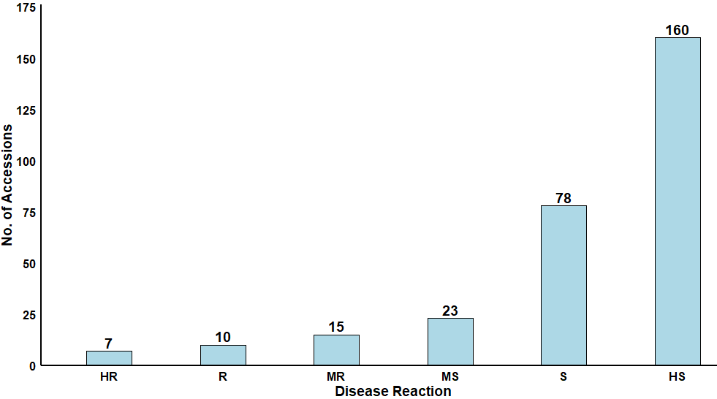

**Figure 3:** Frequency distribution of mungbean mini core accessions with different disease reactions in field screening for dry root rot disease at Hyderabad during post rainy season 2023/24.

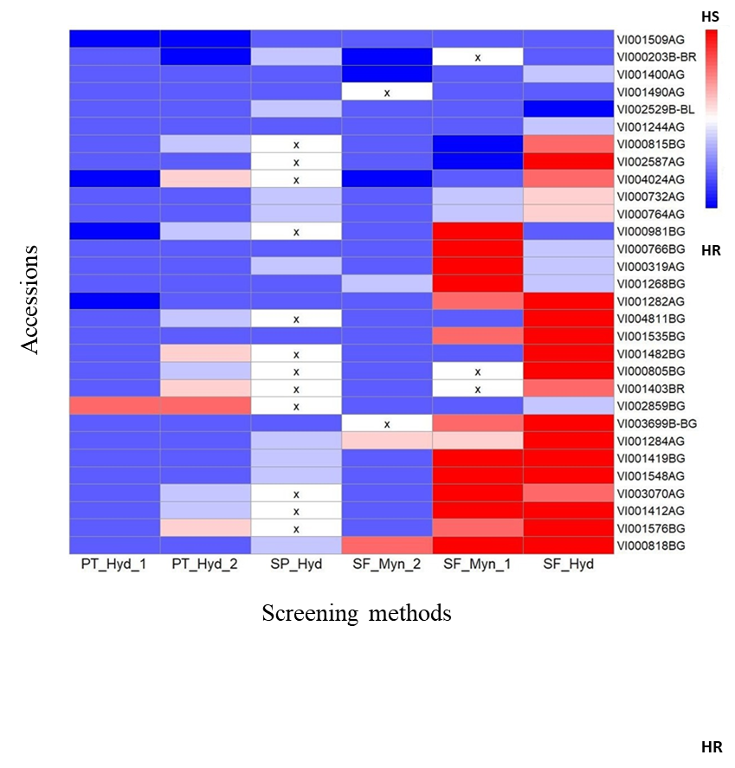

**Figure 4.**A subset of 30 accessions of mungbean mini core collection from different screening methods.Paper towel method at Hyderabad (PT_Hyd_1, PT_Hyd_2), sick pot method Hyderabad (SP_Hyd), sick field at Yezin, Myanmar (SF_Myn_1, SF_Myn_2) and sick field at Hyderabad (SF_Hyd)**.**

**Conclusion:**

Mungbean minicore accessions VI001509 AG, VI000203 B-BR, VI001400 AG, VI001490 AG, VI002529 B-BL and VI001244 AG consistently exhibited resistance to dry root rot (DRR) across different screening methods and locations, highlighting their potential as valuable sources of resistance for mungbean breeding program aimed at development of DRR-resistant varieties.

Artificial intelligence

Author(s) hereby declare that NO generative AI technologies such as Large Language Models (ChatGPT, manuscript.

**References:**

1. Abraheem BA, Al-Hilfy IHH, Al-Abodi HMK, Mahdi AM, Salman KA. Effects of sorghum-mung bean intercropping and nutrient solutions on fruit growth indicators. Res Crop. 2024;25(2):416-24.
2. Ali MA, Khaleel AT, Khaleel ST. Improving the growth and productivity of two varieties of mung bean (Vigna radiata L.) by using different cultivation methods and dates. Legume Res. 2024;47(9):1522-8. doi:10.18805/LRF-802.
3. Aski MS, Rai N, Reddy VRP, Gayacharan, Dikshit HK, Mishra GP, Singh D, Kumar A, Pandey R, Singh MP, Pratap A, Nair RM, Schafleitner R. Assessment of root phenotypes in mungbean mini-core collection (MMC) from the World Vegetable Center (AVRDC), Taiwan. PLoS One. 2021;16:e0247810. doi:10.1371/journal.pone.0247810.
4. Bandamaravuri KB, Saxena A, Srivastava V, Arora D. Identification and detection of Macrophomina phaseolina by using species-specific primers and probe. Mycologia. 2007;99(6):797-803.
5. Basandrai AK, Pandey AK, Somta P, Basandrai D. Macrophomina phaseolina–host interface: Insights into an emerging dry root rot pathogen of mungbean and urdbean, and its mitigation strategies. Plant Pathol. 2021;70(6):1263-75.
6. Bashir M, Malik BA. Diseases of major pulse crops in Pakistan—a review. Trop Pest Manag. 1988;34(3):309-14.
7. Bhatia S, Raghavan KS. An overview of pulse production in the central dry zone of Myanmar, with special reference to chickpea. Int J Inno Res Adv Stud. 2016;3(1):150-8.
8. Chandran USS, Tarafdar A, Mahesha HS, Sharma M. Temperature and soil moisture stress modulate the host defense response in chickpea during dry root rot incidence. Front Plant Sci. 2021;12:653265.
9. Choudhary S, Choudhary AK, Sharma OP. Screening of mungbean (Vigna radiata) accessions to identify sources of resistance to DRR. J Food Leg. 2011;24(2):117-19.
10. Cooke BM. Disease assessment and yield loss. In: Jones DG, Kaye B, editors. The Epidemiology of Plant Diseases. 2nd ed. Dordrecht: Springer; 2006. p. 43-80.
11. Haseeb AF, Sahi ST, Ali S, Fiaz M. Response of different mungbean varieties against Macrophomina phaseolina and in vitro studies of plant extracts against pathogen. Pak J Phytopathol. 2013;25(1):78-83.
12. Iqbal U, Mukhtar T, Iqbal SM. In vitro and in vivo evaluation of antifungal activities of some antagonistic plants against charcoal rot causing fungus Macrophomina phaseolina. Pak J Agric Sci. 2014;51(3):691-96.
13. Kaushik CD, Chand JN. Seedborne nature of Rhizoctonia bataticola causing leaf blight of mungbean. J Mycol Plant Pathol. 1987;17(2):154-57.
14. Kumar KV. Studies on dry root rot disease of chickpea (Cicer arietinum L.) caused by Rhizoctonia bataticola (Taub.) Butler. 2004 (Master’s thesis, University of Agricultural Sciences, GKVK, Dharwad). Retrieved from Krishikosh Repository.
15. Mbeyagala KE, Amayo R, Obuo JP, Pandey AK, War AR, Nair RM. A manual for mungbean (greengram) production in Uganda. Natl Agric Res Organ. 2017;32p.
16. Mehta S, Gangopadhyay S, Prasad J, Panwar P. Screening of mung bean varieties for resistance against Macrophomina phaseolina causing dry root rot. Int J Trop Agric. 2018;36(1):1-5.
17. Nair RM, Pandey AK, War AR, Hanumantharao B, Shwe T, Alam AKMM, Pratap A, Malik SR, Karimi R, Mbeyagala EK, Douglas CA, Rane J, Schafleitner R. Biotic and abiotic constraints in mungbean production—Progress in genetic improvement. Front Plant Sci. 2019;10:1340.
18. Nair R, Schreinemachers P. Global status and economic importance of mungbean. In: Nair RM, Schafleitner R, Lee SH, editors. The Mungbean Genome. Cham: Springer; 2020. p. 1-8.
19. Pandey AK, Yee MY, Win MM, Lwin HMM, Adapala G, Rathore A, Sheu ZM, Nair RM. Identification of new sources of resistance to dry root rot caused by Macrophomina phaseolina isolates from India and Myanmar in a mungbean mini-core collection. Crop Prot. 2021;143:105569.
20. Pandey AK, Burlakoti RR, Kenyon L, Nair RM. Perspectives and challenges for sustainable management of fungal diseases of mungbean (Vigna radiata L. Wilczek var. radiata): A review. Front Environ Sci. 2018;6:53.
21. Renugadevi V, Muthulakshmi P, Sendhilvel V, Rajamani K. Morphological and molecular characterization of Macrophomina phaseolina associated with tuber rot in glory lily. Pharma Innov. 2022;11(1):1719-24.
22. Satya VK, Vijayasamundeeswari A, Paranidharan V, Velazhahan R. Burkholderia sp. strain TNAU-1 for biological control of root rot in mungbean (Vigna radiata L.) caused by Macrophomina phaseolina. J Plant Prot Res. 2011;51(4):273-78.
23. Schafleitner R, Nair RM, Rathore A, Wang Y, Lin C, Chu S, Lin P, Chang J, Ebert AW. The AVRDC–The World Vegetable Center mungbean (Vigna radiata) core and mini core collections. BMC Genomics. 2015;16:344.
24. Sharma M, Pande S. Unravelling effects of temperature and soil moisture stress response on development of dry root rot [Rhizoctonia bataticola (Taub.)] in chickpea. Am J Plant Sci. 2013;4(3):584-89.
25. Wagh, P. Studies on dry root rot (Rhizoctonia bataticola Taub. (Butler)) of chickpea (Cicer arietinum). 2015 (Master’s thesis, Indira Gandhi Krishi Vishwavidyalaya, Raipur). Krishikosh Repository.
26. World Vegetable Center. Establishing the International Mungbean Improvement Network (IMIN). ACIAR Final Rep. 2021;(CIM/2014/079). <https://aciar.gov.au/project/cim-2014-079>

**Supplementary Table 1.Field Screening of MMC for DRR during post-rainy season 2023/24**

|  |  |  |  |
| --- | --- | --- | --- |
| Accession No. | Accession Name | Origin | DRR reaction |
| 1 | VI000020 AY | Thailand | HS |
| 2 | VI000099 AG | India | HS |
| 3 | VI000105 BG | India | HS |
| 4 | VI000164 BG | Afghanistan | S |
| 5 | VI000170 B-BR | Afghanistan | R |
| 6 | VI000175 BY | India | S |
| 7 | VI000188 A-BLM | Pakistan | HS |
| 8 | VI000203 B-BR | Afghanistan | MR |
| 9 | VI000212 A-BLM | USA | S |
| 10 | VI000232 AG | Iran | S |
| 11 | VI000238 AG | Afghanistan | S |
| 12 | VI000253 AG | India | HS |
| 13 | VI000316 AG | Pakistan | HS |
| 14 | VI000317 BG | Pakistan | HS |
| 15 | VI000319 AG | Pakistan | MR |
| 16 | VI000380 AG | Philippines | S |
| 17 | VI000461 BG | Thailand | HS |
| 18 | VI000470 AG | Pakistan | HS |
| 19 | VI000532 BG | India | HS |
| 20 | VI000537 BG | India | HS |
| 21 | VI000542 BY | India | HS |
| 22 | VI000551 AG | India | HS |
| 23 | VI000554 AG | India | S |
| 24 | VI000559 AG | India | HS |
| 25 | VI000578 AG | India | HS |
| 26 | VI000589 B-BR | India | HS |
| 27 | VI000616 BG | Brazil | S |
| 28 | VI000618 AG | India | S |
| 29 | VI000625 B-BR | India | S |
| 30 | VI000680 AG | USA | HS |
| 31 | VI000723 AG | Iran | HS |
| 32 | VI000732 AG | India | MS |
| 33 | VI000735 BG | India | HS |
| 34 | VI000736 AG | India | HS |
| 35 | VI000749 AG | India | HS |
| 36 | VI000764 AG | India | MS |
| 37 | VI000766 BG | India | MR |
| 38 | VI000805 BG | India | HS |
| 39 | VI000815 BG | India | S |
| 40 | VI000818 BG | India | HS |
| 41 | VI000852 AG | India | S |
| 42 | VI000938 AG | India | MS |
| 43 | VI000942 AG | India | HS |
| 44 | VI000953 AG | India | HS |
| 45 | VI000981 BG | Philippines | R |
| 46 | VI001023 BG | India | R |
| 47 | VI001066 BG | Australia | HS |
| 48 | VI001096 AG | Australia | S |
| 49 | VI001124 AG | Australia | HS |
| 50 | VI001126 BG | Australia | HS |
| 51 | VI001162 AG | Australia | HS |
| 52 | VI001191 BG | Philippines | MS |
| 53 | VI001211 AG | Philippines | HS |
| 54 | VI001221 AG | Philippines | HS |
| 55 | VI001244 AG | Philippines | MR |
| 56 | VI001268 BG | India | MS |
| 57 | VI001282 AG | India | HS |
| 58 | VI001284 AG | India | HS |
| 59 | VI001339 AG | Philippines | HS |
| 60 | VI001385 AG | India | HS |
| 61 | VI001400 AG | India | MS |
| 62 | VI001403 B-BR | India | S |
| 63 | VI001406 BG | Pakistan | S |
| 64 | VI001408 BG | India | HS |
| 65 | VI001411 AG | India | HS |
| 66 | VI001412 AG | India | HS |
| 67 | VI001419 BG | India | HS |
| 68 | VI001435 AG | USA | HS |
| 69 | VI001448 A-BLM | India | HS |
| 70 | VI001471 AG | India | HS |
| 71 | VI001482 BG | India | HS |
| 72 | VI001490 AG | Iran | R |
| 73 | VI001509 AG | Pakistan | R |
| 74 | VI001514 AG | India | HS |
| 75 | VI001520 A-BLM | India | S |
| 76 | VI001533 BG | India | HS |
| 77 | VI001535 BG | India | S |
| 78 | VI001539 AG | India | S |
| 79 | VI001548 AG | India | HS |
| 80 | VI001556 BG | India | MS |
| 81 | VI001557 BG | USA | HS |
| 82 | VI001562 AG | India | HS |
| 83 | VI001576 BG | India | HS |
| 84 | VI001579 BG | India | HS |
| 85 | VI001605 BG | India | HS |
| 86 | VI001612 AG | Unknown | HS |
| 87 | VI001628 AG | India | HS |
| 88 | VI001651 BG | India | HS |
| 89 | VI001652 BG | India | HS |
| 90 | VI001654 BG | India | HS |
| 91 | VI001678 BG | India | S |
| 92 | VI001692 AG | India | MS |
| 93 | VI001698 BG | India | S |
| 94 | VI001728 AG | India | S |
| 95 | VI001733 BG | India | MR |
| 96 | VI001743 BG | India | MS |
| 97 | VI001756 BG | India | HS |
| 98 | VI001762 A-GM | India | HS |
| 99 | VI001806 AG | Pakistan | S |
| 100 | VI001806 BG | Pakistan | S |
| 101 | VI001820 BG | France | HS |
| 102 | VI001859 BG | Thailand | HS |
| 103 | VI001974 BG | Korea, Republic of | S |
| 104 | VI001993 BG | Korea, Republic of | R |
| 105 | VI002009 BG | India | S |
| 106 | VI002012 BG | India | S |
| 107 | VI002051 BG | India | HS |
| 108 | VI002063 BG | USA | S |
| 109 | VI002173 AG | India | HR |
| 110 | VI002173 BG | India | HR |
| 111 | VI002176 AG | India | HS |
| 112 | VI002176 BG | India | S |
| 113 | VI002190 BG | India | S |
| 114 | VI002195 AG | Thailand | HS |
| 115 | VI002197 BG | Korea, Republic of | HS |
| 116 | VI002206 AG | Philippines | HS |
| 117 | VI002239 AG | Afghanistan | S |
| 119 | VI002284 BG | Afghanistan | S |
| 120 | VI002402 BG | Thailand | HS |
| 121 | VI002432 AG | Thailand | HS |
| 122 | VI002437 BG | Korea, Republic of | HR |
| 123 | VI002456 AG | Korea, Republic of | HS |
| 124 | VI002469 AG | Philippines | HR |
| 125 | VI002487 AG | Pakistan | HS |
| 126 | VI002523 AG | Thailand | HS |
| 128 | VI002532 AG | India | MS |
| 129 | VI002537 AG | Turkey | S |
| 130 | VI002569 BG | Nigeria | HS |
| 131 | VI002587 AG | Australia | HS |
| 132 | VI002611 AG | Thailand | HS |
| 133 | VI002646 AG | Thailand | MR |
| 134 | VI002647 AG | Thailand | HS |
| 135 | VI002672 AG | Thailand | HS |
| 136 | VI002739 AG | Iran | HS |
| 137 | VI002802 A-BR | Iran | S |
| 138 | VI002859 BG | Iran | MR |
| 139 | VI002860 AG | Iran | S |
| 140 | VI002872 BG | Iran | S |
| 141 | VI002877 BG | Iran | S |
| 142 | VI002894 B-BR | Iran | HS |
| 143 | VI002926 AG | India | S |
| 144 | VI002934 AG | India | S |
| 145 | VI002986 AG | India | S |
| 146 | VI002993 BG | India | HS |
| 147 | VI002999 AG | India | HS |
| 148 | VI003019 A-BLM | Unknown | S |
| 149 | VI003019 BG | Unknown | HS |
| 150 | VI003034 BG | India | HR |
| 151 | VI003035 AG | India | S |
| 152 | VI003057 BG | India | R |
| 153 | VI003062 BG | India | S |
| 154 | VI003068 A-BR | India | S |
| 155 | VI003070 AG | India | S |
| 156 | VI003083 BG | India | S |
| 157 | VI003114 AG | India | S |
| 158 | VI003135 B-BL | India | HS |
| 159 | VI003159 AG | India | HS |
| 160 | VI003172 BG | India | HS |
| 161 | VI003181 B-GM | India | MS |
| 162 | VI003183 AG | India | S |
| 163 | VI003187 BG | India | HS |
| 164 | VI003212 B-BLM | India | HS |
| 165 | VI003220 AG | India | MR |
| 166 | VI003232 AG | India | R |
| 167 | VI003235 AG | India | S |
| 168 | VI003242 AG | India | R |
| 169 | VI003251 A-BL | India | HS |
| 170 | VI003251 A-BLM | India | HS |
| 171 | VI003252 BG | India | HS |
| 172 | VI003255 AG | India | HS |
| 173 | VI003276 BG | India | HS |
| 174 | VI003329 AG | India | HS |
| 175 | VI003332 AG | India | S |
| 176 | VI003337 BG | India | S |
| 177 | VI003364 AG | India | HR |
| 178 | VI003379 BG | India | HS |
| 179 | VI003382 BG | India | S |
| 180 | VI003407 AG | India | S |
| 181 | VI003413 BG | India | HS |
| 182 | VI003440 AG | India | MS |
| 183 | VI003455 AG | India | MS |
| 184 | VI003456 AG | Unknown | HS |
| 185 | VI003465 BG | India | S |
| 186 | VI003470 BG | India | HS |
| 187 | VI003480 BG | India | HS |
| 188 | VI003490 AG | India | HS |
| 189 | VI003493 BG | India | HS |
| 190 | VI003514 BG | India | HS |
| 191 | VI003517 BG | India | S |
| 192 | VI003534 AG | India | HS |
| 193 | VI003534 BG | India | HS |
| 194 | VI003548 AG | India | HS |
| 195 | VI003554 AG | India | HS |
| 196 | VI003560 BG | India | S |
| 197 | VI003563 A-BR | India | HS |
| 198 | VI003577 AG | India | HS |
| 199 | VI003602 AG | India | MR |
| 200 | VI003642 AG | India | HS |
| 201 | VI003648 BG | India | HS |
| 202 | VI003658 BG | India | HS |
| 203 | VI003664 AG | India | S |
| 204 | VI003678 BG | India | HS |
| 205 | VI003685 AG | India | HS |
| 206 | VI003699 BG | India | S |
| 207 | VI003720 BG | India | HS |
| 208 | VI003725 BG | India | MS |
| 209 | VI003733 BG | India | MS |
| 210 | VI003734 B-BR | India | HS |
| 211 | VI003734 B-DG | India | HS |
| 212 | VI003744 AG | India | HS |
| 213 | VI003755 BG | India | HS |
| 214 | VI003760 BG | India | MR |
| 215 | VI003785 BG | India | HS |
| 216 | VI003795 AG | India | MS |
| 217 | VI003801 BG | India | S |
| 218 | VI003882 A-BLM | Afghanistan | HS |
| 219 | VI003886 B-BR | India | HS |
| 220 | VI003886 BY | India | HS |
| 221 | VI003893 AG | India | MS |
| 222 | VI003894 B-BLM | India | HS |
| 223 | VI003907 AG | Iraq | HS |
| 224 | VI003914 AG | India | HS |
| 225 | VI003925 B-BLM | India | HS |
| 226 | VI003927 AG | India | MR |
| 227 | VI003929 A-BL | India | HS |
| 228 | VI003942 AG | Afghanistan | MS |
| 229 | VI003944 B-BR | Afghanistan | HS |
| 230 | VI003947 B-BR | India | MS |
| 231 | VI003948 B-BR | India | HS |
| 232 | VI003951 AG | India | HS |
| 233 | VI003954 BG | India | HS |
| 234 | VI003957 AG | India | HS |
| 235 | VI003958 B-BLM | India | HS |
| 236 | VI003959 BG | India | S |
| 237 | VI004006 A-GM | India | MS |
| 238 | VI004010 AG | India | S |
| 239 | VI004024 AG | Australia | HS |
| 240 | VI004044 BG | India | HS |
| 241 | VI004045 A-DGM | India | HS |
| 242 | VI004048 A-DGM | India | HS |
| 243 | VI004069 BG | India | MR |
| 244 | VI004096 AG | India | HS |
| 245 | VI004096 BG | India | S |
| 246 | VI004129 A-BLM | Unknown | HS |
| 247 | VI004138 BG | India | HS |
| 248 | VI004145 B-BLM | Afghanistan | S |
| 249 | VI004184 AG | Netherlands | S |
| 250 | VI004243 B-BR | Turkey | HS |
| 251 | VI004244 B-BR | India | HS |
| 252 | VI004297 AG | Afghanistan | HS |
| 253 | VI004302 AG | Afghanistan | S |
| 254 | VI004307 AG | Afghanistan | HS |
| 255 | VI004312 AG | India | HS |
| 256 | VI004347 B-BLM | India | HR |
| 257 | VI004351 AG | India | R |
| 258 | VI004423 AG | Iran | MR |
| 259 | VI004432 B-BR | Iran | S |
| 260 | VI004480 AG | Iran | MR |
| 261 | VI004639 AG | Iran | HS |
| 262 | VI004666 AG | Iran | S |
| 263 | VI004691 AG | Iran | MR |
| 264 | VI004694 BG | Iran | S |
| 265 | VI004710 AG | Iran | S |
| 266 | VI004734 AG | Iran | HS |
| 267 | VI004743 AG | India | HS |
| 268 | VI004789 BG | India | HS |
| 269 | VI004810 BG | India | S |
| 270 | VI004811 BG | India | HS |
| 271 | VI004822 BG | India | HS |
| 272 | VI004838 AG | India | S |
| 273 | VI004842 AG | India | S |
| 274 | VI004853 BG | India | MS |
| 275 | VI004871 BG | India | S |
| 276 | VI004877 AG | India | MS |
| 277 | VI004915 BG | India | HS |
| 278 | VI004931 AG | Pakistan | HS |
| 279 | VI004933 AG | Pakistan | HS |
| 280 | VI004934 AG | Pakistan | HS |
| 281 | VI004937 AG | Pakistan | MS |
| 282 | VI004942 BG | Pakistan | S |
| 283 | VI004954 BG | Pakistan | S |
| 284 | VI004956 AG | Pakistan | HS |
| 285 | VI004957 AG | Pakistan | HS |
| 286 | VI004958 BG | Pakistan | HS |
| 287 | VI004965 BG | Pakistan | HS |
| 288 | VI004968 AG | Pakistan | S |
| 289 | VI004969 AG | Pakistan | HS |
| 290 | VI004973 B-BLM | India | S |
| 291 | VI005022 BG | India | HS |
| 293 | VI005030 BY | Mexico | HS |
| 294 | VI005041 AG | Unknown | S |
| 295 | VI005066 A-GM | India | HS |
| 296 | VI014178 BG | Kenya | S |

Dry root rot (DRR) disease reaction, HR=highly resistant; R=resistant; MR=moderately resistant; MR=moderately susceptible; S=susceptible; HS=highly susceptible.

**Supplementary Table 2 .**Weather parameters of the field during the field screening of DRR resistance

|  |  |  |  |  |  |  |  |  |  |
| --- | --- | --- | --- | --- | --- | --- | --- | --- | --- |
| Year | Month | Rain | Evaporation | Max Temp | Min Temp | Relative Humidity | Wind Velocity | Solar Radiation | Bright Sunshine |
| 2023 | Nov | 19.79 | 135.5 | 30.47 | 18.67 | 89.63 | 3.98 | 14.03 | 4.83 |
| 2023 | Dec | 3.2 | 148.09 | 28.7 | 14.15 | 90.38 | 3.5 | 15.37 | 6.54 |
| 2024 | Jan | 0 | 162 | 30.12 | 16.67 | 86.96 | 5.51 | 16.68 | 6.99 |