Enhancing soil characteristics and physiological parameters of soil cultivated with Marigold (*Tagetes erecta* L.) *cv*. Calcutta orange using Pusa Hydrogel

# Abstract

The issue of water management has assumed paramount importance and occupied the centre stage of politico-economic debates in the world. Marigold is a versatile flowering plant that belongs to the Asteraceae family with numerous uses in the floriculture industry, which can be grown in varied agroclimatic conditions, hence used for the present study. The study aimed to understand the effect of different regimes of irrigation, soil characteristics and physiological parameters of soil during the cultivation of Marigold (*Tagetes erecta* L.) *cv*. Calcutta orange. The study was conducted at the College of Horticulture, Bagalkot, University of Horticultural Sciences, Bagalkot, Karnataka, India.

Healthy seedlings of the marigold cultivar “Culcutta Orange” were used for the experiment, collected from Kisan Nursery, Arabhavi. The recorded observations included soil parameters, physiological parameters, Crop growth rate, Relative Growth Rate, and Net Assimilation Rate. The results revealed significantly higher moisture content in marigold grown field soil irrigated with 100 per cent Cumulative Pan Evaporation (CPE) (20.72, 17.50 and 12.24 per cent, respectively) at 30, 60 and 90 Days After Transplanting (DAT). High pH (8.03) and bulk density (1.48 g/cm3) were observed at 80 (I2) and 60 (I3) per cent CPE, respectively. Relative water content was significantly highest in I2: 80 per cent CPE (75.51 and 63.75 per cent, respectively) at 45 and 75 DAT. Maximum values of Crop Growth Rate (CGR) (1.79 g m-2 day-1), Relative Growth Rate (RGR) (0.58 g g-1day-1 × 102) and NAR (0.48 g m-2 day-1) were obtained in the irrigation schedule at 80 per cent CPE. Relative water content of the plant was significantly highest (82.07 and 71.47 per cent, respectively) in 80 per cent CPE with 5.25 kg/ha hydrogel (I2H4) at 45 and 75 DAT. The maximum value of CGR (2.20 g m-2 day-1) was obtained in the irrigation schedule at 80 per cent CPE with 5.25 kg/ha hydrogel (I2H4). Relative growth rate (RGR) and net assimilation rate (NAR) were found to be non-significant with respect to the treatment combination of different levels of irrigation and hydrogel.

**Keywords:** *Pusa hydrogel, Marigold, Physiological parameters, irrigation, water management*

# Introduction

The issue of water management has assumed paramount importance and occupied the centre stage of politico-economic debates in the world. Agricultural production is responsible for nearly 70% of that withdrawal volume, while the industrial sector and the domestic uses are responsible for 22% and 8% of that volume, respectively. Therefore, agriculture is the most water-intensive sector, thereby contributing extensively to water scarcity (Ingrao et al., 2023). India has already entered the shadow of the zone of physical and economic water scarcity (Singh et al., 1991). The area under dryland conditions is 85 million ha (60 per cent of the total cultivated area), which receives average annual rainfall of less than 1150 mm. Also, more than 30 per cent of the total geographical area of the country comes under low rainfall (less than 750 mm). Efficient agricultural water management practices are essential to expand irrigation coverage in India. Effectively managing water resources poses a significant challenge for countries like India. Developing water resources necessitates tackling vital aspects such as storage, conservation, and subsequent utilisation (Tarate et al., 2024). Hence, there is an urgent need for efficient water resource management

through enhanced water use efficiency. As water utilisation is less in industrial (15 per cent) and domestic (5 per cent) sectors compared to agriculture (85 per cent) and there are no further chances to reduce quantity of water in these sectors, the focus should be on the agriculture sector for water saving without compromising on crop production. Hydrogels are found to improve the physical properties of soils, viz., porosity, bulk density, water holding capacity, soil permeability, infiltration rate, etc. Increase in porosity results in improvement in seed germination and rate of seedling emergence, root growth and density, and reduced soil erosion due to reduction in soil compaction.

Hydrogels are a polymer network with a three-dimensional structure that is both hydrophilic and has the ability to hold a significant quantity of water. Hydrogel serves as a reservoir, storing and releasing water and other vital nutrients gradually to maintain a steady supply for plant growth (Kikon et al., 2024). It also increases biological/microbial activities in the soil, which increases oxygen/air availability in the root zone of the plant. Pusa Hydrogel, a semi-synthetic superabsorbent polymer, has been developed by the ICAR-Indian Agriculture Research Institute (IARI). Pusa hydrogel has been in use since 2012, and its benefits are now being reaped across the country. Pusa hydrogels are biodegradable, and they contain labile bonds either in the polymer backbone or in the cross-links used to prepare the hydrogels. The labile bonds can be broken under physiological conditions either enzymatically or chemically over a period of time. End products after degradation are CO2, water and ammonia. Marigold is a versatile flowering plant that belongs to the Asteraceae family with numerous uses in the floriculture industry, which can be grown in varied agroclimatic conditions, hence used for the present study. The study aimed to understand the effect of different regimes of irrigation, soil characteristics and physiological parameters of soil during the cultivation of Marigold (*Tagetes erecta* L.) *cv*. Calcutta orange.

# Materials and Methods

Impact of irrigation and Pusa hydrogel on soil characteristics and physiological parameters of soil cultivated with Marigold (*Tagetes erecta* L.) *cv*. Calcutta orange was carried out during 2021 at the College of Horticulture, Bagalkot. Bagalkot is located in the Northern dry zone (zone-3) of Karnataka state at 160 46' North latitude and 740 59' East longitude at an altitude of 533.0 m above mean sea level. During the growth period of the marigold crop, climate change influenced the growth, yield and quality of marigold. The factors like temperature, relative humidity and distribution of rainfall had an impact on the crop growth and development. As per the meteorological data maximum temperature recorded was 38.61 0C and the minimum 14.98 0C, maximum relative humidity 84.36 per cent and total rainfall of 15.63 mm was recorded during the whole experiment period. Soil sample was collected from a 15 cm depth before transplanting of seedlings, and the developmental stage of the crop. Soil colour in the experimental plot was brown. For estimation of soil pH and EC, randomly selected samples from the plots were analysed for soil pH and electrical conductivity (dsm-2).

# Materials used

**Pusa hydrogel:** It is an indigenously developed product that boosts crop productivity per unit of available water and nutrients, particularly in moisture-stressed conditions. It is made up of loosely interconnected three-dimensional network structures that absorb over 20 g of water per gram of xerogel (dry polymer). Since it is semi-synthetic, it has a lower monomer part load in the finished product. Pusa hydrogel has been reported to contain no traceable residual unreacted monomer, making it environmentally sound. Within a year, this form of gel degrades fully into carbon dioxide, water and ammonia.

**Plant material:** Healthy seedlings of marigold cultivar “Culcutta Orange” were used for the experiment, collected from Kisan Nursery, Arabhavi. Plants had a bushy and upright plant growth habit with serrated leaf margins. This crop is economically used for garland preparation and lutein extraction.

# Treatment details Main plot:

Irrigation interval

(I): Three I1– 100 % CPE, I2– 80 % CPE, I3– 60% CPE (CPE-Cumulative pan evaporation)

# Sub plot:

Hydrogel levels (H):

Five H1– Pusa Hydrogel 3.0 kg/ ha 26 H2– Pusa Hydrogel 3.75 kg/ha

H3– Pusa Hydrogel 4.50 kg/ha H4– Pusa Hydrogel 5.25 kg/ha H5– Control

# Preparation of the experimental site

The land was ploughed and harrowed two to three times up to a depth of 30 cm to bring it to a fine tilth by removing all the weeds, stubble and stones. The beds were prepared as per plan, and FYM (0.5 kg/ plot) was added as per the treatment details. Provision was made for paths (1m) for easy cultural operations. Irrigation was provided through drip irrigation. One-month-old, healthy, uniform seedlings of marigold were used for planting. Seedlings were planted at a spacing of 60 cm x 45 cm, and for the fast establishment of the crop, light irrigation was given once in two days up to 15 days by using drip irrigation.

Irrigation Drippers were installed in the drip irrigation system, made up of a main line, sublines and laterals that were drawn on an experimental plot. The 16 mm diameter laterals were spaced 60 cm apart with holes spaced 45 cm apart. The emitter had a 4-litre per hour discharge rate range. To handle irrigation according to treatment, each drip line was fixed with a control valve. Irrigation was scheduled at weekly intervals based on cumulative pan evaporation.

# Observations recorded:

**Soil parameters**

**Bulk density (g cm-3):** Three soil samples from each treatment combination were taken and their bulk density was determined by the core sampler method (Blake, 1965) on a dry weight basis, and results were expressed in g cm-3.

**pH:** pH of the soil was measured by taking three samples each in 1:2.5 soil water suspension using a digital pH meter with a glass electrode as described by Piper (1966).

**Soil moisture percentage (%):** Soil samples were taken from three selected plots in each treatment. The soil moisture was determined gravimetrically after oven drying the samples at 105

°C for 24 hours to a constant weight. Soil moisture was calculated and expressed as a percentage.

**Soil moisture (%)** = Fresh weight of soil – Oven dry weight of soil

Oven-dry weight of soil

# Physiological parameters Water use efficiency (WUE)

Water use efficiency was calculated as the ratio of biomass yield to the total amount of water applied and expressed as g plant-1 lit-1.

WUE = Biomass yield (g/plant) × Total water used (per lit)

# Relative water content (RWC) of plants (%)

During the stress period, 10 leaf discs of each replication from the third leaf from the top of the primary branch were collected, and relative water content was calculated by using the formula given by Bars and Weatherly (1962) and expressed in percentage.

**RWC (%) =** Fresh weight – Dry weight X 100 Turgid weight – Dry weight Crop growth rate (CGR)

# Crop growth rate (CGR)

During the crop growth period, particularly at two times (45 and 75 days), uproot the entire plant and separate the leaves, stem and root. The fresh biomass was spread and dried in an aerated oven dryer and a protected area from direct sunlight. In artificial drying optimum 34 temperature 50-60 oC was maintained. Using this dry weight, crop growth rate (CGR) was calculated by using the formula given by Watson (1952) and expressed in g. unit land area-1. time-1.

**CGR** = (W2 – W1) × 1

(t2 – t1) A

W1= Dry weight of the plant at time t1, W2= Dry weight of the plant at time t2, A = Land area

# Relative Growth Rate (RGR) (Williams, 1946)

During the crop growth period, particularly after 45 & 75 days, the entire plant was uprooted, then fresh biomass was spread and dried in an aerated oven drier and kept in a protected area away from direct sunlight. Using this dry weight, the Relative Growth Rate (RGR) was calculated using the formula given by Blackman (1919) and expressed in g. g-1 day-1.

**RGR** = (Loge W2) – Log W1) (t2 – t1)

W1= Dry weight of the plant at time t1 W2= Dry weight of the plant at time t2

# Net Assimilation Rate (NAR):

During the crop growth period, the entire plant was uprooted, then fresh biomass, was dried in an aerated oven drier. Using this dry weight, Net Assimilation Rate (NAR) was calculated by using the formula given by Gregory (1926) and expressed in g. unit leaf area-1. unit time-1.

|  |  |  |  |
| --- | --- | --- | --- |
| **NAR** = | (W2 –W1) | × | (Loge L2) – Log L1) |
|  | (t2 – t1) |  | (L2 – L1) |

# Where

L1 and W1 = Leaf area (m2) and dry weight of the plant (g) respectively at time t1. L2 and W2 = Leaf area (m2) and dry weight of the plant (g) respectively at time t2.

# Results and discussion

The data with respect to soil moisture (%) as influenced by different irrigation intervals and hydrogel levels and their interactions are presented in **Table 1**. Soil moisture steadily decreased with the age of the crop. Maximum soil moisture was reported in irrigation at 100 per cent of CPE (I2) (20.72, 17.50 and 12.24 per cent, respectively) at 30, 60 and 90 Days after transplanting, respectively. Whereas, the least soil moisture was noticed in irrigation levels of 60 per cent CPE (I3) (14.15, 12.28 and 9.31 per cent, respectively) at divergent growth stages. Soil moisture was remarkably enhanced by application of various levels of Pusa hydrogel at all phases of growth (30, 60 and 90 DAT). Among all the concentrations, H4 (5.25 kg/ ha) showed much higher soil moisture (23.11, 20.11 and 14.56 per cent, respectively) at all stages of crop 30, 60 and 90 DAT. The results

of the present study were in accordance with the previous work done by Akhter et al. (2004), who opined that the hydrogel addition in soil was effective in improving soil moisture availability and thus increased the plant establishment. The treatment combination I1H4 (irrigation scheduled at 80 per cent CPE with 5.25 kg /ha of hydrogel) documented significantly greater soil moisture (27.00 per cent), and the least was in I3H5 (11.10 per cent) at 30 DAT. The same patterns with respect to soil moisture were observed even at 60 and 90 DAT. I1H4 registered significantly greater soil moisture at 60 and 90 DAT (23.04 and 17.33 per cent, respectively) and the lowest was catalogued in I3H5 (8.83 and 6.46 per cent, respectively). Similar findings were also documented by Anupama et al. (2007) and Kumar et al. (2016) in chrysanthemum, Singh et al. (2017) in mustard, Bala (2018) in Philodendron, and Kumar et al. (2018) in ginger.

There was no significant difference among the irrigation intervals and different hydrogel concentrations, as well as the interaction between different levels of hydrogel and irrigation intervals with respect to the pH of the soil. This might be attributed to the fact that hydrogel has a neutral pH and does not change the pH of the soil. Our results were in accordance with Trung et al. (2009) in Orthosiphon. However, among different irrigation intervals, the highest soil pH (8.03) was noted in I2 (irrigation scheduling at 80 per cent CPE). While the minimum pH was in irrigation at 60 per cent CPE (I3) (7.97). Among different hydrogel levels, maximum pH (8.07) was catalogued with the higher dose H4 (5.25 kg/ha) of hydrogel application. Least pH was noted in control H5 (7.94). The bulk density (BD) was also significantly influenced by irrigation intervals and is presented in the Table.

2. Significantly highest bulk density (1.48 g/cm3) was observed in treatment I3: Irrigation 60 per cent CPE, which was on par with I2 (1.46 g/cm3). Notably least bulk density (1.43 g/cm3) was noted in treatment I1: Irrigation 100 per cent CPE at all growth phases. Significantly minimum bulk density of 1.39 gm/cm3 was recorded in hydrogel (H4) in which highest concentration of hydrogel

5.25 kg/ha was added, which was on par with H3 (1.42g/cm3). Maximum bulk density 1.53 g/cm3 was observed in H5 (without any hydrogel). The interaction between various concentrations of hydrogel and irrigation intervals with respect to bulk density was not significant. The soil particles are displaced and rearranged around the swollen particles of the hydrogel. So, the soil volume increases and hence the ratio of the dry mass of the soil to its volume decreases (El-Hady et al., 2006; Tayel and El-Hady, 1981).

Water use efficiency (WUE) (g /plant/lit) was significantly highest in irrigation I3: Irrigation 60 per cent CPE (11.23 g plant-1 lit-1), followed by I2: 80 per cent CPE (9.64 g plant-1 lit-1)

documented at 45-75 DAT interval and lowest in irrigation, 100 per cent CPE (9.11 g plant-1 lit-1). The higher WUE with lower irrigation might contribute towards less water loss due to evapotranspiration, where water is critical for water supply. Similar findings were documented in Polisgowdar et al. (2013) in marigold and Kumar et al. (2016) in chrysanthemum.

Maximum WUE was noted in H4 (5.25 kg /ha hydrogel), having 10.91 g plant-1 lit-1 which was followed by H3 (10.46 g plant-1 lit-1) documented in the 45-75 DAT interval, and minimum was observed in the control (8.85 g plant-1 lit-1). These records are in confirmation with those of Kumar et al. (2016) in chrysanthemum.

While significantly higher water use efficiency, 12.12 g plant-1 lit-1, was recorded in I3 H4: Irrigation 60 per cent CPE + 5.25 kg/ha hydrogel, which was statistically on par with I3H3 (10.46 g plant-1 lit-1). Significantly lowest water use efficiency, 7.62 g plant-1 lit-1was recorded in I1H5: Irrigation 100 per cent CPE + without application of hydrogel. The influence of irrigation intervals on relative water content is depicted in **Table 3**. It was recorded to be significantly highest in I2: 80 per cent CPE (75.51 and 63.75 per cent, respectively), which was on par with irrigation at I1 (74.67 and 62.78 per cent, respectively) at 45 and 75 DAT. The least relative water content (69.13 and 54.34 per cent, respectively) was noted in treatment I3: Irrigation 60 per cent CPE at 45 and 75 DAT. Reduction of RWC of the leaf due to drought stress is related to the reduction of soil humidity. In these conditions, plants close their stomata to avoid more water wastage. The Abscisic acid that was synthesised in the root in drought stress conditions gets accumulated in stomata cells, thereby promoting the closure of stomata (Chaves et al., 2002). The RWC of leaves was significantly influenced by Pusa hydrogel application, also. Significantly maximum RWC (79.24 and 67.26 per cent, respectively) was revealed in treatment H4 (5.25 kg/ha hydrogel), followed by H3 (77.14 and 64.27 per cent, respectively) at 45 and 75 DAT. Notably, a minimum of 65.38 and 52.26 per cent was noticed in H5 having no hydrogel at 45 and 75 DAT, respectively.

Interaction effects of irrigation interval and hydrogel levels on relative water content at different stages of plant growth revealed that the combination I2H5 (Irrigation scheduled at 80 per cent CPE with 5.25 kg/ha of hydrogel) documented significantly higher relative water content (82.07 and 71.47 per cent, respectively) at 45 and 75 DAT. Notably, the least was observed in I3H5: (65.17 and 50.00 per cent, respectively) at 45 and 75 DAT.

With respect to crop growth rate, **Table 4** at 45 to 75 DAT significantly higher crop growth rate (1.79 g m-2 day-1) was noticed in I2: 80 per cent CPE, which was on par with I1: 100 per cent

CPE (1.67 g m-2 day-1), whereas the least was recorded with I3: 60 per cent CPE (1.52 g m-2 day-1). CGR differed significantly due to hydrogel levels. Hydrogel H4 (5.25 kg/ha) treatment recorded significantly higher CGR (1.99 g m-2 day-1) at 45 to 75 DAT, and the lowest was recorded in control (H5) (1.34 g m-2 day-1).

Among the interactions, higher crop growth rate of 2.20 g m-2 day-1 at 45 to 75 DAT was recorded in treatment combination of I2H4 (irrigation scheduled at 80 per CPE with 5.25 kg/ha of hydrogel) and lowest (1.08 g m-2 day-1) was recorded in I3H5 (irrigation scheduled at 60 per cent CPE with no hydrogel application). At 45 to 75 DAT, among irrigation intervals, higher RGR (0.58

× 102 g g-1 day -1 ) was observed in I2: 80 per cent CPE which was on par with 100 per cent CPE (I1) irrigation schedule (0.55 × 102 g g-1 day-1) and lower RGR was obtained in 60 per cent CPE (I3) irrigation schedule (0.46 × 102 g g-1 day-1). Among different hydrogel levels, H4 (5.25 kg/ha) recorded maximum RGR (0.61 × 102 g g-1 day-1) at 45-75 DAT, which was followed by H3 (0.55 × 102 g g-1 day-1). Drought stress led to weak transfer of mineral nutrients from soil to plant (Hopkins, 2004) and caused a significant reduction in biomass in comparison with control plants. Drought stress has a considerable influence on sorghum and alfalfa fresh and dry weight loss, according to Afsharmanesh (2009).

Whereas the lowest RGR was recorded with no hydrogel (H5) application (0.48 x 102 g g-1 day-1). The interaction between various concentrations of hydrogel and irrigation intervals with respect to relative growth rate was not significant. These findings were consistent with Yazdani et al. (2007) in soybean and Kumar et al. (2018) in ginger.

At 45 to 75 DAT, among irrigation intervals, higher NAR (0.48 g.m-2 day-1) was observed in I2: 80 per cent CPE which was on par with 100 per cent CPE (I1) irrigation schedule (0.46 g.m-2 day-1) and lower NAR was obtained in 60 per cent CPE (I3) irrigation schedule (0.43 g.m-2 day-1). Among different hydrogel levels, H4 (5.25 kg/ha) recorded maximum NAR (0.50 × g.m-2 day-1) at 45-75 DAT, which was on par with H3 (0.47 g.m-2 day-1). Whereas lower NAR was recorded with no hydrogel (H5) application (0.41 g.m-2 day-1). This result was similar to the reports of Munir et al. (2007) and Goksoy et al. (2004).

**Table 1. Effect of Pusa hydrogel and levels of irrigatiom on soil characteristics under various irrigation intervals**

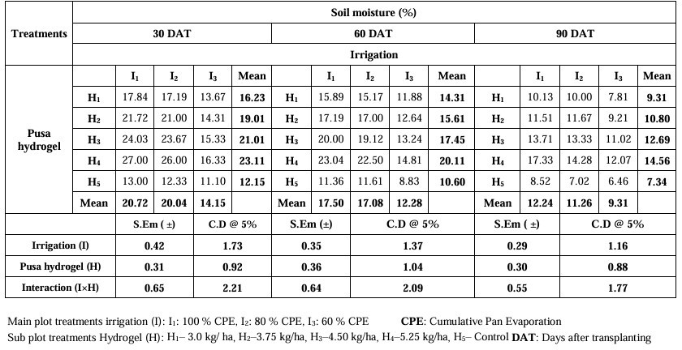

**Table 2. Effect of Pusa hydrogel on soil characteristics under various irrigation intervals**

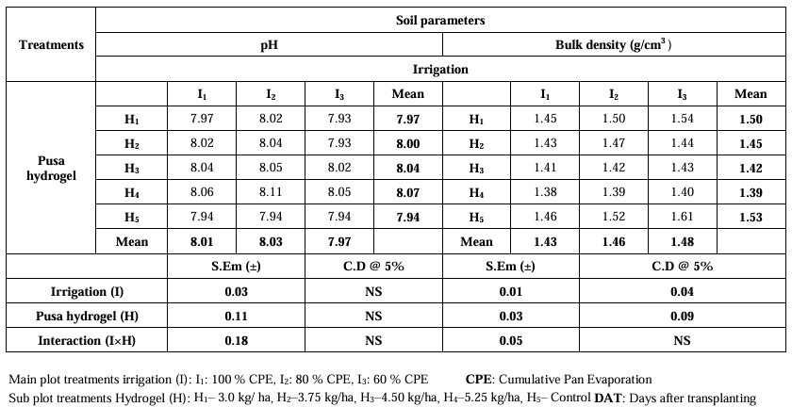

**Table 3. Physiological parameters at various growth stages of marigold as influenced by different levels of irrigation and Pusa hydrogel**

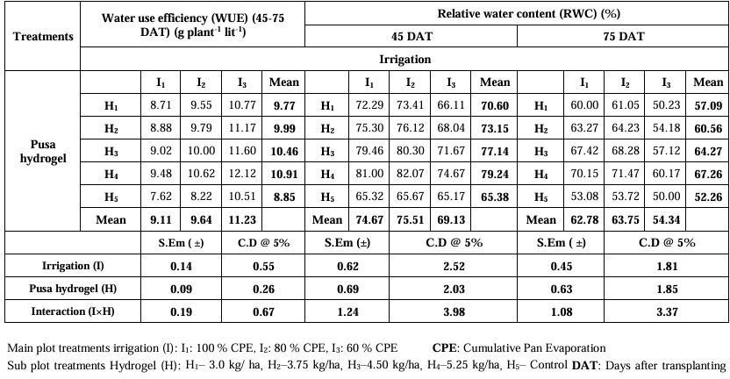

**Table 4. Physiological parameters at various growth stages of marigold as influenced by different levels of irrigation and Pusa hydrogel**

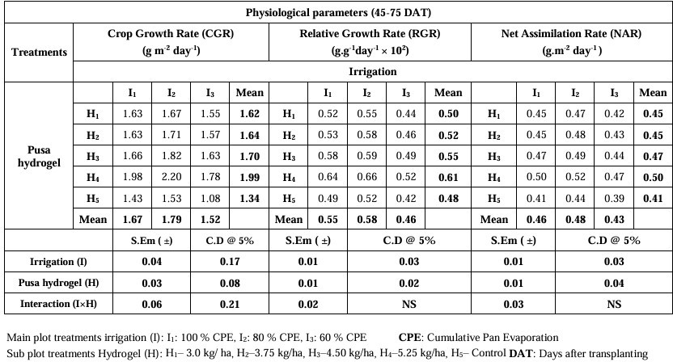

# Summary and Conclusion

Significantly higher moisture content was recorded in soils irrigated with 100 per cent CPE (20.72, 17.50 and 12.24 per cent, respectively) at 30, 60 and 90 DAT, but soils irrigated with the long gap by soils irrigated with 60 per cent CPE (I3) recorded the lowest soil moisture content. Significantly higher moisture content (27.00, 23.04 and 17.33 per cent, respectively) was recorded in soils irrigated with 100 per cent CPE under 5.25 kg/ha hydrogel (I1H4) at 30, 60 and 90 DAT but soils irrigated with the long gap by soils irrigated with 60 per cent CPE and without any hydrogel (I3H5) application recorded the lowest soil moisture content. With respect to high pH (8.03) and bulk density (1.48 g/cm3), maximum was observed at 80 (I2) and 60 (I3) per cent CPE, respectively. Remarkably least pH and BD were observed in 60 (I3) and 100 (I1) per cent, respectively.

The maximum water use efficiency (11.23 g plant-1 lit-1) was observed in the plant irrigated with 60 (I3) per cent CPE at 45-75 DAT. Relative water content was recorded significantly highest in I2: 80 per cent CPE (75.51 and 63.75 per cent, respectively) at 45 and 75 DAT. Maximum values of CGR (1.79 g m-2 day-1), RGR (0.58 g g-1day-1 × 102) and NAR (0.48 g m-2 day-1) obtained in the irrigation schedule at 80 per cent CPE. The maximum water use efficiency (12.12 g plant-1 lit-1) was observed in a plant irrigated with 60 per cent CPE with 5.25kg/ha hydrogel (I3H4) at 45-75 DAT. The least was recorded in the plant treated with 100 per cent CPE without hydrogel (I1H4) application. Irrigation intervals and hydrogel combinedly influence the relative water content of the plant. It was recorded to be significantly highest (82.07 and 71.47 per cent, respectively) in 80 per cent CPE with 5.25 kg/ha hydrogel (I2H4) at 45 and 75 DAT. The least relative water content was noted in the treatment combination of irrigation 60 per cent CPE without hydrogel (I3H5). Crop growth rate (CGR) was also significantly influenced by irrigation schedule and hydrogel level. The maximum value of CGR (2.20 g m-2 day-1) was obtained in the irrigation schedule at 80 per cent CPE with 5.25 kg/ha hydrogel (I2H4). The least value was noted in the treatment combination of irrigation 60 per cent CPE without hydrogel (I3H5). Relative growth rate (RGR) and net assimilation rate (NAR) were found to be non-significant with respect to the treatment combination of different levels of irrigation and hydrogel.

# References:

Afsharmanesh, G., 2009, Study of some morphological traits and selection of drought resistant alfalfa cultivars (Medicago sativa L.) in Jiroft, Iran. *Plant Physiol*., 3: 109-118.

Akhter, J., Mahmood, K., Malik, K.A., Mardan, A., Ahmad, M. and Iqbal, M. M., 2004, Effects of hydrogel amendment on water storage of sandy loam and loam soils and seedling growth of barley, wheat and chickpea. *Plant Soil Environ*., 50(10): 463–469.

Anupama, Singh, M.C., Kumar. R. and Parmar, B.S., 2007, Performance of a new superabsorbent polymer on seedling and post planting growth and water use pattern of chrysanthemum grown under controlled environment. *Acta Hortic*.742:43-49.

Blake, G.R. 1965. Methods of soil analysis, part 1 Physical ana mineralogical properties including statistics of measurement of sampling. *American Society of Agronomy*.9:374-390.

Chaves, M.M., Pereira, J.S., Maroco, J.P., Rodrigues, M.L., Ricardo, C.P., Osorio, M.L., Carvalho, I., Faria, T. and Pinherio, C., 2002, How plants cope with water stress in the field: photosynthesis and growth. Ann. Bot., 89(7): 907-916.

El Hady, O. A. and El Dewiny, C. Y., 2006, The conditioning effect of composts (natural) or/and acrylamid hydrogel (synthesized) on a sandy calcareous soil: Growth response, nutrients uptake, water and fertilizers use efficiency by tomato plants. *Res. J. Appl. Sci*., 2(11): 890- 898.

Goksoy, A. T., Demir, A. O., Turan, Z. M. and Dagustu, N., 2004, Responses of sunflower to limited irrigation at different growth stages. *Filed Crops Res*., 87: 167- 178

Hopkins, W.G., 2004, Introduction to plant physiology (3rd edition). John Wiely and Sons. New York. pp. 557.

Kumar, A.T., Kameswari, P.L. and Girwani, A., 2016, Impact of pusa hydrogel incorporated growing media on floral characters and yield of pot mums (Dendranthema grandiflora L.) under various irrigation regimes. *Int. J. Agri. Sci. Res*., 6:195-200.

Kumar, R., Nadukeri, S., Kolakar, S.S., Hanumanthappa, M., Shivaprasad, M., and Dhananjaya, B.N., 2018, Effect of hydrogel on growth, fresh yield and essential oil content of ginger (Zingiber officinale Rosc.). *Int. J. Phytochem*., 482-485.

Munir, M.J., Nabila, S.K. and Lataifeh, N.K., 2007, Response of croton grown in a zeolite- containing substrate to different concentration of fertilizer solution. *Commun. Soil Sci. Plant Anal*., 35: 2283-2297.

Piper, C. S., 1966, Soil and Plant Analysis. Hands Publishers, Bombay.137-153.

Polisgowdar, B., Nemichandrappa, M. and Satishkumar, U., 2013, Maximisation of flower yield in marigold (Tagetes erecta L.) with precise use of water through drip irrigation, Ph.D. (Agri.) *Thesis*, Univ. Agri. Sci., Raichur (India).

Singh, P.K., Mishra, A.K. and Imtiyaz, M., 1991, Moisture stress and the water use efficiency of mustard. Agric. *Water Manage*., 20(3): 245-253.

Singh, S.M., Anil, S., Sumit, C., Semwal, M.P., Chandra, B., Negi, M.S. and Mahapatra, B.S., 2017, Enhancing water-use efficiency of Indian mustard (Brassica juncea) under deficit and adequate irrigation scheduling with hydrogel. *Int. J. Appl. Agric. Sci*., 15(1):1-4.

Tayel, M.Y. and El Hady, O.A., 1981, Improving sandy soil structure by conditioning. Egypt. J.

*Soil Sci*., 1–11.

Trung, T.N., Joyce, D.C. and Son, Q.D., 2009, Effects of artificial amendments in potting media on Orthosiphon aristatus growth and development. *Sci. Hortic*., 123(1):129-136.

Watson, D.J., 1952, The physiological basis of variation in yield. Adv. *Agron*, 4: 101 145.

Yazdani, F., Allahadadi, I. and Akbari, G. A., 2007, Impact of hydrophilic polymer on yield and growth analysis of soybean (Glycine max L.) under drought stress condition. Pak. *J. Biol. Sci.*, 10(23): 4190-4196.

Kikon, L., Sethi, L. N., & Thong, J. (2024). Effect of Hydrogel on Soil Moisture Dynamics and Crop Growth Inside a Polyhouse in Hill Agro Ecosystem. J. Himalayan Ecol. Sustain. Dev. Vol 19.

Ingrao, C., Strippoli, R., Lagioia, G., & Huisingh, D. (2023). Water scarcity in agriculture: An overview of causes, impacts and approaches for reducing the risks. *Heliyon*, *9*(8).

Tarate, S. B., Patel, N. R., Danodia, A., Pokhariyal, S., & Parida, B. R. (2024). Geospatial technology for sustainable agricultural water management in india—a systematic review. *Geomatics*, *4*(2), 91-123.