***Original Research Article***

**Bio-Effects of *Eucalyptus Globulus* Essential Oil Extract in *Aedes Aegypti* Control**

**ABSTRACT**

*Aedes aegypti* is known widely for its role in transmitting globally significant diseases such as Chikungunya, dengue, Zika virus and yellow fever, hence the need to control them remain a necessity. In recent times, the use of botanical insecticides in the control of mosquitoes have been adopted, due to the development of resistance mechanism in mosquitoes against synthetic insecticides, and also because botanical insecticides pose no threats to human health and the environment. Following this great need, the bio-effects of *Eucalyptus globulus* leaves essential oil at varying concentrations on *Aedes aegypti* was studied. Essential oil from authenticatedfresh samples of *Eucalyptus globulus* leaves were extracted by steam distillation. Bioactive constituents of the oil were analyzed by gas chromatography. The extracted oil taken as 100% concentration was serially diluted to 20%, 10%, 5%, 2.5%, and 1.25% used for larval bioassays and adult repellency tests. Acetone and Odomos® (12% DEET) served as negative and positive controls, respectively. *Aedes aegypti* eggs from National Arbovirus and Vector Research Centre Enugu were reared to 4th instar larvae and adults for the study. Log-probit regression produced LC₅₀ and LT₅₀ while two-way ANOVA indicated significant differences (p<0.05) between mortality and repellency regarding concentrations and exposure times. Bioactive components of the essential oil included ephedrine, tannin, flavonones, Pinene, Anthocyanin, Tannin, eucalyptol and decanal. In-vivo, 1.25% concentration caused 43.8% larval mortality (LC₅₀=2.3%; LT₅₀=9hrs) while 20% concentration caused 100% mortality. There was higher mortality and repellency effects at elevated concentrations. The essential oil of *Eucalyptus globulus* showed larvicidal and adult repellency properties, hence highlighting strong eco-friendly potential for *Aedes aegypti* control.

**Keywords:** *Eucalyptus globulus*, *Aedes aegypti*, essential oil, Bio-effects, control

**INTRODUCTION**

*Aedes aegypti* (Linnaeus) is the primary carrier of deadly mosquito-borne diseases that cause dengue, dengue hemorrhagic fever, yellow fever, chikungunya, Zika virus and this vector is widely spread over large areas of the tropics and subtropics. *Aedes aegypti* can be recognized by a marking in form of a lyre on the upper surface of its thorax and a black and white markings on the legs, they are active and bite only during the daytime, and also, are adapted to urban sites and prefer clean water containers for egg laying and further development [1]. Dengue is endemic in 129 countries and Western Pacific, South-Eastern Asia, Americas are seriously affected regions [2]. There is an effective vaccine for dengue, but it's not widely available yet, the vaccine is called Dengvaxia, and it was developed by Sanofi Pasteur, it was approved for use in several countries in 2016, including Brazil, Mexico, the Philippines, and Singapore. However, it has not yet been approved for use in the United States. Dengvaxia is a live, attenuated vaccine, which means that it contains a weakened form of the virus. The vaccine is given in three doses over the course of one year, while Dengvaxia is an effective vaccine, it has some risks. In attempts to control Aedes aegypti, chemical measures implemented were effective initially but these have failed as their constant use has resulted in resistance among mosquitoes, insect outbreak, environmental pollution and undesirable effects on non-target organisms [3].

Since the advent of DDT, mosquito control approaches have been almost completely based on synthetic organic insecticides and the extensive use of these synthetic organic insecticides has resulted in the development of resistance by the disease vectors as well as constituting environmental hazards in the forms of pollution and leaving of toxic residuals on plants, which pose serious health risks to humans [4]. These drawbacks have necessitated the need for continued and development of new environmentally safe and low cost indigenous methods of vector control which can be used with minimum care by individuals and communities in specific situations. As a result, different measures have been used against the arthropod vector which transmits pathogens, one of these includes the use of botanical insecticides [5]. Botanical insecticides have been used to control *Aedes aegypti* and *Aedes albopictus,* two species of mosquitoes that are vectors of several diseases, including dengue, chikungunya, and Zika [6].

Essential oil has been the active principle of most important herbal remedies since ancient times, the repellency properties of essential oil are well recognized for many years and used in some of the repellent products as active ingredients. Some of the most commonly studied botanical insecticides for control of *Aedes aegypti* and *Aedes* *albopictus* include neem oil, pyrethrins, and essential oils such as *Eucalyptus* oil, lemongrass oil, clove oil, and cedarwood oil [7]. Plant extracts with insecticidal, ovicidal, larvicidal and repellent properties have been tried in recent times for the control of various insect pests and vectors and these are well documented from many parts of the world [8]. *Eucalyptus globulus* essential oil has been shown to be effective in controlling *Aedes aegypti,* possesses the ability to kill the mosquito egg, larvae, pupae and repelling adult mosquitoes. *Eucalyptus globulus* essential oil have also been tested for toxicity and was found to be safe for humans [9].

*Eucalyptus globulus* commonly known as blue gum, is among the most significant plants belonging to the family Myrtaceae possessing more than 700 species. It grows well in different parts of the world and has been known of its rich ethno medicinal and therapeutic importance [10]. The use of botanicals insecticides have been seen to pose a great threat to the arthropod insects. Hence, the evaluation of these botanicals become a matter of importance for the surveillance of mosquito in public health. By this evaluation, cost of production of synthetic insecticides would be saved, also healthy living would be encouraged.

**MATERIALS AND METHODS**

The study was carried out in the Laboratory of the Department of Parasitology and Entomology, Faculty of Biosciences, Nnamdi Azikiwe University, Awka, Anambra State, Nigeria with geographical coordinates of Latitude 6.242889°N and longitude 7.118289°E.

The study was an experimental work involving the evaluation of the efficacy of essential oils extracted from the leaves of *Eucalyptus globulus*, on the Larval and Adult life stages of *Aedes aegypti*. Five different concentrations: 20%, 10%, 5%, 2.5%, 1.25% were used, and each treatment was replicated three times including the control; in a Completely Randomized Design (CRD).

The leaves were identified and authenticated at Botany Department, Nnamdi Azikiwe University, Awka, Nigeria. The essential oil in the sample of *Eucalyptus globulus*, was extracted using steam distillation according to the method of Scott (2005). Each of the prepared samples was loaded into 250ml round bottom flask of Clavenger’s Distillation Apparatus.

**GC-FID ANALYSIS**

The phytochemical constituents of the essential oil was analyzed using the method of Kelly and Nelson (2014). The analysis of bioactive ingredients was performed on a BUCK M910 Gas chromatography equipped with a flame ionization detector. A RESTEK 15 meter MXT-1 column (15m x 250um x 0.15um) was used. The injector temperature was 280°C with splitless injection of 2ul of sample and a linear velocity of 30cms-1. Helium 5.0 pa was the carrier gas with a flow rate of 40ml/min. The oven operated initially at 200°C was heated to 330°C at a rate of 3°C min-1 and was kept at this temperature for 5min. The detector was operated at a temperature of 320°C.

**FORMULATION OF THE LEAF EXTRACTS**

Serial dilutions of the essential oil of the leaves of *Eucalyptus globulus*, were prepared in acetone. The extracts were taken as 100% concentration which were then diluted serially to 20%, 10%, 5%, 2.5%, 1.25% of the extract by adding 16 mls of acetone to 4ml of the extracts, 18ml of acetone to 2ml of the extracts, 19ml of acetone to 1ml of the extracts, 19.5mls of acetone to 0.5ml of the extracts, 19.75ml of acetone to 0.25ml of the extracts using 20ml syringe respectively yielding 200 µg/ml, 100 µg/ml, 50 µg/ml, 25 µg/ml and 12.5 µg/ml.

**SOURCE OF MOSQUITO EGGS AND LARVAE**

Mosquito eggs were obtained and identified as that of *Aedes aegypti* at the Federal Ministry of Health, Department of Public Health National Arbovirus and Vector Research Centre, 33 Park Avenue, G.R.A, Enugu, Nigeria.

**EVALUATION OF THE LARVICIDAL ACTIVITY OF THE PLANT ESSENTIAL OIL EXTRACT**

The methods and procedure used were those adopted by Amakiri *et al*., [11] The different concentrations of the essential oils were obtained from diluting in acetone. Appropriate aliquots 1ml in ml/ml of the essential oil formulations 20%, 10%, 5%, 2.5%, 1.25% OR this 200 µg/ml, 100 µg/ml, 50 µg/ml, 25 µg/ml and 12.5 µg/ml were added in plastic containers containing 200ml of distilled water for the plant essential oils. Twenty cohorts of fourth instar larvae of *Aedes aegypti* were added in each container accordingly. Each treatment and control were replicated three times and each bioassay repeated twice. The bioassay was carried out in the laboratory at measured temperature and humidity with a photo period of 12:12 hr (Light: Dark). Mortality inhibitions of emergence assessments were made after 0, 12, 24, 48 and 72 hr post-exposure period. Dead larvae were counted and recorded and those unable to wriggle (that is moribund larvae) were counted as dead. Correction of the mortality obtained were corrected using Abbot formula (1925).Percentage Mortality= Number of dead larvae /Number of larvae introduced x100.

**EVALUATION OF REPELLENCY EFFECT OF *EUCALYPTUS GLOBULUS* ESSENTIAL OIL**

The standard method used for testing repellency effect was the Arm-in-cage method. The different concentrations were used each for testing repellency activity of the plantoil extracts using synthetic repellent, DEET (*N,N*-diethyl-3-methylbenzamide) as a positive control and acetone as a negative control.

Sixty, non-infected, 5- 7 day old colony bred female *Aedes aegypti* mosquitoes were placed in three cages measuring 50*50*50cm. One cage each for Eucalyptus leave oil, acetone, and DEET. Three adult immunized volunteers (two males and one female) who did not apply any lotion, perfume, oil or scented soap on the day of the bioassay were recruited for the study.

The fore arms of each volunteer from the elbow was washed with unscented soap and rinsed with water, then rinsed with a solution of 70% ethanol in water and dried with a clean towel. 2ml each of the test oil samples and the controls, starting from the lowest concentration were spread evenly over the treatment area (from elbow to the wrists through the tips of the fingers). The treated arm surface was then exposed to the mosquitoes inside the cage. The same caged mosquitoes were used for a particular sample and for a particular person. Sequential exposure to high dosages for 30 minutes were done and timed observations of the reaction of mosquitoes were recorded.

After bioassay of each concentration, the hands were washed and allowed to dry naturally for about a period of 20 minutes before dispensing the subsequent concentrations. The number of mosquitoes that landed, probed and knocked down were counted and recorded for each volunteer. Mosquitoes were shaken off the arm before they imbibed any blood. However, the abdomen of the mosquitoes were examined for presence of blood meal.

**Calculation of Repellency (%)**

The repellency index was calculated according to the formula;

Percentage repellency = $\left[\frac{Ta-Tb}{Ta}\right]x100$

Where, Ta is the number of mosquitoes in control and Tb, the number of mosquitoes in the treated (Lawal *et al.,* 2012).

**STATISTICAL ANALYSIS**

The data were subjected to probit regression analysis according to Finney (1971) for determining LC50 and LC90. The log doses were plotted against the probit values. Analysis of variance was also performed on the mortality data to determine the effect of concentration and time.

**RESULTS**

**Table 1. GC-FID Analysis Result of *Eucalyptus globulus* essential oil.**

Table 1 shows the Phytochemical composition of *Eucalyptus globulus* essential oil. The result revealed the presence of Kaemoferol, pinene, thujene, Limonene, anthocyanin, aphyllidine, dihydrocytisine, decanal, ammodendrine, tannin, nonanal, flavone, ribalinidine, spartein, decanal, terpenene, epihedrine, sapogenine in varying amounts.

| **Component** | **Retention** (**(ug/ml)** |
| --- | --- |
| Kaempferol | 0.280 |
| Pinene | 2.390 |
| Thujene | 4.120 |
| Limonene | 6.016 |
| Anthocyanin | 7.470 |
| Aphyllidine | 10.366 |
| Dihydrocytisine | 12.970 |
| Decanal | 15.460 |
| eucalyptol | 17.966 |
| Ammodendrine | 20.313 |
| Tannin | 22.730 |
| Nonanal | 25.650 |
| Flavonones | 27.536 |
| Flavone | 29.860 |
| Ribalinidine | 32.996 |
| Sparteine | 34.600 |
| Decanal | 36.876 |
| Terpenene | 39.200 |
| Ephedrine | 42.276 |
| Sapogenin | 44.170 |

### **Mortality rate of *Aedes aegypti* larvae after exposure to *Eucalyptus globulus* essential oil extract.**

Mortality rate of *Aedes aegypti* larvae exposed to the toxicity of *Eucalyptus globulus* essential oil at 12 hourly intervals for 72 hours showed that there was a concentration dependent mortality response to the toxicant. At the highest concentration of 20%; mortality was 100%, while at the lowest concentration of 1.25%; mortality was 43.8% as shown in table 2. This showed increase in mortality with increase in concentration.

**Table 2: Mortality response of *Aedes aegypti* larvae exposed to residual application of *Eucalyptus globulus* essential oil at 12 hourly intervals.**

|  |  |  |  |  |  |  |  |
| --- | --- | --- | --- | --- | --- | --- | --- |
| **Concentration**  **(%)** | **12hrs** | **24hrs** | **48hrs** | **72hrs** | **Mean±s.e** | **%**  **Mortality Probit** | |
| **20** | 20 | 20 | 20 | 20 | 20.00±0.00 | 100 | 8.09 |
| **10** | 11 | 17.7 | 18.7 | 18.3 | 18.17±0.21 | 82 | 5.87 |
| **5** | 9.0 | 15.3 | 15.7 | 15.3 | 13.25±1.40 | 69 | 5.43 |
| **2.5** | 6.0 | 11 | 12.3 | 13 | 10.72±0.72 | 52.8 | 5.00 |
| **1.25** | 5.0 | 9.3 | 9.7 | 11 | 8.25±0.98 | 43.8 | 4.76 |
| **Mean±s.e** | 10.00±2.67 | 14.67±2.00 | 15.28±1.93 | 15.52±1.65 |  |  |  |
| **% Mortality** | 51 | 73.3 | 76.4 | 77.6 |  |  |  |
| **Control** | 5 | 4.7 | 6.3 | 7.3 | 5.82±0.60 | 5 |  |
| **Probit** | 4.95 | 5.57 | 5.68 | 5.71 |  |  |  |

Mean of the three replicates (±s.e), Pv=0.000; Pv=0.272

Figure 1 shows the result of LC50 and LC90 of *Eucalyptus globulus* essential oil extract, where the values are 2.3% and 7.6% respectively. In addition, the analysis of variance of the concentrations showed the mean hatchability as a result of concentrations was significantly different (P<0.05, P=0.000) adjusted R-square (Adj R² = .652) further supports this, indicating that professional competence accounts for approximately 65.2% of the variance in students' academic engagement.

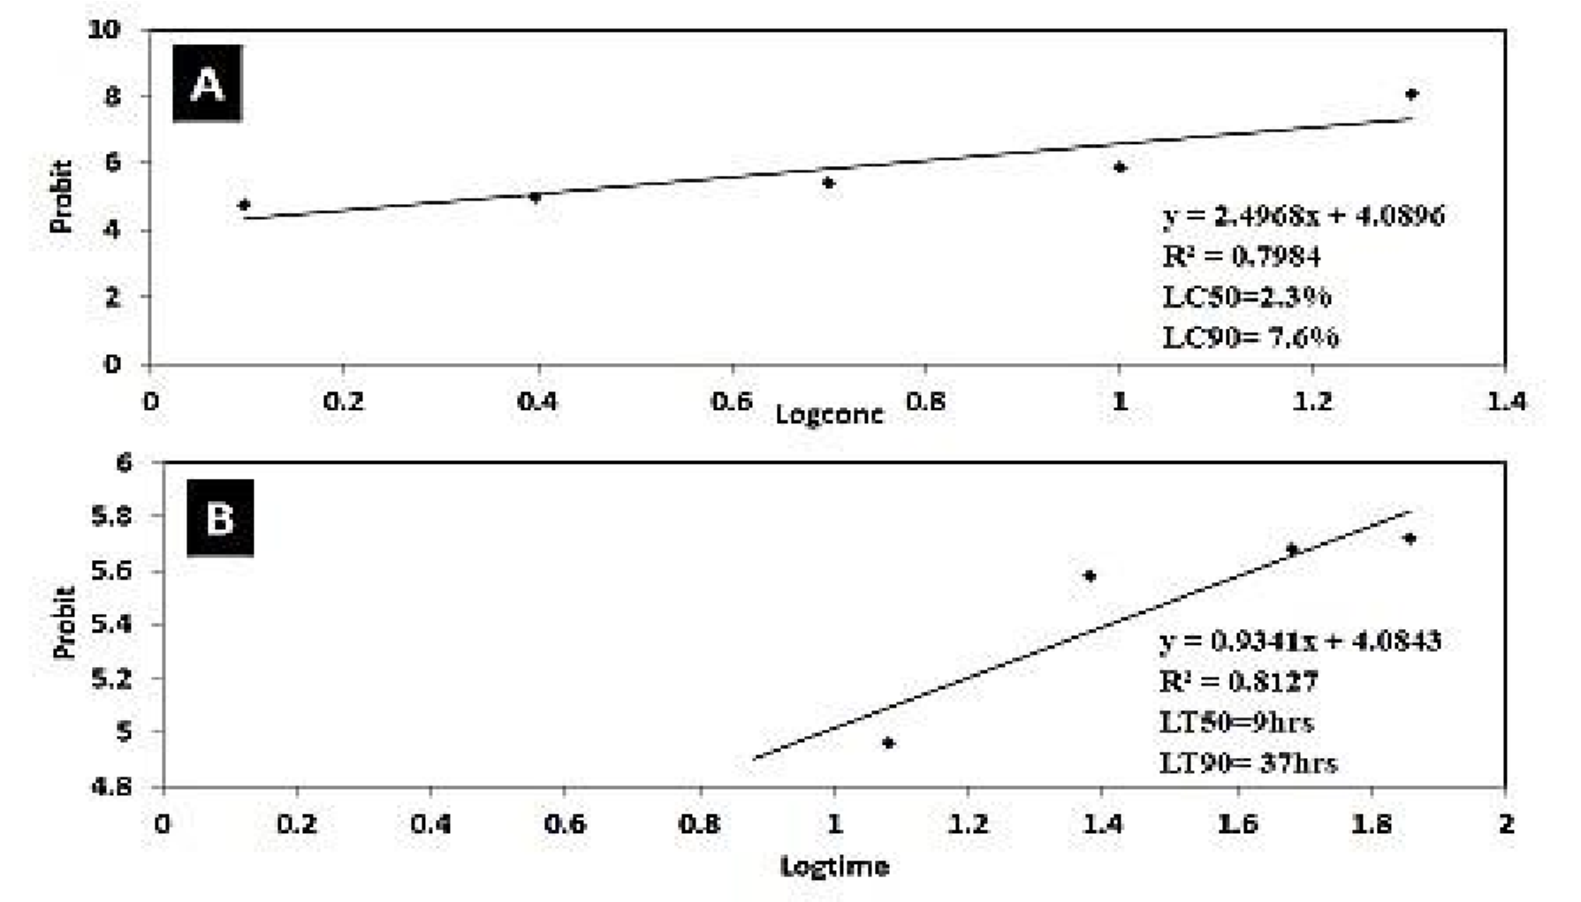

*Figure 1 :[A] Probit against Logconc of Eucalyptus globulus oil extract on Larvae of Aedes aegypti mosquito. [B] Probit against Logtime of Eucalyptus globulus oil extract on Larvae of Aedes aegypti mosquito****.***

### Table 3. Mortality response of *Aedes aegypti* larvae exposed to theextracts of *Eucalyptus globulus* in a simulated field trial

The contact toxicity (Table 3) showed that there was dose dependent mortality response to *E. globulus.* Mortality increased in accordance with increase in concentration of *E. globulus.* The highest doses of *E. globulus* (20%) caused the highest percentage mortalities (77.00%) followed by 10% (75.00%) while least significantly different in the control (0.00%). The statistical analysis showed the mortality of *Aedes aegypti* significantly different among doses (P<0.05). The logprobit regression analysis showed that the LD50 of *E. globulus* was 9.350 % (Figure 2).

The result of 72 hours’ exposure to *E. globulus* to *Aedes aegypti* is presented in Table 3. The result showed increased in mortality with increase in exposure time. At 12-hours mortality increased from 19 % to 29% at 72 hours. There was significant difference in the mortality of *Aedes aegypti* between the various time of exposure (P<0.05). The log-probit regression analysis showed that the LT50 was 66.09 hours (Figure 2).

**Table 3: Mortality response of *Aedes aegypti* larva exposed to extracts of *E. globulus* in a simulated field trial**

|  |  |  |  |  |  |  |  |  |
| --- | --- | --- | --- | --- | --- | --- | --- | --- |
| **Conc** | **12.00** | **24.00** | **48.00** | **72.00** | **Mean±SEM** | **% observed mortality** | **Probit** | **Log conc.** |
| **20** | 12.00 | 13.00 | 12.33 | 15.33 | 13.17±0.44 | 77 | 5.74 | 1.30 |
| **10** | 8.33 | 12.00 | 12.67 | 15.00 | 12.00±0.77 | 75 | 5.67 | 1.00 |
| **5** | 2.33 | 0.00 | 0.00 | 1.67 | 1.00±0.54 | 8 | 3.59 | 0.70 |
| **2.5** | 0.00 | 0.00 | 0.00 | 1.33 | 0.33±0.33 | 7 | 3.52 | 0.40 |
| **1.25** | 0.00 | 0.00 | 0.00 | 1.00 | 0.25±0.25 | 5 | 3.36 | 0.10 |
| **Control** | 0.00 | 0.00 | 0.00 | 0.00 | 0.00±0.00 | 0 |  |  |
| **Mean ±SD** | 3.78±1.16 | 4.17±1.43 | 4.17±1.43 | 5.72±1.67 |  |  |  |  |
| **%mortality** | 19 | 21 | 21 | 29 |  |  |  |  |
| **Probit** | 4.12 | 4.19 | 4.19 | 5.58 |  |  |  |  |
| **Log of** 1.08 1.38 1.68 1.86  **time** | | | | | | | | |

Means of three replicates (±S.e), P-value for the concentration =0.000, P-value for time = 0.000

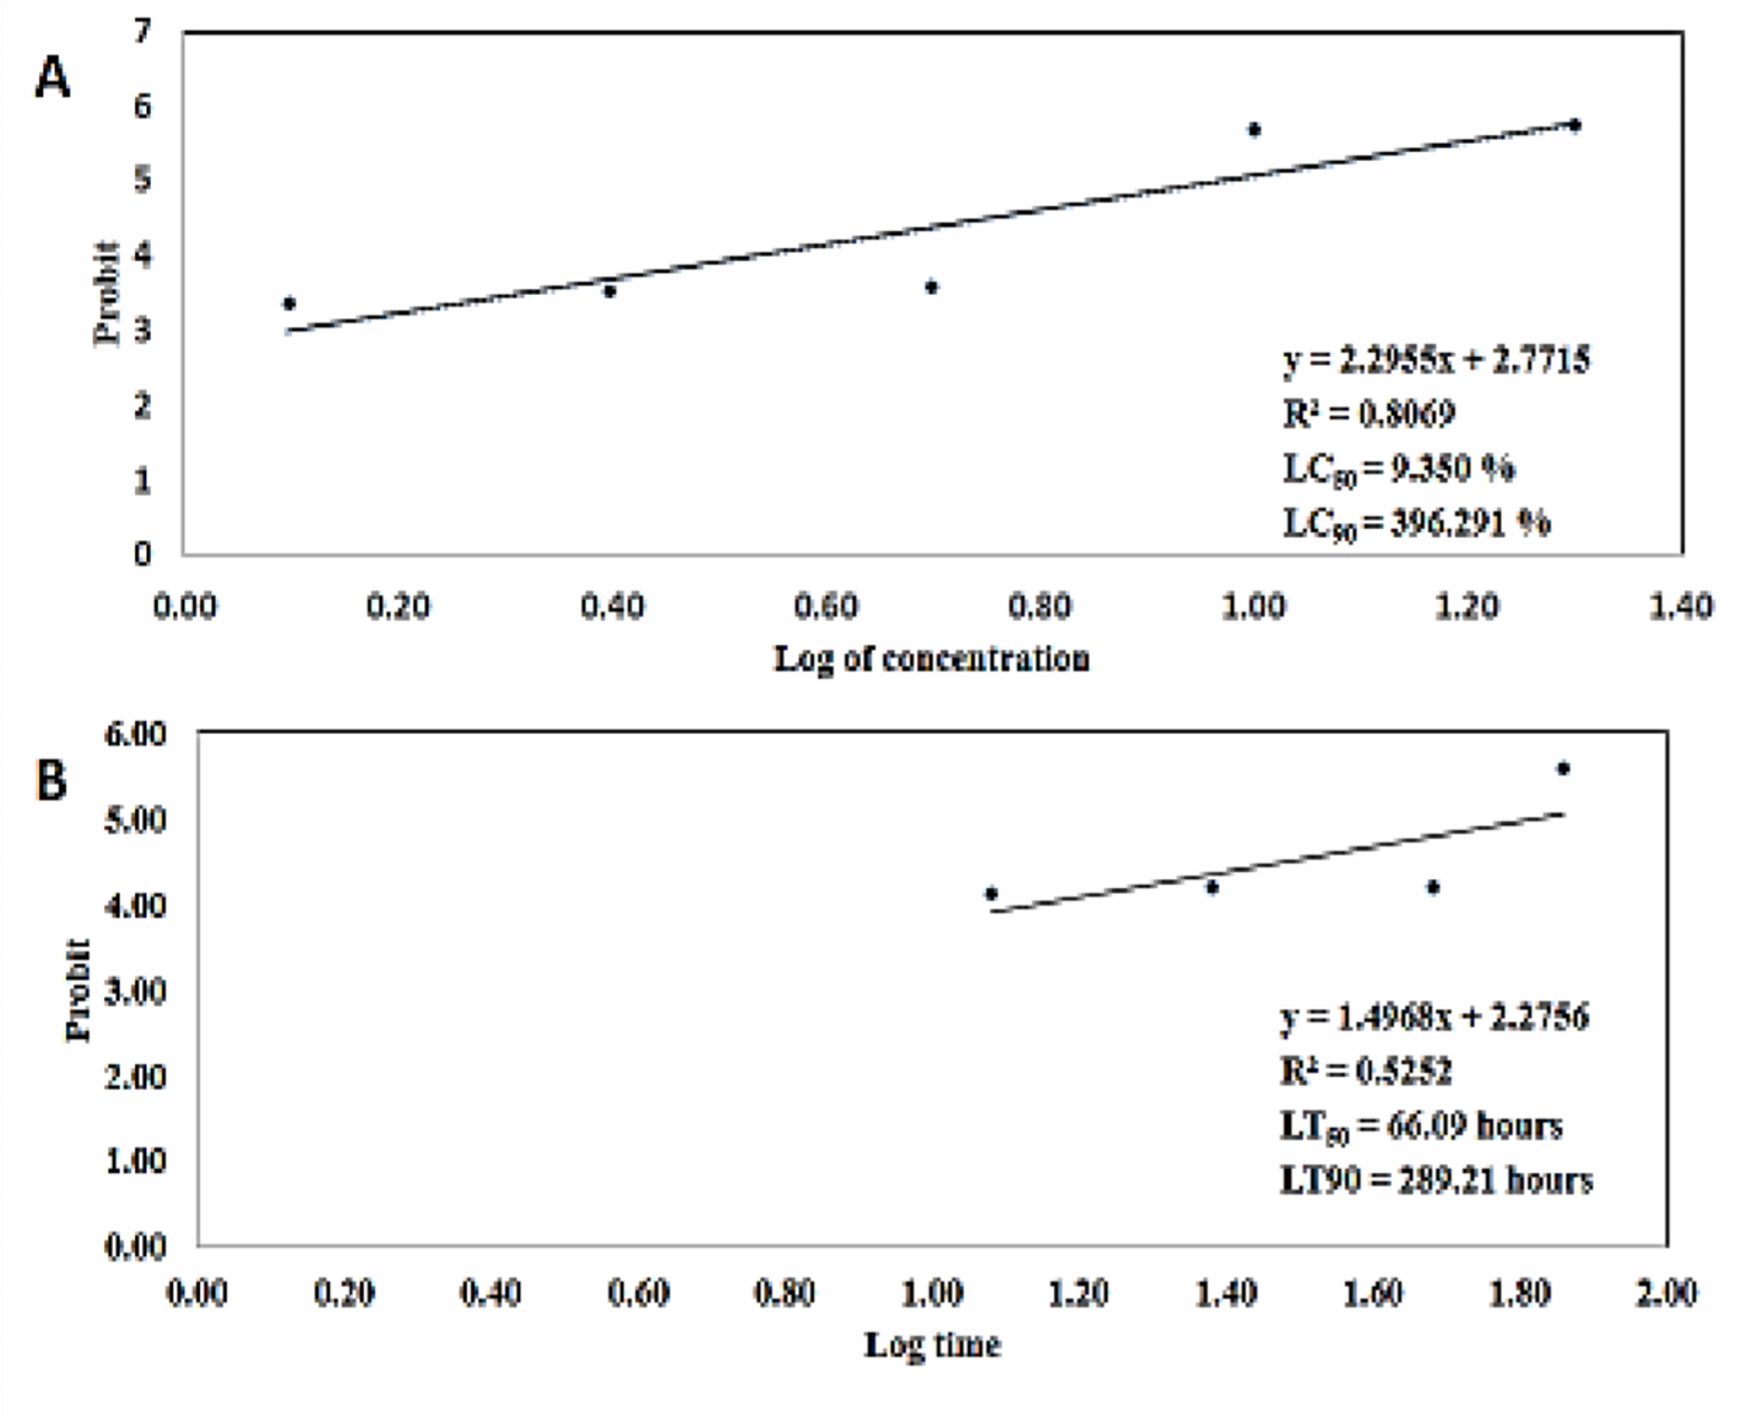

*Figure 2 : [A] Probit against Log of Concentration of Eucalyptus globulus in a simulated field trial. [B] Time versus Probit to show LT50 for Eucalyptus globulus in a simulated field trial.*

**Table 4. Repellency Effect of the Essential Oil of *Eucalyptus globulus* on the adult of *Aedes aegypti.***

At 0 minute, 30 minutes, 60 minutes, 90 minutes, 120 minutes, 150 minutes and 180 minutes, the percentage repellency recorded were 46.7%, 63.3%, 76.7%, 80.0%, and 93.3%, respectively as shown in Table 4. There is significance difference between repellency rate among the different concentrations in relation to exposure time. (Pv=0.037; Pv=0.000).

**Table 4: Repellency effect on *Aedes aegypti* exposed to varying concentrations of *Eucalyptus globulus* oil extract at 30mins intervals**

**Exposure time(mins)**

|  |  |  |  |  |  |  |  |  |
| --- | --- | --- | --- | --- | --- | --- | --- | --- |
| **Conc.(%)** | **0** | **30** | **60** | **90** | **120** | **150** | **180** | **Mean** **%**  **(**±se) **Repellency** |
| **20** | 1.00 | 2.67 | 3.67 | 4.00 | 5.67 | 8.00 | 9.33 | 4.90±1.11 93.3 |
| **10** | 0.67 | 1.67 | 2.67 | 3.67 | 5.00 | 6.67 | 8.00 | 4.05±1.00 80.05 |
| **0.33** | 1.67 | 2.33 | 3.33 | 4.67 | 5.67 | 7.67 |  | 3.67±0.95 76.7 |
| **2.5** | 0.33 | 1.33 | 2.00 | 2.67 | 3.67 | 4.00 | 6.33 | 2.90±0.75 63.3 |
| **1.25** | 0.00 | 0.67 | 1.33 | 2.00 | 2.67 | 3.67 | 4.67 | 2.14±0.63 46.7 |
| **Mean±s.e** | 0.46±0.2 1.60±0.3 2.40±0.4 3.13±0.4 4.34±0.53 5.60±0.8 7.06±0.8 | | | | | | |  |
| **Control%** | 0.00 0.00 0.00 0.33 0.67 1.00 1.33 | | | | | | | 0.48±0.20 14.9 |
| 5.4 13.3 22.0 31.3 42.0 55.4 70.7  **Repellency** | | | | | | | |  |

Mean of the three replicates (±s.e), Pvc =0.009; Pvt=0.000

**DISCUSSION**

This study was focused at increasing our knowledge on how botanical insecticides could be used as an alternative to synthetic insecticides in providing high level control of *Aedes aegypti* without posing risk to humans or contamination of the environment. This study showed that the insecticides of botanical origin have toxic and repellency effects on the larvae and adult stages of *Aedes aegypti*. The result of the phytochemical analysis (GC-FID analysis) showed that *Eucalyptus globulus* essential oil contained important phytochemical constituents. This agreed with Khodes *et al*.,[12] who reported that the major compounds in the essential oil were 1,8-cineole (eucalyptol), alpha-pinene and limonene. The phytochemical analysis of *Eucalyptus globulus* essential oil revealed the presence of Kaemoferol, pinene, thujene, Limonene, eucalyptol, anthocyanin, aphyllidine, dihydrocytisine, decanal, ammodendrine, tannin, nonanal, flavone, ribalinidine, spartein, decanal, terpenene, epihedrine, sapogenine in varying amounts. Similarly, Yunus *et al*., [13], reported that the GC-MS analysis of *Eucalyptus globulus* essential oil revealed the presence of a variety of compounds, including eucalyptol, alpha-pinene, p-cymene, and beta-caryophyllene. The essential oil was found to be effective against *Aedes aegypti* larvae, with LC50 and LC90 values of 2.3% and 7.6%, respectively. The active ingredients in *Eucalyptus globulus* essential oil has variety of uses which includes, anti-inflammatory, antiviral, antibacterial and antioxidant activity [9]. The larval bioassay result showed that at 20% concentration, 100% mortality was recorded compared to 43.8% mortality that was recorded in 1.25% concentration. The result showed that increase in concentration led to increase in mortality of larvae as the exposure time increased, 12hrs exposure of *Aedes aegypti* larvae to *Eucalyptus globulus* essential oil showed a mortality rate of 51% while 72hrs of exposure showed a mortality rate of 77.6%. A mortality above 50% shows that the *Eucalyptus globulus* essential oil exhibited significant mortality rate on the larvae of *Aedes aegypti.* This agreed with Abdullah *et al*.,[14] who reported that the rate of mortality increased with an increase in concentration of the plant origin as well as increase in time. It was observed from the study that the longer the exposure time, there was a significant increase in mortality. From the larval bioassay result, the *Eucalyptus globulus* essential oil had an LC50 value of 2.3%, indicating that it requires 2.3% of the *Eucalyptus globulus* essential oil to cause 50% mortality of the fourth instar larvae of *Aedes aegypti.* The LC90, of the *Eucalyptus globulus* essential oil was 7.6%, indicating that it requires 7.6% of the *Eucalyptus globulus* essential oil to cause 90% mortality of the fourth instar larvae of *Aedes aegypti.* This was consistent with the work carried out by Zarif *et al*.,  [14] which showed that *Eucalyptus globulus* essential oil has a great Larvicidal effect against *Aedes aegypti*. Similarly, in the study carried out by Zarif *et al*., [15] where the toxic effect of *Eucalyptus globulus* essential oil was tested on *Aedes aegypti* larvae*,* the result recorded an increase in the rate of mortality with increased time of exposure. From the larval bioassay result, the LT50 of the *Eucalyptus globulus* essential oil was 9 hours, indicating that at 9 hours, 50% mortality of the larvae was recorded. The LT90 of the *Eucalyptus globulus* essential oil was 37 hours, indicating that at 37 hours, 90% mortality of the larvae was recorded. Also, during the treatment of *Aedes aegypti* with the *Eucalyptus globulus* essential oil, no further ova and larval development was recorded. Therefore, there was no larval and pupal formation respectively. This was consistent with the work carried out by Muthuraaj *et al*., [16] on testing the Ovicidal and Larvicidal effect of *Eucalyptus globulus* essential oil against *Aedes aegypti.* *Eucalyptus globulus* essential had varying degree of repellency against adult *Aedes aegypti*. Repellency was dose-dependent and decreased with reduction in concentration of essential oil. Thus, at the highest concentration of 20%, we observed a mean repellency of 4.90±1.11 93.3, indicating that *Eucalyptus globulus* may be very effective in the control of *Aedes* *aegypti*. The *Eucalyptus globulus* essential oil tested in this study showed effective Larvicidal and repellent properties against *Aedes aegypti* and inhibited adult emergence at very low concentrations. It can be prepared and applied at their breeding sites, repeated applications over a period of time would ensure better and total eradication of the larvae of *Aedes* aegypti, the level of its effectiveness shows that higher concentration is paramount to achieve mortality [18]. The ability of *Eucalyptus globulus* essential oil to cause mortality to the larvae of *Aedes aegypti* shows the possibility of their usage as alternatives to synthetic insecticides in the control of *Aedes aegypti*. [19]

**CONCLUSION**

The *Eucalyptus globulus* essential oil tested in this study showed effective Larvicidal and repellent properties against *Aedes aegypti* and inhibited adult emergence at very low concentrations. It can be prepared and applied at their breeding sites, repeated applications over a period of time would ensure better and total eradication of the egg and larvae of *Aedes aegypti*, the level of its effectiveness shows that higher concentration is paramount to achieve mortality. The ability of *Eucalyptus globulus* essential oil to cause mortality to the larvae of *Aedes aegypti* and repel the adult stage shows the possibility of their usage as alternatives to synthetic insecticides in the control of *Aedes aegypti*. The use of these plant extracts to a large extent reduces the rate of dependence on synthetic insecticides which can be expensive and as such not readily available. It also reduces the high level of resistance that has been developed by mosquitoes against synthetic insecticides.

Disclaimer (Artificial intelligence)

Option 1: Author(s) hereby declare that NO generative AI technologies such as Large Language Models (ChatGPT, manuscript.

**Ethical Approval:** The authors declare that they obtained ethical approval for this research from the Anambra State Ministry of Health.

**REFERENCES**

1. Lindsay, S. W., Wilson, A., Golding, N., Scott, T. W., & Takken, W. (2017). Improving the built environment in urban areas to control Aedes aegypti borne diseases. Bulletin of the World Health Organization, **95**(8),607–608. https://doi.org/10.2471/BLT.16.189688

2. Pessoa, Z. L., Duarte, J. L., Ferreira, R. M., Oliveira, A. E., & Cruz, R. A. (2018). Nanosuspension of quercetin: preparation, characterization and effects against Aedes aegypti larvae. Revista Brasileira de Farmacognosia, **28**, 618–625. <https://doi.org/10.1016/j.bjp.2018.07.003>

3. Antwi, F. B., & Reddy, G. V. (2017). Toxicological effects of pyrethroids on non target aquatic insects. Environmental Toxicology and Pharmacology, **40**, 915–923. https://www.sciencedirect.com/science/article/pii/S1382668915301010

4. Krikoryan, A., Kaul, S. K., Stein, A., Dagnelie, P., Khalsa, B., Scales, T. A., & Kilpatrick, A. M. (2022). Remote sensing based approaches for monitoring Aedes aegypti: a systematic review. Applied Geomatics, **16**, 166–183. (Full text not freely available—please access via your institution or contact authors.) (scholar.google.com)

5. Sang, J., Wang, F., & Wu, W. (2022). Integrated control strategies for Aedes aegypti mosquitoes: old solutions and new challenges. Journal of Medical Entomology, **59**(5), 1275–1288.

6. Singh, S., Prakash, J., Zaffar, S. A., Farooqi, S. S., & Hussain, M. I. (2022). Botanical insecticides for control of Aedes aegypti and Aedes albopictus: a review. Malaria Journal, **21**(1), 54. https://malariajournal.biomedcentral.com/articles/10.1186/s12936-022-04320-5

7. Brady, G., Origan, M. C., Nene, V., Hogg, P., & Ritchie, S. A. (2022). Repellent and oviposition deterrent activity of Monarda fistulosa essential oil against Aedes aegypti and Aedes albopictus. International Journal of Mosquito Research, **20**(22), 1–20.

8. Oliveira, A. E., Duarte, J. L., Cruz, R. A., Souto, R. N., & Ferreira, R. (2017). Pterodon emarginatus oleoresin based nanoemulsion: promising tool for Culex quinquefasciatus control. Journal of Nanobiotechnology, **15**, 2. https://doi.org/10.1186/s12951-016-0234-5

9. Patricio, A., Méndez, V. G., Pulgarín, A. M., Morales, A., & Julio, L. (2022). Efficacy of Eucalyptus globulus essential oil as mosquito larvicidal and repellent. Vector-Borne Diseases, **53**(4), 401–408.

10. Bachheti, R. (2015). Chemical composition and antibacterial activity of the essential oil from the leaves of Eucalyptus globulus collected from Haramaya University, Ethiopia. Der Pharma Chemica, **7**(2), 209–214.

11. Amakiri, P. C., Nwankwo, E. N., Amakiri, A. C., Egbuche, M. C., Osuagwu, I. F., Izunna, S. O., Offor, V., & Acha, C. T. (2019). Phytochemical analysis and toxicity of Annona muricata stem bark and leaf extracts on Anopheles gambiae larvae. Journal of Parasitic Diseases and Diagnostic Therapy, 5, 7.

12. Khodes, H., Sharifnia, F., Dadashi, S., Jadid, N., & Rezaei, B. (2023). GC FID analysis and biomarker compounds of Eucalyptus globulus Labill. essential oil. International Journal of Herbal Medicine, **9**(1), 1–8.

13. Yunus, H. M., Othman, K. H., Abdullah, A. I., Zulkefly, Z., Nazarian, J., Nurul, I. A., & Mutalib, A. R. (2023). Analysis of chemical compounds of Eucalyptus globulus essential oil by GC MS and its effects on fourth instar larvae of Aedes aegypti. International Journal of Chemical Studies, **7**(1), 319–329.

14. Abdullah, A., Nordin, R. M., Rohan, N. S., Mohamad, M. R., & Mahmood, N. (2023). Developmental toxicity of Eucalyptus globulus essential oil against Aedes aegypti. International Journal of Sciences: Basic and Applied Research, **69**(1), 1320–1330.

15. Zarif, M. S., Sharif, N. M., Bakir, S. M., Noor, A. A., Ahmad, S. N., Mahfuz, N. F., Abdullah, F. S., & Idris, A. S. (2023). Toxicity of essential oils against Aedes aegypti larvae (Diptera: Culicidae). Journal of Entomology and Zoology Studies, **11**(1), 512–517.

16. Muthuraaj, M., Karuppayah, K., Ahmad, N., & Halim, F. A. (2023). Larvicidal, pupicidal, ovicidal and repellent activity of Eucalyptus globulus essential oil on Aedes aegypti. Parasitology Research, **122**(4), 1411–1420.

17. Ngongo-Kapenga, J., Kwete, S. M., Yefile-Mposhi, S., Kalonji-Mbangila, A., Mulumba-Badibanga, G., Ngombo-Nzokwani, A., Kalonji-Kabemba, N., Kalala, B. K., Kalonji-Mbuyi, A., & Muengula-Manyi, M. (2021). (2021). Use of essential oil of Eucalyptus globulus leaves against Sitophilus zeamais Motsch. Asian Journal of Biology, **10**(4), 74–82. https://doi.org/10.9734/ajob/2020/v10i430127

18. Ebadollahi, A., Naseri, B., Abedi, Z., Setzer, W. N., & Changbunjong, T. (2022). Promising insecticidal efficiency of essential oils from four cultivated Eucalyptus species in Iran against Rhyzopertha dominica. Insects, **13**(6), 517. https://doi.org/10.3390/insects13060517