**Bio-efficacy of entomopathogenic nematode, *Heterorhabditis bacteriophora* infecting termite (*Odontotermis obesus*** **Rambur) under field condition**

**Abstract**

Field efficacy of entomopathogenic nematodes (EPNs), *Heterorhabditis* *bacteriophora* were evaluated to ensure the feasibility of native isolate of entomopathogenic nematode to be used in the bio-control of termite (*Odontotermes obesus*) infestation. EPNs were applied as a soil drenching method at two different doses up to three times of application on termite mound. Results revealed that *H.bacteriophora* were able to infect *O.obesus* and cause mortality up to 58.30% within the mound. The Per cent mortality *O. obesus* were highest with *H.bacteriophora* at 5.0×109 IJs/mound, three time application at one month interval. *H.bacteriophora* successfully penetrated and reproduced well in both workers and soldiers of *O.obesus* in all the treatments. After one month of last application of nematode, persistence was better as shown by the mortality of *Galleria mellonella* larvae (5.2-43.8%).

*Key words:* Termite (*Odontotermes obesus*), entomopathogenic nematodes (EPNs), *Heterorhabditis* *bacteriophora,* infestation, bioefficacy, soil drenching.

**Introduction**

Termites are a group of social insects belong to the order Isoptera. These insects are found throughout the world (Eggleton, 2000). “Out of around 2600 species, 70-80 species are of economic importance as pests in agriculture” (Traniello & Leuthold, 2000; Krishna and Grimaldi, 2003). “Termite colonies consist of three principal castes: workers (pseudergates), soldiers, and reproductive (king, queen, alates or swarmers)”(Potter, 2011). “A termite mound is the general form of termite nest. The major mound-building species in India are *Odontotermes obesus*, *O. redemanni*, *O. wallonensis,* and *Microtermes obesi”* (Chhillar *et al*., 2006; [Paul](https://www.researchgate.net/profile/Bishwajeet-Paul?_tp=eyJjb250ZXh0Ijp7ImZpcnN0UGFnZSI6InB1YmxpY2F0aW9uIiwicGFnZSI6InB1YmxpY2F0aW9uIn19) *et al*.,2018). “*Odontotermes* *obesus* Rambur (Blattodea: Termitidae) build both subterranean and epigeal nests. Due to feeding habits, the worker causes the extensive damage resulting into major economic losses in tropical and subtropical areas by devastating agricultural crops, forestry and wooden structures in houses” (Sindhu *et al*., 2011). “Economic losses due to termite in India have been projected around 35.12 million US$” (Joshi et al. 2005); “Severe losses in different regions of India have been estimated on highly susceptible crops such as wheat and sugarcane in North India; maize, groundnuts, and sunflower in South India; cotton in Western India; and tea in Northeast India” (Das, 1965; Roonwal, 1979; Choudhury, 1999; Rajagopal, 2002; Roy *et al*.,2020).

“In general termite control practices are focused on total abolition of termite population rather than managing or sustaining their population. Most common methods for controlling these termites are the application of chemical insecticides (termiticides)” (Su and Scheffrahn, 1990; Woodrow *et al.,*2006). “However, other methods viz., queen removal, breaking up termite galleries, crop rotation, and application of wood ash or burning with straw, application of plant insecticides are also followed. Due to increasing alarms about the side effects of chemical insecticides, there has been great awareness in using other methods, especially biological control” (Grace, 2003; Grace *et al*., 2009). “Biocontrol agents like predators, parasitoids and pathogens have been tested to suppress termite populations” (Sindhu *et al*., 2011). “The reproductives and nymphs of subterranean termites are concentrated in nests near or below ground level” (Potter, 2011), “and are out of reach of predators, parasitoids and pathogens. Entomopathogenic nematodes (EPNs), *Steinernema* spp. and *Heterorhabditis* spp. can be applied as a bio-control agent against termite colonies” (Fujii, 1975; Poinar 1979; Georgis & Poinar , 1982; Georgis *et al.,*1982; Epsky and Capinera 1988; Wang *et al*., 2002; Yu *et al*., 2006; Hiranwrongwera *et al.,* 2007; El-Bassiouny & Randa, 2011; Al-Zaidawi *et al*.,2020; Javed *et al*., 2021; Aslam *et* *al*., 2023; Gutema *et al*., 2025). “These EPNs have been recognized as potential bio-control agent against most of the soil dwelling pests” (Poinar, 1975; Burnell and Stock, 2000; Tarasco *et* *al*.,2023). “The infective juveniles (IJs) of EPNs are soil dwelling and obligate parasites of insects” (Kaya and Gaugler, 1993). “Once IJs locate a possible host in the soil environment, they enter the host hemolymph through natural openings such as mouth, anus, and spiracle or directly through the integument” (Lewis *et al*., 2006). “Having penetrated the host, the nematodes release the bacteria (*Xenorhabdus* spp. in *Steinernema* spp. and *Photorhabdus* spp. in *Heterorhabditis* spp.) into the host hemolymph that cause septicemia and death of the insect. The nematode feeds on the proliferating bacteria and two or three cycles of reproduction occur in the host prior to emergence of infective stages” (Adams *et al*., 2006). “Apart from being environmentally safe, the use of EPN in pest control in general, and in termite control in particular, is rapid, sustainable, cost effective, and easy to apply. Moreover, IJs can find host actively or passively and are compatible with many pesticides” (Smart, 1995). “Termites live and forage in habitats that are moist, cool, and without direct sunlight. These environmental conditions are ideal for the survival and movement of EPNs, and, therefore, provide the basis for the interest in their role in control of termites” (Chouvenc *et al*., 2011). “The first report on use of nematodes was proposed by Tamashiro (1968) at Hawai and thereafter, many other researchers pursued this approach. Fujii (1975) observed 96 % mortality of *C. formosanus* under laboratory condition within 7 days of treatment with *Steinernema carpocapsae*. Yu *et al*.,(2006) observed the potential efficacy of *Steinernema riobrave*, *S. carpocapsae*, *S. feltiae*, and *Heterorhabditis bacteriophora* against *Heterotermes* *aureus*, *Gnathamitermes perplexus* and *Reticulitermes flavipes* in laboratory sand experiments. Mortality of workers of *H. aureus* by *S. riobrave* depends significantly on the concentration of nematodes and the time of incubation as infection rate is highest in sand. *In vitro* screening of *H.bacteriophora* at 100 IJs reported more than 50% mortality of *O.obesus* after 48h of application” (Devi *et al*., 2018). “Certain species of nematodes although effective in laboratory control is often quite variable under field conditions” (Wu *et al*.,1991; Wang *et al*., 2002). “Soil moisture and soil type appear to limit the nematode’s ability to move in the soil and locate termites” (Poinar and Georgis, 1989; Michael, 2005). “Only a limited number of field studies have been conducted using EPNs as control agents for termites” (Murugan and  Vasugi, 2011; Mohan *et al*.,2016; Rathour *et al*.,2017; Wagutu *et al*.,2017). Therefore, the field study was conducted to determine the efficacy of native EPN species, *Heterorhabditis bacteriophora* under biologically relevant concentrations against termite, *O.obesus*.

**Materials and Method**

**Source of Entomopathogenic nematodes**

EPN, *H. bacteriophora* previously recovered from the District Majuli were used in this study (Devi *et al*.,2016).The EPNs were reared *in vivo* on the last instar larvae of *Galleria mellonella* (Lepidoptera: Pyralidae) under laboratory conditions. The larvae of *G.mellonella* were obtained from the Department of Entomology, AAU, Jorhat. The last larval stage of this insect was used to maintain and propagate the nematodes throughout the entire period of time in this study. *G.mellonella* were multiplied in glass jars at 28± 2oC, 60% RH, with an artificial diet described by Metwally *et al*., (2012). The harvested IJs were kept at 10-12°C for experiments for less than a week before they were applied in the experiment. Before use, they were allowed to warm up to room temperature (25 ±1°C) for 2 h (Woodring and Kaya,1998). Also, their viability for motion was confirmed using dissected microscope.

**Field trial**

The field trials were conducted to evaluate the efficacy of *H.bacteriophora* during 2022-2023 in various agricultural fields covering horticultural as well as field crops under the District Jorhat. Jorhat district covers an area of 285100 hectares in Assam, lies between 26.20" and 27 10.30" north latitude and 93.39" and 94 36.30" east longitudes, at an altitude of 86.8 m above mean sea level. The district falls under subtropical climatic condition with warm humid summer and cool dry winter with mean annual rainfall of 2029 mm. The average maximum temperature is 42°C and minimum temperature is 8°C. On an average, the relative humidity is more than 80% throughout the year. The agricultural fields were naturally infected with the termite pest (*Odontotermis obesus* Rambur).No natural colonization of the termite nests by EPN was detected after baiting (*G. mellonella*) soil samples from the nests. Experiments were performed on *O.obesus* with mounds or a central nest structure. In preliminary assays, it was observed that *O.obesus* colonies were able to reconstruct an aboveground nest within one month after its demolition. So, the aboveground nests were first pull downed before the application of treatment regardless of the nest size. *H. bacteriophora* were used in the field trials carried out in the rainy season. Treatment (EPN) was applied over the demolished surface. Six treatments were compared: T1:2.5×109IJs/mound (One time application), T2:2.5×109 IJs/mound (Two times , one month interval) , T3:2.5×109 IJs/mound (Three times, one month interval) , T4:5.0×109 IJs/mound (One time application) , T5:5.0×109 IJs/mound (Two times ,one month interval) , T6:5.0×109 IJs/mound (Three times, one month interval) and (T7) untreated control. The nematodes were applied with different doses using a manual sprayer as a soil drench. Sterilized water alone was added to the untreated control. The trial was conducted in a randomized complete block design with three replications. Soil drenching was done with the required dose of EPNs after employing cold weather practices as described in the Field management manual of Tea Research Association.

Three parameters *viz*. Mortality of different life stages of termites, Progeny production of nematode inside their host, nematode persistence in the nests were recorded.

**Mortality of different life stages of termites**

Seven days after application of last treatment, the top nests made by *O.obesus* were broken to collect the dead insects. Samples of 250 g each were collected from four corners as well as from the middle of the nest. Samples were collected in plastic containers, mixed properly, and transferred to the laboratory. From the mixer, 250g of samples were taken for observation. Dead individuals of worker and soldiers were separated and counted. Dead insects were dissected for presence of nematodes.

**Progeny production of nematode inside their host**

To assess progeny production, the dead insects were rinsed and transferred to White traps in 2.2-cm diam. plates lined with a filter paper, individually and incubated at room temperature (25±1°C) for 10 days. The total number of emerging IJs from each insect was determined.

**Nematode persistence**

Nematode persistencein the nest area was assessed by randomly taking soil samples composed of 3 cores (0-15 cm depth) from each treated nest 30 days after last treatment (application). The three soil core samples were individually baited with 10 last instar *G. mellonella* larvae and kept at room temperature (25±1°C) for one week. Then, dead larvae (%) were recorded daily from the fifth day to the seventh. Cadavers were dissected to confirm EPN infection.

**Statistical analysis**

Prior to analysis, all data were corrected for the mortality rate of the control group using Abbott’s formula (Abbott, 1925; Fleming and Retnakam, 1985). To stabilize the variance of means, mortality percentages were arcsine transformed and subjected to one way ANOVA (OPSTAT) to test for significant differences among treatment means (Sheoran *et al*.,1998). The 5% level of probability was used in all statistical tests.

**Results and Discussion**

From the results (Table 1. Fig.1), it was observed that *H.bacteriophora* caused a significant mortality of *O.obesus*. Insect mortality was found to be increased with increasing doses and frequency of application. There was a significant difference with other treatments in mean mortality (58.3%) of *O.obesus* when application was done three times at higher dose (5.0×109 IJs/mound). Significant difference was observed in the treatments for the mortality of workers (9.1-32.6%) as well as soldiers (7.1-24.4%) of *O.obesus*. High virulence and ability to search and locate host in cryptic habitats of the EPN isolate is one important characteristic required for the successful biological control of a pest. The native isolate *H.bacteriophora* is having all the characteristics against termite. Wilson-Rich *et al*., (2007) showed that *S.carpocapsae* cause dose dependent mortality of the dampwood termite (*Zootermopsis angusticollis*). In Sri Lanka the live wood tea termite, *Glyptotermes dilatatus* was successfully controlled by *Heterorhabditis* sp within 2-3 months in tea plantations (Danthanarayana and Vitarana,1987). Lenz *et al*., (2000) eliminated *Neotermes* sp. colonies through the use of nematodes and fungal pathogens from coconut palms, citrus and mahogany trees. Epsky and Capinera,(1988) reported that the foraging workers of *Reticulitermes tibialis* was capable of escaping contact with *Steinernema feltiae*, therefore entire colony should be treated at the rate of 1x107 per m2 directly beneath baited traps to the soil rather than feeding sites. Rathour *et al*., (2014) evaluated *S.thermophilum* based formulation ‘PusaNemagel’ for the management of *O. obesus* in wheat and pearl millet in India. The results showed that a single dose of nematode formulation could reduce the termite incidence in wheat and pearl millet by 48-78% and 44%, respectively. Weeks and Baker (2004) and Yu *et al.,*(2008) evaluated the differences in survivability, detectability and ability of *S. carpocapsae* and *H. bacteriophora* to kill *Heterotermes aureus*. *S. riobrave* (TP) caused 75% and 91% mortality in *R. flavipes* and *C. formosanus ,* respectively under laboratory condition (Yu *et al*., 2010). Wu *et al.,*(1991) attempted to control *Coptotermes formosanus* with *S. feltiae* in large field colonies. Manzoor (2012) reported synergism between imidacloprid and *S. carpocapsae* and *H. bacteriophora* that caused more than 50 % mortality of workers and nymphs of *R. flavipes* . Amarasinghe and Hominick (1993) reported that higher doses of *S. carpocapsae* and *S. feltiae* showed promising control of live-wood termite *Postelectrotermes militaris* in tea plantations. Studies indicate that colonies of *Neotermes* attacking in the South Pacific Islands can be eliminated using *Heterorhabditis* sp. from palms and other trees (Dolinski and Lacey, 2007).

**Table 1. Mortality (%) of workers and soldiers of *Odontotermes obesus* at different doses of application of *Heterorhabditis bacteriophora***

|  |  |  |  |
| --- | --- | --- | --- |
| **Treatments** | **Observations (Av. of 3 replications)** | | |
| Mortality (%) of caste of termites | | |
| Worker | Soldier | Total |
| T1:2.5×109 IJs/mound  ( One time application) | 9.1  (17.52)e | 7.1  (15.47)e | 16.6  (24.04)e |
| T2:2.5×109 IJs/mound  ( Two times , one month interval) | 11.2  (19.55)de | 9.1  (17.58)de | 20.8  (27.12)de |
| T3:2.5×109 IJs/mound  ( Three times ,one month interval) | 14.2  (22.17)cd | 10.2  (18.56)cd | 24.9  (29.95)d |
| T4:5.0×109 IJs/mound  ( One time application) | 18.3  (25.28)c | 13.2  (21.34)c | 32.2  (34.6)c |
| T5:5.0×109 IJs/mound  ( Two times ,one month interval) | 24.4  (29.64)b | 17.3  (24.52)b | 42.7  (40.78)b |
| T6:5.0×109 IJs/mound  ( Three times ,one month interval) | 32.6  (34.82)a | 24.4  (29.6)a | 58.3  (49.81)a |
| T7: Control | 2.0  (8.13)f | 2.0  (8.13)f | 4.0  (11.53)f |
| CD(0.05) | (3.40) | (2.86) | (4.17) |

Perusal of data from the Table 2 and Fig 2 , it was observed that, *H.bacteriophora* reproduced well in workers and soldiers of *O.obesus.* The level of progeny production did not varied significantly between doses. However, it was found to be higher progeny production of *H.bacteriophora* (1280 - 1590) at higher dose (5.0×109 IJs/mound) with three time application. The larger size of either worker or soldiers of *O.obesus* enabled the higher number of IJ /insect whereas the small soldiers and workers of *O.obesus* produced the fewest number of IJ /insect. This is in agreement with findings of Blinova and Ivanova (1987) and Flanders *et al.* (1996), who demonstrated that IJ yield is proportional to host size. *H.bacteriophora* penetrated and successfully established in soldiers as well as workers. Progeny production or multiplication is an essential character for EPN populations to increase their chance for getting established in the insect environment (Phan *et al.*, 2005; Griffin , 2012) . In samples collected at 30 days after last application of EPNs, baiting was done and mortality of *G.mellonella* larvae (5.2-43.8%) was observed . Mortality of *G.mellonella* larvae was due to the presence of *H.bacteriophora* in soil samples (Table 2). Koppenhofer *et al*., (1997) and Susurluk and Ehlers, (2008) stated that the number of infected larvae found by sampling was related to the number of nematodes that were present in the soil after application of nematodes. One of the most important factors for sustainable biological control is their successful establishment in the soil, infectivity against pest insects, reproductive potential and persistence in released areas. Entomopathogenic nematodes also differ in their abilities to survive different environmental conditions (Baimey *et al*., 2015). Successful nematode establishment in the larvae implies a potential for recycling of EPNs in the host environment, thereby enhancing the control potential (Bedding & Stanfield, 1981; Mankowski *et al*., 2007).

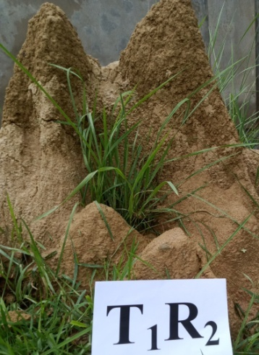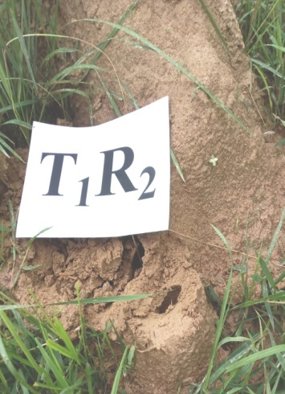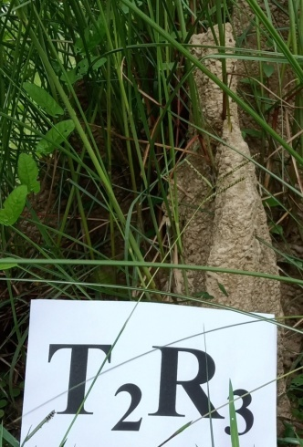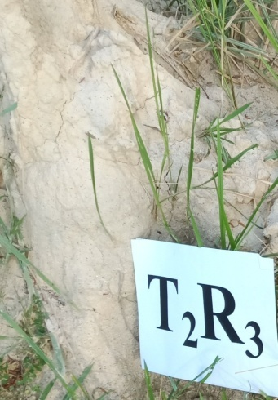

b

b

a

a

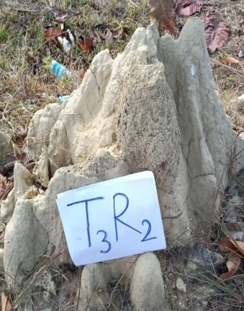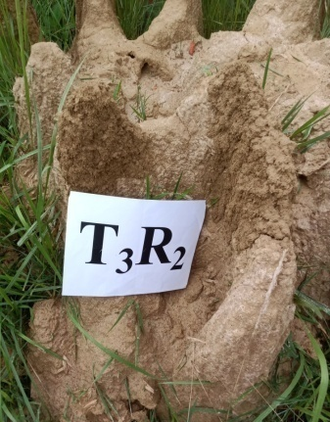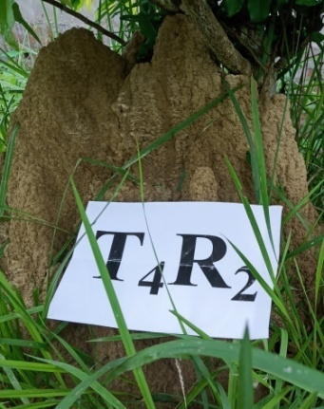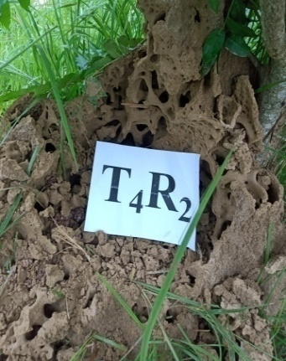

a

b

b

a

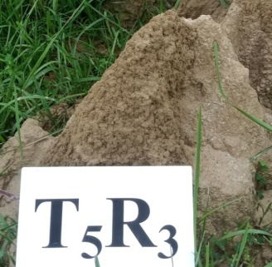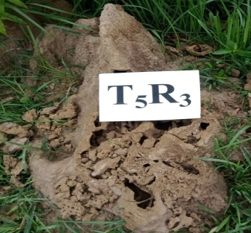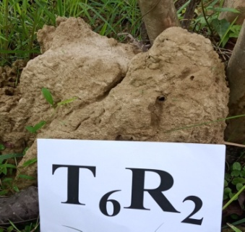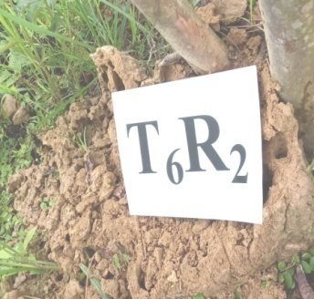

a

b

b

a



control

Fig.1. Termite mound (*Odontotermis obesus*), before (b) and after (a) application of *H.bacteriophora*

**Table 2. Progeny production and persistence of *Heterorhabditis bacteriophora* on termite, *Odontotermes obesus* .**

|  |  |  |  |
| --- | --- | --- | --- |
| Treatments | Observations (Av. of 3 replications) | | |
| Progeny production of nematode inside their host (mean± SE) | | Persistence of the nematodes in the nests  Insect  (*Galleria mellonella* ) mortality(%) |
| Worker | Soldier |
| T1:2.5×109 IJs/mound  ( One time application) | 1260-1500  (1416±2.65) | 1240-1500  (1418±2.75) | 5.2  (13.25)c |
| T2:2.5×109 IJs/mound  ( Two times , one month interval) | 1230-1520  (1416±3.56) | 1250-1530  (1430±4.90) | 8.7  (16.64)c |
| T3:2.5×109 IJs/mound  ( Three times ,one month interval) | 1240-1540  (1420±2.75) | 1280-1550  (1430±5.85) | 19.2  (25.89)b |
| T4:5.0×109 IJs/mound  ( One time application) | 1242-1550  (1425±3.28) | 1260-1540  (1440±3.90) | 22.8  (28.37)b |
| T5:5.0×109 IJs/mound  ( Two times ,one month interval) | 1240-1582  (1464±3.33) | 1290-1560  (1460±3.65) | 33.3  (35.20)a |
| T6:5.0×109 IJs/mound  ( Three times ,one month interval) | 1282-1590  (1478±3.65) | 1280-1580  (1470±4.75) | 43.8  (41.44)a |
| T7: Control |  |  | 2.0  (6.40)d |
| CD(0.05) |  |  | (6.55) |

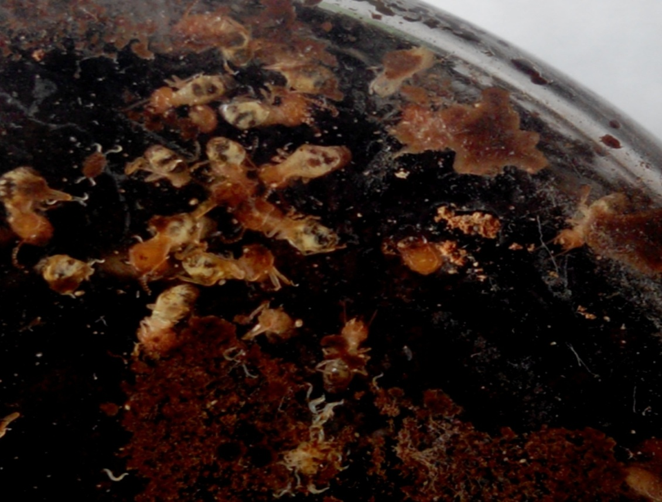

Fig.2. *Odontotermes obesus* infected by *Heterorhabditis bacteriophora*

**Conclusion**

Based on the outcome of the field study,it is affirmed that the native isolate of EPN, *H. bacteriophora* is potent biocontrol agent ahainst *O.obesus* and possess the characteristics needed to create an epizootic within the mound i.e., to self-replicate, disperse and reach secondary cycling within the termites (Zadji *et al*.,2013; Zadji *et al.,*2014) with higher environmental standards (Su,2002). Termite workers and soldiers might come across EPNs in soil when foraging, or when de-winged reproductive burrow into soil to establish initial colonies (Razia *et al.,*2017; Labaude and Griffin, 2018).Three time application of *H. bacteriophora* at one month interval could able to cause mortality up-to 58.3% with successful persistence may support the hypothesis that biological control for termites only works with inundative methods where most of the nest is accessible for treatments and sequential instead of simultaneous application of EPN is effective (Mauldin and Beal ,1989; Zhu, 2002; Georgis *et al*., 2006 ). However, various factors viz., physical and chemical properties of soil (e.g., moisture, temperature, pore size, oxygen and carbon dioxide levels, pH, salinity, and the presence of artificial chemicals) and biotic factors such as competition or competitive interactions with other soil species, restricted motility, and termite behaviors influence the efficacy of nematodes in biocontrol programmes (Gaugler, 1988). Further deep knowledge on genetic manipulation, combinations with other control agents, ecology and biology of nematodes is required for their insecticidal potency.

**DISCLAIMER (ARTIFICIAL INTELLIGENCE)**

Author hereby declare that NO generative AI technologies such as Large Language Models (ChatGPT, COPILOT, etc) and text-to-image generators have been used during writing or editing of this manuscript.

**COMPETING INTERESTS**

Author has declared that no competing interests exist.

**AUTHORS’ CONTRIBUTIONS**

Author ‘GD’ designed the study, performed the experiment and statistical analysis, and wrote the first draft of the manuscript. Author ‘BB’ managed the experiment and analyses the study and finalized the manuscript. Both authors read and approved the final manuscript.

**REFERENCES**

Abbott, W.S. 1925. A method of computing the effectiveness of an insecticide. Journal of Economic Entomology.  18(2): 265-267. <https://doi.org/10.1093/jee/18.2.265a>

Adams, B.J., Fodor, A., Koppenhofer, H.S., Stackenbrandt, E., Stock, S.P. & Klein, M.G. 2006. Biodiversity and systematics of nematode-bacterium entomopathogens. Biological Control. 37(1): 32-49. DOI:[10.1016/j.biocontrol.2005.11.008](http://dx.doi.org/10.1016/j.biocontrol.2005.11.008).

Al-Zaidawi, J.B., Karimi, J.,& Mahdikhani Moghadam, E. 2020. Entomopathogenic nematodes as potential biological control agents of Subterranean termite, *Microcerotermes diversus* (Blattodea: Termitidae) in Iraq. Environmental Entomology.  49(2):412-421. <https://doi.org/10.1093/ee/nvaa014>.

Amarasinghe LD. & Hominick WM.1993. Efficacy of entomopathogenic nematodes to control up-country live-wood termite. Sri Lanka Journal of Tea Science. 62(1):16-24.<https://dl-tri.nsf.gov.lk/handle/1/1283>.

Amarasinghe LD. 2008 .Entomopathogenic nematodes from the costal belt of Sri Lanka and their efficacy in controlling termites. Pest Technology. 2(2):125-129. <http://repository.kln.ac.lk/handle/123456789/4460>

Aslam, A., Chi, D.F., Abbasi, A. & Arshad M. 2023. Biocontrol potential of Entomopathogenic nematodes against *Odontotermis obesus* (Blattodea: Termitidae) under laboratory and field conditions. *Forests*.14(3),580.https://doi.org/10.3390/f14030580.

Baimey, H., Zadji L., Afouda L., Moens M., & Decraemer W. 2015. Influence of pesticides, soil temperature and moisture on entomopathogenic nematodes from southern Benin and control of underground termite nest populations. Nematology. 17(9): 1057-1069. <https://doi.org/10.1163/15685411-00002923>

Bedding, RA. & Stanfield. M. 1981. Nematodes for insect control *Mastotermes*, Annual Report. CSIRO Division of Entomology, Canberra, Australia. pp. 79-80.

Blinova, S.L. & Ivanova, E.S. 1987. Culturing the nematode bacterial complex of *Neoaplectana carpocapsae* in insects. In: Helminths of Insects. M.D. Sonin (Ed.).American Publishing Company, New Delhi, pp.22-26.

Burnell, A.M. & Stock, P.S. 2000. *Heterorhabditis*, *Steinernema* and their bacterial symbionts-Lethal pathogens of insects. *Nematology.* 2: 31-42.[10.1163/156854100508872](https://doi.org/10.1163/156854100508872).

Chhillar BS, Saini RK, Roshan Lal (2006) Emerging trends in economic entomology. Chaudhary Charan Singh Haryana Agricultural University Press, Center of Advance Studies,Department of Entomology, Hissar, pp. 191-192.

Choudhury, P.1999. Studies on the pests of *Camellia sinensis* L (O) Kuntze and their control in the tea agro-ecosystem in Barak Valley, Assam. Ph.D. thesis, Gauhati University, India.

Chouvenc, T., Su, Nan-Yao., Grace, JK. 2011. Fifty years of attempted biological control of termites-Analysis of a failure. *Biological Control* 59(2): 69-82.<https://doi.org/10.1016/j.biocontrol.2011.06.015>

Danthanarayana, W.& Vitarana, SL. 1987. Control of the live-wood tea termite *Glyptotermes dilatus* using *Heterorhabditis* sp. (*Nemat.*).Agriculture Ecosystems and Environment*.* 19(4): 333-342.

Das, G. M. 1965. Pests of tea in North East India and their control. Memo No. 27, Tocklai Experimental Station, Tea Research Association, pp. 169- 173.

Devi, G., Bhattacharyya, B., Mishra, H .& Nath, DJ. 2018. Rearing of two entomopathogenic nematodes, *Heterorhabditis bacteriophora* Poinar and *Steinernema* sp. in termite (*Odontotermes obesus* Ramb.)Applied Biological Research.20(1): 77-81. DOI:[10.5958/0974-4517.2018.00009.5](http://dx.doi.org/10.5958/0974-4517.2018.00009.5)

Devi, G., Mishra, H., Bhattacharyya, B. and Nath, D.J. 2016. Occurrence of entomopathogenic nematode (Rhabditida: Heterorhabditidae, Steinernematidae) in white grub infested areas of Majuli, Assam, India. Journal of Biopesticides. 9(2):148-156. DOI:[10.57182/jbiopestic.9.2.148-156](http://dx.doi.org/10.57182/jbiopestic.9.2.148-156)

Dolinski C, & Lacey LA.2007. Microbial control of arthropod pests of tropical tree fruits. Neotropical Entomology. 36(2):161-179.doi: 10.1590/s1519-566x2007000200001.

Eggleton P.2000. Global patterns of termite diversity. In: Abe T, Bignell DE, Higashi M (eds).Termites: evolution, sociality, symbioses, ecology. Kluwer, Dordrecht, pp. 25-51.https://doi.org/10.1007/978-94-017-3223-9_2

El-Bassiouny, AR., & Randa M.A. 2011. Susceptibility of Egyptian subterranean termite to some entomopathogenic nematodes. Egyptian Journal of Agricultural Research. 89(1): 121-135. DOI:[10.21608/ejar.2011.173943](http://dx.doi.org/10.21608/ejar.2011.173943).

Epsky, ND. & Capinera, JL. 1988. Efficacy of the entomogenous nematode *Steinernema feltiae* against a subterranean termite, *Reticulitermes tibialis* (Isoptera, Rhinotermitidae). Journal of Economic Entomology. 81(5): 1313-1317. DOI: 10.1093/jee/81.5.1313

Flanders, K.L., Miller, J.M. & Shields, EJ.1996. In vitro production of *Heterorhabditis bacteriophora* ‘Oswego’ (Rhabditida: Heterorhabditidae), a potential biological control agent for soil inhabiting insects in temperate regions. Journal of Economic Entomology. 89(2): 373-380.<https://doi.org/10.1093/jee/89.2.373>

Fleming, R. & Retnakam, A. 1985. Evaluating single treatment data using Abbott’s formula with reference to insecticides. Journal of Economic Entomology. 78(6): 1179-1181. https: //doi. Org /10. 1093 /jee/78.6.1179.

Fujii, JK. 1975. Effects of an entomopathogenous nematode *Neoaplectana carpocapsae* Weiser, on the Formosan subterranean termite, *Coptotermes* *formosanus* Shiraki, with ecological and biological studies on *C. formosanus*. Ph D thesis. University of Hawaii, Honolulu. U. S. A.

Georgis, R. and Poinar G.O.& Wilson, AP 1982. Susceptibility of damp-wood termites and soil and wood-dwelling termites to the entomogenous nematode *Neoaplectana carpocapsae*. IRCS Med Sci. 10: 563.

Georgis, R., Koppenhofer, A.M., Lacey, L.A., Belair, G., Duncan, L.W., Grewal, P.S., Samish, M., Tan, L., Torr, P., van Tol, R.W.H.M. 2006. Successes and failures in the use of parasitic nematodes for pest control. Biological Control. 38(1):103-123. <https://doi.org/10.1016/j.biocontrol.2005.11.005>

Grace, J.K. 2003. Approaches to biological control of termites. Sociobiology. 41(1):115-121. <https://www.researchgate.net/publication/259000347>.

Tamashiro M. 1968. Susceptibility of termites to microbes. A research proposal submitted to the Office of Naval Research. Department of Entomology, University of Hawaii, Honolulu. 7 pp.

Grace,J.K., Woodrow, R.J. and Oshiro, R.J. 2009. Expansive gallery systems of one piece termites (Isoptera: Kalotermitidae). Sociobiology. 54:37-44. https://www.researchgate.net/publication/258995812

Griffin, C.T. 2012. Perspectives on the behavior of entomopathogenic nematodes from dispersal to reproduction: Traits contributing to nematode fitness and biocontrol efficacy. Journal of Nematology. 44(2):177-184. PMID: 23482343.

Gutema BA, Achlehum DM, Edosa TT, Feyisa B, Yimer F, Dinka TD.2025. Evaluation of entomopathogenic nematode isolates against subterranean termites under laboratory and field. F1000 Research. 12:1601. https://doi.org/10.12688/f1000research.138237.3

Hiranwrongwera,C., Adisettakul,P., Tansirichaiya,S., Piyabun,O., Somsuk,V.2007. Efficacy of a nematode (*Steinernema carpocapsae*) and its symbiotic bacterium (*Xenorhabdus nematophila*) at eliminating the termite *Coptotermes curvignathus* that infests para rubber(*Hevea brasiliiensis*).The 5th International Symposium on Biocontrol and Biotechnology, November 1-3, 2007. Khon Kaen University, Nong Khai Campus, Nong Khai, Thailand. p.90.

Javed, S., Ali, A. & Khanum,T.A. 2021. Biocontrol potential of the entomopathogenic nematodes (Rhabditida: Steinernematidae and Heterorhabditidae) against the termite species, *Microtermes* *obesi* (Holmgren) (Blattodea: Termitidae). Egyptian Journal of Biological Pest Control.31:99.https://doi.org/10.1186/s41938-021-00448-9.

Joshi PK, Singh NP, Singh NN, Gerpacio RV,& Pingali PL.2005. Maize in India: production systems, constraints, and research priorities. Mexico, DF CIMMYT, p 1-42..https://www.researchgate.net/publication/242460207;ISBN: 970-648-117-6

Kaya, H.K. and Gaugler, R. 1993. Entomopathogenic Nematodes. Annual Review of Entomology. 38(1):181-206. DOI:[10.1146/annurev.en.38.010193.001145](http://dx.doi.org/10.1146/annurev.en.38.010193.001145)

Koppenhofer, A.M., Baur, M.E., Stock, S.P., Choo, H.Y., Chinnarsri, B.and Kaya, H.K.1997. Survival of entomopathogenic nematodes within host cadavers in dry soil. Applied Soil Ecology.6(3): 231-240. [10.1016/S0929-1393(97)00018-8](https://ui.adsabs.harvard.edu/link_gateway/1997AppSE...6..231K/doi:10.1016/S0929-1393(97)00018-8).

Krishna K,& Grimaldi DA. 2003. The first cretaceous Rhinotermitidae (Isoptera): a new species, genus, and subfamily in Burmese Amber. New York, NY American Museum of Natural History.3390:10.DOI: [https://doi.org/10.1206/0003-0082 (2003) 390<0001 :TFCRIA > 2.0.CO;2](https://doi.org/10.1206/0003-0082%20(2003)%20390%3c0001%20:TFCRIA%20%3e%202.0.CO;2)OCLC: 51783175.

Labaude, S. & Griffin, C.T. 2018. Transmission success of entomopathogenic nematodes used in pest control. *Insects*. 9(2):72 doi: 10.3390 /insects9020072.

Lenz, M., Kamath, M.K., Lal, S. & Senivasa, E. 2000. Status of the tree-damaging *Neotermes* sp., in Fiji’s American mahogany plantation and preliminary evaluation of the use of entomopathogens for their control. Project Report. ACIAR small project No.FST/96/205.P.111.

Lewis, E.E., Campbell, J., Griffin, C., Kaya, H.& Peters, A. 2006. Behavioral ecology of entomopathogenic nematodes. Biological Control. 38(1):66-79. <https://doi.org/10.1016/j.biocontrol.2005.11.007>

Mankowski, M.E, Kaya, H.K., Grace, J.K. & Sipes, B. 2007. Differential susceptibility of subterranean termite castes to entomopathogenic nematodes. Biocontrol Science and Technology.15(4): 367-377. [10.1080/09583150400016951](https://doi.org/10.1080/09583150400016951)

Manzoor, F. 2012.  Synergism of Imidacloprid and entomopathogenic nematodes for the control of eastern subterranean termite, Reticulitermes flavipes (Isoptera: Rhinotermitidae). Pakistan Journal of Zoology. 44(5): 1397-1403.

Mauldin, J.K. & Beal R.H. 1989. Entomogenous nematodes for control of subterranean termites, *Reticulitermes* spp. (Isoptera: Rhinotermitidae). Journal of Economic Entomology. 82(6): 1638-1642.<https://doi.org/10.1093/jee/82.6.1638>

Metwally, H.M.S., Hafez,G.A., Hussein, M.A., Hussein, M.A., Salem H.A. & Saleh,M.M.E. 2012. Low cost artificial diet for rearing the greater wax moth, *Galleria mellonella* L. (Lepidoptera: Pyralidae) as a host for entomopathogenic nematodes. Egyptian Journal of Biological Pest Control.22(1):15-17.

Michael L.2005.Biological control in termite management: The potential of nematode and fungal pathogen. Proceedings of the 5th International Conference on Urban Pests. July 11-12, Singapore, pp.48–50.

Mohan,S., Upadhyay A.& Gupta,R. 2016.[Control of primary reproductives of *Microtermes* spp. in soil treated with *Galleria* cadavers infected with *Heterorhabditis indica*](https://www.researchgate.net/publication/311518277_Control_of_primary_reproductives_of_Microtermes_spp_in_soil_treated_with_Galleria_cadavers_infected_with_Heterorhabditis_indica). Nematology. 18(9):1113-1118.<https://doi.org/10.1163/15685411-00003019>.

Murugan K., &  Vasugi C. 2011. Combined effect of *Azadirachta indica* and the entomopathogenic nematode *Steinernema glaseri* against subterranean termite, *Reticulitermes flavipes*. Journal of Entomological and Acarological Research. 43(2): 253-259.<https://doi.org/10.4081/jear.2011.253>.

Phan, K.L., Tirry, L. & Moens, M. 2005. Pathogenic potential of six isolates of entomopathogenic nematodes (Rhabditida: Steinernematidae) from Vietnam. *BioControl*. 50(3): 477-491. DOI:[10.1007/s10526-004-6122-1](http://dx.doi.org/10.1007/s10526-004-6122-1).

Poinar, Jr GO. 1979. Nematodes for biological control of insects.pp.249. CRC, Boca Raton, FL. ISBN 13: 978-1-315-89585-7 (hbk).

Poinar, Jr GO.& Georgis, R. 1989. Biological control of social insects with nematodes. *In* A. R. Leslie and R. L. Metcalf (eds.), Integrated pest management for turfgrass and ornamentals. U.S. Environmental Protection Agency, Washinton D. C. pp.257-272.

Potter, MF. 2011. Termites. In: Handbook of Pest Control: the behavior, life history, and control of household pests, A. Mallis (Ed.) G I E Pub; 10th edition. ISBN-13 ‏: ‎978-1890561024.

Rajagopal D. 2002. Economically important termite species in India. Sociobiology. 40:33-46.  [https://doi.org/10.13102/sociobiology.v40i1.33–46](https://doi.org/10.13102/sociobiology.v40i1.33%E2%80%9346).

[Paul](https://www.researchgate.net/profile/Bishwajeet-Paul?_tp=eyJjb250ZXh0Ijp7ImZpcnN0UGFnZSI6InB1YmxpY2F0aW9uIiwicGFnZSI6InB1YmxpY2F0aW9uIn19),B,  [Khan](https://www.researchgate.net/profile/Mohiuddin-Khan-4?_tp=eyJjb250ZXh0Ijp7ImZpcnN0UGFnZSI6InB1YmxpY2F0aW9uIiwicGFnZSI6InB1YmxpY2F0aW9uIn19), [Sangeeta Paul](https://www.researchgate.net/profile/Sangeeta-Paul?_tp=eyJjb250ZXh0Ijp7ImZpcnN0UGFnZSI6InB1YmxpY2F0aW9uIiwicGFnZSI6InB1YmxpY2F0aW9uIn19), S.,  [Shankarganesh](https://www.researchgate.net/profile/Karuppan-Shankarganesh-2?_tp=eyJjb250ZXh0Ijp7ImZpcnN0UGFnZSI6InB1YmxpY2F0aW9uIiwicGFnZSI6InB1YmxpY2F0aW9uIn19), K.& [Chakravorty](https://www.researchgate.net/profile/Sarbashish-Chakravorty?_tp=eyJjb250ZXh0Ijp7ImZpcnN0UGFnZSI6InB1YmxpY2F0aW9uIiwicGFnZSI6InB1YmxpY2F0aW9uIn19), S.2018. Termites and Indian Agriculture. In: Termites and Sustainable Management. Springer International Publishing. pp.51-96. DOI:[10.1007/978-3-319-68726-1_3](http://dx.doi.org/10.1007/978-3-319-68726-1_3).

Rathour, KS, Ganguly S, Anupama, Das TK, Singh P, Kumar A .& Somvanshi VS. 2014. Biological Management of Subterranean termites (*Odontotermes obesus*)infesting wheat and pearl millet crops by entomopathogenic nematodes. Indian journal of Nematology. 44(1):97-100.

Razia M., & Sivaramakrishnan S. 2016. Evaluation of entomopathogenic nematodes against termites. Journal of Entomology and Zoology Studies. 4(4):324-327. E-ISSN: 2320-7078

Razia, M.; Baïmey, H.; Zadji, L.; Afouda, L.; Fanou, A.; Kotchofa, R.; Decraemer, W. 2017.Searching for better methodologies for successful control of termites using entomopathogenic nematodes. In: Nematology-Concepts, Diagnosis and Control; Intech: London, UK. p. 53.

Roonwal ML.1979. Termite life and termite control in tropical south Asia. Scientific Publishers: distributers [sic], United Book Traders, ISBN: 8185046026, 9788185046020.pp.177.

Roy, S., Barooah, A.K., Ahmed, K.Z., Baruah, R.D., Prasad, A.K.& Mukhopadhyay, A. 2020. Impact of climate change on tea pest status in northeast India and effective plans for mitigation. *Acta Ecologica Sin*ica. 40(6):432-442. https:// doi.org/ 10.1016/ j.chnaes. 2019.08.003

Shahina, F.& Tabassum, KA. 2010.Virulence of *Steinernema pakistanense* against different insect species in laboratory condition. Pakistan Journal of Nematology. 28:279-284

Sheoran,O.P., Tonk, D.S.,Kaushik,L.S., Hasija,R.C. & Pannu, R.S.1998. Statistical software package for Agricultural research workers. In: Recent Advances in information theory, Statistics & Computer Applications .D.S.Hooda & R.C. Hasija (Ed.), Department of Mathematics Statistics, CCS HAU, Hisar .

Sindhu, S.S., Rakshiya, Y.S., & Verma M.K.2011. Biological control of termites by antagonistic soil microorganisms. Bioaugmentation, Biostimulation and Biocontrol. A. Singh, N Parmar, R Kuhad. (eds.), Springer, Berlin, Heidelberg. pp.261-309. DOI 10.1007/978-3-642-19769-7_12

Smart, G.C.Jr. 1995. Entomopathogenic nematodes for the biological control of insects. Journal of Nematology. 27(4S): 529–534. PMC2619649.

Su NY. & Scheffrahn RH (1990) Economically important termites in the United States and their control. Sociobiology. 17(1):77-94. https://europepmc.org/article/AGR/IND90046844.

Su,NY. 2002. Novel technologies for subterranean termite control. Sociobiology, 40 (1):95-102 https://www.researchgate.net/publication/281510561.

Susurluk, I.A. & Ehlers, R.U. 2008. Comparison of some characterizations of recovered from soil and newly fermented entomopathogenic nematode, *Heterorhabditis bacteriophora*. *Journal of Biological and Environmental Sciences.* 2(6):65-71.

Tarasco E, Fanelli E, Salvemini C,El-Khoury Y, Troccoli A, Vovlas A & De Luca F.2023. Entomopathogenic nematodes and their symbiotic bacteria: from genes to field uses. Frontiers in Insect Science. 3:1195254.doi: 10.3389/finsc.2023.1195254

Traniello, J.F.A.,& Leuthold, R.H. (2000). Behavior and ecology of foraging in Termites. In: Abe, T., Bignell, D.E., Higashi, M. (eds) Termites: Evolution, Sociality, Symbioses, Ecology. Springer, Dordrecht. https://doi.org/10.1007/978-94-017-3223-9_7

Wagutu GK., Kang’ethe LN.,& Waturu CN. 2017. Efficacy of entomopathogenic nematode (*Steinernema karii*) in control of termites (*Coptorermes formosanus*). Journal of Agriculture Science and Technology. 18(1): 55-64.

Wang C, Powell JE, & Nguyen,K 2002.Laboratory Evaluations of four Entomopathogenic nematodes for control of Subterranean Termites (Isoptera: Rhinotermitidae), Environmental Entomology.31(2):381-387.  [https: //doi.org/ 10.1603/ 0046-225X-31.2.381](https://doi.org/10.1603/0046-225X-31.2.381).

Weeks, B. & Baker, P. 2004. Subterranean termite (Isoptera: Rhinotermitidae) mortality due to Entomopathogenic Nematodes (Nematoda: Steinernematidae, Heterorhabditidae) Turfgrass and Ornamental Research Report, index at: http: //cals. arizona. Edu / pubs/ crops/ az1359/.

Wilson-Rich N., Stuart R.J., & Rosengaus R.B. 2007. Susceptibility and behavioral responses of the dampwood termite *Zootermopsis angusticollis* to the entomopathogenic nematode *Steinernema carpocapsae.* Journal of Invertebrate Pathology. 95: 17-25. [10.1016/j.jip.2006.11.004](https://doi.org/10.1016/j.jip.2006.11.004)

Woodring JL. & Kaya HK.,1998. Steinernematidae and a Heterorhabditidae nematodes: A handbook of Biology and techniques. Nematode Subcommittee on the Southern Regional Project S135-Entomopathogens for use in Pest Management Systems, Arkansas: Southern Cooperative, (Series Bulletin No.331)

Woodrow, R.J., Grace, J.K. & Oshiro, R.J. 2006. Comparison of localized injections of spinosad and selected insecticides for the control of *Cryptotermes brevis* (Isoptera: Kalotermitidae) in naturally infested structurally mesocosms. Journal of Economic Entomology. 99(4): 1354-1362.doi: 0022-0493/06/1354-1362-04.00/0

Wu, HJ., Wang, ZN., Ou, CF., Tsai, RS., & Chow, YS. 1991. Susceptibility of two formosan termites to the entomogenous nematode, *Steinernema feltiae* Filipjev. *Bull Inst Zool Acad Sin.* 30:31-39.

Yu H, Gouge DH, & Baker P. 2006. Parasitism of subterranean termites (Isoptera: Rhinotermitidae:Termitidae) by entomopathogenic nematodes (Rhabditida: Steinernematidae; Heterorhabditidae). Journal of Economic Entomology. 99(4): 1112–1119. <https://doi.org/10.1093/jee/99.4.1112>.

Yu H, Gouge DH,& Shapiro-Ilan DI. 2010. A novel strain of *Steinernema riobrave* (Rhabditida: Steinernematidae) possesses superior virulence to subterranean termites (Isoptera: Rhinotermitidae). Journal of Nematology.42(2): 91-95. PMID: [22736844](https://pubmed.ncbi.nlm.nih.gov/22736844/)

Yu, H., Gouge, DH., Stock, SP., & Baker, PB. 2008. Development of Entomopathogenic Nematodes (Rhabditida: Steinernematidae; Heterorhabditidae) in the Desert Subterranean Termite *Heterotermes aureus* (Isoptera: Rhinotermitidae).Journal of Nematology. 40(4): 311-317. https://www.researchgate.net/publication/285838138.

Zadji, L., Baimey, H., Afouda, L., Moens, M. & Decraemer, W. 2014. Characterization of biocontrol traits of heterorhabditid entomopathogenic nematode isolates from South Benin targeting the termite pest *Macrotermes bellicosus*. BioControl.59:333-344. https://doi.org/10.1007/s10526-014-9568-9.

Zadji, L., Baimey, H., Afouda, L., Moens, M., & Decraemer, W. 2013. Effectiveness of different *Heterorhabditis* isolates from Southern Benin for biocontrol of the subterranean termite, *Macrotermes bellicosus* (Isoptera: Macrotermitinae), in laboratory trials. *Nematology.* 16(10) : 109-120. DOI:[10.1163/15685411-00002749](http://dx.doi.org/10.1163/15685411-00002749).

Zaidawi JB, Karimi J, & Moghadam EM. 2020. Entomopathogenic nematodes as potential biological control agents of subterranean termite, *Microcerotermes diversus* (Blattodea: Termitidae) in Iraq. Environmental Entomology. 49(2): 412-421 DOI: [10.1093/ee/nvaa014](https://doi.org/10.1093/ee/nvaa014).

Zhu, JH.2002. Study on application of entomopathogenic nematodes to control *Odontotermes formosanus* Shiraki on Eucalyptus. Journal of Fujian College of Forestry. 22(4): 366-370.

Khan, M. A., Ahmad, W., Paul, B., Paul, S., Khan, Z., & Aggarwal, C. (2016). Entomopathogenic nematodes for the management of subterranean termites. Plant, Soil and Microbes: Volume 1: Implications in Crop Science, 317-352.