**Application of BAP and IAA for *in vitro* callus formation of rose (*Rosa indica cv*. Ganganagri Gulab)**

**Abstract-** A callus is a mass of undifferentiated cells capable of producing secondary metabolites. In this study, callus induction in Rosa spp. was evaluated using different concentrations of 6-Benzylaminopurine (BAP) and Indole-3-acetic acid (IAA) across the first, second, and third nodal segments under in vitro conditions. Callus formation was consistently observed in all tested combinations, with response rates ranging from 60% to 90% within 18.6 to 29 days of incubation. The highest callus induction was recorded in the third nodal segment, where a combination of 2.0 mg/L BAP + 2.0 mg/L IAA resulted in an 85% response rate and 0.93 g of callus weight in 18.6 days. A similar trend was noted in the second nodal segment, where 1.5 mg/L BAP + 1.5 mg/L IAA produced a 90% response rate and 0.93 g of callus weight in 20.6 days. The results indicated that equal concentrations of BAP and IAA yielded the highest callus induction across all nodal segments, with progressively increasing response rates and callus biomass from the first to the third nodal segment. Lower concentrations of IAA (0.5 mg/L) resulted in reduced callus formation, whereas higher concentrations (2.0 mg/L IAA) enhanced both the frequency of response and callus biomass.

**Key words:** *in vitro propagation, callus induction, BAP, IAA, nodal segments, plant growth regulators, tissue culture*

# INTRODUCTION

Plant tissue culture, commonly referred to as micropropagation, is a vital technique for large-scale propagation of plants through the in vitro culture of plant cells or tissues under controlled, sterile conditions (George *et al.*, 2008). This method creates a suitable microenvironment for plant development and has diverse applications in agriculture, horticulture, and plant biotechnology (Thorpe, 2007). It not only facilitates commercial-scale multiplication of plants but also serves as a fundamental tool for research in plant cell biology, genetics, and biochemistry (Reed, 2008). Tissue culture techniques encompass the culture of cells, anthers, ovules, embryos, protoplast isolation and fusion, cell selection, and meristem and bud culture (Rout *et al.*, 2006). In particular, in vitro propagation has gained popularity as an alternative to conventional methods, especially in the floriculture and horticulture industries (Debnath *et al.*, 2006). Its advantages include a high multiplication rate within a relatively short time, year-round production, and the generation of genetically uniform, healthy, and pathogen-free plants (Bhojwani & Razdan, 1996).

The Ganganagri Gulab, a traditional or desi rose variety identified for cultivation in Rajasthan, has attracted attention due to its distinct fragrance, preserved in value-added products such as rose oil and rose water. This rose grows up to 2–3 meters tall and possesses numerous hard and sharp prickles, providing natural defense against herbivores. Its well-developed vascular cambium aids in water conservation by reducing evapotranspiration losses from aerial parts. The plant thrives in arid and semi-arid climates, particularly in the Sri Ganganagar region of Rajasthan, where it is traditionally cultivated. Callus formation is a critical step in tissue culture protocols, serving as a precursor for plant regeneration and genetic transformation (Ikeuchi *et al.*, 2013). The induction of callus is largely influenced by the balance between auxins and cytokinins, with specific combinations essential for optimal growth. Among the most commonly used growth regulators, indole-3-acetic acid (IAA), an auxin, and 6-benzylaminopurine (BAP), a cytokinin, have been extensively studied for their roles in promoting cell division and callus initiation (Skoog & Miller, 1957; Pierik, 1997). In rose tissue culture, equal concentrations of IAA and BAP have been shown to promote substantial callus development from nodal segments.

Furthermore, the addition of secondary metabolites to the culture medium has been reported to enhance callus induction, possibly by stimulating cellular activity and metabolic responses. This study aims to investigate the application of BAP and IAA in callus induction in the Ganganagri Gulab rose variety, with a focus on identifying optimal hormone concentrations and evaluating the effect of metabolic enhancers on callus formation.

# MATERIAL AND METHODS

# The present research investigation was conducted in the Micropropagation Laboratory, Division of Plant Breeding and Genetics, Swami Keshwanand Rajasthan Agricultural University (SKRAU), Bikaner. The experiment was laid out in a Complete Randomized Design (CRD) with three replications. Stem cuttings of rose (Rosa spp.) were collected from the Agricultural Research Station, Bikaner, and used as the source of explants. After the formation of nodal segments, they were utilized as explants for callus induction. Two different concentrations of plant growth regulators (PGRs) were employed to initiate callus formation. Prior to the culture initiation, the required hormones and vitamins were added to the protocol medium as per standard requirements. The pH of the culture medium was adjusted to 5.8 before sterilization in a microwave oven. Culture bottles containing the medium were autoclaved at 121°C under 15 psi pressure for 20 minutes. For in vitro culture initiation, the culture containers were transferred to a growth chamber maintained at 25 ± 2°C with a 16/8 hours light/dark photoperiod. Illumination was provided by cool white fluorescent tubes with a light intensity of approximately 2000 lux.

# Sterilized rose explants were taken from regenerated plantlets for callus induction. The prepared stem segments were washed thoroughly with sterilized distilled water under a laminar airflow cabinet, and all subsequent handling was done under sterile conditions. Surface sterilization of explants was performed using 70% ethanol for 1 minute, followed by treatment with 0.1% mercuric chloride (HgCl₂) for approximately 5 minutes. The explants were then rinsed three times with sterilized distilled water to remove traces of disinfectant.

# Present research investigation was performed in Completely randomized design at Plant Micropropagation Lab, Department of Genetics and Plant Breeding, College of Agriculture, Swami Keshwanand Rajasthan agricultural University, Bikaner. Explant Used Different type of explants like first, second and third nodal segments of 1-2 cm were collected from healthy mulberry trees grown ARS, Bikaner. In this experiment, three different types of explants, first, second and third nodes removed from the mature grown rose cv. Ganganagri gulab plant were employed surface sterilization of explants before subjected in IAA and BAP media for callus induction

# ****2.1 surface Sterilization and Culture Establishment****

# Explant materials were initially washed under running tap water for 10 minutes to eliminate soil particles, dust, and debris. Following this, explants were treated with a few drops of Tween-20 liquid detergent for 5–10 minutes to further remove surface contaminants. The explants were then rinsed thoroughly three to four times with double distilled water to eliminate detergent residues. Subsequently, the explants were surface sterilized using 70% ethanol and mercuric chloride (HgCl₂) at varying concentrations, both individually and in combination, for durations of 1, 5, and 10 minutes depending on the treatment. After chemical sterilization, explants were rinsed four to five times with sterile double distilled water to remove all traces of the sterilants.

# Sterilized explants were inoculated onto Murashige and Skoog (MS) medium supplemented with different concentrations and combinations of BAP (6-benzylaminopurine) and IAA (indole-3-acetic acid) for callus induction. The cultures were maintained under controlled environmental conditions (typically 24–26°C) with a photoperiod of 16/8 hours (light/dark). Subculturing was carried out three to four times to ensure culture viability and growth. The first subculture was done within 24 hours of inoculation to minimize the impact of phenolic exudation, which could hinder callus formation.

# ****2.2 Statistical Analysis****

# The experimental data were analyzed using a Completely Randomized Design (CRD) with three replications per treatment. The significance of treatment effects was evaluated using Critical Difference (CD) at a 5% probability level. Treatments were considered statistically significant when the observed mean differences exceeded the calculated CD values.

# RESULT AND DISCUSSION

# 3.1 Effect of plant growth regulators on callus formation under *in vitro* condition

The callus induction through various explant in rose were initated with the comination of BAP and IAA at several concentration. For the callus induction the three explant were used which as follows first, second and third nodal segment. A high auxin-to-cytokinin ratio generally favors callus formation. The choice of explant—such as leaf segments, nodal sections, or shoot apices also affects callogenesis, with young, meristematic tissues responding more effectively. The shoot apex were not selected for callus induction due to its low callus prolification rate and soft base.

**3.2 Callus induction from different PGR combination of 1.5 BAP + IAA (0.5- 2.0 mg/L)**

Callus formation was consistently observed across all tested combinations of BAP and IAA in first, second, and third nodal segment explants within 20 to 29 days of incubation, with a response frequency ranging from 60% to 85%. This was followed by the combination of 1.5 mg/L BAP + 1.0 mg/L IAA, which resulted in a 60% response rate and produced 0.63 g of callus weight within 17 days. Media containing 1.5 mg/L BAP+0.5 mg/L to 2.0 mg/L IAA induced callus formation with response rates ranging from 60% to 65%, and the fresh weight of the callus varied between 0.53 g and 0.54 g. According to the data, the most effective results were obtained with equal concentrations of both BAP and IAA. The combination of 1.5 mg/L BAP and 1.5 mg/L IAA produced the highest response rate (85%), resulting in 0.89 g of callus weight after 20.4 days. This was closely followed by the combination of 1.5 mg/L BAP and 2.0 mg/L IAA, which exhibited an 80% response rate and produced 0.77 g of callus weight in 22.1 days. The combination of 1.5 mg/L BAP and 1.0 mg/L IAA also showed an 80% response rate, yielding 0.76 g of callus weight after 23.5 days. The combination of 1.5 mg/L BAP and 0.5 mg/L IAA resulted in the lowest response rate (75%), producing 0.61 g of callus weight in 23.7 days.

Callus induction from third nodal segments was consistently observed across all tested combinations of BAP and IAA. According to the data, the most effective results were achieved with equal concentrations of both BAP and IAA.Medium supplemented with appropriate PGRs, serves as a common basal medium for callus induction. Additionally, environmental conditions like light intensity, temperature (usually 24–26°C), and dark incubation during the initial days play an important role in successful callus development. The texture, color, and growth rate of the callus can also vary depending on hormonal combinations and explant source The combination of 1.5 mg/L BAP and 1.5 mg/L IAA exhibited the highest response rate (90%), producing 0.93 g of callus weight in 20.6 days. This was followed by the combination of 1.5 mg/L BAP and 2.0 mg/L IAA, which yielded an 85% response rate with 0.54 g of callus weight after 22.8 days. The combination of 1.5 mg/L BAP and 1.0 mg/L IAA resulted in an 80% response rate, with 0.82 g of callus weight in 23.7 days. The combination of 1.5 mg/L BAP and 0.5 mg/L IAA showed the lowest response rate (70%), producing 0.61 g of callus weight in 25.4 days. Based on the CD (Critical Difference) analysis, BAP and IAA combinations significantly affected the mean days to callus initiation and response percentage across all three nodal segments of rose explant.

In the first nodal segment, the CD for mean days was 1.20, and the observed difference was 2.8, indicating significance. Similarly, the response percentage showed a significant difference of 10 against a CD of 3.62. In the second nodal segment, mean days (CD = 0.94, diff = 3.3) and response (%) (CD = 3.60, diff = 10) were also significantly affected. The third nodal segment followed the same pattern, with a CD of 1.01 for mean days and 3.60 for response, both exceeded by differences of 4.8 and 20, respectively. However, for fresh weight of callus, the observed differences (ranging from 0.23 to 0.39) were consistently lower than the CD values (ranging from 1.03 to 1.32), indicating that this parameter was not significantly influenced by the treatments.

**Table 1. Effect of BAP and IAA in callus development on different explant of rose**

**First nodal segment**

|  |  |  |  |
| --- | --- | --- | --- |
| **IAA**  **mg/L** | **BAP (1.5 mg/L)** | | |
| **Mean days taken in callus initiation** | **Fresh weight of callus(g)** | **Response (%)** |
| 0.5 | 27.1 | 0.59 | 60.0 |
| 1.0 | 25.3 | 0.63 | 60.0 |
| 1.5 | **24.3** | **0.77** | **70.0** |
| 2.0 | 25.8 | 0.54 | 65.0 |
| **SE(m) ±** | 0.34 | 0.10 | 0.45 |
| **CD at 5%** | 1.20 | 1.03 | 3.62 |

**Second nodal segment**

|  |  |  |  |
| --- | --- | --- | --- |
| **IAA**  **mg/L** | **BAP (1.5 mg/L)** | | |
| **Mean days taken in callus initiation** | **Fresh weight of callus(g)** | **Response (%)** |
| 0.5 | 23.7 | 0.61 | 75.0 |
| 1.0 | 23.5 | 0.76 | 80.0 |
| 1.5 | **20.4** | **0.89** | **85.0** |
| 2.0 | 22.1 | 0.77 | 80.0 |
| **SE(m) ±** | 0.33 | 0.03 | 1.13 |
| **CD at 5%** | 0.94 | 1.32 | 3.60 |

**Third nodal segment**

|  |  |  |  |
| --- | --- | --- | --- |
| **IAA**  **mg/L** | **BAP (1.5 mg/L)** | | |
| **Mean days taken in callus initiation** | **Fresh weight of callus(g)** | **Response (%)** |
| 0.5 | 25.4 | 0.61 | 70.0 |
| 1.0 | 23.7 | 0.82 | 80.0 |
| 1.5 | **20.6** | **0.93** | **90.0** |
| 2.0 | 22.8 | 0.54 | 85.0 |
| **SE(m) ±** | 0.31 | 0.04 | 0.50 |
| **CD at 5%** | 1.01 | 1.04 | 3.60 |

**3.3 Callus induct from different PGR combination of 2.0 BAP + IAA (0.5-2.0** **mg/L)**

Callus induction from first nodal segments was consistently observed across all tested combinations of BAP and IAA. According to the data, the most effective results were obtained with equal concentrations of both BAP and IAA. The callus development were mostly seen in hard explants like first nodal segments, second nodal segments and the third nodal segments and callus development were rarely or minimum seen of shoot apex which are softest explant among all. The combination of 2.0 mg/L BAP and 2.0 mg/L IAA produced the highest response rate (65%), resulting in 0.67 g of callus weight after 21.8days. This was closely followed by the combination of 2.0 mg/L BAP and 1.5 mg/L IAA, which exhibited an 60% response rate and produced 0.54 g of callus weight in 23.8 days. The combination of 2.0 mg/L BAP and 1.0 mg/L IAA also showed an 55% response rate, yielding 0.43 g of callus weight after 26.4 days. The combination of 2.0 mg/L BAP and 0.5 mg/L IAA resulted in the lowest response rate (50%), producing 0.39 g of callus weight in 27.2 days.

Callus induction from second nodal segments was consistently observed across all tested combinations of BAP and IAA. According to the data, the most effective results were obtained with equal concentrations of both BAP and IAA. Morever the whitish yellowish were a healthiest callus texture among all. The combination of 2.0 mg/L BAP and 2.0 mg/L IAA produced the highest response rate (70%), resulting in 0.88 g of callus weight after 20.3days. This was closely followed by the combination of 2.0 mg/L BAP and 1.5 mg/L IAA, which exhibited an 70% response rate and produced 0.73 g of callus weight in 22.0 days. The combination of 2.0 mg/L BAP and 1.0 mg/L IAA also showed an 65% response rate, yielding 0.69 g of callus weight after 23.6 days. The combination of 2.0 mg/L BAP and 0.5 mg/L IAA resulted in the lowest response rate (60%), producing 0.51 g of callus weight in 25.8 days.

Callus induction from third nodal segments was consistently observed across all tested combinations of BAP and IAA. According to the data, the most effective results were obtained with equal concentrations of both BAP and IAA. The combination of 2.0 mg/L BAP and 2.0 mg/L IAA produced the highest response rate (85%), resulting in 0.93 g of callus weight after 18.6days. This was closely followed by the combination of 2.0 mg/L BAP and 1.5 mg/L IAA, which exhibited an 85% response rate and produced 0.86 g of callus weight in 22.5 days. The combination of 2.0 mg/L BAP and 1.0 mg/L IAA also showed an 80% response rate, yielding 0.73 g of callus weight after 22.8 days. The combination of 2.0 mg/L BAP and 0.5 mg/L IAA resulted in the lowest response rate (75%), producing 0.65 g of callus weight in 23.6 days.

For all three nodal segments, the mean days to callus initiation and response percentage showed significant variation among treatments, as the differences between highest and lowest means exceeded their respective CD values (e.g., in the first nodal segment, the difference in mean days was 27.2 - 21.8 = 5.4, which is greater than the CD of 1.19; response difference 65% - 50% = 15% > CD 3.30). However, the fresh weight of callus differences (ranging roughly 0.14 to 0.28) were below or just around the CD values (e.g., CD 1.04 for first nodal), suggesting these differences were generally not statistically significant or marginal. Overall, BAP at 2.0 mg/L combined with varying IAA levels significantly influenced callus initiation speed and frequency but had limited impact on callus biomass across different explants.

The present study highlights the influence of various concentrations of BAP and IAA on callus induction in Rosa spp. (cv. Ganganagri Gulab) using different nodal segments. The results clearly demonstrate that the third nodal segment responded most effectively to equal concentrations of BAP and IAA, particularly at 1.5 mg/L and 2.0 mg/L levels, yielding the highest callus response rates (90% and 85%) and fresh weight (~0.93 g).

The positive interaction between auxin (IAA) and cytokinin (BAP) observed in this study is consistent with previous reports, where a balanced ratio of these growth regulators enhanced cell proliferation and callogenesis (Pierik, 1997). Auxins are known to initiate cell division and dedifferentiation, while cytokinins support cell proliferation and expansion. The synergistic effect observed with equal concentrations likely optimized the hormonal signaling necessary for callus formation.

Interestingly, the callus response decreased at lower concentrations of IAA (0.5 mg/L), suggesting a threshold requirement of auxin for effective callogenesis. Similar findings were reported by Ikeuchi et al. (2013), who emphasized the necessity of an appropriate auxin–cytokinin balance for successful in vitro morphogenesis.

The differential response across nodal segments may be attributed to physiological differences, including age, endogenous hormone levels, and tissue hardness. The third nodal segment, being more mature than the first, may have a more responsive vascular cambium and higher meristematic activity, facilitating greater callus formation (George et al., 2008). Conversely, the shoot apex was excluded due to its poor callusing potential, likely due to its soft tissue and lower regenerative capacity under the tested conditions. Although callus biomass differences were not statistically significant in most cases, the trend toward increased weight at higher IAA concentrations, especially with 2.0 mg/L BAP, is noteworthy. Ramachandran et al. (2010) suggested that metabolic activators and secondary metabolite accumulation might also play a role in callus texture and biomass, an area worth exploring in future studies.Overall, the results align with earlier findings in rose and other ornamental crops, where equal or slightly higher auxin levels favored callus initiation and maintenance (Rout et al., 2006; Debnath et al., 2006). This confirms that a tailored approach to hormone concentration, combined with careful explant selection, is essential for optimizing callus culture in rose micropropagation protocols.

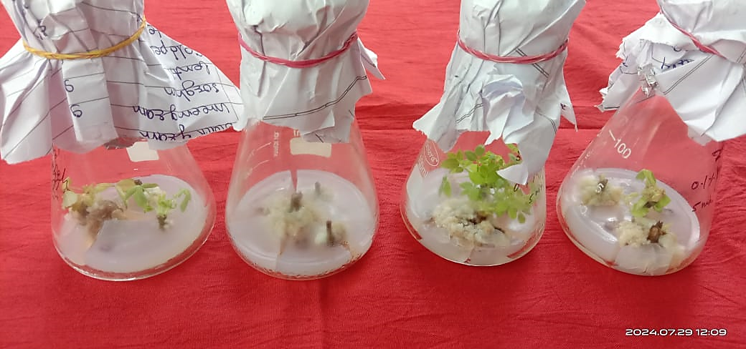

**Fig. 1 Callus induction in second third nodal segment of rose**

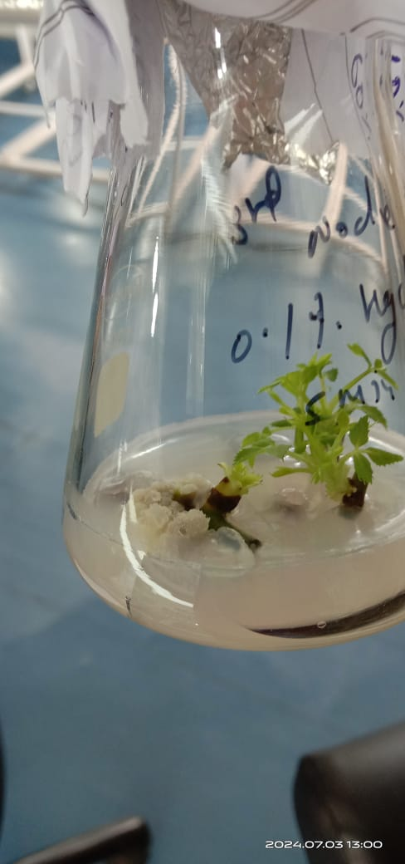

**Fig.2 Callus induction from first nodal segment of rose**

**Tabel 2. Effect of BAP and IAA in callus development on different explant of rose**

**First nodal segment**

|  |  |  |  |
| --- | --- | --- | --- |
| **IAA**  **mg/L** | **BAP (2.0 mg/L)** | | |
| **Mean days taken in callus initiation** | **Fresh weight of callus(g)** | **Response (%)** |
| 0.5 | 27.2 | 0.39 | 50.0 |
| 1.0 | 26.4 | 0.43 | 55.0 |
| 1.5 | 23.8 | 0.54 | 60.0 |
| 2.0 | **21.8** | **0.67** | **65.0** |
| **SE(m) ±** | 0.33 | 0.14 | 0.52 |
| **CD at 5%** | 1.19 | 1.04 | 3.30 |

**Second nodal segment**

|  |  |  |  |
| --- | --- | --- | --- |
| **IAA**  **mg/L** | **BAP (2.0 mg/L)** | | |
| **Mean days taken in callus initiation** | **Fresh weight of callus(g)** | **Response (%)** |
| 0.5 | 25.8 | 0.51 | 60.0 |
| 1.0 | 23.6 | 0.69 | 65.0 |
| 1.5 | 22.0 | 0.73 | 70.0 |
| 2.0 | **20.3** | **0.88** | **70.0** |
| **SE(m) ±** | 0.32 | 0.02 | 0.65 |
| **CD at 5%** | 1.17 | 0.99 | 4.31 |

**Third nodal segment**

|  |  |  |  |
| --- | --- | --- | --- |
| **IAA**  **mg/L** | **BAP (2.0 mg/L)** | | |
| **Mean days taken in callus initiation** | **Fresh weight of callus(g)** | **Response (%)** |
| 0.5 | 23.6 | 0.65 | 75.0 |
| 1.0 | 22.8 | 0.73 | 80.0 |
| 1.5 | 22.5 | 0.86 | 85.0 |
| 2.0 | **18.06** | **0.93** | **85.0** |
| **SE(m) ±** | 0.36 | 0.02 | 0.83 |
| **CD at 5%** | 1.38 | 0.92 | 4.22 |

# CONCLUSION

The combined effect of benzylaminopurine (BAP) and indole-3-acetic acid (IAA) on callus induction in rose plants was investigated. Three nodal segments were used in the experiment, and the following combinations of BAP and IAA concentrations were tested: BAP 1.5 mg/L + IAA 1.0, 1.5, 2.0 mg/L, and BAP 2.0 mg/L + IAA 1.0, 1.5, 2.0 mg/L. The most efficient results were observed when both BAP and IAA were combined at equal concentrations, particularly in the third nodal segment of rose. The combination of 1.5 mg/L BAP and 1.5 mg/L IAA produced the highest response rate (90%), with a callus weight of 0.93g after 20.6 days. Similarly, the combination of 2.0 mg/L BAP and 2.0 mg/L IAA resulted in a response rate of 85%, with a callus weight of 0.93 g after 18.6 days. These findings suggest that balanced concentrations of both BAP and IAA are effective in enhancing callus induction in rose explants, with slightly higher concentrations of BAP and IAA promoting faster callus growth

Disclaimer (Artificial intelligence)

Option 1:

Author(s) hereby declare that NO generative AI technologies such as Large Language Models (ChatGPT, COPILOT, etc.) and text-to-image generators have been used during the writing or editing of this manuscript.

Option 2:

Author(s) hereby declare that generative AI technologies such as Large Language Models, etc. have been used during the writing or editing of manuscripts. This explanation will include the name, version, model, and source of the generative AI technology and as well as all input prompts provided to the generative AI technology

Details of the AI usage are given below:

1.

2.

3.

# REFRENCE

1. Bhojwani, S. S., & Razdan, M. K. (1996). Plant tissue culture: Theory and practice (1st ed.). Elsevier.
2. Debnath, S. C., Malik, S. K., & Bisen, P. S. (2006). Micropropagation: A tool for the production of elite plant material. Current Science, 90(10), 1234–1242.
3. George, E. F., Hall, M. A., & De Klerk, G.-J. (2008). Plant propagation by tissue culture: Volume 1. The background (3rd ed.). Springer.
4. Ikeuchi, M., Sugimoto, K., Iwase, A., & Seo, M. (2013). Plant callus: Mechanisms of induction and repression. The Plant Cell, 25(9), 3159–3173. <https://doi.org/10.1105/tpc.113.116053>
5. Pierik, R. L. M. (1997). In vitro culture of higher plants (2nd ed.). Springer.
6. Reed, B. M. (2008). Plant cryopreservation: A practical guide. In B. M. Reed (Ed.), Plant cryopreservation: A practical guide (pp. 1–22). Springer.
7. Rout, G. R., Samantaray, S., & Das, P. (2006). Tissue culture of ornamental pot plant: A critical review. Plant Cell, Tissue and Organ Culture, 64(2), 105–114. <https://doi.org/10.1023/A:1010623203553>
8. Skoog, F., & Miller, C. O. (1957). Chemical regulation of growth and organ formation in plant tissues cultured in vitro. Symposia of the Society for Experimental Biology, 11, 118–130.
9. Thorpe, T. A. (2007). History of plant tissue culture. Molecular Biotechnology, 37(2), 169–180. <https://doi.org/10.1007/s12033-007-0031-3>
10. Wylie, A. P. (1954). The history of garden roses – Part 1. J. R. Horticsoc79:555-571