Serotyping and antibiogram of Escherichia coli isolated from raw poultry meat in Jammu, India

Abstract
This study investigates the prevalence, serological diversity, and antimicrobial resistance patterns of Escherichia coli strains isolated from raw poultry meat samples collected from retail outlets in Jammu, India. Out of 65 raw poultry meat samples examined, 25 samples (38.46%) tested positive for E. coli contamination. These isolates were further identified through serotyping and antimicrobial susceptibility testing. The isolated E. coli strains belonged to eleven different serotypes, including serogroups O111 and O157, which are recognized as important zoonotic pathogens. Antimicrobial susceptibility testing revealed concerning patterns of resistance, with isolates showing high resistance rates to commonly used antibiotics such as ampicillin (87.69%), nalidixic acid (78.46%), and tetracycline, while maintaining relatively high susceptibility to ciprofloxacin (90.76%) and chloramphenicol (86.15%). Considering the presence of zoonotic E. coli serogroups O111 and O157, it is crucial to implement strict hygiene protocols in retail meat shops to mitigate health risks for both consumers and vendors.
Keywords: Escherichia coli, serotyping, antimicrobial resistance, food safety, zoonotic pathogens
Introduction
Global Context of Foodborne Pathogens in Poultry
Poultry meat represents one of the most consumed protein sources worldwide, with global chicken meat production reaching 102.389 million tons in 2023. However, this widespread consumption is accompanied by significant food safety challenges, as poultry products frequently harbor pathogenic microorganisms that pose substantial risks to human health (Scallan et al.,2011). Raw chicken meat can harbour various microorganisms, including bacteria like Salmonella, Campylobacter, Escherichia coli, and Staphylococcus aureus, which are known causes of foodborne diseases in humans. The prevalence of gram-negative bacteria, particularly coliforms like Escherichia coli, indicates the potential for foodborne illnesses originating from meat products (Clarence et al., 2009). Contamination can occur at various stages, including slaughtering, evisceration, and packaging, exacerbated by environmental factors and human contact (Cohen et al., 2007). These pathogens can enter the meat during various stages of production, processing, transportation, and storage, with retail outlets being a critical point of concern due to frequent consumer interaction and potential for cross-contamination. Ensuring food safety requires rigorous hygiene practices throughout the meat production chain, including slaughtering, processing, storage, and distribution. Factors influencing microbial contamination include animal husbandry practices, slaughter conditions, temperature control, packaging, and consumer handling (Cerveny et al., 2009; Mead, 1989). Understanding these factors helps in developing strategies to improve food safety standards and reduce the risk of foodborne illnesses.
Serotyping and Its Significance
Serotyping of E. coli based on O (somatic) and H (flagellar) antigens remains a fundamental tool for epidemiological surveillance, outbreak investigation, and risk assessment (Johnson and Stell,2000; Mainil and Daube,2005). Certain serotypes, particularly O157:H7, O111, O26, O103, and O145, are associated with severe human diseases, including hemolytic uremic syndrome (HUS) and hemorrhagic colitis (Johnson and Stell,2000; Karmali et al.,2010). The detection of these pathogenic serotypes in food products serves as an important indicator of potential public health risks (Mead and Griffin ,1998; Karmali et al.,2010). Recent molecular epidemiological studies have revealed complex relationships between E. coli strains found in poultry and those causing human infections. The E. coli sequence type ST131, particularly the ST131-H22 sublineage, has been identified as a significant foodborne pathogen that can be transmitted from poultry to humans, causing urinary tract infections and other extraintestinal diseases (Johnson et al.,2009; Manges and Johnson,2017; Alonso,2017).
Materials and Methods
Sample Collection and Processing
A total number of 65 samples of chicken meat from Jammu were collected.10 gm of each sample was taken in sterilized packs and transported in ice box with all aseptic precautions. The samples were randomly collected from local markets. After collection, all the samples were labelled accordingly and held at 4⁰C until examination. To keep time factor constant between sample collection and analysis, all the samples were analyzed within 2-3hrs after collection. This rapid processing protocol is critical for accurate enumeration of viable bacteria and prevents alterations in microbial populations that could occur during extended storage periods.
Bacterial Isolation and Identification
The isolation of E. coli was performed using MacConkey agar, a selective and differential medium that facilitates the growth of gram-negative bacteria while inhibiting gram-positive organisms (Murray et al.,1999). MacConkey agar contains lactose as a fermentable carbohydrate, bile salts as selective agents, and neutral red as a pH indicator, allowing for the differentiation of lactose-fermenting bacteria like E. coli, which appear as pink colonies with characteristic morphology. Briefly, 0.1 ml of the 10⁻² and 10⁻³ dilution were spread plated in triplicate on dried plates of Mac Conkey agar and incubated at 37±2 oC for 24h. The presumptive colonies were determined by counting number of sharp pinkish colonies with about 0.5 mm in diameter and the average numbers of colonies were recorded as log cfu/g of sample.E coli colonies were further confirmed by streaking 4-5 colonies on to EMB agar (Eosin-methylene-blue agar) and colonies with typical metallic sheen were further confirmed by biochemical tests using HiMViCTM test kit (Hi-Media, Mumbai, India) and were transferred to Nutrient agar slants and incubated at 37ºC for 24 hrs. and stored at 4ºC .Subsequently, biochemical confirmation was performed using the HiMViC test kit, which evaluates hydrogen sulfide production, indole formation, methyl red reaction, Voges-Proskauer test, and citrate utilization (Kumar et al.,2018).
Serotyping Methodology
The isolates were sent to the National Salmonella and Escherichia Centre in Kasauli, Himachal Pradesh, India, for additional confirmation and serotyping.
Antimicrobial Susceptibility Testing
Antimicrobial susceptibility testing was performed using the standardized disk diffusion method according to Bauer-Kirby guidelines. This method involves the placement of antibiotic-impregnated disks on Mueller-Hinton agar plates inoculated with a standardized bacterial suspension. The zones of inhibition around each disk are measured after incubation and compared with established interpretive criteria to determine susceptibility, intermediate resistance, or resistance. The antibiotic panel included agents commonly used in both veterinary and human medicine, representing different antimicrobial classes: beta-lactams (ampicillin, amoxicillin), fluoroquinolones (ciprofloxacin, nalidixic acid), tetracyclines (tetracycline), phenicols (chloramphenicol), folate pathway inhibitors (co-trimoxazole), and polymyxins (polymyxin B). This comprehensive panel allows for the assessment of resistance patterns across multiple drug classes and identification of multidrug-resistant strains (Kumar et al.,2018).
Results
Prevalence of E. coli Contamination
Various microorganisms are known to cause foodborne illnesses, with E. coli being a significant pathogen responsible for food poisoning. This study examined poultry meat samples collected from different retail shops, revealing contamination with several strains of E. coli that could pose a risk to both consumers and individuals involved in the meat processing industry. Out of 65 poultry meat samples, 25(38.46%) tested positive for E. coli (fig1). This indicates that poultry meat contamination with E. coli strains is a concern, potentially linked to lapses in proper hygiene practices before and during slaughter.
Serotyping Results and Serogroup Distribution
Serotyping analysis conducted at the National Salmonella and Escherichia Centre successfully characterized 19 out of 21 E. coli isolates, with 2 isolates remaining untypeable and 2 identified as rough strains lacking complete O-antigen expression. The serotyping results revealed considerable diversity among the isolated strains, with representation from multiple serogroups of varying pathogenic potential.
The most prevalent serogroup was O7, accounting for 8 isolates (32% of total isolates). Serogroups O111 and O120 were each represented by 3 isolates (12%), while O17 was found in 2 isolates (8%). Several other serogroups, including O18, O22, O88, O109, and O158, were each represented by single isolates (4% each)(fig2). This diversity in serogroup representation is consistent with the heterogeneous nature of E. coli populations in poultry environments and reflects the complex ecological dynamics of these bacteria in food production system (Kumar et al.,2018). Of particular concern was the detection of serogroups O111 and O157, both of which are recognized as important zoonotic pathogens with the potential to cause severe human disease. Serogroup O111 is classified among the "Big Six" non-O157 Shiga toxin-producing E. coli (STEC) serogroups that are regulated by food safety authorities in many countries due to their association with serious foodborne illness outbreaks. Similarly, O157 strains, particularly O157:H7, are well-established causes of hemorrhagic colitis and hemolytic uremic syndrome (Karmali et al.,2010).
Antimicrobial Resistance Patterns
The antimicrobial susceptibility testing revealed concerning patterns of resistance among the E. coli isolates, with significant implications for both veterinary and human medicine. The isolates demonstrated the highest susceptibility to ciprofloxacin (90.76%), followed by chloramphenicol (86.15%), co-trimoxazole (86.61%), and polymyxin B (81.53%). These findings suggest that these antimicrobial agents may remain effective for treating E. coli infections in the immediate term, although continuous monitoring is essential to detect emerging resistance. Conversely, the isolates exhibited alarming levels of resistance to several commonly used antibiotics. Ampicillin resistance was observed in 87.69% of isolates, representing the highest resistance rate among all tested antibiotics. Nalidixic acid resistance was found in 78.46% of isolates, while tetracycline resistance affected a substantial proportion of the bacterial population (fig 3). These high resistance rates are consistent with global trends in antimicrobial resistance among E. coli isolates from poultry sources (Li et al.,2007). The observed resistance patterns reflect the selective pressure exerted by the widespread use of antimicrobials in poultry production systems. Ampicillin, a beta-lactam antibiotic, has been extensively used in veterinary medicine for both therapeutic and prophylactic purposes, leading to the selection and proliferation of resistant strains (Bush and Bradford,2016; Livermore,1995). Similarly, the high resistance rates to nalidixic acid and tetracycline can be attributed to their frequent use in poultry farming operations (Li et al.,2007).
Discussion
The microbiological analysis revealed that 25 out of 65 raw poultry meat samples (38.46%) were contaminated with E. coli. This contamination rate is consistent with international monitoring reports, which have identified E. coli prevalence rates ranging from 34.6% to 79.8% in retail poultry products (Zhao et al., 2001). The observed prevalence aligns closely with studies conducted in other regions of India and neighboring countries, suggesting similar challenges in poultry production and handling practices across South Asian markets (Nataro and Kaper, 1998; Dierikx et al., 2010). The 38.46% prevalence rate observed in this study falls within the range reported by comparable investigations in developing countries (Fig. 1). For instance, studies from West Bengal, India, reported 39.76% contamination in raw poultry meat, while investigations in Bangladesh documented prevalence rates of 78.67% in layer chickens and 82% in broiler chickens. Similarly, a study conducted in Uganda by Nagingo et al. (2022) found significant E. coli contamination in both street-cooked and raw meat sold in local markets, highlighting the widespread nature of bacterial contamination in meat across different low- and middle-income settings. In support of these findings, Azzawi and Essa (2022) reported the presence of enteric bacteria, including E. coli, in meat and meat products sold in Mosul City, further emphasizing the global nature of microbial contamination in meat. This variation in contamination rates likely reflects differences in production systems, processing methods, hygiene practices, and environmental conditions across different geographical locations (Nataro and Kaper, 1998).
Based on the antibiogram pattern of E. coli (n=65), E. coli isolates revealed highest resistance to ampicillin (87.69%) while lowest resistance was shown against Ciprofloxacin (3.07%) and co-trimoxazole (4.61%). Our results are in corroboration with other workers who found higher resistance of E. coli against ampicillin, 100 percent by (Hossnera et al., 2007); 98.02 percent by (Saha et al., 2003); 77.5 percent by (Dhanushree and Mallaya,2008). The resistance of E. coli isolates against above mentioned microbial agent may be due to indiscriminate and irrational use in the fields (Saha et al., 2003). The reason behind highest resistance may be due to indiscriminate use of antibiotics making gram positive bacteria resistant to that drug.
Conclusion, Recommendations and Future Directions
Enhanced Surveillance Systems
The development of surveillance systems for monitoring foodborne pathogens and antimicrobial resistance in poultry production is important for the early detection of emerging threats.
Regulatory Framework Development
The strong regulatory systems are essential to supervise the use of antimicrobial in livestock for controlling the rise of resistance. These systems should enforce rules such as allowing only prescription-based antibiotic use, ensuring veterinary supervision, limiting the use of critically important antimicrobials, and adopting national strategies that are in line with international efforts (WHO, 2015).
Conclusion
In summary, foodborne illnesses linked to pathogens such as Salmonella, Staphylococcus aureus, and Escherichia coli pose serious global health challenges, largely due to the consumption of contaminated meat. Poor hygiene during various stages of meat production and distribution significantly increases the risk of microbial contamination. Minimizing these threats requires the consistent application of standard protocols, including routine inspections, regular hygiene monitoring, health screening of meat handlers, and strict adherence to regulations in both authorized and unauthorized slaughter facilities. Promoting awareness about safe handling practices for raw meat, along with continuous microbiological surveillance, is vital for ensuring meat safety and safeguarding public health. A multifaceted approach emphasizing improved sanitation, responsible antibiotic use, alternative methods to control pathogens, and robust monitoring systems is critical for lowering the incidence of foodborne diseases and tackling antimicrobial resistance (McEwen and Collignon, 2017).

Data Availability statement: Nil
Disclaimer (Artificial intelligence)
Author(s) hereby declare that NO generative AI technologies such as Large Language Models in the manuscript.
References
- Alonso CA, Zarazaga M, Ben Sallem R, Jouini A, Ben Slama K, Torres C. Antibiotic resistance in Escherichia coli in husbandry animals: the African perspective. Lett Appl Microbiol. 2017;64(5):318-34. doi:10.1111/lam.12724.
- Azzawi MA, Essa MA. The prevalence and distribution of enteric bacteria in meat and meat products in Mosul City. South Asian J Res Microbiol. 2022;13(3):12–17. doi:10.9734/sajrm/2022/v13i330299.
- Bush K, Bradford PA. Beta-lactams and beta-lactamase inhibitors: an overview. Cold Spring Harb Perspect Med. 2016;6(8):a025247. doi:10.1101/cshperspect.a025247.
- Cerveny J, Meyer JD, Hall PA. Microbiological spoilage of meat and poultry products. In: Reineke K, editor. Compendium of the microbiological spoilage of foods and beverages. 1st ed. Amsterdam: Elsevier; 2009. p. 69–86.
- Clarence SY, Obinna CN, Shalom NC. Assessment of bacteriological quality of ready to eat food (Meat pie) in Benin City metropolis, Nigeria. Afr J Microbiol Res. 2009;3(6):390–5.
- Cohen N, Ennaji H, Bouchrif B, Hassar M, Karib H. Comparative study of microbiological quality of raw poultry meat at various seasons and for different slaughtering processes in Casablanca (Morocco). J Appl Poult Res. 2007;16(4):502–8.
- Dhanashree B, Mallya PS. Detection of shiga toxigenic Escherichia coli (STEC) in diarrhoeagenic stool and meat samples in Mangalore, India. Indian J Med Res. 2008;128:271–7.
- Dierikx C, van Essen-Zandbergen A, Veldman K, Smith H, Mevius D. Increased detection of extended spectrum beta-lactamase producing Salmonella enterica and Escherichia coli isolates from poultry. Vet Microbiol. 2010;145(3-4):273-8. doi:10.1016/j.vetmic.2010.03.019.
- Hossnera AA, Khan MSR, Islam MJ, Nazir KHMNH, Rahman MT. Detection of colicinogenic Escherichia coli isolates and interrelatedness with their enteropathogenicity and antibiotic resistant pattern. J Bangladesh Soc Agric Sci Technol. 2007;4(1 & 2):173–6.
- Johnson JR, Menard M, Johnston B, Kuskowski MA, Nichol K, Zhanel GG. Epidemic clonal groups of Escherichia coli as a cause of antimicrobial-resistant urinary tract infections in Canada, 2002 to 2004. Antimicrob Agents Chemother. 2009;53(7):2733-9. doi:10.1128/AAC.00297-09.
- Johnson JR, Stell AL. Extended virulence genotypes of Escherichia coli strains from patients with urosepsis in relation to phylogeny and host compromise. J Infect Dis. 2000;181(1):261-72. doi:10.1086/315217.
- Karmali MA, Gannon V, Sargeant JM. Verocytotoxin-producing Escherichia coli (VTEC). Vet Microbiol. 2010;140(3-4):360-70. doi:10.1016/j.vetmic.2009.04.011
- Kumar A, Sharma NK, Gupta A, Singh SP. Serotyping and antibiogram of Escherichia coli isolated from raw poultry meat in Jammu region. J Adv Biol Biotechnol. 2018;17(2):1-8.
- Li XZ, Mehrotra M, Ghimire S, Adewoye L. Beta-lactam resistance and beta-lactamases in bacteria of animal origin. Vet Microbiol. 2007;121(3-4):197-214. doi:10.1016/j.vetmic.2007.01.015
- Livermore DM. Beta-lactamases in laboratory and clinical resistance. Clin Microbiol Rev. 1995;8(4):557-84. doi:10.1128/CMR.8.4.557
- Mainil JG, Daube G. Verotoxigenic Escherichia coli from animals, humans and foods: who's who? J Appl Microbiol. 2005;98(6):1332-44. doi:10.1111/j.1365-2672.2005.02653.x
- Manges AR, Johnson JR. Food-borne origins of Escherichia coli causing extraintestinal infections. Clin Infect Dis. 2012;55(5):712-9. doi:10.1093/cid/cis502
- McEwen SA, Collignon PJ. Antimicrobial resistance: a One Health perspective. Microbiol Spectr. 2018;6(2):ARBA-0009-2017. doi:10.1128/microbiolspec.ARBA-0009-2017
- Mead C. Hygiene problems and control of process contamination. In: Mead GC, editor. Processing of poultry. Amsterdam: Elsevier Science Publishers; 1989. p. 183–220.
- Mead PS, Griffin PM. Escherichia coli O157:H7. Lancet. 1998;352(9135):1207-12. doi:10.1016/S0140-6736(98)01267-7
- Murray PR, Baron EJ, Pfaller MA, Tenover FC, Yolken RH, editors. Manual of Clinical Microbiology. 7th ed. Washington (DC): American Society for Microbiology; 1999.
- Nagingo P, Omara D, Mwesigwa JP, Lujjimbirwa F. Pathogenic bacteria profiles in street cooked and raw meat from selected markets in Entebbe Municipality, Uganda. J Adv Microbiol. 2022;22(11):49–54. doi:10.9734/jamb/2022/v22i11681.
- Nataro JP, Kaper JB. Diarrheagenic Escherichia coli. Clin Microbiol Rev. 1998;11(1):142-201. doi:10.1128/CMR.11.1.142.
- Saha A, Hui AK, Das R, Roy JP, Ray N, Mahata TK. Occurrence of Escherichia coli from broiler birds in Bengal and their antibiogram. Indian J Anim Health. 2003;42(2):136–41
- Scallan E, Hoekstra RM, Angulo FJ, Tauxe RV, Widdowson MA, Roy SL, et al. Foodborne illness acquired in the United States—major pathogens. Emerg Infect Dis. 2011;17(1):7-15. doi:10.3201/eid1701.P11101.
- Stanescu V, Chirila F, Sahleanu C, Vana V. Occurrence of E. coli serogroups in raw and pasteurized milk and in chicken meat: pathogenic potential in man and animal. In: Proceedings of the 3rd World Congress on Foodborne Infections and Intoxications; 1992 Jun 16–19; Berlin, Germany. Berlin: Robert von Ostertag-Institute; 1992. p. 509–12.
- World Health Organization. Global action plan on antimicrobial resistance. Geneva: World Health Organization; 2015.
- Zhao S, White DG, McDermott PF, et al. Identification and expression of cephamycinase bla(CMY) genes in Escherichia coli and Salmonella isolates from food animals and ground meat. Antimicrob Agents Chemother. 2001;45(12):3647-50. doi:10.1128/AAC.45.12.3647-3650.2001.

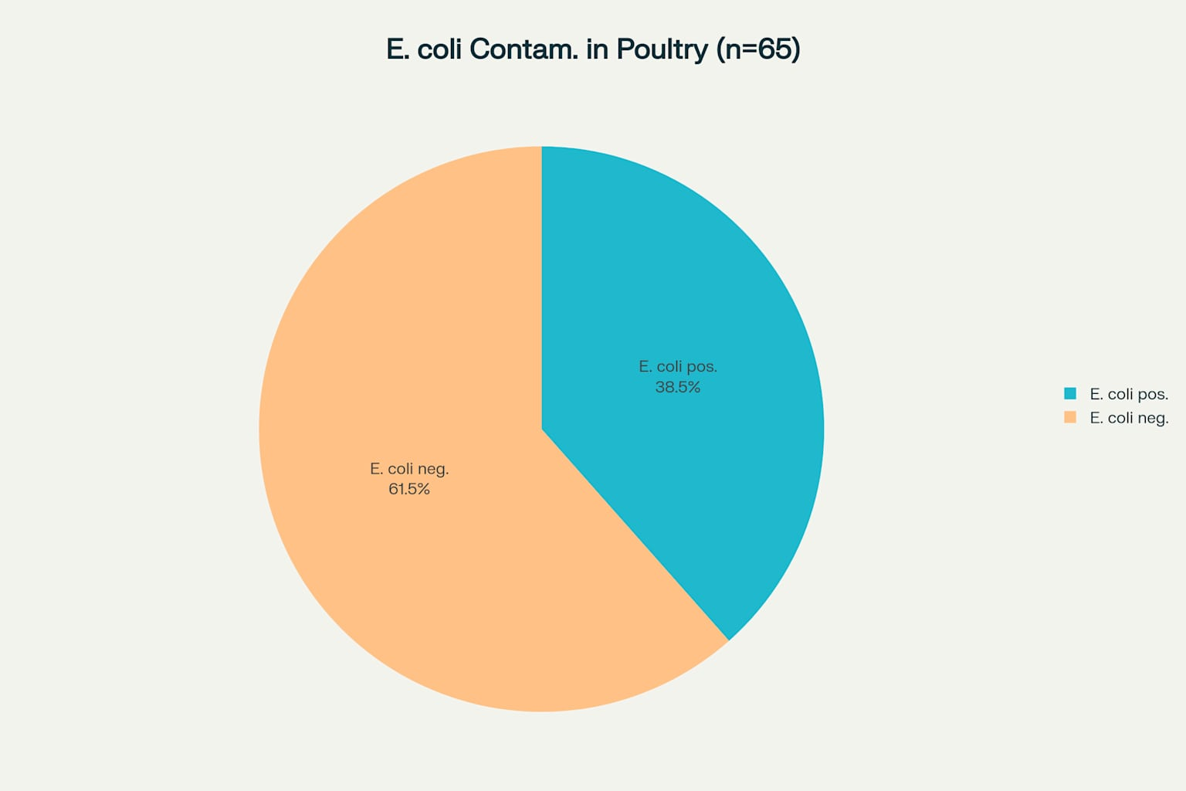
Figure 1: Overall prevalence of E. coli contamination in raw poultry meat samples collected from retail outlets
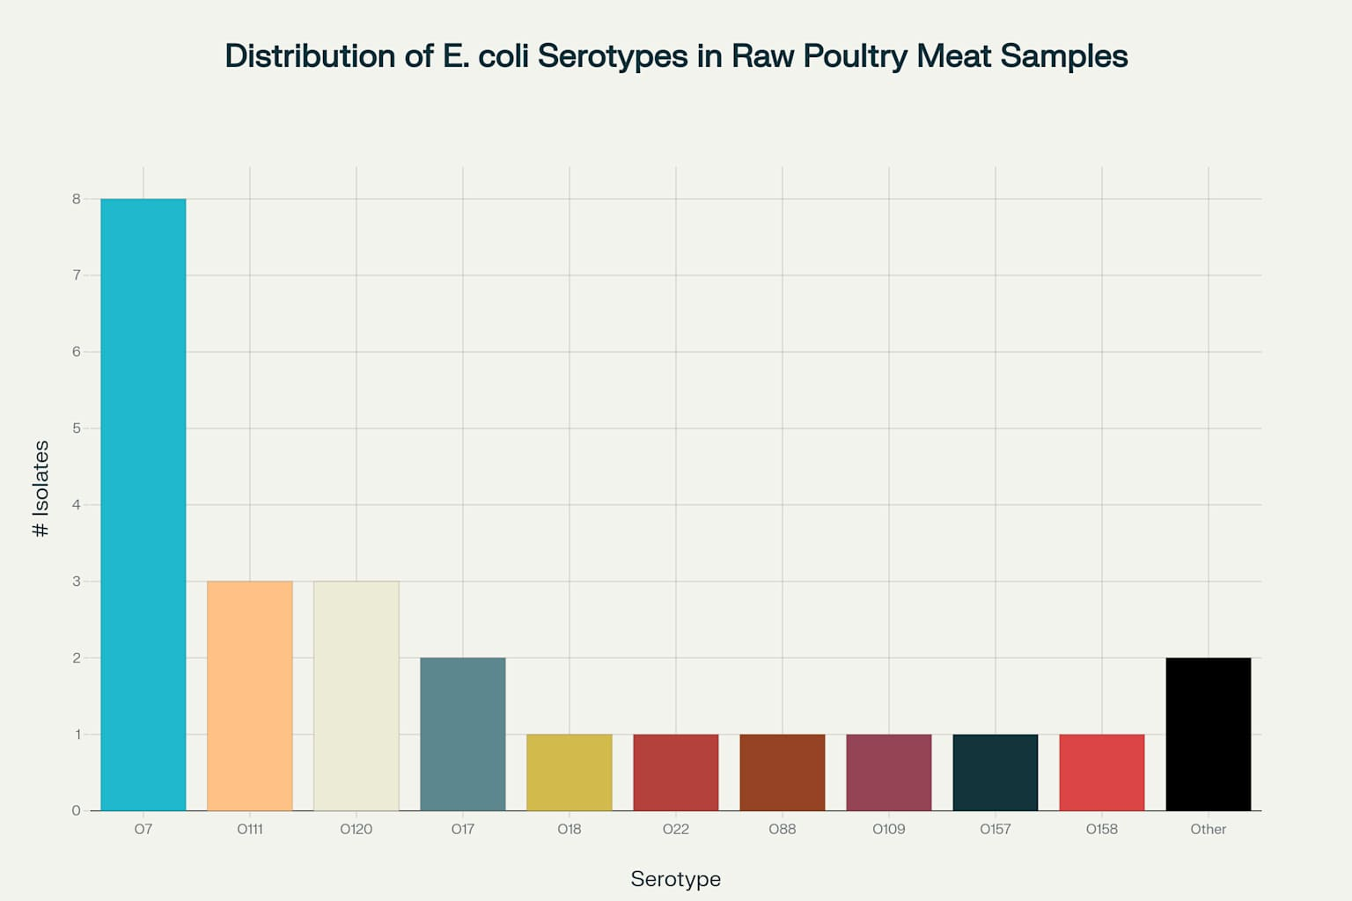
Figure 2: Distribution of E. coli serotypes isolated from raw poultry meat samples, showing O7 as the most prevalent serogroup

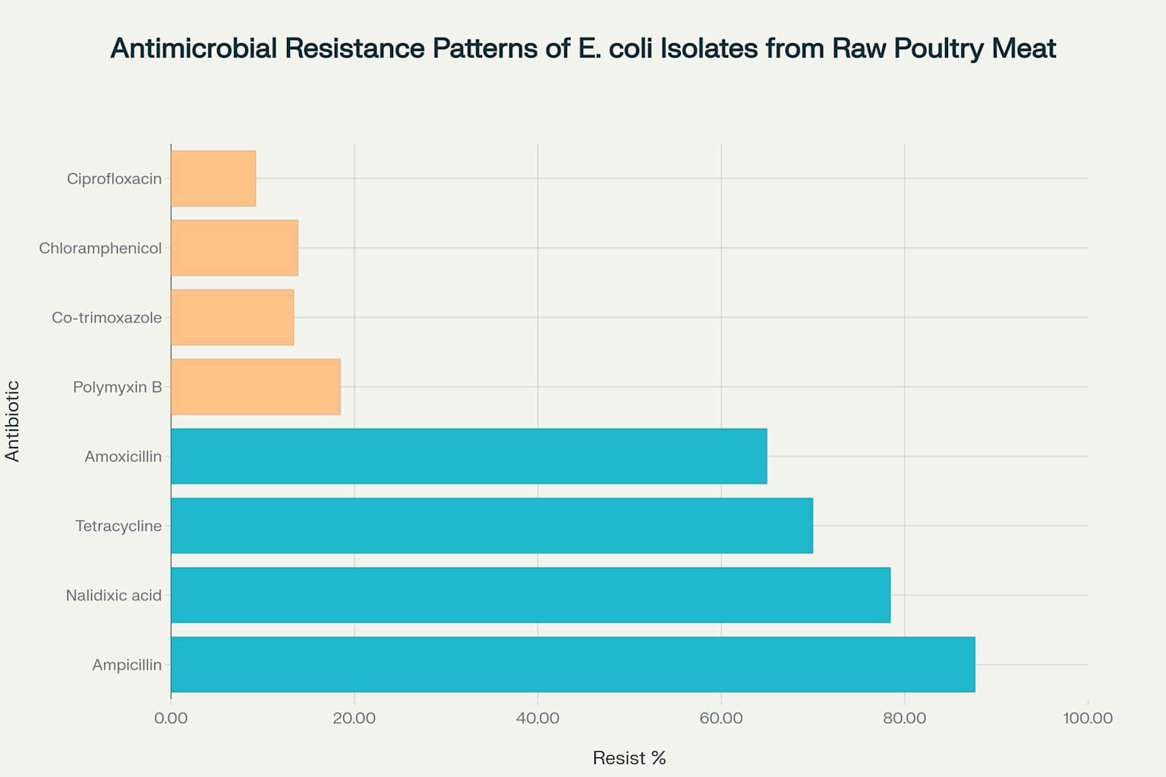
Figure 3: Antimicrobial resistance patterns showing high resistance to beta-lactams and quinolones, with preserved susceptibility to chloramphenicol and ciprofloxacin

