**Biotechnological Routes to Detoxification of Mining Pollutants: A Comprehensive Review of Recent Trends and Mechanisms in Heavy Metal Bioremediation**

**Abstract**

Water pollution caused by mining activity presents significant environmental and public health challenges. Open-pit mining, acid mine drainage (AMD), and heavy metals such as arsenic, mercury, lead, and cadmium threaten local ecosystems and populations. Open-pit mining, acid mine drainage (AMD), and heavy metals such as arsenic, mercury, lead, and cadmium threaten local ecosystems and tribal populations. Hydrogeochemical analysis reveals pH levels of 7.1 to 7.9 and total dissolved solids (TDS) up to 437 mg/L, TDS, turbidity, and SO42− exceeded the Bureau of Indian Standards (BIS) drinking acceptable limits and suggested that water is unsuitable for direct consumption with pollution sources including mining discharge (22.4%) and ash dumping (41.3%). Biotechnological solutions show promise for mitigating mining pollution. Desulfovibrio desulfuricans and Acidithiobacillus ferrooxidans detoxify AMD by neutralizing acidity and removing metals like cadmium and lead. Bacillus cereus combined with biochar efficiently removes arsenic, cadmium, and chromium without harming aquatic life or crops. Systematic water sampling analyzed pH, turbidity, and heavy metals using advanced spectroscopy techniques. Insights from mines highlight microbial diversity in methane wells, dominated by Methanobacteria for hydrogenotrophic methanogenesis, and Roseomonas and Methylobacterium in marginal wells aiding methane utilization. This study aims to identify specific pollutants affecting water quality near mining areas and explore sustainable microbial treatments for detoxification. Evaluating health risks from long-term exposure to toxic metals will address knowledge gaps and guide actionable recommendations for improving water quality, safeguarding public health, and promoting sustainable mining practices in the region

**Keywords**: Water Pollution, Mining, Heavy Metals, Microbial Remediation, Bioremediation, Acid Mine Drainage, Public Health

**Introduction**

Mining refers to the process of extracting metals and minerals from the earth. The mining industry is one of the most energy-intensive sectors globally, accounting for approximately 38% of total industrial energy consumption and 15% of global electricity usage (Igogo et al., 2021), and plays a crucial role in providing the essential raw materials required for various sectors such as agriculture, housing, music, telecommunications, environmental services, construction, space exploration, and healthcare (Li et al., 2024). In today’s world, it is nearly impossible to imagine life without minerals (Jhariya and Chourasia, 2010). While the mining industry significantly contributes to the comfort and convenience of our daily lives, it is important to recognize that every activity has two sides-positive and negative. Mining, a key economic activity in many developing nations, not only supports economic growth but also creates numerous employment opportunities (Sumi et al., 2016). However, it significantly contributes to environmental degradation, especially water pollution. Wastewater from mining sites is often rich in heavy metals, metalloids, sulfates, and acidic compounds, which pose long-term risks to ecosystems and human health (Wolkersdorfer et al., 2022). Acid mine drainage AMD, one of the most severe consequences, leads to the leaching of toxic metals into surrounding water bodies, causing acidification and metal contamination (Gomes et al., 2024). These heavy metals present significant risks to both human health and ecosystems (Li et al., 2023).

Heavy metals such as arsenic, cadmium, and lead, commonly present in mining wastewater, pose significant health hazards to humans. Chronic exposure to these toxic elements through contaminated water can result in severe health issues. For instance, lead exposure has been linked to neurological damage, particularly affecting children's cognitive development and IQ levels (Jomova et al., 2024). Cadmium accumulation in the body can lead to kidney and liver dysfunction, while long-term exposure to arsenic is associated with an increased risk of various cancers, including those of the skin, lungs, and bladder (Ghosh et al., 2022; WHO, 2017; Pandey et al., 2014). Moreover, communities residing near mining areas frequently face challenges such as inadequate sanitation and a high incidence of waterborne diseases, largely due to polluted groundwater and ineffective remediation strategies (Kim et al., 2024). In aquatic environments, low water pH increases the bioavailability and toxicity of these metals, thereby reducing the diversity of aquatic biota, including microbes, periphyton, macroinvertebrates, and fish (García et al., 2015; Hogsden et al., 2012). These metals bioaccumulate and biomagnify, leading to gill damage, reproductive failure in fish, amphibian sensitivity, and reduced biodiversity downstream (Hussain et al., 2021; Jain et al., 2021; Pereira et al., 2020). On land, heavy metals in mining wastewater inhibit plant growth by disrupting root development, reducing soil enzyme activity, and suppressing photosynthesis by damaging chloroplasts and interfering with light absorption and carbon fixation (Paul et al., 2024; Ghosh et al., 2023; Singh et al., 2021; Wu et al., 2016). Soil microbial diversity also declines, affecting soil fertility and natural biodegradation processes. Although physicochemical methods like chemical precipitation and membrane filtration are used to treat mining effluents, they are often costly, energy-intensive, and generate toxic sludge, limiting their effectiveness in complex or resource-poor settings (Saxena et al., 2024; Padma et al., 2023).

Traditional methods to manage mining-induced water pollution, such as chemical treatments and physical filtration, are resource-intensive and limited in scope. Biotechnological approaches, particularly microbial remediation, have emerged as sustainable alternatives. Bioremediation is a sustainable and cost-effective technology that uses bacteria, other microorganisms, and plants to degrade or remove pollutants. It relies on natural metabolic processes to detoxify contaminated environments. This eco-friendly approach reduces chemical usage and minimizes environmental impact (Sahu et al., 2024; Shreedevi et al., 2022). Identifying low-cost and less invasive technologies is necessary for addressing the remediation of HM-contaminated sites. In situ bioremediation approaches, i.e., biostimulation, biosparging, bioventing, and bioaugmentation or microorganisms-assisted phytoremediation have been recently considered for the decontamination of HMs contaminated soils (Soldi et al., 2020). The use of bioremediation technologies can prevent secondary HMs dispersal and unnecessary human exposure can be avoided. Biogenic and recycled materials from microbes, plants, and animals offer eco-friendly wastewater treatment by binding contaminants through biosorption. Fungi act as cost-effective biosorbents for arsenic removal (Kumar et al., 2021) while Bacillus arsenicus biofilm on Neem leaves, combined with MnFe₂O₄ composite, efficiently removes arsenic ions. This process follows film diffusion, reaching equilibrium at 30°C, making it a sustainable and efficient method for heavy metal remediation (Shim J, 2019).

This review aims to explore current research on water pollution in areas surrounding mining activities and evaluate microbe-based treatment methods for the removal of heavy metals, hydrocarbons, acidic substances, and other pollutants from contaminated water. The primary objectives of this study are to identify the major pollutants commonly found in mining wastewater and to explore the underlying mechanisms by which bacteria and fungi interact with and transform these contaminants. Additionally, the study aims to present recent case studies that demonstrate successful applications of microbial bioremediation in mining-affected environments. Finally, it seeks to evaluate the overall effectiveness of microbial remediation strategies, examine the associated challenges, and assess their future prospects for sustainable and eco-friendly wastewater management and bridge knowledge gaps, and promote sustainable approaches to managing mining-related water pollution through microbial technologies.

**Overview of Previous Research**

Mining areas are regions where minerals, ores, and other valuable materials are extracted from the earth. These areas are classified into various types, including surface mining, underground mining, placer mining, and mountaintop removal. Surface mining techniques, such as open-pit and strip mining, involve removing large sections of earth to access valuable materials like coal, gold, and copper ( Li et al., 2024).

The applications of mining are vast and vital to the global economy. Mining provides raw materials for energy production, such as coal and uranium, which are essential for electricity generation and nuclear power. Additionally, metals like copper, gold, silver, and aluminum, along with industrial minerals such as limestone and gypsum, are crucial for manufacturing, infrastructure, and construction. Mining also plays a significant role in producing rare earth minerals used in technology, including lithium for batteries and neodymium for magnets. (USGS, 2023).

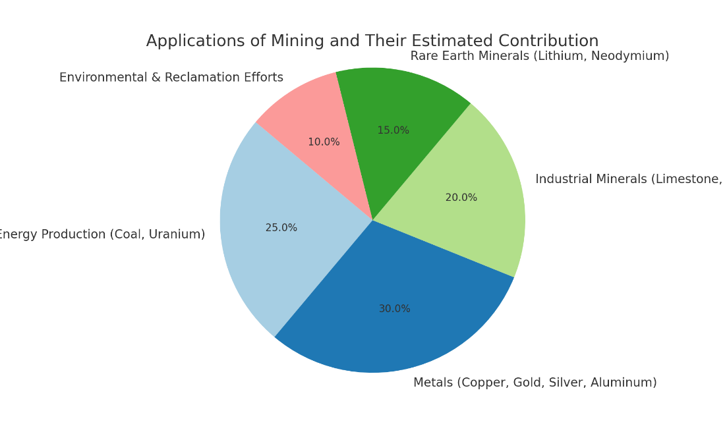

**Figure 1: Application of mining and its estimated Contribution (USGS, 2023).**

The estimated global production volumes of major mining materials increased slightly from 2023 to 2024, reflecting rising demand across energy, construction, and technology sectors. Large-scale resources such as coal, copper, and limestone continue to dominate global output, supporting electricity generation, infrastructure, and industrial use. Meanwhile, high-value or critical materials like lithium and neodymium, although produced in smaller quantities, remain essential for battery technologies and advanced electronics. The table presented here offers a snapshot of how both traditional and emerging materials are contributing to the global mining landscape. ( IEA, 2023-24)

**Table 1 - Estimated Global Production of Key Mining Materials (2023 vs. 2024)**

|  |  |  |  |
| --- | --- | --- | --- |
| Material | 2023 Production | 2024 Production | Unit |
| Coal (Energy Production) | 8,000 | 8,100 | Mt |
| Uranium (Nuclear Energy) | 50 | 52 | Kt |
| Copper (Electronics/Construction) | 21,000 | 21,500 | Kt |
| Gold (Finance/Technology) | 3,300 | 3,350 | Kt |
| Silver (Electronics/Industry) | 27,000 | 27,500 | Kt |
| Aluminum (Construction/Transport) | 68,000 | 69,000 | Kt |
| Limestone (Cement/Industry) | 4,000,000 | 4,050,000 | Kt |
| Gypsum (Construction) | 150,000 | 152,000 | Kt |
| Lithium (Batteries) | 130 | 135 | Kt |
| Neodymium (Magnets/Technology) | 60 | 62 | Kt |

(IEA report, 2023-24)

**Environmental and reclamation efforts in mining, including restoring ecosystems post-mining and recycling valuable materials, are becoming increasingly important due to growing concerns about sustainability (Hoxha et al., 2025).** Despite the economic benefits, mining faces challenges such as deforestation, water pollution, worker safety, and the displacement of local communities. These issues make it essential for the industry to adopt more sustainable practices to minimize its environmental and social impacts ( Mononen et al., 2022). Wang et al ( 2021) describe types of pollution generated by mining activity, including air pollution from dust and emissions, water pollution from the discharge of chemicals and heavy metals, and soil contamination due to the improper disposal of waste materials. These pollutants can severely affect surrounding ecosystems, human health, and biodiversity. Sustainable mining practices aim to minimize these pollutants and restore affected environments.

**Table 2 - Pollutant Type, Source in Mining Areas and Environmental Impact**

|  |  |  |  |  |
| --- | --- | --- | --- | --- |
| S.  no. | Pollutant Type | Source in Mining Areas | Environmental Impact | Refrences |
| 1. | Heavy Metals | Mining of metals like copper, lead, zinc, and gold (e.g., from pyrite) | Toxic to aquatic life, bioaccumulation, soil contamination | Smith, J., et al. (2023). |
| 2. | Acid Mine Drainage (AMD) | Oxidation of sulfide minerals (e.g., pyrite) | Lowers pH, mobilizes toxic metals, harms aquatic life | Brown, P., et al. (2015). |
| 3. | Suspended Solids/Sediments | Blasting, excavation, runoff | Increases turbidity, disrupts aquatic habitats | Lee, H., et al. (2019) |
| 4. | Cyanide & Mercury | Gold and silver extraction, amalgamation | Highly toxic, water contamination, bioaccumulation | Turner, R., et al. (2018 |
| 5. | Hydrocarbons/Oils | Machinery leaks, fuel spills | Soil and water contamination, toxic to microbes and plants | Chen et al. (2022chen). |
| 6. | Nutrients (Nitrates/Phosphates) | Explosives, fertilizers in reclamation areas | Eutrophication, algal blooms | |  | | --- | |  |  |  | | --- | | Zhang, Y., et al. (2022). | |
| 7. | Dust/Particulate Matter | Crushing, transport, wind erosion | Air pollution, respiratory issues | Kumar, V., et al. (2020). |
| 8. | Radionuclides | Uranium and rare earth mining | Radiation exposure, long-term soil and water contamination | Zhang, L., et al. (2021) |

**Soil Degradation Due to Mining Practices-**

Coal contamination in soils significantly alters microbial diversity. Zhang et al ( 2025) studied that **Coal-Contaminated Soils (CCS)**, with coal carbon content ranging from 7.08–11.44%, showed an increase in microbial diversity compared to **Coal-Free Soils (CFS)**, which had 0% coal carbon. Certain microorganisms like ***Anaerolineae****,* ***SBR1031***, ***Streptosporangiales****,* and ***Chryseolinea****,* which are efficient in **carbohydrate degradation**, thrived in CCS. This suggests that coal contamination selects for microbes that can break down coal-related compounds. Bacterial diversity in CCS increased by 0.16 units, and fungal diversity also rose, indicating that coal pollution supports a broader range of microbial life. The microbial network in CCS became more complex, with increased connections between species, indicating a more resilient and adaptable community. Soil pollution can lead to the contamination of food crops with harmful heavy metals and toxins, which, when consumed, can cause serious health issues like organ damage, cancer, and neurological disorders. It also disrupts ecosystems, affecting water quality and air, further impacting human health ( Abadia et al., 2022).

**Table 3-** The table illustrates how the age of mines influences soil contamination levels. Older mines, such as the Huize lead-zinc mine in China (>50 years) and the Carajas iron mine in Brazil (>40 years), show higher concentrations of heavy metals in the surrounding soil.ilient and adaptable community

|  |  |  |  |  |  |  |
| --- | --- | --- | --- | --- | --- | --- |
| Mining Type | Country | Heavy Metal Ions | Standard Range in Soil (µg/g) | Total Concentration (µg/g) | Age of Mine | Reference |
| Lead-zinc mining | China | Lead, | 10 – 100 | 1230 | >50 years | Cao et al., 2022, |
| Iron mining | Brazil | Iron | - | 950 | >40 years | Cruz et al., 2021, |
| Copper mining | Chile | Copper | 15-75 | 800 | >30 years | Arratia-Solar and Paredes, 2023, |
| Manganese mining | South Africa | Manganese | 300-1000 | 720 | >25 years | Lukich and Ecker, 2022 |
| Zinc mining | Australia | Zinc | 10 - 300 | 1100 | >35 years | Zheng et al., 2021 |
| Lead mining | USA | Lead | - | 1050 | >48 years | Walton-Day and Mills, 2015 |

**Mining-Induced Water Contamination-**

Mining causes water pollution by releasing acid mine drainage and heavy metals like lead and mercury into water bodies. Chemical spills and sediment runoff also degrade water quality, harming both ecosystems and human health (Briffa et al., 2020). Hydrogeochemical analysis by Tiwari et al. (2024) shows pH levels ranging from 7.1 to 7.9 and total dissolved solids (TDS) reaching up to 437 mg/L. Parameters like TDS, turbidity, and sulfate (SO₄²⁻) exceeded the Bureau of Indian Standards (BIS) permissible limits for drinking water, indicating that the water is unfit for direct consumption. Mining discharge was identified as a major pollution source, contributing approximately 22.4% to the contamination Haan et al. ( 2018) outlined the permissible limits for mining-affected water as follows: Total Dissolved Solids (TDS) between 500–2000 mg/L, Suspended Solids (SS) 10–100 mg/L, Biological Oxygen Demand (BOD) up to 5 mg/L, Chemical Oxygen Demand (COD) 10–100 mg/L, pH range 7–9.5, conductivity between 600–10,000 µS/cm, and colour levels ranging from 30–600 units. In Malaysia, ex-mining lakes hold substantial water volumes and are being considered as potential sources for daily water supply. Tripathi et al. (2016) observed varying concentrations of heavy metals in Central Asia. The levels were as follows: Copper ranged from 0.002 to 1.8 ppm, Chromium from 0.001 to 2.1 ppm, Lead from 0.001 to 4.03 ppm, Nickel from 0.0001 to 2.3 ppm, Iron from 0.003 to 5.43 ppm, and Cadmium from 0.0002 to 1.7 ppm. These findings provide a snapshot of the heavy metal contamination levels in the area, highlighting the variations in concentration that may be influenced by both natural and anthropogenic factors.

**Table 4** Heavy metal concentrations, along with their permissible limits set by WHO for drinking water, help to determine which concentrations are high or low:

|  |  |  |  |
| --- | --- | --- | --- |
| Heavy Metal | Observed Range (ppm) | WHO Permissible Limit (ppm) | Comparison |
| Copper (Cu) | 0.002 – 1.8 | 1.0 | Higher in some locations |
| Chromium (Cr) | 0.001 – 2.1 | 0.05 | Higher in several locations |
| Lead (Pb) | 0.001 – 4.03 | 0.01 | High in 50% of samples |
| Nickel (Ni) | 0.0001 – 2.3 | 0.02 | Higher in many locations |
| Iron (Fe) | 0.003 – 5.43 | 0.3 | High in most samples |
| Cadmium (Cd) | 0.0002 – 1.7 | 0.003 | Higher in 54% of samples |

Due to the increasing contamination of soils and water bodies with heavy metals, which poses significant environmental and health risks, bioremediation has emerged as a viable solution. This process uses microorganisms to degrade or transform toxic substances into less harmful forms, offering an eco-friendly and cost-effective alternative. Bioremediation helps restore contaminated environments, reducing the long-term impact of heavy metal pollution Rajput et al., 2025).

**Bioremediation** involves the use of microorganisms, such as bacteria and fungi, to remove or neutralize pollutants from contaminated soil and water. The primary goal is to restore polluted environments by harnessing the natural metabolic processes of microbes to degrade, transform, or detoxify harmful substances ( Praveen et al., 2022). Dangerous substances on the surface are removed through biological treatment, where bacteria multiply to break down organic matter. This process involves delivering oxygen and nutrients to the contaminated area, aiding in the degradation of pollutants ( Mery Kensa, 2017).

**A. Plant-Mediated Metal Detoxification-**

**Phytoremediation** is an eco-friendly, cost-effective bioremediation technique that uses green plants to remove, degrade, or stabilize contaminants, such as heavy metals, pesticides, solvents, and petroleum products, from soil, water, or air (Xing et al., 2022). Plants growing in soils contaminated with heavy metals face significant challenges, particularly at the root level, which is the first part exposed to the pollutants. To manage this stress, plant roots have developed adaptive mechanisms—often described as a "cry for help"—where they release specific chemical signals that attract beneficial microorganisms to assist in stress reduction (Rizaludin et al., 2021; Rolli et al., 2021).

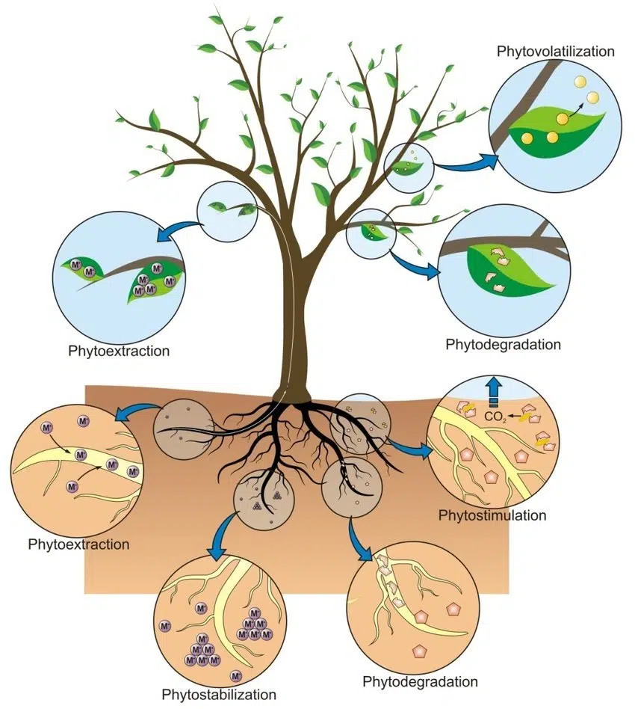

**Figure 2: Phytoremediation ( sigmaearth.com)**

Plants naturally produce a diverse range of metabolites that vary based on environmental conditions. These include both volatile and soluble compounds that play an important role in drawing in plant growth–promoting microorganisms (PGPMs), which not only help reduce metal toxicity but also support plant development (Hartmann, 2004; Ma et al., 2016; Rolfe et al., 2019). When under heavy metal stress, plants modify the composition and quantity of root exudates—compounds secreted into the rhizosphere—to attract microbes suited for that specific condition. These exudates, rich in nutrients like amino acids and organic acids, often contain molecules such as phytochelatins that can bind to heavy metals (Mishra et al., 2017). The beneficial microbes recruited through these signals work synergistically with root exudates to release heavy metals from soil particles, making them more accessible to plants and facilitating phytoremediation.

**Mechanism of phytoremediation:**

* **Phytoextraction (Phytoaccumulation):**  
  Plants absorb contaminants (mainly heavy metals) from the soil or water and accumulate them in their shoots and leaves.  
  ***Example:*** *Brassica juncea (Indian mustard) accumulates lead, cadmium, and chromium ( (*Ali et al.,2017*) .*
* **Phytostabilization:**  
  Plants immobilize contaminants in the soil through root exudates or by adsorption to root surfaces, preventing their migration.  
  ***Example:*** *Vetiver grass is used to stabilize lead and arsenic* ( Chen et al., 2021)
* **Rhizofiltration:**  
  Plant roots absorb, concentrate, and precipitate heavy metals from contaminated water.  
  ***Example:*** *Sunflower roots absorb uranium and lead from water*(Chen et al., 2020).
* **Phytodegradation (Phytotransformation):**  
  Plants and their associated microbes enzymatically degrade organic pollutants into less toxic forms.  
  *Example: Poplar trees degrade trichloroethylene (TCE).*
* **Phytovolatilization:**  
  Plants take up pollutants and release them into the atmosphere in a volatile form after transformation.  
  *Example: Certain plants volatilize mercury and selenium*

**Table 5 - Plant species that help in Phytoremediation**

|  |  |  |  |  |
| --- | --- | --- | --- | --- |
| S. No. | Plant Species | Target Metal | Bioremediation Strategy | Reference |
| 1. | *Brassica juncea* (Indian mustard) | Pb, Cd, Ni | Phytoextraction, high accumulation in shoots | Ma et al., 2016 |
| 2. | *Helianthus annuus* (Sunflower) | Cd, Zn | Rhizofiltration and phytoextraction | Rizaludin et al., 2021 |
| 3. | *Vetiveria zizanioides* (Vetiver grass) | As, Cr | Stabilization and phytostabilization | Rolli et al., 2021 |
| 4. | *Pteris vittata* | As | Hyperaccumulator of arsenic | Rolfe et al., 2019 |

Phytoremediation has limitations such as slow remediation rates, shallow root penetration, and reduced effectiveness in highly toxic environments. Due to these drawbacks, microbial bioremediation is often preferred, as microbes can degrade or transform contaminants more rapidly, even in deeper and more hostile conditions.

**B. Microbial–mediated Metal Detoxification-**

Microorganisms play a vital role in the mobilization and immobilization of metals through various mechanisms. Metals can be mobilized by microbial processes such as autotrophic and heterotrophic leaching, chelation by microbial metabolites like siderophores, and methylation, which can lead to volatilization (Arasiro et al., 2018). On the other hand, metals can be immobilized through processes like sorption to cell components or exopolymers, intracellular sequestration, or precipitation as insoluble compounds such as oxalates, sulfides, or phosphates. Additionally, microbial oxidation-reduction reactions can either mobilize metals, as in the case of Mn (IV) to Mn (II) or Fe (III) to Fe (II), or immobilize them, as seen with Cr (VI) to Cr (III) and U (VI) to U (IV) (Shao et al., 2019).

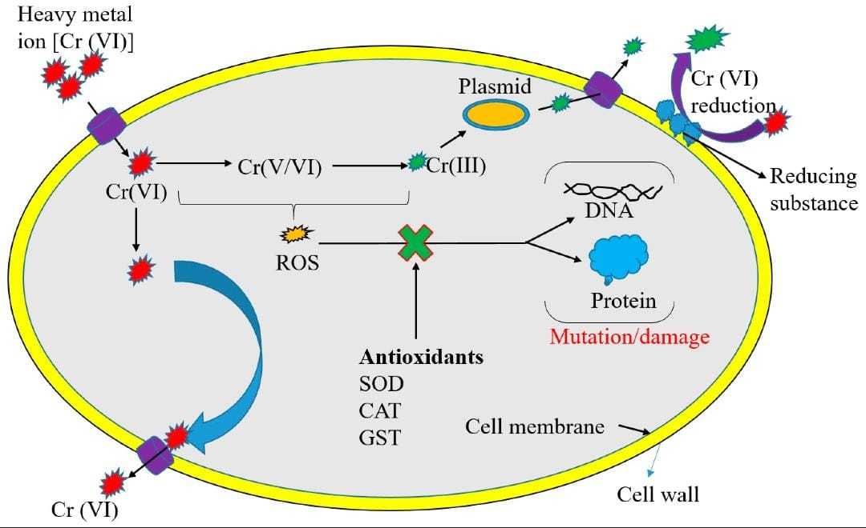

**Figure 3: Process of Detoxification (Zhou et al., 2023)**

The resistance mechanisms of microbes to heavy metals include the excretion of metals via efflux transport systems, binding and detoxifying metals with sequestering compounds in the cytosol, the release of chelators into the extracellular environment to fix metals, the reduction of metals to less toxic forms, and the binding of metals by the cell envelope to prevent their influx. These diverse mechanisms allow microorganisms to adapt to and survive in environments contaminated with heavy metals ( Haferburg and Kothe, 2007).

**1**) **Nature-Assisted Detoxification-** **Nature-assisted detoxification** refers to the process of using **natural biological agents, such** **as bacteria, fungi, or algae**, to **break down, absorb, or neutralize environmental pollutants** like heavy metals, pesticides, or industrial waste. Biosorption is a **physicochemical, metabolism-independent** process where heavy metals are removed using **negatively charged compounds** on microbial cell membranes, typically from **non-living biomass**. This method is often more efficient than using live microorganisms. Its effectiveness depends on factors like **surface properties, pH, temperature**, and **electrostatic interactions.** Several biosorption mechanisms work simultaneously at different rates, including. ( Shamim et al., 2018):  
(i) **Ion exchange** – reversible swapping of metal ions with similarly charged ions,  
(ii) **Complexation** – binding of metal ions to functional groups on the cell surface,  
(iii) **Physical adsorption** – the attraction of metal ions through intermolecular forces, such as Van der Waals forces. Understanding these mechanisms is key to optimizing biosorption for heavy metal removal ( Zabochnicka et al., 2014).

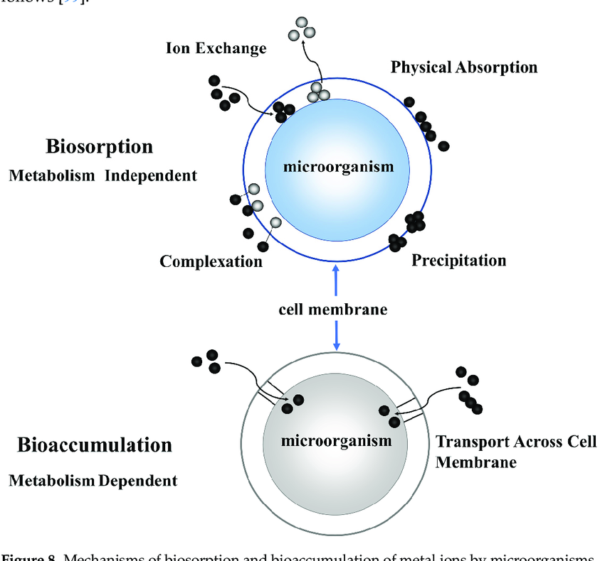

**Figure 4: Biosorption (** Mingqi et al., 2023)

**It** is a process where metals stick to the surface of bacteria or other biological materials without using energy. For example, Bacillus thuringiensis OSM29 was able to remove metals like cadmium (Cd), chromium (Cr), copper (Cu), lead (Pb), and nickel (Ni), with 94% efficiency for nickel. Another bacterium, Bacillus cereus 12-2, changed lead (Pb²⁺) into tiny lead-based minerals (Oves et al. 2013; Chen et al. 2016). Similarly, Bacillus thuringiensis helped reduce uranium (U⁶⁺) into nano-sized uramphite through biosorption, and Shewanella oneidensis MR-1 removed more than 99% of metals, with better results when combined with nanotechnology (Pan et al. 2015; Syarifuddin et al. 2025). This first step of biosorption helps start more advanced processes to clean up metal pollution. Additionally, *Bacillus selenitireducens* reduced arsenic and selenium, and *Bacillus mycoides* SeITE01 formed selenium nanoparticles from selenite (Wells et al. 2019, Lampis et al. 2014). Sulfur-oxidizing bacteria like Thiobacillus denitrificans and Acidithiobacillus ferrooxidans utilize different electron acceptors to support their metabolic processes. T. denitrificans uses nitrate as an electron acceptor and reduced sulfur compounds (such as thiosulfate or sulfide) as electron donors. Under autotrophic conditions, it can reduce approximately 2–20 mM of nitrate, with nitrate reduction rates ranging between 0.5 to 1.2 mM per day, depending on environmental conditions (Fike et al., 2016). On the other hand, A. ferrooxidans oxidizes ferrous iron (Fe²⁺) to ferric iron (Fe³⁺), especially in acidic environments, using oxygen or Fe(III) as the terminal electron acceptor. It can oxidize up to 180 mM Fe²⁺, producing 20–60 mM of Fe(III), with a specific oxidation rate of around 10⁻⁸ mol Fe²⁺ per cell per day (Osorio et al., 2013). In contrast, manganese-oxidizing bacteria such as Candidatus Manganitrophus noduliformans utilize Mn(II) as an electron donor under aerobic conditions, leading to the formation of Mn(III) and Mn(IV) oxides. This organism can oxidize around 1 mM Mn²⁺ over several days, yielding approximately 10–50 µmol of manganese oxides per milligram of cellular protein (Yu & Leadbetter, 2020). Similarly, other Mn(II)-oxidizing bacteria like species of Pseudomonas and Bacillus can oxidize Mn²⁺ at rates of about 0.1 to 0.3 mM per day, resulting in Mn oxide production up to 30–50 mg/L (Newsome et al., 2021). These microbial processes not only drive key biogeochemical cycles but also contribute to the natural sequestration of metals through the formation of stable oxide minerals.. Cristina et al. (2021) reported that filamentous fungi from Hg-contaminated rhizosphere soils exhibited strong resistance to multiple heavy metals and high mercury biosorption capacity. Key isolates like *Fusarium oxysporum and Cladosporium sp.* showed MICs of 140–200 mg/L Hg and removed up to 97% Hg from solution. These native fungi show promising potential for mercury bioremediation.

2) **Bioremediation by Extracellular Polymeric Substances (EPS) :**

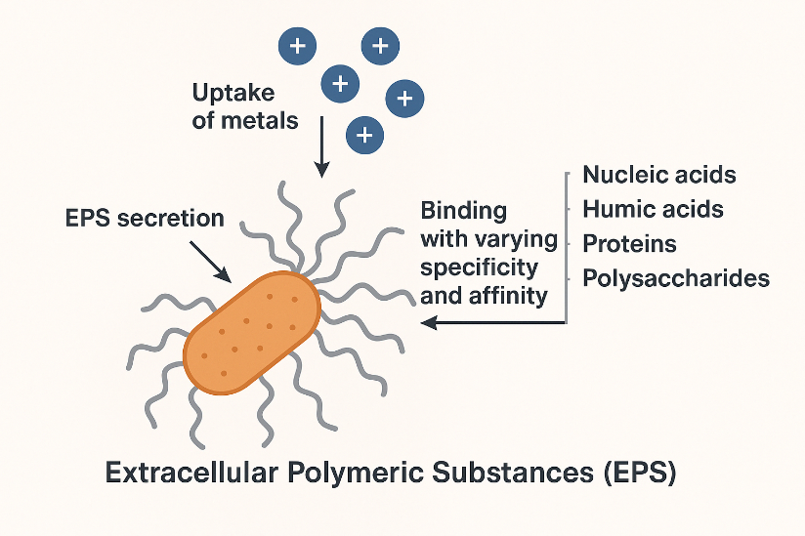

**Figure 5: Secretion of Extracellular Polymeric Substances (EPS)**

Another important way that metal-tolerant bacteria help clean up heavy metals is by releasing **extracellular polymeric substances (EPS)** (Figure 5) (Kumawat et al., 2021). These substances include **nucleic acids, humic acids, proteins, and polysaccharides**, which can bind positively charged metal ions (cations) with different strengths and selectivity (Tiquia et al., 2018). EPS plays a key role in **binding and clumping (flocculating)** metal ions from contaminated water ( Salehizadeh et al., 2003). Among the EPS-producing microorganisms, those that produce **exopolysaccharides** are especially important for heavy metal removal (Kumawat et al., 2021). The efficiency of metal removal by EPS can depend on factors such as the **initial concentration of metals** and the **pH** of the environment. Mehta et al. (2024) focus on enhancing exopolysaccharide (EPS) production by *Klebsiella variicola* SMHMZ46, a bacterium isolated from the Zawar mining area in Udaipur, India, and explain how EPS production was optimized using One Factor At a Time (OFAT) and Response Surface Methodology (CCD-RSM). The highest EPS yield was achieved in a medium containing 9.5% sucrose, 3% casein hydrolysate, and 0.5% NaCl. Interestingly, the presence of heavy metals like Pb(II), Cd(II), and Ni(II) further increased EPS production. The EPS was characterized using TLC, FT-IR, and FEG-SEM, revealing important functional groups and rough surface changes after binding with metals. The bacterium and its EPS showed high removal efficiency: 99.18% for Pb(II), 98.20% for Cd(II), and 97.60% for Ni(II). Additionally, dried EPS alone could remove 85.76% Pb, 72.40% Ni, and 71.53% Cd from water. FEG-SEM–EDX confirmed the presence of metals on the EPS surface, proving its strong biosorption ability and potential in heavy metal bioremediation. **Kalpana et al ( 2018)** isolated an exopolysaccharide (EPS)-producing bacterium, Bacillus cereus VK1. The EPS was then **purified, quantified,** and **characterized** using **FTIR, GC-MS**, and **thermogravimetric analysis (TGA).** To enhance EPS production, the researchers used **response surface methodology (RSM)** for **media optimization**. The results showed a significant improvement in mercury adsorption: while the strain grown in standard LB medium could adsorb **80.22 µg of Hg²⁺ in 20 minutes,** the strain grownin the RSM-optimized medium adsorbed **up to 295.53 µg of Hg²⁺** in the same time frame. In the field of fungi, Cristia et al. (2021) reported that filamentous fungi from Hg-contaminated rhizosphere soils exhibited strong resistance to multiple heavy metals and high mercury biosorption capacity. Key isolates like Fusarium oxysporum and Cladosporium sp. showed MICs of 140–200 mg/L Hg and removed up to 97% Hg from solution. These native fungi show promising potential for mercury bioremediation.

**3) Bioactive Metal Uptake and Trapping**



**Figure 6: Metal uptake and their Bioaccumulation ( Mingqi et al., 2023)**

It is an energy-dependent, intracellular process carried out by metabolically active microbes, unlike passive biosorption ( Sharma et al., 2021). It is influenced by microbial physiology, genetics, environmental conditions, and cell surface properties such as charge and temperature ( Morila e al., 2008). A key mechanism involves metallothioneins—cysteine-rich, low molecular weight proteins (encoded by genes like “bmtA”)—that bind heavy metals like Pb, Hg, Ni, and Cd inside cells. These genes can be plasmid-borne, enabling horizontal transfer. Das et al ( 2014) reported that “ars operon” genes (e.g., *arsA*, *arsB*, *arsC*) mediate arsenic detoxification in *Bacillus* spp., while lead bioaccumulation involves the *pbrD* gene. Singh et al. ( 2016) reported that *Bacillus aryabhattai* possesses the ability to bioaccumulate and volatilize arsenate [As(V)]. Additionally, the bioaccumulation of the relatively less toxic nickel (Ni) has been observed in *Bacillus cereus*. Laura et al. conducted a preliminary screening using various concentrations of arsenic (0, 200, 400, 800, and 1600 μg L⁻¹), identifying Aspergillus niger and Penicillium expansum as the best-performing strains among both autochthonous and allochthonous fungi. All selected strains were further evaluated for their bioaccumulation capacity at the highest concentration of 1600 μg L⁻¹.

**4) Bio-induced Precipitation-**

Bioprecipitation is a microbial bioremediation strategy in which bacteria convert dissolved, toxic heavy metals into insoluble forms, typically by altering their chemical state or forming stable metal complexes. This process reduces the **bioavailability** and **toxicity** of the metals in the environment, making them easier to separate or immobilize. For exampleLead-resistant bacteria like *Bacillus iodinium* GP13 and *Bacillus pumilus* S3 can convert toxic lead ions (Pb²⁺) into insoluble lead sulfide (PbS) through biogenic hydrogen sulfide production. As reported by De et al. (2008), these strains tolerated up to 2–5 mM Pb²⁺ and achieved over 80% lead removal within 48–72 hours, forming visible PbS precipitates. This demonstrates their strong potential for use in microbial lead bioremediation. In this process, the bacteria likely produce sulfide ions (through metabolic activities or enzyme action), which then react with soluble Pb²⁺ ions to form PbS, a highly insoluble and stable compound. This conversion not only detoxifies the lead but also prevents it from entering biological systems or groundwater, making bioprecipitation an effective and eco-friendly remediation approach.

5) **Genetically Engineered Microorganisms: Enhancing Native Bioremediation Processes-**

While natural microbial processes such as biosorption, bioaccumulation, EPS-mediated metal binding, and bioprecipitation form the cornerstone of bioremediation in mining environments, the efficiency of these processes can be hindered under extreme conditions like high metal loads, acidic pH, or nutrient imbalance. To address these limitations, recent advancements have explored the use of genetically engineered microorganisms (GEMs), which are designed to enhance these native processes ( Bermanec et al., 2021). For instance, genes responsible for EPS overproduction, metal transporter proteins, or enzymes involved in phosphate/nitrate reduction can be engineered to improve microbial resilience and functional output. These engineered strains are not replacements but tailored tools that amplify existing microbial capabilities, making them especially useful in complex or heavily contaminated sites.

Oil pollution involves a complex mix of hydrocarbons that are often difficult for native microbes to break down completely. Genetically modified microorganisms (GMMs) can be engineered to be more efficient in degrading these compounds. For example, superbugs can be developed by inserting plasmids carrying multiple genes that code for degrading enzymes ( Rebello et al., 2021). One such engineered strain, *Acinetobacter baumannii* S30 pJES, was created to degrade total petroleum hydrocarbons (TPH) and includes a lux reporter gene that enables real-time monitoring of the bioremediation process. Similarly, *Streptomyces coelicolor* M145 was modified to enhance the breakdown of n-hexadecane, a hydrocarbon, by overexpressing the alkB gene, which produces the enzyme alkane monooxygenase. Efflux systems are critical for heavy metal tolerance in many bacterial species such as *Pseudomonas aeruginosa*, *Candida albicans*, and *Escherichia coli*, where they help reduce toxicity by exporting heavy metals from the cytoplasm to the extracellular environment (Abdi et al., 2020). For example, arsenite (As³⁺), a highly toxic form of arsenic, is expelled through proteins encoded by the **ars operon**, such as **arsB** or **acr3** (Yang et al., 2012). Naturally occurring bacteria like *Sporosarcina luteola* M10 and *Stenotrophomonas* spp. possess these genes and show remarkable arsenic tolerance (Salam et al., 2020). Building on this natural resistance, **genetic engineering has enabled the enhancement of metal efflux systems in laboratory strains**. For instance, the overexpression of **ars operon genes (arsB/acr3)** in model organisms like *E. coli* or *Pseudomonas* strains can significantly increase their arsenic detoxification capacity ( (Soto, 2013; ). Researchers have also constructed recombinant strains with plasmids carrying multiple resistance operons, allowing these GEMs to survive in highly contaminated environments and perform targeted metal remediation. Similarly, the **cad operon** (cadABC), responsible for cadmium resistance, has been cloned and overexpressed in GEMs such as *E. coli* and *Bacillus subtilis* to boost cadmium efflux. In *Pseudomonas putida*, genetic tools have been used to upregulate the **CadR regulator** and **CadA3/CzcCBA efflux proteins**, improving cadmium removal (Liu et al., 2021). Such genetically engineered constructs not only enhance metal resistance but also make it possible to design microbes tailored for **bioremediation of specific contaminated sites**, especially where natural strains may be less effective.

**Table 6** - Genetically engineered microorganisms used for heavy [metal ions](https://www.sciencedirect.com/topics/pharmacology-toxicology-and-pharmaceutical-science/metal-ion) removal.

|  |  |  |  |
| --- | --- | --- | --- |
| **Genetically Modified Microorganisms** | **Modified Gene** | **Mode of Expression** | **References** |
| ***Deinococcus radiodurans*** | MerH; Ion transporter | Produce resistance against mercury and degrades *marinum strain* | ([Meruvu, 2021](https://www.sciencedirect.com/science/article/pii/S0045653522032441" \l "bib106)) |
| ***Acidithiobacillus ferrooxidans*** | Mer C; Ion transporter | Mercury degradation | ([Arshadi and Yaghmaei, 2020](https://www.sciencedirect.com/science/article/pii/S0045653522032441" \l "bib11)) |
| ***Mesorhizobium huakuii*** | Incorporated genes from *Arabidopsis thaliana* encoding PCs | Degradation and accumulation of Cd2+ | [Luo et al. (2020)](https://www.sciencedirect.com/science/article/pii/S0045653522032441" \l "bib97) |
| ***E. coli* SE5000 strain** | nixA; express nickle transporting system | Degradation of nickle from aqueous system | [Tsyganov et al. (2020)](https://www.sciencedirect.com/science/article/pii/S0045653522032441" \l "bib170) |
| ***Pseudomonas* K-62** | Exhibit expression of organomercurial lyase and Hg degradation | Degradation of mercury | ([Sharma, 2020a](https://www.sciencedirect.com/science/article/pii/S0045653522032441" \l "bib151)) |

**THE ROLE OF VARIOUS MICROORGANISM IN BIODEGRADATION-**

**1) Bacteria-**

|  |  |  |  |  |
| --- | --- | --- | --- | --- |
| **S. No.** | **Bacteria Name** | **Target metal** | **Efficiency** | **References** |
| 1. | *Bacillussp.*strain FM1 | Chromium | Completely reduced 100mg/LCr(VI) within 48h | Masood and Malik., 2011 |
| 2. | *Bacillus sp.*KK-1 | Lead | Converted Pb(NO3)2 intoleadsulfide(PbS) and lead silicon oxide (PbSiO3) | Govarthanan et al., 2013 |
| 3. | *Bacillus licheniformis* SPB-2 | Copper | Reduced [Co(III)–EDTA]–to [Co(II)–EDTA]2–which was further absorbed by strainSPG-2 | Paraneelswaran et al., 2015 |
| 4. | *Bacillus thuringiensis* OSM29 | Ni and Cu | Biosorption capacity of the strain OSM29 for the metallic ions was highest for Ni (94%), which was followed by Cu(91.8%). | Oves et al., 2013 |
| 5. | *Bacillus sp. strain Arzi* | Mb | Reduced molybdate to molybdenum blue | Othman et al., 2013 |

**2) Fungi**

|  |  |  |  |  |
| --- | --- | --- | --- | --- |
| **S. No.** | **Fungi Name** | **Target metal** | **Efficiency** | **References** |
| **1.** | *Aspergillus niger* | Pb, Cr(VI), Ni | Biosorption and enzymatic reduction; up to 97% Pb removal | Laura et al., 2022 |
| **2.** | *Fusarium oxysporum* | Hg | MIC = 140–200 mg/L, Hg uptake 33.8–54.9 mg/g | Cristia et al., 2021 |
| **3.** | *Candida albicans* | Cr(VI), Pb, Ag, Cd, As(III), Co, Hg, Cu, Zn | Biosorption and bioaccumulation; removal efficiencies: Cr(VI) (76%), Pb (57%), Ag (51%), Cd (46%), As(III) (40%), Co (37%), Hg (36%), Cu (31%), Zn (22%) | Acosta Rodríguez et al., 2017 |

**Case Study-**

**Sino-Metals Leach Zambia Tailings Dam Failure – Kafue River Contamination, 2025**

In one of the most alarming recent mining-related environmental disasters, a tailings dam owned by Sino-Metals Leach Zambia—a Chinese-run copper mining operation—collapsed on February 18, 2025, in Zambia’s Copperbelt Province. This catastrophic event led to the release of an estimated 50 million liters of highly acidic and metal-contaminated mine waste into the Kafue River, a crucial water source that supports drinking water, agriculture, fishing, and industry for millions of Zambians. Within hours of the discharge, the Kafue River turned visibly discolored and emitted a foul odor, leading to the mass death of fish and aquatic organisms. The city of Kitwe, home to over 700,000 people, was forced to shut down its municipal water supply due to dangerous pH levels and elevated concentrations of heavy metals, including copper and manganese. Eyewitnesses and local officials described the river as having "died overnight." Preliminary environmental assessments reported that the river’s pH dropped sharply, rendering the water corrosive and unfit for human use or irrigation. Farmers reported crop wilting along riverbanks, likely caused by toxic infiltration into agricultural soils. The spill has not only triggered a humanitarian crisis in the region but also reignited debates around foreign ownership of African mineral resources and the environmental negligence associated with some transnational mining firms. Environmental advocacy groups have demanded immediate remediation and legal accountability, while government agencies launched investigations into regulatory lapses. The incident underscores the fragile balance between economic development and environmental protection in mining-intensive regions. It highlights the pressing need for independent monitoring, transparent impact assessments, and stronger environmental governance, especially in regions where water resources are already under stress. As of March 2025, clean-up efforts and long-term health impact assessments are ongoing. ( AP News, 2025), ( Zimba and Jacob, 2025), ( Africa news, 2025).

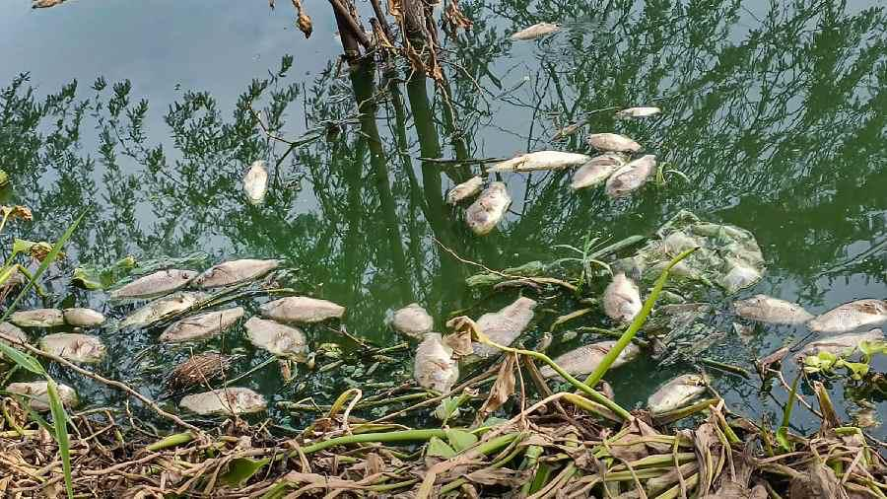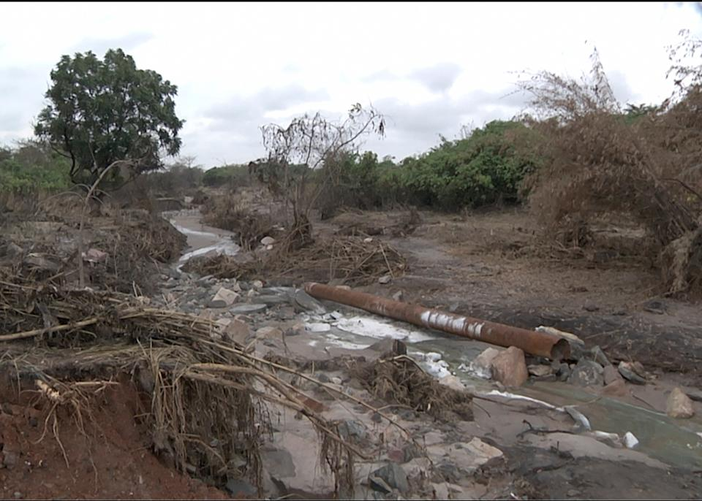

**Figure 7: Affect of metal on aquatic animal ( Africa news, 2023)**

**Bioremediation of Acid Mine Drainage Using Constructed Wetlands – IIT Guwahati, India**

In 2022, researchers from the Indian Institute of Technology (IIT) Guwahati, led by Shweta Singh and Saswati Chakraborty, published a study titled *"Biochemical treatment of coal mine drainage in constructed wetlands: Influence of electron donor, biotic–abiotic pathways, and microbial diversity"* in the *Chemical Engineering Journal*. The research aimed to evaluate the effectiveness of constructed wetlands (CWs) for treating Acid Mine Drainage (AMD) from coal mining regions in Northeast India. The study utilized CWs planted with indigenous species such as *Typha angustifolia* (bulrush) and *Phragmites australis* (common reed), which are known for their ability to thrive in contaminated environments. The wetlands were used to neutralize the acidity and remove toxic heavy metals like iron and copper from the AMD-impacted water. The study demonstrated that the constructed wetlands significantly improved the pH of the AMD water, increasing it from around 3.5 (acidic) to a neutral range of 6.5–7.0. Additionally, there was a remarkable reduction in heavy metal concentrations, with iron and copper levels decreasing

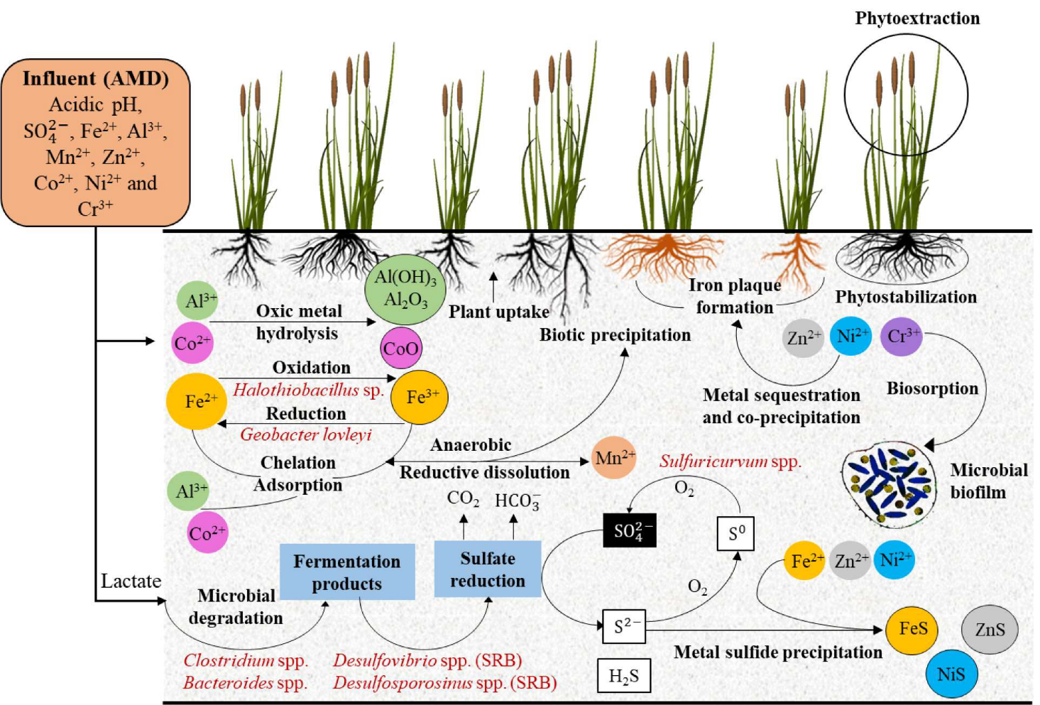by more than 80%. A key aspect of the research was the role of microbial communities in the bioremediation process. The study specifically highlighted the bacterium *Desulfosporosinus meridiei*, a sulfate-reducing bacterium, which played a crucial role in the treatment of AMD by reducing sulfate ions, promoting metal precipitation, and enhancing the overall water quality.

**Figure 8: process of bioremediation ( Chakraborty and singh, 2022)**

This study provides strong evidence that CWs, through the combined action of plants and specific microbial species, can serve as an effective, eco-friendly method for treating AMD in coal mining areas, offering a sustainable solution to mitigate the harmful effects of mining activities on local water systems.

**Conclusion-**

While numerous studies have explored the use of bacteria for cleaning polluted water near mining sites, several critical areas still require further investigation and attention to optimize the effectiveness and scalability of these methods. One major issue is how fertilizers are used during **land reclamation**—the process of trying to restore the land after mining. To help plants grow again, fertilizers (rich in nitrates and phosphates) are added to the soil. But these fertilizers can **wash into nearby rivers, ponds, and lakes**, leading to **water pollution**. This pollution can cause **algae overgrowth, fish death, and lower oxygen levels in water**, making it unsafe for both animals and people. However, **very little research has focused on this specific problem**, especially in areas where mine land has been reclaimed but not monitored properly.

Also, even though many types of bacteria (like *Bacillus*, *Pseudomonas*, and *Shewanella*) have been shown in labs to remove harmful metals like mercury, lead, and chromium from water, **real-life use in mining areas is still very limited**. In the environment, the pollution is more complicated—water might be polluted with **multiple harmful things at once**, like explosives, oil, and excess fertilizers. But there aren't many studies testing how bacteria can work in these **complex, mixed-pollution conditions**.

Some research has looked at **constructed wetlands** (artificial swamps) using plants and bacteria to clean acid mine water, like a study in India that used the bacterium *Desulfosporosinus meridiei*. These methods look promising, but we still don’t know how well they work over the long term, in different seasons, or in large-scale projects.

Another area that is not well understood is how added bacteria behave in the **disturbed soils** of mine sites. The natural soil microbes may have been damaged by mining, and it’s unclear how well helpful bacteria can survive or work in such environments.

Finally, even though advanced tools like **genetically modified bacteria or nanotechnology** are being developed, there is **no clear plan** on how to safely use them in open, natural areas.

In short, more research is needed to understand how fertilizers used in reclamation affect water quality, and how **microbial methods** can be used to clean not just heavy metals but also **nutrient pollution**. Right now, most land restoration efforts don’t use bioremediation, which is a missed opportunity for **sustainable water and land recovery** in mining-affected areas.

Disclaimer (Artificial intelligence)

Option 1:

Author(s) hereby declare that NO generative AI technologies such as Large Language Models (ChatGPT, COPILOT, etc.) and text-to-image generators have been used during the writing or editing of this manuscript.

Option 2:

Author(s) hereby declare that generative AI technologies such as Large Language Models, etc. have been used during the writing or editing of manuscripts. This explanation will include the name, version, model, and source of the generative AI technology and as well as all input prompts provided to the generative AI technology

Details of the AI usage are given below:

1.

2.

3.

**References**

1. Akob, D. M., Kerkhof, L., Küsel, K., Watson, D. B., Palumbo, A. V., & Kostka, J. E. (2011). Linking specific heterotrophic bacterial populations to bioreduction of uranium and nitrate in contaminated subsurface sediments by using stable isotope probing. *Applied and Environmental Microbiology*, 77(24), 8197–8200. <https://doi.org/10.1128/AEM.05794-11>
2. Alvillo-Rivera, A., Garrido-Hoyos, S., Buitrón, G., Thangarasu-Sarasvathi, P., & Rosano-Ortega, G. (2021). Biological treatment for the degradation of cyanide: A review. *Journal of Materials Research and Technology*, 12, 1418–1433. <https://doi.org/10.1016/j.jmrt.2021.02.022>
3. Arora, P. K., Srivastava, A., Garg, S. K., & Singh, V. P. (2018). Recent advances in the degradation of chloronitrophenols. *Bioresource Technology*, 250, 902–909. <https://doi.org/10.1016/j.biortech.2017.12.007>
4. Sharma, S., Shaikh, S., Mohana, S., et al. (2024). Current trends in bioremediation and bio-integrated treatment of petroleum hydrocarbons. *Environmental Science and Pollution Research*, 31, 57397–57416. <https://doi.org/10.1007/s11356-023-30479-8>
5. Cao, S., Wen, D., Chen, X., Duan, X., Zhang, L., Wang, B., Qin, N., & Wei, F. (2022). Source identification of pollution and health risks to metals in household indoor and outdoor dust: A cross-sectional study in a typical mining town, China. *Environmental Pollution*, 293, 118573. <https://doi.org/10.1016/j.envpol.2021.118573>
6. Cusick, K., Iturbide, A., Gautam, P., Price, A., Polson, S., MacDonald, M., & Erill, I. (2021). Enhanced copper-resistance gene repertoire in *Alteromonas macleodii* strains isolated from copper-treated marine coatings. *PLOS ONE*, 16(9), e0257318. <https://doi.org/10.1371/journal.pone.0257318>
7. Dang, T. C. H., Nguyen, D. T., Thai, H., Nguyen, T. C., Tran, T. T. H., Le, V. H., et al. (2018). Plastic degradation by thermophilic *Bacillus* sp. BCBT21 isolated from composting agricultural residuals in Vietnam. *Advances in Natural Sciences: Nanoscience and Nanotechnology*, 9(1), 015014. <https://doi.org/10.1088/2043-6254/aaa90c>
8. Dell’Anno, F., Brunet, C., van Zyl, L. J., Trindade, M., Golyshin, P. N., Dell’Anno, A., Ianora, A., & Sansone, C. (2020). Degradation of hydrocarbons and heavy metal reduction by marine bacteria in highly contaminated sediments. *Microorganisms*, 8(9), 1402. <https://doi.org/10.3390/microorganisms8091402>
9. Fike, D. A., Bradley, A. S., & Leavitt, W. D. (2016). Geomicrobiology of sulfur. In H. L. Ehrlich, D. K. Newman, & A. Kappler (Eds.), *Ehrlich's Geomicrobiology* (6th ed., p. 37). CRC Press.
10. Naz, M., Raza, M. A., Tariq, M., Dai, Z., Du, D. (2022). Heavy metal contamination and their remediation. In T. Aftab & K. Hakeem (Eds.), *Metals Metalloids Soil Plant Water Systems* (Chapter 12, pp. 255). Academic Press. <https://doi.org/10.1016/B978-0-323-91675-2.00012-3>
11. Ghosh, S., Sarkar, B., Imboon, T., & Thongmee, S. (2024). Microbe-mediated mercury bioremediation for wastewater treatment. In M. P. Shah (Ed.), *Microbial Metagenomics in Effluent Treatment Plant* (pp. 239–255). Elsevier. <https://doi.org/10.1016/B978-0-323-95823-0.00012-9>
12. Gomes, P., & Valente, T. (2024). Seasonal impact of acid mine drainage on water quality and potential ecological risk in an old sulfide exploitation. *Environmental Science and Pollution Research*, 31(14), 21124–21135. <https://doi.org/10.1007/s11356-024-33098-5>
13. Gupta, P. K., Mustapha, H. I., Singh, B., & Sharma, Y. C. (2022). Bioremediation of petroleum contaminated soil-water resources using neat biodiesel: A review. *Sustainable Energy Technologies and Assessments*, 53(D), 102571. <https://doi.org/10.1016/j.seta.2022.102571>
14. Hazen, T. C. (2010). Cometabolic bioremediation. In K. N. Timmis (Ed.), *Handbook of Hydrocarbon and Lipid Microbiology* (pp. 2505–2514). Springer. <https://doi.org/10.1007/978-3-540-77587-4_186>
15. Hogsden, K. L., & Harding, J. S. (2012). Consequences of acid mine drainage for the structure and function of benthic stream communities: A review. *Freshwater Science*, 31(1), 108–120. <https://doi.org/10.1899/11-091.1>
16. Hussain, S., Sultana, T., Sultana, S., Hussain, B., Mahboob, S., Al-Ghanim, K. A., & Riaz, M. N. (2021). Seasonal monitoring of river through heavy metal bioaccumulation and histopathological alterations in selected fish organs. *Journal of King Saud University - Science*, 33, 101626. <https://doi.org/10.1016/j.jksus.2020.101626>
17. Ismail, S., & Dadrasnia, A. (2015). Biotechnological potential of Bacillus salmalaya 139SI: A novel strain for remediating water polluted with crude oil waste. PLOS ONE, 10(3), e0119495. <https://doi.org/10.1371/journal.pone.0119495>
18. Jhariya, D., & Choraisia, K. (2010). Khanij utpadan ka jal sansadhan aivam jal sanrakshan par prabhav. In Bhu - Jal Sanvardhan aivam Jal sansadhano ka sanrakshan.
19. Das, A. P., & Ghosh, S. (2022). Role of microorganisms in extenuation of mining and industrial wastes. Geomicrobiology Journal, 39(3–5), 173–175. <https://doi.org/10.1080/01490451.2022.2038953>
20. Li, H., Yao, J., Sunahara, G., Min, N., Li, C., & Duran, R. (2023). Quantifying ecological and human health risks of metal(loid)s pollution from non-ferrous metal mining and smelting activities in Southwest China. Science of The Total Environment, 873, 162433. <https://doi.org/10.1016/j.scitotenv.2023.162433>
21. Masood, F., & Malik, A. (2011). Hexavalent chromium reduction by Bacillus sp. strain FM1 isolated from heavy-metal contaminated soil. Bulletin of Environmental Contamination and Toxicology, 86, 114–119. <https://doi.org/10.1007/s00128-010-0215-1>
22. Méndez-García, C., Peláez, A. I., Mesa, V., Sánchez, J., Golyshina, O. V., & Ferrer, M. (2015). Microbial diversity and metabolic networks in acid mine drainage habitats. Frontiers in Microbiology, 6, 475. <https://doi.org/10.3389/fmicb.2015.00475>
23. Moore, J. N., & Luoma, S. N. (1990). Hazardous wastes from large-scale metal extraction: A case study. Environmental Science & Technology, 24(9), 1278–1285. <https://doi.org/10.1021/es00079a001>
24. Tayang, A., & Songachan, L. (2021). Microbial bioremediation of heavy metals. Current Science, 120, 1013–1025. https://doi.org/10.18520/cs/v120/i6/1013-1025
25. Mekonnen, B. A., Aragaw, T. A., & Genet, M. (2024). Bioremediation of petroleum hydrocarbon contaminated soil: A review on principles, degradation mechanisms, and advancements. Frontiers in Environmental Science, 12. https://doi.org/10.3389/fenvs.2024.1354422
26. Vélez, J. M. B., Martínez, J. G., Ospina, J. T., & Agudelo, S. O. (2021). Bioremediation potential of Pseudomonas genus isolates from residual water, capable of tolerating lead through mechanisms of exopolysaccharide production and biosorption. Biotechnology Reports, 32, e00685. <https://doi.org/10.1016/j.btre.2021.e00685>
27. Matebese, F., Mosai, A. K., Tutu, H., & Tshentu, Z. R. (2024). Mining wastewater treatment technologies and resource recovery techniques: A review. Heliyon, 10(3), e24730. <https://doi.org/10.1016/j.heliyon.2024.e24730>
28. Mohammad, S. J., et al. (2025). Heavy metal pollution and transformation in soil: A comprehensive review of natural bioremediation strategies. Environmental Science and Pollution Research. <https://link.springer.com/article/10.1007/s43994-025-00241-6>
29. Chen, L., Msigwa, G., Yang, M., Osman, A. I., Fawzy, S., Rooney, D. W., & Yap, P. S. (2022). Strategies to achieve a carbon neutral society: a review. Environmental chemistry letters, 20(4), 2277-2310.
30. Qattan, S. Y. A., & Newsome, L., & Falagán, C. (2025). Harnessing bacterial consortia for effective bioremediation: Targeted removal of heavy metals, hydrocarbons, and persistent pollutants. Environmental Sciences Europe, 37, 85. <https://doi.org/10.1186/s12302-025-01103-y>
31. Nimbrana, S., Ranga, P., & Malik, A. (2023). Bioremediation of mining sites: Sustainable approach to restore a healthy ecosystem. In R. P. Singh, P. Singh, & A. Srivastava (Eds.), Heavy Metal Toxicity: Environmental Concerns, Remediation and Opportunities (pp. [insert pages]). Springer. <https://doi.org/10.1007/978-981-99-0397-9_16>
32. Igogo, T., Awuah-Offei, K., Newman, A., Lowder, T., & Engel-Cox, J. (2021). Integrating renewable energy into mining operations: Opportunities, challenges, and enabling approaches. *Applied Energy, 300*, 117361.
33. Li, X., Gu, Q., Wang, Q., Luo, J., Liu, D., & Chang, Y. (2024). Renewable energy in the mining industry: Status, opportunities and challenges. *Energy Strategy Reviews, 56*, 100899.
34. Jomova, K., Alomar, S. Y., Nepovimova, E., et al. (2025). Heavy metals: Toxicity and human health effects. *Archives of Toxicology, 99*, 153–209. <https://doi.org/10.1007/s00204-024-03903-2>
35. Kim, Y. S., Chung, Y. H., Seo, D. S., et al. (2018). Twenty-eight-day repeated inhalation toxicity study of aluminum oxide nanoparticles in male Sprague-Dawley rats. *Toxicological Research, 34*(4), 343–354.
36. Praveen, R., & Nagalakshmi, R. (2022). Review on bioremediation and phytoremediation techniques of heavy metals in contaminated soil from dump site. *Materials Today: Proceedings, 68*(5), 1562–1567.
37. Kensa, V. M. (2011). Bioremediation – An overview. *Journal of Industrial Pollution Control, 27*(2), 161–168.
38. Dixit, R., Wasiullah, Malaviya, D., Pandiyan, K., Singh, U. B., Sahu, A., et al. (2015). Bioremediation of heavy metals from soil and aquatic environment: An overview of principles and criteria of fundamental processes. *Sustainability, 7*(2), 2189–2212.
39. Comte, S., Guibaud, G., & Baudu, M. (2008). Biosorption properties of extracellular polymeric substances (EPS) towards Cd, Cu and Pb for different pH values. *Journal of Hazardous Materials, 151*, 185–193.
40. Gan, S., Lau, E. V., & Ng, H. K. (2009). Remediation of soils contaminated with polycyclic aromatic hydrocarbons (PAHs). *Journal of Hazardous Materials, 3*. *(Note: Missing issue or page number; please confirm if available.)*
41. Tiquia-Arashiro, S. M. (2018). Lead absorption mechanisms in bacteria as strategies for lead bioremediation. *Applied Microbiology and Biotechnology, 102*, 5437–5444.
42. Shao, W., Li, M., Teng, Z., Qiu, B., Huo, Y., & Zhang, K. (2019). Effects of Pb (II) and Cr (VI) stress on phosphate-solubilizing bacteria (*Bacillus* sp. strain MRP-3): Oxidative stress and bioaccumulation potential. *International Journal of Environmental Research and Public Health, 16*, 2172.
43. Haferburg, G., & Kothe, E. (2007). Microbes and metals: Interactions in the environment. *Journal of Basic Microbiology, 47*, 453–467.
44. Zabochnicka-Świątek, M., & Krzywonos, M. (2014). Potentials of biosorption and bioaccumulation processes for heavy metal removal. *Polish Journal of Environmental Studies, 23*, 551–561.
45. Kumawat, T. K., Kumawat, V., Sharma, S., Kandwani, N., & Biyani, M. (2021). Applications of EPS in environmental bioremediations. In Nadda, A. K., Sajna, K. V., & Sharma, S. (Eds.), *Microbial exopolysaccharides as novel and significant biomaterials* (pp. 285–302). Springer. <https://doi.org/10.1007/978-3-030-75288-0>
46. Tiquia-Arashiro, S. M. (2018). Lead absorption mechanisms in bacteria as strategies for lead bioremediation. *Applied Microbiology and Biotechnology, 102*, 5437–5444. *(Duplicate of #10 — consider removing.)*
47. Salehizadeh, H., & Shojaosadati, S. A. (2003). Removal of metal ions from aqueous solution by polysaccharide produced from *Bacillus firmus*. *Water Research, 37*, 4231–4235.
48. Kalpana, R., Angelaalincy, M. J., Kamatchirajan, B. V., Vasantha, V. S., Ashokkumar, B., Ganesh, V., & Varalakshmi, P. (2018). Exopolysaccharide from *Bacillus cereus* VK1: Enhancement, characterization and its potential application in heavy metal removal. *Colloids and Surfaces B: Biointerfaces, 171*, 327–334.
49. Jia, M., Jiang, G., Chen, H., Pang, Y., Yuan, F., Zhang, Z., et al. (2022). Recent developments on processes for recovery of rhodium metal from spent catalysts. *Catalysts, 12*, 1415. <https://doi.org/10.3390/catal12111415>
50. Soldi, E., Casey, C., Murphy, B. R., & Hodkinson, T. R. (2020). Fungal endophytes for grass-based bioremediation: An endophytic consortium isolated from *Agrostis stolonifera* stimulates the growth of *Festuca arundinacea* in lead-contaminated soil. *Journal of Fungi, 6*, 254.
51. Brar, S. K., Verma, M., Tyagi, R. D., & Valéro, J. R. (2006). Bioremediation of hazardous wastes—a review. *Practice Periodical of Hazardous, Toxic, and Radioactive Waste Management*, *10*(2), 59–72.
52. Bolan, N., Kunhikrishnan, A., Thangarajan, R., Kumpiene, J., Park, J., Makino, T., et al. (2014). Remediation of heavy metal(loid)s contaminated soils – To mobilize or to immobilize? *Journal of Hazardous Materials*, *266*, 141–166.
53. Singh, P., Singh, V. K., Singh, R., Borthakur, A., Madhav, S., Ahamad, A., Kumar, A., Pal, D. B., Tiwary, D., & Mishra, P. K. (2020). Bioremediation: A sustainable approach for management of environmental contaminants. In P. Singh, A. Kumar, & A. Borthakur (Eds.), *Abatement of Environmental Pollutants* (pp. 1–23). Elsevier. <https://doi.org/10.1016/B978-0-12-818095-2.00001-1>
54. Kang, C. H., Kwon, Y. J., & So, J. S. (2016). Bioremediation of heavy metals by using bacterial mixtures. *Ecological Engineering*, *89*, 64–69.
55. Wuana, R. A., & Okieimen, F. E. (2011). Heavy metals in contaminated soils: A review of sources, chemistry, risks and best available strategies for remediation. *ISRN Ecology*, *2011*, 1–20. <https://doi.org/10.5402/2011/402647>
56. Srivastava, S., & Thakur, I. S. (2006). Isolation and process parameter optimization of *Aspergillus* sp. for removal of chromium from tannery effluent. *Bioresource Technology*, *97*, 1167–1173.
57. Kumar, A., Bisht, B. S., Joshi, V. D., & Dhewa, T. (2011). Review on bioremediation of polluted environment: A management tool. *International Journal of Environmental Sciences*, *1*(6), 1079–1093.
58. Murthy, M. K., Khandayataray, P., & Samal, D. (2022). Chromium toxicity and its remediation by using endophytic bacteria and nanomaterials: A review. *Journal of Environmental Management*, *318*, 115620. <https://doi.org/10.1016/j.jenvman.2022.115620>
59. Gupta, A., Joia, J., Sood, A., Sood, R., Sidhu, C., & Kaur, G. (2016). Microbes as a potential tool for remediation of heavy metals: A review. *Journal of Microbial & Biochemical Technology*, *8*(4), 364–372.
60. Mishra, S., Bharagava, R. N., More, N. S., Yadav, A., Zainith, S., Mani, S., & Chowdhary, P. (2018). Heavy metal contamination: An alarming threat to the environment and human health. In R. N. Bharagava (Ed.), *Environmental Pollutants and Their Bioremediation Approaches* (pp. 103–116). CRC Press.
61. Gadd, G. M. (2010). Metals, minerals, and microbes: Geomicrobiology and bioremediation. *Microbiology*, *156*(3), 609–643.
62. Singh, J., & Kalamdhad, A. S. (2011). Effects of heavy metals on soil, plants, human health and aquatic life. *International Journal of Research in Chemistry and Environment*, *1*(2), 15–21.
63. Leong, Y. K., & Chang, J.-S. (2020). Bioremediation of heavy metals using microalgae: Recent advances and mechanisms. *Bioresource Technology*, *303*, 122886. <https://doi.org/10.1016/j.biortech.2020.122886>
64. Volesky, B. (2001). Detoxification of metal-bearing effluents: Biosorption for the next century. *Hydrometallurgy*, *59*, 203–216. <http://dx.doi.org/10.1016/S0304-386X(00)00160-2>
65. Pardo, R., Herguedas, M., Barrado, E., & Vega, M. (2003). Biosorption of cadmium, copper, lead, and zinc by inactive biomass of *Pseudomonas putida*. *Analytical and Bioanalytical Chemistry*, *376*, 26–32. <https://doi.org/10.1007/s00216-003-1843-z>
66. Ordóñez, J. I., Cortés, S., Maluenda, P., & Soto, I. (2023). Biosorption of heavy metals with algae: Critical review of its application in real effluents. *Sustainability*, *15*, 5521. <https://doi.org/10.3390/su15065521>
67. Wang, J., & Chen, C. (2009). Biosorbents for heavy metals removal and their future. *Biotechnology Advances*, *27*(2), 195–226. https://doi.org/10.1016/j.biotechadv.2008.11.002
68. Kour, D., Kaur, T., Devi, R., Yadav, A., Singh, M., Joshi, D., Singh, J., Suyal, D. C., Kumar, A., Rajput, V. D., Yadav, A. N., Singh, K., Singh, J., Sayyed, R. Z., Arora, N. K., & Saxena, A. K. (2021). Beneficial microbiomes for bioremediation of diverse contaminated environments for environmental sustainability: Present status and future challenges. *Environmental Science and Pollution Research*, *28*(20), 24917–24939. https://doi.org/10.1007/s11356-021-13252-7
69. Mehta, S. K., & Gaur, J. P. (2005). Use of algae for removing heavy metal ions from wastewater: Progress and prospects. *Critical Reviews in Biotechnology*, *25*(3), 113–152. <https://doi.org/10.1080/07388550500248571>
70. Vijayaraghavan, K., & Yun, Y. S. (2008). Bacterial biosorbents and biosorption. *Biotechnology Advances*, *26*(3), 266–291. <https://doi.org/10.1016/j.biotechadv.2008.02.002>.

**Abbreviation**:**-**

* **AMD** – Acid Mine Drainage
* **IQ** – Intelligence Quotient
* **HM** – Heavy Metal
* **USGS** – United States Geological Survey
* **CCS** – Coal Contaminated Soil
* **CFS** – Coal Free Soil
* **TDS** – Total Dissolved Solids
* **BOD** – Biological Oxygen Demand
* **COD** – Chemical Oxygen Demand
* **SS** – Suspended Solids
* **PGPM** – Plant Growth Promoting Microorganisms
* **TLC** – Thin Layer Chromatography
* **FT-IR** / **FTIR** – Fourier Transform Infrared Spectroscopy
* **FEG-SEM** – Field Emission Gun Scanning Electron Microscope
* **TCD-RSM** – Thermal Conductivity Detector - Response Surface Methodology
* **FEG-SEM-EDX** – Field Emission Gun Scanning Electron Microscope with Energy Dispersive X-ray Analysis
* **GC-MS** – Gas Chromatography-Mass Spectrometry
* **GEM** – Genetically Engineered Microorganisms
* **GMM** – Genetically Modified Microorganism
* **TPH** – Total Petroleum Hydrocarbon
* **CW** – Constructed Wetland