**Using Stress Indices in Soybean for the Identification Genotypes Adapted to Non-Traditional Growing Seasons**

Abstract

Soybean is a predominant kharif season crop in Telangana, recognized for its high yield potential and economic importance as a major oilseed. With the expansion of irrigation infrastructure in the region, there is growing potential to cultivate soybeans during the rabi season as well. However, the adoption of rabi soybean cultivation remains limited, primarily due to the absence of climate-resilient and photoperiod-insensitive varieties suitable for short-day winter conditions. The present study aimed to identify soybean genotypes with stable performance across both seasons by evaluating 50 genotypes, including advanced breeding lines and released varieties, during the 2021–2022 cropping. Field trials were conducted under optimal (kharif, Yp) and stress (rabi, Ys) environments. Seven widely used stress tolerance indices, Stress Susceptibility Index (SSI), Mean Productivity (MP), Geometric Mean Productivity (GMP), Tolerance (TOL), Stress Tolerance Index (STI), Harmonic Mean Productivity (HM), Yield Index (YI), and Yield Stability Index (YSI) were employed to assess genotype resilience based on grain yield performance. The indices STI, GMP, MP, and YI showed strong associations with both Yp and Ys, underlining their reliability in screening genotypes for seasonal adaptability. Genotypes were ranked using an average sum score derived from all eight indices. Based on this integrated evaluation, genotypes G50, G5, G15, G38, and G21 were identified as highly resilient and suitable for dual-season cultivation. These findings offer valuable insights for breeding programs aimed at developing soybean cultivars adapted to changing climatic conditions and expanding the sowing window beyond traditional kharif periods. Based on the average sum rank (ASR) derived from all eight stress indices, genotypes G50, G5, G15, G38, and G21 consistently exhibited high yield and stability across both seasons. These genotypes are therefore promising candidates for cultivation under variable seasonal conditions due to their yield resilience and adaptability.

Key words: Stress Tolerance Index (STI), rabi soybean, Yield Stability Index (YSI), Biplot

**Introduction:**

Early sowing to avoid stress later in the season is limited by low early spring temperatures and unpredictable cold spells within recommended sowing dates. To achieve successful crop production, it is essential to understand plant stress responses, enabling breeders and producers to better address climate change challenges. Researching genetic variability for cold stress is key to developing cold-tolerant crops (Dharshini et al., 2024; Matoša Kočar et al., 2025). Soybean (*Glycine max* L. Merr.) (2n=40) is a photothermo-sensitive crop of major significance to the food and feed industries. During the 2024–25 season, it was cultivated across 126.9 lakh hectares in India, producing 151.3 lakh tonnes. In Telangana, soybean is primarily grown during the *kharif* season, covering 1.62 lakh hectares with a production of 2.8 lakh tonnes and an average productivity of 1502 kg/ha (Department of Agriculture, India, 2024). With improved irrigation infrastructure, there is growing potential to extend cultivation into the *rabi* season. However, the lack of genotypes suited to *rabi* conditions has limited its adoption. Substantial growth in soybean production and cultivated area over the past two decades, coupled with a rise in the frequency of adverse weather events, has led to ongoing adaptations in production technology and breeding efforts aimed at mitigating the negative impacts of climate change (Devi et al., 2023; Matoša Kočar et al., 2025). Expanding *rabi* soybean cultivation could enhance cropping diversity and seed quality in the region. Nationally, limited research has focused on identifying genotypes suited for both *kharif* and *rabi* seasons. Spoorthi *et al*. (2024) reported significant genotypic variation in yield and quality traits across *kharif*, *rabi*, and summer seasons, with *rabi* yields generally lower due to photoperiod sensitivity and genotype-by-environment interactions. Selection strategies often rely on mean and relative yield performance under both optimal and stress conditions, with higher relative yield indicating better adaptability (Bahrami *et al*., 2021). Combining yield stability (via stress indices) with high relative yield has proven effective in identifying resilient genotypes (Chugh *et al*., 2022). Stress indices such as SSI, MP, TOL, STI, HM, YI, and YSI are widely used across crops to evaluate genotype performance under adverse conditions (Pandey *et al*., 2015; Kumar *et al*., 2020; Bahrami *et al*., 2021; Abou-Elwafa and Shehzad, 2021; Banerjee *et al*., 2020). Fischer and Maurer (1978) proposed SSI, based on relative yield reductions, while Rosielle and Hamblin (1981) introduced TOL and MP. Fernandez (1992) suggested GMP and STI for identifying stable, high-yielding genotypes under both conditions. Gavuzzi *et al*. (1997) and Bouslama and Schapaugh (1984) introduced YI and YSI, respectively, for assessing yield stability. Genotypes are commonly classified into four categories viz., group-I with high yield in both environments, group-II with high yield under optimal conditions, group III with high yield under stress and group-IV with low yield in both environments.

However, limited information is available on the utilization of these stress indices for evaluating soybean genotypes under off-season conditions. Therefore, the present study aimed to identify the most relevant stress indices correlated with yield, with a focus on selecting high-yielding and stable genotypes suitable for both seasons.

**Material and Methods**

The experimental trial was conducted at the Regional Sugarcane and Rice Research Station, PJTSAU, Rudrur with 50 soybean genotypes sown during the first fortnight of November during *rabi*, 2021–2022 and *kharif*, 2023 in alpha lattice design with two replications. The 50 genotypes were randomized in 10 incomplete blocks, consisting of 5 genotypes per block per replication. Each plot consisted of two rows with a row length of 2 meters, spaced 45 cm apart between rows and 5 cm within rows, resulting in a plot size of 1.8 m². All recommended agronomic practices were followed as per the *PJTSAU Diksuchi* guidelines to raise a healthy and uniform crop. Seed yield was recorded on a plot basis and later converted to yield per hectare using the formula: Plot yield (kg) × (10,000 m² / 1.8 m²)

The stress indices, Ys, Yp, Ȳs, and Ȳp represent the yield of a genotype under *rabi* (stress) and *kharif* (optimal) conditions, and mean yield under *rabi* and *kharif* conditions, respectively. An online tool, iPASTIC (Pour-Aboughadareh *et al*., 2019), was used to compute the stress susceptibility and tolerance indices. Formulae for estimation of stress indices along with the selection pattern of soybean genotypes evaluated under *kharif* (optimal) and *rabi* (Off season) conditions as given below.

**Table 1: Formulae for estimation of stress indices and selection pattern of soybean genotypes**

|  |  |  |  |
| --- | --- | --- | --- |
| Index | Formula | Selection Criterion | Reference |
| Tolerance index (TOL) | TOL = Yp - Ys | Minimum value | Rosielle and Hamblin (1981) |
| Mean productivity (MP) | MP = (Yp + Ys) / 2 | Maximum value | Rosielle and Hamblin (1981) |
| Geometric mean productivity (GMP) | GMP = √(Ys × Yp) | Maximum value | Fernandez (1992) |
| Harmonic mean productivity (HM) | HM = 2 (Ys × Yp) / (Ys + Yp) | Maximum value | Bidinger et al. (1987) |
| Stress susceptibility index (SSI) | SSI = [1 - (Ys/Yp)] / [1 - (Ȳs/Ȳp)] | Minimum value | Fischer and Maurer (1978) |
| Stress tolerance index (STI) | STI = (Ys × Yp) / (Ȳp)2 | Maximum value | Fernandez (1992) |
| Yield index (YI) | YI = Ys / Ȳs | Maximum value | Gavuzzi et al. (1997) |
| Yield stability index (YSI) | YSI = Ys / Yp | Maximum value | Bouslama and Schapaugh (1984) |

The principal component analysis (PCA) was performed to identify the key indices contributing maximum variations and also plot the genotypes to four quadrants (Anderson, 1972)

**RESULTS AND DISCUSSION:**

Eight stress indices; Stress Susceptibility Index (SSI), Mean Productivity (MP), Tolerance index (TOL), Stress Tolerance Index (STI), Harmonic Mean Productivity (HM), Geometric Mean Productivity (GMP), Yield Index (YI), and Yield Stability Index (YSI) were used to screen soybean genotypes for high and stable yields across *kharif* (optimal) and *rabi* (stress) seasons. To identify the most appropriate indices, correlation analysis was conducted to evaluate the relationship among indices and yield under both environments. According to Farshadfar *et al*. (2001), the most suitable indices for selecting stress-tolerant cultivars are those showing strong correlations with yield in both stress and non-stress environments. In the present study, a significant and positive correlation (r = 0.3*) was observed between yield under stress (Ys) and optimal conditions (Yp), indicating that high-yielding genotypes under optimal conditions may also perform well under stress (Figure 1). This finding aligns with the observations of Jaishreepriyanka *et al*. (2024). SSI exhibited a negative correlation with Ys and a positive correlation with Yp, consistent with the findings of Rad and Abbasian (2011) in winter rapeseed. All indices, except SSI and TOL, showed significant positive correlations with yield under stress. Similarly, all indices except SSI and YSI were positively correlated with yield under optimal conditions. Overall STI, GMP, MP, and YI emerged as the most reliable indicators due to their strong and significant associations with both Yp and Ys, making them suitable for identifying resilient soybean genotypes. Similar results have been reported in wheat (Poudel *et al*., 2021; Devi *et al*., 2021) and Brassica species (Sharma *et al*., 2022; Chugh *et al*., 2022).

The performance of genotypes across the various stress indices is presented in Table 2. A lower value of Tolerance (TOL) indicates a genotype’s superior stress tolerance, as it reflects minimal yield reduction under stress. Similarly, a lower Stress Susceptibility Index (SSI) suggests reduced sensitivity to adverse environments, indicating better stability. Both TOL and SSI are useful in identifying drought-tolerant genotypes. According to Fernandez (1992), selection based on the Stress Tolerance Index (STI) enables identification of genotypes with high yield potential under both stress and non-stress conditions. Yield under stress (Ys) ranged from 683 kg/ha (G25) to 2472 kg/ha (G50), with a mean of 1649 kg/ha. Under optimal conditions, yield ranged from 1515 kg/ha (G25) to 3234 kg/ha (G30), with a mean of 2719 kg/ha. Table 3 shows the best five climate resilient soybean genotypes selected from each tolerance indices. Based on the average sum rank (ASR) across all eight indices, genotypes G50 (42), G5 (57), G15 (62), G38 (65), and G21 (77) were identified as high-yielding and stable across both seasons (Table 2).

Principal component analysis (PCA) was conducted to understand the association between indices and yield traits. Of the five extracted components, the first two were significant, explaining 99.7% of the total variation (Figure 2). PC1 accounted for 76.4% of the variation and was strongly associated with Ys, STI, GMP, MP, and YI. PC2 contributed 23.1% of the variation, mainly associated with Yp and TOL. These findings are consistent with Jaishreepriyanka et al. (2024) and Chugh et al. (2022), who reported that the first two PCs sufficiently explained more than 95% of the total variation.

Based on PCA, genotypes were classified into four groups:

* Group I (High PC1 & High PC2): Genotypes with high yield potential and tolerance across environments
* Group II (Low PC1 & High PC2): Genotypes with poor performance under stress
* Group III (Low PC1 & Low PC2): Genotypes with low yield under both conditions
* Group IV (High PC1 & Low PC2): Genotypes with superior performance under stress conditions

According to Thiry *et al*. (2016), genotypes in Groups I and IV are most suitable for dual-season cultivation. Kaya *et al*. (2002) further emphasized that genotypes with high PC1 and low PC2 scores are stable and high-yielding, while those with low PC1 and high PC2 are unstable and low-yielding. Genotypes with PC1 scores near zero are considered stable across environments. The results of the PCA biplot were consistent with stress index analysis, reinforcing the reliability of using combined indices and PCA for screening high-performing, stress-resilient soybean genotypes.

**Conclusion:**

Overall, the findings of the present investigation facilitated the identification of soybean genotypes exhibiting superior performance under both timely sown (*kharif*) and off-season (*rabi*) conditions. Among the stress tolerance indices evaluated, Stress Tolerance Index (STI), Geometric Mean Productivity (GMP), Mean Productivity (MP), and Yield Index (YI) demonstrated strong associations with yield under both environments, making them reliable indicators for genotype evaluation under seasonal stress. Based on the average sum rank (ASR) derived from all eight stress indices, genotypes G50, G5, G15, G38, and G21 consistently exhibited high yield and stability across both seasons. These genotypes are therefore promising candidates for cultivation under variable seasonal conditions due to their yield resilience and adaptability.

**Figure 1:** Correlations between yield and stress indices

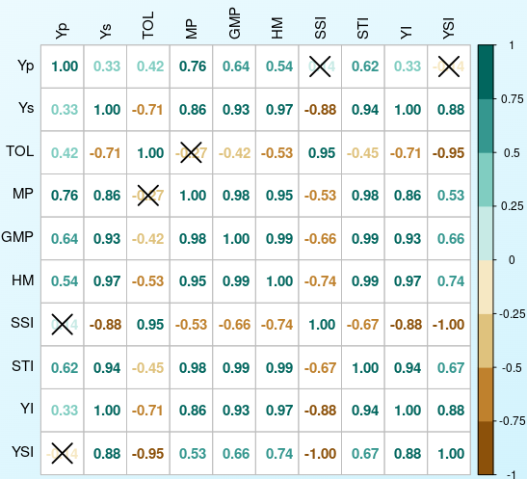

Stress susceptibility index (SSI), mean productivity (MP), tolerance (TOL), stress tolerance index (STI), Harmonic mean productivity (HM), Geometric mean productivity (GMP), Yield index (YI) and Yield stability index (YSI); Ys: genotype yield under *Rabi* conditions, Yp: represent genotype yield under optimal conditions; X in the figure denotes significant below p = 0.05.

Table 2. Mean yield and estimates of stress indices for the fifty soybean genotypes.

|  |  |  |  |  |  |  |  |  |  |  |  |  |
| --- | --- | --- | --- | --- | --- | --- | --- | --- | --- | --- | --- | --- |
| Genotype Code | Yp | Ys | RC | TOL | MP | GMP | HM | SSI | STI | YI | YSI | ASR |
| G1 | 3002.80 | 1273.60 | 57.59 | 1729.20 | 2138.20 | 1955.60 | 1788.59 | 1.46 | 0.52 | 0.77 | 0.42 | 36.36 |
| G10 | 3206.90 | 1791.70 | 44.13 | 1415.20 | 2499.30 | 2397.04 | 2298.96 | 1.12 | 0.78 | 1.09 | 0.56 | 21.00 |
| G11 | 2708.30 | 1116.70 | 58.77 | 1591.60 | 1912.50 | 1739.07 | 1581.36 | 1.49 | 0.41 | 0.68 | 0.41 | 43.64 |
| G12 | 2927.80 | 1327.80 | 54.65 | 1600.00 | 2127.80 | 1971.68 | 1827.02 | 1.39 | 0.53 | 0.80 | 0.45 | 34.91 |
| G13 | 3044.40 | 1577.80 | 48.17 | 1466.60 | 2311.10 | 2191.68 | 2078.43 | 1.22 | 0.65 | 0.96 | 0.52 | 26.91 |
| G14 | 2427.80 | 1490.30 | 38.62 | 937.50 | 1959.05 | 1902.14 | 1846.89 | 0.98 | 0.49 | 0.90 | 0.61 | 29.91 |
| **G15** | **2827.80** | **2308.30** | **18.37** | **519.50** | **2568.05** | **2554.88** | **2541.78** | **0.47** | **0.88** | **1.40** | **0.82** | **5.64** |
| G16 | 3095.80 | 1119.40 | 63.84 | 1976.40 | 2107.60 | 1861.57 | 1644.26 | 1.62 | 0.47 | 0.68 | 0.36 | 40.00 |
| G17 | 2650.00 | 1202.80 | 54.61 | 1447.20 | 1926.40 | 1785.33 | 1654.60 | 1.39 | 0.43 | 0.73 | 0.45 | 40.36 |
| G18 | 3136.10 | 1975.00 | 37.02 | 1161.10 | 2555.55 | 2488.73 | 2423.67 | 0.94 | 0.84 | 1.20 | 0.63 | 14.55 |
| G19 | 2369.40 | 1272.20 | 46.31 | 1097.20 | 1820.80 | 1736.19 | 1655.51 | 1.18 | 0.41 | 0.77 | 0.54 | 39.55 |
| G2 | 2748.60 | 1943.10 | 29.31 | 805.50 | 2345.85 | 2311.02 | 2276.70 | 0.75 | 0.72 | 1.18 | 0.71 | 16.27 |
| G20 | 2279.20 | 2205.60 | 3.23 | 73.60 | 2242.40 | 2242.10 | 2241.80 | 0.08 | 0.68 | 1.34 | 0.97 | 12.82 |
| **G21** | **2791.70** | **2291.70** | **17.91** | **500.00** | **2541.70** | **2529.38** | **2517.11** | **0.46** | **0.87** | **1.39** | **0.82** | **7.00** |
| G22 | 2735.60 | 1427.80 | 47.81 | 1307.80 | 2081.70 | 1976.33 | 1876.30 | 1.22 | 0.53 | 0.87 | 0.52 | 33.73 |
| G23 | 2744.40 | 1721.90 | 37.26 | 1022.50 | 2233.15 | 2173.84 | 2116.11 | 0.95 | 0.64 | 1.04 | 0.63 | 23.00 |
| G24 | 3108.30 | 2115.30 | 31.95 | 993.00 | 2611.80 | 2564.17 | 2517.42 | 0.81 | 0.89 | 1.28 | 0.68 | 10.18 |
| G25 | 1515.60 | 863.90 | 43.00 | 651.70 | 1189.75 | 1144.26 | 1100.51 | 1.09 | 0.18 | 0.52 | 0.57 | 41.36 |
| G26 | 2686.10 | 1169.40 | 56.46 | 1516.70 | 1927.75 | 1772.32 | 1629.43 | 1.44 | 0.42 | 0.71 | 0.44 | 41.82 |
| G27 | 2866.70 | 1200.00 | 58.14 | 1666.70 | 2033.35 | 1854.73 | 1691.81 | 1.48 | 0.47 | 0.73 | 0.42 | 39.55 |
| G28 | 2197.20 | 1450.00 | 34.01 | 747.20 | 1823.60 | 1784.92 | 1747.06 | 0.86 | 0.43 | 0.88 | 0.66 | 31.73 |
| G29 | 2472.20 | 1848.60 | 25.22 | 623.60 | 2160.40 | 2137.78 | 2115.40 | 0.64 | 0.62 | 1.12 | 0.75 | 19.73 |
| G3 | 2765.30 | 927.80 | 66.45 | 1837.50 | 1846.55 | 1601.76 | 1389.43 | 1.69 | 0.35 | 0.56 | 0.34 | 45.73 |
| G30 | 3234.70 | 1838.90 | 43.15 | 1395.80 | 2536.80 | 2438.91 | 2344.80 | 1.10 | 0.80 | 1.11 | 0.57 | 19.36 |
| G31 | 2812.80 | 1819.40 | 35.32 | 993.40 | 2316.10 | 2262.21 | 2209.58 | 0.90 | 0.69 | 1.10 | 0.65 | 19.09 |
| G32 | 3186.10 | 2001.40 | 37.18 | 1184.70 | 2593.75 | 2525.21 | 2458.47 | 0.95 | 0.86 | 1.21 | 0.63 | 13.64 |
| G33 | 2663.90 | 2023.60 | 24.04 | 640.30 | 2343.75 | 2321.78 | 2300.02 | 0.61 | 0.73 | 1.23 | 0.76 | 14.27 |
| G34 | 2976.40 | 2147.20 | 27.86 | 829.20 | 2561.80 | 2528.03 | 2494.70 | 0.71 | 0.86 | 1.30 | 0.72 | 10.36 |
| G35 | 2800.00 | 2266.70 | 19.05 | 533.30 | 2533.35 | 2519.28 | 2505.28 | 0.48 | 0.86 | 1.37 | 0.81 | 8.64 |
| G36 | 2792.50 | 1647.20 | 41.01 | 1145.30 | 2219.85 | 2144.72 | 2072.12 | 1.04 | 0.62 | 1.00 | 0.59 | 24.91 |
| G37 | 2605.60 | 1516.70 | 41.79 | 1088.90 | 2061.15 | 1987.94 | 1917.33 | 1.06 | 0.53 | 0.92 | 0.58 | 29.82 |
| **G38** | **3050.00** | **2308.30** | **24.32** | **741.70** | **2679.15** | **2653.36** | **2627.82** | **0.62** | **0.95** | **1.40** | **0.76** | **5.91** |
| G39 | 3184.70 | 1455.60 | 54.29 | 1729.10 | 2320.15 | 2153.06 | 1998.00 | 1.38 | 0.63 | 0.88 | 0.46 | 29.64 |
| G4 | 2836.40 | 1669.40 | 41.14 | 1167.00 | 2252.90 | 2176.03 | 2101.77 | 1.05 | 0.64 | 1.01 | 0.59 | 23.64 |
| G40 | 2466.70 | 1729.20 | 29.90 | 737.50 | 2097.95 | 2065.29 | 2033.14 | 0.76 | 0.58 | 1.05 | 0.70 | 23.55 |
| G41 | 2527.80 | 911.10 | 63.96 | 1616.70 | 1719.45 | 1517.59 | 1339.43 | 1.63 | 0.31 | 0.55 | 0.36 | 47.00 |
| G42 | 2983.30 | 1755.60 | 41.15 | 1227.70 | 2369.45 | 2288.55 | 2210.42 | 1.05 | 0.71 | 1.06 | 0.59 | 21.45 |
| G43 | 2152.20 | 1650.00 | 23.33 | 502.20 | 1901.10 | 1884.44 | 1867.93 | 0.59 | 0.48 | 1.00 | 0.77 | 25.36 |
| G44 | 2311.10 | 1861.10 | 19.47 | 450.00 | 2086.10 | 2073.93 | 2061.83 | 0.50 | 0.58 | 1.13 | 0.81 | 19.27 |
| G45 | 2483.30 | 1433.30 | 42.28 | 1050.00 | 1958.30 | 1886.61 | 1817.55 | 1.07 | 0.48 | 0.87 | 0.58 | 33.18 |
| G46 | 2588.90 | 1286.10 | 50.32 | 1302.80 | 1937.50 | 1824.71 | 1718.50 | 1.28 | 0.45 | 0.78 | 0.50 | 38.27 |
| G47 | 2758.30 | 2144.40 | 22.26 | 613.90 | 2451.35 | 2432.06 | 2412.91 | 0.57 | 0.80 | 1.30 | 0.78 | 11.36 |
| G48 | 2441.70 | 1441.70 | 40.96 | 1000.00 | 1941.70 | 1876.22 | 1812.95 | 1.04 | 0.48 | 0.87 | 0.59 | 32.09 |
| G49 | 2833.30 | 1988.90 | 29.80 | 844.40 | 2411.10 | 2373.85 | 2337.17 | 0.76 | 0.76 | 1.21 | 0.70 | 14.64 |
| **G5** | **2812.50** | **2316.70** | **17.63** | **495.80** | **2564.60** | **2552.59** | **2540.64** | **0.45** | **0.88** | **1.40** | **0.82** | **5.18** |
| **G50** | **2769.70** | **2472.20** | **10.74** | **297.50** | **2620.95** | **2616.73** | **2612.51** | **0.27** | **0.93** | **1.50** | **0.89** | **3.82** |
| G6 | 2481.90 | 905.60 | 63.51 | 1576.30 | 1693.75 | 1499.20 | 1327.00 | 1.61 | 0.30 | 0.55 | 0.36 | 46.91 |
| G7 | 2747.20 | 1502.80 | 45.30 | 1244.40 | 2125.00 | 2031.87 | 1942.82 | 1.15 | 0.56 | 0.91 | 0.55 | 30.64 |
| G8 | 2168.10 | 1277.80 | 41.06 | 890.30 | 1722.95 | 1664.45 | 1607.94 | 1.04 | 0.37 | 0.77 | 0.59 | 37.00 |
| G9 | 2980.60 | 1487.50 | 50.09 | 1493.10 | 2234.05 | 2105.62 | 1984.58 | 1.27 | 0.60 | 0.90 | 0.50 | 30.09 |

Bold font indicate the most stable and high yielding genotypes under *Kharif* and *Rabi* season

Table 3: Best five genotypes across Individual Selection Indices

|  |  |  |  |  |  |  |
| --- | --- | --- | --- | --- | --- | --- |
| indices | Selection pattern | Top five genotypes | | | | |
| Tolerance index (TOL) | minimam value | G20 | G50 | G44 | G5 | G21 |
| Mean productivity (MP) | Maximum value | G38 | G50 | G24 | G32 | G15 |
| Geometric mean productivity (GMP) | Maximum value | G38 | G50 | G20 | G15 | G5 |
| Harmonic mean productivity (HM) | Maximum value | G38 | G50 | G15 | G5 | G24 |
| Stress susceptibility index (SSI) | minimum value | G20 | G50 | G5 | G21 | G15 |
| Stress tolerance index (STI) | Maximum value | G38 | G50 | G24 | G15 | G5 |
| Yield index (YI) | Maximum value | G50 | G50 | G38 | G15 | G21 |
| Yield stability index (YSI) | Maximum value | G50 | G50 | G5 | G21 | G15 |

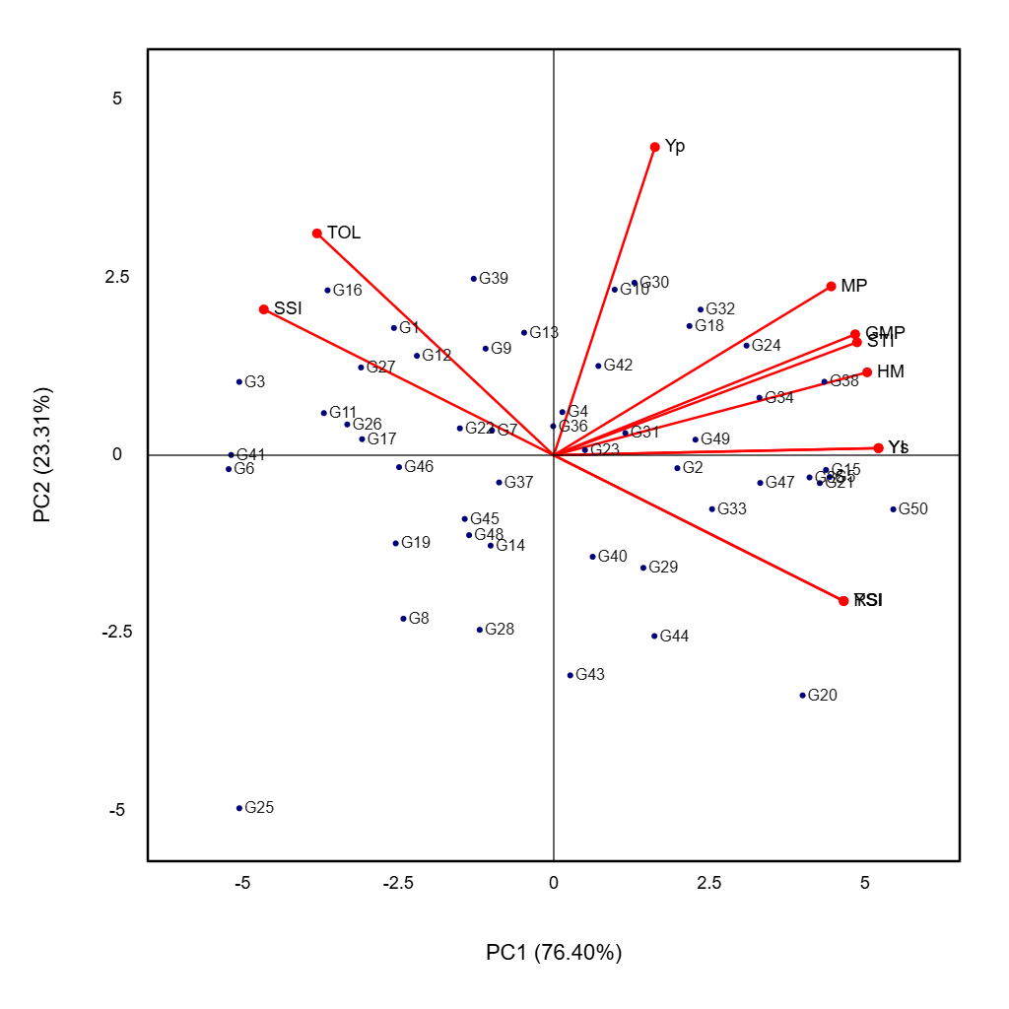

Figure 2: Biplot based on principal component analysis of stress indices and 50 soybean genotypes evaluated in *kharif* and *rabi* season (off season)

**Disclaimer (Artificial intelligence)**

Option 1:

Author(s) hereby declare that NO generative AI technologies such as Large Language Models (ChatGPT, COPILOT, etc.) and text-to-image generators have been used during the writing or editing of this manuscript.

Option 2:

Author(s) hereby declare that generative AI technologies such as Large Language Models, etc. have been used during the writing or editing of manuscripts. This explanation will include the name, version, model, and source of the generative AI technology and as well as all input prompts provided to the generative AI technology

Details of the AI usage are given below:

1.

2.

3.

**References:**

Abou-Elwafa S.F. and Shehzad T.2021. Genetic diversity, GWAS and prediction for drought and terminal heat stress tolerance in bread wheat (Triticum aestivum L.). Genet. Res. Crop. Evol., 68(2): 711-728

Anderson T W. 1972. An introduction to multivariate Analysis. Wiley Eastem Pvt Ltd. New Delhi.

Bahrami F., Arzani A. and Rahimmalek M. 2021. A novel tolerance index to identify heat tolerance in cultivated and wild barley genotypes. Bio Rxiv: 2020-05.DOI: 10.1101/2020.05.31.125971

Banerjee, J., Shrivastava, M. K., Amrate, P. K., Singh, Y., Upadhyay, A., & Soni, M. (2022). Genetic variability and association of yield contributing traits in advanced breeding lines of soybean. *Electronic Journal of Plant Breeding*, *13*(2), 597-607.

Bidinger, F. R., Mahalakshmi, V., & Rao, G. D. P. (1987). Assessment of drought resistance in pearl millet [Pennisetum americanum (L.) Leeke]. Field Crops Research, 17(2–3), 135–146. <https://doi.org/10.1016/0378-4290(87)90018-1>

Bouslama, M., & Schapaugh, W. T. (1984). Stress tolerance in soybean. I. Evaluation of three screening techniques for heat and drought tolerance. Crop Science, 24(5), 933–937. <https://doi.org/10.2135/cropsci1984.0011183X002400050026x>

Chugh P., Sharma P., Sharma R., Singh M. 2022. Study on heat stress indices and their correlation with yield in Indian mustard genotypes under diverse conditions. Indian J. Genet. Plant Breed., 82(2): 186-192.

Department of Agriculture & Farmers Welfare, Ministry of Agriculture, New Delhi, 2024.

Devi K., Chahal S., Singh S., KarnamVenkatesh K., Mamrutha H.M., Raghav N., Singh G., Singh G.P. and Tiwari R. 2021. Assessment of wheat genotypes based on various indices under different heat stress conditions. Indian J. Genet. Plant Breed., 81(3): 376-382. doi: 10.31742/IJGPB.81.3.4.

Farshadfar, E., Ghanadha, Sutka, J. and Zahravi, M. 2001. Generation mean analysis of drought tolerance in wheat (Triticum aestivum L.). Acta Agronomica Hungarica, 49(1): 59-66

Fernandez, G. C. J. (1992). Effective selection criteria for assessing plant stress tolerance. In: Proceedings of the International Symposium on Adaptation of Vegetables and Other Food Crops in Temperature and Water Stress, Taiwan, 257–270.

Fischer, R. A., & Maurer, R. (1978). Drought resistance in spring wheat cultivars. I. Grain yield responses. Australian Journal of Agricultural Research, 29(5), 897–912. <https://doi.org/10.1071/AR9780897>

García, M.F.P.  and García, P.I.P. (2010). Principal component analysis applied to filtered signals for maintenance management. Quality and Reliability Engineering International.  26(6): 523-527.

Gavuzzi, P., Rizza, F., Palumbo, M., Campanile, R. G., Ricciardi, G. L., & Borghi, B. (1997). Evaluation of field and laboratory predictors of drought and heat tolerance in winter cereals. Canadian Journal of Plant Science, 77(4), 523–531. <https://doi.org/10.4141/P96-136>

Kaya Y., Palta C. and Taner S. 2002. Additive main effects and multiplicative interactions analysis of yield performances in bread wheat genotypes across environments. Turk. J. Agric. For., 26(5): 275-279.

Kumar N., Poddar A., Shankar V., Ojha C. S. P. and Adeloye A. J. 2020. Crop water stress index for scheduling irrigation of Indian mustard (Brassica juncea) based on water use efficiency considerations. J. Agron. Crop Sci., 206(1): 148-159.

Pandey G. C., Mamrutha H.M., Tiwari R., Sareen S., Bhatia S., Siwach P., Tiwari V. and Sharma I. 2015. Physiological traits associated with heat tolerance in bread wheat (Triticum aestivum L.) Physiol. Mol. Biol. Plants, 21(1): 93–99.

Poudel P. B., Poudel M.R. and Puri R.R. 2021. Evaluation of heat stress tolerance in spring wheat (Triticum aestivum  L.) genotypes using stress tolerance indices in western region of Nepal. J. Agric. Food Res., 5: 100179

Pour-Aboughadareh, A., Yousefian, M., Moradkhani, H., Moghaddam, V, M., Poczai, P., and Siddique. K. H. M. (2019). iPASTIC: An online toolkit to estimate plant abiotic stress indices. Applications in Plant Sciences, 7(7): e11278.

R. Jaishreepriyanka , R., Ravikesavan, K., Iyanar, D., Uma. & Senthil, N. 2024. Exploring the usefulness of drought tolerance indices in screening of maize inter-racial derivatives. Electronic journal of plant breeding. Vol 15(3) : 592-603

Rad A. H. S. and Abbasian A. 2011. Evaluation of drought tolerance in winter rapeseed cultivars based on tolerance and sensitivity indices.  Notulae Botanicae Horti Agrobotanici., 98(1): 41-48.

Rosielle, A. A., & Hamblin, J. (1981). Theoretical aspects of selection for yield in stress and non-stress environments. Crop Science, 21(6), 943–946. <https://doi.org/10.2135/cropsci1981.0011183X002100060033x>

Sharma H., Singh K., Kumar V.V., Meena H.S. and Meena B. 2022. Genetic study of terminal heat stress in indigenous collections of Indian mustard (Brassica juncea. L.) germplasm. J. Environ. Biol., 43(1): 161-69

Spoorthi, B., Naidu, G., Deshpande, S., & Mummigatti, U. (2024). Impact of seasons on genetic variability parameters in soybean (Glycine max (L.) Merrill). Journal of Farm Sciences, 37(01), 1-6.

Thiry A. A, Chavez Dulanto P. N., Reynolds M. P., and Davies W. J. 2016. How can we improve crop genotypes to increase stress resilience and productivity in a future climate? A new crop screening method based on productivity and resistance to abiotic stress. J. Exp. Bot., 67(19): 5593-5603.

Matoša Kočar, M., Sudarić, A., Duvnjak, T., & Mazur, M. (2025). Soybean Genotype-Specific Cold Stress and Priming Responses: Chlorophyll a Fluorescence and Pigment-Related Spectral Reflectance Indices as Tools for Breeding. Agronomy, 15(2), 390.

Devi , Y. L., Singh , K. N., & Samuthirapandi , S. (2023). Characterization and Evaluation of Some Genotypes of Soybean [(Glycine max (L.) Merrill] under Acidic Soil Condition in Meghalaya, India. International Journal of Environment and Climate Change, 13(9), 3173–3180. https://doi.org/10.9734/ijecc/2023/v13i92561

Dharshini M. S., Macwana , S. S., Parmar D. J., & Patil , K. (2024). Multi Environment Analysis of Soybean Genotypes to Delineate Stability and Adaptability for Yield and Quality Parameters. Journal of Scientific Research and Reports, 30(5), 259–275. https://doi.org/10.9734/jsrr/2024/v30i51941