Effect of Organic Acid Concentration and Leaching Time on the Efficiency of Nickel and Zinc Recovery from Waste Printed Circuit Boards of Mobile Phones

.ABSTRACT

|  |
| --- |
| **Aims:** The present work evaluated the effect of organic acid concentration and reaction time on the recovery of Zn and Ni from waste printed circuit boards of cell phone.  **Study design:** A survey research design was adopted.  **Place and Duration of Study:** Materials and Energy Technology Lab in Projects Development institute (PRODA) Enugu Nigeria, between March 2021 and December 2024.  **Methodology:** Cables and plastics were removed from circuit boards, and metals were extracted using heat, washed, dried, and treated in sodium hydroxide before being crushed and characterized using SEM-EDX and XRD. Acid leaching was then conducted using varying acid concentrations (1M, 2M, 3M, 4M and 5M) and times (2hrs, 3hrs, 4hrs, 5hrs and 6hrs) to compare metal recovery efficiency. Leachates were filtered and analyzed with atomic absorption spectrophotometry to quantify metal content following standard procedures.  **Results:** The SEM-EDX and XRD result indicates a copper-zinc-nickel alloy, likely a type of brass or nickel silver. The morphology shows an irregular surface, possibly with some porosity or particle clusters with some trace elements as impurities. Zn and Ni were successfully recovered from waste PCB of cell phone when leached with oxalic acid for 2 hours recording the highest recovery efficiency of 14.90% and 37.5% as leaching time was varied. Then citric acid (15.75%), malic acid (12.95%) and the combination of citric, malic and oxalic acids (6.39%) were recorded as highest efficiencies at 2 hours when Ni was leached. At varied concentration, oxalic acid had the highest efficiency in the recovery of Zn and Ni (53.12 % and 88.91 %) as compared to other acids and their combination.  **Conclusion:** The impact of concentration on leaching efficiency was higher compared to the impact observed when time was varied. It is suggested that leaching with different degrees of oxidant be carried out to enhance the efficiency of the other acids. |

Keywords*:* **printed circuit board; acid leaching; base metal; e- waste; kinetics**

1. **INTRODUCTION**

The manufacturing of electrical and electronic equipment (EEE) and the associated generation of electronic waste (e-waste) is experiencing a rapid growth due to the high consumption of electronic devices and their early obsolescence throughout the world. Electrical and electronic items such as computers, TV sets, mobile phones etc. have made our life simpler. However, it is one type of waste with great environmental concern and economic value (Ajiboye et al., 2019). On the other end, management of the waste generated by these products has become a serious challenge to environmentalists, waste management professionals and governments around the world (Musson et al, 2000, Cui et al, 2003; Naik and Eswari, 2022). Disposal of e-waste in landfill causes metal leaching (Dagan et al 2007) while burning of e-waste produces extremely hazardous dioxins and furans (Li et al, 2007; Saha et al., 2021; Morell Llorens et al., 2025). Proper management of e waste will help the economic implication of their reuse if well harnessed. Mobile phones are one of the major contributors of e-waste because the newer technologies are incorporated and older versions are discarded rapidly. Therefore, these are regarded as short-life-cycle electronic products (Santos et al 2010). The average life of mobile phones is less than two years in the developed countries and three years in the developing countries (Ogunniyi et al., 2009; Guo and Yan, 2017). Mobile phone is a complex machine comprised of various components, wherein plastic, printed Circuit board (PCB), battery, and liquid crystal display (LCD) are the major ones.

The major methods for recovering metals from PCBs of cell phone include pyrometallurgical and hydrometallurgical processes (Birloaga et al., 2013; Morell Llorens et al., 2025). In recent years, the hydrometallurgical processes attracted particular attention for the treatment of E-waste. Several researchers showed the effectiveness of strong acids as leachant for leaching of metals (Tuncuk et al. 2012; Akcil et al. 2015; Ajiboye et al., 2019). However, the release of Cl2, SO3, NOx, and the acidic wastewaters during the leaching process are a threat to the environment. Therefore, there is a need for the development of environmentally friendly hydro metallurgical processes for future applications. Use of organic acids, is a suitable alternative. Organic acids are considered to be leaching media that do not pollute the environment; they are ecologically friendly and efficient, and can be used for the selective leaching of metals. Organic acids are biodegradable and the waste generated in the leaching stage is easy to handle. Although some organic acids are more expensive than inorganic acids, their use is still cost effective. Several researchers have used citric acid and H2O2 for leaching of metals from scrap battery paste, sewage sludge, and waste lithium cobalt battery (Sonmez and Kumar 2009;). Citric acid dissolves in water easily. It degrades under aerobic and anaerobic conditions. Therefore, the waste solutions generated after metal leaching can be treated easily. Jadhav et al. (2016) showed that the combination of organic acid and H2O2 was as effective in the leaching of PCBs as the use of inorganic acids. The present work evaluated the effect of organic acid concentration and reaction time on the recovery of Zn and Ni from waste printed circuit boards of cell phone.

1. **MATERIALS AND METHODS**

Waste samples of printed circuit boards of cell phones, obtained from store rooms of Project Development Institute (PRODA) Enugu, Nigeria were the metal source in the present study. They were then taken to the Materials and energy technology lab in Projects Development institute (PRODA) Enugu Nigeria for further analysis.

**2.1 Sample Preparation**

Cables and plastic materials attached to the circuit board matrix were manually removed from the board. Dismantling products such as plastic film, ferrous scraps and paper pieces were separated. Metal components were removed from the printed circuit board by the use of hot air gun. The detached metals, after size reduction, were washed in distilled water and allowed to drain. They were subsequently dried at 300C immersed and stirred in 1M sodium hydroxide solution with mild agitation (100 rpm) at 600C for 4 hours. The treated and dried metals were crushed to powdered form of 75µm using laboratory jaw crusher, this was sieved for uniform size (Plate 1) and then characterized using SEM-EDX and XRD.

**2.2 Acid leaching experiments**

The leaching of zinc and nickel were carried out in a temperature controlled Erlenmeyer glass reactor fitted with a reflux condenser to avoid the loss of liquid in a form of vapor during the experiment. To optimize the experimental conditions for effective leaching the study was made varying different process parameters for example leaching time, organic acid type and organic acid concentration while temperature remained constant at 50oC and Constant pulp density used was 25g/1. In a three necked Erlenmeyer glass reactor 1g of the sample with 10mls of the acid were put and heated using hot plate with magnetic stirrer and a thermometer to maintain a steady temperature of 50oC. The samples were drawn at regular time interval i.e. (2, 3, 4, 5, 6 hours) the acids at known concentrations of (1M, 2M, 3M, 4M and 5M) were also varied.

***Effect of leaching time on metal leaching:*** To monitor the effect of time on the leaching of zinc and nickel, 1g of the PCB powder (the sample) was weighed and 10mls 3M citric acid was measured into the three necked Erlenmeyer glass reactor heated for 2 hours using hot plate with magnetic stirrer and a thermometer to maintain a steady temperature of 50oC. This was repeated at 4 different time intervals (3, 4, 5, 6 hours). As time is varied, temperature and concentration remained constant. (3M and 50oC)

**Effect of acid concentration on metal leaching:** To achieve this 1g of the sample and 10 mls of 1M citric acid was measured into the three necked Erlenmeyer glass reactor heated for 4 hours using hot plate with magnetic stirrer and a thermometer to maintain a steady temperature of 50oC. This was repeated for 4 different concentrations of the acid (2, 3, 4, 5M). As concentration is varied, temperature and time remained constant. (4hrs and 50oC).

**Effect of acid type on metal leaching:** All the experimental runs carried out to monitor leaching time and acid concentration were repeated with citric acid, malic acid, oxalic acid and the blend of the three acids (citric + malic + oxalic) at equal ratio.

The leached liquor from each sample was filtered and analyzed using AAS (Buck 404, Buck Scientific, United Kingdom) to get the percentage extraction efficiency.

Extraction efficiency (%) = (Cm×10000)/(P×Ym)

Where:

Cm is the concentration of metals in the leached solution in grams per litter (g/L);

P is the pulp density of the sample in percentage (%; i.e., 25g/1000 mL); and

Ym is the metal content in the original sample (%; 1%= 10,000 g/L).

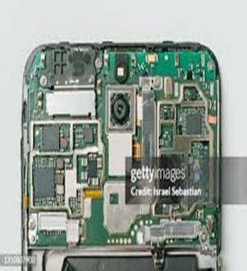 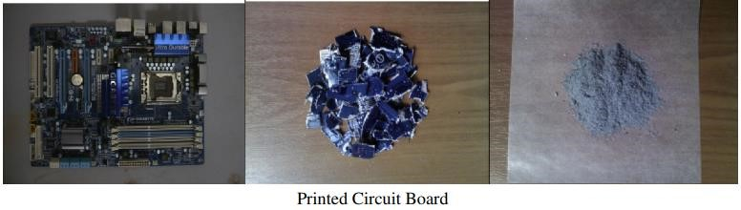 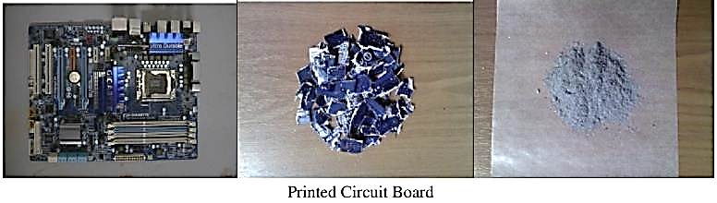

**Plate 1: Waste printed Circuit Board of Cellphone, after dismantling and after pulverization.**

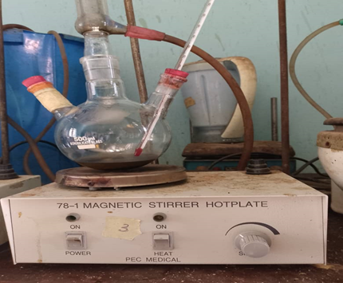

**Plate 2: Process design for leaching**

1. results and discussion

3.1 CHARACTERISTICS of PCB of Cellphone Waste

The SEM/EDX result as presented on table 1 shows the elemental composition of cellphone PBS waste. the waste contained 20 different metals with cu being the most dominant compound followed by Zn and Ni. On the other hand, Fe was the least concentrated (Table 1). More so, Fig 1 shows the chromatogram of the XRD analysis of cellphone PBS waste. It was noted that Tridymite showed visible peaks. However, Cu was present in various forms (Table 2). The Plate 3 showed the SEM morphology of pulverized waste PCB of cellphone. The morphology shows an irregular surface, possibly with some porosity or particle clusters with some trace elements as impurities (Plate 3).

**Table 1: SEM / EDX Result of Waste Printed Circuit Board of Cellphone**

|  |  |  |  |  |
| --- | --- | --- | --- | --- |
| **Element Number** | **Symbol Number** | **Element Name** | **Atomic Conc.** | **Weight Conc.** |
| 29 | Cu | Copper | 49.14 | 52.34 |
| 30 | Zn | Zinc | 22.56 | 24.73 |
| 28 | Ni | Nickel | 15.10 | 14.86 |
| 50 | Sn | Tin | 0.71 | 1.41 |
| 11 | Na | Sodium | 3.12 | 1.20 |
| 47 | Ag | Silver | 0.59 | 1.06 |
| 6 | C | Carbon | 4.08 | 0.82 |
| 41 | Nb | Niobium | 0.35 | 0.54 |
| 22 | C | Titanium | 0.67 | 0.54 |
| 39 | Y | Yttrium | 0.34 | 0.50 |
| 19 | K | Potassium | 0.71 | 0.47 |
| 24 | Cr | Chromium | 0.38 | 0.33 |
| 17 | Cl | chlorine | 0.48 | 0.28 |
| 20 | Ca | Calcium | 0.42 | 0.28 |
| 14 | Si | Silicon | 0.59 | 0.28 |
| 16 | S | Sulfur | 0.26 | 0.14 |
| 13 | Al | Aluminium | 0.27 | 0.12 |
| 12 | Mg | Magnesium | 0.23 | 0.09 |
| 15 | P | Phosphorus | 0.00 | 0.00 |
| 26 | Fe | Iron | 0.00 | 0.00 |

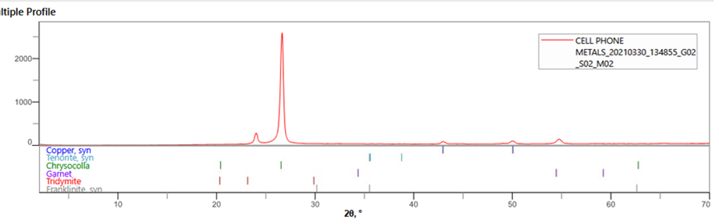

**Fig 1: X-Ray Diffraction (XRD) Spectrum of Waste PCB** **of Cellphone**

**Table 2: Phase Identification Table or XRD Phase Analysis Summary of Waste PCB of Cellphone**

|  |  |  |
| --- | --- | --- |
| **Phase Name** | **Formula** | **Figure of Merit** |
| Copper, syn | Cu | 2.182 |
| Tenorite , syn | Cu O | 2.770 |
| Chrysocolla | Cu Si O3.2H2O | 2.850 |
| Gamet | 3 (Ca , Fe, Mg ) O.(Al, Fe…. | 3.186 |
| Tridymite | Si O2 | 3. 250 |
| Franklinite, syn | (Zn0.68 Ni0.10 Cu0,05 Fe0.1… | 2.770 |

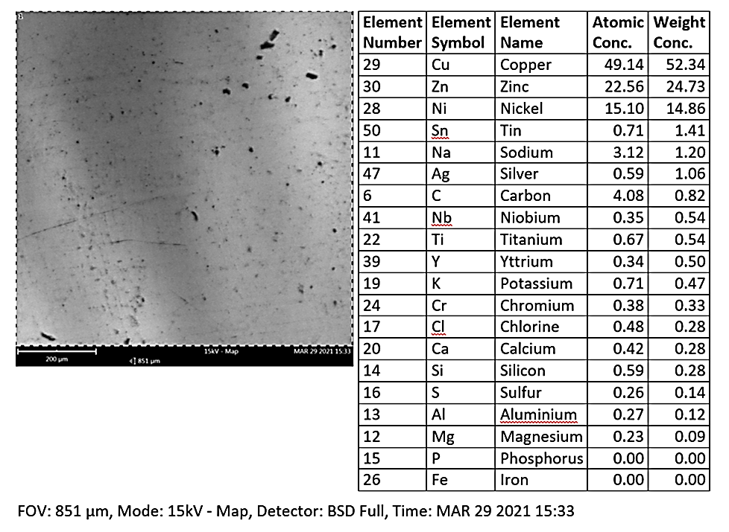

**Plate 3: Scanning Electron Microscope (SEM) Morphology of Pulverized waste PCB of Cellphone**

**3.2 Effect of time**

This work investigated the performance of malic acid, oxalic and citric acid and their potential synergy in a mixed-acid leaching system for the recovery of valuable metals. The recovery efficiency was highest at 2 hours across all the leaching agents used (Fig 2). The yield was quite lower than when only oxalic acid was used in the same experiment (Fig 3). Zn and Ni were successfully recovered from waste PCB of cell phone when leached with oxalic acid for 2 hours recording the highest recovery efficiency of 14.90% and 37.5% as leaching time was varied (Fig 4). Then citric acid (15.75%), malic acid (12.95%) and the combination of citric, malic and oxalic acids (6.39%) were recorded as highest efficiencies at 2 hours when Ni was leached. Malic acid recorded its highest efficiency at 3 hours (9.28 %) when Zn was leached (Fig 4). Oxalic acid had the highest efficiency in the recovery of Zn and Ni as compared to other acids and their combinations. Oxalic acid was observed to be a stronger chelating agent than citric acid in this study. This is in line with Gadd *et al*. (1999). According to Vega et al. (2022), oxalic acid (OxA) and its conjugate base oxalate can form salts with K, Cu, Mg, and Ca, the most prevalent being calcium oxalate (CaOx). Its chelating ability allows it to form stable complexes with metal ions, such as tin, copper, and zinc, which enhances its leaching efficiency. Oxalic acid (pKa1 ≈ 1.25, pKa2 ≈ 4.27) is a stronger acid than citric acid (pKa1 ≈ 3.13, pKa2 ≈ 4.76, pKa3 ≈ 6.40) and this means that oxalic acid is more effective at donating protons (H+ ions) to break bonds and solubilize metal ions. Its reducing ability also enables it to solubilize metal ions (Vehmaanperä et al., 2022). The combination of all the acids had the lowest recovery efficiency of Zn and Ni (Fig 4). In some studies, combining acids (e.g., oxalic + citric or citric + ascorbic) can result in synergistic effects, improving recovery due to combined chelation, protonation, and reduction. In this scenarios, competition between acids, pH buffering, or formation of less soluble complexes might had led to lower recovery of the metals.

Zn and Ni had the highest efficiency at 2 hours which decreased significantly with increased time. However, when the equilibrium state was reached, no significant change in metal dissolution was noticed on further increasing the reaction time. This align closely with previous study carried out by Xiao et al. (2022). The increase in reaction time between the organic acids and the PCB powder causes more H+ ions of organic acids to dissociate and form the metallic salt compound, so the percentage of leaching of the metals will increase. However, the amount of dissociated H+ ions from the acids will be difficult to increase when it has reached its saturation point, so that longer leaching time will not have a significant effect on the leaching efficiency and tend to be constant when it reaches its optimum time. At this variation of leaching time, it is concluded that the maximum leaching time for leaching of metals from printed circuit boards of cell phone is 2 hours based on this research work.

**3.3 Effect of concentration**

The results showed variation in recovery efficiency of metals across different concentrations. The results further showed that Zn and Ni all had a concentration dependent variation (Fig 5). Zn showed a concentration dependent decrease in recovery efficiency. Increase in acid concentration increases the flux of H+ ion across the particle boundaries and hence increased the rate of reaction (Sawahbkeh et al., 2010). But this increasing dissolution rate of the metals leached in solution is valid up to a certain acid concentration only. As a result, the concentration of the various organic acid influenced metal leaching. According to previous research, the leaching efficiency decreases with increasing organic acid concentration (Li et al., 2010). When the concentration of the organic acids used increased to 1 M, the leaching behaviour improved. This is due to the formation of metal complexes, which were eventually degraded to release free metal ions in the solution. As the concentration rises further from 4 to 5 M, (oxalic acid recorded 31.24 and 29.69% respectively) for nickel, the acid forms more complexes with the metals but were unable to convert them to metal ions due to lack of oxidant, resulting in a decrease in leaching efficiency. Several studies have reported that as acid concentration is increased, there is an initial increase in leaching rate and extend up to a certain point where a further increase in the amount of acid results in no change in the leaching efficiency or has an adverse effect on the leaching (Yuliusman et al., 2017). This is consistent with the result in this study and is usually due to a change in the rate limiting step as the acid concentration is increased. In general, acid concentration has pronounced effect on metal extraction and is one of the important factors of optimizing leaching conditions in metal recovery. The results as presented in Fig. 6 shows that there were significant variations in efficiency of the different leachates on metals recovery based on concentration variation. Oxalic acid had the highest efficiency in the recovery of Zn and Ni (53.12 % and 88.91 %) as compared to other acids and their combination. However, malic acid recorded the lowest efficiency of the acids in the leaching of nickel (12.95%) (Fig 7).

**3.4 Adsorption kinetics**

Reaction pathways for the recovery of metals from panel waste after leaching were determined by the sorption kinetic model of the Pseudo-First order. The Pseudo-first order plots of log(qe- qt) versus time, t(min) for the recovery of heavy metals by different leaching agents are parameters were generated and listed in Table 3.. With respect to the range of values of R2, Di Bucchianico (2008) suggested that values of R2 ​< ​0.5 indicate a weak relation between the predictor (or independent) variable(s) and the response variable, while 0.5< R2 ​< ​0.8 indicate that the model is not adequate. This implies that R2 ​≥ ​0.8 indicate good fit between the data and the model, which was applied by Simonin (2016) in his work. From this study, the outcome of the plot and its non-linearity shows that the pseudo-first order kinetic model could not portray the mechanism of Ni adsorption by the acid combination. This is due to the low correlation coefficient (r2) values 0.7796. On the other hand, the model was a good fit to explain the mechanism of Zn and Ni adsorption by the leaches except Ni with the combined acids. This is an indication of availability of Zn and Ni in cell phone circuit board.

**Fig 2: Comparative Evaluation of the Efficiency of Time on Metal Recovery from Waste Printed Circuit Board of Cell phone**

**Fig 3: Comparative Evaluation of Organic Acids Efficiency for the Recovery of Metals from Waste Printed Circuit Boards of Cell phone**

**Fig 4**: **Recovery** **Efficiency of Organic Acids on Zn and Ni from Waste Printed Circuit Boards of Cellphone at Different Time Intervals at Constant Temperature and Concentration.**

**Fig 5: Comparative evaluation of the efficiency of metals recovery from waste printed circuit boards at different concentration.**

**Fig 6: Comparative Evaluation of the Efficiency of Organic Acids on Metals Recovery from Waste Printed Circuit Board of Cell Phone at Different Concentrations**

**Fig 7: Efficiency of Organic Acids on Zn and Ni Recovery from Waste Printed Circuit Boards of Cellphone at Constant Temperature and Time While Concentration is Varied**

**Fig 8: kinetics of Leaching of Nickel at different time intervals**

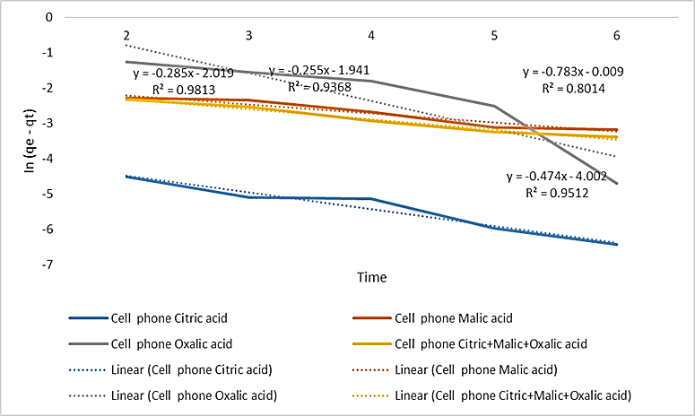

**Fig 9: kinetics of Leaching of Zinc at Different Time Intervals**

**Table 3: Pseudo First Order Model for Organic Acid Leaching of Zinc and Nickel from Waste PCB of Cellphone**

|  |  |  |  |  |  |  |
| --- | --- | --- | --- | --- | --- | --- |
|  |  | **Intercept** | **Slope** | **R-Square** | **Rate constant (Kt)min-1** | **qe** |
| Zn | Citric acid | -0.4744 | -4.0029 | 0.9813 | 0.04003 | 0.62226 |
| Malic acid | -0.2532 | -1.9488 | 0.9368 | 0.01949 | 0.77631 |
| Oxalic acid | -0.7838 | -0.0046 | 0.8014 | 4.60E-05 | 0.45667 |
| Citric+Malic+ Oxalic acid | -0.2833 | -2.0254 | 0.9512 | 0.02025 | 0.75329 |
| Ni | Citric acid | -0.2791 | -1.714 | 0.8274 | 0.01714 | 0.75646 |
| Malic acid | -0.5469 | -2.2728 | 0.9398 | 0.02273 | 0.57874 |
| Oxalic acid | -0.6603 | 1.1852 | 0.8861 | -0.0119 | 0.5167 |
| Citric+Malic+ Oxalic acid | -0.2159 | -2.435 | 0.7796 | 0.02435 | 0.80582 |

**4.0 Conclusion**

The rapid growth of electronic devices, their subsequent obsolescence and disposal has resulted in electronic waste (e-waste) being one of the fastest increasing waste streams worldwide. The leaching with acids is one of many methods used for recovery of valuable components from industrial wastes. The study analyzed PCBs from discarded cellphones by determining their metal content through characterization. The SEM-EDX result of the waste PCBs analyzed showed copper, zinc and nickel as metals present in significant quantities. The leaching experiment showed oxalic acid as a better leachate in the recovery of nickel with the efficiency of 88.91% at 1 M concentration and 2 hrs and constant temperature of 50oC this was carried out without any oxidant. In the recovery of zinc, oxalic acid recorded highest efficiency of 53.12%. However, it was deduced from this work that the impact of concentration on leaching efficiency is more compared the impact observed when time was varied. It is suggested that leaching with different degrees of oxidant be carried out to enhance the efficiency of the other acids.

Disclaimer (Artificial intelligence)

Author(s) hereby declare that NO generative AI technologies such as Large Language Models (ChatGPT, COPILOT, etc.) and text-to-image generators have been used during the writing or editing of this manuscript.

**References**

Ajiboye, A. E., Olasehinde, F. E., Adebayo, O. A., Ajayi, O. J., Ghosh, M. K., & Basu, S. (2019). Extraction of Copper and Zinc from Waste Printed Circuit Boards. Recycling, 4(3), 36. <https://doi.org/10.3390/recycling4030036>

Akcil, A., Erust, C., Gahan, C. S., Ozgun, M., Sahin, M., & Tuncuk, A. (2015). Precious metal recovery from waste printed circuit boards using cyanide and non-cyanide lixiviants–a review. *Waste management*, *45*, 258-271. <https://doi.org/10.1016/j.wasman.2015.01.017>.

Birloaga, I., De Michelis, I., Ferella, F., Buzatu, M., & Vegliò, F. (2013). Study on the influence of various factors in the hydrometallurgical processing of waste printed circuit boards for copper and gold recovery. *Waste management*, *33*(4), 935-941. <https://doi.org/10.1016/j.wasman.2013.01.003>.

Cui, J., & Forssberg, E. (2003). Mechanical recycling of waste electric and electronic equipment: a review. *Journal of hazardous materials*, *99*(3), 243-263. <https://doi.org/10.1016/S0304-3894(03)00061-X>.

Dagan, R., Dubey, B., Bitton, G., & Townsend, T. (2007). Aquatic toxicity of leachates generated from electronic devices. *Archives of environmental contamination and toxicology*, *53*, 168-173. https://doi.org/10.1007/s00244 006-0205-1.

Guo, X., & Yan, K. (2017). Estimation of obsolete cellular phones generation: A case study of China. *Science of the Total Environment*, *575*, 321-329.

Jadhav, U., Su, C., & Hocheng, H. (2016). Leaching of metals from large pieces of printed circuit boards using citric acid and hydrogen peroxide. *Environmental Science and Pollution Research*, *23*, 24384-24392. <https://doi.org/10.1007/s11356-016-7695-9>.

Jha, M. K., Choubey, P. K., Jha, A. K., Kumari, A., Lee, J. C., Kumar, V., & Jeong, J. (2012). Leaching studies for tin recovery from waste e-scrap. *Waste management*, *32*(10), 1919-1925.

Li, H., Yu, L., Sheng, G., Fu, J., & Peng, P. A. (2007). Severe PCDD/F and PBDD/F pollution in air around an electronic waste dismantling area in China. *Environmental Science & Technology*, *41*(16), 5641-5646. <https://doi.org/10.1021/es0702925>.

Morell Llorens, J., Lao Luque, C., Solé Sardans, M. M., Ribas Fargas, D., Guimerà Villalba, X., & Dorado Castaño, A. D. (2025). Closed-loop bioleaching for mobile phones from the bioregeneration of the leaching agent to the recovery of metal: a review. *Journal of Industrial and Engineering Chemistry*. <https://doi.org/10.1016/j.jiec.2025.04.020>

Musson, S. E., Jang, Y. C., Townsend, T. G., & Chung, I. H. (2000). Characterization of lead leachability from cathode ray tubes using the toxicity characteristic leaching procedure. *Environmental science & technology*, *34*(20), 4376-4381. <https://doi.org/10.1021/es0009020>

Naik, S., & Eswari, J. S. (2022). Electrical waste management: Recent advances challenges and future outlook. *Total Environment Research Themes*, *1*, 100002. <https://doi.org/10.1016/j.totert.2022.100002>

Ogunniyi, I. O., Vermaak, M. K. G., & Groot, D. R. (2009). Chemical composition and liberation characterization of printed circuit board comminution fines for beneficiation investigations. *Waste Management*, *29*(7): 2140-2146. <https://doi.org/10.1016/j.wasman.2009.03.004>.

Saha, L., Kumar, V., Tiwari, J., Rawat, S., Singh, J., & Bauddh, K. (2021). Electronic waste and their leachates impact on human health and environment: Global ecological threat and management. *Environmental Technology & Innovation*, *24*, 102049.

Santos, M. C., Nóbrega, J. A., Baccan, N., & Cadore, S. (2010). Determination of toxic elements in plastics from waste electrical and electronic equipment by slurry sampling electrothermal atomic absorption spectrometry. *Talanta*, *81*(4-5), 1781-1787. <https://doi.org/10.1016/j.talanta.2010.03.038>.

Sonmez, M. S., & Kumar, R. V. (2009). Leaching of waste battery paste components. Part 1: Lead citrate synthesis from PbO and PbO2. *Hydrometallurgy*, *95*(1-2), 53-60. <https://doi.org/10.1016/j.hydromet.2008.04.019>.

Vega, A., Delgado, N., & Handford, M. (2022). Increasing Heavy Metal Tolerance by the Exogenous Application of Organic Acids. International Journal of Molecule Science, 13;23(10):5438. <https://doi.org/10.3390/ijms23105438>.

Vehmaanperä, P., Sihvonen, T., Salmimies, R., & Häkkinen, A. (2022). Dissolution of Magnetite and Hematite in Mixtures of Oxalic and Nitric Acid: Mechanisms and Kinetics. Minerals, 12(5), 560. <https://doi.org/10.3390/min12050560>

Williams, E., Kahhat, R., Allenby, B., Kavazanjian, E., Kim, J., & Xu, M. (2008). Environmental, social, and economic implications of global reuse and recycling of personal computers. *Environmental science & technology*, *42*(17), 6446-6454. <https://doi.org/10.1021/es702255z>.