**Study on the transition of defense mechanisms from a healthy frame of mind to a depressed outlook on life**

**ABSTRACT**

**Aims:** This study examines changes in various defense mechanisms as individuals transition from a healthy state of mind to a depressed state, as well as the prevalence of different defense mechanisms.

**Study Design:** Hospital- and Community-Based Cross-Sectional Study

**Place and Duration of the Study:** Department of psychiatry of Late Shri Lakhiram Agrawal Memorial Government Medical College, Raigarh & various institutes of Raigarh and community homes of Raigarh, Chhattisgarh, from June 1, 2022, to April 30, 2023

**Methodology:** We enrolled 201 patients clinically diagnosed with depression and 1187 subjects from the general population. The Hamilton Depression Rating Scale and Defense Style Questionnaire 40 and Eysenck Personality Questionnaire- revised were used to collect data. The collected data were analysed using SPSS software, and appropriate parametric tests were applied to assess the reliability of the data.

**Results:** Findings indicate that the prevalence of defense mechanisms such as undoing, idealization, reaction formation, isolation, displacement, somatization, denial, projection, passive-aggression, devaluation, and autistic fantasy increased with heightened levels of depression severity measured by the Depression Rating Scale. Conversely, humor and sublimation were observed to diminish as depression severity intensified. Additionally, mechanisms like dissociation, splitting, acting out, anticipation, suppression, pseudo-altruism, and rationalization exhibited no significant variation. Furthermore, no substantial correlations between personality traits and depression were identified. We were unable to identify any significant relationships between personality traits and depression.

**Conclusion:** This study suggests focusing on or preventing defective defensive mechanisms and evaluating patient prognosis in individuals with clinical or subclinical depression. These findings may assist in integrating novel therapeutic modalities into cognitive behavioral therapy.

**Keywords: defense** mechanism; maladaptive and adaptive defence mechanisms; mental illness, depression, psychological diseases, defence style questionnaire, Hamilton depression scale

**1. INTRODUCTION**

Mood can be defined as a central theme of the mind through which we perceive the world. A positive mood can enhance our ability to cope with even the most challenging situations, while a negative self-perception can lead to significant adverse effects even in relatively simple circumstances. [1] Depression, although not an incurable disease, continues to have a rising prevalence in today's complex society and is often inadvertently stigmatized. [2]

Defense mechanisms, functioning as a component of the "ego," play a pivotal role in preserving positive mood during stressful situations and maintaining mental clarity. However, certain defense mechanisms may have adverse effects, potentially resulting in prolonged depressive states. (3)

Although there is still no official data on depression prevalence in our state, two parallel reports published concurrently have drawn significant attention. The first report, issued by AIIMS State Capital, highlights an 11.2% prevalence of mental health morbidity within our state, a 2.2% suicide risk, and notes that 32.40% of psychoactive substance abusers (primarily tobacco and alcohol) are clinically depressed. [4] Additionally, fewer than 50% of districts are covered under the District Mental Health Programme (DMHP) of our state. The second report, published by AIIMS Delhi, claims that our state has the second-highest alcohol consumption rate across India. [5]

It is a well-established fact that certain defense mechanisms can contribute to the development of mental illnesses [6][7]. However, there is limited information available on how variations in defense mechanisms influence the progression of psychological diseases. People exhibit various categories of personality traits to various extent. Some personality traits may be more prone towards causing depression and certain may act as protective factors.

The definitive treatment for depression is Cognitive Behavioral Therapy (CBT), which aims to alter the patient's perspective on life. We propose that targeted therapy focusing on correcting maladaptive “bad” defense mechanisms and promoting adaptive “good” ones could enhance the efficacy of current treatment approaches. Furthermore, if we can identify specific changes in defense mechanisms that predispose patients to clinically diagnosed depression, we may be able to prevent their progression towards advanced stages of the disease.

This study examines the transformation of various defense mechanisms as individuals transition from a healthy state of mind to a depressed state of mind. It also analyses the prevalence of different defense mechanisms during this transition.

**2. REVIEW OF LITERATURE:**

**1. Mood lability and psychopathology in youth.**

“Mood lability is a concept widely used. However, data on its prevalence and morbid associations are scarce. This study sought to establish the occurrence and importance of mood lability in a large community sample of children and adolescents by testing a priori hypotheses. Cross-sectional data were taken from a national mental health survey including 5326 subjects aged 8-19 years in the UK. The outcomes were prevalence and characteristics of mood lability and its associations with psychopathology and overall impairment. Mood lability occurred in more than 5% of the population of children and adolescents, both by parent and self-report. Mood lability was strongly associated with a wide range of psychopathology and was linked to significant impairment even in the absence of psychiatric disorders. Mood lability was particularly strongly associated with comorbidity between internalizing and externalizing disorders, even when adjusting for the association with individual disorders. The pattern of results did not change after excluding youth with bipolar disorder or with episodes of elated mood. Clinically significant mood lability is relatively common in the community. The findings indicate that mood lability is not a mere consequence of other psychopathology in that it is associated with significant impairment even in the absence of psychiatric diagnoses. Moreover, the pattern of association of mood lability with comorbidity suggests that it could be a risk factor shared by both internalizing and externalizing disorders. Our data point to the need for greater awareness of mood lability and its implications for treatment” (Stringaris A and Goodman R., 2008)

**Correlation with our study:** In our study, we tried to find the association of ego defense mechanisms with depression. Participants who were taken were not only suffering from clinically diagnosed depression but also had some feeling of depressed mood.

**2. Ego mechanisms of defense and personality psychopathology.**

“It is often not just life stress but also a person's idiosyncratic response to life stress that leads to psychopathology. Thus, despite problems in reliability, the validity of defenses makes them a valuable diagnostic axis for understanding psychopathology. By including a patient's defensive style as part of the diagnostic formulation, the clinician is better able to comprehend what seems initially most unreasonable about the patient and to appreciate what is adaptive as well as maladaptive about the patient's defensive distortions of inner and outer reality. Clinical appreciation of the immature defenses (e.g., hypochondriasis, fantasy, dissociation, acting out, projection, and passive aggression) is particularly useful in classifying and caring for individuals with personality disorders” (Vaillant GE., 1994).

**Correlation with our study:** As pointed out by this study too, mood disorders have an association with a person’s ego defense mechanism response. In our study we tried to find out those defense mechanisms that are more liable for depression and those that prevent it or have no association with it.

**3. Association of Ego Defense Mechanisms with Academic Performance, Anxiety, and Depression in Medical Students: A Mixed Methods Study.**

“Ego defense mechanisms are unconscious psychological processes that help an individual to prevent anxiety when exposed to a stressful situation. These mechanisms are important in psychiatric practice to assess an individual's personality dynamics, psychopathologies, and modes of coping with stressful situations, and hence, to design appropriate individualized treatment. Our study delineates the relationship of ego defense mechanisms with anxiety, depression, and academic performance of Pakistani medical students. This cross-sectional study was done at CMH Lahore Medical College and Fatima Memorial Hospital Medical and Dental College, both in Lahore, Pakistan, from December 1, 2014, to January 15, 2015. Convenience sampling was used and only students who agreed to take part in this study were included. The questionnaire consisted of three sections: 1) Demographics, documenting demographic data and academic scores on participants' most recent exams; 2) Hospital Anxiety and Depression Scale (HADS); and 3) Defence Style Questionnaire-40 (DSQ-40). The data were analysed with SPSS v. 20. Mean scores and frequencies were calculated for demographic variables and ego defence mechanisms. Bivariate correlations, one-way ANOVA, and multiple linear regression were used to identify associations between academic scores, demographics, ego defence mechanisms, anxiety, and depression. A total of 409 medical students participated, of whom 286 (70%) were females and 123 (30%) were males. Mean percentage score on the most recent exams was 75.6% in medical students. Bivariate correlation revealed a direct association between mature and neurotic ego defence mechanisms and academic performance, and an indirect association between immature mechanisms and academic performance. One-way ANOVA showed that moderate levels of anxiety (P < .05) and low levels of depression (P < .05) were associated with higher academic performance. There was a significant association between academic performance and ego defence mechanisms, anxiety, and depression levels in our sample of Pakistani medical students” (Waqas A. et al., 2015).

**Correlation with our study:** This study tried to find association between academic performance and ego defence mechanism. In our study we tried to establish a relation between the various defence mechanism and the severity of depression associated with it.

**4. Defense Mechanisms and Suicide Risk in Major Depression**

“Past suicide attempt has been consistently reported to be the best predictor of future suicide attempt. The need to identify predictors that can be targets of therapy is of great importance. Coping styles and defense mechanisms have now been linked to suicide in numerous reports. In this study, we expand on past research by exploring differences in defense mechanism use between three groups: 1) without current suicide ideation/attempt; 2) with current suicide ideation/no attempt; and 3) with current suicide attempt. We also explored the contribution of covariates, such as symptom severity and past attempt. Seventy-five adult patients who were within 48 hours of hospital admission for current major depressive episode were recruited. Clinical interview was conducted to verify diagnosis and assess symptom severity. Patients completed the Defense Style Questionnaire within 48 hours of admission based on their current thoughts and beliefs. Logistic regressions were used to determine the best predictors of current suicide status. Consistently, the use of more image-distorting mechanisms was the best predictor of current suicide attempt. Symptom severity and past attempt were not significant predictors after controlling for influence of defense styles. Decreased use of image-distorting mechanisms in adult patients with major depressive disorder should be considered as a distinct target of therapy” (Katie C. Lewis. 2018).

**Correlation with our study:** In the study Defense Style Questionnaire were applied to major depressive disorder patients. Our study applied it throughout the spectrum of depression

**3. MATERIAL AND METHODS:**

It was a cross-sectional study, done at Department of Psychiatry of our institute. The study began after receiving approval from the Institutional Ethical Committee. The study involved participants aged between 18 and 60 years who provided informed consent. The duration of the study was from June 1, 2022, to April 30, 2023. We are limiting data collection to college students to gather more information from non-diagnosed depressive and sub-depressive individuals.

The study was entirely questionnaire-based. It consisted of two parts: personal data collection and three sections of questions. Section 1 featured the Hamilton Depression Rating Scale (HDRS) with 17 questions and a maximum score of 56.[10] Section 2 used the Defence Style Questionnaire (DSQ-40) with 40 questions, each scored from 1 (strongly disagree) to 9 (strongly agree). [11] and Section 3 featured Eysenck Personality Questionnaire- revised (ESQ-R) [12]. The tools' scoring and assessment methods were used.

A table was made to correlate HDRS and DSQ scores. The mean DSQ values for each HDRS score were calculated. A graph with HDRS scores on the X axis and DSQ scores on the Y axis was plotted after calculating the correlation for all subjects. The overall trend observed in the graph for each defence mechanism was recorded.

The questionnaire included a section for identity information to ensure data reliability and facilitate future contact with the subjects if necessary. This section was entirely separate from the main questionnaire, and patient identities were kept confidential, disclosed only to the research team.

Hypothesis for study: ***“Psychological Defence Mechanism and personality traits varies across the spectrum of depression.”***

**4. RESULTS AND DISCUSSION**

The study involved 1388 subjects, of which 168 subjects scored more than 5 in lie scale of ESQ-R so were withdrawn: 184 with depression, 244 medical students, 312 nursing students, 142 law students, 164-degree university students, and 174 residents from five city colonies. Data was collected via consent forms and interviews. The sample included 894 females and 326 males. Age distribution was: 826 aged 18-30, 186 aged 31-40, 136 aged 41-50, and 72 aged 51-60. Socioeconomic categorisation using the Modified Kuppuswamy Scale [13] showed: 184 lower class, 376 upper lower class, 430 lower middle class, 136 upper middle class, and 94 upper class. Females scored higher on the HDRS, likely because there were more female subjects. Similarly, the 18-30 age group had higher scores due to a larger number of participants in that range.

Correlation of HDRS with Mature Defence Mechanisms: Humour: The slope decreases significantly as depression severity increases. Sublimation: There is a noticeable decrease in slope with increased depression severity. Suppression and Anticipation: The graph remains stable with occasional declines.

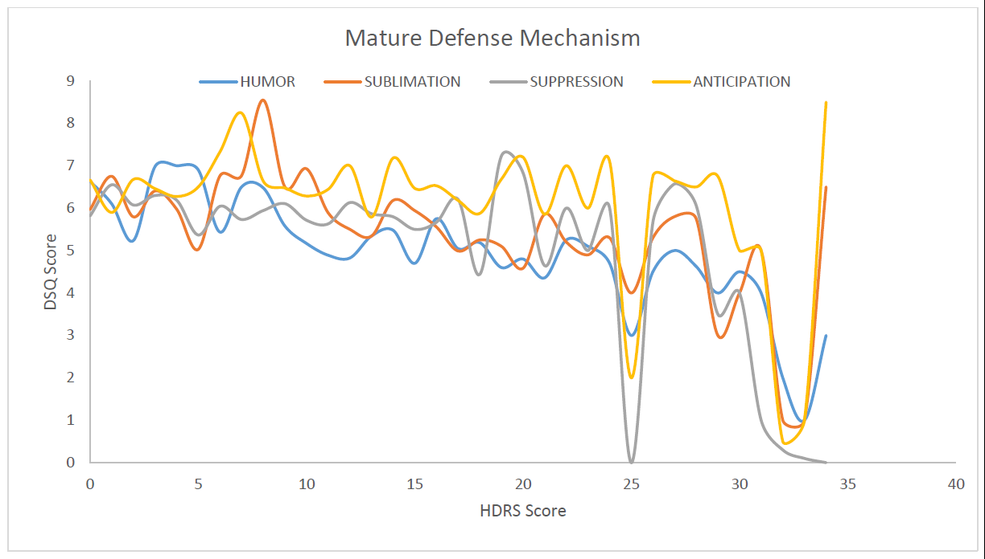

Figure 1: Correlation between HDRS Score and DSQ Score for Mature Defence Mechanism

Correlation of HDRS with Psychotic Defence Mechanism: Denial – The slope of the graph increases gradually throughout the curve.

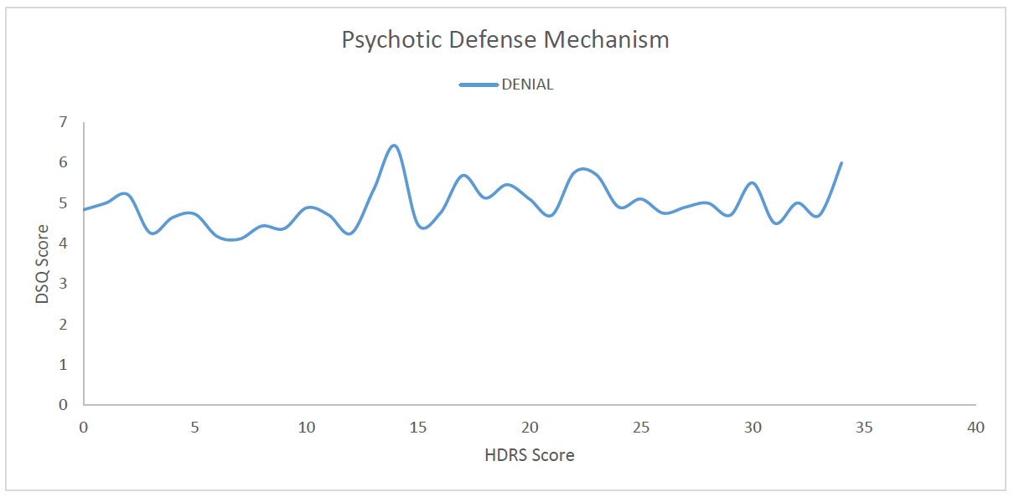Figure 2: Correlation between HDRS Score and DSQ Score for Psychotic Defence Mechanism

Correlation of HDRS with Neurotic Defence Mechanism: Undoing: Depression rises steadily on the HDRS scoring. Pseudo-altruism: Stable slope throughout the HDRS scoring. Idealisation and Reaction Formation: Steady dips and rises as depression increases on the HDRS scoring. Rationalization: Stable slope throughout the curve. Isolation and Displacement: Slope increases slightly throughout the curve. Somatization: Slope gradually increases throughout the curve.

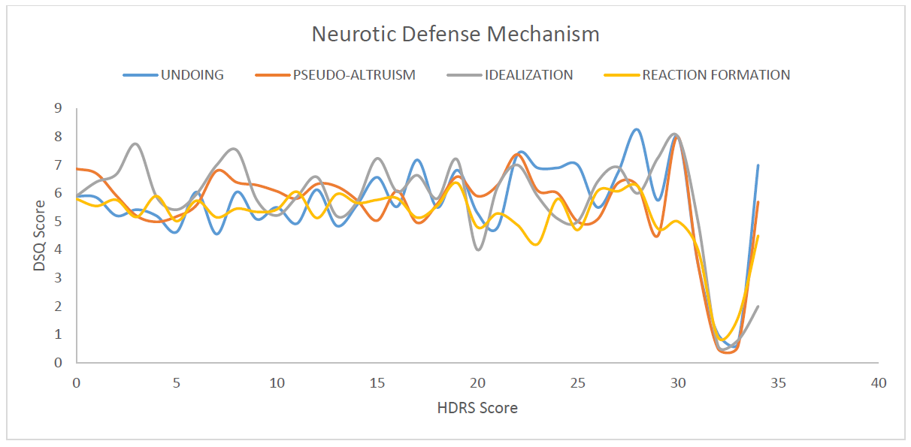

**(a)**

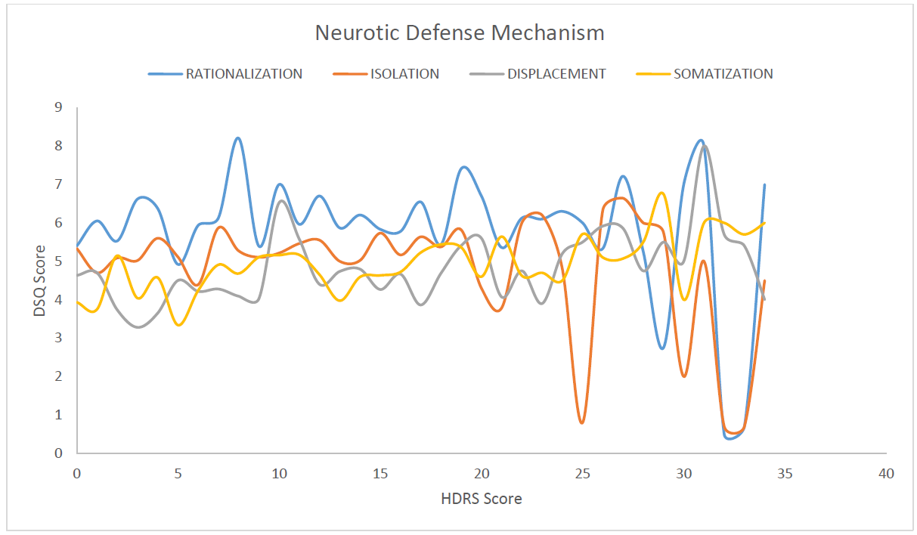

(b)

Figure 3(a-b): Correlation between HDRS Score and DSQ Score for Neurotic Defence Mechanism

Correlation of HDRS with Immature Defence Mechanisms: Projection: The slope initially rises, followed by a slight dip, and then increases to remain stable. Passive Aggression: The slope is initially stable, then rises and remains constant in the later phase of the curve. Autistic Fantasy: There is an initial steady increase in the slope, which subsequently stabilises. Devaluation: The slope of the graph increases steadily throughout the curve. Acting Out, Dissociation, and Splitting: The slope of the graph remains stable throughout the curve.

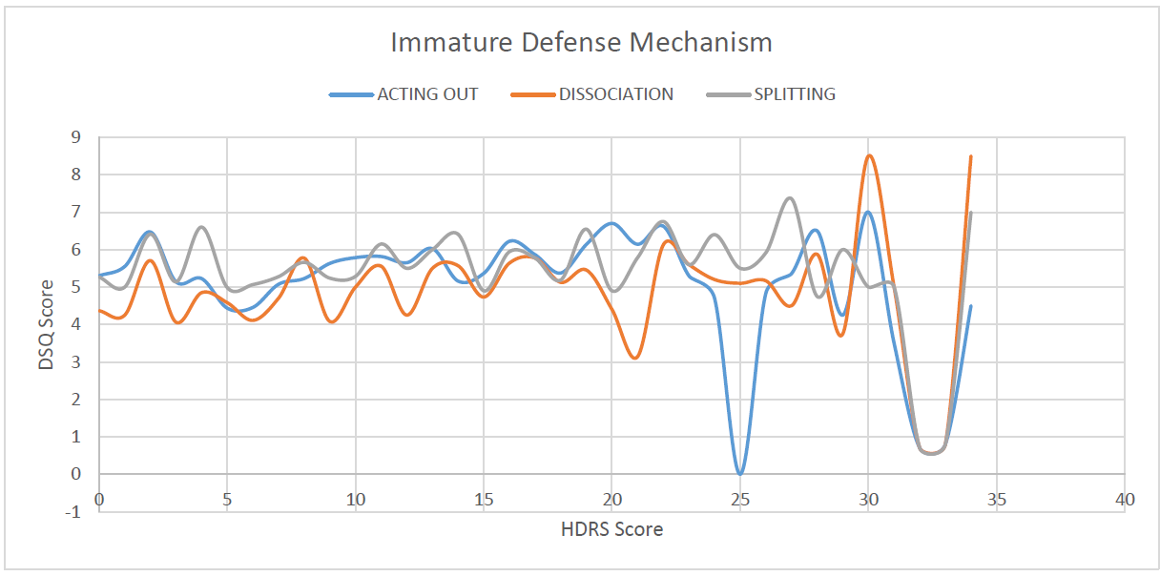Figure 4 Correlation between HDRS Score and DSQ Score for Immature Defense Mechanism (Acting Out, Dissociation and Splitting)

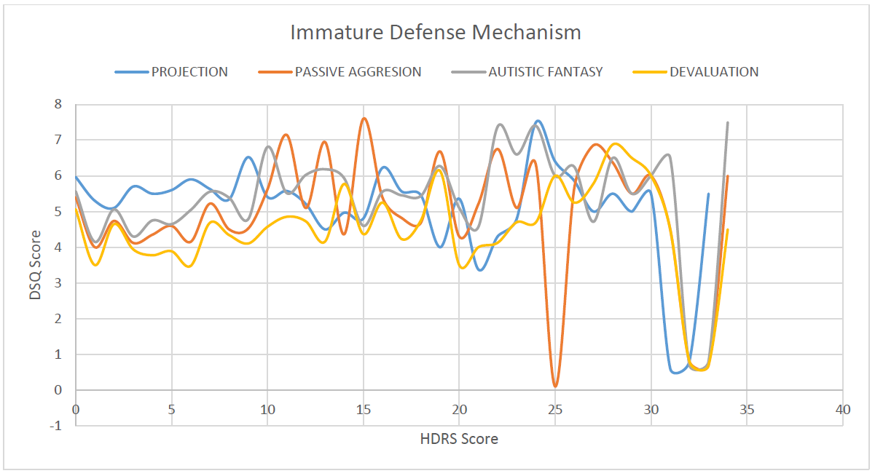Figure 5. Correlation between HDRS Score and DSQ Score for Immature Defense Mechanism (Projection, Passive Aggression, Autistic Fantasy and Devaluation)

**Reliability of Data:** The chi-square test on data from 6 groups showed a p-value of <0.003, confirming the validity of our research data.

Correlation of ESQR with HDRS: We took a total of 1220 subjects for our study in the ESQR questionnaire. Neuroticism personality trait increased with higher scores in HDRS and Extraversion eventually decreased. We found the data extremely variable and non-uniform which provided us with no significant relation with the HDRS scale (p value> 0.05).

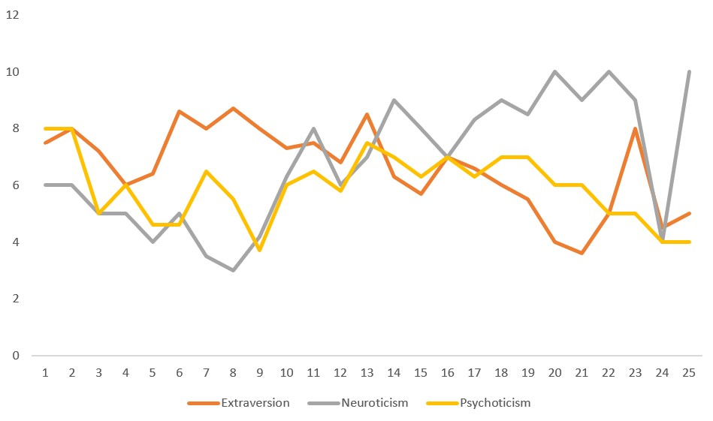

Figure 6. Correlation between HDRS Score and ESQ-R Score for Immature Defense Mechanism

In our study, the defence mechanisms of undoing, idealization, reaction formation, isolation, displacement, somatization, denial, projection, passive aggression, devaluation, and autistic fantasy were observed to increase in correlation with the severity of depression. This conclusion was corroborated by the meta-analysis presented in Chapter 10: Defence Mechanisms in Depressed Patients, Psychodynamic Treatment of Depression, 2nd edition. [14]

In our study, we observed that as the severity of depression increased, the use of certain Neurotic, Psychotic, and Immature defence mechanisms also increased, while some remained constant. None of these mechanisms appeared to decrease. Similar conclusions were drawn in cohort studies on patients recovering from depression conducted by K. Akkerman et al. [15][16], Yves de Rotan [17], Michael Bond. [18], and Olga Colovic et al [19] Mature defence mechanisms decreased or remained stable as depression severity increased, which was expected.

The study suggests that assessing defence mechanisms can aid in treatment planning, identify the severity of depression, screen individuals prone to depression, and infer treatment prognosis. Bond et al. [20] support this hypothesis.

No correlation of personality trait was found with depression. Same results were also found by the authors Kendell et al(21) and Coppen et al.(22) We suspect that the personality traits defined in Eysenck Personality Questionnaire were not adequate enough to establish a significant correlation. Furthermore, we would like to examine our hypothesis and methodology with a different personality questionnaire.

**5. CONCLUSION:**

* We observed that the use of defence mechanisms such as Undoing, Idealization, Reaction Formation, Isolation, Displacement, Somatization, Denial, Projection, Passive-Aggression, Devaluation, and Autistic Fantasy increased with the severity of depression as measured by the Depression Rating Scale. The presence and development of these mechanisms in individuals may indicate a higher susceptibility to developing depression and potentially poorer prognostic outcomes. These can be categorized as "maladaptive" defence mechanisms for depression.
* Conversely, Humour and Sublimation were found to decrease with increased severity of depression according to the Depression Rating Scale. A reduction in these mechanisms may suggest a greater risk of developing depression. These mechanisms can be classified as "adaptive" defence mechanisms against depression.
* There was no significant change observed in the employment of Dissociation, Splitting, Acting-Out, Anticipation, Suppression, Pseudo-Altruism, and Rationalization across the depression rating scale.
* The methodology employed in our study demonstrated significant reliability and can be utilized in future research exploring the relationship between ego defence mechanisms and various other mental health disorders.
* We were not able to establish a significant correlation between Depression and Personality traits in our study
* Data collection from older age groups (age > 40 years) was limited due to a lack of consent from participants. This highlights an issue of unwillingness and insufficient awareness about depression among this demographic.

Sugestions and recommendations

* Cognitive Behavioral therapy and Dialectic Therapy must focus on enhancing adaptive defense mechanisms and resolving maladaptive defense mechanisms.
* We are seeing this study as a preliminary step in solidifying our hypothesis. So far, we stand by our hypothesis (stated in Material and Methods section). We would further like to continue this study and establish a theory based on our studies.
* Other researched are encouraged to apply such methodology to various neurotic psychological diseases as well as alteration with respect to personality traits.

Consent

Informed consent was taken from each and every participant.

Ethical approval

Institutional Ethical Committee, Late Shri Lakhiram Agrawal Memorial Government Medical College Raigarh, C.G. clearance was obtained on 05/07/2022 vide latter number S.No./ Med./ Ethics Commi./ 2022/ 219

**DISCLAIMER (ARTIFICIAL INTELLIGENCE)**

Author(s) hereby declare that NO generative AI technologies such as Large Language Models (ChatGPT, COPILOT, etc.) and text-to-image generators have been used during the writing or editing of this manuscript.

**REFERENCE:**

1. Stringaris A, Goodman R. Mood lability and psychopathology in youth. Psychological Medicine. 2008 Dec 11;39(8):1237–45.
2. Grover S, Dutt A, Avasthi A. An overview of Indian research in depression. Indian Journal of Psychiatry [Internet]. 2010;52(7):178. Available from: <https://www.ncbi.nlm.nih.gov/pmc/articles/PMC3146226/>
3. Waqas A, Rehman A, Malik A, Muhammad U, Khan S, Mahmood N. Association of Ego Defense Mechanisms with Academic Performance, Anxiety and Depression in Medical Students: A Mixed Methods Study. Cureus [Internet]. 2015 Sep 30;7(9). Available from: <https://www.ncbi.nlm.nih.gov/pmc/articles/PMC4627837/>
4. Key Outcomes, National Medical Health Survey http://indianmhs.nimhans.ac.in/Docs/statereports/chhattisgarh-NMHS-Report.pdf
5. Page 13, Magnitude of Substance Use in India, Available at: http://socialjustice.nic.in/writereaddata/UploadFile/Magnitude_Substance_Use_India_REPORT.pdf
6. CORRUBLE E, BRONNEC M, FALISSARD B, HARDY P. Defense styles in depressed suicide attempters. Psychiatry and Clinical Neurosciences. 2004 Jun;58(3):285–8.
7. SPINHOVEN P, KOOIMAN CG. Defense Style in Depressed and Anxious Psychiatric Outpatients: An Explorative Study. The Journal of Nervous & Mental Disease. 1997 Feb;185(2):87–94.
8. Vaillant GE. Ego mechanisms of defense and personality psychopathology. J Abnorm Psychol. 1994;103(1):44-50. doi:10.1037//0021-843x.103.1.44
9. Katie C. Lewis. (2018) [The Treacherous Path: Developmental Psychopathology and the Evolution of Risk for Suicide](https://www.tandfonline.com/doi/full/10.1080/00797308.2017.1415070). *The Psychoanalytic Study of the Child* 71:1, pages 5-19.
10. HAMILTON M. A rating scale for depression. J Neurol Neurosurg Psychiatry. 1960 Feb;23(1):56-62. doi: 10.1136/jnnp.23.1.56. PMID: 14399272; PMCID: PMC4953319
11. ANDREWS, GAVIN M.D.1; SINGH, MICHELLE B.Sc. (HONS)1; BOND, MICHAEL M.D.2 The Defence Style Questionnaire, The Journal of Nervous and Mental Disease: April 1993 - Volume 181 - Issue 4 - p 246-256
12. Eysenck, S. B., Eysenck, H. J., & Barrett, P. (1985). A revised version of the Psychoticism scale. Personality and Individual Differences, 6(1), 21–29. https://doi.org/10.1016/0191-8869(85)90026-1
13. Wani RT. Socioeconomic status scales-modified Kuppuswamy and Udai Pareekh's scale updated for 2019. J Family Med Prim Care. 2019 Jun;8(6):1846-1849. doi: 10.4103/jfmpc.jfmpc_288_19. PMID: 31334143; PMCID: PMC6618222.
14. Available at: https://psychiatryonline.org/doi/10.1176/appi.books.9781615371013.fb10#u2015-10-29T131745134-0400d1e8215
15. Akkerman K, Carr V, Lewin T. Changes in ego defenses with recovery from depression. J Nerv Ment Dis. 1992;180(10):634-638. doi:10.1097/00005053-199210000-00004
16. Akkerman K, Lewin TJ, Carr VJ. Long-term changes in defense style among patients recovering from major depression. J Nerv Ment Dis. 1999;187(2):80-87. doi:10.1097/00005053-199902000-00003
17. de Roten Yves, Djillali Slimane, Crettaz von Roten Fabienne,et al. Defense Mechanisms and Treatment Response in Depressed Inpatients. Frontiers in Psychology, Volume 12, 2021. DOI=10.3389/fpsyg.2021.633939. ISSN=1664-1078 https://www.frontiersin.org/articles/10.3389/fpsyg.2021.633939
18. Bond M, Perry JC. Long-term changes in defense styles with psychodynamic psychotherapy for depressive, anxiety, and personality disorders. Am J Psychiatry. 2004;161(9):1665-1671. doi:10.1176/appi.ajp.161.9.1665
19. Colovic, Olga MD, MA*†; Lecic Tosevski, Dusica MD, PhD*‡§; Perunicic Mladenovic, Ivana MA*; Milosavljevic, Maja MD*; Munjiza, Ana MD*. Defense Mechanisms in “Pure” Anxiety and “Pure” Depressive Disorders Summarize with AI Summarizer Save 2 minutes reading time. The Journal of Nervous and Mental Disease 204(10):p 746-751, October 2016. | DOI: 10.1097/NMD.0000000000000559
20. Bond, M. (2004). Empirical Studies of Defense Style: Relationships with Psychopathology and Change. Harvard Review of Psychiatry, 12(5), 263–278. https://doi.org/10.1080/10673220490886167
21. Kendell, R., & DiScipio, W. (1968). Eysenck Personality Inventory Scores of Patients with Depressive Illnesses. British Journal of Psychiatry, 114(511), 767-770. doi:10.1192/bjp.114.511.767
22. Coppen, A., & Metcalfe, M. (1965). Effect of a Depressive Illness on M.P.I. Scores. British Journal of Psychiatry, 111(472), 236-239. doi:10.1192/bjp.111.472.236
23. Rajewska‐Rager, A., Dmitrzak‐Weglarz, M., Lepczynska, N., Kapelski, P., Pawlak, J., & Skibinska, M. (2023). Clinical assessment of impulsiveness and defence mechanisms in young patients with mood disorders in a two‐year prospective study. Early Intervention in Psychiatry, 17(10), 1001-1011.