Original Research Article

Complications of total abdominal hysterectomy for benign gynecological disease: Experience from a high specialty center in Mexico City

.

ABSTRACT

Aims: To identify the frequency and type of complications of total abdominal hysterectomy (TAH) in a retrospective cohort of patients with benign gynecological pathology.
Study design: Cross-sectional study.
Place and Duration of Study: Department of Gynecology from High Specialty Medical Unit, Gynecology and Obstetrics Hospital No. 3 of the National Medical Center "La Raza". Mexican Institute of Social Security, Mexico City between January 1 to December 31, 2024.
Methodology: The frequency and type of surgical and postoperative complications in a retrospective cohort of 139 patients were studied. Data were compared between patients without complications and those with complications according to gynecological pathology, TAH technique, body mass index (BMI), surgical time, estimated bleeding, transfusion, intensive care, hospital stay and mortality. Data were analyzed using descriptive and inferential statistics (Kolmogorov-Smirnov, Mann-Whitney U and Chi-square tests); a P value <.05 was considered significant. The statistical program SPSS™ version 22 was used.
Results: The complication rate was 20.14% (28 complications), which occurred in 13.67% of patients (n=19/139). Patients with one complication n=13, two complications n=3, and three complications n=3. Types: hemorrhage (n=11), infections (n=9), reoperation (n=5), and bladder injury (n=3). Gynecological pathology: leiomyomatosis 69.06%, uterine prolapse 5.94%, abnormal uterine bleeding 9.35%, other 16.55%. Patients with complications had a higher BMI (P=.001), prolonged surgical time (P=.001), increased bleeding (P=.001), transfusion requirement (47.37%, n=9/19), and longer hospital stay (P=.001), with intensive care 0% and mortality 0%.
Conclusion: The incidence of complications was high. The main complication was blood loss, both during surgery and postoperative period. Based on the findings, a series of practical recommendations can be made to improve results.

Keywords: Total abdominal hysterectomy; Abdominal hysterectomy; Hysterectomy; Complications of hysterectomy; Benign gynecological pathology; Elective uterine surgery.

1. INTRODUCTION

Hysterectomy is one of the most common gynecological procedures worldwide. It can be performed using various approaches. Abdominal hysterectomy involves the removal of the uterus through an incision in the lower abdomen. Specifically, total abdominal hysterectomy (TAH) is the surgical procedure used to remove the uterus and cervix through an abdominal incision. Bilateral salpingo-oophorectomy (BSO) involves the removal of the ovaries and fallopian tubes during the same procedure or as a single procedure. (Pickett, 2023).
The first abdominal hysterectomy was performed by Charles Clay in Manchester, England, in 1843. Edward Richardson introduced the TAH in 1929; his technique remains the gold standard today. Abdominal hysterectomy is an open procedure. It is the most common type and accounts for approximately 54% of hysterectomies performed for noncancerous (benign) conditions. The infraumbilical median incision is the most frequently used approach. The transverse incision, introduced by Johanns Pfannenstiel in the 1920s, is the other option for the abdominal approach in selected cases. (Sutton, 1997).
TAH is a conventional open surgery that continues to be performed despite the availability of other more recent novel techniques (vaginal, laparoscopic, robotic, Natural orifice transluminal endoscopic vaginal surgery “vNOTES”). (Aarts, 2015). The selection of the access technique to perform TAH for benign causes includes several factors such as the size and shape of the vagina and uterus, accessibility to the uterus, extent of uterine and extrauterine disease, need for concurrent procedures, average uterine volume, training and experience of surgeon and gynecologists, available technology, devices and hospital support, whether the case is urgent or elective, estimated recovery time, quality of life, cosmetic scar, and patient preference once informed. (ACOG, 2017).
The most common indications for TAH have not changed over the years and include abnormal uterine bleeding, the presence of malignancy or premalignant disease, uterine leiomyomatosis, endometriosis, pelvic organ prolapse, chronic pelvic pain, and pelvic infection or abscess. (Merrill RM, 2008).
The most common complications of TAH include wound or surgical site infections (10.5%), injury to adjacent genitourinary (1% to 2%) and gastrointestinal (0.1% to 1%) organs, hemorrhage (mean 238 to 660.5 mL), nerve injury (0.2% to 2%), vaginal cuff dehiscence (0.15%), deep vein thrombosis during surgery, and pulmonary embolism detected postoperatively (1% to 12%). (Clarke-Pearson, 2013).
The type and frequency of complications may be different if TAH is performed in a highly specialized center where future surgeons and gynecologists are trained. (Rabiu, 2017. Michael, 2020). The hospital hosting this study corresponds to a highly specialized university teaching center for gynecology and obstetrics located in Mexico City.

1.1 Objective

To identify the frequency and type of complications of TAH in a retrospective cohort of patients with benign gynecological pathology from a high specialty center in Mexico City.

2. material and methods

A cross-sectional study was conducted in patients undergoing TAH for benign gynecological pathology in the Department of Gynecology of the High Specialty Medical Unit, Gynecology and Obstetrics Hospital No. 3 of the National Medical Center "La Raza," Mexican Institute of Social Security in Mexico City between January 1 to December 31, 2024.
To select patients, the registry of procedures performed at the host hospital during 2024 was consulted. Only patients undergoing TAH of any age, parity, morbidities, and benign gynecological pathology were included. Patients with a confirmed preoperative diagnosis of malignancy were excluded. Cases with unavailable or incomplete medical records were eliminated.
A cohort of 139 patients met the selection criteria. Each medical record was reviewed to document their age, morbidities, and the diagnosis of benign gynecological pathology. The frequency and type of surgical and postoperative complications (hemorrhage, injury to neighboring organs, infections, reinterventions, etc.) were studied. Data were compared between patients without complications and those with complications according to gynecological pathology, body mass index (BMI), TAH technical data, surgical time, estimated bleeding, transfusion requirement, intensive care, hospital stay, and mortality. In all cases, the patients underwent to scheduled TAH. All surgical interventions and reinterventions were performed by the team of surgeons and gynecologists from the Department of Gynecology at the same facilities as the host hospital.
2.1 Statistical Analysis
Descriptive statistics were used for data analysis with measures of central tendency (mean, median) and dispersion (standard deviation, range). The Kolmogorov-Smirnov test was applied to determine the distribution of quantitative variables and was found to be non-normal. Therefore, the data were analyzed using the Mann-Whitney U test. The chi-square test was used to analyze qualitative variables. A P-value <.05 was considered significant. For data analysis, the statistical program Excel 2016 for Windows and the statistical package SPSS™ version 22 were used.
3. results

During 2024, 1,219 surgeries were performed in the Department of Gynecology of which 19.60% (239 surgeries) were hysterectomies with the following distribution: open hysterectomy 139, laparoscopic 34, vaginal 66, robotic-assisted 0, Natural orifice transluminal endoscopic vaginal surgery “vNOTES” 0). Thus, open hysterectomy was the most frequent technique representing 11.40% of the total surgeries (139/1,219) and 58.15% (139/239) of hysterectomies.
The complication rate was 20.14% (28 complications), which occurred in 13.67% of patients who underwent open hysterectomy (n=19/139) (Figure 1). One or more complications occurred per patient, either during surgery, in the postoperative period, or both (Table 1).

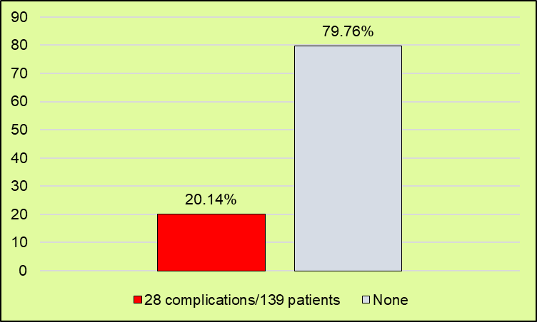
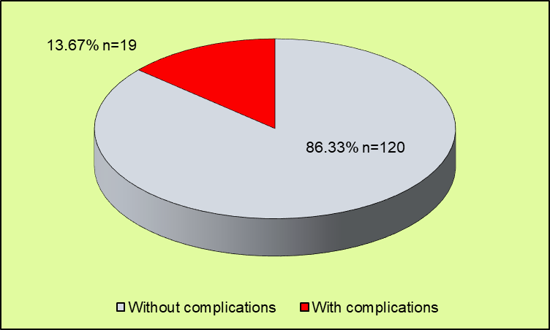
Figure 1. Top: Frequency of complications in 139 patients. Bottom: Frequency of patients with complications.

Table 1. Distribution of complications of total abdominal hysterectomy*
Complications | Description
One complication  7 cases  6 cases | Intraoperative hemorrhage  Wound infection
Two complications  2 cases  1 case | Postoperative bleeding and reoperation  Postoperative bleeding and wound infection
Three complications  2 cases  1 case | Bladder injury, reoperation for postoperative bleeding and wound infection  Bladder injury, postoperative bleeding and reintervention
* Total: 28 complications in 19/139 patients = 20.14%

The most frequent complications were intraoperative hemorrhage (n=11), wound infections (n=9), the need for reoperation to correct postoperative bleeding (n=5), and bladder injury (n=3). No bowel injuries were recorded. Bladder injuries were noted during hysterectomy, and the repair technique included primary closure at the same surgical time in all cases (Figure 2).

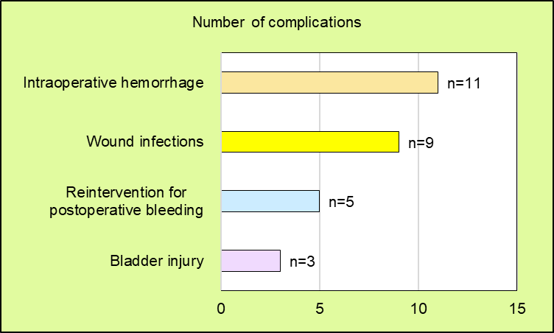
Figure 2. Distribution of 28 complications in 19/139 patients undergoing total abdominal hysterectomy

Ten complications (35.71%) occurred during surgery, consisting of seven hemorrhagic events and three bladder injuries. Eighteen complications were recorded in the postoperative period (64.29%): nine wound infections, five reinterventions to control bleeding and four bleeding events that did not require further surgery (Figure 3). As can be seen, 16 bleeding events occurred (7 intraoperative and 9 postoperative), representing 57.14% of the total 28 complications. Thus, the main complication in the cohort studied during surgery and the postoperative period was blood loss.

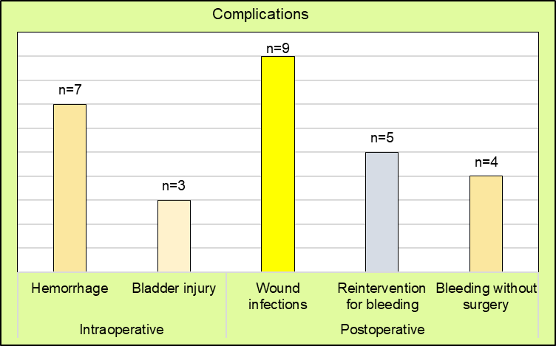
Figure 3. Distribution of 28 complications in 19 patients during surgery and in the postoperative period

Table 2 shows the general data for all patients (n=139) and for the groups, without complications (n=120) and with complications (n=19). The overall mean age was in the fifth decade of life, with no significant intergroup differences. The same was true for the frequency of cases with diabetes mellitus, arterial hypertension, previous surgeries, and benign pathology. In patients with complications, the frequency of postmenopause was higher (P = .04) and the BMI was significantly higher than in the other patients (P = .001).

Table 2. General and group data
Parameters | All patients  n=139 | Patients and complications |  | Value P
Parameters | All patients  n=139 | No  n= 120 | Yes  n=19 | Value P
Age years mean±DE  (range) | 47.53±6.76  (33 to 58) | 46.76±6.72  (33 to 57) | 48.53±6.95  (34 to 58) | .48
Postmenopause % (n) | 14.38 (20) | 13.33 (16) | 21.05 (4) | .04
Morbidities % (n)  Diabetes mellitus  Arterial hypertension  BMI* >30 median  Previous abdominal surgery | 23.74 (33)  20.86 (29)  29.75  53.95 (75) | 23.3 (28)  21.7 (26)  28.2  52.94 (64) | 26.32 (5)  15.79 (3)  31.3  56.92 (11) | .77  .55  .001  .93
Benign gynecological pathology % (n)  Leiomyomatosis  Uterine prolapse  Abnormal uterine bleeding  Others | 69.06 (96)  5.04 (7)  9.35(13)  16.55 (23) | 70 (84)  4.2 (5)  9.2 (11)  16.66 (20) | 63.2 (12)  10.5 (2)  10.5 (2)  15.79 (3) | .06  -----  -----  -----
* BMI: Body Mass Index calculated with the Quetelet formula: weight in K/(height in m)²

Table 3 shows data on the anesthetic technique, description of surgery, operative time, estimated bleeding, cases requiring transfusion, need for admission to the intensive care unit, hospital stay, and mortality. As can be seen, the most frequent anesthetic technique was regional block, but there was no intergroup difference (P = .09). TAH without bilateral salpingo-oophorectomy (BSO) was the most frequent procedure, but TAH with BSO had a statistically significant difference in favor of the group of patients with complications (P = .003). Similarly, operative time, estimated bleeding, and hospital stay were longer in cases with complications (P = .001). No patients required intensive care, and there were no cases of mortality.

Table 3. Technical data of anesthesia and surgery, postoperative management, hospital stay and mortality
Parameters | All patients  n=139 | Patients and complications |  | Value P
Parameters | All patients  n=139 | No  n= 120 | Yes  n=19 | Value P
Anesthetic technique % (n)  Regional blocking  General anesthesia  Combined | 50.36 (70)  44.60 (62)  5.04 (7) | 49.17 (59)  45.83 (55)  5 (6) | 57.90 (11)  36.80 (7)  5.30 (1) | .09  .07  -----
Incision type % (n)  Middle  Pfannenstiel | 80.57 (112)  19.43 (27) | 80 (96)  20 (24) | 84.21 (16)  15.79 (3) | .08  .07
TAH* % (n) | 91.37 (127) | 94.17 (113) | 73.69 (14) | .09
TAH with BSO** | 8.63 (12) | 5.83 (7) | 26.32 (5) | .003
Weight of the surgical piece g  (range) | 443.83±491.16  (70 to 2370) | 490.58±557.94  (90 to 2370) | 382.69±400.98  (70 to 1400) | .56
Surgical time minutes | 109±20 | 87±17 | 131±23 | .001
Estimated bleeding ml | 502.5±280 | 293±199 | 712±511 | .001
Transfusion % (n) | 6.47 (9) | 0 | 47.37 (9) | -----
Admission to the ICU*** % (n) | 0 | 0 | 0 | -----
Hospital stay days | 4.8±2.3 | 3±1 | 7±4 | .001
Mortality % (n) | 0 | 0 | 0 | 0
* TAH: Total Abdominal Hysterectomy
** BSO: Bilateral salpingo-oophorectomy
*** ICU: Intensive Care Unit

4. DISCUSSION

Abdominal hysterectomy has maintained its position despite the increasing frequency of other less invasive techniques in recent decades. It is an open procedure with complications inherent to the technique and factors associated with patient morbidity, the complexity of benign gynecological pathology and the skills of the surgical team, particularly if the surgery is performed by surgeons and gynecologists with limited operative experience. (Pun, 2017).
The frequency of complications in the study cohort (20.14%, 28 complications in 19/139 patients) was very high compared to the results of most studies conducted and published in Mexico (Table 4) (Hollman-Montiel, 2014), (Aguilar, 2019), (Camarena-Pulido, 2023), (Aurioles-Quintana, 2024).

Table 4. Comparison of findings in research conducted in Mexico
Data | Hollman | Aguilar | Camarena | Aurioles | Flores ^{current}
Year of publication | 2014 | 2019 | 2023 | 2024 | 2025
Year of data | 2011 to 2013 | 2012 to 2016 | 2019 to 2020 | 2018 to 2023 | 2024
Number of patients with TAH | 438 | 880/1208 | 262/790 | 443/1234 | 139/239
Age years | 43.04±6.28 | 47.06±8.26 | 45±7.2 | 48.63±9.22 | 47.53±6.76
Complications % (n) | 15.06 (66) * | 2.15 (19) | 34 (89) | 11.18 (46) | 20.14 (28) *
Type of complications % (n)  Hemorrhage  Bladder injury  Ureteral section  Infections  Bronchospasm  Nerve injury  Fistula  Reintervention  Wound dehiscence  Intestinal injury  Acute pulmonary edema  Myocardial ischemia  Myocardial infarction  Metabolic ileus  Pulmonary embolism  Mortality | 9.1 (40)  0.9 (4)  1.1 (5)  3.7 (16)  0  0  0  3.2 (14)  3.2 (14)  1.1 (5)  0.9 (4)  0.7 (3)  0.2 (1)  0.2 (1)  0.2 (1)  0 | 31.57 (6)  21.05 (4)  10.52 (2)  10.52 (2)  10.52 (2)  10.52 (2)  5.26 (1)  0  0  0  0  0  0  0  0  0 | 16 (42)  5 (13)  0  7 (18)  0  0  0  0  6 (16)  0  0  0  0  0  0  0 | 9.83 (40)  1.35 (6)  0  0  0  0  0  0  0  0  0  0  0  0  0  0 | 7.91 (11)  2.16 (3)  -----  6.47 (9)  0  0  0  3.60 (5)  0  0  0  0  0  0  0  0
* A patient had one or more complications simultaneously

The frequency of complications falls within the range estimated in international reports (Figure 4). As can be seen, the rate is exceeded by reports from research conducted in developing countries (Tanzania, India, Nigeria). (Michael, 2020), (Yadav, 2019), (Rabiu, 2017), (Zea, 2010), (Kovac, 2000).

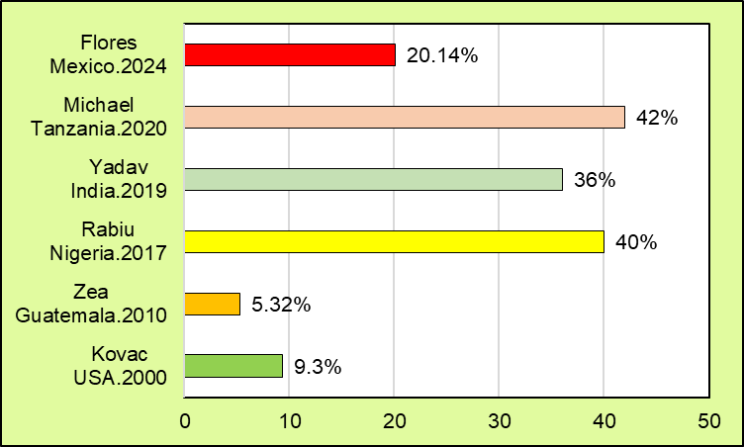
Figure 4. Complication rate in patients undergoing abdominal hysterectomy according to international research

Complications were found to be more frequent in postmenopausal patients, with a higher BMI and simultaneous BSO with TAH. The surgical time was longer and they had a greater amount of bleeding, need for transfusion and longer hospital stay (Table 2 and 3).
Evidence has shown that morbidities such as diabetes mellitus, arterial hypertension, obesity, heavy tobacco use and heart failure, as well as uterine weight >250 g, coexisting genitourinary infections, removal of the tubes and ovaries, removal of the cervix and other concurrent procedures such as vascular maneuvers to control bleeding can increase the degree of complexity of the surgery and the surgical time regardless of the technical approach. In turn, prolonged surgical time is a factor clearly associated with complications such as hemorrhage, anemia and transfusions, urgent reoperations, infections or sepsis, damage to vital organs, prolonged hospital stay, readmissions, and higher mortality. (Margulies, 2020), (Liu, 2025), (Zeng, 2025).
Abdominal hysterectomy has been associated with a 54% increased risk of bowel obstruction compared with minimally invasive laparoscopic or vaginal hysterectomy. (Norrbom, 2024). Furthermore, postoperative ileus is more common in patients undergoing open hysterectomy than in patients undergoing other techniques. (Hou, 2024). Predictive models for length of stay after gynecologic surgery, complications, and duration of surgery using machine learning methods are useful tools for patient selection and hysterectomy technique. Their application is recommended in all gynecologic surgery cases. (Metsker, 2021).

The types of complications (hemorrhage, infections, reoperations for bleeding, bladder injury) were not different from national (Table 4) and international reports (Figure 4), but their distribution was. Blood loss accounted for 57.14% (n=16) of the total 28 complications; it was the main cause found in the cohort studied during surgery and in the postoperative period. This data is relevant because these were patients with scheduled, but not urgent TAH, in which case a higher rate would be expected. The data source for this study did not specifically include the participation of resident physicians in the surgery, which is important because it has been reported that the frequency of complications in patients operated on in a private hospital (7%) increases significantly (15%) when the interventions are carried out in government hospitals with residents. (Istre, 2018).

The findings allow for the development of some specific recommendations: (a) Selecting candidate patients for elective TAH with more rigorous criteria and the application of validated predictive models, (b) Proposing the available surgical approach that provides the greatest advantages and the lowest frequency of complications (minimally invasive surgery), (c) Emphasizing the training of surgeons and gynecologists with the use of simulators, (d) Assistance from advisors with greater experience during open surgery, (e) Participation of surgeons expert in vascular procedures for the management of hemorrhages, (f) Monitoring the skills and abilities of students with validated learning curve instruments and (f) Periodically reviewing surgical results. (Rahman, 2017), (Metsker, 2021), (Fatima, 2022).
The main strength of this study lies in its identification of the high frequency of complications from planned TAH in women with benign gynecological conditions and its recognition of blood loss as the main cause. The study's weaknesses include its retrospective observational design, small sample size, and analysis of local data, which limit the generalizability of the findings.
5. CONCLUSIONS
The frequency of complications from TAH in women with benign gynecological conditions was high. Blood loss was identified as the main cause. More rigorous patient selection criteria, the use of predictive models, counseling during surgery, the involvement of vascular surgery experts and training the surgical team in other minimally invasive techniques can all contribute to better outcomes.

DISCLAIMER (ARTIFICIAL INTELLIGENCE)

Author(s) hereby declare that no generative AI technologies such as large language models (chat gpt, copilot, etc.) and text-to-image generators have been used during the writing or editing of this manuscript

CONSENT

As per international standards or university standards, patient(s) written consent has been collected and preserved by the author(s).

Ethical approval

Authorization was obtained from the Local Medical Research Committee and the Ethics Committee for Medical Research at the host hospital (Registry 2025-3504-001). Both committees determined that it was not necessary to obtain written informed consent from the patients or their legal guardians given that this was an observational, retrospective, descriptive, and analytical study and the information necessary for conducting the research was contained in the patient records. The database is protected by the authors and the authorities of the host hospital.

References

Aarts, J.W.M., Nieboer, T.E., Johnson, N., Tavender, E., Garry, R., Mol, B.W., et al. (2015). Surgical approach to hysterectomy for benign gynaecological disease. Cochrane Database Syst Rev, 12(8), CD003677. DOI: 10.1002/14651858.CD003677.pub5.
ACOG. (2017). Choosing the route of hysterectomy for benign disease. Committee Opinion No. 701. American College of Obstetricians and Gynecologists. Obstet Gynecol, 129, e155-e159. DOI: 10.1097/AOG.0000000000002112.
Aguilar, V.A.F., Zavala, G.A., Arredondo, M.R. (2019). Comparación de tasas de complicaciones quirúrgicas entre histerectomía total por vía laparotomía y laparoscópica en un hospital privado de tercer nivel. Acta Med Grupo Ángeles, 17(4), 336-339. https://www.scielo.org.mx/pdf/amga/v17n4/1870-7203-amga-17-04-336.pdf
Aurioles-Quintana, L.D., Pedraza-González, L.A., López-Jurado, J.C., Figueroa-Gómez Crespo, P. (2024). Tendencias de la histerectomía y riesgo de complicaciones. Ginecol Obstet Mex, 92(7), 295-302. DOI: 10.24245/gom.v92i7.9794
Camarena-Pulido, E.E., Corona-Gutiérrez, A.A., Robledo-Aceves, M., Cárdenas-Rodríguez, J.S. (2023). Factores relacionados con la histerectomía ginecológica por patología benigna en un hospital escuela del occidente de México. Ginecol Obstet Mex, 91(8), 562-569. DOI: 10.24245/gom.v91i8.7897
Clarke-Pearson, D.L., Geller, E.J. (2013). Complications of hysterectomy. Obstet Gynecol, 121(3), 654-673. DOI: 10.1097/AOG.0b013e3182841594.
Fatima, M., Maqsood, S., Laqa, S., Kashif, S., Rehman, S., Masood, Z. (2022). Outcomes of laparoscopic hysterectomies: An assessment of a learning curve experience of a gynae laparoscopic surgeries. PJHS, 3(7), 20-24. DOI: 10.54393/pjhs.v3i07.293
Hollman-Montiel, J.P., Rodríguez, A.G. (2014). Complicaciones de la histerectomía total abdominal ginecológica por patología benigna. Arch Invest Mat Inf, 6(1), 25-30. https://www.medigraphic.com/pdfs/imi/imi-2014/imi141f.pdf
Hou, Z., Liu, T., Li, X., Lv, H., Sun, Q. (2024). Risk factors for postoperative ileus in hysterectomy: A systematic review and meta-analysis. PLoS ONE, 19(8), e0308175. DOI: 10.1371/journal.pone.0308175
Istre, O., Snejbjerg, D. (2018). Complication rate of laparoscopic hysterectomies in Denmark, 2011-2016. JSLS, 22(1), e2017.00078. DOI: 10.4293/JSLS.2017.00078
Kovac, S.R. (2000). Hysterectomy outcomes in patients with similar indications. Obstet Gynecol, 95(6 Pt1), 787-793. DOI: 10.1016/s0029-7844(99)00641-9.
Liu, Y., Liu, Y., Yang, Z., Wu, J., Li, J. (2025). Risk factors for surgical site infection(SSI) in patients undergoing hysterectomy: a systematic review and meta-analysis. BMJ Open, 15e093072. DOI: 10.1136/bmjopen-2024-093072
Margulies, S.L., Vargas, M.V., Denny, K., Sparks, A.D., Marfori, C.Q., Moawad, G., et al. (2020). Comparing benign laparoscopic and abdominal hysterectomy outcomes by time. Surgical Endoscopy, 34(2), 758-769. DOI: 10.1007/s00464-019-06825-8
Merrill, R.M. (2008). Hysterectomy surveillance in the United States, 1997 through 2005. Med Sci Monit, 14(1), CR24-CR31. PMID: 18160941.
Metsker, O., Kopanitsa, G., Malushko, A., Komlichenko, E., Bolgova, K., Paskoshev, D. (2021). Gynecological surgery and machine learning: complications and length of stay prediction. Stud Health Technol Inform, 281, 575-579. DOI: 10.3233/SHTI210236.
Michael, D., Mremi, A., Swai, P., Shayo, B.C., Mchome, B. (2020). Gynecological hysterectomy in Northern Tanzania: a cross- sectional study on the outcomes and correlation between clinical and histological diagnoses. BMC Women's Health, 20(1), 122. DOI: 10.1186/s12905-020-00985-9
Norrbom, C., Osler, M., Krabbe-Sorensen, M., Rasmussen, S.C., Carlsen, S.E., Nilas, L., et al. (2024). Risk of bowel obstruction after hysterectomy for benign indication according to surgical method in Denmark, 1984-2013. J Minim Invasive Gynecol, 31(10), 855-869. DOI: 10.1016/j.jmig.2024.06.010
Pickett, C.M., Seeratan, D.D., Mol, B.W.J., Nieboer, T.E., Johnson, N., Bonestroo, T., et al. (2023). Surgical approach to hysterectomy for benign gynaecological disease. Cochrane Database of Systematic Reviews, 8, CD003677. DOI: 10.1002/14651858.CD003677.pub6.
Pun, T.C. (2017). Hysterectomy for benign disease. Hong Kong J Gynaecol Obstet Midwifery, 17(2), 121-128. DOI: 10.12809/hkjgom.17.2.233
Rabiu, A., Habib, R. (2017). Elective abdominal hysterectomy: Appraisal of indications and complications at Aminu Kano Teaching Hospital - An 8-year review. Trop J Obstet Gynaecol, 34(3), 224-228. DOI: 10.4103/TJOG.TJOG_45_17
Rahman, R., Gupta, S., Manyonda, I. (2017). Hysterectomy for benign gynaecological disease. Obstetrics Gynecology & Reproductive Medicine, 27(4), 125-131. DOI: 10.1016/j.ogrm.2017.01.012
Sutton, C. (1997). Hysterectomy: a historical perspective. Baillieres Clin Obstet Gynaecol, 11(1), 1-22. DOI: 10.1016/S0950-3552(97)80047-8
Yadav, N., Tiwari, P., Mangeshikar, A., Kumar, S. (2019). Assessment of the learning curve: total laparoscopic hysterectomy versus total abdominal hysterectomy. Int J Reprod Contracept Obstet Gynecol, 8(10), 4045-4050. DOI: 10.18203/2320-1770.ijrcog20194378
Zea-Vega, J.C., Calderón-Donis, R., Reyes-Morales, E.Y. (2010). Complicaciones peri-operatorias en histerectomía abdominal, laparoscópica y vaginal. REVCOG, 15:(3), 79-85. DOI: 10.37980/im.journal.revcog.3564
Zeng, Y., Lei, Y., Li, M., Liu, W., Zhou, J., Zhong, J., et al. (2025). The impact of diabetes on postoperative outcomes following hysterectomy: a systematic review and meta-analysis. BMC Women's Health, 25, 284. DOI: 10.1186/s12905-025-03835-8

