Self-Breast Examination: Knowledge, Attitudes, and Practices Among Female Students in a Senior High School Setting, Ghana

**ABSTRACT**

Breast cancer remained a leading cause of morbidity and mortality among women globally, with early detection playing a critical role in improving outcomes. Self-breast examination (SBE) is a cost-effective and accessible screening tool, especially important for younger women who may have limited access to other screening methods. Despite its importance, knowledge, attitudes, and practices regarding SBE remain understudied among adolescent females in Ghana. This study assessed the knowledge, attitudes, and practices related to SBE among female students and examined factors influencing their awareness and performance of SBE. A cross-sectional survey was conducted among about 1000 female students. Descriptive statistics summarized participants’ demographic characteristics, knowledge, and practices regarding SBE. Inferential analysis using Chi-square tests examined associations between demographic factors and SBE knowledge and practice, with statistical significance set at p < 0.05. While a majority of students had heard of SBE, detailed knowledge about proper technique, timing, and significance was lacking, particularly among younger students. Age showed a significant association with SBE knowledge (p = 0.0012), whereas religion did not (p = 0.223). The gap between general awareness and in-depth understanding indicates that information exposure does not always translate into comprehensive knowledge or effective practice. There is an urgent need to implement structured, evidence-based breast health education early in the school curriculum to address knowledge gaps, particularly among younger students in this study setting. Interventions should include practical demonstrations and be delivered by healthcare professionals to enhance understanding and foster regular SBE practice. Addressing these gaps can improve early detection of breast abnormalities and contribute to better health outcomes.

**Keywords:** Self-breast examination, adolescent health, breast cancer, knowledge, Ghana

**Introduction**

**Background of the Study**

Breast cancer is the most prevalent cancer affecting women worldwide and remains one of the leading causes of cancer-related morbidity and mortality globally (Bellanger et al., 2018; Maurya & Brahmachari, 2021; Srinath et al., 2023). It is characterized by the uncontrolled growth of malignant cells originating from breast tissue. According to recent global cancer statistics, breast cancer accounts for approximately 11.6% of all new cancer cases, representing 2.1 million diagnoses annually, and contributes to 6.6% of all cancer-related deaths worldwide, equating to around 627,000 deaths each year (Arnold et al., 2022; Ferlay et al., 2019; Siegel et al., 2025). The burden of breast cancer has traditionally been higher in developed regions; however, rising incidence and mortality rates are now increasingly reported in low- and middle-income countries across all continents (Arnold et al., 2022). This shifting epidemiological pattern underscores the growing public health challenge breast cancer poses worldwide.

The increasing burden in less resourced settings is particularly concerning because healthcare systems often lack the infrastructure, resources, and awareness programs necessary for effective cancer control. Early detection and timely treatment, which are key to improving survival rates, are often inadequate or inaccessible in many developing countries (Omotoso et al., 2023). Furthermore, cultural beliefs, socioeconomic factors, and limited health education impede the uptake of screening and preventive measures, resulting in delayed presentation and diagnosis at advanced stages of the disease (Abubakari et al., 2025; Afaya et al., 2024) .

In Ghana, breast cancer represents a major national health concern and is among the top causes of cancer morbidity and mortality among women. The country reports an incidence rate of 43.0 and a mortality rate of 17.7 per 100,000 women, figures that reflect a significant and growing public health burden (Mensah & Mensah, 2020). Late-stage diagnosis remains the principal factor associated with poor prognosis and high mortality, as many patients present to health facilities when the disease has already progressed beyond curative treatment options (Al-Worafi, 2024; Mensah & Mensah, 2020). Breast cancer treatment in Ghana typically involves multidisciplinary approaches, including surgery, chemotherapy, and radiotherapy. However, access to these treatment modalities is often limited by financial constraints, geographical barriers, and inadequate healthcare infrastructure (Mutebi et al., 2020). Moreover, cancer diagnosis and treatment impose significant psychosocial stress and economic hardship on patients and their families, further complicating disease management (Böckerman et al., 2025; Carrera et al., 2018) .

Early detection of breast cancer is critical for improving survival rates and reducing disease burden. Various screening strategies are recommended globally, including mammography, clinical breast examination, and self-breast examination (SBE) (Ahmed et al., 2024; Molassiotis et al., 2021; Mushosho et al., 2024). Mammography remains the gold standard screening tool with proven efficacy in reducing mortality, and it is generally recommended for women aged 40 years and older (*ACS Breast Cancer Screening Guidelines | American Cancer Society*, n.d.) However, younger women, including adolescents and young adults, often have denser breast tissue that reduces the sensitivity of mammograms, thereby limiting its utility as a primary screening modality in this population.

In this context, self-breast examination emerges as a critical, accessible, and cost-effective screening method for younger females. SBE is a non-invasive procedure that allows women to become familiar with their breast anatomy and detect any abnormal changes such as lumps, thickening, or discharge (Pippin & Boyd, 2023). Healthcare professionals globally advocate for regular SBE as an essential component of breast health awareness and early detection efforts. Its advantages include ease of performance, no requirement for specialized equipment, and the empowerment of women to take an active role in their health monitoring (Joyce et al., 2020; Kandasamy et al., 2024).

Despite these benefits, numerous studies from low- and middle-income countries, including several sub-Saharan African nations, report low levels of awareness, knowledge, and practice of SBE, particularly among young women and adolescents (Johnson, 2019). Barriers to effective SBE include lack of education on correct techniques, cultural taboos surrounding breast health discussions, and misconceptions about breast cancer risk at younger ages (Amegbedzi et al., 2022). These factors contribute to missed opportunities for early detection and intervention, exacerbating the burden of late-stage breast cancer diagnosis and poor clinical outcomes.

Research underscores that the practice of regular SBE from an early age improves early detection rates of breast abnormalities, which can ultimately enhance breast cancer prognosis and survival (Wolde et al., 2023). For senior high school students, who are transitioning into adulthood and establishing lifelong health behaviors, acquiring adequate knowledge, a positive attitude, and proper SBE practice is paramount. However, in Ghana, there is a notable paucity of research assessing these factors among female senior high school students. No prior study has specifically investigated the knowledge, attitudes, and practices of SBE among students at Sunyani Senior High School, a key educational institution in the Bono Region. This research gap hampers the design and implementation of culturally appropriate, targeted breast health education and early detection strategies tailored for this young population.

Addressing this gap is critical to promoting breast cancer awareness and fostering preventative health behaviors among young women in Ghana. By evaluating the knowledge, attitudes, and practices of self-breast examination among female students at Sunyani Senior High School, this study aims to provide vital insights that will inform effective educational interventions. Such initiatives are essential to empower young women with the skills and confidence to engage in regular breast health monitoring, thereby enhancing early detection efforts and ultimately reducing breast cancer morbidity and mortality within this demographic and beyond.

**METHODOLOGY**

**Study Area**

The study was at Sunyani senior high school, one of the public senior high schools in Ghana. Sunyani Senior High School (SUSEC) is a coeducational second cycle institution, located in the heart of the Sunyani East municipality of the Bono region of Ghana. Sunyani Secondary School as previously known is referred to as ‘SUSEC´, is one of the products of Ghana Education Trust. It was formed in 1960 by Prime Minister Kwame Nkrumah, later Ghana's first President. The institution expanded over the years. The count of non-teaching employees rose from nine (9) to one hundred and five (105), and that of the teaching personnel escalated from four (4) to one hundred and ninety-eight (198) . According to the school’s administrative records, the student body comprises four thousand, four hundred thirty-seven (4437) students. Sunyani Senior high School offer courses including general science, agricultural science, general arts, graphic arts, home economics, and business. The school is located in the heart of the Sunyani East municipality of the Bono region.

**Study Design**

A descriptive cross-sectional study was used to assess the knowledge, attitude and practice of Self Breast Examination among female students at Sunyani senior high school. A descriptive cross-sectional study is a research design that examines data at a single point in time to assess the prevalence of variables or conditions within a population (Capili, 2021). It is commonly used in public health, epidemiology, and social sciences to identify patterns, trends, and associations. While this design offers several advantages, it also has notable limitations. Cross-sectional studies are relatively fast to conduct because they do not require long-term follow-ups, they however, cannot establish causal relationships between variables, only associations (Wang & Cheng, 2020).

**Study Population**

The study population comprised adolescent female students within the school, typically ranging in age from 15 to 19 years above. These students were selected to represent the broader adolescent female demographic, providing insights into breast health awareness and self-breast examination practices among young women at a formative stage for establishing lifelong health behaviors.

**Sample size determination and Sampling Technique**

The sample size was calculated using the formula (Yamane, 1973) below:

n = N/1 + N (e2),

Where n = sample size,

N = population size,

e = margin of error (5%),

Substituting,

$n=\frac{1000}{1+1000 (0.05)(0.05)}$**= 278**

Therefore, a minimum required sample size is 278 participants.

A simple random sampling technique was employed to select the 278 female senior high school (SHS) students who participated in the study. This method was chosen because it ensures that every female student in the study population had an equal and unbiased chance of being selected, which helps to produce a representative sample and reduces selection bias. The selection process was conducted through a balloting system, where each female student was given an equal opportunity to participate by drawing a slip labeled either "YES" or "NO." Students who picked "YES" were included in the study sample, while those who picked "NO" were excluded. This random and transparent approach guarantees fairness in participant selection and enhances the validity of the study findings by accurately reflecting the diversity of the female student population at Sunyani Senior High School.

**Data Collection and Instruments**

The data for the study was collected from March to May 2025. Structured questionnaire was used for data collection. Questionnaires were made up of close ended questions and was developed in English based on objectives of the study and after reviewing relevant literature. Questionnaires were used to solicit information on socio demographic characteristics of study participants, knowledge of SBE among female SHS students, attitude on SBE among female SHS students and the practices on SBE among female SHS students.

The questionnaires were administered to study participants and data collected on the spot by the principal investigators at Sunyani Senior High School. This was done after a written consent has been sought from study participants. The study had a 100% response rate as principal investigators were actively involved in the data collection process, closely supervising and encouraging participants to complete the questionnaires and ensuring that all selected students were reached and their responses properly recorded.

**Data Analysis Techniques**

The data collected for this study were analyzed using descriptive statistical methods to provide a clear and detailed summary of the findings. The Statistical Package for Social Sciences (SPSS) version 23 was utilized to organize, manage, and analyze the data efficiently. Descriptive statistics, including frequencies, percentages, means, and standard deviations, were computed to summarize the demographic characteristics of the participants as well as their knowledge, attitudes, and practices related to Self-Breast Examination. These measures allowed for the presentation of data in a straightforward and interpretable manner, using tables, bar charts, and pie charts to visually illustrate key findings. Moreover, inferential statistical studies were performed to examine relationships between categorical variables. Chi-square (χ²) tests were employed to analyze the associations between participants' demographic variables (including age group, and religion) and their knowledge or practice of Self-Breast Examination. The threshold for statistical significance was established at a p-value of 0.05. Chi-square analysis results are presented alongside their respective p-values, with associations deemed significant at p < 0.05. By employing these descriptive techniques, the study was able to identify patterns and trends within the data, offering insight into the level of awareness and engagement with Self-Breast Examination among female students at Sunyani Senior High School.

**Inclusion and Exclusion Criteria**

The study included female students who were currently enrolled at Sunyani Senior High School and fell within the typical age range for senior high school attendance, approximately between 15 and 19 years. Only those students who willingly provided informed consent to participate were considered eligible. This ensured that participants were able to understand the nature of the study and agreed voluntarily to take part, which is essential for ethical research conduct.

Conversely, female students who declined to participate or refused consent were excluded from the study. Additionally, students who were absent or unavailable during the data collection period were not considered, as their participation was not feasible. Furthermore, students with a prior diagnosis of breast cancer or any medical condition that could impair their ability to correctly perform Self-Breast Examination or provide accurate responses to the questionnaire were also excluded. These criteria helped to maintain the integrity and reliability of the study findings by focusing on a healthy adolescent population representative of typical senior high school students.

**Ethical Considerations**

An introductory letter was taken from the Department of Midwifery at Garden City University College and presented to Sunyani Senior High School to seek their approval to conduct this study. The purpose of the study was explained to all prospective participants before recruitment. All consenting participants signed an informed consent before being recruited for the study. No personal identifiers such as name or phone numbers were part of the data acquisition process to ensure that the data cannot be traced to any participant at any point in time. Anonymity and confidentiality were assured during the data acquisition, analysis and publication of results of the study.

**RESULTS**

**Demographic information of respondents**

The study sample consisted of 278 female students with a mean age of 17.4 years (SD = 1.4), indicating that most participants were late adolescents. According to the results of the study, 30 respondents representing 11 % were under 14–15 years, 89 respondents representing 32.0% were between the ages of 16–17 years, and the remaining 159 respondents representing 57 % were 18 years and above. This suggests that the sample was largely composed of students approaching adulthood, which is significant for breast health education, as these years are formative for establishing preventive health behaviors. With respect to class, the majority representing 51 % were in SHS 3, 29 % were in SHS 2, and the remaining 20 % were in SHS 1. Regarding religion, 44 % of the respondents were Christians, 36 % were Muslims, 10 % were traditionalists, and the remaining 9 % did not indicate any religious affiliation. This religious diversity may influence attitudes and openness towards breast health discussions, as cultural and religious beliefs can affect health-seeking behaviors and perceptions of practices such as Self-Breast Examination (SBE).

**Table 1**: **Demographic Characteristics of Respondents (N = 196)**

|  |  |  |  |
| --- | --- | --- | --- |
| Response | | Frequency | Percentage |
| Age | Under 14-15 years  16-17 years  18 years and above | 30  89  159 | 11  32  57 |
|  | **Mean Age (SD)** | **17.4 (1.4)** |  |
| Class | SHS 1  SHS 2  SHS 3 | 55  81  142 | 20  29  51 |
| Religion | Christian  Muslim  Traditionalist  None | 122  102  28  26 | 44  37  10  9 |

**Source: Field study (2025)**

**Association Between Demographic Characteristics and Knowledge of Self-Breast Examination Among Female Students**

The analysis revealed a significant association between age group and knowledge of Self-Breast Examination (SBE) **(p = 0.0012),** with older students being more likely to know about SBE than their younger counterparts. In contrast, no significant association was found between religion and SBE knowledge **(p = 0.223),** indicating that awareness of SBE is similar across different religious groups. These findings suggest that breast health education should prioritize younger students, while religious background does not require special consideration in program design.

**Table 2: Association Between Demographic Characteristics and Knowledge of Self-Breast Examination Among Female Students**

|  |  |  |  |  |  |  |  |
| --- | --- | --- | --- | --- | --- | --- | --- |
| Variable/Group | Category | | SBE Knowledge: Yes | | SBE Knowledge: No | Total | χ² / p-value |
| **Age Group vs. SBE Knowledge** |  |  | |  | |  |  |
| Age Group | 14–15 years | | 10 | | 20 | 30 | χ² = 13.38 p = 0.0012 |
|  | 16–17 years | | 60 | | 29 | 89 |  |
|  | 18+ years | | 107 | | 52 | 159 |  |
|  | Total | | 177 | | 101 | 278 |  |
| **Religion vs. SBE Knowledge** |  |  | |  | |  |  |
| Religion | Christian | | 83 | | 39 | 122 | χ² = 4.39 p = 0.223 |
|  | Muslim | | 66 | | 36 | 102 |  |
|  | Traditionalist | | 15 | | 13 | 28 |  |
|  | None | | 13 | | 13 | 26 |  |
|  | Total | | 177 | | 101 | 278 |  |

**Authors field work 2025**

## **Knowledge of Self-Breast Examination among female students**

Among the 278 female students surveyed, 177/64 % reported knowing about Self-Breast Examination (SBE) whiles 101/36% did not (Figure 1).

**Figure 1: Knowledge of Self-Breast Examination**

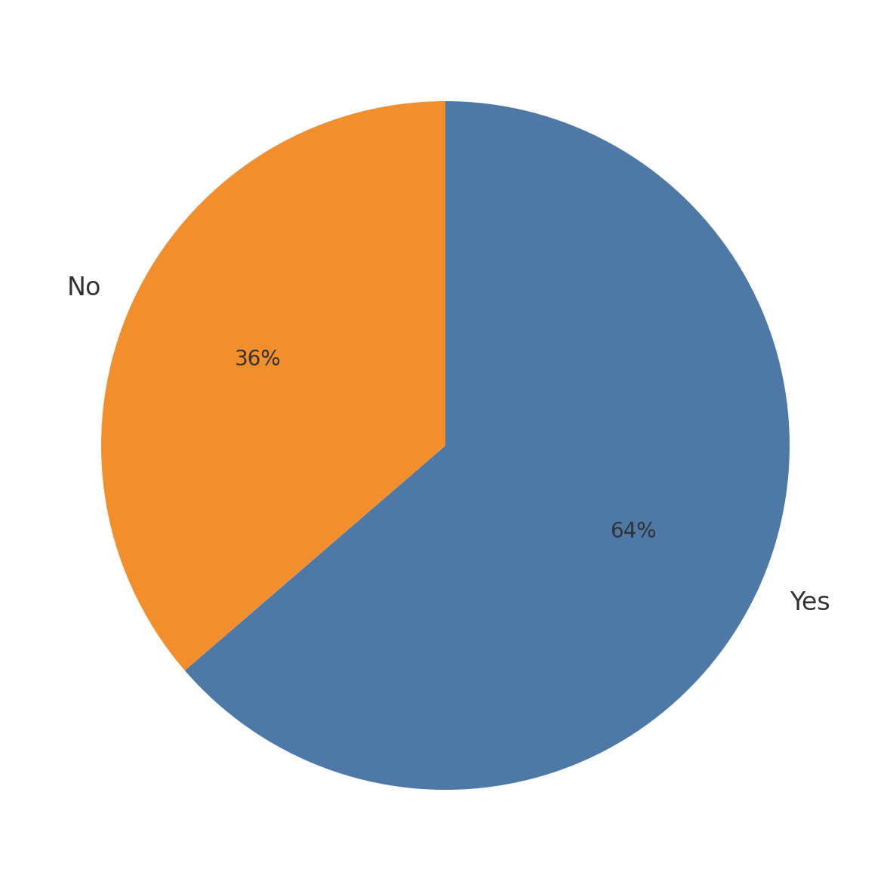

Only 115/ 42% correctly identified the appropriate time to perform SBE (a few days after menstruation), while 109/ 39 % thought it could be done anytime (Figure 2).

Figure 2: Appropriate time to perform a Self-Breast Examination

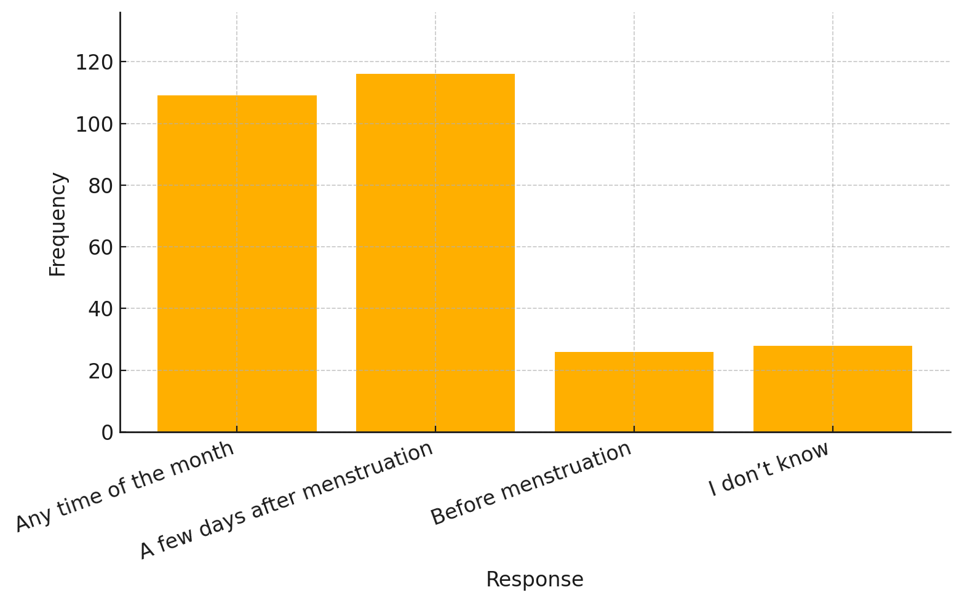

Regarding frequency, 118/43 % knew that SBE should be done monthly, but significant proportions believed it should be done weekly 61/22 % or annually 40/ 14 %, and 59/21 % were unsure (Figure 3).

**Figure 3: How often should a woman perform Self-Breast Examination**

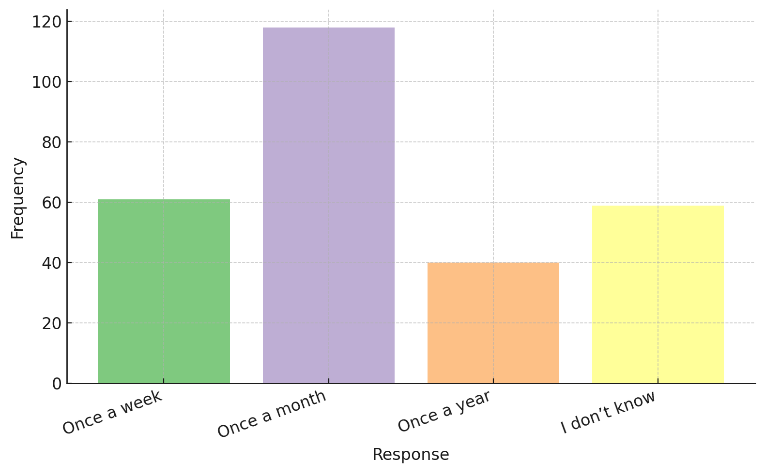

Awareness of breast abnormality warning signs varied, with the highest recognition for changes in breast shape or size 116/42 %, followed by lumps/swelling 68/24%, nipple discharge 51/18 %, and skin changes 43/16 % (Figure 4).

**Figure 4: Common warning signs of breast abnormalities**

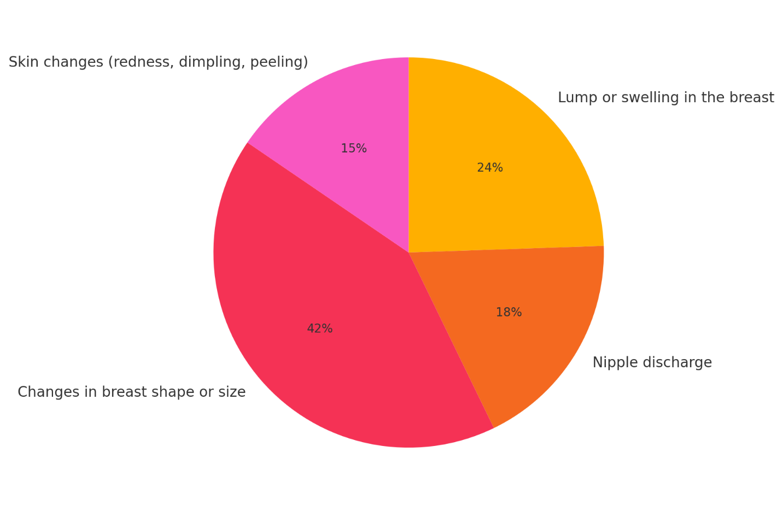

**Source: Field study (2025)**

## **Attitude on Self-Breast Examination among female students**

The mean scores for the attitude statements reflect generally positive perceptions among female students at Sunyani Senior High School regarding SBE, although some uncertainty remains in specific areas.

The statement, “Educational interventions increase not only knowledge but also confidence in performing SBE regularly,” received the highest mean score of 4.12, indicating strong agreement that education and training effectively enhance both understanding and confidence. This suggests students recognize the value of targeted programs in promoting regular and correct SBE practice.

Similarly, the statement, “Many female students are aware of breast cancer but may lack proper knowledge about how and when to perform SBE,” had a high mean of 4.09, indicating broad agreement that while awareness exists, knowledge gaps remain concerning the correct practice of SBE.

The item, “Those who receive training or demonstrations on SBE tend to have higher confidence in performing it correctly,” scored 3.83 on average, showing moderate to strong agreement that practical training improves students’ confidence.

Some uncertainty is evident in responses to “Many students feel unsure about how to perform SBE correctly” (mean = 3.40) and “Some students do not perform SBE due to limited knowledge about its importance or the correct method” (mean = 3.67). These moderate scores suggest that a significant portion of students still experience doubts or lack motivation stemming from insufficient knowledge.

The perception that “Some view SBE as a way to take control of their health and reduce anxiety about breast cancer” scored 3.73, reflecting a moderately positive attitude toward SBE as an empowering health behavior.

Lastly, the lowest mean (3.33) was for the statement, “Some students believe they are too young to develop breast cancer and see SBE as unnecessary,” indicating mild agreement with this misconception. This highlights an attitudinal barrier where some students underestimate their risk, potentially limiting engagement with preventive practices.

The standard deviations, mostly around 1.0, indicate moderate variability in responses, with the exception of the first statement, which had a higher SD of 3.72—likely due to a wider range of opinions on awareness versus knowledge.

Overall, the results suggest generally positive attitudes toward SBE among students, with recognition of the importance of education and training, but also reveal existing uncertainties and misconceptions that may hinder consistent practice. These findings underscore the need for enhanced educational efforts to address knowledge gaps and attitudes to improve SBE uptake.

**Table 3: Attitude on Self-Breast Examination among female students**

| **Statement** | **Responses (N)** | **Mean** | **Standard Deviation** |
| --- | --- | --- | --- |
| Many female students are aware of breast cancer but may lack proper knowledge about how and when to perform SBE. | 278 | 4.09 | 3.72 |
| Those who receive training or demonstrations on SBE tend to have higher confidence in performing it correctly. | 278 | 3.83 | 0.93 |
| Many students feel unsure about how to perform SBE correctly. | 278 | 3.40 | 1.04 |
| Educational interventions increase not only knowledge but also confidence in performing SBE regularly. | 278 | 4.12 | 1.21 |
| Some view SBE as a way to take control of their health and reduce anxiety about breast cancer. | 278 | 3.73 | 0.99 |
| Some students do not perform SBE due to limited knowledge about its importance or the correct method. | 278 | 3.67 | 1.04 |
| Some students believe they are too young to develop breast cancer and see SBE as unnecessary. | 278 | 3.33 | 0.91 |

## **Practices on Self-Breast Examination among female students**

This section explores the self-breast examination (SBE) practices of female students at Sunyani Senior High School. The findings indicate that most respondents demonstrated good knowledge of key SBE techniques. A majority agreed that observing the breasts in front of a mirror—while positioning the arms relaxed, raised, and on the hips—to detect changes in size, shape, or skin texture is important, reflected by a high mean score of 3.85 (SD = 0.88).

Respondents also recognized the importance of raising the arms overhead and repeating the inspection, with a mean score of 3.36 (SD = 1.26), indicating moderate agreement. The practice of using the pads of the fingers to feel for lumps in a circular motion, starting from the outer breast towards the nipple, was similarly acknowledged (mean = 3.52, SD = 1.17). Manual palpation while lying down was agreed upon by most students (mean = 3.50, SD = 1.07), showing awareness of proper examination posture.

Notably, applying varying pressure—light near the skin, medium in the middle, and firm deeper in the tissue—received the highest agreement with a mean score of 4.03 (SD = 0.88), highlighting good understanding of palpation techniques. Additionally, gently squeezing the nipple to check for unusual discharge was widely accepted as part of the examination (mean = 3.79, SD = 0.99).

Overall, the results suggest that the majority of female students at Sunyani Senior High School are aware of essential practices involved in Self-Breast Examination, reflecting a promising foundation for breast health monitoring in this population.

**Table 4.:** Practices on Self-Brest Examination among female students at Sunyani senior high school

|  |  |  |
| --- | --- | --- |
| Statement | Mean | Std. deviation |
| Observing the breasts in front of a mirror with arms at different positions (relaxed, raised, and on hips) to check for changes in size, shape, or skin texture. | 3.8571 | .88289 |
| Raise your arms overhead and repeat the inspection. | 3.3673 | 1.26805 |
| Using the pads of the fingers to feel for lumps in a circular motion, starting from the outer breast and moving towards the nipple. | 3.5255 | 1.17424 |
| Manual palpation while lying down. | 3.5051 | 1.07416 |
| Apply light pressure near the skin, medium pressure in the middle of the breast, and firm pressure deeper in the tissue. | 4.0306 | .88235 |
| Gently squeezing the nipple to check for any unusual discharge, such as blood or pus. | 3.7908 | .99337 |

**Source: Field survey (2025)**

**Discussion**

This study aimed to assess the knowledge, attitudes, and practices related to Self-Breast Examination (SBE) among female students at Sunyani Senior High School. The findings are discussed in relation to each research objective and contextualized with existing literature to provide deeper insight and implications for breast health promotion.

**Knowledge of SBE and Demographic Factors**

The study revealed that while a majority of female students had some awareness of SBE, detailed knowledge regarding correct techniques, timing, and importance was insufficient. Whiles this finding is in alignment with Heena et al., (2019), it is inconsistent with studies conducted in similar settings, such as G Koc, (2019); and JA Ogunkayode, (2021), which reported gaps in procedural knowledge despite general awareness. The disparity between awareness and in-depth understanding reflects a common challenge in adolescent health education where exposure to information does not always translate into comprehensive knowledge. It is observed in the study that a strong correlation existed between age group and SBE knowledge (p = 0.0012), indicating that older students were more knowledgeable than their younger counterparts. This corresponds with previous research in other contexts, indicating that advancing age correlates with heightened exposure to health education, increased maturity, and enhanced health-seeking behavior (Boateng et al., 2022). The finding underscores the critical need for early introduction of breast health education in the school curriculum, targeting students in lower classes before misconceptions and risky behaviors are established. Conversely, religion had no significant correlation with SBE knowledge (p = 0.223), indicating that, in this situation, breast health awareness surpasses religious divisions. This finding departs from research conducted in other multicultural contexts, where studies indicate that religious affiliation can markedly affect health habits and receptiveness to secular health programs (Gutusa & Roets, 2023; Gyedu et al., 2018) As a result, interventions to promote SBE in some contexts may require adaptation to specific religious or cultural groups rather than a universal approach.

The identified gaps in SBE knowledge among students could hinder effective early detection of breast abnormalities, potentially delaying diagnosis and increasing risks of adverse outcomes. Addressing this requires structured and targeted breast health education introduced early in the school curriculum. Evidence-based and practical teaching methods, delivered by health professionals, can improve students’ knowledge, confidence, and regular practice of SBE, ultimately supporting earlier detection and better health outcomes.

**Attitude Towards Self-Breast Examination**

Attitudes towards Self-Breast Examination (SBE) among the students demonstrated variability, influenced by factors such as perceived susceptibility and cultural beliefs. This aligns with findings from Fondjo et al., (2018), which highlight that while awareness of SBE is relatively high, actual practice is inconsistent due to uncertainty about technique and low perceived risk. The moderate confidence levels and occasional misconceptions about breast cancer risk among younger females identified in this study resonate with these prior findings by Calys-Tagoe et al., (2025) .

The health implications are significant: negative or uncertain attitudes toward SBE can deter regular practice, undermine early detection efforts and potentially lead to delayed diagnosis and poorer breast cancer outcomes. Cultural taboos and societal norms, as described byAfaya et al., 2024; Calys-Tagoe et al., (2025), often inhibit open discussion about breast health, limiting education and reinforcement of positive attitudes. Access to guidance from healthcare professionals, which positively influences attitudes and adherence, remains uneven, particularly in resource-limited settings (Fondjo et al., 2018) . Therefore, addressing these attitudinal barriers through culturally sensitive awareness campaigns, peer education programs, and facilitating easier access to professional advice is essential. These efforts will help to normalize breast health conversations, build confidence in performing SBE, and foster a proactive approach toward breast health among young women.

**Practices of Self-Breast Examination**

Regarding SBE practice, the study found that while some students viewed it as an empowering health behavior to reduce anxiety, actual adherence to recommended techniques and frequency was suboptimal. This mirrors findings by Wolde et al., (2023) , who observed a gap between awareness and correct practice, and Mohebi et al., (2023), who noted that misinformation and cultural misconceptions hinder proper SBE adherence. The low rate of regular, correctly performed SBE practices is a concern, especially given that the American Cancer Society recommends monthly self-examinations for early detection (Capaccione et al., 2021) . Factors such as lack of confidence, fear of discovering abnormalities, and busy lifestyles; as noted by Calys-Tagoe et al., (2025); and Fondjo et al., (2018) ; likely contribute to this trend. Additionally, younger females and those with lower educational levels, like many in this study’s population, tend to exhibit lower adherence (Mohebi et al., 2023). The misconception that breast cancer is solely hereditary and thus irrelevant for personal prevention efforts further reduces motivation to practice SBE (Calys-Tagoe et al., 2025). The health implications are profound: insufficient practice of SBE delays identification of breast changes, leading to later-stage diagnoses and poorer prognoses. Interventions that combine educational campaigns with community and healthcare provider engagement have shown promise in improving SBE knowledge and practice (Liaw & Ting, 2025). Incorporating such strategies at the school level could enhance early detection behaviors among young women in Ghana.

**Conclusion**

The study revealed that while a majority of female students demonstrated some awareness of self-breast examination (SBE), detailed knowledge regarding its correct technique, timing, and importance was lacking—especially among younger students. Age was significantly associated with SBE knowledge, indicating that older students were better informed, while religious affiliation showed no significant effect. These findings underscore the importance of early, comprehensive breast health education in schools to close the knowledge gap and promote effective SBE practices, ultimately supporting earlier detection and improved health outcomes for young women.

**Study Limitation**

A key limitation of this study is its cross-sectional design, which captures information at a single point in time and cannot establish causality. The study was also conducted in a single school setting, which may limit the generalizability of the findings to other regions or student populations. Self-reported data may be subject to recall and social desirability bias, potentially affecting the accuracy of reported knowledge and practices. Future studies could address these limitations by including multiple schools, employing longitudinal designs, and using observational methods to validate self-reported behaviors.

**Recommendations**

It is recommended that educational authorities incorporate structured and practical breast health education into the school curriculum at all levels, with particular focus on students in lower classes. Health education initiatives should utilize interactive teaching methods and involve healthcare professionals to deliver accurate and practical demonstrations. Additionally, ongoing refresher sessions and peer support strategies can reinforce learning and foster regular SBE practice. While religion was not a significant factor in this setting, culturally sensitive approaches should still be considered in more diverse or multicultural contexts.

Consent for publication

Not applicable

Data Availability

Data used to support this study are available from the corresponding author upon request.

Conflicts of Interest

The authors declared that they have no competing interests.

Disclaimer (Artificial intelligence)

Authors at this moment declare that generative AI (ChatGPT) has been used during the editing of manuscripts.

Funding Statement

The authors did not receive specific funding for this work.

Authors’ Contributions

All authors contributed equally.

Acknowledgment

We thank all the study participants who avail themselves of being part of the study at will.

REFERENCE

Abubakari, A. K., Gross, J., & Adusei-Poku, E. (2025). Factors influencing clinical breast cancer screening: A cross-sectional study among Islamic women in Kumasi Metropolis of Ghana. *PLOS ONE*, *20*(5 May). https://doi.org/10.1371/journal.pone.0320726

*ACS Breast Cancer Screening Guidelines | American Cancer Society*. (n.d.). Retrieved June 28, 2025, from https://www.cancer.org/cancer/types/breast-cancer/screening-tests-and-early-detection/american-cancer-society-recommendations-for-the-early-detection-of-breast-cancer.html

Afaya, A., Anaba, E. A., Bam, V., Afaya, R. A., Yahaya, A. R., Seidu, A. A., & Ahinkorah, B. O. (2024). Socio-cultural beliefs and perceptions influencing diagnosis and treatment of breast cancer among women in Ghana: a systematic review. *BMC Women’s Health*, *24*(1). https://doi.org/10.1186/S12905-024-03106-Y

Ahmed, W. R., Hossny, E. K., Mohammed, G. T., Elrahman, S. A. A. A., Abdelkader, A. M., Abdelrahem, A. S. A., Omar, N. N., & Mohamed, H. M. (2024). Risk Assessment Tool of Breast Cancer and Barriers against Breast Self-Examination among Nurses: An Educational Program. *Nursing Forum*, *2024*. https://doi.org/10.1155/2024/5452953

Al-Worafi, Y. M. (2024). Cancer: Risk Factors in Developing Countries. *Handbook of Medical and Health Sciences in Developing Countries*, 1–23. https://doi.org/10.1007/978-3-030-74786-2_326-1

Amegbedzi, R. A., Komesuor, J., Amu, H., & Tarkang, E. E. (2022). Factors Influencing the Practice of Breast Self-Examination among Female Tertiary Students in Ho, Ghana. *Advances in Public Health*, *2022*. https://doi.org/10.1155/2022/7724050

Arnold, M., Morgan, E., Rumgay, H., Mafra, A., Singh, D., Laversanne, M., Vignat, J., Gralow, J. R., Cardoso, F., Siesling, S., & Soerjomataram, I. (2022). Current and future burden of breast cancer: Global statistics for 2020 and 2040. *Breast*, *66*, 15–23. https://doi.org/10.1016/j.breast.2022.08.010

Bellanger, M., Zeinomar, N., Tehranifar, P., & Terry, M. B. (2018). Are global breast cancer incidence and mortality patterns related to country-specific economic development and prevention strategies? *Journal of Global Oncology*, *2018*(4), 1–16. https://doi.org/10.1200/JGO.17.00207

Boateng, S., Baah, A., Boakye-Ansah, D., & Aboagye, B. (2022). Senior High School Students’ Knowledge and Attitudes Toward Information on Their Health in the Kumasi Metropolis. *Frontiers in Public Health*, *9*, 752195. https://doi.org/10.3389/FPUBH.2021.752195

Böckerman, P., Kortelainen, M., Salokangas, H., & Vaalavuo, M. (2025). A family affair? Long-term economic and mental health effects of spousal cancer. *Journal of Population Economics*, *38*(1). https://doi.org/10.1007/S00148-025-01070-X

Calys-Tagoe, B. N. L., Brownson, K., Nsaful, J., Dedey, F., Coleman, N., Laryea, R. Y., & Clegg-Lamptey, J. N. (2025). EXPLORING KNOWLEDGE, BELIEFS, AND MISCONCEPTIONS ON BREAST CANCER IN AN URBAN FISHING COMMUNITY IN GHANA-A QUALITATIVE STUDY. *Postgraduate Medical Journal of Ghana*, *14*(1), 28–35. https://doi.org/10.60014/pmjg.v14i1.394

Capaccione, K. M., Huang, S., West, E., Deng, A., Salvatore, M. M., & Desperito, E. (2021). Differential effects of the 2015 American Cancer Society guidelines on screening mammography exams based on socioeconomic status. *Journal of Clinical Oncology*, *39*(15_suppl), 10539–10539. https://doi.org/10.1200/JCO.2021.39.15_SUPPL.10539

Capili, B. (2021). Overview: Cross-Sectional Studies. *The American Journal of Nursing*, *121*(10), 59. https://doi.org/10.1097/01.NAJ.0000794280.73744.FE

Carrera, P. M., Kantarjian, H. M., & Blinder, V. S. (2018). The financial burden and distress of patients with cancer: Understanding and stepping‐up action on the financial toxicity of cancer treatment. *CA: A Cancer Journal for Clinicians*, *68*(2), 153–165. https://doi.org/10.3322/CAAC.21443

Ferlay, J., Colombet, M., Soerjomataram, I., Mathers, C., Parkin, D. M., Piñeros, M., Znaor, A., & Bray, F. (2019). Estimating the global cancer incidence and mortality in 2018: GLOBOCAN sources and methods. *International Journal of Cancer*, *144*(8), 1941–1953. https://doi.org/10.1002/IJC.31937

Fondjo, L. A., Owusu-Afriyie, O., Sakyi, S. A., Wiafe, A. A., Amankwaa, B., Acheampong, E., Ephraim, R. K. D., & Owiredu, W. K. B. A. (2018). Comparative Assessment of Knowledge, Attitudes, and Practice of Breast Self-Examination among Female Secondary and Tertiary School Students in Ghana. *International Journal of Breast Cancer*, *2018*. https://doi.org/10.1155/2018/7502047

G Koc, H. G.-S. S. E. M. Y.-C. N. A. (2019). Female university students’ knowledge and practice of breast self-examination in Turkey. *Niger J Clin Pract*, *22*(3), 410–415.

Gutusa, F., & Roets, L. (2023). Early cervical cancer screening: The influence of culture and religion. *African Journal of Primary Health Care & Family Medicine*, *15*(1), 3776. https://doi.org/10.4102/PHCFM.V15I1.3776

Gyedu, A., Boakye, G., Abdulai, A. R., Stewart, B., Gaskill, C. E., Anderson, B. O., & Stewart, B. (2018). Differences in perception of breast cancer among muslim and christian women in Ghana. *Journal of Global Oncology*, *2018*(4). https://doi.org/10.1200/JGO.2017.009910,

Heena, H., Durrani, S., Riaz, M., Alfayyad, I., Tabasim, R., Parvez, G., & Abu-Shaheen, A. (2019). Knowledge, attitudes, and practices related to breast cancer screening among female health care professionals: A cross sectional study. *BMC Women’s Health*, *19*(1). https://doi.org/10.1186/S12905-019-0819-X

JA Ogunkayode, A. A. (2021). Knowledge, attitude, and practice of breast self-examination among female secondary school students in Ibadan, Nigeria. *Arch Basic Appl Med*, *9*(1), 5–11.

Johnson, O. E. (2019). Awareness and Practice of Breast Self Examination among Women in Different African Countries: A 10-Year Review of Literature. *Nigerian Medical Journal : Journal of the Nigeria Medical Association*, *60*(5), 219. https://doi.org/10.4103/NMJ.NMJ_84_19

Joyce, C., Ssenyonga, L. V. N., & Iramiot, J. S. (2020). Breast self-examination among female clients in a tertiary hospital in Eastern Uganda. *International Journal of Africa Nursing Sciences*, *12*. https://doi.org/10.1016/j.ijans.2019.100186

Kandasamy, G., Almaghaslah, D., Almanasef, M., & Alamri, R. D. A. (2024). Knowledge, attitude, and practice towards breast self-examination among women: a web based community study. *Frontiers in Public Health*, *12*, 1450082. https://doi.org/10.3389/FPUBH.2024.1450082

Liaw, M. K.-P., & Ting, S.-H. (2025). Communicating Barriers to Breast Cancer Screening and Treatment Among Sarawakian Women: An Extended Parallel Process Model Analysis. *Journal of Communication in Scientific Inquiry (JCSI)*, *7*(1), 93–103. https://doi.org/10.58915/JCSI.V7I1.1866

Maurya, A. P., & Brahmachari, S. (2021). Current Status of Breast Cancer Management in India. *Indian Journal of Surgery*, *83*, 316–321. https://doi.org/10.1007/S12262-020-02388-4

Mensah, K. B., & Mensah, A. B. B. (2020). Cancer control in Ghana: A narrative review in global context. *Heliyon*, *6*(8). https://doi.org/10.1016/j.heliyon.2020.e04564

Mohebi, Z., Heidari Sarvestani, M., Moradi, Z., & Naghizadeh, M. M. (2023). Female high school students’ knowledge and attitude toward breast cancer. *BMC Women’s Health*, *23*(1), 1–10. https://doi.org/10.1186/S12905-023-02155-Z/TABLES/7

Molassiotis, A., Tyrovolas, S., Giné-Vázquez, I., Yeo, W., Aapro, M., & Herrstedt, J. (2021). Organized breast cancer screening not only reduces mortality from breast cancer but also significantly decreases disability-adjusted life years: analysis of the Global Burden of Disease Study and screening programme availability in 130 countries. *ESMO Open*, *6*(3). https://doi.org/10.1016/j.esmoop.2021.100111

Mushosho, E. Y., Muziringa, M. C., Radebe, M., & Nkosi, P. B. (2024). A model to enhance breast cancer screening among rural women aged 40–75 years in Sub-Saharan Africa (SSA): A scoping review. *Journal of Medical Imaging and Radiation Sciences*, *55*(1), 109–124. https://doi.org/10.1016/j.jmir.2023.12.003

Mutebi, M., Anderson, B. O., Duggan, C., Adebamowo, C., Agarwal, G., Ali, Z., Bird, P., Bourque, J. M., DeBoer, R., Gebrim, L. H., Masetti, R., Masood, S., Menon, M., Nakigudde, G., Ng’ang’a, A., Niyonzima, N., Rositch, A. F., Unger-Saldaña, K., Villarreal-Garza, C., … Eniu, A. (2020). Breast cancer treatment: A phased approach to implementation. *Cancer*, *126*(S10), 2365–2378. https://doi.org/10.1002/CNCR.32910

Omotoso, O., Teibo, J. O., Atiba, F. A., Oladimeji, T., Paimo, O. K., Ataya, F. S., Batiha, G. E. S., & Alexiou, A. (2023). Addressing cancer care inequities in sub-Saharan Africa: current challenges and proposed solutions. *International Journal for Equity in Health*, *22*(1). https://doi.org/10.1186/S12939-023-01962-Y

Pippin, M. M., & Boyd, R. (2023). Breast Self-Examination. *StatPearls*. https://www.ncbi.nlm.nih.gov/books/NBK565846/

Siegel, R. L., Kratzer, T. B., Giaquinto, A. N., Sung, H., & Jemal, A. (2025). Cancer statistics, 2025. *CA: A Cancer Journal for Clinicians*. https://doi.org/10.3322/CAAC.21871

Srinath, A., Van Merode, F., Rao, S. V., & Pavlova, M. (2023). Barriers to cervical cancer and breast cancer screening uptake in low- and middle-income countries: a systematic review. In *Health Policy and Planning* (Vol. 38, Issue 4, pp. 509–527). Oxford University Press. https://doi.org/10.1093/heapol/czac104

Wang, X., & Cheng, Z. (2020). Cross-Sectional Studies: Strengths, Weaknesses, and Recommendations. *Chest*, *158*(1), S65–S71. https://doi.org/10.1016/J.CHEST.2020.03.012,

Wolde, M. T., Okova, R., Habtu, M., Wondafrash, M., & Bekele, A. (2023). The practice of breast self-examination and associated factors among female healthcare professionals working in selected hospitals in Kigali, Rwanda: a cross sectional study. *BMC Women’s Health*, *23*(1). https://doi.org/10.1186/S12905-023-02776-4

Yamane, T. (1973). *Statistics: An introductory analysis*. https://www.researchgate.net/profile/Mazyar-Ghadiri-Nejad/post/Would_you_mind_sending_me_the_full_text_book_of_Yamane_Taro_1967_Statistics_Introduction_to_Analysis_New_York_Harper_and_Row/attachment/5a38faffb53d2f0bba456a9c/AS%3A573245188915200%401513683711929/download/252560191.pdf