**Interceptive Management of Pseudo-Class III Malocclusion in a Growing Patient Using a Sagittal Screw Appliance: A Case Report**

**ABSTRACT**

Functional anterior crossbite is often misdiagnosed as skeletal Class III malocclusion, necessitating careful evaluation and timely intervention. This case report describes the interceptive orthodontic management of a 14-year-old female with anterior crossbite and a forward mandibular shift. Clinical and cephalometric findings confirmed a functional discrepancy without true skeletal Class III features. Treatment involved a sagittal screw appliance with posterior bite blocks to advance the maxillary anterior segment and eliminate occlusal interference. This was followed by fixed mechanotherapy using the MBT 0.018" prescription to align and level both arches. Post-treatment cephalometric analysis showed improvement in ANB angle (from –2° to 0°), increased overjet, and deep bite correction. A stable Class I occlusion with improved facial profile was achieved. Early diagnosis and use of functional appliances in growing patients can successfully correct CR–CO discrepancies, minimize skeletal progression, and reduce the need for surgical intervention.

**Keywords:** *Sagittal screw appliance, Anterior crossbite, Functional shift, Interceptive orthodontics, Growing patient*

**1. INTRODUCTION**

Class III malocclusion represents a challenging growth-related condition in orthodontics as growth redirection is more predictable as compared to growth retainment. It is characterized by an anterior-posterior discrepancy between the maxilla and mandible in one or more plane of space. Its prevalence varies by population, ranging from 1% to 4% among Caucasians and up to 14% in Asian populations [1].

The etiology in causation of class III malocclusion often involves skeletal, dental or functional components. While skeletal Class III is known to result from maxillary deficiency, mandibular prognathism, or a combination of both; functional Class III or pseudo-Class III malocclusion arises primarily from occlusal interferences leading to a forward functional mandibular shift often regarded as a discrepancy in centric relation and centric occlusion [2][3].

Pseudo-Class III also referred as functional class III malocclusion where the patient is observed to appear a true skeletal class III relation but, the underlying cause can be a forward mandibular shift due to occlusal interference. It is typically identified by the presence of a functional shift from centric relation to centric occlusion, anterior crossbite, and upright or retroclined mandibular incisors. Cephalometric features often show normal SNA, slightly increased SNB with negative values of ANB. Importantly, such cases frequently lack a family history of Class III skeletal patterns [4]. Early diagnosis and treatment are essential to correct the condition harnessing the growth potential for stable correction and prevent its progression into a true skeletal Class III [5].

Among various interceptive options for growing individuals, the sagittal screw appliance is known to provide promising results in treating pseudo-Class III. This removable active plate allows for controlled advancement of maxillary incisors while promoting bite opening and eliminating occlusal interference. Owen [6] reported effective anterior movement of up to 2.5 mm and significant improvement in overjet and facial balance using the sagittal screw appliance. Its use during the growth phase can help achieve favorable skeletal and dento-alveolar changes [7][8].

**2. PRESENTATION OF CASE**

A 14-year-old female patient reported for orthodontic evaluation with the chief complaint of anterior crossbite. Extraoral examination revealed a concave soft tissue profile, mesoprosopic facial form, and competent lips at rest. The facial divergence was anterior, and the mandibular plane appeared flat, suggesting a horizontal growth pattern.

Intraoral examination demonstrated bilateral Angle's Class I molar and canine relationships. An anterior crossbite involving the maxillary and mandibular incisors was observed, accompanied by mild crowding in both arches. The maxillary arch was ovoid, while the mandibular arch was tapering in form. A forward path of mandibular closure was evident on functional examination, confirming a functional shift indicative of a pseudo-Class III malocclusion. Additionally, a deep overbite was noted in the vertical dimension with a deep curve of spee. (Figure 1)

Skeletal maturity was assessed using the Cervical Vertebral Maturation Index (CVMI), and the patient was found to be in Stage 4, indicating that the active phase of pubertal growth—an optimal period for orthodontic intervention.

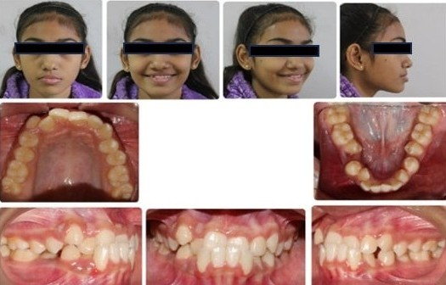

**Fig. 1. Pre-treatment extraoral and intraoral photographs showing facial profile and dental occlusion.**

**2.1 Diagnosis**

The patient was diagnosed with a pseudo-Class III malocclusion characterized by a forward functional mandibular shift on closure. The skeletal pattern suggested a horizontal growth tendency, with a concave soft tissue profile and a flat mandibular plane. Bilateral Angle’s Class I molar and canine relationships were present in centric relation. Dentally, the patient exhibited an anterior crossbite, mild crowding in both arches, a deep overbite, and a pronounced curve of Spee. Skeletal maturity assessment indicated the patient was in the active phase of pubertal growth, making this an ideal time for interceptive orthodontic treatment.

**2.2 Treatment Objectives**

* To eliminate the functional mandibular shift and establish a stable centric relation.
* To correct the anterior crossbite and normalize overjet and overbite.
* To improve incisor inclinations and relieve mild crowding.
* To maintain the existing Class I molar and canine relationships.
* To enhance facial esthetics and achieve a stable, functional occlusion.

**2.3 Treatment Plan and Progress**

**2.3.1 Phase I**

The preliminary step involved identifying the presence of a functional forward mandibular shift, suggestive of a pseudo-Class III malocclusion. To establish the true maxilla-mandibular relationship, a centric relation record was obtained using a wax bite with adequate vertical clearance, eliminating the habitual shift and aiding in accurate appliance planning and fabrication [9][10]. The wax record was mounted on a mean value articulator and the sagittal screw appliance was fabricated using a self-cure resin incorporating posterior occlusal bite blocks to facilitate anterior disocclusion and promote anterior correction. A 9 mm jackscrew was places sagittally in the midline and separation in the acrylic was made distally to canines. Adams clasps were utilized on the maxillary molars for optimal appliance retention. (Figure 2)

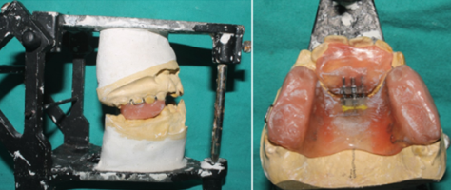

**Fig. 2. Fabrication of sagittal screw appliance on a mean value articulator.**

The sagittal screw was activated at a rate of 0.5 mm per week, with periodic clinical evaluation. Activation was continued until correction of the anterior crossbite was achieved, thus resolving the functional discrepancy.To maintain the achieved arch integrity and prevent mesial migration of the mandibular molars, a passive mandibular lingual holding arch was placed, ensuring space maintenance and stabilizing the occlusion during the transition phase. (Figure 3)

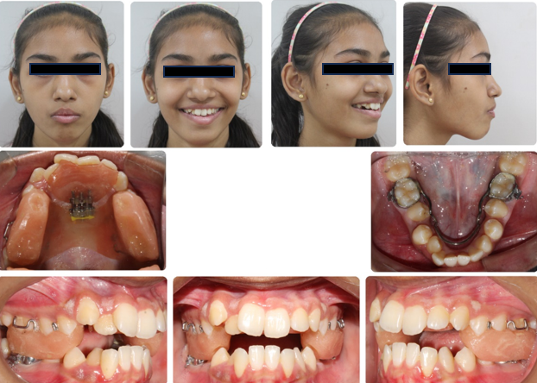

**Fig. 3. Intraoral and extraoral views showing the sagittal screw appliance during the active treatment phase.**

**2.3.2 Phase II**

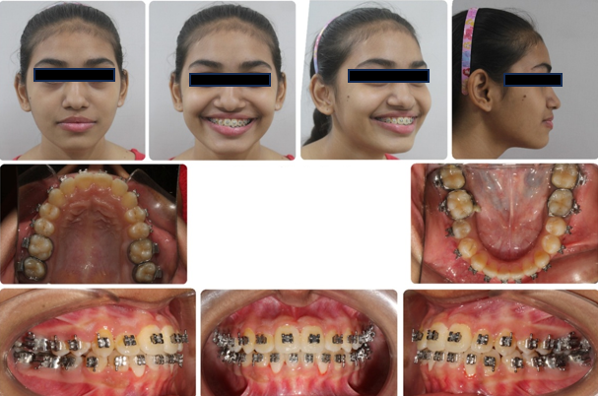Fixed mechanotherapy was undertaken using the MBT appliance system with a 0.018" slot prescription. The primary objectives in this phase were the alignment, leveling, and comprehensive finishing of both arches. Space available distal to the mandibular first premolars was judiciously utilized for the resolution of anterior crowding. Labial root torque of the maxillary incisors was achieved by incorporating labial torque into a 0.017" × 0.025" stainless steel arch wire, with precision V-bends placed mesial to the maxillary canines to enhance torque expression. This phase of treatment resulted in the normalization of the overjet and overbite, and the maintain correction of the functional anterior mandibular shift. A stable Class I occlusion was achieved, accompanied by a harmonious facial profile and improved soft tissue balance. (Figure 4)

**Fig. 4. Mid-treatment photographs showing fixed orthodontic treatment following sagittal correction.**

Final finishing was carried out with light elastics to refine the occlusion. After satisfactory intercuspation was achieved, debonding was carried out. The post-treatment extraoral and intraoral photographs demonstrate improved facial profile, corrected anterior and posterior occlusion, and stable arch form (Figure 5).

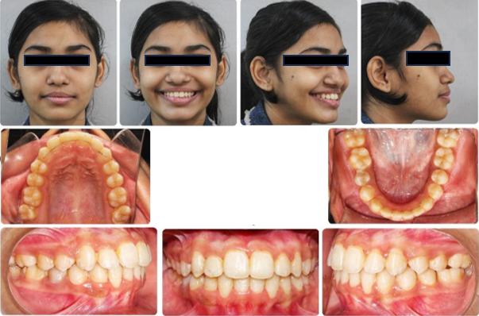

**Fig. 5. Post-treatment extraoral and intraoral photographs**

**2.3.3 Retention Protocol**

post-treatment, a maxillary wraparound Hawley retainer and fixed bonded lingual retainer were given to maintain incisor position and transverse arch form. In the mandibular arch, a fixed bonded retainer was placed from canine to canine to prevent relapse of anterior alignment. The upper retainer was worn full-time for 6 months, followed by night-time wear. The patient was monitored at regular intervals to ensure occlusal stability and appliance integrity.

**Table 1. Cephalometric comparison**

|  |  |  |
| --- | --- | --- |
| **Parameter** | **Pre-Treatment** | **Post-Treatment** |
| SNA (°) | 82 | 83 |
| SNB (°) | 84 | 83 |
| ANB (°) | -2 | 0 |
| Wits (mm) | -4 | -3 |
| FMA (°) | 28 | 30 |
| U1 to NA (°) | 23 | 27 |
| L1 to NB (°) | 27 | 26 |
| Occlusal Plane-SN (°) | 14 | 16 |
| Mandibular plane Angle | 28 | 27 |
| Maxillary Length (mm) | 78 | 78.5 |
| Mandibular Length (mm) | 102 | 103 |
| LAFH (mm) | 55 | 59 |
| E line: Upper Lip  Lower Lip | -5  2 | -3  0 |
| S line: Upper Lip  Lower Lip | -2  5 | 0  3 |

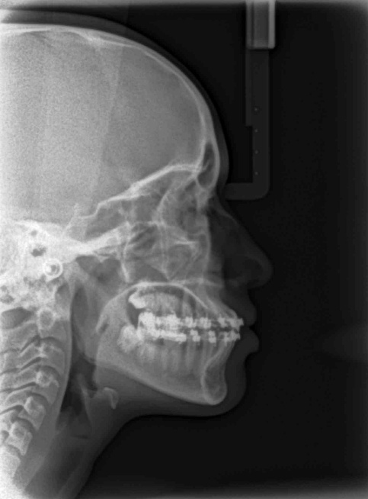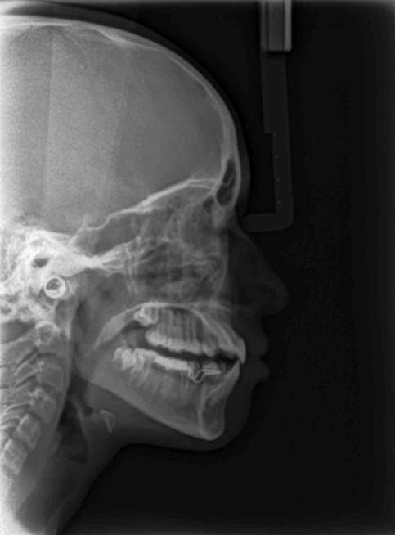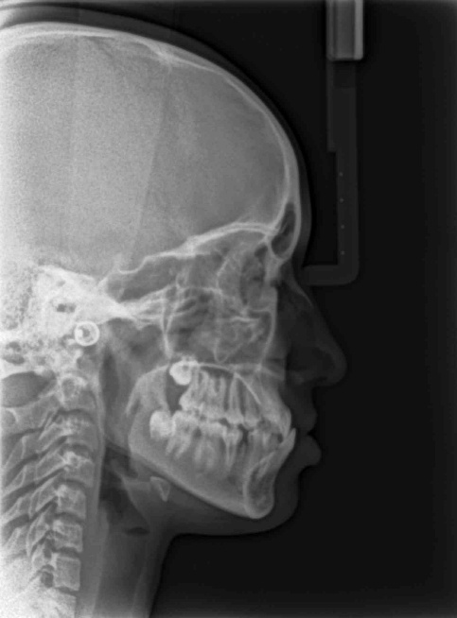

**Fig. 6. Pre Treatment, Post sagittal screw appliance and during Fixed mechanotherapy Lateral cephalograms**

**3. DISCUSSION**

Pseudo-Class III malocclusion is most effectively managed during the growth phase through timely and appropriate interceptive orthodontic interventions. These malocclusions are typically characterized by a functional anterior mandibular shift resulting from occlusal interferences or sometimes, labially erupting mandibular incisors leading to an attainment of an anterior bite of convenience. Early identification and correction of the functional shift can redirect mandibular growth along a more favorable path, thereby preventing the establishment of a true skeletal Class III relationship. The sagittal relationship is usually class I or mild class III [11]. Interceptive treatment during this critical period may significantly reduce the severity of the malocclusion and minimize or eliminate the need for future orthognathic surgical intervention [12].

The sagittal screw appliance offers a focused approach to such corrections by facilitating controlled advancement of the maxillary anterior segment. This helps eliminate occlusal interferences and restores normal incisor overlap. Owen’s findings [6], supported by recent literature [13], confirm its effectiveness in advancing the maxillary incisors and opening the bite—key steps in interceptive treatment of pseudo-Class III.

In the present case, post-treatment cephalometric analysis revealed favourable skeletal changes in both the sagittal and vertical dimensions. In the sagittal plane, notable improvements were observed in the ANB angle and Wits appraisal, indicating a more harmonious maxillo-mandibular relationship. Cephalometric changes observed in this case support the orthopedic effect of the sagittal screw appliance. The SNA angle increased slightly from 82° to 83°, indicating minor forward movement of the maxilla. Simultaneously, a reduction in SNB from 84° to 83° may reflect posterior adaptation of the mandible following elimination of the functional shift.

Vertically, correction of the deep bite was achieved through a clockwise rotation of the mandibular plane and the establishment of a more favorable occlusal plane-SN angle indicates beneficial vertical development, which contributed to an increase in lower anterior facial height and improved vertical facial proportions. The E-line and S-line assessments indicate improved lip position relative to the facial plane. The upper lip moved closer to the E-line (from –5 mm to –3 mm), and lower lip from –2 mm to 0 mm, reflecting balanced soft tissue support. These improvements support better facial harmony and patient esthetics.

The observed improvements in both sagittal and vertical dimensions further substantiate the effectiveness of the appliance in facilitating favorable skeletal remodeling and promoting maxillo-mandibular balance. These findings are in alignment with recent analytical studies that emphasize the utility of such appliances in guiding craniofacial growth and achieving orthopedic correction during the developmental phase [14].

Early intervention not only helped in correcting the functional crossbite but also stabilized the occlusion, minimized the need for extraoral appliances or surgical correction, and likely enhanced long-term stability. Several studies underline the importance of interceptive correction at the appropriate time to maximize growth potential and achieve stable [15][16].

**4. CONCLUSION**

This case demonstrates that early interceptive management of pseudo-Class III malocclusion using a sagittal screw appliance can produce favorable skeletal and dentoalveolar changes. The sagittal screw appliance not only facilitates forward maxillary advancement but also harmonizes incisor angulation and eliminates the functional shift simultaneously, addressing both the dental and positional components of the malocclusion in a single phase of treatment. Early diagnosis and utilizing the growth phase for skeletal correction can prevent further worsening of class III malocclusion during adulthood.

**DISCLAIMER (ARTIFICIAL INTELLIGENCE)**

Author(s) hereby declare that NO generative AI technologies such as Large Language Models (ChatGPT, COPILOT, etc) and text-to-image generators have been used during writing or editing of this manuscript.

**CONSENT**

As per international standards or university standards, patient(s) written consent has been collected and preserved by the author(s).

**REFERENCES**

1. Angle EH. Classification of malocclusion. Dent Cosmos. 1899;41:248–264.
2. Moyers RE. Handbook of Orthodontics. 4th ed. Chicago: Year Book Medical Publishers; 1988.
3. Jacobson A. The “Wits” appraisal of jaw disharmony. American journal of orthodontics. 1975 Feb 1;67(2):125-38.
4. Zohud O, Lone IM, Midlej K, Obaida A, Masarwa S, Schröder A, Küchler EC, Nashef A, Kassem F, Reiser V, Chaushu G. Towards genetic dissection of skeletal class III malocclusion: a review of genetic variations underlying the phenotype in humans and future directions. Journal of Clinical Medicine. 2023 Apr 29;12(9):3212.
5. DiBiase AT, Seehra J, Papageorgiou SN, Cobourne MT. Do we get better outcomes from early treatment of Class III discrepancies?. British Dental Journal. 2022 Aug 12;233(3):197-201.
6. Owen III AH. The maxillary sagittal appliance: a clinical study. American Journal of Orthodontics and Dentofacial Orthopedics. 1987 Apr 1;91(4):271-85.
7. Zhang J, Liu C, Dong Y. Finite element analysis of sagittal screw expander appliance in the treatment of anterior maxillary hypoplasia. Frontiers in Bioengineering and Biotechnology. 2023 Oct 26;11:1245764.
8. Inchingolo AM, Inchingolo AD, Trilli I, Ferrante L, Di Noia A, de Ruvo E, Palermo A, Inchingolo F, Dipalma G. Orthopedic Devices for Skeletal Class III Malocclusion Treatment in Growing Patients: A Comparative Effectiveness Systematic Review. Journal of Clinical Medicine. 2024 Nov 25;13(23):7141.
9. Hamidaddin MA. Optimal treatment timing in Orthodontics: a scoping review. European Journal of Dentistry. 2024 Feb;18(01):086-96.
10. Wiedel AP, Bondemark L. Stability of anterior crossbite correction: a randomized controlled trial with a 2-year follow-up. The Angle Orthodontist. 2015 Mar 1;85(2):189-95.
11. Jaradat, Mohammad. 2018. “An Overview of Class III Malocclusion (Prevalence, Etiology and Management)”. Journal of Advances in Medicine and Medical Research 25 (7):1-13.
12. Zhou X, Chen S, Zhou C, Jin Z, He H, Bai Y, Li W, Wang J, Hu M, Cao Y, Liu Y. Expert consensus on early orthodontic treatment of class III malocclusion. International Journal of Oral Science. 2025 Apr 1;17(1):20.
13. Dolci GS, et al. Hybrid mechanics in anterior crossbite. J Aligner Orthod. 2021;5:175–183.
14. McNamara Jr JA. Components of Class II malocclusion in children 8–10 years of age. The Angle Orthodontist. 1981 Jul 1;51(3):177-202.
15. Raghupathy Y, Ananthanarayanan V, Kailasam V, Padmanabhan S. Posttreatment stability following facemask therapy in patients with skeletal class iii malocclusion: a systematic review. International Journal of Clinical Pediatric Dentistry. 2023 Nov;16(6):897.
16. Azamian Z, Shirban F. Treatment options for class III malocclusion in growing patients with emphasis on maxillary protraction. Scientifica. 2016;2016(1):8105163
17. Alfaifi AH. Restorative Management and Treatment of Pseudo‐Class III Malocclusion. Case Reports in Dentistry. 2021;2021(1):8470222.
18. Laviv A, Hija A, Allon DM. Assessing the Impact of Maxillomandibular Difference on the Success of Orthodontic Decompensation Preparation in Orthognathic Surgical Skeletal Class-III Patients. Applied Sciences. 2023 Jul 11;13(14):8069.
19. Lee NK, Kim SH, Park JH, Son DW, Choi TH. Comparison of treatment effects between two types of facemasks in early Class III patients. Clinical and Experimental Dental Research. 2023 Feb;9(1):212-8.
20. Alotaibi S. Orthodontic camouflage treatment of pseudo‐Class III malocclusion on skeletal class III Base complicated with canine impaction treated with temporary anchorage devices: A case report. Clinical Case Reports. 2023 Jun;11(6):e7394.