**Costello Syndrome: Case report and review of literature**

**Abstract:**

Costello syndrome is a rare inherited disorder due to a genetic mutation in the HRAS (Harvey Rat Sarcoma) proto-oncogene that affects multiple organ systems. Individuals typically present with craniofacial abnormalities, short stature, poor weight gain, developmental delays, cardiac, dermatological, musculoskeletal, oral abnormalities and cancer predisposition, particularly rhabdomyosarcoma. This report presents a clinical case of a 13-year-old male diagnosed with Costello syndrome. He was born from a consanguineous marriage and has a healthy sibling. General examination revealed intellectual disability with delayed speech and motor skills, short stature (height of 120 cm), distinct facial dysmorphisms, low-set ears, and macrocephaly(head circumference of 49 cm). Oral findings include a large mouth, thick lips,hypomineralized enamel and macroglossia. Based on these clinical findings, a diagnosis of Costello syndrome was made. Genetic testing confirmed the diagnosis with a mutation in G12S in the HRAS gene. This report highlights a case of Costello syndrome with oral manifestations and reinforces the importance of early detection and a multidisciplinary approach for improved patient outcomes.

**Keywords:** Costello syndrome, HRAS,RASopathies, multidisciplinary team,oral manifestations,rare disease, genetic disorder

**Introduction:**

Costello syndrome (CS), also known as facio-cutaneous-skeletal (FCS) syndrome (OMIM #218040), was first described by Dr. Jack Costello in 1977 [1]. This syndrome is characterised by developmental delays, cognitive impairment, and intellectual disability, with various congenital abnormalities. Globally, between 300 to 400 cases have been documented, with an estimated prevalence ranging from 1 in 300,000 to 1 in 1.25 million individuals [2].

Common clinical features include a coarse face, short neck, hyperpigmented skin, sparse curly hair, and neurological, dermatological, and most importantly, cardiovascular malformations, such as congenital heart disease, arrhythmias, and hypertrophic cardiomyopathy. Difficulty in feeding during infancy, and an increased predilection for tumours such as nasal papillomas are also seen.[2]

Several oral manifestations can occur in these cases. A case of Costello syndrome with such oral manifestations is reported herewith.

**Presentation of the Case:**

**History:**

A 13 13-year-old boy reported to the Department of Oral Medicine and Radiology with a chief complaint of tooth pain for the past 2 months.

The child was born during the 7th month of pregnancy by C-section delivery in the hospital (40 days). Birth weight was 3.5 kg. The child was kept in an incubator for 2 weeks.H/o neonatal seizure disorder after birth.H/o of delayed speech and motor milestones, behaviours like temper tantrums, self-inflicting injuries present. The child recognises family members and expresses his needs through gestures. Genetic testing was performed during the first year of life, and Costello syndrome was confirmed.

The parents were alive and apparently healthy. Parental consanguinity was present. The patient has a normal younger sibling. The mother had low blood pressure during pregnancy.

**Clinical examination:**

The patient exhibited a dysmorphic face with an increased forehead circumference (HC=40.5). The patient was of short stature. His height and weight were 92 cm and 24 kg, respectively. He remained below the 3rd percentile for height and weight. Extraoral examination revealed macrocephaly, sparse hair and eyebrows, eyes with epicanthal folds, a short bulbous nose, low-set ears, loose wrinkled skin with hyperextensible fingers, and an inguinal hernia. Heart auscultation findings were normal. Dental findings included (large mouth, thick lips,hypomineralized enamel, macroglossia) and multiple papillomas of the neck.

**Discussion :**

Costello described Costello syndrome in 1971. A mutation in the HRAS gene is responsible for this syndrome. Diagnosis is mainly based on clinical findings. The average age of diagnosis is 4.2 years [3] The cause of this syndrome is linked to polyhydramnios (90%) older parents (62%), macrosomia (50%) early birth (50%) and, less commonly, fetal tachyarrhythmia[6]

RASopathy syndromes are a group of rare disorders caused by mutations in specific genes that produce proteins involved in the Ras/MAPK cell signalling pathway. Numerous cell processes, including cell growth, maturation, and cell death, are regulated by this pathway. [5]

RASopathy syndromes include Neurofibromatosis type 1 (NF1), Legius syndrome, Costello and cardio-facio-cutaneous (CFC) syndromes, Noonan syndrome, and LEOPARD syndrome. [5]

Costello syndrome is one of the rarest RASopathies, affecting one in every 300,000 births. It shares many overlapping characteristics with other RASopathy syndromes.[6]

Costello syndrome occurs due to different mutations in the HRAS gene, with the G12S mutation being the most frequently identified, followed by the G12A variant.

These mutations increase RAS/MAPK signalling by the constitutive activation of HRAS. Siblings are rarely impacted as in the case of our patient, because the majority of these mutations are de novo, though reports of gonad mosaicism in fathers have been recorded.[6] Genetic counseling will help the parents to understand the nature of inheritance. Preimplantation genetic diagnosis (PGD) and prenatal testing via chorionic villus sampling or amniocentesis may help to prevent or minimise risk in future pregnancies. [4,5]

Clinical features typically begin in infancy, while most patients fail to thrive. Patients suffer from cognitive impairment, musculoskeletal, ectodermal and ocular abnormalities. Coarse facial features, low muscle tone, and poor weight gain were also evident.[6] Our patient exhibited several typical features, such as short stature, macrocephaly, epicanthal folds, low-set ears, and a short nose.

Individuals with Costello syndrome often develop cardiac malformations, such as hypertrophic cardiomyopathy and arrhythmia.

There is also a significantly increased risk of developing cancer. Our patient had multiple neck papillomas, which aligns with the finding that more than 70% of these patients have papillomas. Interestingly, this particular neoplasm is not seen in other RASopathies, along with other dermatological features such as deep folds with loose wrinkled skin, which provides a clue in establishing the diagnosis. Up to 20% of affected individuals may develop malignant tumours, including neuroblastoma, transitional cell carcinoma, and rhabdomyosarcoma. [6]

The prognosis depends on the severity of cardiac involvement and the development of tumours, especially rhabdomyosarcoma and neuroblastoma[3]

Recent studies show that understanding of the etiology and personalised treatment approaches has improved the life expectancy of CS patients. Multidisciplinary approaches throughout the life of the patients help to treat co-morbidities sooner and improve the treatment outcomes. Leoni et al suggest a multidisciplinary team involving cardiologists, neurologists, paediatricians, nutritionists, endocrinologists and physical therapists. They stress the importance of continuous and personalised care from infancy throughout adulthood to improve quality of life. [10] Cardiac monitoring is important due to the risk of Hypertrophic Cardiomyopathy and arrhythmia in these patients.MEK inhibitors have shown benefits in Hypertrophic Cardiomyopathy ( Geddes et al, 2023) [11]. MEK inhibitors also have the potential to downregulate the overactive MAPK pathway and offer a promising approach for early intervention in RASopathies[10]. Dystonia impacts the posture and gait and contributes to musculoskeletal abnormalities in CS. Romeo et al used Trihexyphenidyl to treat dystonia in CS patients.[12] Grabala et al successfully demonstrated the surgical management of Scoliosis in a 14-year-old patient with Costello syndrome[13]. Furthermore, routine evaluation by a dermatologist, an oncologist, and an ophthalmologist is needed for comprehensive care. Currently, studies are being conducted to target HRAS by Farnesyl Transferase Inhibitors like Tipifarnib. This may open up another treatment opportunity with sufficient clinical trials.[10]

**Costello Syndrome: Oral and Dental Manifestations**

Patients with CS often experience some of the most severe dental and oral issues among individuals with other RASopathies[4]. Our patient had several notable oral and dental findings consistent with Costello syndrome. Specifically, the patient exhibited a large mouth, thick lips, and macroglossia. The presence of macroglossia and a high-arched narrow palate can cause difficulties in speech and feeding and contribute to airway obstruction, which can cause obstructive sleep apnea. A significant majority (93%) of these patients exhibited delayed tooth development and eruption. [4] Gingival hypertrophy is also common (Hart et al., 2002) which was absent in this case.[9]

According to Goodwin et al. (2014), individuals with CS typically have an anterior open bite with a posterior crossbite, as in the case of our patient. This is often attributed to oral habits, such as an open-mouth posture and severe teeth grinding (bruxism). Additionally, a high percentage of patients (37%) are prone to Class III malocclusion (Goodwin, Oberoi, et al., 2014). Our patient had hypomineralized enamel, which supports the findings of Goodwin et al., who described that almost all individuals with CS have an enamel defect that appears as demineralised white localised lesions, increasing susceptibility to abrasion and caries[7]. Our patient presented with a chief complaint of tooth pain due to caries, for which restorative treatment was subsequently performed. This highlights the importance of meticulous oral hygiene and increased fluoride therapy to reduce the risk of dental caries in these patients. Supernumerary teeth, hypodontia, increased dental crowding, and abnormal tooth morphology are generally absent, although microdontia has been reported. (Takahashi & Ohashi, 2013), which was not observed in the present case.[8]

Regular dental examinations by a pediatric or general dentist are crucial for managing patients with CS. Although rare, dentists should be aware of the clinical features of Costello syndrome. When they encounter such patients in their clinical practice, this can help them in early detection, implementation of preventive strategies and plan appropriate treatment as part of a multidisciplinary approach.

While our patient was cooperative during the procedure, many patients require anaesthesia for dental procedures.[4]

Early guidance for parents regarding the risk of delayed tooth development and eruption is recommended. In cases of bruxism, a customised mouthguard may be used. Early orthodontic intervention is advisable, especially for Class III malocclusion.[4]

**CONCLUSION**

Costello syndrome is a rare inherited condition caused by mutations in the HRAS gene.Because HRAS expression is widespread, CS is a complex condition that affects several organ systems and predisposes individuals to cancer. Similar to those with other RASopathies, patients with CS exhibit unique craniofacial characteristics, growth and developmental delays, cardiac abnormalities, and neurological, orthopaedic, ophthalmic, and dermatological problems. Expert evaluation and ongoing follow-up using a routine multidisciplinary approach are crucial for patients. [4]

**Consent:**

As per international or university standards, the patient(s) written consent has been collected and preserved by the author(s).

**Disclaimer (Artificial intelligence)**

Option 1:

Author(s) hereby declare that NO generative AI technologies such as Large Language Models (ChatGPT, COPILOT, etc.) and text-to-image generators have been used during the writing or editing of this manuscript.

Option 2:

Author(s) hereby declare that generative AI technologies such as Large Language Models, etc. have been used during the writing or editing of manuscripts. This explanation will include the name, version, model, and source of the generative AI technology and as well as all input prompts provided to the generative AI technology

Details of the AI usage are given below:

1.

2.

3.

**REFERENCES :**

1.Der M, Moroz B, McIntosh N, Watters AK, Blaichman S. Costello syndrome. American Journal of Medical Genetics. 1991 Oct 1;41(1):69–73.

2.Vahedi L, et al. First Case Report of Costello Syndrome in the Azeri Turkish Population. Ann Med Health Sci Res. 2017; 7: 435-4378

3.Hakim K, Rafik Boussaada, Hamdi I, Hela Msaad. Cardiac events in Costello syndrome: One case and a review of the literature. Journal of the Saudi Heart Association. 2013 Nov 13;26(2):105–9.

4.Gripp KW, Morse LA, Axelrad M, Chatfield KC, Chidekel A, Dobyns W, et al. Costello syndrome: Clinical phenotype, genotype, and management guidelines. American Journal of Medical Genetics Part A. 2019 Jun 20;179(9):1725–44.

5.Rauen KA. Defining RASopathy. Disease Models & Mechanisms. 2022 Feb 1;15(2).

6.Riller Q, Rieux-Laucat F. RASopathies: From germline mutations to somatic and multigenic diseases. Biomedical Journal. 2021 Aug;44(4):422–32.

7.Goodwin AF, Oberoi S, Landan M, Charles C, Massie JC, Fairley C, et al. Craniofacial and dental development in Costello syndrome. American Journal of Medical Genetics Part A [Internet]. 2014 Mar 25 [cited 2024 Dec 22];164(6):1425–30. ‌

8.Takahashi M, Ohashi H. Craniofacial and dental malformations in Costello syndrome: A detailed evaluation using multi-detector row computed tomography. Congenital Anomalies. 2013 Jun;53(2):67–72.

‌9.Hart TC, Zhang Y, Gorry MC, Hart PS, Cooper M, Marazita ML, et al. A Mutation in the SOS1 Gene Causes Hereditary Gingival Fibromatosis Type 1. The American Journal of Human Genetics. 2002 Apr;70(4):943–54.

10.Leoni C, Viscogliosi G, Tartaglia M, Aoki Y, Zampino G. Multidisciplinary Management of Costello Syndrome: Current Perspectives. Journal of Multidisciplinary Healthcare. 2022 Jun;Volume 15:1277–96.

11.Geddes GC, Parent JJ, Lander J, Aamir Jeewa, Ware SM, Villa C, et al. MEK Inhibition Improves Cardiomyopathy in Costello Syndrome. Journal of the American College of Cardiology. 2023 Apr 1;81(14):1439–41.

12.Romeo DM, Alessandro Specchia, Fasano A, Leoni C, Onesimo R, Brogna C, et al. Treatment of Dystonia Using Trihexyphenidyl in Costello Syndrome. Brain Sciences. 2020 Jul 14;10(7):450–0

13.Grabala P, Kowalski P, Rudziński MJ, Polis B, Grabala M. The Surgical Management of Severe Scoliosis in Immature Patient with a Very Rare Disease Costello Syndrome-Clinical Example and Brief Literature Review. 2024 Oct;14(6):740.

Figures 1

1a) 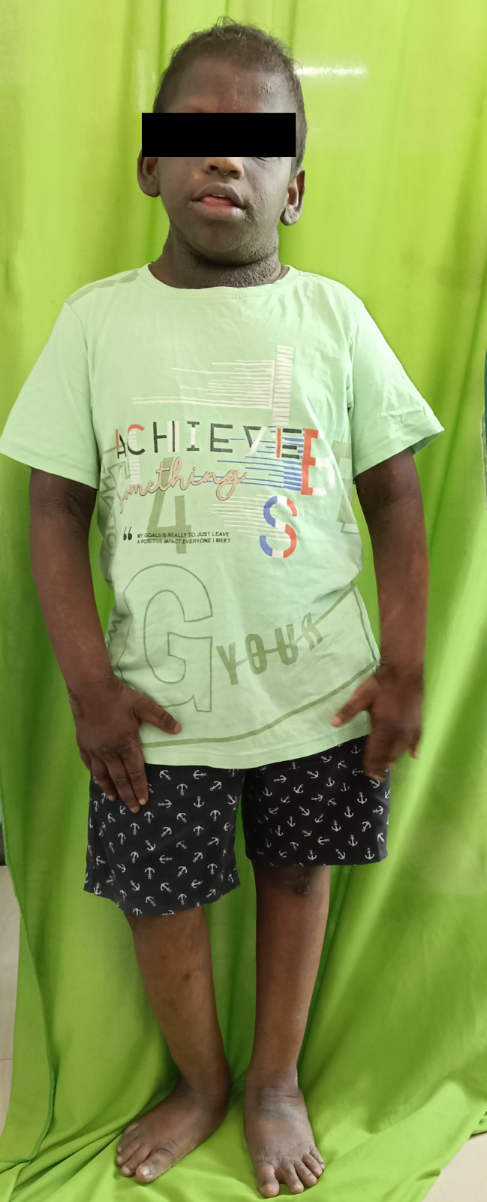

1b) 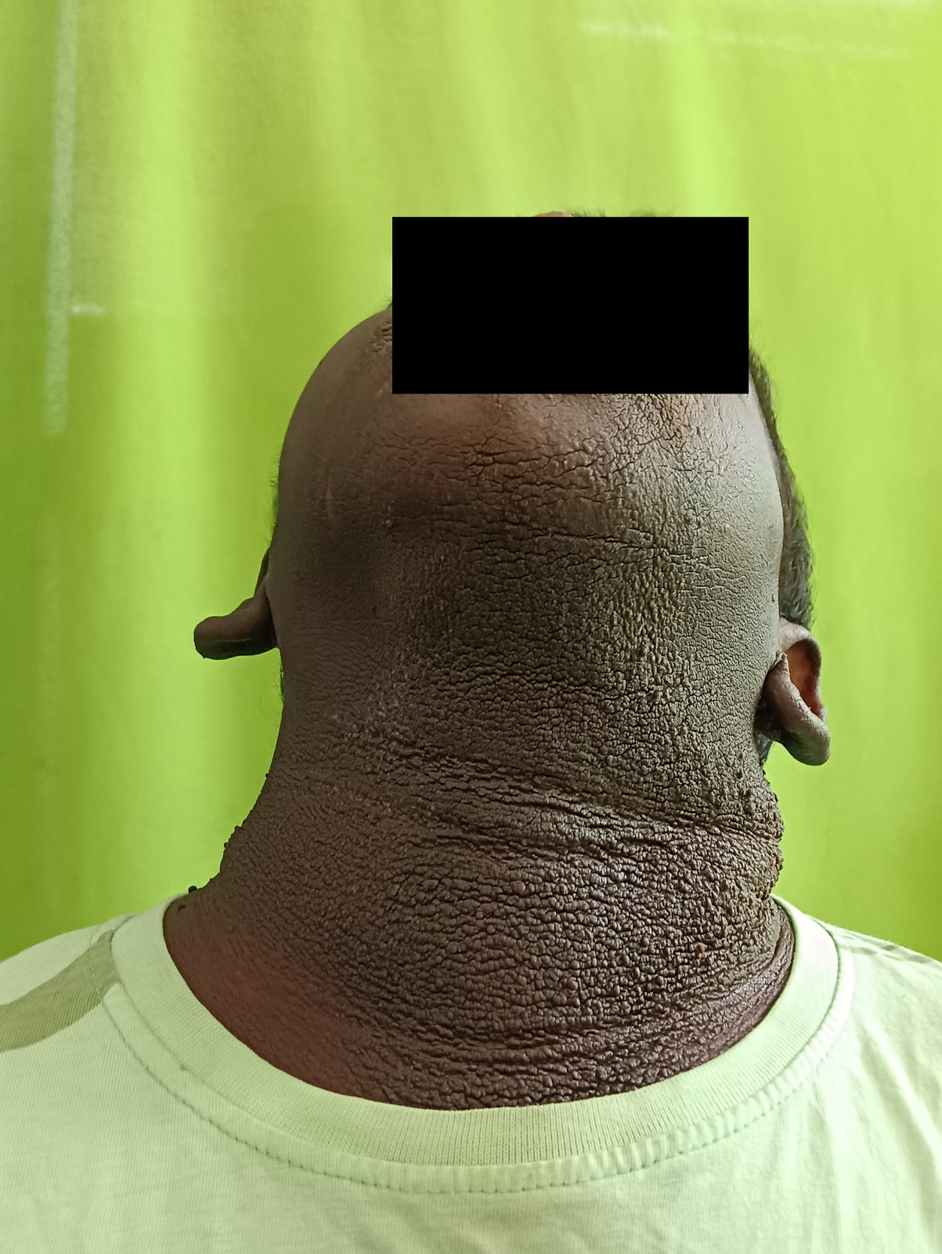

1c)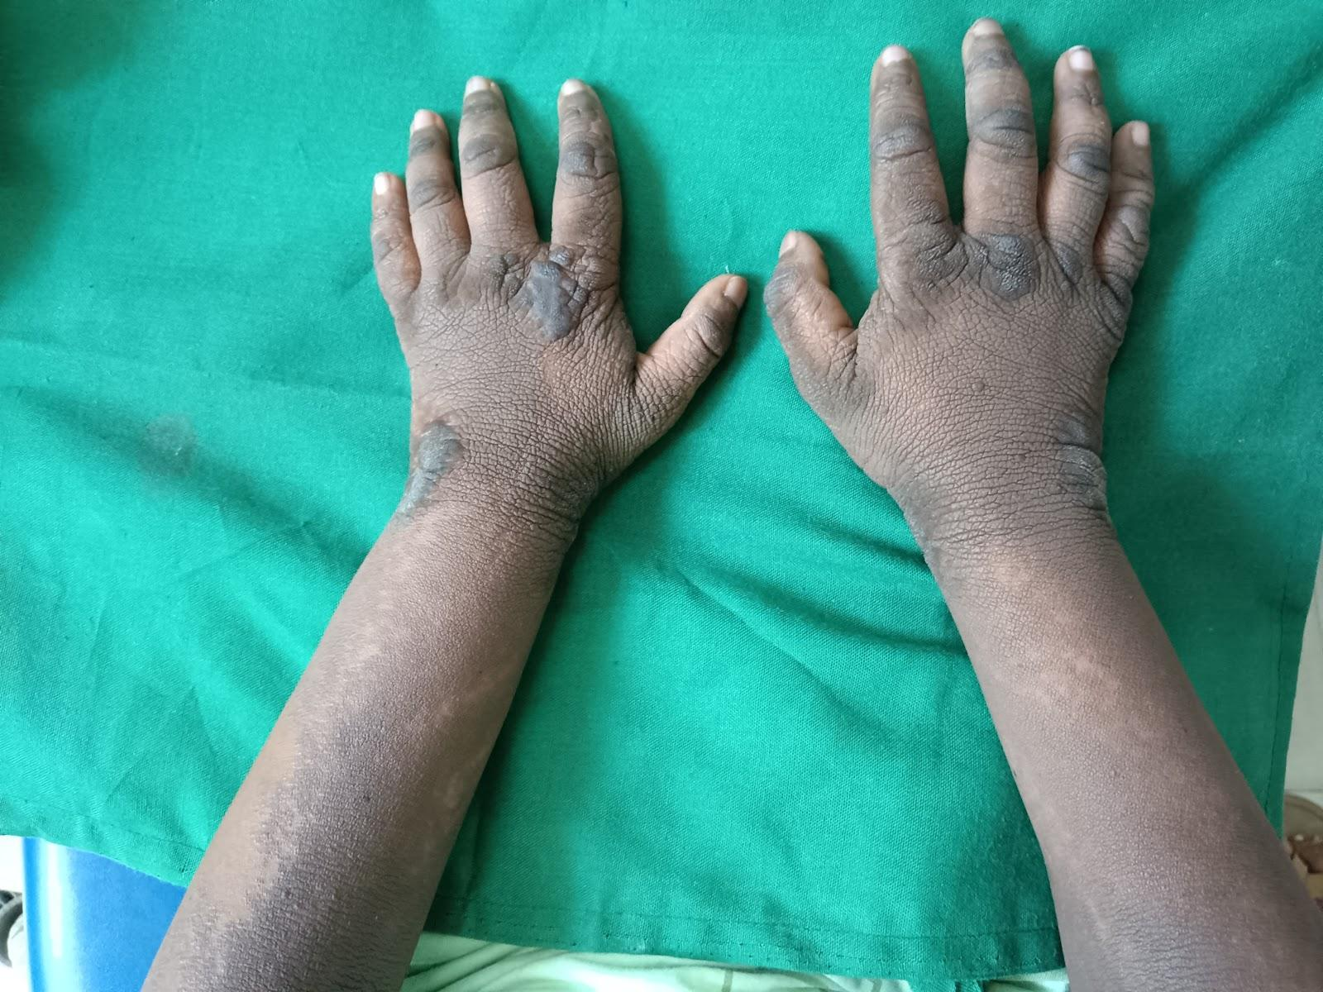

1d) 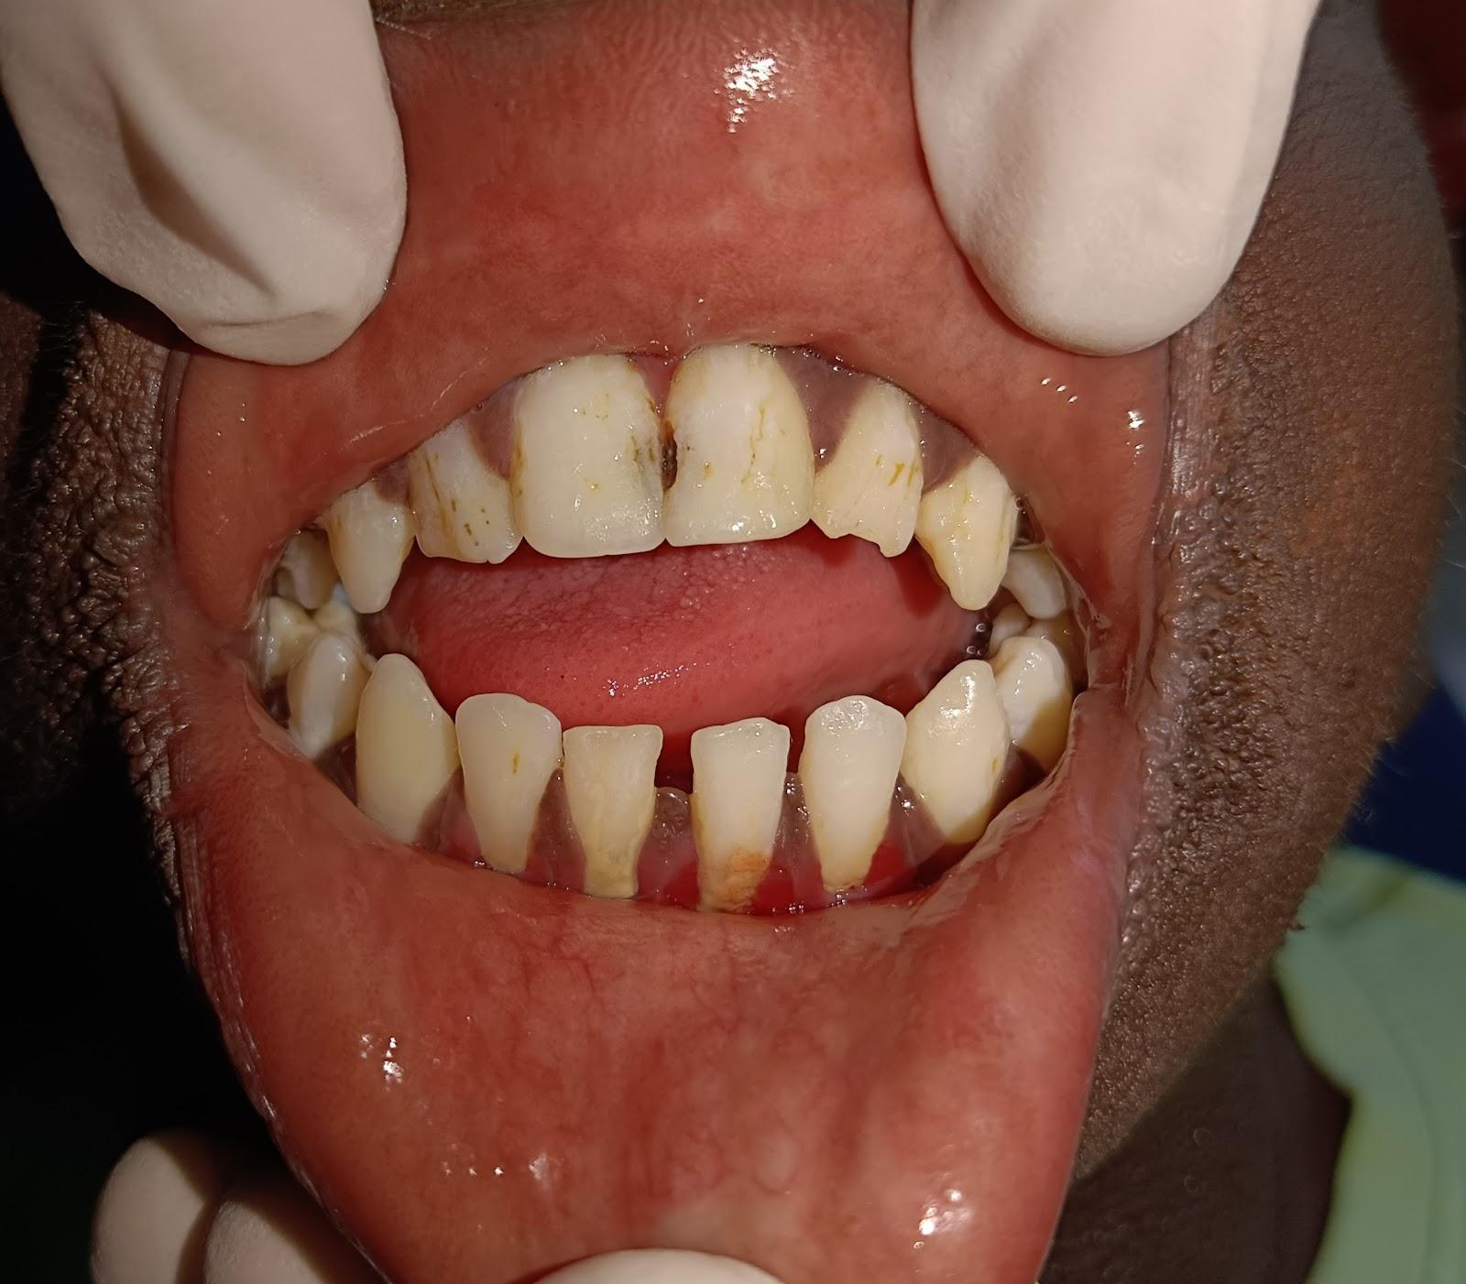

1e )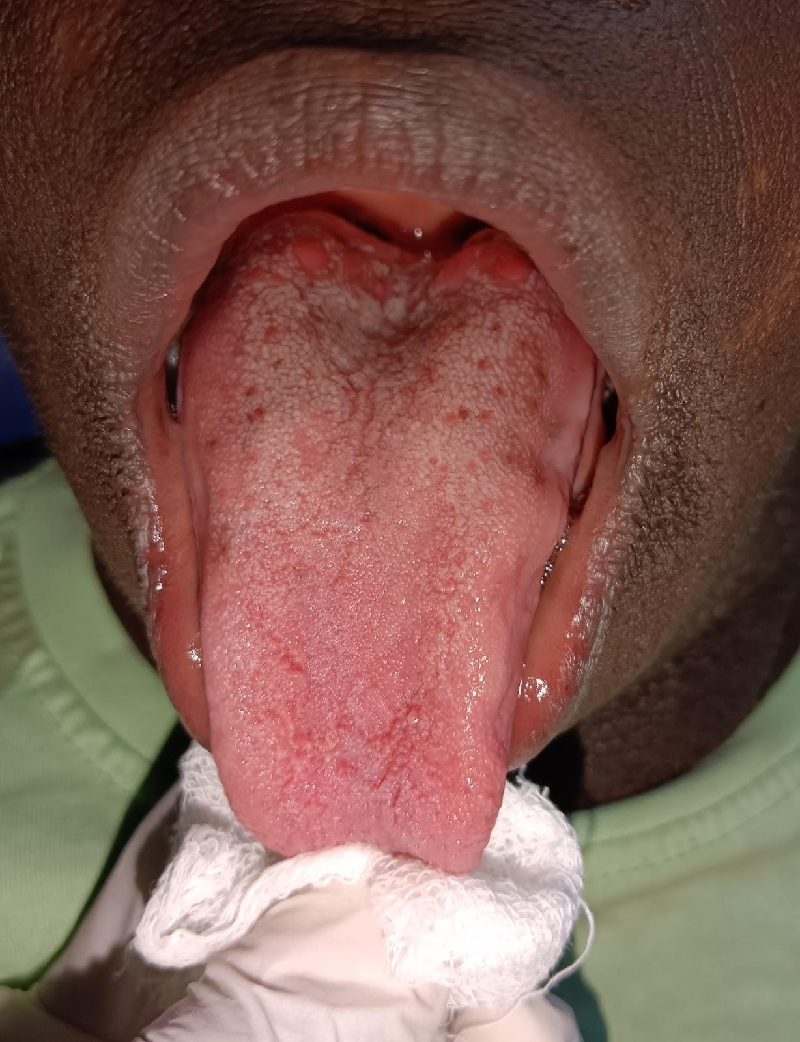

Figure 1: a) Typical features of Costello syndrome, such as short stature, macrocephaly, dysmorphic facial features, and sparse hair. Extraoral features like a large mouth with full lips. b) Multiple papillomas of the neck.c) Loose wrinkled skin with hyperextensible fingers. d) Anterior open bite and presence of Hypoplasia of enamel. e) Macroglossia