**Challenges in the diagnosis of mucoepidermoid carcinoma: A case report**

**Abstract**

A whole range of benign and malignant bone tumours are commonly seen in the maxillofacial region. Thorough Knowledge of the clinical features and how these tumours appear in radiographic imaging is essential for diagnosis. Thus familiarity with the imaging appearance of bone tumours of the maxillofacial region facilitates and helps radiologists to narrow the list of differential diagnoses. We present a case of 40-year-old male patient who complained of mild pain in the left middle third of the face since 6 months and swelling in the palate since 2 years. Clinical features showed swelling in the left side of the hard palate and the radiographic features in the Orthopantomograph(OPG) revealed multilocular osteolytic lesion involving left maxillary sinus, CBCT showed multilocular osteolytic lesion involving the entire left maxillary sinus causing perforation of the medial wall of the sinus. Incisional biopsy showed features of low grade mucoepidermoid carcinoma and later was surgically excised. The final histopathological report was suggestive of intermediate grade mucoepidermoid carcinoma. Here we highlight a unique case of multilocular radiolucency associated with mucoepidermoid carcinoma clinically mimicking a benign tumor.

**Key Words:** Mucoepidermoid Carcinoma (MEC), Multilocular radiolucency, Palate, Maxillary Sinus

**Introduction**

“Salivary gland tumors are clinically diverse group of neoplasms, of which pleomorphic adenoma and mucoepidermoid carcinoma (MEC) are most common benign and malignant tumors respectively. Mucoepidermoid carcinoma of minor salivary glands is a rare entity which manifests frequently in the palate. Minor salivary gland tumor accounts for about 15% of all the salivary gland neoplasm, of which MEC accounts to about 35.9%”. 1 “When it develops in minor salivary glands, it can be located on the palate, retro molar area, floor of the mouth, buccal mucosa, lips, and tongue”. 2 “About 5% of these occur in younger age group usually less than 18 years with female predominance. It is composed of mucus, squamous, and intermediate type of cells. Histologically, it is classified into low, intermediate, and high grade”.3,2Here we present a case of 40-year-old male patient who was diagnosed with intermediate grade mucoepidermoid carcinoma of palate and later treated with wide surgical excision. This case highlights a unique feature of multilocular radiolucency associated with mucoepidermoid carcinoma of the palate with benign clinical features posing a challenge in formulating differential diagnosis.

**Case presentation**

A 40-year-old male patient (Fig 1) came to the department with a chief complaint of pain in the left upper posterior tooth region since 6 months and swelling in the left side of the palate since 2 years. The pain was insidious in onset, mild in intensity, intermittent in nature and radiated to the middle third of the face, swelling was initially small in size and increased to the present size gradually without any associated symptoms like numbness, dysphagia, speech and masticatory difficulties. There was no history of trauma, no other associated systemic diseases or adverse habits. On general physical examination patient was moderately built and nourished and well oriented to time, place and person and all vital signs were within normal limits. On extra oral examination there was no facial asymmetry or lymphadenopathy. Intraoral examination revealed a solitary diffuse swelling present in the left posterior palate extending anteroposteriorly from the mesial aspect of 24 to distal aspect of 28 and Medio laterally from the midline of the palate to the alveolar crest of 24, 25, 26, 27, 28 measuring about 4x 4 cm, surface over the swelling was smooth with reddish purple discoloration,(Fig 2) mild obliteration of vestibule was present irt 25,26,27 and on palpation the swelling was soft in the middle and firm in consistency in the periphery. On hard tissue examination a full complement of teeth was present with mild palatal cortical bone expansion in relation to 25,26 and 27. A provisional diagnosis of a benign tumor of the left palate and alveolar bone was considered and a differential diagnosis of vascular tumor like hemangioma which appears as flat or raised reddish-blue lesions and are generally solitary, affecting women in younger age groups, however neoplastic form appears in middle life or in older people, oral lesions generally appear on the lips, buccal mucosa and tongue, but rarely on the palate, salivary gland tumor like pleomorphic adenoma of the hard palate presents as a painless firm submucosal mass without tenderness, ulceration, or surrounding inflammation, localization to the palate accounts for 60% when minor salivary glands are involved, but involvement of bone is rare and a possibility of mucoepidermoid carcinoma was also considered as there was mild bony changes and the patient was subjected for investigations like OPG and occlusal radiograph. OPG (Fig 3) showed a solitary osteolytic lesion in the left Maxilla measuring about 5x6cm extending anteroposteriorly from mesial aspect of 23 to distal aspect of 28 and super inferiorly from the medial aspect of the inferior orbital margin involving the left maxillary sinus till the middle third of the tooth in relation to 22 to 28, with well-defined margins and internal structure showing multilocular appearance. Occlusal view(Fig:4) showed multilocular radiolucency extending from midline of the palate to left alveolar crest with no evidence of expansion if cortical plates.

Patient was subjected to Doppler ultrasound (Fig 5) to rule out vascular tumor, there was no abnormal vascularity nor vascular malformation on color Doppler imaging

CBCT (Fig 6) was advised which showed a multilocular osteolytic lesion involving the left maxilla extending anteroposteriorly from 22 to pterygoid process and Medio laterally from mid palatal region to the alveolar crest and superioinferiorly from the inferior orbital margin till the palate involving the entire left maxillary sinus causing perforation of the medial wall of the maxillary sinus resulting in involvement of the left nasal cavity causing deviation of the nasal septum to right side. Perforation is evident on the palatal cortical plate in relation to 25,26,27 and the floor of the nasal cavity is involved resulting in raising of the floor on the left side. The internal structure showed multilocular pattern.

Radiographic differential diagnosis of central giant cell tumor was considered which is generally a benign slow growing tumor of maxilla in which severe bony destruction may result occasionally depending on the location and clinical presentation of the tumor, it occurs more in younger age group and in females and rare in craniofacial region. Primary Intra osseous Carcinoma and Ameloblastoma of Maxilla was ruled out since an extra osseous soft tissue lesion was evident. Thus Mucoepidermoid carcinoma was also considered a possibility. The patient was sent for further investigations like complete Heamogram, where all the parameters were within normal limits. Incisional biopsy was done which consisted predominantly of well differentiated Squamous cell with clear cytoplasm and mucocytes, cells arranged in sheath and cords invading collagenous stroma and stratified squamous epithelium with sub epithelial collagenous tissue and mucin secreting glands suggestive of Low grade Mucoepidermoid Carcinoma PAS Stain was positive for mucocytes, Mucicarmine Stain was positive for mucin. Patient was referred to Department of Oral Surgery where contrast CT (Fig:7) was advised to see the extent of the involvement of the tumor which showed contrast enhanced osteolytic lesion involving the entire left maxillary sinus, and left nasal cavity, subtotal maxillectomy of left side of maxilla was done under GA (Fig :8) and the specimen was sent for histopathology which showed features of mucoepidermoid carcinoma –intermediate grade tumor (Fig:9) composed of predominantly intermediate cells with areas of squamous differentiation and mucous differentiation and no perineural invasion or lymph vascular invasion. Further the patient was advised for Radiotherapy and is under follow-up.

**Discussion**

“Mucoepidermoid carcinoma (MEC) is an epithelial salivary gland neoplasm”.4 It was first reported by Massao and Berger in 1942 and was described as a separate pathological entity by Stewart et al. in 19454,5. Later in 1991 World Health Organization changed the name to mucoepidermoid carcinoma due to the metastatic nature of the tumor. “The etiology of these tumors is obscure but a number of risk factors have been identified including radiation exposure, tobacco use, genetic predisposition, viruses and environmental chemicals”.6 “Mucoepidermoid carcinoma is one of the most common salivary gland malignant tumours in adults and children. It accounts for 12-15% of all salivary gland tumors and 29.3% to 34 % of malignant tumours originating from salivary glands”.7 “About two-third of MEC arise within the parotid gland, and one-third develops within the minor salivary glands that is it occurs most commonly in the parotid gland (45%-56.9 %) followed by minor salivary glands (22.9%-37.1%)”.7 “Mucoepidermoid carcinoma of the oral cavity arises from the pluripotent reserve cells of excretory ducts that are capable of differentiating into squamous, columnar, and mucous cells” 2,8 of the major salivary glands or minor salivary gland. It commonly occurs in the fifth and sixth decades of life. It shows female predilection (54.5%) with an average age of occurrence of 48.8 years.9 Though rare, it is the main malignant salivary gland tumor in adolescent age.10,2 When it develops in minor salivary glands, the most common site of occurrence includes the palate, retro molar area, floor of the mouth, buccal mucosa, lips, and tongue 5,11 Clinically, the majority of palatal MEC appears as firm, painless swellings2 Five cases of calcification affecting the MECs were found in the minor salivary gland tumours till date and one case reported in parotid gland.8

The lesions like fibroma or fibrosed pyogenic granuloma, lymphoid hyperplasia, palatal abscess, benign and malignant salivary gland neoplasms and rarely arteriovenous malformation and haemangiomas can also be considered for the differential diagnosis for palatal swellings 12

Conventional radiographs like IOPA, Occlusal radiographs and OPG can be advised to see the involvement of bone and advanced radiographic techniques like CT, CBCT and MRI shows the extent and aggressiveness of the lesion. Mild bony erosion is the most common radiographic finding in most of the cases of palatal mucoepidermoid, destruction of palatal cortical plate with involvement of the nasal cavity and osteolytic lesions with calcifications have also been reported in some cases. “Ultrasonography of low-grade tumors shows well-circumscribed hypoechoic lesions. On CT, low-grade tumors appear as well circumscribed masses with a mixed appearance, including hyperattenuating solid components, cystic components and occasional calcification. High-grade tumors are solid with poorly defined margins and local infiltration. MR imaging shows a hypo intense lesion on both T1 and T2 weighted image. Low grade mucoepidermoid carcinoma demonstrates low intermediate signal intensity on T1 weighted images. On T2 weighted images, low-grade mucoepidermoid carcinoma demonstrates intermediate to high signal intensity”.13

Histologically mucoepidermoid carcinoma is classified as low, intermediate or high-grade tumors depending on the ratio of epidermal cells to mucous cells, amount of cyst formation, and degree of cytologic atypia. Microscopically several types of cells are seen like mucous‐ secreting cells, epidermoid cells, intermediate cells and clear cells. Conventional MECs is the most frequent type, which occurs followed by the clear cell subtype. 8 “Low-grade tumors show prominent cyst formation, minimal cellular atypia and high proportion of mucous cells. High-grade tumors consist of solid islands of epidermoid and intermediate cells. They also demonstrate considerable pleomorphism and mitotic activity. Intermediate grade all 3 major cell type will be present, but intermediate cell predominates. Cellular atypia may or may not be present”.2

Mucoepidermoid carcinoma shows immunopositivity for fp63, EMA, carcinoembryonic antigen (CEA) and cytokeratin like CK5, CK6, CK7, CK8, CK14, CK18, and CK19. It is negative for CK20, SMA.7 Immunohistochemical staining with a combination of CD44, CD133, SOX2 tumor markers was found to have the strongest prognostic value for palatal MEC patients.14

The prognosis of studies reported that the 5-year survival rate for low-grade lesions is up to 95% and in high or intermediate -grade tumours the ratio is lower than 50%. It has been reported that the recurrence rate is 10% for low-grade tumours and 74 % for high-grade tumours.15

Surgical resection is the treatment of choice for all grades of Mucoepidermoid carcinoma, in low to intermediate- grade tumors wide local excision with adequate tumour-free margins is the most opted treatment plan. High grade tumours require more aggressive surgery with or without postoperative radiotherapy and chemotherapy.5,16 In salivary gland MECs distant metastases was noted to occur in 9.2% of cases, most frequently in the lungs.17

**Conclusion**

MEC is a rare tumour of salivary glands, palatal lesions are even rarer. Low and intermediate grade tumours have a favourable outcome compared to high grade MECs. High grade cases have a tendency to recur and metastasise. So early diagnosis and prompt treatment is required to decrease the morbidity and mortality rates. Surgical excision is the first line treatment. Adjunct radiotherapy and chemotherapy are done in cases with positive resection margin

Although mucoepidermoid carcinoma is one of the most common malignant salivary gland tumours and palate is the most common site for minor salivary gland involvement, its presentation involving maxillary sinus is very rare. Atypical sites, different clinico pathological and radiological presentations of the same lesion can mislead the clinicians. In such cases a detailed knowledge about histopathological features of mucoepidermoid carcinoma is helpful in its early detection and appropriate timely treatment for better prognosis.

**Consent**

As per international standards or university standards, patient(s) written consent has been collected and preserved by the author(s).

**Acknowledgement:**

We would like to thank the Department of Oral and Maxillofacial Surgery, Bapuji Dental College and Hospital for providing us with the surgical photographs and histopathology reports.

**Disclaimer (Artificial intelligence)**

Option 1:

Author(s) hereby declare that NO generative AI technologies such as Large Language Models (ChatGPT, in the manuscript.

**REFERENCES**

1. Gill S, Mohan A, Aggarwal S, Varshney A. Mucoepidermoid carcinoma of hard palate. Indian Journal of Pathology and Microbiology. 2018 Jul 1;61(3):397.
2. Mathew AL, Joseph BB, Sarojini DM, Premkumar P, Nair SS. Mucoepidermoid carcinoma of palate - a rare entity. Clin. Pract. 2017 Oct 6; 7(4): 1009.
3. Suvarna R, Sorake S, Vachhani D, Boricha V, Rao PK, Kini R et al. Mucoepidermoid carcinoma at an uncommon location. J Indian Acad. Oral Med Radiol. 2018; 30(2):161-64.
4. Hicks J, Flaitz C. Mucoepidermoid carcinoma of salivary glands in children and adolescents: assessment of proliferation markers. Oral Oncol 2000;36: 454-60
5. K Anjana, SK Padma Kumar, Varghese DelnaLucia, G Nivin. Mucoepidermoid carcinoma of the palate: A case series. International Journal Dental and Medical Sciences Research 2022; 4(4): 548-551.
6. Agrawal M, Khan T S, Sheoran J, Taranum A, Treatment of Low grade Mucoepidermoid carcinoma of hard palate: A conservative approach. J Oral Med Oral Surg Oral Pathol Oral Radiol 2016; 2(3): 193-195.
7. Paul S, Varghese BE, Cherian LM, Indu M, Sasikumar D, Sanil S. Mucoepidermoid carcinoma involving hard palate and a rare presentation on maxillary sinus: two case reports with immunohistochemical evaluation. Oral Maxillofac Pathol J 2021; 12(1): 41-45.
8. YR Girish and M Shruthi. Mucoepidermoid carcinoma of the palate with calcifications: A rare entity. Int. J. Appl. Dent. Sci. 2019; 5(3): 398-400.
9. Peraza A, Gómez R, Beltran J, Amarista FJ. Mucoepidermoid carcinoma. An update and review of the literature. Journal of Stomatology, Oral and Maxillofacial Surgery 2020 ;121(6):713–20.
10. Lee WH, Yoon JH. Mucoepidermoid carcinoma of the hard palate: a rare cause of hypervascular tumor. Yonsei Med J 2003; 44:723-6.
11. Neville BW, Damm D, Allen CM, Bouquot JE. Salivary gland pathology. Oral and Maxillofacial Pathol 2009;495-7
12. Jarde SJ, Das S, Narayanswamy SA, Chatterjee A, Babu C. Mucoepidermoid carcinoma of the palate: A rare case report. J Indian Soc Periodontol. 2016 Mar-Apr; 20(2): 203-6.
13. Mitchell N. Ta, BS, Triet M. Do, MD, Amy C. Yu, DO1, Jagan D. Gupta, MD, Neel D. Gupta, MD1, and Enrique Palacios, MD. Mucoepidermoid Carcinoma of the Hard Palate in a Middle-Aged Man Ear, Nose & Throat Journal 2022, Vol. 0(0) 1–2
14. Xu W, Wang Y, Qi X, Xie J, Wei Z, Yin X, Wang Z, Meng J, Han W. Prognostic factors of palatal mucoepidermoid carcinoma: a retrospective analysis based on a double-center study. Sci Rep. 2017 Mar 6; 7: 43907
15. Auclair PL, Ellis GL, Gnepp DR, et al.: Salivary gland neoplasms: general considerations. In: Ellis GL, Auclair PL, Gnepp DR, eds.: Surgical Pathology of the Salivary Glands. Philadelphia, Pa: Saunders, 1991;135-164.
16. Brandwein MS, Ivanov K, Wallace DI, Hille JJ, Wang B, Fahmy A, et al. Mucoepidermoid carcinoma: a clinicopathologic study of 80 patients with special reference to histological grading. Am J Surg Pathol 2001;25(7):835–45
17. Okami J, Tomita Y, Higashiyama M, Kodama K. Solitary pulmonary metastasis of mucoepidermoid carcinoma of the palate 43 years after the initial treatment. Interactive CardioVascular and Thoracic Surgery 2009;9(4) :728–729



Fig:1: 40-year-old male patient (No facial asymmetry)

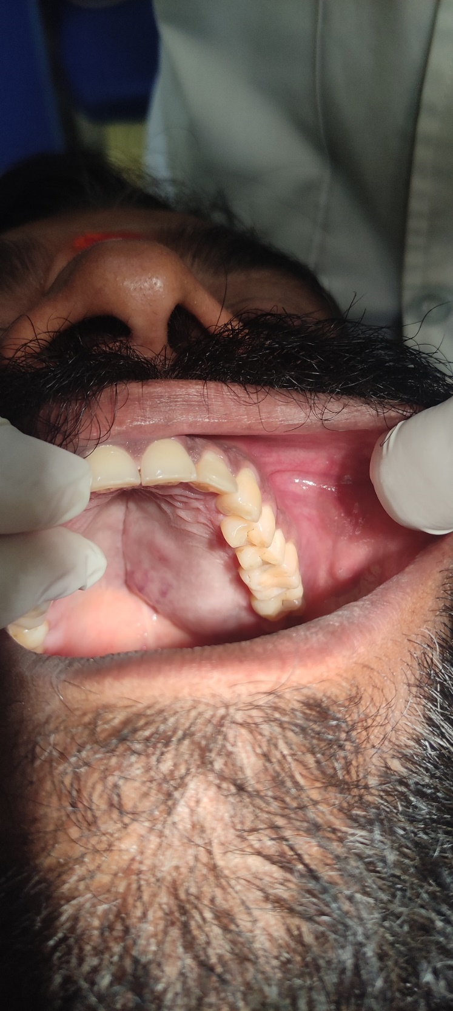

Fig:2: Swelling in the left side of the palate

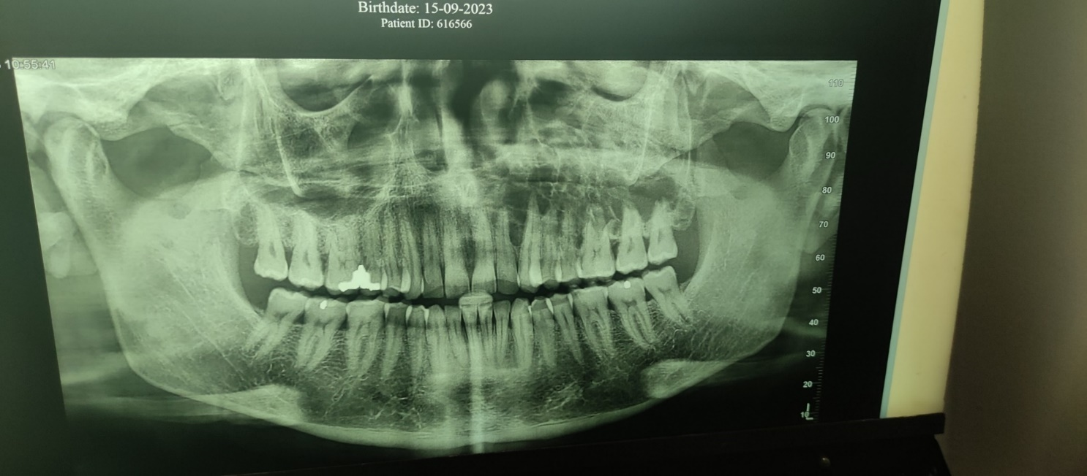

Fig:3: Solitary osteolytic multilocular lesion in the left Maxilla measuring about 5x6cm extending antero-posteriorly from mesial aspect of 23 to distal aspect of 28

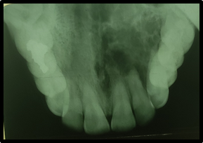

Fig:4 Multilocular radiolucency extending from midline of the palate to left alveolar crest with no evidence of expansion if cortical plates.

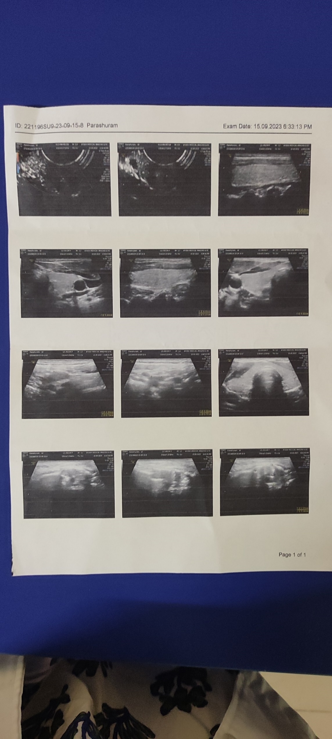

Fig:5: No abnormal vascularity nor vascular malformation on color Doppler imaging

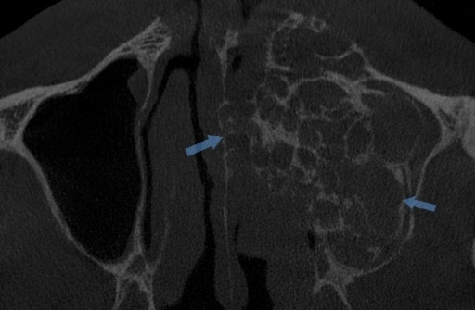 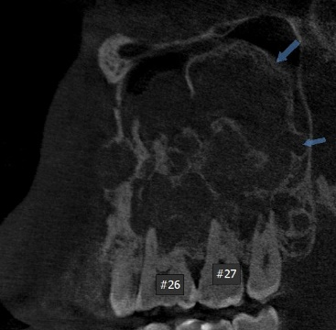 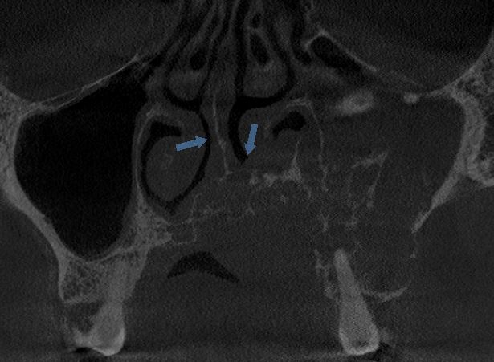

**AXIAL SECTION SAGITTAL SECTION CORONAL SECTION**

Fig:6: CBCT Showing multilocular osteolytic lesion involving the left maxilla involving the entire left maxillary sinus causing perforation of the medial wall of the maxillary sinus. Perforation is evident on the palatal cortical plate and the floor of the nasal cavity is involved resulting in raising of the floor on the left side.

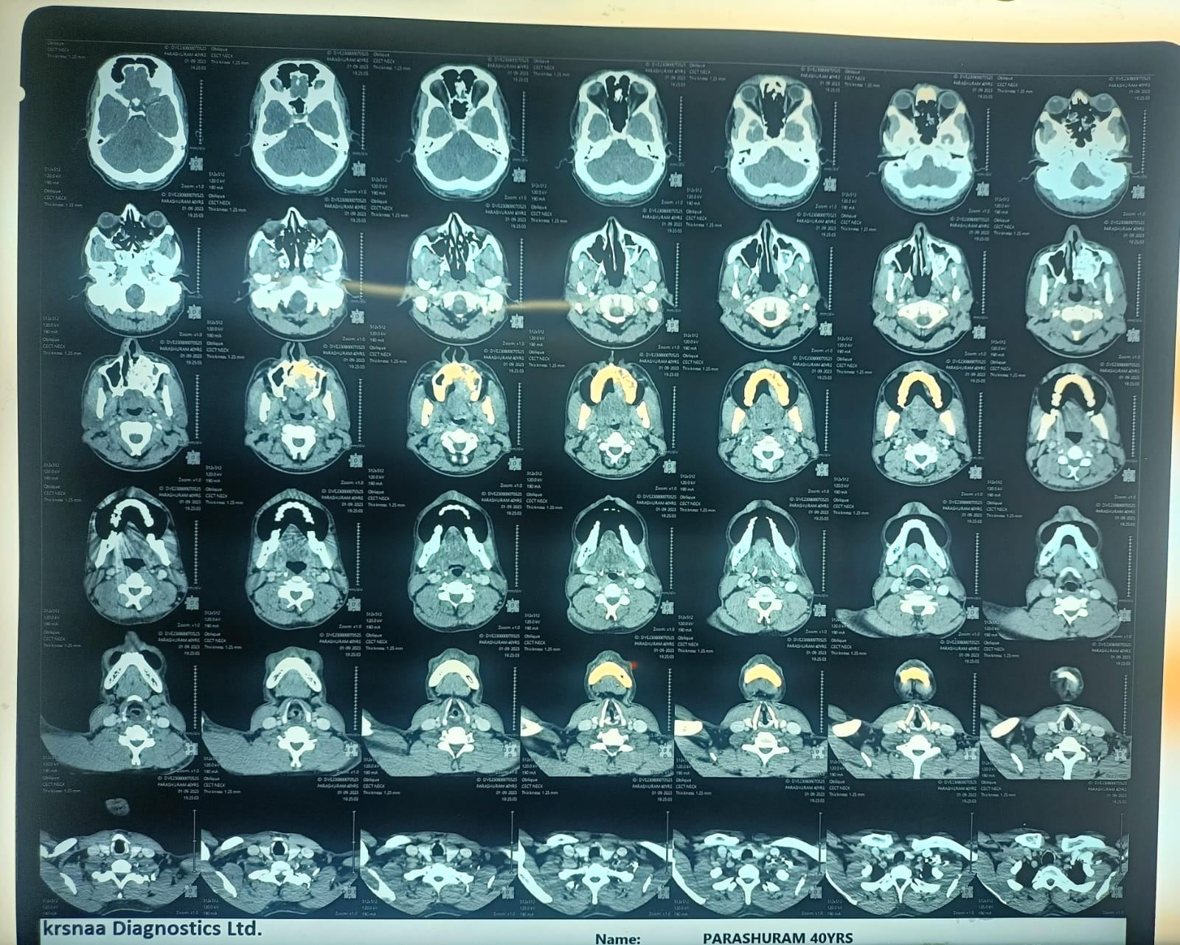

Fig :7: Contrast enhanced osteolytic lesion involving the entire left maxillary sinus, and left nasal cavityCrossing the nasal septum

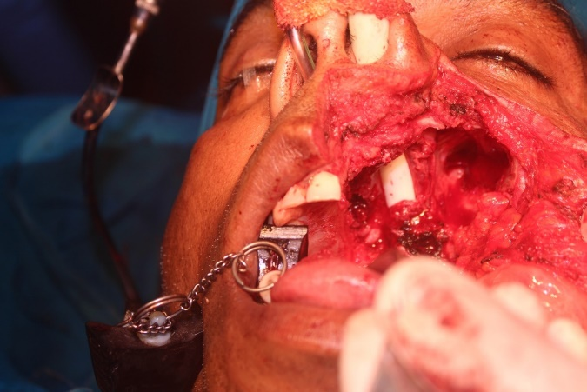

Fig:8: Subtotal maxillectomy of left side of maxilla was done under GA

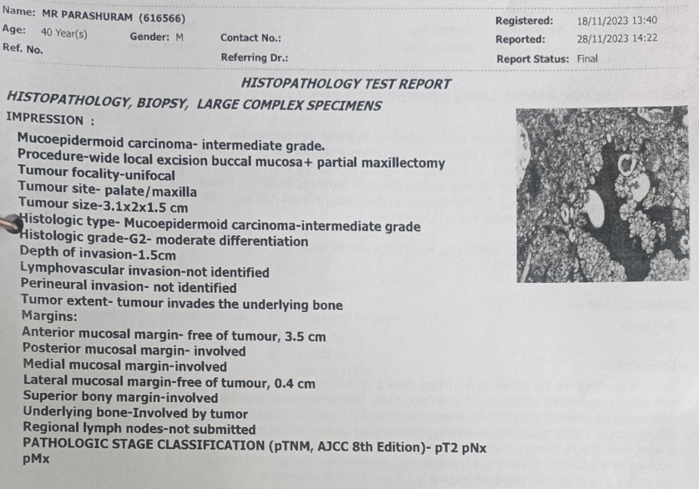

Fig:9: Histopathology showing features of mucoepidermoid carcinoma-intermediate grade tumor