**Short Research Article**

**Improving Soil Fertility and Tomato Yield Using Organic Matter and Vermicompost in the Agroecosystem of Netrokona, Bangladesh**

**Abstract**

Excessive reliance on chemical fertilizers in modern agriculture has led to soil degradation and reduced sustainability. This study assessed the effects of organic matter (OM) and vermicompost (VC) on soil fertility and the growth performance of tomato (Solanum lycopersicum) under **field conditions in Netrokona’s low-organic matter soils.** The experiment was structured using a randomized block design comprising four treatment groups: Control (T₀), organic matter (T₁), vermicompost (T₂), and a combined organic amendment (T₃, consisting of 2.5 t/ha OM + 1.25 t/ha VC). The T₃ treatment improved tomato yield per plant by 66% and soil organic matter content by 93% compared to the control. The combined application (T₃) significantly enhanced plant height, fruit number, fruit weight, and yield compared to other treatments. **Tomato yield increased by 66% and soil organic matter content rose by 93% under T₃ relative to the control.** Soil analyses revealed that T₂ and T₃ improved organic matter content, total nitrogen, available phosphorus, sulfur, and micronutrients (Zn and B), with T₃ showing the most pronounced effects. Specifically, T₃ raised total nitrogen to 0.19%, available phosphorus to 22.8 ppm, potassium to 144 ppm, and micronutrients like Zn and B to 1.04 ppm and 0.38 ppm, respectively.Soil pH remained within the optimal range across all treatments, indicating the buffering capacity of the organic amendments. The results demonstrate that integrating compost and vermicompost synergistically improves soil nutrient status and crop productivity. These findings highlight the potential of OM + VC application as a sustainable nutrient management strategy. This is especially important for low-input, organic matter-deficient subtropical soils.

**Keywords :** Tomato (*Solanum lycopersicum*); Organic matter; Vermicompost; Soil fertility; Sustainable agriculture; BIRTAN Netrokona; Soil health; Organic amendments

**1. Introduction**

Soil degradation due to intensive chemical fertilizer use is a growing concern for sustainable agriculture, particularly in developing countries (FAO, 2017; Lal, 2016). Although synthetic inputs have historically boosted crop yields, prolonged use has been linked to reduced soil organic matter, declining microbial diversity, and environmental pollution (Gao et al., 2023; Xu et al., 2020). These challenges have prompted increased global interest in biologically based and sustainable nutrient management strategies.

Among organic alternatives, compost and vermicompost have demonstrated the ability to enhance soil structure, improve nutrient retention, and support beneficial microbial populations (Edwards et al., 2010; Lazcano, 2011). Vermicomposting, in particular, accelerates organic matter decomposition and improves nutrient bioavailability through earthworm-mediated processes (Sinha et al., 2009; Gómez-Brandón, 2013). Empirical studies have shown that vermicompost application can increase crop yield, improve fruit quality, and strengthen resilience to both biotic and abiotic stressors (Gopal et al., 2009; Yang et al., 2015).

Tomato (Solanum lycopersicum), a high-value and nutrient-demanding crop, responds sensitively to soil fertility improvements. Prior research confirms that compost and vermicompost improve tomato productivity and suppress soil-borne diseases (Jadhav et al., 2024; Manzoor et al., 2024). Notably, the combined use of compost and vermicompost has yielded synergistic effects, enhancing crop performance and nutrient cycling beyond individual applications (Arancon et al., 2006; Vambe et al., 2023).

Moreover, the study by **Mojeremane et al. (2016)** in Botswana provides compelling evidence that tomato yield attributes such as fruit number and weight respond significantly to organic fertilizer amendments. Similarly, **Sutejo et al. (2024)** demonstrated enhanced growth and yield in tomato (Gustavi variety) when cow manure vermicompost was applied in combination with NASA liquid organic fertilizer in Indonesia. These studies reinforce the notion that tailored organic amendments can promote sustainable tomato cultivation across agro-ecological zones.

In Bangladesh, and particularly in Netrokona, soils are typically deficient in organic matter and vulnerable to nutrient exhaustion due to conventional high-input practices (Hassan et al., 2012). Despite the documented benefits of organic inputs, empirical field-based evidence under these specific agro-ecological conditions remains limited.

Therefore, this study hypothesizes that the integrated application of compost and vermicompost will significantly enhance both soil nutrient status and tomato yield compared to individual applications.

**2. Objectives**

1. To determine how compost, vermicompost, and their combined application influence the chemical fertility of soil under field conditions.
2. To examine the impact of these organic treatments on growth performance, yield attributes, and harvest index of tomato plants.
3. To identify a sustainable organic management strategy for smallholder farmers in organic matter-deficient soils.

**3. Methodology**

**3.1. Experimental Location**

The experiment was conducted during the Rabi season (October 2024 to February 2025) at the BIRTAN research field, Netrokona, Bangladesh. The site features silty loam soil, low organic matter content, and a humid subtropical climate.

**3.2. Planting Material**

A locally adapted tomato (Solanum lycopersicum) variety was sourced from the Netrokona regional market to ensure agroecological suitability.

**3.3. Experimental Treatments**

Table 1. The experimental design included four treatments

|  |  |  |
| --- | --- | --- |
| SI No | Treatments | Amount |
|  | T0 (Control) | (No organic amendment) |
|  | T1 (Organic Matter) | 5t /ha |
|  | T2 (Vermicompost) | 2.5 t/ha |
|  | T3 (Combined) | Om 2.5 t/ha + Vermicompost1.25 t/ha |

All organic treatments were incorporated into the soil 14 days before transplanting the tomato seedlings.

**3.4. Experimental Design**

The study followed a Randomized Complete Block Design (RCBD), comprising three replications for each of the four treatments, resulting in 12 experimental plots. Each plot measured 2 meters by 2 meters (4 m²), with 50 cm spacing maintained both between rows and individual plants. A buffer zone of 0.5 meters was provided between plots to minimize the risk of nutrient interference.

Uniform agronomic practices—including irrigation, staking, weed management, and pest control—were consistently applied across all plots to ensure experimental reliability.

**3.5. Data Collection**

**3.5.1. Plant Growth and Yield Parameters**

The following growth and yield attributes were measured from five randomly selected plants per plot:

1. Plant height (cm)
2. Number of fruits per plant
3. Average fruit weight (g)
4. Yield per plant (kg)
5. Harvest index (%)

**3.5.2. Soil Chemical Analysis**

Table 2. Soil samples were collected before planting and after harvest from the 0–15 cm depth and analyzed using the methods outlined

|  |  |  |
| --- | --- | --- |
| SI No | Sample Name | Method |
|  | Organic Matter % | Waljkley-Black method |
|  | Total Nitrogen % | Kjeldhal method |
|  | Available Phosphorus | Olsen method |
|  | Exchangeable K, Ca, Mg | Ammonium acetate extraction, measure via AAS |
|  | Sulfur | Turbimetric method |
|  | Soil Ph | Measured in a 1:2.5 soil-water suspension |
|  | ZINC, Boron | DTPA extraction, measured by AAS |

**3.6. Statistical Analysis**

The collected data were subjected to analysis of variance (ANOVA), appropriate for a randomized complete block design, using R software version 4.3.0 with the 'agricolae' package. Mean differences among treatments were evaluated using the Least Significant Difference (LSD) test at a 5% significance level. The Coefficient of Variation (CV) was calculated to assess the consistency and precision of the experiment. All statistical analyses were performed using the R statistical software environment.

**4. Results**

**4.1. Effects of Organic Amendments on Soil Nutrient Status**

The application of organic matter and vermicompost significantly improved soil chemical properties compared to the control, as presented in Table 3 and Figures 1a and 1b. The combined treatment (T₃) consistently recorded the highest levels of organic matter (%OM), total nitrogen (N), available phosphorus (P), sulfur (S), and micronutrients (Zn and B). Potassium (K) concentrations were also significantly elevated under T₃ and T₂, likely due to the mineralization of exchangeable K from organic sources. Although calcium (Ca) and magnesium (Mg) were monitored, their values are not reported in Table 3. Slight increases under T₂ and T₃ suggest vermicompost may contribute to improved base saturation and cation exchange. Soil pH remained within a moderately favorable range (6.0–6.5) across all treatments, with slight increases in T₂ and T₃. The significantly higher Zn and B levels in T₃ further indicate the role of organic amendments in enhancing micronutrient bioavailability.

C:\Users\Khalid\Downloads\Figure_1a_Soil_Nutrients_Part1.tif

**Figure 1a. Effects of organic treatments on soil macronutrients: organic matter (%), nitrogen (%), phosphorus (ppm), and potassium (ppm).**

**Bars indicate mean values with standard deviation (± SD). Means labeled with different letters are significantly different at the 5% probability level (p < 0.05).** 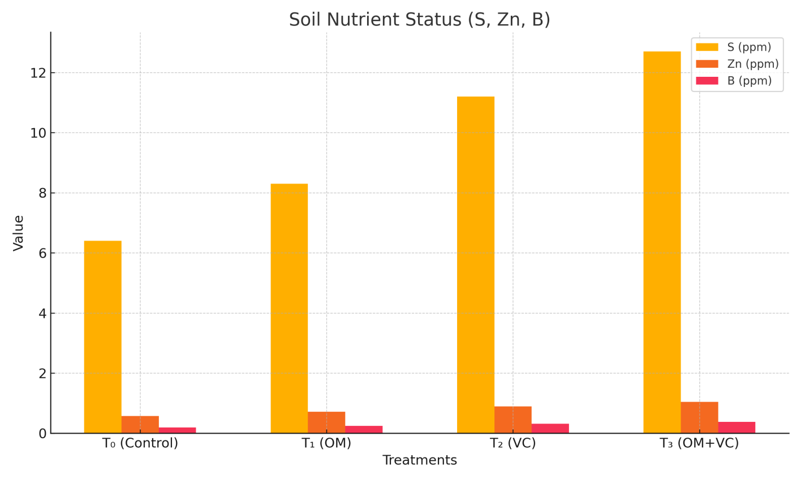

**Figure 1b. Effects of organic treatments on sulfur and micronutrient concentrations: sulfur (ppm), zinc (ppm), and boron (ppm).**

**Bars indicate mean values with standard deviation (± SD). Means labeled with different letters are significantly different at the 5% probability level (p < 0.05).**

**Table 3. Soil chemical properties as affected by organic matter and vermicompost treatments.**

Data are presented as means ± standard deviation (n = 3). Values within a row followed by different letters are significantly different at the 5% level according to the LSD test.

|  |  |  |  |  |  |
| --- | --- | --- | --- | --- | --- |
| **Parameter** | **T₀ (Control)** | **T₁ (OM)** | **T₂ (VC)** | **T₃ (OM + VC)** | **LSD (0.05)** |
| Organic Matter (%) | 1.21 ± 0.05 | 1.68 ± 0.07 | 2.03 ± 0.09 | 2.34 ± 0.10 | 0.19 |
| Total N (%) | 0.09 ± 0.01 | 0.13 ± 0.01 | 0.16 ± 0.01 | 0.19 ± 0.01 | 0.02 |
| Available P (ppm) | 13.7 ± 1.2 | 16.5 ± 1.0 | 19.6 ± 1.5 | 22.8 ± 1.6 | 2.1 |
| Exchangeable K (ppm) | 89 ± 5 | 104 ± 6 | 128 ± 7 | 144 ± 8 | 10 |
| S (ppm) | 6.4 ± 0.8 | 8.3 ± 0.9 | 11.2 ± 0.9 | 12.7 ± 1.0 | 1.5 |
| pH | 6.0 ± 0.1 | 6.1 ± 0.1 | 6.4 ± 0.1 | 6.5 ± 0.1 | 0.2 |
| Zn (ppm) | 0.57 ± 0.05 | 0.72 ± 0.06 | 0.89 ± 0.07 | 1.04 ± 0.08 | 0.1 |
| B (ppm) | 0.19 ± 0.02 | 0.25 ± 0.02 | 0.32 ± 0.02 | 0.38 ± 0.02 | 0.04 |

**4.2. Effects on Tomato Growth and Yield**

Tomato growth and yield components responded significantly to organic treatments, as shown in Table 4. The combined application (T₃) resulted in the tallest plants (49.6 cm), highest fruit number per plant (16), and greatest average fruit weight (219 g), while the control (T₀) recorded the lowest values. Vermicompost alone (T₂) significantly outperformed organic matter alone (T₁), but their combination (T₃) yielded the most pronounced improvements.

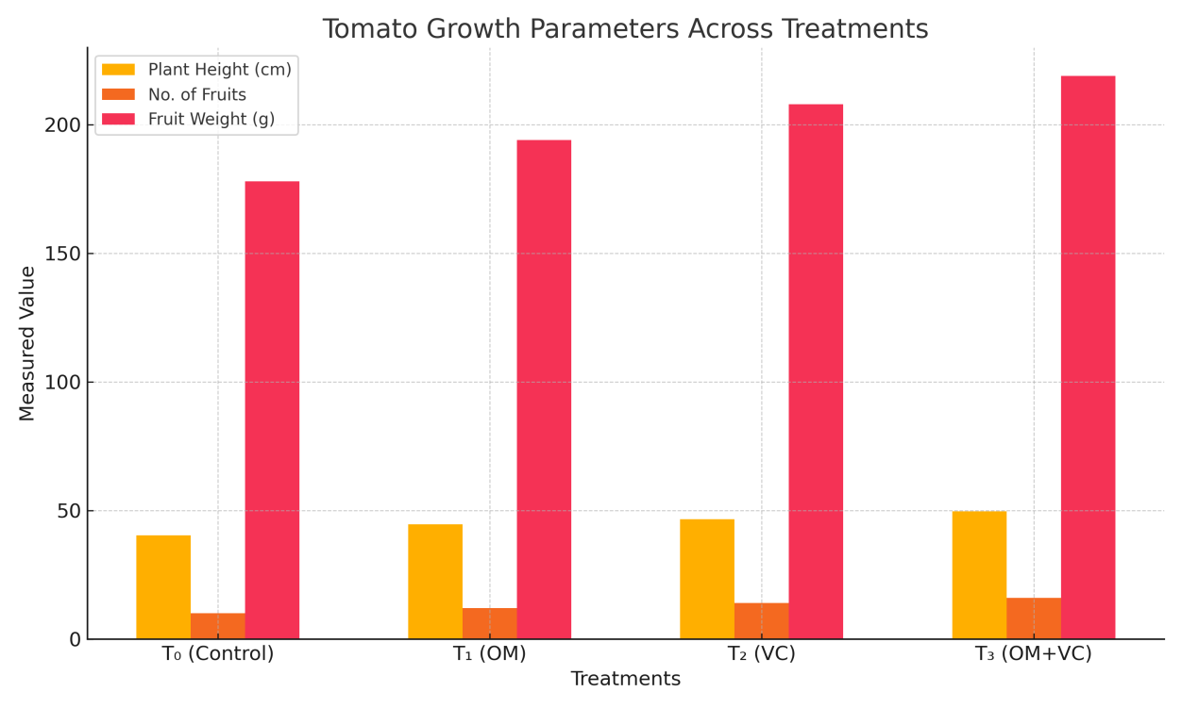

**Figure 2**.**Plant height, fruit number per plant, and fruit weight of tomato under different organic treatments.**

**Error bars show standard deviation. Letters indicate significant differences at p < 0.05.**

**Table 4. Effects of organic treatments on tomato growth and yield parameters.**

Data are presented as means ± standard deviation (n = 3). Values within a row followed by different letters are significantly different at the 5% level according to the LSD test.

|  |  |  |  |  |  |
| --- | --- | --- | --- | --- | --- |
| **Treatment** | **Plant Height (cm)** | **No. of Fruits** | **Fruit Weight (g)** | **Yield per Plant (kg)** | **Harvest Index (%)** |
| T₀ (Control) | 40.4 ± 1.4 d | 10 ± 0.5 d | 178 ± 6.8 d | 2.14 ± 0.09 d | 29.6 ± 1.3 d |
| T₁ (OM) | 44.6 ± 1.1 c | 12 ± 0.6 c | 194 ± 5.9 c | 2.64 ± 0.10 c | 32.8 ± 1.4 c |
| T₂ (VC) | 46.6 ± 1.0 b | 14 ± 0.7 b | 208 ± 5.9 b | 3.08 ± 0.13 b | 37.0 ± 1.6 b |
| T₃ (OM + VC) | 49.6 ± 1.2 a | 16 ± 0.8 a | 219 ± 7.7 a | 3.56 ± 0.15 a | 42.0 ± 1.8 a |
| **CV (%)** | 2.36 | 5.02 | 2.85 | 4.37 | 4.33 |
| **LSD (0.05)** | 1.44 | 0.88 | 7.69 | 0.17 | 1.68 |

**4.3. Yield and Harvest Index**

Yield per plant followed the same trend, with the highest value in T₃ (3.56 kg), followed by T₂ (3.08 kg), T₁ (2.64 kg), and T₀ (2.14 kg). The harvest index (HI), which reflects the efficiency of converting total biomass into economic yield, was also highest in T₃ (42%).

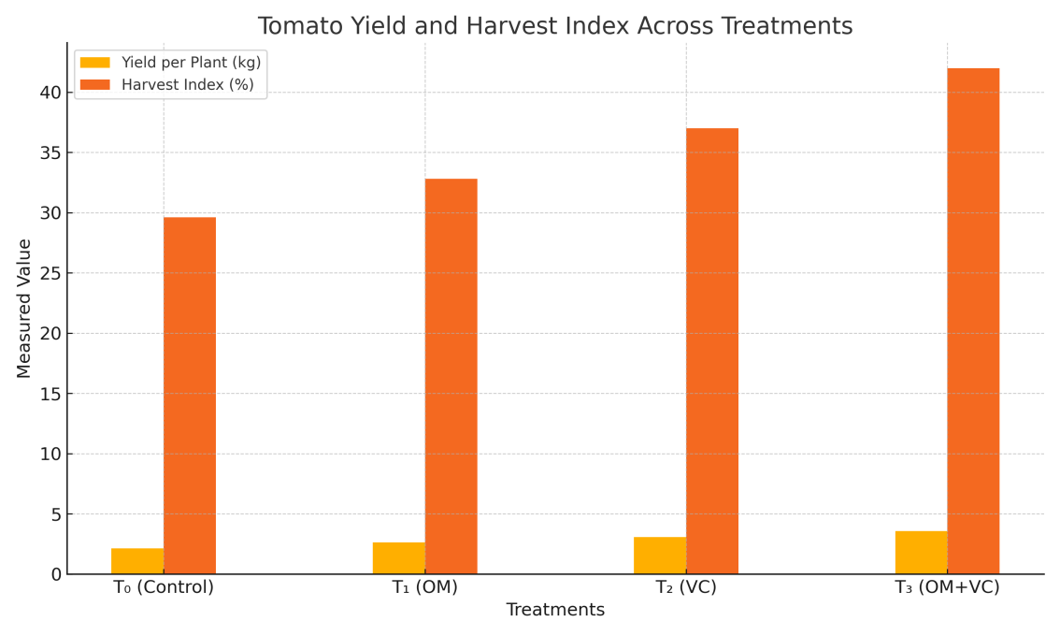

**Figure 3.** Tomato yield per plant (kg) and harvest index (%) under different organic treatments.

Bars indicate mean values with standard deviation (± SD). Means labeled with different letters are significantly different at the 5% probability level (p < 0.05).

**4.4. Statistical Validation**

All measured parameters differed significantly among treatments (p < 0.05), as confirmed by ANOVA using the LSD test at a 5% significance level). The coefficient of variation (CV) ranged from 2.36% to 5.02% across variables, indicating acceptable experimental precision. Statistical analyses were performed using **R software.**

**5 Discussion**

This study confirms the superior performance of integrated organic inputs (OM + VC) over individual applications in improving soil chemical properties and enhancing tomato growth. The T₃ treatment delivered the highest gains in soil organic matter, macro- and micronutrient levels, and crop performance metrics.

These results are congruent with findings by Arancon et al. (2006), Vasileva et al. (2023), and Bhat et al. (2018), who have emphasized the role of vermicompost in enhancing soil fertility and plant growth. The pH-buffering capacity and enhanced micronutrient (Zn, B) availability observed here are also supported by Al-Dahash et al. (2022) and Rehman et al. (2023). Enhanced nutrient solubilization and hormonal activity triggered by microbial stimulation may explain these results (Edwards et al., 2010; Pathma and Sakthivel, 2012).

The improved yield and harvest index are particularly notable. Studies by Sharma and Prasad (2009) and Gutiérrez-Miceli et al. (2007) confirm similar outcomes under vermicompost regimes. Interestingly, **Mojeremane et al. (2016)** reported significant improvements in tomato fruit size and weight in Botswana using organic fertilizer alone, a finding aligned with the increased average fruit weight (219 g) seen in T₃ here. Similarly, **Sutejo et al. (2024)** demonstrated that combining cow manure vermicompost and liquid biofertilizer produced optimal growth and fruit yield in tomato plants in Indonesian field trials.

These parallels suggest that integrated organic management, particularly using regionally available inputs, can serve as a scalable model across agroecological zones. While liquid organic fertilizers such as NASA (used by Sutejo et al.2024) were not tested in this study, their synergistic effects with compost-based inputs indicate future research directions.

**6. Conclusion**

The combined application of compost and vermicompost significantly enhanced soil fertility and tomato productivity under field conditions in Netrokona. This treatment improved macro- and micronutrient levels, increased plant height, fruit number, weight, yield, and harvest index. The study provides robust field-based evidence that integrated organic nutrient management is a viable, sustainable solution for improving soil health and productivity in organic matter-depleted soils. The results underscore the value of organic amendments such as compost and vermicompost in sustainably enhancing crop productivity, particularly in resource-limited and organic matter-deficient farming systems.

**Data Availability:** The datasets used in the current study are available from the corresponding author on reasonable request.

**COMPETING INTERESTS DISCLAIMER**:

Authors have declared that they have no known competing financial interests OR non-financial interests OR personal relationships that could have appeared to influence the work reported in this paper.

**Disclaimer (Artificial intelligence)**

Author(s) hereby declare that NO generative AI technologies such as Large Language Models (ChatGPT, COPILOT, etc.) and text-to-image generators have been used during the writing or editing of this manuscript.

**References**

1. Arancon NQ, CA Edwards, P Bierman (2006). Influences of vermicomposts on field strawberries: part 2. Effects on soil microbiological and chemical properties. Bioresour Technol 97:831–840

2. Aseri GK, N Jain, J Panwar, AV Rao, PR Meghwal (2008). Biofertilizers improve plant growth, fruit yield, nutrition, metabolism and rhizosphere enzyme activities of Pomegranate (Punica granatum L.) in Indian Thar Desert. Sci Hortic 117:130–135

3. Bhat SA, S Singh, J Singh, S Kumar, Bhawana, AP Vig (2018). Bioremediation and detoxification of industrial wastes by earthworms: Vermicompost as powerful crop nutrient in sustainable agriculture. Bioresour Technol 252:172–179

4. Ceritoğlu M, S Şahin, M Erman (2018). Effects of Vermicompost on Plant Growth and Soil Structure. Selcuk J Agric Food Sci 32:607–615

5. Edwards CA, NQ Arancon, RL Sherman (2010). Vermiculture Technology: Earthworms, Organic Wastes, and Environmental Management. CRC Press, Boca Raton, Florida, USA

6. FAO (2017). The future of food and agriculture – Trends and challenges. Food and Agriculture Organization of the United Nations, Rome, Italy

7. Gao RP, Y Duan, J Zhang, YF Ren, JM Liang, YP Jing, PY Zhao (2023). [Effects of Long-term Fertilization on Soil Microbial Diversity and Community Structure in the Agro-pastoral Ecotone]. Huan Jing Ke Xue 44(2):1063–1073 (in Chinese)

8. Gopal M, A Gupta, E Sunil, GV Thomas (2009). Amplification of Plant Beneficial Microbial Communities During Conversion of Coconut Leaf Substrate to Vermicompost by Eudrilus sp. Curr Microbiol 59:15–20

9. Gutiérrez-Miceli FA, J Santiago-Borraz, JA Montes Molina, CC Nafate, M Abud-Archila, MA Oliva Llaven, R Rincón-Rosales, L Dendooven (2007). Vermicompost as a soil supplement to improve growth, yield and fruit quality of tomato (Lycopersicum esculentum). Bioresour Technol 98(15):2781–2786

10. Gómez-Brandón M (2013). The influence of earthworms on nutrient dynamics during the process of vermicomposting. Waste Manag Res 31:10.1177/0734242X13497079

11. Hassan MM, M Jahiruddin, MN Noor, MS Sarker, SA Shah, MS Khan, S Bokhtiar, MQ Quddus, MH Hasan, S Razia, MS Satter (2012). Fertilizer Recommendation Guide-2012. Bangladesh Agricultural Research Council, Dhaka, Bangladesh

12. Jadhav A, AB Gosavi, SA Jadhav, AV Patil (2024). Influence of Different Substrates on Nutrient Composition of Vermicompost and Vermiwash. Int J Plant Soil Sci 36:340–352

13. Lal R (2016). Soil health and carbon management. Food Energy Secur 5:212–222

14. Lazcano C (2011). The use of vermicompost in sustainable agriculture: impact on plant growth and soil fertility. In: Soil Nutrients and Plant Health, Nova Science Publishers, New York, USA

15. Manzoor A, MS Naveed, RMA Ali, MA Naseer, M UL-Hussan, M Saqib, S Hussain, M Farooq (2024). Vermicompost: A potential organic fertilizer for sustainable vegetable cultivation. Sci Hortic 336:113443

16. Mojeremane, W., Moseki, O., Mathowa, T., Legwaila, G. M., & Machacha, S. (2016). Yield and Yield Attributes of Tomato as Influenced by Organic Fertilizer. Journal of Experimental Agriculture International, 12(1), 1–10. https://doi.org/10.9734/AJEA/2016/24630

17. Pathma J, N Sakthivel (2012). Microbial diversity of vermicompost bacteria that exhibit useful agricultural traits and waste management potential. Springerplus 1:26

18. Sinha RK, S Herat, DB Valani, KA Chauhan (2009). Earthworms vermicompost: a powerful crop nutrient over the conventional compost and protective soil conditioner. Am Eurasian J Agric Environ Sci 5:14–22

19. Sutejo, Hery, Marisi Napitupulu, Desi Mantika, Abdul Rahmi, and Abdul Fatah. (2024). “Growth and Yield of Tomato (Solanum Lycopersicum Mill) Gustavi Variety Applied With Varying Levels of Cow Manure Vermicompost and Nasa Liquid Organic Fertilizer”. Journal of Agriculture and Ecology Research International, 25(3), 205–213. https://doi.org/10.9734/jaeri/2024/v25i3607

20. USDA (2021). Food Data Central (Nutrient Database). United States Department of Agriculture. Available at: https://fdc.nal.usda.gov/ (Accessed: January 26, 2024)

21. Vambe M, RM Coopoosamy, G Arthur, K Naidoo (2023). Potential role of vermicompost and its extracts in alleviating climatic impacts on crop production. J Agric Food Res 12:100585

22. Wen YC, HY Li, ZA Lin, et al. (2020). Long-term fertilization alters soil properties and fungal community composition in fluvo-aquic soil of the North China Plain. Sci Rep 10:7198

23. Xu Q, W Zhu, Z Tian, Y Wang, H Liu, X Zhang (2020). Long-term chemical-only fertilization induces a diversity decline and deep selection on the soil bacteria. mSystems 5:e00337-20