Original Research Article

**Effect of Varying Water Temperature on Germination of Selected Tree Species in Delta State,** **Nigeria**

ABSTRACT

|  |
| --- |
| **Aims:** Effective seed germination is a prerequisite for successful tree planting project. Effect of varying water temperature on germination of selected tree species was examined.  **Study design:** 4 X 4 factorial experiments in Completely Randomized Design with 3 replicates.  **Place and Duration of Study:** Experiment was conducted in the laboratory of Science Laboratory Technology of Delta State University, Abraka between June 12 and July 26, 2023.  **Methodology:** Twenty-four seeds each of *Terminalia mantaly* (TM), *Senna siamea* (SS), *Delonix regia* (DR), *Polyalthia longifolia* (PL) were randomly selected and soaked at varying durations in cold-water (120C- 24hrs, 48hrs, 72hrs and 0hrs); warm-water (40oC- 5mins, 10mins, 15mins and 0mins); hot-water (100oC-30secs, 60secs, 90secs and 0secs) and control. A 4 X 4 factorial experiment in Complete Randomized design was adopted. Data on days to germination, sprouts and germination percentage were obtained and analyzed using ANOVA at *α0.05.*  **Results:** Germination and soaking duration of seeds in cold-water were not significant (P>0.05). Seeds of SS and PL recorded the least and highest days to germinate (11.92±2.31 and 15.30±2.31) and sprout (14.83±2.39 and 18.10±2.39), respectively. One seed each of *SS* soaked for 24 and 48 hours germinated at day 4 with 66.7% germination (at week 2). Hot-water had significant effect (P<.05) on germination and sprout of seeds while soaking duration and interaction were not significant for germination. Seeds of SS and DR performed best with (6.67±1.33 and 7.58±1.33; 8.42±1.62 and 10.50±1.62) average days to germinate and sprout, respectively. Seeds of SS (60 seconds) and DR(30 seconds) germinated and sprouted within 5 and 8 days with 91.7% germination (weeks 2). Warm-water had significant (P<.05) effect on germination, sprout and soaking duration of seeds. Seeds of SS germinated and sprouted at 6.42±0.78 and 9.57±0.88 days respectively, with earliest days to germinate (5.00±2.22-10mins) and sprout (8.00±2.14- 5mins). DR soaked in warm-water for 10 mins germinated and sprouted within 4 and 8 days after planting. At week 2, seeds of SS and DR had 91.7% germination.  **Conclusion:** Seed pretreatment contributed to the germination of species as no seed was damaged. |

*Keywords: Pre-treatment, Seed Dormancy, Germination; Tree Species.*

1. INTRODUCTION

Towns and cities are dominated by over half of human population. With increased migration and birthrate, human dominance in cities is heightened (UN 2014). When cities are properly planned and administered, they are great habitat for man. However, urbanization causes environmental challenges from deforestation to heat islands, flooding and air pollution. The effects of environmental hazard to man is reflected in deteriorating well-being; for the earth, increased greenhouse gas emissions, waste pollution, degradation of soils, altering of waterways and disruption of bio-geochemical circle that maintain the health and sustainability of the earth’s ecosystem.

Trees are important components of any landscape as they benefit the environment by providing ecosystem services such as natural filters, carbon sequestration, storm-water mitigation, and air-quality improvements (Oldfield *et al*., 2015) and serve as safety net against storms since they act as windbreak thus protecting infrastructures (Borelli, Conigliaro, Quaglia and Salbitano, 2017).Trees benefit man by providing fruits, shades, woods, seeds, latex and improve the physical and mental health of citizens (Ohwo *et al*., 2020). Cities need forests. Forest beautifies cities and enhances social cohesion (Ohwo *et al*., 2024). The act of planting, maintaining, monitoring, and managing tree population in urban areas to ensure that trees benefits the people via providing and protecting is termed urban forestry. The activities of Urban forestry involves planting, maintaining and removing trees, tree inventory, pest monitoring and plant health care, tree risk assessment, planning for future tree planting and management, and educating the public on the benefits and care of trees and advocating on behalf of the urban forest (Vogte, 2020).

Trees are planted either via sexual or asexually. Sexually, Seed germination is the basic form of tree propagation. Seeds can germinate quickly and establish seedlings in time under suitable environmental conditions, which can increase the probability of successful afforestation exercise. For tree planting programs to succeed, it is important to secure viable, genetically superior seeds in adequate quantity. It is challenging to regenerate most tree species because of inherent slow growth, problems of irregular fruiting, pests and diseases, seed dormancy and environmental factors (Oboho and Ogana, 2012).

Baskin and Baskin (2004) noted that impervious seed coat sometimes stimulates physical dormancy in seeds, thus, must be broken to allow air and water into seed embryo for germination to occur. Most coats of seeds of tree species are impervious to water causing seed dormancy, and extend germination over several months (Odoi, Mugeni, Kiiza, Apolot and Gwali, 2019). Seed dormancy is broken naturally or artificially. Artificially, seed dormancy is broken by pre-treatments which involve the imitation and utilization of natural dormancy breaking procedure (Azad *et al*., 2010).

Temperature and water have been identified as important environmental factors for seed germination (Hu *et al*., 2020). High temperatures (hot water) within a certain temperature range are conducive to seed germination, while excessively high and low temperatures outside a certain range are disadvantageous (Yan *et al*., 2016). The right temperature for seed germination is comparatively restricted, while some seeds have the tendency to germinating at a specific temperature. However, this is not uniform between species (Iralu *et al*., 2019. Varying pre-sowing treatments (acid, cold, water, hot water, endocarp removal, and seed coat removal/cracking) have been used to break seed dormancy in many tropical tree species (Oboho and Ogana, 2012). The use of acid is restricted especially with its handling and cost. Seed coat cracking is laborious and time consuming. This difficulty observed during germination of hard coated seeds tree species in nursery is a fundamental challenge in their utilization for reforestation and afforestation exercise. Therefore, it is expedient to understand the temperature requirement that favours dormancy removal from seeds of selected urban tree species. *Delonix regia* (Plate 1), *Polyalthia longifolia* (Plate 2), *Terminalia mantaly* (Plate 3)*,* and *Senna siamea* (Plate 4)*,* are majorly used species because of their aesthetics value. However, inadequate information exists on the germination and propagation methods of these four urban tree species for professional planner and management of our urban space and environment. The utilization of soaking treatment for enhanced seed germination of selected urban tree species was carried out to provide information to urban foresters on the suitable dormancy treatment to adopt during nursery operations.

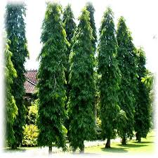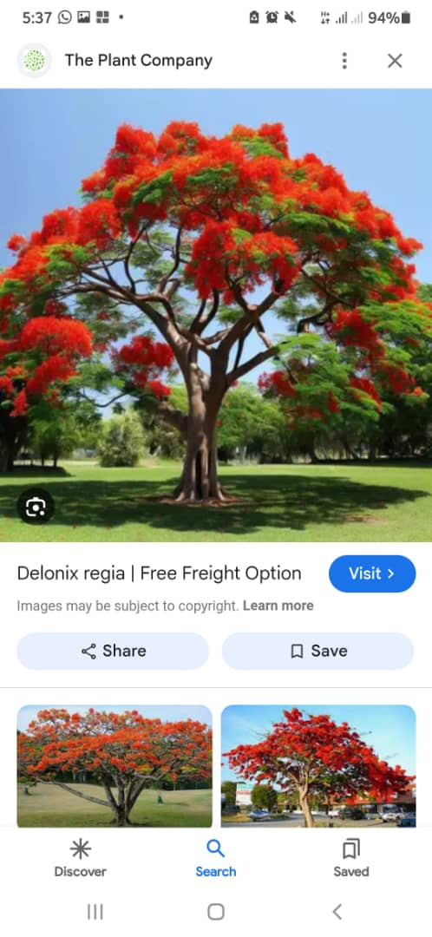   
 ***Plate 1: Denolix rigea* Plate 2: *Polyalthia longifolia***

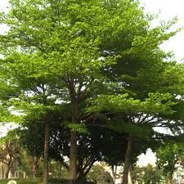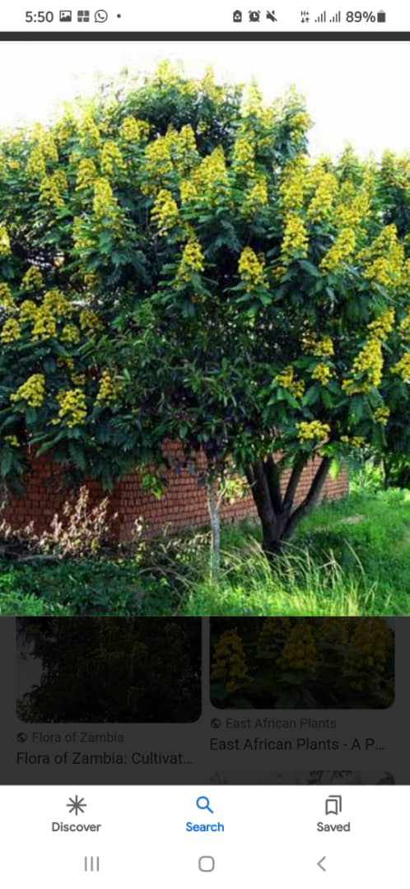

***Palte 3: Terminalia mantaly Plate 4: Senna siemea***

2. material and methods

**2.1 Study Area:** Experiment was conducted in the laboratory of Science Laboratory Technology of Delta State University, Abraka. Delta State lies at latitude 5°00ꞌ and 6°30ꞌ North and longitude 5°00ꞌ and 6°45ꞌ and the study site latitude 6°7ꞌ42" and 6°7ꞌ43" North and longitude 5°47ꞌ51" and 5°47ꞌ51" East.

**2.2 Seed collection:** Seeds of *Terminalia mantaly, Senna siamea, Delonix regia* and *Polyalthia longifolia* were procured from the Forestry Research Institute (FRIN) Ibadan Oyo State, Nigeria.

**2.2.1 Procedure**

Morphologically similar and viable seeds were selected and used for the study. The seeds were counted by hand The seed weight was determined according to International Seed Testing Association (ISTA, 1993) method. Seventy-two (72) seeds were weighed for 3 replications separately. The 72 seeds were selected randomly for each treatment (cold water, warm water, hot water and control). The planting top soil was thoroughly mixed and sieved to get a uniform soil mixture for the seedlings. Polythene pots of size 12cm x 24cm was filled with soil and the seeds sown at the rate of two seeds per pot at 5cm depth.

**2.3. Data collection**

Data on first day emergence and number of germinated seeds were collected to calculate seedling germination rate in comparison with the control and treatments. The seedling germination rate was measured within and between the four species. A seed is considered to have germinated when the tip of the radical emerges free from the coat (Wiese and Binning, 2012).

**2.4 Pre-germination Experiments**

**2.4.1 Procedure**:

Seventy-two (72) healthy morphologically similar seeds of four tree species were subjected to three varying water temperature experiments (1) Cold-water (2) Warm-water (3) Hot-water and (4) control. Twenty-four (24) seeds each for temperature, warm and hot water were soaked in Thermostat water bath (Plate 5) and Polyethylene Terephthalate bottles (PET) for cold water. The control was not soaked.

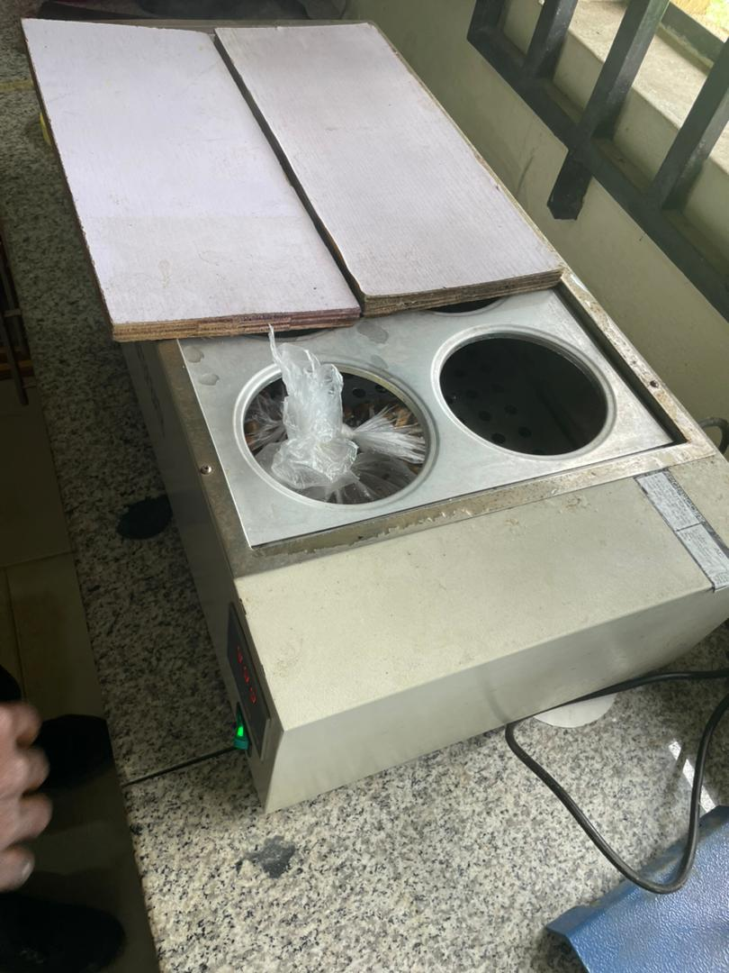

**Plate 5: Thermostat water bath**

**2.4.2 Experiment: Effect of varying water temperature and soaking duration on the germination rate and germination percentage of seeds of man**.

Twenty-four (24) seeds each of the four tree species were placed in 4 PET bottles each, 6 seeds per bottle, and soaked in Cold-water (120C) with soaking time (24hrs, 48hrs, 72hrs and 0hrs), Warm-water (40oC) at (5mins, 10mins, 15mins and 0mins) and Hot-water at 100oC at varying soaking time (30secs, 60secs, 90secs and 0secs) .

* + Followed by the gradual removal of seeds according to soaking time, which was transferred and sown at a depth of 5cm in already prepared poly pot filled with 2kg top soil at 2 seeds per poly pot and replicated 3 times.
  + This was followed by daily monitoring to record emerged seedlings.
  + Watering was done daily at fifteen centi liters per poly pot.

**2.5 Data Collection:** Data on the parameters and method of collection is as shown in the Table below;

**Table 1. Germination parameters and method of collection**

|  |  |  |
| --- | --- | --- |
| S/N | **Parameters** | **Instruments** |
| 1 | First day emergence | Visual observation |
| 2 | Number of germinated seeds | Visual observation |
| 3 | Percentage germination | Germination % = Number of germinated seed/ Number of seeds sown X 100 |

**2.6 Experimental Design:** For the laboratory experiment, completely randomized design was used. The pot experiment was carried out in the Nursery site (Plate 6) of the Department of Forestry and Wildlife and laid out using a 4 X 4 factorial experiment in Randomized Complete Block Randomized Design (RCBD) with the model below

$Y_{i,j,k}= Џ+ B_{i}+P_{j}+ T_{k}+ {PT}_{jk}+ e_{i,j,k}$

Where,

Yijk = Individual observations

Џ = Overall mean

Bi = Effect of blocks (or replicates)

Pj = Effect of Plants

Tk = Effects of treatments (Temperature/Soaking duration)

PTjk = Effects of interactions PT

eijk = Experimental error

A total of 288 seedlings were planted for *Terminalia mantaly, Senna siamea, Delonix regia* and *Polyalthia longifolia* respectively. The Experiments lasted for 44 days (12th of June to 25th July 2023).

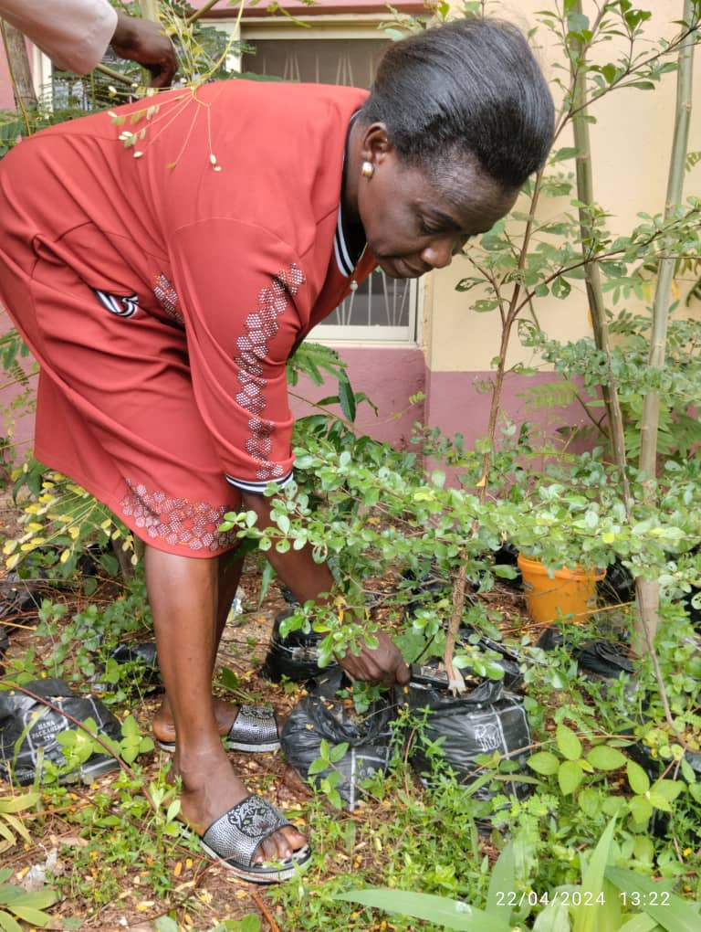

Plate 6: Nursery site of the Department of Forestry and Wildlife

**2.7 Data Analysis**

Germination assessment and growth parameters of seedlings was subjected to analysis of variance (ANOVA) using SAS to statistically verify the significant difference of effects of treatment and soaking period on the seed’s germination at 95 percent confidence level.

3. results and discussion

**3.1 Effect of Cold-water on Sprout and Germination of Seeds of Selected Trees Species**

The effects of cold-water (120C) on the germination of seeds of the four urban trees presented in Table 2 were not significant. Seeds of *Senna siamea* soaked for 72hours had the earliest days to germinate (8±0.85) and sprout (11.33±0.85) while those of *Terminalia mantaly* and *Polyalthia longifolia* soaked for 24 hours had the highest days (19.33±0.85 and 22.50±0.85) to germinate and sprout respectively. The interaction effects of the four selected urban tree seeds and the soaking duration were not significant for germination and sprouting. Seeds of *Senna siamea* soaked for 24 and 48 hours both germinated and sprouted within 4 days and 7 days after sowing respectively (Figure 1). *Terminalia mantaly* seeds without soaking (control) had the longest days-16 and 24 to germinate and sprout respectively (Figure 1). One seed each of *Senna siamea* soaked for 24 and 48 hours germinated at day 4 after sowing (Figure 2).

Usman, *et al.,* (2010) observed that no significant difference existed in sprout of *Acacia senegal* seeds soaked in cold-water at room temperature for 8, 12 and 24 hours respectively. Amusa (2011) also reported that there were no significant difference in seeds of *Afzelia africana* (Sm. ex Pers) treated with cold-water at 1, 12 and 24 hours as with *A. africana* seeds treated with hot water and sulphuric acid. Nikhil *et al.,* (2024) reported that seed germination of *Mimusops elengi* L., (bullet wood) soaked in cold-water for 24 hours enhanced seed germination. Seed dormancy of *Polyalthia longifolia, Terminalia mantaly, Senna siamea* and *Delonix regia* can be easily broken when soaked in cold-water for 42 hours. Odoi *et al.*, (2019) observed that dormancy in seeds of *Maesopsis eminii* and *Terminalia catappa* was broken when soaked for 12-24 hours in cold-water. The above report by various authors corroborated our findings in this study.

All seeds of the four selected trees treated with cold water had 100 percent germination rate (Figure 3). Seeds of *Senna siamea* and *Delonix regia* had 66.7% and 58.3 % germination percentage respectively at week 2. This shows that cold water enhances the germination and sprout of seeds of *Polyalthia longifolia, Terminalia mantaly, Senna siamea* and *Delonix regia*. Authors (Odoi *et al*., 2019; Billah *et al.,* 2015) observed that pre-germination treatment of seeds enhances seed germination and sprout. Tree seed pre-germination treatment studies conducted by a number of researchers have shown that pre-sowing treatments significantly increase seed germination rates. Jothy *et al*., (2013) reported that *Polyalthia longifolia* and *Terminalia mantaly,* propagated by seeds, germinated between 1-6 weeks of planting which is in line with the findings of this study. All the reports underscore the importance of pre-germination treatment to break seed dormancy as also evident in our study.

**Table 2. Effects of cold-water (12˚C) soaking on the germination and sprout of each of the selected species**

|  |  |  |  |
| --- | --- | --- | --- |
| **Tree species** | **Hours** | **Germination (days)** | **Sprout (days)** |
| *Polyalthia longifolia* |  |  |  |
|  | 0 | 11.33d | 13.33c |
|  | 24 | 18.50a | 22.50a |
|  | 48 | 14.00c | 16.50b |
|  | 72 | 18.00b | 21.00a |
| *Terminalia mantaly* |  |  |  |
|  | 0 | 17.33a | 19.67b |
|  | 24 | 19.33a | 22.33a |
|  | 48 | 12.67b | 14.67c |
|  | 72 | 11.00c | 12.33d |
| *Senna siamea* |  |  |  |
|  | 0 | 13.67a | 16.67a |
|  | 24 | 13.33a | 16.33a |
|  | 48 | 12.67a | 15.00b |
|  | 72 | 8.00b | 11.33c |
| *Delonix regia* |  |  |  |
|  | 0 | 13.33b | 16.00b |
|  | 24 | 11.67d | 14.33d |
|  | 48 | 12.67c | 14.67c |
|  | 72 | 17.33a | 20.00a |
| LSD(0.05) |  | 2.37 | 2.38 |
| SE |  | 0.85 | 0.85 |

**N.B.**: Mean with the same alphabet is not significantly different from each other

**Figure 1: Germination and sprout in days of seeds of the selected urban trees soaked in cold-water**

**Figure 2: Number of germinated seeds in days of tree species soaked in cold-water**

**Figure 3: Percentage germination of seeds of tree species**

**3.2 Effect of Hot-water Treatment on Germination and Sprout of Seeds of Selected Trees**

The effect of hot-water treatment on the germination and sprout of seeds of the four urban trees presented in Table 3 was significant (P< 0.05). Seeds of *Senna siamea* soaked for 90 seconds and *Delonix regia* soaked for 60 seconds had the earliest days (6.00±2.99) to germinate while seeds of *Polyalthia longifolia* soaked for 30 seconds had the longest days (41.00±2.83) to sprout (Table 3).However, soaking duration in hot water significantly (P<0.05) influenced the sprout of seeds. Seeds soaked for 60 seconds in hot water sprouted early with an average of 13.56±0.71 days. The control took longer time (20.92±0.71) to sprout (Table 3). The effect of interaction of seeds of the four selected urban trees and soaking duration in hot-water was not significant for germinate, however, for sprout, the interaction effects were significant (P<0.05). Seeds of *Senna siamea* soaked for 60 seconds and *Delonix regia* soaked for 30 seconds germinated and sprouted within 5 and 8 days after planting respectively (Figure 4). *Polyalthia longifolia* seeds soaked in hot-water for 30 seconds took the longest days of 23 and 25 to germinate and sprout respectively (Figure 4). One seed each of *Senna siamea* soaked for 60 and 90 seconds and *Delonix regia* soaked for 30 and 60 seconds germinated at day 5 after sowing (Figure 5). One hundred germination percent was observed for seeds of the selected urban trees soaked in hot-water at varying soaking duration by week 7 (Figure 6). Seeds of the selected trees soaked in hot-water all had 41.7% germination rate at week 2. Seeds of *Senna siamea* had 91.7% germination at weeks 2 while *Polyalthia longifolia* had 41.7% germination rate at week 6 (Figure 6).

The report by Amusa (2011), who observed unfavourable sprout and germination in *Afzelia africana* soaked in hot water (100oC) for 1, 12 and 24 hours, confirmed our findings on hot-water pre-treatment. The study by Sharma *et al.* (2020) who observed that seeds of *Albizzia lebbeck* and *Peltophorum pterocarpum* soaked in hot-water for 60 seconds attained satisfactory germination (94 and 97% respectively) lend credence to our findings in this study. Ogungbesan *et al.,* (2017) reported that seeds of *Cassia siamea* L. soaked in hot-water (100oC) for 12 minutes recorded 100 percent germination rate compared to seeds soaked for 24, 36, 48 and 60 hours as also reported in our study. Abdulazeez (2016) observed that seeds dormancy of *Senna obtusifolia* from Bichi, Nigeria, was broken when soaked in hot-water (100oC) for 2 to 20 minutes within 3 days of sprouting after sowing and 100 percent germination rate as confirmed in this study. Sodimu *et al.,* (2023) observed that pre-sowing treatment with hot-water (100oC) for 0, 15, 30, 60, 90 and 150 seconds significantly influenced final germination percentage of *Faidherbia albida* (Delile) A. Chev. seeds in Kaduna, Nigeria which corroborates our earlier findings. Sodimu *et al*. (2023) recommended pre-germination treatment of seeds of *F. albida* (Delile) A. Chev soaked in hot-water (100oC) for 15 and 20 seconds for nursery establishment. Odoi *et al*., (2019) reported that soaking period and water temperature significantly influenced seedling vigor of forest trees. The above findings are a testament of the effectiveness of soaking in hot water.

**Table 3. Effects of hot-water (100oC) soaking on the germination and sprout of each of the selected species**

|  |  |  |  |
| --- | --- | --- | --- |
| **Tree species** | **Seconds** | **Germination (Days)** | **Sprout (Days)** |
| *Polyalthia longifolia* |  |  |  |
|  | 0 | 32.00a | 36.67a |
|  | 30 | 37.50a | 41.00a |
|  | 60 | 20.00b | 36.50a |
|  | 90 | 29.33a | 40.00a |
| *Terminalia mantaly* |  |  |  |
|  | 0 | 21.00b | 24.67b |
|  | 30 | 21.00b | 24.67b |
|  | 60 | 21.33b | 24.67b |
|  | 90 | 38.00a | 39.00a |
| *Senna siamea* |  |  |  |
|  | 0 | 6.67a | 8.67a |
|  | 30 | 7.67a | 9.00a |
|  | 60 | 6.33a | 8.33a |
|  | 90 | 6.00a | 7.67a |
| *Delonix regia* |  |  |  |
|  | 0 | 10.33a | 13.67a |
|  | 30 | 7.67a | 12.67a |
|  | 60 | 6.00a | 7.67a |
|  | 90 | 6.33a | 8.00a |
| LSD(0.05) |  | 8.38 | 7.91 |
| SE |  | 2.99 | 2.82 |

**N.B.**: Mean with the same alphabet is not significantly different from each other

**Figure 4. Germination and sprout in days of seeds of the selected urban trees soaked in Hot-water**

**Figure 5. Number of germinated seeds in days of each tree species soaked in hot-water**

**Figure 6. Germination percentage of seed of tree species in hot-water**

**3.3 Effect of Warm-Water Treatment on Germination and Sprout of Seeds of Selected Urban Trees**

The effect of warm-water treatment on germination and sprout of seeds of the four urban trees presented in Tables 4 was significant (P < 0.05). Seeds of *Senna siamea* soaked for 10 and 5 minutes had the earliest days to germinate (5.00±2.22) and sprout (8.00±2.14) respectively. Seeds of *Delonix regia* soaked for 10 minutes germinated within 4 days of sowing and sprouted 8 days after planting, while for control, seeds of *Polyalthia longifolia* germinated and sprouted within 21 and 25 days after sowing respectively (Figure 7). One, three and one seed each of *Senna siamea* soaked for 5, 10 and 15 minutes germinated at day 5 after sowing (Figure 8) One hundred percent germination was recorded for seeds of the selected urban trees soaked in warmwater at varying soaking duration (Figure 9). At week 2, seeds of the urban trees soaked for 0minutes and 15 minutes had 50.0% germination percent while seeds of *Senna siamea* and *Delonix regia* had 91.7% germination.

Doody and O'Relly (2008) examined effect of varying temperature (200C, 220C, 250C, 270C, 300C, 320C, 350C, and 370C) on germination of seed of *Jathropha curcas*. The germination percentage at varying temperatures differs significantly (P<0.0001). The highest germination recorded was at 35oC which corroborated our earlier findings in this study. Hanif *et al.,* (2019) observed significant differences in germination of seeds of *Vigna radiata* L. Wilczek soaked in water at 100C, 200C and 300C. Hanif *et al*. (2019) observed high emergence for seeds of *Vigna radiata* soaked at 30°C in water. Saleem *et al.,* (2014) reported early emergence (6.28 days) and higher germination rate in bitter gourd cultivars seeds soaked in water. Guo *et al.,* (2024) reported that seeds of *Lilium concolor* var. megalanthum soaked in water at 25°C were significantly higher in terms of germination percentage when compared to other temperatures (10°C, 15°C, 20°C, 25°C). Zhang *et al.,* (2015) reported that seeds of litchi cultivars soaked in water (37-440C) had a better germination performance (90%) in comparison with seeds not soaked. Luo *et al.,* (2022) observed a higher germination rate for seeds of *Betula platyphylla* Suk soaked at 250C and 300C relative to those soaked at 150C and 200C. Odoi *et al*. (2019) observed that soaking period and water temperature greatly impacted seed germination (90.0% for *Terminalia catappa* and 85.0% for *Maesopsi seminii*. Masilamani *et al*. (2013) reported a high germination rate of 80.0 - 98.0% and 98.0% for seeds of *Terminalia cattapa* sowed without and with pre-germination treatment respectively. The above findings corroborate the results for warm water pre-treatment observed in this study.

**Table 4. Effects of warm-water (40oC) soaking on the germination and sprout of each of the selected species**

|  |  |  |  |
| --- | --- | --- | --- |
| **Tree species** | **Minutes** | **Germinate** (days) | **Sprout** (days) |
| *Polyalthia longifolia* |  |  |  |
|  | 0 | 23.00a | 26.67b |
|  | 5 | 29.00a | 34.67a |
|  | 10 | 22.33b | 26.00c |
|  | 15 | 25.00a | 28.33b |
| *Terminalia mantaly* |  |  |  |
|  | 0 | 21.67a | 24.67a |
|  | 5 | 22.00a | 25.33a |
|  | 10 | 22.33a | 26.33a |
|  | 15 | 24.67a | 29.33a |
| *Senna siamea* |  |  |  |
|  | 0 | 8.33a | 12.67a |
|  | 5 | 6.00a | 8.00a |
|  | 10 | 5.00a | 8.33a |
|  | 15 | 6.33a | 10.00a |
| *Delonix regia* |  |  |  |
|  | 0 | 7.33a | 9.67a |
|  | 5 | 10.00a | 12.33a |
|  | 10 | 7.00a | 11.00a |
|  | 15 | 8.00a | 10.00a |
| LSD (0.05) |  | 6.22 | 6.00 |
| SE |  | 2.22 | 2.14 |

**N.B.**: Mean with the same alphabet is not significantly different from each other

**Figure 7. Germination and sprout of seeds of the selected urban trees soaked in warm-water**

**Figure 8. Germination percentage of warm-water experiment**

**Figure 9. Number of germinated seeds of selected urban tree species soaked in warm water**

4. Conclusion

Seed pretreatment contributed positively to the germination of the study species, it is therefore advised that seed pretreatment of tropical trees in these media is needed to break seed dormancy and quicken germination. Seed coat cracking is laborious and time consuming. This difficulty observed during germination of hard coated seeds tree species in nursery is a fundamental challenge in their utilization for reforestation and afforestation exercise. Therefore, it is expedient to understand the temperature requirement that favours dormancy removal from seeds of selected urban tree species.

COMPETING INTERESTS DISCLAIMER:

Authors have declared that they have no known competing financial interests OR non-financial interests OR personal relationships that could have appeared to influence the work reported in this paper.

Disclaimer (Artificial intelligence)

Option 1:

Author(s) hereby declare that NO generative AI technologies such as Large Language Models (ChatGPT, COPILOT, etc.) and text-to-image generators have been used during the writing or editing of this manuscript.

Option 2:

Author(s) hereby declare that generative AI technologies such as Large Language Models, etc. have been used during the writing or editing of manuscripts. This explanation will include the name, version, model, and source of the generative AI technology and as well as all input prompts provided to the generative AI technology

Details of the AI usage are given below:

1.

2.

3.

References

Abdulazeez, A. (2016). Effects of hot water on breaking seed dormancy of *Senna obtusifolia* from Bichi, Nigeria, in green house conditions. IOSR Journal of Agriculture and Veterinary Science (IOSR-JAVS), 9 (10): 29-32

Amusa, T. O. (2011). Effects of three pre-treatment techniques on dormancy and germination of seeds of Afzelia africana (Sm. Ex pers). Journal of Horticulture and Forestry Vol. 3(4), pp. 96-103

Azad, M.S., Musa Z.A. & Matin, A. (2010). Effect of pre-sowing treatments on seed germination of Melia azedarach. Journal of Forestry Research, 21(2):193- 196.

Baskin, J.M. & Baskin, C.C. (2004). A classification system for seed dormancy. Seed Sci. Res. 14, 1–16

Billah, M.A.S., Kawsar, M.H., Titu, A.P., Pavel, M.A.A. & Masum, K.M. (2015). Effect of Pre-Sowing Treatments on Seed Germination of *Tectona grandis*. International Journal of Bioinformatics and Biomedical Engineering, 1(1): 37-42

Borelli, S., Chen, Y., Conigliaro, M. & Salbitano, F. (2015). Green infrastructure: a new paradigm for developing cities. Technical paper at the XIV World Forestry Congress, Durban, South Africa, 7–11 September.

Doody, C.N. & O’Relly, C. (2008). Dry and soaking pretreatment affect germination of peduncilat oak. Ann Forest Science 65 (5).1-8

Guo, M., Zong, J., Zhang, J., Wei, L., Wei, W., Fan, R., Zhang, T., Tang, Z. & Zhang, G. (2024). Effects of temperature and drought stress on the seed germination of a peatland lily (*Lilium concolor* var. megalanthum). Front. Plant Sci. 15:1462655 (1-11)

Hanif, M., Khattak, M.K., Haq, I.U., Gul, K., Khan, A., Ullah, K., Khan, A. & Ali, A. (2019). Effects of temperature and water purity on germination and yield of Mungbean sprouts. Sains Malaysiana, 48(4): 711–717

Hu, X.J., Liu, C., Li, A.R., Yang, X.Y. & Baskin, C. (2020). Effect of temperature and moist conditions on seed dormancy cycling of two sympatric limestone species, *Begonia guishanensis* and *Paraisometrum mileense*, in Southern China. Seed Sci. Res. 30: 29–36

Iralu, V., Barbhuyan, H. S. A., & Upadhaya, K. (2019). Ecology of seed germination in threatened trees: A review. Energy, Ecology and Environment, 4, 189-210.

Jothy, S.L., Choong, Y.S., Saravanan, D. Deivanai, S., Latha, L.Y. Vijayarathna, S. & Sasidharan, S. (2013). *Polyalthialongifolia*Sonn: an ancient remedy to explore for novel therapeutic agents. Research Journal of Pharmaceutical, Biological and Chemical Sciences, 4(1): 714-730

Luo,Y., Cheng, J., Yan, X., Zhang, J. & Zhang, J. (2022). Germination of seeds subjected to temperature and water availability: implications for ecological restoration. Forests, 13, 1854: 1-11

Masilamani, P., Yasodha. P. & Annadurai, K. (2013). Influence of seed pretreatments and sowing conditions on germination and initial seedling vigour of indian almond (*Terminalia catappa).* Indian Forester*,* 139 (3): 248-252

Nikhil, K. S. Venugopala Gowda, K.S., Sathish, B. N., Upadhya, V. & Ashwath, M. N. (2024). Studies on morphometric traits and effect of presowing treatments in seeds of *Mimusops elengi* L. Emergent Life Science Research, 10(1): 123-128

Oboho, E. G. & Ogana, F. N. (2012). Effects of varying hot water temperatures on the germination and early growth of Dialuim guineense (Willd) seeds. Annals of Biological Research. 3 (3):1247-1254

Odoi, J. B., Mugeni, D., Kiiza, R., Apolot, B. & Gwali, S. (2019). Effect of Soaking Treatment on Germination of Hard Coated Tropical Forest Tree Seeds, Uganda. Journal of Agricultural Sciences. 19(2): 1 – 9

Ogungbesan, A.M., Ogunsola, O. R., Lamidi, A. & Ishiaku, Y.M. (2017).Effect of hot water on the germination rate of *Cassia siamea* L. seeds. Agricultural and Food Science Journal of Ghana, 10 (1): 780-786

Ohwo, O.A., Onakpoma, I. & Okoromaraye E. (2020). Evaluation of properties of graded density fibreboard produced from wood residues (sawdust and corrugated paper). Baltic Forestry, 26 (2):259-264

Ohwo, O.A., Oyibo, O. & Itoje, B.A. (2024). Assessment of perception on the environmental benefit of urban trees in Asaba, Delta State. Taraba Journal of Agricultural Research. 12(1): 1-10

Oldfield, E.E., Warren, R.J., Felson, A.J.& Bradford, M.A. (2013). FORUM: challenges and future directions in urban afforestation. Journal of Applied Ecology. 50:1169–1177

Saleem, M.S., Sajid, M., Ahmed, Z., Ahmed, S., Ahmed, N. & Islam, M. S. U. (2014). Effect of seed soaking on seed germination and growth of bitter gourd cultivars. IOSR Journal of Agriculture and Veterinary Science (IOSR-JAVS). 6(6): 7-11

Sharma, P., Meena, P. D. & Kumar, S. (2020). Biopesticides for sustainable management of tomato diseases. Journal of Plant Pathology. 102(3), 669-680.

Sodimu, A.I., Olaifa, R.K., Baba, G.O., Lapkat, G.L., Olorukooba, M.M., Olumuyiwa, S.A., Salau, L.O. & Rasheed, F.M. (2023). Effects of Pre-sowing Treatment on Seed Gemination and Seedling Early Growth Performance of *Faidherbia albida*. (del.) A. Chev. seeds in Kaduna Northern Guinea Savannah Agrological Zone of Nigeria, International Journal of Agriculture and Earth Science*.* 9(7): 32-40

United Nations (2014) World Urbanization Prospects. The 2014 Revision. Highlights. New York. Available at: <http://esa.un.org/unpd/wup/highlights/wup2014-highlights.pdf>

Usman, A., Sotannde, O.A., Mbaya, Y.P. & Musa, Y. (2010). Effects of hot and cold water pre- treatments on emergence of *Acacia senegal* seeds in the nursery. Journal of Research in Forestry, Wildlife and Environment. 2 (2): 207-213

Van Leeuwen, B. (2010). Dealing with urban diversity: promises and challenges of city life for intercultural citizenship. Polit Theor*.* 38(5):631–657

Vogte, J. (2020). Urban Forests: biophysical features and benefits, Encyclopedia of the World's Biomes, Pp 1-10, available at [https://doi.org/10.1016/B978-0-12-409548-9.12404-2](http://word/https:/doi.org/10.1016/B978-0-12-409548-9.12404-2)

Yan, X.F., Zhou, L.B., Si, B.B., Sun, Y., Gao, Y.F. & Wang, R.X. (2016). Stress effects of simulated drought by polyethylene glycol on the germination of Caragana korshinskii Kom. Seeds under varying temperature conditions. Acta Ecol. Sin. 36:1989–1996

Zhang, C., Wu, J., Fu, D., Wang, L., Chen, J., Cai, C., & Ou, L. (2015). Soaking, temperature, and seed placement affect seed germination and seedling emergence of litchi (Litchi chinensis). HortScience, 50(4): 628–632. <https://doi.org/10.21273/HORTSCI.50.4.628>

Baskin, J.M. & Baskin, C.C. (2004). A classification system for seed dormancy. Seed Sci. Res. 14, 1–16