**Smart Farming with the Khamari App: A Geospatial Solution for Site-Specific Agricultural Planning**

ABSTRACT

|  |
| --- |
| The Bangladesh Agricultural Research Council (BARC) has developed the ‘Khamari’ mobile application as an innovative tool to enhance agricultural productivity and optimise the use of natural resources. This advanced digital platform empowers farmers by delivering precise, **location-specific** agricultural recommendations, with a strong emphasis on sustainable and efficient farming practices. The Khamari app serves as a crop production advisory tool, aiming to increase productivity, profitability, and drive overall growth within the agricultural sector by equipping farmers and stakeholders with essential information directly at their fingertips. The primary objective of this study was to assess the impact of fertiliser recommendations provided by the ‘Khamari’ mobile app on crop yield and fertiliser input efficiency. The field trials compared app-recommended fertiliser doses with traditional farming practices for transplanted Aman and Boro rice across 34 and 60 locations, respectively, spanning 20 Agro-Ecological Zones. A unique feature of the Khamari app is its integration of geospatial technology, which enables users to access pertinent information while standing on their own land. Through the Khamari app, farmers can make informed decisions on selecting a suitable crop, enhancing crop yields through balanced fertiliser use, and maintaining soil health and environmental sustainability. By aligning with the Crop Zoning System of Bangladesh, the app supports local-level crop production planning and has demonstrated significant potential to increase food production and foster the adoption of precision agriculture nationwide. Demonstration trials for rice crops have shown promising results, particularly in promoting the adoption of high-performing and climate-resilient varieties. For T. Aman rice trials in 34 locations in 2023, the app's recommendations led to a 34% reduction in fertiliser costs and approximately 7% increase in yield, resulting in a minimum profit of 15,615 Taka per hectare. Boro rice trials in 60 locations during the 2023-24 season showed an 18% reduction in fertiliser costs and around a 6% increase in yield, offering farmers an additional 16,222 Taka per hectare. These findings highlight the substantial benefits of the 'Khamari' app in enabling smart, sustainable agricultural practices, positioning it as a valuable tool for both economic gains and long-term agricultural resilience. |

***Keywords****: Khamari; rice; geospatial; precision agriculture; sustainable land use; smart agriculture; crop zoning; balanced fertilizer*

1. INTRODUCTION

Agriculture plays a vital role in Bangladesh’s economic development and remains the largest employment sector. In FY 2022–23, the agriculture sector contributed 11.38% to the country’s GDP (BBS, 2024) and employed approximately 45.33% of the total labour force (BBS, 2023). The sector’s performance has a significant impact on key macroeconomic objectives, including employment generation, poverty reduction, human resource development, and national food security.

Despite its importance, the agriculture sector faces numerous challenges, such as the loss of arable land, rapid population growth, and the adverse effects of climate change. These pressures pose serious threats to the sustainability of agricultural production. Without timely and strategic interventions, they may undermine the sector’s ability to meet the food demands of a growing population.

In this context, sustainable land use planning based on crop zoning has emerged as a critical strategy. Crop zoning aligns agricultural production with the biophysical and socio-economic characteristics of specific regions, thereby ensuring more efficient resource use, protecting soil health, and enhancing long-term productivity. This approach supports both physical sustainability through conservation of soil quality and fertility and economic sustainability by guiding investment in suitable crops and farming systems tailored to local conditions (De Wrachien, 2003).

Crop zoning has been recognised as essential for sustainable agricultural planning to meet increasing food demands (Pereira, A.R., 1983; Sivakumar, M.V.K. & Valentin, C., 1997). Bangladesh’s 8th Five-Year Plan identifies crop zoning as a cornerstone for land use planning and production management (Bangladesh Planning Commission, 2020). Similarly, the Food and Agriculture Organisation (FAO) and the United Nations Development Programme (UNDP) (1988) have emphasised the importance of land resource appraisal in achieving sustainable agricultural development.

To support this initiative, the Bangladesh Agricultural Research Council (BARC) has taken a leading role in implementing a national Crop Zoning System to identify regions with optimal agro-ecological conditions for specific crops. This system is designed to maximise the productive potential of land and water resources, improve economic returns, reduce environmental degradation, and promote sustainable farming practices.

In contemporary agriculture, software applications have emerged as a vital necessity, addressing the complexities and demands of modern farming practices. Information technology (IT) empowers individuals and machines alike by providing information that is converted into knowledge and intelligence (Sarma et al., 2024; Malhotra & Goyal, 2014).

Mobile apps are software designed to take advantage of mobile technology, enabling the collection and transmission of data for economic and social activities, whether for commercial, administrative or entertainment purposes (Prasad, 2012).

The online Crop Zoning System (available at [cropzoning.gov.bd](http://www.cropzoning.gov.bd)) and a robust geodatabase have been developed using advanced geospatial technologies, including Geographic Information System (GIS), Remote Sensing (RS), and Global Positioning System (GPS). The system consists of four core components:

1. **Crop Zoning Information System (CZIS):** A centralised GIS-based analytical platform that enables data management, crop suitability assessment, and map visualisation.
2. **Crop Zoning Dashboard:** A real-time decision-support interface designed for policymakers, researchers, and agricultural planners.
3. **Agri-Advisory Portal:** A web-based platform for disseminating agricultural knowledge and guidance.
4. **Khamari Mobile App:** A user-friendly mobile application developed in Bangla, providing farmers with localised, real-time agricultural advisory services.

Among these components, the Khamari Mobile App plays a key role in supporting precision agriculture. The app empowers farmers with site-specific recommendations for crop selection, fertilizer application, and resource optimization. Leveraging geospatial data, it allows users to access advisory services while standing on their own land, helping them make informed decisions that enhance productivity and sustainability.

Positioned as a smart agriculture tool, the Khamari app addresses critical challenges such as declining arable land, rising input costs, and environmental degradation. Its localized guidance promotes efficient use of fertilizers and natural resources, contributing to improved soil health and increased crop yields.

Mobile-based advisory services like Khamari are increasingly being used to deliver site-specific information, including crop suitability, input use, pest and disease alerts, and market prices. Research by Mittal and Mehar (2016) shows that such services significantly influence farmer knowledge, behaviour, and productivity, particularly in South Asia. Bangladesh has made notable progress in digitalising its agricultural extension services. According to FAO (2022), digital tools like Krishi Call Centres, Digital Soil Maps, and Khamari are transforming extension services by offering real-time, location-specific recommendations.

Wolfert *et al.* (2017) emphasise that digital farming depends on the integration of data-driven insights, and mobile applications like Khamari serve as a vital bridge between traditional farming and modern agricultural innovation.

**2. KHAMARI MOBILE APP**

The Khamari app is an innovative smart farming technology that delivers location-specific crop production advice to farmers, aiming to boost productivity. A distinctive feature of the app is its integration of geospatial technology, enabling farmers to make precise decisions on crop selection and fertiliser use directly on their lands. This targeted approach promotes better soil health, higher yields, and increased profitability. Developed in Bangla for accessibility, the Khamari app is user-friendly and available for both Android and iOS, making it a convenient and valuable resource for Bangladeshi farmers. The app provides essential information for:

1. Crop Suitability Recommendations: Tailored guidance based on land and soil conditions, and agro-climate for enhanced productivity.
2. Balanced Fertiliser Guidance: Customised fertiliser doses for crop type and rotation based on soil fertility and also application methods by crop.
3. Agricultural Technology Insights: Information on crop varieties, yield potential, crop life spans and production technology.
4. Upazila-wise Crop Planning: Supports efficient production planning with data on suitable crop areas per Upazila.
5. Soil Information: Details on land and soil characteristics, organic content, and fertility levels.
6. Profitability Assessment: Insights on selecting crops for farming based on profitability.
7. Soil Nutrient Management: Guidelines on nutrient management practices for sustainable crop production.

Positioned as a smart farming tool, the Khamari app redefines traditional practices with sustainable, efficient solutions tailored to local conditions. By leveraging geospatial technology and localized advisory services, the app enables data-driven decision-making at the farm level, helping farmers adopt best practices in crop selection, fertilizer use, and land management. Its use in local-level crop production planning holds significant promise for boosting food production, enhancing resource efficiency, and advancing smart agriculture across Bangladesh. As a scalable digital innovation, *Khamari* stands to become a cornerstone in the country's transition toward climate-resilient and precision-based agricultural systems.

**3. KEY OBJECTIVES**

The primary objective of this study was to assess the impact of fertiliser recommendations provided by the **‘Khamari’ mobile app** on crop yield and fertiliser input efficiency. The findings are intended to support data-driven decision-making for sustainable land use and optimised agricultural input management. The key objectives are as follows:

1. **Enhanced Crop Productivity:** To validate the effectiveness of the Khamari app in improving crop growth and increasing yields under field conditions.
2. **Cost and Input Efficiency:** To evaluate the economic benefits and input savings—particularly fertiliser use—achieved by farmers following Khamari app-based recommendations compared to traditional practices.

4. material and methods

In developing fertiliser recommendations, soil fertility data from Upazila Nirdeshika, prepared by the Soil Resource Development Institute (SRDI), serves as the foundation. Derived from detailed soil analyses at 200-hectare intervals within each upazila, these data guide fertiliser dose formulation, strictly following the guidelines in the Bangladesh Agricultural Research Council (BARC) Fertiliser Recommendation Guide (Ahmmed *et al.* 2018). Traditional blanket fertiliser application often leads to overuse or underuse of inputs, affecting both yields and environmental health. Site-specific nutrient management (SSNM) addresses this by tailoring fertiliser recommendations based on local soil fertility and crop needs. SSNM can improve crop yields while reducing unnecessary input use (Pampolino *et al*., 2012). In Bangladesh, the BARC Fertiliser Recommendation Guide provides science-based guidance, which serves as the backbone for apps like Khamari to deliver localised fertiliser schedules.

The integration of geospatial tools such as Geographic Information Systems (GIS), Global Positioning Systems (GPS), and Remote Sensing (RS) has enhanced the capacity of farmers and policymakers to assess land quality, crop suitability, and nutrient needs. Technologies are essential for land-use planning and achieving sustainable agricultural intensification (De Wrachien, 2003). The Crop Zoning Information System (CZIS) and its linkage with the Khamari mobile app illustrate an effective model of applying geospatial intelligence at the farmer level.

To encourage farmers to adopt the ‘Khamari’ mobile app for fertiliser recommendations, demonstration trials were set up in farmers’ fields. These trials used fertilisers, Urea, DAP, TSP, MoP, Gypsum and Zinc Sulphate. These trials aimed to raise awareness and assess the impact of app-prescribed fertiliser doses on crop yield by comparing two approaches:

Fertiliser Prescription Based on Khamari Mobile App: Recommendations derived from scientifically informed soil test results.

Farmers' Traditional Practice: Reflecting customary fertiliser application methods.

While fertiliser doses differed, all other crop management and intercultural operations were kept consistent across the trials to ensure accurate comparisons.

The Department of Agricultural Extension (DAE), Bangladesh Agricultural Research Institute (BARI), Bangladesh Rice Research Institute (BRRI), Bangladesh Institute of Nuclear Agriculture (BINA), Soil Resource Development Institute (SRDI), and Bangladesh Wheat and Maize Research Institute (BWMRI) conducted these trials to demonstrate the 'Khamari' app's efficacy. Field trials focused on comparing recommended doses by the app with traditional farmer practices during the Kharif-2 season (July 1–October 15) in 2023, and the Rabi season (October 16–March 15) in 2023-24 for transplanted Aman rice and Boro rice, respectively.

**4.1. Demonstration Trials by Season and AEZ**

Demonstration trials for T. Aman rice were conducted across 34 locations during the Kharif-2 season, and for Boro rice across 60 locations during the Rabi season. These trials were carried out within 20 Agro-Ecological Zones (AEZs) (FAO/UNDP, 1988), which collectively represent approximately 93% of the total cultivable land area (Table 1).

Each demonstration plot spanned 10 decimals, with separate plots for the ‘Khamari’ app-based recommendations and farmers’ traditional practices. Post-harvest, crop weights were measured with 14% moisture content to determine yield per plot. The cost of fertiliser was calculated according to the selling price fixed by the government.

**Table 1: List of AEZs with their Areas and Key Features**

| **Agro-ecological Zone** | **Cultivable Area (ha);**  **Percent** | **Key features** |
| --- | --- | --- |
| Old Himalayan Piedmont Plain | 373989  (3.23%) | HL (63%), MHL (36%), MLL (1%); Sandy loam (26%), Loam (57%), Clay loam (12%) soils; Strongly acidic (6%), Moderately acidic (94%); Annual rainfall 1600 - 2500mm |
| Tista Meander Floodplain | 858957 (7.43%) | HL (38%), MHL (56%), MLL (5%), LL (1%); Predominately Loam (83%), Clay loam (9%) soils; Moderately acidic (95%), Neutral (5%); Annual rainfall 1500 - 2300mm |
| Karatoya-Bangali Floodplain | 221181 (1.91%) | HL (27%), MHL (52%), MLL (16%), LL (5%); Loam (40%), Clay loam (12%), Clay (44%) soils; Moderately acidic (72%), Neutral (28%); Annual rainfall 1500 - 1800mm |
| Lower Atrai Basin | 81350  (0.70%) | HL (2%), MHL (9%), MLL (22%), LL (67%); Loam (14%), Clay loam (3%), Clay (83%) soils; Strongly acidic (49%), Moderately acidic (49%), Neutral (2%); Annual rainfall 1500 - 1600mm |
| Young Brahmaputra and Jamuna Floodplain | 518561 (4.49%) | HL (21%), MHL (47%), MLL (22%), LL (10%); Loam (44%), Clay loam (25%), Clay (40%) soils; Strongly acidic (1%), Moderately acidic (69%), Neutral (30%); Annual rainfall 1500 - 2500mm |
| Old Brahmaputra Floodplain | 651010 (5.63%) | HL (31%), MHL (39%), MLL (22%), LL (8%); Loam (38%), Clay loam (8%), Clay (50%) soils; Strongly acidic (2%), Moderately acidic (95%), Neutral (3%); Annual rainfall 2000 - 4000mm |
| High Ganges River Floodplain | 1171049 (10.13%) | HL (48%), MHL (36%), MLL (14%), LL (2%); Loam (23%), Clay loam (16%), Clay (61%) soils; Moderately acidic (43%), Neutral (57%); Annual rainfall 1400 - 1800mm |
| Low Ganges River Floodplain | 703547 (6.09%) | HL (14%), MHL (33%), MLL (35%), LL (16%), VLL (2%); Loam (6%), Clay loam (15%), Clay (78%) soils; Moderately acidic (34%), Neutral (66%); Annual rainfall 1600 - 2000mm |
| Ganges Tidal Floodplain | 957595 (8.28%) | HL (4%), MHL (94%), MLL (2%); Loam (6%), Clay loam (14%), Clay (79%) soils; Extremely acidic (5%), Moderately acidic (71%), Neutral (24%); Annual rainfall 1700 - 3300mm |
| Gopalganj-Khulna Bils | 215706  (1.87%) | HL (3%), MHL (13%), MLL (42%), LL (30%), VLL (12%); Loam (7%), Clay loam (14%), Clay (75%), Peat (3%) soils; Strongly acidic (4%), Moderately acidic (67%), Neutral (29%); Annual rainfall 1600 - 2000mm |
| Young Meghna Estuarine Floodplain | 487261 (4.21%) | MHL (86%), MLL (14%); Loam (53%), Clay loam (30%), Clay (16%) soils; Moderately acidic (10%), Neutral (90%); Annual rainfall 2500 - 3000mm |
| Old Meghna Estuarine Floodplain | 641220 (5.55%) | HL (2%), MHL (29%), MLL (39%), LL (26%), VLL (4%); Loam (56%), Clay loam (12%), Clay (31%) soils; Moderately acidic (90%), Neutral (10%); Annual rainfall 2000 - 3000mm |
| Eastern Surma-Kusiyara Floodplain | 398529 (3.45%) | HL (6%), MHL (29%), MLL (23%), LL (42%); Sandy loam (2%), Loam (23%), Clay (74%) soils; Strongly acidic (2%), Moderately acidic (98%); Annual rainfall 2500 - 5000mm |
| Sylhet Basin | 409204  (3.54%) | MHL (4%), MLL (22%), LL (48%), VLL (26%); Loam (9%), Clay loam (6%), Clay (85%) soils; Strongly acidic (1%), Moderately acidic (99%); Annual rainfall 2500 - 5000mm |
| Northern and Eastern Piedmont Plain | 364016 (3.15%) | HL (36%), MHL (35%), MLL (18%), LL (10%), VLL (1%); Sand (2%), Sandy loam (10%), Loam (45%), Clay loam (13%) and Clay (28%) soils; Strongly acidic (17%), Moderately acidic (83%); Annual rainfall 2000 - 5000mm |
| Chittagong Coastal Plain | 273134 (2.36%) | HL (23%), MHL (60%), MLL (17%); Sand (4%), Loam (49%), Clay loam (22%), Clay (24%) soils; Extremely acidic (3%), Strongly acidic (3%), Moderately acidic (74%), Neutral (18%), Moderately alkaline (2%); Annual rainfall 2500 - 3500mm |
| Level Barind Tract | 457752  (3.96%) | HL (33%), MHL (60%), MLL (5%), LL (2%); Loam (72%), Clay loam (23%), Clay (5%) soils; Strongly acidic (13%), Moderately acidic (87%); Annual rainfall 1300 - 2000mm |
| High Barind Tract | 150855 (1.30%) | HL (99%), MHL (1%); Loam (77%), Clay loam (20%), Clay (2%) soils; Strongly acidic (1%), Moderately acidic (96%), Neutral (3%); Annual rainfall 1300 - 1400mm |
| Madhupur Tract | 381512 (3.30%) | HL (61%), MHL (20%), MLL (8%), LL (11%); Loam (56%), Clay loam (24%), Clay (19%) soils; Strongly acidic (66%), Moderately acidic (33%), Neutral (1%); Annual rainfall 2000 - 2300mm |
| Northern and Eastern Hills | 1422796 (12.31%) | HL (96%), MHL (3%), MLL (1%); Sandy loam (37%), Loam (58%) and Clay loam (4%) soils; Strongly acidic (83%), Moderately acidic (17%); Annual rainfall 2000 - 5000mm |
| **Total** | **10739224 (92.88%)** |  |

*HL-Highland, MHL-Medium Highland, MLL-Medium Lowland, LL-Lowland, VLL-Very Lowland*

**4.2. Statistical Analysis**

To assess the effectiveness of the 'Khamari' app recommendations, data from the demonstration trials were analysed using a t-test at a 5% significance level, providing insight into whether differences in yield and fertiliser costs were statistically significant.

5. results and discussion

* 1. **T. Aman demo trial (2023)**

The demonstration trials conducted in 2023 for transplanted Aman rice across 34 locations have revealed the substantial benefits of adopting the scientifically informed fertiliser recommendations provided by the 'Khamari' app (Table 2). The average yield in plots using the 'Khamari' app recommendations was 5.32 tons/ha, while farmers’ traditional practices yielded an average of 4.98 tons/ha. This marks a 6.83% increase in yield, or an additional yield of 340 kg/ha in favour of 'Khamari' app-recommended plots. Furthermore, the per-hectare fertiliser costs were significantly reduced by 33.99% in the 'Khamari' plots compared to the farmers’ traditional practices plots. The graph showing the demonstration trial result of T. Aman rice is presented in Fig. 1.

**Table 2: Outcomes of the demonstration trials for T. Aman rice conducted in Kharif-2 season**

|  |  |  |  |  |  |  |  |
| --- | --- | --- | --- | --- | --- | --- | --- |
| **Crop Name and Number of demonstration trials** | **Demo Trial**  **(Year)** | **Fertilizer Cost (Tk/ha)** | | **Khamari Fertilizer Cost Compared to Farmer (%)** | **Yield (Ton/ha)** | | **Khamari Yield Compared to Farmer (%)** |
| **Khamari** | **Farmers** | **Khamari** | **Farmers** |
| T. Aman (34) | 2023 | 9,194 | 13,929 | -33.99% | 5.32 | 4.98 | +6.83% |

*Note: The Number of demonstration trial sites are presented within parentheses.*

The paired sample t-test conducted for the demonstration trials aimed to statistically analyse the differences in yield and fertiliser cost between the fertiliser recommendations provided by the 'Khamari' app and the farmer’s traditional practices. There is a statistically significant increase in yield with the 'Khamari' app (Mean = 5.32, SD = 0.746) compared to farmers’ practices (Mean = 4.98, SD = 0.794) with t-test result, t(33) = 4.915, p = .000. A significant reduction in fertilizer cost was also observed between ‘Khamari’ app (Mean = 9194, SD = 1675.30) and farmers’ practices (Mean = 13929, SD = 5831.20) with t-test result, t(33) = -4.520, p = .000.

Analysing the results of 34 demonstration trials of T. Aman rice shows that using the fertiliser recommendations provided by the 'Khamari' app can save farmers 4,735/- Taka per hectare in fertiliser costs. Due to increased yields, additional production of 0.34 metric tons per hectare can be achieved, which is worth 10,880/- Taka (at the rate of 32/- Taka per kg). In total, using the fertiliser recommendations from the Khamari app would provide farmers a net financial gain of 15,615/- Taka per hectare (Table-3). This analysis clearly demonstrates the economic and productivity advantages of scientifically guided fertilizer recommendations provided by the 'Khamari' app.

**Table-3: Expected financial benefits of using Khamari App recommended fertiliser**

|  |  |  |  |  |
| --- | --- | --- | --- | --- |
| **Crop Name and Number of demonstration trials** | **Fertilizer cost saving using Khamari app (Taka/ha)** | **Increased yield using Khamari app (Ton/ha)** | **Price of additional yield (Taka/ha)** | **Financial benefit of using Khamari app (Taka/ha)** |
| T. Aman (34) | 4,735 | 0.34 | 10,880 | 15,615 |

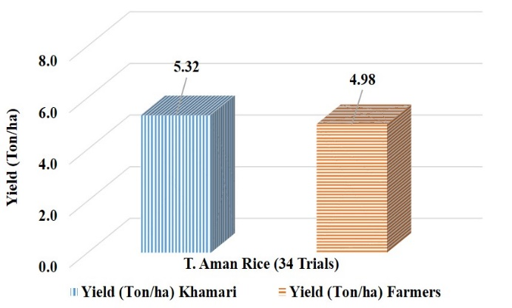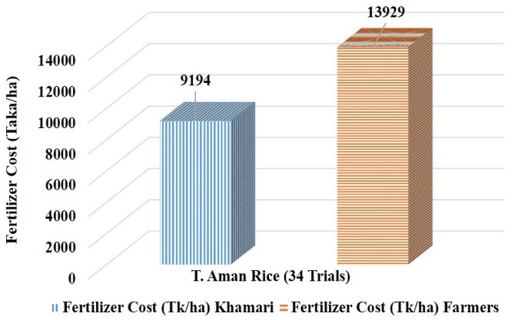

**Fig. 1: Yield and fertiliser cost of T. Aman rice averaged on 34 demonstration trial**

**5.1.1 Fertiliser use in T. Aman demo trial**

In the demonstration trials, the per-hectare use of various fertilisers such as DAP, TSP, MoP and Gypsum was significantly lower with Khamari app-based recommendations compared to farmers’ traditional practices. The use of Urea decreased by 12%, DAP by 59%, TSP by 72%, MoP by 14% and Gypsum by 20%. These results are illustrated in Fig. 2.

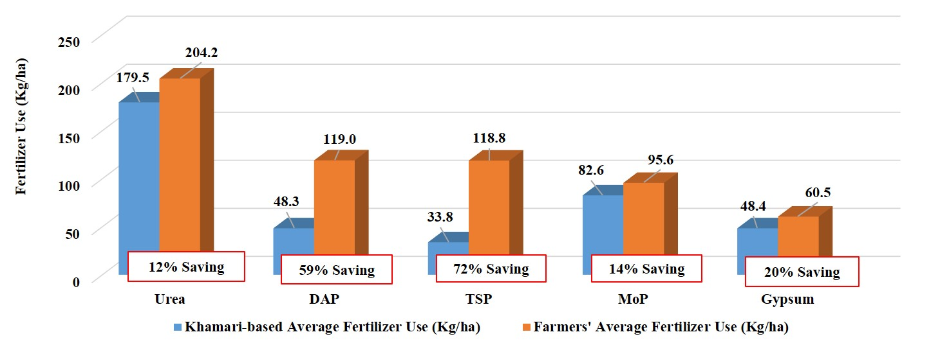

**Fig. 2: Average fertilizer use in T. Aman rice demonstration trials conducted in 34 locations**

**5.2. Boro demo trial (2023-24)**

The results of the demonstration trials for Boro rice, conducted during 2023-24, in 60 locations across different AEZ using the 'Khamari' mobile app for fertiliser recommendations, are presented in the following sections.

In summary, the outcome of demonstration trials is presented in Table 4. The average yield of the Khamari app-based fertiliser recommendation plot was 7.36 ton/ha, while the yield of farmers’ traditional practice-based fertiliser application plot was 6.97 ton/ha, highlighting the positive impact of scientific fertiliser prescriptions. The yield of boro rice averaged on 60 demonstration trials is 5.59% higher for the Khamari plot compared to the Farmers’ plot. In contrast, the fertiliser cost is 18.21% lower in the case of Khamari app-based fertiliser recommendation compared to the farmer’s fertiliser application. The graph showing the demonstration trial result of Boro rice yield and fertiliser cost is presented in Fig. 3.

**Table 4: Outcomes of the demonstration trials for Boro rice conducted in Rabi season**

|  |  |  |  |  |  |  |  |
| --- | --- | --- | --- | --- | --- | --- | --- |
| **Crop Name and Number of demonstration trials** | **Demo Trial**  **(Year)** | **Fertiliser Cost (Tk/ha)** | | **Khamari Fertiliser Cost Compared to Farmer (%)** | **Yield (Ton/ha)** | | **Khamari Yield Compared to Farmer (%)** |
| **Khamari** | **Farmers** | **Khamari** | **Farmers** |
| Boro rice (60) | 2023-24 | 16,809 | 20,551 | -18.21% | 7.36 | 6.97 | +5.59% |

*Note: The Number of demonstration trial sites is presented within parentheses.*

A paired sample t-test confirmed significant differences in yield: 'Khamari' plots (Mean = 7.36, SD = 1.167) vs. Farmers’ plots (Mean=6.97, SD=1.174); t(59) = 5.997, p = .000; and fertilizer cost: 'Khamari' plots (Mean=16809, SD=5444.96) vs. farmers’ plots (Mean=20551, SD=6278.52); t(59) = -5.143, p = .000.

It was observed from both T. Aman and Boro rice demonstration trials that the paired sample t-test strongly supports the benefits of the 'Khamari' app in enhancing yield and reducing fertiliser costs, promoting sustainable agricultural practices.

Analysing the results of 60 demonstration trials of Boro rice shows that using the fertiliser recommendations provided by the 'Khamari' app can save farmers 3,742/- Taka per hectare in fertiliser costs. Due to increased yields, additional production of 0.39 metric tons per hectare can be achieved, which is worth 12,480/- Taka (at the rate of 32/- Taka per kg). In total, using the fertiliser recommendations from the Khamari app would provide farmers a net financial gain of 16,222/- Taka per hectare (Table 5).

**Table 5: Expected financial benefits of using Khamari App recommended fertiliser**

|  |  |  |  |  |
| --- | --- | --- | --- | --- |
| **Crop Name and Number of demonstration trials** | **Fertiliser cost saving using Khamari app (Taka/ha)** | **Increased yield using Khamari app (Ton/ha)** | **Price of additional yield (Taka/ha)** | **Financial benefit of using the Khamari app (Taka/ha)** |
| Boro rice (60) | 3,742 | 0.39 | 12,480 | 16,222 |

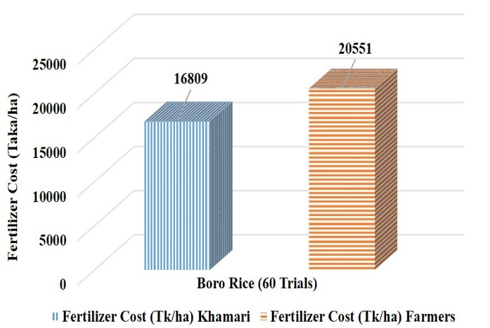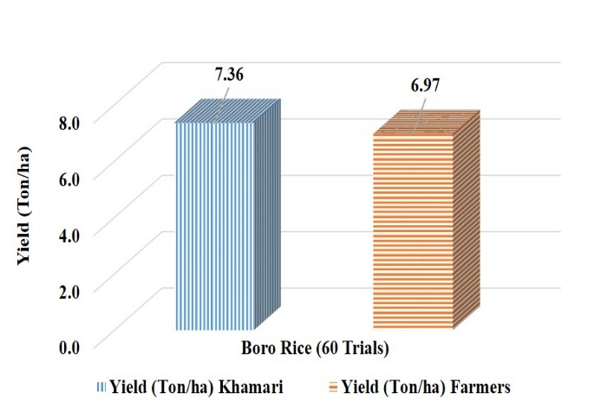

**Fig. 3: Yield and Fertiliser Cost of Boro rice averaged on 60 demonstration trials**

**5.2.1 Fertilizer use in Boro demo trial**

In the demonstration trials, the per-hectare use of various fertilisers such as DAP, TSP, MoP and Gypsum was significantly lower with Khamari app-based recommendations compared to traditional farmers’ practices. Specifically, the use of DAP decreased by 44.57%, TSP by 56.18%, MoP by 15.32% and Gypsum by 9.72%. However, the use of urea was 0.91% higher than in traditional practices. These results are illustrated in Fig. 4.

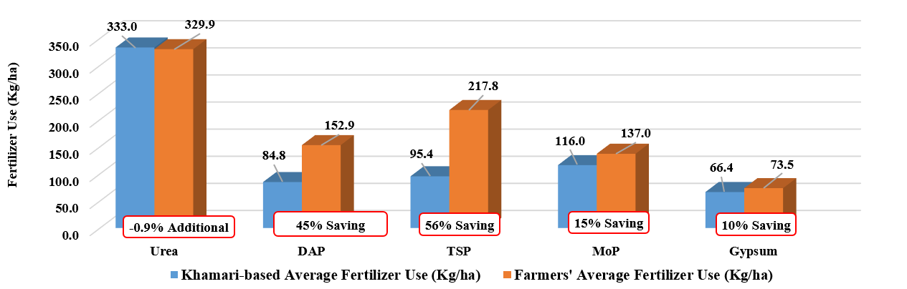

**Fig. 4: Average fertiliser use in Boro rice demonstration trials conducted in 60 locations**

Field demonstrations are a critical component for technology transfer, validating the effectiveness of recommendations in real-world conditions. Singh *et al.* (2015) noted that participatory demonstrations improve farmer confidence and adoption rates of SSNM (Site-Specific Nutrient Management) practices. The Khamari app’s effectiveness, validated through demonstration trials on T. Aman and Boro rice, supports this approach, revealing significant improvements in yield and cost savings.

6. SUMMARY

The results from demonstration trials of the ‘Khamari’ app for Aman and Boro rice emphasise the app’s considerable economic impact potential on Bangladesh’s agricultural sector.

With 5.7 million hectares (Mha) of Aman rice cultivated in Bangladesh, using the Khamari app's fertiliser recommendations could generate an estimated 89,655.3 million BDT in financial benefits across the nation. Given that Boro rice is grown on 5.058 Mha, widespread adoption of the app’s fertiliser recommendations could yield a financial benefit of 82,050.8 million BDT.

These results highlight the potential financial gains of 171,706.1 million BDT if Khamari app recommendations were broadly adopted, illustrating how digital agricultural tools can transform productivity

7. Conclusion

The 'Khamari' mobile app is a vital tool for promoting smart agriculture by integrating technology to optimise resource management and support data-driven decision-making. Through real-time recommendations, the app enables farmers to make informed choices, leading to increased crop yields, reduced input costs, and greater efficiency in agricultural practices. By offering precise fertiliser recommendations, the app not only cuts expenses but also boosts crop productivity and supports environmentally sustainable farming practices. Additionally, by fostering eco-friendly approaches, it has the potential to decrease greenhouse gas emissions, enhance soil health, and save the government significant costs, especially since fertilisers are imported.

The 'Khamari' app aligns closely with the goals of sustainable development (SDGs), encouraging resource conservation, environmental stewardship, and food security. By delivering localized, actionable insights and encouraging eco-friendly agricultural practices, it supports the resilience of farming systems, promotes rural economic development, and reinforces national food security. As such, it is a valuable asset for farmers, extension workers, and policymakers committed to building a more sustainable agricultural future in Bangladesh.

The Khamari App exemplifies the integration of precision agriculture and mobile-based advisory services tailored to the context of Bangladesh. Initial field trial results have demonstrated measurable gains in efficiency and productivity. However, scaling its impact will require concerted efforts to overcome challenges related to digital infrastructure, farmer digital literacy, and supportive policy environments.

Research and global experiences emphasise the importance of:

* Localised adaptation of technology to agro-ecological and socio-economic conditions,
* Farmer-centric design that ensures usability regardless of literacy levels, and
* Robust governance frameworks that ensure data accuracy, content validation, and institutional collaboration.

With the right support mechanisms in place, the ‘Khamari’ app can serve as a model for digital agriculture, not only within Bangladesh but also across other developing regions aiming to modernise their agricultural advisory systems through smart, sustainable, and inclusive digital solutions.

COMPETING INTERESTS DISCLAIMER:

Authors have declared that they have no known competing financial interests OR non-financial interests OR personal relationships that could have appeared to influence the work reported in this paper.

Disclaimer (Artificial intelligence)

Option 1:

Author(s) hereby declare that NO generative AI technologies such as Large Language Models (ChatGPT, COPILOT, etc.) and text-to-image generators have been used during the writing or editing of this manuscript.

Option 2:

Author(s) hereby declare that generative AI technologies such as Large Language Models, etc. have been used during the writing or editing of manuscripts. This explanation will include the name, version, model, and source of the generative AI technology and as well as all input prompts provided to the generative AI technology

Details of the AI usage are given below:

1.

2.

3.

11. References

Ahmmed, M., Rahman, M. A., Hossain, M. A., & Ahmed, M. M. (2018). Fertilizer Recommendation Guide-2018. Bangladesh Agricultural Research Council (BARC). Farmgate, Dhaka 1215. 223p

Bangladesh Planning Commission. (2020). Eighth Five Year Plan (July2020-June2025), Ministry of Planning, Government of Bangladesh.

BBS. (2023). Labor Force Survey 2022 Final Report. Dhaka: Bangladesh Bureau of Statistics, Ministry of Planning, Government of Bangladesh.

BBS. (2024). Yearbook of Agricultural Statistics. Dhaka: Bangladesh Bureau of Statistics, Ministry of Planning, Government of Bangladesh.

De Wrachien, D. (2003). Land use planning: A key to sustainable agriculture. In L. Garcia-Torres, J. Benites, A. Martinez-Vilela, & A. Holgado-Cabrera (Eds.), Conservation agriculture (pp. 471–484). Springer. <https://doi.org/10.1007/978-94-017-1143-2_57>

FAO/UNDP. (1988). Land Resources Appraisal of Bangladesh for Agricultural Development. FAO/UNDP Project (BGD/81/035).

FAO. (2022). *Digital agriculture transformation in Bangladesh: Status and prospects*. Food and Agriculture Organization of the United Nations.

Mittal, S., & Mehar, M. (2016). *Socio-economic factors affecting adoption of modern information and communication technology by farmers in India*. Agricultural Economics Research Review, 29(2), 249–260.

Pampolino, M. F., Johnston, A., Sato, S., Crutz, D. C., & Gerard, B. (2012). Development approach and evaluation of the Nutrient Expert software for rice. Agronomy Journal, 104(2), 196–209. <https://doi.org/10.2134/agronj2011.0301>

# Pereira, A. R. (1983). Crop planning for different environments. Symposium on Potential Productivity of Field Crops under different Environments. International Rice Research Institute. 415-420.

Singh, U., Buresh, R. J., & Dobermann, A. (2015). Site-specific nutrient management: A framework for managing plant nutrient for intensive rice production. IRRI Technical Bulletin, 5. International Rice Research Institute.

Sivakumar, M. V. K., & Valentin, C. (1997). Agroecological zones and the assessment of crop production potential. Philosophical Transactions of the Royal Society B: Biological Sciences, 352(1356), 907–916. <https://doi.org/10.1098/rstb.1997.0070>

Wolfert, S., Ge, L., Verdouw, C., & Bogaardt, M. J. (2017). Big Data in Smart Farming – A review. Agricultural Systems, 153, 69–80. <https://doi.org/10.1016/j.agsy.2017.01.023>

Sarma, H. H., Das, B. C., Deka, T., Rahman, S., Medhi, M., & Kakoti, M. (2024). Data-driven Agriculture: Software Innovations for Enhanced Soil Health, Crop Nutrients, Disease Detection, Weather Forecasting and Fertilizer Optimization in Agriculture. Journal of Advances in Biology & Biotechnology, 27(8), 878–896. <https://doi.org/10.9734/jabb/2024/v27i81209>

Malhotra, P. K., & Goyal, R. C. (2014). Information Systems and Software Development at IASRI: An Overview. IASRI-An era of Excellence.

Prasad, K. (2012). Mobile communication for sustainable development: change and challenges in South Asia. Proceedings of M4D 2012 28-29 February 2012 New Delhi, India, 28(29), 161.